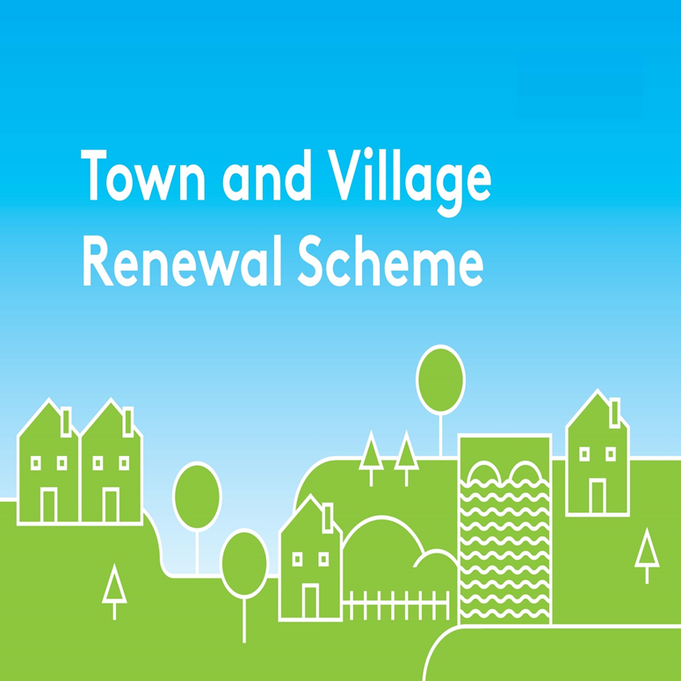 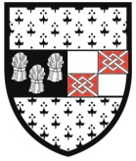Kilkenny County Council

Kilkenny County Council will host an evening information session on the 2017 Town and Village Renewal Scheme on Thursday 11th May at 7.15pm in the Springhill Hotel, Waterford Road, Kilkenny City.

Town & Village Renewal Scheme can grant aid up to 80% of the projects costs for project between €20,000 and €100,000. Kilkenny County Council will submit 15 applications to Department of Arts, Heritage, Regional Rural and Gealtacht Affairs for funding.
The first stage of applying for this grant is to submit an expression of interest to Kilkenny County Council by Wednesday 17th May 2017.

The purpose of the Information Session is to give a broad outline of the 2017 Scheme and the types of projects that local communities might seek to focus on in the context of their Expressions of Interest.

The Agenda will include;
- 7.15pm Introductions
- 7.20pm General Presentation on the 2017 TVRS
- 7.35pm Completing the Expressions of Interests Forms
- 7.45pm Questions and Answers
- 8.15pm Closing Remarks

