**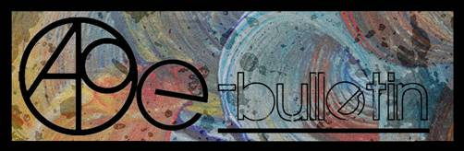**

**Kilkenny County Council Arts Office E-bulletin 13th June, 2014**

Dear All,   
  
Welcome to this week’s e-bulletin from Kilkenny County Council's Arts Office. Each bulletin is packed with the latest information on Kilkenny Arts Office activities, county events as well as news and opportunities for arts practitioners from around the country.

We have decided to shorten information included in the e-bulletin for easier use. This should particularly work well for those reading off tablets and smartphones.

This service will be provided fortnightly. To include an item in the next e-bulletin please send a brief outline of your advert with relevant contact details, including any websites or pages with links to [**julianne.morgan@kilkennycoco.ie**](mailto:julianne.morgan@kilkennycoco.ie) **before 25th June**. The next e-bulletin will be on **27th June**.

**PLEASE NOTE THE NEW EMAIL ADDRESS TO SEND INFORMATION FOR INCLUSION IN THE E-BULLETIN.**

While every effort has been made to ensure the accuracy of our information, we strongly advise readers to verify all details to their own satisfaction.

**It’s come to our attention that emails from Niamh Finn, Arts Administrator, may be going to your Spam. Niamh has changed her surname after marriage so please note her new email address is** [**niamh.brophy@kilkennycoco.ie**](mailto:niamh.brophy@kilkennycoco.ie)**and add it to your safe list and contacts for future reference.**

Regards,  
Julianne Morgan  
Arts Office,  
T: 056 7794938  
E: [Julianne.Morgan@kilkennycoco.ie](mailto:Julianne.Morgan@kilkennycoco.ie)   
W: [www.kilkennycoco.ie/eng/Services/Arts/](http://www.kilkennycoco.ie/eng/Services/Arts/)  
Kilkenny County Council Arts Office Partner Local Authority of the ArtLinks Programme [www.artlinks.ie](http://www.artlinks.ie)

**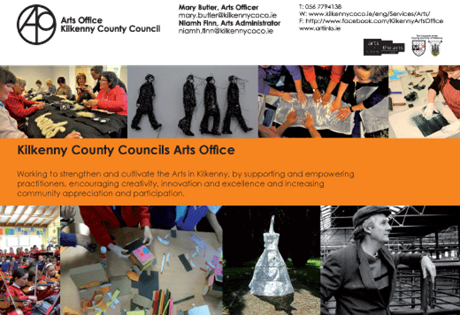**

**\_\_\_\_\_\_\_\_\_\_\_\_\_\_\_\_\_\_\_\_\_\_\_\_\_\_\_\_\_\_\_\_\_\_\_\_\_\_\_\_\_\_\_\_\_\_\_\_\_\_\_\_\_\_\_\_\_\_\_\_\_\_\_\_\_\_\_\_\_\_\_\_\_\_\_**

**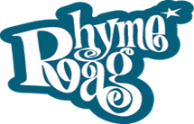**                     ****

**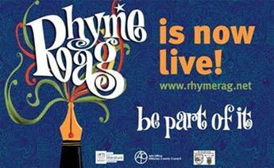**

The Rhyme Rag is a poetry publication featuring the work of young Kilkenny writers and was initiated in 2005.

Rhyme Rag horraay, we have just published our first two poems.

<http://www.rhymerag.net/category/poems/>

 It was so worth the wait, the struggles, the hurdles, the excitement, the emotion....and remember this is only the beginning. And oh my goodness the writing talents and skills of the teenagers we have in this county is heartening. The work came flooding in and John Sexton, editor, had the joy of reading and replying to all the poets but also the difficulty of selecting only two poems to publish and Ale Mercado, as ever, has done an amazing job of illustrating the selected poems. Watch this space there is plenty more to come, so check in every month people. Thank you one and all.

Some of you will definitely hear from me again in the near future as your continued support will always be needed and very welcome.

Thank you and Best regards,

Mary



Illustration by Alé Mercado for ‘Where’s My Child’, Harry Kealy

[http://www.rhymerag.net/2014/06/wheres-my-child/](http://l.facebook.com/l.php?u=http%3A%2F%2Fwww.rhymerag.net%2F2014%2F06%2Fwheres-my-child%2F&h=qAQFdq73w&s=1)

**BECOME PART OF IT, SUBMIT A POEM.....**[www.rhymerag.net](http://kk-moss/Sites/arts_office/Shared%20Documents/Julianne%20Morgan/E-bulletin/30th%20May%20e-bulletin/www.rhymerag.net)

Should you have any questions or require and further details please do not hesitate to contact me on 056 7794138 / [mary.butler@kilkennycoco.ie](mailto:mary.butler@kilkennycoco.ie)

Mary Butler, Arts Officer.

****            **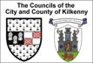**           **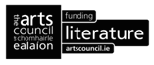**

**\_\_\_\_\_\_\_\_\_\_\_\_\_\_\_\_\_\_\_\_\_\_\_\_\_\_\_\_\_\_\_\_\_\_\_\_\_\_\_\_\_\_\_\_\_\_\_\_\_\_\_\_\_\_\_\_\_\_\_\_\_\_\_\_\_\_\_\_\_\_\_\_\_\_\_**

# Short Story Workshop with Margaret Irish

****

As part of our on-going commitment to Kilkenny writers, Kilkenny County Council Arts Office announced a Short Story Workshop with Kilkenny based writer Margaret Irish. This one-day workshop explored the craft of short story writing. The basics of how stories work, and the key issue of knowing the rules and knowing when to break them were discussed.

Dates: This workshop ran twice in May on **Saturday 24th** and **Friday 30th May** in St. Mary's Day Care Centre, Gaol Rd, Haughney Green, Kilkenny.

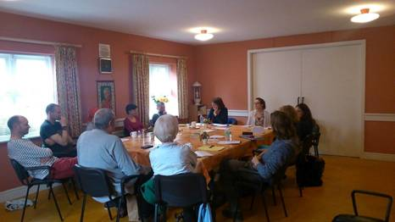

Short story workshop with Margaret Irish

**Biography:** Margaret Irish's short fiction has been published in Ireland, the UK, Canada, and broadcast on RTE and BBC radio. Two radio plays have been produced by RTE, including a PJ O'Connor Award winner. Her stage play Ravine has had a public reading by Accidental Theatre Productions, Belfast. Her most recent story is included in the Dark Mountain anthology, published in the UK in April.

****

**\_\_\_\_\_\_\_\_\_\_\_\_\_\_\_\_\_\_\_\_\_\_\_\_\_\_\_\_\_\_\_\_\_\_\_\_\_\_\_\_\_\_\_\_\_\_\_\_\_\_\_\_\_\_\_\_\_\_\_\_\_\_\_\_\_\_\_\_\_\_\_\_\_\_\_**

**Open Circle - Social Fabric: Portraits of Kilkenny Women**

**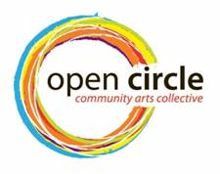**

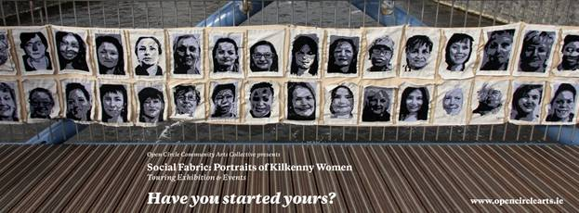

‘Social Fabric: Portraits of Kilkenny Women’, forty hand embroidered portraits, is now on display in Loughboy library, Kilkenny, for the month of June.

'Social Fabric: Portraits of Kilkenny Women' is a project initiated by the women of Open Circle Community Arts Collective. Participants of Open Circle invited other women from throughout Kilkenny to join them in the creation of this collaborative artwork. Textile artist Deirdre Harte responded to the groups ideas with an embroidery project that was both collaborative and distinctly individual, a collection of portraits. Emphasis was placed on bringing women together to make communally. Forty women took part in this project to celebrate International Women’s Day 2014 in Kilkenny.

If you are interested in taking part in the next round of workshops contact [opencirclearts@gmail.com](mailto:opencirclearts@gmail.com) to find out how you can get involved.

More info at [http://tinyurl.com/n9zbg7u](http://tinyurl.com/n9zbg7u%20)

**\_\_\_\_\_\_\_\_\_\_\_\_\_\_\_\_\_\_\_\_\_\_\_\_\_\_\_\_\_\_\_\_\_\_\_\_\_\_\_\_\_\_\_\_\_\_\_\_\_\_\_\_\_\_\_\_\_\_\_\_\_\_\_\_\_\_\_\_\_\_\_\_\_\_\_**

# Kilkenny Arts Office Irish Youth Choir Summer School Bursary 2014 – Deadline today!

****

The Association of Irish Choirs is pleased to partner with Kilkenny County Council's Arts Office, to offer a bursary to attend the Irish Youth Choir Summer School, taking place from 29th June to 7th July. This bursary is open to singers aged between 18 and 28 with relevant choral experience, who live within Kilkenny County Council's administrative area. Selection is via IYC's application form, and candidates will be required to complete a short form for Kilkenny Arts Office should they fulfil the criteria.

**Closing date for the receipt of bursary applications is no later than 4pm on Friday 13th June 2014.**

Download your application here: [Irish Youth Choir Summer School Bursary Application Form 2014](http://www.kilkennycoco.ie/eng/Services/Arts/News/Irish-youth-choir-summer-school-bursary-application-form.doc)

For application forms regarding the bursary please contact:   
Niamh Brophy, Arts Administrator, Kilkenny County Council Arts Office, John's Green House, John's Green, Kilkenny.  
T: 056 779 4138 E: [niamh.brophy@kilkennycoco.ie](mailto:niamh.brophy@kilkennycoco.ie)

Or contact the Association of Irish Choir's (AOIC), Irish Youth Choir Summer School at: <http://www.aoic.ie/iyc/>

\*\*\*\*\*\*\*\*\*\*\*\*\*\*\*\*\*\*\*\*\*\*\*\*\*\*\*\*\*\*\*\*\*\*\*\*\*\*\*\*\*\*\*\*\*\*\*\*\*

**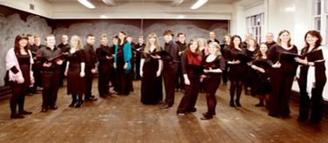**

**AOIC's Irish Youth Choir Summer School Information**

Made up of Ireland's finest young singers aged 18 to 28, the Irish Youth Choir meets annually for a main intensive rehearsal course in the summer under the expert tuition of the Artistic Director, Greg Beardsell, and a team of tutors and vocal coaches. The week culminates in a number of performances in varying touring venues at the beginning of July and August. Delivered by the Association of Irish Choirs, the Irish Youth Choir Summer school 2014 is a residential week in the University of Limerick, running from 29th June- 7th July 2014. During the residency, singers undertake intensive training and professional development.

**When: 29th June to 7th July (inclusive)**

**Where:** University of Limerick

**Who is this suitable for?**  
Those aged between 18 and 28 on 28th June 2014 with relevant choral/singing experience, who wish to train with leading vocal and choral professionals during a week-long residential summer course.

**What's the damage?**  
The cost of attending the school is as follows:  
- Full board, Waged €499 Unwaged / student €459   
- Accommodation only, Waged €370 Unwaged / student €340   
- Food only, Waged €370 Unwaged / student €340   
- Tuition only, Waged €260 Unwaged / student €240

**Where do I sign up?**  
Download the I.Y.C application form here: <http://www.aoic.ie/iyc/join_us/?gclid=CPir4oTEnL4CFcJ82wodRkkA5g>

**\_\_\_\_\_\_\_\_\_\_\_\_\_\_\_\_\_\_\_\_\_\_\_\_\_\_\_\_\_\_\_\_\_\_\_\_\_\_\_\_\_\_\_\_\_\_\_\_\_\_\_\_\_\_\_\_\_\_\_\_\_\_\_\_\_\_\_\_\_\_\_\_\_\_\_**

**Exhibition ‘THE UNHAPPY ISLAND’, works by Saturio Alonso**

**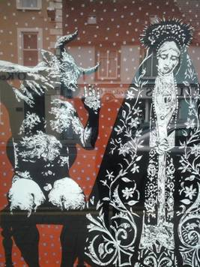**

Last chance to see Saturio Alonso's work as part of the Unhappy Island series in the window of no.76 John Street, Kilkenny.

**\_\_\_\_\_\_\_\_\_\_\_\_\_\_\_\_\_\_\_\_\_\_\_\_\_\_\_\_\_\_\_\_\_\_\_\_\_\_\_\_\_\_\_\_\_\_\_\_\_\_\_\_\_\_\_\_\_\_\_\_\_\_\_\_\_\_\_\_\_\_\_\_\_\_\_**

**Siamsa**

**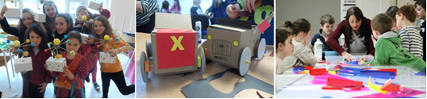**

Our Siamsa programme finished on May 18th, following five weeks of hands-on learning experience through scientific experiments and art making projects.

So what do the children get up to at SIAMSA? Look at this beautiful little film of our creative SIAMSA participants: <http://youtu.be/U34xgnPNfQQ>

**\_\_\_\_\_\_\_\_\_\_\_\_\_\_\_\_\_\_\_\_\_\_\_\_\_\_\_\_\_\_\_\_\_\_\_\_\_\_\_\_\_\_\_\_\_\_\_\_\_\_\_\_\_\_\_\_\_\_\_\_\_\_\_\_\_\_\_\_\_\_\_\_\_\_\_**

**Kilkenny poetry broadsheet issue 14 - Record number of entries**

**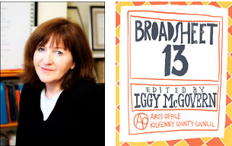**

A record number of entries was received for submissions to this year's Kilkenny Poetry Broadsheet. Editor Enda Coyle-Greene will have plenty of reading to do over the coming weeks. Thanks so much to all who entered and the best of luck!

Kilkenny Poetry Broadsheet will be launched in August as an **OFFICIAL EVENT** of the **KILKENNY ARTS FESTIVAL (8th – 17th August).**

**\_\_\_\_\_\_\_\_\_\_\_\_\_\_\_\_\_\_\_\_\_\_\_\_\_\_\_\_\_\_\_\_\_\_\_\_\_\_\_\_\_\_\_\_\_\_\_\_\_\_\_\_\_\_\_\_\_\_\_\_\_\_\_\_\_\_\_\_\_\_\_\_\_\_\_**

**Kilkenny Events**

**\_\_\_\_\_\_\_\_\_\_\_\_\_\_\_\_\_\_\_\_\_\_\_\_\_\_\_\_\_\_\_\_\_\_\_\_\_\_\_\_\_\_\_\_\_\_\_\_\_\_\_\_\_\_\_\_\_\_\_\_\_\_\_\_\_\_\_\_\_\_\_\_\_\_\_**

**Upstairs Gallery – "Cognition" by Marilyn Gaffney**

**An exhibition of new works by Dublin based artist Marilyn Gaffney**

**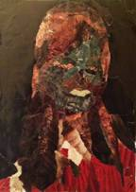**

*Negative*, 17x19cm, collage, Marilyn Gaffney 2013

Venue: The Upstairs Gallery, The Watergate Theatre, Parliament Street, Kilkenny City

Date: **June 1st- 30th, 10am-6pm week days, Saturday 2pm – 6pm**

**Please join us at the opening Sunday June 1st at 6pm**

The show is suitable for adults and children alike and everyone is welcome!

Investigating the mental process of knowing through the process of painting forms as research within this new body of work. Awareness, perception, reasoning and judgment are obvious applications of conscious reasoning but thought takes many subtler forms, such as interpreting. Sensory input, guiding physical actions and empathizing with others.

Mobile: 0857053979

For further information please check out [facebook.com/upstairsgallerykilkenny](http://facebook.com/upstairsgallerykilkenny)

Watergate: [www.watergatetheatre.com](http://www.watergatetheatre.com)

**\_\_\_\_\_\_\_\_\_\_\_\_\_\_\_\_\_\_\_\_\_\_\_\_\_\_\_\_\_\_\_\_\_\_\_\_\_\_\_\_\_\_\_\_\_\_\_\_\_\_\_\_\_\_\_\_\_\_\_\_\_\_\_\_\_\_\_\_\_\_\_\_\_\_\_**

**Poetry  Reading**

**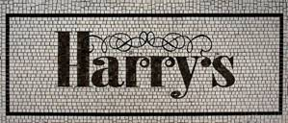**

\*\*\*\*\*\*\*

**First Tuesday of each month**

Time: **8 pm**

Venue:Harry’s Bar, Langton’s House Hotel

\*\*\*\*\*\*\*

Come along and read your poems or read your favourite poems or just listen and mingle.

\*\*\*\*\*\*\*

All are welcome

 Admission is free

**\_\_\_\_\_\_\_\_\_\_\_\_\_\_\_\_\_\_\_\_\_\_\_\_\_\_\_\_\_\_\_\_\_\_\_\_\_\_\_\_\_\_\_\_\_\_\_\_\_\_\_\_\_\_\_\_\_\_\_\_\_\_\_\_\_\_\_\_\_\_\_\_\_\_\_**

**Devious Theatre – Flood Back- July 8th, 9th, 10th**

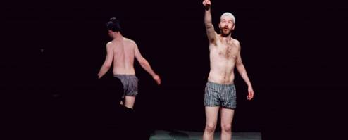

We’ll be bringing John Doran and Kevin Mooney’s new show back for a limited run in Kilkenny this July. On **July 8th** and **9th** we’ll be bringing the show to the [Red Door Theatre](https://www.facebook.com/pages/Red-Door-Music-and-Arts/213467048695170?fref=ts) at The Bridgebrook Arms in Thomastown. We’re looking forward to heading back out to Thomastown after our brief run of [*War Of Attrition*](http://devioustheatre.com/past-shows/war-of-attrition-2013/) out there last year.

We’ll be following that up with a one night only performance in [The Watergate Theatre](http://www.watergatetheatre.com) on **July 10th** as part of a week long festival of theatre as part of the Watergate’s 21st birthday celebrations. You can book your tickets at the Watergate box office or on **056-7761674**!

W: <http://devioustheatre.com/flood-back-20140520/>

**Here Be Dragons – Workhouse. Callan – 26 / 27 / 28th June**

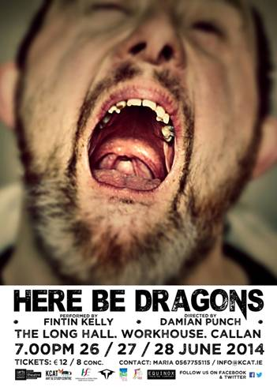

Let yourself be taken on a theatrical journey of how one man views the world we live in. Devised by these two theatre professionals and shaped into a unique multi-media production that incorporates both film and live action, **HERE BE DRAGONS** promises to be a theatrical experience not to be missed.

**"HERE BE DRAGONS"**, directed by Damian Punch, stars Fintin Kelly of Equinox Theatre Company, KCAT.

HERE BE DRAGONS runs as part of the Abhainn Rí Festival.

Venue: The Long Hall - The Workhouse, Callan, Co. Kilkenny

Dates:  **26th, 27th, 28th of June @ 7p.m** (40 min approx)

Tickets: **€12/8** - available from KCAT Art & Study Centre

To book or for more information please contact Maria or Joan

056 7755115 - [info@kcat.ie](http://kk-moss/Sites/arts_office/Shared%20Documents/Julianne%20Morgan/E-bulletin/13th%20June/info@kcat.ie)

**\_\_\_\_\_\_\_\_\_\_\_\_\_\_\_\_\_\_\_\_\_\_\_\_\_\_\_\_\_\_\_\_\_\_\_\_\_\_\_\_\_\_\_\_\_\_\_\_\_\_\_\_\_\_\_\_\_\_\_\_\_\_\_\_\_\_\_\_\_\_\_\_\_\_\_**

**Kilkenny based Eoghan McGrath is ‘Vanishing Art’ Artist in Residence at Carton House**

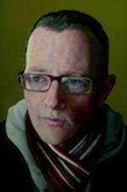

Vanishing Art returns to Carton House for its second year this year and with it the launch of the Artist in Residence programme. Kilkenny based, Eoghan McGrath is this year’s resident artist. McGrath is a primarily self taught painter having previously studied medicine for several years. He has gained recognition for his portraiture, being shortlisted for the Davy Portrait Award in 2009. His work features in both national and international collections.

More info at <http://tinyurl.com/kzg83vz>

**\_\_\_\_\_\_\_\_\_\_\_\_\_\_\_\_\_\_\_\_\_\_\_\_\_\_\_\_\_\_\_\_\_\_\_\_\_\_\_\_\_\_\_\_\_\_\_\_\_\_\_\_\_\_\_\_\_\_\_\_\_\_\_\_\_\_\_\_\_\_\_\_\_\_\_**

**Kilkenny School of Music – Calling Young Musicians, Enrol now for September**



Pre-instrumental foundation class: **€198 for year**

Beginner violin, cello, piano & wind: **€260 per term**

Solo instrumental lessons: **€360 per term**

W: <http://www.kilkennyschoolofmusic.net/>

**\_\_\_\_\_\_\_\_\_\_\_\_\_\_\_\_\_\_\_\_\_\_\_\_\_\_\_\_\_\_\_\_\_\_\_\_\_\_\_\_\_\_\_\_\_\_\_\_\_\_\_\_\_\_\_\_\_\_\_\_\_\_\_\_\_\_\_\_\_\_\_\_\_\_\_**

**Workshops with Tunde Toth in Inistioge, Co. Kilkenny**

**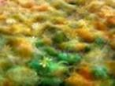**

**15th JUNE** (Sunday): BATIK Techniques - for beginners and participants with some previous experience

Fee: **€70** for the full day workshop – INCLUDING all materials

This is a full day course n BATIK: introducing a traditional, ancient technique of dyeing and decorating fabrics using hot wax as a resist and fabric dyes.

**6th JULY** (Sunday): PAPERMAKING DAY

Fee:**€ 35** per workshop **OR €65** for the full day – INCLUDING all materials

**10am - 1pm**: HAND PAPERMAKING– beginners and/or some experience

Introducing traditional and contemporary techniques of making beautiful textured and decorated handmade papers from pure plant fibres and recycled materials.

**2.30 – 5.30pm**: SILK FIBRE PAPERMAKING– beginners and/or some experience

This workshop introduces contemporary techniques used in silk papermaking using a variety of raw silk fibres combined with plant fibres and dyes; creating unique, colourful, striking silk papers ideal for many projects.

CALL FOR INTEREST - ADVANCED LEVEL PAPER ART COURSE

Following a number of requests we are calling for artists, crafts practitioners, teachers etc. - participants with previous experience in hand papermaking processes.

Please let us know if you are interested in participating in a FULL DAY ADVANCED LEVEL PAPER ART COURSE and if either of these days would suit you: **22nd JUNE (Sunday)** **OR 28th JUNE (Saturday).**

FULL WORKSHOP DESCRIPTIONS on: [www.tundetothpaperart.blogspot.com](http://www.tundetothpaperart.blogspot.com/)

CONTACT Tunde: 087-2543362

E-mail: [tundetune@gmail.com](mailto:tundetune@gmail.com)

W: [www.tundetoth.com](http://www.tundetoth.com)

Blog: <http://www.tundetothpaperart.blogspot.com>

**\_\_\_\_\_\_\_\_\_\_\_\_\_\_\_\_\_\_\_\_\_\_\_\_\_\_\_\_\_\_\_\_\_\_\_\_\_\_\_\_\_\_\_\_\_\_\_\_\_\_\_\_\_\_\_\_\_\_\_\_\_\_\_\_\_\_\_\_\_\_\_\_\_\_\_**

**Hillside Studio – Mike Skidmore Portraits Equestrian Animals**

Hillside Studio, Donoughmore, Ballyragget, Co. Kilkenny

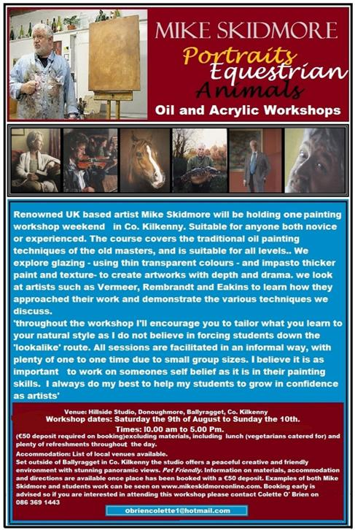

Workshop dates: **Saturday, 9th August – Sunday 10th**

Times: **10.00 am – 5.00 Pm.**

For more information, dates (all dates to suit students) and bookings, please call Colette on 086 3691443 or email [obriencolette1@hotmail.com](mailto:obriencolette1@hotmail.com)

**\_\_\_\_\_\_\_\_\_\_\_\_\_\_\_\_\_\_\_\_\_\_\_\_\_\_\_\_\_\_\_\_\_\_\_\_\_\_\_\_\_\_\_\_\_\_\_\_\_\_\_\_\_\_\_\_\_\_\_\_\_\_\_\_\_\_\_\_\_\_\_\_\_\_\_**

**Barnstorm theatre company Youth Drama Camp, deadline to secure a place - 13th June 2014**

**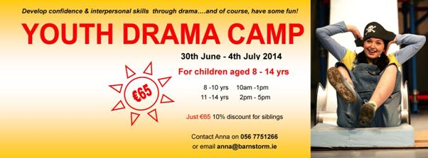**

For children aged 8 to 14 years

Develop confidence and interpersonal skills through drama

Facilitated by a professional youth drama facilitator

* The cost is **€65**, with a 10% discount for members of the same family
* Parental consent, a registration form and a non-refundable deposit of **€30** is required to secure a place by **13th June 2014.**
* Please make cheques payable to: Barnstorm Theatre Company
* If you have any further questions please do not hesitate to contact **Anna** at [anna@barnstorm.ie](http://kk-moss/Sites/arts_office/Shared%20Documents/Julianne%20Morgan/E-bulletin/16th%20May%20e-bulletin/anna@barnstorm.ie)or 056 7751266.

**\_\_\_\_\_\_\_\_\_\_\_\_\_\_\_\_\_\_\_\_\_\_\_\_\_\_\_\_\_\_\_\_\_\_\_\_\_\_\_\_\_\_\_\_\_\_\_\_\_\_\_\_\_\_\_\_\_\_\_\_\_\_\_\_\_\_\_\_\_\_\_\_\_\_\_**

# George McCutcheon – KCAT GALLERY

### [http://www.kcat.ie/WP/wp-content/themes/kcat/images/KCATLogo_Level001.jpg](http://www.kcat.ie/)

### A retrospective collection of work

### Date: opening Saturday 21st June at 3pm – Sunday 29th (Open ****12pm - 5pm Daily)**** Venue: KCAT Gallery, Mill Lane, Co. Kilkenny

Showcasing the 'Father of KCAT', this exhibition will highlight the breadth of approaches employed by George over his creative life. Curated by George and the KCAT Studio the selection will be a representation of the many facets to George's work including mosaic, drawing, painting and construction.

**To coincide with the exhibition a special 48 page publication on George and his work will be launched and available to buy for €10.**

More info at <http://tinyurl.com/ot3l6bk>

<http://www.kcat.ie/WP/>  
**\_\_\_\_\_\_\_\_\_\_\_\_\_\_\_\_\_\_\_\_\_\_\_\_\_\_\_\_\_\_\_\_\_\_\_\_\_\_\_\_\_\_\_\_\_\_\_\_\_\_\_\_\_\_\_\_\_\_\_\_\_\_\_\_\_\_\_\_\_\_\_\_\_\_\_**

**The Carice Singers - Concert at St. Canice’s Cathedral, Friday 22nd August 2014**

**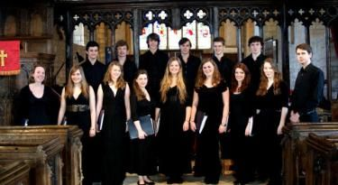**

We shall be performing in St. Canice’s Cathedral on the evening **of Friday 22nd August** as part of our tour of the Republic of Ireland, with a programme of music highlighting British composers who were influenced by Ireland.

Since its founding in 2011, the choir has given many acclaimed performances across the UK, and are the youngest ensemble to have recorded a disc for the record label Naxos. For more information on the choir, please visit our website: [www.thecaricesingers.co.uk](http://www.thecaricesingers.co.uk/).

We cannot wait to visit and perform in Kilkenny this summer.

With best wishes,

George Parris,

Musical Director -- The Carice Singers

Sidney Sussex College

Sidney Street

Cambridge

CB2 3HU

[gp359@cam.ac.uk](mailto:gp359@cam.ac.uk)

tel. 07735 547262

**\_\_\_\_\_\_\_\_\_\_\_\_\_\_\_\_\_\_\_\_\_\_\_\_\_\_\_\_\_\_\_\_\_\_\_\_\_\_\_\_\_\_\_\_\_\_\_\_\_\_\_\_\_\_\_\_\_\_\_\_\_\_\_\_\_\_\_\_\_\_\_\_\_\_\_**

**Library News**

****

'Social Fabric: Portraits of Kilkenny Women'

Venue: Loughboy library

Date: **9th June – 30th June**

**Telephone:** 7794176/7794177

**Contact Person:** Caitriona Kenneally

**E mail:** [loughboy@kilkennylibrary.ie](mailto:loughboy@kilkennylibrary.ie)

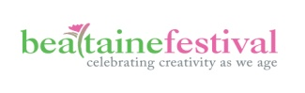

Introduction to Holistic Therapies, in association with Glosna House

**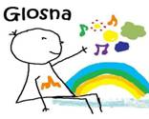**

**Holistic Treatments & Their Benefits with Claire McEvoy and Angie Byrne**

Date: **Wednesday 18th June 11:30am to 1pm**

**What is Art Therapy? with Rebekkah Carroll**

Date: **Wednesday 25th June 11:30am to 1pm**

Venue: City Library, John’s Quay

Tel: 056 779 4174

Email: [citylibrary@kilkennylibrary.ie](mailto:citylibrary@kilkennylibrary.ie)

**\_\_\_\_\_\_\_\_\_\_\_\_\_\_\_\_\_\_\_\_\_\_\_\_\_\_\_\_\_\_\_\_\_\_\_\_\_\_\_\_\_\_\_\_\_\_\_\_\_\_\_\_\_\_\_\_\_\_\_\_\_\_\_\_\_\_\_\_\_\_\_\_\_\_\_**

**Thomastown Amateur Dramatics Society: Happy Families – Community Centre**

**[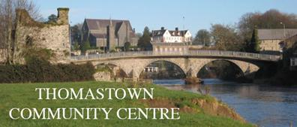](http://www.thomastownparish.ie/thomastown-community-centre-update/community-centre/)**

**Date & time: 14th June, 8pm**

**Admission: €10**

**The Brewery Project – Fund it campaign**

**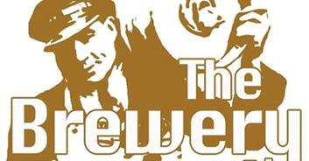**

The Brewery Project are Ita Morrissey, Liselott Olofsson & Darragh Byrne. We are a Kilkenny based arts collective, together we are a theatre maker, ceramic artist and videographer. We have come together because we recognise a need for a creative community celebration to mark the rich history of Smithwick's brewery in light of it's closure.The Brewery Project is a unique opportunity to mark this important moment in Kilkenny's history and we need you to make it happen! Thank you.

**For more info and to view the Brewery Project Fund it campaign video, please see** <http://fundit.ie/project/the-brewery-project>

**\_\_\_\_\_\_\_\_\_\_\_\_\_\_\_\_\_\_\_\_\_\_\_\_\_\_\_\_\_\_\_\_\_\_\_\_\_\_\_\_\_\_\_\_\_\_\_\_\_\_\_\_\_\_\_\_\_\_\_\_\_\_\_\_\_\_\_\_\_\_\_\_\_\_\_**

**Butler Gallery**

Felicity Clear

[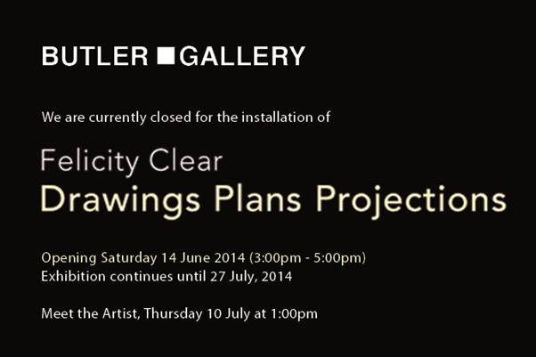](http://www.butlergallery.com/?p=4480)

Date: **June 14 – July 27th, 2014**

The Butler Gallery is delighted to present Drawings Plans Projections, an exhibition by Felicity Clear, which includes wall drawings, structures and animation.

Clear’s earlier work included precise large-scale drawings using graphite and acrylic on paper of high-rise modernist building schemes, suburban parking lots, and ghost cranes hovering over building sites with wide empty skies.

Employment opportunity

**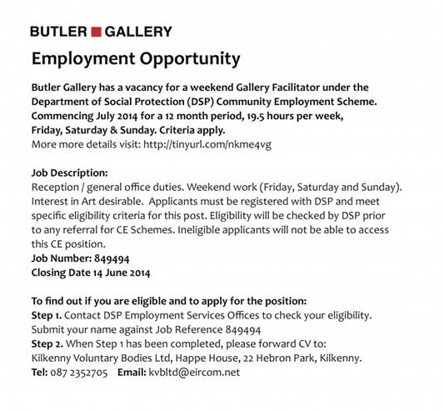**

Read more at <http://www.butlergallery.com/> and [https://www.facebook.com/#!/butlergallery?fref=ts](https://www.facebook.com/%23!/butlergallery?fref=ts)

Email: [kvbltd@eircom.net](http://kk-moss/Sites/arts_office/Shared%20Documents/Julianne%20Morgan/E-bulletin/13th%20June/kvbltd@eircom.net)

**\_\_\_\_\_\_\_\_\_\_\_\_\_\_\_\_\_\_\_\_\_\_\_\_\_\_\_\_\_\_\_\_\_\_\_\_\_\_\_\_\_\_\_\_\_\_\_\_\_\_\_\_\_\_\_\_\_\_\_\_\_\_\_\_\_\_\_\_\_\_\_\_\_\_\_**

**What’s happening in the Watergate?**

### The Irish Chamber Collective

### cid:image052.jpg@01CF86F3.BAD30440

### Date(s): 21st Jun 2014 Time: 8:00 PM - 10:00 PM

**Tickets:** **€16/€12**

The Irish Chamber Collective is an exciting new ensemble comprised of talented young Irish classical musicians.

Find on Facebook | Follow On Twitter | Official Website

Dance Upon A Dream

****

Date(s): **26th Jun 2014 until 28th Jun 2014**  
Time: **8:00 PM - 10:00 PM**

**Tickets:** **€12/€10**

Dancewise Academy are proud to present this year’s annual show “Dance Upon A Dream”. Our show promises excitement, fun and as always fantastic talent.

[Find on Facebook](https://www.facebook.com/pages/Dancewise-Studios/138031826225218?fref=pb&hc_location=profile_browser) | [Follow On Twitter](https://twitter.com/DancewiseStudio) | Official Website

A Night At The Movies

****

Date: **June 29th**

Time: **7:30 PM - 9:30 PM**

Tickets: **€12/€6**

Grainne Mulvey School Of Ballet & Modern Dance presents “A Night At The Movies”. Students from 3-18 years from both Bagenalstown and Kilkenny will perform a variety of dances to iconic music from the movies, showcasing their Ballet and Jazz styles.

[Find on Facebook](https://www.facebook.com/pages/Gr%C3%A1inne-Mulvey-School-of-Ballet-Modern/176432272376310?fref=ts) | Follow On Twitter | [Official Website](http://www.schoolofballet.ie/)

DA



Date(s): **21st Jul 2014 until 26th Jul 2014**

Time: ***8:00 PM - 10:00 PM***

**Tickets:** **€16/€13/€10**

Hugh Leonard’s hilarious comedy *Da* explores the relationship of Charlie, a successful playwright, with his adoptive father. In this semi-autobiographical play set in 1960s Dublin, we find Charlie in his childhood home just after Da’s funeral.

Find on Facebook | Follow On Twitter | Official Website

View more at <http://watergatetheatre.com/>

Want tickets? Call the box office now on 056-7761674 or click here to book online: [https://www.ctb.ie/tickets/watergate/?shows=%](https://www.ctb.ie/tickets/watergate/?shows=%25)

**\_\_\_\_\_\_\_\_\_\_\_\_\_\_\_\_\_\_\_\_\_\_\_\_\_\_\_\_\_\_\_\_\_\_\_\_\_\_\_\_\_\_\_\_\_\_\_\_\_\_\_\_\_\_\_\_\_\_\_\_\_\_\_\_\_\_\_\_\_\_\_\_\_\_\_**

**National craft gallery**

Beauty is the First Test

****

**16th May 2014 – 9th July 2014**

Mathematical concepts underpin many craft techniques, especially around textile construction, and can be key tools for artistic development. This exhibition’s intention is to unlock and demystify maths by showing unique and stimulating works of art.

For more info of the above, please visit: <http://www.nationalcraftgallery.ie/exhibitions>

Tours: Beauty is the First Test

[Beauty is the First Test](http://nationalcraftgallery.cmail2.com/t/y-l-irdtddt-jlklezkr-yk/) is ideal for school groups and tours. Concerned with the close relationship between art and mathematics, this is an exciting exhibition with a strong educational theme.

**For** [more information](http://nationalcraftgallery.cmail2.com/t/y-l-irdtddt-jlklezkr-yu/) or to [**book a tour**](http://nationalcraftgallery.cmail2.com/t/y-l-irdtddt-jlklezkr-jl/) with our Education Department please contact: [events@nationalcraftgallery.ie](mailto:events@nationalcraftgallery.ie?body=Class%3A%0ANo%20of%20students%3A%0ATeacher%20Name%3A%0ATeacher%20Contact%20No%3A%0APreferred%20dates%3A%0APreferred%20time%3A%0AOther%20info%3A&subject=School%20tour) / Phone 056 7796151

Family Day: Origami with Gina Faustino

Date**: Sat 14th June, 10.30 am + 12 noon**

Join us for our crafty Family Day where we will be trying out origami inspired by our current exhibition Beauty is the First Test with textile artist Gina Faustino. Workshops suitable for 5 +. All the family are welcome to stay and take part. Booking essential as places are limited.

To book: [events@nationalcraftgallery.ie](http://kk-moss/Sites/arts_office/Shared%20Documents/Julianne%20Morgan/E-bulletin/30th%20May%20e-bulletin/events@nationalcraftgallery.ie) / Phone 056 7796151

Late Date: Spirostitch Textile Workshop

Date**: Thurs 26th June, 6.30pm**

We'll be getting crafty for our Late Date this month, trying our hand at stitching patterns and embroidery inspired by the pattern and geometry of the spirograph in our current exhibition Beauty is the First Test. Join us for a glass of wine and a relaxed, informal evening of stitching and textile making. Free event. No booking required.

Read more about the above events at <http://www.nationalcraftgallery.ie/events>

For more information: [events@nationalcraftgallery.ie](mailto:events@nationalcraftgallery.ie) / 056 7796151

Market Development Assistant - Crafts Council of Ireland

****

The intern will gain practical experience in working in a busy market development team, delivering multiple projects in liaison with project managers, craftspeople, galleries and retailers. Also in monitoring, documenting and evaluating work in progress and producing reports.

Apply by emailing a cover letter and c.v. to Nuala McGrath: [recruitment@dccoi.ie](http://kk-moss/Sites/arts_office/Shared%20Documents/Julianne%20Morgan/E-bulletin/30th%20May%20e-bulletin/recruitment@dccoi.ie)

More info at <http://miniurl.com/da8df>

Internship Opportunity Summer 2014

National Craft Gallery is delighted to announce an exciting internship opportunity for students / graduates of art, craft, design or related courses. This internship / work placement will offer the candidate the opportunity to work closely with the Education & Outreach Officer and the NCG team.

View full internship details [here](http://www.nationalcraftgallery.ie/content/files/NCG_GalleryEducationSupport_WorkExperience_Summer2014.docx). Please forward a letter of application, outlining your interest and potential availability, with a current CV to [recruitment@dccoi.ie](javascript:void(location.href='mailto:'+String.fromCharCode(114,101,99,114,117,105,116,109,101,110,116,64,100,99,99,111,105,46,105,101)+'?subject=NCG%20Internship%20Opportunity%20-%20NCG%20ezine')) by **5pm on Friday 20th June.**

More info at [http://tinyurl.com/odmwacy](http://tinyurl.com/odmwacy%20)

**\_\_\_\_\_\_\_\_\_\_\_\_\_\_\_\_\_\_\_\_\_\_\_\_\_\_\_\_\_\_\_\_\_\_\_\_\_\_\_\_\_\_\_\_\_\_\_\_\_\_\_\_\_\_\_\_\_\_\_\_\_\_\_\_\_\_\_\_\_\_\_\_\_\_\_**

**Summer Chapter Room concerts – St. Canice’s Cathedral**

**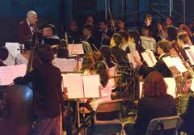**

**5pm, Sunday 15th June** - Freddy Walsh (classical guitar) – This Sunday, Freddy performs music by Bach, Jerome de Bromhead, Albéniz and others

**5pm, Sunday 22nd June** - Malcolm Proud (harpsichord) plays CPE Bach and Rameau

**5pm, Sunday 29th June** - Camerata Kilkenny plays CPE Bach and Telemann

Tickets: **€10 / €5 concession**

Have a musical Summer - Malcolm Proud

E: [proudmussm@gmail.com](http://kk-moss/Sites/arts_office/Shared%20Documents/Julianne%20Morgan/E-bulletin/30th%20May%20e-bulletin/proudmussm@gmail.com)

**\_\_\_\_\_\_\_\_\_\_\_\_\_\_\_\_\_\_\_\_\_\_\_\_\_\_\_\_\_\_\_\_\_\_\_\_\_\_\_\_\_\_\_\_\_\_\_\_\_\_\_\_\_\_\_\_\_\_\_\_\_\_\_\_\_\_\_\_\_\_\_\_\_\_\_**

**Introduction to Tapestry Weaving – 2 Day Workshop**

**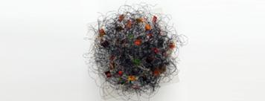**

Venue: Textile Works Studio, Annamult, Bennettsbridge, co. Kilkenny

Date: **14th & 15th June 2014**

Fee: **€150,** inclusive of all materials and a light lunch and refreshments on both days.

This course is for complete beginners and those who already have skills in tapestry weaving and are keen to explore the medium further.

If you are interested in attending the Workshop please email Anne at [anneharte.annamult@gmail.com](mailto:anneharte.annamult@gmail.com) for a reservation form and further details of the Course. Places are strictly limited to 10 participants so early booking is recommended

Phone: 087 297 8033

E‐mail: [anneharte.annamult@gmail.com](http://kk-moss/Sites/arts_office/Shared%20Documents/Julianne%20Morgan/E-bulletin/16th%20May%20e-bulletin/anneharte.annamult@gmail.com)

**\_\_\_\_\_\_\_\_\_\_\_\_\_\_\_\_\_\_\_\_\_\_\_\_\_\_\_\_\_\_\_\_\_\_\_\_\_\_\_\_\_\_\_\_\_\_\_\_\_\_\_\_\_\_\_\_\_\_\_\_\_\_\_\_\_\_\_\_\_\_\_\_\_\_\_**

**Ballykeeffe Amphitheatre - Music is what feelings sound like…**

****

Summer Solstice Music FestivalwithRonan Ó Snodaigh & Friends, The Whileaways, Declan Sinnott & Vickie Keating, The Corn Potato String Band

* **Sunday, 22nd June, from 4 p.m.**
* Tickets**€27.50** (early bird until **June 3rd €22.50**)

Mundy

* **Saturday, 12th July**
* Tickets **€20** (early bird until June 30th **€18**)

      Emily Brontë’s ‘Wuthering Heights‘ presented by Chapterhouse Theatre Company

* **Friday, July 18th**
* Tickets **€15**, concessions **€10**, families (2 adults, 2 children) **€45**

        Nathan Carter and Band

* **Thursday,** **7th August**
* Tickets **€30**, (early bird until 15th June **€27.50**)

      William Shakespeare’s ‘**A Midsummer Night’s Dream**‘ presented by Chapterhouse Theatre Company

* **Friday,** **August 8th**
* Tickets **€15**, concessions **€10**, families (2 adults, 2 children) **€45**

Climb Festival

* first weekend in September
* *admission free, car park charges*

W: <http://ballykeeffeamphitheatre.com/hello-world/>

**\_\_\_\_\_\_\_\_\_\_\_\_\_\_\_\_\_\_\_\_\_\_\_\_\_\_\_\_\_\_\_\_\_\_\_\_\_\_\_\_\_\_\_\_\_\_\_\_\_\_\_\_\_\_\_\_\_\_\_\_\_\_\_\_\_\_\_\_\_\_\_\_\_\_\_**

**Kats Theatre Group –** **CATS THE MUSICAL**

**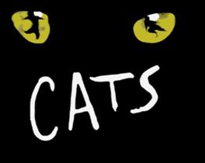**

JPR PRODUCTIONS / STARLIGHT present their 10th Anniversary production CATS THE MUSICAL with a youthful cast made up of over 70 talented county Kilkenny children all under 15 years of age!! CATS is one of Andrew Lloyd Webbers most famous and successful shows.

Here is Elaine Paige singing the iconic theme from the show MEMORY ......   
<https://www.youtube.com/watch?v=4-L6rEm0rnY>

Venue: Callan Parish Hall for 3 performances only, **Thursday 19th to Saturday 21st of June 2014**

Tickets cost **€10 all seats.** Booking can be made in advance by calling the ticket hotline 083 118 7801 or emailing [jasonpaulryanproductions@gmail.com](mailto:jasonpaulryanproductions@gmail.com)

Facebook – JPR productions: [https://www.facebook.com/#!/JPRProductionsIreland?fref=ts](https://www.facebook.com/%23!/JPRProductionsIreland?fref=ts)

**\_\_\_\_\_\_\_\_\_\_\_\_\_\_\_\_\_\_\_\_\_\_\_\_\_\_\_\_\_\_\_\_\_\_\_\_\_\_\_\_\_\_\_\_\_\_\_\_\_\_\_\_\_\_\_\_\_\_\_\_\_\_\_\_\_\_\_\_\_\_\_\_\_\_\_**

**Starlight 1D Musical Summer Camp**

[Photo: STARLIGHT SUMMER CAMP 2014 @ Set Theatre 21st - 23rd July 

Based on the songs of One Direction this fun musical workshop over three days features all the usual fun and laughter of Starlight's annual summer camps. Booking on 083 118 7801 - camp runs from 9.30am to 2.00pm with a performance on the final day - Cost of the camp is € 60.00 (ask for family discounts)](https://www.facebook.com/photo.php?fbid=10152133562662536&set=a.134554807535.118705.134544912535&type=1&relevant_count=1)

STARLIGHT SUMMER CAMP 2014 @ Set Theatre **21st - 23rd July**   
  
Based on the songs of One Direction this fun musical workshop over three days features all the usual fun and laughter of Starlight's annual summer camps. Booking on 083 118 7801 - camp runs from **9.30am to 2.00pm** with a performance on the final day - Cost of the camp is **€ 60.00** (ask for family discounts)

**\_\_\_\_\_\_\_\_\_\_\_\_\_\_\_\_\_\_\_\_\_\_\_\_\_\_\_\_\_\_\_\_\_\_\_\_\_\_\_\_\_\_\_\_\_\_\_\_\_\_\_\_\_\_\_\_\_\_\_\_\_\_\_\_\_\_\_\_\_\_\_\_\_\_\_**

**Barn Owl Players present *War Brides & In the Shadow of the Glen***

**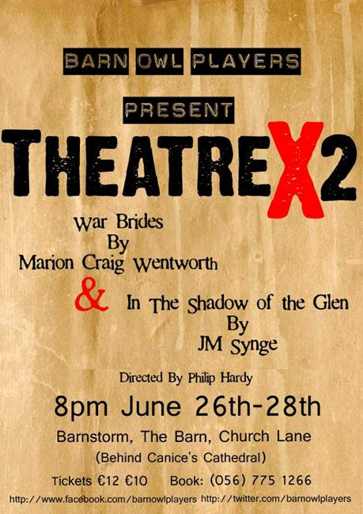**

F: <https://www.facebook.com/barnowlplayers>

**\_\_\_\_\_\_\_\_\_\_\_\_\_\_\_\_\_\_\_\_\_\_\_\_\_\_\_\_\_\_\_\_\_\_\_\_\_\_\_\_\_\_\_\_\_\_\_\_\_\_\_\_\_\_\_\_\_\_\_\_\_\_\_\_\_\_\_\_\_\_\_\_\_\_\_**

**Hole in the Wall**

****

LES DEUX MAGGOTS: A tenor in other words (LDM)

Date: **June 15th (Sun)**

Venue: Archer Room of Hole in the Wall

Admission: **€15 on door** or from Hole in the Wall on weekends

This SingSpiel is the story of James Joyce - with particular focus on his sojourn in Paris (1920/30s). It will contain readings of excerpts from ‘Ulysses’ and ‘Portrait of an Artist as a Young Man’, his play ‘Exiles’, various biographies and also focus on his talent as a - Count John McCormack quality - tenor.

Paris En Reve (PER)

Date: **July 13th (Bastille Day) (Sun)**

Venue: Archer Room of Hole in the Wall

Admission: **€15 on door** or from Hole in the Wall on weekends

This is a montage about the city of Paris and its nightlife with songs from ChAznavour (the story of Charles Aznavour (‘Emmenez Moi’, ‘La Boheme’, ‘Etre’, and Jacques Brel’s ‘Dans Le Port d’Amsterdam’ sung by Michael Conway) and footage from Hole in the Wall’s show - Being Edith Piaf).

Ballad Session every Friday and most Saturdays **from 10.00pm**.

Call: 087 8075650

Facebook: [http://tinyurl.com/kkhvwse](http://tinyurl.com/kkhvwse%20)

W: <http://www.holeinthewall.ie/>

**\_\_\_\_\_\_\_\_\_\_\_\_\_\_\_\_\_\_\_\_\_\_\_\_\_\_\_\_\_\_\_\_\_\_\_\_\_\_\_\_\_\_\_\_\_\_\_\_\_\_\_\_\_\_\_\_\_\_\_\_\_\_\_\_\_\_\_\_\_\_\_\_\_\_\_**

**YIFM - Film Summer camps & Call for funding**

**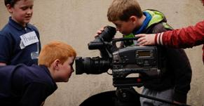**

How about a summer camp with a difference this year? Have you ever dreamed of working on a film set, of making your very own movie, of shouting those famous words ‘lights, camera, action!.’ Well, now is your chance.

### Dates for the summer camps are:

**June 30th – July 4th**  
**July 21st – July 25th**   
**July 28th – August 1st**

**Price: €140 (Snacks included)**

**Time: 9am – 5pm (Mon – Fri)**

**Junior Camp (9-12years)**

**Senior Camp (13-16years)**

Book online at <http://yifm.com/summer-camps-2014/>

Tel: 056 7764677

Funding

We are looking for funding to make an innovative film, made by 13-18 year olds from all over Ireland. However, it's a very expensive programme to run and we need the funding for equipment, licensing, accommodation, food, and insurance. If you pledge, you will get to choose from a variety of our rewards; a DVD copy of the movies produced by the NYFS, a YIFM t-shirt, or a mention in the credits of one of our films. As an added bonus, the more funding we receive, we will add more footage onto our film in progress "Conflict" that we gave you a teaser clip of in our ad!

See more at: <http://www.sponsume.com/project/national-youth-film-school>

**\_\_\_\_\_\_\_\_\_\_\_\_\_\_\_\_\_\_\_\_\_\_\_\_\_\_\_\_\_\_\_\_\_\_\_\_\_\_\_\_\_\_\_\_\_\_\_\_\_\_\_\_\_\_\_\_\_\_\_\_\_\_\_\_\_\_\_\_\_\_\_\_\_\_\_**

**Light Colour Sound Festival**

****

Light Colour Sound is Kilkenny's newest Irish summer festival and boasts two days of music, food, art, culture, literature, comedy, open forums, workshops and dance. This eclectic festival has already created a stir in the music scene both locally and nationally and boasts one of the best line ups of the summer.

HMV will sponsor the Main Stage at the festival, which will feature performances by international and Irish acts including Dan le Sac vs Scroobuis Pip, And So I Watch You From Afar, Cathy Davey, Jerry Fish, Wallis Bird, Jape, O Emperor, R.S.A.G., Engine Alley, Minutes, Kila, Raglans, The Barley Mob, I Draw Slow, and Halves.

Light Colour Sound is proud to be a small independent festival, get your tickets before they sell out. On line <http://lightcoloursoundfestival.com/tickets/>

Tickets available from   
Rollercoaster records Kilkenny  
X-tra vision Kilkenny  
The Brewery Corner Kilkenny  
HMV Grafton st Dublin  
HMV Henry St Dublin  
The Book Shop Thomastown  
Hunter Gatherer Thomastown  
Hunter Gatherer Callan

### [LCS Kilkenny Launch At The Set Theatre](http://lightcoloursoundfestival.com/lcs-kilkenny-launch-at-the-set-theatre/)

Thursday **19th June** will see the Light Colour Sound Juggernaut really kick into gear, as we host our Kilkenny launch at The Set on Johns St. Expect a myriad of bands, colour and good vibes on the night, as we count down the days to the big weekend.

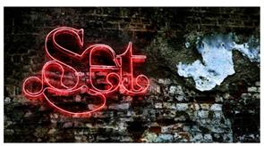

W: [www.lightcoloursoundfestival.com](http://www.lightcoloursoundfestival.com/)

F: [http://tinyurl.com/l2du7jm](http://tinyurl.com/l2du7jm%20)

**\_\_\_\_\_\_\_\_\_\_\_\_\_\_\_\_\_\_\_\_\_\_\_\_\_\_\_\_\_\_\_\_\_\_\_\_\_\_\_\_\_\_\_\_\_\_\_\_\_\_\_\_\_\_\_\_\_\_\_\_\_\_\_\_\_\_\_\_\_\_\_\_\_\_\_**

**Kilkenny Violin Week 2014, 7th – 11th July 2014**

**[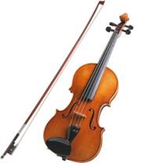](http://eofdreams.com/data_images/dreams/violin/violin-02.jpg)**

Kilkenny Violin Week is an exciting week long course of masterclasses, lessons, composition workshops and performances exclusively for violins!   
This summer the course will run in the Kilkenny School of Music from **7th-11th July 2014**.

W: <http://kilkennyviolinweek.weebly.com/>

To apply, click here <http://kilkennyviolinweek.weebly.com/contact.html>

**\_\_\_\_\_\_\_\_\_\_\_\_\_\_\_\_\_\_\_\_\_\_\_\_\_\_\_\_\_\_\_\_\_\_\_\_\_\_\_\_\_\_\_\_\_\_\_\_\_\_\_\_\_\_\_\_\_\_\_\_\_\_\_\_\_\_\_\_\_\_\_\_\_\_\_**

**Cleere’s theatre**

Fishes, 11th – 14th June

**[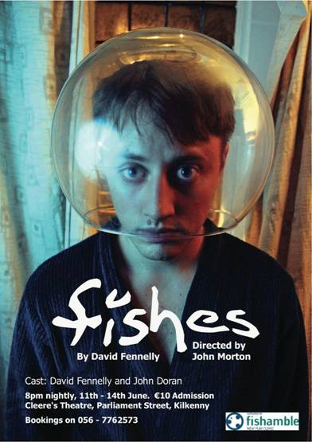](https://twitter.com/FishesPlay/status/467329966196420608/photo/1/large)**

The acclaimed comedy *Fishes* by David Fennelly is coming to Cleere’s Theatre from **June 11th-13th**. It tells the story of unemployed, heartbroken mechanic Larry as he begins to form a comically odd friendship with his dole officer Eldridge. It also stars John Doran and is directed by John Morton, both of this parish.

Here's the nice review Fishes got from The Irish Times: [Review: Fishes](http://www.irishtimes.com/culture/stage/review-fishes-1.1723956)

A new play sketches a young Irish male in a rut of loneliness, idleness and drunkenness. What’s the catch?

<http://cleeres.com/>

**Sessions House Arts Centre, Thomastown – What’s happening Next…**

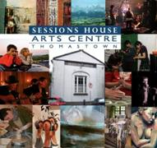

Summer Programme 2014

July Theatre Camp for 10 - 12 year olds...  
Theatre Camp for 12 - 14 year olds  
Radio Playwriting Camp for 9 – 14 year olds

Aug Puppet Skills Camp

Details of each camp, dates, times, ages etc will be announced over the next couple of days.  
All camps will run either morning or evening over 5 days and will cost approx **€50** each. Places are limited on each camp so keep your eyes peeled, booking will open soon!

W: [https://www.facebook.com/home.php#!/SessionsHouseArtsCentre?fref=nf](https://www.facebook.com/home.php%23!/SessionsHouseArtsCentre?fref=nf)

**\_\_\_\_\_\_\_\_\_\_\_\_\_\_\_\_\_\_\_\_\_\_\_\_\_\_\_\_\_\_\_\_\_\_\_\_\_\_\_\_\_\_\_\_\_\_\_\_\_\_\_\_\_\_\_\_\_\_\_\_\_\_\_\_\_\_\_\_\_\_\_\_\_\_\_**

**Ciclovia 2014 - Sunday 15th & Sunday 22nd June - Open Street Fiesta from 2-4pm with Bike Activies, Martial Arts Display, Dance Troupes, Street Basketball and more**

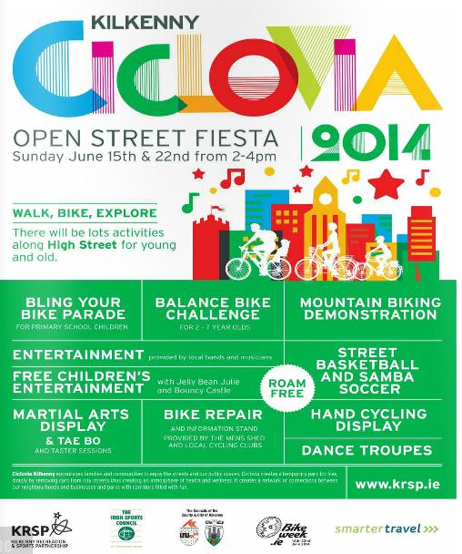

For further details, contact KRSP at 056 7794990

**\_\_\_\_\_\_\_\_\_\_\_\_\_\_\_\_\_\_\_\_\_\_\_\_\_\_\_\_\_\_\_\_\_\_\_\_\_\_\_\_\_\_\_\_\_\_\_\_\_\_\_\_\_\_\_\_\_\_\_\_\_\_\_\_\_\_\_\_\_\_\_\_\_\_\_**

## 3rd Kilkenny International Gospel Choir Festival

### Friday 13th June to Sunday 15th June 2014

### cid:image077.gif@01CF86F3.BAD30440

The 3rd Kilkenny International Gospel Choir Festival will take place from **Friday 13th June to Sunday 15th June 2014**. This will be the perfect opportunity for Choirs from across the world to share – Music – Performances – Experience, and above all our love of Gospel Music and all that it represents.

**Email:** [info@kilkennygospelfestival.com](mailto:info@kilkennygospelfestival.com)

**Web:** <http://kilkennygospelchoirfestival.com/>

Phone: 056 7770261

**\_\_\_\_\_\_\_\_\_\_\_\_\_\_\_\_\_\_\_\_\_\_\_\_\_\_\_\_\_\_\_\_\_\_\_\_\_\_\_\_\_\_\_\_\_\_\_\_\_\_\_\_\_\_\_\_\_\_\_\_\_\_\_\_\_\_\_\_\_\_\_\_\_\_\_**

**Set theatre**

**Date & time: Saturday 14th June, *9.30pm***

**Concert: The Hot Sprockets [album launch]** - Set Theatre, John Street

Admission: **€5**

2014 will see the band launch their second album Brother Nature in Dublin and Kilkenny. The Irish Mirror called them "A must see live act."

Damien Dempsey

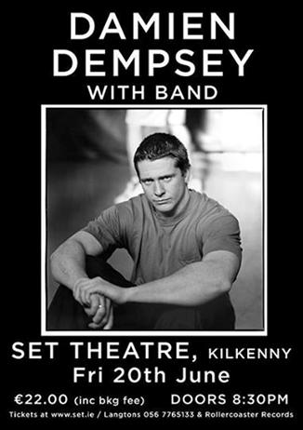

Jack L

**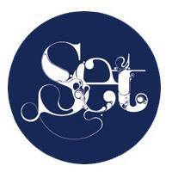**

* + Date & time: **Saturday, June 21st 8pm**
  + Admission: **€21.50**
  + Facebook: [https://www.facebook.com/home.php#!/settheatrekilkenny?fref=ts](https://www.facebook.com/home.php%23!/settheatrekilkenny?fref=ts)
  + W: [www.set.ie](http://kk-moss/Sites/arts_office/Shared%20Documents/Julianne%20Morgan/E-bulletin/13th%20June/www.set.ie)

**\_\_\_\_\_\_\_\_\_\_\_\_\_\_\_\_\_\_\_\_\_\_\_\_\_\_\_\_\_\_\_\_\_\_\_\_\_\_\_\_\_\_\_\_\_\_\_\_\_\_\_\_\_\_\_\_\_\_\_\_\_\_\_\_\_\_\_\_\_\_\_\_\_\_\_**

**Abhainn RíFestival, Callan, 20th-29th June 2014**

Volunteer at Abhainn RíFestival

**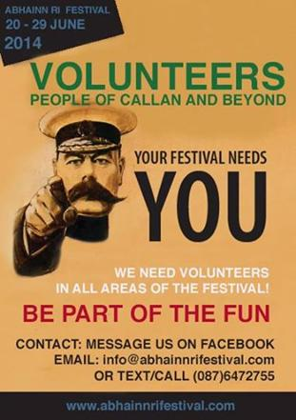**

Programme

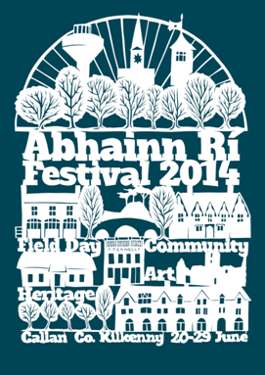

Paper cut design by artist Paul Bokslag.

The Abhainn Ri Festival of Participation and Inclusion is proud to announce the programme for our 5th annual festival, running from the **20th to 29th of June**. We hope that once again, this year’s diverse programme will highlight the beauty and unique built heritage of our town. You can read and download our programme [here.](http://abhainnrifestival.cmail1.com/t/i-l-vwkit-ptldkjdu-j/) The festival opens with a Midsummer International Dinner & Dance on Friday 20th which promises to be a special night.

More info at <http://abhainnrifestival.com/>

**\_\_\_\_\_\_\_\_\_\_\_\_\_\_\_\_\_\_\_\_\_\_\_\_\_\_\_\_\_\_\_\_\_\_\_\_\_\_\_\_\_\_\_\_\_\_\_\_\_\_\_\_\_\_\_\_\_\_\_\_\_\_\_\_\_\_\_\_\_\_\_\_\_\_\_**

**Devious Theatre Company – Fundraising table quiz**



It's back! Our first fundraising effort of 2014 is the second annual Great Big Devious Table Game Of General Knowledge Show? Or a table quiz… if you’re into the whole brevity thing. It takes place on **Thursday June 19th in Billy Byrnes Bar at 8pm.** There will be rounds on theatre (of course), film, music, Kilkenny trivia, general knowledge, The World Cup and creative audio visual conundrums. There will also be a lot of brilliant prizes up for grabs. Start rallying your teams and memorising Wikipedia!

Register on the night or at <http://devioustheatre.com/>

**\_\_\_\_\_\_\_\_\_\_\_\_\_\_\_\_\_\_\_\_\_\_\_\_\_\_\_\_\_\_\_\_\_\_\_\_\_\_\_\_\_\_\_\_\_\_\_\_\_\_\_\_\_\_\_\_\_\_\_\_\_\_\_\_\_\_\_\_\_\_\_\_\_\_\_**

**Bagenalstown – Drama – July 14th to 18th**

**July 14th to 18,** for 6-12 years from **10am to 2pm** with Mary Farrell and Amy Nolan. In the McGrath Hall. For booking and information contact Amy on 087 7459092.

**\_\_\_\_\_\_\_\_\_\_\_\_\_\_\_\_\_\_\_\_\_\_\_\_\_\_\_\_\_\_\_\_\_\_\_\_\_\_\_\_\_\_\_\_\_\_\_\_\_\_\_\_\_\_\_\_\_\_\_\_\_\_\_\_\_\_\_\_\_\_\_\_\_\_\_**

**Courses / Training / Jobs**

**\_\_\_\_\_\_\_\_\_\_\_\_\_\_\_\_\_\_\_\_\_\_\_\_\_\_\_\_\_\_\_\_\_\_\_\_\_\_\_\_\_\_\_\_\_\_\_\_\_\_\_\_\_\_\_\_\_\_\_\_\_\_\_\_\_\_\_\_\_\_\_\_\_\_\_**

**Ulysses Opera Theatre Company -Assistant Coordinator**

[](http://www.theatreforum.ie/)

Opportunity: Assistant Coordinator

Duration of : 2 months from July to September 10, 2014 (Flexible hours: 3 day per week in July, 4 days per week in August for the Opening Ceremony of the Dublin Fringe Festival on Saturday September 6th.

To make an application for this position – send in a CV with a cover letter of why you would like to work on the project to [Harpschords@gmail.com](http://kk-moss/Sites/arts_office/Shared%20Documents/Julianne%20Morgan/E-bulletin/13th%20June/Harpschords@gmail.com) by **6pm Friday 13th June**.

**\_\_\_\_\_\_\_\_\_\_\_\_\_\_\_\_\_\_\_\_\_\_\_\_\_\_\_\_\_\_\_\_\_\_\_\_\_\_\_\_\_\_\_\_\_\_\_\_\_\_\_\_\_\_\_\_\_\_\_\_\_\_\_\_\_\_\_\_\_\_\_\_\_\_\_**

**Artwork Specialist**



Artwork Specialist Contract role Dublin In strict confidence please send an up to date CV and cover letter to Laurentina Kennedy at [laurentina@rftgroup.ie](http://kk-moss/Sites/arts_office/Shared%20Documents/Julianne%20Morgan/E-bulletin/13th%20June/laurentina@rftgroup.ie) 01 2302400 / [www.rftgroup.ie](http://www.rftgroup.ie)

**Artwork Specialist  Dublin**   
The Artwork Specialist will be responsible for controlling artwork for all products, ensuring compliance   
with internal and external guidelines and maintaining accurate records  
Reporting to Head of Global Supply Chain

**Apply at** <http://www.irishjobs.ie/Jobs/Artwork-Specialist-7320748.aspx>

**\_\_\_\_\_\_\_\_\_\_\_\_\_\_\_\_\_\_\_\_\_\_\_\_\_\_\_\_\_\_\_\_\_\_\_\_\_\_\_\_\_\_\_\_\_\_\_\_\_\_\_\_\_\_\_\_\_\_\_\_\_\_\_\_\_\_\_\_\_\_\_\_\_\_\_**

## [The Summit seeks Junior Graphic Designer](http://visualartists.ie/jobs-ops/jobvac/summit-seeks-junior-graphic-designer/)



We are looking for a Junior Graphic Designer to join our in-house Event Design Team. The successful candidate will have the opportunity to work on design collateral for high profile tech conferences on a global scale. Applicant must have a great attention to detail, the ability to work to very tight deadlines and be team-orientated in their approach to graphic problem.

Please apply to [design@thesummit.com](http://kk-moss/Sites/arts_office/Shared%20Documents/Julianne%20Morgan/E-bulletin/13th%20June/design@thesummit.com). Applications only accepted containing a link to portfolio and PDF version of CV.

[www.thesummit.com](http://www.thesummit.com/)

More info at http://visualartists.ie/category/jobs-ops/

**\_\_\_\_\_\_\_\_\_\_\_\_\_\_\_\_\_\_\_\_\_\_\_\_\_\_\_\_\_\_\_\_\_\_\_\_\_\_\_\_\_\_\_\_\_\_\_\_\_\_\_\_\_\_\_\_\_\_\_\_\_\_\_\_\_\_\_\_\_\_\_\_\_\_\_**

**Killeeshil and Clonaneese Historical Society: Recruitment of an Artist / Facilitator**



Killeeshil and Clonaneese Historical Society  
Building Peace through the Arts – Re-Imaging Communities  
Recruitment of an Artist / Facilitator

**Closing Date for Submissions 27th June 2014**

The Killeeshil and Clonaneese Historical Society wishes to recruit an experienced artist / facilitator to carry out community consultation and creative engagement. We welcome bids from collaborating artists and peace building facilitators.

[Download the full brief here](http://lists.visualartists.ie/lt.php?c=1162&m=4202&nl=1&s=e97e60e0a85e4e4156f0ad241cfbea58&lid=88362&l=-http--visualartists.ie/wp-content/uploads/2014/06/KC_ToR_Arts_facilitator.pdf)

|  |  |
| --- | --- |
| |  | | --- | |  | |

**\_\_\_\_\_\_\_\_\_\_\_\_\_\_\_\_\_\_\_\_\_\_\_\_\_\_\_\_\_\_\_\_\_\_\_\_\_\_\_\_\_\_\_\_\_\_\_\_\_\_\_\_\_\_\_\_\_\_\_\_\_\_\_\_\_\_\_\_\_\_\_\_\_\_\_**

**Gaiety School of Acting**

[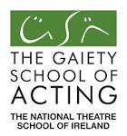](http://www.google.ie/url?url=http://gaietyschoolofacting.wordpress.com/2010/08/page/2/&rct=j&frm=1&q=&esrc=s&sa=U&ei=QGqQU-SfBOuu7Abt7oHwCw&ved=0CCIQ9QEwAQ&usg=AFQjCNHOc2DueaTSp0K6Ak-0y6aTiNHpfg)

[Stage Manager](http://www.theatreforum.ie/jobs-board/view/jobs/jobaction/show/job/stage-manager-5/)

[Set/Lighting Designer](http://www.theatreforum.ie/jobs-board/view/jobs/jobaction/show/job/setlighting-designer/)

The Gaiety School of Acting, the National Theatre School of Ireland are currently looking for a stage manager and Set/Lighting Designer to join the Shakespeare Schools Programme production team. The Programme is staging Shakespeare's Othello and Romeo and Juliet for the coming 2014/15 academic year. Further details will be given at point of enquiry.

Please send CV and further details to Kate Canning (Shakespeare Schools Co-ordinator)

[kate.canning@gaietyschool.com](http://kk-moss/Sites/arts_office/Shared%20Documents/Julianne%20Morgan/E-bulletin/13th%20June/kate.canning@gaietyschool.com)

Closing date: **June 19th**

W: <http://www.theatreforum.ie/jobs-board/>

**\_\_\_\_\_\_\_\_\_\_\_\_\_\_\_\_\_\_\_\_\_\_\_\_\_\_\_\_\_\_\_\_\_\_\_\_\_\_\_\_\_\_\_\_\_\_\_\_\_\_\_\_\_\_\_\_\_\_\_\_\_\_\_\_\_\_\_\_\_\_\_\_\_\_\_**

**Music Network seeks Programmes Administrator**

[](http://www.musicnetwork.ie/)

Music Network is now seeking to appoint a Programmes Administrator to support the effective planning, delivery and management of its programmes.  As well as providing important administrative support, the role has a focus on enhancing the music education and audience development impact of programmes through well-informed initiatives and engaging and supporting musicians, promoters and other stakeholders.

For a more complete job description and details of the application process, please contact John Deely at Pinpoint [- recruit@pinpoint.ie](mailto:-%20recruit@pinpoint.ie ) (01) 6425721)

**Closing Date: Thursday, 19th June 2014 at 1pm.**

- See more at: <http://tinyurl.com/mm8gz9j>

**\_\_\_\_\_\_\_\_\_\_\_\_\_\_\_\_\_\_\_\_\_\_\_\_\_\_\_\_\_\_\_\_\_\_\_\_\_\_\_\_\_\_\_\_\_\_\_\_\_\_\_\_\_\_\_\_\_\_\_\_\_\_\_\_\_\_\_\_\_\_\_\_\_\_\_**

**Press Intern**

[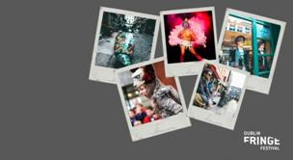](http://www.fringefest.com/festival/visit)

Job Title: Press Intern

Reporting To: Publicity & PR Manager

Duration of internship: **July – Sep (full time)**

Dublin Fringe Festival is a multi-disciplinary festival and year-round organisation focusing on new and innovative approaches to the arts.

The Press Intern is a key member of the festival team, working closely with the Publicity and PR Manager ensuring that the festival’s PR and communications strategy is carried out. Training will be provided in all the relevant tools.

**Closing Date for applications is 5pm Thursday June 26th.**

To apply for this position, please complete this form [bit.ly/1gieGGg](http://bit.ly/1gieGGg) and email your CV to [jessica@fringefest.com](http://kk-moss/Sites/arts_office/Shared%20Documents/Julianne%20Morgan/E-bulletin/13th%20June/jessica@fringefest.com)

More info at <http://www.fringefest.com/news/press-intern-required-2>

**\_\_\_\_\_\_\_\_\_\_\_\_\_\_\_\_\_\_\_\_\_\_\_\_\_\_\_\_\_\_\_\_\_\_\_\_\_\_\_\_\_\_\_\_\_\_\_\_\_\_\_\_\_\_\_\_\_\_\_\_\_\_\_\_\_\_\_\_\_\_\_\_\_\_\_**

**The Hunt Museum Invitation to Tender for Design/Exhibition Services**



The Hunt Museum is currently developing an active community arts and culture programme through outreach with a range of local groups.

As part of Limerick City of Culture, The Hunt Museum proposes to design, develop and deliver Communities of Culture, a programme exploring the different unique cultural experiences and heritages of each of Limerick’s regeneration areas – Southill, Ballinacurra Weston, Moyross and St Mary’s Park. In connection with this project, we are consequently seeking an experienced and creative design company to undertake the design and production of a range of programmes. For full details [see design brief](http://lists.visualartists.ie/lt.php?c=1164&m=4204&nl=1&s=d3c261c0eeb6b48867f449d29e09414b&lid=88832&l=-http--visualartists.ie/wp-content/uploads/2014/06/CommunitiesofCulture_Design_brief.pdf)

**The deadline for receipt of materials is 5.00pm Thursday 19th June 2014**

**\_\_\_\_\_\_\_\_\_\_\_\_\_\_\_\_\_\_\_\_\_\_\_\_\_\_\_\_\_\_\_\_\_\_\_\_\_\_\_\_\_\_\_\_\_\_\_\_\_\_\_\_\_\_\_\_\_\_\_\_\_\_\_\_\_\_\_\_\_\_\_\_\_\_\_**

**These Immovable Walls: Performing Power at Dublin Castle’ – International Performance Exhibition | Call for Volunteers**

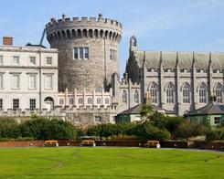

We are looking for a team of volunteers for These Immovable Walls: Performing Power at Dublin Castle, an international exhibition of live performance taking place on **11 & 12th July 2014.** Dublin Castle has been the seat of power in the city for much of its 800-year history; this exhibition will focus on the theme of power and its relationship to performance.

If you would like to be involved, send a cover letter to [michellembrowne@gmail.com](http://kk-moss/Sites/arts_office/Shared%20Documents/Julianne%20Morgan/E-bulletin/13th%20June/michellembrowne@gmail.com) with VOLUNTEER in the subject line explaining why you would like to work with us and please share with us any relevant experience you have.

**Deadline: 6pm June 18th**

**More info at** [http://tinyurl.com/p8r8omw](http://tinyurl.com/p8r8omw%20)

[**Mapping an Altered landscape: Cultural Policy and Management in Ireland’ | IADT/UCD Conference at Fitzgerald Debating Chamber, UCD, 25th June 2014**](http://visualartists.ie/jobs-ops/talks-lectures/mapping-altered-landscape-cultural-policy-management-ireland-iadtucd-conference-fitzgerald-debating-chamber-ucd-25th-june-2014/)



Date: **25th June 2014**

This one-day conference will bring together speakers and contributors from a wide variety of backgrounds across the arts and heritage dimensions of cultural activity in Ireland.

For further information (including registration), please contact: [Kerry.McCall@iadt.ie](http://kk-moss/Sites/arts_office/Shared%20Documents/Julianne%20Morgan/E-bulletin/13th%20June/Kerry.McCall@iadt.ie) or [Pat.Cooke@ucd.ie](http://kk-moss/Sites/arts_office/Shared%20Documents/Julianne%20Morgan/E-bulletin/13th%20June/Pat.Cooke@ucd.ie).

Full programme information now available at: [www.culturalpolicyconference2014.ie](http://www.culturalpolicyconference2014.ie)

**\_\_\_\_\_\_\_\_\_\_\_\_\_\_\_\_\_\_\_\_\_\_\_\_\_\_\_\_\_\_\_\_\_\_\_\_\_\_\_\_\_\_\_\_\_\_\_\_\_\_\_\_\_\_\_\_\_\_\_\_\_\_\_\_\_\_\_\_\_\_\_\_\_\_\_**

**‘Art and Design Strategies in Healthcare’ | Seminar in Cork University Hospital and CREATE**

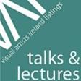

Helium Arts in partnership with Create are hosting a seminar on ‘Art and Design Strategies in Healthcare’ with Jackie Sands (Arts & Health Improvement Senior with the NHS Greater Glasgow & Clyde) and Vicky Charnock (Arts Coordinator at Alder Hey Children’s Hospital, Liverpool). This seminar will be of interest to those in arts and health project management or coordination, as well as healthcare managers or anyone involved in implementing *Per Cent for Art* in healthcare settings.

CORK  
With speaker Jackie Sands  
Date: **17th June, Tuesday | Time: 11-12:30pm** | Venue: The boardroom, Cork University Hospital, Wilton, Cork

DUBLIN  
With speaker Jackie Sands and Vicky Charnock  
Date: **16th June, Monday | Time: 10:30-12:30** | Venue: Create, 2 Curved Street (Filmbase Building), Dublin 2

Booking: please email [info@create-ireland.ie](http://kk-moss/Sites/arts_office/Shared%20Documents/Julianne%20Morgan/E-bulletin/13th%20June/info@create-ireland.ie). Attendance is FREE. Places are limited and will be allocated on a first come first serve basis.

[www.alderhey.nhs.uk/departments/arts-for-health/](http://lists.visualartists.ie/lt.php?c=1162&m=4202&nl=1&s=e784eec6bf8bb9680747b324b9c9eee1&lid=88401&l=-http--www.alderhey.nhs.uk/departments/arts-for-health/)  [www.nhsggc.org.uk/content/default.asp?page=home\_Arts%20and%20Health](http://lists.visualartists.ie/lt.php?c=1162&m=4202&nl=1&s=e784eec6bf8bb9680747b324b9c9eee1&lid=88402&l=-http--www.nhsggc.org.uk/content/default.asp--Q-page--E-home_Arts%20and%20Health)

[www.helium.ie](http://lists.visualartists.ie/lt.php?c=1162&m=4202&nl=1&s=e784eec6bf8bb9680747b324b9c9eee1&lid=88403&l=-http--www.helium.ie/) | [www.create-ireland.ie](http://lists.visualartists.ie/lt.php?c=1162&m=4202&nl=1&s=e784eec6bf8bb9680747b324b9c9eee1&lid=88404&l=-http--www.create-ireland.ie/)

Read more of the above at [http://tinyurl.com/my9lslc](http://tinyurl.com/my9lslc%20)

**\_\_\_\_\_\_\_\_\_\_\_\_\_\_\_\_\_\_\_\_\_\_\_\_\_\_\_\_\_\_\_\_\_\_\_\_\_\_\_\_\_\_\_\_\_\_\_\_\_\_\_\_\_\_\_\_\_\_\_\_\_\_\_\_\_\_\_\_\_\_\_\_\_\_\_**

# Walton’s New School of Music - We Are Now Accepting Enrolments for Summer Term 2014 Courses

# http://www.newschool.ie/_fileupload/Image/54_introguitarchildren.jpg *July Courses for Beginners (5 weeks)*

‘Introducing’ and ‘Taster’ courses are designed for absolute beginners and assume no previous musical experience.

**FOR ADULTS & OLDER TEENS**

* [Introducing 5-String Banjo](http://www.newschool.ie/Introducing_5_String_Banjo/Default.2838.html) | **Thursdays 6.30 – 8.30 pm**
* [Introducing Guitar for Adults](http://www.newschool.ie/Introducing_Guitar_for_Adults/Default.253.html) | **Tuesdays 6.30 – 8.30 pm | Wednesdays 7 – 9 pm**
* [Introducing Piano/Keyboard for Adults](http://www.newschool.ie/Introducing_Piano_Keyboard_for_Adults/Default.256.html) | **Tuesdays 6.30 – 8.30 pm | Wednesdays 6.30 – 8.30 pm**
* [Introducing Singing for Adults](http://www.newschool.ie/Introducing_Singing_for_Adults/Default.258.html) | **Tuesdays 6.30 – 8.30 pm | Wednesdays 6.30 – 8.30 pm**
* [Introducing Violin for Adults](http://www.newschool.ie/Introducing_Violin_for_Adults/Default.260.html) | **Tuesdays 6.30 – 8.30 pm**

**FOR CHILDREN**

* [Summer Taster Guitar for Children](http://www.newschool.ie/Summer_Taster_Guitar_for_Children/Default.1650.html) (including instrument) | **Wednesdays 3 – 4 pm**
* [Summer Taster Violin for Children](http://www.newschool.ie/Summer_Taster_Violin_for_Children/Default.1656.html) (including instrument) | **Saturdays 12 – 1 pm**

#### August Courses for Beginners

* [Introducing Guitar for Adults](http://www.newschool.ie/Introducing_Guitar_for_Adults/Default.253.html) | **Tuesdays 6.30 – 8.30 pm**
* [Introducing Piano/Keyboard for Adults](http://www.newschool.ie/Introducing_Piano_Keyboard_for_Adults/Default.256.html) | **Wednesdays 6.30 – 8.30 pm**
* [Introducing Singing for Adults](http://www.newschool.ie/Introducing_Singing_for_Adults/Default.258.html) | **Tuesdays 6.30 – 8.30 pm**

#### The Art & Craft of Songwriting

**Thursday 3rd July, Tuesday 8th July & Thursday 10th July | 6.30 – 9.30 pm**

Now in its sixth year, this 3-day, 9-hour intensive songwriting workshop with acclaimed singer-songwriter Melanie O’Reilly will take you through the entire songwriting process, integrating the craft's many skills into a seamless artistic whole. See [The Art & Craft of Songwriting](http://www.newschool.ie/The_Art_and_Craft_of_Songwriting/Default.2190.html) for more information.

Read more at <http://miniurl.com/9b0c3>

**\_\_\_\_\_\_\_\_\_\_\_\_\_\_\_\_\_\_\_\_\_\_\_\_\_\_\_\_\_\_\_\_\_\_\_\_\_\_\_\_\_\_\_\_\_\_\_\_\_\_\_\_\_\_\_\_\_\_\_\_\_\_\_\_\_\_\_\_\_\_\_\_\_\_\_**

### Simply Music

### http://www.simplymusic.ie/st-topban.jpg

**BOOK A WORKSHOP**

**Simply Music (supported by The Arts Council of Ireland**) delivers [European Award Winning](http://www.medea2020.eu/news/project/march-issue-media-learning-news-promotes-medea2020-workshops) English & Gaelscoileanna music workshops. These workshops combine **Interactive technology and Live Music Performance** with percussion through a fun-filled and engaging process.

Hands On!

**Juniors: €350**

1 day Workshop for Junior Infants to 1st class

Hands On!

**Seniors: €595**

2 day Workshop/Concert for 2nd to 6th class pupils

Ar Láimha agus Foghlaim

**€795**

2 day Workshop/ Concert for 2nd to 6th class pupils

(Delivered in the Irish Language & facilitated by 2 musicians)

Music Jam

**€795**

2 day Composition/Song writing/Performance Workshop

(facilitated by 2 musicians)

**CONTACT US**

Email:[info@simplymusic.ie](http://kk-moss/Sites/arts_office/Shared%20Documents/Julianne%20Morgan/E-bulletin/13th%20June/info@simplymusic.ie)

Website:[www.simplymusic.ie](http://kk-moss/Sites/arts_office/Shared%20Documents/Julianne%20Morgan/E-bulletin/13th%20June/www.simplymusic.ie)

Telephone: +353 1 2856162

Mobile: + 353 87 2227718

**\_\_\_\_\_\_\_\_\_\_\_\_\_\_\_\_\_\_\_\_\_\_\_\_\_\_\_\_\_\_\_\_\_\_\_\_\_\_\_\_\_\_\_\_\_\_\_\_\_\_\_\_\_\_\_\_\_\_\_\_\_\_\_\_\_\_\_\_\_\_\_\_\_\_\_**

**The Gaiety School of Acting**

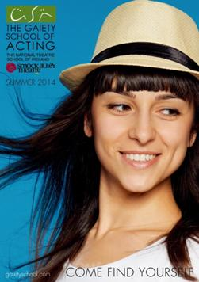

We are happy to announce our schedule for Summer 2014 Courses at the Gaiety School of Acting! This year we are pushing the boundaries to deliver an even more enthralling line up which will appeal to every age and ability. We have been doing what we do for almost 30 years and we feel we are the best in the business – so make you sign up early to avoid disappointment.

See below for a list of all the courses available this Summer in Temple Bar.

[Download a copy of our Summer 2014 Brochure here!](http://gaietyschool.com/summer-2014)

* [Adult Summer Courses](http://gaietyschool.com/category/courses/summer_courses/adult_summer_courses)
* [Gormanston Drama Summer School](http://gaietyschool.com/category/courses/summer_courses/gormanston)
* [Summer Weekend Workshops](http://gaietyschool.com/category/courses/summer_courses/summer_weekend_workshops)
* [Young Gaiety Summer School](http://gaietyschool.com/category/courses/summer_courses/young_gaiety_summer)

W: <http://gaietyschool.com/>

**\_\_\_\_\_\_\_\_\_\_\_\_\_\_\_\_\_\_\_\_\_\_\_\_\_\_\_\_\_\_\_\_\_\_\_\_\_\_\_\_\_\_\_\_\_\_\_\_\_\_\_\_\_\_\_\_\_\_\_\_\_\_\_\_\_\_\_\_\_\_\_\_\_\_\_**

**How To Be A Writer - a summer workshop for teen writers (ages 14-17)**

[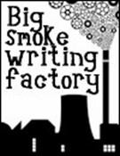](http://www.bigsmokewritingfactory.com/)

The ‘How To Be A Writer’ workshop for teenagers (ages 14-17)

Venue: Big Smoke Writing Factory, 7 Lower Hatch Street, Dublin 2

Length: 1 week (**Monday 30th June – Friday 4th July, 11am-3pm with lunch break, Fri 11am-1pm**)  
Fee: **€150**   
Facilitators: [Dave Lordan](http://www.bigsmokewritingfactory.com/About_Dave.php), [Nicole Rourke](http://www.bigsmokewritingfactory.com/About_Nicole.php), [Jessica Traynor](http://www.bigsmokewritingfactory.com/About_Jessica.php)

This summer programme is designed for talented teen writers looking to develop their skills, learn about the practicalities of being and becoming a writer in today's world, and to have fun. The workshop is suitable for those interested in all genres, from poetry to fantasy to video-game scripts. Topics such as finding inspiration, exploring and refining ideas, planning and editing, and discipline will all be covered.

For teen workshops, all participants and their parents/guardians should fill out [this registration form](http://www.bigsmokewritingfactory.com/docs/BSWFregistration_teen.doc) even if paying online.

**\_\_\_\_\_\_\_\_\_\_\_\_\_\_\_\_\_\_\_\_\_\_\_\_\_\_\_\_\_\_\_\_\_\_\_\_\_\_\_\_\_\_\_\_\_\_\_\_\_\_\_\_\_\_\_\_\_\_\_\_\_\_\_\_\_\_\_\_\_\_\_\_\_\_\_**

|  |
| --- |
| **Writing from Within: Haiku and Mindfulness Workshop** |
| writing workshop  Maeve O'Sullivan and Kim Richardson present a weekend workshop on Haiku and Mindfulness. Combining haiku poetry with mindfulness practices and the natural beauty of the nearby forests and mountains, the goal is to increase one's powers of observation and description. The workshop will also get outside for at least one ginko, a composition stroll, taking inspiration from the local views, flora and wildlife.    For more information regarding the cost of the weekend or how to reserve your spot, visit the workshop's website.  Venue: Carousel Creates Writers Centre, Rathfarnam, Co. Dublin Time: **Saturday and Sunday, 28th & 29th June, 9am-5pm** Admission: **€250 residential / €200 non-residential** T: +353 (0) 86 192361 E: [carolann@copland.org.uk](mailto:carolann@copland.org.uk) W: [https://www.facebook.com/events/283757888446613](http://https:/www.facebook.com/events/283757888446613) |  |

**\_\_\_\_\_\_\_\_\_\_\_\_\_\_\_\_\_\_\_\_\_\_\_\_\_\_\_\_\_\_\_\_\_\_\_\_\_\_\_\_\_\_\_\_\_\_\_\_\_\_\_\_\_\_\_\_\_\_\_\_\_\_\_\_\_\_\_\_\_\_\_\_\_\_\_**

### Evening Classes @ DanceHouse

[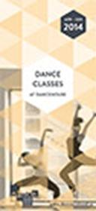](http://www.danceireland.ie/downloads/brochures/classes.pdf)

Running until July  
**Monday - Thursday from 6pm**Venue: DanceHouse, Dublin  
Price: Varies per class  
  
[READ MORE](http://danceireland.us5.list-manage.com/track/click?u=5121d0fedd423c64bdbf0d66b&id=564c741e56&e=1505fd3a45)

**\_\_\_\_\_\_\_\_\_\_\_\_\_\_\_\_\_\_\_\_\_\_\_\_\_\_\_\_\_\_\_\_\_\_\_\_\_\_\_\_\_\_\_\_\_\_\_\_\_\_\_\_\_\_\_\_\_\_\_\_\_\_\_\_\_\_\_\_\_\_\_\_\_\_\_**

**Create & the NSF Presents: Public Art Now with Claire Doherty, Situations**



Save the Date!  
Dates: **Wednesday 16th and Thursday 17th July**  
Venue: Cork City

 Create, the national development agency for collaborative arts, and the National Sculpture Factory are delighted to be working with Cork City Arts Office and the Office of Public Works to present a two day event on public art, with a keynote by Claire Doherty (Director of Situations) and a master class by the Situations team, for artists and commissioners looking at emerging and growing trends within International Public Art commissioning

**16th July**:  
Keynote by Claire Doherty, Situations,  
Public and Free

**17th July**:  
Commissioner / Producer Masterclasses  
Booking and application process will be announced on **June 13th**  
Limited capacity

W: <http://www.situations.org.uk/product/new-rules-public-art>

**\_\_\_\_\_\_\_\_\_\_\_\_\_\_\_\_\_\_\_\_\_\_\_\_\_\_\_\_\_\_\_\_\_\_\_\_\_\_\_\_\_\_\_\_\_\_\_\_\_\_\_\_\_\_\_\_\_\_\_\_\_\_\_\_\_\_\_\_\_\_\_\_\_\_\_**

**Proposals in Practice: Workshop at the LAB**

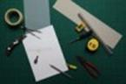

Date: **Tuesday June 17th, 2-5pm**  
The Lab, Foley St., Dublin 1

Artists, curators, critics and those interested in art research are invited to attend a workshop at the LAB, on **Tuesday June 17, 2-5pm**, led by IADT faculty Maeve Connolly and Sinead Hogan and invited practitioners Rosie Lynch (curator and researcher) and Fiona Marron (artist).

The workshop will explore how processes of enquiry and experimentation are articulated by practitioners in the form of a research proposal. All workshop participants will be invited to present ideas for proposals, including those potentially suitable for IADT’s newly-developed masters in Art Research Collaboration.

Admission is free but places are limited, so should be booked in advance at [http://tinyurl.com/kp5gptq](http://tinyurl.com/kp5gptq%20)

**\_\_\_\_\_\_\_\_\_\_\_\_\_\_\_\_\_\_\_\_\_\_\_\_\_\_\_\_\_\_\_\_\_\_\_\_\_\_\_\_\_\_\_\_\_\_\_\_\_\_\_\_\_\_\_\_\_\_\_\_\_\_\_\_\_\_\_\_\_\_\_\_\_\_\_**

**‘Cut/Make/Do #1′ – Interactive Textiles Workshop with Amor Muñoz at BLOCK T**

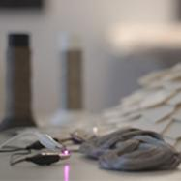

BLOCK T, 1-6 Haymarket, Smithfield, Dublin 7

Date: **June 14th, 12 – 5pm**

PRICE: **€50** (includes materials)  
LIMITED TO 12 SPACES

Cut/Make/Do is an ongoing series of events exploring the intersection between fashion, art and technology. The series spotlights innovative Irish and International designers and will feature workshops, talks, pop ups and much more. Cut/Make/Do is curated by Nora O Murchú.

This workshop is suitable for designers, artists, engineers, illustrators, choreographers and students.

Book a ticket here or email [cutmakedo@gmail.com](mailto:cutmakedo@gmail.com)

More info: [www.cutmakedo.com](http://www.cutmakedo.com)

To be involved or propose an event visit [www.cutmakedo.com](http://www.cutmakedo.com)

**\_\_\_\_\_\_\_\_\_\_\_\_\_\_\_\_\_\_\_\_\_\_\_\_\_\_\_\_\_\_\_\_\_\_\_\_\_\_\_\_\_\_\_\_\_\_\_\_\_\_\_\_\_\_\_\_\_\_\_\_\_\_\_\_\_\_\_\_\_\_\_\_\_\_\_**

## Origami Workshops with Japanese Paper Craft Expert Naomi Fleury at the National Print Museum

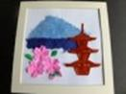

Venue: National Print Museum, Garrison Chapel, Beggar’s Bush Barracks, Haddington Rd, Dublin

Date & time: **Saturday 21st June, 10.00 – 12.30, €45**, Max 8 people

Create a beautiful Japanese scene using a combination of Origami and Chigiri-e techniques. Origami is a traditional Japanese art of paper folding, and Chigiri-e is a Japanese art form in which coloured paper is torn to create images.

Book & pay online via: <http://miniurl.com/4c8df>

Find out more about Naomi Fleury – [www.japanesepapercraft.com/about.html](http://www.japanesepapercraft.com/about.html)

**\_\_\_\_\_\_\_\_\_\_\_\_\_\_\_\_\_\_\_\_\_\_\_\_\_\_\_\_\_\_\_\_\_\_\_\_\_\_\_\_\_\_\_\_\_\_\_\_\_\_\_\_\_\_\_\_\_\_\_\_\_\_\_\_\_\_\_\_\_\_\_\_\_\_\_**

## [Summer Courses with Mary Burke at NCAD](http://visualartists.ie/jobs-ops/courses/summer-courses-mary-burke-ncad/)

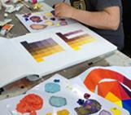

* National College of Art & Design,  100 Thomas Street, Dublin 8
* Colour Mixing Workshop
* Date: **7th July – 9th July**  
  FEE: **€145**  
  TUTOR: Mary Burke S D/P 103

The purpose of this 3 day course is to introduce students to basic colour theory as it relates to painting and to provide a better understanding of how colours react with one another.

The course is suitable for beginners as well as more experienced students.  
Class size: 16 students

W: [www.ncad.ie](http://www.ncad.ie )

**\_\_\_\_\_\_\_\_\_\_\_\_\_\_\_\_\_\_\_\_\_\_\_\_\_\_\_\_\_\_\_\_\_\_\_\_\_\_\_\_\_\_\_\_\_\_\_\_\_\_\_\_\_\_\_\_\_\_\_\_\_\_\_\_\_\_\_\_\_\_\_\_\_\_\_**

|  |  |
| --- | --- |
| |  | | --- | | FunnyFest – Comedy Writing Workshops at The Ark | |

**[](http://ark.ie/events/view/comedy-writing-workshops)**

### Comedy Writing Workshops

### Date (s) & time: 22-25th July @ 11am-12pm

Ages 5-7  
**Tue 22nd-Fri 25th July @ 11am-12pm**

Ages 8-12  
**Tue 22nd-Fri 25th July @ 2pm-3.30pm**

What are the funniest words in the world? Join poet Tony Curtis as he shares some of his favourite funny poems, rhymes and songs and helps you write some of your own!

More info and booking details at <http://miniurl.com/8b93c>

**\_\_\_\_\_\_\_\_\_\_\_\_\_\_\_\_\_\_\_\_\_\_\_\_\_\_\_\_\_\_\_\_\_\_\_\_\_\_\_\_\_\_\_\_\_\_\_\_\_\_\_\_\_\_\_\_\_\_\_\_\_\_\_\_\_\_\_\_\_\_\_\_\_\_\_**

**Pulse College - Scriptwriting and Screenwriting Course**

[](http://www.pulsecollege.eu/music/ba-hons-degree-music-production/)

Duration:  5 Days

Start Date: **July 7th, 2014**

Venue: **Pulse College,** 20 Ringsend Road

We might all have more than one film idea in us, but many of us believe we can’t write (or will never be able to learn). Not true! Writing a script isn’t rocket science, and this screenwriting course is designed to break the myths with hands-on exercises, by learning from case studies and with interactive tasks. The week long writing course will aim to provide students with a supportive environment that allows their natural story-telling talent to shine through. ‘Write Here, Write Now’ is a five day intensive course which has an interactive and proactive narrative approach rather than focusing on theory. Participants’ own ideas and skills as a writer will be encouraged in a fun environment as part of the course.

Tel:: [+353 1 478 4045](tel:+353%201%20478%204045)  
[contact us](http://www.pulsecollege.eu/contact)

Apply at <http://tinyurl.com/o7hrs92>

**\_\_\_\_\_\_\_\_\_\_\_\_\_\_\_\_\_\_\_\_\_\_\_\_\_\_\_\_\_\_\_\_\_\_\_\_\_\_\_\_\_\_\_\_\_\_\_\_\_\_\_\_\_\_\_\_\_\_\_\_\_\_\_\_\_\_\_\_\_\_\_\_\_\_\_**

## Bloomsday Workshops, Sunday 15th June – Circa Words 2014

## http://www.writerscentre.ie/images/logos/new%20logo.jpg

To celebrate Bloomsday weekend, **14 & 15th June**, we're running our first experimental fiction festival--Circa Words 2014

On **Sunday 15th June**, as part of the festival, we're running two experimental fiction workshops:

**10.30am-4.30pm | Interactive fiction: experimenting with the digital future**

Writer and gamer Charlene Putney will take participants through their paces on how to produce interactive fiction (or hypertext fiction). Learn how to create a story that changes depending on the choices that a reader makes.

**€40/€35 members**. For booking [click here](http://r20.rs6.net/tn.jsp?f=001soZ5TVUXElTABwdjoVAQV_bZpfyAUKFbu3CKc5aQC-_tm87AyV4KUKAf9Q8Z6hW4ca-2RsIdxNh6B-gLweSD2sF5PmIXLMllF5z9J6FD5r6_ZrexwGY1IO7U4GXA2vtXqPjCKPV1CqT15zwe5tEj99Gj7PsR33vD3Yr2rChjV_n9pSr1z9e_lo_h4xXt3Ps2VX3a5Hh6TF6hSwLbTbCM2Q==&c=mhfxYCkm6fQ1PgfJl51-SAnuCymhK0IuA_5PeY0_ibs4zSogI8qNGw==&ch=A91wx4HedWph4-SRWZQvdjuSKgEuvFsp6KHObjXr12E-kUnUxQo0mw==) and scroll down, or call 01 8721302.

**2.30pm-4.30pm | Cyclops**

Dave Lordan's 'Cyclops' writing workshop will delve into the mesmerically successful techniques used by Joyce in Ulysses, including stream of consciousness, collage, genre-slicing, and imi-texting. A fun introduction to some essential experimental writing techniques.

**€40/€35 members**. For booking [click here](http://r20.rs6.net/tn.jsp?f=001soZ5TVUXElTABwdjoVAQV_bZpfyAUKFbu3CKc5aQC-_tm87AyV4KUKJaFri8T3tmi_DhacVLqm6mRGz6Q1fqwweValrJ2J9dNH2ev4uDUOyyCwLqICZrtuJjQXh4VAfaYWZAKRFUwuqX7Z1WR5sUEpNwHEii7D3jYCZzId8lyf5Go0G38T8H0z4PoV_WvY56IuZ01EQIoGxvj9cUsupF9LQ81_vyYt_A&c=mhfxYCkm6fQ1PgfJl51-SAnuCymhK0IuA_5PeY0_ibs4zSogI8qNGw==&ch=A91wx4HedWph4-SRWZQvdjuSKgEuvFsp6KHObjXr12E-kUnUxQo0mw==) and scroll down, or call 01 8721302.

***On Saturday 14th June!!*** We've too much going on to tell you about here, so if you're interested in finding out more, visit our [events page](http://r20.rs6.net/tn.jsp?f=001soZ5TVUXElTABwdjoVAQV_bZpfyAUKFbu3CKc5aQC-_tm87AyV4KUKAf9Q8Z6hW4ca-2RsIdxNh6B-gLweSD2sF5PmIXLMllF5z9J6FD5r6_ZrexwGY1IO7U4GXA2vtXqPjCKPV1CqT15zwe5tEj99Gj7PsR33vD3Yr2rChjV_n9pSr1z9e_lo_h4xXt3Ps2VX3a5Hh6TF6hSwLbTbCM2Q==&c=mhfxYCkm6fQ1PgfJl51-SAnuCymhK0IuA_5PeY0_ibs4zSogI8qNGw==&ch=A91wx4HedWph4-SRWZQvdjuSKgEuvFsp6KHObjXr12E-kUnUxQo0mw==).

For booking visit [irishwriterscentre.ie](http://r20.rs6.net/tn.jsp?f=001soZ5TVUXElTABwdjoVAQV_bZpfyAUKFbu3CKc5aQC-_tm87AyV4KUGc5fyoApSTvN_Gm3BwQq6RcXg6fW_p54nhQ9CqclckfnakY9bAOGkZsmn41xzcGHedcWEvrrc8u23LGI7YAZvLknCMaqB5WdyRPXsHO6-6o-2oBzlvcIRo=&c=mhfxYCkm6fQ1PgfJl51-SAnuCymhK0IuA_5PeY0_ibs4zSogI8qNGw==&ch=A91wx4HedWph4-SRWZQvdjuSKgEuvFsp6KHObjXr12E-kUnUxQo0mw==) OR call 01-8721302.

**\_\_\_\_\_\_\_\_\_\_\_\_\_\_\_\_\_\_\_\_\_\_\_\_\_\_\_\_\_\_\_\_\_\_\_\_\_\_\_\_\_\_\_\_\_\_\_\_\_\_\_\_\_\_\_\_\_\_\_\_\_\_\_\_\_\_\_\_\_\_\_\_\_\_\_**

## Performance Art: Personal Rituals of/for Postmodern Times | Practical Laboratory of Performance Art at the Golden Thread Gallery

[](http://goldenthreadgallery.co.uk/)

With Alastair Maclennan & Elvira Santamaría

Venue: Golden Thread Gallery, 84-94 Great Patrick St, Belfast BT1 2LU  
Date: **Tue 17th to Thursday, 19th June, with final presentations on Fri 20th June**

Cost: The cost of the Workshop will be **£50**. This price includes a light lunch.

Beyond a form of art, performance art is the practice of personal values as well as a relational expression of our times. The existence of the artist/person is made manifest by the aesthetic acts he/she proposes.

Booking: To book your place, please contact Brian Patterson at [bbeyond@europe.com](http://kk-moss/Sites/arts_office/Shared%20Documents/Julianne%20Morgan/E-bulletin/13th%20June/bbeyond@europe.com)

W: <http://miniurl.com/7dac5>

**\_\_\_\_\_\_\_\_\_\_\_\_\_\_\_\_\_\_\_\_\_\_\_\_\_\_\_\_\_\_\_\_\_\_\_\_\_\_\_\_\_\_\_\_\_\_\_\_\_\_\_\_\_\_\_\_\_\_\_\_\_\_\_\_\_\_\_\_\_\_\_\_\_\_\_**

**Introductory Level Photography Course at Bond Street Studios**



Date & time: **21st June | 9.30am – 5pm**

1 day introductory level photography course with Barry McCall taking place at Bond Street Studios, Dublin 8 on Saturday June 21st.

We will cover best file management and getting the most from the settings on the camera before moving on to an introduction to studio lighting and achieving a great portrait with our model for the day.

Contact Roisin on 01 4166888 or info@barrymccallphotographer.com for more details and to book your space.

W: [www.barrymccallphotographer.com](http://barrymccallphotographer.com/)

**\_\_\_\_\_\_\_\_\_\_\_\_\_\_\_\_\_\_\_\_\_\_\_\_\_\_\_\_\_\_\_\_\_\_\_\_\_\_\_\_\_\_\_\_\_\_\_\_\_\_\_\_\_\_\_\_\_\_\_\_\_\_\_\_\_\_\_\_\_\_\_\_\_\_\_**

**Call for Submissions / Residencies**

**\_\_\_\_\_\_\_\_\_\_\_\_\_\_\_\_\_\_\_\_\_\_\_\_\_\_\_\_\_\_\_\_\_\_\_\_\_\_\_\_\_\_\_\_\_\_\_\_\_\_\_\_\_\_\_\_\_\_\_\_\_\_\_\_\_\_\_\_\_\_\_\_\_\_\_**

**Sculpture in Carton House - Maynooth 2014**

[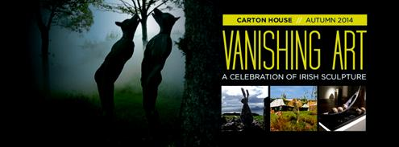](http://vanishingart.ie/)

Artists are invited to submit entries by July 30th for pre-selection to Vanishing Art’s 2nd annual appearance on the grounds of Carton House.

This year Vanishing Art is delighted to announce the Carton House Sculpture Award.  
€5,000 will be awarded to the outdoor sculpture judged by a select panel.

For details see: [http://vanishingart.ie/](http://lists.visualartists.ie/lt.php?c=1163&m=4203&nl=1&s=e784eec6bf8bb9680747b324b9c9eee1&lid=88521&l=-http--vanishingart.ie)

**\_\_\_\_\_\_\_\_\_\_\_\_\_\_\_\_\_\_\_\_\_\_\_\_\_\_\_\_\_\_\_\_\_\_\_\_\_\_\_\_\_\_\_\_\_\_\_\_\_\_\_\_\_\_\_\_\_\_\_\_\_\_\_\_\_\_\_\_\_\_\_\_\_\_\_**

# Light Moves: Festival of Screendance – Submissions Now Open

# [http://gallery.mailchimp.com/5121d0fedd423c64bdbf0d66b/images/c9a93e91-eb82-4f78-9ec7-51d48ba7f4f6.jpg](http://danceireland.us5.list-manage1.com/track/click?u=5121d0fedd423c64bdbf0d66b&id=d2b83c08ae&e=1505fd3a45)

Application deadline: **22nd July / 1st August**

*Light Moves* *Festival of Screendance* is excited to announce the opening of submissions for our inaugural festival scheduled for **6th – 9th November**, Dance Limerick, Ireland.

[READ MORE](http://danceireland.us5.list-manage1.com/track/click?u=5121d0fedd423c64bdbf0d66b&id=94a5b29753&e=1505fd3a45)

**\_\_\_\_\_\_\_\_\_\_\_\_\_\_\_\_\_\_\_\_\_\_\_\_\_\_\_\_\_\_\_\_\_\_\_\_\_\_\_\_\_\_\_\_\_\_\_\_\_\_\_\_\_\_\_\_\_\_\_\_\_\_\_\_\_\_\_\_\_\_\_\_\_\_\_**

**Boyle Arts Festival – Contemporary Visual Arts Exhibition | Call for Submissions**

****

**Deadline 20th June 2014, 4pm**  
Boyle Arts Festival Contemporary Visual Arts Exhibition  
**24th July- 2nd Aug 2014**  
Open to professional practicing visual artists resident in County Roscommon.

Curators Linda Shevlin and Angie Duignan are delighted to announce that an exhibition of contemporary visual Art will take place in Boyle Co. Roscommon to coincide with the Boyle Arts Festival 2014. We would like to invite submissions from visual artists based in County Roscommon that responds to ones rural, geographic location and are interested in work produced within the context of being situated or affected by ones placement.

Submissions and enquiries to [RVAF14submission@gmail.com](http://kk-moss/Sites/arts_office/Shared%20Documents/Julianne%20Morgan/E-bulletin/13th%20June/RVAF14submission@gmail.com)

Application details and more info at <http://miniurl.com/42a16>

**\_\_\_\_\_\_\_\_\_\_\_\_\_\_\_\_\_\_\_\_\_\_\_\_\_\_\_\_\_\_\_\_\_\_\_\_\_\_\_\_\_\_\_\_\_\_\_\_\_\_\_\_\_\_\_\_\_\_\_\_\_\_\_\_\_\_\_\_\_\_\_\_\_\_\_**

**Re-launch of Residency Programme at IMMA**

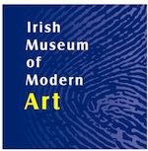

The Irish Museum of Modern Art has announced the re-launch of the Residency Programme at IMMA. The Residency Programme reopens with refreshed studio spaces and living quarters and a full schedule of activities for 2014.

This month the Residency Programme will accept new applications for the 2014/2015 Programme, approximately 10 residencies will be awarded.

In addition to the open call for residencies, IMMA has developed new programmes offering opportunities for arts practitioners at various stages of their career. This year will see the  introduction of a 12-month studio award for a selected artist/project from Ireland, and a studio award for a recent graduate – this will be a shorter residency aimed at emerging artists, providing a chance to work alongside an exciting mix of national and international artists.

[www.imma.ie](http://lists.visualartists.ie/lt.php?c=1162&m=4202&nl=1&s=e97e60e0a85e4e4156f0ad241cfbea58&lid=88350&l=-http--www.imma.ie)

**\_\_\_\_\_\_\_\_\_\_\_\_\_\_\_\_\_\_\_\_\_\_\_\_\_\_\_\_\_\_\_\_\_\_\_\_\_\_\_\_\_\_\_\_\_\_\_\_\_\_\_\_\_\_\_\_\_\_\_\_\_\_\_\_\_\_\_\_\_\_\_\_\_\_\_**

**Reminder: 2014 Valerie Earley Residency Award | Call for Applicants**



In 2013 Visual Artists Ireland put in place a commemoration of our late friend and colleague Valerie Earley who worked with us as Membership Manager for over 17 years.

The Valerie Earley Residency award is open to all members of Visual Artists Ireland and takes the form of a two-week residency in the Tyrone Guthrie Centre.

The application process is subject to the standard terms and conditions of the Tyrone Guthrie Centre.

**Closing date: 27th June 2014**

Tyrone Guthrie Centre, Annaghmakerrig, Newbliss, Co. Monaghan  
00353 47 54003  
[info@tyroneguthrie.ie](mailto:info@tyroneguthrie.ie)

[www.tyroneguthrie.ie](http://lists.visualartists.ie/lt.php?c=1162&m=4202&nl=1&s=e97e60e0a85e4e4156f0ad241cfbea58&lid=88347&l=-http--www.tyroneguthrie.ie)

**\_\_\_\_\_\_\_\_\_\_\_\_\_\_\_\_\_\_\_\_\_\_\_\_\_\_\_\_\_\_\_\_\_\_\_\_\_\_\_\_\_\_\_\_\_\_\_\_\_\_\_\_\_\_\_\_\_\_\_\_\_\_\_\_\_\_\_\_\_\_\_\_\_\_\_**

**4 Week Creative Lab/Residency**

**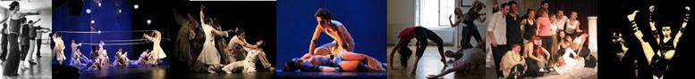**

For Dancers, Physical Theatre Actors and Contemporary Circus Performers

Date: **September 8 - October 6th, 2014**

[Stavropol, Russia](http://www.stagedirectorslab.org/home/stavropol)

The 4-week Lab is a special project which offers a unique opportunity to performers from different countries to become the part of the international multidisciplinary artistic team and to collaborate on the work-in-progress in the creative space of the Russian repertory theatre.

Registration fee: **€300** (early bird reduced registration fee) / **€450**.

The fee covers participation in the programme.  
Accommodation support in Russia is provided to participants.

W: <http://www.stagedirectorslab.org/4weekresidency>

**\_\_\_\_\_\_\_\_\_\_\_\_\_\_\_\_\_\_\_\_\_\_\_\_\_\_\_\_\_\_\_\_\_\_\_\_\_\_\_\_\_\_\_\_\_\_\_\_\_\_\_\_\_\_\_\_\_\_\_\_\_\_\_\_\_\_\_\_\_\_\_\_\_\_\_**

#### Film Artist in Residence (Screenwriter)

#### cid:image248.png@01CF8703.7D0E1400cid:image249.png@01CF8703.7D0E1400

#### Closing Date for Applications: 27th June 2014 Contract Type: Fixed Term Whole-Time Job Type: Academic Salary: €20,000

**1st September 2014 – 31st August 2015**

Applications are invited from film artists of distinction for the above role, jointly funded by the Arts Council and University College Cork, in association with the Cork Film Festival.

The Film Artist in Residence is designed to provide a screenwriter with a unique opportunity to develop his/her practice in a university environment while offering students the opportunity to engage with a practicing artist in a meaningful way during the course of their studies.

To Apply:

Please apply by letter or email outlining your suitability for the role, on or by **27th June**, including a comprehensive C.V. with details of screenwriting experience. Informal enquiries about the post may be made to Dr Gwenda Young, UCC ([g.young@ucc.ie](mailto:g.young@ucc.ie) ). Interviews will be held in Cork on **23rd July**. Please send applications to [UCCFilmStudies@ucc.ie](mailto:UCCFilmStudies@ucc.ie)

More info at [http://tinyurl.com/jwf9gg7](http://tinyurl.com/jwf9gg7%20)

**\_\_\_\_\_\_\_\_\_\_\_\_\_\_\_\_\_\_\_\_\_\_\_\_\_\_\_\_\_\_\_\_\_\_\_\_\_\_\_\_\_\_\_\_\_\_\_\_\_\_\_\_\_\_\_\_\_\_\_\_\_\_\_\_\_\_\_\_\_\_\_\_\_\_\_**

**Writers' Residency Week**

Tin Jug Studio, Birr, County Offaly

October 2014

Applications are sought for a new Writers' Residency in the Midlands of Ireland. This residency-cum-retreat is in the Georgian heritage town of Birr. The opportunity is for professional writers who are seeking a short break from daily routines; it is for those who feel the need to re-invigorate themselves into completing current work; and it is also for writers who may simply need inspiration, through a change of place and stimuli. [www.tinjugstudio.com](http://www.tinjugstudio.com)

**What is Included**: The bursary includes one week's accommodation in one of the period rooms of the guest house with breakfast and evening communal supper.

**Length of Stay:**  6 nights / 7 days

**Optional Dates:** Between the **3rd and 25th October, 2014**

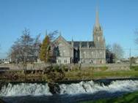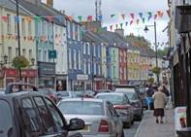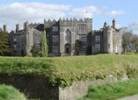

**WHO MAY APPLY?**

The residency bursary is open to professional published writers of any genre such as literary fiction, poetry, playwrights, journalism or travel writing. There are three places available, for newly published or experienced writers from across the 32 counties.

**Note:**

This pilot residency is being sponsored by Offaly County Council's Arts Office.

**FINAL DATE FOR RECEIPT OF APPLICATIONS**

**Closing date is Monday June 30th at 5pm**

Applications are preferred in hard copy (so as to include samples of published work) to

Rosalind Fanning, Saint Brendan Street, Birr, County Offaly.

Applications may also be accepted by email, with appropriate links to published work and inquires are welcome to [info@tinjugstudio.com](mailto:info@tinjugstudio.com)

For more into, please email Sinéad O'Reilly •  Arts Officer, [arts@offalycoco.ie](mailto:arts@offalycoco.ie)

**\_\_\_\_\_\_\_\_\_\_\_\_\_\_\_\_\_\_\_\_\_\_\_\_\_\_\_\_\_\_\_\_\_\_\_\_\_\_\_\_\_\_\_\_\_\_\_\_\_\_\_\_\_\_\_\_\_\_\_\_\_\_\_\_\_\_\_\_\_\_\_\_\_\_\_**

**Studio Available at New Art Studio**

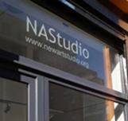

New Art Studio, 2-3 Mary’s Abbey, off Capel Street, Dublin 7

Studio available from **July 1st**. Initially for 6 months but could be extended.

Individual room with lockable door. 12 ft x 12 ft . Natural light. **€162 per month**. 24 hour access. Access also to framing workshop, photographic studio and computer lab.

Please send CV and images or weblink to [newartstudioadmin@gmail.com](http://kk-moss/Sites/arts_office/Shared%20Documents/Julianne%20Morgan/E-bulletin/13th%20June/newartstudioadmin@gmail.com)

**\_\_\_\_\_\_\_\_\_\_\_\_\_\_\_\_\_\_\_\_\_\_\_\_\_\_\_\_\_\_\_\_\_\_\_\_\_\_\_\_\_\_\_\_\_\_\_\_\_\_\_\_\_\_\_\_\_\_\_\_\_\_\_\_\_\_\_\_\_\_\_\_\_\_\_**

[**Audition: Riccardo Buscarini**](http://www.danceireland.ie/board/2014/05/audition-riccardo-buscarini/)

[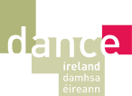](http://www.danceireland.ie/index.php)

Male dancers wanted for the Research & Development of Riccardo Buscarini’s new full length work *No Lander.*

**Deadline for application: 16th June**Where: London, UK  
When: **24 – 26th June**

Place Prize 2013 winning choreographer Riccardo Buscarini is looking for versatile male dancers with strong technique together with suppleness, exceptional improvisational and partnering skills, and who want to embark on an exciting and challenging creative journey.

Application details and more info at <http://www.danceireland.ie/board/category/opportunities/>

**\_\_\_\_\_\_\_\_\_\_\_\_\_\_\_\_\_\_\_\_\_\_\_\_\_\_\_\_\_\_\_\_\_\_\_\_\_\_\_\_\_\_\_\_\_\_\_\_\_\_\_\_\_\_\_\_\_\_\_\_\_\_\_\_\_\_\_\_\_\_\_\_\_\_\_**

**Group Show and Tartine Restaurant | Call for Submissions**

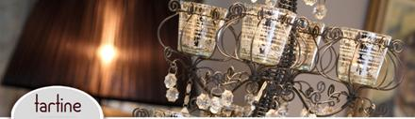

Tartine Restaurant, Distillers Arms, Bushmills, Co Antrim

Tartine Restaurant is offering the chance for your artwork to be shown as part of its restaurant collection. Through an online submission process, selected works will be chosen through the means of a juried competition and be part of a temporary 8 week group show during the summer of 2014. Approx 24 artworks will be selected for display as the restaurant collection with one outright winner being given the opportunity for a solo show at Tartine in 2015.

**Submission Deadline 27th June 2014.**

Winners announced on website **14th July 2014.**

W: [www.distillersarms.com](http://lists.visualartists.ie/lt.php?c=1162&m=4202&nl=1&s=e97e60e0a85e4e4156f0ad241cfbea58&lid=88373&l=-http--www.distillersarms.com)

**\_\_\_\_\_\_\_\_\_\_\_\_\_\_\_\_\_\_\_\_\_\_\_\_\_\_\_\_\_\_\_\_\_\_\_\_\_\_\_\_\_\_\_\_\_\_\_\_\_\_\_\_\_\_\_\_\_\_\_\_\_\_\_\_\_\_\_\_\_\_\_\_\_\_\_**

### Seeking Artists to Take Visual Minutes for 1-day Energy Awareness Event

### Print

Codema is Dublin’s Energy Agency and was founded in 1997 as a not-for-profit limited company. We are currently running the Think Energy campaign in Dublin City Council, which is an energy awareness campaign.

**Who we need?**We are looking for creative cartoonist, sketch or illustration artist to prepare visual minutes at this energy awareness event.

**When we need you?**  
The event is taking place on **Wednesday, 25th June 2014** in the canteen of Civic Offices at Wood Quay Venue from 10am – 2pm. A minimum of 2 hours would be required on the day.

If you are interested in sending us a quote, please email verena.brennan@codema.ie or call us on 01-707 9818 for further information.

Codema | The Loft | 2-4 Crown Alley | Temple Bar | Dublin 2 | [www.codema.ie](http://www.codema.ie)

Full details: [www.codema.ie/about-us/careers](http://www.codema.ie/about-us/careers)

**\_\_\_\_\_\_\_\_\_\_\_\_\_\_\_\_\_\_\_\_\_\_\_\_\_\_\_\_\_\_\_\_\_\_\_\_\_\_\_\_\_\_\_\_\_\_\_\_\_\_\_\_\_\_\_\_\_\_\_\_\_\_\_\_\_\_\_\_\_\_\_\_\_\_\_**

### Nowhere Magazine’s Spring 2014 Travel Writing Contest

[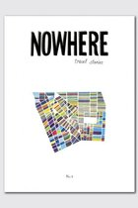](http://www.writing.ie/writing-comps/nowhere-magazines-spring-2014-travel-writing-contest/)**[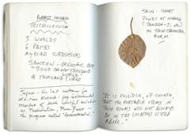](http://nowheremag.com/wp-content/uploads/Bill-Berkson-Japan-journal.jpg)**

Award-winning literary travel magazine, Nowhere, is teaming up with Outside Magazine Executive Editor Sam Moulton for the first Nowhere Spring Travel Writing Contest. We are looking for young, old, novice and veteran voices with a powerful sense of place in their writing. Stories can be fiction or non-fiction, but please indicate which at the top of each manuscript. Entries should be be between 800-5,000 words and must not have been previously chosen as a winner in another contest. Previously published work is accepted, but again, please indicate this.

**Competition Entry Fee:  $15 entry fee**

**Closing date 15th June 2014**

**Prizes:**

The winner will be awarded **$1,000** and published in an upcoming issue of Nowhere. The top 10 stories will be announced on the website and published on nowheremag.com.

For more information check out: <http://nowheremag.com/>

**\_\_\_\_\_\_\_\_\_\_\_\_\_\_\_\_\_\_\_\_\_\_\_\_\_\_\_\_\_\_\_\_\_\_\_\_\_\_\_\_\_\_\_\_\_\_\_\_\_\_\_\_\_\_\_\_\_\_\_\_\_\_\_\_\_\_\_\_\_\_\_\_\_\_\_**

### 2014 Over The Edge New Writer of The Year Competition

[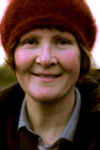](http://www.writing.ie/writing-comps/2014-over-the-edge-new-writer-of-the-year-competition/)

Competition judge: Eleanor Hooker

Open to poets and fiction writers worldwide, and now taking online payments, Over The Edge is continuing its exciting annual international creative writing competition in 2014.

Since its inception in 2007, it has grown to become one of the most important competition’s for emerging writers in Ireland and internationally. The competition is open to both poets and fiction writers worldwide.

The best fiction entry will win **€300**.

The best poetry entry will win **€300**.

One of these will then be chosen as **the overall winner** and will receive an additional **€400**, giving the overall winner total prize money of **€700** and the title *Over The Edge New Writer of The Year 2014*.

**Closing date for entries: Wednesday, August 6th, 2014**

W: <http://miniurl.com/a649b>

Contact Over The Edge on 087-6431748,

E-mail [over-the-edge-openreadings@hotmail.com](mailto:over-the-edge-openreadings@hotmail.com) or to make an online payment see [http://overtheedgeliteraryevents.blogspot.com](http://overtheedgeliteraryevents.blogspot.com/)

**\_\_\_\_\_\_\_\_\_\_\_\_\_\_\_\_\_\_\_\_\_\_\_\_\_\_\_\_\_\_\_\_\_\_\_\_\_\_\_\_\_\_\_\_\_\_\_\_\_\_\_\_\_\_\_\_\_\_\_\_\_\_\_\_\_\_\_\_\_\_\_\_\_\_\_**

**Per Cent for Art Scheme: River Tolka Flood Defence Commission**

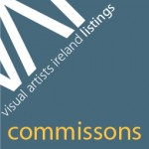

The Office of Public Works (OPW) under the Per Cent for Art Scheme has provided funding for Create, the national development agency for collaborative art, to undertake the management of Per Cent for Art commissions relating to the creation of flood defence systems on the River Tolka in catchment areas across Dublin City Council, Fingal County Council and Meath County Council. Create will manage an open call for proposals from artists, curators and creative producers for the commissions.

The total value of the commission(s) is **€66,000**

A briefing meeting will be arranged for artists, curators or creative producers interested in the commission. The briefing meeting will take place on **June 17th 11am** in the Create offices, 2 Curved Street, Temple Bar, Dublin 2.

**Closing date for Stage 1 proposals – Friday July 27th 2014 at 2pm**

[See briefing document here](http://lists.visualartists.ie/lt.php?c=1162&m=4202&nl=1&s=e97e60e0a85e4e4156f0ad241cfbea58&lid=88363&l=-http--visualartists.ie/wp-content/uploads/2014/05/TolkaBrief.compressed.pdf)

**\_\_\_\_\_\_\_\_\_\_\_\_\_\_\_\_\_\_\_\_\_\_\_\_\_\_\_\_\_\_\_\_\_\_\_\_\_\_\_\_\_\_\_\_\_\_\_\_\_\_\_\_\_\_\_\_\_\_\_\_\_\_\_\_\_\_\_\_\_\_\_\_\_\_\_**

**Swift Satire Festival – The Battle of the Books**

[](http://www.google.ie/url?url=http://irishwritingblog.wordpress.com/2013/07/04/upcoming-events-swift-satire-festival-ezra-pound-international-conference-gerard-manley-hopkins-festival/&rct=j&frm=1&q=&esrc=s&sa=U&ei=1CKPU7-rL-n07Abm7YCIAg&ved=0CCgQ9QEwBA&usg=AFQjCNHNtqumiPhnf93BWqVGgYka7nPksA)

**Deadline:** **Tuesday 1st July, 2014.**

**Poems**: minimum 40 lines, maximum 60 lines.

**Prose:** minimum 800 words, maximum 1,000 words.

**Entry fee**: **€5 per entry or €10 for three entries**.

**Prize:** **€500**

*The Battle of the Books* is an international writing competition (open to poetry and prose) organised by the Swift Satire Festival in Trim, Co Meath. A prize of **€500** will go to the winning entry.

More info at <http://swiftsatirefestival.com/whats-on/the-battle-of-the-books-2/>

**\_\_\_\_\_\_\_\_\_\_\_\_\_\_\_\_\_\_\_\_\_\_\_\_\_\_\_\_\_\_\_\_\_\_\_\_\_\_\_\_\_\_\_\_\_\_\_\_\_\_\_\_\_\_\_\_\_\_\_\_\_\_\_\_\_\_\_\_\_\_\_\_\_\_\_**

**Call for works/ BabelScores® Reading Panel 2014**

[](http://www.google.ie/url?url=http://garcia-vitoria.com/?cat=2&rct=j&frm=1&q=&esrc=s&sa=U&ei=YnyQU4ryLvLg7QbMvIHYAw&ved=0CCoQ9QEwBQ&usg=AFQjCNGIh-8BCjH61GU-Rhv2eFMZ4K2NEg)

Deadline for submitting your work: **20th June 2014**

BabelScores® continue looking for the most creative and innovative composers from all over the world to build a global quality catalog with important contemporary music pieces. We strongly encourage composers of any age or nationality to submit two to four works of any instrumentation or for electronics or mixed media to the BabelScores® Reading Pannel 2014. If the submitted pieces are accepted then BabelScores® will invite you to be part of its catalog and to upload more pieces.

**Details:**  
Via internet, in our website at [www.babelscores.com/submit](http://www.babelscores.com/submit), then click make submission. We invite you to visit our site [www.babelscores.com](http://www.babelscores.com). Should you have any questions or remarks, please do not hesitate to write to us at [contact@babelscores.com](mailto:contact@babelscores.com) http://www.cmc.ie/images/dot-clear.gif

**\_\_\_\_\_\_\_\_\_\_\_\_\_\_\_\_\_\_\_\_\_\_\_\_\_\_\_\_\_\_\_\_\_\_\_\_\_\_\_\_\_\_\_\_\_\_\_\_\_\_\_\_\_\_\_\_\_\_\_\_\_\_\_\_\_\_\_\_\_\_\_\_\_\_\_**

**Call for Proposals**

[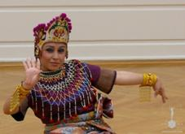](https://twitter.com/iugte_art/status/473814849290780672/photo/1)  
  
International Conference in Italy  
Date: **December 18 – 22nd, 2014**  
Theatre - Dance - Music - Visual & Multimedia Art - Arts administration - Theater Design and Technology  
  
The conference is open to performing arts practitioners and researchers from different countries: performing arts academics, arts educators and teachers, performers of various genres and techniques, theatre directors, dancers and choreographers, arts administrators and producers, musicians, stage designers costume designers, mask makers, multimedia artists, scriptwriters, playwrights, theatre critics, arts journalists, etc.  
  
The conference working language is English.  
  
For conference programme, submission guidelines and practical details for Presenters and Speakers please visit: <https://twitter.com/iugte_art>

**\_\_\_\_\_\_\_\_\_\_\_\_\_\_\_\_\_\_\_\_\_\_\_\_\_\_\_\_\_\_\_\_\_\_\_\_\_\_\_\_\_\_\_\_\_\_\_\_\_\_\_\_\_\_\_\_\_\_\_\_\_\_\_\_\_\_\_\_\_\_\_\_\_\_\_**

**Open** [**Call For:**](http://filmireland.net/2014/05/21/call-for-submissions-for-capital-irish-film-fesitval/)  [Video Production Students](http://filmireland.net/2014/05/29/call-for-video-production-students/)

**[](http://filmireland.net/wp-content/uploads/2012/04/Callfor-Final14.jpg)**

[Cycle Ataxia](http://filmireland.net/2014/05/29/call-for-video-production-students/www.CYCLEATAXIA.ie) is looking for students studying film production and/or post production that may be interested in producing a short, but slick video presentation of Charity cycling event in aid of Ataxia Ireland. The event will take place from Ashbourne/ Donaghmore GAA club, on **Sunday, 10th of August**.

At this stage, Cycle Ataxia cannot offer financial payment for any services, other than covering direct costs incurred, as they are focused on minimizing expense, to maximise benefit to their charities.

Please email :[Barry@CycleAtaxia.ie](mailto:Barry@CycleAtaxia.ie" \t "_blank) for further information.

W: <http://miniurl.com/885c4>

**\_\_\_\_\_\_\_\_\_\_\_\_\_\_\_\_\_\_\_\_\_\_\_\_\_\_\_\_\_\_\_\_\_\_\_\_\_\_\_\_\_\_\_\_\_\_\_\_\_\_\_\_\_\_\_\_\_\_\_\_\_\_\_\_\_\_\_\_\_\_\_\_\_\_\_**

## Wicklow County Arts Office & County Wicklow Film Commission

## *Call for WICKED Film Project Proposal Engaging Young People*

## [http://www.wicklow.ie/sites/default/files/logo-new_0.png](http://www.wicklow.ie/)

Wicklow County Arts Office and County Wicklow Film Commission would like to invite filmmaker/s working in any context to submit for a project opportunity to work with young people in County Wicklow.  The successful filmmaker/s will propose a project model, which will work with young people either over a period of months or in a concentrated period of weeks within 2014. During this time the filmmaker/s will engage with young people in the experience of developing a film (group to be indicated in proposal) on their proposed project. The available budget for the opportunity is **€8,000** to cover three components: fees, outcomes and materials.

**Closing Date: Wednesday 25th June @ 12 Noon**

For further info and application details, please contact Liz Kelly: [lizculloty.45@gmail.com](mailto:lizculloty.45@gmail.com) or [liz.kelly@ul.ie](mailto:liz.kelly@ul.ie)

**\_\_\_\_\_\_\_\_\_\_\_\_\_\_\_\_\_\_\_\_\_\_\_\_\_\_\_\_\_\_\_\_\_\_\_\_\_\_\_\_\_\_\_\_\_\_\_\_\_\_\_\_\_\_\_\_\_\_\_\_\_\_\_\_\_\_\_\_\_\_\_\_\_\_\_**

# Lights Camera Action! Cork Young Filmmakers: Call Out for County Cork Young Filmmakers!

# http://www.corkcoco.ie/graphics/arts_mast_jpg_0.jpg

Cork County Council have teamed up with Cork Film Centre to launch a new programme of film making for young people in schools, youth projects and clubs and a wide range of organisations working with young people age 12 to 21. To kick start the 2014 filmmaking activity *Cork Young Filmmakers,* managed by Cork Film Centre with funding and support from Cork County Council, is now offering places to 42 young people in July on two Summer Film Weeks this year!

This year first will take place in **Midleton** (June 30-July 4) and the second in **Mallow**, (July 14 to 18th).

More info and applications details at <http://miniurl.com/a3aea>

**\_\_\_\_\_\_\_\_\_\_\_\_\_\_\_\_\_\_\_\_\_\_\_\_\_\_\_\_\_\_\_\_\_\_\_\_\_\_\_\_\_\_\_\_\_\_\_\_\_\_\_\_\_\_\_\_\_\_\_\_\_\_\_\_\_\_\_\_\_\_\_\_\_\_\_**

**Awards / Bursaries / Schemes**

**\_\_\_\_\_\_\_\_\_\_\_\_\_\_\_\_\_\_\_\_\_\_\_\_\_\_\_\_\_\_\_\_\_\_\_\_\_\_\_\_\_\_\_\_\_\_\_\_\_\_\_\_\_\_\_\_\_\_\_\_\_\_\_\_\_\_\_\_\_\_\_\_\_\_\_**

# Community Arts Partnership – PIMS – Announcing the inaugural Seamus Heaney Award for Achievement

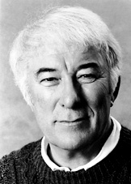

This award is supported by The Arts Council for Northern Ireland and the Heaney family and will be facilitated through our Poetry in Motion Schools project. All participating schools will be eligible to have their submissions considered for the award which will be made to an individual, group or school participating in our schools projects. Schools should apply for the Poetry in Motion Schools’ project in order to participate.

**Applications must be returned to us by Thursday 19th June** – Application packs can be found at the link below.

[Application pack PIM Schools 2014](http://comartspartner.org/wp-content/uploads/2014/06/Application-pack-PIM-Schools-2014.docx)

**\_\_\_\_\_\_\_\_\_\_\_\_\_\_\_\_\_\_\_\_\_\_\_\_\_\_\_\_\_\_\_\_\_\_\_\_\_\_\_\_\_\_\_\_\_\_\_\_\_\_\_\_\_\_\_\_\_\_\_\_\_\_\_\_\_\_\_\_\_\_\_\_\_\_\_**

# Apply Now for the Coca-Cola Thank You Fund

# [Coca-Cola Thank You Fund](https://secure.coca-cola.ie/community/thank-you-fund/application-form.html)

Voluntary and non-profit organisations which want to kick-start new programmes encouraging people to become more active could win **€25,000** to get them up and running.

Five grants totalling **€125,000** are up for grabs for new sport and physical activity initiatives under the Coca‑Cola Thank You Fund (the Fund), which was recently launched by Minister for Transport, Tourism and Sport, Leo Varadkar TD and Irish athlete Derval O’Rourke. Derval is this year’s ambassador for the Coca‑Cola Thank You Fund.

Deadline for applications: **16th June 2014.**

Applications for the Fund are being accepted online from today until 6pm on 16 June at: [www.coca-cola.ie/thankyou](http://www.coca-cola.ie/thankyou).

More information about the Fund is available at [www.coca-cola.ie/thankyou](http://www.coca-cola.ie/thankyou).

**\_\_\_\_\_\_\_\_\_\_\_\_\_\_\_\_\_\_\_\_\_\_\_\_\_\_\_\_\_\_\_\_\_\_\_\_\_\_\_\_\_\_\_\_\_\_\_\_\_\_\_\_\_\_\_\_\_\_\_\_\_\_\_\_\_\_\_\_\_\_\_\_\_\_\_**

**Galway County Council Arts Office Artist in Schools Scheme 2014**



Artist in School Scheme is about to commence its 2014 programme and consists of up to five residencies throughout the county in a variety of art forms. This scheme is run by Galway County Council Arts Office and is open to all primary schools in the County.

Its aim is to offer children the opportunity to work with a professional artist on a once-off project in visual arts, dance, literature, drama, music, photography, film, etc.

Artist in Schools Scheme 2014 DEADLINE: **20th June 2014, 4.00pm**

Please read the [Application Guidelines](http://lists.visualartists.ie/lt.php?c=1162&m=4202&nl=1&s=e97e60e0a85e4e4156f0ad241cfbea58&lid=88376&l=-http--visualartists.ie/wp-content/uploads/2014/05/Guidelines_Galway_ArtistsinSchools.pdf) before completing the [application form.](http://lists.visualartists.ie/lt.php?c=1162&m=4202&nl=1&s=e97e60e0a85e4e4156f0ad241cfbea58&lid=88377&l=-http--visualartists.ie/wp-content/uploads/2014/05/Application_Galway_ArtistsinSchools.pdf)

Applications in Full to be sent to:

Arts Office, Galway County Council  
Aras An Chontae, Prospect Hill Galway

Or by email to [artsoffice@galwaycoco.ie](mailto:artsoffice@galwaycoco.ie)  
For further information please contact 091 509000

**\_\_\_\_\_\_\_\_\_\_\_\_\_\_\_\_\_\_\_\_\_\_\_\_\_\_\_\_\_\_\_\_\_\_\_\_\_\_\_\_\_\_\_\_\_\_\_\_\_\_\_\_\_\_\_\_\_\_\_\_\_\_\_\_\_\_\_\_\_\_\_\_\_\_\_**

**The Arts Council – Funding**

**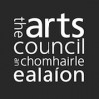**

Artist in the community scheme

Twice yearly, the Arts Council offers grants to enable artists and communities of place/or interest to work together on projects.

There are two phases to the scheme.

**Phase One**

[Research & Development](http://newsletter.artscouncil.ie/1rlddxfaj7v14rbsgtdsq9?a=6&p=47027345&t=17684704)  
[Research & Development/Mentoring](http://newsletter.artscouncil.ie/2x9bljt4rjn14rbsgtdsq9?a=6&p=47027345&t=17684704)

**Phase Two**

[Project Realisation](http://newsletter.artscouncil.ie/1my9i3o2ve114rbsgtdsq9?a=6&p=47027345&t=17684704),

Deadline: **June 23rd**

Full details on the application criteria on the Create website: <http://tinyurl.com/ms68f5e>

Visual artists in prisons scheme

Maximum awarded: **€2, 400**

This scheme provides financial support to selected visual artists to conduct workshops over a period of 10 days in the education units in any of the Republic’s prisons. The maximum awarded per workshop is **€2,400**. A panel of interested and suitably qualified artists is currently being compiled.

Writers in schools scheme

Maximum awarded: **€304**

The Writers in Schools Scheme part-funds visits by writers and storytellers to schools throughout the Republic of Ireland. There are over 250 writers and storytellers to choose from in the Writers in Schools (WIS) Web-Directory of Writers on our website. The maximum awarded per visit is **€304**.

More info of the above funding and contact details at <http://www.artscouncil.ie/available-funding/>

**\_\_\_\_\_\_\_\_\_\_\_\_\_\_\_\_\_\_\_\_\_\_\_\_\_\_\_\_\_\_\_\_\_\_\_\_\_\_\_\_\_\_\_\_\_\_\_\_\_\_\_\_\_\_\_\_\_\_\_\_\_\_\_\_\_\_\_\_\_\_\_\_\_\_\_**

**The Arts Council - Awards**

Beyond Borders

Closing date: **Thursday, 10th July, 2014**

Maximum awarded: **€15, 000**

This opportunity stimulates collaboration between organisations and bands/ensembles in England, Northern lreland, the Republic of Ireland, Scotland and Wales. It enables music creators to produce exceptional new material to be performed in at least three of these countries.   
  
Funding of up to £15,000 is available for projects that include new commissions, recordings and repeat performances of music written in the past five years.  
  
To apply and for more information please go to <http://miniurl.com/59c34>

Travel and training award

Closing date: **There are no formal deadlines for the Travel and Training Award.**

Maximum awarded: **€3, 000**

The objective of the travel and training outbound award is to support individuals who wish to avail of training and other professional development opportunities abroad (outside the Island of Ireland).

Bursary Awards

The deadline for the next round of the Arts Council’s Bursary Awards is **Thursday, 17th July 2014 at 5.30pm.** The window for making an application opens on **Tuesday, 17th June 2014.**

The following awards are available:

• YPCE Bursary Award

• Traditional Arts Bursary Award

• Literature Bursary Award (English Language)

• Visual Arts Bursary Award

The Arts Council provides Bursary Awards in order to assist individual artists in the development of their art practice.

View all at <http://www.artscouncil.ie/en/funding_deadlines.aspx>

Information clinic – Literature Bursary Award

In advance of this deadline, the Arts Council will hold an information clinic in the Irish Writers' Centre to offer advice and information on the application process. The clinic will be held on **Thursday, 26th June from 11am until 12:30pm** in the Irish Writers' Centre, 19 Parnell Square, Dublin 2.

To book a place at the clinic

Places on the clinic are free but participants must confirm their attendance to [events@writerscentre.ie](mailto:events@writerscentre.ie) by **Thursday, 19th June 2014.**

[Read more](http://newsletter.artscouncil.ie/1pf2vscfzl31eenva7sbzm?email=true&a=2&p=47587297&t=17684674)

Project award

Please note that the Arts Council will only be running one round of the Project Award in Visual Arts in 2015. This means that the upcoming deadline of 28th August 2014 for the Project Award Round 1 2015 will be the only available award for visual arts projects taking place in 2015.

Read more at [http://www.artscouncil.ie/Funds/Visual-arts-project-award](http://lists.visualartists.ie/lt.php?c=1162&m=4202&nl=1&s=e97e60e0a85e4e4156f0ad241cfbea58&lid=88351&l=-http--www.artscouncil.ie/Funds/Visual-arts-project-award)

**\_\_\_\_\_\_\_\_\_\_\_\_\_\_\_\_\_\_\_\_\_\_\_\_\_\_\_\_\_\_\_\_\_\_\_\_\_\_\_\_\_\_\_\_\_\_\_\_\_\_\_\_\_\_\_\_\_\_\_\_\_\_\_\_\_\_\_\_\_\_\_\_\_\_\_**

|  |  |  |  |
| --- | --- | --- | --- |
| **Reality Bites**   |  | | --- | |  | | Reality Bites |   Reality Bites is a scheme to enable the making of short documentaries.  The scheme aims to encourage experimentation and the realisation of fresh approaches to non-fiction filmmaking.  Closing date: **Tuesday, July 1st,2014**  Budget per film: **Maximum €15, 000**  More info and application details at <http://miniurl.com/cf2c6> |  |

**\_\_\_\_\_\_\_\_\_\_\_\_\_\_\_\_\_\_\_\_\_\_\_\_\_\_\_\_\_\_\_\_\_\_\_\_\_\_\_\_\_\_\_\_\_\_\_\_\_\_\_\_\_\_\_\_\_\_\_\_\_\_\_\_\_\_\_\_\_\_\_\_\_\_\_**

**Fundit.ie Update**

**[cid:image179.gif@01CF86F3.BAD30440](http://fundit.ie/)**  
   
[Fund it](http://cts.vresp.com/c/?BusinesstoArts/a038446613/608128ad7e/e285aeb424) has provided a platform for 633 projects across the creative industries to be funded by their fans, followers, families and friends.  
   
46,000 people from all over the world have pledged money to Irish creative ideas and €2.3m has been paid out to successful projects. It’s worth considering if Fund it should be part of your broad funding landscape.

**\_\_\_\_\_\_\_\_\_\_\_\_\_\_\_\_\_\_\_\_\_\_\_\_\_\_\_\_\_\_\_\_\_\_\_\_\_\_\_\_\_\_\_\_\_\_\_\_\_\_\_\_\_\_\_\_\_\_\_\_\_\_\_\_\_\_\_\_\_\_\_\_\_\_\_**

**Deadline fast approaching for RDS Student Art Awards - 4.00pm, June 18th**

****

Prize Fund **€17,600**  
  
The RDS Student Art Awards are open to students at degree and postgraduate level, enrolled Irish art colleges.  
  
The Taylor Art Award is also open to Irish art students studying abroad.  
RDS Taylor Art Award **€5,000**  
R.C Lewis-Crosby Award for Painting **€3,000**  
RDS James White Award for Drawing **€2,200**  
RDS Printmaking Award **€2,200**  
RDS Lens Based Art Award **€2,200** (NEW)  
RDS Monster Truck 1 Year Studio Award (NEW)  
(Non-cash prize worth **€2,500**)  
Model Arts and Niland Gallery 1 Month Residency Award **(€500** Stipend awarded by RDS)  
  
Winning and highly commended entries will be shown at RDS Student Art Awards Exhibition at the Discover Ireland Dublin Horse Show, RDS (6 – 10 August, 2014) and the Bourn Vincent Gallery, University of Limerick (4 September –10 October, 2014).

Application forms are accessible online at [www.rds.ie./arts](http://lists.visualartists.ie/lt.php?c=1132&m=4172&nl=1&s=e784eec6bf8bb9680747b324b9c9eee1&lid=85354&l=-http--www.rds.ie./arts) until the **closing date deadline of 4.00pm, June 18th.**

For more info, follow us on facebook (RDSDublin) or Twitter (TheRDS).

Enter online at [www.rds.ie/arts](http://lists.visualartists.ie/lt.php?c=1156&m=4196&nl=1&s=e97e60e0a85e4e4156f0ad241cfbea58&lid=87702&l=-http--www.rds.ie/arts)

**\_\_\_\_\_\_\_\_\_\_\_\_\_\_\_\_\_\_\_\_\_\_\_\_\_\_\_\_\_\_\_\_\_\_\_\_\_\_\_\_\_\_\_\_\_\_\_\_\_\_\_\_\_\_\_\_\_\_\_\_\_\_\_\_\_\_\_\_\_\_\_\_\_\_\_**

# European Cultural Foundation – STEP travel grants – ongoing

# [https://encrypted-tbn3.gstatic.com/images?q=tbn:ANd9GcRwApiNK0P9SYmynEq0tXb8JtgSHpsXF27jEBYHqh_2mdgpVLCdIE24j9w](http://www.google.ie/url?url=http://www.moreeurope.org/?q=about-us/partners&rct=j&frm=1&q=&esrc=s&sa=U&ei=kCWPU_m_NqzA7AbN_IH4Bg&ved=0CCQQ9QEwAg&usg=AFQjCNEgS7cjBMS2HHhHxn_dGUHtxgPK7w)

**STEP Beyond Travel grants fund up and coming artists and cultural workers – giving priority to individuals up to 35 years and/or in the first 10 years of their career – to travel between EU and countries bordering the EU.**

There is no deadline for this grant scheme, so you can apply at any time but at least one month before your planned travel. The selection process takes up to one month.

For more information on how to apply, a list of eligible travel destinations and to access the application form, go to the “how to apply guidelines” at <http://miniurl.com/1e091>

# \_\_\_\_\_\_\_\_\_\_\_\_\_\_\_\_\_\_\_\_\_\_\_\_\_\_\_\_\_\_\_\_\_\_\_\_\_\_\_\_\_\_\_\_\_\_\_\_\_\_\_\_\_\_\_\_\_\_\_\_\_\_\_\_\_\_\_\_\_\_\_\_\_\_\_

**Limerick Arts Office Offering Two Bursaries for Tyrone Guthrie Centre**



Limerick Arts Office is offering 2 bursaries for the Tyrone Guthrie Centre. Each Bursary covers all board and lodging expenses for a week. The Tyrone Guthrie Centre at Annaghmakerrig is a residential workplace for artists, dedicated to supporting and facilitating creativity within a welcoming and trusted environment.

[Download your application form here.](http://lists.visualartists.ie/lt.php?c=1162&m=4202&nl=1&s=e97e60e0a85e4e4156f0ad241cfbea58&lid=88365&l=-http--visualartists.ie/wp-content/uploads/2014/06/Tyrone_Guthrie_Limerick_CoCo.pdf)

CLOSING DATE FOR APPLICATIONS: **No later than 5PM FRIDAY 4th JULY**

# All applications to Limerick Arts Office must be submitted electronically to [artsoffice@limerick.ie](mailto:artsoffice@limerick.ie) and marked clearly as ‘TGB 14’ \_\_\_\_\_\_\_\_\_\_\_\_\_\_\_\_\_\_\_\_\_\_\_\_\_\_\_\_\_\_\_\_\_\_\_\_\_\_\_\_\_\_\_\_\_\_\_\_\_\_\_\_\_\_\_\_\_\_\_\_\_\_\_\_\_\_\_\_\_\_\_\_\_\_\_

# Arts and Disability Connect scheme 2014

## [cid:image184.gif@01CF86F3.BAD30440](http://www.adiarts.ie/)

# **Arts & Disability Ireland and Arts Council announce Arts and Disability Connect (ADC) a new scheme open to artists with disabilities working in any artform.**This scheme is designed to support artists with disabilities to make new and ambitious work.

**Arts and Disability Connect New Work**  
2 awards of up to **€8,000 each**

**Arts and Disability Connect Mentoring**                                             
3 awards of up to **€2,000 each**

**Arts and Disability Connect Training**                                                     
3 awards of up to **€1,000 each**

All application forms, guidelines and information documents can be downloaded <http://tinyurl.com/oagpchq>

A completed application form along with all supporting material must be sent to [info@adiarts.ie](http://kk-moss/Sites/arts_office/Shared%20Documents/Julianne%20Morgan/E-bulletin/16th%20May/info@adiarts.ie%20) using WeTransfer by **5pm on** **12th June 2014.**

**Further information:**Contact Arts & Disability Ireland at 01 850 9002 or email [info@adiarts.ie](http://kk-moss/Sites/arts_office/Shared%20Documents/Julianne%20Morgan/E-bulletin/16th%20May/info@adiarts.ie )

# \_\_\_\_\_\_\_\_\_\_\_\_\_\_\_\_\_\_\_\_\_\_\_\_\_\_\_\_\_\_\_\_\_\_\_\_\_\_\_\_\_\_\_\_\_\_\_\_\_\_\_\_\_\_\_\_\_\_\_\_\_\_\_\_\_\_\_\_\_\_\_\_\_\_\_

# Art Universe – Scholarship Opportunities – International Physical Theatre Laboratory 2014

**[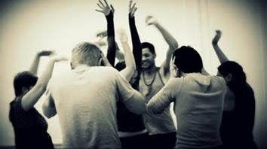](https://picasaweb.google.com/globtheatre)**

**“ArtUniverse” in partnership with the International University ”Global Theatre Experience” (IUGTE)** have announced several partial scholarships for professional dancers, choreographers, actors and circus performers.

International Physical Theatre Laboratory 2014

**Project Dates and Location:**

**July 7-12** – Styria, Austria [View Post](http://comartspartner.org/news/opportunities/art-universe-scholarship-opportunities-international-physical-theatre-laboratory-2014/)  
Each scholarship grant covers up to **€400** (four hundred) of the total participation fee.

**December 15-22** – Tuscany, Italy  
Each scholarship grant covers up to **€300.00** (three hundred) of the total participation fee.

More info at <http://miniurl.com/Keod>

# \_\_\_\_\_\_\_\_\_\_\_\_\_\_\_\_\_\_\_\_\_\_\_\_\_\_\_\_\_\_\_\_\_\_\_\_\_\_\_\_\_\_\_\_\_\_\_\_\_\_\_\_\_\_\_\_\_\_\_\_\_\_\_\_\_\_\_\_\_\_\_\_\_\_\_

**Reminder: 2014 DCC / VAI Critical Art Writing Award**

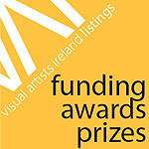

DCC / VAI Critical Art Writing Award was launched in 2012 and is a developmental opportunity for writers.

For the 2014 DCC / VAI Critical Art Writing Award, art writers are invited to consider the significance of cities as contexts for festival-type visual arts programming. Writers are asked to propose an abstract that considers issues around ‘festivalisation’ – nationally and internationally – with an emphasis on Dublin as a context in terms of history, current events and / or future potential.

**Application closing date: 5pm, Friday 4th July 2014**

Applications should be addressed to: [jason@visualartists.ie](mailto:jason@visualartists.ie)

Late applications will not be accepted; applicants will receive confirmation of receipt.

The DCC / VAI Critical Art Writing Award is supported by Dublin City Council Arts Office, The LAB and VAI’s Professional Development training programmes.

Read more at <http://tinyurl.com/l535p4j>

# \_\_\_\_\_\_\_\_\_\_\_\_\_\_\_\_\_\_\_\_\_\_\_\_\_\_\_\_\_\_\_\_\_\_\_\_\_\_\_\_\_\_\_\_\_\_\_\_\_\_\_\_\_\_\_\_\_\_\_\_\_\_\_\_\_\_\_\_\_\_\_\_\_\_\_

**Of Interest**

**\_\_\_\_\_\_\_\_\_\_\_\_\_\_\_\_\_\_\_\_\_\_\_\_\_\_\_\_\_\_\_\_\_\_\_\_\_\_\_\_\_\_\_\_\_\_\_\_\_\_\_\_\_\_\_\_\_\_\_\_\_\_\_\_\_\_\_\_\_\_\_\_\_\_\_**

# Blaise Smith ARHA – Elevation – June 5th to July 3rd

|  |  |  |  |  |
| --- | --- | --- | --- | --- |
| |  |  |  |  | | --- | --- | --- | --- | | **cid:image260.jpg@01CF8703.7D0E1400**  **Red swing door,**oil on gesso panel, 30 x 48 inches | |  |  | | --- | --- | | Blaise Smith ARHA  **Elevation June 5th - July 3rd, 2014**  **You are invited to a private viewing on Thursday, June 5th, from 5.30-7.30pm**.  \_\_\_  Preview the work online at [**www.molesworthgallery.com**](http://www.molesworthgallery.com/)  Opening times during exhibitions: Mon-Fri 10am-5.30pm; Sat 11am-2pm | **cid:image189.gif@01CF86F3.BAD30440** | |      Hi all     I have an exhibition of new work opening on Thursday at 5.30pm in the Molesworth Gallery. Six Large Paintings all of sheds and concrete walls.    Look forward to seeing you there.    Regards,    Blaise Smith ARHA    check out  <http://www.blaisesmith.com/news.html>  [www.blaisesmith.com](http://www.blaisesmith.com) \_\_\_\_\_\_\_\_\_\_\_\_\_\_\_\_\_\_\_\_\_\_\_\_\_\_\_\_\_\_\_\_\_\_\_\_\_\_\_\_\_\_\_\_\_\_\_\_\_\_\_\_\_\_\_\_\_\_\_\_\_\_\_\_\_\_\_\_\_\_\_\_\_\_\_\_\_\_\_\_\_\_\_\_\_\_\_\_\_\_\_\_\_\_\_\_\_\_\_\_\_\_\_\_\_\_\_\_\_\_\_\_\_\_\_\_\_\_\_\_\_\_\_\_\_\_\_\_\_\_\_\_\_\_\_\_\_\_\_\_\_\_\_\_\_\_\_\_\_\_\_\_\_\_\_\_\_\_ |

**Dublin Institute of Technology BA Photography Graduate Exhibition 2014**

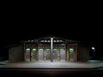

**31st May – 15th June 2014**

Opening hours: Tuesday – **Saturday: 11am – 6pm, Sunday: 1pm – 6pm**

The 2014 BA Photography graduate exhibition features the photographic projects of fourteen final year students and reflects a diverse range of approaches to contemporary photography and the production of images. These photographers explore themes and issues of both global and local resonance, some travelling long distances to document particular phenomena, others locating themselves close to home to document space and place, the performance of cultural identity and processes of memorialisation. Underpinning all work is an attentiveness to how the photograph records varying states of absence and presence, two registers on which the photographic economy is based.

There will be an opportunity to purchase the photographs and photobooks on display.

[www.ditphoto14.com](http://lists.visualartists.ie/lt.php?c=1161&m=4201&nl=3&s=e97e60e0a85e4e4156f0ad241cfbea58&lid=88218&l=-http--www.ditphoto14.com/) | [www.dit.ie/photography/newsandevents/](http://lists.visualartists.ie/lt.php?c=1161&m=4201&nl=3&s=e97e60e0a85e4e4156f0ad241cfbea58&lid=88219&l=-http--www.dit.ie/photography/newsandevents/)

# \_\_\_\_\_\_\_\_\_\_\_\_\_\_\_\_\_\_\_\_\_\_\_\_\_\_\_\_\_\_\_\_\_\_\_\_\_\_\_\_\_\_\_\_\_\_\_\_\_\_\_\_\_\_\_\_\_\_\_\_\_\_\_\_\_\_\_\_\_\_\_\_\_\_\_

**Sounding Lines by artists Claire Halpin and Maree Hensey**

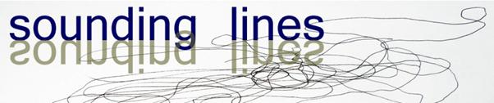

Sounding Lines is a visual art project by Claire Halpin and Maree Hensey which intends to encourage participants to navigate and encounter the River Suir in an innovative and unexpected way. Communities will experience a heightened awareness and reverence for the river as a unique historical, cultural and ecological natural resource. It is designed to take you places you might not otherwise go, to see familiar places in a new light and encourage a strong connectivity to the River Suir through sound and visuals.

To participate or find out more about the project see <http://soundinglines.wordpress.com/>

# \_\_\_\_\_\_\_\_\_\_\_\_\_\_\_\_\_\_\_\_\_\_\_\_\_\_\_\_\_\_\_\_\_\_\_\_\_\_\_\_\_\_\_\_\_\_\_\_\_\_\_\_\_\_\_\_\_\_\_\_\_\_\_\_\_\_\_\_\_\_\_\_\_\_\_

**Online Archive**

# ****Poetry Ireland Review****

**[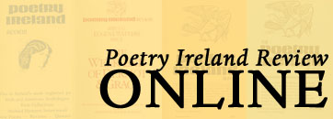](http://www.poetryireland.ie/publications/pir-archive)**

Issues 1 to 30 are now available online. [*» Search here*](http://poetryireland.ie/publications/pir-archive/)

# \_\_\_\_\_\_\_\_\_\_\_\_\_\_\_\_\_\_\_\_\_\_\_\_\_\_\_\_\_\_\_\_\_\_\_\_\_\_\_\_\_\_\_\_\_\_\_\_\_\_\_\_\_\_\_\_\_\_\_\_\_\_\_\_\_\_\_\_\_\_\_\_\_\_\_

**Alan Counihan at Culture Box**

*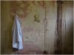*

Personal Effects: a history of possession  
**4 – 15th June**Culture Box, 12 East Essex Street, Temple Bar, Dublin 2

Personal Effects: a history of possession is a work by artist and writer Alan Counihan based on the personal effects of dead or discharged patients of Grangegorman Mental Hospital which were discovered in an attic of that institution in 2010.

Following on from its installation at Culture Box the work will next be shown within the theatre space at Axis, Ballymun, Dublin from 5-15th August 2014.

A radio documentary tracking the work’s development and responses to it is currently in process for RTE’s Documentary on One series. [www.templebar.ie/culture/article/culture-box](http://lists.visualartists.ie/lt.php?c=1161&m=4201&nl=3&s=e97e60e0a85e4e4156f0ad241cfbea58&lid=88252&l=-http--www.templebar.ie/culture/article/culture-box)

**\_\_\_\_\_\_\_\_\_\_\_\_\_\_\_\_\_\_\_\_\_\_\_\_\_\_\_\_\_\_\_\_\_\_\_\_\_\_\_\_\_\_\_\_\_\_\_\_\_\_\_\_\_\_\_\_\_\_\_\_\_\_\_\_\_\_\_\_\_\_\_\_\_\_\_**

# Director’s Talk at Lismore Castle Arts



Date: Saturday **14th June, 5 – 6.30pm**

Director’s Talk: Eamonn Maxwell on Wilhelm Sasnal

Eamonn Maxwell, director of Lismore Castle Arts, will give a talk on the Wilhelm Sasnal exhibition in the main gallery. Join us for a glass of Pimms, strawberries and finger food in the Asian Tent in the castle gardens, followed by a tour around the exhibition.

Wilhelm Sasnal is one of the key figures in contemporary painting in the last decade.

Lismore Castle Arts is delighted to present this event to coincide with the IMMRAMA festival – the travel writing festival in Lismore from 12 – 15 June. Tickets for this event are €10 (€5 Members of the Friends Scheme / Concessions). To reserve a ticket for this event please contact Paul McAree at 058 54061

[www.lismorecastlearts.ie](http://www.lismorecastlearts.ie/)

**\_\_\_\_\_\_\_\_\_\_\_\_\_\_\_\_\_\_\_\_\_\_\_\_\_\_\_\_\_\_\_\_\_\_\_\_\_\_\_\_\_\_\_\_\_\_\_\_\_\_\_\_\_\_\_\_\_\_\_\_\_\_\_\_\_\_\_\_\_\_\_\_\_\_\_**

# IFI Open Day 2014 Announced for 14th June. A FULL DAY OF FREE CINEMA!

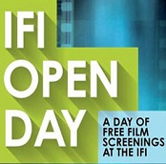

Wouldn’t it be great if the home of film in Ireland opened its doors for a whole day and invited the public into a full day of specially selected films that are all completely FREE? Believe it or not, that’s what’s happening at IFI on 14th June for the famous and fantastic IFI OPEN DAY 2014.

For more visitor information about IFI Open Dayvisit[www.ifi.ie/openday](http://kk-moss/Sites/arts_office/Shared%20Documents/Julianne%20Morgan/E-bulletin/13th%20June/www.ifi.ie/openday)

Download the full Open Day programme (PDF): <http://bit.ly/IFIOpenDay2014>

**\_\_\_\_\_\_\_\_\_\_\_\_\_\_\_\_\_\_\_\_\_\_\_\_\_\_\_\_\_\_\_\_\_\_\_\_\_\_\_\_\_\_\_\_\_\_\_\_\_\_\_\_\_\_\_\_\_\_\_\_\_\_\_\_\_\_\_\_\_\_\_\_\_\_\_**

**Minister Deenihan Announces Funding for Promotion of Irish Arts Worldwide**



Funding of just under €**500,000** has been announced by Jimmy Deenihan TD, Minister for Arts, Heritage and the Gaeltacht, for the promotion of Irish arts abroad in the remainder of 2014 and into 2015, through his Department’s Culture Ireland programme.

For the full list of projects funded see: <http://miniurl.com/76eaf>

**\_\_\_\_\_\_\_\_\_\_\_\_\_\_\_\_\_\_\_\_\_\_\_\_\_\_\_\_\_\_\_\_\_\_\_\_\_\_\_\_\_\_\_\_\_\_\_\_\_\_\_\_\_\_\_\_\_\_\_\_\_\_\_\_\_\_\_\_\_\_\_\_\_\_\_**

### Irish Youth Dance Festival

### [http://www.danceireland.ie/board/wp-content/uploads/2014/05/dublin_youth_dance_fest-300x196.jpg](http://www.danceireland.ie/board/wp-content/uploads/2014/05/dublin_youth_dance_fest.jpg)

DanceHouse, Dublin  
Pavilion Theatre, Dun Laoghaire  
27, 28 & 29 June  
Tickets: DanceHouse - Free  
Pavilion Theatre - **1 day €14 / 2 days €25**  
  
[READ MORE](http://danceireland.us5.list-manage.com/track/click?u=5121d0fedd423c64bdbf0d66b&id=e9b61b0174&e=1505fd3a45)

**\_\_\_\_\_\_\_\_\_\_\_\_\_\_\_\_\_\_\_\_\_\_\_\_\_\_\_\_\_\_\_\_\_\_\_\_\_\_\_\_\_\_\_\_\_\_\_\_\_\_\_\_\_\_\_\_\_\_\_\_\_\_\_\_\_\_\_\_\_\_\_\_\_\_\_**

**Opening of ‘The Nine Stones Artists’**

[9 Stones Artists - Friday 13th June at 6.00pm
Borris House, Co. Carlow as par tof the Éigse Carlow Arts Festival www.carlowartsfestival.com 

Exhibition Open form 10am - 7pm, 13-15 June.](https://www.facebook.com/photo.php?fbid=10152462203612235&set=a.136927457234.107849.136629927234&type=1)

**Date: Friday, 13th June, 6pm**

**Venue: The Town House, Main street, Borris, Co.Carlow**

**F:** [Éigse Carlow Arts Festival](https://www.facebook.com/EigseCarlow) [www.carlowartsfestival.com](http://www.carlowartsfestival.com/)

W: <http://carlowartsfestival.com/>

**\*\*\*\*\*\*\*\*\*\*\*\*\*\*\*\*\*\*\*\*\*\*\*\*\*\*\*\*\*\*\*\*\*\*\*\*\*\*\*\*\*\*\*\*\*\*\*\*\*\*\*\*\*\*\*\*\*\*\*\*\*\*\*\*\*\*\*\*\*\*\*\*\*\*\***