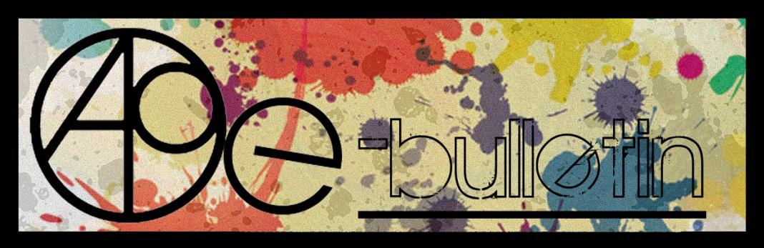

**Kilkenny County Council Arts Office E-bulletin 12th December 2014**

Dear All,   
  
Welcome to the fortnightly e-bulletin from Kilkenny County Council's Arts Office. Each bulletin is packed with the latest information on Kilkenny Arts Office activities, county events as well as news and opportunities for arts practitioners from around the country.

THIS IS THE FINAL E-BULLETIN OF 2014.

This service will be provided fortnightly. To include an item in the next e-bulletin please send a brief outline of your advert with relevant contact details, including any websites or pages with links to [**niamh.brophy@kilkennycoco.ie**](mailto:niamh.brophy@kilkennycoco.ie) **before 7th January**. The next e-bulletin will be on the **9th January.**

While every effort has been made to ensure the accuracy of our information, we strongly advise readers to verify all details to their own satisfaction.

MERRY CHRISTMAS AND HAPPY NEW YEAR FROM THE ARTS OFFICE!



Regards,  
Niamh Brophy  
Arts Office,  
T: 056 7794138  
E: [niamh.brophy@kilkennycoco.ie](mailto:niamh.brophy@kilkennycoco.ie)   
W: [www.kilkennycoco.ie/eng/Services/Arts/](http://www.kilkennycoco.ie/eng/Services/Arts/)

BECOME PART OF IT, SUBMIT A POEM.....[www.rhymerag.net](http://kk-moss/Sites/arts_office/Shared%20Documents/Julianne%20Morgan/E-bulletin/30th%20May%20e-bulletin/www.rhymerag.net)  
Kilkenny County Council Arts Office Partner Local Authority of the ArtLinks Programme [www.artlinks.ie](http://www.artlinks.ie)

|  |  |
| --- | --- |
|  |  |
|  |  |

**Kilkenny County Council Arts Office calls for applications for a Writing Bursary at a the new National Residential Writing Centre ‘The Story House’.**

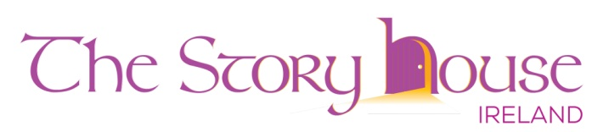

The Story House Ireland is a not-for-profit residential writing centre inspired by The Arvon Foundation. Set in tranquil woodlands near Colligan, Dungarvan, Co. Waterford, ‘The Story House’ will run its first 5 day writing course (on Short Fiction), from Mon. 23rd to Sat. 28th March 2015. The course will be led by experienced and award-winning writers and tutors Julian Gough and Susie Maguire. Their mid-week guest writer will be Donal Ryan (*The Spinning Heart, The Thing About December*), winner of The Guardian First Book Award.

The Story House aims to provide real support for developing writers of all ages and backgrounds, complementing the work of existing writing centres. As it grows it will provide a focus for the development in Ireland of a community of writers, teaching opportunities for professional writers, and also work to “ensure anyone can benefit from the transformative power of writing”.

Thanks to the support of the Arts Office, Kilkenny County Council, this inaugural course is being offered to one Kilkenny writer and includes: 5 nights accommodation; full board; all workshops; one-to-one sessions with each writer to discuss your work; time and space to write; reading and discussion with guest writer.

Co-founders of The Story House, Margaret O'Brien and Nollaig Brennan, intend that ‘The Story House’ will be a home for writers and writing and will also welcome many new faces to the arts scene in the south-east and to the beauty of the Waterford coast and countryside.

For more information on ‘The Story House’ see

[www.thestoryhouseireland.org](http://www.thestoryhouseireland.org) email: [thestoryhouseireland@gmail.com](mailto:thestoryhouseireland@gmail.com) or Twitter: @TSHIreland

**Closing Date for receipt of applications (hard copies only by post) is**

**4pm on Wednesday 7th January 2015.**

**For further details and an application form to apply for this bursary please contact:**

**Niamh Brophy, Arts Office, Kilkenny County Council**

**T: 056 779 4138 E:** [**niamh.brophy @kilkennycoco.ie**](mailto:Julianne.Morgan@kilkennycoco.ie)

**Application forms can also be downloaded from** [**http://www.kilkennycoco.ie/eng/Services/Arts/**](http://www.kilkennycoco.ie/eng/Services/Arts/)

**Artlinks Bursary Programme 2015 now open for applications**



The ArtLinks Partners in Carlow, Kilkenny, Waterford and Wexford are pleased to announce that they are accepting applications for the ArtLinks Bursary Awards 2015. Now in its 9th year, the programme supports artists who are members of ArtLinks with three separate awards:

**Emerging Artist Award** *(for those commencing a career in the arts sector)*

**Professional Development Award** *(for professional artists)*

**Collaborative Award** *(for collaborative projects between ArtLinks members)*

Artists interested in applying for an ArtLinks Bursary can download the application forms and guidelines here: <http://www.artlinks.ie/support/bursaries>

Artists must be a Member of ArtLinks to avail of these supports. Membership is free and is open to both Professional and Emerging Artists who are resident within the four partner Local Authorities. If you are not already a member log on to [www.artlinks.ie](http://www.artlinks.ie) to register for membership today.

**The closing date for receipt of Bursary Award Applications is**

**Thursday 5th February 2015 at 4pm.**

ArtLinks is a partnership of the four Local Authority Arts Offices in Carlow, Kilkenny, Waterford and Wexford . It is supported by the Arts Council/An Chomhairle Ealaíon. ArtLinks provides professional development opportunities and supports for established and emerging artists who are resident in the four partner local authority areas in the South East region.

**Open Circle – Call for New Members**

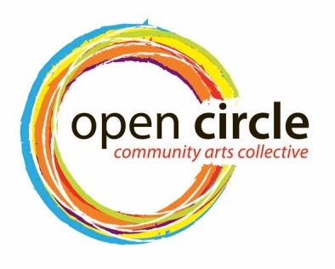

CALLING ALL KILKENNY WOMEN INTERESTED IN GETTING INVOLVED WITH A COMMUNITY ART PROJECT.  
  
Application forms for Open Circle Community Arts Membership in 2015 are now available.  
  
Email [opencirclearts@gmail.com](mailto:opencirclearts@gmail.com) for an application or pick one up in Kilkenny County Council, Johns Green, next door to Centra. DEADLINE DECEMBER 17TH.

**Read the next Rhyme Rag published poem**

The next poem to be published for **Rhyme Rag** is **‘Drown’** by **Ben Guilfoyle.**

**Ben Guilfoyle** is 16 and attends Coláiste Mhuire in Johnstown. Ben is a musician, magician and aspiring poet from Urlingford. He mainly writes poems in a haiku or rensaku format. His hope is that this is the first of many publications of his work.

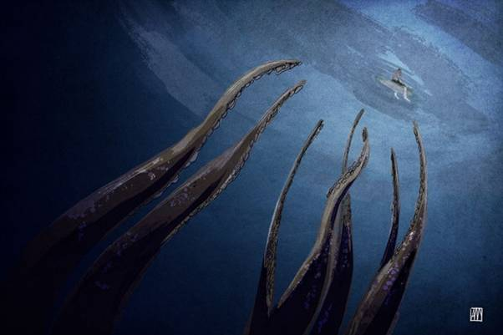

This poem was selected by Editor John W. Sexton and Illustrated by Ale Mercado.

**Read it here:** <http://www.rhymerag.net/2014/12/drown/>

Thanks to all for submitting poems. And don’t forget to submit work or encourage others you may know to do so! See all details on [www.rhymerag.net](http://www.rhymerag.net)

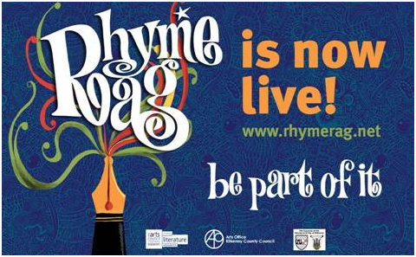

**Kilkenny Events**



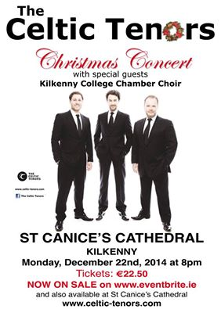



**Celebrate with Blackstack Studio and Mugshot Cafe**

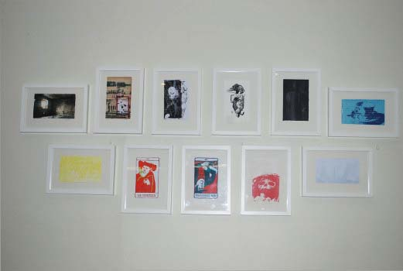

Mugshot Cafe are now showing work by Blackstack Studio and they have kindly offered to host a small celebration next Wed 17th at 6pm in the cafe, No. 25 James's St., Kilkenny.

We'd love to see you there for a pre Christmas catch up, some mulled wine and nibbles. All welcome....feel free to bring friends and spread the word!!

**Christmas in Kilkenny!**

The 2014 Christmas Lights in Kilkenny City will be switched on by Mayors Andrew McGuinness and visiting Mayor Kevin Taaffe, Mayor of Kilkenny Minnesota on this Saturday November 29th 2014 at 4pm on 'The Parade'.

The man himself, **Mr Claus** will be travelling to the 'switch on' by vintage car from his cosy grotto at Market Cross Shopping Centre where he has been busily meeting all the fantastic children from Kilkenny.

Santa Claus will be joined by **'Trix the Elf'** who will be skipping down John Street to the beautiful Remembrance Tree on the Parade to help with the 'switch-on'. Watch out for Little Red Riding Hood and her friends from the Watergate Theatre's Panto Group who will be meeting all the children of Kilkenny ahead of her post Christmas performance.

Musical entertainment on Saturday will be provided by St Patrick's Brass Band, so an enjoyable time for all is promised.

**Everyone is encouraged to attend at 4pm on Saturday, and kick Christmas off in Kilkenny.**

**(**The launch of the MADE IN KILKENNY Christmas Pop-up shop on John Street will follow the switch-on.)

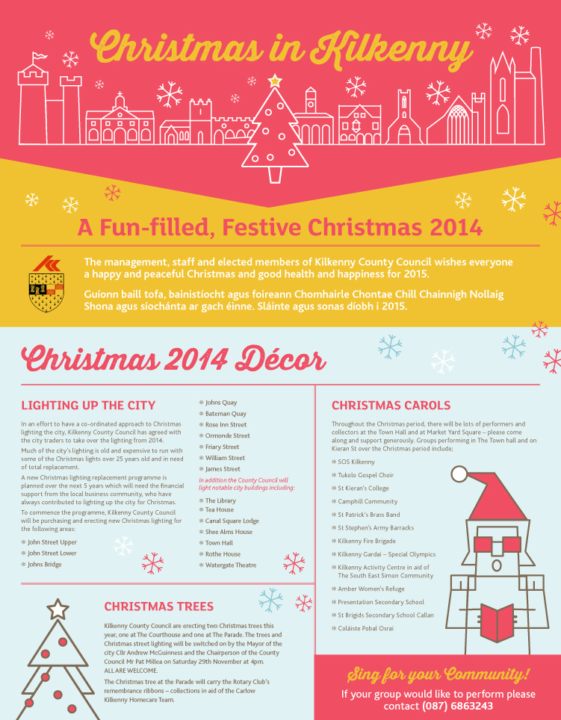 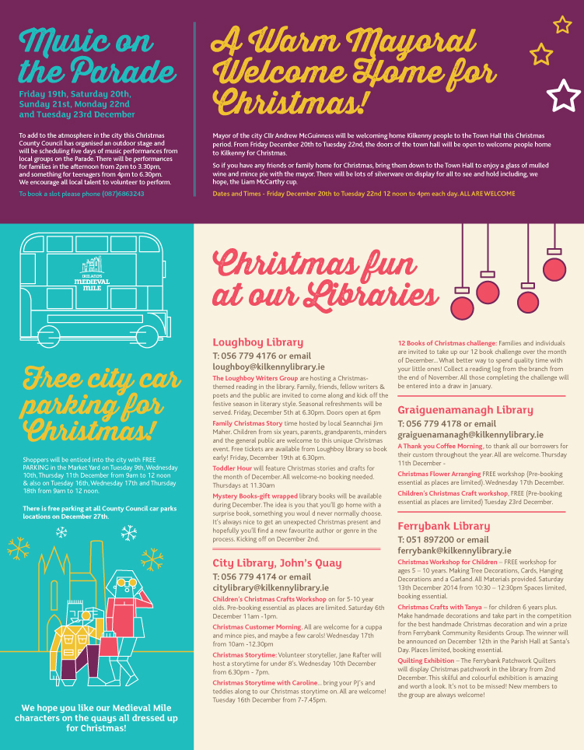

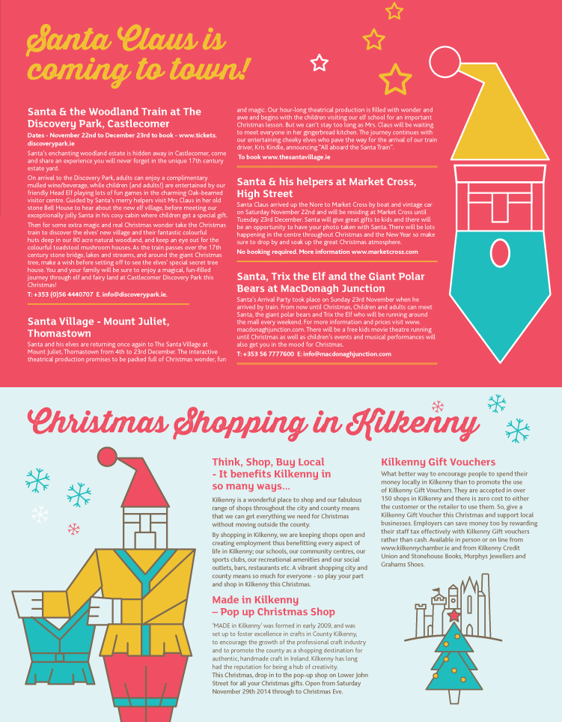 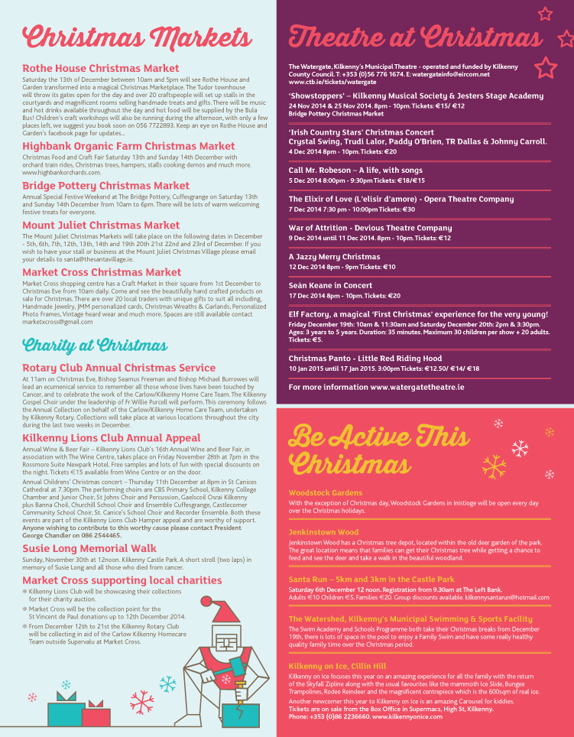

**IT’S CHRISTMAS! With Barn Owl Players**

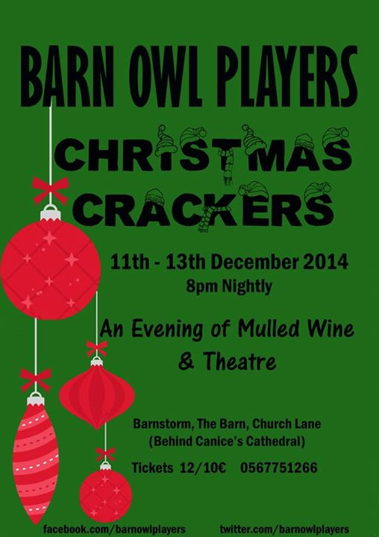

Christmas comes to the Barn Theatre from 11 to 13 December as local drama group, Barn Owl Players, return to the stage with their popular annual “Christmas Crackers.” Every year this talented and enterprising group of local actors concocts an exciting adventure through plays, poetry and music in response to the yuletide season.

This year is no exception and promises to wow audience members with their festive fare including songs, mulled wine and nibbles (and of course the raffle!).

In the shadow of a 14ft Christmas tree and a cabaret-style setting the actors will present offerings from Charles Dickens, Donal O’Kelly, Emily Dickenson and James Joyce amongst a feast of others. The evening is a must to get the Christmas spirits high.

Christmas Crackers takes place in The Barn, Barnstorm Theatre Company, Church Lane (behind St Canice’s Cathedral) for three nights only 11-13 December.

Tickets cost €12 (€10 concession) and includes wine and nibbles.

For bookings contact 0567751266

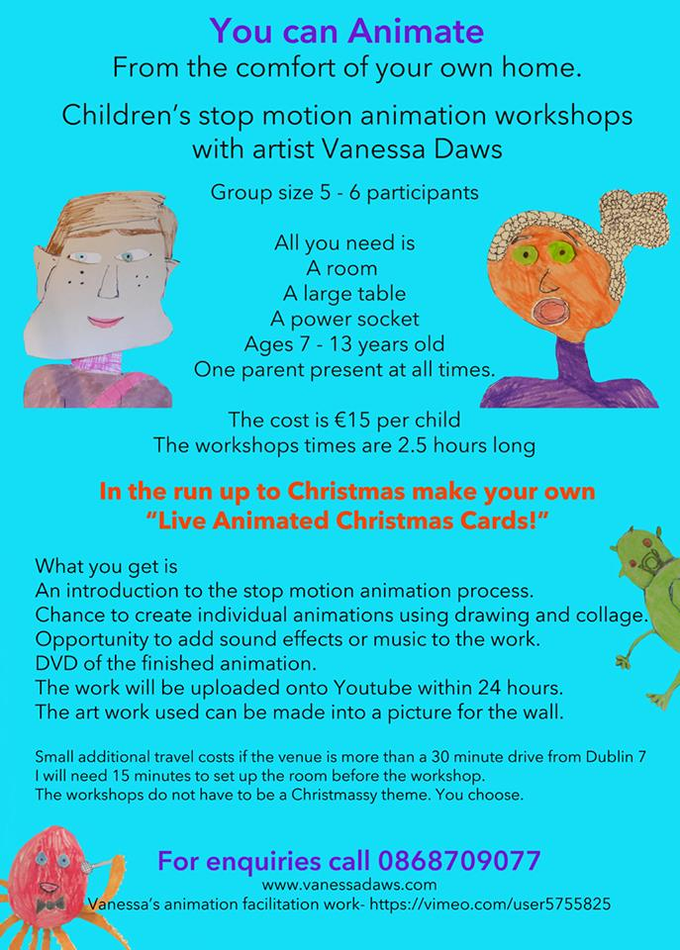

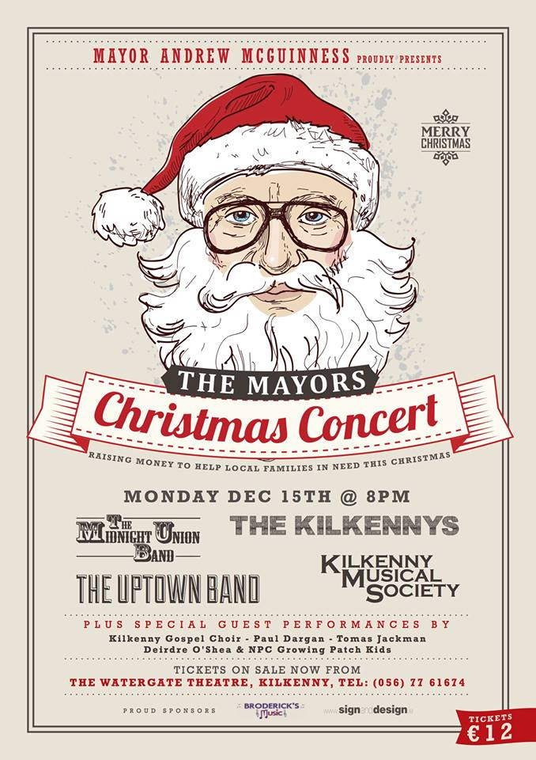



**Christmas at Rothe House**

So excited!... Saturday the 13th of December will see our charming courtyards and beautiful rooms transformed into a magical Christmas Market! We're throwing our doors open for the day and over 20 craftspeople and vendors will join us selling handmade treats and gifts.

There will be music and hot drinks available throughout the day and hot food will be supplied by the one and only Bula Bus.

Children's craft workshops will also be running during the day and with only a few places left we suggest you book soon on 056 7722893!

Keep checking back for updates...



**Applications for Casual Trading Licence 2015/2016**

**Applications for Casual Trading Licence 2015/2016KILKENNY COUNTY COUNCIL**

**CASUAL TRADING BYE-LAWS 2013**

Applications are invited for a Casual Trading Licence for the designated Casual Trading Area at The Parade, Kilkenny, for the period 1st March, 2015 to 28th February, 2016.

Applications forms are available from the undersigned or can be downloaded from Kilkenny County Council's website [www.kilkennycoco.ie](http://www.kilkennycoco.ie/). **Closing date for receipt of completed applications is Friday 30th January, 2015.**

Copies of Kilkenny County Council Casual Trading Bye-Laws 2013 are available for inspection and can be purchased at the offices of Kilkenny County Council, City Hall, High Street, Kilkenny or can be downloaded from Kilkenny County Council's website [www.kilkennycoco.ie](http://www.kilkennycoco.ie/)

**Brian Tyrrell,  
Senior Executive Officer,  
Kilkenny County Council  
City Hall  
High Street  
Kilkenny  
Email: info@kilkennycity.ie**

**InsideOut Project in Callan**

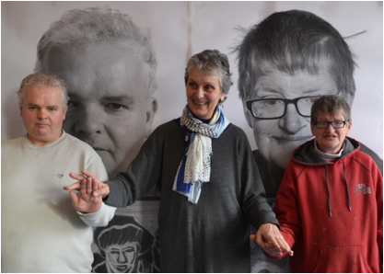

Francis Casey, Gypsy Ray, and Lorna Corrigan in front of the photographs for the InsideOut Global Project launched in Callan, Co. Kilkenny on 11, December, 2014, at around 2pm

The Inside Out Global Photographic Project is a worldwide photographic project based in New York City and founded by French artist JR. On March 2, 2011, JR won the TED prize at the TED Conference in Long Beach, California, and called for the creation of a global participatory art project with the potential to change the world. This project is called INSIDE OUT. Inspired by JR’s large‐format street "pastings", INSIDE OUT gives everyone the opportunity to share their portrait and make a statement for what they stand for. It is a global platform for people to share their untold stories and transform messages of personal identity into works of public art.

Each INSIDE OUT group action around the world is documented, archived and exhibited online. Nearly 200,000 people from more than 112 countries & territories have participated transforming messages of personal and political identity into works of art. The Inside Out Project has recently assisted the presentation of photographic projects in Kenya, Portugal, Scotland, New York City and Mexico.

Now the Inside Out Global Photographic Project is about to arrive in Callan, Co. Kilkenny! Artist Gypsy Ray's portraits of the 14 studio artists at KCAT Art and Study Centre were produced as part of the Inside Out Projects. She has teamed up with the KCAT artists, staff and others at the Kilkenny Collective for Arts Talent and along with the broader community of Callan will be displaying these larger than life size portraits on the 11th of December. They will be shown first outside the Art Centre's building on Mill Lane in Callan and then in various windows along Bridge Street in the town.

The title for these images is: "WE ARE! We are ARTISTS.  No other labels please."  It addresses the issue that artists who also have special needs are always labeled as 'special' rather than simply as the artists they are. The artists here portrayed are dedicated practitioners whose work deserves no special status, just the same careful and critical attention afforded to any other work of art.

For further information contact Gypsy Ray at [gypsyray@eircom.net](mailto:gypsyray@eircom.net) or 056-775-9935

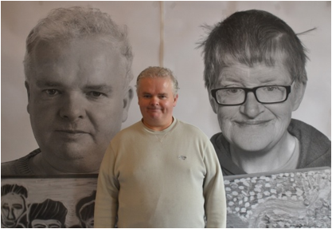

Francis Casey, artist, in front of InsideOut Project Posters

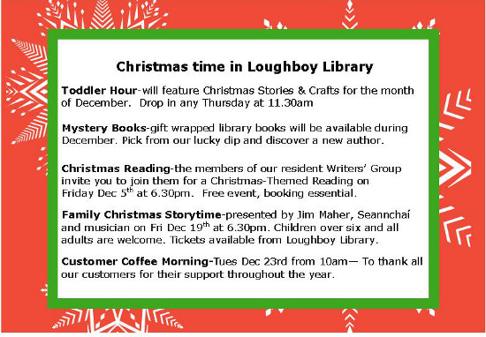

|  |  |  |  |  |  |  |  |  |  |  |  |  |  |  |  |  |  |  |  |  |  |  |  |  |  |  |  |  |  |  |  |  |  |  |  |  |  |  |  |
| --- | --- | --- | --- | --- | --- | --- | --- | --- | --- | --- | --- | --- | --- | --- | --- | --- | --- | --- | --- | --- | --- | --- | --- | --- | --- | --- | --- | --- | --- | --- | --- | --- | --- | --- | --- | --- | --- | --- | --- |
| [National Craft Gallery](http://www.nationalcraftgallery.ie/)   |  | | --- | | As the weather is getting frostier, our festive spirit is alive at the [**National Craft Gallery**](http://nationalcraftgallery.cmail2.com/t/y-l-iiujiyy-sdthjjktk-g/). Our [**Second Skin**](http://nationalcraftgallery.cmail2.com/t/y-l-iiujiyy-sdthjjktk-w/) exhibiton is continuing to serve up lots of interesting events to get us through the winter months ahead. We have a full range of activites for all ages taking place right into the new year, hope to see you soon. | |  |  |  |  |  |  |  | | --- | --- | --- | --- | --- | | [WORKSHOPS: Saturday Sewing Sessions](http://nationalcraftgallery.cmail2.com/t/y-l-iiujiyy-sdthjjktk-yu/)   |  |  | | --- | --- | | [http://i2.cmail2.com/ei/y/39/0D0/5C0/csimport/ScreenShot2014-11-04at17.38.57.173926.114633.png](http://nationalcraftgallery.cmail2.com/t/y-l-iiujiyy-sdthjjktk-jl/) |  | |  |  |   **6 Dec, 17 Jan & 24 Jan, 10am - 2pm**  Make a garment from a pattern with [**Joan Brennan**](http://nationalcraftgallery.cmail2.com/t/y-l-iiujiyy-sdthjjktk-jr/), fashion designer and educator. These guided making sessions for adults will teach you the basics of working with a pattern, cutting, pinning, shaping, sewing and finishing your garment. This four hour intensive Saturday workshop session will equip you with new skills, giving you the confidence to make your own garment from scratch. Participants are welcome to bring your own sewing machine or work on the shared machines. €15 per participant.  Book through 0569677151 or email [**events@nationalcraftgallery.ie**](mailto:events@nationalcraftgallery.ie?subject=NCG%20Ezine) | |  |  |  |  |  |  |  | | --- | --- | --- | --- | --- | | [Family Day: Fairytales in Stitch with Caroline Schofield](http://nationalcraftgallery.cmail2.com/t/y-l-iiujiyy-sdthjjktk-jy/)   |  |  | | --- | --- | |  | [http://i3.cmail2.com/ei/y/39/0D0/5C0/csimport/natalie_process-933x250.111633.jpg](http://nationalcraftgallery.cmail2.com/t/y-l-iiujiyy-sdthjjktk-jj/) | |  |  |   **13 Dec 10.30am & 12noon**  Join textile artist [**Caroline Schofield**](http://nationalcraftgallery.cmail2.com/t/y-l-iiujiyy-sdthjjktk-jt/) for a morning of stories and stitch. Caroline will share with the children how she collaborated with fashion designer [**Natalie B Coleman**](http://nationalcraftgallery.cmail2.com/t/y-l-iiujiyy-sdthjjktk-ji/) in designing fabric for the [**Second Skin**](http://nationalcraftgallery.cmail2.com/t/y-l-iiujiyy-sdthjjktk-jd/) project. Taking inspiration from this piece the children will collaborate to create a group textile piece that will stay in the gallery for the duration of the [**Second Skin**](http://nationalcraftgallery.cmail2.com/t/y-l-iiujiyy-sdthjjktk-jh/) exhibition.  Booking through 056 9677151 or email [**events@nationalcraftgallery.ie**](mailto:events@nationalcraftgallery.ie?body=Parent%20Name%20-%20%0AParent%20Tel.%20-%0AParent%20Email%20-%20%0AChild(ren)%20Name%20-%20%0AChild(ren)%20Age%20-%20%0APreferred%20Workshop%20-&subject=NCG%20Ezine) | |  |  |  |  |  |  |  | | --- | --- | --- | --- | --- | | [LATE DATE: Up-cycle Jumper Jam](http://nationalcraftgallery.cmail2.com/t/y-l-iiujiyy-sdthjjktk-jk/)   |  |  | | --- | --- | | [http://i4.cmail2.com/ei/y/39/0D0/5C0/csimport/DSCF9133.110743.JPG](http://nationalcraftgallery.cmail2.com/t/y-l-iiujiyy-sdthjjktk-ju/) |  | |  |  |   **18 Dec, 6.30pm**  Bring along a jumper in need of a fresh look and put your stitching skills to good use to up-cycle it into the ultimate festive accessory – a hand finished Christmas jumper. Learn embroidery and appliqué techniques that will help you make your jumper stand out from the crowd. Make a date with a friend, bring an old jumper to re-design and we will supply the sparkle, threads, festive music and refreshments. | |  |  |  |  |  |  |  | | --- | --- | --- | --- | --- | | [Family Day: Second Skin Children's Studio Session](http://nationalcraftgallery.cmail2.com/t/y-l-iiujiyy-sdthjjktk-tl/)   |  |  | | --- | --- | |  | [http://i5.cmail2.com/ei/y/39/0D0/5C0/csimport/7jCfP5FhQV5OrTztGejjAd7uLdj5yuNjd8sDBdUTlw.120413.jpeg](http://nationalcraftgallery.cmail2.com/t/y-l-iiujiyy-sdthjjktk-tr/) | |  |  |   **10 Jan, 10.30am & 12 noon**  The [**Second Skin**](http://nationalcraftgallery.cmail2.com/t/y-l-iiujiyy-sdthjjktk-ty/) Studio Floor is throwing open its doors for the morning and inviting children to become designers and makers. Taking inspiration from the exhibition, children will design their own unique wearable garment from an old piece of clothing. Add, subtract, stitch, rip or twist to create a one-of-a-kind piece of fashion. Children will be supervised in using the tools on offer on the Second Skin Studio Floor.  Booking through 056 9677151 or email [**events@nationalcraftgallery.ie**](mailto:events@nationalcraftgallery.ie?body=Parent%20Name%20-%20%0AParent%20Tel.%20-%20%0AParent%20Email%20-%20%0AChild(ren)%20Name%20-%20%0AChild(ren)%20Age%20-%20%0APreferred%20Workshop%20-&subject=NCG%20Ezine) | |  |  |  |  |  |  |  | | --- | --- | --- | --- | --- | | [Designer Masterclass: Fashion](http://nationalcraftgallery.cmail2.com/t/y-l-iiujiyy-sdthjjktk-tj/)   |  |  | | --- | --- | | [http://i6.cmail2.com/ei/y/39/0D0/5C0/csimport/image_511.112811.jpg](http://nationalcraftgallery.cmail2.com/t/y-l-iiujiyy-sdthjjktk-tt/) |  | |  |  |   **22 Jan, 2pm**  Irish Fashion Designers [**Natalie B Coleman**](http://nationalcraftgallery.cmail2.com/t/y-l-iiujiyy-sdthjjktk-ti/) and [**Anna Vahey**](http://nationalcraftgallery.cmail2.com/t/y-l-iiujiyy-sdthjjktk-td/) will host a workshop titled 'Twisted Layers' for design students and recent fashion graduates. The Masterclass will be based on translating Origami concepts into fabric; reconstructing basic flat bodice blocks into 3 dimensional stylised shapes through cutting and draping techniques.  Booking through 056 7796151 or email [**events@nationalcraftgallery.ie**](mailto:events@nationalcraftgallery.ie?subject=NCG%20Ezine) | |  |  |  |  |  |  |  | | --- | --- | --- | --- | --- | | [STUDIO FLOOR: Access to Studio Space](http://nationalcraftgallery.cmail2.com/t/y-l-iiujiyy-sdthjjktk-th/)   |  |  | | --- | --- | |  | [http://i7.cmail2.com/ei/y/39/0D0/5C0/csimport/ScreenShot2014-11-04at17.53.59.175437.11501.103128.png](http://nationalcraftgallery.cmail2.com/t/y-l-iiujiyy-sdthjjktk-tk/) | |  |  |   Throughout the [**Second Skin**](http://nationalcraftgallery.cmail2.com/t/y-l-iiujiyy-sdthjjktk-tu/) exhibition we offer Gallery 1 as a drop-in Studio where fashion designers / textile artists / sewing enthusiasts can come in and make garments. Utilise patterns we provide or work on your own project. A suite of sewing machines will be available to competent users. Take some time to learn more about ethical fashion by browsing our reading library and video tutorials. Full and half day studio slots are available throughout the exhibition run, book a slot by emailing [**events@nationalcraftgallery.ie**](mailto:events@nationalcraftgallery.ie?body=Preferred%20Date%20-%20%0APreferred%20Time%20-%20%0ALevel%20of%20Experience%20(none%2Fbasic%2Fcompetent%2Fexpert)%20-&subject=NCG%20Ezine) with preferred dates and your level of experience. | |  |  |  | | --- | | CHRISTMAS OPENING  The gallery will be open to the public throughout the holiday season except for Christmas Day, Stephens Day and New Years Day. If you are in Kilkenny please call in and visit our [**Second Skin**](http://nationalcraftgallery.cmail2.com/t/y-l-iiujiyy-sdthjjktk-il/) exhibition, which runs until **25 Jan 2015**. | |

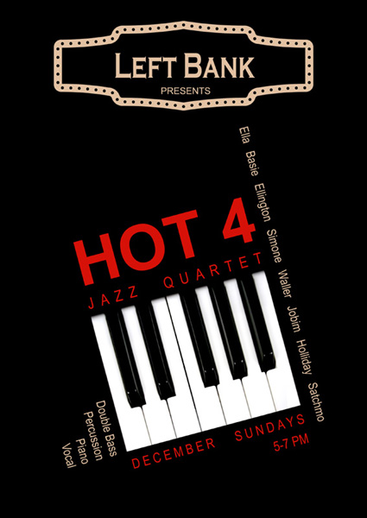

Introducing the brand new **HOT 4** Jazz Quartet playing every Sunday in December from 5-7pm at Left Bank, Kilkenny. We look forward to entertaining you with timeless Jazz & Swing classics while you enjoy a cappuccino, a beer, a glass of mulled wine, or even a dance! Band lineup includes Carole Nelson (Piano), Marie Glynn (Vocals), Brian O'Driscoll (Drums), Adrian Jackson (Double Bass).

**Debra Bowden at Toradh Gallery**

Meath County Council Arts Office is delighted to present ‘Beginnings’ by acclaimed artist Debra Bowden in the Toradh Gallery, Ashbourne Library & Cultural Centre, Ashbourne, Co. Meath. The exhibition will be opened by Aidan Dunne at 7pm on Tuesday 18th November. All welcome. Beginnings runs until 16th December.

Beginnings is an exhibition of work spanning the past five years exploring the origins of art, communication and the written word.

**______________________________________________________________________________________**

**`The Christmas Wishing Tree` - Interactive Installation Project** and  **FESTIVE OPEN DAYS at KOZO Studio**

By **TUNDE TOTH** Visual Artist

At CASTLECOMER DISCOVERY PARK

Christmas 2014

The `Christmas Wishing Tree` is an interactive installation project, imagined and created by visual artist Tunde Toth at the Visitor Centre of the Castlecomer Discovery Park in Co. Kilkenny.

The centre piece of the installation is a tall, fragile looking `paper - tree`, made entirely of recycled and reused materials – wires, cardboard tubes and sheets, baking parchment, tracing papers and various threads and fibres. Strikingly beautiful, it`s suspended from the ceiling, lit with small white fairy lights – creating a magical presence in the Visitor Centre.

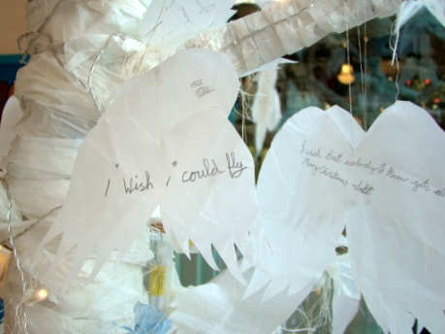 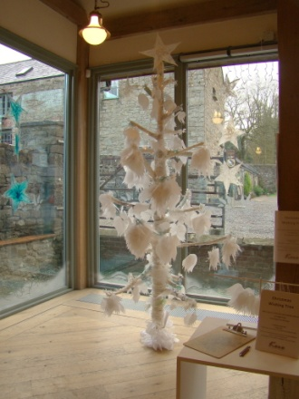

**This project is an interactive programme:** the Tree is part of the ongoing festive programme at The Castlecomer Discovery Park and visitors are invited to write down their very special wishes with pencils on prepared angel wings (cut from tracing papers) and place them on the tree. During the time approaching Christmas the tree is filled and gradually changes shape and form.

And of course – wishes do come true!

Various stages of the `Christmas Wishing Tree` is photographed and documented by the artist – some images will be displayed alongside the installation closer to Christmas.

Also displayed in the Visitor Centre are sets of the unique SILK FIBRE STARs created by Tunde Toth.

100% handmade from raw silk, metallic leaf and threads – they are beautiful, lightweight and lasting interior decorations with a see through, fibrous texture in various colour ranges: whites with silver and gold, shades of light blue and seasonal reds.

Tunde is holding **festive open studio days** at her new workshop in The Estate Yard on the last weekend before Christmas: on the **20th and 21st of December.**

Visitors are welcome for a glass of mulled wine or spiced hot apple juice and can avail of special discounts and offers on most art and craft works and gifts at KOZO Studio.

Gift Vouchers are available for the new year`s programme of professional art and craft workshops – the ultimate present for the creative and curious!

Tunde Toth is a visual arts practitioner living and working in Co. Kilkenny since 1998. She specializes in traditional and experimental forms of hand papermaking and paper art techniques, contemporary textiles, intaglio print making and arts education. She also works on various visual art projects in community and educational contexts.

Tunde is based in The Estate Yard at the Castlecomer Discovery Park where she opened KOZO, her new studio space in October this year.

She created the `Christmas Wishing Tree` project on a voluntary basis.

**Embodied Response**

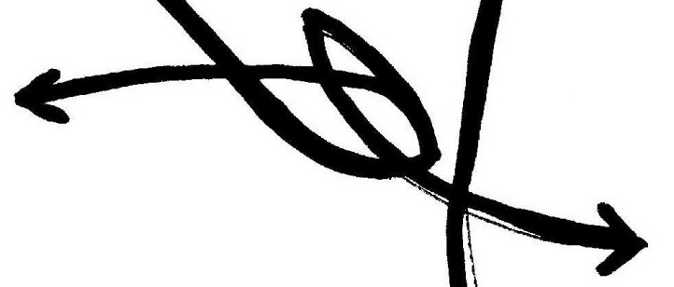

Embodied Response ([embodiedresponse.tumblr.com](http://www.embodiedresponse.tumblr.com)) is a new blog generated by writer and editor Jeffrey Gormly. It seeks to offer considered, constructive reflections on dance and other bodied performances.

“I hope to support and amplify the valuable work of dancers and other performers by openly receiving that work, giving myself time to digest my own reactions and reflect on the encounter with another’s work, and construct a reflection that extends a dialogue with the performer, and allows the thought process of the piece to move forward. I hope that over time Embodied Response becomes a site for the amplification of embodied thought processes, in Ireland and internationally.”

Contact [jeffreyvgormly@yahoo.ie](mailto:jeffreyvgormly@yahoo.ie)

Jeffrey Gormly was an Associate Artist with Daghdha Dance Company, and is still Editor of choreograph.net. A founder member of the Institute for Social Choreography, he has recently collaborated with Michael Klien on Parliament and Jerusalem: Choreography for Greece, and is a participant in the ongoing RICE-on-Hydra project.

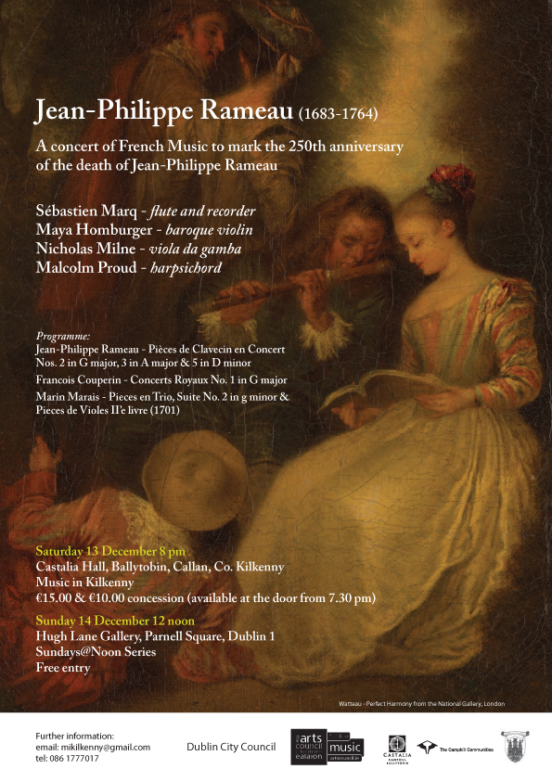

**Exhibition at City Library**

A beautiful exhibition of paintings by Waterford artists Emily Moore and Suzanne Carroll are currently on display in the City Library,John’s Quay. The 14 stunning pieces have been created in a range of styles, and are available for sale at prices ranging from €35-€55.

Emily’s love for art has grown over the past 7 years. Having begun with an interest in abstract art, she has now progressed onto pop art style. Emily’s style is full of vibrancy and colours, and she finds the work very therapeutic.

Suzanne has been painting for the past 5 years, and her inspiration comes from the beauty that’s around her, and she expresses it in an abstract form. She enjoys painting on canvases, and, like Emily, uses colour to express positive emotions in her work.

Ask at the desk for information on purchase arrangements. These will be on display until Saturday 20th December.

**Kilkenny Cafe – Exhibition Space available**

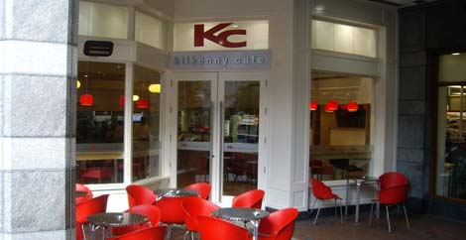

Kilkenny Café is located in Market Cross Shopping Centre in the heart of Kilkenny. It is a vibrant, busy space that has a large volume of visitors every week. It prides itself on being a place that serves good wholesome food, in a friendly relaxed atmosphere. It is now 20 years in operation and is part of the history of Kilkenny coffee culture.

Kilkenny Café is interested in receiving proposals from individual artists or groups interested in exhibiting in our café space. The meeting room at Kilkenny Café while not a gallery space is a beautiful space and offers high exposure to groups or artists wishing to exhibit.

If interested in using the space for exhibiting, please send example of the work via email (jpegs) with details of the work, the artists and the concepts to [katpurcell@hotmail.com](mailto:katpurcell@hotmail.com). We are accepting proposals currently.

As this is a busy café there are some conditions that the group must be willing to comply with prior to making a submission.

The artists or group is responsible for hanging the work in an appropriate and safe manner. Exhibition space measurements are 8 blocks of 165mm x 110mm. The group must also dismantle.

Kilkenny Café do no take responsibility for the work and therefore any additional insurances should be made.

The opening times of the space is dictated by the business hours of the café.

Kilkenny Café cannot handle sales inquiries or sales, appropriate information will need to be provided on the person to contact regarding sales.

If you are interested please contact Kathy Purcell by email on [katpurcell@hotmail.com](mailto:katpurcell@hotmail.com)

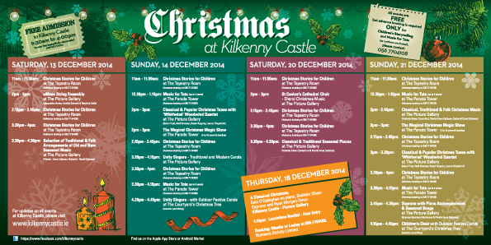

**Courses / Training / Jobs / Internships**

**_______________________________________________________________________________________**

**Insurance for Artists: Professional Development Workshop at the National Sculpture Factory**

Trainer: Peter Kirwan, Commercial Sales Manager, McCarthy Insurance Group  
Trainer: Alan O’Brien, Commercial Account Executive, McCarthy Insurance Group  
Date: Thursday, 29 January 2015  
10.30 – 1.00 pm  
Venue: NSF mezzanine  
Places 15  
€ Free

Peter Kirwan & Alan O’Brien will be available for a workshop to provide practical advice on insurance options/requirements. They will be happy to field any questions or suggestions you may have.

McCarthy Insurance Group, which was founded in 1952, is one of Ireland’s largest independent insurance brokers. They have 12 offices around the country and employ 150 staff. They provide over 45,000 customers with commercial, personal and financial services. They pride themselves on the professional, efficient and personal service they provide.

Duration of the workshop – Two hours with a 30-minute clinic afterwards for Q&A

To book places contact Elma O’Donovan at 021 4314353 or email elma@nationalsculpturefactory.com – Places will be allocated on a first come basis so please ensure you can commit if you apply.

**IN THE NEW YEAR Over The Edge Offers Poets Worldwide Online Poetry Workshop with Kevin Higgins**

Starting in very early February, **Over The Edge** is offering aspiring poets worldwide a ten week online poetry workshop with poet **Kevin Higgins**, whose best-selling first collection, The Boy With No Face, published by Salmon Poetry, was short-listed for the 2006 Strong Award for Best First Collection by an Irish poet. Kevin’s second collection of poems, Time Gentlemen, Please, was published in 2008 by Salmon Poetry and his poetry is discussed in The Cambridge Introduction to Modern Irish Poetry. His third collection Frightening New Furniture was published in 2010 by Salmon and his work also appears in the generation defining anthology Identity Parade –New British and Irish Poets (Ed. Roddy Lumsden, Bloodaxe, 2010) and in *The Hundred Years’ War: modern war poems* (Ed. Neil Astley, Bloodaxe, April 2014). A collection of Kevin’s essays and book reviews, Mentioning The War, was published by Salmon Poetry in 2012. Kevin’s poetry has been translated into Greek, Spanish, Turkish, Italian, Japanese & Portuguese. His most recent collection of poetry, The Ghost in The Lobby, was published in February 2014, also by Salmon.

Each of the ten weeks Kevin will email participants a poetry writing exercise for the following week and participants will submit one of their poems to Kevin for constructive criticism. Kevin will work with participants on making each of their poems the best possible poem it can be.

Kevin is a highly experienced workshop facilitator and several of his students have gone on to achieve publication success. He has facilitated poetry workshops at Galway Arts Centre for the past ten years. One of his workshop participants at won the prestigious Hennessy Award for New Irish Poetry, two have won the Cúirt New Writing Prize, and another the Cúirt Poetry Grand Slam, while several have published collections of their poems with reputable publishers. Kevin teaches poetry on the NUI Galway Summer School programme and mentors poetry students on the NUIG BA Creative Writing Connect programme. Kevin is also co-organiser of the successful Over The Edge: Open Reading series which specialises in promoting new writers.

The workshop will run for **ten weeks**, commencing **Wednesday February 4th**. The cost to participants is **€110**. There are no refunds. The workshop will be conducted in English only.

**YOU CAN REGISTER ONLINE NOW**

<http://www.overtheedgeliteraryevents.blogspot.ie/2014/02/over-edge-offers-poets-worldwide-online.html>

**Winter School 2015 – NYCI Arts Programme Pilot Training Initiative**

[](http://www.youtharts.ie/)

Winter School is a 2-day residential youth arts training which will take place in The Marino Institute of Education, Dublin running from Friday 30th Jan -  Sunday 1st Feb  2015. Following on from the success of Summer School, the training is aimed at youth workers with some experience of drama and/or film and is intended to cement and enrich that experience in one of those areas. The programme will focus on issue-based arts practice, through documentary film making and ‘Drama for Dialogue’, a drama programme which will support young people to explore issues of concern to them and problem solve.

In addition to workshops there will be evening events which will stimulate your imagination, support you to network and give you an opportunity to reflect on your practice.

The 2-day in depth workshop experience will give you the inspiration, practical know-how and skills to work in new ways with your young people and offer them high quality arts experiences.

**When?           Friday,  January 30th – Sunday,  February 1st 2015**

**Where?          Marino Institute of Education, Dublin**

**Who is this suitable for?**

Anyone working with young people in the nonformal education sector who wishes to explore ways of enhancing and extending youth arts provision for the young people with whom they work. It is aimed at those looking to improve their artform and delivery techniques in either film or drama

Find out more here: [www.youtharts.ie/winterschool](http://www.youtharts.ie/winterschool)

**Writing the Artists’ Statement and CV with Kerry McCall at the National Sculpture Factory**

Date: Monday, 9 February 2015  
Time: 10.30 – 4.30 pm  
€40 NSF Members / €45 non-members  
Places 8  
Venue: NSF mezzanine, National Sculpture Factory, Albert Road, Cork City

As an artist much of your time will be spent making proposals and writing grant applications. Because funding bodies don’t have the capacity to interview everyone seeking funding, they need to get a picture of who you are very quickly. Your artist CV aims to do this and should be snapshot of you and your professional achievements to date. It can also be augmented by an informative but focussed artist’s statement. This course is designed to give artists the know-how and understanding to write a clearly articulated, well presented and comprehensive CVs and an artists statements which should prove useful for a variety of situations including proposals for funding, proposals to galleries and job applications.

[www.nationalsculpturefactory.com](http://lists.visualartists.ie/lt.php?c=1270&m=4308&nl=1&s=d3c261c0eeb6b48867f449d29e09414b&lid=100087&l=-http--www.nationalsculpturefactory.com)

To book a place contact Elma O’Donovan at 021 4314353 or email [elma@nationalsculpturefactory.com](mailto:elma@nationalsculpturefactory.com)

Places will be allocated on a first come basis so please ensure you can commit if you apply!

**Irish Youth Choir - Auditions**

The 2015 course will take place from 28th June-6th July at the University of Limerick.

**IYC auditions**

January 17th  Galway & 24th Cork

February 7th Dublin, 14th Kilkenny & 21st Limerick

Choir members are selected following auditions held annually in a number of centres nationwide. Following successful audition, membership lasts for two years, after which time the singer must re-audition to join that year's intake.

Contact [aoic@ul.ie](mailto:aoic@ul.ie) for more information.

Download the application form from [www.aoic.ie/iyc/join_us](http://www.aoic.ie/iyc/join_us)

Singers presenting for audition for the Irish Youth Choir prepare a song of their own choice and can expect to be asked to sing some vocal exercises and to demonstrate a high level of musical ability. An accompanist is available to all singers and candidates are asked to provide two spare copies of their chosen piece of music at audition.

**Crowdfunding Workshop – Dublin**

**Tuesday 13 January 2015, 5.00pm**   
Thinking of crowdfunding as part of a fundraising drive for a creative project? Fund it will hold a series of introductory Crowdfunding workshops around the country in the new year. Our expert team of Fund it Moderators will be joined by experienced Creators to show you how you can tap into your network to bring your creative dreams alive!  
  
<http://www.businesstoarts.ie>

**Upskill your team with Training Programmes from Irish Times Training**

Business to Arts Affiliates are eligible for discounts of up to 70% on top skills-development programmes delivered by Irish Times Training.  
  
Popular upcoming courses include:  
  
• [Managing People](http://cts.vresp.com/c/?BusinesstoArts/ce21f4596f/608128ad7e/fbc3d0ec33) 1/2 December; 16/17 Feb, €775 reduced to €250  
• [Executive Secretary PA](http://cts.vresp.com/c/?BusinesstoArts/ce21f4596f/608128ad7e/220b4c5edb) 12/15 Dec, 2/3 Mar, €625 reduced to €250  
• [Report Writing](http://cts.vresp.com/c/?BusinesstoArts/ce21f4596f/608128ad7e/e1a6922a9d) 15/16 Dec, 11-12 Feb, 19/20 Mar, €625 reduced to €250  
• [Assertiveness Skills](http://cts.vresp.com/c/?BusinesstoArts/ce21f4596f/608128ad7e/d45b2694a7) 26/27 Mar, €625 reduced to €250  
• [Influencing & Persuading](http://cts.vresp.com/c/?BusinesstoArts/ce21f4596f/608128ad7e/e961dacb16), 18 Mar, €425 reduced to €250  
• [Minute Taking](http://cts.vresp.com/c/?BusinesstoArts/ce21f4596f/608128ad7e/9d6e2656ed) 4 Dec, 27 Jan, 10 Mar, €425 reduced to €250  
• [Presentation Skills](http://cts.vresp.com/c/?BusinesstoArts/ce21f4596f/608128ad7e/6727b65992) 11/12 Mar, €625 reduced to €250  
• [Time Management](http://cts.vresp.com/c/?BusinesstoArts/ce21f4596f/608128ad7e/dda644b29e) 10 Dec, 30 Jan, 3 Mar, €425 reduced to €250  
• [Negotiation Skills](http://cts.vresp.com/c/?BusinesstoArts/ce21f4596f/608128ad7e/546f09c865) 11/12 Dec, 16/17 Feb, €650 reduced to €250  
• [Change Management](http://cts.vresp.com/c/?BusinesstoArts/ce21f4596f/608128ad7e/55329ed0d1) 26/27 Feb, €625 reduced to €250  
• [Finance for the non-Financial Manager](http://cts.vresp.com/c/?BusinesstoArts/ce21f4596f/608128ad7e/c1b192d2bf) 10/11 Feb, €750 reduced to €250  
• [Personal Leadership & Team Building](http://cts.vresp.com/c/?BusinesstoArts/ce21f4596f/608128ad7e/b7be2838d2) 12/13 Feb, €650 reduced to €250  
• [Business Writing Skills](http://cts.vresp.com/c/?BusinesstoArts/ce21f4596f/608128ad7e/38858a2554) 26 Feb, €425 reduced to €250  
• [Chairing Meetings](http://cts.vresp.com/c/?BusinesstoArts/ce21f4596f/608128ad7e/f79e88d0e3) 4 Mar, €425 reduced to €250  
  
Check the [Irish Times Training site](http://cts.vresp.com/c/?BusinesstoArts/ce21f4596f/608128ad7e/9f6375a7db) for the complete list of courses. Discounts can only be secured for Business to Arts affiliates, and must be booked via our office.

**Training Links Programme, 2014 – 2016**

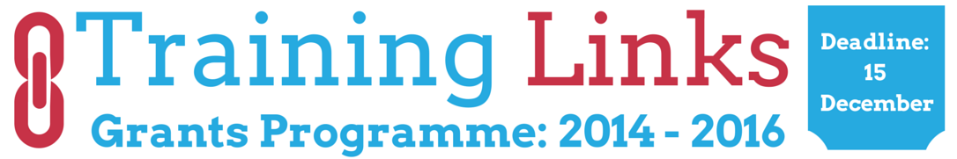

Training Links is an innovative support service developed by The Wheel to enhance the skills and employability of people working in the community and voluntary sector in Ireland. Training Links offers funding opportunities to groups of organisations that chose to come together and work collaboratively to address their shared training needs as a Training Network. It is anticipated that between 15 - 20 networks will be chosen and will receive grants of between €5,000 (minimum) and €25,000 (maximum) each. The last Training Links programme ran from September 2011 to mid 2013.

Download the official Training Links application pack below, including full guidelines and application form.

Closing date:  Monday, 15 December 2014 @ 5pm

<http://www.wheel.ie/traininglinks>

**Shadowbox Theatre CompanyCourse**

**In association with Mermaid County Wicklow Arts Centre**

**Spring Training In Visual Theatre Workshop**

**Mondays 19 January – 23rd March**

**10.30-3.30**

**Cost: €200 for 10 week course**

**Mermaid Arts Centre, Main Street, Bray**

Mermaid Arts Centre will be holding a spring training course in visual theatre for adults with

intellectual disability. The workshops will be facilitated by Gemma Gallagher from Shadowbox

running every Monday for 10 weeks. The course is intended for people with some experience of

theatre who wish to build their knowledge and skills.

The workshops will explore the creation of visual theatre, drawing on the instincts and emotional

language of the participants. The work will focus on the creation of ensemble, and how

collaborative work can strengthen the creation of new and vibrant theatre. Over the weeks the

course will look at Heightening Sensory creativity and **i**magination,improvisation,

use of m**usic** and sound in theatre,**NON** verbal communication, ***e***nsemble work and

**Devising** techniques. The aim is to build confidence in the participating actors and to

encourage the creation of visual theatre through the exploration of simple stimulus such as art,

work, everyday objects, stories in the news and what is important to the group themselves.

**Places will be limited so please book as soon as you can.**

**Bookings: contact admin@shadowboxireland.com or 086 3451457**

**or directly through Mermaid Arts Centre on 01 2724030**

**Call for Tenders in Audience Development and Public Art**

The Arts Council is seeking to engage suitably qualified persons or companies to supply the following services:

Study in Audience Development:

The undertaking of a study (review and report) on the Council’s work in the area of audience development.

Per Cent for Art Adviser:

The provision of advisory services to the Arts Council in per cent for art and public art.

Per Cent for Art Development Services

Editorial management of the website publicart.ie and other related services.

Full details of these contracts and of the tendering process for same are to be found on [www.etenders.gov.ie](http://newsletter.artscouncil.ie/18winbk7eok14rbsgtdsq9?a=6&p=48079179&t=17684704)

**Mourne Heritage Trust – Mourne Public Art Programme – seeking Artists/Design Teams**

PUBLIC ART COMMISSION – HILLTOWN, CO DOWN

The Mourne Heritage Trust is requesting expressions of interest for a piece of public artwork from experienced and suitably qualified artists or design teams  
to design, arrange the production, delivery and installation of a piece of public art.

The public artwork will be located in the village of Hilltown within the Mourne Area of Outstanding Natural Beauty. The total budget available is £15250 inclusive of VAT where applicable.

The project seeks to enhance the visitor experience and by introducing high quality, visually appealing, strong and site specific piece of public art which reflects the unique assets of Hilltown and which enhances the interpretation/public realm of the area.

The artwork will be created in consultation with a Steering Group and by engaging the local community in a participatory creative experience.

The project must be completed by 30 June 2015.

The budget for the project is £15250 inclusive of VAT where applicable.

Artists / design teams wishing to participate must initially submit an Expression of Interest application.

Details of how to apply and an Artists Brief can be downloaded from the Mourne Heritage Trust website [www.mournelive.com](http://www.mournelive.com/)

**Stage 1 applications must be received before 4PM on 2nd January 2015.**  
 **All requests for clarification or further information or any questions about the procurement should be submitted by email to Mandy McAvoy, Mourne Heritage Trust (mandy.mcavoy@mourne.co.uk)**

The selection panel intends to select up to 3 artists for the final tender stage who will be invited to develop proposals on the basis of information provided.

**Call for Submissions / Residencies**

**Parity Studios & UCD College of Human Sciences – Artist in Residence**

The UCD College of Human Sciences, in partnership with Parity Studios, is very pleased to announce the call for an artist in residence. A one year residency is offered to a professional artist. This includes studio space at UCD Parity Studios, a fee of €5000 and access to all of the lectures, research seminars and other resources of the College. The artist will have the opportunity to engage with staff in the College towards the creation of work reflective of the research being undertaken on the multifaceted social issues and challenges in contemporary society.

Key areas of collaborative research interest for the College of Human Sciences includes: Identity and Conflict; Environment, Policy and Society, Child and Youth Well-being; Demographic Change and Migration. The College is particularly interested in applications from artists who have already engaged in work related to one or more of these fields. However, it also welcomes those who are new to these areas of research. The principal aims of the scheme are to support mutual exchange between the artist and College staff, students and researchers and to explore areas of research, current and prospective, through the lens of artistic practice.

Closing date for applications is Sunday 11th January 2014. We will confirm receipt of your application by e-mail .

Full details on [http://www.ucdartinscience.com/parity-studios-artists-in-resi/4579007317](http://lists.visualartists.ie/lt.php?c=1270&m=4308&nl=1&s=d3c261c0eeb6b48867f449d29e09414b&lid=100084&l=-http--www.ucdartinscience.com/parity-studios-artists-in-resi/4579007317)

**National Gallery of Ireland Research Day 2015 – Call for Proposals**

CONDITIONS OF DISPLAY: RESEARCH AND PRACTICE

National Gallery of Ireland Research Day

The National Gallery of Ireland will hold a Research Day on 6th March 2015, exploring new ideas, projects and research at post-graduate level, creating opportunity for discussion and debate between institutions and organisations and students at various levels of study.

The theme for the event is “Conditions of Display: Research and Practice”.

As the NGI approaches 2016 and the re-opening of its historic buildings, it faces the challenges of re-hanging and re-imagining the collection, all of which will be informed by the myriad conditions and concerns of display.

In order to investigate this topic, applications are invited from students currently pursuing practical, historical or theoretical research on display and the conditions that inform this practice – e.g. Practical solutions for art practitioners, historical conventions, museum strategies for permanent collections, education and engagement, artist v curator, design and presentation, digital display, constraints of animating collections (financial, special, environmental) etc. Papers dealing with any aspect of the NGI and its collections will also be considered.

SUBMISSION GUIDELINES:  
Proposals: No more than 250 words, 12 point font, single-spaced.  
Format: Name/E-mail address/Course of Study/University/Title of paper/Proposal  
Deadline: Proposals should be sent to [education@ngi.ie](mailto:education@ngi.ie) by 20 January 2015.  
Further Information: [education@ngi.ie](mailto:education@ngi.ie) or 01 663 3504/5/6/7/9

**ArtsOasis: June 1 - 6, 2015**

**International residential workshop for Dancers, Actors, Performers**

**The residency will take place at the 12th century Monastery in Tuscany, Italy.**  
**Accommodation & meals are provided**.

Please find more details on:  
[**https://twitter.com/iugte_art**](https://twitter.com/iugte_art)

**Light Work Artist-in-Residence Program**

Each year Light Work invites 12-15 artists to participate in its residency program, including one artist co-sponsored by Autograph ABP and one artist in conjunction with the Urban Video Project (UVP). Artists selected for the residency program are invited to live in Syracuse for one month. They receive a $5,000 stipend, an apartment to stay in, a private digital studio, a private darkroom, and 24-hour access to our facility.

Participants in the residency program are expected to use their month to pursue their own projects: photographing in the area, scanning or printing for a specific project or book, and so on. Artists are not obligated to lecture at our facility, though we hope that the artists are friendly and accessible to local artists and students. Work by each Artist-in-Residence becomes a part of the Light Work Collection and is published in a special edition of Contact Sheet: The Light Work Annual along with an essay commissioned by Light Work.

Questions? : Questions about the facility may be directed to [lab@lightwork.org](mailto:lab@lightwork.org) and questions about the application process or residency can be sent [toair@lightwork.org](mailto:toair@lightwork.org).

Deadline 1 July 2015

For information about our facilities, see [www.lightwork.org/lab](http://www.lightwork.org/lab)

**The Incubator Journal**

Now acceptingflash fiction (1000 words and under) 3 pieces max and short fiction (3000 words max.) 1 piece  
The contemporary short story is at the heart of The Incubator, however, we also love memoir, plays, essays and poems too. We have special issues for these (please see above).  
Full details

**Prole Call for Submissions**

Prole is open to submissions of prose and poetry all year round. Their aim for a four week turn around and offer royalty payments on accepted pieces. Submission guidelines are here: [http://www.prolebooks.co.uk/page3.html](http://irishwriterscentre.us9.list-manage.com/track/click?u=b6ac145e44235d03eb0c4adb6&id=af7281eee2&e=055476dad7)

**Prole Poetry competition**

The 2015 Prole Laureate Competition is open for entries until **January 31st, 2015**. This year, Helen Ivory is the judge and there is a prize fund of £300 and publication on offer. Full details are here: [http://www.prolebooks.co.uk/page6.html](http://irishwriterscentre.us9.list-manage1.com/track/click?u=b6ac145e44235d03eb0c4adb6&id=adc382caca&e=055476dad7)

**Ballymaloe International Poetry Prize**

There are four cash prizes for a single unpublished poem: €10,000 for the overall winner and three runner-up prizes of €1,000. A shortlist will be announced in the spring of 2015 and the four winning poems will feature in the spring issue of The Moth. The overall winner will be announced at a special award ceremony in Dublin in March 2015. **Closing date 31 December 2014**. For more information, visit [www.themothmagazine.com](http://irishwriterscentre.us9.list-manage1.com/track/click?u=b6ac145e44235d03eb0c4adb6&id=e020805ad4&e=055476dad7).

**The Stockholm Review**

Looking for feminist essays, articles and creative non-fiction.  
**Submissions received until 4 January 2015** will be considered for publication in The Stockholm Review of Literature's 6th edition.  
Please direct all queries and submissions to [stockholmlitreview@gmail.com](mailto:stockholmlitreview@gmail.com)  
More details [http://thestockholmreview.org/submissions/](http://thestockholmreview.org/submissions/?utm_source=Main+Mailing+List&utm_campaign=519427317a-Newsletter_3_December_201412_1_2014&utm_medium=email&utm_term=0_615d15ae04-519427317a-230601717)

**Five Word Poetry Competition**

**2nd Ó Bhéal Five Words International Poetry Competition**  
**Closing date: 27 January 2015**  
Prize: €500 plus reading  
Entry fee: €5 euro  
Each week on Tuesday at midday (GMT), five words are posted on the Ó Bhéal competition page at [www.obheal.ie](http://irishwriterscentre.us9.list-manage1.com/track/click?u=b6ac145e44235d03eb0c4adb6&id=4b897b6063&e=055476dad7). Entrants have one week to compose and submit poems that must include all five words for that week. At noon the following Tuesday, these words are no longer eligible, and replaced with five new words. The competition will run for a total of forty-one weeks, until the last week of January 2015.

For more details and submission guidelines <http://www.obheal.ie/blog/>

**Australian Book Review**

Welcoming entries in the ninth Calibre Prize for an Outstanding Essay, which is now worth a total of AU$5,000.   
Essays must be between 3,000 and 7,000 words and must be written in English.  
Judges: Delia Falconer and Peter Rose  
**Deadline for entries is 19 January 201**5  
First Prize: $5,000 and publication in Australian Book Review  
All details <https://www.australianbookreview.com.au/>

**Convill and Walsh Word of Mouth Prize**

The Word of Mouth Prize will focus on novels that people just can't stop talking about. We're looking for fiction that is brilliantly written but accessible, has depth but isn't dense and is innovative but identifiable. We'd love to find novels with that must-read quality, which would be perfect for book club discussions. These are the kind of books that can become a word of mouth phenomenon, and which Conville & Walsh are known for representing. The winner will receive a cheque for £1,000 and, if mutually agreeable, representation by Conville & Walsh.  
**Deadline 31st of January**  
<http://www.convilleandwalsh.com/>

**Fish Short Memoir Contest**

**Deadline 31st of January**  
First Prize €1000  
The ten published authors will each receive five copies of the Anthology and will be invited to read at the launch during the West Cork Literary Festival in July.  
All details <http://www.fishpublishing.com/>

**The White Review**

**Deadline: 1  March 2015**  
Submissions opens on 1 December 2014  
First prize: £2,500 Judges: Ned Beauman   
The White Review Short Story Prize is an annual short story competition for emerging writers. We encourage submissions from all literary genres, and there are no restrictions on theme or subject matter. We would only emphasise that the prize was founded to reward ambitious, imaginative and innovative approaches to creative writing.    
More details <http://www.thewhitereview.org/prizes/the-white-review-short-story-prize-2015/>

**The Caterpillar International Poetry Prize**

**Closing date: 31 March 2015**  
Prize: €1,000 plus publication in The Caterpillar   
Details: To celebrate the first year of The Caterpillar, an arts & literature magazine for children, we're looking for a stand-out poem written by an adult for children (aged 7-11) to which we can award a prize of €1,000. The prize is open to everyone, as long as the work is original and previously unpublished. The entry fee is €12 per poem, and you can enter as many poems as you like. The prize will be judged by the publishers of The Caterpillar and The Moth. For further details go to [www.thecaterpillarmagazine.com](http://irishwriterscentre.us9.list-manage.com/track/click?u=b6ac145e44235d03eb0c4adb6&id=65c6e8f88d&e=055476dad7)

**Scottish Arts Club Short Story Competition**

**Deadline 31 March 2015**  
First Prize of £800 The competition is open to all writers worldwide aged over 16 years, published and unpublished. Stories entered for the competition should be 1,500 words or less and can be on any topic. The stories do not have to be associated with Scotland.    
All details <http://www.scottishartsclub.co.uk>

**2015 Bristol Short Story Prize**

Open to all published and unpublished writers, UK and non-UK based, over 16 years of age.  
Stories can be on any theme or subject and entry can be made online via the website or by  
post. Entries must be previously unpublished with a maximum length of 4,000 words (There is no minimum). The entry fee is £8 per story. The closing date for entries is April 30th 2015.  
Prizes:   
1st £1000 plus £150 Waterstone's gift card  
2nd £700 plus £100 Waterstone's gift card  
3rd £400 plus £100 Waterstone's gift card

17 further prizes of £100 will be presented to the writers whose stories appear on the shortlist. All 20 shortlisted writers will have their stories published in the Bristol Short Story Prize Anthology Volume 8.   
Full details and rules at [www.bristolprize.co.uk](http://irishwriterscentre.us9.list-manage.com/track/click?u=b6ac145e44235d03eb0c4adb6&id=2ed33bae2e&e=055476dad7)

**Original Writing Winter Flash Fiction Competition**

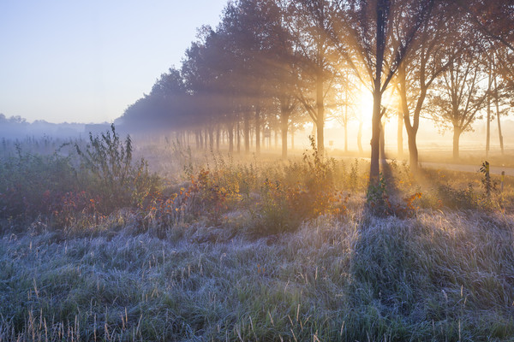  
  
Interested in seeing your writing online? Testing your writing skills? In that case welcome to **Original Writing Flash Fiction** competitions. We've had a fantastic response to our competitions so we're running another one for writers, featuring short pieces on different themes. This time our theme will be **"Making a Difference".**

The Competition  
Write a piece of between 750 and 1000 words on the theme *of "Making a Difference"*. It can be satirical, serious,humorous, poignant or whatever appeals to you.

Prizes

The 5 finalists will have their writing published on the Original Writing website, a great showcase for your work. The overall winner will also have an additional article about their work on our website and blog. Along with that we’ll also give the winner a **€200 Amazon voucher**.

The 4 runners up will receive a **€25 Amazon Voucher**each.

Entry Details

**Entries must be between 750 and 1000 words long.** All you need to do is submit your entry using the form below or submit via email to ***info@originalwriting.ie*** with the subject line "Winter Flash Fiction*'".*

The closing date for the entries on the topic ***Making a Difference*** is **Wednesday 31st December 2014**. We will announce the shortlist and winner in the New Year.

<http://www.originalwriting.ie/pages/competition-page-001>

**The Excel Gallery – Artistic Programme | Call for Submissions**

The Excel Gallery, Excel Centre, Mitchell Street, Tipperary Town, Co. Tipperary

The Excel Gallery is now looking for submissions for exhibitions to take place in its gallery space from April 2015-March 2016. The gallery welcomes innovative and challenging proposals from established artists and from artists who wish to present a debut exhibition. Group submissions are also welcome.

Submissions should include:  
A) 8 slides (or a CD with six images) of recent or previous work  
B) an Arts-related C.V.  
C) and an exhibition proposal relating to the artists intention for the show  
D) submissions should be marked ‘Gallery Submission’ and posted to the above address.

We are taking submission on an ongoing basis

A floor plan of the Gallery and further details available at 062-80520

[www.tipperary-excel.com](http://lists.visualartists.ie/lt.php?c=1253&m=4291&nl=1&s=d3c261c0eeb6b48867f449d29e09414b&lid=97908&l=-http--www.tipperary-excel.com)

**2015 Phase One Electronic Music and Arts Festival at The Dock Arts Centre | Call for Submissions**

We are delighted to announce a call for artists working with new media to participate in the 2015 Phase One Electronic Music and Arts Festival at The Dock Arts Centre, Carrick-on-Shannon, April 3-5 2015.

Now in its third year, Phase One has been granted use of the full and expansive gallery space at The Dock, and we are accepting proposals from artists at all stages of their career to use this spectacular space.

The Dock is a former courthouse, and using this as a concept we are asking artists to respond to the history of the space by looking at the idea of law (or digital law), the practice of reinventing places, and the relationship between art and the history of a place. We are looking for engaging and interesting proposals for our audience of over 200, and this can include (but is not exclusive to) interactive media art, illustration, print, mobile art, pervasive art, projection/video or any other work that uses digital media as a theme or medium.As the space is very large the scope for scale of work is broad, and there is the potential to stage artworks off-site.

A panel will assess every entry on its merit and on its relevance to the theme. They will look at past exhibition experience as a guide to the level of quality of the artist’s practice. New works are very welcome, but we would appreciate a detailed description with sketches and evidence of past work that demonstrates an ability to create the proposed artwork.

This festival is voluntarily run and there is a limited budget. We are very conscious of the Visual Artists Ireland visual arts payment guides, and would hope to be able to properly fund the exhibition. No proposal will be refused based on an artist’s proposed budget if supplied. As a small token of thanks we offer a free pass to any exhibiting artists to the events over the weekend, and there is a range of equipment available at the gallery for experimental works, including computers, projectors and video screens if artists would like to experiment with new works. We welcome this sort of proposal and look forward to seeing all entries.

Please provide: A CV, a project proposal (if relevant), and a short portfolio in any digital format (up to 10 works, links to online digital work/documentation or online portfolios are perfectly acceptable). Provide any other supporting documentation you feel will assist your application. If proposing a new work please provide sketches and a description of work.

E-mail submissions only to [visualarts@phaseonefestival.com](mailto:visualarts@phaseonefestival.com), with “Visual Arts Submission 2015″ in the subject bar. Further questions can also be directed to Shane or Edel at this email address.

Deadline for entries is January 15, 2015, but please apply early as works will be assessed at intervals between now and the closing date.

[www.phaseonefestival.com](http://lists.visualartists.ie/lt.php?c=1260&m=4298&nl=1&s=d3c261c0eeb6b48867f449d29e09414b&lid=98864&l=-http--phaseonefestival.com/)

**Nenagh Hospital: Tender for Public Art Work under the ‘Per Cent for Art Scheme’**

Nenagh Hospital has recently undergone significant redevelopment works to provide a modern theatre suite, pre-operative assessment unit, consulting rooms, staff facilities and a refurbished day ward at first floor level. At ground floor level modern canteen facilities have been developed along with some ancillary support spaces for the hospital.

The HSE is now inviting Artists to tender for the provision of original art work(s) for display, under the terms of the Government ”Per Cent for Art Scheme”.

The total available funding is €51,000.

Please note the HSE is not obliged to accept any proposal submitted and should the standard of work or proposals be deemed unacceptable then no art work commission may be awarded.

The deadline for receipt of proposals is by 4pm on Wednesday 14th January 2015.

The detailed Invitation to Tender document is at <http://visualartists.ie/wp-content/uploads/2014/11/PerCentforArt_Brief_NenaghHospital.pdf>

**Awards / Bursaries / Schemes**

**_______________________________________________________________________________________**

**Sky Academy Arts Scholarships 2015 confirm €38k fund for an emerging artist based in Ireland**



Sky Academy have confirmed that an artist based in Ireland aged 18-30 will be among this year’s Arts Scholarship winners, receiving an investment of €38,000 plus high level mentoring – giving the time and support to develop their creative practice and take their career to the next level.  
   
Sky Academy Arts Scholarships are open to artists aged 18 to 30 living in the UK and Ireland.  Applicants need to be a member of [IdeasTap.com](http://cts.vresp.com/c/?BusinesstoArts/ce21f4596f/608128ad7e/aed53b3e9e), which is free to join, and can submit either a written or filmed application in the categories of visual art, theatre, dance, music, creative writing (excluding film or TV scripts) and creative producing. Applications will be assessed by industry professionals as well as individuals from Sky and IdeasTap, with winners announced at the South Bank Awards in June 2015.  
   
Business to Arts and Sky Ireland along with Sky Academy will host a briefing session in Dublin in January for artists interested in applying. Date TBC. To express your please see <http://www.businesstoarts.ie>

**Sky Arts Amplify - a fund for Arts Organisations and Production Companies to collaborate on innovative TV projects**

Business to Arts and Sky Ireland will shortly announce a date for a Dublin Briefing Session for Irish arts organisations and film production companies to brainstorm ideas for Sky Arts Amplify, a new €1.25m annual fund for new TV ideas to be created collaboratively, as part of a broader investment by Sky in the UK and Ireland’s creative industries.  
   
Find out more <http://www.businesstoarts.ie>

**2014/2015 Dates and Deadlines for Culture Ireland Grant Rounds**

Please note Culture Ireland has set funding rounds and deadlines for 2015. There will be three funding rounds in 2015 and seperate calls for showcasing opportunities and Edinburgh Festivals will be announced during the year.

**Application Deadline | Timing of Project/Event | Decision Due**

* 15 February 2015 |  May 2015 onwards |  Early April
* 15 June 2015  | September 2015 onwards | Early August
* 15 October 2015 |  January 2016 onwards | Early December

[http://www.cultureireland.ie/](http://lists.visualartists.ie/lt.php?c=1232&m=4271&nl=1&s=d3c261c0eeb6b48867f449d29e09414b&lid=96096&l=-http--www.cultureireland.ie/)

**Arts Council Bursary Awards – Next Closing Date 5:30 pm Thursday, 22 Jan 2015**

The Arts Council provides Bursary Awards in order to assist individual artists in the development of their art practice. The award emphasises the value and benefit to an artist’s development that is derived from a focused period of engagement with their practice.

The deadline for the next round of the Arts Council’s Bursary Awards is Thursday, 22 January 2015

The window for making an application opens on Tuesday, 16 December 2014

 The Bursary Award is available in the following artforms:

* Architecture
* Arts Participation
* Dance
* Film
* Literature (English Language)
* Music
* Visual Arts

Guidelines for each award are published on the available funding section on the website.

Please note: Applications will only be accepted through the Arts Council’s online services website. Applicants who have not previously used this system must register in advance of making an application. It is recommended that applicants allow five working days for registration prior to making an application.

[www.artscouncil.ie](http://lists.visualartists.ie/lt.php?c=1255&m=4293&nl=1&s=e784eec6bf8bb9680747b324b9c9eee1&lid=98099&l=-http--www.artscouncil.ie)

**_____________________________________________________________________________________**

**Reminder: Touring and Dissemination of work scheme**

Thursday, 4 December is the deadline for applications to the [Touring and Dissemination of Work Scheme](http://newsletter.artscouncil.ie/18k2iagwkxh14rbsgtdsq9?a=6&p=48079173&t=17684704) for tours beginning in the period July to December 2015. The [Advance Planning strand](http://newsletter.artscouncil.ie/18k2iagwkxh14rbsgtdsq9?i=2&a=6&p=48079173&t=17684704) for this scheme has the same deadline for tours from January to December 2016.

As with previous rounds of the scheme we have agreed with our colleagues in the Arts Council of Northern Ireland to make it easier to extend tours across the border. This means that applications from the North and the South can include dates in either jurisdiction and if the application is successful, we will support all legs of the tour.

This is an incentive to companies and venues to work together in both jurisdictions to enable excellent work to be seen on the whole island. Since its introduction in 2010 the Touring schemes have been based on the principle of collaboration between those who produce and those who present work to audiences. So we hope that the two Arts Councils working together on this will help foster stronger ties between artists in the two jurisdictions.

For general details on the scheme, please contact Val Ballance or Regina O'Shea. If you have questions specifically related to art forms, then email the relevant team. All contact details are on the Arts Council's website [Contacts page](http://newsletter.artscouncil.ie/o3t6h58avxs14rbsgtdsq9?a=6&p=48079173&t=17684704).

Arts Audiences is running Pre-Application Workshops aimed at any organisation or individual who is considering applying for funding under the upcoming Touring and Dissemination of Work Scheme. These workshops will cover questions about how to set audience targets, how to incorporate Northern Ireland in a tour and whether you are ready to apply this round.  Two workshops will take place in Highlanes Gallery, Drogheda on Monday November 10 and in Dublin on Tuesday November 11. These workshops are aimed at those who have applied before, and/or toured before, as well as those who are new to application. The window for applications opens on November 4, and your ideas for touring would ideally be formulated by then and you will be getting ready to make a detailed application. The workshop is there for applicants who have developed their ideas, to help with specific areas, and answer questions.

Registration has now closed, but there is a waiting list for places.  If interested, please contact Gillian Clarke, Arts Audiences directly, at [gclarke@templebar.ie](mailto:gclarke@templebar.ie).

**European Cultural Foundation – STEP travel grants – ongoing**

[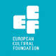](http://www.google.ie/url?url=http://sideshow-circusmagazine.com/research/funding-sources/step-beyond-travel-grants&rct=j&frm=1&q=&esrc=s&sa=U&ei=nYDGU4mnCtKe7AbIhYDoCw&ved=0CCAQ9QEwBg&usg=AFQjCNGnthfC8RitJQx109ixVGPR1pNiAA)

**STEP Beyond Travel grants fund up and coming artists and cultural workers – giving priority to individuals up to 35 years and/or in the first 10 years of their career – to travel between EU and countries bordering the EU.**

There is no deadline for this grant scheme, so you can apply at any time but at least one month before your planned travel. The selection process takes up to one month.

For more information on how to apply, a list of eligible travel destinations and to access the application form, go to the “how to apply guidelines”: [http://tinyurl.com/p26gd7n](http://tinyurl.com/p26gd7n%20)

These guidelines are also available in Russian but please note that the final application has to be in English. You can also access the application form directly here – [ecflabs.org/step-beyond-apply?gids[]=4707#group_step_1](http://ecflabs.org/step-beyond-apply?gids%5b%5d=4707#group_step_1)

**Of Interest**

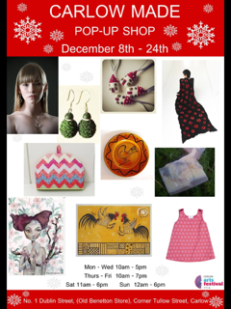

**Irish Design 2015 | Call for Volunteers**

Irish Design 2015 (ID2015) is seeking enthusiastic and dedicated volunteers to support ID2015’s exciting programme of exhibitions and events at Dublin Castle in the Coach House, Dublin’s Design Hub for ID2015

By becoming a volunteer with ID2015, you will be involved in a dynamic programme celebrating and promoting Irish design and designers throughout 2015. You’ll be part of a core team who will engage the wider public with this celebration, ensuring a quality experience for national and international visitors to ID 2015 exhibitions and events in the Coach House at Dublin Castle. Key activities would include supporting gallery invigilation, exhibition mediation and interacting with visitors to ID2015 exhibitions and events.

All volunteers must be aged 18 years or older. Volunteers will receive full training with our curators and exhibitions team, a volunteer handbook, special access to selected ID 2015 events and a dedicated staff member to ensure that your ID 2015 volunteering experience is fulfilling and enjoyable.

Interested? Submit your CV along with your name, address, phone number to: [hello@irishdesign2015.ie](mailto:hello@irishdesign2015.ie)

[www.irishdesign2015.ie](http://lists.visualartists.ie/lt.php?c=1270&m=4308&nl=1&s=d3c261c0eeb6b48867f449d29e09414b&lid=100099&l=-http--www.irishdesign2015.ie)