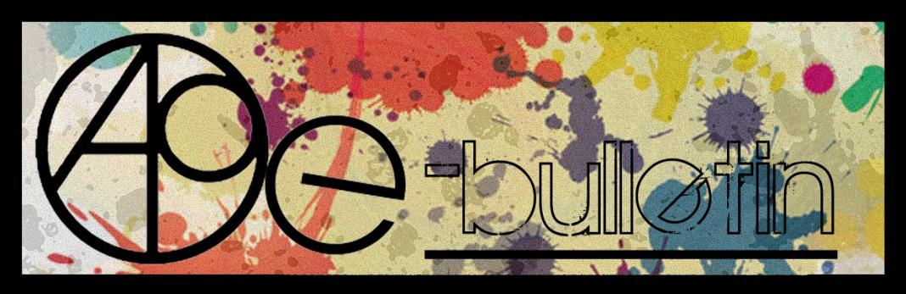

**Kilkenny County Council Arts Office E-bulletin 3rd October 2014**

Dear All,   
  
Welcome to the fortnightly e-bulletin from Kilkenny County Council's Arts Office. Each bulletin is packed with the latest information on Kilkenny Arts Office activities, county events as well as news and opportunities for arts practitioners from around the country.

This service will be provided fortnightly. To include an item in the next e-bulletin please send a brief outline of your advert with relevant contact details, including any websites or pages with links to [**niamh.brophy@kilkennycoco.ie**](mailto:niamh.brophy@kilkennycoco.ie) **before 15th October**. The next e-bulletin will be on the **16th October.**

While every effort has been made to ensure the accuracy of our information, we strongly advise readers to verify all details to their own satisfaction.

Regards,  
Niamh Brophy  
Arts Office,  
T: 056 7794138  
E: [niamh.brophy@kilkennycoco.ie](mailto:niamh.brophy@kilkennycoco.ie)   
W: [www.kilkennycoco.ie/eng/Services/Arts/](http://www.kilkennycoco.ie/eng/Services/Arts/)

BECOME PART OF IT, SUBMIT A POEM.....[www.rhymerag.net](http://kk-moss/Sites/arts_office/Shared%20Documents/Julianne%20Morgan/E-bulletin/30th%20May%20e-bulletin/www.rhymerag.net)  
Kilkenny County Council Arts Office Partner Local Authority of the ArtLinks Programme [www.artlinks.ie](http://www.artlinks.ie)

**Read the next Rhyme Rag published poem and get involved in R3VERSE free writing workshops for teenagers**

The next poem to be published for **Rhyme Rag** is **'Exequies of an Angel'** by **Alan Mooney.**

Alan Mooney has just started 5th Year in St. Kieran's College, Kilkenny. He was involved in the ‘What is Art’ book project with the Butler Gallery in Kilkenny. He has also had a short story, ‘Tied to the Tracks’, broadcast on KCLR.

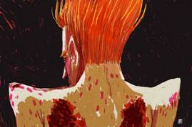

This poem was selected by Editor John W. Sexton and Illustrated by Ale Mercado.

**Read it here:**  
<http://www.rhymerag.net/2014/09/exequies-of-an-angel>

**So would you like to submit work to Rhyme Rag** but want to learn how to write poetry, to improve your poetry writing skills, meet new people and have fun doing so? Then the upcoming **Я3VERSE - FREE Poetry Workshops for teenagers** are for you. All workshop details will be circulated shortly. These are a fantastic opportunity to discover the wonder of creative writing and poetry.

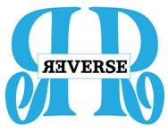

Thanks to all for submitting poems. And don’t forget to submit work or encourage others you may know to do so!

**ArtLinks announces new Training Programme for Artists in Kilkenny**

Kilkenny Arts Office in association with ArtLinks is pleased to announce the reintroduction of its Training Programme for Artists which it launched earlier today. The programme is designed to meet the needs of artists living and working in the south east region and due to levels of funding available for the arts in recent years, had not formed part of the ArtLinks annual programme.

The programme will be delivered by industry experts for each session and will comprise programmes across the four partner counties of Carlow, Kilkenny, Waterford and Wexford. Training programmes which will be held this season include:

* Taxation for Artists
* Writing Successful Funding Applications
* Developing your Professional network
* Maximising your Online Presence
* Strategic Planning for your Artistic Business

Speaking earlier today Mary Butler, Arts Officer Kilkenny County Council stated.

*“Myself and my ArtLinks partner colleagues are really pleased to be in a position to reintroduce the ArtLinks Training Programme this Autumn. We have listened and responded to what artists on the ground are saying to us and have designed a programme which is suited specifically to their needs at the present time. In addition, ArtLinks is lending financial support to this programme to keep fees for programmes to a minimum. It is our intention to continue to develop this programme over the next number of years, funding permitting, and look forward to continuing to develop a programme which suits the needs of both professional and emerging artists in Kilkenny.”*

**Registration for the programme is essential as places for each training programme are limited.**

**Priority booking will be offered to ArtLinks members for a period of one week from Friday 12th September 2014.** Booking for non members will open onFriday 19th September.

**For further information on the programme or to place a registration log on to** [**www.artlinks.ie/traning**](http://www.artlinks.ie/traning)

ArtLinks is supported by the four Local County Councils of Arts Officers for Carlow, Kilkenny, Waterford and Wexford and the Arts Council / An Chomhairle Ealaíon.

**Maximising Your Online Presence with t**rainer Niall Flaherty **took place on** 30th September. Image here from the workshop

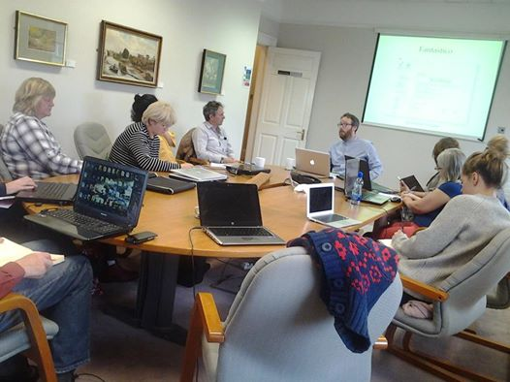

**Developing a Marketing Plan for your Artistic Business**

Trainer: Karan Thompson

Date: Thursday 6th November 2014

Time: 10:00 – 17:00

Location: Butler House, Kilkenny

Artists can also avail of other ArtLinks training programmes being run across the partner region. Further information on this programme is available at [www.artlinks.ie/training](http://www.artlinks.ie/training)

**Kilkenny Events**

**\_\_\_\_\_\_\_\_\_\_\_\_\_\_\_\_\_\_\_\_\_\_\_\_\_\_\_\_\_\_\_\_\_\_\_\_\_\_\_\_\_\_\_\_\_\_\_\_\_\_\_\_\_\_\_\_\_\_\_\_\_\_\_\_\_\_\_\_\_\_\_\_\_\_\_\_\_\_\_\_\_\_\_\_\_\_\_**

**Classes Autumn 2013 - Blackstack Studio, 42 Parliament St., Kilkenny**

Bookings can be made on the website [www.blackstackstudio.com](http://www.blackstackstudio.com/), or by emailing [sylvia@blackstackstudio.com](mailto:sylvia@blackstackstudio.com)

# Special workshops can also be arranged for groups of 3 or 4 people (email as above)

# C:\Users\nfinn\Desktop\1013820_780682718639588_1836831308429994777_n.jpg

# Weekend Workshops

**Screenprinting** (Weekend 18th & 19th October. **or** 15th & 16th November. 10am-4pm €170)

This is a beginners or refreshers screenprinting class for visual artists. You will learn how to make screenprints with photographic or hand drawn imagery. Cleaning and coating the  screen, exposing the image, and registration and printing will all be covered.

**Bookbinding** (One-day workshop. Saturday 8th November 10am – 4pm €85)

Create beautiful functional handmade books using historical longstitch and linkstitch bookbinding techniques.

In this workshop you will learn how to make multi section books, constructed using different stitch methods, where the sewing is exposed as a feature on the outside cover spine of the book. The sewing method can be applied to hard and soft back covers. The workshop is designed for participants with or without bookbinding experience.

**Introduction to Drypoint and Non-Toxic Etching.** (Weekend 22nd & 23rd November 10am – 4pm €170)

An intensive two-day course for visual artists and curious beginners. Over

the two days participants will learn the essentials of Intaglio

printmaking and then enjoy experimenting with colour, texture and technique

through a range of different printmaking methods. Participants will leave

with a new set of skills, a knowledge of Non-Toxic printmaking methods and

an array of beautiful prints!

**Friday Workshops**

Screenprinting for Graphic Designers & Illustrators  (2 Fridays,17th & 24h October or 21st & 28th November.10am-4pm €180)

A course for professionals in the field of visual communications who want to get back to hand-produced products while keeping their digital skills. The course will go through the stages of producing screenprinted materials starting from digital designs and how to prepare files to get them ready for production to the final  printing of the designs on paper. Tutor: Ale Mercado.

**Butler Gallery: Amy Walsh ‘The Talking Earth**

**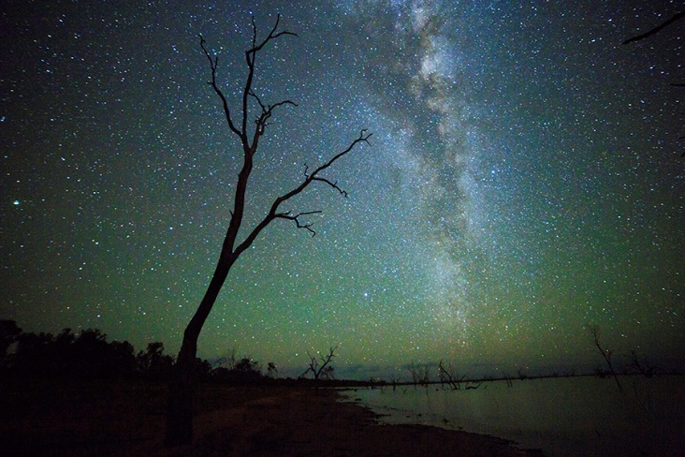**

October 18 – December 14, 2014

Following an artist residency with the Broken Hill Art Exchange in New South Wales in Australia.

Amy Walsh will present an exhibition of video projections, installations and a series of photographs. This work explores our relationship to place and time by showing the movement of the stars against the Australian night sky, evidencing our place within this larger system.

Amy Walsh lives and works in Dublin. Her practice is primarily in video, photography and digital media. She is a lecturer in Dublin Institute of Technology.

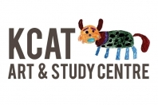

## KCAT is looking for a Studio Facilitator (P/T)

#### KCAT wishes to appoint a part-time Studio Facilitator. The position requires a good knowledge of visual art techniques and a good understanding of art facilitation. The successful candidates will have a passion for arts participation centred cultural work and be expected to support high quality artist led development for all the KCAT Studio artists.

For more information: <http://www.kcat.ie/WP/2014/09/kcat-wishes-to-appoint-a-studio-facilitator-pt/>

**Introducing... NEST!**

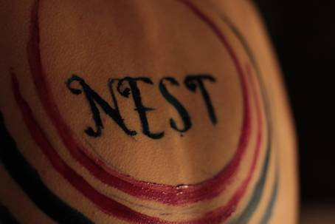

Taking place in the heart of Kilkenny, NEST is a three day event that will traverse through performing arts disciplines in pursuit of what exactly is the essence of being a female performance artist (actor/visual artist/musician etc) working in the industry today.

We will have theatrical shows, music, workshops, work in progress showings, and panel discussion, all provided by the array of amazing women around the country working in the performing arts world.

We feel our visibility is not enough, and we want to know why!

We need to know more about how we make our work, and why!

Friday evening, Saturday, and Sunday will be jam packed with performances/workshops/installation by Susie Lamb, Niamh Shaw, Zoe Uí Fhaolain, Aine Phillips, Niamh Moroney, Joanne Boyle, Eszter Nemethi, Ita Morrissey, Gillian Grattan, ...and many more!

For full details of the time-tables please check out our blogger at

[nestkilkenny.blogspot.ie](http://nestkilkenny.blogspot.ie) or find us on facebook under “Nest Kilkenny”-be our friend!

Weekend Ticket €100 (Friday evening 5pm-Sunday night10.30pm))

Saturday Ticket €50 (access to ALL events Saturday 9.30am-10.30pm)

Sunday Ticket €50 (access to ALL events Sunday 9.30am-10.30pm)

Pick and Mix tickets for the weekend will be available, get in touch for more information! If you would like to pick and mix out of the schedule then please get in touch at the e mail address or by calling 0831510156. If you wish to attend a workshop, you MUST buy a FULL ticket for that day, this is the only rule! :)

Tickets can be booked by e mailing [nestkilkenny@gmail.com](mailto:nestkilkenny@gmail.com) and putting “BOOKING” in the subject box or by calling Niamh on 0831510156.

Singe event tickets can be bought at the door, you may call ahead to see if there are any left on this number 0831510156 as tickets are seriously limited.

Nest was instigated by two independent Kilkenny based performers and writers; Susie Lamb and Niamh Moroney. This event is born out of the need to investigate aspects of female made performance.

NEST says....

-Men of course are very welcome (so far men are some of our main supporters!)

-There will be a publication made after the festival which will include all the information we gathered over the weekend-this will be made available at a later date.

-Tickets are seriously limited so please make sure to book-our space is small therefore so must our numbers.

-Start small dream big!

-See you in October – contact re information regarding accommodation. We may have some hosts.

-Looking forward to seeing you there!

**SONGWRITERS IN THE ROUND**

Thursday 9th October

Hole in the Wall, Kilkenny

8.30pm

5 Euro on the door

The exciting SONGWRITERS IN THE ROUND series of events continues on Thursday 9th October at Hole in the Wall in Kilkenny.

Join host Martin Bridgeman and this month’s featured songwriters - Ultan Conlon, Clive Barnes, Mike Ryan (of New Blue Sue), and Jimmy Trigger (of USA bands We Are The Riot and Switchpin) as they play a selection of their songs and give an insight into their songwriting.

To be part of the intimate audience come along at 8.30pm to the Kilkenny’s unique and historical Hole in the Wall venue. Tickets are 5 Euro on the door.

See the event page on Facebook:

<https://www.facebook.com/events/293956860800108/293958267466634/>

**Kilkenny Choir welcomes new members**

Kilkenny Choir has just commenced rehearsals for their next concert which is in December. If you fancy joining, have a look at the website, [www.kilkennychoir.webs.com](http://www.kilkennychoir.webs.com)

**\_\_\_\_\_\_\_\_\_\_\_\_\_\_\_\_\_\_\_\_\_\_\_\_\_\_\_\_\_\_\_\_\_\_\_\_\_\_\_\_\_\_\_\_\_\_\_\_\_\_\_\_\_\_\_\_\_\_\_\_\_\_\_\_\_\_\_\_\_\_\_\_\_\_\_\_\_\_\_\_\_\_\_\_\_\_**

**The Art of Meditation & Meditative Art**

Every Friday 10am – 1.30pm  
From 5th September – 21 November 2014

Aanahata Yoga and Healing Centre, Castlecomer Discovery Park, Castlecomer, Co. Kilkenny.  
Contact Gillian Campden 087 9738342 for more information on this new and exciting class or to book a space on either session

10.00 am-11.00 am Guided Meditation Session  
Learn to meditate and develop an Insight Practice where you can start to experience a greater sense of concentration, focus, calm, clarity, compassion and happiness. Suitable for all levels, including beginners.

11.15 am- 1.15 pm Meditative Art Class  
Develop or enhance your own creativity and style with appreciation of the nature of things as they are. learn to express yourself without any struggle of thoughts, hesitation or fear. Free yourself from the battle of the competative mind and the insecurities that brings, become free to express yourself. Suitable for all levels and experience, don’t worry if you have no previous experience but would love to paint, please come along and discover your hidden potential.

T: 087 9738342

[www.gilliancampden.com](http://lists.visualartists.ie/lt.php?c=1204&m=4243&nl=1&s=e784eec6bf8bb9680747b324b9c9eee1&lid=94098&l=-http--www.gilliancampden.com)

**Saturday Family Theatre!**

**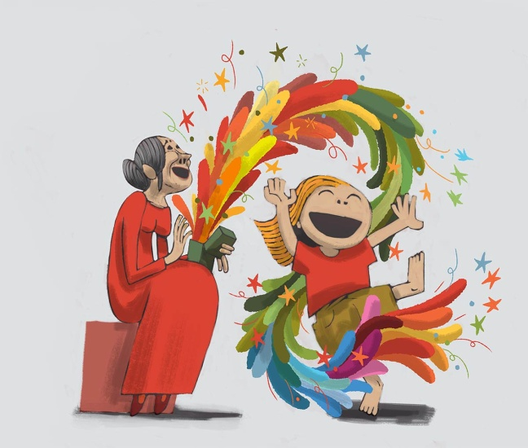**

**Barnstorm presents two family performances of Monday’s Child on Sat 11th & Sat 18th Oct at 2.30pm & 4pm.**

*Monday’s Child* tells a simple poetic story of the unique bond between an old woman and a little girl. Together in a dream-like garden, they sing and dance and dress up as they joyously explore a treasure trove of memories.

At opposite ends of the life cycle, the old woman and the young girl share an ongoing effort to name the world, thereby making sense of it. The girl is building her vocabulary while the older woman appears to be losing hers. Delightfully, the use of made-up words makes sense to them both; a clock is a “time-ticker”, binoculars are “faraways” and when determining what day it is, the girl confidently informs the older woman that “It’s today”.

For the young girl, the older woman’s memory loss becomes a word game, a puzzle to be solved. If the girl ever feels frustrated, she is never sharp or critical with her companion.

*Monday‘s Child* is written by award-winning writer Brendan Murray (Writers’ Guild of Great Britain -*Best Children’s Play 2012*). ‘Murray’s way with words and logic is winning, with a Lewis Carroll twist to some of the exchanges’ (British Theatre Guide), and ‘Beautiful, uplifting and very very tender’ (The Independent).

This sensitive, imaginative yet funny story that explores how we make and store memories as we grow up and discover the world, how these shape who we are, and how they help us meet the challenges of growing old.

*Monday‘s Child* is a theatrical treat for all members of the family. Be sure to book early!  
  
**Saturday 11th & Saturday 18th October**   
2:30pm & 4:00pm   
Tickets: €6  
Family of 4: €20

**BOOKING:** 056-7751266;   
E : [info@barnstorm.ie](mailto:info@barnstorm.ie)

W: [www.barnstorm.ie](http://www.barnstorm.ie)  
F: <https://www.facebook.com/barnstormtheatrecompany>

# C:\Users\nfinn\Desktop\photo.JPG

# Savour Kilkenny 2014 Literary Cake Competition

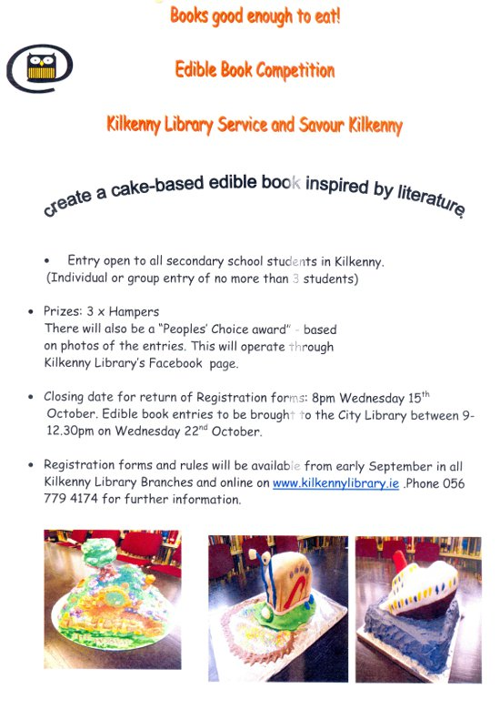

**The Kilkenny Person of the Year Awards 2014**

The Kilkenny Person of the Year Awards 2014 will be held at the Newpark Hotel on Friday the 7th of November 2014 at 8pm

Please see attached for your information the nomination form – if you would like to make a nomination for 2014 please complete the Form attached and return it by Wednesday the 7th of October 2014 to:

Kilkenny Person of the Year Award

C/o Billy Gardiner

C/o Kilkenny People

High Street

Kilkenny

**Also please note that any further information or queries should be directed to Billy Gardiner on 086-8183283 or Hugh Maddock at** [hugh.maddock@rehab.ie](mailto:hugh.maddock@rehab.ie)

**Library News**

****

# Autumn 2014 at Loughboy Library

**Computer Course-Benefit 4 IT Training** has commenced at Loughboy library. Funded by Kilkenny Leader Partnership this course covers e-mail, internet, digital photography basics, skype and introduction to online social networking. The course runs on Tuesdays from 10am-12 noon for five weeks. It is currently full but interested parties may put their names on a waiting list for further courses. Contact Connie McGee, KLP Development Officer 086 7718040 or Loughboy library 056 7794176.

Please note there will be NO computers available for the public at Loughboy library during the above class times.

**Patchwork Exhibition**-The South Midlands Branch of the Irish Patchwork Society are currently exhibiting at Loughboy Library. This exhibition is dedicated to Kathleen Delany, one of the society's founder members who died recently. The branch was formed in 2005 and they hold their meetings at 7pm on the first Thursday of the month (Sept-Dec and Feb-June) in the Springhill Court Hotel. All are welcome to go along for some sewing demonstrations and to listen to their various speakers. For further information please call Alison 087 2506999.

Loughboy library offers free exhibition space throughout the year.

**Science and Engineering Week 2014**-Mr Paul McDonald, engineer will present a lecture "Global Engineering, Science and Other Careers" at Loughboy, John's Quay and Castlecomer libraries on Wed November 12th. This lecture is free and is aimed at second-level schools. It will be most interesting for students who are considering a career in the science field. Teachers are invited to book at their preferred library.

Mobile Phone, Iphone, Notebook, I Pad etc-usage tips available on Fridays from 3.45pm on a drop-in basis.

**National Adult Literacy Agency NALA**-a learner ambassador from NALA is available at Loughboy Library to speak to adults who may be thinking of returning to education. As an adult learner herself she hopes by sharing her story that others will be encouraged to engage in further learning. She will outline the various supports that NALA provides to help adults improve their literacy, reading, writing, numeracy and IT skills. Enquiries to Loughboy library 056 7794176.

\*\*\*\*\*\*\*\*\*\*\*\*\*\*\*\*\*\*\*\*\*\*\*\*

Craft Group Workshops in Kilkenny Libraries

* City Library, John’s Quay: Tuesday evenings **6-8pm**
* Castlecomer Library: Thursday mornings, year round, **10-12pm**
* Graiguenamanagh Library: Wednesday mornings **10.30am to 12.30pm**
* Ferrybank library: Patchwork quilting – Tues morning at **11.45-1.20**

Knitting – Thurs mornings **10-12.00**(Both groups taking a break for the summer.)

We also have once off workshops e.g. Origami class **Wed 6th, 13th & 20th Aug – 11.30 -1pm**

Contact details for libraries:

<http://kilkennylibrary.kilkenny.ie/eng/Libraries_Locations/>

**\_\_\_\_\_\_\_\_\_\_\_\_\_\_\_\_\_\_\_\_\_\_\_\_\_\_\_\_\_\_\_\_\_\_\_\_\_\_\_\_\_\_\_\_\_\_\_\_\_\_\_\_\_\_\_\_\_\_\_\_\_\_\_\_\_\_\_\_\_\_\_\_\_\_\_\_\_\_\_\_\_\_\_\_\_\_**

**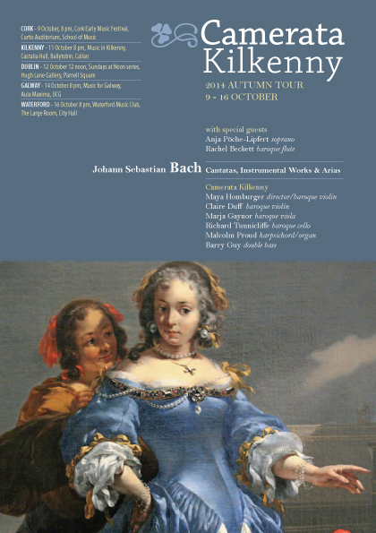**

**New Programme of Art and Craft Workshops with Tunde Toth at KOZO Studio**

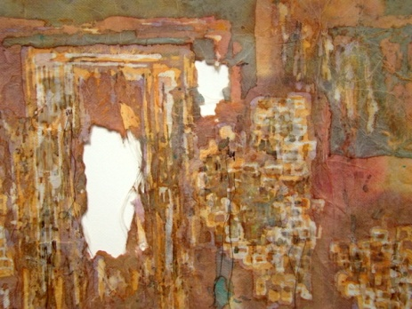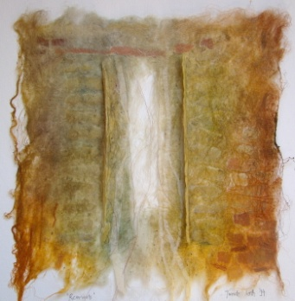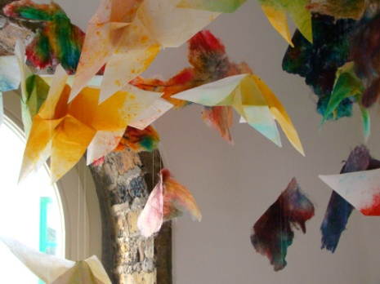​

KOZO Studio, The Estate Yard, Castlecomer Discovery Park, Castlecomer, Co. Kilkenny

5 October (Sunday) BATIK | 10.30am – 5pm | € 65 for the full day – including all materials  
A full day workshop introducing traditional processes of BATIK, and an ancient fabric dyeing technique where hot wax is used as a resist on cloth.  
Suitable for beginners and participants with some previous experience.  
€ 65 for the full day – including all materials

12 October (Sunday) ADVANCED LEVEL PAPER MAKING and PAPER ART COURSE | 10.30am – 5.30pm | € 75 for the full day – including all materials  
This is a professional development programme for artists and crafts people: a follow-on, advanced level course in hand paper making and paper art. Suitable for participants with previous experience and those who took part at beginner`s workshops.  The course focuses on three dimensional and sculptural works, installations, contemporary paper art processes and interactive, collaborative projects.

KOZO Studio and Gallery OPENING RECEPTION: The Studio will be launched with a solo exhibition of Tunde`s new and recent works from 6pm on Friday 26th of September

Professional Courses for small groups of participants – suitable for adults and young people from 15 years of age  
Bookings and all info: 087-2543362 | [tundetune@gmail.com](mailto:tundetune@gmail.com)

[www.tundetoth.com](http://lists.visualartists.ie/lt.php?c=1207&m=4246&nl=1&s=d3c261c0eeb6b48867f449d29e09414b&lid=94339&l=-http--www.tundetoth.com) | [www.kozostudio.wordpress.com](http://lists.visualartists.ie/lt.php?c=1207&m=4246&nl=1&s=d3c261c0eeb6b48867f449d29e09414b&lid=94340&l=-http--www.kozostudio.wordpress.com)

### C:\Users\nfinn\Desktop\A4 poster low res.jpg

### cid:ii_hz5op2470_147fe628ee8d47c0

**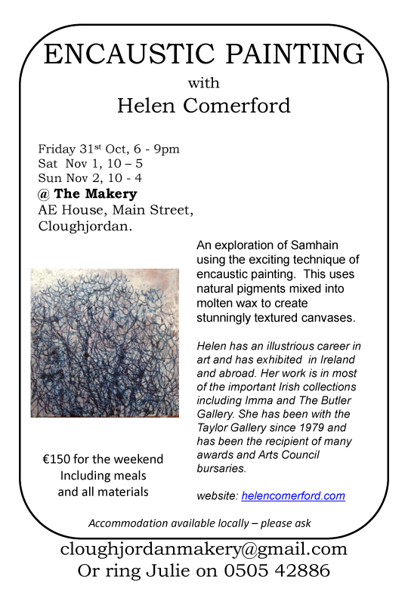**

**Barrow Consultancy and Training - Ongoing FETAC/QQI Courses**

Barrow Consultancy and Training - Ongoing FETAC/QQI Courses in Train the Trainer, Coaching, Supervisory Management and more…

Barrow Training – offer training programmes to companies and individuals in a wide range of areas.  
   
**We are currently offering:**

* Train the Trainer FETAC/QQI level 6 (Flyer attached)
* Professional Coaching Skills  FETAC/QQI level 6 (Flyer attached)
* Supervisory Management for Healthcare Managers FETAC/QQI level 6 (Flyer attached)
* Special Needs Assisting FETAC/QQI level 6 (Flyer attached)
* Non Violent Personal Safety and De-escalation Training  (Flyer attached)

Currently offering some special deals if you book online at [www.barrowtraining.ie](http://www.barrowtraining.ie/)

**Current schedule:** <http://www.barrowtraining.ie/schedule/>

**Region:**

Waterford, Wexford, Carlow, Kilkenny, Tipperary

**\_\_\_\_\_\_\_\_\_\_\_\_\_\_\_\_\_\_\_\_\_\_\_\_\_\_\_\_\_\_\_\_\_\_\_\_\_\_\_\_\_\_\_\_\_\_\_\_\_\_\_\_\_\_\_\_\_\_\_\_\_\_\_\_\_\_\_\_\_\_\_\_\_\_\_\_\_\_\_\_\_\_\_\_\_\_\_**

**Courses / Training / Jobs / Internships**

**\_\_\_\_\_\_\_\_\_\_\_\_\_\_\_\_\_\_\_\_\_\_\_\_\_\_\_\_\_\_\_\_\_\_\_\_\_\_\_\_\_\_\_\_\_\_\_\_\_\_\_\_\_\_\_\_\_\_\_\_\_\_\_\_\_\_\_\_\_\_\_\_\_\_\_\_\_\_\_\_\_\_\_\_\_\_\_**

**Communications / PR and media training services for charities & not-for-profits**

* Does your organisation need a communications health check?
* Are you mounting a fundraising campaign, organising a public education initiative or hosting a conference and want to spread the word?
* Do you want to ensure that your organisation makes the most of media opportunities?

If your answer to any of these questions is yes, and you need support, then talk to d2 communications today. d2 communications is an indigenous Irish public relations consultancy specialising in the charity, not-for-profit and voluntary sectors and delivering a range of cost-effective communications solutions, including:

* strategic communications planning
* PR/publicity
* conference promotion
* publications management
* media training

Through d2 communications' intensive and practical media training workshops, interviews are filmed and reviewed helping participants to prepare for the questions that are likely to pop up and to address difficult or challenging issues. In doing so, d2 communications can help ensure that when the media comes calling that organisations are best equipped to communicate their key messages and call to action.

d2 communications offers an outstanding track record of success and has a reputation for delivering on, and exceeding, targets as well as providing clients with a level of care and commitment that is second to none.

The director of d2 communications is Don Delaney. A former radio and television broadcaster with Midlands 103 and RTÉ, Don continues to guest present current affairs radio programmes on Midlands 103. He has also previously held senior communications roles with the Irish Cancer Society, Fleishman-Hillard, the Health Service Executive and the Rehab Group. Don is a winner of a national media award for outstanding broadcasting and the winner of a number of awards for excellence in public relations. He was a board member of the Public Relations Institute of Ireland from December 2010 to December 2013.

If you would like to find out more about d2 communications’ range of communications services, talk to Don on 087 7933249 or email [hello@d2communications.ie](mailto:hello@d2communications.ie)

For more information, visit [www.d2communications.ie](http://www.d2communications.ie/)

**Guided Tour: A Way With Words**

National Museum of Ireland – Decorative Arts & History, Collins Barracks

Sunday 12th October at 3.00pm

Join Adrian McBreen on a journey around the Museum exploring

objects with 'hidden' connections to writers and writing.

Hear the stories behind artefacts linked to

James Joyce, Jonathan Swift, W.B. Yeats and others.

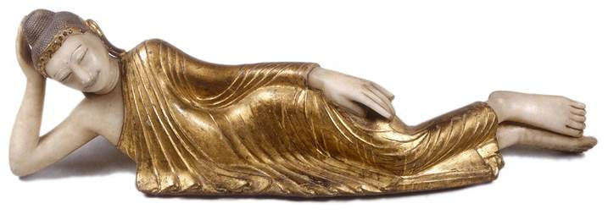

**No booking required.**

**Places allocated on a first come basis 15 minutes before tour starts.**

 \_\_\_\_\_\_\_\_\_\_\_\_\_\_\_\_\_\_\_\_\_\_\_\_\_\_\_\_\_\_\_\_\_\_\_\_\_\_\_\_\_\_\_\_\_\_\_

### C:\Users\nfinn\Desktop\bookbindingOct14.jpg

**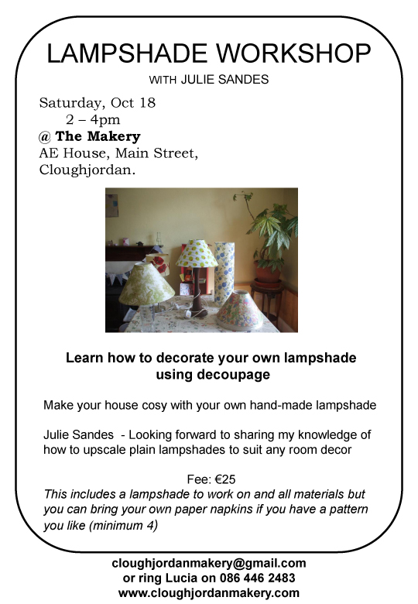**

**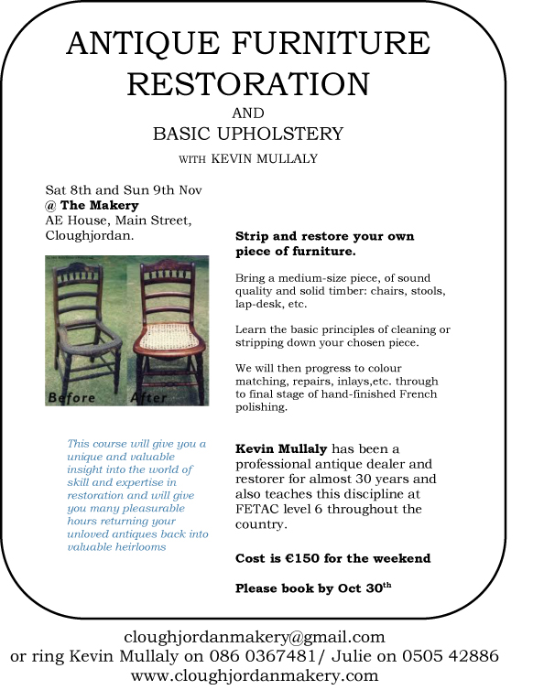**

**Calling for applications to the 2014-2015 NUI Certificate in Youth Arts!**

The Certificate in Youth Arts is a part time, year long university accredited course of study in Irish Youth Arts Practice managed and delivered by the Arts Programme at NYCI.

(Accrediting body: NUI Maynooth, Dept of Applied Social Studies)

The Certificate in Youth Arts aims to introduce those working in the non-formal education sector to the concepts, principles and practice of youth arts using a context and practice approach.

We are now accepting applications for the Certificate in Youth Arts 2014- 2015.

The downloadable Prospectus for 2014-2015 includes information on Certificate content, dates and assessment. You can access the prospectus, application form and frequently asked questions  at [www.youtharts.ie/cert](http://www.youtharts.ie/cert)

If you have an application related query please contact Anne O'Gorman, Senior Project Officer, Youth Arts: [anneog@nyci.ie](mailto:anneog@nyci.ie) 01 4255932

### TDP'14   |  10-11-12 OCT 2014

Tipperary Dance Residency is delighted to announce the 5th edition of the international festival Tipperary Dance Platform: TDP’14. Nested in County Tipperary, TDP'14 offers a unique line-up of contemporary dance artists from Ireland and abroad.  
  
At TDP’14, you can participate by attending shows, a forum, a videos screening, and taking dance classes (possibly for the first time in your life!). TDP'14 is also a space where artists gather to mingle, discuss, and take a masterclass. Sunday (12 Oct) is entirely dedicated to families, with a show by Catalan company Mucab Dans, and dance classes for children.  
  
Multiplying opportunities to discover and be together, TDP'14 LAB takes place in the same week. The LAB is a comprehensive package that provides a professional research and training environment for a selected group of dancers.  
   
This newsletter gives you a preview of the Platform's events. You will find a detailed programme at [www.tdp-danceplatform.ie](http://iselichiodi.us7.list-manage.com/track/click?u=d78dad8d91cb506d750878301&id=0a0299ede0&e=50d8829ddc)  
  
***PRACTICAL INFO***  
  
**VENUE**: Tipperary Excel Arts Centre, Mitchell Street, Tipperary  
  
**GETTING HERE**:  
By train (Limerick Junction),  
By Bus (Bus Eireann)  
  
**INFO**:  
[tdp@tdp-danceplatform.ie](mailto:tdp@tdp-danceplatform.ie?subject=about%20TDP'14)  
+353 (0)85 16 83 611  
  
**BOOKINGS**: +353 (0)62 80 520

**CreateSound.ie: music-making workshops (on wheels)**

We run workshops and classes in community projects, youth centres and schools showing students how to make music in modern genres such as Hip Hop and Dance Music. We provide ALL the equipment (e.g. laptops, software, keyboards etc) so that it’s convenient, accessible and so that you don’t need to worry about spending money on these things! Students get to engage in a creative activity, through music styles they enjoy whilst also getting valuable experience using the latest computer hardware and software.

We have various options to suit different budgets (e.g. short once-off workshops or a series of classes) along with occasional funded programmes. We mainly operate in Leinster and Ulster, but run programmes further afield depending on duration.  The activity is best suited to teens and older. Please call or email for more information.

Students get the following benefits:

* Getting to make music in a modern style that they enjoy and can relate to.
* Valuable experience working with the latest hardware (e.g. MacBook Pros) and creative IT applications (e.g. Ableton Live).
* A flavour of the technical elements of sound production and editing, skills highly relevant in expanding media industries.
* A chance to express themselves creatively through music.

**Phone:** 086 1296995  
**Email:** [info@createsound.ie](mailto:info@createsound.ie)

**Video & further info online:** [www.createsound.ie](http://www.createsound.ie/)

**Examples locations**: <https://goo.gl/maps/Z2qxB>

**Examples of student music:** <http://www.createsound.ie/#/sounds/4572448276>

**Drama Facilitators: Register your interest in ArtsTrain**

**The waiting list for ArtsTrain, NAYD's full-time drama facilitation training programme, is currently open**. Participation on the course could be an opportunity for you to formalise your understanding of youth theatre practice and gain a qualification in the field. Equally it could also be an opportunity for less experienced leaders or senior members to equip themselves with the skills and experience necessary to deliver high quality work.

ArtsTrain is the only dedicated youth drama facilitation training programme in Ireland. The aim of the course is to provide training in drama facilitation and youth arts while also developing participants' understanding of good youth theatre practice.

As part of the programme, participants undertake a range of modules including creating drama, drama facilitation theory & practice and improvisation. The training is delivered at FETAC level 6 and successful trainees will achieve a FETAC Major Award in Drama.

**Level 6  FETAC Major Award in Drama 6M3566**  
Code                          Title                                                       
6N3545                      Engaging with Drama  
6N3546                      Creating Drama  
6N2191                      Leadership  
6N1946                      Work Experience  
6N3552                      Improvisation  
6N3547                      Process Drama  
6N3549                      Drama Facilitation Theory  
6N3550                      Drama Facilitation Practice

**Potential trainees should register their interest by October 15th to ensure they receive further updates.**

To register your interest in the course or to find out more about ArtsTrain, please contact John on 01-8781301 or [john@nayd.ie](mailto:john@nayd.ie)

**FREE to Dance Ireland members**

Non-members: €10 / €5 concession per event  
Booking: 01 855 8800 / [reception@danceireland.ie](javascript:void(location.href='mailto:'+String.fromCharCode(114,101,99,101,112,116,105,111,110,64,100,97,110,99,101,105,114,101,108,97,110,100,46,105,101)))

Following on from the Dance Ireland on Tourinitiative Dance Ireland is once again taking to the road in a series of Professional Development Sessions in partnership with Dance Limerick, Firkin Crane (Cork) and Galway Dance Project.

These practical workshops and knowledge-sharing sessions are aimed at supporting the dance communities artistic goals. Each session has been specifically designed to meet with the needs of the partner organisations audiences as well as the wider dance community. Topics covered will include understanding your tax return, career development for dance artists, communications and resourcing your work.

These working sessions are open to all and will build to give a well rounded platform for dance artists to work from. Participation in these sessions is free to Dance Ireland members with a small fee applicable to non-members.

This event has been curated by Eleanor Creighton as part of the [Léim dance leadership project](http://www.leimproject.eu/).

Secure your place NOW! Phone: 01 855 8800 / Email: [reception@danceireland.ie](javascript:void(location.href='mailto:'+String.fromCharCode(114,101,99,101,112,116,105,111,110,64,100,97,110,99,101,105,114,101,108,97,110,100,46,105,101)))

**Demystifying your Tax Return**  
Gaby Smyth  
DanceHouse, Dublin  
22 September 2014  
12noon - 2pm

Gaby Smyth of Chartered Accountants Gaby Smyth & Co offers his expertise and advice on looking after your taxes, covering: self-employed and PAYE earnings, allowable deductions, VAT registration – the pros and cons, artist exemption rules and more. Includes a short Q&A.

**The road less travelled: career development for Dance Artists**  
Dance Limerick, Limerick  
Facilitated by Jo Mangan  
02 October 2014  
4:30 - 6:30pm

Jo Mangan (Festival Programmer and CEO of Performance Corporation) will draw together the extensive knowledge and experiences of the panellists and share her own insights into thinking strategically about your artistic career. We aim to have a lively conversation about the options available and the skills needed to build a career in dance – so come with ideas, thoughts and questions!

Panellists include: Paul Johnson (Dance Ireland), Muirne Bloomer (Independent Artist), Lisa McLoughlin (Independent Artist), Dr. Orfhlaith Ní Bhriain (Lecturer, Irish World Academy of Music & Dance) and Megan Kennedy (Co-Artistic Director of junk ensemble & Limerick Dance Artist in Residence).

**Communications: from good sales tactics to long term strategies**  
Town Hall Theatre, Galway  
Annette Nugent and Sinead McPhillips  
20 November 2014  
11am – 3.30pm

A practical, intensive session with two leading arts communications consultants. Annette Nugent will share her expertise and experience in developing strategic approaches to communicating about dance and your own work with a variety of audiences and stakeholders. Sinead McPhillips will provide insights and tactics to help you market your events successfully and build audiences locally and beyond. They'll both get you thinking – and practicing!

**Context, space, time & money: finding resources to make your work**  
Firkin Crane, Cork  
07 December 2014  
3 - 6pm

This session features presentations with practical tips on accessing funding and other resources to make your work happen. Our panel discussion will open up questions about new contexts and support structures for making artistic work. You will also have the chance to put the ideas and tips shared into action for your own projects.

Panellists include: Liz Meaney (Cork City Arts Office), Siân Cunningham (Dance Ireland), Laura Murphy (Cork City Dance Artist in Residence) and Sophie Motley (Willfredd Theatre).

**VAI: Professional Development Training Programme Autumn/Winter 2014**

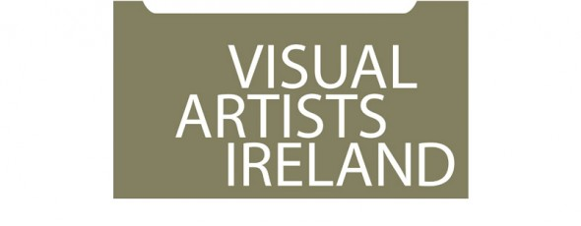

Visual Artists Ireland operates a wide range of professional development training and events throughout the year including **workshops, peer discussion groups, seminars and talks**. The delivery of this programme is greatly supported by our relationship with local and international visual art professionals and partner organisations throughout the island of Ireland. VAI works in partnership with Local Authorities, visual arts venues and others, combining resources to support the professional development of visual artists at regional level.

To register and for further information see: [http://visualartists.ie/professional-developmentp/](http://lists.visualartists.ie/lt.php?c=1191&m=4230&nl=1&s=d3c261c0eeb6b48867f449d29e09414b&lid=91545&l=-http--visualartists.ie/professional-developmentp/)

\*\*\*\*\*\*\*\*\*\*\*\*\*\*\*\*\*\*\*\*

**Dublin**

**Towards Sustainability – Mapping your Career** with Patricia Clyne-Kelly, John Daly and Brian Kennedy hosted *by Fingal Arts*

Thur. 9 Oct (10.30 – 16.30)

Venue to be confirmed

Places: 25 - 30

Cost: €60 / 30

[http://visualartists.ie/professional-developmentp/?ee=155](http://lists.visualartists.ie/lt.php?c=1191&m=4230&nl=1&s=d3c261c0eeb6b48867f449d29e09414b&lid=92517&l=-http--visualartists.ie/professional-developmentp/--Q-ee--E-155)

**Writing about Your Work** with Niamh O'Malley

Thur. 16 Oct (10.30 – 16.30) tbc

@ Visual Artists Ireland

Places: 10 - 12

Cost: €80 / 40 (VAI Members)

*Further information available on this session online in early Sept.*

**Developing Creative Proposals** with Annette Moloney

Wed. 19 Nov. (10.30 – 16.30)

@ Visual Artists Ireland

Places: 12 – 16

Cost: €80 / 40

[http://visualartists.ie/professional-developmentp/?ee=164](http://lists.visualartists.ie/lt.php?c=1191&m=4230&nl=1&s=d3c261c0eeb6b48867f449d29e09414b&lid=92518&l=-http--visualartists.ie/professional-developmentp/--Q-ee--E-164)

**Arts Council Funding Information Session -** Dublin

Wed. 5 Nov (time to be confirmed)

@Visual Artists Ireland

Places: 20 – 25

[http://visualartists.ie/professional-developmentp/?ee=166](http://lists.visualartists.ie/lt.php?c=1191&m=4230&nl=1&s=d3c261c0eeb6b48867f449d29e09414b&lid=92519&l=-http--visualartists.ie/professional-developmentp/--Q-ee--E-166)

\*\*\*\*\*\*\*\*\*\*\*\*\*\*\*\*\*\*\*\*

**Limerick**

*In partnership with LCGA, Limerick City & County Council and Clare and Tipperary County Councils*

**Developing Creative Proposals** with Annette Moloney

Tues. 21 Oct. (10.30 – 16.30)

Venue to be confirmed

Places: 12 - 16

Cost: €10 / 5 (VAI Members)

[http://visualartists.ie/professional-developmentp/?ee=162](http://lists.visualartists.ie/lt.php?c=1191&m=4230&nl=1&s=d3c261c0eeb6b48867f449d29e09414b&lid=92524&l=-http--visualartists.ie/professional-developmentp/--Q-ee--E-162)

\*\*\*\*\*\*\*\*\*\*\*\*\*\*\*\*\*\*\*\*

**Meath**

*Events in partnership with Meath County Council Arts Office*

**Presenting yourself & Your Work** with Patricia Clyne-Kelly

Tues. 18 Nov (10.30 – 16.30) tbc

Places: 10 - 12

Cost: €80 / 40 (VAI Members)

*Further information available on this session online in early Sept.*

**Developing Opportunities for your Work** with Elaine Grainger and Elaine Leader

Tues. 11 Nov (10.30 – 16.30)

Places: 15 - 20

Cost: €50 / 25 (VAI Members)

[http://visualartists.ie/professional-developmentp/?ee=158](http://lists.visualartists.ie/lt.php?c=1191&m=4230&nl=1&s=d3c261c0eeb6b48867f449d29e09414b&lid=92525&l=-http--visualartists.ie/professional-developmentp/--Q-ee--E-158)

**Documenting your Work** with Tim Durham

Date to be confirmed

Places: 10 - 12

Cost: €80 / 40 (VAI Members)

*Further information available on this session online in early Sept.*

\*\*\*\*\*\*\*\*\*\*\*\*\*\*\*\*\*\*\*\*

**Roscommon**

*Event in partnership with Roscommon Visual Artists Forum*

**Protecting and Caring for Your Work** (half day) with Alan Ragget

Wed. 22 Oct (11.30 – 17.00)

@ King House, Boyle

Places: 15 - 20

[http://visualartists.ie/professional-developmentp/?ee=165](http://lists.visualartists.ie/lt.php?c=1191&m=4230&nl=1&s=d3c261c0eeb6b48867f449d29e09414b&lid=92529&l=-http--visualartists.ie/professional-developmentp/--Q-ee--E-165)

FREE to visual artists based in Roscommon

**Visiting Curators Sept & Nov, 2014**

**Dublin Live Art Fesitival**

In addition to these events above we also look forward to welcoming visiting Curators **Jonas Stampe** in September working in conjunction with the Dublin Live Art Festival.

**Bea de Souza** from The Agency Gallery London who will meet with artists connected with our regional partners in Galway in November.

**To register and for further information see:** [http://visualartists.ie/professional-developmentp/](http://lists.visualartists.ie/lt.php?c=1191&m=4230&nl=1&s=d3c261c0eeb6b48867f449d29e09414b&lid=91545&l=-http--visualartists.ie/professional-developmentp/)

 \*\*\*\*\*\*\*\*\*\*\*\*\*\*\*\*\*\*\*\*

**Bookings  Payments**

Booking and payment is required in advance for all sessions.  We encourage artists to register online where possible and if you wish to make payments off line following registration please do provide a mobile phone number on the registration form. We accept payment in the following ways: through PayPal online; by stg£ or Euro cheque made out to Visual Artists Ireland or by credit card over the phone.

 If an event is not listed on our online system please email [monica@visualartists.ie](mailto:monica@visualartists.ie) to register interest in an event. State the full title of the event, the location and date and provide your name and mobile number in your email.   
  
To register online for Republic of Ireland training: [http://visualartists.ie/professional-developmentp/](http://lists.visualartists.ie/lt.php?c=1191&m=4230&nl=1&s=d3c261c0eeb6b48867f449d29e09414b&lid=91545&l=-http--visualartists.ie/professional-developmentp/)  
To register online for Northern Ireland training: [http://visualartists.org.uk/services/professionaldevelopment/current/](http://lists.visualartists.ie/lt.php?c=1191&m=4230&nl=1&s=d3c261c0eeb6b48867f449d29e09414b&lid=91546&l=-http--visualartists.org.uk/services/professionaldevelopment/current)

**Fees:**

VAI members receive preferential discount of 50% on fees for all training and professional development events.  
  
**Tell us about your training needs!**

If you are interested in training please do get in touch with us directly or forward an expression of interest in a topic/s through the Professional Development Training web page.  We often repeat workshops when there is a strong demand for a topic.    
  
**Artist & Tutors Panel**

Visual Artists Ireland has an ongoing open submission process for artists and arts professionals interested in being part of an available panel of tutors contributing to the VAI Professional Development Training Programme. For details go to our training registration page and click on Register for the PDT Artists Panel: [http://visualartists.ie/professional-developmentp/?ee=71](http://lists.visualartists.ie/lt.php?c=1191&m=4230&nl=1&s=d3c261c0eeb6b48867f449d29e09414b&lid=91547&l=-http--visualartists.ie/professional-developmentp/--Q-ee--E-71)

# National Youth Council of Ireland: Child Protection and Web Safety Training

#### [Child Protection Programme - National Youth Council of Ireland logo](http://www.childprotection.ie/)

#### [Websafety in Youth Work - Cork](http://www.nycitraining.org/courses/websafety-youth-work-cork)

Date: **1st December 2014**

**Description:** This 3.5 hour course is designed to raise awareness among youth leaders about young people’s online life, to identify on line risks and opportunities and to deal with cyberbullying. This training is supported by the free online resource website for youth workers <http://websafety.youth.ie/>  
   
**Venue:** Metropole Hotel, Cork

Please contact Geraldine Mahon at 01-4784122 to register or email [training@nyci.ie](mailto:training@nyci.ie)

**National Child Protection Training Centre: Training Courses**

The National Child Protection Training Centre offers a number of bespoke training courses as part of its comprehensive Child Protection Training Framework. Each training course is specifically designed to equip people with the skills, knowledge and attitudes they need to respond to any Child Protection and Safeguarding concerns or suspicions and be able to take timely and effective action to get children the protection & help they need, when they need it.

Some of the courses now on offer nationally are:

* 'Seeing the Signs' – An introduction to Child Protection & Safeguarding of children and young people
* 'Child Protection & Safeguarding for Frontline Services' – Child Protection & Safeguarding for Ambulance, Fire and Rescue Services
* 'It shouldn't happen to a Child' – Children, Young People and Domestic Abuse - The Influence and Implication of the Convention on the Rights of the Child
* 'Seeing the Signs in Sport' – Child Protection & Safeguarding in Sport and Recreational activities

For more details about each course and schedule of forthcoming training dates & locations, please contact Colm at  
Phone Number - +353 (0)91 781234  
Mobile Number - +353 (0)86 2460994

Website: <http://www.ncptc.ie/>  
Email: [coldem@eircom.net](mailto:coldem@eircom.net)

**NUIM Certificate in Child Protection and Welfare**

The aim of this course is to provide workers (including paid staff and volunteers) who have a responsibility for, and professional interest in, child protection and welfare with the knowledge, skills and competencies related to the key issues involved for their organisations. It also provides them with an up to date and comprehensive overview of child protection and welfare and how it relates to their area of work and/or organisation.

Deadline for applications: 31/10/2014

[www.childprotection.ie](http://www.childprotection.ie)

[info@nyci.ie](mailto:info@nyci.ie)

**'Virtually There? Are we on the road to meaningful arts experiences with children in schools?' | Symposium at Mary Immaculate College 1 – 5.30pm**

Mary Immaculate College, LimerickKids' Own and Mary Immaculate College, Limerick, will host a national symposium for the education & arts sectors on Thursday 16 October 2014 on the theme "Virtually There? Are we on the road to meaningful arts experiences with children in schools?”The symposium will explore how we create, support, share and document this activity. The Virtually There symposium is a free event and will take place at Mary Immaculate College from 1-5.30pm. The day will include a panel discussion with representatives from the arts and education sectors and small group sessions with delegates.Places for this event must be booked through

Eventbrite:[https://www.eventbrite.ie/e/virtually-there-symposium-tickets-13307313533](http://lists.visualartists.ie/lt.php?c=1232&m=4271&nl=1&s=d3c261c0eeb6b48867f449d29e09414b&lid=96110&l=-https--www.eventbrite.ie/e/virtually-there-symposium-tickets-13307313533).For further information contact Kids' Own: [info@kidsown.ie](mailto:info@kidsown.ie) or ph. 071-9124945.This symposium is hosted in conjunction with the Virtually There national exhibition tour of work created by artists, children and teachers through online residencies. Virtually There is the only long-term professional arts programme running in Northern Irish schools. Managed by Kids' Own, it has been funded by the Arts Council of Northern Ireland since 2007, and is now piloting in the South in partnership with Tralee and Carrick-on-Shannon Education Centres.A pilot programme at Mary Immaculate College is mirroring the process being carried out in schools with students at the college over a 5-week period. The Virtually There exhibition and event tour (2014-15) is funded by the Arts Council of Ireland's Touring and Dissemination of Work Award in partnership with the Arts Council of Northern Ireland.See [www.kidsown.ie](http://lists.visualartists.ie/lt.php?c=1232&m=4271&nl=1&s=d3c261c0eeb6b48867f449d29e09414b&lid=96111&l=-http--www.kidsown.ie/) for more information.

# Sanjoy Ganguly, the founder of Jana Sanskriti, India, to facilitate a scripting workshop in Galway.

## **Sanjoy Ganguly, the founder of Jana Sanskriti, in conjunction with ALâ, is facilitating a 3 day workshop from Friday  17th to 19th October in the Diocesan Pastoral Centre, Arus De Brun, Newtownsmith, Galway**

### The workshop will revisit Boal and advise on how to script plays instead of playing the script using games as social metaphor.  There for it will be of great benefit to people who have experience in, work with Theatre Forum and use it to facilitate dialogue around social issues and who wish to develop their skills in writing scripts for Forum Theatre. It must be stressed that this is not a workshop for beginners to Theatre of the Oppressed.

### It is a self-funding workshop and ALâ has made every effort to keep costs to a minimum of €250 for organisations and €195 for voluntary and community group members.

### Sanjoy suggests participants read his Book **“Jana Sanskriti Forum Theatre And Democracy In India”,** Routledge London, 2010  if possible before his workshop.

TO REGISTER AND/OR FURTHER INFORMATION CONTACT AINE AT [OUTREACH@ALACT.IE](http://ala-ct.ie/?sendpress=eyJpZCI6IjY2NjgiLCJyZXBvcnQiOiIxNzQ3IiwidXJsSUQiOiI5NCIsInZpZXciOiJsaW5rIn0)

Name(required)

Email(required)

Phone

City/County

Comment(required)

## **WHO IS SANJOY GANGULY?**

[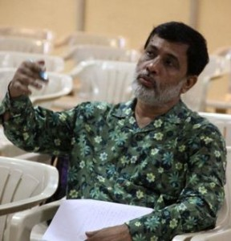](http://ala-ct.ie/?sendpress=eyJpZCI6IjY2NjgiLCJyZXBvcnQiOiIxNzQ3IiwidXJsSUQiOiI5NSIsInZpZXciOiJsaW5rIn0)

Sanjoy has used Theatre of the Oppressed (TO) to create a 25.000 people mass movement in India, Jana Sanskriti Centre for Theatre of the Oppressed which is the largest TO movement in the world.

## **WHAT IS JANA SANSKRITI?**

Jana Sanskriti, 27 years ago, a group of actors from different areas in India tried an experiment in utilising theatre as a method of social change. After encountering Augusto Boal’s ‘Theatre of the Oppressed” which envisages theatre as a powerful instrument of change, the idea of democratising theatre began to take shape.

 Jana Sanskriti is a cultural movement based on humanism, it empowers people to fight oppression, it believes that the culture of monologue needs to be  broken and a habit of dialogue established. Dialogue opens up space for rational thinking. Once empowered the people become aware of their ability to plan  and provide dynamic, constructive leadership in their society.

Jana Sanskriti’s belief in the strength and efficacy of theatre as a tool, not only of communication but also of empowerment, has resulted in the formation of 30 active theatre teams under its banner, each of these teams comprises men and women from agricultural worker families who put on  theatre performances regularly in  their villages which deal with pressing current issues.

“Jana Sanskriti wants to set forth a proposal, so that people in our villages are forced to think, and then act. This approach is very different, in fact diametrically opposite to that of political parties and NGOs, which encourages people to follow rather than think intellectually, rationally towards collective and individual development.”

**Call for Submissions / Residencies**

**\_\_\_\_\_\_\_\_\_\_\_\_\_\_\_\_\_\_\_\_\_\_\_\_\_\_\_\_\_\_\_\_\_\_\_\_\_\_\_\_\_\_\_\_\_\_\_\_\_\_\_\_\_\_\_\_\_\_\_\_\_\_\_\_\_\_\_\_\_\_\_\_\_\_\_\_\_\_\_\_\_\_\_\_\_\_\_**

[](http://stingingfly.org/)

**Submission Guidelines**

We are currently seeking submissions for our Summer 2015 issue which will have a special theme and focus: London.

Similar to how we did the [New York issue](http://www.stingingfly.org/issue/issue-20) in 2011, a good share of the work will be specially commissioned. We want to gather stories, poems and essays that reflect London life and that explore some of the manifold relationships and connections that exist between Ireland and this major world city. We have published many London-based writers in the magazine down through the years and we hope to get new work from some of these writers for this special issue. As ever, we also want to discover new voices.

**How to Submit:**

Rather than follow our usual guidelines below, we'd ask you to send us an email with a brief introduction and proposal for what you wish to submit.

If it is poetry, please send us no more than two poems (previously unpublished) — pasted into the email or into one attached document.

If it is a short story or novel extract, please send us a brief outline and an attachment with the first two pages of the story (double spaced).

If it is an essay, please send a brief outline that includes proposed word count.

Send submissions to [london.stingingfly@gmail.com](mailto:london.stingingfly@gmail.com) and use SUBMISSION and POEM, STORY or ESSAY in the subject line.

All submissions/expressions of interest must be received by **October 31st 2014**. We will seek to respond to all submission emails by the end of November.

We would also be very happy to hear from you at this email address if you have any suggestions for writers we might want to feature in the issue — or topics we might want to cover.

**Horizons « Arts-Nature » in Sancy (France) > call for proposals**

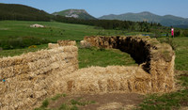

**Horizons « Arts-Nature » in Sancy**, will take place between the **13th June and 27th September 2015**. This is the ninth edition of a contemporary art event based on short-lived visual works of art specifically made for the Sancy massif (heart of the Massif Central in France).  
  
Managed by the Sancy Tourist Office, the call for projects involves the creation of **10 works of art** in the Sancy Massif.  
  
Art remuneration: a payment of **€8,000** **VAT** will be given to each selected artist (covering the creation, **travel expenses**, the transport of materials from the studio to the site, installation of the work, food and accommodation for the artist in the area)  
  
The event is open to all artists, without any limit of age, and to **young talents** (just or recently - less than 2 years- graduated from art school)  
  
Type of artworks: installations in situ  
  
Number of  selected candidates: **10**

**Deadline: 12 November**

[Find all details online](http://www.horizons-sancy.com/edition2015/appel-candidature2015)

http://www.horizons-sancy.com/gb/home

**Killeshin NS, Laois: Per Cent for Art Commission**

Call for Interest document for a Per Cent for Art Commission in Scoil Chomhgháin Naofa – Killeshin NS, Killeshin, Co.Laois. This commission is aimed at Professional Artists who have experience working with schools and in the creation of permanent artworks. Budget is €15,000 and closing date for Stage 1 applications is 12 noon, Friday 7th November, 2014.

Scoil Chomhgháin Naofa, Killeshin NS, Co.Laois wish to commission a site specific public artwork/s under the ‘Per Cent for Art Scheme’, funded by the Department of Education and Science. The artwork/s will be site specific with a permanent element to be sited in or/and around the buildings and environs. The brief asks the artist/s to:

* Reflect the previous and future history of the school, it’s students, teachers and community
* Reflect the strong ethos, vision and identity of the school
* Respond to the location of the school
* Partake in an element of interaction with the pupils
* That the artwork (s) are of an interactive nature

 Applicants can make enquiries regarding the commission to Rina Whyte, email [rinawhyte@yahoo.com](mailto:rinawhyte@yahoo.com) or by telephone + 353 87 238 9591.

You can [Download the brief here](http://lists.visualartists.ie/lt.php?c=1207&m=4246&nl=1&s=d3c261c0eeb6b48867f449d29e09414b&lid=94313&l=-http--visualartists.ie/wp-content/uploads/2014/09/KilleshinNS_Commissions.pdf)

Closing date for Stage 1 applications is 12 noon, Friday 7th November, 2014.

**TACTIC – 2014/2015 Artistic Programme | Call for Submissions**

TACTIC, 3rd Floor, Sample-Studios, Former Gov Buildings, Sullivan’s Quay, Cork

TACTIC Gallery announces it’s open call for curator led exhibitions to take place 2014/2015. It also invites proposals for other artist led events, such as a series of talks.

The program is open to practicing artists and curators of any medium. Proposals for new work as well as existing works will be considered. Preference will be given to artists adopting a new approach and advancement in their practice. TACTIC Gallery hopes to promote the emergence of curators as well as artists, and so ask for only curator led exhibitions be proposed.

Selection is based on the strength of the application, the suitability of the project for the space as well as the resolution of the ideas underpinning the curator’s/artist’s proposal.

Submission Guidelines – Please submit the following:  
– An exhibition proposal that out lines both the background and plan for the exhibition. (max 500 words)  
– Artists statements/biographical info of participating artists/curator  
– C.V.  
– Images of previous projects and/or of artists work you may wish to include.  
– Estimated time frame that exhibition will run, specifying when the project would be realised.

Submissions to be sent to: [tactic@sample-studios.com](mailto:tactic@sample-studios.com)

Deadline: October 10th 2014

[www.tactic-art.info](http://lists.visualartists.ie/lt.php?c=1207&m=4246&nl=1&s=d3c261c0eeb6b48867f449d29e09414b&lid=94316&l=-http--www.tactic-art.info) | [www.sample-studios.com/tactic-about.html](http://lists.visualartists.ie/lt.php?c=1207&m=4246&nl=1&s=d3c261c0eeb6b48867f449d29e09414b&lid=94317&l=-http--www.sample-studios.com/tactic-about.html) | [www.facebook.com/TACTICart](http://lists.visualartists.ie/lt.php?c=1207&m=4246&nl=1&s=d3c261c0eeb6b48867f449d29e09414b&lid=94318&l=-http--www.facebook.com/TACTICart%20)

**UK/Irish Printmaker Residency at BPW | Call for Applications**

Belfast Print Workshop, Waring St, Belfast BT1 2ED

This Artist-in-Residence Program is seeking an artist printmaker with at least 2 years’ professional experience from the UK or Ireland. The residency will conclude with a month-long exhibition in October 2015 in BPW Gallery.

Duration: The residency will last between 2-4 weeks. (Commencement date negotiable from August the 1st 2015 to September 30th 2015)

Artist Stipend: £150 sterling per week. The residency does not include accommodation or travel expenses. Whilst Belfast Print Workshop will endeavour to assist the artist in every way to secure affordable accommodation, the selected artist must make their own travel and living arrangements. All expenses incurred are the responsibility of the selected artist.

Responsibilities:  
The recipient artist will be required to give a demonstration and provide a talk on their practice during their residency,  
The recipient will donate one work from each edition produced to Belfast Print Workshop’s Archive and editions for fund raising.  
The selected artist will not be an employee of the studio or its funding bodies, and any taxes or contributions that may be due from any fees paid are the sole responsibility of the artist.

For a list of BPW equipment & resources please visit [http://bpw.org.uk/the-workshop/](http://lists.visualartists.ie/lt.php?c=1207&m=4246&nl=1&s=d3c261c0eeb6b48867f449d29e09414b&lid=94328&l=-http--bpw.org.uk/the-workshop/) for further info.

All applications and accompanying materials must arrive by 4.00pm Friday 6th February 2015.

How to Apply: Application form is available to download from [http://bpw.org.uk/BPW-AIR/](http://lists.visualartists.ie/lt.php?c=1207&m=4246&nl=1&s=d3c261c0eeb6b48867f449d29e09414b&lid=94329&l=-http--bpw.org.uk/BPW-AIR/)

**Printmaking Residency for a ‘Non-Printmaker’ at BPW | Call for Applications**

Belfast Print Workshop, Waring St, Belfast BT1 2ED

This Artist-in-Residence Programme is seeking a non-printmaking artist (i.e. a painter, photographer, sculptor etc) who is looking to explore the medium of printmaking. The residency will conclude with an exhibition at BPW Gallery in April 2015.

Duration: The residency will last for 4 weeks. Commencement date negotiable between January to March 2015.

Artist stipend £100 sterling per week. The residency will include materials. The residency does not include accommodation or travel expenses. Whilst Belfast Print Workshop will endeavour to assist the artist in every way to secure affordable accommodation, the selected artist must make their own travel and living arrangements. All expenses incurred are the responsibility of the selected artist.

Responsibilities:  
– The recipient artist will be required to give a demonstration and provide a talk on their practice during their residency,  
– The recipient will donate one work from each edition produced to Belfast Print Workshop’s Archive and editions for fund raising.  
– The selected artist will not be an employee of the studio or its funding bodies, and any taxes or contributions that may be due from any fees paid are the sole responsibility of the artist.

For a list of BPW equipment & resources please visit [http://bpw.org.uk/the-workshop/](http://lists.visualartists.ie/lt.php?c=1207&m=4246&nl=1&s=d3c261c0eeb6b48867f449d29e09414b&lid=94328&l=-http--bpw.org.uk/the-workshop/) for further info.

All applications and accompanying materials must arrive by 4.00pm Monday 3rd November 2014.

How to Apply:

Application form is available to download from [http://bpw.org.uk/BPW-AIR/](http://lists.visualartists.ie/lt.php?c=1207&m=4246&nl=1&s=d3c261c0eeb6b48867f449d29e09414b&lid=94329&l=-http--bpw.org.uk/BPW-AIR/)

**Marymount University Hospital & Hospice: Percent for Art Commission**

Artists are invited to submit CV’s and images for consideration to be placed on a shortlist for creating a permanent outdoor artwork for the above well-known development for eldery care and palliative services. The aggregate value of the commission is €61,500.

It is an open brief for an outdoor permanent artwork in any medium, considered appropriate to outdoor exposure and longevity.

Deadline 4pm Friday 31 October 2014

Marymount University Hospital & Hospice, Curraheen, Co. Cork

For all details see: [www.marymount.ie](http://lists.visualartists.ie/lt.php?c=1204&m=4243&nl=1&s=e784eec6bf8bb9680747b324b9c9eee1&lid=94063&l=-http--www.marymount.ie)

**Applications for Project Studios, TBG+S**

Deadline: 15 October 2014

Web: <http://www.templebargallery.com/studios/apply>

Email: [info@templebargallery.com](mailto:info@templebargallery.com)

TBG+S is now accepting applications for Project Studios.

Project Studios are generally awarded to artists at an earlier point in their career, who demonstrate talent and potential.

Project Studios are awarded for one year in duration and do not confer company membership on the awardee.

Monthly studio rents at TBG+S are considerably subsidised and are inclusive of heating, electricity and WiFi.

Successful applicants will be informed by end October 2014

Artists must be available to take up residency at the beginning of January 2015

Applications for Project Studios 2014 must be made online.

**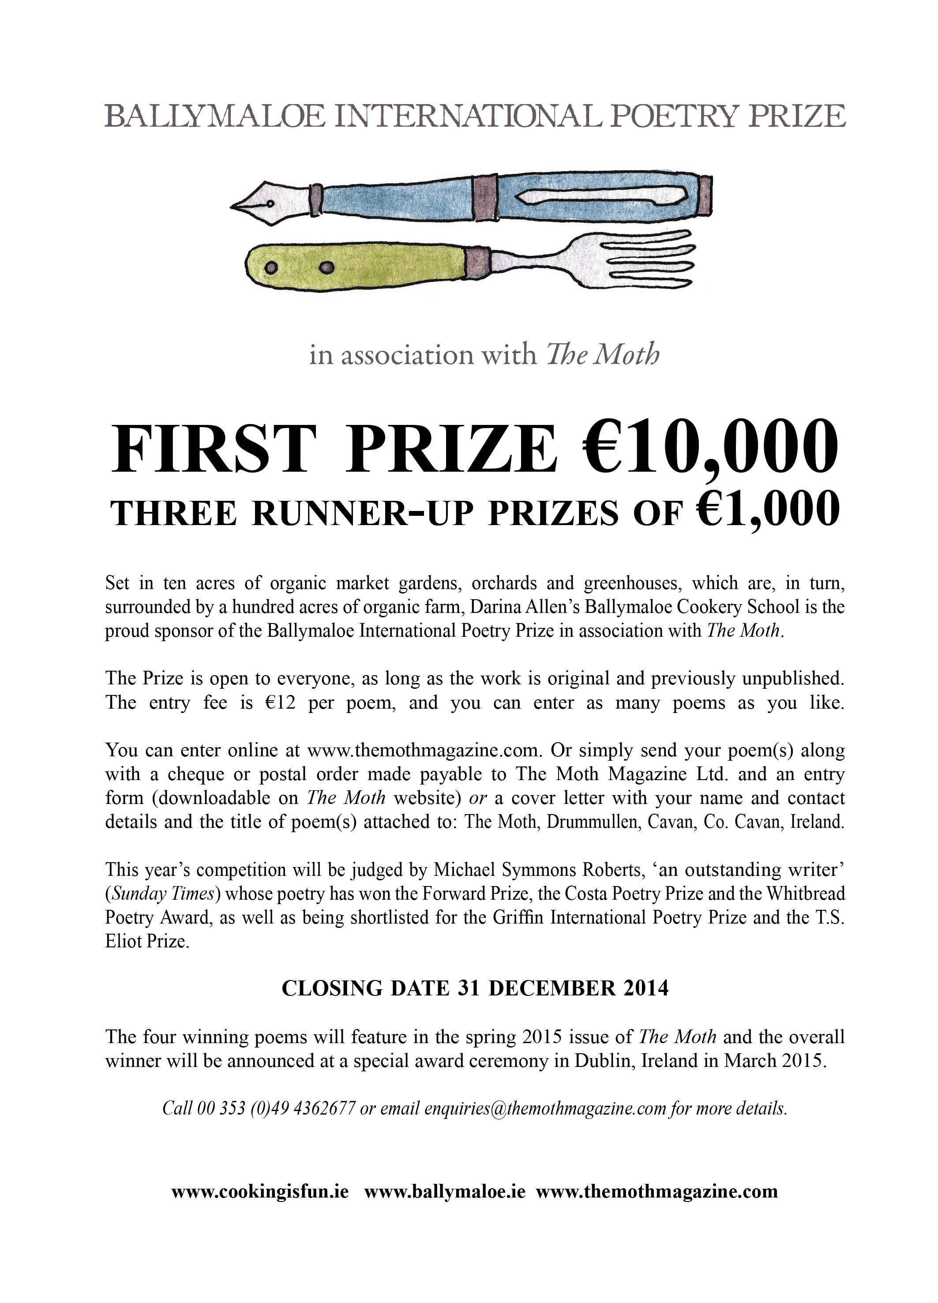**

## \_\_\_\_\_\_\_\_\_\_\_\_\_\_\_\_\_\_\_\_\_\_\_\_\_\_\_\_\_\_\_\_\_\_\_\_\_\_\_\_\_\_\_\_\_\_\_\_\_\_\_\_\_\_\_\_\_\_\_\_\_\_\_\_\_\_\_\_\_\_\_\_\_\_\_\_\_\_\_\_\_\_\_\_\_\_\_

**Awards / Bursaries / Schemes**

**\_\_\_\_\_\_\_\_\_\_\_\_\_\_\_\_\_\_\_\_\_\_\_\_\_\_\_\_\_\_\_\_\_\_\_\_\_\_\_\_\_\_\_\_\_\_\_\_\_\_\_\_\_\_\_\_\_\_\_\_\_\_\_\_\_\_\_\_\_\_\_\_\_\_\_\_\_\_\_\_\_\_\_\_\_\_\_**

**Music Capital Scheme**

The Music Capital Scheme, supported by the Department of Arts, Heritage and the Gaeltacht and managed by Music Network, provides funding for the purchase of musical instruments to both non-professional performing groups/ensembles and professional musicians.

The closing date for applications is **4pm Friday 10th October 2014.**

We will be running advice clinics for the Music Capital Scheme at the venues listed below.

Please find attached further details regarding the advice clinics. Please note that although the clinics will be free to attend, booking will be required as numbers will be limited.

Monday 22nd September at An Taibhdhearc, Galway; Wednesday 24th September at Music Network, National Concert Hall Building, Dublin; Thursday 25th September at Triskel Christchurch, Cork City.

For additional information about the Music Capital Scheme and to download a copy of the guidelines please visit <http://www.musicnetwork.ie/musicians/funding/>

Please note that the clinics are free but places are limited. In order to reserve a place please contact the Programmes Administrator, Aoife Faughnan, by September 16th. **Note:** It is important to read the guidelines carefully and to confirm your eligibility before reserving a place.

**Email:** [programmesadmin@musicnetwork.ie](mailto:programmesadmin@musicnetwork.ie)

**Phone:** 01 4750224

# Arts Council’s Artist in the Community Scheme - Bursary Award 2014 : Collaborative Dance

The Arts Council Artist in the Community Scheme Bursary Award 2014: Collaborative Dance aims to support individual professional dance artists working in the area of collaborative dance or with groups of non-dancers . This is the fifth year that the Arts Council has provided a €10,000 bursary award as part of the Artist in the Community Scheme, which is managed by Create. This year for the first time the focus will be artform specific as opposed to focusing on a social or community context.

### Purpose and priorities of the award

The purpose of the Bursary Award is to support and nurture professional arts practice and it is specifically aimed at a dance artist/s who have a track record of worked collaboratively with groups to produce dance works/performances.

The Bursary Award of €10,000 provides the selected artist with the time and resources to carry out research, and to reflect on and re-consider the questions associated with creating dance work with non-dancers or those who are not professionally trained.

It is expected that the successful applicant will share the learning arising from the Bursary with the wider dance community and collaborative arts sector.

[Create](http://www.create-ireland.ie/) will work in partnership with [Dance Ireland](http://www.danceireland.ie/) in providing information sessions and on the selection process.

For further information, contact Katherine Atkinson, Professional Development, [support@create-ireland.ie](mailto:support@create-ireland.ie)

**Deadline for applications: 24 October at 5pm.**

**Arts Council of Ireland – Reel Art 2014**

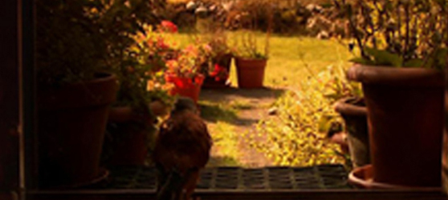

Deadline for receipt of applications: **Friday 17th October 2014, 17:00**.

Reel Art is an Arts Council scheme designed to provide film artists with a unique opportunity to make highly creative, imaginative and experimental documentaries on an artistic theme. Operated in association with Filmbase and the Jameson Dublin International Film Festival, Reel Art will support two films with a grant of **€70-80,000** per project.

Updated guidelines for Reel Art 2014, together with application forms for the scheme are available for download from the website [www.filmbase.ie/reelart](http://newsletter.artscouncil.ie/17xca9zxkab1eenva7sbzm?a=6&p=47682585&t=17684704)  as are details of previous Reel Art projects.

**Arts Council of Ireland – Visual artists in prisons scheme**

Maximum awarded: **€2,400**

This scheme provides financial support to selected visual artists to conduct workshops over a period of 10 days in the education units in any of the Republic’s prisons.

More info of the above funding and contact details at <http://miniurl.com/4b062>

**Arts Council of Ireland –** Writers in schools scheme

Maximum awarded: **€304**

The Writers in Schools Scheme part-funds visits by writers and storytellers to schools throughout the Republic of Ireland.

More info of the above funding and contact details at <http://miniurl.com/4b062>

**Arts Council of Ireland –** [Writers in prisons scheme](http://www.artscouncil.ie/funds/Writers-in-prisons-scheme/)

Maximum awarded: **€1,000**

The scheme offers writers the opportunity to work with prisoners in prison/detention centres and complements an existing arts and education programme in the Education Units within the prison system.

More info of the above funding and contact details at <http://miniurl.com/4b062>

**\_\_\_\_\_\_\_\_\_\_\_\_\_\_\_\_\_\_\_\_\_\_\_\_\_\_\_\_\_\_\_\_\_\_\_\_\_\_\_\_\_\_\_\_\_\_\_\_\_\_\_\_\_\_\_\_\_\_\_\_\_\_\_\_\_\_\_\_\_\_\_\_\_\_\_\_\_\_\_\_\_\_\_\_\_\_\_**

### Arts Council's Artist in the Community Scheme - Bursary Award 2014: Collaborative Dance

Deadline:  **24th October (5pm)**

Web: [www.create-ireland.ie](http://www.create-ireland.ie)

The Arts Council Artist in the Community Scheme Bursary Award 2014: Collaborative Dance aims to support individual professional dance artists working in the area of collaborative dance or with groups of non dancers . This is the fifth year that the Arts Council has provided a **€10,000** bursary award as part of the Artist in the Community Scheme, which is managed by Create. This year for the first time the focus will be art-form specific as opposed to focusing on a social or community context.

The Bursary Award of **€10,000** provides the selected artist with the time and resources to carry out research, and to reflect on and re-consider the questions associated with creating dance work with non dancers or those who are not professionally trained.It is expected that the successful applicant will share the learning arising from the Bursary with the wider dance community and collaborative arts sector.

Create will work in partnership with Dance Ireland in providing information sessions and on the selection process and details on the dates for the sessions will be announced on

[www.create-ireland.ie](http://r20.rs6.net/tn.jsp?f=001m_3HN6KNk-_p-lEuScFgF_UY6xVp4vNqCYfvI774zvPzJRuBVTviPmR0bhAhK4xEKkLqk7V1qB_nULsCET51obKdkVpOPftQSyf2BNHXd1BoAPVYvcbRMI1B7QkcCrbu_mu-VoT-BtoybBJfGs04rnhjzQLVlM0W6QdTSBfnhdquK8poMUydjg==&c=b3o4qYKY5DRFLoW7qs_or2gpbar_P3jxMjR9oNqZJG2uemcoc1SpNQ==&ch=V-wO1x9Pap4bDqoHf7ynABRbSPcRgTxqSOSf5GaLTsQnSKlON1G8ww==)

[www.danceireland.ie](http://r20.rs6.net/tn.jsp?f=001m_3HN6KNk-_p-lEuScFgF_UY6xVp4vNqCYfvI774zvPzJRuBVTviPm0ghaMIryxQhbp6zz_4FBRPZoJ39XwBzTHvIiwNKwoqGC3HlWBx8OoT_FRc84jCQPxI1SDDUIxecWzdycw44t-qt8veRy9wAaNlt5_BmQ9CXqmDkwkLs6I=&c=b3o4qYKY5DRFLoW7qs_or2gpbar_P3jxMjR9oNqZJG2uemcoc1SpNQ==&ch=V-wO1x9Pap4bDqoHf7ynABRbSPcRgTxqSOSf5GaLTsQnSKlON1G8ww==)

For further information on the application, contact Katherine Atkinson, Professional Development, [support@create-ireland.ie](mailto:support@create-ireland.ie)

**\_\_\_\_\_\_\_\_\_\_\_\_\_\_\_\_\_\_\_\_\_\_\_\_\_\_\_\_\_\_\_\_\_\_\_\_\_\_\_\_\_\_\_\_\_\_\_\_\_\_\_\_\_\_\_\_\_\_\_\_\_\_\_\_\_\_\_\_\_\_\_\_\_\_\_\_\_\_\_\_\_\_\_\_\_**

**2014/2015 Dates and Deadlines for Culture Ireland Grant Rounds**

Please note Culture Ireland has set funding rounds and deadlines for 2015. There will be three funding rounds in 2015 and seperate calls for showcasing opportunities and Edinburgh Festivals will be announced during the year. **Application Deadline | Timing of Project/Event | Decision Due**

* 15 October 2014 | January 2015 onwards | Early December
* 15 February 2015 |  May 2015 onwards |  Early April
* 15 June 2015  | September 2015 onwards | Early August
* 15 October 2015 |  January 2016 onwards | Early December

[http://www.cultureireland.ie/](http://lists.visualartists.ie/lt.php?c=1232&m=4271&nl=1&s=d3c261c0eeb6b48867f449d29e09414b&lid=96096&l=-http--www.cultureireland.ie/)

**Fire Station Artists' Studios and Arts & Disability Ireland (ADI) Mentoring Programme 2015**

Closing date for applications: Friday 31st Oct 2014.  
  
Fire Station and ADI are pleased to announce our Mentoring Programme for visual artists with disabilities for 2015. The follows the successful mentoring programme initiated as part of the Fire Station ADI studio award. Mentoring offers professionally focused development for artists. It opens the potential for knowledge, sharing and gives artists the opportunity to observe and formally review aspects of their own practice in action.Two artists will be selected as mentees to take part in this programme in 2015 and will be teamed with a mentor from a panel of artists, curators and studio providers convened by ADI and FSAS. What does the programme entail?•This programme will run for January – June 2015.

•It involves a minimum of 6 meetings over a 6 month period between mentor and mentee.  
•A budget of €500 will be awarded to the mentee towards expenses e.g.: travel.  
•Free day studio space in Fire Station Artists' Studios will be awarded the mentee for period of 1-5 months (depending on needs of mentee and availability of space).

•This opportunity is open to visual artists with disabilities who are living and working in the Republic of Ireland.Awarded mentees in 2014 were Emma Donaldson, Liz Smith and Paul Moore. Mentors are Rayne Booth, Padraic Moore and Catherine Barragry.For application procedure and guidelines on the mentoring programme go to [www.firestation.ie/programme/disability/](http://lists.visualartists.ie/lt.php?c=1232&m=4271&nl=1&s=d3c261c0eeb6b48867f449d29e09414b&lid=96098&l=-http--www.firestation.ie/programme/disability) or contact [artadmin@firestation.ie](mailto:artadmin@firestation.ie) /  Tel: 01 8069010Applications to be emailed to [artadmin@firestation.ie](mailto:artadmin@firestation.ie) or posted to Fire Station Artists' Studios, 9-12 Lower Buckingham St, Dublin 1.[www.firestation.ie](http://lists.visualartists.ie/lt.php?c=1232&m=4271&nl=1&s=d3c261c0eeb6b48867f449d29e09414b&lid=96099&l=-http--www.firestation.ie/)  | [www.adiarts.ie](http://lists.visualartists.ie/lt.php?c=1232&m=4271&nl=1&s=d3c261c0eeb6b48867f449d29e09414b&lid=96100&l=-http--www.adiarts.ie/)

**European Union Prize for Cultural Heritage / Europa Nostra Awards**

[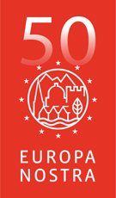](http://www.europanostra.org/)

The **European Union Prize for Cultural Heritage / Europa Nostra Awards** is Europe’s most prestigious prize in the heritage field. Every year, it honours the most outstanding heritage achievements from all over Europe. It recognises the excellence and dedication by architects, craftsmen, cultural heritage experts, volunteers, schools, local communities, heritage owners and the media. It stimulates creativity and innovation, through the power of example.

**DEADLINE 15th OCTOBER 2014**

In 2015, the Awards will be given to up to 30 remarkable heritage projects and initiatives in four categories. Up to seven will be selected as Grand Prix winners and receive **€10,000 each**. One will get the Public Choice Award.

More info at <http://www.europanostra.org/apply-for-an-award-2015/>

**European Cultural Foundation – STEP travel grants – ongoing**

[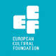](http://www.google.ie/url?url=http://sideshow-circusmagazine.com/research/funding-sources/step-beyond-travel-grants&rct=j&frm=1&q=&esrc=s&sa=U&ei=nYDGU4mnCtKe7AbIhYDoCw&ved=0CCAQ9QEwBg&usg=AFQjCNGnthfC8RitJQx109ixVGPR1pNiAA)

**STEP Beyond Travel grants fund up and coming artists and cultural workers – giving priority to individuals up to 35 years and/or in the first 10 years of their career – to travel between EU and countries bordering the EU.**

There is no deadline for this grant scheme, so you can apply at any time but at least one month before your planned travel. The selection process takes up to one month.

For more information on how to apply, a list of eligible travel destinations and to access the application form, go to the “how to apply guidelines”: [http://tinyurl.com/p26gd7n](http://tinyurl.com/p26gd7n%20)

These guidelines are also available in Russian but please note that the final application has to be in English. You can also access the application form directly here – [ecflabs.org/step-beyond-apply?gids[]=4707#group\_step\_1](http://ecflabs.org/step-beyond-apply?gids%5b%5d=4707#group_step_1)

**\_\_\_\_\_\_\_\_\_\_\_\_\_\_\_\_\_\_\_\_\_\_\_\_\_\_\_\_\_\_\_\_\_\_\_\_\_\_\_\_\_\_\_\_\_\_\_\_\_\_\_\_\_\_\_\_\_\_\_\_\_\_\_\_\_\_\_\_\_\_\_\_\_\_\_**

**The Golden Fleece Award - Call for Applications for the 2015 Award**

****

The Golden Fleece Award aims to support and promote the diversity of contemporary Irish creativity in the arts and crafts. Its mission is to help artists of innovative talent, needing support at strategic stages of their careers. Applicants will normally have been born on the island of Ireland and must maintain a strong connection with Ireland. They should be artists or researchers working in the area of figurative visual art or of the traditional crafts.

Closing date for applications: **Friday, 21st November 2014**

Full details of submission requirements and procedures can be found on our website at www.goldenfleeceaward.com.

# \_\_\_\_\_\_\_\_\_\_\_\_\_\_\_\_\_\_\_\_\_\_\_\_\_\_\_\_\_\_\_\_\_\_\_\_\_\_\_\_\_\_\_\_\_\_\_\_\_\_\_\_\_\_\_\_\_\_\_\_\_\_\_\_\_\_\_\_\_\_\_\_\_\_\_\_\_\_\_\_\_\_\_\_\_\_\_

**Of Interest**

# \_\_\_\_\_\_\_\_\_\_\_\_\_\_\_\_\_\_\_\_\_\_\_\_\_\_\_\_\_\_\_\_\_\_\_\_\_\_\_\_\_\_\_\_\_\_\_\_\_\_\_\_\_\_\_\_\_\_\_\_\_\_\_\_\_\_\_\_\_\_\_\_\_\_\_\_\_\_\_\_\_\_\_\_\_\_\_

**Sculpture in Context 2014 at the National Botanic Gardens**

4th September – 17th October 2014  
National Botanic Gardens, Glasnevin, Dublin 9.  
Opening Times: Monday – Friday 9am to 5pm; Saturday & Sunday 10am – 6pm; (Botanic Garden Café open daily)

Sculpture in Context 2014 returns once again to the National Botanic Gardens this September, showcasing the work of Irish and international artists, it is the largest and most exciting outdoor sculpture exhibition in Ireland.

For the duration of the exhibition, the 50 acre botanical paradise will be transformed into a magnificent outdoor gallery, providing a striking backdrop for the sculptures. This quiet oasis is just 3.5 km from the centre of Dublin City and provides a wonderful venue for artists to create work in response to specific surroundings. Visitors will discover sculptures in the most unexpected and surprising places. Over 150 sculptures will be displayed in the gardens, ponds, Great Palm House, and Curvilinear Range of glasshouses. Smaller pieces are exhibited in the gallery above the visitors’ centre.

Sculpture in Context is a thought provoking, inspirational and unique experience and offers an unparalleled opportunity to view Ireland’s well established and most promising artists.

This year will see the addition of a major new award – The New Ireland Assurance Sculpture Award

Guided Tours: Saturdays at 3pm, and Tuesday mornings at 10.30 for the duration of the exhibition.

ADMISSION FREE | Car Park €2.

The National Botanic Gardens are located 3 Kilometres North of Dublin city centre, 10 minutes by bus from O’Connell Street (Nos. 4, 9 and 83)

For further information please see [www.sculptureincontext.com](http://lists.visualartists.ie/lt.php?c=1200&m=4239&nl=1&s=d3c261c0eeb6b48867f449d29e09414b&lid=94008&l=-http--www.sculptureincontext.com)

**'idir' Press Release September 2014**

What happens when sixteen visual artists, two sculptors, a performance poet, a writer, a

musician, a singer, a performance artist and an actor / producer meet in a room in Ireland?

Between them they decide to collaborate, to join talents and move their art into spheres they

haven't explored before. Between them they set up the first intercultural, cross disciplinary

artistic collaborative to come out of Ireland ...in 2014. And they call themselves:

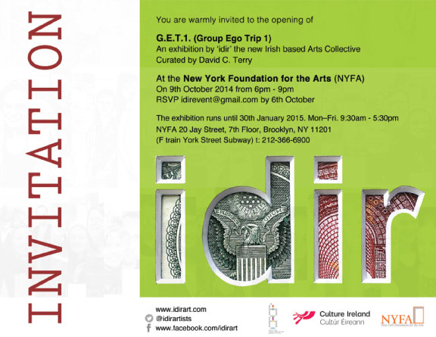

'idir'

- from the gaelic for 'between' ...signifying collaboration between artists, between cultures,

between countries and continents.

This October they are invited by the New York Foundation For The Arts ( NYFA.org )

to tour their work to DUMBO, NY for a four month exhibition. Please join us on 9th October

6-9pm with Hozier for the opening of the New York exhibition.

Event: Group Ego Trip 1 curated by David C. Terry

Where: 20 Jay Street, 7th Floor, Brooklyn, NY 11201 (F train York St Subway)

Tel: (212) 366-6900

When: 9th October 2014 - 30th January 2015

What time: 6.30pm – 9pm

RSVP: by 1st October 2014 to idirevent@gmail.com

Website: www.idirart.com

Facebook: https://www.facebook.com/idirart

Twitter: https://twitter.com/idirartists

Further Press Information: Iris Park - irispark14@gmail.com 00353863621166

idir was established as a collective in 2013, by twenty six Irish based practitioners.

The creative artists met at the Centre For Creative Practices, Dublin during The Profitable

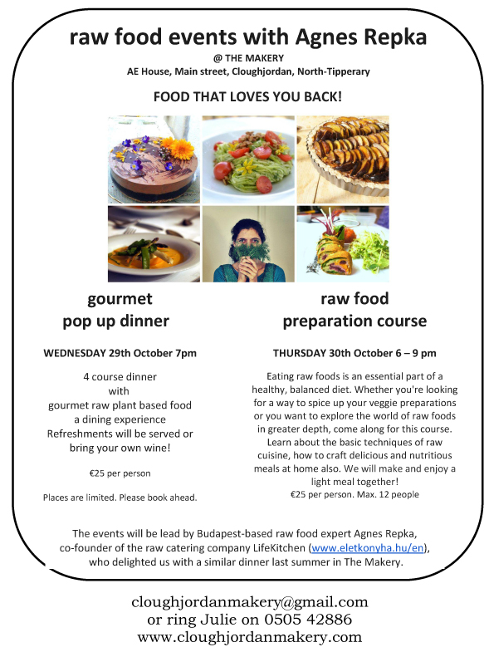

**Irish Arts Review: Diary Listings**

We are now compiling our **DIARY** and **LISTINGS** of exhibitions throughout **December, January and February** for our Winter 2014 edition.    
  
If you would like your exhibitions and visual arts events to be considered for our **Whats On** and **Diary** sections, please forward a full press release and mac compatible jpegs/tiff to: [production@irishartsreview.com](mailto:production@irishartsreview.com) by **13 October.**  (Details received after this deadline will not be included)  
   
The Diary section is selected by our editor and we endeavour to include as many entries as possible in the Listings section.