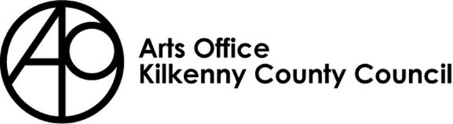
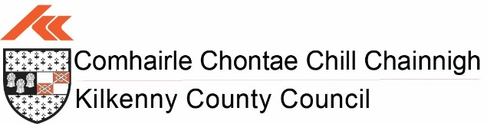

Kilkenny County Council

Arts Office

Arts Act Grant 2024
Kilkenny County Council has prepared a scheme for the disbursement of grants under Section 12 of the Arts Act of 2003.

Return completed applications to:

Mary Butler, Arts Officer

Kilkenny County Council Arts Office,

Patricks Court, Patrick Street

Kilkenny

Please mark envelopes ‘Arts Act Grant 2024’

Closing date is no later than

Monday 22nd January 2024, 4PM

An independent assessment panel will award funding on a competitive basis; therefore, all applications submitted must be accompanied by * comprehensive supporting information. If you do not provide the relevant documentation/images we will consider your application ineligible.

Arts Act Grants 2024 Application Form

*please note that detailed information and guidelines on how to make an application are available at: https://kilkennyartsoffice.ie/

Please note that there is no guarantee of funding for projects that nonetheless may have achieved the minimum criteria. The funding available is limited and eligible applications will be evaluated on a competitive basis.

Full name and/or Organisation name:

- Main contact:

- Full contact address:

Telephone: Email:

Website / Blog / Social Media:

4. How many years have you been resident in Kilkenny:

5. Please describe in twenty words or less the activity for which you are applying to Kilkenny County Council For:
Please write your answer here

6. Please tick the main type of arts activity involved in your work

- Visual Arts | - Music
- Theatre/Drama | - Multi media
- Literature | - Film
- Dance  - Other  Please specify: | - Multidisciplinary  (list main art forms involved)

7. What is the total cost of your proposed activity? €

8. How much are you applying to Kilkenny County Council for (note, a minimum of 20% match funding is required) €

9. Which fund are you applying to: (please tick one only)

- Groups and organisations

Individual

10. Give details of any previous awards received, including those from national and local organisations, e.g. Arts Council, ArtLinks, Local Authority, other professional organisations. Please list any current applications for which you have recently applied and are awaiting decision. (Past awards will not hinder any application.)

Title of Award | Year Received | Amount Received

- If you are applying for a grant for professional development course(s), please give details of the course and confirm whether you have been given a place. If not, state the stage your negotiations have reached. If you have not yet applied, give names of courses /bodies you are applying to. Grants will only be awarded once proof of acceptance on the course has been submitted.

- Please give a detailed description of your project: (300 words max)

- How does your project fulfil the Arts Act Grant criteria?

- Who will benefit from your proposed project:

- Please outline dates of event(s) if relevant or important dates of your project:

Income & Expenditure

Please complete (in block capitals) only those sections relevant to your proposal and itemise your information where possible.

Estimated Expenditure

DESCRIPTION | COST €
Venue Hire
Artists Fees
Travel/ Subsistence
Equipment Hire
Materials
Publicity/Printing
Administration Costs
Insurance
Other Costs (please itemise)
TOTAL EXPENDITURE

Estimated Income

DESCRIPTION | COST € | CONFIRMED √
Public Source/ Grants
Membership Fees
Private Sponsorship
Ticket Sales
Workshop Fees
Sale of Art Work
Advertising Income
Other Sources (please itemise)
TOTAL INCOME

*IF FUNDING HAS BEEN CONFIRMED FROM ANOTHER FUNDER, PLEASE INCLUDE A COPY OF THE FUNDING OFFER WITH YOUR APPLICATION

YOUR SUPPORTING INFORMATION - Please attach details under the following headings. (Typed or block capitals only)

- Description of you / your group’s activities since 2020. No more than half of an A4 page.
- Individual artists please include an up to date relevant CV and images if relevant

Important
When completing the Income & Expenditure sheet please make sure that it balances i.e. Income = Expenditure

Failure to supply all the above details will result in the elimination of the application for consideration.

I confirm that I am over 18 and that all of the information I have provided is correct as of the date of signing. □

I consent to the processing, sharing and holding of my personal data with external assessors for the purposes of this award only. I understand that this information will not be used for any other purposes.

Please tick the box if you want to be added to our email database for upcoming activities and events with the Kilkenny Arts Office. Yes No

Signed: Date:

Check List
- Completed Application Form □
- Supporting Documentation □
- Curriculum Vitae (where applicable) □
- Images (Visual artists) □

Completed application form to be returned to:
Mary Butler, Arts Office, Kilkenny County Council Arts Office, Patricks Court, Patrick Street, Kilkenny, R95 N28F

Please mark your envelope clearly as ‘Arts Act Grant 2024’

For queries please contact the Arts Office at 056 7794289 or email diane.seale@kilkennycoco.ie

