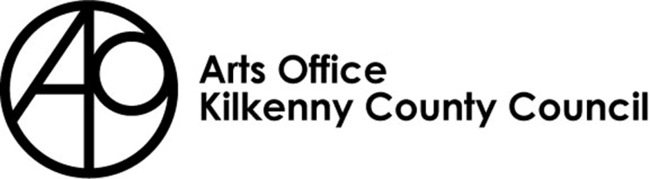

KILKENNY POETRY BROADSHEET 2024
ISSUE 24 - APPLICATION FORM

Kilkenny County Council Arts Office is inviting submissions from poets born or based in Kilkenny City and County for the 24th Issue of Kilkenny Poetry Broadsheet.

We are delighted to announce that James Harpur will be editor of this year’s Broadsheet. James Harpur has published eight books of poetry, including The Examined Life (2021), a verse memoir of his time at boarding school. He has also published a debut novel, The Pathless Country, set in Galway, Dublin and London in the years leading up to the 1916 Rising. It was winner of the JG Farrell Award and shortlisted for the John McGahern Prize. He is a member of Aosdána and lives in West Cork. You can visit his website at: www.jamesharpur.com

Rules of Submission

Submissions can be in English or Irish

Submissions must be the work of the entrant (no third party submissions)

Entrants must be 18 years of age or over

Limit of TWO entries per person.

Submissions MUST be typed and no longer than 30 lines

Work MUST NOT be signed

Entrants must be born or based in Kilkenny City or County

Submissions may have been published previously

Details of any such publication must be included with your application

The editor’s selection of published and shortlisted poems is final
- To be accepted for publication the editor may suggest edits to your poem/s for your consideration
- There is no submission fee but entries will not be returned

Please send submissions preferably in digital format (Microsoft Word) by email to deirdre.southey@kilkennycoco.ie . Hardcopy applications can still be submitted to: Kilkenny Arts Office, St. Patricks Court, Patrick Street, Kilkenny, R95 N28F

The closing date for submissions: Friday 29th March 4pm

Further information 056 7794547

KILKENNY POETRY BROADSHEET ISSUE 24

APPLICATION FORM

Name in full (Block letters)

Postal address

________________________________________
________________________________________
________________________________________

Tel. Number

Email Address

Title of Work(s)

- ___________________________________
- __________________________________________

Have you had work(s) (those submitted here or otherwise)
published previously?
Yes No

_______________________________________________
_______________________________________________
_______________________________________________
_______________________________________________
_______________________________________________
_______________________________________________

If so, please give brief details

I consent to the holding and processing of my personal data for the purposes of this application only and I understand that it will not be used for any other purposes.
I confirm that I am 18 years of age or over and I was born or resident in Kilkenny.

Signed: ____________________________ Date:________________________________

