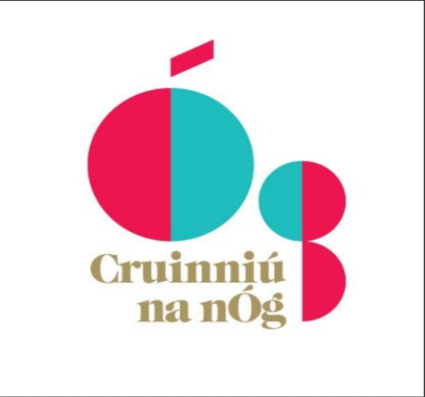

Kilkenny County Council
Creative Ireland
Cruinniú na nÓg
Grant Scheme 2024
Application Form
Closing date: Monday 12th of February, 2024 at 4.00pm.
N.B. READ GUIDANCE NOTES PRIOR TO COMPLETING
LATE AND INCOMPLETE APPLICATIONS (SECTIONS NOT COMPLETED/ALL RELEVANT SUPPORTING MATERIALS NOT ENCLOSED) WILL BE INELIGIBLE.
Return completed applications to: creativeireland@kilkennycoco.ie

Community & Culture Section, Kilkenny County Council, Patricks Court, Kilkenny.
Telephone: 056 -7794338 or Email: creativeireland@kilkennycoco.ie
An independent assessment panel will award funding on a competitive basis; therefore, all applications submitted must be accompanied by comprehensive supporting information. If you do not provide the relevant documentation we will consider your application ineligible.

An independent assessment panel will award funding on a competitive basis; therefore, all applications submitted must be accompanied by comprehensive supporting information. If you do not provide the relevant documentation

Purpose of the Scheme
All Local Authorities under Creative Ireland support the delivery of Pillar 2 of the national Creative Ireland Programme; “Creative Communities - Enabling creativity in every community”. Its vision is:
“That every person living in Ireland will have the opportunity to fully realise his or her creative potential.”
In partnership with Creative Ireland, Kilkenny County Council invite groups to apply for the Cruinniú na nÓg funding scheme. Cruinniú na nÓg is one of the key actions committed to in the Creative Youth Plan (Pillar 1 of the Creative Ireland Programme). It is a national day of free creativity for children and young people up to the age of 18. This programme should be activity based with children and young people ‘doing’, ‘making’, and ‘creating’. Proposed for the (June 8th 2024).
As per the Rights of the Child (Article 7 and 12); The right of the child to be heard, we have an obligation to ensure a child centric approach and to enable without discrimination. We must engage and listen to the voice of every child in relation to our events. Organisations have the same obligations as government departments to uphold all aspects of the CRC. Projects who demonstrate that they have consulted with young people will be prioritised.
Resources: Consultation process: https://youtu.be/-Zg8v8JkK04?si=5y9FUdpfhor_Ko1e
Toolkit & Guidelines | Hub na nÓg (hubnanog.ie)
Your application must align with the County Kilkenny – Culture and Creativity Strategy 2023-2027

Kilkenny’s Creative Ireland Programme aims to empower creatives and communities to express creativity throughout society and relevant programmes and policies. We ask you to directly link your idea/proposal/initiative to one (or more) five strategic priorities with clear objectives to fulfil the Council’s creative vision for Kilkenny:

- Enable best practice delivery of culture and creativity
- Increase and diversify participation in culture and creativity
- Support culture and creativity in rural and urban areas
- Engage children and young people in culture and creativity
- Communicate the value of culture and creativity

Click link to view: kilkenny-culture-and-creativity-strategy-2023-2028.pdf (kilkennycoco.ie)

What items and expenses are ineligible?
- Publications.
- Spend on alcoholic beverages, fines, penalty payments, legal cost, audit fees, financial consultancy fees.
- Any proposal where it is determined that the main beneficiary would be a private entity.
- In general, the cost of items for resale.
- Assets or equipment e.g.: vouchers, memoirs for participants, art works, projectors, laptops, tablets etc.
- Accommodation.
- Projects that do not relate to the Kilkenny’s Culture and/or the Creative Ireland Programme
Guiding Principles for Cruinniú na nÓg:

- To empower children and young people to develop their creative expression by providing opportunities for them to participate in creative activities in their local area;
- To increase awareness of the benefits of participation in creative activities;
- To prioritise (where possible) harder to reach children and young people (i.e. children with disabilities, seldom heard children, direct provision);
- To focus on what children and young people (up to 18) want and need and ensure that they are involved in the creation of the programme;
- Majority of events should be activity based, i.e., children and young people ‘doing’, ‘making’, ‘creating’ but with a selection of suitable commissioned events also;
- Ground-up, community led approach mixed with commissioned pieces based on a clear and transparent, open-call process;
- Programme of activities should be diverse covering a range of creative activities and events (beyond just the traditional arts and cultural activities and include for example heritage, tech and STEAM);
- Quality over quantity;
- New local partners involved.
- Capturing levels of participation and engagement.

Click link: Cruinniú na nÓg - A day of free creativity for children and young people (creativeireland.gov.ie)
Grant applications will be assessed using the following criteria:

To be fully transparent as to how your application will be assessed the following criteria will be used by an external panel to assess your application.
- The extent to which the proposed event/project is aligned to the Creative Ireland Programme/ Cruinniú na nÓg programme and the priorities of Kilkenny’s Culture and Creativity Strategy 2023- 2027 programme. (20 marks)
- The scope of the project/event and the extent to which it maximises community/citizen engagement (including inclusivity and diversity in approach) (20 marks)
- The legacy potential of the proposed event/project in terms of benefiting the wider community, ambition, innovation and the fostering of creativity (20 marks)
- The quality, feasibility, cost of the proposed event/project and its proven capacity to see it through to fruition. (20 marks)
- Potential to promote Health, Wellbeing, Heritage, Biodiversity or Creative climate action projects (20 marks) for example:
Creative climate action projects. Projects will be assessed on the extent to which they creatively aim to improve or engage in actions that enable behavioural change towards climate action or active engagement on climate action in the community. This may include engaging with and mobilising communities to rethink lifestyles, understand climate change, adapt places, ensure a just transition, connect the biodiversity and climate crises.
Health, Wellbeing. Projects will be assessed on the extent to which they creatively aim to improve or engage in actions that promote health and wellbeing. (Sports programmes are not eligible).
Monday 12th of February, 2024 at 4.00pm.
Creative Ireland Cruinniú na nÓg Grant Scheme 2024 - APPLICATION FORM
* Indicates Compulsory field.
Projects must be completed by Saturday the 8th of June, 2024

- APPLICANT DETAILS * Please fill in all sections.

Name of Applicant/Lead contact: _________________________________________________________

Organisation (if applicable) ______________________________________________________________

Name and Title of contact person (for payment purposes):

____________________________________________________________________________________

Tel: ______________________________ E-Mail_____________________________________________

Website: (if applicable) _________________________________________________________________

Social media: (if applicable) _____________________________________________________________

Address: ____________________________________________________________________________

___________________________________________________________________________________

2. Project Name and Type * Please fill in all sections.
Title of project: (The name of your project should be short and snappy. For advertising samples, please look at samples on the Creative Ireland website)

Genre: (Film, archaeology, music, comprehensive list detailed in the guidelines)

Type of Initiative: (e.g. Festival, talk, exhibition comprehensive list attached in guidelines)

Target Audience: (Artists, Creatives, Children, Young Adults, Disability Groups, Older Audience, General public etc) N.B. Please indicate age categories. (eg. 0-4, 5-8, 13-18)

3. Project Description Please summarise in no more than three short points what you intend to do, how and why (max 500 words). Successful, summaries will be used in reports regarding Who & what we have funded during the year. * Please fill in all sections.
Please give a brief description of the project, addressing each of the following:
- An outline of your project/initiative. What you write here is a key part of your proposal, and should help those involved in assessing your application to understand the full scope of what you want to do, how and why?
- Demonstrate how your project promotes active participation in creativity and culture across all ages, communities and abilities throughout Kilkenny. Please see page 13 of our Kilkenny Culture and Creativity 2023-2027 Strategy.
- Demonstrate how it addresses the 5 Priorities and Key Principles outlined in Kilkenny’s Culture and Creativity Strategy 2023-2027 programme.

Information as supporting material should include:
- Details of the key personnel involved. your policy and creative goals and ambitions, and also practical details such as schedules, information on key partners, and any other administrative, technical or financial details you consider relevant. You may include more-detailed.

For example, to include one or more of the following:
- Rural Communities.
- Active engagement of communities networking and development of skills and talents.
- Supporting the sustainability and security for emerging or practicing Irish, artists, architects, musicians, writers, etc working in the creative and cultural sector.
- Collaboration with communities to develop and promote opportunities and experiences for engaging communities.
- Creative ways of promoting actions to combat climate action, economic sustainability, health and wellbeing.

- Project Team, Audience and Outcomes * Please fill in indicated sections.
* Who is facilitating the project? (please also indicate the number of artists, musicians, writers etc)
* Who will be involved in organising the project/event? (other team members, or partners)
* Please provide details of your experience in delivering projects of this nature. (please attach relevant documents)
* Who are the target audience(s) for your project? (communities, children, families etc)
If you intend on collaborating please include details of groups or organisations.
* Estimated audience figures: (based on realistic estimates) (communities, children, families, specific audience – e.g. targeted groups, children under 12 etc) Communities, including young people and hard to reach voices.
* Describe the anticipated impact/outcome of the event for your community and audience. Use this section to set out the substance of your application.
For example:
- Increased participation of ( xx ) young people from a wide demographic.
- Young people were involved in decision making
- Young people developed skills through activity based.
- Increased engagement in traditional arts and cultural activities and include for example heritage, tech and STEAM).
- Consideration was given to climate friendly approaches and sustainable projects.

5. Finance: NB: Income and expenditure must balance. NB: Approval from the Creative Ireland team must be sought for alterations to proposed budget if successful. Please note that receipts (marked paid) are required on completion of the project.
Are you applying for funding from any other sources? Yes _______  No__________
If YES, please give details below
If NO, please indicate how you intend to fund the balance of your costs below in the income section
Describe Details of Income.  Please provide a detailed breakdown of all income sources, if any: ITEM (e.g. sponsorship, own resources, other funding sources) | € Income | Describe details of Expenditure. N.B. Please refer to the list of items and expenses that are ineligible asindicated on page 2 of this document.  Please provide a detailed breakdown of costs. Where relevant, supply quotes or tenders if available.  Element of Work /Programme/ Item | €  Expenditure PROJECT Estimated COSTS.
What is the estimated overall cost of the event/project? | € xxxxx | Artists | € xxxxx
Any other Public Funding? | € xxxxx | Organisations | € xxxxx
Source of Other Public Funding (Other Departments of Stage Agencies/Bodies) if applicable for example: Arts Council, KLP | €xxxxx | Staffing/ Project management | € xxxxx
Any Private Funding?  (Advertising Sales) | € xxxxx | Marketing/Branding/PR | € xxxxx
Any Philanthropic Funding? | € xxxxx | Overheads | € xxxxx
Box Office Income? | € xxxxx | Venue Hire | € xxxxx
Any Benefit in Kind? | € xxxxx | Other expenses: | € xxxxx
 |  | Details: materials | € xxxxx
Total Estimated Income | € xxxxx | Total Estimated Expenditure | € xxxxx

- ACKNOWLEDGEMENT
Recognition must be given to Kilkenny County Council and Creative Ireland in all promotional material associated with the project/event. Relevant logos will be provided to projects which are awarded grants. Attendance records and consent forms will be provided with relevant logos attached.
Please state how your organisation proposes to publicly acknowledge Kilkenny County Council’s Creative Ireland Community Event contribution?
___________________________________________________________________________
___________________________________________________________________________
___________________________________________________________________________

- DISCLAIMER
Kilkenny County Council will not be liable in respect of any loss, damage or costs of any nature arising directly or indirectly from this application or the subject matter of the application. Kilkenny County Council, its servants or agents shall not at any time in any circumstances be held responsible or liable in relation to any matter whatsoever arising in connection with the development, planning, construction, operation, management and/or administration of individual projects.

I/we have read the above terms and conditions and I certify that the information supplied here is a true and fair representation of this organisation’s position.

Signed: -__________________________________ Date: ___________________________

- DATA PROTECTION
Kilkenny County Council collects some personal data during the application and processing of this grant scheme, particularly, names, addresses and contact details (emails and telephone numbers). These details are necessary for the consideration and adjudication on the grants scheme. The grant applications are sometimes shared between relevant County Council Departments for the purpose of supporting the application and also to ensure that similar events are not double funded, and in relation to other festival/events funded by the Council. At all stages the personal data is handled in full accordance with the Data Protection Legislation.
Your express consent is required, acknowledging that you understand that you may be submitting personal data. Please sign here by way of agreement.
Signed: ________________________________ Date: _____________________________
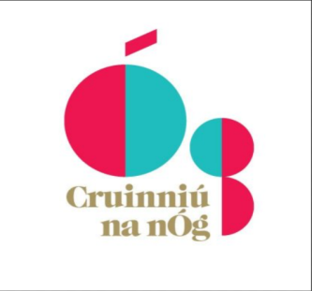
Part A
To be completed returned by Friday the 1st of March, 2024, if and when application is accepted and deemed successful. Groups will be notified of the outcome of the panel review by mid-March.
- Booking Generic phone numbers should not be provided for the public to book an event. A much more useful tool is to provide an email address or preferably a clickable link to, for example, an Eventbrite listing. It is hard to gauge the actual numbers that will turn up for events even with
adequate booking systems in place
- When events change and need to be updated, do not forget to update and notify us without delay.
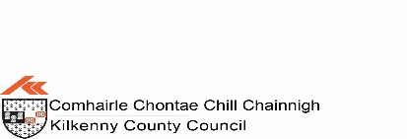
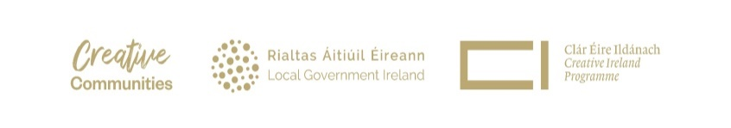
9. Promotion, Dates and Venue. * Please fill in all sections.
NB: please note if there are multiple events you must duplicate this section and supply the relevant dates venues and details outlined below.
* How will you access participants/audiences?

* How do participants get involved? (How do they sign up?)

* Where can participants access online projects / events? (YouTube, Zoom etc.)

* What kind of ticketing is used for this event? Where do you acquire tickets?
Free but booking required?
Free event?
Ticketed event?
N/A?
* What equipment do participants need? (if any)
* What links will you use for bookings/more info: (e.g http://)
* How will the project be promoted? (posters, radio, social media, newspaper, etc.)
* Start date
* End date: (Note: projects must be completed by 8th of June. Part A Reports must be returned by Friday the 15th of March, 2024, with requested additional documents.)
Start & End Time (if relevant)
* Total running time (hrs/mins/ days as appropriate)
* You must submit an image to publicise this event which must be in line with GDPR legislation. 128 MB limit. Allowed types: jpg gif jpeg png.
N.B. Consent form must be provided. Not typed. Hand signed scanned only: Word, docx pdf.
* Venue (full address, including Eircode)

