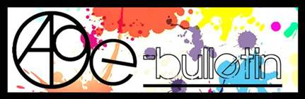

**Kilkenny County Council Arts Office- E-bulletin 4th April 2014**

Dear All,   
  
Welcome to this week’s e-bulletin from Kilkenny County Council's Arts Office. Each bulletin is packed with the latest information on Kilkenny Arts Office activities, county events as well as news and opportunities for arts practitioners from around the country.

We have decided to shorten information included in the e-bulletin for easier use. This should particularly work well for those reading off tablets and smartphones.

This service will be provided fortnightly. To include an item in the next e-bulletin please send a brief outline of your advert with relevant contact details, including any websites or pages with links to [Julianne.Morgan@kilkennycoco.ie](mailto:Julianne.Morgan@kilkennycoco.ie) **before 15th April**. The next e-bulletin will be on **17th April**.

**PLEASE NOTE THE NEW EMAIL ADDRESS TO SEND INFORMATION FOR INCLUSION IN THE E-BULLETIN.**

While every effort has been made to ensure the accuracy of our information, we strongly advise readers to verify all details to their own satisfaction.  
Regards,  
Julianne Morgan,  
Arts Office  
T: 056 7794938  
E: [Julianne.Morgan@kilkennycoco.ie](mailto:Julianne.Morgan@kilkennycoco.ie)   
W: [www.kilkennycoco.ie/eng/Services/Arts/](http://www.kilkennycoco.ie/eng/Services/Arts/)  
Kilkenny County Council Arts Office Partner Local Authority of the ArtLinks Programme [www.artlinks.ie](http://www.artlinks.ie)

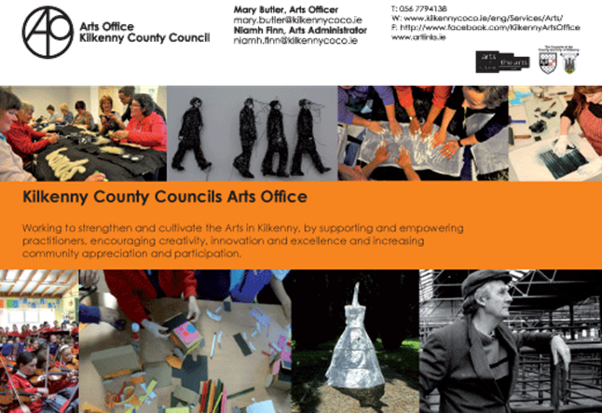

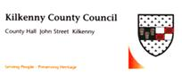**Call for Submissions: Kilkenny Poetry Broadsheet Issue 14**

Kilkenny County Council Arts Office is delighted to announce a call for submissions for the publication of the fourteenth issue of the very popular **Kilkenny Poetry Broadsheet**. The aim of the publication is to give local writers a platform for their work. Each poem selected is included in the broadsheet which is available free throughout the County. One hundred and three poems were submitted for inclusion by forty one writers for the 2013 edition.

This fourteenth issue of Kilkenny Poetry Broadsheet will be edited by Enda Coyle-Greene.

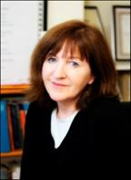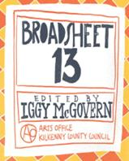

Enda Coyle-Greene lives in Co. Dublin. Published widely in print and online journals, she is also a frequent contributor to programmes on RTÉ Radio.

Her work featured in anthologies such as *Sunday Miscellany – a Selection from 2004 -2006* (2006), *The Echoing Years* – *An Anthology of Contemporary Poetry and Translation from Canada and Ireland* (2007), *The Quiet Quarter – Ten Years of Great Irish Writing,* (2009), *Shine On* – *Irish Writers for Shine* (2011) and, most recently, *If Ever You Go – A Map of Dublin in Poetry and Song*, the UNESCO City of Literature, Dublin: One City, One Book title for 2014.

Her first collection of poetry, *Snow Negatives,* won the Patrick Kavanagh Award in 2006 and was published by the Dedalus Press the following year. Her second collection, *Map of the Last*, also from Dedalus, was published in 2013.

We are now accepting submissions from poets born or based in Kilkenny City and County.

Application forms and submission rules are available from the Arts Office, John’s Green house, John’s Green, Kilkenny. T: 056 7794138,

E: [niamh.finn@kilkennycoco.ie](mailto:niamh.finn@kilkennycoco.ie) / [julianne.morgan@kilkennycoco.ie](mailto:julianne.morgan@kilkennycoco.ie)

Or can be downloaded from:

[www.kilkennycoco.ie/eng/Services/Arts](http://www.kilkennycoco.ie/eng/Services/Arts)

No electronic submissions accepted.

**Closing date for receipt of submissions is no later than 4pm on Friday 23rd May.**

**Ends.**

Images:  Enda Coyle-Greene and Broadsheet 2013

For further information or images please contact The Arts Office

T: 056 7794138 / E: [niamh.finn@kilkennycoco.ie](mailto:niamh.finn@kilkennycoco.ie)

**___________________________________________________________________________**

**Siamsa 2014**

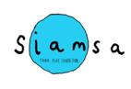

***“Now that your children have covered the laws of Physics, we are introducing them to environmental chemistry”***

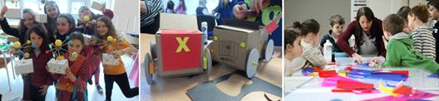

Kilkenny County Council Arts Office is delighted to be hosting its 2014 ‘Siamsa’ programme for 5 to 12 year olds. This year a five week programme runs on Sunday’s March 23rd and 30th, May 4th, 11th, and 18th. The programme will offer children the opportunity to learn about the natural environment around them through the integration of science and art using a variety of exciting workshops and projects.

‘Siamsa’ has been part of the Arts Office’s programme since 2011. This fun programme has supported children in developing numerous skills including drawing, painting and making in a diverse range of media. The workshops have included origami, clay modelling, Lego art as well as textile work. Our most recent workshop included arts and science working together.

Following the positive experiences of previous participants, this year’s workshops include practical, hands-on learning experience through scientific experiments and art making projects. Participants will learn about the water cycle and plants by creating their own mini greenhouse garden, explore the secret lives of flowers, get down and dirty with the surprising science of soil, extract DNA from a strawberry and more curious discoveries!

**Ends.**

For further information contact:

Mary Butler

E: [mary.butler@kilkennycoco.ie](mailto:mary.butler@kilkennycoco.ie)

W: <http://miniurl.com/c4kI>

Kilkenny County Council Arts Office Partner Local Authority of the ArtLinks Programme [www.artlinks.ie](http://www.artlinks.ie)

**___________________________________________________________________________**

# Spring 2014 Writers' Workshops

# Spring 2014 Writers' Workshops



**As part of our on-going commitment to Kilkenny writers, Kilkenny County Council Arts Office & Library Service programmed their Spring 2014 Writers' Workshops. This year's Spring workshops were facilitated by two professional writers.**

Creative Prose with Ken Bourke

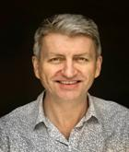

Over six weeks, participants had the opportunity to develop their prose-writing skills in a relaxed atmosphere. They were encouraged to identify their writing objectives in terms of how, where, what and when they will write. The workshops focused on shorter prose forms, but there were opportunities to discuss other aspects of story-telling, and the focus and objectives of the workshop were tailored to the needs of the participants. All levels of experience were welcome, the diversity of the group was one of their key resources, and numbers were limited to encourage full participation by all present. Thomastown library hosted these workshops.

Ken Bourke has been a professional writer for over twenty years. He is an experienced facilitator and has worked with a wide range of groups. He lives in Kilkenny.

'Poetry for Spring: Getting Started' with Derek Coyle



Participants started plenty of new work in the course of six weeks. They began many short pieces, but also started a longer poem and continued working on it. In the workshops they learned what to look at in a poem from a writer's point of view. They worked on developing their skills as makers of poems by learning how to read and examine carefully the work of other makers. Participants learned some new words and techniques so that they can become more confident readers and writers of poetry. Participants learned about line-breaks, couplets, quatrains, irony and satire. Along the way they looked at a selection of poems by well established poets from Ireland and abroad. St. Mary's Day Care Centre hosted these workshops.

Derek Coyle lectures in English Literature and Irish Studies at Carlow College. Recently, he has had poems published in Mexico, in Cuadrivio, in their Irish issue. He has been shortlisted for the Patrick Kavanagh Award (2010), and the Bradshaw Prize (2011).

**Ends.**  
For further information contact:   
Mary Butler   
Arts Officer  
E: [mary.butler@kilkennycoco.ie](mailto:mary.butler@kilkennycoco.ie)

W: <http://miniurl.com/7Sby>

Kilkenny County Council Arts Office Partner Local Authority of the ArtLinks Programme [www.artlinks.ie](http://www.artlinks.ie)

**___________________________________________________________________________**

**Kilkenny Events**

**___________________________________________________________________________**

**Upstairs Gallery celebrates 21 years – launch of ‘21 years of artists’**

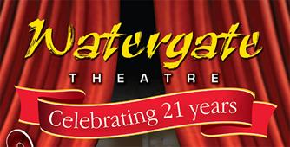

For the Watergate Theatre's 21st Birthday, the Upstairs Gallery presents a group show of work from across the county of Kilkenny. We hope to see you at the launch, which will happen on **Friday, April 4th from 6pm to 7pm**, Everyone’s welcome!

**Showing work on the day will be:**

Dathaí Óh Uallachaín, Shane Hughes, Brian Griffin, Vicki Cody, Francis Walshe, Phyl Cleere, Eamon Downes, Stef Auler, Vincent Morton, Mary-Ann Gelly, Kathleen Holohan, Jeffrey Gormley, Andrew Small, Dave Nissen, Paul Mosse, Stephen Morton, Ita Bourke, Martin Taylor, Bernadette Kiely, Julie Moorhouse, Martin Taylor, Shiela Foley, Tommy Harding, Judie Rhatigan

                                                                                       Come out to celebrate with us!

**Venue: Upstairs Gallery, Watergate Theatre**,

Date: **Friday, April 4th at 6pm (On display till April 30th)**

[www.watergatetheatre.com](http://www.watergatetheatre.com)

<http://www.upstairs-gallery.org/>

**___________________________________________________________________________**

**Kilkenny Youth Theatre presents Romeo & Juliet**

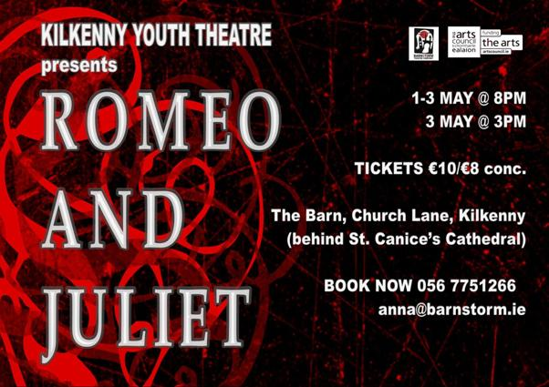

A tale of woe, a tale of joy, of love and hate, youth and age, life and death, Kilkenny Youth Theatre presents Shakespeare’s Romeo and Juliet from **Thurs 1st May to Sat 3rd May, 8pm nightly**, with a matinee on the Sat at The Barn, Church Lane, Kilkenny.

Tickets are **€10/€8 conc**., and can be booked at 056 7751266 or by emailing [anna@barnstorm.ie](http://kk-moss/Sites/arts_office/Shared%20Documents/Julianne%20Morgan/E-bulletin/4th%20April/anna@barnstorm.ie).

**___________________________________________________________________________**

**Rothe House & Gardens – Medieval Week 2014 (March 28th – April 6th) ‘Swords and Shields’**

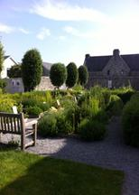

Date: **Saturday, 5th April**

Time: **10.30 - 12.30**

Price: **€8.50 per child**

A creative morning for children aged 5 to 12, where they will make and paint their own swords and shields which they can bring home at the end of the workshop.  Places are limited so please book by contacting 056 7722893 or emailing [info@rothehouse.com](mailto:info@rothehouse.com).  A non-refundable deposit of **€5** is required to be paid at time of booking.

Rothe House & Garden, Kilkenny

T: 056 7722893

M: 086 2321275

W: [www.rothehouse.com](http://kk-moss/Sites/arts_office/Shared%20Documents/Julianne%20Morgan/E-bulletin/E-bulletin%20-%207th%20March/www.rothehouse.com)

E:  [info@rothehouse.com](mailto:info@rothehouse.com)

**___________________________________________________________________________**

**Light Colour Sound Festival, 4th/5th July 2014**

[](http://www.lightcoloursoundfestival.com/lineup.php)

W: <http://www.lightcoloursoundfestival.com/>

**___________________________________________________________________________**

## Film Dinner 3/6 Series 2

## https://scontent-a-cdg.xx.fbcdn.net/hphotos-frc3/v/t1.0-9/10153929_10152375296429874_1203213840_n.jpg?oh=880cc28ce903769ec9106cfe2a7aaa14&oe=53AC01B8

## Date: 5th April, 6.30PM

Venue:Fennelly's, Upper Bridge St, Callan, co. Kilkenny

Price: **€30 per person**

Email: [FENNELLYSCALLAN@GMAIL.COM](mailto:FENNELLYSCALLAN@GMAIL.COM)

**___________________________________________________________________________**

## Mark Geary – Cleere’s theatre

## https://fbcdn-sphotos-b-a.akamaihd.net/hphotos-ak-prn2/t1.0-9/1621678_582182298529986_832932117_n.jpg

## Venue: Cleere’s theatre, Kilkenny

Date: **11th April 2014 - 21:30**

Tickets: On sale @ CLEERE'S bar or via 056 7762573

Mark Geary is a Dublin born musician who has split his time between Ireland and New York City over the last 20 years. He spent his early years performing in NYC at the famed Sin-e Café alongside other up and coming musicians, including friend Jeff Buckley, garnering respect and attention from both audiences and fellow artists.

For more info, see <http://cleeres.com/events/6614/mark-geary/>

F: <http://miniurl.com/7JUu>

**___________________________________________________________________________**

**Kilkenny Castle - The 'Book of Pottlerath' Exhibition of framed exerts**

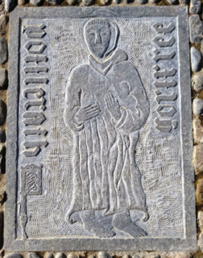

The ‘Book of Pottlerath’ is a rare and fascinating book, which forms a major part of Kilkenny’s past.  Today it lies in a vault at Oxford University in England.

'The Book of Pottlerath will be exhibited, free of charge to the public, at The Sallyport Cellar of Kilkenny Castle daily from **Friday 28th March – Sunday 6th April, 9:30am to 4:40pm**.

See more at [kilkennycastle.ie](http://www.kilkennycastle.ie/NewsEvents/Title,30328,en.html)

**___________________________________________________________________________**

**Library News**

City Library

Poets on Board:

Anyone wishing to submit poems for our May display can email them to [citylibrary@kilkennylibrary.ie](mailto:citylibrary@kilkennylibrary.ie) by **15th May.**

Craft Clubs:



**Tuesdays 6-8pm**

**Thursdays: 11-1pm.**

All are welcome, bring your project and work while socialising!

Exhibition space available:

Anyone interested in using our free exhibition space for paintings, photos, or suitable works of art can do so by contacting the branch on 056 779 4174.

Castlecomer library

Forbidden Screams ceramic exhibition:

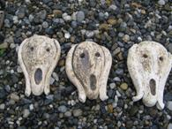

Date: **April 1 - 26**

An exhibition of Ceramic Masks by Gay Sampson. The artist is a Castlecomer native – Gay Kelly Sampson.

Talk ‘John McGahern Young and Old’ by Denis Sampson:

[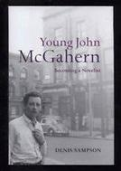](https://www.facebook.com/photo.php?fbid=688890347839924&set=a.193880444007586.52112.150354328360198&type=1&relevant_count=1)

Date: **Tuesday, 22nd April, 8pm**

Denis Sampson is the author of 4 books and is an authority on the writer John McGahern.

Rambling house night for Bealtaine

Date: **May 14th from 8pm**

A night of ceol and craic! If you are interested in participating please contact us.

Contact: Mary Morrissey

Email: [castlecomer@kilkennylibrary.ie](mailto:Castlecomer@kilkennylibrary.ie)

Thomastown library

Interested in joining our poetry circle in Thomastown library, please ring 056 7794331.

**___________________________________________________________________________**

**Butler Gallery**

[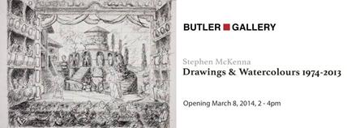](https://www.facebook.com/butlergallery/photos/gm.1414121812170682/10152250607864666/?type=1)

**March 8th – April 20th, 2014**

Opening hours: 10am – 1pm, 2pm – 4.30pm

This exhibition will be dedicated to the works on paper by Carlow based artist Stephen McKenna.

Read more at <http://www.butlergallery.com/>

Butler Gallery seeks workshop proposals for National Drawing Day 2014

Butler Gallery Kilkenny invites artists to submit workshop proposals for National Drawing Day 2014. Successful applicants will direct set-up before 12pm and run the workshop on **Saturday 17th May between 12pm-4pm.**  A fee will be paid to successful applicants.

We welcome proposals that encourage participation from a diverse age-range. Please email your proposal to Education Curator Bairbre-Ann Harkin at [bairbre.ann@butlergallery.com](mailto:bairbre.ann@butlergallery.com) by **5pm Friday 4th April**.  Emails should be marked ‘National Drawing Day 2014 Proposal’ in the subject bar and include the following;

Artist CV

Example of current work (link to website / media attached to email)

Outline of proposed activity

List of materials required and estimate of cost

For more information about National Drawing Day in Kilkenny, please see <http://vimeo.com/butlergallery> and [www.butlergallery.com](http://www.butlergallery.com). If you have any questions, contact Bairbre-Ann at [bairbre.ann@butlergallery.com](mailto:bairbre.ann@butlergallery.com) / 056 7761106.

**___________________________________________________________________________**

**What’s happening in the Watergate?**

### Watergate’s 21st birthday celebration - St. Patrick’s Brass & Reed band

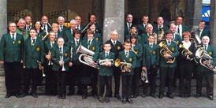

Date(s): **4th April**Time: lunchtime concert, **1:00 PM - 2:00 PM**

**Tickets:**  Free admission, Booking at 056 7761674 is strongly advised

To celebrate the 21st Birthday of the Watergate Theatre, St Patrick’s Brass and Reed Band will perform a Lunchtime Concert. Conductor Norman Cree.

Watergate’s 21st birthday celebration - Sue Nunn, KCLR

Date: **4th April**

Time: **10.00am – 2pm**

Sue Nunn will broadcast her KCLR programme, featuring a host of host of special guests, live from the theatre between **10.00am to 2pm.**

Michael Collins

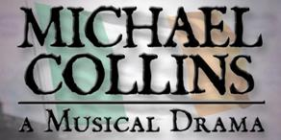

Date(s): **6th Apr 2014 until 12th Apr 2014**Time: **8:00 PM - 10:30 PM**

Tickets: **€18/€12**

Set against the backdrop of the War Of Independence, the treaty negotiations and ensuing civil war, Michael Collins -Musical Drama is a mesmerizing piece of musical theatre with rousing chorus numbers such as ‘Flag of Freedom’ as well as haunting ballads in particular ‘I’m Not That Man’.

### The Willis Clan

### The Willis Clan

Date(s): **20th Apr 2014**Time: **8:00 PM - 10:00 PM**

**Tickets: €12/€10**

The Willis Clan is a family band from Music City USA – Nashville, TN.  As regular performers on the legendary Grand Ole Opry they have shared the stage with country music superstars such as Carrie Underwood, Charlie Daniels, Vince Gill, Ricky Scaggs and many more.

View more at <http://watergatetheatre.com/>

Want tickets? Call the box office now on 056-7761674 or click here to book online: [https://www.ctb.ie/tickets/watergate/?shows=%](https://www.ctb.ie/tickets/watergate/?shows=%25)

Rehearsals for schools edition of Miss Saigon

[](http://watergatetheatre.com/miss-saigon-auditions/)

The Watergate Theatre Youth Productions will be holding auditions on **Tuesday, April 22nd** for the hit musical, Miss Saigon Schools Edition. The auditions will take place at the Watergate Theatre and begin with an induction session at **10am**, all are requested to be available **until 1pm, and again from 2pm until 4pm** for the auditions.

Read more at <http://watergatetheatre.com/miss-saigon-auditions/>

**___________________________________________________________________________**

**National craft gallery – INTERLACE**

**28th March 2014 – 7th May 2014**

Castle Yard, Kilkenny

Interlace is an exhibition which focuses on contemporary interpretations of lace. The concept of the show developed by the National Craft Gallery is to explore how traditional material culture creates a resonant source for contemporary practice.

For more info, please visit: <http://www.nationalcraftgallery.ie/exhibitions>

**Slow Art Day**

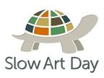

Date: **Sat 12th April, 2.30pm**

Venue: Butler Gallery continuing to National Craft Gallery, Kilkenny

‘It’s not what you look at that matters, it’s what you see.’  
Henry David Thoreau

The Louvre discovered that visitors look at the Mona Lisa for just 15 seconds on average!

This April, take your time and really look. [*International Slow Art Day*](http://www.nationalcraftgallery.ie/news/article/slow-art-day) on **12th April** encourages you to pause and find inspiration within a small selection of artworks for up to 10 minutes each. Afterwards visitors are invited to come together to discuss the experience over a coffee. The [National Craft Gallery](http://www.nationalcraftgallery.ie/), together with the [Butler Gallery](http://www.butlergallery.com/)**,**two of the country’s leading galleries in art, craft and design, invite you to take part in this year’s ***Slow Art Day***.

Read more at <http://miniurl.com/80YZ> or contact:Jane Pearson at National Craft Gallery on 056 7796151/ [events@nationalcraftgallery.ie](mailto:events@nationalcraftgallery.ie)

Masterclass: Contemporary Lace - Traditional Techniques & Innovation

[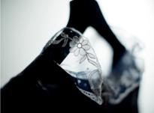](http://nationalcraftgallery.cmail3.com/t/y-l-illdlkl-jlklezkr-tj/)

Date: **Friday 25th April**

Time: **10.30 am**

Fee: **€20 / €10**

As part of the Interlace education programme, National Craft Gallery are delighted to offer a masterclass in contemporary lace and design, aimed at textile artists and lace makers.

Read more about the above events at <http://miniurl.com/7P2D>

For more information: [events@nationalcraftgallery.ie](mailto:events@nationalcraftgallery.ie) / 056 7796151

**___________________________________________________________________________**

**Music in Kilkenny presents Trio Rodin**

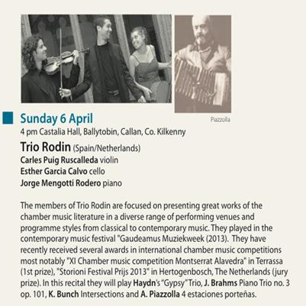

Tickets for all concerts: **€15.00** **(€10** concession)   
Season ticket: **€100.00**   
Further information:  
Susan Proud – 0861777017  
email: [mikilkenny@gmail.com](mailto:mikilkenny@gmail.com)

View more concerts at <http://www.musicinkilkenny.com/whats-on.html>

**___________________________________________________________________________**

**Ryan’s bar**

An exhibition of works by Michelle Mulhall & Caroline Kellaghan

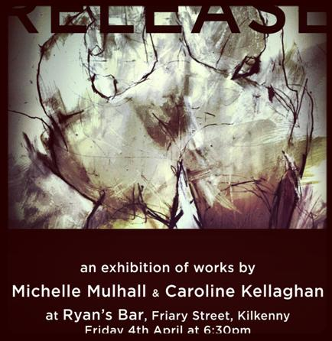

Date: **Friday, 4th April, 6:30pm**

Venue: Ryan’s bar

Sneaky Rinse

[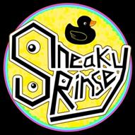](https://www.facebook.com/photo.php?fbid=444282242368957&set=a.444281399035708.1073741834.338156106314905&type=1&relevant_count=1)

Sneaky Rinse is a Kilkenny based blues, funk band. Made up of complete head cases.

Date: **Friday, 4th April,** **10:30pm**

Venue: Ryan’s bar

W: <http://ryanskilkenny.com/>

Facebook: <https://www.facebook.com/ryansbar>

**___________________________________________________________________________**

**Hole in the Wall – Singspiel**

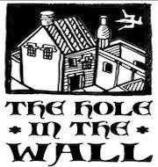

Friday Session

Date: **4th April, 10pm**

Singspiel - NO FOREVER BRIDE: Arise in Revolution (NFB)

Date: **April 24th, 9:00pm,**

Tickets: **€15** on door or from Hole in the Wall on weekends.

This is the story of Easter Monday 1916, as imagined from the British perspective. It explores the build-up to the Rising and the personal lives and loves of the patriots.

Ballad Session every Friday and most Saturdays **from 10.00pm**.

Call: 087 8075650

Facebook: <http://miniurl.com/7ilP>

W: <http://www.holeinthewall.ie/>

**___________________________________________________________________________**

**KCAT ART & STUDY CENTRE**

[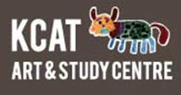](http://www.kcat.ie/)

Engagement project

KCAT Studio is calling for professional visual artists with a studio practice who are interested in participating in the Engagement project. Engagement will be a process driven project aiming to match individual KCAT Studio artists with fellow professionals working in Ireland to develop creative collaborative partnerships.

The project will develop over the next 3 years. Some partnerships may be as short as 10 weeks while others may last as long as both partners wish. If you are a visual Artists and interested in being involved please e-mail [studio@kcat.ie](mailto:studio@kcat.ie)

Contact KCAT Studio for further information on:

E-mail: [studio@kcat.ie](mailto:studio@kcat.ie)

W: [www.kcat.ie/studio](http://www.kcat.ie/studio)

00 353 56 7755115

4 day icon-painting course!

Venue:  KCAT Art & Study Centre

**Date: Mon 14th April – Thursday 17th April 2014**

Price: **€ 145** including materials, tea /coffee.    
Optional: Traditional wooden board **€50 extra**.  
Time: **9.30 am– 4.30pm**  
   
**To book your place contact KCAT**   
056 7755115 (Joan/Anja) or [info@kcat.ie](mailto:info@kcat.ie)  
Deposit **50 Euro** (non-refundable).

W: <http://www.kcat.ie/>

**___________________________________________________________________________**

**Art It at Macdonagh Junction - Medieval Week 2014**

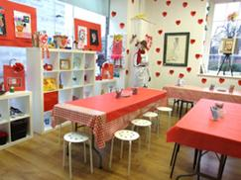

**Venue: Art It at Macdonagh Junction**

Dates: **Friday 28th March - Sunday 6th April (Each Day)**

Price: **€9.50 per child**

Art It at MacDonagh Junction Shopping centre will be running circa hour long medieval craft drop-in workshops.

CONTACT

T: +353 56 7777600  
E: [info@macdonaghjunction.com](mailto:info@macdonaghjunction.com)  
Facebook: [facebook.com/Art-It-Kilkenny](https://www.facebook.com/pages/Art-It-Kilkenny/515977515080472)  
Open Tuesday – Sunday.

**___________________________________________________________________________**

**Upcoming Classes at Blackstack Studio**



Blackstack Studio, 42 Parliament St., Kilkenny

 WEEKEND WORKSHOPS

* Screenprinting (Weekend **12th & 13th April. 10am-4pm,** €160)
* Collograph Printing (**Weekend 5th & 6th April 10am-4pm,** €160)
* Non-Toxic Etching (**Weekend 26th & 27th April. 10am-4pm,** €160)

SATURDAY WORKSHOPS

* Bookbinding II – Continuation (**Saturday 24th May. 10am-4pm,** €80)
* Printmaking for Teachers (**Saturday 10th May & Saturday 17th May,** €160)

Bookings can be made on the website [www.blackstackstudio.com](http://www.blackstackstudio.com) or by emailing [sylvia@blackstackstudio.com](http://kk-moss/Sites/arts_office/Shared%20Documents/Julianne%20Morgan/E-bulletin/21st%20March/sylvia@blackstackstudio.com) . If you have a group of 3 or 4 people we can also arrange a special workshop to suit you - email Sylvia at the above address.

More info about the above workshops at <http://miniurl.com/7vXo>

**___________________________________________________________________________**

**Set Dancing - Urlingford**

Set dancing continues in the Parochial Hall in Urlingford on Monday nights from **8.15pm – 10.30pm.**

**___________________________________________________________________________**

**Life drawing classes**

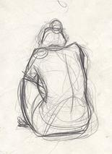

Thursday night at the Maltings, off James Street.

Fee: **€100 for ten 2hr sessions or €15 on the night**

If interested, please contact Roger O’Reilly on 086 2640967

**___________________________________________________________________________**

**Kilkenny film club - Le Week-End**

[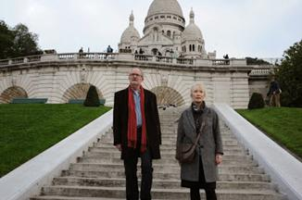](http://1.bp.blogspot.com/-fdMEYtgU9HY/UrMtlxkn3lI/AAAAAAAAAKM/H1VIDXOB0go/s1600/Le+Weekend+2.jpeg)

Venue: The Set Theatre, John St, Kilkenny

Date: **Tuesday, April 15th**

Seasonal membership (including admission to 8 films): **€48**

Single film membership: **€8**

Jim Broadbent and Lindsay Duncan play Nick and Meg Burrows, a philosophy lecturer and a biology teacher who return to Paris thirty years after their honeymoon to see what has changed. The answer, of course, is them.

Membership and tickets are available at the venue from **7.30pm** on the evening. Films begin at **8.00pm**.

See more at <http://www.kilkennyfilmclub.com/>

Further enquiries, contact Steve Cullen on 086 1217211

**___________________________________________________________________________**

**Creative writing – Callan**



A Creative writing group takes place in Droichead FRC **every Friday at 10.30am**. A talented writer will facilitate the group. All participates must pay **€2 per session**.

**___________________________________________________________________________**

**St Raphael's Creative & Healing Arts Centre in Bennettsbridge (across from the grotto, above the auctioneers) – Spring Workshops**

[](https://www.facebook.com/St.RaphaelsCentre/photos/a.1385605661713814.1073741827.1385588021715578/1385605378380509/?type=1)

**Saturday 5th April 10:30 to 3:30, €20, 'Tell Your Story - Poetry for Beginners' with Michael Massey**

To write poetry is to tell your side of the story –what it’s like to be you...how you see the world.Through a variety of writing and reading activities, we will create a reservoir of beginnings – writings to take away and nourish into fully-fledged poems. To ensure your place on the day ring: 0857765927.

**Friday 25th April, 10-5pm, €60, 'Family Sculpting Experience'** Presented by Janet E Sahafi, author and psychodramatist. This workshop is a way of understanding family dynamics without the family present through three dimensional living sculptures.

Centre is only open during events: For More Information ring 086-3401833

**___________________________________________________________________________**

**Grennan Mill Craft School - Summer Courses 2014**

**[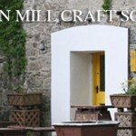](http://www.thomastownparish.ie/wp-content/uploads/2013/04/Grennan-Mill-Craft-School.jpg)**

Introduction to Hand Made Printmaking suitable for Beginners & Improvers

**Wednesday 25th June** – Mono printing from glass slabs

**Thursday 26th June** – Mono printing from woodblocks

**Friday 27th and Saturday 28th June** – Collagraph (printing from a collage)

All classes run from 10am – 5pm

Course Fee: One day **€75** / Two days **€150** / Three days **€165** / Four days **€200**

Enamelling & Silver Jewellery for Beginners & Improvers

**Thurs 26th - Sat 28th June** / **10am-5pm**

Course Fee: **€160**

Materials Fee **€25** - includes 10grms silver, enamels, copper, solders & sundries.

Metalcraft for Beginners & Improvers

**Mon 30th June - Thurs 3rd July / 10am-4pm**

Minimum 6 – Maximum 9 persons

Course Fee: **€170**

Materials Fee**: €15** - includes copper & gilding metal, enamels, solders & sundries.

**For all summer courses:**

Application Forms available from Grennan Mill Craft School, Mill Street, Thomastown, Co Kilkenny

**Completed application form and non-refundable deposit of €50.00 are required by:**  
**Friday 30th May for ALL courses**  
• Cheques made payable to ‘Grennan Mill Craft School’  
• Class formation is dependent on an adequate number of applicants – usually 10 participants necessary  
• Should Grennan Mill cancel the course, your monies will be refunded in full

**For further details: Tel: (056) 7724557** [grennanmill@eircom.net](mailto:grennanmill@eircom.net)

**Courses / Training / Jobs**

**___________________________________________________________________________**

**Craft Workshop on Valencia Island, Co. Kerry**

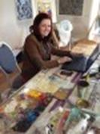

Dates: **Friday to Monday May Bank Holiday 2014**  
Time: Exact time TBC – Friday afternoon to lunchtime Monday.  
Venue: Knightstown, Valencia Island, Co. Kerry  
Price: **€260**  
Fee does not include materials, food or accommodation.

Four days of craft and technique balanced with inspiration and creativity with painting and hands on practical exercises.

For full details on the workshop, please visit: [www.roisinofarrell.com](http://kk-moss/Sites/arts_office/Shared%20Documents/Julianne%20Morgan/E-bulletin/4th%20April/www.roisinofarrell.com)

**___________________________________________________________________________**

**Events and Hospitality Manager – VISUAL**

[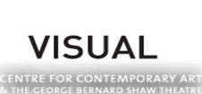](http://www.visualcarlow.ie/)

VISUAL is seeking an Events and Hospitality Manager.

**Closing date for receipt of applications: 5pm on Friday 4th April**

For job specification and further information please contact [info(at)visualcarlow.ie](javascript:linkTo_UnCryptMailto('nbjmup+jogpAwjtvbmdbsmpx/jf');)

Download from <http://www.visualcarlow.ie/about/opportunities>

**___________________________________________________________________________**

# Last chance to sign up! ****Thinking of applying for funding to Tour?****

**These workshops are for YOU.**

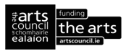

Considering making an application under The Arts Council's **'Touring and dissemination of work'** scheme? (**Next deadline, May 8th, 2014**).

Sign up **NOW**for these workshops and**learn all about the scheme, including how to set audience targets for your application. There will also be a case study presentation.**

Kilkenny, Langton’s hotel, Monday, **April 7th, 1:30 – 4:30**.  Click [here](https://www.surveymonkey.com/s/VHC25D3)

Dublin, Abbey theatre, Tuesday, **April 8th, 1:30 – 4:30**. Click [here](https://www.surveymonkey.com/s/6GB2PH9)

**Spaces are limited, so apply today**, at <http://miniurl.com/7wXo>

Gillian Clarke

Phone: 01 677 2255

Web: [www.artsaudiences.ie](http://www.artsaudiences.ie)

Follow us on Twitter: <https://twitter.com/#!/Arts_Audiences>

Sign up to our mailing list by contacting: [gclarke@templebar.ie](mailto:gclarke@templebar.ie)

Sign up for our RSS feed: artsaudiences.ie/feed/

**___________________________________________________________________________**

**How We Learn** – **a seminar discussing approaches to visual art in education**

[](http://www.belfastexposed.org/)

**Venue:** Belfast Exposed Gallery, Donegal St, Belfast

Date: Wed**. 30th April**, (14.00 - 16.00)

Places:  30+

FREE

The seminiar is scheduled to happen in conjunction with the BX exhibition *How we Learn*.  Presenters Include: The Mobile Art School; artist Marysa Dowling and Annie Bicknell - TATE, Art Exchange a network for Teachers, Artists and Schools.  *How We Learn* is supported by Paul Hamlyn Foundation and will coincide with the first Belfast Children's Photography Festival.

To register and for info see: [http://www.belfastexposed.org/exhibition/How_We_Learn](http://lists.visualartists.ie/lt.php?c=1104&m=4144&nl=1&s=e97e60e0a85e4e4156f0ad241cfbea58&lid=81413&l=-http--www.belfastexposed.org/exhibition/How_We_Learn)

**___________________________________________________________________________**

**Draíocht Workshops**

Watercolour & Pastels For Beginners with Jenny Cleary



  Venue: Draíocht Workshop Room

  Date: **Wed 30 Apr - Wed 4 Jun 2014**

  Time: **WEDNESDAYS, 2PM-4.30PM**  
**6 WEEKS / 30 APRIL-04 JUNE 2014**

  Course Fee **€65** / **€50** conc / **€35** OAP (includes materials)  
  In these classes we will go through the basic techniques of watercolour and pastels.

  Limited Availability

Discover Theatre: Feel & See Costumes for Theatre

Theatre Talks and Workshops for 14-18 year olds

Venue: Draíocht

Date: **Sun 27th April 2014**

Time: **12PM-2PM**

ADMISSION: **fREE**

This is a chance to find out more about Theatre. Each session will be a mixture of games, improvisation, voice works, technical theatre, working from scripts and production talks.

Bodhrán Taster Course with Walton’s John Sweeney

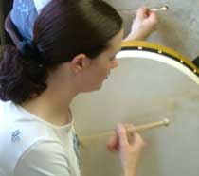

Venue: Draíocht Workshop Room

Date: **Thu 1 May - Thu 5 Jun 2014**

 Time: **6.30PM-7.30PM**

Course Fee: **€90 / €75 conc / €60 OAP.** Course fee includes your Bodhrán and Beater.

**6 WEEKS / 01 MAY-05 JUNE 2014**  
  
The bodhrán, a wood and goatskin drum beaten with a wooden stick, is the heartbeat of Irish music - and great fun to play! You will learn the main rhythms of traditional Irish music in this course – including reels and jigs – but we won’t stop there!

Booking through Draíocht’s Box Office on 01-885 2622 or email [emer@draiocht.ie](http://kk-moss/Sites/arts_office/Shared%20Documents/Julianne%20Morgan/E-bulletin/4th%20April/emer@draiocht.ie). Limited availability for above workshops.

Read more at <http://www.draiocht.ie/events/category/classes>

**___________________________________________________________________________**

**Performance Art Workshop Kira O'Reilly, Fire Station Artists Studios**

[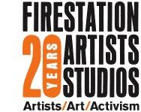](http://www.firestation.ie/)

Date: **22nd & 23rd May 2014**Time: **10am - 5pm**  
Venue: Fire Station Artists' Studios

Cost: **€90** (includes lunch on both days)

10 places  
  
Kira O'Reilly is a UK based artist; her practice, both wilfully interdisciplinary and entirely undisciplined, stems from a visual art background; it employs performance, biotechnical practices and writing with which to consider speculative reconfigurations around The Body.

"In this workshop we shall attempt to encourage slips and slipperiness. So there might be movements across drawing, writing, walking, moving, placing, as well as learning exercise that enhance our extended awareness from out physicality."

More info at <http://www.firestation.ie/skills/schedule/category/masterclass/>

[kiraoreilly.com/blog/](http://www.kiraoreilly.com/blog/)

[Download Booking Form](http://www.firestation.ie/content/files/Booking_form_Kira_OReilly_Workshop.doc)

**___________________________________________________________________________**

**The Wheel Training Calendar 2014**

[](http://www.wheel.ie/)

We have created an interesting and varied calendar of training events for 2014, covering our regular fields such as governance, social media, HR events and risk management. We're also continuing our popular CEO's Forums and introducing new fundraising workshops and time management seminars.

Please click on the link below to read more or to book your place online.  
[The Wheel Training Calendar 2014](http://www.wheel.ie/content/training-events-calendar-2011)

**___________________________________________________________________________**

**Darklight Festival: Call for Volunteers**

[](http://www.darklight.ie/)

We are now enrolling volunteers to be part of this year's Darklight - Festival of Independent Creativity, taking place in venues across Smithfield, 24 - 27 April. Meet like-minded people, learn new skills and get to experience Darklight from behind the scenes. This will be a fun and film-fueled four days, packed with screenings, workshops, panel discussions, parties and games! Let us know your skills be it in technical support, customer service or being a very fast runner!

For a Volunteer Application Form email: [info@darklight.ie](mailto:info@darklight.ie)

Team Darklight  
[www.darklight.ie](http://www.darklight.ie)  
facebook.com/darklightfestival  
twitter.com/darklightfest

## Region:

Dublin

**___________________________________________________________________________**

# Fingal Film Festival Are Seeking for Volunteers for 2014



If you have a couple of days to spare a week for the next couple of months and are dedicated to Media, we are looking for enthusiastic , with some experience in production, for this years Fingal Film Festival 2014. Please apply with CV to the following email: [info@fingalfilmfest.com](mailto:info@fingalfilmfest.com) also check out our volunteers’ page on our website [www.fingalfilmfest.com](http://www.fingalfilmfest.com)

**Closing date 11th April 2014**

Read more at <http://miniurl.com/7H6T>

**___________________________________________________________________________**

**The Arts Council: Procurement of Arts Advisers**

[](http://etenders.gov.ie/)

The Arts Council wishes to procure the services of a number of Arts Advisers to meet the needs of the organisation both from a quality and service delivery perspective. The art form areas to which this relates are: Arts Participation; Dance; Irish Language Literature; English Language Literature; Public Art; Visual Arts; Young People Children and Education.

Application for each of these contracts is exclusively by a public tender process offered via the eTenders procurement website on **Monday 7th April**: [www.etenders.gov.ie](http://lists.visualartists.ie/lt.php?c=1036&m=4076&nl=1&s=d3c261c0eeb6b48867f449d29e09414b&lid=82663&l=-http--www.etenders.gov.ie).

All proposals should be submitted by **Monday 28th April 2014**.

Read more at <http://miniurl.com/7YAF>

**___________________________________________________________________________**

**Upstart Project Coordinator Internships, now available in Arts Coordination, Community Engagement, Site Build**

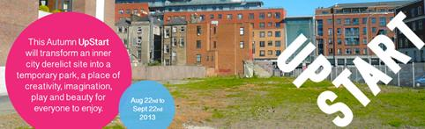

The intern will work alongside the Upstart core group and other stakeholders to help realise the vision for the 2013 Pop-Up Park. This internship will provide valuable insight, practical skills and experience for an individual who wants to expand their skills in project development.

**Deadline Ongoing**

Positions starting immediately

1st Information Session scheduled for **15th July 10.30am** on Parnell Street

Please apply to [helpout@upstart.ie](http://kk-moss/Sites/arts_office/Shared%20Documents/Julianne%20Morgan/E-bulletin/4th%20April/helpout@upstart.ie) with your CV and a one-page cover letter us why you want to be an Upstart Intern.

Find Upstart on Facebook, visit [www.upstart.ie](http://kk-moss/Sites/arts_office/Shared%20Documents/Julianne%20Morgan/E-bulletin/4th%20April/www.upstart.ie) or call a member of the Upstart Core Team on 0871252184.

[download job spec](http://artsireland.files.wordpress.com/2007/08/upstart-internship-spec-2013.doc) here

**___________________________________________________________________________**

**Set Dancing Classes: dance class in Marino/Drumcondra, Dublin City North, Griffith Avenue / Bus 123**

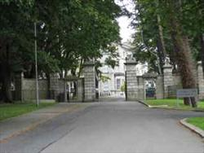

Date: **9th Apr 2014 (Wed) from 20:00 - 22:00**Date: **16th Apr 2014 (Wed) from 20:00 - 22:00**  
Come along and try out Irish set dancing. No experienced required, people who never danced before are especially welcome.

For more information and directions, please click on the link: <http://www.ceili.ie/wednesday/>

**___________________________________________________________________________**

**Dublin City Council Arts Office – call for artists**

[](http://etenders.gov.ie/)

“Dublin City Council Arts Office is currently seeking enthusiastic, motivated and skilled artists to join their Artists’ Panel for 2014.  This call is now advertised on the eTenders website.

The deadline for receipt of applications is **Thursday 17th April at 12 noon** and potential applicants must register on eTenders ([www.etender.gov.ie](http://www.etender.gov.ie)) to obtain application documentation.”

**___________________________________________________________________________**

**Administration Manager (Part-Time)**

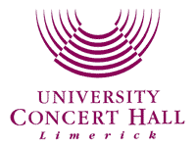

As the largest live performance venue in the Mid West region, University Concert Hall Limerick hosts some of the biggest names in music, comedy and musical theatre.  
Applications are now invited for a part-time Administration Manager role (Maternity Cover).

**Closing Date Monday 14th April 2014**

For more information go to www.uch.ie

**___________________________________________________________________________**

### Big Smoke Writing Factory – Courses and Workshops

### http://bigsmokewritingfactory.com/bigsmokelogo_border.jpg

[Introduction to Writing Speculative Fiction](http://clicks.aweber.com/y/ct/?l=BjhQw&m=3VrWhKAS0yEc6a0&b=dtVOXwPAqk3VmgW4dmKEHw)

Date: **TUESDAYS, starting 8th April 2014, (6 weeks), 6.30pm-8.30pm**

Fee: **€150**

Facilitator: [John Kenny](http://www.bigsmokewritingfactory.com/About_John.php)

[Write The Play workshop](http://www.bigsmokewritingfactory.com/Courses_playworkshop.php)   
Date: **THURSDAYS, starting 24th April 2014, (6 weeks), 6.30pm-8.30pm**

Fee: **€150**

Facilitator: [Jessica Traynor](http://www.bigsmokewritingfactory.com/About_Jessica.php)

[Creative Writing [drop in]](http://www.bigsmokewritingfactory.com/Courses_dropin.php)   
**MONDAYS** (ongoing), **6.30pm-7.30pm**

Fee: **€15** per class

More info about the above workshops at<http://miniurl.com/7K6i>

Click to view available [online courses](http://www.bigsmokewritingfactory.com/OnlineCourses.php) **Contact details:**[bigsmokewritingfactory@gmail.com](http://kk-moss/Sites/arts_office/Shared%20Documents/Julianne%20Morgan/E-bulletin/21st%20March/bigsmokewritingfactory@gmail.com)or over the phone at 087-976-6253

**___________________________________________________________________________**

**Asymmetrical Participation & Digital Collaborations**  
**Artist workshop by Blast Theory**

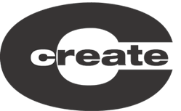  
  
Date: **25th April, 1-day workshop**   
Time:  **10.00 - 17.00**   
Venue: Science Gallery, Dublin  
Price:  **€30** non-members / **€25** Create members  
  
Create and Live Collision, in partnership with The Lab - Dublin City Arts Office and the Lir, Ireland's National Academy of Dramatic Arts with the support of  British Council Ireland and the Science Gallery, are delighted to announce a unique workshop opportunity for artists led by internationally renowned artists Blast Theory.      
  
The workshop will be practical in nature and provide an insight into creating strategies for engaging in meaningful collaborations and dialogues through technology.

More info and Booking at <http://miniurl.com/7HjR>

**___________________________________________________________________________**

**Cúirt International Festival of Literature 2014**

[http://www.cuirt.ie/images/logo-sml.png](http://www.cuirt.ie/)

Editing workshop

Venue: HOTEL MEYRICK, Eyre square, Galway

Date: **THURS 10TH APRIL, 10:00AM - 12NOON**

ADMISSION: **€24**

Join one of literature’s most respected poetry editors for a two-hour session on editing with Q&A. Neil will cover editing poems for a collection, offering perspectives of interest to both writers and readers.

Telling stories in a digital world with Julian Gough

Venue: HOTEL MEYRICK, Eyre square, Galway

Date: **Friday 11th April, 10:00AM - 12NOON**

ADMISSION: **€24**

This workshop will explore what this transition to digital means for the writer who wants to tell a story, and find an audience for it.

Town Hall Theatre Box Office is open to personal callers at: Courthouse Square, Galway

**Monday - Saturday 10am - 7.30pm**

Phone: 091 569777(during above hours)

Visa, Access, Mastercard and Laser are accepted.

*Telephone and personal bookings are subject to Town Hall Theatre refurbishment charge of 50cent per ticket.

Discounts apply for groups of eight or more.

Please contact 091 569777 for assistance.

Read more at <http://www.cuirt.ie/en>

**___________________________________________________________________________**

**Brewery lane theatre writers’ weekend, April 11th – 13th 2014**

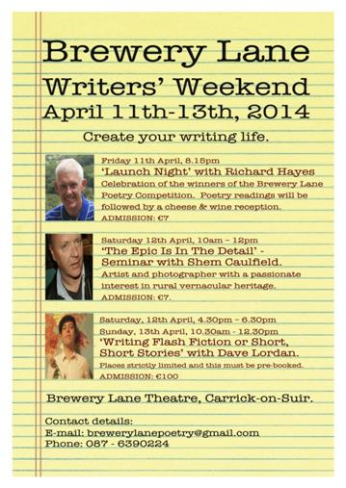

There will be writing workshops, poetry night, a seminar, film screening, writers' dinner etc. Writers can choose to book for the full weekend (places limited for Dave Lordan, this must be pre-booked) or attend one or two events.

Booking Details:The fee for the full weekend (excl. accommodation & Sat. evening dinner) is **€100**. This needs to be pre-booked with a non-refundable deposit of **€40** and balance to be paid by **Friday, April 4th**.  Enquiries by email to [brewerylanepoetry@gmail.com](mailto:brewerylanepoetry@gmail.com)

Read the weekend itinerary at <http://brewerylanetheatre.com/?page_id=3266>

Poetry awards

The poetry competition is run in conjunction with the 2014 Brewery Lane Writers' Weekend. The poetry awards will be presented on the opening night. View 2014 winning entries at <http://miniurl.com/882G>

**___________________________________________________________________________**

**GET TOGETHER 2014 – Bookings are now open!**



Venue: IMMA

Date: **Friday, 23rd May**

We're back with our annual day-long event of networking, talks, presentations and learning for visual artists, art groups and organisations at Get Together 2014 generously hosted by The Irish Museum of Modern Art. The event will comprise briefing sessions, artists' talks, speed curating, critical writing, show & tell, The Common Room Café, and much more....

Check our [Get Together pages](http://lists.visualartists.ie/lt.php?c=1114&m=4154&nl=1&s=d3c261c0eeb6b48867f449d29e09414b&lid=82893&l=-http--visualartists.ie/visual-artists-ireland/130750-2/) for more details on the individual events and don't miss out of what always proves to be an exciting and active day.

The detailed programme with times will be published one week before the event in case you want to dip in and out of the day.

Bookings open at <http://visualartists.ie/visual-artists-ireland/130750-2/book-now/>

**___________________________________________________________________________**

**Board Members Helium - Board Member Position Available – Financial**

[](http://www.helium.ie/)  
Helium Arts is looking for a new board member with significant financial management/ accounting experience to provide direction and guidance to the board in relation to financial management; matters including annual accounts, budgeting, and reporting to funders. The board member must also have an understanding of the not-for-profit and arts sectors. All board members should undertake to be involved in the organisation's current and future fundraising activities in consultation with the CEO. This is a voluntary position.   
  
 For further information and an application form please contact [anna@helium.ie](mailto:anna@helium.ie)

**___________________________________________________________________________**

**Digital Illustration Workshop at Fumbally Exchange**



Digital Illustration Workshop (using Adobe Photoshop and Illustrator) taking place in the Fumbally Exchange, 5 Dame Lane, Dublin 2, **for 3 Saturdays, May 10th, 17th & 24th**, with Melissa Doran | Go Radiate.

The Digital Illustration workshop is a unique opportunity for artists and architects to help develop their digital graphic skills.

Full details (class breakdown, FAQ and testimonials) and booking here: <http://goradiate.ie/training/digital-illustration>

**___________________________________________________________________________**

**Call for Submissions / Residencies**

**___________________________________________________________________________**

**Galway Ensemble in Residence: ConTempo Quartet**

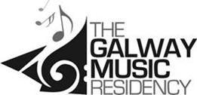

Spend One Year Fine-Tuning Musical Skills with The Galway Ensemble in Residence:

ConTempo Quartet

**The Galway Music Residency** is calling musicians interested in becoming its Apprentice Ensemble 2014-15 to submit applications.  Now in its 8th year, the apprentice ensemble programme offers a group of musicians free dedicated tuition time with the world renowned Galway Ensemble in Residence: ConTempo Quartet.

**Closing date for the Apprentice Ensemble Scheme is 11th April 2014** with auditions happening in Galway the following week. The Application form is available on the website at [www.thegalwaymusicresidency.ie](http://www.thegalwaymusicresidency.ie/) or by email.  For further information call + 353 91 586706 or send an email to [info@thegalwaymusicresidency.ie](mailto:info@thegalwaymusicresidency.ie)

**___________________________________________________________________________**

**4-Week Creative Residency in Russia for Dancers, Actors and Contemporary Circus Performers  
September 8 - October 6, 2014**

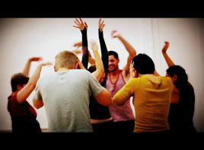  
  
The project mission is to create the **"live creation platform"** and the fascinating encounter of artists from diverse artistic backgrounds and techniques in multicultural and multilingual artistic environment. The programme includes practical training, rehearsals and the intensive creative process on the way to the **performance/work-in-progress**.  
  
For programme and application details, please visit<http://www.stagedirectorslab.org/4weekresidency>

**___________________________________________________________________________**

**Bealtaine Festival Exhibition Open Call 2014**

[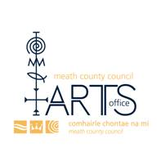](http://www.meathartsgroup.com/wp/wp-content/uploads/2013/09/image001.jpg)  
  
Deadline: **10th April**  
Email: [artsoffice@meathcoco.ie](http://kk-moss/Sites/arts_office/Shared%20Documents/Julianne%20Morgan/E-bulletin/4th%20April/artsoffice@meathcoco.ie)  
  
Each May, Meath County Council Arts Office runs an extensive, creative Bealtaine Festival that celebrates creativity as we age. The theme of this year's festival is "And Catch the Heart off Guard" from Postscript by Seamus Heaney. This exhibition will be held in the Toradh Gallery, Ashbourne Library and Cultural Centre **from May 13th - June 3rd**. Up to two pieces of art work may be submitted for consideration and must be delivered to the Toradh Gallery, Ashbourne Library and Cultura Centre on **Thursday April 10th 2014** from **10am - 4 pm.**  
  
For more information on how to submit your work for consideration contact Meath County Council Arts Office on 046 9097414.

More info at <http://miniurl.com/7Hd9>   
**___________________________________________________________________________**

**Wicklow County Arts Office & Mermaid Arts Centre Thinking Visual**

[](http://www.mermaidartscentre.ie/)

Deadline: **11th April, 2014 @ 12 Noon**

Wicklow County Arts Office and Mermaid Arts Centre would like to invite visual arts practitioners working in any medium to submit for a residency opportunity. The successful practitioner will become artist-in-residence at Blessington Community College, Blessington, County Wicklow over a four month period from September to December 2014.

More info and application details at <http://miniurl.com/7He1>

Email Maria on [mckinneymaria@googlemail.com](mailto:mckinneymaria@googlemail.com?subject=Thinking%20Visual)

**___________________________________________________________________________**

***The Moth* Short Story Prize 2014**

[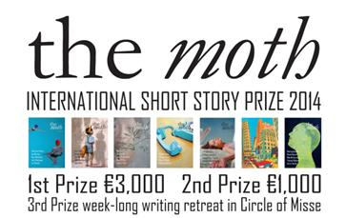](http://shortstopsuk.files.wordpress.com/2014/01/shor.jpg)

*The Moth* Short Story Prize is sponsored by the arts & literature magazine *The Moth*, recently described by the novelist David Mitchell as ‘a beautiful creature’. The competition has become a fixture on the international writing calendar, and this year the first and second prizes have increased to **€3,000 and €1,000**. There is also a very attractive third prize of a week-long writing retreat at Circle of Misse in France. The Circle of Misse house rests on the banks of the Thouet River, a tributary of the Loire. Circle of Misse will kindly **pay €250** towards travel expenses.

**The closing date for the competition is 30th June 2014.**

For details of how to enter the competition go to [www.themothmagazine.com](http://www.themothmagazine.com), email enquiries@themothmagazine.com or call 00 353 49 4362677.

**___________________________________________________________________________**

**ICCL Human Rights Film Festival – call for submissions**

[](http://www.flickr.com/photos/63083264@N05/11403895716/)  
  
Founded in 2009, the ICCL Human Rights Film Awards is Ireland's first and only short film awards dedicated to human rights. A full application pack can be downloaded [HERE](http://www.humanrightsfilmawards.org/easyedit/files/2014%20Application%20pack%20-%20rules%20+%20Checklist%20+%20form%2016.12.13.pdf).  
  
Deadline: **Monday, 14th April 2014**Website: <http://www.humanrightsfilmawards.org/>  
Email: [info@iccl.ie](mailto:info@iccl.ie)   
**___________________________________________________________________________**

**DIY 11: 2014 Call for proposals**

[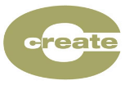](http://www.create-ireland.ie/)  
  
Create is absolutely delighted to be working in partnership with the Live Art Development Agency on  DIY 11 a scheme for  professional development FOR artists LED BY artists.   
  
This year Create in a full partnership with LADA, offering Irish artists an opportunity to be involved in DIY11. Professional development projects BY artists FOR artists. DIY is an opportunity for artists working in Live Art to conceive and run unusual training and professional development projects for other artists.

Deadline: **Tuesday April 29th, 2014 at Noon**

All details and links to online application form on LADA website can be found on Create website <http://is.gd/0zGIu7>

[Download further details and guidelines](http://www.create-ireland.ie/images/Docs/DIY%2011_call_for_proposals_brief.docx)  
For more information please contact Patrick Fox, [director@create-ireland.ie](mailto:director@create-ireland.ie) or phone 01-4736600

**___________________________________________________________________________**

**Tomcat Street Festival - Call for Artists!!**

[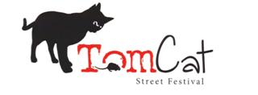](https://www.facebook.com/TomcatStreetFestival/photos/a.437274926365632.1073741827.437001733059618/437274933032298/?type=1)The call is open to both established and emerging artists. Please send your proposal, up to 3 images and your CV to submissions@tomcat.ie  
  
Deadline: Midnight, Monday, 14th April, 2014  
  
For more information contact submissions@tomcat.ie  
[www.facebook.com/TomcatStreetFestival](https://www.facebook.com/TomcatStreetFestival)We are looking for expressions of interest on the theme of Curiosity in the areas of visual and multimedia artists, including photography, sculpture, painting, video, performance, and the socially engaged as well as poetry, theater and dance. We also welcome ideas on artists’ talks, creative workshops and multidisciplinary seminars.We are looking for expressions of interest on the theme of Curiosity in the areas of visual and multimedia artists, including photography, sculpture, painting, video, performance, and the socially engaged as well as poetry, theater and dance. We also welcome ideas on artists’ talks, creative workshops and multidisciplinary seminars.

We are looking for expressions of interest on the theme of curiosity in the areas of visual and multimedia artists, including photography, sculpture, painting, video, performance, and the socially engaged as well as poetry, theatre, dance. We also welcome ideas on artists’ talks, creative workshops and multidisciplinary seminars.

**Deadline: Midnight, Monday, 14th April, 2014**

The call is open to both established and emerging artists. Please send your proposal, up to three images and your CV to [submissions@tomcat.ie](http://kk-moss/Sites/arts_office/Shared%20Documents/Julianne%20Morgan/E-bulletin/4th%20April/submissions@tomcat.ie)

Facebook: [www.facebook.com/TomcatStreetFestival](http://www.facebook.com/TomcatStreetFestival)

**___________________________________________________________________________**

# National Gallery and Hennessy Announce: The Hennessy Portrait Prize



The Hennessy Portrait Prize is a new competition which will celebrate the richness and diversity of portraiture and encourage public interest in the work of contemporary artists.

The winning artist will receive a prize of **€15,000** plus a commission worth **€5,000** to produce a portrait of an Irish sitter for inclusion in the National Portrait Collection.

**Deadline: Thursday 31st July 2014**

For full details see:  <http://miniurl.com/7pYZ>

**___________________________________________________________________________**

## [JW3 Artists’ Film Salon | Call for Submissions](http://visualartists.ie/jobs-ops/opportunities-international/jw3-artists-film-salon-call-for-submissions/)

jw3

Calling filmmakers and all curious film fans! Our new film club is an opportunity to experience contemporary, cutting edge artists’ moving image from short films to video art at London’s newest independent cinema, housed at JW3.

If you are a filmmaker or artist creating short films, video art or any other type of artists’ moving image, submit your work to be shown on the big screen in our plush boutique 60 seater cinema. Each evening will feature an informal talk from an artist – filmmaker with a different perspective to share on the world of artists’ moving image.

Please submit to [cinema@jw3.org.uk](http://kk-moss/Sites/arts_office/Shared%20Documents/Julianne%20Morgan/E-bulletin/4th%20April/cinema@jw3.org.uk)

Read more at <http://visualartists.ie/category/jobs-ops/>

[www.jw3.org.uk](http://www.jw3.org.uk)

**___________________________________________________________________________**

**‘Encircling Worlds: Imagining Irish Suburbia’ – call for papers**

Carlow College and VISUAL Centre for Contemporary Art

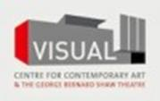

This conference seeks to explore how Irish writers and artists have consciously responded to the evolution of the Irish suburb and also how the changed nature of the Irish suburb has placed new demands and pressures upon Irish cultural and artistic forms.

**Closing date for receipt of proposals: 30th May, 2014**

Please send proposals of 200-250 words and a brief biography to the following email address: [risbcarlow@gmail.com](mailto:risbcarlow@gmail.com)

More info and application details at <http://miniurl.com/85qa>

**___________________________________________________________________________**

**Residency at Bathouse Studio, Coney Island | Call for Applications**

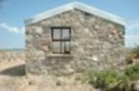

Bathouse Studio, Coney Island, Sligo Bay

Two Residency places available for 1- 2 weeks.

Tuition, critique sessions with Artist Neal Greig.

Shared Accommodation in the Lodge, full access to studio.

Supplement for companion. Lunch and refreshments.

Residency Dates 2014  
**9 – 16 May  
16 – 23 May  
23 – 30 May  
6 – 13 June  
20 – 27 June  
12 – 19 September  
19 – 26 September  
26 – 3 October  
10 – 17 October**

For an information sheet, please email: [eileenferguson5@gmail.com](http://kk-moss/Sites/arts_office/Shared%20Documents/Julianne%20Morgan/E-bulletin/4th%20April/eileenferguson5@gmail.com)

W: [www.nealgreig.com](http://www.nealgreig.com)

Read more at <http://miniurl.com/caaU>

**___________________________________________________________________________**

**Yeats Day 2014 – open call for submissions**

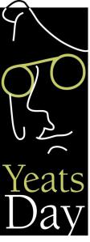

William Butler Yeats was one of the most important poets of the 20th century. We are inviting artists and admirers of Yeat's work around the world to send a self designed postcard artwork to help celebrate Yeats Day 2014.   
  
**The closing date for receipt of submissions is 30th May 2014.**

The [blog](http://happybirthdaymisteryeats.wordpress.com/) will be used to display contributions as well as an exhibition space in Sligo.

There is also a [Facebook page](https://www.facebook.com/HappyBirthdayMisterYeats) for the project which is updated regularly.

If you have any queries please do not hesitate to contact us at medbhgillard@hotmail.com paulmurray51@eircom.net or via the Blog or Facebook pages.

More info at <http://happybirthdaymisteryeats.wordpress.com/>

**___________________________________________________________________________**

[**IMA Forums 2014: Education & Outreach | Call for Papers**](http://visualartists.ie/jobs-ops/opportunities-ireland/ima-forums-2014-education-outreach-call-for-papers/)

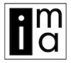

If you have been working on a new and innovative access, outreach & education project – or have an example of creative engagement and learning – that is happening on the ground in museums, galleries, libraries or archives, we want to hear from you.

**Submission Deadline: Monday, May 5th, 2014**

More info and application details at http://visualartists.ie/category/jobs-ops/

**___________________________________________________________________________**

**Visual Artists Ireland, Get Together 2014**



**Call for Artists’ Books / Publishers for Get Together 2014 – 23rd May, IMMA**

Visual Artists Ireland is now accepting submissions for the Artists’ Books stand in the Common Room area at Get Together 2014. No more than five copies of a book should be sent, and each book should not exceed 30 x 30cm in size. They can be dropped off at our offices or sent by post. There will be no charge or commission taken by VAI but publishers must organise for the return of any unsold items.

Please emai**l** [lily@visualartists.ie](mailto:lily@visualartists.ie) with details of the book you intend to submit (title, size, price, quantity, short description). Publications must be received by **5pm, Wednesday 14th May**. For further info call: +353 (0)1 672 9488. Send your publications to: Visual Artists Ireland, Central Hotel Chambers, 7/9 Dame Court, Dublin 2.

Call for Get Together temporary staff

Visual Artists Ireland is calling for enthusiastic and flexible temporary staff to help with our annual Get Together event.

**Deadline for applications 4th April 2014**

For further information and to apply to be involved, please email a brief description of relevant experience to: [lily@visualartists.ie](http://kk-moss/Sites/arts_office/Shared%20Documents/Julianne%20Morgan/E-bulletin/4th%20April/lily@visualartists.ie)

Read more at <http://miniurl.com/c3Bw>

**___________________________________________________________________________**

**Awards / Bursaries / Schemes**

**___________________________________________________________________________**

**Call for applications: artsandhealth.ie documentation bursary**

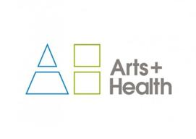

artsandhealth.ie[artsandhealth.ie](http://www.artsandhealth.ie) invites applications from arts and health practitioners (artists working in healthcare settings, healthcare professionals, arts and health partnerships etc.) for a bursary to produce documentation of an arts and health project. A bursary of **€4000** will be made available to the successful applicant for the production of film / audio documentary and / or publication about an arts and health project.

**Submissions should be sent by email to** [info@artsandhealth.ie](mailto:info@artsandhealth.ie)  **by Friday, 30th May 2014 at 12 noon.**

 Click [here](http://www.artsandhealth.ie/wp-content/uploads/2014/03/Call-for-applications-artsandhealth-ie-bursary-for-documentation-of-an-arts-and-health-project-21.3.14.docx) to download the application form.

More info at <http://miniurl.com/g7UA>

**___________________________________________________________________________**

**The Jim McNaughton/TileStyle €10,000 Artist’s Bursary | Call for Applicants**

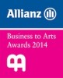

The Jim McNaughton/TileStyle **€10,000 bursary** will be awarded towards the evolution of a work, body of work or project by an emerging artist(s) in any art form.

The bursary is designed to develop an artist’s creative practice and help take an idea to realisation, whether that be in writing, composing, performing, or creating in a visual or other medium.

Awarded as part of the Allianz Business to Arts Awards 2013, the Bursary is for projects and the development of ideas **realised before 1 September 2014.**

**The closing date for receipt of nominations is 5pm, Tuesday 6th May 2014.**

For more information and to download the application form visit: [www.businesstoarts.ie/awards](http://www.businesstoarts.ie/awards)

**___________________________________________________________________________**

**The Arts Council – Funding**

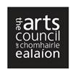

[Deis recording award](http://www.artscouncil.ie/en/view_fund.aspx?fid=692f180d-da55-4795-b531-4ac99a58affd)

The purpose of the Deis Recording Award is to provide support for traditional arts recording projects, or recording projects involving collaboration between the traditional arts and other artforms. **Maximum awarded:** **€10000**

**Closing date: 5.30pm, 10th April 2014**

Contact: Karen Whelan / Catherine Boothman

Email: [traditionalarts@artscouncil.ie](mailto:traditionalarts@artscouncil.ie)

[Young ensembles scheme](http://www.artscouncil.ie/en/view_fund.aspx?fid=fab83980-329f-4013-94d7-0a7789841f83)

The primary purpose of this award is to support groups of young people between the ages of 12 and 23 to create ambitious and original work together in any art form (e.g., circus, dance, digital media, film, music, theatre, literature, visual arts or any combination of the above). Maximum awarded: **€10000**

**Closing date: 10th April 2014**

Contact: Karen Whelan

Email: [karen.whelan@artscouncil.ie](mailto:karen.whelan@artscouncil.ie)

Theatre artist residency scheme

The purpose of this scheme is to offer theatre artists the opportunity to create a year-long work programme in partnership with venues and local authorities. Maximum awarded: **€20000.**

**Closing date: 5.30pm, Thursday 1ST May, 2014**

Contact: Maeve Giles

**Email:** [maeve.giles@artscouncil.ie](mailto:maeve.giles@artscouncil.ie)

New Awards Scheme for Artists with Disabilities

New Awards Scheme for Artists with Disabilities, The Arts Council is working with Arts and Disability Ireland to devise a new Awards Scheme for Artists with Disabilities in the Republic of Ireland. Supported by the Arts Council it is anticipated that the scheme will have a fund of **€25,000** to distribute as part of its initial pilot phase in 2014.

Read more at <http://miniurl.com/7pRn>

More info about the above funding at <http://www.artscouncil.ie/en/funding_deadlines.aspx>

**___________________________________________________________________________**

**OPEN CALL: DANCE IRELAND MENTORING SUPPORT RESIDENCY AWARDS**

[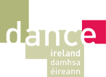](http://www.danceireland.ie/index.php)

In a new development for 2014/2015, Dance Ireland is offering **3 Mentoring Support Residency Awards (€2000 per award)** per applicant (individual or company) **focusing one each on classical ballet, traditional Irish dance and contemporary dance**. Professional dance artists, who are members of Dance Ireland, working in the genres outlined are eligible to apply.

**DEADLINE: 16th APRIL 2014 AT 12 NOON**

Please download the detailed information sheet below which contains information required to make an application for Dance Ireland Mentoring Support Residency Award.

[DOWNLOAD: DANCE IRELAND MENTORING SUPPORT RESIDENCY AWARDS INFORMATION SHEET](http://www.danceireland.ie/resources/file/DIMentoringResidencyAwardInfoSheet_11Feb14_SC.pdf)**FOR FURTHER INFORMATION:**

**Telephone:** 01 855 8800

**Email:** [judith.cooper@danceIreland.ie](mailto:judith.cooper@danceIreland.ie)

**___________________________________________________________________________**

**The Éigse Award – call for entries**

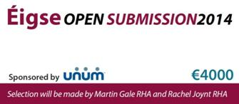

The Éigse Award of **€4000** for Visual Arts will be presented for the ‘most outstanding work in any medium’ at the Opening of the Carlow Arts Festival on Friday 6 June 2014.

**The deadline for postal applications is 16th May 2014.**

Please note that this year **NO E-MAIL SUBMISSIONS** will be accepted, it must be the actual artwork.

**€10 per entry**, limited to 3 per artist. Works must be new or recent, and not yet exhibited in public.

 For more information contact [Lisa Williamson](mailto:lwilliamson@carlowartsfestival.com)

**Application form terms & conditions available for download on link below**

[*Open Submission 2014 Application – Download*](http://carlowartsfestival.com/wp-content/uploads/2014/01/Open-Submission-2014-Application-Download.doc)

More info at <http://carlowartsfestival.com/open-submission/>

**___________________________________________________________________________**

**Call for Nominations for the Allianz Business to Arts Awards**



Nominations are being accepted for this year's Allianz Business to Arts Awards and Bursaries. With the support of sponsors Allianz, Dublin Airport Authority and TileStyle, there are bursaries available for artists, community and arts organisations who engage with businesses in a creative way and work to bring the arts to new communities.  
  
**The closing date for receipt of entries is Tuesday 6th May.** Nomination information available [here](http://cts.vresp.com/c/?BusinesstoArts/0f8ad097d5/608128ad7e/8dcac1c0b1).  **Further information and application form can be had by logging on to** [**www.waterfordyoutharts.com**](http://www.waterfordyoutharts.com/) **and visiting O’Regan Bursary. Or you can pick up an application form at Garter Lane Arts Centre and Greyfriars Gallery in Waterford City and The Old Market House Arts Centre, Dungarvan   
If you have any queries re. the process please ring Ollie at 086-1759188. The closing date for the receipt of applications is May 29th and the winners will be announced in July.**

**___________________________________________________________________________**

**Arts Grants and Bursary Awards 2014 – South Dublin County Council**

South Dublin County Council

We are delighted to announce that applications are now invited for the South Dublin County Council Arts Bursary Awards 2014. There are two categories this year for artists who are originally from, living in, or working in the South Dublin County Council administrative area.

1.) Bursaries for Individual Artists 2014

2.) Annette Halpin Memorial Music Award 2014

Read more at <http://www.sdcc.ie/services/parks-recreation/arts/arts-grants-bursary-awards>

**___________________________________________________________________________**

**NCAD Postgraduate Opportunities**



NCAD is offering two full fee tuition scholarships for its new studio masters programmes, MFA Design and MFA Fine Art. NCAD is also offering:

* Full fee tuition scholarships for its two MA Visual Culture programmes, MA Art in the Contemporary World and MA Design History and Material Culture
* Reduced fees for MSc Medical Device Design and MFA Art in the Digital World due to tuition fee support from the HEA Graduate Skills Conversion Programme.

**Application closing dates to be eligible for the scholarships are the 7th of April for MFA Fine Art and MFA Art in the Digital World and the 30th of April for the other programmes.**

For more information and application procedure, please visit: <http://miniurl.com/7zjX>

**___________________________________________________________________________**

# Rehab Group Visual and Performing Arts Fund

# Rehab - Investing in People, Changing Perspectives

Applications for the 2014 round of funding are now being sought from individuals with disabilities and individuals with mental health difficulties working or studying in the arts who require financial support for the forthcoming year and is open to people interested in a wide range of visual and performing arts – from painting, sculpture and graphic art to film, drama, music and dance.

Artists must be aged 17 years of age or over at the time of application.  
Applicants can seek funding of between **€1,000 and €10,000** per project or individual.

**The closing date for receipt of applications is 5pm on Friday, 11th April 2014.**

More info and application details at <http://miniurl.com/7H8z>

For further information email: [artsfund@rehab.ie](mailto:artsfund@rehab.ie) or call 01 2057 397.

**Scholarships for dance, theatre, circus**

The scholarship programme supports performers from different countries and various art forms and techniques:

Application details, policy and more information available at <http://www.artuniverse.org/news>

[artuniverseagency@gmail.com](http://kk-moss/Sites/arts_office/Shared%20Documents/Julianne%20Morgan/E-bulletin/E-bulletin%20-%207th%20March/artuniverseagency@gmail.com )

**__________________________________________________________________________**

**Sculpture in Context – The New Ireland Assurance Award | Call for Applications**

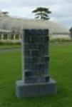

This award of **€3,000** is one of the largest prizes available to sculptors in Ireland and should prove to be a major incentive for artists to exhibit larger pieces in the National Botanic Gardens.

This exciting new award will continue to raise the profile of the show both nationally and internationally and will complement our other awards, which include:

* Four Sculpture in Context Awards to the value of **€500 each**
* Two ‘People’s Choice Awards’ – to the value of **€250 each**
* The CAST Award – This award is for foundry costs to the value of **€1,250** for casting a work in bronze
* The Mill Cove Award – Immediate representation from the gallery, and the opportunity of a solo exhibition in 2014/2015 at the Mill Cove Gallery and Sculpture Gardens, Castletownbere

**Closing date for submissions is Friday, 11th April, 2014**

More info and application details at [www.sculptureincontext.com](http://lists.visualartists.ie/lt.php?c=1113&m=4153&nl=1&s=e784eec6bf8bb9680747b324b9c9eee1&lid=82800&l=-http--www.sculptureincontext.com)

**___________________________________________________________________________**

**Irish Sculpture Awards at Mill Cove Gallery | Call for Entries**

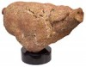

The exhibition is open to any sculptor living in Ireland (north and south).

Submissions must be original and of a high standard, both in presentation and content. The work should not have been previously exhibited and created within the last 2 years.

For full submission details and an entry form, please visit: [www.millcovegallery.com/isa2014.html](http://www.millcovegallery.com/isa2014.html)

**___________________________________________________________________________**

**Of Interest**

**___________________________________________________________________________**

**Gravity, Rush and Braking Bad**

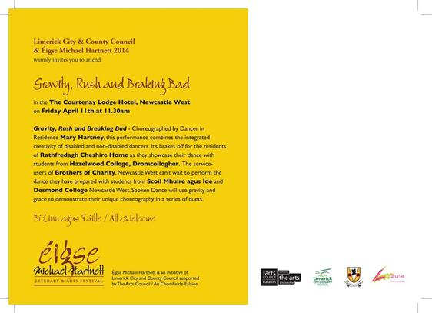

[Gravity, Rush and Braking Bad](http://limerickcityofculture.ie/content/gravity-rush-and-braking-bad)

**Venue:** The Courtenay Lodge Hotel, Newcastle West, Limerick

**Date: Friday, April 11, 2014 - 11:30**

As part of Éigse Michael Hartnett

All welcome

**Gravity, Rush and Braking Bad** - Choreographed by Dancer in Residence **Mary Hartney**, this performance combines the integrated creativity of disabled and non-disabled dancers

**Read more at** <http://miniurl.com/7YcZ>

**___________________________________________________________________________**

**Elaine Byrne Wins Arte Laguna International Art Prize**

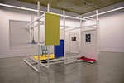

Irish artist Elaine Byrne is the winner of the 8th Arte Laguna International Art Prize for sculpture 2014. The Arte Laguna Prize is an international competition aimed at promoting and enhancing Contemporary Art.

The exhibition of finalist artists is currently on in the Venice Arsenale **until 7th April 2014**.

[www.artelagunaprize.com/index.php/sculptur-winners-1314.html](http://lists.visualartists.ie/lt.php?c=1106&m=4146&nl=1&s=e97e60e0a85e4e4156f0ad241cfbea58&lid=82030&l=-http--www.artelagunaprize.com/index.php/sculptur-winners-1314.html)

[www.elainebyrne.net/](http://lists.visualartists.ie/lt.php?c=1106&m=4146&nl=1&s=e97e60e0a85e4e4156f0ad241cfbea58&lid=82031&l=-http--www.elainebyrne.net)

**___________________________________________________________________________**

**SPOTLIGHT on...Tallaght Community Arts Weather Stations**

[](http://globalweatherstations.com/wp-content/uploads/2014/01/WSEngEULU-Blue-2.jpg)

Weather Stations is an international project that places literature and storytelling at the heart of discussions about climate change.

# 'The Weather Stations project is a wonderful opportunity for Tallaght Community Arts to work with our international partners to explore ways in which the power of the art of writing can contribute to how we integrate the reality of climate change into our daily lives...’ Tony Fegan, Director of Tallaght Community Arts

# Website: <http://globalweatherstations.com>

**___________________________________________________________________________**

# ****Cork International Choral Festival**** - April 30th to May 4th

# [http://testserver.doodlecreative.ie/choral/wp-content/uploads/2013/03/choral-festival-logo6.png](http://www.corkchoral.ie/)

# A wealth of choirs from around the world will once again head for Cork City and participate in what is now regarded as one of (at least) Europe's top choral festivals. Choir concerts, choir competitions and a rousing no-holds-barred performance of Carmina Burana at Cork City Hall are on the menu.

# More Information on their website - [corkchoral.ie](http://www.corkchoral.ie/)

**___________________________________________________________________________**

**Artist/Filmmaker Lisa Fingleton Wins Dingle International Film Festival Audience Award**

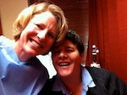

The winner of this year’s Audience Award at the Dingle Film Festival went to artist/filmmaker Lisa Fingleton’s film ‘Waiting for you’. The film was selected from 51 shorts as the winner of the prestigious award. The film is an intimate, brave, and creative documentary spanning five years of the filmmakers’ journey through the rollercoaster world of farming and fertility treatment. The film skillfully weaves together drawings, visual notebooks and video diary footage and gives a privileged insight into an intimate world. For more information about future screenings: [www.lisafingleton.com](http://lists.visualartists.ie/lt.php?c=1103&m=4143&nl=3&s=e97e60e0a85e4e4156f0ad241cfbea58&lid=81604&l=-http--www.lisafingleton.com)

**___________________________________________________________________________**

**Exquisite & Rare: Bookbindings from the Library of Benjamin Guinness – Marsh’s library**

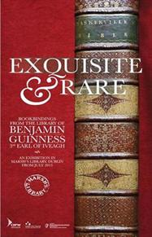

Date: **23rd Jul 2013 (Tue) - 30th Jun 2014 (Mon) from 09:30 - 17:00**

This exhibition showcases a small selection - 64 in total - of the items in Benjamin Iveagh's collection of books. This is the first time that any of these books have been publicly displayed.

The books will be on display in Marsh's Library, St Patrick's Close, Dublin 8 **until 30th June 2014**

**Read more at** <http://www.marshlibrary.ie/our-new-exhibition-has-arrived/>

**\*\*\*\*\*\*\*\*\*\*\*\*\*\*\*\*\*\*\*\*\*\*\*\*\*\*\*\*\*\*\*\*\*\*\*\*\*\*\*\*\*\*\*\*\*\*\*\*\*\*\*\*\*\*\*\*\*\*\*\*\*\*\*\*\*\*\*\*\*\*\*\*\*\*\***