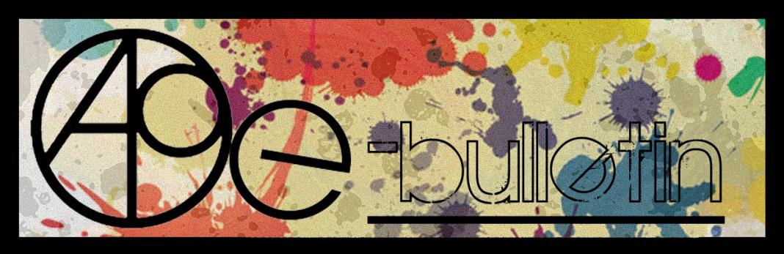

**Kilkenny County Council Arts Office E-bulletin 9th October 2015**

Dear All,   
  
Welcome to the fortnightly e-bulletin from Kilkenny County Council's Arts Office. Each bulletin is packed with the latest information on Kilkenny Arts Office activities, county events as well as news and opportunities for arts practitioners from around the country.

This service will be provided fortnightly. To include an item in the next e-bulletin please send a brief outline of your advert with relevant contact details, including any websites or pages with links to [**julie.mcguirk@kilkennycoco.ie**](mailto:julie.mcguirk@kilkennycoco.ie) **before 22nd October**. The next e-bulletin will be on the **23rd October.**

While every effort has been made to ensure the accuracy of our information, we strongly advise readers to verify all details to their own satisfaction.

Regards,

Julie McGuirk  
Arts Office,  
T: 056 7794547  
E: [julie.mcguirk@kilkennycoco.ie](mailto:julie.mcguirk@kilkennycoco.ie)   
W: [www.kilkennycoco.ie/eng/Services/Arts/](http://www.kilkennycoco.ie/eng/Services/Arts/)

BECOME PART OF IT, SUBMIT A POEM.....[www.rhymerag.net](http://kk-moss/Sites/arts_office/Shared%20Documents/Julianne%20Morgan/E-bulletin/30th%20May%20e-bulletin/www.rhymerag.net)  
Kilkenny County Council Arts Office Partner Local Authority of the ArtLinks Programme [www.artlinks.ie](http://www.artlinks.ie)

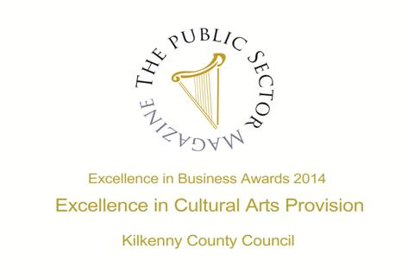

|  |  |
| --- | --- |
|  |  |
|  |  |

**Arts Office**

* **Bursaries Available for ‘The Story House’ to Kilkenny Writers**

**Kilkenny Events**

* **Concert: The Minutes at the Set Theatre**
* **Concert: Albert Hammond at the Watergate Theatre**
* **Halloween mask making fun at Kozo Studio**
* **Kilkenny Tourism brings Kilkenny FREE day to our city and county on Saturday 10th October 2015**
* **Autumn at the** [**National Craft Gallery**](http://www.nationalcraftgallery.ie/exhibitions)**, Kilkenny ‘Ó’**

**Courses / Training / Jobs / Internships**

* **Encaustic Painting Workshop with Joanna Kidney, Bray**
* **Introduction To Documentary Making Course with Roisin Loughrey at The Dock**
* **Painting From Life With Mary Ronayne at The Dock**
* **Life Drawing Class With Kiera O’Toole At The Dock**
* **Principles of Art Therapy Certificate Course, Dublin**

**Call for Submissions / Residencies**

* **Artists in Residence at The Leitrim Sculpture Centre: Call for Applications for 2016**
* **Open Call for Printed Work for Halftone, Dublin Print Fair**
* **Over The Line Studios, Cork: Residency Available**
* **Donegal Creameries \ North West Words Poetry Prize 2015**
* **Seeking submissions for 1916 Today: An Anthology of Reactions**
* **The Irish Concrete Society 2015 Sculpture Award**

**Awards / Bursaries / Schemes**

* **Arts Council Artist in the Community Scheme: Bursary Award: Collaborative Arts & Architecture**
* **Arts Council Ireland – Travel and Training award – ongoing**
* **Creative Europe: EU Funding Opportunities – ongoing**
* **Culture Ireland Grants – 2014-2015 Deadlines**
* **European Cultural Foundation – STEP travel grants – ongoing**
* **From the Well Short Story Competition 2016**

**Of Interest**

* **Behind Closed Doors Architecture Event in Waterford City**
* **Imagine Arts Festival Waterford, 15th-25th October 2015**

**Arts Office**

**Bursaries Available for ‘The Story House’ to Kilkenny Writers**

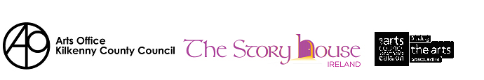

The Arts Office, Kilkenny County Council is pleased to announce their support for the second year to the Story House Bursary 2016.

The Story House Ireland is a not-for-profit residential writing centre inspired by The Arvon Foundation. A Poetry Course will be run on the grounds of Borris House , Co. Carlow from 11th to 16th April 2016 with tutors Nessa O’ Mahoney and Peter Sirr.

See [www.thestoryhouseireland.org](http://www.thestoryhouseireland.org) for full details.

The Arts Office, Kilkenny County Council is awarding a bursary of €500 to a Kilkenny writer to attend The Story House 2016 to support their professional development. For an application form go to Arts Section of [www.KilkennyCoCo.ie](http://www.KilkennyCoCo.ie) or contact Julie McGuirk, Arts Administrator on 0567794547 [julie.mcguirk@kilkennycoco.ie](mailto:julie.mcguirk@kilkennycoco.ie)

Follow The Story House Ireland on Twitter@TSHIreland

**Recipients of the Story House Bursary 2015, cannot enter for the current 2016 bursary.**

**Completed application forms must be submitted on or before 12 noon on Monday 16th November 2015.**

**Kilkenny Events**

**Concert: The Minutes at the Set Theatre**

Time and Date: Friday 16th October at 9pm

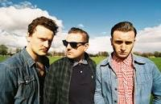

Tickets €11. Support by Kilkenny band Kingston. The Minutes believe in the power of rock 'n' roll. The power of dreams. The energy of rebirth. The Minutes believe in Belief.

<http://www.set.ie/events-guide/events/the-minutes-%281%29>

- See more at: http://www.visitkilkenny.ie/the_minutes_live_in_kilkenny#sthash.cn2zwfZh.dpuf

**Concert: Albert Hammond at the Watergate Theatre**

Time and Date: Sunday 11th October 2015 at 8pm

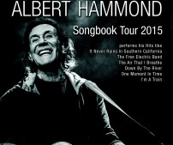

Tickets €27. Albert Hammond has been writing hit songs for over fifty years. This is not to just to say that it has been fifty years since his first hit. This is to say that there has not been a single decade in which Albert has not written multiple hits songs since he scored his first hit with “Little Arrows” at the age of 24. His songs have been responsible for the sale of over 360 million records worldwide including over 30 chart-topping hits. Many of his most beloved songs, like “The Air That I Breathe” and “When I Need You,” have become hits multiple times with various artists, decade after decade.

http://watergatetheatre.com/programme/albert-hammond-songbook-tour-2015/ http://www.alberthammond.net/ - See more at: <http://www.visitkilkenny.ie/albert_hammond_in_kilkenny#sthash.xPGbvuCh.dpuf>

**Halloween mask making fun at Kozo Studio**

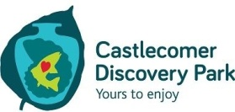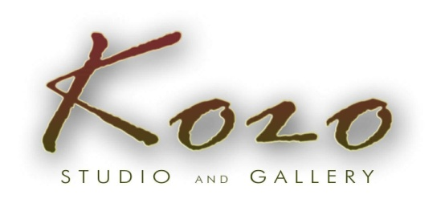 **Workshops for children and families during midterm break**

**Make and decorate your own unique masks!**

You need a family member or a friend to work together with: you will be sculpting your masks on each other`s faces using plaster cloth. The mask takes your facial features and it will only fit you!

After a short drying time you can paint and decorate your mask to suit your HALLOWEEN outfit or any design/style you wish.

**Suitable for children from 6/7 years of age.**

**Younger children** can participate in mask painting and decorating, working on pre-made masks.

**26 – 30 OCTOBER**

**12 – 4pm daily**

Each activity lasts approx. 1 hr – 1 hr 30 min

**Mask making** (plaster cloth) + painting/decorating: € 10 per participant

**Mask painting and decorating**: € 7 per child

Previous bookings are advisable

**CONTACT and BOOKINGS:**

**Tunde Toth –** Artist, Arts Educator **087-2543362**E: [tundetune@gmail.com](mailto:tundetune@gmail.com)  
[www.tundetoth.com](http://www.tundetoth.com)

[www.kozostudio.wordpress.com](http://www.kozostudio.wordpress.com)

*Copyright © 2015 KOZO Studio and Gallery, All rights reserved.*

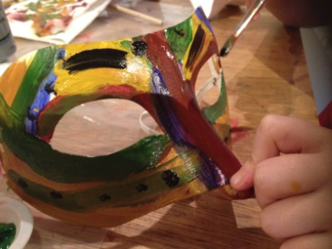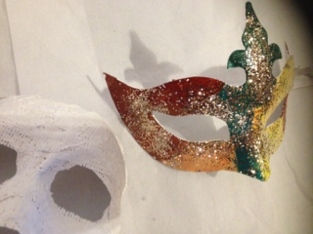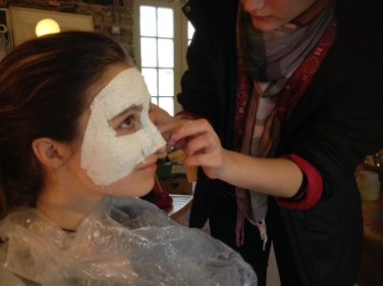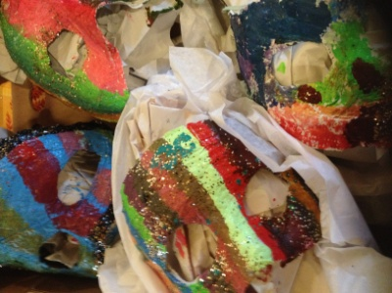

**Kilkenny Tourism brings Kilkenny FREE day to our city and county on Saturday 10th October 2015**

**For one day only everywhere you want to be in Kilkenny for FREE!**

[**Downloadable PDF Brochure**](http://www.visitkilkenny.ie/sites/default/files/Downloads/Kilkenny%20Free%20Day%202015%20Timetable.pdf)

Kilkenny Tourism is delighted to announce Kilkenny FREE Day 2015 on 10th October.  Following on from a very successful FREE day in 2014 and coinciding with the Feast Day of St. Canice, Kilkenny’s patron Saint, buildings and attractions throughout the City and County will again open their doors and offer FREE guided tours and activities throughout the day.

If you are an adventure seeker or heritage lover there will be something for people of all ages.  Nearly fifty tourism businesses and public buildings are opening their doors free of charge on October 10th. Chairperson of Kilkenny Tourism Colin Ahern, is urging everyone to spread the word, “we are really excited to bring back Kilkenny FREE day. We are encouraging schools and families to take full advantage of the FREE access and guided tours to a wide range of visitor attractions and public buildings, more details can be found on free events on Kilkenny Tourism’s website [www.visitkilkenny.ie](http://www.visitkilkenny.ie/)”.

- See more at: <http://www.visitkilkenny.ie/kilkenny_day#sthash.aBpe9wwJ.dpuf>



**Autumn at the** [**National Craft Gallery**](http://www.nationalcraftgallery.ie/exhibitions)**, Kilkenny ‘Ó’**

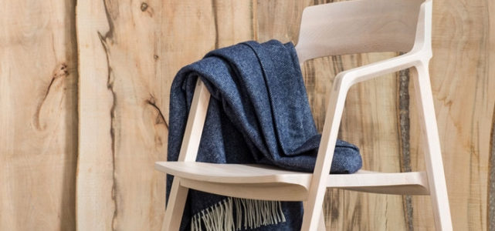

**9 OCTOBER 2015 – 10 JANUARY 2016**

Be sure to visit the [National Craft Gallery](http://www.nationalcraftgallery.ie/) this autumn when we shine a spotlight on contemporary Irish craft and design with our new exhibition [Ó.](http://www.nationalcraftgallery.ie/exhibitions/o) The team at the [National Craft Gallery](http://www.nationalcraftgallery.ie/) is looking forward to a busy and exciting programme of events including talks, creative family workshops, schools programme and professional development workshops for craft and design educators. Explore and learn at the [National Craft Gallery](http://www.nationalcraftgallery.ie/) this autumn in the relaxed and beautiful surrounds of the Castle Yard, Kilkenny.

**Click on event to find out more information.**

[**Curators Talk**](http://www.nationalcraftgallery.ie/exhibitions)withSteven McNamara**,** 6pm, Fri 9 Oct

[**Family Day: Look, Draw, Design**](mailto:http://www.nationalcraftgallery.ie/news/article/o-family-days)Sat 10 Oct, 10.30am + 12noon Teen Workshop:Sat 10 Oct, 2.30pm

**Creative Links: Community Workshops** Wed 21Oct, Wed 25 Nov, 10am

[**Transition Year Workshops:**](http://www.nationalcraftgallery.ie/news/article/o-teachers-schools-programme) **Exploring & Researching Creative Design Ideas for Junk Kouture**

Thurs Oct 15, Oct 22, Nov 5, 1.30pm -3.30pm

[**CPD for Post Primary Teachers**](http://www.nationalcraftgallery.ie/news/article/o-teachers-schools-programme)

Pattern Drafting with Joan Brennan, Thur 15Oct, 6.30pm

Ceramic Skills with Ciara O Sullivan, Mon 23Nov 6.30pm

[**Late Date,** **Design Talk,**](http://www.nationalcraftgallery.ie/news/article/o-teachers-schools-programme) **Ceadogán Rugs**  Thur 22 Oct, 6.30pm

**Mid Term Break: Discover & Design,** Drop in, no booking required. 26, 27, 28, 29, 30, Oct 12pm – 4pm

[**Family Day**: **Craftpack Workshop**](http://www.nationalcraftgallery.ie/news/article/o-family-days)with Whackpack

Sat 7 Nov, 10.30 am + 12noon

Teen Workshop, Sat 7 Nov, 2.30pm

[**Late Date: Design Talk, Made In Kilkenny**](http://www.nationalcraftgallery.ie/news/article/o-teachers-schools-programme) Thur 26 Nov, 6.30pm

[**Family Day:** **Festive Willow Decorations**](http://www.nationalcraftgallery.ie/news/article/o-family-days) with Eamon Tobin

Sat Dec 12, 10.30am + 12noon

Teen Workshop, Sat 12 Dec, 2.30pm

[**Late Date**: **Festive Event**](http://www.nationalcraftgallery.ie/news/article/o-late-dates)Thur 17 Dec, 6.30pm

[**Family Day: Pattern Weave**](http://www.nationalcraftgallery.ie/news/article/o-family-days)

Sat 9 Jan, 10.30am + 12noon

Teen Workshop, Sat 9 Jan, 2.30pm

Booking information 056 779 6151 or email [events@nationalcraftgallery.ie](javascript:void(location.href='mailto:'+String.fromCharCode(101,118,101,110,116,115,64,110,97,116,105,111,110,97,108,99,114,97,102,116,103,97,108,108,101,114,121,46,105,101)))

**Courses / Training / Jobs / Internships**

**Encaustic Painting Workshop with Joanna Kidney, Bray**  
18 October, 10am-3pm | Cost: €55 (€50 for CG members) includes all materials  
Common Ground, Beverly Studios, Church Terrace, Bray, Co. Wicklow.

Encaustic painting (coming from the Greek word Enkaustikos which means to burn in) is an ancient, immediate and tactile painting process using molten pigmented beeswax. This workshop will introduce you to the basic techniques of encaustic painting, imparting its exciting qualities of working spontaneously with colour and texture and its flexibility with building up and breaking down layers. Using an experimental approach to explore multiple techniques and manipulate the paint, you will first make a test panel followed by a small finished painting. Suitable for beginners and those with previous experience of encaustic.

For booking and further info: T: 087 2377613, E: [joann@joannakidney.com](mailto:joann@joannakidney.com).

[**commongroundbray.com/**](http://commongroundbray.com/) | [**joannakidney.com**](http://joannakidney.com)

**Introduction To Documentary Making Course with Roisin Loughrey at The Dock**  
Friday 20 November 7 – 9pm and Saturday 21 November 10 – 4pm| Cost: €55  
The Dock, St. George’s Terrace, Carrick on Shannon, Co. Leitrim

This is a short introduction to the theory and practise of making creative documentaries with multi-award-winning documentary film-maker and artist Róisín Loughrey. This course is designed for adult beginners with an interest in making their own documentary films and will cover the theory of documentary looking at examples of work.

It will also give an introduction to the practical skills of conceiving, filming and editing their own short documentaries. The course will give participants an overview of the whole documentary process, from idea to screen. Participants are asked to bring their own notebooks and a digital video camera or digital stills camera with video, if they have one.

Discount available on two or more master classes.

For further information and booking please visit: [**www.thedock.ie**](http://www.thedock.ie)  
T: 071 9650828, E: [lmahon@leitrimcoco.ie](mailto:lmahon@leitrimcoco.ie)

**Painting From Life With Mary Ronayne at The Dock**  
Oct 02, 2015 05:06 pm

Saturday 7 November, 11am to 4.30pm | Cost: €55  
The Dock, St. George’s Terrace, Carrick on Shannon, Co. Leitrim

Painting from life – water based medium with Artist Mary Ronayne. This workshop is for artists interested in developing skill and new approaches to portraiture. Designed to free-up ideas and approaches it is an opportunity to allow drips or ‘mistakes’ to be an important part of the piece. The day will start with some quick poses and then work on a longer piece.

T: 071 9650828, E: [lmahon@leitrimcoco.ie](mailto:lmahon@leitrimcoco.ie)

For further information please visit: [**www.thedock.ie**](http://www.thedock.ie)

**Life Drawing Class With Kiera O’Toole At The Dock**

Saturday 14 November, 11am to 4pm | Cost: €55  
The Dock, St. George’s Terrace, Carrick on Shannon, Co. Leitrim

New Perspectives with artist Kiera O’Toole at The Dock.  
In this master class participants will engage in traditional drawing practices through a dynamic and exploratory approach. By drawing the life model with wearable sculptural props, music and movement, participants will explore diverse techniques, processes, concepts and subject matter to explore formal ideas of drawing practices: tone, negative/positive space, light & shade, composition.

T: 071 9650828, E: [lmahon@leitrimcoco.ie](mailto:lmahon@leitrimcoco.ie)

For further information please visit: [**www.thedock.ie**](http://www.thedock.ie)

**Principles of Art Therapy Certificate Course, Dublin**  
Dates: 23 October 2015 to May 2016 | Cost: €1450 including registration and exam fees  
The Haven Adult Education Centre, Basin Lane, Basin Street, Dublin 8.

This is the last opportunity to take part in The Principles of Art Therapy Certificate (formerly Art Therapy Certificate Foundation Course) course in Dublin for the 2015-2016 year. This is a QQI level 8 (10 credit) course. This course provides an opportunity to explore Art Therapy within a group setting. Each weekend students will participate in experiential workshops with qualified arts therapists. A variety of approaches to the process of Art Therapy are introduced through workshops, lectures and seminars.  
This is an exciting initiative between the Children’s Therapy Centre and CIT Crawford College of Art & Design.

E: [childrenstherapycentre@gmail.com](mailto:childrenstherapycentre@gmail.com) for full details.  
[**www.childrenstherapycentre.ie/principles-of-art-therapy-certificate**](http://www.childrenstherapycentre.ie/principles-of-art-therapy-certificate)

**Calls for Submissions/Residencies**

**Artists in Residence at The Leitrim Sculpture Centre: Call for Applications for 2016**

Leitrim Sculpture Centre in association with Leitrim County Council Arts Office, are offering five residencies to visual artists, based at LSC.  
Each residency includes an artist’s stipend of €2,500 and comes with a one-person exhibition at the end of the residency period.

For further information and guidelines on how to apply [**CLICK HERE**](http://www.leitrimsculpturecentre.ie/programme/residencies.html)**Deadline**: Monday 21 September at 5pm  
E: [info@leitrimsculpturecentre.ie](mailto:info@leitrimsculpturecentre.ie)  
T: 071 985 5098  
[www.leitrimsculpturecentre.ie](http://www.leitrimsculpturecentre.ie)  
Leitrim Sculpture Centre, New Line, Manorhamilton, Co Leitrim  
Ionad Dealbhóireachta, Cluainín, Co Liatroim

**Open Call for Printed Work for Halftone, Dublin Print Fair**

Submission deadline: 2 November  
HALFTONE 2015, Dublin’s Print Fair, 19 to 22 November 2015  
The Library Project & Black Church Print Studio, Dublin

PhotoIreland and Black Church Print Studio present the first instalment of ‘Halftone’, Dublin’s fresh new print fair. HALFTONE looks at how different printing processes coexist in a diverse range of artistic and creative practices; we will celebrate the printed matter in all its forms.  
Applications are now invited from fine art printers, illustrators, designers, photographers and any artists and creatives alike to submit works to be displayed and sold at the HALFTONE print fair. Submissions can include the proposed works in any technique such as screenprint, stencil, lithography, etching, inkjet printing, etc., without any limitation of approach or concept. All works will be on display during HALFTONE, at The Library Project and Black Church Print Studio from the launch at 7pm on Thursday 19 November 2015, when they will go on sale.

All submissions to the Open Call must be made online at [**halftone.ie**](http://halftone.ie)

[**photoireland.org/news/**](http://photoireland.org/news/)

**Over The Line Studios, Cork: Residency Available**

Over The Line Studios announce the opening of new purpose built fine art and ceramic studios in Cork city. Located on the north side in Ballyvolane, studio residencies with exhibition opportunities are offered. The aim is to provide a relaxed, supportive and productive environment. The open plan space has ample natural light, 24hr access, a fully equipped canteen and free parking. Over The Line Studios are now accepting applications for the first three-month residency that includes an exhibition in mid December.  €130 euros per month.  
Further information:  
E: [info@overthelinestudios.com](mailto:info@overthelinestudios.com)

**Donegal Creameries \ North West Words Poetry Prize 2015**

**Donegal Creameries \ North West Words Poetry Prize €250 + Cup**

**Information, Rules and Conditions of Entry- English Poetry Competition**

This prize is open to anyone over the age of 18 as long as the poem is the original work of the author submitting it. Entries must not have been previously published in any media, self-published, broadcast, and/or won any competition.

The maximum number of poems per entrant is 3.

Send your poem(s) along with a cover letter with name, address, and phone number and/or email address, and title(s) of each poem submitted. Please do not put your name or personal contact details on the same page as the poem(s).

Postal entries to North West Words Poetry Prize 2015, 54 Thornberry, Letterkenny, Co. Donegal. Online entries should be attached in one document and copied into the body of the email and sent to editornww@yahoo.com

**Entries must be received by the closing date - Friday, 27 November 2015.**

North West Words is a non-profit organisation run on voluntary effort. The competition fee of €5 per entry (up to three poems) goes towards the administrative costs of the competition. Payment may be made by Cheque, Postal Order, Money Order or via Paypal on our website www.northwestwords.com.

No alterations can be made to the entry once it has been submitted, and entries cannot be returned so please keep your own copy.

The 2015 English Poetry competition will be judged by Kate Newman from Summer Palace Press. All decisions of the Judge are final and no correspondence or discussion can be entered into regarding those decisions. Any attempt to contact the Judge in regard to competition will result in immediate disqualification.

A shortlist will be published on North West Words’ Facebook page and at North West Words’ Christmas event in Café Blend mid-December. The winner of the competition will be announced and the prize awarded at North West Words Event in Café Blend, Letterkenny, on Thursday, 28th January 2016. (The winning poet will be notified on Thursday, 14 January 2016) The author will be invited to read their winning poem at this North West Words event.

Copyright remains with the poet, but North West Words reserves the right to first publication or broadcast of the winning poem.

**Submission of an entry implies the author’s acceptance of the conditions set out above.**

**Seeking submissions for 1916 Today: An Anthology of Reactions**

**Deadline: 31 Dec 2015**

The Limerick Writers’ Centre is seeking submissions for an anthology to be published in the spring of 2016 to mark the centenary celebration of the 1916 Rising.

Seeking quality writing which reflect reactions to the 1916 Rising and what it means for us today, these may be historical, or of a contemporary nature. Word count is limited to 1500/2000, poetry and graphics can also be submitted and is limited to three poems/graphics per submission. New and established writers are invited to submit.

Submission is by email only and must be submitted in one attached Word document.

>>Find out more [limerickwriterscentre@gmail.com](javascript:void(location.href='mailto:'+String.fromCharCode(108,105,109,101,114,105,99,107,119,114,105,116,101,114,115,99,101,110,116,114,101,64,103,109,97,105,108,46,99,111,109)))

**The Irish Concrete Society 2015 Sculpture Award**

Closing date for return of nominations: Friday 8 November 2015.

The Irish Concrete Society is pleased to announce the return of an award in which the Society recognises excellence in the design/construction of sculptural in concrete. In addition, the Society is sponsoring a cash prize of €1,000 to the winning sculptor.

This award scheme enables the society to acknowledge the work of sculptors who use concrete as a medium of expression. Entries are eligible which use concrete as the main visual element in the sculpture. The adjudication will be carried out by an independent jury convened by the council of the society.

Nominations for the award may be made by sculptors or others directly involved in the nomination. Nominations must refer to work completed since August 1st 2013 which is currently in Ireland and that can be made available for inspection by the jury later in the year, if requested.

The winner will be announced at the Irish Concrete Society prestigious Annual Awards Evening to be held in early 2016.

Nomination forms may be obtained from the Society website: [**www.concrete.ie**](http://www.concrete.ie) or by contacting the Society at 041 9876466

The submission period is from now to the end of December 2015. The anthology while welcoming submissions from writers with a Limerick connection is also open to writers from other parts of the country. Specifically we are seeking quality writing which reflect reactions to the 1916 Rising and what it means for us today, these may be historical, or of a contemporary nature. Word count is limited to 1500/2000, poetry and graphics can also be submitted and is limited to three poems/graphics per submission. New and established writers are invited to submit.  
Contributors will receive a copy of the anthology in which their work is featured and can order further copies at a discounted rate.  
The anthology will be edited by John Liddy and Dominic Taylor and will be published by The Limerick Writers’ Centre.  
Submission is by email only and must be submitted in one attached Word document.  
Further Information: Dominic Taylor, The Limerick Writers’ Centre, 12 Barrington Street, Limerick 087 2996409. Email limerickwriterscentre@gmail.com

The submission period is from now to the end of December 2015. The anthology while welcoming submissions from writers with a Limerick connection is also open to writers from other parts of the country. Specifically we are seeking quality writing which reflect reactions to the 1916 Rising and what it means for us today, these may be historical, or of a contemporary nature. Word count is limited to 1500/2000, poetry and graphics can also be submitted and is limited to three poems/graphics per submission. New and established writers are invited to submit.  
Contributors will receive a copy of the anthology in which their work is featured and can order further copies at a discounted rate.  
The anthology will be edited by John Liddy and Dominic Taylor and will be published by The Limerick Writers’ Centre.  
Submission is by email only and must be submitted in one attached Word document.  
Further Information: Dominic Taylor, The Limerick Writers’ Centre, 12 Barrington Street, Limerick 087 2996409. Email limerickwriterscentre@gmail.com

**Awards / Bursaries / Schemes**

**Arts Council Artist in the Community Scheme: Bursary Award: Collaborative Arts & Architecture**

The Arts Council Artist in the Community Scheme Bursary Award 2015 aims to support individual professional architects / artists working in the area of engaged and/or collaborative architecture. The Arts Council has provided this €10,000 bursary award as part of the Artist in the Community Scheme, which is managed by Create.

The purpose of the Bursary Award is to support and nurture professional arts practice and it is specifically aimed at an architect/ arts practitioner who has a track record of working collaboratively. The Bursary Award of €10,000 provides the selected architect/artist with time and resources to carry out research and to reflect on practice. More particularly, the Bursary allows the architect / artist to consider key questions associated with creating architecture using collaborative methodologies.

It is expected that the successful applicant will share the learning arising from the Bursary with the wider architectural community and collaborative arts sector. Create will work in partnership with the Irish Architecture Foundation in providing information sessions and on the selection process. Further details on sessions will be available on [www.create-ireland.ie](http://www.create-ireland.ie)

For further information, contact Katherine Atkinson, Project Support, Professional Development, [support@create-ireland.ie](mailto:support@create-ireland.ie)

Deadline for applications: 16 November at 5pm.

**Arts Council Ireland – Travel and Training award – ongoing**

**The Travel and Training Award has three main strands with different objectives and priorities.**

**Travel and training outbound:**

The objective of the travel and training outbound award is to support individuals who wish to avail of training and other professional development opportunities abroad (outside the Island of Ireland).

**Travel and training inbound:**

The objective of travel and training inbound is to support individuals or organisations who wish to invite specialists from abroad (outside the Island of Ireland) to deliver high-level training or mentoring for the professional development of artists and others working professionally in the arts in Ireland.

**Creative Europe (Culture sub-programme) Travel Award:**

The Creative Europe (Culture sub-programme) Travel Award only supports applications from arts organisations planning to make applications for EU culture funding under the Creative Europe Programme 2014-2020.

The award is intended to cover some of the costs associated with face-to-face meetings with partner organisations in Europe and will not support training costs or courses.

There are no formal deadlines for the Travel and Training Award.

Applications are accepted on an ongoing basis.

[Guidelines](http://comartspartner.org/wp-content/uploads/2015/08/Guidelines_TravelTraining.doc)

**For more information and to apply online, click** [**here**](http://www.artscouncil.ie/Funds/Travel-and-Training-award/)**.**

**Creative Europe: EU Funding Opportunities – ongoing**

Several funding opportunities are currently available through Creative Europe, the EU’s funding programme for the cultural, creative and audiovisual sectors across Europe.

Not only are there funding opportunities available for organisations working in film and TV, but there are also opportunities for financial support with literary translation projects and collaborative creative, cultural or heritage projects across any art form.

For more information

|  |  |
| --- | --- |
| **Katie Lowry** Creative Europe Desk Ireland Culture Office +353 16180248 | **Audrey Keane** Creative Europe Desk Ireland Culture Office +353 16180256  [cedculture@artscouncil.ie](javascript:void(location.href='mailto:'+String.fromCharCode(99,101,100,99,117,108,116,117,114,101,64,97,114,116,115,99,111,117,110,99,105,108,46,105,101)))                 The Arts Council 70 Merrion Square Dublin 2 |

**Culture Ireland Grants – 2014-2015 Deadlines**

**2014/2015 Dates and Deadlines for Culture Ireland Grant Rounds**

Please note Culture Ireland has set funding rounds and deadlines for 2015. There will be three funding rounds in 2015 and seperate calls for showcasing opportunities and Edinburgh Festivals will be announced during the year.

Application Deadline | Timing of Project/Event | Decision Due

15 October 2015 | January 2016 onwards | Early December

[**www.cultureireland.ie/**](http://www.cultureireland.ie/)

**European Cultural Foundation – STEP travel grants – ongoing**

**STEP Beyond Travel grants fund up and coming artists and cultural workers – giving priority to individuals up to 35 years and/or in the first 10 years of their career – to travel between EU and countries bordering the EU.**

There is no deadline for this grant scheme, so you can apply at any time but at least one month before your planned travel. The selection process takes up to one month.

For more information on how to apply, a list of eligible travel destinations and to access the application form, go to the “how to apply guidelines”. [ecflabs.org/sites/www.ecflabs.org/files/step-beyond-grant/guidelines/guidelines_step.pdf](http://ecflabs.org/sites/www.ecflabs.org/files/step-beyond-grant/guidelines/guidelines_step.pdf)

These guidelines are also available in Russian but please note that the final application has to be in English. You can also access the application form directly here – [ecflabs.org/step-beyond-apply?gids[]=4707#group_step_1](http://ecflabs.org/step-beyond-apply?gids%5b%5d=4707#group_step_1)

**From the Well Short Story Competition 2016**

The Cork County Library and Arts Service is launching the *From the Well* Short Story competition 2016. The competition invites entries from writers aged 18 and over who are registered members of any library. To mark the 1916 Centenary, the theme of this year’s short story competition is **Revolution**.

Entrants may interpret the theme in its broadest sense.

Twenty stories will be shortlisted by Cork writer Billy O’Callaghan and will be announced in January 2016

A winner from the shortlisted stories will be selected by a panel of judges.

The winning story and the 19 other shortlisted will be published in an anthology in April 2016

The winning story will be the title of this publication

The winning writer will win a place on a week long workshop of their choice at the West Cork Literary Festival 2016 and €250 towards accommodation.

For further information please contact Sinead Donnelly, County Arts Office 021-4346210

Entries should be sent to Arts Office, Library Headquarters, Carrigrohane Road, Cork or [shortstorycompetition@corkcoco.ie](mailto:shortstorycompetition@corkcoco.ie)

The closing date for receipt of entries is 5pm on **Friday 20th November**

Full details and application form:

<http://www.corkcoco.ie/co/pdf/182388252.pdf>

**Of Interest**

**Behind Closed Doors Architecture Event in Waterford City**

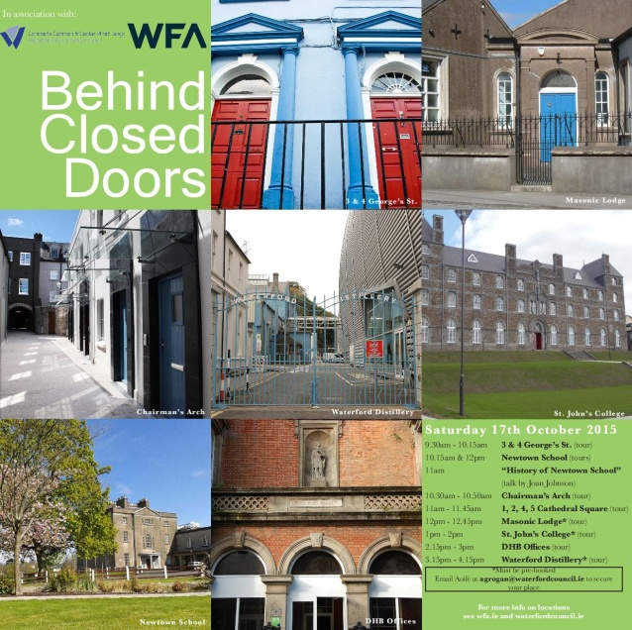

The aim of this event is to celebrate Waterford’s City rich and varied architecture and it is a great opportunity to visit properties, not normally open to the public.

The event is taking place at several locations thorough the city on Saturday the 17th of October.

Tours include the Masonic Lodge*, the award winning housing scheme at Chairmans Arch, conservation works at Cathedral Square, Newtown School, the new Respond housing at St Johns College*, DHB architects office, 3 and 4 Georges Street and the new Waterford distillery* located at the site of a brewery dating from 1775.

All tours are free and the locations, times and details of the tours are available at [Behind Closed Doors](http://wfa.ie/).

* denotes need to book in advance   [agrogan@waterfordcouncil.ie](mailto:agrogan@waterfordcouncil.ie)

**Imagine Arts Festival Waterford, 15th-25th October 2015**

<http://imagineartsfestival.com/>

Imagine Arts Festival is a unique, volunteer – led celebration of the arts in Waterford in late October of each year. Ireland’s oldest city sets the backdrop for the Arts Festival as a vibrant city full of energy and enthusiasm. The Festival transforms the city through the arts in an engaging, fun and authentic way.

The 2015 festival is an exciting multi-disciplinary series of events that promotes the best of local arts mixed with top national and international work. Acting as a platform for emerging as well as established artists, Imagine encourages awareness and participation in the Arts through accessibility and value for money.

Now in its 14th year Imagine has seen considerable growth in both scale and content for the past years and has firmly established itself as the key festival of arts in the city. Imagine features live performances, exhibitions and interactive arts experiences for people of all ages and interests including: dance, film, visual art, theatre, spoken word (including comedy, storytelling and literature), contemporary and traditional music, cultural heritage, as well as children and youth celebrations.

[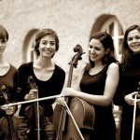](http://imagineartsfestival.com/wp-content/uploads/2015/07/zaide2w.jpg)[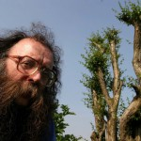](http://imagineartsfestival.com/wp-content/uploads/2015/07/eddie-lenihan.jpg)[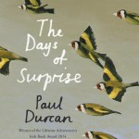](http://imagineartsfestival.com/wp-content/uploads/2015/07/Paul-Durcan-Days-of-Surprise-The.jpg)[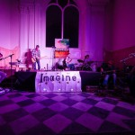](http://imagineartsfestival.com/wp-content/uploads/2015/07/3HUfblxQsD9cx1Ap57mFhDuFaf1VDBYU25I7u-MFpw41.jpg)[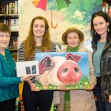](http://imagineartsfestival.com/wp-content/uploads/2015/07/new-3.jpg)[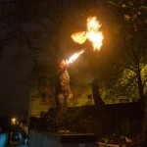](http://imagineartsfestival.com/wp-content/uploads/2015/07/Fire-pic.jpg)

**15th October to 25th October 2015, Imagine Festival Waterford**

***Come Celebrate with ART in UNEXPECTED Places***

***Winner of AOIFE 2014 FESTIVAL AWARDS***

***Best POSTER and Best OVERALL MARKETING***

***Runner-up BEST WEBSITE***

Imagine Arts Festival was started by a group of voluntary artists to provide a showcase for the local artistic and creative community, provide opportunities for arts participation and engagement across the community and could help attract high calibre national & international arts performers to Waterford. This founding ethos and volunteer driven model remains at the heart of Imagine. It is run entirely on volunteer energies, over 60 creative persons work on programming content and operations each year. The festival is built on this energy and on the amazing support of community groups, local business support and public funding from Waterford council, Fáilte Ireland and a part-time administrator provided under the CE scheme from the Department of Social Protection.