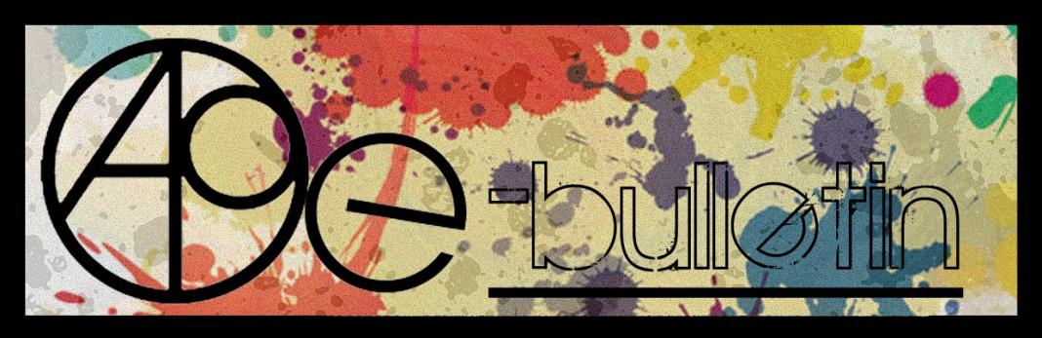

**Kilkenny County Council Arts Office E-bulletin 15th May 2015**

Dear All,   
  
Welcome to the fortnightly e-bulletin from Kilkenny County Council's Arts Office. Each bulletin is packed with the latest information on Kilkenny Arts Office activities, county events as well as news and opportunities for arts practitioners from around the country.

This service will be provided fortnightly. To include an item in the next e-bulletin please send a brief outline of your advert with relevant contact details, including any websites or pages with links to [**niamh.brophy@kilkennycoco.ie**](mailto:niamh.brophy@kilkennycoco.ie) **before 27th May**. The next e-bulletin will be on the **29th May.**

While every effort has been made to ensure the accuracy of our information, we strongly advise readers to verify all details to their own satisfaction.

Regards,

Niamh Brophy  
Arts Office,  
T: 056 7794138  
E: [niamh.brophy@kilkennycoco.ie](mailto:niamh.brophy@kilkennycoco.ie)   
W: [www.kilkennycoco.ie/eng/Services/Arts/](http://www.kilkennycoco.ie/eng/Services/Arts/)

BECOME PART OF IT, SUBMIT A POEM.....[www.rhymerag.net](http://kk-moss/Sites/arts_office/Shared%20Documents/Julianne%20Morgan/E-bulletin/30th%20May%20e-bulletin/www.rhymerag.net)  
Kilkenny County Council Arts Office Partner Local Authority of the ArtLinks Programme [www.artlinks.ie](http://www.artlinks.ie)

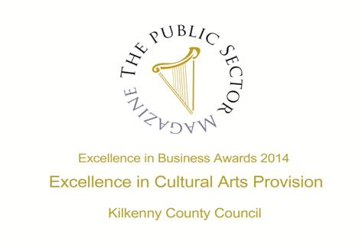

|  |  |
| --- | --- |
|  |  |
|  |  |

**Arts Office**

* Stunning poetry and illustration at the launch of Rhyme Rag
* Read the next Rhyme Rag poem!
* Social Fabric Exhibition and return of portraits

**Kilkenny Events**

* **National Drawing Day, Castle Park, Saturday 16th May**
* **Barn Owl Players One Act Festivals**
* Kilkenny Creative Hub – Expression of interest sought
* **At a loss for Words - Workshop**
* **Gypsy Ray Photograph’s at the Butler Gallery: Meet the artist**
* **Culture Club - Taster Event**
* Ballykeeffe Amphitheatre Kilmanagh Summer Concert Schedule
* **Kilkenny International Gospel Choir Festival**
* Classes Spring 2013 - Blackstack Studio, 42 Parliament St., Kilkenny
* **National Craft Gallery - Crafternoon Tea**
* **National Craft Gallery – National Drawing Day, Saturday 16th May**
* **National Craft Gallery – Appetite for Design**
* **Kilkenny County Library Information**
* KATS Theatre Group are coming to Cleere’s Theatre
* **Stone Carving Workshop, with James Horan and Aileen Anne Brannigan, Kilkenny**
* Joe Hill Songwriting Competition - Thomastown
* Grennan Mill Craft School - Summer Courses 2015
* **Kilkenny County Council Community and Cultural Facilities Capital Funding**
* **Dance and Movement Improve Workshop at KCAT**
* Coming Soon to the Watergate Theatre
* KOZO Workshop Programme 2015

**Courses / Training / Jobs / Internships**

* **MA SPACE Limerick School of Art & Design | Call for Applications**
* NYCI Youth Arts programme is pleased to announce the details of our Summer School programme 2015
* Arts Audiences – Webinar Series 2-TGI reports - The Arts in Irish Life & Marketing the Arts.

**Call for Submissions / Residencies**

* Bursary for documentation of an arts and health project
* The Soloist – Call for Musicians
* Emerging Visual Artist Award 2015 - Call for Applications
* **RDS National Craft Awards 2015: Call for Entries**
* **Social Mhuire National School, Barnstown, Wexford, Percent for Art Commission: Call for Artists**
* **Colour Exhibition at Hive Emerging | Call for Submissions**
* **Summer Residencies at GMIT, Castlebar**

**Awards / Bursaries / Schemes**

* **2014/2015 Dates and Deadlines for Culture Ireland Grant Rounds**
* Arts and Disability Connect
* Local Diaspora Engagement Fund Applications for Funding 2015
* Bursary Awards next closing date – 5.30pm, Thursday, 16 July 2015
* **Arts Council’s Artist in the Community Scheme – Deadlines 2015**

**Of Interest**

* Barrow River Arts Festival 15th – 17th May 2015
* Coming Soon: Movie-style trailers for all the arts
* Jockey by WillFred Production at GBS, Carlow
* **European Commission Survey on Remuneration for Photographers, Illustrators and Designers**
* **Irish Arts Organisations Successful in Accessing European Culture Funds**

**Arts Office**

**Stunning poetry and illustration at the launch of Rhyme Rag**

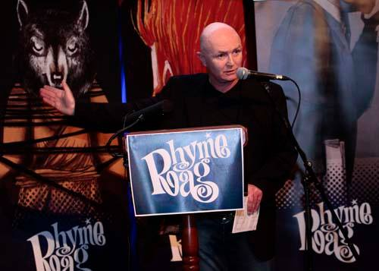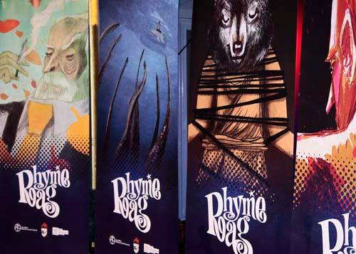

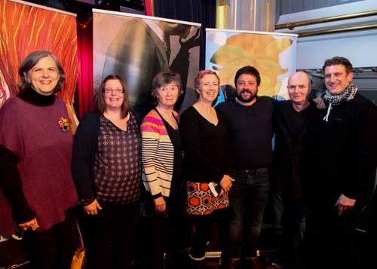 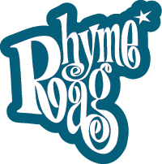

On Tuesday 28th April the Set Theatre was a haven of new poetry from Kilkenny young writers at the launch of ***Rhyme Rag*** ([www.rhymerag.net](http://www.rhymerag.net)), an online online illustrated poetry journalfor young Kilkenny writers aged 12-21.

So how does it work? Young people are asked to submit poems online at [www.rhymerag.net](http://www.rhymerag.net); resident editor, poet John W. Sexton, reads all the poems and gives personal feedback on all work submitted selecting two poems per month, which are then professionally illustrated and published on the website by illustrator and designer Ale Mercado. In addition, the *Kilkenny People* features a poem from the website every week.

Arts Officer Mary Butler comments ‘Tuesday’s launch was a great opportunity to celebrate and showcase great poetry from our young writers and allow for a community to come together, to start connecting with each other and to get a sense of themselves as part of a creative community and for all to be inspired.’

A stunning backdrop of Ale Mercado’s illustrated works complimented the fifteen young Kilkenny poets who took to the stage to read their work and included Orla McGovern, Fabian Gaspari, Melanie Byrne, Anna Eileen Doyle, Jack Larkin, Ciara Delaney, Luke O’Dwyer, Maeve Moran, Aine O’Neill, Liam Wallace, Tarla Murphy, Aoife Hughes, Alan Mooney, Laura Nash and Matt Burke.

Siobhán Parkinson, Ireland’s first Children’s’ Laureate, launched the event with a speech about how a poem is a dynamic force that holds the energy of the writer. ‘Whatever it is that drives a poem — an insight,  a thought, an image, an emotion, a sound — the poet’s task is to find a form of words that can hold that energy in tension. The verbal structure we call a poem holds its energy so that the reader can also experience that energy; in the same way, Rhyme Rag holds the energy of all these young poets’ poetry, and that energy leaps out of this beautiful website at the reader. ‘

St. Kieran’s College English teacher Larry Cotter talked about poetry in the classroom and about his collaboration on the new *Rhyme Rag* Teachers’ Information Pack, which was made available to teachers at the launch and can be obtained on request from the Kilkenny Arts Office. He says ‘*Rhyme Rag* is a great help to any teacher trying to encourage students to write. Only poems of the highest quality appear and this high standard promotes a real sense of achievement among the students whose work is chosen. It is also an invaluable resource in the classroom. To have local young voices appear in print and on the web in such an attractive publication is a great creative stimulant. I encourage all teachers of English to use the resource pack to get their students writing their own poems. When the students are happy with their work send it in. Who knows maybe they will be next to appear online or in the pages of the Kilkenny People?’

To round off the event, performance poet Stephen Murray, who ran a marathon of poetry workshops in schools that day, gave an exciting reading of his own work that left everyone asking for more.

**Those attending commented: *‘***I actually haven't stopped telling people about my experience at your recent Rhyme Rag Launch. It made a powerful impact on me. The contemporary and professional level of the setting, presentation and speeches afforded the respect and dignity the teens deserved and I believe this kind of  support for young adults is crucial as they make the transition into adult hood.’ (Alice Bennett);

‘What a fantastic event yesterday, congratulations to all involved particularly the young poets. Amazing talent and courage displayed in getting up there in front of a crowd and reciting their work.’ (Trish, Lifeline Kilkenny);

*‘*The launch was fantastic, everyone was very friendly and nice, John W. Sexton was so great in aiding us all to read our poems. Reading my poem out was great life experience and to make people aware of it. My brother and I had a great time and I am grateful for being published and for the invite.’ (Fabian Gaspari, published poet)

***Rhyme Rag*** is initiated and produced by Kilkenny County Councils Arts Office. It is complemented by poetry workshops and school residencies. These projects are further supported by Poetry Ireland, Kilkenny Library Service and the Arts Council of Ireland.

**BECOME PART OF IT, SUBMIT A POEM** [**www.rhymerag.net**](http://www.rhymerag.net)

**Read the next Rhyme Rag published poem**

The next poem to be published for **Rhyme Rag** is **‘Sooth-Said** by **Orla McGovern.**

Orla McGovern is 17 and attends Presentation Secondary School in Loughboy. She enjoys reading fantasy in particular but will dip into other genres as well. She also enjoys video games, but books are her main interest. Orla has had work previously published in Words to Tie to Bricks, which was part of the writing course in CTY Ireland 2013. She mostly writes poetry but has also been known to write a bit of prose here and there. She has twice appeared in Rhyme Rag.

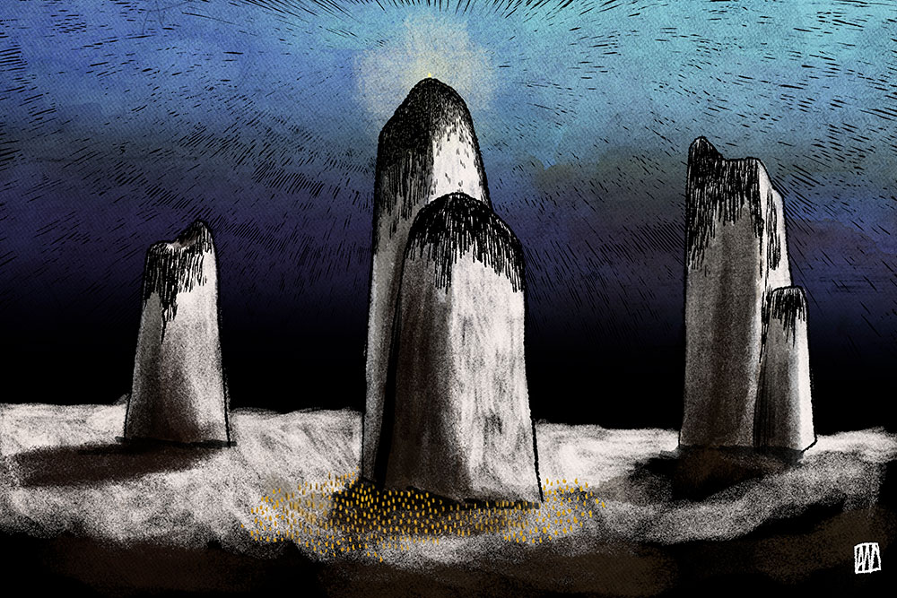

This poem was selected by Editor John W. Sexton and Illustrated by Ale Mercado.

**Read it here:** <http://www.rhymerag.net/2015/05/sooth-said/>

Thanks to all for submitting poems. And don’t forget to submit work or encourage others you may know to do so! See all details on [www.rhymerag.net](http://www.rhymerag.net)

**Social Fabric Exhibition and return of portraits**

To Social Fabric Participants!

Thank you for being a part of the Social Fabric Project - Portraits of Kilkenny Women.

I would like to invite you to the **Social Fabric Exhibition** on **Wednesday May 20th from 6pm - 8pm** in the Open Circle House (High Hayes, John's Green)  where you can come and view all of the embroidered portraits together one last time before they all go home with their respective owners.

If you still haven't returned your portrait but would like it to be a part of the exhibition please post it to:  
  
FAO Sandra McAllister   
Open Circle Arts   
John's Green House,   
John's Green,   
Kilkenny

**Please make sure you include your name and email/phone number.**

N.B If you are hand delivering it the offices are open from 9am-1pm and 2pm-4.30pm Monday to Friday.

All the best,

Sandra

**Kilkenny Events**

### FB NDD Event

 National Drawing Day is almost here again – a day when Butler Gallery invites people of all ages to indulge their creative side with a host of **FREE** activities throughout Kilkenny Castle Park.  What to expect? The unexpected!  With ten artist-led activities all around [Kilkenny Castle Park](http://www.kilkennycastle.ie/) and special [Cartoon Saloon](http://www.cartoonsaloon.ie/) animation activities taking over the Parade Tower, there will be something for everyone!

Fore more details see [www.butlergallery.com](http://www.butlergallery.com)

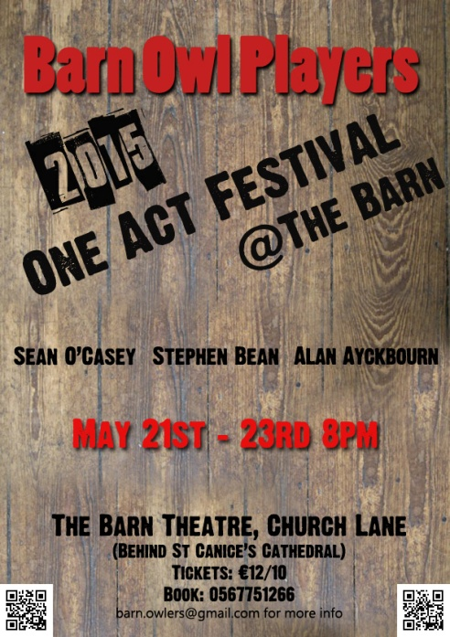

Local drama group, Barn Owl Players, present their annual One-Act Festival this May. Following on from 2014’s*Theatre X 2*, the group presents three one-act plays in The Barn Theatre. All three plays will be directed and produced by members of the group who are presenting a night of comedy, farce and burlesque.

*A Little Box of* Oblivion is an absurd play by Stephen Bean that focuses on a box left on a park bench and an unlikely bunch of people who meet on the scene. The content of the box is a mystery but the extreme characters who encounter it each have a wildly improbable theory about the box, leading to hilarious consequences. Directed by Martin Matthews the play stars Filomila Grigoriou, Frances Hopkinson, Cara O’Doherty, Declan Finneran and John Whitley.

The second play is *Mother Figure* by the master of farce Alan Ayckbourn. Telling the story of Lucy, a housebound mother of two, so caught up in the drudgery of motherhood that she cannot engage with her neighbours when they come to visit. Treating them as children and speaking to them in baby talk, this black comedy is sure to strike a chord with anyone who spends a lot of time caring for children. Directed by Mags Whitley the cast includes Mary Cody, Dee Gibney and Jim Carroll.

The third play for the night is a gem from Irish playwright Sean O’Casey. *A Bedtime Story*, set in Dublin in the 1950s, sees John Jo struggle with his conscience following an inappropriate night with a girl. Hijinks ensue when he tries to sneak Angela out of his flat without his landlady catching them, a task made difficult by Angela’s lack of interest in leaving. Directed by Trish Brennan the cast includes Seamus Greene, Natasha Murray, Michael Somers and Mary Byrne.

The show opens in The Barn Theatre, (behind St Canice’s Cathedral) at 8pm 21st May and runs nightly until 23rd May. Tickets are available by calling 056 775 1266 and cost €12/10. More information can be found at facebook.com/barnowlplayers or by emailing [barn.owlers@gmail.com](mailto:barn.owlers@gmail.com)

**Kilkenny Creative Hub – Expression of interest sought**

A group from the UCD Innovation Academy, on behalf of KK Co. Co., are exploring what it would take to develop Kilkenny city and county into a coordinated Creative Hub. They are looking for input from artists and creative people from all disciplines.

If you would be willing to share your thoughts and ideas, please contact Evan on 086-2472345 or [evan@knowyournumbers.ie](mailto:evan@knowyournumbers.ie)

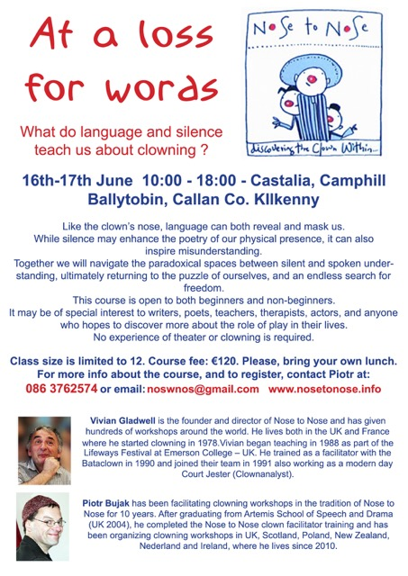

|  |
| --- |
| As part of the [Bealtaine Festival](http://butlergallery.us1.list-manage.com/track/click?u=7dd9a7764fd86ddd199d3320b&id=9d890ae0b6&e=0a3f410a56), we are delighted to welcome artist **Gypsy Ray** to Butler Gallery on Thursday 14th May at 1pm for our 'Meet the Artist' lunchtime event. This informal exhibition walkthrough will give you a chance to hear about Gypsy's practice and learn about the work featured in Gypsy Ray: Photographs, the current exhibition at Butler Gallery.  **Places are limited so booking is advised. Please call 056 7761106 to book your place.**    https://gallery.mailchimp.com/7dd9a7764fd86ddd199d3320b/images/6f8d3be5-1fc1-4126-a4c2-a98d02b510be.jpg |

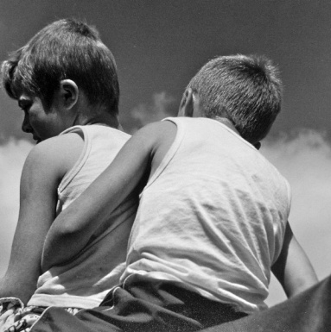

**Culture Club - Taster Event**

**Tuesday, 19 May, 11am**

**The Parade Tower, Kilkenny Castle**

Do you have an interest in visual art or theatre? Maybe you’ve always been curious about how an exhibition or theatre production comes together? Join us for this informal coffee morning, where you can find out more about Culture Club, a group for adults who meet regularly with trained facilitators and artists to explore how they can make informed opinions about art and theatre.   
  
Booking necessary, please contact Pauline at 056 7761006 or [pauline@butlergallery.com](mailto:pauline@butlergallery.com).

Culture Club is a Butler Gallery project in association with [Barnstorm Theatre](http://butlergallery.us1.list-manage.com/track/click?u=7dd9a7764fd86ddd199d3320b&id=caaf6aa0f3&e=0a3f410a56).

**Ballykeeffe Amphitheatre Kilmanagh Summer Concert Schedule**   
  
**Nathan Carter** June 12th   
**Goldilocks and the Three Bears (children's theatre show)** June 28th  
**Sharon Shannon** ,July 25th  
**Jane Eyre** by Chapterhouse Outdoor Theatre July 31st  
**Damien Dempsey** Aug 8th.  
  
More acts to be added.  
Tickets for Nathan Carter are now on sale at Ticketmaster ,Kilkenny Book Centre, Rollercoaster records and locally.  
@ 25 euro  
  
Events contact is Matt O'Sullivan - 087 6261134

**[Kilkenny International Gospel Choir Festival](http://kilkennygospelchoirfestival.com/" \o "Kilkenny International Gospel Choir Festival)**

[19-21 June 2015](http://kilkennygospelchoirfestival.com/" \o "Kilkenny International Gospel Choir Festival)

Programme 2015

**Friday, June 19th (Ormonde Hotel)**

10 – 12 am  Workshop for Primary School Children, Mr. Marcanthony Henry, Director/Musician/Singer from New York City

5.00 pm      Official Opening of the Festival performed by Mayor Andrew McGuinness in Kilkenny City Hall.   Complimentary light refreshments will be available.

8 – 9 pm       Introductory workshop with Mr. Marcanthony Henry.

**Saturday, June 20th (Ormonde Hotel)**

09.30 am  Morning Praise – Rev William Purcell, Musical Director, Kilkenny Gospel Choir

10.00 am  Workshop 1 – Mr. Marcanthony Henry

11.00 am  Tea/Coffee

11.30 am  Workshop 2 – Mr. Marcanthony Henry

12.30 pm  Lunch

02.00 pm  Workshop 3 – Mr. Marcanthony Henry

03.30 pm  Tea/Coffee

04.30 pm Concert Rehearsal

05.30 pm  Break

08.00 pm Celebration Concert in the  Black Abbey

**Sunday, June 21st (St. Mary’s Cathedral)**

11.00 am  Worship – Special Festival Mass

03.00 pm  Gospel Singing/Walking Tour of Kilkenny’s Medival City

Costs: $40.00 (€35.00) per person for weekend.

Children €5.00

All food and accommodation will be extra.  There will be a discounted menu available to participants during the workshops in the Ormonde Hotel.

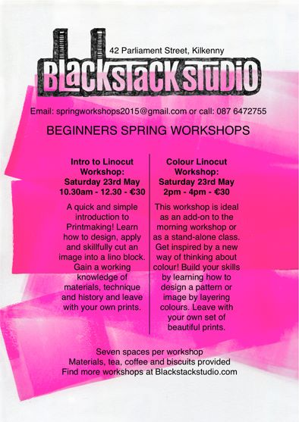

|  |
| --- |
| http://i2.cmail2.com/ti/y/C0/837/BB6/043645/images/ncg_logo.111537.gif |
|  |
| |  |  |  |  |  |  |  | | --- | --- | --- | --- | --- | --- | --- | |  | |  | | --- | |  | |  |  |  | | --- | |  | | **'Crafternoon Tea' at NCG, 22nd May**  We invite you to join us at the National Craft Gallery for 'Crafternoon Tea' and an informal tour of our exhibitions on Friday 22nd May at 1pm.  The talk and tour will explore the exhibition Appetite for Design an exhibition featuring the work of leading Irish designers, architects, cooks and restaurateurs which will document, discuss and speculate about the design of food and our experience of it.  FREE EVENT  For more details contact  events@nationalcraftgallery.ie or phone 056 7796151 | |  | |

[www.nationalcraftgallery.ie](http://nationalcraftgallery.cmail2.com/t/y-l-iunhdd-jtddlybih-yh/)



National Drawing Day   
  
Sat May 16, 12noon – 4pm  
FREE EVENT, Fun drawing workshops & activities for all ages  
  
The National Craft Gallery have programmed an afternoon of drawing activities with a craft and design twist. Families are invited to investigate, explore and discover new ways of seeing with our fun range of experimental drawing workshops and activities.  
  
GIANT FIBRE PORTRAITS with textile artist Caroline Schofield  
  
Transform the Castle Yard into a magical large-scale drawing with Caroline Schofield using the grass as a giant canvas. Strike a pose on the grass while the shape of your body is mapped using brightly colored yarns. Watch the map grow bigger and brighter through out the day. How about a unique family fiber portrait!  
  
YUMMY PRINTS with textile print-maker Caroline Ryan  
  
Inspired by our exhibition Appetite for Design textile print-maker Caroline Ryan of PRINTBLOCK Collective will explore all things foodie through silk-screen printing. Explore line, colour, design and cook up a colourful textile print on the day to take home. Suitable for all the family.



[**APPETITE FOR DESIGN**](http://www.nationalcraftgallery.ie/exhibitions)

**8 MAY 2015 – 30 JUNE 2015**

[Appetite for Design](http://www.nationalcraftgallery.ie/exhibitions) features the work of leading Irish and international designers, cooks and restaurateurs, documenting, discussing and speculating about the design of food and our experience of it.   Food is no longer merely about the simple act of eating, and the pure experience of smell and taste. New trends and materials have led to unique opportunities for the designers of today to enhance and elevate one's culinary experience by speaking to our minds as well as our stomachs. Engaging all our senses in a holistic culinary experience.

[Appetite for Design](http://www.nationalcraftgallery.ie/exhibitions) showcases examples of the aesthetics, promotion, communication and representation of food, along with the equipment and tools used to prepare and consume food. Featured work includes Bompas & Parr, Marije Vogelzang, Omer Polek, The Decorators, Chapter One and Loam.

A series of culinary evenings and performances to accompany the exhibition will hosted by [Godless Domestic](http://www.thedomesticgodless.com/), [Dublin Pop-up,](https://www.facebook.com/dublinpopup) [Culinary Counter](https://www.facebook.com/theculinarycounter) and Barry Fitzgerald.

The exhibition is curated by [Designgoat](http://wearedesigngoat.com/) and explores the very best of Food Design and builds on the increasing global recognition of outstanding Irish produce from coast to coast, and seabed to soil.

**APPETITE FOR DESIGN Eating Experiences**

[Eating Experience Programme](http://www.nationalcraftgallery.ie/news/article/eating-experience-programme)

As part of Appetite for Design exhibition curators, Designgoat, invite chefs, food designers and artists to create a series of Eating Experiences, presented in the National Craft Gallery. Each individual Eating Experience will be a totally different culinary encounter; showcasing seasonal, wonderful and bizarre foods.

[Eating Experience 1 with Barry Fitzgerald](http://www.nationalcraftgallery.ie/news/article/eating-experience-programme) Sat 9 May, 6.30pm

Former Head Chef of Etto, Dublin and of Michelin-starred the Hardwood Arms, London; Barry’s style of food is seasonal, creative, uncomplicated and approachable.

[Eating Experience 2 with Godless Domestic](http://www.nationalcraftgallery.ie/news/article/eating-experience-programme) Sat 23 May, 6.30pm

The Domestic Godless, explore the potential of food, through its taste, its presentation, its history and its cultural values, as a vehicle for irreverent artistic endeavour and experimentation.

[Eating Experience 3 with Culinary Counter](http://www.nationalcraftgallery.ie/news/article/eating-experience-programme) - Sat 6 June, 6.30pm.

The Culinary Counter, run by chefs Mark Moriarty and Ciaran Sweeney, aims to break down barriers between the kitchen and the customer. An exciting theatrical tasting menu will be served from these young brilliant chefs.

[Eating Experience 4 with Dublin Pop-Up](http://www.nationalcraftgallery.ie/news/article/eating-experience-programme) - Sat 20  June, 6.30pm.

Cúán Greene and Harry Colley of Dublin Pop Up offer innovative and extraordinary fine dining catering experiences, which play with traditional dining formats through dramatic food and unique locations.

**Booking for the Eating Experience series is through** [**eventbrite.com**](http://www.eventbrite.com/e/appetite-for-design-eating-experience-1-tickets-16675895051?aff=es2)**, which will be open from Monday 27th April. Limited places available. Unfortunately, special dietary requirements cannot be accommodated.**

**Exhibition Curator’s Talk & Launch**

Fri 8 May, 6.30pm

Designers Ahmed Fakhry and Cian Corcoran in conversation, followed by the exhibition Launch.

[**Family Day: National Drawing Day**](http://www.nationalcraftgallery.ie/news/article/national-drawing-day)

Sat 16 May, 12noon – 4pm

Drop-in drawing workshops and activities for all ages with a craft and design twist.

More info [here](http://www.nationalcraftgallery.ie/news/article/national-drawing-day)

Families are invited to investigate, explore and discover new ways of seeing with our fun range of experimental drawing workshops and activities inspired by our current exhibition [Appetite for Design.](http://www.nationalcraftgallery.ie/) Take part in one of our free craft and design-based workshops, **Yummy Prints**, **Giant Fibre Portraits** and **The Drawing Banquet** with plenty more self guided activities for all ages to enjoy.

**YUMMY PRINTS** *with textile print-maker Caroline Ryan*

Inspired by our exhibition Appetite for Design textile print-maker Caroline Ryan of [PRINTBLOCK](http://printblock.ie/) Collective will explore all things foodie through silk-screen printing. Explore line, colour, design and cook up a colourful textile print on the day to take home. Suitable for all the family

**GIANT FIBRE PORTRAITS** *with textile artist Caroline Schofield*

Transform the Castle Yard into a magical large-scale drawing with Caroline Schofield using the grass as a giant canvas. Strike a pose on the grass while the shape of your body is mapped using brightly colored yarns. Watch the map grow bigger and brighter through out the day. How about a unique family fiber portrait!

**DRAWING BANQUET** *with artist Mella Cahill*

Let the tablecloth be your canvas and the food your drawing tools at this dinner party like no other. Artist Mella Cahill will lead this imaginative drawing workshop inspired by the dinner table, suitable for all the family.

**All Drop –in, Ideal family activities. No booking required**

<http://www.nationalcraftgallery.ie/news/article/national-drawing-day>

[**Late Date: Packaging Design For Food**](http://www.nationalcraftgallery.ie/news/article/late-date-packaging-design-for-food)

Thurs 21May, 6.30pm

Kathryn Wilson of [Slater Design](http://www.slaterdesign.com), Karen and Natalie Keane *of* [Bean and Goose Chocolate](http://wearedesigngoat.com/?ds-gallery=bean-and-goose) with Sarah and Eleanor Duggan of[The Little Green Grocer](https://afternoon-dlite.squarespace.com/afternoon-dlite/2014/04/10/the-little-green-grocer%20-%20https://afternoon-dlite.squarespace.com/afternoon-dlite/2014/04/10/the-little-green-grocer)*,* talk inventive packaging design - the vital ingredient.

[**Bealtaine Festival: Crafternoon Tea**](http://www.nationalcraftgallery.ie/news/article/bealtaine-festival-crafternoon-tea)Fri 22 May, 1pm

A social afternoon to celebrate creativity as we age, join us for a food design talk, tour and afternoon tea.

[**Family Day: Mad Hatter’s Tea Party**](http://www.nationalcraftgallery.ie/exhibitions)

Sat 13 June 10.30am & 12noon

Children are invited to a Mad Hatter’s tea party were creativity and food will collide to create a magical eating experience.

[**Late Date: Public Spaces & Food**](http://www.nationalcraftgallery.ie/exhibitions)

Thurs 25 June, 6.30pm

Suzanne O’Connell of [The Decorators](http://the-decorators.net/About) and John Mahon of [The Locals](http://www.thelocals.ie/about), talk eating spaces.

[**Schools**](http://www.nationalcraftgallery.ie/learn/schools)

Tuesday – Friday, 10am & 12noon

Food Design focused tour and activities for Primary School students.

**WEEKENDS: DISCOVER & DESIGN**

Visitors of all ages can design, draw, build, and create with self-guided activities at the weekend. Drop in and get creative.

**Eating Experience tickets are available through eventbrite.com**

**To book our other events please contact us at 056 7796151 or email** [**events@nationalcraftgallery.ie**](http://kk-moss/Sites/arts_office/Shared%20Documents/Internal/Niamh/2015%20projects/E-bulletin/Downloads/events@nationalcraftgallery.ie)

**[nationalcraftgallery.ie](http://www.nationalcraftgallery.ie)**

[**facebook.com/NationalCraftGallery**](https://www.facebook.com/NationalCraftGallery)

[twitter.com/NCGKilkenny](http://kk-moss/Sites/arts_office/Shared%20Documents/Internal/Niamh/2015%20projects/E-bulletin/Downloads/twitter.com/NCGKilkenny)

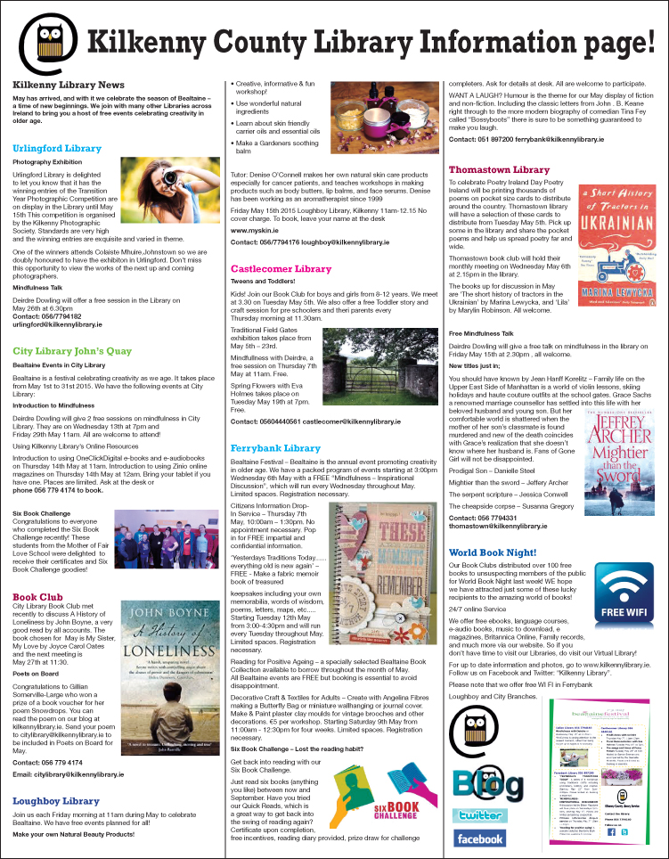

**KATS Theatre Group are coming to Cleere’s Theatre**



KATS Theatre Group are coming to Cleere’s Theatre for three nights of drama from 21st May to 23rd of May with their upcoming production ‘KATS 1 AKTS’. Featuring an incredible mix of KATS regulars as well as some amazing talent making their KATS debuts, here is just a flavor of what to expect:  
  
Setting the tone for the *Eugene O’Neill* dominant First Act, we open with **Kevin Mooney** (Devious Theatre) and **Kevina Hayes** (KATS, Kilkenny Musical Society) performing two of *O’Neill's* raw, goose-bump inducing monologues.  
  
The mouthwatering feast of drama continues as we take you to 1920’s gritty New York tenement for *'The Web' by Eugene O'Neill* which will be directed by **Alan Butler** (KATS, Devious Theatre). The cast features **Elaine O'Hara, John Prendergast, Ben Warner, Kevin Mooney, Niall O'Riordan** & **Tommy Maher**.  
  
Next, in his directorial debut, **Niall Bambrick** (KATS, KMS, Watergate Productions) takes over affairs and the countdown beings with *'Murder by Midnight' by Jeff Goode*. Hotel detective Dick Piston has less than ten minutes to solve a brutal murder or risk losing the case to the day shift. This hilarious over the top farce is one twist after another and features a very stellar cast of **John Holland, Kevina Hayes & Niall O'Riordan**.  
  
 Finally, we pay our respects to writer *Colin Calvert* with his play *‘Last Respects*’. Henry (deceased) has decreed that a wake should be held in his honour at the funeral parlour. The guests, previously unknown to each other, are his wife and his two mistresses. Hilarity ensures in this black comedy directed by **Niall Bambrick** and features a superb cast of KATS regulars **Matt Berry, Nicola Brennan** & **Maeve O’Flynn** along with **Emma De Burca** making her KATS debut.  
  
‘KATS 1 AKTS’ takes place in Cleere’s Theatre from May 21st to May 23rd. Tickets are €10.00 and on sale now by calling Cleere’s Theatre on 056 7762573 or emailing [katstheatregroup@gmail.com](mailto:katstheatregroup@gmail.com). (Please note that seating is limited so book early to avoid missing out!)

**Stone Carving Workshop, with James Horan and Aileen Anne Brannigan, Kilkenny**

Beginners course in letter carving or sculpting in stone  
13th & 14th June 10am – 4.30pm both days  
Cost €150

Venue: Mill Lane, Callan, Co Kilkenny

Tools and stone provided. Each student should bring home a finished piece, basic stone carving skills and good memories.

Tea and coffee provided but please bring a lunch!  
Design and carve your own sculpture/plaque/ sign

Further information:  
T:  0861676219  
E: [jameshsculpture@hotmail.com](mailto:jameshsculpture@hotmail.com)

**Joe Hill Songwriting Competition - Thomastown**

The George Brown Memorial Committee is pleased to announce their first ever songwriting competition. 2015 marks the 100th anniversary of the execution of Joe Hill in Utah, USA. Joe was a workers activist and member of the Industrial Workers of the World. His execution was controversial and is considered to be a miscarriage of justice resulting from his trade union activities.

Joe Hill will be a central theme of the 2015 George Brown Commemoration, with a key-note speech on his story and subsequent influence on the worker’s movement. We are also offering a prize of €150 for the best submission in our songwriting competition, where we are asking for words to two new verses for the song Joe Hill. These verses should deal with the difficulties experienced by workers since 1915 and/or the advances achieved over the subsequent century. They should follow the standard format of the other verses and fit to the usual tune for the song. If you are not familiar with the song you can find a version by Luke Kelly on Youtube at:

<https://www.youtube.com/watch?v=Q2OivplOBq8>

The closing date for the competition is midnight Monday 1st June 2015. Submissions should be made to the George Brown E-mail address:

[georgebrown.inistioge@gmail.com](mailto:georgebrown.inistioge@gmail.com)

or to Joe Doyle, George Brown Memorial Committee, Thomastown, County Kilkenny

I dreamed I saw Joe Hill last night  
Alive as you and me  
Says I, "But Joe, you're ten years dead"  
"I never died", says he  
"I never died", says he.

In Salt Lake, Joe, says I  
Him standing by my side  
"They framed you on a murder charge"  
Says Joe, "I never died"  
Says Joe, "I never died."

The copper bosses they shot you, Joe,  
They filled you full of lead  
"Takes more than guns to kill a man"  
Says Joe, "And I ain't dead"  
Says Joe, "And I ain't dead."

And standing there as big as life  
And smiling with his eyes  
Says Joe, "What they forgot to kill"  
"Went on to organize"  
"Went on to organize."

Joe Hill ain't dead, he says to me  
Joe Hill ain't never died  
Where working man are out on strike  
Joe Hill is at their side  
Joe Hill is at their side.

In San Diego up to Maine  
In every mine and mill  
Where working men defend their rights  
It's there you'll find Joe Hill  
It's there you'll find Joe Hill.

I dreamed I saw Joe Hill last night  
Alive as you and me  
Says I, But Joe, you're ten years dead  
I never died, says he  
I never died, says he.

**Grennan Mill Craft School - Summer Courses 2015**

• Metalcraft & Jewellery for Beginners & Improvers  
**Thursday 4th June - Sunday 7th June** / 10am-5pm   
4 day course exploring many techniques in Metalsmithing & Jewellery-making including enamelling, soldering, forming, surface decoration & more...   
Minimum 6 – Maximum 8 persons  
Course Fee €260  
Materials Fee €15 - includes copper & gilding metal, enamels, solders & sundries.

• Silver Jewellery for Beginners & Improvers  
**Friday 12th June - Sunday 14th June** / 10am-5pm   
3 day course exploring many techniques in Silver Jewellery making  
Minimum 6 – Maximum 9 persons  
Course Fee €200  
Materials Fee €20 (includes 8 grams of silver)

***For more details please text / phone Metalcraft Tutor Eva Lynch on 087 6210830 or email at [evylynch@hotmail.com](mailto:evylynch@hotmail.com) ***

Place will only be secured once deposit of 50% or full payment has been received. Full course fee required by: Friday 29th May for ALL courses  
• Cheques made payable to ‘’Grennan College’  
• Class formation is dependent on an adequate number of applicants – minimum 6 persons for each individual course irrespective of craft  
• Should Grennan Mill cancel the course, your monies will be refunded in full

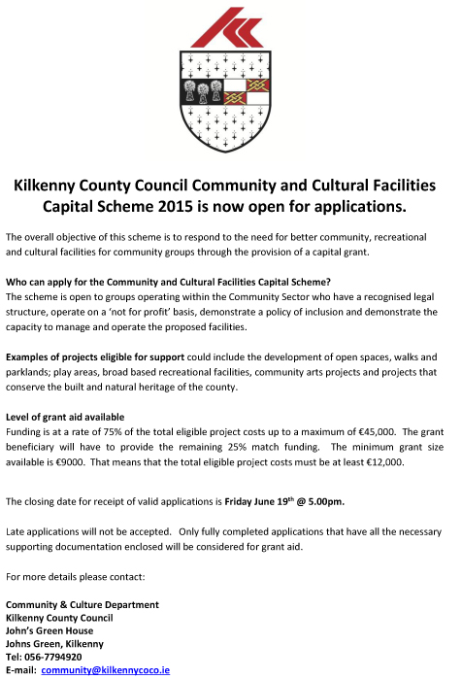

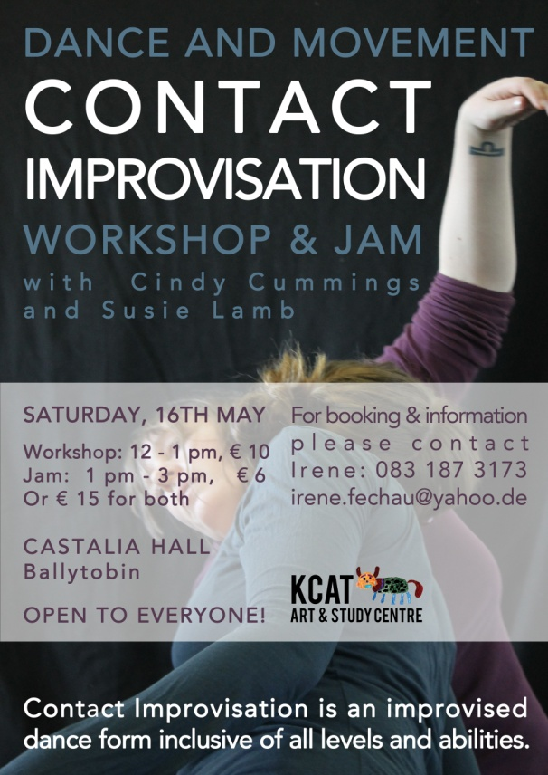

## Coming Soon to the Watergate Theatre

Here’s a look at some of the shows, gigs and other events taking place here at the Watergate Theatre in the next few weeks. You can speak to our helpful box office staff at any time by phoning [056 7761674](tel:+353567761674).

[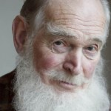](http://watergatetheatre.com/programme/my-fair-ladies/)

### [My Fair Ladies](http://watergatetheatre.com/programme/my-fair-ladies/) (17/05/2015)

Devised and performed by Des Keogh..

[**Book Online**](http://watergatetheatre.com/programme/my-fair-ladies/)

[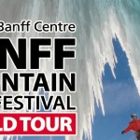](http://watergatetheatre.com/programme/banff-mountain-film-festival-world-tour/)

### [Banff Mountain Film Festival World Tour](http://watergatetheatre.com/programme/banff-mountain-film-festival-world-tour/) (21/05/2015)

The world's most prestigious mountain film festival returns to Kilkenny with a new selection of extraordinary short films.

[**Book Online**](http://watergatetheatre.com/programme/banff-mountain-film-festival-world-tour/)

[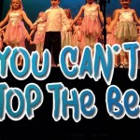](http://watergatetheatre.com/programme/you-cant-stop-the-beat/)

### [You Can't Stop The Beat](http://watergatetheatre.com/programme/you-cant-stop-the-beat/) (23/05/2015)

Variety show by members of Stagedoor, Stoneyford..

[**Book Online**](http://watergatetheatre.com/programme/you-cant-stop-the-beat/)

### [St. Kieran's College Awards Night](http://watergatetheatre.com/programme/st-kierans-college-awards-night/) (26/05/2015)

Celebrating the academic and sporting achievements of St. Kieran's College.

[**Book Online**](http://watergatetheatre.com/programme/st-kierans-college-awards-night/)

[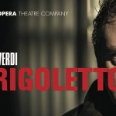](http://watergatetheatre.com/programme/rigoletto/)

### [Rigoletto](http://watergatetheatre.com/programme/rigoletto/) (28/05/2015)

[**Book Online**](http://watergatetheatre.com/programme/rigoletto/)

[](http://watergatetheatre.com/programme/the-man-in-the-womans-shoes-3/)

### [The Man In The Woman's Shoes](http://watergatetheatre.com/programme/the-man-in-the-womans-shoes-3/) (29/05/2015)

A one-man show written and performed by Mikel Murfi - back by popular demand!. See [full event & ticket details](http://watergatetheatre.com/programme/the-man-in-the-womans-shoes-3/).

[**Book Online**](http://watergatetheatre.com/programme/the-man-in-the-womans-shoes-3/)

### [Jesters Stage Academy presents Movie Mayhem](http://watergatetheatre.com/programme/jesters-stage-academy-presents-movie-mayhem/) (11/06/2015)

An evening of movie blockbusters with Jesters.

[**Book Online**](http://watergatetheatre.com/programme/jesters-stage-academy-presents-movie-mayhem/)

### [Dancewise Academy presents Movie Magic](http://watergatetheatre.com/programme/dancewise-academy-presents-movie-magic/) (25/06/2015)

A night of dance from your favourite movies and musicals..

[**Book Online**](http://watergatetheatre.com/programme/dancewise-academy-presents-movie-magic/)

### [Moll](http://watergatetheatre.com/programme/moll/) (02/07/2015)

Performing 2-4 and 9-11 July.

<http://watergatetheatre.com/>

**KOZO Workshop Programme 2015**

**KOZO Studio WORKSHOP Programme  
for adults (incl. young people from 16 years)**

**APRIL - JUNE 2015**

The **WORKSHOP PROGRAMME** at KOZO Studio continues this SPRING with extra dates added for PAPERMAKING Courses – all designed and run for small groups of participants at KOZO Studio in The Estate Yard, Castlecomer Discovery Park, Co. Kilkenny.

We scheduled workshops for **complete beginners** as well as **returning participants** and those of you with **previous experience** or your own creative practices.

**Tutor:** Tunde Toth – Visual Arts Practitioner, Arts Educator, Papermaker

Read on to check out our **inspiring choice of workshops:**

#### EMBROIDERY WORKSHOP for BEGINNERS with Alexis Bernstorff - Textile Artist and Textile Restoration expert from the ROS TAPESTRY 23 MAY (Saturday) 11am - 5pm

This workshop will teach 6 principal stitches and their variations - using wool, cotton/silk and metallic threads. Participants will be inspired by a range of techniques to realise simple designs.  
  
Alexis has 15 years experience teaching crewelwork embroidery and is the guide behind the dynamics of the Ros Tapestry. There will be designs from the Ros Tapestry available to purchase on request.  
€ 70 for the full day - including all materials 

#### Advanced Level EMBROIDERY WORKSHOP with Alexis Bernstorff - from the ROS TAPESTRY 20 JUNE (Saturday) 11am - 5pm

This is a follow-on, advanced level course, offering comprehensive tools to realise a variety of designs and artworks.  
It will refresh participants on basic stitches (if necessary) and teach four more stitches using wool, cotton/silk and metallic threads and other materials such as wire and unspun wool and silk.  
The workshop will focus on Form, Volume and Effects and each stitch will be explored under these headings. Stitch direction, padding and consideration of the fall of light will allow participants to expand on the potential of embroidery as a creative, artistic medium.  
€ 70 for the full day - including all materials

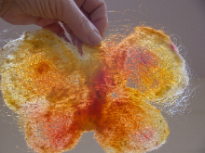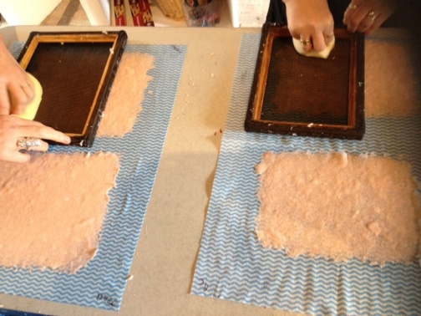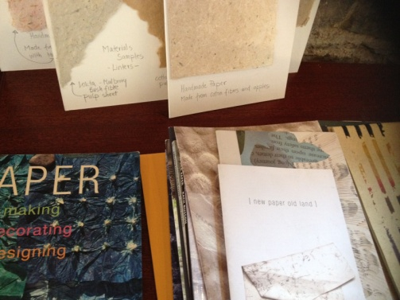

**********  
**17 May (Sunday): PAPER MAKING  DAY**- Beginners and participants with some previous experience  
For details see PAPER MAKING DAY programme above (19 April)  
   
**********  
**7 June (Sunday): PAPER ART and HAND PAPER MAKING**  
FOLLOW-ON, ADVANCED LEVEL COURSE - only for participants with previous experience.  
10.30am - 5.30pm  
  
Designed for participants who already work with paper/fibre based processes, this course offers assistance and guidance in areas of three dimensional, sculptural and installation based works, experimental processes of batik, paper dyeing and texturing. It also covers ideas for the preparation and use of plant based pulps (without added chemicals). Participants are encouraged to bring their own ideas and questions into the workshop and invited to show and discuss previous works and projects. The day also includes a short slideshow presentation on examples of contemporary paper art and paper making.  
Places are limited for 5 participants.  
€ 80 for the full day, including all materials  
  
**********  
**14 June (Sunday): BATIK Workshop**- Beginners  
A full day programme introducing an ancient technique of fabric dyeing where hot wax is used as a resist.  
Participants will learn all necessary basic techniques - and complete three small/medium batik pieces with up to 4 colours on cotton fabric and/or paper.  
€ 70 for the full day, including all materials  
  
  
GIFT VOUCHERS are available for the workshop of your choice!  
   
BOOKINGS are confirmed with € 30 deposit paid in advance.*  
Courses are run for small groups of participants only so please call to book early.  
With any questions, for advice or check availability and for all BOOKINGS please contact TUNDE directly:  
  
**Tunde Toth - Artist**  
**087-2543362**  
[tundetune@gmail.com](mailto:tundetune@gmail.com)  
[www.tundetoth.com](http://tundetoth.us9.list-manage.com/track/click?u=927a06abce3366093569f0241&id=73399962f2&e=1f1b25985b)  
[www.tundetothpaperart.blogspot.com](http://tundetoth.us9.list-manage1.com/track/click?u=927a06abce3366093569f0241&id=4fd328d620&e=1f1b25985b)

**Courses / Training / Jobs / Internships**

**MA SPACE Limerick School of Art & Design | Call for Applications**

MA SPACE invites candidates from Art, Design and other related fields who are interested in creating art that addresses topics such as; Space and Place, Food Politics, Gender Politics, Ecology, Climate Change, environmental politics, Science and Art, Civil Rights, Globalization and Economics, Health, Trans-Global Movement, Labour and Land Politics, etc

Social Practice is located in the overlap of art, society and politics. It has been described as art activism, critical art, socially engaged art, social practice art, activism, political art, participatory, dialogical or collaborative art.

Second round MA SPACE applications for the academic year 2015-16 are now being considered, application form and information on the programme at: [http://www.lit.ie/Courses/MASPACE/](http://lists.visualartists.ie/lt.php?c=1342&m=4379&nl=1&s=e784eec6bf8bb9680747b324b9c9eee1&lid=112565&l=-http--www.lit.ie/Courses/MASPACE/)

Deadline for applications 5pm on Friday 5th June 2015.

**NYCI Youth Arts programme is pleased to announce the details of our Summer School programme 2015**

Summer School 2015 is a three day residential youth arts practice training in NUI Galway, running from 10th-12th June 2015 (check in on Tuesday 9th June). The theme this year is Story Making. Summer School is about approaching your work with young people in a fresh way. It is an opportunity to be inspired, use new art forms, break out of your everyday routine, network and get creative!

Summer School is suitable for anyone working with young people in the non-formal education sector who wishes to explore ways of introducing, enhancing and extending youth arts provision for the young people with whom they work. It is aimed both at those looking to improve their art form and delivery techniques or those totally new to youth arts.

You can download the brochure here:

<http://www.youtharts.ie/sites/default/files/NYCI_Summer_School_2015.pdf>

You can download the booking form here:

<http://www.nycitraining.org/yass2015>

The workshops on offer this year are:

**Story Theatre and Ensemble Improvisation** – Annie Ryan of Corn Exchange Theatre will teach improvisation techniques which will allow participants to engage their youth group in story making.

**Discover Your Voice** – Max Hafler will teach hands on techniques to find and understand your voice and to be able to work through voice with a youth group.

**Paper, Story and Space** – Maeve Clancy will give you the know how to create comic books and 3D paper models all in the pursuit of storytelling with your youth group.

For queries contact Niamh at 01-4784122 Niamh@nyci.ie.

*“I would just like to thank you again for such a great experience. It was a wonderful few days and I’m so pleased I got to meet and work with a wide variety of people. I feel so much more confident now with my approach to working with young people.”* ***Participant Summer School 2014***

|  |
| --- |
| http://newsletter.artscouncil.ie/nwstatic/spacer.gif |

**Arts Audiences – Webinar Series 2-TGI reports - The Arts in Irish Life & Marketing the Arts.**

**Wednesday, 27 May, 11am-12pm.**

Arts Audiences has arranged an online session on the two major reports drawn from TGI -  The Arts in Irish Life and Marketing the Arts.

**WHO IS IT FOR?** If you are engaged in Arts Marketing this session will deepen your understanding of Irish Audiences, how they behave, who they are, where they are and much more.

**HOW DOES IT WORK?** The session will take place online, and you will be able to interact with Eimear Faughnan of Kantar Media and Una Carmody of Arts Audiences, live from your own desktop on Google Hangout.

**WHO IS IT FOR?** Venue and festival managers, production companies, resource organisations, everyone engaged in developing audiences for the arts.

**HOW DO I SIGN UP?** Click here: [http://tinyurl.com/kx39xa4](http://newsletter.artscouncil.ie/1gsz389dsis14rbsgtdsq9?a=6&p=48727905&t=28179891) as soon as possible. The session is free of charge and we encourage you to ask questions beforehand in the space provided. Detailed instructions on how to join the webinar will be provided to those who have registered in advance of the event.

**Call for Submissions / Residencies**

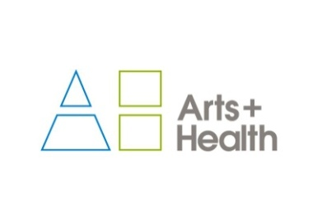

**artsandhealth.ie**

**Bursary for documentation of an arts and health project**

artsandhealth.ie is the national website providing a focal point and resource for the field of [arts and health](http://www.artsandhealth.ie/about/what-is-arts-and-health/) in Ireland. Developed by the Waterford Healing Arts Trust (WHAT) and Create in 2011 with funding from the Arts Council, the site is now managed by WHAT.

artsandhealth.ie invites applications from arts and health practitioners (artists working in healthcare settings, healthcare professionals, arts and health partnerships etc.) for a bursary to produce documentation of an arts and health project. The proposed documentation can take the form of a **short film / audio documentary and / or publication** which can be widely disseminated with a view to encouraging high quality, creative documentation of arts and health practice and creating a greater national understanding of the nature of this practice

Examples of existing documentation of arts and health practice can be found in the Resources section of artsandhealth.ie

**Bursary**

A bursary of €4000 will be made available to the successful applicant for the production of film / audio documentary and / or publication about an arts and health project.

**Eligibility Criteria**

Anyone responsible for delivering/co-delivering an arts and health project in the Republic of Ireland, in keeping with artsandhealth.ie’s definition of arts and health, may apply (see [www.artsandhealth.ie/about/what-is-arts-and-health](http://www.artsandhealth.ie/about/what-is-arts-and-health)).

**Who can not apply?**

Projects managed directly by WHAT or by members of the [Editorial Panel](http://www.artsandhealth.ie/about/about-artsandhealth-ie) of artsandhealth.ie cannot apply.

**Timeframe**

The closing date for the receipt of applications is 29th May. Applicants will be notified of decisions by 19th June 2015. It is expected that the final documentation will be completed and submitted to artsandhealth.ie by 31st March 2016.

**Application Procedure**

Please complete the application form below and submit with:

* CV(s) of artist(s) / arts and health practitioner(s)
* CV(s) of lead documenter(s)
* Up to five captioned photographic images of project and / or examples of previous, relevant work of lead artist(s) / arts and health practitioner(s). Website links are acceptable.
* Examples of previous, relevant work of lead documenter(s). Website links are acceptable.
* Support letter(s) from partner(s)

**Submissions should be sent by email to** [info@artsandhealth.ie](mailto:info@artsandhealth.ie) **by Friday, 29th May at 12 noon.**

For further information, contact [info@artsandhealth.ie](mailto:info@artsandhealth.ie)

**The Soloist**

|  |
| --- |
|  |
|  |
|  |

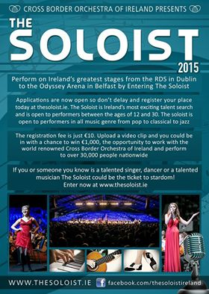

**Emerging Visual Artist Award 2015 - Call for Applications**

|  |  |
| --- | --- |
| |  | | --- | | Wexford Arts Centre and Wexford County Council are pleased to announce a call for submissions for their annual Emerging Visual Artist Award.    The Emerging Visual Artist Award is a partnership initiative between Wexford Arts Centre, Wexford County Council and the Arts Council.   The initiative supports promising visual artists in Ireland with an award of €5,000 and a solo exhibition at Wexford Arts Centre.  It aims to recognize and support the development of committed emerging artists, in kick starting their career and achieving professional recognition.   The successful recipient  will be required to create a new body of work during the period October 2015 – December 2016, which will be exhibited at Wexford Arts Centre during January – February 2017.  **Who is eligible to apply for the Award?** - Applicants practicing any visual art form are eligible to apply; - Applicants must have resided in Ireland for a minimum twelve month period to be eligible to apply; - Applicants cannot be enrolled in an undergraduate programme in their art form at the time of the application deadline;   **What selection criteria will be used?** - Applicant’s demonstrated commitment as a serious professional to her/his art form; - Overall excellence of the applicant’s art work; - Demonstration of exceptional talent; | |

|  |  |
| --- | --- |
| |  | | --- | |  | |

|  |  |
| --- | --- |
| |  | | --- | | Submissions must be emailed to [emergingvisualartistaward@gmail.com](mailto:emergingvisualartistaward@gmail.com) and include the following: - An up to date CV; - A work statement detailing themes, working methods and medium – 300 word limit; - A proposal in relation to the body of work which will be undertaken – 350 word limit; - Timescale breakdown – research, production, delivery; - Budget breakdown – materials, travel, studio hire, etc.;   - Examples of work to date i.e. documentation in the form of 10 jpeg images;  Full details for each image is required, i.e. title, medium, measurements, date of work. Three copies of each film, video or audio work can be sent by post to: Emerging Visual Artist Award, Wexford Arts Centre, Cornmarket, Wexford Town or alternatively links to video and/or audio works can be emailed.   **Notes on submissions:** **Please adhere to the following notes whilst preparing your application:** - Please format all information in **one document** and keep to the word limit on the artist statement and proposal; - Please save each Jpeg image with the following details: Artist’s Name_Title_Medium_Dimensions_Year (for example: NoelSmith_LandscapeInBlue_AcrylicOnWoodenPanel_43x30cms_2015); - If sending film, audio or video work please label with your name and contact number, work title, and duration; **-** Do not submit any hardcopy material including catalogues, invitations, artist books, etc.  **Please enclose a €7.50 processing fee with your application.** Cheques should be made payable to Wexford Arts Centre, or you can ring the Box Office at Wexford Arts Centre on +353 (0)53 9123764 with your debit card details.   The deadline for receipt of email submissions is **4.00p.m. Thursday 4th June 2015**. For gallery plans and images please log on to <http://www.wexfordartscentre.ie/application-process-20151.html>.  Images: Teresa Gillespie (2013 EVA Award Winner), below explanation (clocks stop at 3pm and existence continues), exhibition in-situ at Wexford Arts Centre, January-February 2015. | |
|  |
|  |
|  |

**RDS National Craft Awards 2015: Call for Entries**

**[Please note a nominal fee applies]**

The RDS is now calling for entries for the 2015 RDS National Craft Awards which has an increased prize fund of €40,000. The annual RDS National Craft Awards showcase and reward excellence in Irish craft.

Major Awards:

* RDS Award of Excellence €5,000 (top prize awarded in each strand)
* Irish Design 2015 Award €5,000 (open to emerging & established category winners)
* RDS IACI Muriel Gahan Award €2,000 (emerging maker)
* RDS Graduate Award €2,000 (emerging maker)
* National Crafts & Design Fair Award (value €2,000, emerging maker)
* RDS William Smith O’Brien Perpetual Challenge Cup (open to emerging & established makers)

The category prizes in the 2015 RDS National Craft Awards are sponsored by the Design & Crafts Council of Ireland. This year the 13 category prize winners in each strand will receive €500 as well as an RDS medal & certificate. There is also a special additional €5,000 prize to celebrate Irish Design 2015, which will be awarded for design innovation and excellence in a craft entry this year.

See [www.rds.ie/craft](http://lists.visualartists.ie/lt.php?c=1315&m=4352&nl=1&s=d3c261c0eeb6b48867f449d29e09414b&lid=104719&l=-http--www.rds.ie/craft)  for details of the many other sponsored prizes and to view the rules of entry.  
Winning and selected entries will be shown at the RDS National Craft Awards Exhibition at the Discover Ireland Dublin Horse Show, RDS, August, 2015, and award winners will be shown at the National Crafts and Design Fair, RDS, December, 2015.

Enter online at [www.rds.ie/craft](http://lists.visualartists.ie/lt.php?c=1315&m=4352&nl=1&s=d3c261c0eeb6b48867f449d29e09414b&lid=104720&l=-http--www.rds.ie/craft%C2%A0)  
Deadline 10 June 2015

**Social Mhuire National School, Barnstown, Wexford, Percent for Art Commission: Call for Artists**

The Board of Management of Scoil Mhuire National School, Barntown wishes to commission two site specific public artworks under the Per Cent for Art Scheme, funded by the Department of Education and Science. Scoil Mhuire Barntown is a parish, co-educational primary school which caters for pupils from junior infants to sixth class. The school serves the community of Barntown which encompasses the outer reaches of Wexford town. We think of ourselves as a rural school and love the way our school nestles under Forth mountain. The view from our new front door is a fabulous panoramic view of the mountains from Mount Brandon and the Blackstairs to the Wicklow mountains.

Budget €18,000

Applicants are requested to read the full content of the Artist Brief, [CLICK HERE](http://lists.visualartists.ie/lt.php?c=1342&m=4379&nl=1&s=e784eec6bf8bb9680747b324b9c9eee1&lid=112531&l=-http--visualartists.ie/wp-content/uploads/2015/05/Artist-Brief-Scoil-Mhuire-Barntown.pdf), carefully as it contains important information pertaining to all stages of the commission.

**Stage 1**  
Artists are invited to express their interest in being considered for this project at the first stage of this commission.  
Please submit  
•            CV  
•            Images /recordings of previous work, no more than 5  
•            Artist’s proposal/sketch, no more than 500 words

These should be combined into a single PDF file of no more than 10MB.  
**Deadline**: stage 1 completed application form together with supporting documentation and material is **26th June 2015, 12 noon.**

**Stage 2**  
From the completed stage 1 applications, a shortlist of not more than six artists will be selected by panel jury. This panel, whose decision is final, has the right to clarify any issue which may arise in the course of selection.  A fee of €500 will be paid to shortlisted artists if further work is required to prepare a detailed submission including written outline, budget outline, feasible timeline/schedule and visual representation. The shortlisted artists will also be invited to present/develop their proposals in a way that will be easily accessible to staff and pupils. The committee will actively seek input of pupils and staff in the selection process.

Site Visits  
Site visits will be arranged for shortlisted artists at Stage 2 of the commissioning process.

Shortlisted artists will be required to submit a **Tax Clearance Certificate** and subject to **Garda vetting**  
Social Mhuire, Barnstown reserves the right not to proceed with any of the submissions received.

Further information and digital submissions to:  
E: [info@barntownns.ie](mailto:info@barntownns.ie)  
Hard copy submissions to be posted to:  
Scoil Mhuire Nation School, Barntown, Co. Wexford  
**Deadline 26th June 2015, 12 noon**

**Colour Exhibition at Hive Emerging | Call for Submissions**

Hive Emerging, 25 Michael Street, Waterford City

Hive is due to launch the second event of its 2015 summer program. The gallery & its guest curators are staging an open call for artworks which fall within the theme of colour.

Artists, when applying, are requested to submit

• an artist’s CV  
• images of work (as attachments) including medium, dimensions, price & hanging specifications (within the file title)  
• a concise statement outlining the artist and their current/submitted work

With regards to video and performance art we would require exemplary video as part of submissions. Hive accepts links to both Youtube & Vimeo.

Deadline: Friday 22nd of May, 5.30pm

[hiveemerging.com](http://lists.visualartists.ie/lt.php?c=1342&m=4379&nl=1&s=e784eec6bf8bb9680747b324b9c9eee1&lid=112539&l=-http--hiveemerging.com/)

**Summer Residencies at GMIT, Castlebar**

GMIT Mayo has launched its Artists Summer Residency Programme 2015 which supports emerging and established artists in the region. The programme provides opportunities for artists to research and develop their practice through the provision of studio space on campus, access to GMIT’s library facilities and participation in an exhibition at the historic Mayo campus. The residency will take place over six weeks in July and August and applications are now being accepted for the programme. Four places will be available, following an interview process that is to take place in mid-June on campus.

To apply for a place on this programme and for further information:  
E: John.Mulloy@gmit.ie  
[www.gmit.ie](http://lists.visualartists.ie/lt.php?c=1342&m=4379&nl=1&s=e784eec6bf8bb9680747b324b9c9eee1&lid=112549&l=-http--www.gmit.ie/news/gmit-mayo-launches-artists-summer-residency-programme)  
**Deadline 5 June 2015**

**Awards / Bursaries / Schemes**

**2014/2015 Dates and Deadlines for Culture Ireland Grant Rounds**

Please note Culture Ireland has set funding rounds and deadlines for 2015. There will be three funding rounds in 2015 and seperate calls for showcasing opportunities and Edinburgh Festivals will be announced during the year.

**Application Deadline | Timing of Project/Event | Decision Due**

* 15 June 2015  | September 2015 onwards | Early August
* 15 October 2015 |  January 2016 onwards | Early December

[http://www.cultureireland.ie/](http://lists.visualartists.ie/lt.php?c=1232&m=4271&nl=1&s=d3c261c0eeb6b48867f449d29e09414b&lid=96096&l=-http--www.cultureireland.ie/)

**Arts and Disability Connect**

|  |
| --- |
| http://newsletter.artscouncil.ie/nwstatic/spacer.gif |

The Arts Council and Arts & Disability Ireland announce the second phase of Arts and Disability Connect, a new awards scheme for artists with disabilities in the Republic of Ireland. Supported by the Arts Council the scheme will have a fund of €25,000 to distribute in 2015.

Specifically targeted at individual artists with disabilities Arts and Disability Connect includes New Work, Mentoring and Training awards. The scheme offers artists the opportunity to: connect with other practitioners or venues; make a change in their practice; ‘step up’ in terms of scope and scale; reach new audiences and to engage in mentoring and training.  
  
Application forms and guidelines for 2015 will be available to download from Thursday 2 April 2015 at [www.adiarts.ie](http://newsletter.artscouncil.ie/brj9j540ptj14rbsgtdsq9?a=6&p=48507525&t=28179891)

**Deadline: Thursday 21 May 2015 at 4pm**

For general queries about the awards please contact:   
[info@adiarts.ie/](mailto:info@adiarts.ie/) 01 8509002

**Bursary Awards next closing date – 5.30pm, Thursday, 16 July 2015**

|  |
| --- |
| http://newsletter.artscouncil.ie/nwstatic/spacer.gif |

The window for making an application opens on Tuesday, 16 June 2015. The deadline for the Arts Council's Bursary Awards is **Thursday, 16 July 2015 at 5.30pm.**

The Bursary Award is available in the following artforms:

* Literature (Irish & English Language)
* Theatre
* Traditional Arts
* Visual Arts
* YPCE

The Arts Council provides Bursary Awards in order to assist individual artists in the development of their art practice. The award emphasises the value and benefit to an artist’s development that is derived from a focused period of engagement with their practice.

Guidelines for each award are published on the [available funding](http://newsletter.artscouncil.ie/1i2sre0kp1s14rbsgtdsq9?a=6&p=48727903&t=28179891)section on our website.

***Please note***

Applications will only be accepted through the Arts Council’s [online services](http://newsletter.artscouncil.ie/1pxvszvni3w14rbsgtdsq9?a=6&p=48727903&t=28179891) website. Applicants who have not previously used this system must register in advance of making an application. It is recommended that applicants allow five working days for registration prior to making an application.

**Local Diaspora Engagement Fund Applications for Funding 2015**

Applications are now being invited for funding for local diaspora engagement projects and initiatives under the Local Diaspora Engagement Fund from local and community groups and organisations based in Ireland.

**Purpose of funding**

The purpose of the funding is to promote diaspora engagement at a county, local and community level. This is in line with the objectives of *Global Irish: Ireland’s Diaspora Policy* which was published in March, 2015 and acknowledges the importance of a sense of place to the members of the Irish diaspora and the potential for communities and counties in Ireland to reach out to their own diaspora and build relationships for mutual benefit. The aim is to provide support to local and community projects and initiatives that are focused on developing strong diaspora links within the community.

**Qualification and evaluation criteria**

In order to qualify for consideration, applicants will have to confirm compliance with the conditions of the scheme as to funding and timescale for delivery. The evaluation criteria will include:

* the quality and relevance of the proposal;
* the likely impact of the project relative to the size of the grant sought;
* the nature of the activities planned.

**Budget and grants available:**

**There is a total of €200,000 available under this grant scheme. The maximum amount of an individual grant to be awarded to a project is €10,000 and no more than 75% of the overall cost of any project will be funded.**

**Application process**

The closing date for funding applications is **12 noon on 29 May**.

Please return your completed application via email to [localdiasporafund@taoiseach.gov.ie](mailto:localdiasporafund@taoiseach.gov.ie).

Alternatively, if you would like to return this via post, please send your application to: Brenda Boylan, Department of the Taoiseach, Upper Merrion Street, Dublin 2.

You can also contact us via [localdiasporafund@taoiseach.gov.ie](mailto:localdiasporafund@taoiseach.gov.ie) or via phone at 01 619 4318 if you have any queries.

**Department of the Taoiseach**

**May, 2015**

**Arts Council’s Artist in the Community Scheme – Deadlines 2015**

Twice yearly, the Arts Council offers grants to enable artists and communities of place/or interest to work together on projects. The Artist in the Community Scheme is managed by Create, the national development agency for collaborative arts.

The scheme is open to artists from any of the following artform disciplines: architecture, circus, street art and spectacle, dance, film, literature (Irish and English language), music, opera, theatre, visual arts and traditional arts. The projects can take place in a diverse range of social and community contexts eg arts and health; arts in prisons; arts and older people; arts and cultural diversity.

The aim of the scheme is to encourage meaningful collaboration between communities of place and/or interest and artists. It is essential that consultation take place between the artist and the community group, so that both parties are involved in deciding on the nature of the project realisation. Group ownership of the art should be maintained at every stage. The Project Realisation may result in a variety of outcomes.

There are two phases to the scheme. Phase One [Research & Development,](http://lists.visualartists.ie/lt.php?c=1289&m=4326&nl=1&s=d3c261c0eeb6b48867f449d29e09414b&lid=101957&l=-http--www.create-ireland.ie/artist-in-the-community-scheme-research-and-development-award.html) is open to artists who wish to research and develop a project in a community context.

There is also a [Research & Development/Mentoring](http://lists.visualartists.ie/lt.php?c=1289&m=4326&nl=1&s=d3c261c0eeb6b48867f449d29e09414b&lid=101958&l=-http--www.create-ireland.ie/artist-in-the-community-scheme-research-and-development/mentoring-award.html) strand, open to artists who wish to develop a community based project and who have identified an artist mentor they want to work with during the research and development phase.

Phase Two [Project Realisation](http://lists.visualartists.ie/lt.php?c=1289&m=4326&nl=1&s=d3c261c0eeb6b48867f449d29e09414b&lid=101959&l=-http--www.create-ireland.ie/artist-in-the-community-project-realisation-award.html) , is open to communities of interest or place (or their representative organisations) with an artist.

**2015 Deadlines:  
(Round 2)   29 June 2015**

For information on the Scheme and advice on applying, contact Katherine Atkinson, [support@create-ireland.ie](mailto:support@create-ireland.ie) or phone 01-4736600  
Visit [http://www.create-ireland.ie/about-the-artist-in-the-community-scheme.html](http://lists.visualartists.ie/lt.php?c=1289&m=4326&nl=1&s=d3c261c0eeb6b48867f449d29e09414b&lid=101960&l=-http--www.create-ireland.ie/about-the-artist-in-the-community-scheme.html)

**_____________________________________________________________________________________**

**Of Interest**

**Barrow River Arts Festival 15th – 17th May 2015**

**Borris House, Borris, Co. Carlow, Ireland**

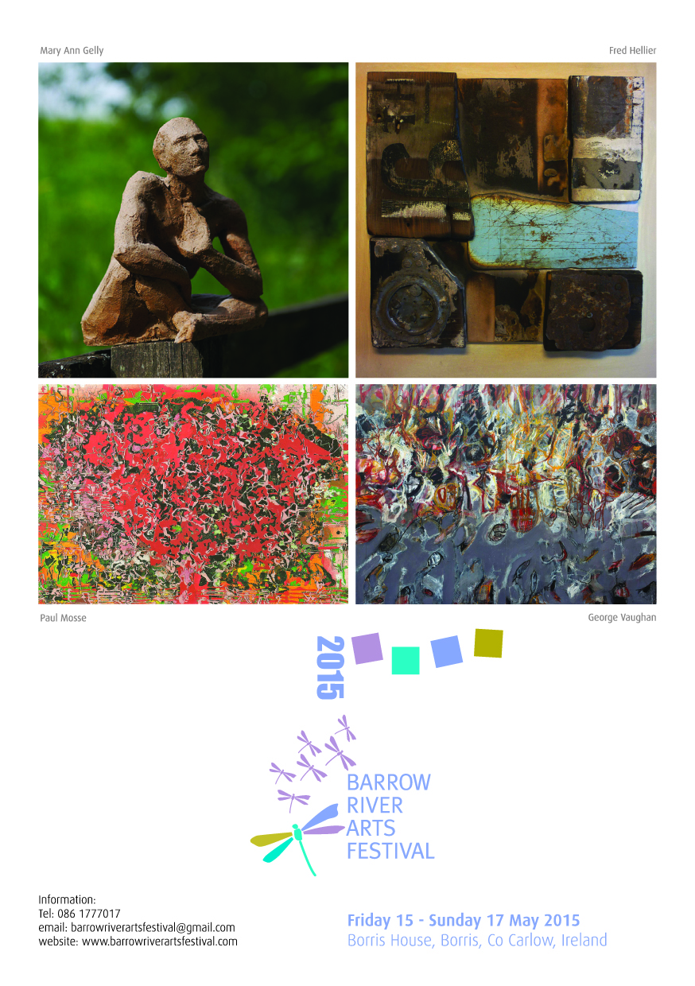

The fifth Barrow River Arts Festival will be officially opened on Friday 15 May by writer and former BBC producer Sean Hardie.  The festival runs from 15 - 17 May in the magnificent setting of Borris House, Borris, Co. Carlow, the ancestral home of the MacMorrough Kavanagh family. Throughout the weekend musicians from Ireland, Germany, U.S.A., U.K., Spain, Belgium and Russian will perform chamber music by a.o. Schumann, Bach, Mozart, Brahms alongside more contemporary works by Barry Guy, Garth Knox, Benjamin Dwyer, Ligeti and Rory Boyle.

Some of the star names appearing include Russian pianist Polina Leschenko with Belgian viola player Nathan Braude, German soprano Anja Pöche and Irish pianist Finghin Collins, Spanish clarinettist Maximilliano Martín with the Badke String Quartet, viola player Garth Knox,  jazz pianist from New York Marilyn Crispell with fellow improvisers Paul Lytton percussion, Barry Guy bass and Greek vocalist Savina Yannatou. On the final night Camerata Kilkenny directed by Swiss violinist Maya Homburger perform Bach Cantatas with soloists Michael Niesemann (oboe) and Anja Pöche (soprano).

There sill also be an art exhibition with works by Londoner Fred Hellier and three Kilkenny based artists George Vaughan, Paul Mosse and Mary Ann Gelly.

Renowned Beckett actor Barry McGovern will read from Flann O’Brien’s letters to the Irish Times and New Dublin Press are launching *Imagines -* a limited-edition publication in which designer Rossi McAuley, composer Benjamin Dwyer, poet Kimberly Campanello, violist Garth Knox and author/ editor Jonathan Creasy come together to create a truly unique work of art. With musical score, performance, poems and commentary, the book documents years of artistic research and practice by a world-class group of artists. *Imagines* is one of the most innovative and high-quality books produced this year in Ireland.

Further Information from:

Susan Proud - Administrator

Old Court, Inistioge Co. Kilkenny, Ireland.

**Email:** [barrowriverartsfestival@gmail.com](mailto:barrowriverartsfestival@gmail.com)

Tel: [+ 353 (0)86 1777017](tel:%2B%20353%20%280%2986%201777017)

[www.barrowriverartsfestival.com](http://www.barrowriverartsfestival.com)

**Festival Committee:** Barry Guy, Maya Homburger (Artistic Directors), Andrew Kavanagh, Olivia O’Leary, Malcolm Proud

**Coming Soon: Movie-style trailers for all the arts**

|  |
| --- |
| http://newsletter.artscouncil.ie/nwstatic/spacer.gif |

In our digital world, video has become a powerful way to promote upcoming arts events, and many people would rather watch a movie-style trailer or a short news report than read an article or a brochure.

Although some arts organisations in Ireland, are already making these sort of promotional /news videos, and would like them to be viewed by as many people as possible, we don’t have a central structure for distributing them.

The Arts Council would like to create such a structure, to help generate more videos, ensure they are in a unifying format, distribute them in as many additional ways as possible (eg. social media, Culturefox, YouTube, Vimeo), and package some as ‘arts magazine’ programmes for broadcast.

Our ambition is that within a year, most arts organisations will be making and editing their own trailers or news pieces about upcoming concerts, plays, gigs, performances, exhibitions -- and encouraging people to attend.

This is an exciting prospect -- imagine, for example, if for every work that goes on tour you could see a short interview with the artist, the director, the curator to whet your appetite before it reached your local venue!

We’ve engaged the Institute of Local Television for this project; its team members have considerable experience of this from Scotland, they take a very practical approach and are focused on getting things done.

To that end they will be engaging with arts organisations across the country in the months ahead, making videos, training/mentoring and helping arts organisations to make and edit their own, assisting with promotion, building a central structure.

So watch out for them at arts events, please extend them every courtesy. If you're an artist or you work for an arts organisation and you would like to get involved, Dr David Rushton of the Institute of Local Television would love to hear from at [local.tv@virgin.net](mailto:local.tv@virgin.net)

**In preparation for this show acclaimed dancer Emma O’Kane learned to ride a race horse for the very first time …..**

**WillFredd Theatre** presents the world premiere of

**JOCKEY**

Exploring the physical relationship between the dancer, the jockey and the Irish thoroughbred horse.

Directed by Sophie Motley. Co-created with Emma O’Kane

**15 & 16 May - VISUAL, Carlow**

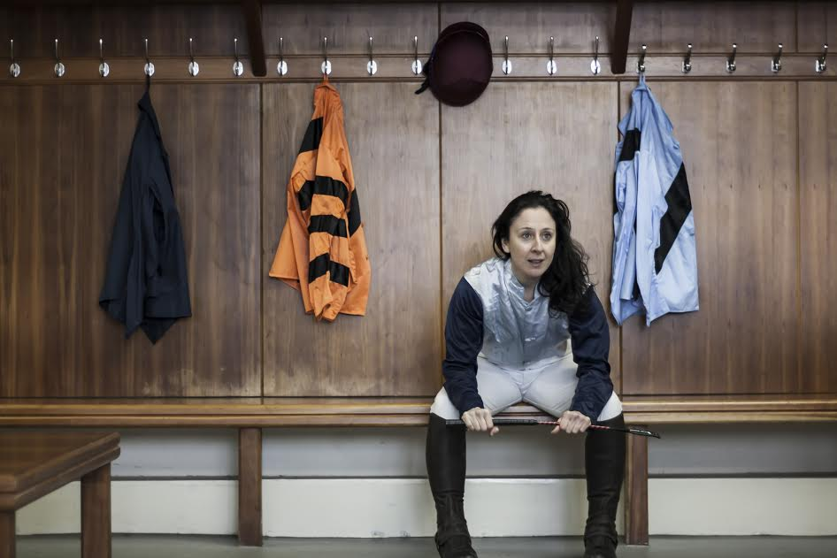

Although she didn’t know it, renowned dancer Emma O’Kane has been preparing for this show most of her life. Emma had never ridden a horse before but the first time she did she realized that all her years of dance training had prepared her well. She became fascinated by the similarities between jockeys and dancers, both honing the same muscles, both so physical, needing the same stamina, the intensity of training, striving to be the best and that same rush adrenaline of performing or riding in a race.

Not only that but the first time she went near a horse the trainer told her she was a natural, that horse racing was in her blood. Although Emma discounted the idea some research unearthed the fact that her grandfather Phillip de Burgh O' Brien who died before she was born, had been a bloodstock agent and racing journalist.  From Phillip’s writings to Emma’s own experience of recently learning to ride a racehorse, Jockey explores the physical relationship between the dancer, the jockey and the Irish thoroughbred horse.

This extraordinary piece is the culmination of a year-long collaboration between WillFredd Theatre, Emma O’Kane and the Irish Racing Community.

Credits: Directed by Sophie Motley, Designed by Sarah Jane Shiels, Composition and Sound Design Jack Cawley, Video Design by Kilian Waters, Choreographed and Performed by Emma O’Kane.

**About WillFredd:**WillFredd Theatre was founded in 2011 in Dublin, Ireland. We are Co-Artistic Directors Sophie Motley and Sarah Jane Shiels, and Producer Kate Ferris. WillFredd's work engages with contemporary culture, actively inviting new audiences into the theatre. Through ethical encounters between artists and communities of place, space and interest, the company develop theatre which responds to and represents elements of these communities. WillFredd believe in constant evaluation and interrogation of our work through extensive Research and Development phases where work is shown back to communities we develop it with.The company have made three full productions to date: FOLLOW (2011) , FARM (2012) and CARE (2014). Two new productions, JOCKEY and BEES will premiere in 2015.

*'A constantly inventive, affectionate and beautifully performed production... it's outstanding in its field.'*Irish Times on FARM

*'respective, intelligent and inventive'*Irish Times on CARE

*'Every journey to the theatre commences in hope – here it is totally justified'*Irish Theatre Magazine on FOLLOW

**LISTINGS INFO:**

WillFredd Theatre presents ***Jockey***co-created with Emma O’Kane

•         **VISUAL, Carlow**

Friday 15th May & Saturday 16th May. 8pm

059 917 2400  / [www.visualcarlow.ie](http://www.visualcarlow.ie/) WillFredd Theatre / @WeAreWillFredd / @VisualGBShaw

**European Commission Survey on Remuneration for Photographers, Illustrators and Designers**

**The European Commission** have commissioned a study on the remuneration of **photographers, illustrators, and designers** for the use of their works.

The results of the study are likely to influence the legislative framework and EC policies that govern the remuneration of artists in this sector and this survey gives Irish creators the chance to contribute to the research.

The study, being undertaken by Europe Economics and the Institute for Information Law of the University of Amsterdam, will examine the different national rules and mechanisms to ensure photographers, illustrators and designers (‘visual artists’) receive remuneration for the exploitation of their works across a selection of Member States. It will also determine whether, and to what extent, the differences that exist among the Member States affect levels of remuneration.

To do this, they are undertaking an online survey of visual artists in ten European countries. Visual artists are likely to have more detailed knowledge of their own remuneration than anyone else and so it is important for them to gather this information first-hand. The study concerns your activities as self-employed and/or employed visual artists. Other activities such as creation of fine arts and any other activity you are undertaking to make a living are not part of this study.

**It should take a maximum of 10 – 15 minutes to complete the survey and the responses are anonymous**  
**Deadline to complete the survey is 30 May 2015**  
Further information and to take the survey:  
[ec.europa.eu](http://lists.visualartists.ie/lt.php?c=1342&m=4379&nl=1&s=e784eec6bf8bb9680747b324b9c9eee1&lid=112520&l=-https--ec.europa.eu/eusurvey/runner/QuestionnaireforVisualArtists)

**Irish Arts Organisations Successful in Accessing European Culture Funds**

The latest funding results have been announced for Creative Europe’s Cooperation Projects Strand. 13 Irish organisations are involved in 11 successful projects with combined grant awards of over €5 million. To date under the Creative Europe Programme over €12.6 million has gone to projects with Irish partners with €2 million going to Irish led projects. The latest grants went to organisations across the country with projects funded in Galway, Waterford, Limerick and Cork and Dublin. The Crawford Art Gallery was successful as a lead partner with a project entitled Prospects. The project’s overall objective is “to exchange, develop and innovate creative engagement practices and platforms for those working in the field of inclusive visual arts studio practices with artists with intellectual disabilities and mental health issues”.  The largest single award for a project with Irish partners was for €1.9 million and went to the project Follow the Vikings, which aims to “promote, celebrate, transfer knowledge and skills and facilitate the exchange of cultural material relating to the Viking World.” The project had two Irish partners: Dublinia and Waterford Treasures at the Granary.

Below is a list of all the successful Irish organisations in this latest funding round

Crawford Art Gallery (lead) Cork Institute of Technology (co-partner) Prospects  
Cork Institute of Technology (co-partner) Trans National Creative Exchange.  
NOHO Ltd and University College Dublin (co-partners) Connecting Early Medieval European Collections  
Photo Ireland Festival (co-partner) Flaneur – New Urban Narratives  
Dublinia Ltd & Waterford Treasures at the Granary (co-partners) Follow the Vikings  
University of Limerick (co-partner) Future Artist Maker Labs  
Galway Arts Centre (co-partner) Sharing the Word  
National College of Art and Design (co-partner) In Public, In Particular  
First Fortnight Ltd (co-partner) Networking European Festivals for Mental Life Enhancement  
The Irish Youth Orchestra (co-partner) MusXchange  
Foras na Gaeilge (co-partner) OtherWords – Literary Circuit for Small and Minority Languages  
You can find the full results published on the Education, Audio-Visual and Culture Executive Agency (EACEA) here.

The Arts Council hosts the Creative Europe Desk Ireland – Culture Office which promotes EU culture funding at local, regional and national level and provides information, advice and technical assistance to prospective applicants.

For further information please see:  
E: [cedculture@artscouncil.ie](mailto:cedculture@artscouncil.ie)  
[www.creativeeuropeireland.eu](http://lists.visualartists.ie/lt.php?c=1342&m=4379&nl=1&s=e784eec6bf8bb9680747b324b9c9eee1&lid=112528&l=-http--www.creativeeuropeireland.eu)