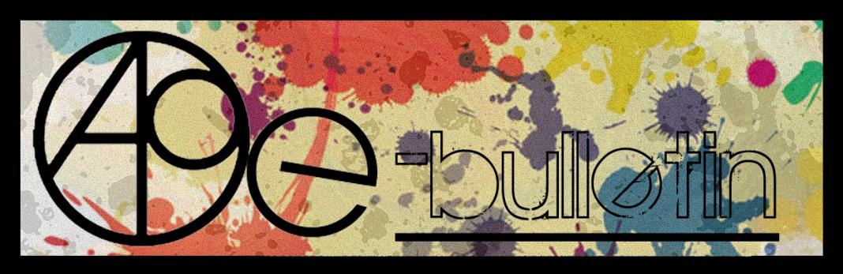

**Kilkenny County Council Arts Office E-bulletin 17th June 2016**

Dear All,   
  
Welcome to the fortnightly e-bulletin from Kilkenny County Council's Arts Office. Each bulletin is packed with the latest information on Kilkenny Arts Office activities, county events as well as news and opportunities for arts practitioners from around the country.

This service will be provided fortnightly. To include an item in the next e-bulletin please send a brief outline of your advert with relevant contact details, including any websites or pages with links to [**niamh.brophy@kilkennycoco.ie**](mailto:niamh.brophy@kilkennycoco.ie) **before 29th June.** The next e-bulletin will be on the **1st July.**

While every effort has been made to ensure the accuracy of our information, we strongly advise readers to verify all details to their own satisfaction.

Regards,

**Niamh Brophy, Arts Administrator**

Arts Office LogoWithText01

5 Dean Street, Kilkenny

T: (056) 7794138

E: [niamh.brophy@kilkennycoco.ie](niamh.brophy@kilkennycoco.ie%20)

W: <www.kilkennycoco.ie/eng/Services/Arts>

[Facebook](https://www.facebook.com/KilkennyArtsOffice/) [twitter](https://twitter.com/kkartsoffice)

[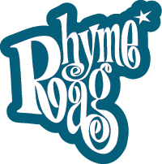](http://www.rhymerag.net/) [Facebook](https://www.facebook.com/KilkennyArtsOffice/) 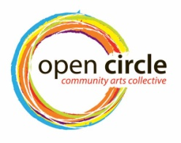 [Facebook](https://www.facebook.com/KilkennyArtsOffice/) [twitter](https://twitter.com/kkartsoffice) [](http://www.artlinks.ie/) [Facebook](https://www.facebook.com/KilkennyArtsOffice/)

<www.rhymerag.net> <https://opencirclearts.ie/> [www.artlinks.ie](http://www.artlinks.ie)

**Kilkenny County Council Cultural Services -**

**Creating and Sustaining Great Communities and Places**

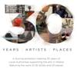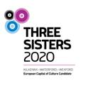 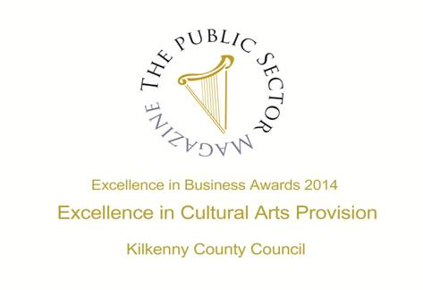

**Arts Office**

* **NEW! SEWCIALISING Workshops with Open Circle – limited spaces so book now!**
* **NEW!** SEWCIALISING - Rosie O’Reilly, Re-dress, talked about the social, environmental and economic effects of our purchasing choices
* SEWCIALISING Workshops – Sign Up Now!
* Our latest Rhyme Rag poem to be published is ‘The Heart-Hive’ by Tarla Murphy

**Kilkenny Events**

* **NEW! Courtyard Screen | Woodturning, Wood Carving, Sewing and Storytelling Workshops, Callan**

# ****NEW!** Mandala Workshop with Alice Bennett at Blackwatch Studio**

# ****NEW!** Polymer Clay Workshop at Blackwatch Studio, Co. Kilkenny**

* **NEW!** ‘Just for Men’ Art and Sculpture Course

# ****NEW!**** Cliona Harmey: Block and Receive at the Butler Gallery

* **NEW!** Kilkenny Arts Festival - Welcome to ten days and nights of artistic adventure…
* **NEW!** S[tarting Points or How did we get Here](http://kcat.ie/starting-points-or-how-did-we-get-here/)
* **NEW!** The Courage to Be – Improvised Performance
* **NEW!** Shoeniversity Summer Shoemaking Courses, Castlecomer
* **NEW!** ‘See You in Two Minutes Ma’, Book Launch
* **NEW!** LESSAC Voice Training
* **NEW!** ‘Famous Faces’ – a retrospective exhibition of the work of Francis Casey, at KCAT
* **NEW!** Inguna Mainule Finnerty exhibition at Castlecomer Library
* **NEW!** ‘From the Forest’ Book Launch and Exhibition of Woodcarvings
* **NEW!** Call For Participants’: Kilkenny Libraries Poetry Reading Event October 2016
* **NEW!** Municipal District of Kilkenny City - East & West Streetscape Paint Scheme 2016
* **NEW!** Abhainn Ri Festival 2016 dates
* **NEW!** Ballykeeffe Amphitheatre in Kilmanagh, the only amphitheatre in Ireland, has launched its exciting programme of events for summer 2016
* Full Circle | Debra Bowden at Cill Rialaig Arts Centre, Co. Kerry
* Dreaming in Blue Kilkenny artist, Julie Cusack at Solomon Fine Art
* Outdoor Cinema at Kilkenny Castle
* National Craft Gallery News
* Upcoming Workshops at Kozo Studio and Gallery

**Courses / Training / Jobs / Internships**

* **Dublin Writers Conference**
* **NEW! Backwater Artists Group Seeking Studio Coordinator/Research Assistant**
* **NEW! IMA Forum: Education and Outreach Forum 2016, National Museum of Ireland**
* **NEW!** NYCI Certificate in Youth Arts 2016/2017
* **NEW! CCAD/CIT Portfolio Summer Course in Uillinn, West Cork Art Centre, Skibbereen**
* **NEW! Draíocht Blanchardstown seeks Administration Assistant**
* **NEW! The National Gallery of Ireland seeking Education Manager**
* **NEW! St. Patrick’s Festival seeking Artistic Director**
* **NEW! Call for Volunteers | PhotoIreland Festival 2016**
* **NEW!** The Killarney Municipal District of Kerry County Council : Schools Drama Programme

**Call for Submissions / Residencies / Public Art**

* **NEW! The Sean O Faolain International Short Story Award**
* **NEW! Per Cent for Art Commission | St. Raphael’s College, Loughrea, Co. Galway**
* **NEW! Open Competition | Irish Ceramic Awards, Mill Cove Gallery**
* **NEW!** Music Network Artist Residency
* **NEW!** 2016 Over The Edge New Writer of The Year competition
* Linen Hall Library – 2016 Michael McLaverty Short Story Award – closing Thursday 30th June
* **Open Call | The McCann FitzGerald Law into Art Project**
* Open Call for Exhibitions | Linenhall Arts Centre, Castlebar
* Open Call | OpenART Biennial 2017, Sweden
* Royal Ulster Academy 135th Annual Exhibition Open For Entries
* Hennessy Portrait Prize 2016 l National Gallery of Ireland
* Open Call | Emerging Irish Artist Residency Award 2016 | Burren College of Art
* Glebe House Poetry Competition

**Awards / Bursaries / Schemes**

* Arts Council of Ireland: Upcoming Funding Deadlines
* Belltable and Fishamble: Open Call for Applications for Mentoring Programme for Playwrights and Directors
* Tyrone Guthrie Centre – Film Maker Bursary

**Of Interest**

* **NEW! What Next? | Weekly NCFA Meeting | Wednesday 22 June**
* **NEW! Taoiseach Commits to Bring Culture 2025 to the Oireachtas for Debate and Finalisation**
* **NEW!** The 2016 New Generation Gallery is now live!

**Arts Office**

**NEW! SEWCIALISING Workshops with Open Circle – limited spaces so book now!**

**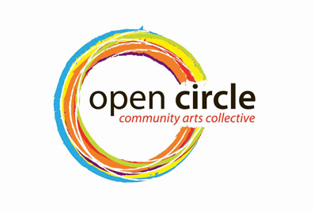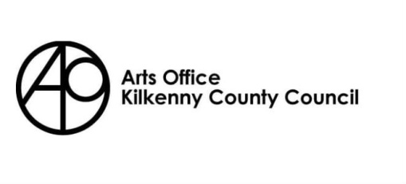**

**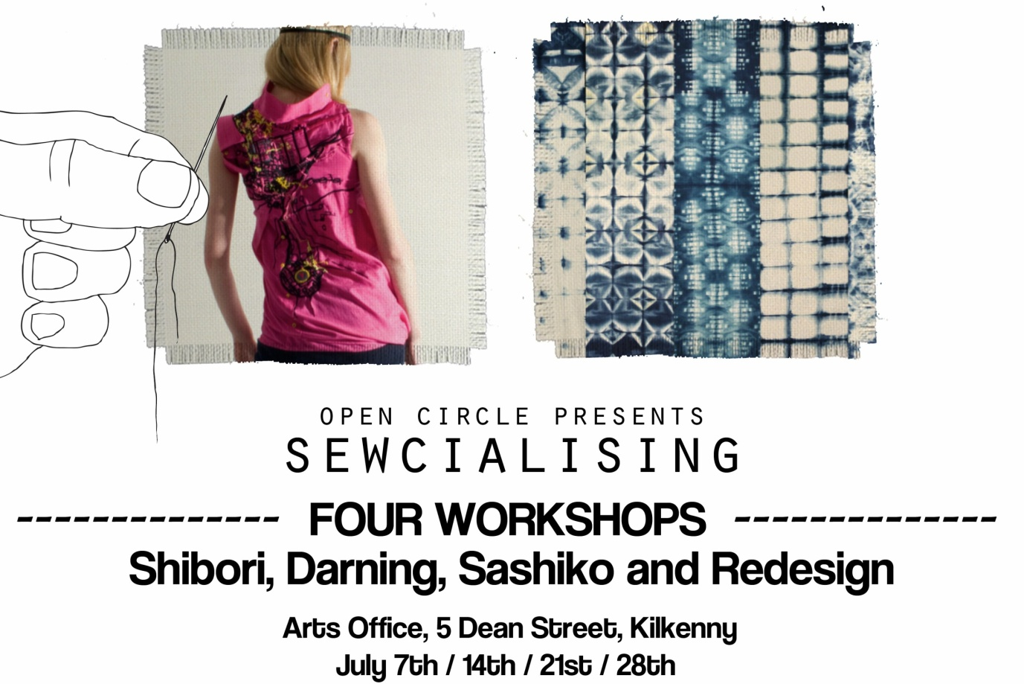**

Open Circle Arts is once again running an exciting summer outreach programme. The Sewcialising Project will investigate our relationship with our clothes. It aims to open up discussions about the clothes we choose to wear, where they come from and where they end up. The series of workshops running through the month of July will explore the (re) making of clothing through re-designing, repairing and mending. Boro is the Japanese art of mending textiles, which celebrates the visible repair of clothing. The first workshop will involve you in using the embroidery technique of Sashiko, teaching you how to repair your denim clothing. Our second workshop will explore traditional wool darning techniques investigating the care involved in mending. Week four will see you redesigning a shirt. Just bring along an old cotton shirt in need of some TLC and learn how to repurpose your shirt for the construction of a new item of clothing. Finally you will learn the basic techniques and patterns for dying your garments using the traditional art of Shibori.

By re-claiming material from worn and discarded garments, the very fibres are charged with meaning, they are saturated with the traces of everyday life; through wear and tear.  Can discarded garments reflect our history, becoming actual material memories of times past, love lost or found, disappointments endured or victories won? These garments could then be read as a guide to our past, reconstructed and brought back to life. Central to this discussion is the value we place on these everyday items. Each workshop is designed to explore the ways in which we can extend the life of these garments to keep them in active service.

**PLACES ARE LIMITED and BOOKING IS ESSENTIAL, EARLY BOOKING ADVISED**

**Venue: Kilkenny Arts Office, no. 5 Dean Street**

**Dates: July 7th /14th /21st /28th**

**Times: 10.30am – 12.30am OR 7pm – 9pm**

**Cost: €30 for all four workshops**

**For more information and booking:** [**sewcialisingproject@gmail.com**](mailto:sewcialisingproject@gmail.com) **or call Dee on 087 652 8448**

Please see the Open Circle Arts website [**www.opencirclearts.ie**](http://www.opencirclearts.ie) for further information on this and other programs. Visit and Like our Facebook pages Open Circle Arts / Kilkenny Arts Office

Open Circle Arts is a Kilkenny Arts Office programme. The Arts Office acknowledges the support of the Arts Council, Carlow Kilkenny ETB and Kilkenny County Council’s Waste Prevention Programme.

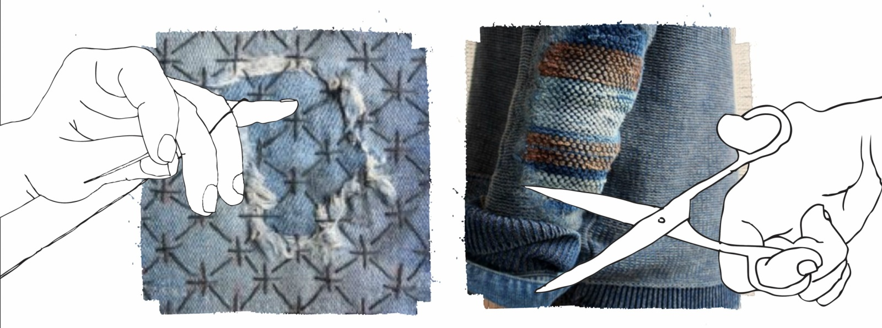

**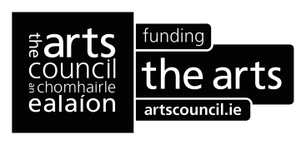**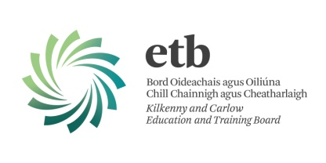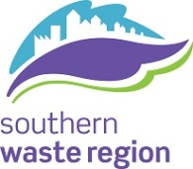

**\_\_\_\_\_\_\_\_\_\_\_\_\_\_\_\_\_\_\_\_\_\_\_\_\_\_\_\_\_\_\_\_\_\_\_\_\_\_\_\_\_\_\_\_\_\_\_\_\_\_\_\_\_\_\_\_\_\_\_\_\_\_\_\_\_\_\_\_\_\_\_\_\_\_\_\_\_\_\_\_\_\_\_\_\_**

**NEW! SEWCIALISING - Rosie O’Reilly, Re-dress, talked about the social, environmental and economic effects of our purchasing choices**

Open Circle Arts is once again running an exciting summer outreach programme. The Sewcialising Project investigates our relationship with our clothes. It aims to open up discussions about the clothes we choose to wear, where they come from and where they end up. The series of workshops for the month of July explores the (re) making of clothing through re-designing, repairing and mending; by reclaiming material from worn and discarded garments, the very fibres are charged with meaning, they are saturated with the traces of everyday life; through wear and tear.  Can discarded garments reflect our history, becoming actual material memories of times past, love lost or found, disappointments endured or victories won? These garments could then be read as a guide to our past, reconstructed and brought back to life. Central to the discussion is the value we place on these everyday items, each workshop is designed to explore the ways in which we can extend the life of these garments to keep them in active service.

As an introduction to this wonderful project Rosie O’ Reilly from Re-dress on Tuesday 14th June at the Arts Office, 5 Dean Street, (image below). Rosie talked about the social, environmental and economic effects of purchasing choices, telling the unheard stories of supply chains in fashion and beyond.

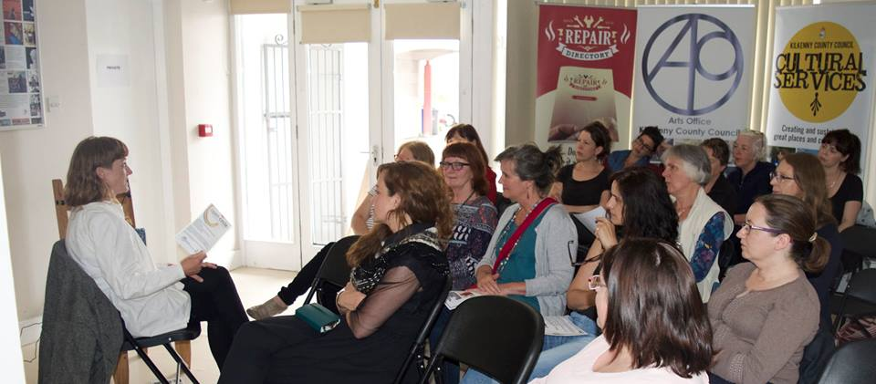

Rosie O'Reilly works as a visual artists and designer. Her work as an artist is concerned with reframing environmental discourse. She has exhibited at ‘Seasons in Translation’, Spain, (2014), Museum of Contemporary Art, Dublin (2013), and had a solo show at ‘4/704’,The Fringe Theatre Festival, Dublin, (2013). She is the designer of contemporary brand WE ARE ISLANDERS which brings art to fashion with limited runs of hand painted pieces. She co-founded [re-dress.ie](http://scanmail.trustwave.com/?c=6600&d=kKnO12zS8YAg0DmPw0I_Z27Vpeh-cbcqAVM299wgjA&s=380&u=http%3a%2f%2fre-dress%2eie), a communications project that since 2008 has been telling the unheard stories of supply chains in fashion and beyond through creative collaborations, events and workshops.

For more information on ‘Sewcialising’ please see the Open Circle Arts website or Facebook page [www.opencirclearts.ie](http://www.opencirclearts.ie)

**\_\_\_\_\_\_\_\_\_\_\_\_\_\_\_\_\_\_\_\_\_\_\_\_\_\_\_\_\_\_\_\_\_\_\_\_\_\_\_\_\_\_\_\_\_\_\_\_\_\_\_\_\_\_\_\_\_\_\_\_\_\_\_\_\_\_\_\_\_\_\_\_\_\_\_\_\_\_\_\_\_\_\_\_\_\_\_**

**Our latest Rhyme Rag poem to be published is ‘The Heart-Hive’ by Tarla Murphy**

This was selected by our editor Kathy D'Arcy [@KathyDArcyCork](https://twitter.com/KathyDArcyCork)

and illustrated by [Alé Mercado/Atticus/Pitercios](http://scanmail.trustwave.com/?c=6600&d=8ObM13z3nSs3KvCzjpLzLxQ6l3tT4bQdsc7e_HLjuQ&s=380&u=https%3a%2f%2fwww%2efacebook%2ecom%2fAleMercadoAtticusPitercios) [@AtticusMercado](http://scanmail.trustwave.com/?c=6600&d=8ObM13z3nSs3KvCzjpLzLxQ6l3tT4bQdsZff9ifivA&s=380&u=http%3a%2f%2ftwitter%2ecom%2f%23%21%2fatticusmercado)

See this poem and more at <http://www.rhymerag.net/>

Or on the Rhyme Rag Facebook page <https://www.facebook.com/rhymerag/?fref=ts>

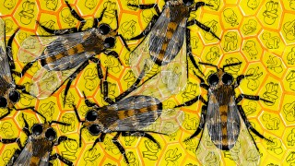

**Kilkenny Events**

**NEW! Courtyard Screen | Woodturning, Wood Carving, Sewing and Storytelling Workshops**

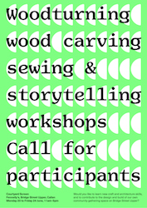

Monday 20 to Friday 24 June, 11am-5pm  
Fennelly’s, Bridge Street Upper, Callan, Co. Kilkenny

A chance to learn new craft and architecture skills, and contribute to the design and build of a community gathering space on Bridge Street Upper.

Courtyard Screen is the third year of activities on Bridge Street Upper, creating a community led vision for the future of the street. Develop through workshops led by Studio Weave, an award winning architecture practice based in London, and with the help of local participants. The hope is to build a new community gathering space in Fennelly’s courtyard.

Courtyard Screen have up to 15-20 spaces daily for drop-in workshops led by an experienced team of skilled architects, craft designers, a wood wrights and a carpenter.

Courtyard Screen is produced by Fennelly’s and Callan Workhouse Union.

How to apply?  
Week long participants or drop-in sessions are both welcomed, but we encourage you to book, as places are limited. To reserve a place or for further information please ring Hollie on 087 991 2001 or email [**info@callanworkhouseunion.com**](mailto:info@callanworkhouseunion.com).

[**www.facebook.com/CallanWorkhouseUnion/**](http://scanmail.trustwave.com/?c=6600&d=tMPh14YpATtUHjBOn-g1kRfLlHfFfLCxISyUIZy2Yg&s=380&u=http%3a%2f%2fvisualartists%2eus9%2elist-manage1%2ecom%2ftrack%2fclick%3fu%3de67e46c7b14e756132f46a50c%26id%3d6278326fe6%26e%3d1968c52731)

**\_\_\_\_\_\_\_\_\_\_\_\_\_\_\_\_\_\_\_\_\_\_\_\_\_\_\_\_\_\_\_\_\_\_\_\_\_\_\_\_\_\_\_\_\_\_\_\_\_\_\_\_\_\_\_\_\_\_\_\_\_\_\_\_\_\_\_\_\_\_\_\_\_\_\_\_\_\_\_\_\_\_\_\_\_\_\_**

# ****NEW!** **Mandala Workshop with Alice Bennett at Blackwatch Studio****

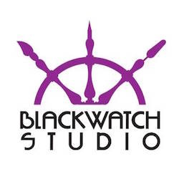

23 July  
Fee: €75 including materials.

In this workshop, artist Alice Bennett will introduce you to the practical steps of making a Mandala. Through these steps each participant will be enabled to start on a personal journey of calmness, self discovery and potentially of healing. There is no need to be artistic to create your own Mandala.

The word ”Mandala” originates from the language of Sanskrit and loosely translated means circle. It represents wholeness and can be seen as a basic structure of life itself, the world that extends both beyond and within our bodies and minds. A Mandala describes both material and non-material realities. It appears in all aspects of life: from the interior of a flower to the celestial circles we call earth, sun and moon. Mandala’s can convey the conceptual circles we belong to, friends, family and community.

Blackwatch Studio, Frenesytown, Clifden, Co Kilkenny  
T: 0868370205  
E: [**blackwatchstudiokk@gmail.com**](mailto:blackwatchstudiokk@gmail.com)  
W: [**blackwatchstudio.ie**](http://scanmail.trustwave.com/?c=6600&d=tcPh11THHiOQBK_PYveGX6Bp0DAcAv52ez6Z05nizQ&s=380&u=http%3a%2f%2fvisualartists%2eus9%2elist-manage1%2ecom%2ftrack%2fclick%3fu%3de67e46c7b14e756132f46a50c%26id%3d778ccf118a%26e%3d1968c52731)

**\_\_\_\_\_\_\_\_\_\_\_\_\_\_\_\_\_\_\_\_\_\_\_\_\_\_\_\_\_\_\_\_\_\_\_\_\_\_\_\_\_\_\_\_\_\_\_\_\_\_\_\_\_\_\_\_\_\_\_\_\_\_\_\_\_\_\_\_\_\_\_\_\_\_\_\_\_\_\_\_\_\_\_\_\_\_\_**

**NEW! Polymer Clay Workshop at Blackwatch Studio, Co. Kilkenny**

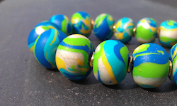

Blackwatch Studio, Freneystown, Clifden, Co. Kilkenny

Polymer Clay Course (3 weekend workshops) with Artist Tia Vellan  
Cost: €195 (including materials)

Weekend 1 | Fundamentals of Polymer Clay  
Saturday 25 June, 10am to 5pm  
Marbled beads, swirling lentils, appliqué, sheet techniques, canes, millefiori and jewellery-making (bracelets, necklaces, earrings)

Weekend 2 | Intermediate Level Polymer Clay  
Saturday 2 July, 10am to 5pm  
Colour-mixing, pearl powders, metal leaf, mosaic, mokume gane, polishing and jewellery-making (pendants, cabochons)

Weekend 3 | Advanced Techniques in Polymer Clay  
Saturday 9 July, 10am to 5pm  
Colour-blending (the most beautiful technique of all), carving, stamping, hand-building, simulating gems (coral, agate, jade, turquoise) and mold-making

For further details call Vicki, T: 086 837 0205, E: blackwatchstudiokk@gmail.com  
[**www.blackwatchstudio.ie**](http://scanmail.trustwave.com/?c=6600&d=vojY1yNAdCk6LIEP80STc3qT1T93cJ-PWt3-jusqCQ&s=380&u=http%3a%2f%2fvisualartists%2eus9%2elist-manage1%2ecom%2ftrack%2fclick%3fu%3de67e46c7b14e756132f46a50c%26id%3d793e307eab%26e%3df4dbf7f416)

# \_\_\_\_\_\_\_\_\_\_\_\_\_\_\_\_\_\_\_\_\_\_\_\_\_\_\_\_\_\_\_\_\_\_\_\_\_\_\_\_\_\_\_\_\_\_\_\_\_\_\_\_\_\_\_\_\_\_\_\_\_\_\_\_\_\_\_\_\_\_\_\_\_\_

**NEW! ‘Just for Men’ Art and Sculpture Course**

During this four week course Artist and Sculptress, *Julie Moorehouse* will teach you how to make an open framework on which your sculpture is then moulded in air drying clay. When the piece has dried, participants will have the option to decorate their piece.

MEETING WEDNESDAY EVENING for 4 WEEKS

Running from Wednesday 6 July to Wednesday 27 July

FROM 7PM-9PM €100 (including materials)

€30 deposit secures place

*Gift Vouchers available / Ideal Father’s Day Surprise*

For further details call Vicki on 086 837 0205 Email:blackwatchstudiokk@gmail.com

Blackwatch Studio, Freneystown, Clifden, Co. Kilkenny.

**\_\_\_\_\_\_\_\_\_\_\_\_\_\_\_\_\_\_\_\_\_\_\_\_\_\_\_\_\_\_\_\_\_\_\_\_\_\_\_\_\_\_\_\_\_\_\_\_\_\_\_\_\_\_\_\_\_\_\_\_\_\_\_\_\_\_\_\_\_\_\_\_\_\_\_\_\_\_\_\_\_\_\_\_\_**

# NEW! Cliona Harmey: Block and Receive at the Butler Gallery

# Invite image

### **Opening Saturday June 25 2016** **2.30 – 4.30pm**

# **Cliona Harmey:** Block and Receive

Exhibition Open Daily 10am – 5.30pm

**Meet the Artist** 1pm Wednesday July 13 2016

The Butler Gallery is delighted to present Block and Receive, an exhibition of new and recent works by Dublin artist, Cliona Harmey.

Technology is central to Harmey’s practice and drives her thinking. In her work, she rigorously explores and investigates the language of technology, its physicality, and ultimately its gaps and limitations. This exhibition works with ideas of transmission, reception, noise, masked or failed reception and disappearance to create works that draw on communication processes.

Block and Receive includes a series of hybrid media-based sculptural works, screen-based animations, and three short, interlinked film works. Some of the sculptural works propose imaginary measurement systems, and allude to subjective measurement as well as the calibration lines used in satellite transmission images. In the creation of these sculptural objects, Harmey repurposes utilitarian materials, such as blackboard paint, foil and conductive fabric and labelling ribbon. Another sculptural work uses a partially masked reflective radar beacon, usually used to improve boats’ visibility. Ideas of distance and lines of sight are referenced in the image received from a satellite passing overhead; whereas ideas of blocked or lost communication are also cited in the failed image visible as lines and noise.

Harmey’s three film works were shot at Haulbowline Naval base in Cobh with the co-operation and assistance of the Irish Navy and The Sirius Arts Centre. In the films we see slow motion message sequences of the hand-operated morse signalling lamp. The films allow us to see the bare bones light signals, which we can imagine are at the root of many forms of communication. The lamp is still used at times by operators for the secure transmission of encrypted and unencrypted messages.

In another work “Flag”, we see a screen with a small-scale animation which also references lost or redundant signals. The image sequence, is based on international maritime signal flags spelling of the shipname “Ocean Shield” with omissions and additions. Ocean Shield was one of several Australian vessels to take part in a search for the missing flight MH370.

The exhibition also includes a vitrine that contains studies and sources used by the artist as touchstones or inspiration in the development of the overall exhibition.

Cliona Harmey drags the power cables out from behind the couch, slows things down, and in doing so, helps to demystify the seductive power of technology to a more human pace**.** Block and Receive provides much for the inquisitive mind to ponder and enjoy.

Cliona Harmey studied Fine Art Sculpture at the National College of Art & Design, completed a one-year residency at Arthouse Multimedia Centre in 1999, received a HDip in Computer Science at UCD and has an MA in Visual Art Practices from IADT. In 2015, Harmey produced Dublin Ships ([www.dublinships.ie](http://www.dublinships.ie/)) a highly successful temporary public artwork located at Scherzer Bridge and commissioned by Dublin City Council as part of Dublin City Public Art Programme. Cliona Harmey has exhibited widely and is a lecturer in the Fine Art Media Department at NCAD, the National College of Art and Design, Dublin.

With thanks to the Arts Council for essential annual funding, to [Sirius Arts Centre](http://www.siriusartscentre.ie/), and to the OPW, Department of Social Protection, The Heritage Council and Kilkenny Local Authorities for additional assistance. \* The artist would also like to acknowledge the assistance of the Communications Section of the [Irish Naval Service](http://www.military.ie/naval-service/) (Defence Forces of Ireland) at Haulbowline for facilitating the film work in this exhibition. Work was produced during a research and production residency at the Sirius Arts Centre, Cobh.

Discovery Pens will be available to visitors, giving access to additional audio information. This is facilitated in partnership with [*Arts & Disability Ireland*](http://www.adiarts.ie/), with funding from the Arts Council.

### \_\_\_\_\_\_\_\_\_\_\_\_\_\_\_\_\_\_\_\_\_\_\_\_\_\_\_\_\_\_\_\_\_\_\_\_\_\_\_\_\_\_\_\_\_\_\_\_\_\_\_\_\_\_\_\_\_\_\_\_\_\_\_\_\_\_\_\_\_\_\_\_\_

|  |
| --- |
| **NEW! Kilkenny Arts Festival - Welcome to ten days and nights of artistic adventure…** |

[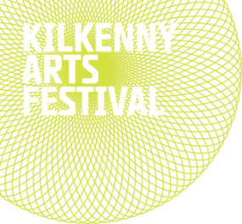](http://www.kilkennyarts.ie/)

|  |  |  |  |  |
| --- | --- | --- | --- | --- |
| |  |  | | --- | --- | | |  | | --- | | Today we’re thrilled to announce the full programme for the 43rd Kilkenny Arts Festival! We’re looking forward to hosting scores of incredible artists from around the world in Ireland’s medieval city in August….  One of Europe’s legendary theatre ensembles will pitch their famous tent on the river bank opposite Kilkenny Castle – **Footsbarn Theatre**. Fusing visual poetry, masks, puppetry, music and reach emotion, we expect high demand for the Irish premieres of their two contrasting productions, [*The Incomplete Works of Shakespeare*](http://scanmail.trustwave.com/?c=6600&d=3bzg14euyL-itoYZ-ibsuBbFtl5gk3F54ZOvH1excA&s=380&u=http%3a%2f%2fr1%2earts-mail%2ecom%2f3Q47-1WPH-GN21Z-IE4O-1%2fc%2easpx) and [*Cuckoo’s Nest.*](http://scanmail.trustwave.com/?c=6600&d=3bzg14euyL-itoYZ-ibsuBbFtl5gk3F54cP7Gwy0fw&s=380&u=http%3a%2f%2fr1%2earts-mail%2ecom%2f3Q47-1WPH-GN21Z-IE4P-1%2fc%2easpx)  Our classical centrepiece [**MOZART: PRINCE OF MUSIC**](http://scanmail.trustwave.com/?c=6600&d=3bzg14euyL-itoYZ-ibsuBbFtl5gk3F54catTlezcQ&s=380&u=http%3a%2f%2fr1%2earts-mail%2ecom%2f3Q47-1WPH-GN21Z-IE4Q-1%2fc%2easpx)has created quite a stir since its early announcement in February. From his operatic masterpiece [*Idomeneo*](http://scanmail.trustwave.com/?c=6600&d=3bzg14euyL-itoYZ-ibsuBbFtl5gk3F54cP_Tl7pJg&s=380&u=http%3a%2f%2fr1%2earts-mail%2ecom%2f3Q47-1WPH-GN21Z-IE4R-1%2fc%2easpx) to cycles of symphonies, piano sonatas and string quartets, this is the most ambitious Mozartian season ever staged in Ireland. | | |  |  |
| Our series of global musical dialogues, the **MARBLE CITY SESSIONS**, returns with host **Martin Hayes**, who has gathered extraordinary artists from three continents to create unique collaborations in Kilkenny, including two pairs of singing sisters, [**The Unthanks**](http://scanmail.trustwave.com/?c=6600&d=3bzg14euyL-itoYZ-ibsuBbFtl5gk3F54cWmTwrmdg&s=380&u=http%3a%2f%2fr1%2earts-mail%2ecom%2f3Q47-1WPH-GN21Z-IE4S-1%2fc%2easpx) and [**Maighread & Tríona Ní Dhomhnaill**](http://scanmail.trustwave.com/?c=6600&d=3bzg14euyL-itoYZ-ibsuBbFtl5gk3F54ZKvGVe1Ig&s=380&u=http%3a%2f%2fr1%2earts-mail%2ecom%2f3Q47-1WPH-GN21Z-IE4T-1%2fc%2easpx), Indian jazz raga pianist [**Utsav Lal**](http://scanmail.trustwave.com/?c=6600&d=3bzg14euyL-itoYZ-ibsuBbFtl5gk3F54cb8SVrpdw&s=380&u=http%3a%2f%2fr1%2earts-mail%2ecom%2f3Q47-1WPH-GN21Z-IE4U-1%2fc%2easpx), and Martin's own new ensemble: the [**Martin Hayes Quartet.**](http://scanmail.trustwave.com/?c=6600&d=3bzg14euyL-itoYZ-ibsuBbFtl5gk3F54cX_TQ21Jg&s=380&u=http%3a%2f%2fr1%2earts-mail%2ecom%2f3Q47-1WPH-GN21Z-IE4V-1%2fc%2easpx) | | |
| In a unique project for the Festival, **Stephen Rea** reads the spellbinding final work by **Seamus Heaney**, [*Aeneid Book VI*](http://scanmail.trustwave.com/?c=6600&d=3bzg14euyL-itoYZ-ibsuBbFtl5gk3F54cL4Eg3mJQ&s=380&u=http%3a%2f%2fr1%2earts-mail%2ecom%2f3Q47-1WPH-GN21Z-IE4X-1%2fc%2easpx)- the journey to the Underworld -with a live soundscape by composer and cellist **Neil Martin**. Stephen also performs excerpts in KIlkenny's own ancient underworld, the haunting Dunmore Cave... | | | | |
| **Loudon Wainwright III**, one of the great American singer-songwriters, performs his one-man show [Surviving Twin](http://scanmail.trustwave.com/?c=6600&d=3bzg14euyL-itoYZ-ibsuBbFtl5gk3F54ZKmTVbmIw&s=380&u=http%3a%2f%2fr1%2earts-mail%2ecom%2f3Q47-1WPH-GN21Z-IN1P-1%2fc%2easpx), a funny and heartfelt meditation on family, blending song and story in this European premiere at the Watergate Theatre. | | | | |
| Our sensational line-up in the Set Theatre includes [**Villagers**](http://scanmail.trustwave.com/?c=6600&d=3bzg14euyL-itoYZ-ibsuBbFtl5gk3F54cb9G1rncw&s=380&u=http%3a%2f%2fr1%2earts-mail%2ecom%2f3Q47-1WPH-GN21Z-IN1Q-1%2fc%2easpx), Iceland’s [**FM Belfast**](http://scanmail.trustwave.com/?c=6600&d=3bzg14euyL-itoYZ-ibsuBbFtl5gk3F54ZGmH1vjJA&s=380&u=http%3a%2f%2fr1%2earts-mail%2ecom%2f3Q47-1WPH-GN21Z-IN1R-1%2fc%2easpx), the only Irish performance this season of Mercury-nominated [**Sam Lee & Friends**](http://scanmail.trustwave.com/?c=6600&d=3bzg14euyL-itoYZ-ibsuBbFtl5gk3F54cP9EgjmJQ&s=380&u=http%3a%2f%2fr1%2earts-mail%2ecom%2f3Q47-1WPH-GN21Z-IN1S-1%2fc%2easpx), the unique opening-night [**Wake for Roger Casement**](http://scanmail.trustwave.com/?c=6600&d=3bzg14euyL-itoYZ-ibsuBbFtl5gk3F54catGFvocA&s=380&u=http%3a%2f%2fr1%2earts-mail%2ecom%2f3Q47-1WPH-GN21Z-IN1T-1%2fc%2easpx), and the Irish debut of rising star of jazz piano [**Justin Kauflin**](http://scanmail.trustwave.com/?c=6600&d=3bzg14euyL-itoYZ-ibsuBbFtl5gk3F54cKsHlu0JQ&s=380&u=http%3a%2f%2fr1%2earts-mail%2ecom%2f3Q47-1WPH-GN21Z-IN1U-1%2fc%2easpx). | | | | |
| At the heart of our 43rd Festival are our artists in residence: the definitive 21st-century poet Paul Muldoon; our “embedded artist” [**Mick O’Dea**](http://scanmail.trustwave.com/?c=6600&d=3bzg14euyL-itoYZ-ibsuBbFtl5gk3F54cOuGwvhIQ&s=380&u=http%3a%2f%2fr1%2earts-mail%2ecom%2f3Q47-1WPH-GN21Z-IE5K-1%2fc%2easpx), who returns to report on the festival in paint, and bluegrass legend and champion of roots music [**Ricky Skaggs**](http://scanmail.trustwave.com/?c=6600&d=3bzg14euyL-itoYZ-ibsuBbFtl5gk3F54cioSVbgdA&s=380&u=http%3a%2f%2fr1%2earts-mail%2ecom%2f3Q47-1WPH-GN21Z-IE5L-1%2fc%2easpx) who will collaborate with musicians from both sides of the Atlantic while checking out the corners and cobbles of Kilkenny. | | |
| These are just some of our highlights this year. You’ll discover many more unmissable artists and events in our full programme here. Book early and avoid disappointment! [Booking now open.](http://scanmail.trustwave.com/?c=6600&d=3bzg14euyL-itoYZ-ibsuBbFtl5gk3F54cX9Tw_icw&s=380&u=http%3a%2f%2fr1%2earts-mail%2ecom%2f3Q47-1WPH-GN21Z-IMZU-1%2fc%2easpx)  We look forward to seeing you in Kilkenny this August,  The Festival Team  <http://www.kilkennyarts.ie/> | | |

### \_\_\_\_\_\_\_\_\_\_\_\_\_\_\_\_\_\_\_\_\_\_\_\_\_\_\_\_\_\_\_\_\_\_\_\_\_\_\_\_\_\_\_\_\_\_\_\_\_\_\_\_\_\_\_\_\_\_\_\_\_\_\_\_\_\_\_\_\_\_\_\_\_\_\_

**NEW! S**[**tarting Points or How did we get Here**](http://kcat.ie/starting-points-or-how-did-we-get-here/)

**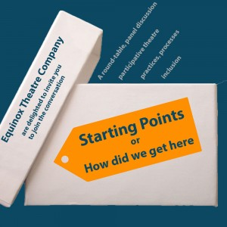** 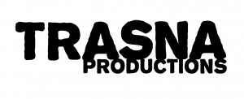

Equinox Theatre Company are delighted to invite you join the conversation:

**Starting Points or How did we get Here** is a round-table / panel discussion about theatre and participation.

Featuring Sophie Motley, Sarah Jane Shiels and Aisling O’Brien (WillFredd); Anna Galligan (Barnstorm); Niamh Ni Chonchubhair (Axis, Ballymun) and Medb Lambert (Equinox Theatre Company).

At the Friary, Mill Street, Callan on Wednesday 29th of June at 2pm.

*Inhabitants* is a series of events across architecture, visual arts and theatre, which artisti­cally examines our relationship to our environment and asks us us to look anew at our role in shaping the future.

*Inhabitants 25 June – 03 July 2016 Callan, Co. Kilkenny*

**\_\_\_\_\_\_\_\_\_\_\_\_\_\_\_\_\_\_\_\_\_\_\_\_\_\_\_\_\_\_\_\_\_\_\_\_\_\_\_\_\_\_\_\_\_\_\_\_\_\_\_\_\_\_\_\_\_\_\_\_\_\_\_\_\_\_\_\_\_\_\_\_\_\_\_\_\_\_\_\_\_\_\_\_\_**

### NEW!

### \\kk-moss\Sites\arts_office\Shared Documents\Internal\Niamh\2016 projects\E-bulletin\June 17th\TheCouragetoBe.jpg

### \_\_\_\_\_\_\_\_\_\_\_\_\_\_\_\_\_\_\_\_\_\_\_\_\_\_\_\_\_\_\_\_\_\_\_\_\_\_\_\_\_\_\_\_\_\_\_\_\_\_\_\_\_\_\_\_\_\_\_\_\_\_\_\_\_\_\_\_\_\_\_

**NEW!**

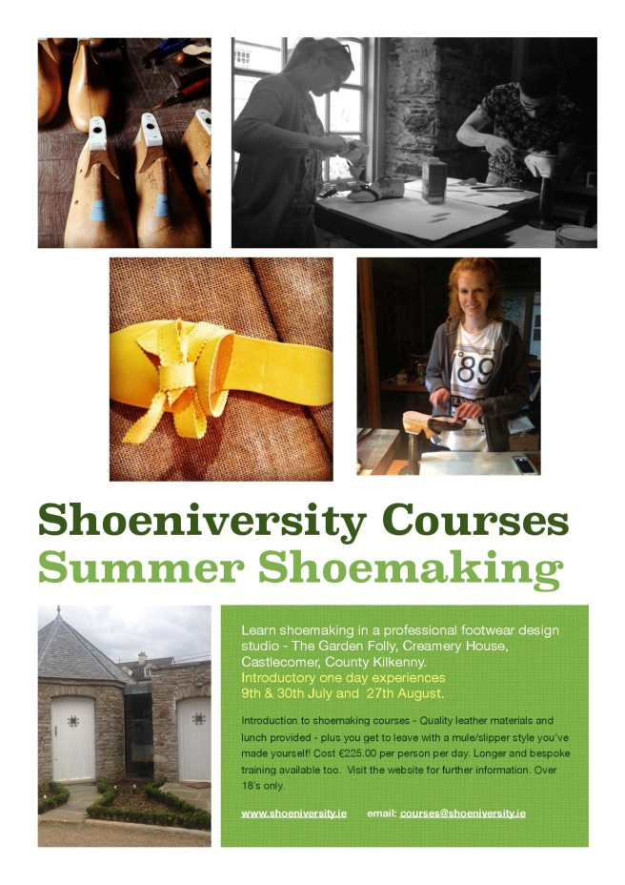

**\_\_\_\_\_\_\_\_\_\_\_\_\_\_\_\_\_\_\_\_\_\_\_\_\_\_\_\_\_\_\_\_\_\_\_\_\_\_\_\_\_\_\_\_\_\_\_\_\_\_\_\_\_\_\_\_\_\_\_\_\_\_\_\_\_\_\_\_\_\_\_\_\_\_\_\_\_\_\_\_\_\_\_\_**

### NEW!

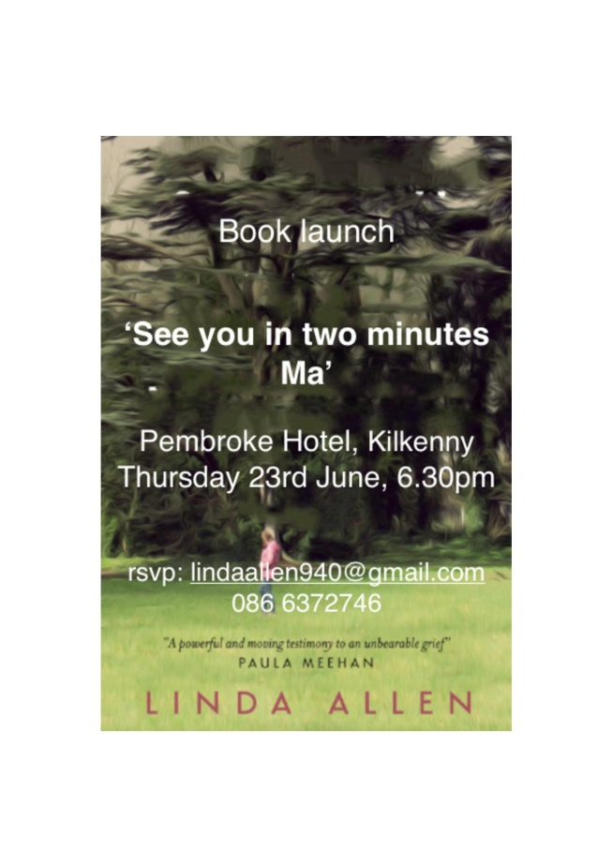

**\_\_\_\_\_\_\_\_\_\_\_\_\_\_\_\_\_\_\_\_\_\_\_\_\_\_\_\_\_\_\_\_\_\_\_\_\_\_\_\_\_\_\_\_\_\_\_\_\_\_\_\_\_\_\_\_\_\_\_\_\_\_\_\_\_\_\_\_\_\_\_\_\_\_\_\_\_\_\_\_\_\_\_\_\_\_\_**

**NEW!** **LESSAC Voice Training**

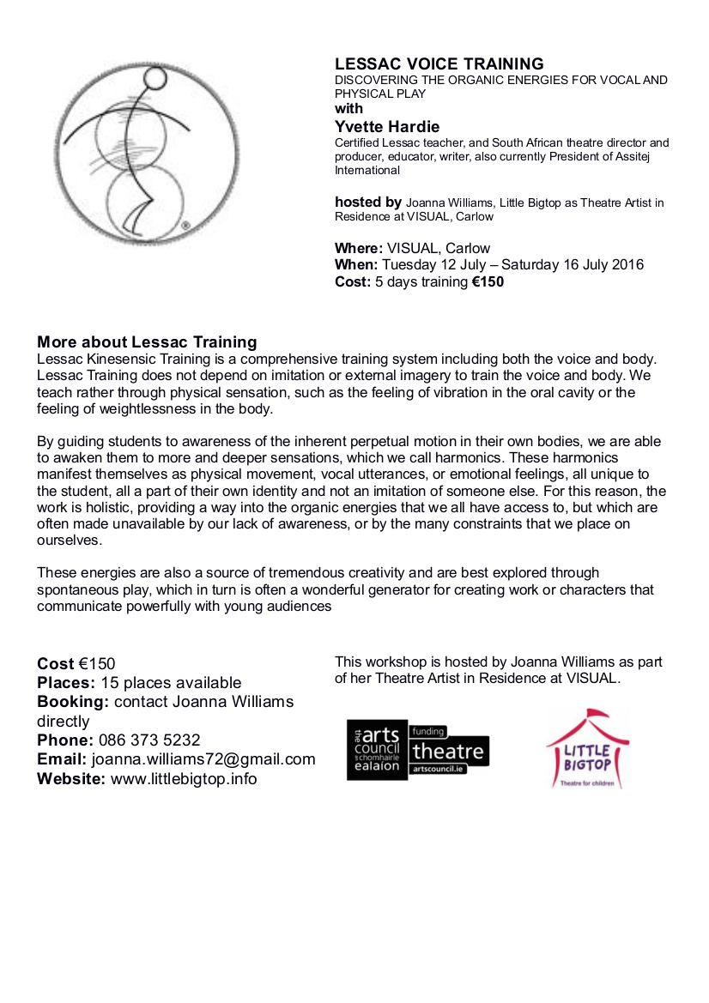

**\_\_\_\_\_\_\_\_\_\_\_\_\_\_\_\_\_\_\_\_\_\_\_\_\_\_\_\_\_\_\_\_\_\_\_\_\_\_\_\_\_\_\_\_\_\_\_\_\_\_\_\_\_\_\_\_\_\_\_\_\_\_\_\_\_\_\_\_\_\_\_\_\_\_\_\_\_\_\_\_\_\_\_\_\_**

**NEW! ‘Famous Faces’ – a retrospective exhibition of the work of Francis Casey, at KCAT**

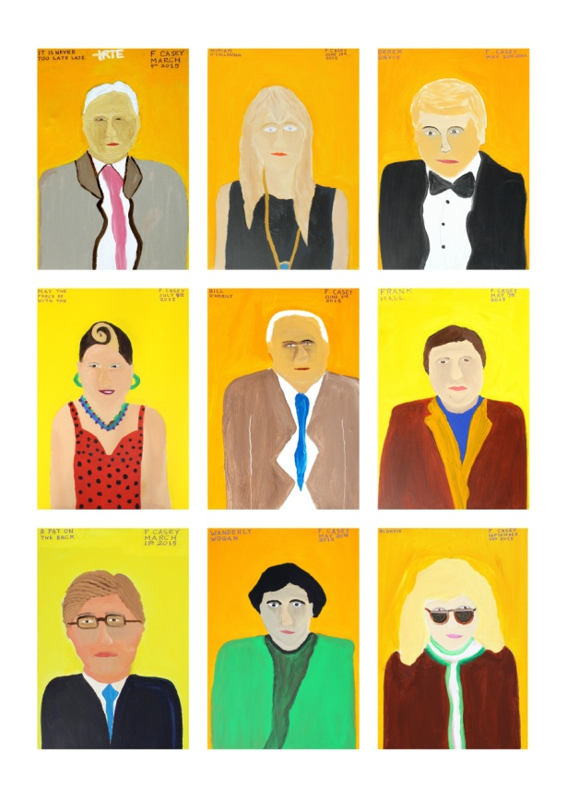 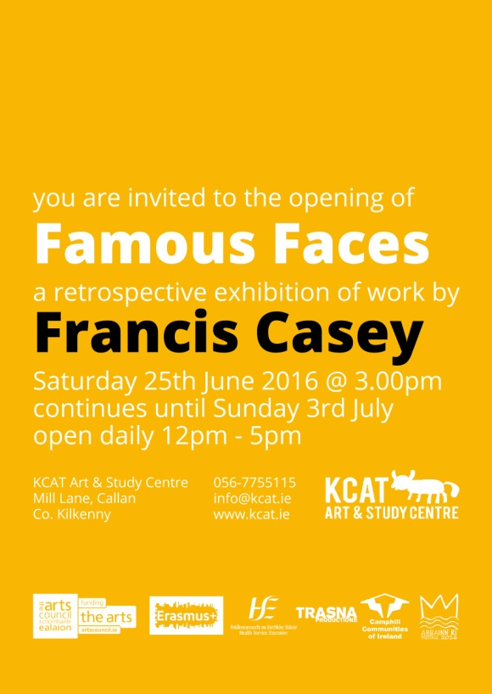

Francis Casey

Famous Faces – A retrospective.

25th June to 3rd July

in KCAT Gallery, KCAT Art and Study Centre, Mill Lane, Callan, Kilkenny.

Francis Casey is a founding member of the KCAT Studio and hails from Carrick-on-Suir, Co. Tipperary.

Initially working primarily in stone, Francis now balances his studio time between drawing, printmaking, copper etching, enameling, painting and sculpture. Alongside his visual work he also produces poetry and prose, often with insightful social commentary. His current body of work identifies cultural icons prominent in the memory of the artist, the subjects coming from the worlds of politics, music, film and TV.

Francis Casey has shown his artwork widely in Ireland including at County Hall Kilkenny, Dundalk Institute of Technology, Kilkenny Arts Festival, St. Luke’s General Hospital Kilkenny, Kilkenny Design Centre, Garter Lane Arts Centre Waterford, the Burren College of Art and Dublin City Council Offices. He has also shown work in many other countries including Finland, Germany, Luxembourg, Italy and the UK. He has taken part in a number of exchange projects including with DADAA Australia, Co-operations Luxembourg, SKID Germany and Pyramid of Arts UK.

In 2014 Francis was commissioned as part of a Percent for Art Scheme at Bunscoil McAuley Rice School, Callan, Co. Kilkenny.

His work features in a number of Publications and in the documentary: *Living Colour* - launched at the Jameson Dublin International Film Festival in 2011.

**\_\_\_\_\_\_\_\_\_\_\_\_\_\_\_\_\_\_\_\_\_\_\_\_\_\_\_\_\_\_\_\_\_\_\_\_\_\_\_\_\_\_\_\_\_\_\_\_\_\_\_\_\_\_\_\_\_\_\_\_\_\_\_\_\_\_\_\_\_\_\_\_\_\_\_\_\_\_\_\_\_\_\_\_\_\_\_**

**NEW! Inguna Mainule Finnerty exhibition at Castlecomer Library**

Castlecomer Library is to host an exhibition by Latvian born artist Inguna Mainule Finnerty from June 7th – July 2nd., Currently studying Fine Art in Abbeyleix, this talented artist, who has been living in Ireland since the turn of the century, has already exhibited nationally at noted galleries.

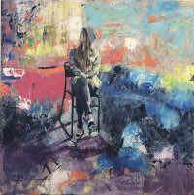

The work featured in the show has been inspired by the local community. Observing Abbeyleix, the artist has commented visually on heritage and surroundings and the connection that locals feel towards the town. Influences were first and foremost based on everything seen, felt and experienced within the place. Abbeyleix bog is one of the areas focused on in this collection. The pieces also take in the urban environment, people and wildlife of the bog that coexist in this breathtaking location and also those who walk along the boardwalk, built within the bog landscape by the local community. The immersion in nature and the ability to forget about daily, mundane lives for a little while is discussed in these visual recording. Still lives also feature, deeply rooted in art history and immediately recognisable, comforting and domestic.

Excited about her forthcoming exhibition Inguna told us, "I have learned to work with different mediums and learned to communicate through my works. I have already exhibited my works nationally and some of my works are in private collections." The artist is also available for commissions.

"The body of work for my exhibition is dedicated to Abbeyleix. In a contextual sense these pieces are, on some level, interpretations of what I see through living my life in this location. These interpretations are themselves the consequence of my own immersion within the social and cultural construct of the society."

**\_\_\_\_\_\_\_\_\_\_\_\_\_\_\_\_\_\_\_\_\_\_\_\_\_\_\_\_\_\_\_\_\_\_\_\_\_\_\_\_\_\_\_\_\_\_\_\_\_\_\_\_\_\_\_\_\_\_\_\_\_\_\_\_\_\_\_\_\_\_\_\_\_\_\_\_\_\_\_\_\_\_\_\_\_\_\_**

**NEW!**

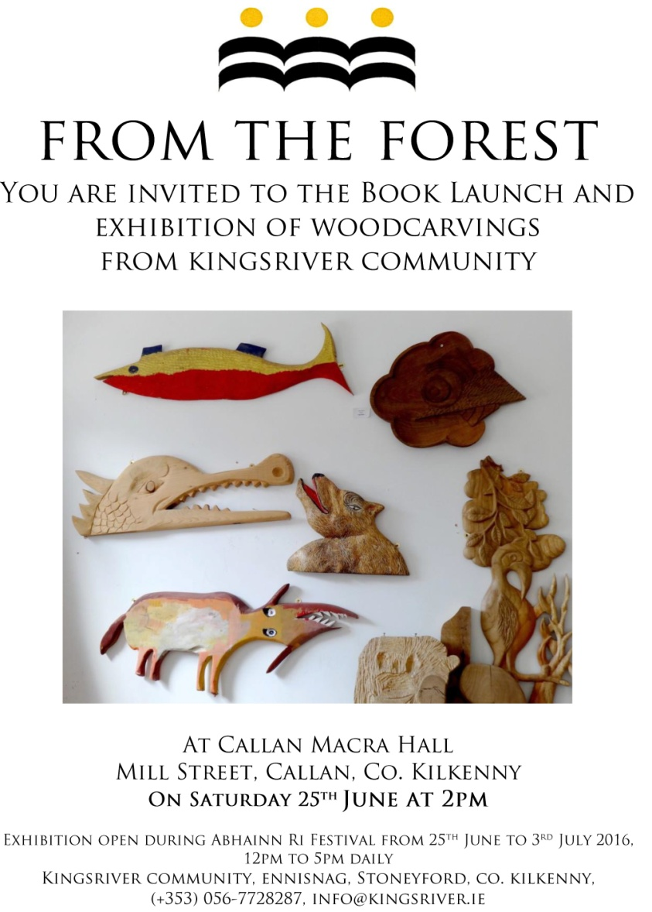

### \_\_\_\_\_\_\_\_\_\_\_\_\_\_\_\_\_\_\_\_\_\_\_\_\_\_\_\_\_\_\_\_\_\_\_\_\_\_\_\_\_\_\_\_\_\_\_\_\_\_\_\_\_\_\_\_\_\_\_\_\_\_\_\_\_\_\_\_\_\_\_\_\_\_

**NEW! Call For Participants’: Kilkenny Libraries Poetry Reading Event October 2016**

Inspired by America’s Favorite Poem Project, where ordinary Americans read aloud their favourite poem for an archive at the Library of Congress, and the recently published anthology in collaboration with Amnesty International “*Poems That Make Grown Women Cry”*, where the editors invited 100 prominent women in the UK to choose their favourite poem and to explain why it moved them, Kilkenny Libraries is holding a poetry reading event in October 2016 in a similar vein where local readers are invited to choose and read a poem that means something to them –an old favourite, or something new. You decide!

Kilkenny Libraries have a number of copies of “*Poems That ...*” which are available to borrow from the library branches around the county, along with other books and anthologies of poetry. The “*Poems That...”* series and others could be a starting point for choosing a poem, or readers might already have a favourite poem that they would like to read.

Kilkenny has a vibrant poetry scene and many talented poets, but for this event we would like to keep to the spirit of the Favourite Poem Project and the *“Poems That ...”–* anthology - so the favourite poem should be someone else’s work – it’s about being moved to read and communicating your reading of that poem to an audience. And you don’t have to be a poet or writer to participate! Even shy readers are encouraged to nominate someone else to read their choice for them if they wish. An all-inclusive adult event showcasing poems that are familiar, or not; poems that may be sad, joyful, celebratory, shocking, inspiring, funny or question things, but have a personal reasons for choice are all welcomed.

We would like to get everyone reading and practicing well in advance – what seems daunting now might seem perfectly feasible by October!  If you don’t have a poem chosen yet, but think you would like to read, please get in touch and get reading – you can let us know your choice of poem during the summer.

To take part in this event or if you have any questions, please contact Mary Morrissey at [mary.morrissey@kilkennylibrary.ie](mailto:mary.morrissey@kilkennylibrary.ie)

For further information on our libraries, this event and other please see [www.kilkennylibrary.ie](http://www.kilkennylibrary.ie)

WATCH THIS SPACE FOR DETAILS OF THIS FREE EVENT TO THE PUBLIC!

**\_\_\_\_\_\_\_\_\_\_\_\_\_\_\_\_\_\_\_\_\_\_\_\_\_\_\_\_\_\_\_\_\_\_\_\_\_\_\_\_\_\_\_\_\_\_\_\_\_\_\_\_\_\_\_\_\_\_\_\_\_\_\_\_\_\_\_\_\_\_\_\_\_\_\_**

**NEW! Municipal District of Kilkenny City - East & West Streetscape Paint Scheme 2016**

Kilkenny County Council is pleased to announce the ‘**Streetscape Paint Scheme 2016**’ whereby a fund has been allocated to assist with the cost of painting the front façade of **commercial / business buildings** and/or hand painted shop signage within the Municipal District of Kilkenny City - East & West, subject to terms and conditions.

This Municipal District includes amongst others, such towns and villages as **Callan, Thomastown, Ballyhale, Bennettsbridge, Dungarvan and Graignamanagh, etc.** However, please contact the undersigned for confirmation of your town / village if you are unsure whether it is included in the relevant Municipal District. **Kilkenny City** is also included in this year’s scheme.

If the scheme is oversubscribed those applicants eligible to continue in the application process will be randomly selected.

Applications are welcome throughout the year subject to funding being available.

Application Forms and further particulars may be obtained from the Property Section, Kilkenny County Council, C/o City Hall, High Street, Kilkenny. Contact - Tel 056 779 4534 or [trevor.byrne@kilkennycoco.ie](mailto:trevor.byrne@kilkennycoco.ie).

**\_\_\_\_\_\_\_\_\_\_\_\_\_\_\_\_\_\_\_\_\_\_\_\_\_\_\_\_\_\_\_\_\_\_\_\_\_\_\_\_\_\_\_\_\_\_\_\_\_\_\_\_\_\_\_\_\_\_\_\_\_\_\_\_\_\_\_\_\_\_\_\_\_\_\_\_\_\_\_\_\_\_\_\_\_\_\_**

**NEW!**

**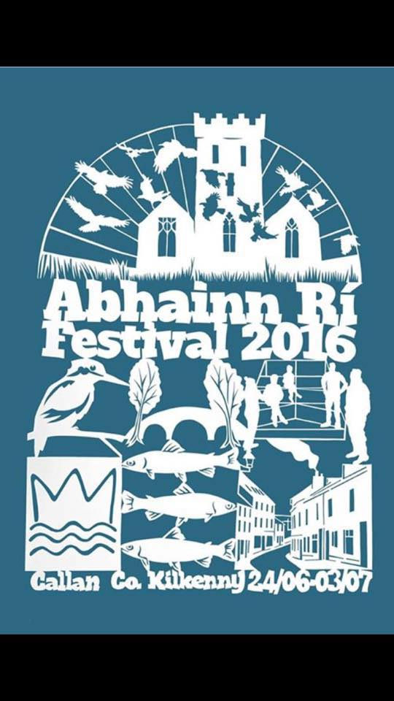**

**\_\_\_\_\_\_\_\_\_\_\_\_\_\_\_\_\_\_\_\_\_\_\_\_\_\_\_\_\_\_\_\_\_\_\_\_\_\_\_\_\_\_\_\_\_\_\_\_\_\_\_\_\_\_\_\_\_\_\_\_\_\_\_\_\_\_\_\_\_\_\_\_\_**

**NEW! Ballykeeffe Amphitheatre in Kilmanagh, the only amphitheatre in Ireland, has launched its exciting programme of events for summer 2016**

Exciting Lineup!

The fun kicks off on Sunday, June 19th with a Punch and Judy puppet show, and Irish rock band The Stunning will headline this year’s phenomenal line-up on July 2nd. The amphitheatre will also see performances from country crooner Derek Ryan (August 12th), Limerick lads Hermitage Green (August 13th) and songstress Eddi Reader (July 30th), while kids and families alike will be well catered for with a performance of Peter Pan (June 24th). The critically acclaimed Declan O’Rourke will take to the stage on July 22nd.

Launching the 2016 programme of events, Cathaoirleach of Kilkenny County Council and elected representative for the local area, Mary Hilda Cavanagh, said:

“I encourage visitors from near and far to visit the Ballykeeffe Amphitheatre this summer, not just to see a fantastic event, but to witness what great community spirit can achieve. This wonderful cultural resource was once a disused quarry but thanks to the dedication of local volunteers, it is now one of the premier cultural attractions in Kilkenny. I congratulate all those involved and look forward to attending events at Ballykeeffe Amphitheatre this summer.”

Also on hand to launch the 2016 season was local Graigue-Ballycallan clubman, Kilkenny Under-21 hurling manager and former county hurling hero Eddie Brennan.

From Chairman of Ballykeeffe Amphitheatre Matt O Sullivan:

“I am privileged to have watched Ballykeeffe Amphitheatre grow from strength to strength over the years, from humble beginnings as an abandoned quarry to a major player on Kilkenny’s very strong music and arts scene. The community involvement in Ballykeeffe Amphitheatre is what makes this venue so special, and our success is due in no small part to the local volunteers who give up their time year after year, as well as the continued support of those who attend our events. We have an excellent line-up for 2016 with something to suit all ages and interests, and look forward to welcoming everyone to Ballykeeffe for what is set to be an unmissable summer season”

For more details see <http://ballykeeffeamphitheatre.com/>

**\_\_\_\_\_\_\_\_\_\_\_\_\_\_\_\_\_\_\_\_\_\_\_\_\_\_\_\_\_\_\_\_\_\_\_\_\_\_\_\_\_\_\_\_\_\_\_\_\_\_\_\_\_\_\_\_\_\_\_\_\_\_\_\_\_\_\_\_\_\_\_\_\_\_**

### Full Circle | Debra Bowden at Cill Rialaig Arts Centre, Co. Kerry

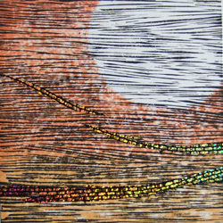

5 to 24 June 2016 |Opening: 5 June, 12.30

Cill Rialaig Arts Centre, Ballinskelligs, Co. Kerry

‘Full Circle’ is an exhibition of woodblock prints by Debra Bowden. Bowden is the first Irish artist to be awarded a scholarship to Awaji Island, Japan to work under the tutelage of masters Toru Ueba sans, Masahiro Takade sans and Shoichi Katamura sans.

E: crsiopa@gmail.com, T: 066 9479277  
[www.facebook.com/CillRialaigArtsCentre/](http://scanmail.trustwave.com/?c=6600&d=-rDK14NjKgMYTTFXhPwuSnYe4IEe4Ps_R9mmLlUjfg&s=380&u=http%3a%2f%2fvisualartists%2eus9%2elist-manage1%2ecom%2ftrack%2fclick%3fu%3de67e46c7b14e756132f46a50c%26id%3dfd703c6f2d%26e%3df4dbf7f416)

**\_\_\_\_\_\_\_\_\_\_\_\_\_\_\_\_\_\_\_\_\_\_\_\_\_\_\_\_\_\_\_\_\_\_\_\_\_\_\_\_\_\_\_\_\_\_\_\_\_\_\_\_\_\_\_\_\_\_\_\_\_\_\_\_\_\_\_\_\_\_\_\_\_\_\_\_\_\_\_\_\_\_\_\_\_\_**

### Dreaming in Blue Kilkenny artist, Julie Cusack at Solomon Fine Art

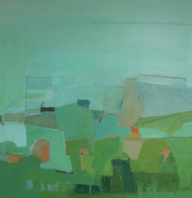

3 to 25 June

An exhibition of new paintings by Julie Cusack, her first solo exhibition with the gallery. This body of work was born out of Cusack’s desire to make paintings that reflect the theatre of landscape and its many elements. Julie’s abstracted landscapes are vibrant, layered and have always been rooted in drawing. Working primarily on paper and board she combines paint with drawn elements as drawing for her is not only a way to represent object or place but is also a way to engage in the intuitive physicality of making marks on a surface. Starting with an image sometimes, from memory, sometimes from observation, she layers paint and graphite on board or paper and begins the process of editing. Some areas become obscured or recede while others push forward and what evolves is a dance between surface and depth, between what is random and what is particular. Ultimately Julie endeavours to create abstracted compositions which represent a fictional place between the external and the internal.

Solomon Fine Art, Balfe Street, Dublin 2  
T: +353 (0)86 8142380  
E: [info@solomonfineart.ie](mailto:info@solomonfineart.ie)  
W: [solomonfineart.ie](http://scanmail.trustwave.com/?c=6600&d=-7DK1_aFqzLhYHrU9YBqV5Akb2rZ1zdJsAe5b2uZKw&s=380&u=http%3a%2f%2fvisualartists%2eus9%2elist-manage%2ecom%2ftrack%2fclick%3fu%3de67e46c7b14e756132f46a50c%26id%3d1ca806cdac%26e%3df4dbf7f416)

**\_\_\_\_\_\_\_\_\_\_\_\_\_\_\_\_\_\_\_\_\_\_\_\_\_\_\_\_\_\_\_\_\_\_\_\_\_\_\_\_\_\_\_\_\_\_\_\_\_\_\_\_\_\_\_\_\_\_\_\_\_\_\_\_\_\_\_\_\_\_\_\_\_\_\_\_\_\_\_\_\_\_\_\_\_\_\_**

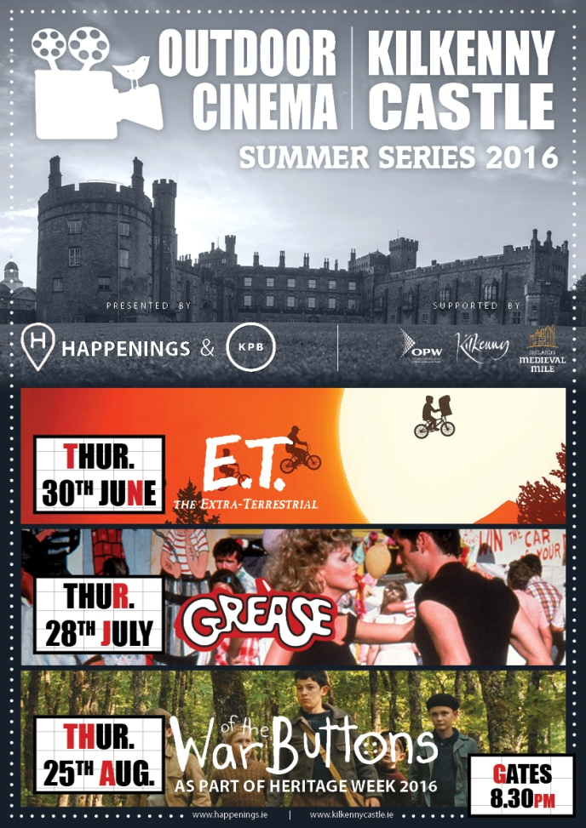

**\_\_\_\_\_\_\_\_\_\_\_\_\_\_\_\_\_\_\_\_\_\_\_\_\_\_\_\_\_\_\_\_\_\_\_\_\_\_\_\_\_\_\_\_\_\_\_\_\_\_\_\_\_\_\_\_\_\_\_\_\_\_\_\_\_\_\_\_\_\_\_\_\_\_\_\_\_\_\_\_\_\_\_\_\_\_\_**



**Exhibition**

**Liminal: Irish Design at the Threshold 8 April 2016 – 3 July 2016**

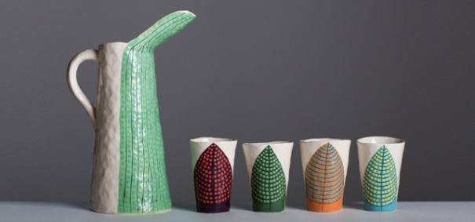

Liminal – Irish design at the threshold, presents some of Ireland’s most exciting design, from product to scientific, architecture to animation, and food to furniture. The exhibiting designers, companies and studios have been selected for the innovative outlook of their work, its connectivity and ability to transcend disciplinary boundaries to address the issues of today. Presenting a pivotal chapter in Irish design, Liminal explores, identifies and showcases Irish creativity, and how designers, companies and studios are moving across disciplinary boundaries and the limits of what design has been, into what design can become. As design increasingly seeks to create holistic experiences and narratives, Ireland is placed to play a significant role in 21st century design, helping meet the challenges of tomorrow. The exhibition demonstrates Irish design excellence across disciplines and considers the possibilities for the future.

The evolving flagship exhibition from ID2015, Liminal – Irish design at the threshold, is presented in Kilkenny after its tour of design weeks in Eindhoven, Milan, New York and Dublin. The exhibition features over 20 designers, companies and studios involved in collaborations across disciplines.

Co-curated by Louise Allen, Alex Milton and Angela O’Kelly

**Education & Outreach**

**FAMILY DAY: CHARACTER DESIGN\* Sat 18 June 10.30am, 12 noon & 2.30pm**

Learn what shapes make a cartoon look happy or sad, quiet or energetic, then design your own character inspired by Cartoon Saloon's Song of the Sea with animator Rory Conway. [Book Now](javascript:void(location.href='mailto:'+String.fromCharCode(101,118,101,110,116,115,64,110,97,116,105,111,110,97,108,99,114,97,102,116,103,97,108,108,101,114,121,46,105,101)+'?subject=Family%20Day%20Booking%20-%20Character%20Design%20June%2018&body=Parent%20Name%0ATel%0APreferred%20Time%2010.30am%20%2F%2012noon%20%2F%202.30pm%0A%0AChild%201%20Name%0AChild%201%20Age%0A%0AChild%202%20Name%0AChild%202%20Age%0A%0AChild%203%20Name%0AChild%203%20Age'))

**LATE DATE: STORY-LED DESIGN EXPERIENCES Thurs 30 June, 6.30pm**

Design consultancy Design Partners talk about the development of products such as the Calor Mini Bbq and Silvair Smart Control System, sharing the story-led design approach they utilise to create exceptional design experiences.

**DROP-IN: DESIGN DISCOVERY Daily**

Drop-in with the family to discover design through Liminal:  
**Liminal Explorer**: Become a design detective, seeking out visual designs  
**ARCKIT Play**: Test your architectural design ideas with ARCKIT

**SCHOOLS: GUIDED VISITS & WORKSHOPS 12 April – 30 June (Tues-Fri)**

Our educators introduce students to design and craft through a tailored exhibition tour and invite you to book a class workshop:  
**Primary:** Line Shape Pattern  
**Secondary:** ARCKIT Modular Homes  
**Leaving Cert:** Art, Craft & Design Gallery Question  
**Third Level:** ARCKIT Modular Builds

**Gallery Tours**

CRAFTERNOON TOURS\* Sat, 3pm Visitors are invited to book for our informal afternoon tour. GUIDED EXHIBITION VISITS\* Would you like to bring a group to the National Craft Gallery? We accommodate groups from 5 to 25 people. No fee applies. Contact us and we will tailor a tour suit the needs of your visit. \*Booking required - email events@nationalcraftgallery.ie or call 056 7796151

**Upcoming Art and Craft Workshops at KOZO Studio and Gallery**

June - July 2016

\*\*\*\*\*\*\*\*\*\*  
**18 June (Saturday)**  
**10.30am - 5pm BATIK Workshop** - ***Beginners***  
A full day programme introducing an ancient technique of fabric dyeing where hot wax is used as a resist.  
Participants will learn all necessary basic techniques - and complete three small/medium batik pieces with up to 4 colours on cotton fabric and/or paper.  
€ 75 for the full day, including all materials  
  
\*\*\*\*\*\*\*\*\*\*  
**16 July (Saturday)**  
**10.30am - 5pm Felt Making Workshop** – ***Beginners***  
The workshop introduces wet felting techniques using dyed and un-dyed Merino wool and silk fibre inclusions.  
Learn to design and make a unique wall piece or a small but beautiful felted bag. Participants will make a small practice piece before progressing to a larger project.  
€ 75 for the full day, including all materials  
   
\*\*\*\*\*\*\*\*\*\*  
**17 July (Sunday)**  
**10.30am – 5.30pm Paper Making and Paper Art Follow-on Course** – ***Advanced Level***  
   
Designed for participants who already work with paper/fibre based processes, this course offers assistance and guidance in areas of three dimensional, sculptural and installation based works, experimental processes of batik, wax based works on paper, paper dyeing and texturing. It also covers ideas for the preparation and use of plant based pulps (without added chemicals). Participants are encouraged to bring their own ideas and questions into the workshop and invited to show and discuss previous works and projects.  
**Places are limited for 5 participants.**  
€ 80 for the full day, including all materials  
    
   
BOOKINGS are confirmed with € 30 deposit paid in advance.\* Courses are run for small groups only so please call to book early.  
**With any questions, for advice or check availability and for all BOOKINGS please contact TUNDE directly:  
087-2543362**  
[**tundetune@gmail.com**](mailto:tundetune@gmail.com)  
[**www.tundetoth.com**](http://www.tundetoth.com/)

**Course / Training / Jobs / Internships**

**Dublin Writers Conference**

The **Irish Writers Centre** is delighted to be hosting the **Dublin Writers Conference** on the 24 - 26 June. This weekend conference will provide first class training in aspects of writing craft as well as digital marketing for authors. It will provide practical support, valuable training and is ideal for both fiction and non-fiction authors.

The writing craft sessions will focus on a variety of methods authors can use to improve their craft and broaden their writing skills. Changes to book promotion due to social media will be discussed during the digital marketing sessions and will focus on how authors can use this to their advantage.

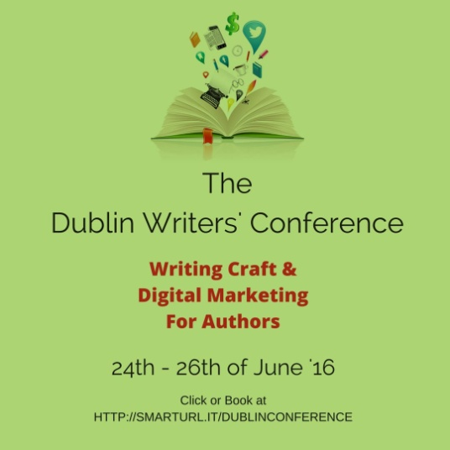

We have a wide range of speakers attending from the US, the UK & Ireland including **Conor Kostick,** **Margaret Murphy, Laurence O'Bryan,** and **Debbie Young.**

Join us this June at a unique event for Dublin, a writer’s conference aimed at writers. Places are limited so please book as soon as possible.

For full information and booking, and a full list of speakers visit: <http://thebookpromoter.com/conference/>

**\_\_\_\_\_\_\_\_\_\_\_\_\_\_\_\_\_\_\_\_\_\_\_\_\_\_\_\_\_\_\_\_\_\_\_\_\_\_\_\_\_\_\_\_\_\_\_\_\_\_\_\_\_\_\_\_\_\_\_\_\_\_\_\_\_\_\_\_\_\_\_\_\_\_\_\_\_\_\_\_\_\_\_\_\_\_\_**

**NEW! Backwater Artists Group Seeking Studio Coordinator/Research Assistant**

Deadline for applications: 30 June, 5pm

Backwater Artists Group is seeking to appoint a Studio Coordinator/Research Assistant for a fixed period of 22 weeks, on a part-time basis. The Studio Coordinator/Research Assistant will assist the Studio Director in the development, co-ordination and promotion of group activities, the artistic programme and the day-to-day office administration of Backwater Artists Group. The Studio Coordinator/Research Assistant will be responsible for conducting research in relation to the review of studio policies and the artistic and outreach programmes. The successful candidate will have an interest and experience working in the visual arts in Ireland.

Position: Studio Coordinator/Research Assistant  
Wage: €12 per hour, 14 hours per week for 22 weeks  
Contract: part-time position of 22 weeks with 4 weeks probationary period  
Reporting to: Studio Director and Board of Directors  
Position Starts: Week Beginning August 1st 2016  
Full Job Description: [**backwaterartists.ie/job-opportunity/**](http://scanmail.trustwave.com/?c=6600&d=tMPh14YpATtUHjBOn-g1kRfLlHfFfLCxIS_CIJ_iMw&s=380&u=http%3a%2f%2fvisualartists%2eus9%2elist-manage%2ecom%2ftrack%2fclick%3fu%3de67e46c7b14e756132f46a50c%26id%3d7b9d5fcca0%26e%3d1968c52731)

Queries by email: [**admin@backwaterartists.ie**](mailto:admin@backwaterartists.ie)  
[**www.backwaterartists.ie**](http://scanmail.trustwave.com/?c=6600&d=tMPh14YpATtUHjBOn-g1kRfLlHfFfLCxISiXIcyxMg&s=380&u=http%3a%2f%2fvisualartists%2eus9%2elist-manage%2ecom%2ftrack%2fclick%3fu%3de67e46c7b14e756132f46a50c%26id%3d1b4179d148%26e%3d1968c52731)

**\_\_\_\_\_\_\_\_\_\_\_\_\_\_\_\_\_\_\_\_\_\_\_\_\_\_\_\_\_\_\_\_\_\_\_\_\_\_\_\_\_\_\_\_\_\_\_\_\_\_\_\_\_\_\_\_\_\_\_\_\_\_\_\_\_\_\_\_\_\_\_\_\_\_\_\_\_\_\_\_\_\_\_\_\_\_\_**

**NEW! IMA Forum: Education and Outreach Forum 2016, National Museum of Ireland**

Friday 1 July, 9.30 am to 3.30pm.

National Museum of Ireland – Decorative Arts and History, Collins Barracks, Benburb Street, Dublin 1

The Irish Museums Association’s Education and Outreach forum is a key event in the calendar for museum educators to meet and discuss topics of interest to their programmes. From resources to individual projects, the IMA forum provides an informal learning exhange opportunity to share your findings and engage with your colleagues working in museums, galleries and cultural institutions. It is intended as a place for critical engagement, examination and experimentation of ideas, where a lasting contribution can be made to the development of education in the museum context.

Speakers will be presenting examples of new and innovative access, outreach / education project that is happening on the ground – or have an example of creative engagement and learning – in museums and galleries across Ireland and the UK.

Speakers:  
Dea Brikett, Creative Director, Kids in Museums, UK  
Ellen Byrne, Creative Director and Cofounder Festival of Curiosity  
Liz Johnson, Artist and Educator  
Sarah McEvoy, Programme Administrator, Learning Department, Victoria and Albert Museum, UK  
Helen Beaumont, Education and Outreach Officer, National Museum of Ireland – Decorative Arts and History  
Fiona Byrne, Acting Curator of Education and Outreach, The Hunt Museum  
Edith Andrees, Project Coordinator, National Museum of Ireland – Decorative Arts and History  
Arlene Bell, Social Inclusion Programme Manager, National Museums Northern Ireland  
Gretta Halpin, Education Officer, National Print Museum, Dublin  
Catherine McGuinness, Museum Educator  
Aoife O’Toole, Education Assistant, National Museum of Ireland – Country Life

For more information on past forums and activities of the Irish Museums Association, visit [**www.irishmuseums.org**](http://scanmail.trustwave.com/?c=6600&d=tMPh14YpATtUHjBOn-g1kRfLlHfFfLCxIXrFJ8HiNQ&s=380&u=http%3a%2f%2fvisualartists%2eus9%2elist-manage1%2ecom%2ftrack%2fclick%3fu%3de67e46c7b14e756132f46a50c%26id%3dcce2d10ec6%26e%3d1968c52731) or contact Gina O’Kelly, Director Irish Museums Association on director@irishmuseums.org  
[**educationandoutreachforum2016.eventbrite.ie**](http://scanmail.trustwave.com/?c=6600&d=tMPh14YpATtUHjBOn-g1kRfLlHfFfLCxIXvGJM2zMg&s=380&u=http%3a%2f%2fvisualartists%2eus9%2elist-manage1%2ecom%2ftrack%2fclick%3fu%3de67e46c7b14e756132f46a50c%26id%3d7503023f2c%26e%3d1968c52731)

**\_\_\_\_\_\_\_\_\_\_\_\_\_\_\_\_\_\_\_\_\_\_\_\_\_\_\_\_\_\_\_\_\_\_\_\_\_\_\_\_\_\_\_\_\_\_\_\_\_\_\_\_\_\_\_\_\_\_\_\_\_\_\_\_\_\_\_\_\_\_\_\_\_\_\_\_\_\_\_\_\_\_\_\_\_\_\_**

**NEW! NYCI Certificate in Youth Arts 2016/2017**

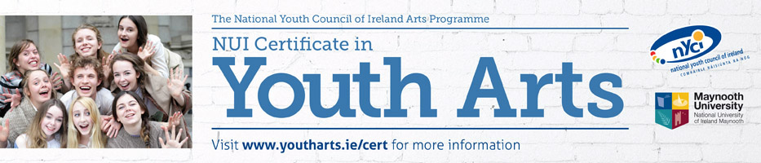

**\*\* \*\*\*\* Closing date for applications - Friday 19th August 2016\*\*\*\* \*\***

**“The course gave me space and time, along with a new vocabulary to think about and therefore understand what youth arts means to me and what it means for society. This increased understanding allowed me to return to my work armed with renewed motivation, new and important contacts, increased policy and sector knowledge and a fired up imagination.”**

**NUI Certificate in Youth Arts**

The **Certificate in Youth Arts** is a part time programme of study in Irish Youth Arts Practice, with 6 modules covered over 12 contact days between October and June. The programme is a partnership initiative of Maynooth University and the National Youth Council of Ireland Arts Programme and leads to an award of the National University of Ireland, placed at Level 7 on the National Qualifications Framework.

The Certificate in Youth Arts aims to introduce those working in the non-formal education sector to the concepts, principles and practice of youth arts using a context and practice approach.

**The Certificate in Youth Arts is recruiting potential candidates in summer 2016for the 2016/17 academic year. For further information or to request an application form, please contact Anna Gunning, Youth Arts Programme, National Youth Council of Ireland on 01 4255932 or** [**anna@nyci.ie**](mailto:anneog@nyci.ie)**.  We look forward to hearing from you!**

**\_\_\_\_\_\_\_\_\_\_\_\_\_\_\_\_\_\_\_\_\_\_\_\_\_\_\_\_\_\_\_\_\_\_\_\_\_\_\_\_\_\_\_\_\_\_\_\_\_\_\_\_\_\_\_\_\_\_\_\_\_\_\_\_\_\_\_\_\_\_\_\_\_\_\_\_\_\_\_\_\_\_\_\_\_\_\_**

**NEW! CCAD/CIT Portfolio Summer Course in Uillinn, West Cork Art Centre, Skibbereen**

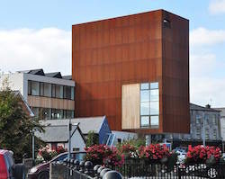

4 to 7 and 11 to 14 July (Monday to Thursday, two weeks)  
10am to 3pm with 3:00pm to 4:30pm free studio time each day.

Participants will be tutored in composition, observational drawing, life drawing, painting, and developing a sketchbook. Other activities, such as photography, collage, 3D, and gallery visits are covered during the course. Tuition will be given in developing a well balanced portfolio.

Participants will be encouraged to make best use of this unique location including Uillinn exhibition and residency programmes, rural landscape and architecture.

The course is suitable for both mature and Leaving Certificate students. Suitable for those seeking art college entry.

West Cork Arts Centre, Uillinn, Cork  
T: (028) 22090  
W: [**facebook.com/uillinnwestcorkartscentre/**](http://scanmail.trustwave.com/?c=6600&d=tMPh14YpATtUHjBOn-g1kRfLlHfFfLCxIX_FesGxMQ&s=380&u=http%3a%2f%2fvisualartists%2eus9%2elist-manage%2ecom%2ftrack%2fclick%3fu%3de67e46c7b14e756132f46a50c%26id%3d38f29df243%26e%3d1968c52731)

**\_\_\_\_\_\_\_\_\_\_\_\_\_\_\_\_\_\_\_\_\_\_\_\_\_\_\_\_\_\_\_\_\_\_\_\_\_\_\_\_\_\_\_\_\_\_\_\_\_\_\_\_\_\_\_\_\_\_\_\_\_\_\_\_\_\_\_\_\_\_\_\_\_**

**NEW! Draíocht Blanchardstown seeks Administration Assistant**  
  
Deadline for Applications: Wednesday 29 June, 5pm.

Draíocht Blanchardstown seeks a full time Administration Assistant on a Short Term Specified Purpose Contract.

The Administration Assistant is responsible for the smooth running of the Children’ and Youth Arts Programme (Maternity Leave Cover) and for Visual Arts Programme Administration (Sickness Absence Cover). This is a specified purpose contract to cover the maternity leave of the permanent post-holder and the absence due to sickness of a permanent post-holder and is expected to last for approximately 6 months, beginning in early August 2016. Your employment will terminate upon the end of the Specified Purpose i.e. Maternity Leave/Sickness Absence and any subsequent associated leave.

Please refer to the Job Description and Person Specifications when telling us about yourself as these are the criteria we will use when short-listing.

CV and Covering Letter should be submitted to: Nicola Murphy, Marketing Press and PR Manager, Draíocht, The Blanchardstown Centre, Dublin 15 or to [**nicola@draiocht.ie**](mailto:nicola@draiocht.ie)

[www.draoicht.ie](http://www.draoicht.ie)

**\_\_\_\_\_\_\_\_\_\_\_\_\_\_\_\_\_\_\_\_\_\_\_\_\_\_\_\_\_\_\_\_\_\_\_\_\_\_\_\_\_\_\_\_\_\_\_\_\_\_\_\_\_\_\_\_\_\_\_\_\_\_\_\_\_\_\_\_\_\_\_\_\_\_\_\_\_\_\_\_\_\_\_\_\_\_\_**  
  
**NEW! The National Gallery of Ireland seeking Education Manager**  
  
Closing date for receipt of applications: Friday 24 June, 4pm.

The National Gallery of Ireland wishes to recruit an Education Manager to strategically manage the delivery of a new educational programme in the Gallery. The Education Manager will lead a team that will develop and deliver informative, accessible and enjoyable programmes that are tailored to suit the Gallery’s diverse audiences (onsite, online and through educational programmes).

For full job description and requirements see: [**The National Gallery of Ireland – Education Manager**](http://scanmail.trustwave.com/?c=6600&d=vYjY184--sf3KlGrqGqgNEeKWpYyRo-LkT26Ny_LdQ&s=380&u=http%3a%2f%2fvisualartists%2eus9%2elist-manage%2ecom%2ftrack%2fclick%3fu%3de67e46c7b14e756132f46a50c%26id%3da7b74a54f4%26e%3df4dbf7f416)

AT [**www.nationalgallery.ie**](http://scanmail.trustwave.com/?c=6600&d=vYjY184--sf3KlGrqGqgNEeKWpYyRo-LkW7vZXyedw&s=380&u=http%3a%2f%2fvisualartists%2eus9%2elist-manage%2ecom%2ftrack%2fclick%3fu%3de67e46c7b14e756132f46a50c%26id%3d28a6784a75%26e%3df4dbf7f416)  
**\_\_\_\_\_\_\_\_\_\_\_\_\_\_\_\_\_\_\_\_\_\_\_\_\_\_\_\_\_\_\_\_\_\_\_\_\_\_\_\_\_\_\_\_\_\_\_\_\_\_\_\_\_\_\_\_\_\_\_\_\_\_\_\_\_\_\_\_\_\_\_\_\_\_\_\_\_\_\_\_\_\_\_\_\_\_\_**

**NEW! St. Patrick’s Festival seeking Artistic Director**

Deadline for applications: Friday 17 June, 5pm

St. Patrick’s Festival is now looking for an outstanding and talented individual who will lead the artistic vision of the festival and the delivery of its multi-disciplinary cultural programme. The Artistic Director will be a confident and persuasive leader and will inspire and motivate diverse groups to engage with the festival.

This is a key management role within the festival which has responsibility for ensuring the continued growth of St Patrick’s Festival as a major National and International event. The Artistic Director reports to the CEO and has:  
• Primary responsibility to work with the CEO to create a vision for the festival.  
• To create passion for that vision amongst the team, the arts community, to a diverse  
stakeholder base, to the media, and to the general public.

For full job description and requirements see: [**www.stpatricksfestival.ie/**](http://scanmail.trustwave.com/?c=6600&d=vYjY184--sf3KlGrqGqgNEeKWpYyRo-LkWy5MHbLdw&s=380&u=http%3a%2f%2fvisualartists%2eus9%2elist-manage1%2ecom%2ftrack%2fclick%3fu%3de67e46c7b14e756132f46a50c%26id%3dbc8a276f4f%26e%3df4dbf7f416)

Interested parties should send curriculum vitae and cover letter to:  
E-mail: [**recruitment@stpatricksfestival.ie**](mailto:recruitment@stpatricksfestival.ie)  
Post: Recruitment, St Patrick’s Festival. 12 Merrion Square, Dublin 2

**\_\_\_\_\_\_\_\_\_\_\_\_\_\_\_\_\_\_\_\_\_\_\_\_\_\_\_\_\_\_\_\_\_\_\_\_\_\_\_\_\_\_\_\_\_\_\_\_\_\_\_\_\_\_\_\_\_\_\_\_\_\_\_\_\_\_\_\_\_\_\_\_\_\_\_\_\_\_\_\_\_\_\_\_\_\_\_**

**NEW! Call for Volunteers | PhotoIreland Festival 2016**

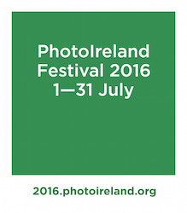

PhotoIreland Festival is seeking expressions of interest from individuals looking to join the festival team in Dublin in July 2016.

We have a lot of exciting and unusual events coming up this year and need all the help we can get.  
Please see our Main Shows listing for a preview of what you will be working with us on: [**photoireland.org/festival/year-2016/**](http://scanmail.trustwave.com/?c=6600&d=vojY1yNAdCk6LIEP80STc3qT1T93cJ-PWtuvhussCQ&s=380&u=http%3a%2f%2fvisualartists%2eus9%2elist-manage%2ecom%2ftrack%2fclick%3fu%3de67e46c7b14e756132f46a50c%26id%3d756b6f90b0%26e%3df4dbf7f416)

We are looking for volunteers to help in aiding to set up the exhibitions, help out on opening nights and events, and invigilation throughout the festival. During this period, you will build a knowledge of the workings of a gallery, exhibition making, develop your skills and contribute towards your working experience. This opportunity would be suitable for anyone looking to hone their knowledge and skills in the arts, with a focus on photography and festivals.

We require volunteers from end of June until the end of July, depending on what kind of help you are happy to offer. While we are not looking necessarily for full-time help (most of us are part-time), we are looking for responsible and dedicated people.

For further details and to express your interest, please contact [**julia.gelezova@photoireland.org**](mailto:julia.gelezova@photoireland.org)

**\_\_\_\_\_\_\_\_\_\_\_\_\_\_\_\_\_\_\_\_\_\_\_\_\_\_\_\_\_\_\_\_\_\_\_\_\_\_\_\_\_\_\_\_\_\_\_\_\_\_\_\_\_\_\_\_\_\_\_\_\_\_\_\_\_\_\_\_\_\_\_\_\_\_\_\_\_\_\_\_\_\_\_\_\_\_\_**

**NEW! The Killarney Municipal District of Kerry County Council: Schools Drama Programme**

The residency will be a part time position (15 hour week)

The successful applicant will be asked to stimulate greater awareness of the potential for theatre to reflect, challenge and engage young people. The focus will be on providing young people with the tools and confidence to create socially engaged theatre with a short end of programme performance of devised work.

The Facilitator will engage with a specific number of schools who will apply to be part of the programme.

A contract for services fee, inclusive of travel and expenses of €7,200 is offered for a 15 week period to commence in September / October 2016 (subject to Garda Vetting). The payment schedule will be: ⅓ on commencement, ⅓ halfway through, ⅓ on completion.

Please refer any queries to Kate Kennelly, Arts Officer on 066 71 83541 or email [arts@kerrycoco.ie](mailto:arts@kerrycoco.ie)

**Call for Submissions / Residencies**

**NEW!**

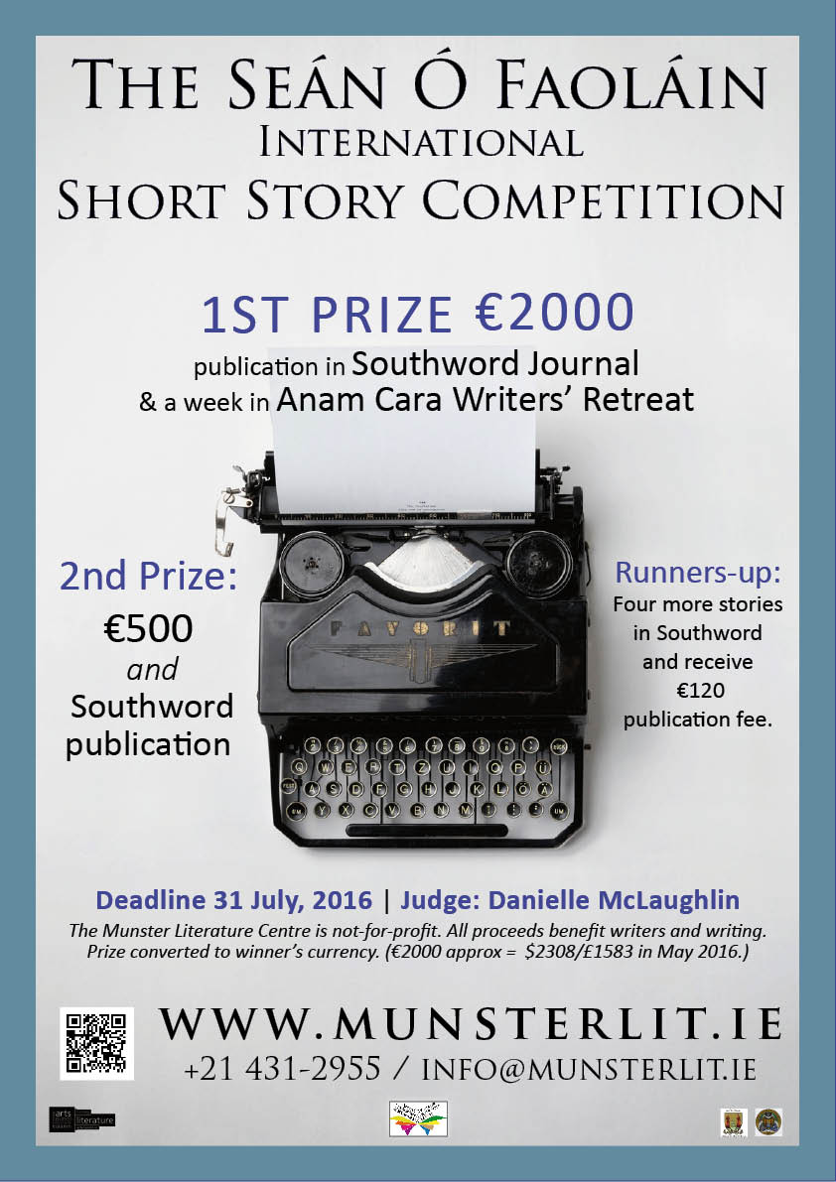

**\_\_\_\_\_\_\_\_\_\_\_\_\_\_\_\_\_\_\_\_\_\_\_\_\_\_\_\_\_\_\_\_\_\_\_\_\_\_\_\_\_\_\_\_\_\_\_\_\_\_\_\_\_\_\_\_\_\_\_\_\_\_\_\_\_\_\_\_\_\_\_\_\_\_\_\_\_\_\_\_\_\_\_\_\_**

**NEW! Per Cent for Art Commission | St. Raphael’s College, Loughrea, Co. Galway**

Deadline for Stage 1 entries: Monday 15 August, 12 noon.

St. Raphael’s for their Per Cent for Art project would like to commission a Professional Artist(s) who can provide them with a new, permanent artwork that would involve engagement with their students and staff. St. Raphael’s College was founded in 1917. It was originally a Mercy Sister’s Convent. They wish to have their Per Cent for Art Commission completed for the official opening of the new school building in September 2017 and to celebrate the school centenary.

**Total Budget**: €35,000 (inclusive of VAT).

Applicants are requested to read the full content of the briefing document carefully as it contains important information pertaining to all stages of the commission.

**Queries:**  
Applicants can make enquiries regarding the commission to Rina Whyte, email [**rinawhyte@yahoo.com**](mailto:rinawhyte@yahoo.com) or by telephone + 353 87 238 9591.

**\_\_\_\_\_\_\_\_\_\_\_\_\_\_\_\_\_\_\_\_\_\_\_\_\_\_\_\_\_\_\_\_\_\_\_\_\_\_\_\_\_\_\_\_\_\_\_\_\_\_\_\_\_\_\_\_\_\_\_\_\_\_\_\_\_\_\_\_\_\_\_\_\_\_\_\_\_\_\_\_\_\_\_\_\_\_\_**

**NEW! Open Competition | Irish Ceramic Awards, Mill Cove Gallery**

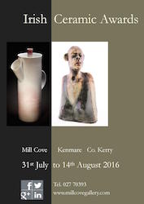

Deadline: 1 July

The Irish Ceramic Awards are open to anyone working in clay in Ireland and Northern Ireland.

Submissions must be original and of a high standard, both in presentation and content. The work should not have been previously exhibited and created within the last 2 years.

There is a submission fee of €15.

**Awards:**  
Irish Ceramic Award 2016 – €850  
Highly Commended Ceramic Award 2016 – €400

The Outstanding Achievement Award in Irish Ceramics 2016 will be announced on or before the end of June 2016. This is a juried selection for an artist who has made a significant contribution to Irish Ceramics during their career.

T

he winning works will be acquired for the Mill Cove Collection. The 2016 Irish Ceramic Awards will include a presentation by Mill Cove Gallery and representation at the galleries in Kenmare, Castletownbere and Dublin.

9th Annual Irish Ceramic Awards exhibition will take place from 31st July to 14th August 2016.

**Applications:**  
The submission fee of €15 applies, regardless of the number of pieces submitted. Fee is payable by cheque or postal order, to Mill Cove Gallery. Debit or credit card telephone 027 70393 or bank transfer: email [**millcovegallery@gmail.com**](mailto:millcovegallery@gmail.com) for details.

Submission forms and more information available on website [**www.millcovegallery.com**](http://scanmail.trustwave.com/?c=6600&d=tMPh14YpATtUHjBOn-g1kRfLlHfFfLCxISuSJ5_kMQ&s=380&u=http%3a%2f%2fvisualartists%2eus9%2elist-manage%2ecom%2ftrack%2fclick%3fu%3de67e46c7b14e756132f46a50c%26id%3d2501614ea2%26e%3d1968c52731) or by email from [**millcovegallery@gmail.com**](mailto:millcovegallery@gmail.com)

**\_\_\_\_\_\_\_\_\_\_\_\_\_\_\_\_\_\_\_\_\_\_\_\_\_\_\_\_\_\_\_\_\_\_\_\_\_\_\_\_\_\_\_\_\_\_\_\_\_\_\_\_\_\_\_\_\_\_\_\_\_\_\_\_\_\_\_\_\_\_\_\_\_\_\_\_\_\_\_\_\_\_\_\_\_**

**NEW! Music Network Artist Residency**

The Music Network Artist Residency Programme aims to provide a musician with funding in order to plan and deliver a programme of concerts, with integrated audience development components, in partnership with a promoter and a local authority, and in dialogue with Music Network. Full details on how to submit an Expression of Interest below.

We are inviting professional musicians, working primarily in classical, jazz/improvised or traditional music that have a strong track record in music performance and a clear commitment to audience development to submit an Expression of Interest.

The programme has been developed to provide the selected musician with access to resources to create a 6-date concert programme to take place within a 6 – 12 month timeframe, in collaboration with Music Network, a promoter and a local authority. It is intended that this programme will positively intersect with local authority arts development plans and, potentially, the work of Music Generation and a range of community music groups. The programme supports Music Network’s mission to make high quality live music available and accessible to people throughout Ireland, while supporting the career development of musicians.

Initiated by Music Network in 2015, and developed in partnership with Triskel Christchurch and supported by Cork City Council, the [Music Network Artist Residency pilot](http://www.musicnetwork.ie/news/details/music_network_artist_residency_in_partnership_with_triskel_arts_centre) involved a concert programme with Irish and international musicians of renown curated by pianist Phil Ware, as well as a series of outreach initiatives and musician mentorships involving a selected group of students from CIT Cork School of Music and tutors from Music Generation Cork City.

Deadline no later than 5pm, Thursday 30th June 2016.

Download the Guidelines document <http://www.musicnetwork.ie/musicians/opportunities>

**\_\_\_\_\_\_\_\_\_\_\_\_\_\_\_\_\_\_\_\_\_\_\_\_\_\_\_\_\_\_\_\_\_\_\_\_\_\_\_\_\_\_\_\_\_\_\_\_\_\_\_\_\_\_\_\_\_\_\_\_\_\_\_\_\_\_\_\_\_\_\_\_\_\_\_**

**NEW!** **2016 Over The Edge New Writer of The Year competition**

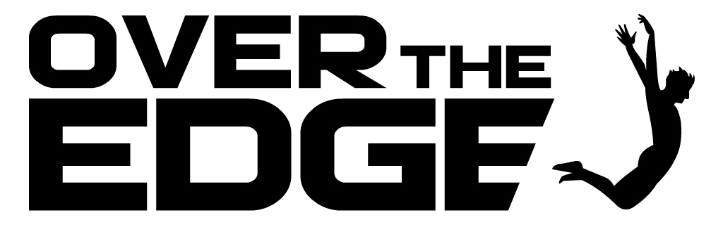

Competition judge: Niamh Boyce

Closing date: Wednesday, August 3rd , 2016

In 2016 Over The Edge is continuing its exciting annual international creative writing competition. Since its inception in 2007, it has grown to become one of the most important competition’s for emerging writers in Ireland and internationally. The competition is open to both poets and fiction writers worldwide. The total prize money is €1,000. The best fiction entry will win €300. The best poetry entry will win €300. One of these will then be chosen as the overall winner and will receive an additional €400, giving the overall winner total prize money of €700 and the title *Over The Edge New Writer of The Year 2016*. The 2016 Over The Edge New Writer of The Year will be a Featured Reader at Ireland’s leading literary reading series, the Over The Edge: Open Readings in Galway City Library, on a date to be scheduled in Winter 2016/17. [Salmon Poetry](http://scanmail.trustwave.com/?c=6600&d=uKvV1_C7H62XpQDu13p76LwimUA6_d2cjg2IFtQMoQ&s=380&u=http%3a%2f%2fwww%2esalmonpoetry%2ecom%2f) will read, without commitment to publish, a manuscript submitted to them by the winner in the poetry category. [Doire Press](http://scanmail.trustwave.com/?c=6600&d=uKvV1_C7H62XpQDu13p76LwimUA6_d2cjg3URoEK9g&s=380&u=http%3a%2f%2fwww%2edoirepress%2ecom%2fHOME%2ehtml) will read, without commitment to publish, a manuscript of short stories submitted to them by the winner in the fiction category. The overall winner will receive a hamper of books for the famous Kenny’s Bookshop of Galway, Ireland.The winner in the poetry category will have one of the poems from her or his winning entry published in the Spring 2017 issue of [*Skylight47*](http://scanmail.trustwave.com/?c=6600&d=uKvV1_C7H62XpQDu13p76LwimUA6_d2cjl2GR4cE8A&s=380&u=https%3a%2f%2fwww%2efacebook%2ecom%2fpages%2fSkylight-Poets%2f300308123389317) magazine.

 For all details and to enter see:

[www.overtheedgeliteraryevents.blogspot.com](http://scanmail.trustwave.com/?c=6600&d=uKvV1_C7H62XpQDu13p76LwimUA6_d2cjgeAR4EN8g&s=380&u=http%3a%2f%2fwww%2eovertheedgeliteraryevents%2eblogspot%2ecom)

**\_\_\_\_\_\_\_\_\_\_\_\_\_\_\_\_\_\_\_\_\_\_\_\_\_\_\_\_\_\_\_\_\_\_\_\_\_\_\_\_\_\_\_\_\_\_\_\_\_\_\_\_\_\_\_\_\_\_\_\_\_\_\_\_\_\_\_\_\_\_\_\_\_\_\_\_\_\_\_\_\_\_\_\_\_\_\_**

**Linen Hall Library – 2016 Michael McLaverty Short Story Award – closing Thursday 30th June**

The Linen Hall Library has announced the launch of the 2016 Michael McLaverty Short Story Award.

This prestigious award, which has run biennially since 2006, was set up to foster and encourage the tradition of the Irish short story.

Adjudicators for this year’s competition are Patsy Horton, Managing Editor of Northern Ireland’s Blackstaff Press, and multi award-winning writer David Park (The Big Snow, The Truth Commissioner, Gods and Angels).

Previous winners of the award have gone on to publish further works. Aiden O’Reilly (2008) has published Greetings, Hero, Michèle Forbes (2010) has published the acclaimed debut novel Ghost Moth, and Mandy Taggart (2012) has published The Man of the House.

Closing date for submissions: Thursday 30th June. For more information please visit [linenhall.com](https://www.linenhall.com/news/167)

**\_\_\_\_\_\_\_\_\_\_\_\_\_\_\_\_\_\_\_\_\_\_\_\_\_\_\_\_\_\_\_\_\_\_\_\_\_\_\_\_\_\_\_\_\_\_\_\_\_\_\_\_\_\_\_\_\_\_\_\_\_\_\_\_\_\_\_\_\_\_\_\_\_\_\_\_\_\_\_\_\_\_\_\_\_\_**

**Open Call | The McCann FitzGerald Law into Art Project**

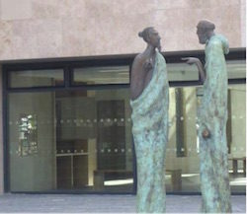

Deadline: June 24

UCD and McCann FitzGerald are inviting expressions of interest from artists who are interested in being considered for an exciting and prestigious art commission for the UCD Sutherland School of Law.

The commission is open to artists at all levels of experience. This will be a two stage commission process. For Stage 1, assessments will be made on previous work, artistic merit and evidence of ability to deliver projects. Shortlisted artists will then receive an honorarium to prepare proposals for Stage 2.

If you wish to be considered for this project please send a hard copy of your CV and images of previous work to:  
Ruth Ferguson – Curator  
UCD Newman House,  
86 St. Steph

en’s Green,  
Dublin 2.

**\_\_\_\_\_\_\_\_\_\_\_\_\_\_\_\_\_\_\_\_\_\_\_\_\_\_\_\_\_\_\_\_\_\_\_\_\_\_\_\_\_\_\_\_\_\_\_\_\_\_\_\_\_\_\_\_\_\_\_\_\_\_\_\_\_\_\_\_\_\_\_\_\_\_**

**Open Call for Exhibitions | Linenhall Arts Centre, Castlebar**



The Linenhall Arts Centre in Castlebar, Co. Mayo is inviting submissions from visual artists of all disciplines for its forthcoming exhibition programme. The Linenhall Arts Centre programmes a range of contemporary visual arts in a series of exhibitions throughout the year, from emerging artists to those of international reputation, and accepts submissions for exhibitions on an ongoing basis. Submissions are considered by the Linenhall’s Visual Arts Committee.

See [www.thelinenhall.com/exhibitions/exhibiting.php](http://www.thelinenhall.com/exhibitions/exhibiting.php) for further details and gallery plan.

The Linenhall Arts Centre, Linenhall Street, Castlebar, Co. Mayo, Ireland  
T: 094 902 3733  
E: [linenhall@anu.ie](mailto:linenhall@anu.ie)  
W: [thelinenhall.com](http://www.thelinenhall.com/)

**\_\_\_\_\_\_\_\_\_\_\_\_\_\_\_\_\_\_\_\_\_\_\_\_\_\_\_\_\_\_\_\_\_\_\_\_\_\_\_\_\_\_\_\_\_\_\_\_\_\_\_\_\_\_\_\_\_\_\_\_\_\_\_\_\_\_\_\_\_\_\_\_\_\_**

**Open Call | OpenART Biennial 2017, Sweden**

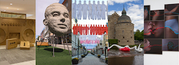

Deadline: 2 August

OpenART is Scandinavia’s biggest public art biennial and takes place in Örebro, Sweden. The city centre is filled with unexpected art that makes people feel happy, disturbed and provoked. Contemporary art from all over the world is showcased for almost three months in the city and offers unexpected encounters. The biennial challenges the visitors to rethink the perception of public space and our way of consuming and digesting art. The cultural exchange with the public is valued through several projects in connection to the exhibition like kids activities, a DIY art course and guided tours. OpenART 2017 will take place from 18 June to 10 September 2017.

Applications are made on the OpenART website, applicants must register and upload images directly at: [opencall.openart.se/Account/](https://opencall.openart.se/Account/Index?ReturnUrl=%2F)

You can enter 3 existing artworks or projects at most per application.  
The submission fee is 300 SEK (approx. €32).

Confirmed artists will receive an artist fee of €1000 (a confirmed group will share €1000), transport, travel and accommodation support. OpenART bears the cost for the transportation to and from the exhibition. In some cases OpenART also provides production support and in dialogue with the artist to find the most appropriate, time-efficient and cost-effective solutions. Artists are expected to participate in the installment of their own artworks. And are also invited to help fellow artists with production and installment on a voluntarily basis. All artists are invited to a set program on the opening weekend of OpenART 2017.

Please send your inquiries to [openart@orebro.se](mailto:openart@orebro.se)

**\_\_\_\_\_\_\_\_\_\_\_\_\_\_\_\_\_\_\_\_\_\_\_\_\_\_\_\_\_\_\_\_\_\_\_\_\_\_\_\_\_\_\_\_\_\_\_\_\_\_\_\_\_\_\_\_\_\_\_\_\_\_\_\_\_\_\_\_\_\_\_\_\_\_**

**Royal Ulster Academy 135th Annual Exhibition Open For Entries**

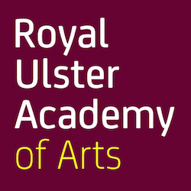

The Royal Ulster Academy 135th Annual Exhibition will take place at the Ulster Museum, Belfast from the 14 October 2016 to 8 January 2017. With over 81,000 visitors in 2015, this long standing event aims to expand contemporary approaches to the visual arts.

The Annual Exhibition showcases works by members of the Academy and works selected through open submission and by invitation.

Fees to enter are £15 per artwork for the first two works and £10 for the third work entered. Students are offered a reduced rate of £10 for the first two works entered and £7.50 for the third work. Your student number must appear on your online entry form for this reduction to apply.

Artists applying through the open submission process can enter a maximum of three works in any medium online, by 15th June 2016. From these entries the Selection Panel will draw up a shortlist of works for delivery to the Academy. The Annual Exhibition will be selected from these shortlisted works.

To enter please visit: [www.royalulsteracademy.org/annual-exhibition](http://www.royalulsteracademy.org/annual-exhibition)

Over £7,000 in prize money will be awarded to exhibiting artists of merit. Independent adjudicator Christopher Le Brun PRA, will select recipients of the Academy’s gold, silver and bronze medal prizes. All other prizes will be awarded by the prize sponsors.

**\_\_\_\_\_\_\_\_\_\_\_\_\_\_\_\_\_\_\_\_\_\_\_\_\_\_\_\_\_\_\_\_\_\_\_\_\_\_\_\_\_\_\_\_\_\_\_\_\_\_\_\_\_\_\_\_\_\_\_\_\_\_\_\_\_\_\_\_\_\_\_\_\_\_**

**Hennessy Portrait Prize 2016 l National Gallery of Ireland**

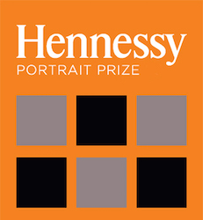

Deadline: 29 July

Application forms for the 2016 competition are now available to download, all submissions must be made online. The Hennessy Portrait Prize is open to artists across all disciplines and aims to encourage interest in contemporary portraiture and raise the profile of the National Portrait Collection. The winner will be announced in November and will once again receive a prize of €15,000 and a commission worth €5,000 to produce a portrait for inclusion in the National Portrait Collection.

For rules and application forms see: [**www.nationalgallery.ie/**](http://www.nationalgallery.ie/en/aboutus/ThisWeek/Hennessy_Portrait_Prize.aspx)

National Gallery of Ireland, Clare Street, Dublin 2

E: [**info@ngi.ie**](mailto:info@ngi.ie)  
T: (01) 661 5133

**Open Call | Emerging Irish Artist Residency Award 2016 | Burren College of Art**

Deadline: 4 July, 5pm

Burren College of Art is inviting artists to submit applications for the Emerging Irish Artist Residency Award 2016. We are looking for recent graduates and emerging artists who are highly motivated and would like the opportunity to receive the following:

• A large artist’s studio for the month of October 2016 with access to all college facilities.  
• Exhibit work in a group show in two venues: BCA Gallery/ 126 Artist-Run Gallery, Galway  
• Opportunity to present a lecture and engage with the College community at BCA.

Applications are welcome from artists working in any medium including: Painting, Drawing, Sculpture, Photography, Performance Art and New Media.

Four selected artists will receive a free one-month residency, including individual studio space and access to all college facilities for October 2016. They will curate and organise a group show based on their time in the Burren and their shared experience, which will be held in the BCA Gallery in 2017 and will travel to 126 Gallery in Galway. Suitable candidates also have the opportunity to present a lecture at the College and engage with students and the broader College community.

There is a €5 submission fee, to cover administration costs. If selected, artists must be willing to pay a one-off fee of €150 to cover housing and utilities costs in Ballyvaughan for one month, and are responsible for covering their own food and material costs.

Selection process by a committee from Burren College of Art and 126 Gallery will take place in July, with successful applicants notified by August 1st.

Residency will take place from October 3rd-28th 2016. Exhibition will take place in BCA & 126 Gallery in Spring 2017.

To submit your application please visit:  
[**www.burrencollege.ie/art/emerging-irish-artist-residency-award-2016**](http://www.burrencollege.ie/art/emerging-irish-artist-residency-award-2016)

*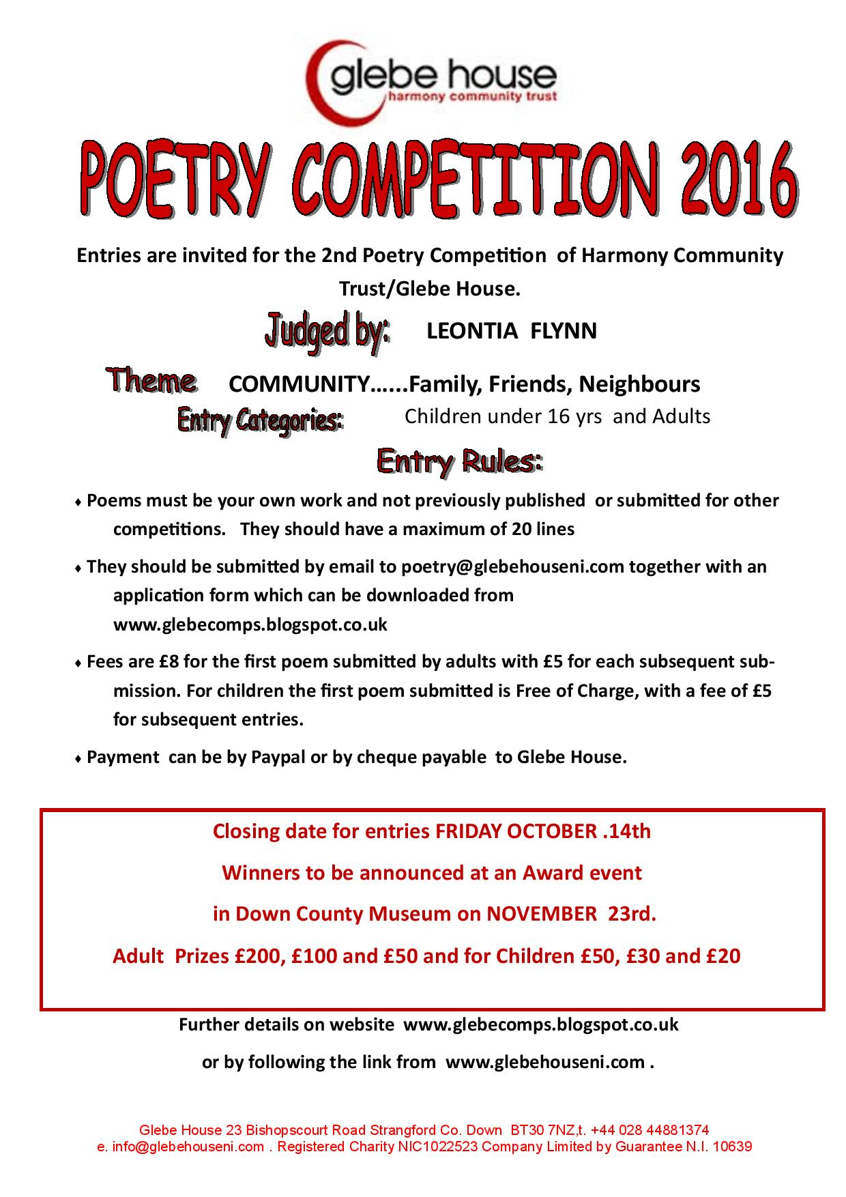*

**Awards / Bursaries / Schemes**

**Arts Council of Ireland: Upcoming Funding Deadlines**

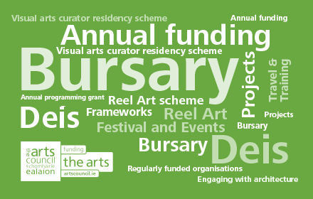

<http://www.artscouncil.ie>

|  |  |  |
| --- | --- | --- |
| Application deadline  **Ongoing** | [**Dámhachtain sparánachta litríochta**](http://www.artscouncil.ie/Funds/Damhachtain-sparanachta-litriochta/)  Dámhachtain sparánachta litríochta | Maximum award **€0**  [**Accepting applications**](http://www.artscouncil.ie/Funds/Damhachtain-sparanachta-litriochta/) |
| Application deadline  **Ongoing** | [**Travel and Training award**](http://www.artscouncil.ie/Funds/Travel-and-Training-award/)  Please note maximum amount awarded differs between artforms. There are three strands to this award: Travel and Training Outbound; Travel and Training Inbound; Creative Europe (Culture sub-programme) Travel Award. | Maximum award **€3,000**  [**Accepting applications**](http://www.artscouncil.ie/Funds/Travel-and-Training-award/) |
| Application deadline  **Ongoing** | [**Visual artists in prisons scheme**](http://www.artscouncil.ie/funds/Visual-artists-in-prisons-scheme/)  The scheme allows artists to work with prisoners in prison/ detention centres for a period of 10 days and complements an existing arts and education programme in the Education Units within the prison system. | Maximum award **€2,400**  [**Accepting applications**](http://www.artscouncil.ie/funds/Visual-artists-in-prisons-scheme/) |
| Application deadline  **Ongoing** | [**Writers in prisons scheme**](http://www.artscouncil.ie/funds/Writers-in-prisons-scheme/)  The scheme offers writers the opportunity to work with prisoners in prison/detention centres and complements an existing arts and education programme in the Education Units within the prison system. | Maximum award **€1,000**  [**Accepting applications**](http://www.artscouncil.ie/funds/Writers-in-prisons-scheme/) |
| Application deadline  **Ongoing** | [**Writers in schools scheme**](http://www.artscouncil.ie/funds/Writers-in-schools-scheme/)  The Writers in Schools Scheme part-funds visits by writers and storytellers to schools throughout the island of Ireland. | Maximum award **€200**  [**Accepting applications**](http://www.artscouncil.ie/funds/Writers-in-schools-scheme/) |

**\_\_\_\_\_\_\_\_\_\_\_\_\_\_\_\_\_\_\_\_\_\_\_\_\_\_\_\_\_\_\_\_\_\_\_\_\_\_\_\_\_\_\_\_\_\_\_\_\_\_\_\_\_\_\_\_\_\_\_\_\_\_\_\_\_\_\_\_\_\_\_\_\_\_\_\_\_\_\_\_\_\_\_\_\_**

**Belltable and Fishamble: Open Call for Applications for Mentoring Programme for Playwrights and Directors**

|  |
| --- |
| http://newsletter.artscouncil.ie/nwstatic/spacer.gif |

As part of the artist development initiative Belltable:Connect, Belltable and Fishamble: The New Play Company have come together to offer a 10-month mentoring programme for playwrights and directors. The initiative is intended to support the development of emerging and established playwrights and directors, who would benefit from an ongoing mentoring process to investigate and enhance their practice.

For more information and to download application forms see <https://www.limetreetheatre.ie/special-announcements/>

Closing date for receipt of applications is strictly 1 July 2016 at 5pm.

**\_\_\_\_\_\_\_\_\_\_\_\_\_\_\_\_\_\_\_\_\_\_\_\_\_\_\_\_\_\_\_\_\_\_\_\_\_\_\_\_\_\_\_\_\_\_\_\_\_\_\_\_\_\_\_\_\_\_\_\_\_\_\_\_\_\_\_\_\_\_\_\_\_\_\_\_\_\_\_\_\_\_\_\_\_\_**

# Tyrone Guthrie Centre – Film Maker Bursary

**This bursary is intended to benefit young/emerging practitioners in the area of filmmaking and scriptwriting thereby nurturing new talent in the sector.**

The film bursary will entitle the successful applicant to progress work in-hand or to develop new proposals over a two-week residency period with accommodation provided in the Big House.

The film bursary is also available for two people who are collaborating on a project together. In the case of a collaborative proposal the bursary is available for a one-week period.

**To apply for the Film Maker bursary please complete the standard** [**online application**](http://www.tyroneguthrie.ie/apply/form)**, outlining your proposal and rationale for this specific award in the “Proposal” section by Friday 24th June.**

<http://www.tyroneguthrie.ie/apply/form>

**Of Interest**

**NEW! What Next? | Weekly NCFA Meeting | Wednesday 22 June**

The next NCFA meeting to discuss ways in which to move the campaign forward will take place on Wednesday 22nd of June at 8.30am to 10am. The meeting is open to cultural practitioners from all disciplines and supporters of the arts.

Location: VAI, 7-9 Central Hotel Chambers, Dame Court, Dublin 2

**Discussed at meeting on 15 June:**

Public Engagement:

* How the campaign can galvanise the support of the public to communicate the value of our culture to government and connect across cultural disciplines.
* Open discussion about plans for the coming weeks and months.

Political Updates:

* NCFA Constituency reps have been meeting with TD’s in their regions and it is having an impact.
* On Tuesday 14 June, NCFA met with Brendan Howlin, Joan Burton and Kevin Humphreys. Following this, Mr. Howlin has since secured the agreement of the Taoiseach that the draft cultural strategy (Culture 2025) will be referred to the Oireachtas Committee for debate and amendment prior to finalisation.
* Fianna Fail have put forward a motion on Arts to be discussed in the Dail next Tuesday evening (21/06)

**About NCFA:**  
Established in 2009 as a response to the McCarthy Report, The National Campaign for the Arts is a nationwide, volunteer-led, grass roots movement that makes the case for the Arts in Ireland. The NCFA’s pre-election manifesto included calls on the government to:

* Commit to increasing annual investment in Arts and Culture to 0.3% of GDP, taking us half way to the European average
* Publish the cultural policy document Culture 2025 in draft form for interrogation by the Oireachtas Arts Committee.
* Maintain on an annual basis, the €50 million allocated to the Department of Arts for 2016 commemorations, and ring-fence it for The Arts Council and The Irish Film Board.
* Implement tax efficiencies/strategies to stimulate corporate and philanthropic giving
* Create a new Arts fund from National Lottery funds.
* Appoint an expert panel of Artists/Cultural Managers to function as Policy and Strategy Advisors to the Minister and the Department.

**\_\_\_\_\_\_\_\_\_\_\_\_\_\_\_\_\_\_\_\_\_\_\_\_\_\_\_\_\_\_\_\_\_\_\_\_\_\_\_\_\_\_\_\_\_\_\_\_\_\_\_\_\_\_\_\_\_\_\_\_\_\_\_\_\_\_\_\_\_\_\_\_\_\_\_\_\_\_\_\_\_\_\_\_\_\_\_**

**NEW! Taoiseach Commits to Bring Culture 2025 to the Oireachtas for Debate and Finalisation**

Taoiseach Enda Kenny commits to bring the draft national cultural strategy (Culture 2025) to the Oireachtas Arts Committee for discussion and finalisation, having been raised on the Order of Business by Labour leader Brendan Howlin. It is vital that the final strategy is backed up by long-term funding commitments.

A debate on the arts will take place in the Dáil on Tuesday 21 June. This is on foot of a Fianna Fáil motion tabled by Arts spokesperson Niamh Smyth to put the arts centre stage.

These actions are the result of increased lobbying of government from the arts community, representative bodies, media and the National Campaign for the Arts in recent weeks. The NCFA will be meeting with party leaders Catherine Murphy (Social Democrats), Gerry Adams (Sinn Féin) and Mícheál Martin (Fianna Fáil) to continue to make the case for the arts and culture over the coming week.

[**ncfa.ie**](http://scanmail.trustwave.com/?c=6600&d=tMPh14YpATtUHjBOn-g1kRfLlHfFfLCxISiSe5vtYg&s=380&u=http%3a%2f%2fvisualartists%2eus9%2elist-manage1%2ecom%2ftrack%2fclick%3fu%3de67e46c7b14e756132f46a50c%26id%3dea8ce98e65%26e%3d1968c52731)

**\_\_\_\_\_\_\_\_\_\_\_\_\_\_\_\_\_\_\_\_\_\_\_\_\_\_\_\_\_\_\_\_\_\_\_\_\_\_\_\_\_\_\_\_\_\_\_\_\_\_\_\_\_\_\_\_\_\_\_\_\_\_\_\_\_\_\_\_\_\_\_\_\_\_\_\_\_\_\_\_\_\_\_\_\_\_**

**NEW! The 2016 New Generation Gallery is now live!**

The New Generation Gallery in association with New Ireland Assurance brings together the work of graduating art and design students from undergraduate and postgraduate programmes in colleges around Ireland.

The 2016 New Generation Gallery is a unique showcase for emerging artists and includes more than 1,000 artworks by graduating students in painting, fashion, ceramics, design, print, sculpture, animation, photography, architecture, and visual communication.

The New Generation Gallery is a free resource for art students. [Click here](http://www.irishartsreview.com/new-generation-artists-online-gallery/?utm_source=Newsletter&utm_campaign=aca1e6eaea-November_Newsletter11_20_2015&utm_medium=email&utm_term=0_957c7d0768-aca1e6eaea-182886677#shipping-restrictions) for registration details. Queries to Aoife Carolan [aoife@irishartsreview.com](mailto:aoife@irishartsreview.com).

<http://www.irishartsreview.com/new-generation-artists-online-gallery/>