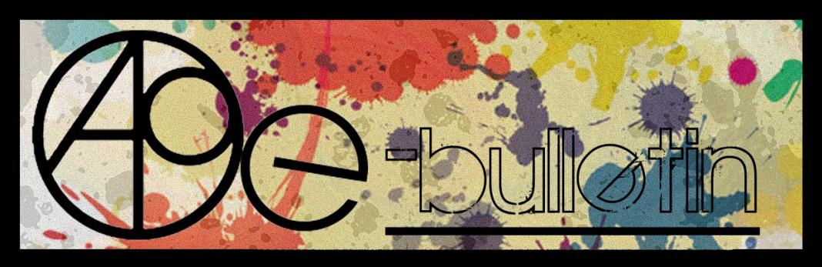

**Kilkenny County Council Arts Office E-bulletin 1st July 2016**

Dear All,   
  
Welcome to the fortnightly e-bulletin from Kilkenny County Council's Arts Office. Each bulletin is packed with the latest information on Kilkenny Arts Office activities, county events as well as news and opportunities for arts practitioners from around the country.

This service will be provided fortnightly. To include an item in the next e-bulletin please send a brief outline of your advert with relevant contact details, including any websites or pages with links to [**niamh.brophy@kilkennycoco.ie**](mailto:niamh.brophy@kilkennycoco.ie) **before 13th July.** The next e-bulletin will be on the **15th July.**

While every effort has been made to ensure the accuracy of our information, we strongly advise readers to verify all details to their own satisfaction.

Regards,

**Niamh Brophy, Arts Administrator**

Arts Office LogoWithText01

5 Dean Street, Kilkenny

T: (056) 7794138

E: [niamh.brophy@kilkennycoco.ie](niamh.brophy@kilkennycoco.ie%20)

W: <www.kilkennycoco.ie/eng/Services/Arts>

[Facebook](https://www.facebook.com/KilkennyArtsOffice/) [twitter](https://twitter.com/kkartsoffice)

[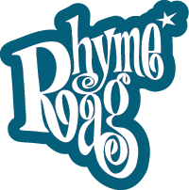](http://www.rhymerag.net/) [Facebook](https://www.facebook.com/KilkennyArtsOffice/) 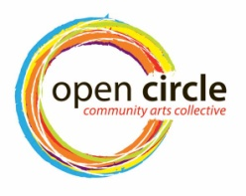 [Facebook](https://www.facebook.com/KilkennyArtsOffice/) [twitter](https://twitter.com/kkartsoffice) [](http://www.artlinks.ie/) [Facebook](https://www.facebook.com/KilkennyArtsOffice/)

<www.rhymerag.net> <https://opencirclearts.ie/> [www.artlinks.ie](http://www.artlinks.ie)

**Kilkenny County Council Cultural Services -**

**Creating and Sustaining Great Communities and Places**

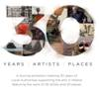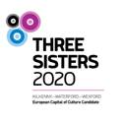 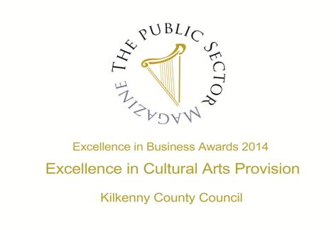

**Arts Office**

* **NEW!** ‘Unfold’ an exhibition by Open Circle Arts
* **SEWCIALISING Workshops with Open Circle – limited spaces so book now!**

**Kilkenny Events**

* **NEW!** Blackstack Studio Manager Position
* **NEW!** Alternative Arts Kilkenny
* **NEW!** Life Drawing Summer Classes
* **NEW!** KCAT enrolling for 2016 / 2017
* **NEW!** Kevin Lawlor's 'Jazz From Now'
* **NEW!** Devious Theatre’s ‘The Hellfire Squad’
* **NEW!** Pipers Union at The Set
* **NEW!** [Waterford Healing Arts Trust](https://www.facebook.com/waterfordhealing.artstrust/?fref=nf) welcomes Caroline Schofield
* **NEW!** L’Arche Kilkenny: Community Leader / Service Manager
* **NEW!** Camphill Callan: House Co-ordinator
* **NEW!** Kilkenny Arts Festival - Extra Footsbarn Show Announced!

# ****NEW!** Cob Building**

# ****NEW!** Ruth Egan exhibition**

# **Mandala Workshop with Alice Bennett at Blackwatch Studio**

# **Polymer Clay Workshop at Blackwatch Studio, Co. Kilkenny**

* ‘Just for Men’ Art and Sculpture Course

# Cliona Harmey: Block and Receive at the Butler Gallery

* Shoeniversity Summer Shoemaking Courses, Castlecomer
* LESSAC Voice Training
* ‘Famous Faces’ – a retrospective exhibition of the work of Francis Casey, at KCAT
* Inguna Mainule Finnerty exhibition at Castlecomer Library
* ‘From the Forest’ Book Launch and Exhibition of Woodcarvings
* Call For Participants’: Kilkenny Libraries Poetry Reading Event October 2016
* Municipal District of Kilkenny City - East & West Streetscape Paint Scheme 2016
* Ballykeeffe Amphitheatre in Kilmanagh, the only amphitheatre in Ireland, has launched its exciting programme of events for summer 2016
* Outdoor Cinema at Kilkenny Castle
* National Craft Gallery News
* **Paper Making and Textile Art Courses at KOZO Studio, Kilkenny**

**Courses / Training / Jobs / Internships**

### NEW! Arts Council Information Clinic and Mindshift: The Business of Writing Applications

* **NEW!** [Physical Theatre & Mask Technique Master Class with Boom Circus (US)](http://www.isacs.ie/physical-theatre-and-mask-technique-master-class-with-boom-circus-us/)
* **NEW! Adult Continuing Education in European Art History at UCC, Cork**
* **NEW!** Irish Film Institute – Press and Marketing Manager
* NYCI Certificate in Youth Arts 2016/2017
* **Call for Volunteers | PhotoIreland Festival 2016**

**Call for Submissions / Residencies / Public Art**

* **NEW!** RTÉ’s new TV programme Painting The Nation – Call for Applications
* **NEW! Fingal County Council Graduate Award 2016 in Partnership with Block T**
* **NEW! D.I.V.A. Collaborative Art Project at Electric Picnic 2016**
* **NEW! Open Call for Exhibitions and Studios Membership | Custom House Studios 2017/18**
* **NEW! Open Call for Emerging Artists | BLOOOM Awards 2016, Germany**
* **NEW! Accepting Applications for VAI / DAS Residency Award 2016**
* **NEW! Open Call for Exhibition Programme 2017, The Séamus Ennis Arts Centre, Co. Dublin**
* **The Sean O Faolain International Short Story Award**
* **Per Cent for Art Commission | St. Raphael’s College, Loughrea, Co. Galway**
* 2016 Over The Edge New Writer of The Year competition
* Open Call | OpenART Biennial 2017, Sweden
* Hennessy Portrait Prize 2016 l National Gallery of Ireland

**Awards / Bursaries / Schemes**

* **NEW! Arts Council Funding**

**Of Interest**

* **NEW!** ‘SILENT MOVES’ short-listed for Modern Ireland in 100 Artworks
* **NEW!** ‘Road, Rail and Rebellion’ Seminar
* **NEW! Visual Artists Ireland advises an extra 48 Million Euro is possible for the Arts**
* **NEW! Government announce change of Department title**
* **NEW!** The Possibilities of Place | 9 Stones Artists’ 10 Year Exhibition at Visual Carlow
* **NEW!** What Next? | Weekly meeting next Wednesday 29 June, 8.30am

**Arts Office**

**NEW! ‘Unfold’ an exhibition by Open Circle Arts**

**Free event**

**Launch 6th August 12pm   |   Open Circle House, High Hayes, Johns Green, Kilkenny**

**Open hours – 12pm – 5pm, 6th – 14th August**

Open Circle Arts is a community arts project providing social spaces for learning and creating. Our mission is to inspire interest and maximum participation in the arts for Kilkenny women. We are committed to offering programs that are characterised by quality Kilkenny women. We are committed to offering programs that are characterised by quality arts learning experiences and inspiring arts participatory engagements. arts learning experiences and inspiring arts participatory engagements.

[www.opencirclearts.ie](http://www.opencirclearts.ie)

**\_\_\_\_\_\_\_\_\_\_\_\_\_\_\_\_\_\_\_\_\_\_\_\_\_\_\_\_\_\_\_\_\_\_\_\_\_\_\_\_\_\_\_\_\_\_\_\_\_\_\_\_\_\_\_\_\_\_\_\_\_\_\_\_\_\_\_\_\_\_\_\_\_\_\_\_\_\_\_\_\_\_\_\_\_\_**

**SEWCIALISING Workshops with Open Circle – limited spaces so book now!**

**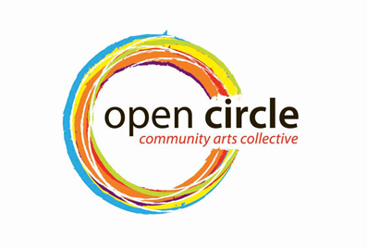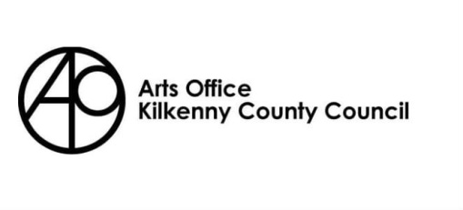**

**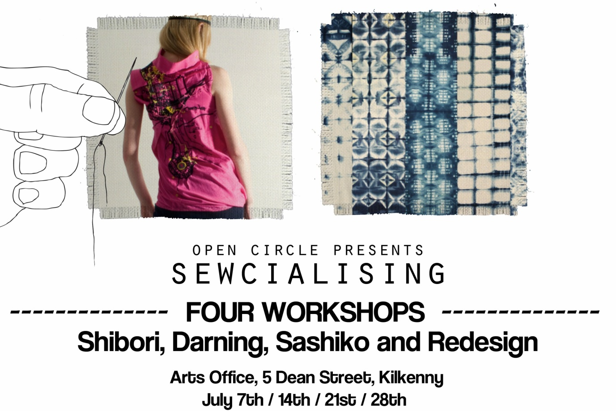**

Open Circle Arts is once again running an exciting summer outreach programme. The Sewcialising Project will investigate our relationship with our clothes. It aims to open up discussions about the clothes we choose to wear, where they come from and where they end up. The series of workshops running through the month of July will explore the (re) making of clothing through re-designing, repairing and mending. Boro is the Japanese art of mending textiles, which celebrates the visible repair of clothing. The first workshop will involve you in using the embroidery technique of Sashiko, teaching you how to repair your denim clothing. Our second workshop will explore traditional wool darning techniques investigating the care involved in mending. Week four will see you redesigning a shirt. Just bring along an old cotton shirt in need of some TLC and learn how to repurpose your shirt for the construction of a new item of clothing. Finally you will learn the basic techniques and patterns for dying your garments using the traditional art of Shibori.

By re-claiming material from worn and discarded garments, the very fibres are charged with meaning, they are saturated with the traces of everyday life; through wear and tear.  Can discarded garments reflect our history, becoming actual material memories of times past, love lost or found, disappointments endured or victories won? These garments could then be read as a guide to our past, reconstructed and brought back to life. Central to this discussion is the value we place on these everyday items. Each workshop is designed to explore the ways in which we can extend the life of these garments to keep them in active service.

**PLACES ARE LIMITED and BOOKING IS ESSENTIAL, EARLY BOOKING ADVISED**

**Venue: Kilkenny Arts Office, no. 5 Dean Street**

**Dates: July 7th /14th /21st /28th**

**Times: 10.30am – 12.30am OR 7pm – 9pm**

**Cost: €30 for all four workshops**

**For more information and booking:** [**sewcialisingproject@gmail.com**](mailto:sewcialisingproject@gmail.com) **or call Dee on 087 652 8448**

Please see the Open Circle Arts website [**www.opencirclearts.ie**](http://www.opencirclearts.ie) for further information on this and other programs. Visit and Like our Facebook pages Open Circle Arts / Kilkenny Arts Office

Open Circle Arts is a Kilkenny Arts Office programme. The Arts Office acknowledges the support of the Arts Council, Carlow Kilkenny ETB and Kilkenny County Council’s Waste Prevention Programme.

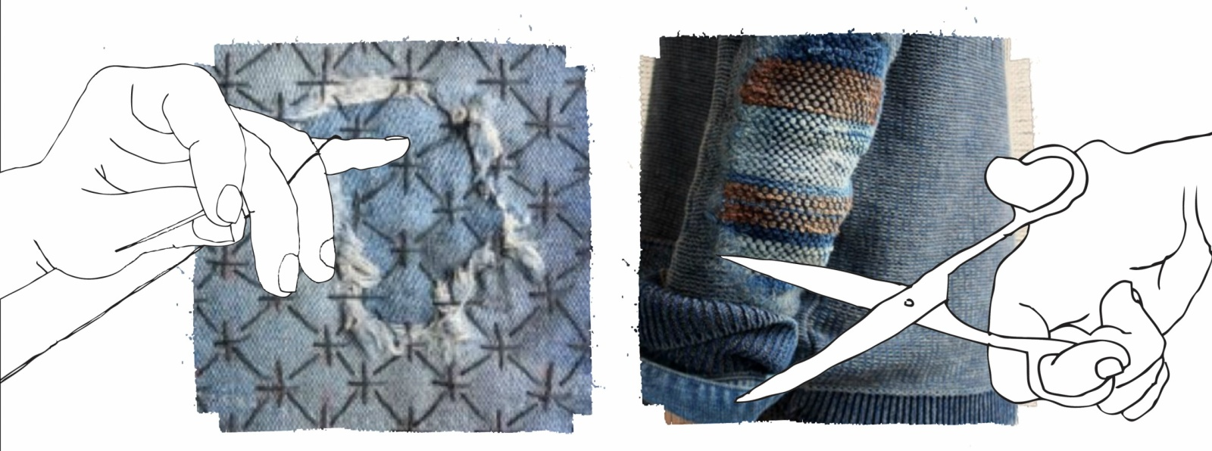

**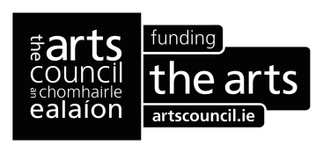**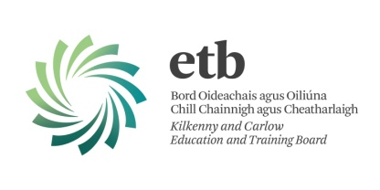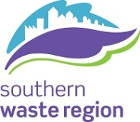

**Kilkenny Events**

**NEW!** **Blackstack Studio Manager Position**



Blackstack Studio, situated in the heart of Kilkenny city, aims to promote the art of printmaking and support artists by providing intaglio and screen print facilities in the southeast. Part of a growing network of green studios worldwide, we use environmentally sustainable printmaking methods. We also provide outreach and education programmes such as workshops, lectures and demonstrations bringing the art of printmaking into the heart of the community.

Blackstack Studio is now looking to appoint a confident and self-motivated person to become our Studio Manager. The successful individual will be responsible for managing the day to day running of Blackstack Studio, reporting directly to the Board via weekly updates and regular meetings. An ability to work independently, excellent administration and organisation skills and creative thinking are essential in this role and applicants must also be able to demonstrate the following:

* Experience in the visual arts, preferably in an arts administration role or work within an arts organisation
* Developing new opportunities, projects and initiatives for Blackstack Studio in conjunction with the Board
* Experience in dealing with funding applications
* Ability to find and create opportunities to promote Blackstack Studio via its website, press releases and on social media, and where applicable to provide press releases and other related content
* Ability to engage with individuals and groups to foster new links, collaborations and exchanges
* Excellent spoken and written communication skills

Knowledge of print and print processes is preferred but not essential.

This is a 12 month contract, 6 hours/week minimum although the successful applicant will be expected to work longer hours at busy periods as necessary. The applicant will be based in Kilkenny Arts Office and Blackstack Studio. All applicants must have their own transport and a full driving licence. In return we offer an excellent remuneration, based on experience, together with a phone allowance and laptop.

To apply:

Application is by email **only**. Please send CV and covering letter to dawn@blackstackstudio.com

Deadline for applications is 5pm on Friday 22 July, 2016.

All successful applicants will be required to interview at Blackstack Studio in Kilkenny.

**\_\_\_\_\_\_\_\_\_\_\_\_\_\_\_\_\_\_\_\_\_\_\_\_\_\_\_\_\_\_\_\_\_\_\_\_\_\_\_\_\_\_\_\_\_\_\_\_\_\_\_\_\_\_\_\_\_\_\_\_\_\_\_\_\_\_\_\_\_\_\_\_\_\_\_\_\_\_\_\_\_\_\_\_\_\_\_**

**NEW! Alternative Arts Kilkenny**

[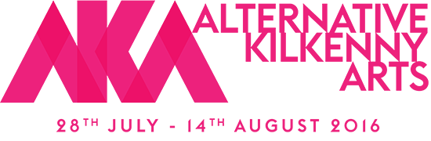](http://akafringe.com/)

Alternative Kilkenny Arts (AKA) is a collaboration of people living in Kilkenny who have an interest in or practice within the arts around the City and County. Alternative Kilkenny Arts Fringe Festival provides a great opportunity for many not involved in the main programme to exhibit, perform, recite and activate their work around the City during the Festival. There has from time to time been a tradition of an informal fringe programme to compliment the main festival. But it has been inconsistent. AKA is endeavouring to bring together these strands under a single programme to promote a diverse range of artistic and creative talent, offer a platform and to raise awareness to patrons of the festival that all of this is going on in our City; all of the time!

In the limited time and within the limited resources we had to put this together, we regret that much of the visual arts strand and many other events are not listed here. It would simply be impossible to cover it all.  It is our hope that in exploring our lovely little City that you will wander in to many of the wonderful exhibitions that cram every available wall space in the City and even on our Mayor’s Walk.

We are most grateful to all who have given of their time, shared their skills and donated hard cash to bring this programme together. A big thanks to Karol Ryan for his graphic design work and to all the artists, musicians, creators, practitioners and misfits who make Kilkenny such a unique melting pot of creativity. Most of all we hope that you will go out and shop local and buy and support Alternative Kilkenny Arts! Enjoy the Festival!

There is no committee as such, but these people helped putting stuff together for what we hope will be the first of many AKA’S. It’s open to everyone and very inclusive so get involved! Willie Meighan, Malcolm Noonan, Karol Ryan, Nicci St George Smith, Arthur Drohan, Niamh Moroney, Cathal McFarlane, Ciaran O Neill, Johnny Keenan, Ann Mulrooney, Mary Butler, Dermot Agnew…

<http://akafringe.com/>

**\_\_\_\_\_\_\_\_\_\_\_\_\_\_\_\_\_\_\_\_\_\_\_\_\_\_\_\_\_\_\_\_\_\_\_\_\_\_\_\_\_\_\_\_\_\_\_\_\_\_\_\_\_\_\_\_\_\_\_\_\_\_\_\_\_\_\_\_\_\_\_\_\_\_\_\_\_\_\_\_\_\_\_\_\_\_\_**

**NEW! Life Drawing Summer Classes**

**15-17th July 2016** **at Grennan Mill Craft School, Thomastown, Kilkenny**

It is a great oppotunity to learn how to draw a Life Model using the laws of proportions, perspective and tone. Participants are going to use different technical tools as well as experimenting with different medias and drawing apporaches in order to develop their observational and technical skills.

**The course is suitable for total beginners as well as for people with some experience and advanced.**

Tutoring is adjusted to individual's level of experience on one to one teaching basis.  
We will be covering: basic composition on a paper, proportions, measuring, linear and tonal drawing, portrait, foreshortening, quick sketching and long poses.

**Cost of the course is € 270**, paper& charcoal provided.

Classes start 10:00 till 5pm with an one hour break for lunch.

**Contact number: 056 772 45 57** (Grennan Mill Craft School)

or **083 1819 775** (Drawing Tutor, Polona Simonic)

Please sign up till 4th of July.

**\_\_\_\_\_\_\_\_\_\_\_\_\_\_\_\_\_\_\_\_\_\_\_\_\_\_\_\_\_\_\_\_\_\_\_\_\_\_\_\_\_\_\_\_\_\_\_\_\_\_\_\_\_\_\_\_\_\_\_\_\_\_\_\_\_\_\_\_\_\_\_\_\_\_\_\_\_\_\_\_\_\_\_\_\_\_\_**

**NEW!**

**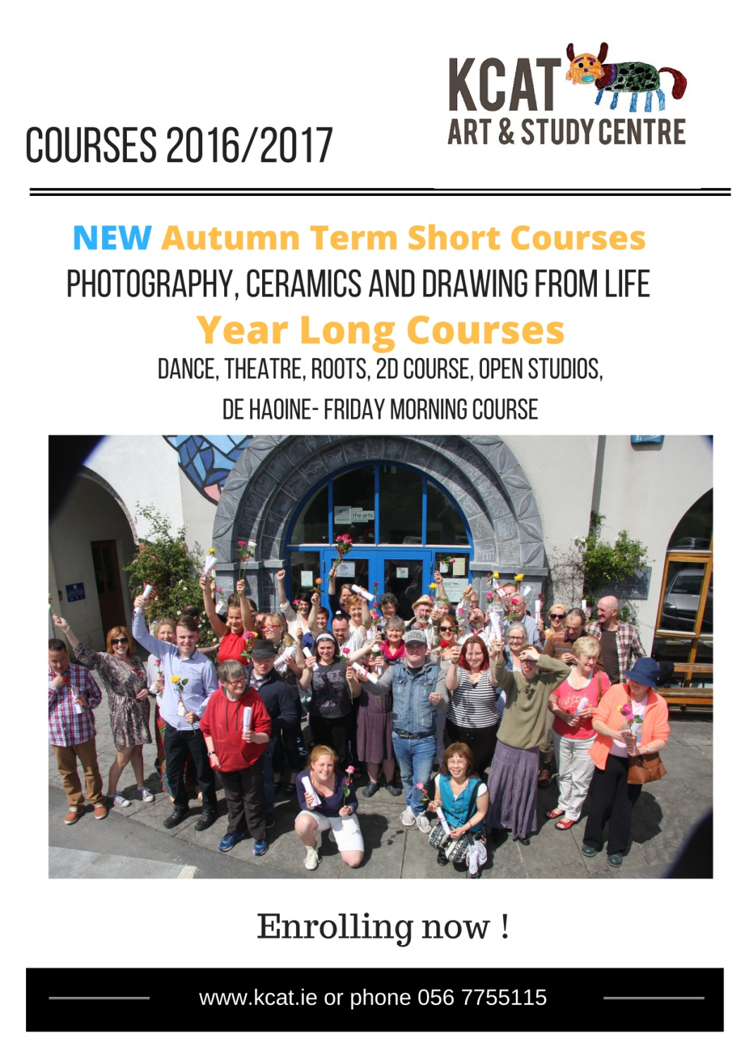**

**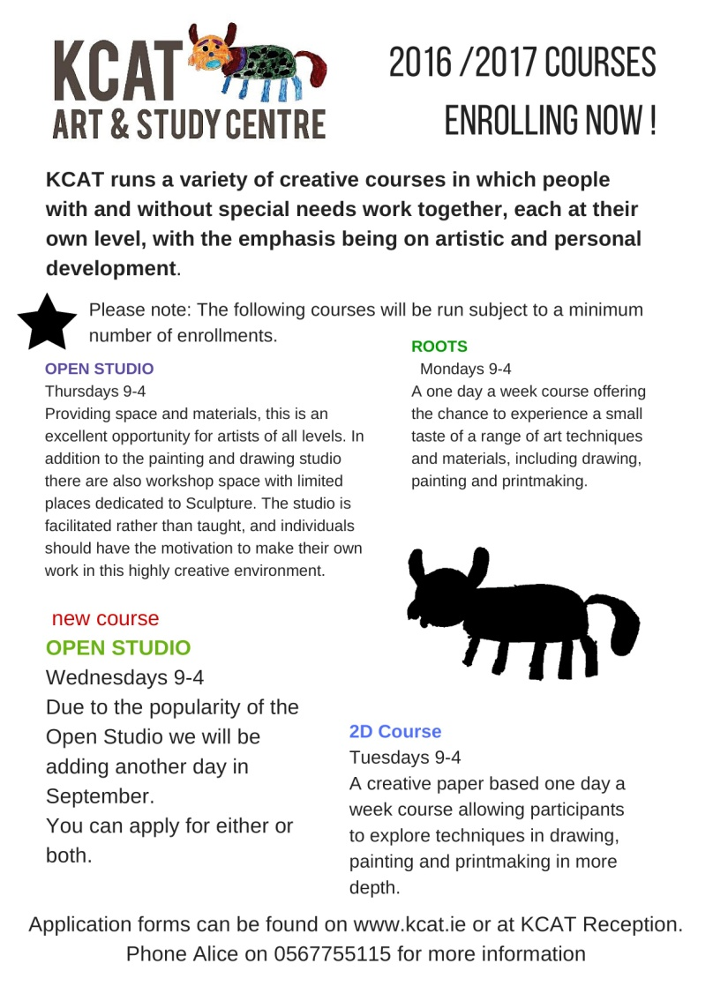**

**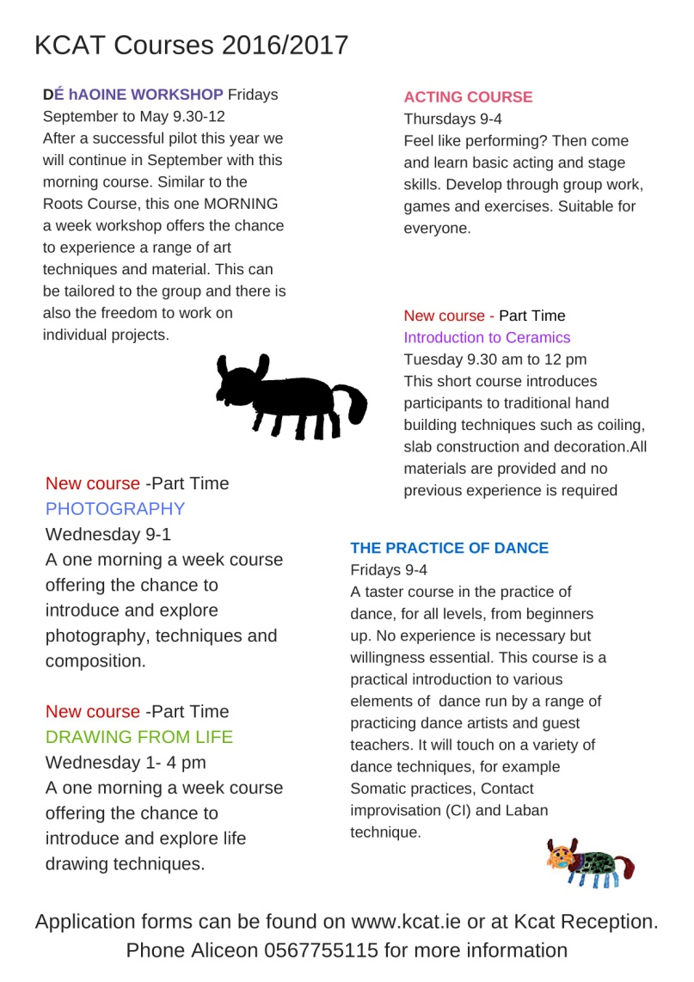**

**\_\_\_\_\_\_\_\_\_\_\_\_\_\_\_\_\_\_\_\_\_\_\_\_\_\_\_\_\_\_\_\_\_\_\_\_\_\_\_\_\_\_\_\_\_\_\_\_\_\_\_\_\_\_\_\_\_\_\_\_\_\_\_\_\_\_\_\_\_\_\_\_\_\_\_**

**NEW!** **Kevin Lawlor's 'Jazz From Now'**

Jazz drummer Kevin Lawlor leads a group of musicians from Wexfordand Kilkenny to perform jazz music from the 21st Century. The recent use of improvising musicians from the jazz scene on David Bowie's Blackstar has shone a light on modern music coming from jazz influences.

Expect to hear exciting music from Bad Plus, GoGo Penguin, Joshua Redman and many more of this century's leading jazz musicians. This performance is supported by the Three Sisters Capital of Culture

Campaign representing Jazz in the Three Sisters region.

**Friday 1st July // Hole in the Wall // Tickets €10 or €8 conc.**  
[https://www.youtube.com/watch?v=OszUB-PghQA](http://scanmail.trustwave.com/?c=6600&d=6uDp13XtWD04xLu85vo5ZXCutCyoL4TD0flpooIQCg&s=380&u=https%3a%2f%2fwww%2eyoutube%2ecom%2fwatch%3fv%3dOszUB-PghQA)  
  
Kevin Lawlor - drums   
Pat Molitor - piano & keys  
Adam Nolan - saxophone   
Steve Tierney - bass

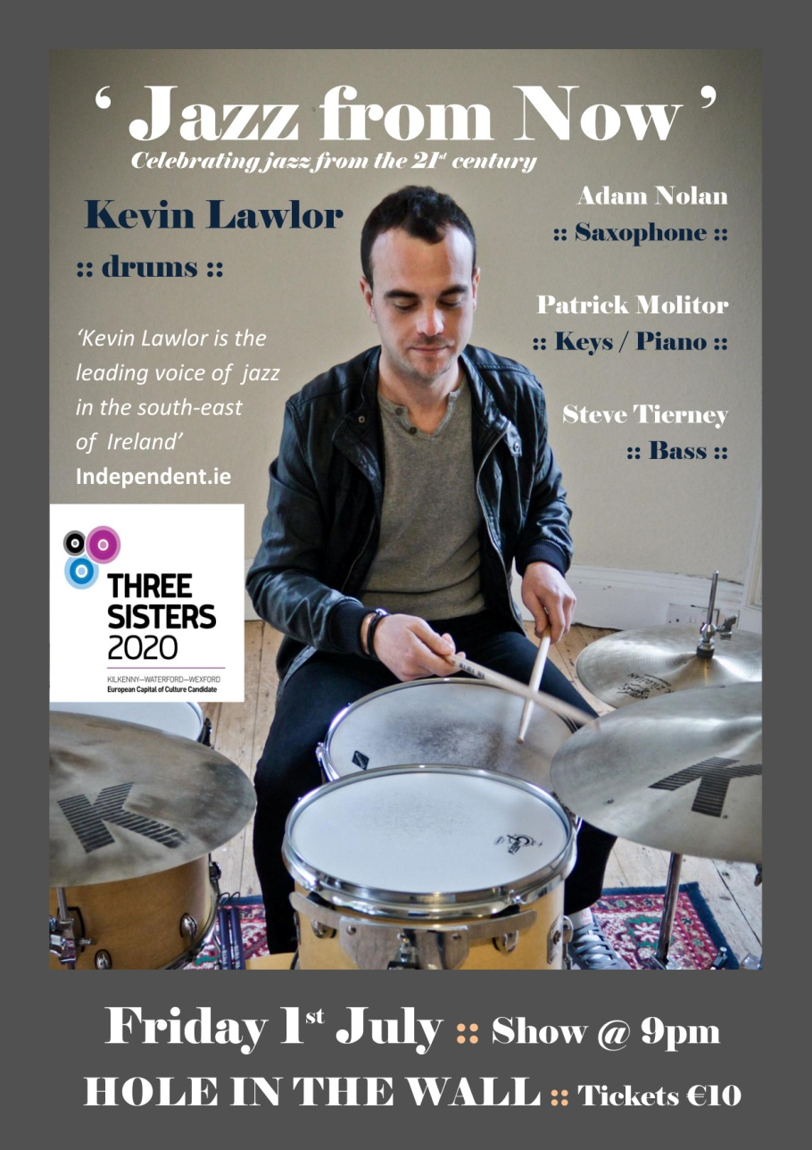

**\_\_\_\_\_\_\_\_\_\_\_\_\_\_\_\_\_\_\_\_\_\_\_\_\_\_\_\_\_\_\_\_\_\_\_\_\_\_\_\_\_\_\_\_\_\_\_\_\_\_\_\_\_\_\_\_\_\_\_\_\_\_\_\_\_\_\_\_\_\_\_\_\_\_\_\_\_\_\_\_\_\_\_\_\_\_**

**NEW!**

**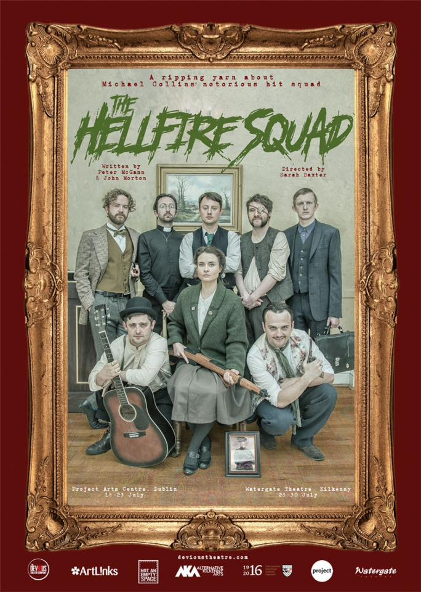**

**\_\_\_\_\_\_\_\_\_\_\_\_\_\_\_\_\_\_\_\_\_\_\_\_\_\_\_\_\_\_\_\_\_\_\_\_\_\_\_\_\_\_\_\_\_\_\_\_\_\_\_\_\_\_\_\_\_\_\_\_\_\_\_\_\_\_\_\_\_\_\_\_\_\_**

**NEW!**

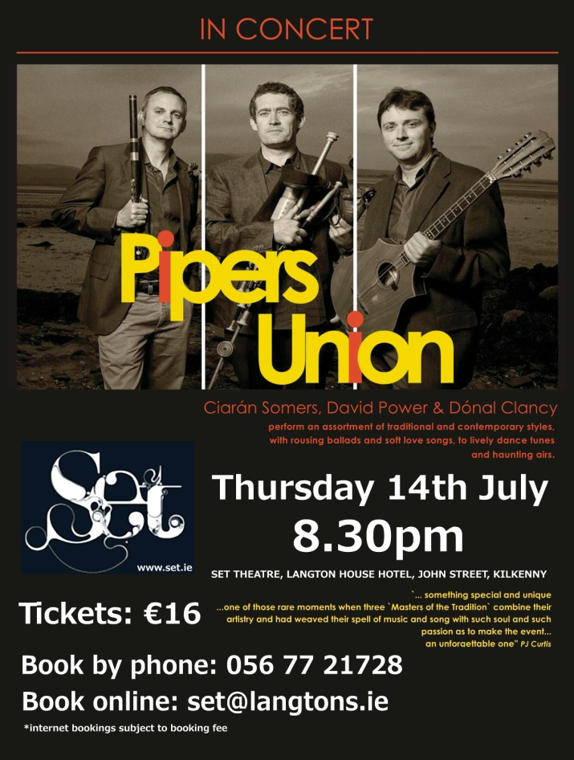

**\_\_\_\_\_\_\_\_\_\_\_\_\_\_\_\_\_\_\_\_\_\_\_\_\_\_\_\_\_\_\_\_\_\_\_\_\_\_\_\_\_\_\_\_\_\_\_\_\_\_\_\_\_\_\_\_\_\_\_\_\_\_\_\_\_\_\_\_\_\_\_\_\_\_\_\_\_\_\_\_\_\_\_\_\_\_**

**NEW!** [**Waterford Healing Arts Trust**](https://www.facebook.com/waterfordhealing.artstrust/?fref=nf) **welcomes Caroline Schofield**

We are delighted to welcome textile artist Caroline Schofield as this year's Artist in Residence. Caroline is interested in exploring the creative use of fabrics, wool and other materials in the life of patients in the hospital. She is open to working with all adult patients in the hospital and plans to base her residency in Medical 5.

[[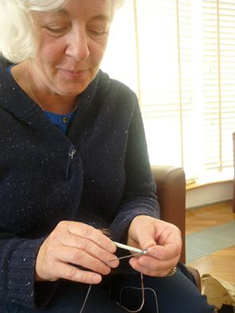](https://www.facebook.com/waterfordhealing.artstrust/photos/a.119560491546209.1073741826.119559938212931/386520948183494/?type=3)](https://www.facebook.com/waterfordhealing.artstrust/photos/a.119560491546209.1073741826.119559938212931/386520948183494/?type=3)

**\_\_\_\_\_\_\_\_\_\_\_\_\_\_\_\_\_\_\_\_\_\_\_\_\_\_\_\_\_\_\_\_\_\_\_\_\_\_\_\_\_\_\_\_\_\_\_\_\_\_\_\_\_\_\_\_\_\_\_\_\_\_\_\_\_\_\_\_\_\_\_\_\_\_\_\_\_\_\_\_\_\_\_\_\_\_\_**

**NEW! L’Arche Kilkenny: Community Leader / Service Manager**

**L’Arche** is an international movement which builds communities with people with intellectual disabilities. The L’Arche vision is unique and inspires an ecumenical Christian community, open to people of all faiths or none, who share its values and mission.

**The purpose of this role is to:**

* Lead the community in line with the Mission and identity of L’Arche, supporting mutually transformative relationships and being a sign of hope in their local community and beyond.
* Assume day to day management responsibility for the delivery of the highest standards of care and support to core members.
* To ensure that the physical, social, emotional, belonging and spiritual needs of the core members are identified and that strategies and care plans and practices are in place to reflect the response to needs identified.
* That the dignity, humanity, the value of each core member and all community members is a permanent feature of all practices.

**Reports to:** The CEO of L’Arche Ireland and Northern Ireland and the Chairperson of the Local Governance Sub Committee.

**To know more:**   
You are encouraged to make informal contact with Monika Bermingham / Mairead Boland Brabazon to ask more as you consider applying.

Contact details: Monika Bermingham  
Mobile: 086 3472052  
Landline: 056 7725628  
Contact details: Mairead Boland Brabazon  
Email: [maireadbb@larcheireland.org](mailto:maireadbb@larcheireland.org)  
Mobile: 086 8924965  
Landline: 056 7755494

**Close Date: 12th July 2016**

**\_\_\_\_\_\_\_\_\_\_\_\_\_\_\_\_\_\_\_\_\_\_\_\_\_\_\_\_\_\_\_\_\_\_\_\_\_\_\_\_\_\_\_\_\_\_\_\_\_\_\_\_\_\_\_\_\_\_\_\_\_\_\_\_\_\_\_\_\_\_\_\_\_\_\_\_\_\_\_\_\_\_\_\_\_\_\_**

**NEW! Camphill Callan: House Co-ordinator**

**House Co-ordinator with Management responsibility**

**(full time, flexible hours)**

The purpose of this role is to co-ordinate support to residents, ensure the day to day running of the house, and support the management group to comply with regulatory requirements while maintaining the Camphill ethos.

Applications are invited from candidates with experience of intellectual disability, strong organizational and leadership skills, familiarity with relevant regulations and an interest in exploring new models of social care.

Applicants should have a third level Social Care qualification.

For full information  and application form  please contact :  [info.callan@camphill.ie](mailto:info.callan@camphill.ie)

**Closing date for applications: July 10th 2016**

<http://www.camphill.ie/callan/index>

**\_\_\_\_\_\_\_\_\_\_\_\_\_\_\_\_\_\_\_\_\_\_\_\_\_\_\_\_\_\_\_\_\_\_\_\_\_\_\_\_\_\_\_\_\_\_\_\_\_\_\_\_\_\_\_\_\_\_\_\_\_\_\_\_\_\_\_\_\_\_\_\_\_\_\_\_\_\_\_\_\_\_\_\_\_\_\_**

**NEW! Kilkenny Arts Festival - Extra Footsbarn Show Announced!**

|  |  |  |  |  |  |
| --- | --- | --- | --- | --- | --- |
| |  | | --- | | **"They are genuinely bananas – that’s why I love them so much"**  **Dominic Dromgoole, former Artistic Director, Shakespeare's Globe** |  |  | | --- | | http://i.emlfiles1.com/cmpimg/5/1/8/3/7/1/files/imagecache/97772/w640_109988_fb_tentsm.jpg |  |  | | --- | | 2016 marks 400 years since the death of Shakespeare and #Shakespeare400 fever has certainly hit Kilkenny Arts Festival. With such strong demand for Footsbarn's [*The Incomplete Works of Shakespeare*](http://scanmail.trustwave.com/?c=6600&d=rtHz13qyDlh3zsliDpXb9xHdGnAgSHYaV6VnOR3tEw&s=380&u=http%3a%2f%2fr1%2earts-mail%2ecom%2f3Q47-23FW-GN21Z-LED3-1%2fc%2easpx) we have decided to add an extra date!  Having enchanted countless audiences worldwide, the legendary travelling ensemble Footsbarn will be pitching its famous tent in the heart of historic Kilkenny. Their productions of Shakespeare have won global acclaim over the years and to celebrate the 400th anniversary of the Bard's death, their newly created [*The Incomplete Works of Shakepeare*](http://scanmail.trustwave.com/?c=6600&d=rtHz13qyDlh3zsliDpXb9xHdGnAgSHYaV6VnOR3tEw&s=380&u=http%3a%2f%2fr1%2earts-mail%2ecom%2f3Q47-23FW-GN21Z-LED3-1%2fc%2easpx) is full of magic and humour, where anything is possible.  Don't miss this Shakespearean evening of surprises!  [Book tickets before it's too late...](http://scanmail.trustwave.com/?c=6600&d=rtHz13qyDlh3zsliDpXb9xHdGnAgSHYaV6VnOR3tEw&s=380&u=http%3a%2f%2fr1%2earts-mail%2ecom%2f3Q47-23FW-GN21Z-LED3-1%2fc%2easpx)SEE [WWW.KILKENNYARTS.IE](http://WWW.KILKENNYARTS.IE) |  |  | | --- | | **What the critics have to say:** |  |  | | --- | | *Footsbarn, indeed, is a theatre festival unto itself, a wonderfully eclectic mixture of styles and influences, of nationalities and cultures, all melded into a seamlessly fluid torrent of pure theatre* **Fintan O’Toole, The Irish Times**  *Footsbarn’s riotous take on Shakespeare has toured the globe for 25 years* **Lyn Gardner, The Guardian**  *...gigantic puppets and sketches that seem to range in influence from Monty Python to Samuel Beckett* **The** **Independent** | |

# ****\_\_\_\_\_\_\_\_\_\_\_\_\_\_\_\_\_\_\_\_\_\_\_\_\_\_\_\_\_\_\_\_\_\_\_\_\_\_\_\_\_\_\_\_\_\_\_\_\_\_\_\_\_\_\_\_\_\_\_\_\_\_\_\_\_\_\_\_\_\_\_\_\_\_\_****

**NEW!**

# \\kk-moss\Sites\arts_office\Shared Documents\Internal\Niamh\2016 projects\E-bulletin\July 1st\cob building.jpg

# ****\_\_\_\_\_\_\_\_\_\_\_\_\_\_\_\_\_\_\_\_\_\_\_\_\_\_\_\_\_\_\_\_\_\_\_\_\_\_\_\_\_\_\_\_\_\_\_\_\_\_\_\_\_\_\_\_\_\_\_\_\_\_\_\_\_\_\_\_\_\_\_\_\_\_****

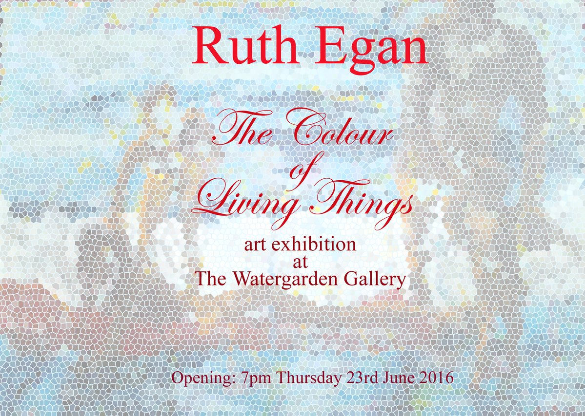

# ****\_\_\_\_\_\_\_\_\_\_\_\_\_\_\_\_\_\_\_\_\_\_\_\_\_\_\_\_\_\_\_\_\_\_\_\_\_\_\_\_\_\_\_\_\_\_\_\_\_\_\_\_\_\_\_\_\_\_\_\_\_\_\_\_\_\_\_\_\_\_\_\_\_\_\_****

# ****Mandala Workshop with Alice Bennett at Blackwatch Studio****

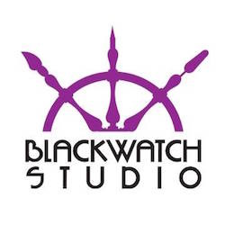

23 July  
Fee: €75 including materials.

In this workshop, artist Alice Bennett will introduce you to the practical steps of making a Mandala. Through these steps each participant will be enabled to start on a personal journey of calmness, self discovery and potentially of healing. There is no need to be artistic to create your own Mandala.

The word ”Mandala” originates from the language of Sanskrit and loosely translated means circle. It represents wholeness and can be seen as a basic structure of life itself, the world that extends both beyond and within our bodies and minds. A Mandala describes both material and non-material realities. It appears in all aspects of life: from the interior of a flower to the celestial circles we call earth, sun and moon. Mandala’s can convey the conceptual circles we belong to, friends, family and community.

Blackwatch Studio, Frenesytown, Clifden, Co Kilkenny  
T: 0868370205  
E: [**blackwatchstudiokk@gmail.com**](mailto:blackwatchstudiokk@gmail.com)  
W: [**blackwatchstudio.ie**](http://scanmail.trustwave.com/?c=6600&d=tcPh11THHiOQBK_PYveGX6Bp0DAcAv52ez6Z05nizQ&s=380&u=http%3a%2f%2fvisualartists%2eus9%2elist-manage1%2ecom%2ftrack%2fclick%3fu%3de67e46c7b14e756132f46a50c%26id%3d778ccf118a%26e%3d1968c52731)

**\_\_\_\_\_\_\_\_\_\_\_\_\_\_\_\_\_\_\_\_\_\_\_\_\_\_\_\_\_\_\_\_\_\_\_\_\_\_\_\_\_\_\_\_\_\_\_\_\_\_\_\_\_\_\_\_\_\_\_\_\_\_\_\_\_\_\_\_\_\_\_\_\_\_\_\_\_\_\_\_\_\_\_\_\_\_\_**

**Polymer Clay Workshop at Blackwatch Studio, Co. Kilkenny**

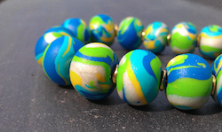

Blackwatch Studio, Freneystown, Clifden, Co. Kilkenny

Polymer Clay Course (3 weekend workshops) with Artist Tia Vellan  
Cost: €195 (including materials)

Weekend 1 | Fundamentals of Polymer Clay  
Saturday 25 June, 10am to 5pm  
Marbled beads, swirling lentils, appliqué, sheet techniques, canes, millefiori and jewellery-making (bracelets, necklaces, earrings)

Weekend 2 | Intermediate Level Polymer Clay  
Saturday 2 July, 10am to 5pm  
Colour-mixing, pearl powders, metal leaf, mosaic, mokume gane, polishing and jewellery-making (pendants, cabochons)

Weekend 3 | Advanced Techniques in Polymer Clay  
Saturday 9 July, 10am to 5pm  
Colour-blending (the most beautiful technique of all), carving, stamping, hand-building, simulating gems (coral, agate, jade, turquoise) and mold-making

For further details call Vicki, T: 086 837 0205, E: blackwatchstudiokk@gmail.com  
[**www.blackwatchstudio.ie**](http://scanmail.trustwave.com/?c=6600&d=vojY1yNAdCk6LIEP80STc3qT1T93cJ-PWt3-jusqCQ&s=380&u=http%3a%2f%2fvisualartists%2eus9%2elist-manage1%2ecom%2ftrack%2fclick%3fu%3de67e46c7b14e756132f46a50c%26id%3d793e307eab%26e%3df4dbf7f416)

# \_\_\_\_\_\_\_\_\_\_\_\_\_\_\_\_\_\_\_\_\_\_\_\_\_\_\_\_\_\_\_\_\_\_\_\_\_\_\_\_\_\_\_\_\_\_\_\_\_\_\_\_\_\_\_\_\_\_\_\_\_\_\_\_\_\_\_\_\_\_\_\_\_\_

**‘Just for Men’ Art and Sculpture Course**

During this four week course Artist and Sculptress, *Julie Moorehouse* will teach you how to make an open framework on which your sculpture is then moulded in air drying clay. When the piece has dried, participants will have the option to decorate their piece.

MEETING WEDNESDAY EVENING for 4 WEEKS

Running from Wednesday 6 July to Wednesday 27 July

FROM 7PM-9PM €100 (including materials)

€30 deposit secures place

*Gift Vouchers available / Ideal Father’s Day Surprise*

For further details call Vicki on 086 837 0205 Email:blackwatchstudiokk@gmail.com

Blackwatch Studio, Freneystown, Clifden, Co. Kilkenny.

**\_\_\_\_\_\_\_\_\_\_\_\_\_\_\_\_\_\_\_\_\_\_\_\_\_\_\_\_\_\_\_\_\_\_\_\_\_\_\_\_\_\_\_\_\_\_\_\_\_\_\_\_\_\_\_\_\_\_\_\_\_\_\_\_\_\_\_\_\_\_\_\_\_\_\_\_\_\_\_\_\_\_\_\_\_**

# Cliona Harmey: Block and Receive at the Butler Gallery

# Invite image

# **Cliona Harmey:** Block and Receive

Exhibition Open Daily 10am – 5.30pm

**Meet the Artist** 1pm Wednesday July 13 2016

The Butler Gallery is delighted to present Block and Receive, an exhibition of new and recent works by Dublin artist, Cliona Harmey.

Technology is central to Harmey’s practice and drives her thinking. In her work, she rigorously explores and investigates the language of technology, its physicality, and ultimately its gaps and limitations. This exhibition works with ideas of transmission, reception, noise, masked or failed reception and disappearance to create works that draw on communication processes.

Block and Receive includes a series of hybrid media-based sculptural works, screen-based animations, and three short, interlinked film works. Some of the sculptural works propose imaginary measurement systems, and allude to subjective measurement as well as the calibration lines used in satellite transmission images. In the creation of these sculptural objects, Harmey repurposes utilitarian materials, such as blackboard paint, foil and conductive fabric and labelling ribbon. Another sculptural work uses a partially masked reflective radar beacon, usually used to improve boats’ visibility. Ideas of distance and lines of sight are referenced in the image received from a satellite passing overhead; whereas ideas of blocked or lost communication are also cited in the failed image visible as lines and noise.

Harmey’s three film works were shot at Haulbowline Naval base in Cobh with the co-operation and assistance of the Irish Navy and The Sirius Arts Centre. In the films we see slow motion message sequences of the hand-operated morse signalling lamp. The films allow us to see the bare bones light signals, which we can imagine are at the root of many forms of communication. The lamp is still used at times by operators for the secure transmission of encrypted and unencrypted messages.

In another work “Flag”, we see a screen with a small-scale animation which also references lost or redundant signals. The image sequence, is based on international maritime signal flags spelling of the shipname “Ocean Shield” with omissions and additions. Ocean Shield was one of several Australian vessels to take part in a search for the missing flight MH370.

The exhibition also includes a vitrine that contains studies and sources used by the artist as touchstones or inspiration in the development of the overall exhibition.

Cliona Harmey drags the power cables out from behind the couch, slows things down, and in doing so, helps to demystify the seductive power of technology to a more human pace**.** Block and Receive provides much for the inquisitive mind to ponder and enjoy.

Cliona Harmey studied Fine Art Sculpture at the National College of Art & Design, completed a one-year residency at Arthouse Multimedia Centre in 1999, received a HDip in Computer Science at UCD and has an MA in Visual Art Practices from IADT. In 2015, Harmey produced Dublin Ships ([www.dublinships.ie](http://www.dublinships.ie/)) a highly successful temporary public artwork located at Scherzer Bridge and commissioned by Dublin City Council as part of Dublin City Public Art Programme. Cliona Harmey has exhibited widely and is a lecturer in the Fine Art Media Department at NCAD, the National College of Art and Design, Dublin.

With thanks to the Arts Council for essential annual funding, to [Sirius Arts Centre](http://www.siriusartscentre.ie/), and to the OPW, Department of Social Protection, The Heritage Council and Kilkenny Local Authorities for additional assistance. \* The artist would also like to acknowledge the assistance of the Communications Section of the [Irish Naval Service](http://www.military.ie/naval-service/) (Defence Forces of Ireland) at Haulbowline for facilitating the film work in this exhibition. Work was produced during a research and production residency at the Sirius Arts Centre, Cobh.

Discovery Pens will be available to visitors, giving access to additional audio information. This is facilitated in partnership with [*Arts & Disability Ireland*](http://www.adiarts.ie/), with funding from the Arts Council.

### \_\_\_\_\_\_\_\_\_\_\_\_\_\_\_\_\_\_\_\_\_\_\_\_\_\_\_\_\_\_\_\_\_\_\_\_\_\_\_\_\_\_\_\_\_\_\_\_\_\_\_\_\_\_\_\_\_\_\_\_\_\_\_\_\_\_\_\_\_\_\_\_\_\_\_

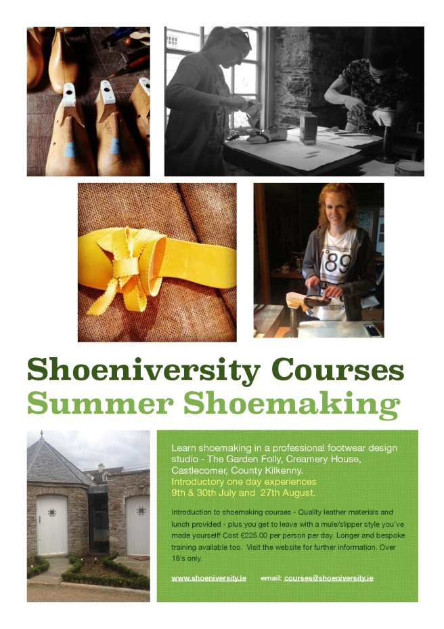

**\_\_\_\_\_\_\_\_\_\_\_\_\_\_\_\_\_\_\_\_\_\_\_\_\_\_\_\_\_\_\_\_\_\_\_\_\_\_\_\_\_\_\_\_\_\_\_\_\_\_\_\_\_\_\_\_\_\_\_\_\_\_\_\_\_\_\_\_\_\_\_\_\_\_\_\_\_\_\_\_\_\_\_\_**

**LESSAC Voice Training**

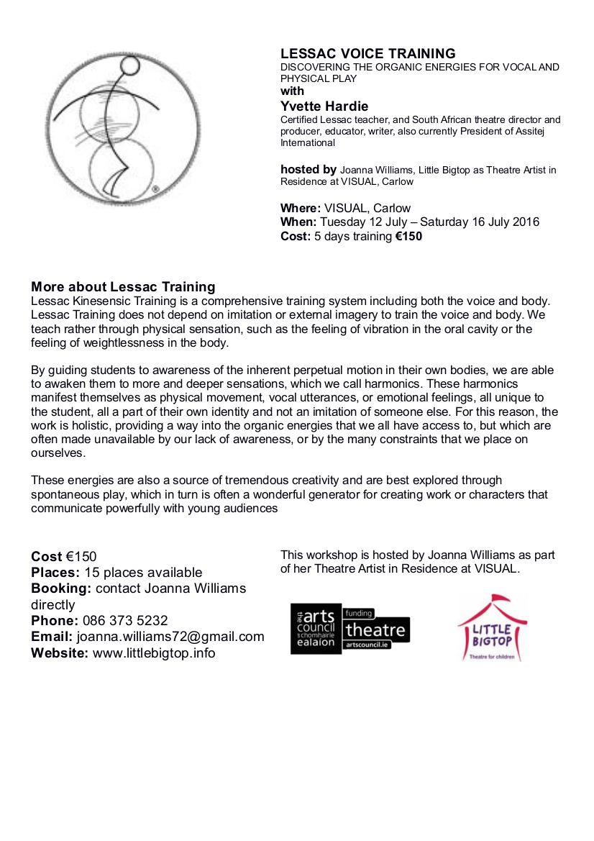

**\_\_\_\_\_\_\_\_\_\_\_\_\_\_\_\_\_\_\_\_\_\_\_\_\_\_\_\_\_\_\_\_\_\_\_\_\_\_\_\_\_\_\_\_\_\_\_\_\_\_\_\_\_\_\_\_\_\_\_\_\_\_\_\_\_\_\_\_\_\_\_\_\_\_\_\_\_\_\_\_\_\_\_\_\_**

**‘Famous Faces’ – a retrospective exhibition of the work of Francis Casey, at KCAT**

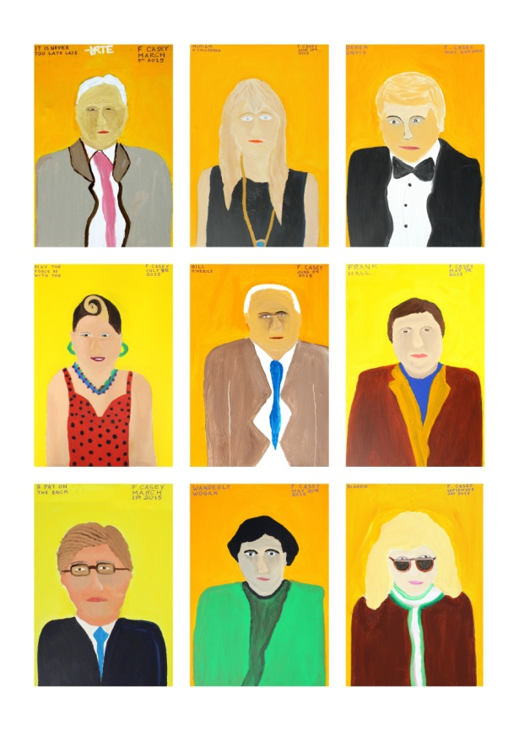 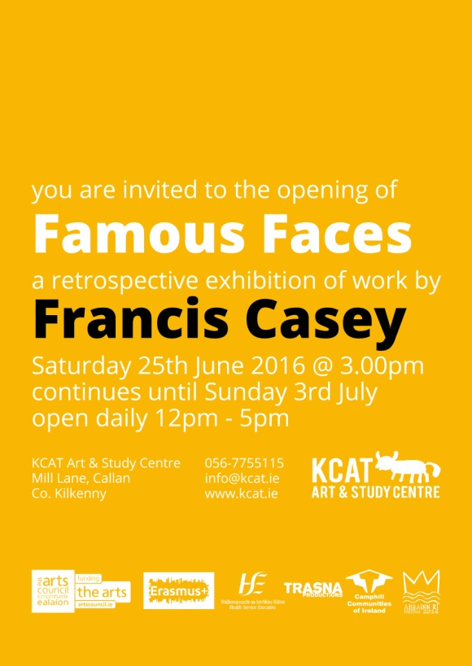

Francis Casey

Famous Faces – A retrospective.

25th June to 3rd July

in KCAT Gallery, KCAT Art and Study Centre, Mill Lane, Callan, Kilkenny.

Francis Casey is a founding member of the KCAT Studio and hails from Carrick-on-Suir, Co. Tipperary.

Initially working primarily in stone, Francis now balances his studio time between drawing, printmaking, copper etching, enameling, painting and sculpture. Alongside his visual work he also produces poetry and prose, often with insightful social commentary. His current body of work identifies cultural icons prominent in the memory of the artist, the subjects coming from the worlds of politics, music, film and TV.

Francis Casey has shown his artwork widely in Ireland including at County Hall Kilkenny, Dundalk Institute of Technology, Kilkenny Arts Festival, St. Luke’s General Hospital Kilkenny, Kilkenny Design Centre, Garter Lane Arts Centre Waterford, the Burren College of Art and Dublin City Council Offices. He has also shown work in many other countries including Finland, Germany, Luxembourg, Italy and the UK. He has taken part in a number of exchange projects including with DADAA Australia, Co-operations Luxembourg, SKID Germany and Pyramid of Arts UK.

In 2014 Francis was commissioned as part of a Percent for Art Scheme at Bunscoil McAuley Rice School, Callan, Co. Kilkenny.

His work features in a number of Publications and in the documentary: *Living Colour* - launched at the Jameson Dublin International Film Festival in 2011.

**\_\_\_\_\_\_\_\_\_\_\_\_\_\_\_\_\_\_\_\_\_\_\_\_\_\_\_\_\_\_\_\_\_\_\_\_\_\_\_\_\_\_\_\_\_\_\_\_\_\_\_\_\_\_\_\_\_\_\_\_\_\_\_\_\_\_\_\_\_\_\_\_\_\_\_\_\_\_\_\_\_\_\_\_\_\_\_**

**Inguna Mainule Finnerty exhibition at Castlecomer Library**

Castlecomer Library is to host an exhibition by Latvian born artist Inguna Mainule Finnerty from June 7th – July 2nd., Currently studying Fine Art in Abbeyleix, this talented artist, who has been living in Ireland since the turn of the century, has already exhibited nationally at noted galleries.

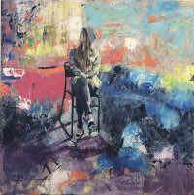

The work featured in the show has been inspired by the local community. Observing Abbeyleix, the artist has commented visually on heritage and surroundings and the connection that locals feel towards the town. Influences were first and foremost based on everything seen, felt and experienced within the place. Abbeyleix bog is one of the areas focused on in this collection. The pieces also take in the urban environment, people and wildlife of the bog that coexist in this breathtaking location and also those who walk along the boardwalk, built within the bog landscape by the local community. The immersion in nature and the ability to forget about daily, mundane lives for a little while is discussed in these visual recording. Still lives also feature, deeply rooted in art history and immediately recognisable, comforting and domestic.

Excited about her forthcoming exhibition Inguna told us, "I have learned to work with different mediums and learned to communicate through my works. I have already exhibited my works nationally and some of my works are in private collections." The artist is also available for commissions.

"The body of work for my exhibition is dedicated to Abbeyleix. In a contextual sense these pieces are, on some level, interpretations of what I see through living my life in this location. These interpretations are themselves the consequence of my own immersion within the social and cultural construct of the society."

**\_\_\_\_\_\_\_\_\_\_\_\_\_\_\_\_\_\_\_\_\_\_\_\_\_\_\_\_\_\_\_\_\_\_\_\_\_\_\_\_\_\_\_\_\_\_\_\_\_\_\_\_\_\_\_\_\_\_\_\_\_\_\_\_\_\_\_\_\_\_\_\_\_\_\_\_\_\_\_\_\_\_\_\_\_\_\_**

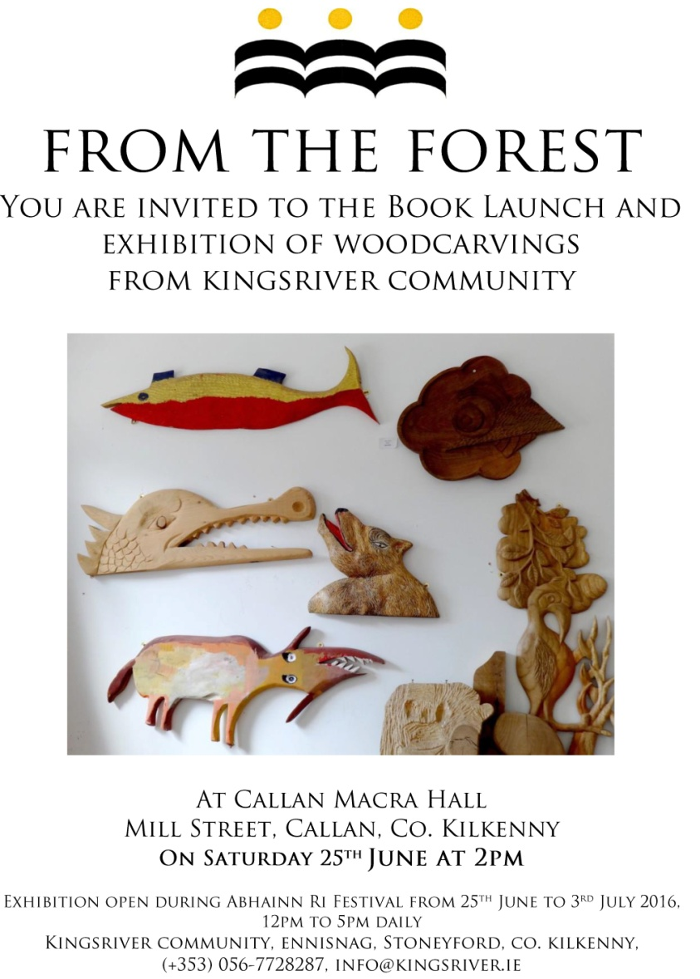

### \_\_\_\_\_\_\_\_\_\_\_\_\_\_\_\_\_\_\_\_\_\_\_\_\_\_\_\_\_\_\_\_\_\_\_\_\_\_\_\_\_\_\_\_\_\_\_\_\_\_\_\_\_\_\_\_\_\_\_\_\_\_\_\_\_\_\_\_\_\_\_\_\_\_

**Call For Participants’: Kilkenny Libraries Poetry Reading Event October 2016**

Inspired by America’s Favorite Poem Project, where ordinary Americans read aloud their favourite poem for an archive at the Library of Congress, and the recently published anthology in collaboration with Amnesty International “*Poems That Make Grown Women Cry”*, where the editors invited 100 prominent women in the UK to choose their favourite poem and to explain why it moved them, Kilkenny Libraries is holding a poetry reading event in October 2016 in a similar vein where local readers are invited to choose and read a poem that means something to them –an old favourite, or something new. You decide!

Kilkenny Libraries have a number of copies of “*Poems That ...*” which are available to borrow from the library branches around the county, along with other books and anthologies of poetry. The “*Poems That...”* series and others could be a starting point for choosing a poem, or readers might already have a favourite poem that they would like to read.

Kilkenny has a vibrant poetry scene and many talented poets, but for this event we would like to keep to the spirit of the Favourite Poem Project and the *“Poems That ...”–* anthology - so the favourite poem should be someone else’s work – it’s about being moved to read and communicating your reading of that poem to an audience. And you don’t have to be a poet or writer to participate! Even shy readers are encouraged to nominate someone else to read their choice for them if they wish. An all-inclusive adult event showcasing poems that are familiar, or not; poems that may be sad, joyful, celebratory, shocking, inspiring, funny or question things, but have a personal reasons for choice are all welcomed.

We would like to get everyone reading and practicing well in advance – what seems daunting now might seem perfectly feasible by October!  If you don’t have a poem chosen yet, but think you would like to read, please get in touch and get reading – you can let us know your choice of poem during the summer.

To take part in this event or if you have any questions, please contact Mary Morrissey at [mary.morrissey@kilkennylibrary.ie](mailto:mary.morrissey@kilkennylibrary.ie)

For further information on our libraries, this event and other please see [www.kilkennylibrary.ie](http://www.kilkennylibrary.ie)

WATCH THIS SPACE FOR DETAILS OF THIS FREE EVENT TO THE PUBLIC!

**\_\_\_\_\_\_\_\_\_\_\_\_\_\_\_\_\_\_\_\_\_\_\_\_\_\_\_\_\_\_\_\_\_\_\_\_\_\_\_\_\_\_\_\_\_\_\_\_\_\_\_\_\_\_\_\_\_\_\_\_\_\_\_\_\_\_\_\_\_\_\_\_\_\_\_**

**Municipal District of Kilkenny City - East & West Streetscape Paint Scheme 2016**

Kilkenny County Council is pleased to announce the ‘**Streetscape Paint Scheme 2016**’ whereby a fund has been allocated to assist with the cost of painting the front façade of **commercial / business buildings** and/or hand painted shop signage within the Municipal District of Kilkenny City - East & West, subject to terms and conditions.

This Municipal District includes amongst others, such towns and villages as **Callan, Thomastown, Ballyhale, Bennettsbridge, Dungarvan and Graignamanagh, etc.** However, please contact the undersigned for confirmation of your town / village if you are unsure whether it is included in the relevant Municipal District. **Kilkenny City** is also included in this year’s scheme.

If the scheme is oversubscribed those applicants eligible to continue in the application process will be randomly selected.

Applications are welcome throughout the year subject to funding being available.

Application Forms and further particulars may be obtained from the Property Section, Kilkenny County Council, C/o City Hall, High Street, Kilkenny. Contact - Tel 056 779 4534 or [trevor.byrne@kilkennycoco.ie](mailto:trevor.byrne@kilkennycoco.ie).

**\_\_\_\_\_\_\_\_\_\_\_\_\_\_\_\_\_\_\_\_\_\_\_\_\_\_\_\_\_\_\_\_\_\_\_\_\_\_\_\_\_\_\_\_\_\_\_\_\_\_\_\_\_\_\_\_\_\_\_\_\_\_\_\_\_\_\_\_\_\_\_\_\_\_\_\_\_\_\_\_\_\_\_\_\_\_\_**

**Ballykeeffe Amphitheatre in Kilmanagh, the only amphitheatre in Ireland, has launched its exciting programme of events for summer 2016**

Exciting Lineup!

The fun kicks off on Sunday, June 19th with a Punch and Judy puppet show, and Irish rock band The Stunning will headline this year’s phenomenal line-up on July 2nd. The amphitheatre will also see performances from country crooner Derek Ryan (August 12th), Limerick lads Hermitage Green (August 13th) and songstress Eddi Reader (July 30th), while kids and families alike will be well catered for with a performance of Peter Pan (June 24th). The critically acclaimed Declan O’Rourke will take to the stage on July 22nd.

Launching the 2016 programme of events, Cathaoirleach of Kilkenny County Council and elected representative for the local area, Mary Hilda Cavanagh, said:

“I encourage visitors from near and far to visit the Ballykeeffe Amphitheatre this summer, not just to see a fantastic event, but to witness what great community spirit can achieve. This wonderful cultural resource was once a disused quarry but thanks to the dedication of local volunteers, it is now one of the premier cultural attractions in Kilkenny. I congratulate all those involved and look forward to attending events at Ballykeeffe Amphitheatre this summer.”

Also on hand to launch the 2016 season was local Graigue-Ballycallan clubman, Kilkenny Under-21 hurling manager and former county hurling hero Eddie Brennan.

From Chairman of Ballykeeffe Amphitheatre Matt O Sullivan:

“I am privileged to have watched Ballykeeffe Amphitheatre grow from strength to strength over the years, from humble beginnings as an abandoned quarry to a major player on Kilkenny’s very strong music and arts scene. The community involvement in Ballykeeffe Amphitheatre is what makes this venue so special, and our success is due in no small part to the local volunteers who give up their time year after year, as well as the continued support of those who attend our events. We have an excellent line-up for 2016 with something to suit all ages and interests, and look forward to welcoming everyone to Ballykeeffe for what is set to be an unmissable summer season”

For more details see <http://ballykeeffeamphitheatre.com/>

**\_\_\_\_\_\_\_\_\_\_\_\_\_\_\_\_\_\_\_\_\_\_\_\_\_\_\_\_\_\_\_\_\_\_\_\_\_\_\_\_\_\_\_\_\_\_\_\_\_\_\_\_\_\_\_\_\_\_\_\_\_\_\_\_\_\_\_\_\_\_\_\_\_\_\_\_\_\_\_\_\_\_\_\_\_\_\_**

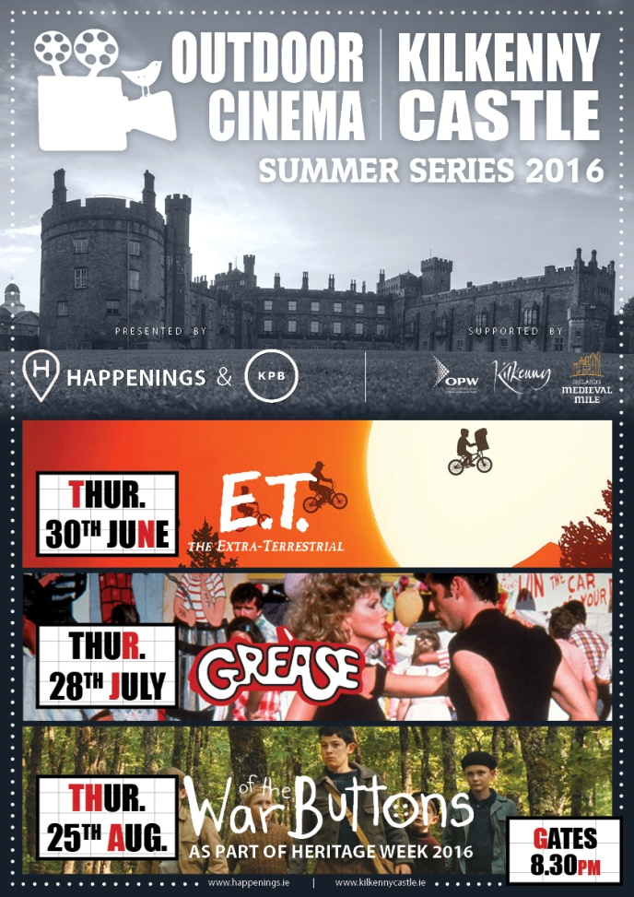

**\_\_\_\_\_\_\_\_\_\_\_\_\_\_\_\_\_\_\_\_\_\_\_\_\_\_\_\_\_\_\_\_\_\_\_\_\_\_\_\_\_\_\_\_\_\_\_\_\_\_\_\_\_\_\_\_\_\_\_\_\_\_\_\_\_\_\_\_\_\_\_\_\_\_\_\_\_\_\_\_\_\_\_\_\_\_\_**

 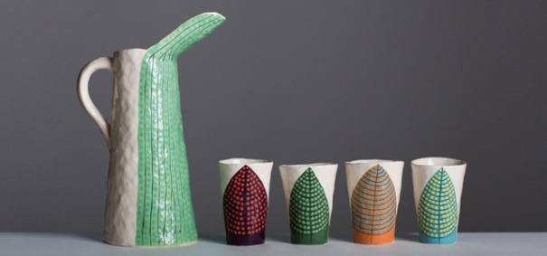

**Liminal: Irish Design at the Threshold 8 April 2016 – 3 July 2016**

Liminal – Irish design at the threshold, presents some of Ireland’s most exciting design, from product to scientific, architecture to animation, and food to furniture. The exhibiting designers, companies and studios have been selected for the innovative outlook of their work, its connectivity and ability to transcend disciplinary boundaries to address the issues of today. Presenting a pivotal chapter in Irish design, Liminal explores, identifies and showcases Irish creativity, and how designers, companies and studios are moving across disciplinary boundaries and the limits of what design has been, into what design can become. As design increasingly seeks to create holistic experiences and narratives, Ireland is placed to play a significant role in 21st century design, helping meet the challenges of tomorrow. The exhibition demonstrates Irish design excellence across disciplines and considers the possibilities for the future.

The evolving flagship exhibition from ID2015, Liminal – Irish design at the threshold, is presented in Kilkenny after its tour of design weeks in Eindhoven, Milan, New York and Dublin. The exhibition features over 20 designers, companies and studios involved in collaborations across disciplines.

Co-curated by Louise Allen, Alex Milton and Angela O’Kelly

**Education & Outreach**

**DROP-IN: DESIGN DISCOVERY Daily**

Drop-in with the family to discover design through Liminal:  
**Liminal Explorer**: Become a design detective, seeking out visual designs  
**ARCKIT Play**: Test your architectural design ideas with ARCKIT

**SCHOOLS: GUIDED VISITS & WORKSHOPS 12 April – 30 June (Tues-Fri)**

Our educators introduce students to design and craft through a tailored exhibition tour and invite you to book a class workshop:  
**Primary:** Line Shape Pattern  
**Secondary:** ARCKIT Modular Homes  
**Leaving Cert:** Art, Craft & Design Gallery Question  
**Third Level:** ARCKIT Modular Builds

**Gallery Tours**

CRAFTERNOON TOURS\* Sat, 3pm Visitors are invited to book for our informal afternoon tour. GUIDED EXHIBITION VISITS\* Would you like to bring a group to the National Craft Gallery? We accommodate groups from 5 to 25 people. No fee applies. Contact us and we will tailor a tour suit the needs of your visit. \*Booking required - email events@nationalcraftgallery.ie or call 056 7796151

**\_\_\_\_\_\_\_\_\_\_\_\_\_\_\_\_\_\_\_\_\_\_\_\_\_\_\_\_\_\_\_\_\_\_\_\_\_\_\_\_\_\_\_\_\_\_\_\_\_\_\_\_\_\_\_\_\_\_\_\_\_\_\_\_\_\_\_\_\_\_\_\_\_\_\_\_\_\_\_\_\_\_\_\_\_\_**

**Paper Making and Textile Art Courses at KOZO Studio, Kilkenny**

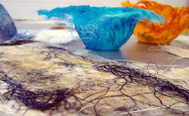

Upcoming Workshop Programme July 2016  
KOZO Studio, The Estate Yard, Castlecomer Discovery Park, Co. Kilkenny

Creative, artistic and experimental weekend workshops for adults in a professional studio setting – beginner`s and advanced level courses.  
3 July | Cost: €65  
Paper Making Day Workshops for beginners: traditional and contemporary hand Paper Making

16 July | Cost: €75  
Felt Making – wet felting techniques for beginners

17 July | Cost: €80  
Paper Art And Paper Making – Advanced level course for participants with previous experience –

Fees include all materials. Places are limited – all courses are run for small groups only.  
E: tundetune@gmail.com  
More info, contact and bookings: [**www.tundetoth.com**](http://scanmail.trustwave.com/?c=6600&d=2v3q11HA7afVmAPzp6f0e8BJowSqiifDnPUvPTpMFg&s=380&u=http%3a%2f%2fvisualartists%2eus9%2elist-manage%2ecom%2ftrack%2fclick%3fu%3de67e46c7b14e756132f46a50c%26id%3de6d427e944%26e%3df4dbf7f416)

**Course / Training / Jobs / Internships**

### NEW! Arts Council Information Clinic and Mindshift: The Business of Writing Applications

**Arts Council Information Clinic**

**Date: Saturday 2 July**  
**Time: 10.30am – 12 noon**   
**Free event but ticketed. Book** [**via Eventbrite**](https://www.eventbrite.ie/e/arts-council-information-clinic-tickets-26074121399)**\***

The deadline for the next round of the Arts Council’s **Literature Bursary Award** (separate awards available for writers working in Irish and in English) is Thursday, **14 July 2016**.

In advance of this deadline, the Arts Council will hold an **information clinic in the Irish Writers Centre** to offer advice and information on the application process. Booking free but essential.

[](http://cdn.shopify.com/s/files/1/0631/7333/products/Mindshift1_PS_text_1024x1024_a29e1ae3-9d8f-4fe6-89b6-c9897915fff5.jpg?v=1465984226)

### Mindshift: The Business of Writing Applications

**Date: Saturday 2 July**  
**Time: 1pm – 4.15pm**   
**Tickets: €15/€10. Book** [**via Eventbrite**](https://www.eventbrite.ie/e/mindshift-the-business-of-writing-applications-tickets-26074150486)**\***

If you wish to learn more about the process of writing applications with a view to improving your success rate for bursaries, residencies, retreats and other writing opportunities, join us for two afternoon sessions which will tackle the tricky subject of business writing.

**1–2pm: Do's and Don'ts of Application Writing:** Learn how to communicate more effectively and present your best self on the page. Topics will include how to draft a quality writer's CV, how to make your application stand out from the rest and what to avoid. This seminar will also incorporate time for Q & A. Speaker tbc.

**2.15–4.15pm:** **The Second Eye:** Take part in one-to-one consultations (15 mins) with those who have expertise in deliberation panels. Bring along some sample material and receive constructive criticism on areas for improvement from Valerie Bistany (Director, Irish Writers Centre), Ruth Hegarty (Publishing Ireland and RIA) and Jack Gilligan (Former Arts Officer, Dublin City Council). Sessions are limited and will be on a first-come, first-served basis.

**\_\_\_\_\_\_\_\_\_\_\_\_\_\_\_\_\_\_\_\_\_\_\_\_\_\_\_\_\_\_\_\_\_\_\_\_\_\_\_\_\_\_\_\_\_\_\_\_\_\_\_\_\_\_\_\_\_\_\_\_\_\_\_\_\_\_\_\_\_\_\_\_\_\_\_**

**NEW!** [**Physical Theatre & Mask Technique Master Class with Boom Circus (US)**](http://www.isacs.ie/physical-theatre-and-mask-technique-master-class-with-boom-circus-us/)

**ISACS** are delighted to host this unique 2 day Master Class in **Physical Theatre** **and** **Mask Techniques,**in association with the [Wexford Arts Centre](http://www.wexfordartscentre.ie/) and [Waterford Spraoi,](http://www.spraoi.com/) led by **David Poznanter** and **Peter Sweet** of **Boom Circus (US) over the 26th + 27th July in Enniscorthy, Co Wexford,** just days before they set to wow the crowds at the Irish premier of their dynamic street show ‘Boom’ at Waterford Spraoi, the longest running street arts festival in Ireland over this August Bank Holiday weekend.

“*BOOM!” breathes new life into the ancient tradition of masked theatre, full of spontaneous improvisation, heartwarming drama, impossible skills and hilarious moments of sheer humanity. Peter Sweet and David Poznanter portray a cast of 6 characters who put on an entire circus, complete with slackrope, Cyr Wheel, juggling and live music*”

**This 2 day workshop will focus on:**

* Spatial awareness.
* Fixed points and articulation.
* Mask technique.
* Contact and clarity in theatrical mask improvisation

**Cost for the 2 days**

**ISACS members : €50.00** / **Non ISACS members: €100.00**

[(Sign up here for annual ISACS membership which starts at €30 per year)](http://www.isacs.ie/registration/)

**Dates:** Tuesday 26th & Wednesday 27th July

**Venue:** [Presentation Centre](http://www.presentationcentre.ie/), Enniscorthy, Co. Wexford

**Times:** 10 am- 3pm with 1 hour lunch break included.

**Booking:** Bookings can be made via Wexford Arts Centre [here](https://wexfordartscentre.ticketsolve.com/#/shows/873557508)

(Please specify if you are an ISACS member to avail of your 50% reduction! Maximum participants is 14 so early booking is recommended!)

Contact [marketing@isacs.ie](mailto:marketing@isacs.ie) with any queries you may have.

[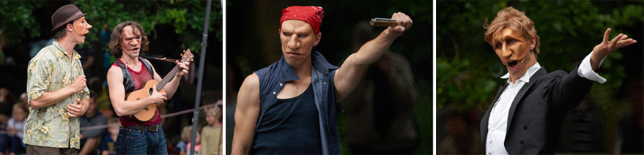](http://www.isacs.ie/wp-content/uploads/2016/06/Boom_3images_banner.jpg)

**\_\_\_\_\_\_\_\_\_\_\_\_\_\_\_\_\_\_\_\_\_\_\_\_\_\_\_\_\_\_\_\_\_\_\_\_\_\_\_\_\_\_\_\_\_\_\_\_\_\_\_\_\_\_\_\_\_\_\_\_\_\_\_\_\_\_\_\_\_\_\_\_\_\_\_\_\_\_\_\_\_\_\_\_\_\_\_**

**NEW! Adult Continuing Education in European Art History at UCC, Cork**

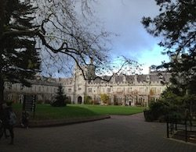

Adult Continuing Education at University College Cork is pleased to announce a new cycle of the Diploma in European Art History beginning in September 2016 and currently taking applications.

This exciting two-year programme asks the question, what is the “idea” of Europe? We will examine this question by looking at visual culture expressed through the push and pull between the metropolitan centres (such as Rome, Venice and Florence and Amsterdam) and European regions across time and space. We will examine how art functions differently from state buildings to religious settings and from public monuments to domestic spaces. We will use cultural artefacts (e.g. paintings, architecture and the decorative arts) to examine these centre/periphery tensions from Classical Antiquity to the Baroque in year one and from neo-Classicism to Modernity in year two.

Programme lectures take place on Tuesday evenings, from late September, on the main UCC campus between 7 and 10pm

For any further queries please contact James Cronin, programme co-ordinator, E: j.cronin@ucc.ie  
For further details and how to apply see [**www.ucc.ie/en/ace-dah/**](http://scanmail.trustwave.com/?c=6600&d=2v3q11HA7afVmAPzp6f0e8BJowSqiifDnKMvPWQcQg&s=380&u=http%3a%2f%2fvisualartists%2eus9%2elist-manage%2ecom%2ftrack%2fclick%3fu%3de67e46c7b14e756132f46a50c%26id%3d7fb5ad118d%26e%3df4dbf7f416)

**\_\_\_\_\_\_\_\_\_\_\_\_\_\_\_\_\_\_\_\_\_\_\_\_\_\_\_\_\_\_\_\_\_\_\_\_\_\_\_\_\_\_\_\_\_\_\_\_\_\_\_\_\_\_\_\_\_\_\_\_\_\_\_\_\_\_\_\_\_\_\_\_\_\_\_\_\_\_\_\_\_\_\_\_\_\_\_**

**NYCI Certificate in Youth Arts 2016/2017**

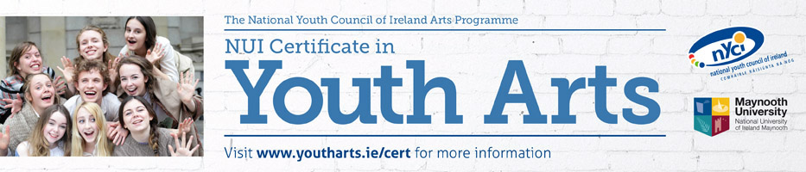

**\*\* \*\*\*\* Closing date for applications - Friday 19th August 2016\*\*\*\* \*\***

**“The course gave me space and time, along with a new vocabulary to think about and therefore understand what youth arts means to me and what it means for society. This increased understanding allowed me to return to my work armed with renewed motivation, new and important contacts, increased policy and sector knowledge and a fired up imagination.”**

**NUI Certificate in Youth Arts**

The **Certificate in Youth Arts** is a part time programme of study in Irish Youth Arts Practice, with 6 modules covered over 12 contact days between October and June. The programme is a partnership initiative of Maynooth University and the National Youth Council of Ireland Arts Programme and leads to an award of the National University of Ireland, placed at Level 7 on the National Qualifications Framework.

The Certificate in Youth Arts aims to introduce those working in the non-formal education sector to the concepts, principles and practice of youth arts using a context and practice approach.

**The Certificate in Youth Arts is recruiting potential candidates in summer 2016for the 2016/17 academic year. For further information or to request an application form, please contact Anna Gunning, Youth Arts Programme, National Youth Council of Ireland on 01 4255932 or** [**anna@nyci.ie**](mailto:anneog@nyci.ie)**.  We look forward to hearing from you!**

**\_\_\_\_\_\_\_\_\_\_\_\_\_\_\_\_\_\_\_\_\_\_\_\_\_\_\_\_\_\_\_\_\_\_\_\_\_\_\_\_\_\_\_\_\_\_\_\_\_\_\_\_\_\_\_\_\_\_\_\_\_\_\_\_\_\_\_\_\_\_\_\_\_\_\_\_\_\_\_\_\_\_\_\_\_\_\_**

**Irish Film Institute – Press and Marketing Manager**

**The IFI is seeking to appoint a Press and Marketing Manager to join the management team.**

They will be responsible for the effective delivery of all marketing, PR and promotional initiatives for the company, incorporating IFI Cinemas, IFI Irish Film Archive, IFI Education, IFI International, IFI National, all film festivals, retrospectives, courses, special events and publishing properties.

This job description provides an outline of the key day-to-day and strategic responsibilities of the role.

**Key Job Purpose**

**Responsibilities include the following key areas:**

* Press and Marketing Strategy
* Online Strategy & Development
* Audience Development
* Financial Management
* Staff Management / HR

**Person Specification**

The successful candidate should be able to demonstrate strong examples from their past experience highlighting that they have both the capability and desire for this role.

**Closing date for applications:**  
Friday 15th July.

For more information please visit [ifi.ie](http://www.ifi.ie/vacancy-press-marketing-manager/)

**\_\_\_\_\_\_\_\_\_\_\_\_\_\_\_\_\_\_\_\_\_\_\_\_\_\_\_\_\_\_\_\_\_\_\_\_\_\_\_\_\_\_\_\_\_\_\_\_\_\_\_\_\_\_\_\_\_\_\_\_\_\_\_\_\_\_\_\_\_\_\_\_\_\_\_\_\_\_\_\_\_\_\_\_\_\_\_**

**Call for Volunteers | PhotoIreland Festival 2016**

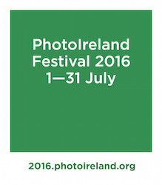

PhotoIreland Festival is seeking expressions of interest from individuals looking to join the festival team in Dublin in July 2016.

We have a lot of exciting and unusual events coming up this year and need all the help we can get.  
Please see our Main Shows listing for a preview of what you will be working with us on: [**photoireland.org/festival/year-2016/**](http://scanmail.trustwave.com/?c=6600&d=vojY1yNAdCk6LIEP80STc3qT1T93cJ-PWtuvhussCQ&s=380&u=http%3a%2f%2fvisualartists%2eus9%2elist-manage%2ecom%2ftrack%2fclick%3fu%3de67e46c7b14e756132f46a50c%26id%3d756b6f90b0%26e%3df4dbf7f416)

We are looking for volunteers to help in aiding to set up the exhibitions, help out on opening nights and events, and invigilation throughout the festival. During this period, you will build a knowledge of the workings of a gallery, exhibition making, develop your skills and contribute towards your working experience. This opportunity would be suitable for anyone looking to hone their knowledge and skills in the arts, with a focus on photography and festivals.

We require volunteers from end of June until the end of July, depending on what kind of help you are happy to offer. While we are not looking necessarily for full-time help (most of us are part-time), we are looking for responsible and dedicated people.

For further details and to express your interest, please contact [**julia.gelezova@photoireland.org**](mailto:julia.gelezova@photoireland.org)

**Call for Submissions / Residencies / Public Art**

**NEW!** **RTÉ’s new TV programme Painting The Nation – Call for Applications**

Are you a talented amateur artist with a passion for painting? Do you love your oils, watercolours, pastels and acrylics - and would you like to showcase your painting talents to the nation? RTÉ is looking for the best amateur painters across the country to take part in this exciting new series that gives aspiring artists a real opportunity to make their mark.

**Painting The Nation** is open to a mix of painters: maybe you went to art college but ended up in another career; maybe you sell a painting or two but its’ not your main source of income; maybe you just love to paint.

This is a competition to uncover and showcase the best amateur painting talent across the island of Ireland. If painting is your passion and you think you have what it takes, we would like to hear from you.

Speaking about her new show, Pauline McLynn said: “*I am really excited to be involved in Painting the Nation. We are looking for passion mixed with real talent, and I would encourage amateur painters out there who think they have what it takes to apply to be part of the show.”*

**How To Apply**

If you are 18 and over on August 1st 2016 you can download an application form at: [http://www.rte.ie/tv/audienceparticipation/](http://scanmail.trustwave.com/?c=6600&d=_e3r1wF9in_5txVHmK6nBqoALvJsIbFPxhq3Pprf8g&s=380&u=http%3a%2f%2fwww%2erte%2eie%2ftv%2faudienceparticipation%2f)

If you would like further information or an application form sent to you please contact Andrew Mills on **01-7088135**or Ciara Kerrigan on **01-7088184**, or email us at**:**[**paintingthenation@indiepics.ie**](mailto:paintingthenation@indiepics.ie)

**\_\_\_\_\_\_\_\_\_\_\_\_\_\_\_\_\_\_\_\_\_\_\_\_\_\_\_\_\_\_\_\_\_\_\_\_\_\_\_\_\_\_\_\_\_\_\_\_\_\_\_\_\_\_\_\_\_\_\_\_\_\_\_\_\_\_\_\_\_\_\_\_\_\_\_**

**NEW! Fingal County Council Graduate Award 2016 in Partnership with Block T**

Fingal County Council Arts Office and BLOCK T are delighted to announce its Graduate Award as part of FUEL, BLOCK T’s Visual Arts Programme dedicated to the support and professional development of recent graduates. As part of an ongoing commitment to professional artists Fingal County Council’s Arts Office are offering a one-year Graduate Studio Award in BLOCK T with a solo exhibition in 2017.

Now in its third year, the residency will be offered to one graduate, the opportunity is part of a series of initiatives by Fingal Arts Office to promote and support the professional practice of emerging artists. It will provide an ideal environment for the development of a graduates practice and an opportunity to network with other artists.

Closing date: 29 July

For further information please email denise.reddy@fingal.ie  
[**www.fingalarts.ie**](http://scanmail.trustwave.com/?c=6600&d=2f3q11fTtd9HUCvOPL8ih8qB4Ijy_J98HfEtpRQt1w&s=380&u=http%3a%2f%2fvisualartists%2eus9%2elist-manage%2ecom%2ftrack%2fclick%3fu%3de67e46c7b14e756132f46a50c%26id%3d06521d28e9%26e%3df4dbf7f416) |  [**www.blockt.ie**](http://scanmail.trustwave.com/?c=6600&d=2f3q11fTtd9HUCvOPL8ih8qB4Ijy_J98HaEqoRUr1Q&s=380&u=http%3a%2f%2fvisualartists%2eus9%2elist-manage1%2ecom%2ftrack%2fclick%3fu%3de67e46c7b14e756132f46a50c%26id%3d0cba8c84d4%26e%3df4dbf7f416)

**\_\_\_\_\_\_\_\_\_\_\_\_\_\_\_\_\_\_\_\_\_\_\_\_\_\_\_\_\_\_\_\_\_\_\_\_\_\_\_\_\_\_\_\_\_\_\_\_\_\_\_\_\_\_\_\_\_\_\_\_\_\_\_\_\_\_\_\_\_\_\_\_\_\_\_\_\_\_\_\_\_\_\_\_\_\_\_**  
  
**NEW! D.I.V.A. Collaborative Art Project at Electric Picnic 2016**

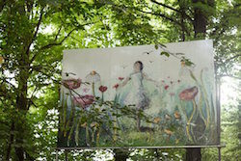

D.I.V.A. stands for Diverse Individual Visual Artists and aims to bring professional visual artists together to collaborate with one another within Electric Picnic’s unique environment and alongside the wider festival team. A bursary of €10,000 will be offered to the successful artists to help create an amazing backdrop to your festival experience.

Electric Picnic is calling on artists to come together to create something magical for the forthcoming festival. The weekend of 2nd, 3rd, 4th of September will see 55,000 people descend on Stradbally. You can apply as a group of artists who would like to take an opportunity to work together or in tandem in this environment. Alternatively you can apply as an individual artist, and should you be successful you will be grouped with 2-3 other artists with whom you will collaborate.

The artists awarded the D.I.V.A. residency will work onsite over a two week period, during the “build phase” of the festival. Works must be completed and installed by the 25th of August. The process will involve a dialogue with co-curators to ensure that the artworks created suit the festival environment, both visually and practically. For this reason, it should be expected that the final artwork may deviate from the original concept.

You do not need to develop a proposal in order to apply for the D.I.V.A. programme. The most important evidence of your ability is your past work, so please make sure and send lots of images.

TO APPLY, simply email images to: [**sorcha@eventdesignstudio.ie**](mailto:sorcha@eventdesignstudio.ie)

More information, including terms and conditions here: [**www.electricpicnic.ie/news/artists-residence-diva**](http://scanmail.trustwave.com/?c=6600&d=2f3q11fTtd9HUCvOPL8ih8qB4Ijy_J98HfQppUAvgg&s=380&u=http%3a%2f%2fvisualartists%2eus9%2elist-manage2%2ecom%2ftrack%2fclick%3fu%3de67e46c7b14e756132f46a50c%26id%3d45f3c82d1e%26e%3df4dbf7f416)

**\_\_\_\_\_\_\_\_\_\_\_\_\_\_\_\_\_\_\_\_\_\_\_\_\_\_\_\_\_\_\_\_\_\_\_\_\_\_\_\_\_\_\_\_\_\_\_\_\_\_\_\_\_\_\_\_\_\_\_\_\_\_\_\_\_\_\_\_\_\_\_\_\_\_\_\_\_\_\_\_\_\_\_\_\_\_\_**

**NEW! Open Call for Exhibitions and Studios Membership | Custom House Studios 2017/18 Programme**

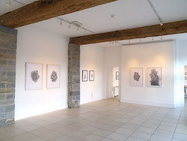Deadline: 31 September 2016

Custom House Studios are now inviting submissions for Exhibitions and Studios for 2017/18. Please submit proposals for exhibitions at the Custom House Studios gallery during 2017/18, and for use of studios ( short term contracts 1 – 3 months) in 2017/18, and long term studios in 2017/8 .

Submissions by Email – include all letters of interest, CVs and documentation of work maximum 10 images in one attached file only in PDF format, (no JPGS or other image formats accepted). For work on video please provide links for online viewing. Send to: [**customhouse@eircom.net**](mailto:customhouse@eircom.net)

For more information:  
T: +353 (0)98 28735  
E: [**info@customhousestudios.ie**](mailto:info@customhousestudios.ie)  
W: [**customhousestudios.ie**](http://scanmail.trustwave.com/?c=6600&d=2f3q11fTtd9HUCvOPL8ih8qB4Ijy_J98Ha50qRV5gA&s=380&u=http%3a%2f%2fvisualartists%2eus9%2elist-manage1%2ecom%2ftrack%2fclick%3fu%3de67e46c7b14e756132f46a50c%26id%3d6117d9a499%26e%3df4dbf7f416)

**\_\_\_\_\_\_\_\_\_\_\_\_\_\_\_\_\_\_\_\_\_\_\_\_\_\_\_\_\_\_\_\_\_\_\_\_\_\_\_\_\_\_\_\_\_\_\_\_\_\_\_\_\_\_\_\_\_\_\_\_\_\_\_\_\_\_\_\_\_\_\_\_\_\_\_\_\_\_\_\_\_\_\_\_\_\_\_**

**NEW! Open Call for Emerging Artists | BLOOOM Awards 2016, Germany**

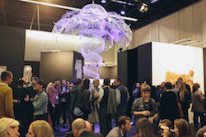Deadline: 31 July

BLOOOM Award by Warsteiner, the international competition for emerging artists, is now open for entries for 2016 and inviting artists around the world to participate.

Eligible for entry are artists who knowingly work at the interfaces between art and creative industries, whose works blur boundaries of traditional forms of expression. Visual arts, Design, Urban art or Video – the artistic potential is not limited in this competition.

This year, a total of ten 10 prizes will be awarded and they include exhibition and mentoring opportunities, sponsorships and trips to different art festivals. BLOOOM Award consciously takes responsibility for the participating artists and is distinguished by a long-term support. For one year, the winner will be actively supported in his/her career: As part of a one-year mentoring by one of the jury members, the winner defines goals with the mentor to boost his/her career. Next steps are planned together and the winner benefits from the contacts and experience of his mentor. (Information on selection panel: [**www.blooomawardbywarsteiner.com/Jury\_members**](http://scanmail.trustwave.com/?c=6600&d=2f3q11fTtd9HUCvOPL8ih8qB4Ijy_J98HaYqoxt70A&s=380&u=http%3a%2f%2fvisualartists%2eus9%2elist-manage1%2ecom%2ftrack%2fclick%3fu%3de67e46c7b14e756132f46a50c%26id%3d3806dd21ad%26e%3df4dbf7f416))

All ten finalists will get the chance to exhibit their works during BLOOOM – the converging art show in Cologne, Germany in front of 35,000 visitors.

Since its beginning in 2010, BLOOOM Award emphasizes interdisciplinarity, power of innovation, courage and progressiveness. For the last edition, more than 1,500 artists applied from 75 countries.

No entry fee. To apply see: [**www.blooomawardbywarsteiner.com/Application**](http://scanmail.trustwave.com/?c=6600&d=2f3q11fTtd9HUCvOPL8ih8qB4Ijy_J98Hacp9RN61w&s=380&u=http%3a%2f%2fvisualartists%2eus9%2elist-manage1%2ecom%2ftrack%2fclick%3fu%3de67e46c7b14e756132f46a50c%26id%3ded1b3432fe%26e%3df4dbf7f416)

**\_\_\_\_\_\_\_\_\_\_\_\_\_\_\_\_\_\_\_\_\_\_\_\_\_\_\_\_\_\_\_\_\_\_\_\_\_\_\_\_\_\_\_\_\_\_\_\_\_\_\_\_\_\_\_\_\_\_\_\_\_\_\_\_\_\_\_\_\_\_\_\_\_\_\_\_\_\_\_\_\_\_\_\_\_\_\_**

**NEW! Accepting Applications for VAI / DAS Residency Award 2016**

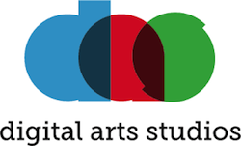

Application deadline: Midnight, July 29th, 2016  
Digital Arts Studios, 38-42 Hill St, Belfast

Applications are now being accepted for the 5th VAI @DAS Residency Award.

The award is open to all professional artists who are members of VAI. The residency at the Digital Arts Studios, Belfast, will run from October 2016 to January 2017 inclusive. The successful applicant will have their own MAC workstation in the shared studios with 24-hour access. They will also have access to a range of audio-visual equipment, assistance from DAS staff, providing the opportunity to develop their practice over the 4 months among a group of peer artists.

Apply online by submitting a proposal, examples of work and a CV at [**digitalartsstudios.com/residencies**](http://scanmail.trustwave.com/?c=6600&d=2P3q1xUHlw54DiYDsLZx_HVK0fGJ_2pAZURutENmIw&s=380&u=http%3a%2f%2fvisualartists%2eus9%2elist-manage1%2ecom%2ftrack%2fclick%3fu%3de67e46c7b14e756132f46a50c%26id%3d96ecc86c3d%26e%3df4dbf7f416)

**\_\_\_\_\_\_\_\_\_\_\_\_\_\_\_\_\_\_\_\_\_\_\_\_\_\_\_\_\_\_\_\_\_\_\_\_\_\_\_\_\_\_\_\_\_\_\_\_\_\_\_\_\_\_\_\_\_\_\_\_\_\_\_\_\_\_\_\_\_\_\_\_\_\_\_**

**NEW! Open Call for Exhibition Programme 2017, The Séamus Ennis Arts Centre, Co. Dublin**  
  
Category: Open Call  
Deadline: 20 September  
Web: [www.tseac.ie/page/apply-to-exhibit](http://scanmail.trustwave.com/?c=6600&d=pM7i12yOQajFCE1hfMU9hOP94_6BJw57h_QPBqPQ2A&s=380&u=http%3a%2f%2fcreate-ireland%2eus11%2elist-manage1%2ecom%2ftrack%2fclick%3fu%3dae8a0e4da904d891196932bf8%26id%3d295a1071d5%26e%3dff568af62e)   
Email: [info@tseac.ie](mailto:info@tseac.ie)  
  
The Séamus Ennis Arts Centre is currently looking for exhibition proposals from artists for solo/two person exhibitions in their Easter Snow Gallery for 2017. All 2D or wall mountable work acceptable including paintings, prints, drawings, photography, etc. Exhibitions will run for eight weeks.  
  
To submit a proposal send five images of recent work on a CD/USB key, Artist CV and Artist Statement/Exhibition Proposal to Colette Lawless, Séamus Ennis Arts Centre, Naul, Co. Dublin.  
  
Please contact Colette with any questions at [info@tseac.ie](mailto:info@tseac.ie)

**\_\_\_\_\_\_\_\_\_\_\_\_\_\_\_\_\_\_\_\_\_\_\_\_\_\_\_\_\_\_\_\_\_\_\_\_\_\_\_\_\_\_\_\_\_\_\_\_\_\_\_\_\_\_\_\_\_\_\_\_\_\_\_\_\_\_\_\_\_\_\_\_\_\_**

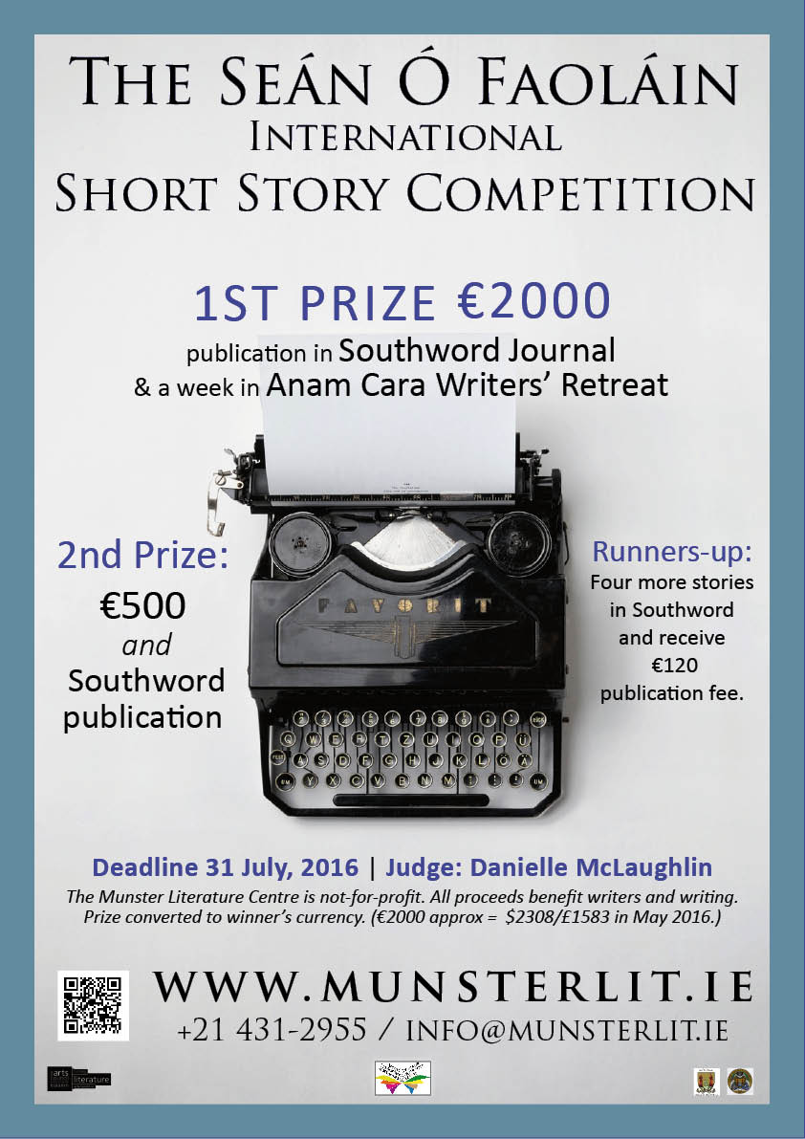

**\_\_\_\_\_\_\_\_\_\_\_\_\_\_\_\_\_\_\_\_\_\_\_\_\_\_\_\_\_\_\_\_\_\_\_\_\_\_\_\_\_\_\_\_\_\_\_\_\_\_\_\_\_\_\_\_\_\_\_\_\_\_\_\_\_\_\_\_\_\_\_\_\_\_\_\_\_\_\_\_\_\_\_\_\_**

**Per Cent for Art Commission | St. Raphael’s College, Loughrea, Co. Galway**

Deadline for Stage 1 entries: Monday 15 August, 12 noon.

St. Raphael’s for their Per Cent for Art project would like to commission a Professional Artist(s) who can provide them with a new, permanent artwork that would involve engagement with their students and staff. St. Raphael’s College was founded in 1917. It was originally a Mercy Sister’s Convent. They wish to have their Per Cent for Art Commission completed for the official opening of the new school building in September 2017 and to celebrate the school centenary.

**Total Budget**: €35,000 (inclusive of VAT).

Applicants are requested to read the full content of the briefing document carefully as it contains important information pertaining to all stages of the commission.

**Queries:**  
Applicants can make enquiries regarding the commission to Rina Whyte, email [**rinawhyte@yahoo.com**](mailto:rinawhyte@yahoo.com) or by telephone + 353 87 238 9591.

**\_\_\_\_\_\_\_\_\_\_\_\_\_\_\_\_\_\_\_\_\_\_\_\_\_\_\_\_\_\_\_\_\_\_\_\_\_\_\_\_\_\_\_\_\_\_\_\_\_\_\_\_\_\_\_\_\_\_\_\_\_\_\_\_\_\_\_\_\_\_\_\_\_\_\_**

**2016 Over The Edge New Writer of The Year competition**

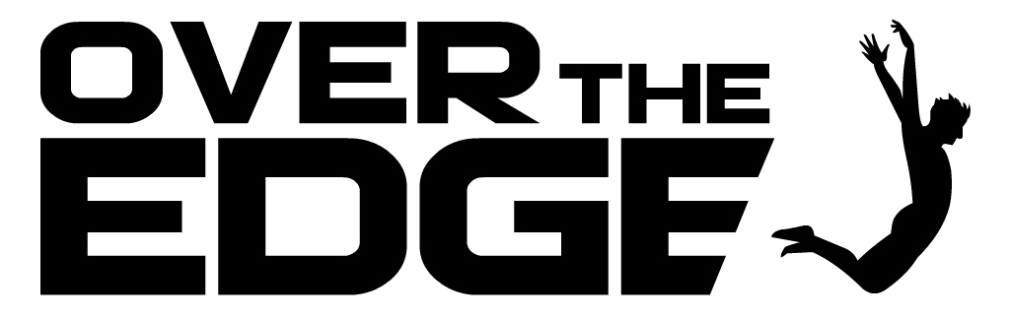

Competition judge: Niamh Boyce

Closing date: Wednesday, August 3rd , 2016

In 2016 Over The Edge is continuing its exciting annual international creative writing competition. Since its inception in 2007, it has grown to become one of the most important competition’s for emerging writers in Ireland and internationally. The competition is open to both poets and fiction writers worldwide. The total prize money is €1,000. The best fiction entry will win €300. The best poetry entry will win €300. One of these will then be chosen as the overall winner and will receive an additional €400, giving the overall winner total prize money of €700 and the title *Over The Edge New Writer of The Year 2016*. The 2016 Over The Edge New Writer of The Year will be a Featured Reader at Ireland’s leading literary reading series, the Over The Edge: Open Readings in Galway City Library, on a date to be scheduled in Winter 2016/17. [Salmon Poetry](http://scanmail.trustwave.com/?c=6600&d=uKvV1_C7H62XpQDu13p76LwimUA6_d2cjg2IFtQMoQ&s=380&u=http%3a%2f%2fwww%2esalmonpoetry%2ecom%2f) will read, without commitment to publish, a manuscript submitted to them by the winner in the poetry category. [Doire Press](http://scanmail.trustwave.com/?c=6600&d=uKvV1_C7H62XpQDu13p76LwimUA6_d2cjg3URoEK9g&s=380&u=http%3a%2f%2fwww%2edoirepress%2ecom%2fHOME%2ehtml) will read, without commitment to publish, a manuscript of short stories submitted to them by the winner in the fiction category. The overall winner will receive a hamper of books for the famous Kenny’s Bookshop of Galway, Ireland.The winner in the poetry category will have one of the poems from her or his winning entry published in the Spring 2017 issue of [*Skylight47*](http://scanmail.trustwave.com/?c=6600&d=uKvV1_C7H62XpQDu13p76LwimUA6_d2cjl2GR4cE8A&s=380&u=https%3a%2f%2fwww%2efacebook%2ecom%2fpages%2fSkylight-Poets%2f300308123389317) magazine.

 For all details and to enter see:

[www.overtheedgeliteraryevents.blogspot.com](http://scanmail.trustwave.com/?c=6600&d=uKvV1_C7H62XpQDu13p76LwimUA6_d2cjgeAR4EN8g&s=380&u=http%3a%2f%2fwww%2eovertheedgeliteraryevents%2eblogspot%2ecom)

**\_\_\_\_\_\_\_\_\_\_\_\_\_\_\_\_\_\_\_\_\_\_\_\_\_\_\_\_\_\_\_\_\_\_\_\_\_\_\_\_\_\_\_\_\_\_\_\_\_\_\_\_\_\_\_\_\_\_\_\_\_\_\_\_\_\_\_\_\_\_\_\_\_\_\_\_\_\_\_\_\_\_\_\_\_\_\_**

**Open Call | OpenART Biennial 2017, Sweden**

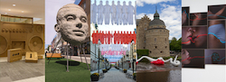

Deadline: 2 August

OpenART is Scandinavia’s biggest public art biennial and takes place in Örebro, Sweden. The city centre is filled with unexpected art that makes people feel happy, disturbed and provoked. Contemporary art from all over the world is showcased for almost three months in the city and offers unexpected encounters. The biennial challenges the visitors to rethink the perception of public space and our way of consuming and digesting art. The cultural exchange with the public is valued through several projects in connection to the exhibition like kids activities, a DIY art course and guided tours. OpenART 2017 will take place from 18 June to 10 September 2017.

Applications are made on the OpenART website, applicants must register and upload images directly at: [opencall.openart.se/Account/](https://opencall.openart.se/Account/Index?ReturnUrl=%2F)

You can enter 3 existing artworks or projects at most per application.  
The submission fee is 300 SEK (approx. €32).

Confirmed artists will receive an artist fee of €1000 (a confirmed group will share €1000), transport, travel and accommodation support. OpenART bears the cost for the transportation to and from the exhibition. In some cases OpenART also provides production support and in dialogue with the artist to find the most appropriate, time-efficient and cost-effective solutions. Artists are expected to participate in the installment of their own artworks. And are also invited to help fellow artists with production and installment on a voluntarily basis. All artists are invited to a set program on the opening weekend of OpenART 2017.

Please send your inquiries to [openart@orebro.se](mailto:openart@orebro.se)

**\_\_\_\_\_\_\_\_\_\_\_\_\_\_\_\_\_\_\_\_\_\_\_\_\_\_\_\_\_\_\_\_\_\_\_\_\_\_\_\_\_\_\_\_\_\_\_\_\_\_\_\_\_\_\_\_\_\_\_\_\_\_\_\_\_\_\_\_\_\_\_\_\_\_**

**Hennessy Portrait Prize 2016 l National Gallery of Ireland**

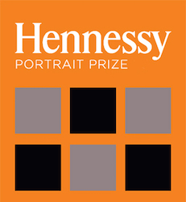

Deadline: 29 July

Application forms for the 2016 competition are now available to download, all submissions must be made online. The Hennessy Portrait Prize is open to artists across all disciplines and aims to encourage interest in contemporary portraiture and raise the profile of the National Portrait Collection. The winner will be announced in November and will once again receive a prize of €15,000 and a commission worth €5,000 to produce a portrait for inclusion in the National Portrait Collection.

For rules and application forms see: [**www.nationalgallery.ie/**](http://www.nationalgallery.ie/en/aboutus/ThisWeek/Hennessy_Portrait_Prize.aspx)

National Gallery of Ireland, Clare Street, Dublin 2

E: [**info@ngi.ie**](mailto:info@ngi.ie)  
T: (01) 661 5133

**Awards / Bursaries / Schemes**

**NEW! Arts Council Funding**  
  
Web: [http://www.artscouncil.ie/](http://scanmail.trustwave.com/?c=6600&d=pM7i12yOQajFCE1hfMU9hOP94_6BJw57h_BeUfDY2w&s=380&u=http%3a%2f%2fcreate-ireland%2eus11%2elist-manage1%2ecom%2ftrack%2fclick%3fu%3dae8a0e4da904d891196932bf8%26id%3db6a2b06d24%26e%3dff568af62e)  
  
**Arts Participation Bursary Award | Deadline: 14 July, 5.30pm**  
The purpose of the award is to support professional artists to develop their art practice. It provides artists with the time and resources to think, research, reflect and critically engage with their art.  
  
**Dámhachtain sparánachta litríochta don ghaeilge | Spriocdháta: an 14 Iúil, 5.30pm**  
Is é cuspóir na dámhachtana tacú le healaíontóirí gairmiúla a gcleachtas ealaíne a fhorbairt. Tugtar am agus acmhainní leis an dámhachtain d’ealaíontóirí smaoineamh, taighde agus machnamh a dhéanamh agus chun dul i ngleic go criticiúil lena gcleachtas ealaíne.  
  
**Literature Bursary Award - English language | Deadline: 14 July, 5.30pm**  
The purpose of the award is to support professional artists to develop their art practice. It provides artists with the time and resources to think, research, reflect and critically engage with their art.  
  
Please note: An Irish language Literature Bursary Award is also available. For details, please see: [Dámhachtain sparánachta litríochta don ghaeilge](http://scanmail.trustwave.com/?c=6600&d=pM7i12yOQajFCE1hfMU9hOP94_6BJw57h_QKAqbR2g&s=380&u=http%3a%2f%2fcreate-ireland%2eus11%2elist-manage1%2ecom%2ftrack%2fclick%3fu%3dae8a0e4da904d891196932bf8%26id%3ddd455462ce%26e%3dff568af62e)  
  
**Next Generation Bursary Award | Deadline: 14 July, 5.30pm**  
The Arts Council is committed to supporting emerging artists of promise. We acknowledge that artists work as lone practitioners and as collaborators in a wide range of contexts. The objective of the award is to support professional artists from across Ireland at an early stage of their career.  
  
It will prioritise those who;

* have innovative, ambitious and original ideas
* demonstrate potential to develop a distinctive practice
* show how they will benefit artistically from timely support for their artistic development.

**Traditional Arts Bursary Award | Deadline: 14 July, 5.30pm**  
The purpose of the award is to support professional artists to develop their art practice. It provides artists with the time and resources to think, research, reflect and critically engage with their art.

**Young People, Children, and Education Bursary Award | Deadline: 14 July, 5.30pm**  
The Young People, Children, and Education Bursary Award supports individual professional artists working with, and producing work for, children and young people across a range of artforms. The purpose of the award is to support professional artists to develop their art practice.

**Visual Arts Bursary Award | Deadline: 14 July, 5.30pm**  
The purpose of the award is to support professional artists to develop their art practice. It provides artists with the time and resources to think, research, reflect and critically engage with their art.

The maximum amount that may be awarded to each successful application is: €15,000

The objective of the Visual Arts Bursary Award is to support individual professional artists to develop their artistic practice.  
The award emphasises the value and benefit to an artist’s development derived from an extended process of engagement with their practice. The award seeks to provide artists with the time and resources to think, research, reflect and engage with their artistic practice. Potential proposals could be those that demonstrate:

* 􏰀 How the award will assist with the development of your artistic practice (this may include support with  
  time, workspace, research facilities, training, residencies, etc.)
* How the award will assist with developing and/or resolving a specific body of work
* How the award will assist with re-engaging with your practice after a break
* How the award will assist you in re-evaluating your practice after a continuous period of outcome-based and deadline-driven project work.

The award is open to practising visual artists working in all genres and at all stages in their professional careers. To be eligible to apply, applicants must:

* 􏰀 Be resident in the Republic of Ireland. There are certain exceptions where the Arts Council may deem eligible applications made by those based outside the Republic of Ireland. However, before admitting as eligible any such application, the Arts Council would need to be satisfied that the outcomes of any such proposal would benefit the arts in the Republic of Ireland.
* Be professional practising artists – although you might not earn income continuously or exclusively from your artistic practice, you must identify yourself, and be recognised by your peers, as a professional practising artist.

The Arts Council is committed to equity and inclusion, and welcomes applications from individuals or groups within culturally diverse communities and from people with disabilities.

All applications must be made through the Arts Council’s Online Services; applications made in any other way (by post, fax or email) will not be accepted.

\*\*\*\*\*\*\*\*\*\*\*\*\*\*\*\*\*\*\*\*\*\*\*\*\*\*\*\*\*\*\*\*\*\*  
The award guidelines can be downloaded from the [available funding](http://scanmail.trustwave.com/?c=6600&d=pM7i12yOQajFCE1hfMU9hOP94_6BJw57h_VcUvWMiA&s=380&u=http%3a%2f%2fcreate-ireland%2eus11%2elist-manage1%2ecom%2ftrack%2fclick%3fu%3dae8a0e4da904d891196932bf8%26id%3d5b1b03031f%26e%3dff568af62e) section of the Arts Council's website.  
  
Applications will only be accepted through the Arts Council's [online services website](http://scanmail.trustwave.com/?c=6600&d=pM7i12yOQajFCE1hfMU9hOP94_6BJw57h_cGBvbQjw&s=380&u=http%3a%2f%2fcreate-ireland%2eus11%2elist-manage1%2ecom%2ftrack%2fclick%3fu%3dae8a0e4da904d891196932bf8%26id%3d1c961fc782%26e%3dff568af62e) and all supporting material must be submitted online. Applicants who have not previously used the online services site must [register in advance](http://scanmail.trustwave.com/?c=6600&d=pM7i12yOQajFCE1hfMU9hOP94_6BJw57h_MICPCIhg&s=380&u=http%3a%2f%2fcreate-ireland%2eus11%2elist-manage1%2ecom%2ftrack%2fclick%3fu%3dae8a0e4da904d891196932bf8%26id%3d7f5f7b3462%26e%3dff568af62e) of making an application.  It may take up to five working days for your registrations to be confirmed so it is very important that you register as early as possible.

**\_\_\_\_\_\_\_\_\_\_\_\_\_\_\_\_\_\_\_\_\_\_\_\_\_\_\_\_\_\_\_\_\_\_\_\_\_\_\_\_\_\_\_\_\_\_\_\_\_\_\_\_\_\_\_\_\_\_\_\_\_\_\_\_\_\_\_\_\_\_\_\_\_\_\_\_\_\_\_\_\_\_\_\_\_\_**

**Of Interest**

**NEW! ‘SILENT MOVES’ short-listed for Modern Ireland in 100 Artworks**

‘Silent Moves’ a film by Aideen Barry, Western Care’s Ridgepool Training Centre and Scannán Technologies, hosted by Ballina Arts Centre and made possible through the IGNITE programme, funded by the Arts Council, ADI & Mayo County Council**,** has been shortlisted for **Modern Ireland in 100 Artworks** by the Irish Times.

The series **Modern Ireland in 100 Artworks**, a collaboration between **The Irish Times** **and the Royal Irish Academy,** is a transverse section of Ireland’s struggles with modernity since 1916. **If it tops the vote, Silent Moves, will become one of the 100 most important artworks of the last 100 years in Ireland.**

The collective talents of the 30 group members with the lead artists, created this wonderful, moving and hilarious film and the partnership is encouraging everyone in the county to get behind the film and to help to celebrate this wonderful acknowledgement of Arts & Disability in Mayo, by voting for the film at the following link. Voting closes on June 30th 2016.

[http://www.irishtimes.com/culture/books/modern-ireland-in-100-artworks-your-chance-to-choose-the-final-entry-1.2687124](http://scanmail.trustwave.com/?c=6600&d=ltrn1w5BPb2dTO26xhYuXHvnd51gZ0EzUFQ2qRXEzw&s=369&u=http%3a%2f%2fwww%2eirishtimes%2ecom%2fculture%2fbooks%2fmodern-ireland-in-100-artworks-your-chance-to-choose-the-final-entry-1%2e2687124)

****

**Every vote counts and you could help to share in this wonderful acknowledgement of Arts & Disability in Mayo!**

Inspired by the classic black and white silent films of Buster Keaton, Charlie Chaplin and Harold Lloyd, this silent filmis 28 minutes long, with a strong emphasis on movement and mime. Irish dance artist and choreographer Emma O’Kane, worked alongside Aideen Barry as the group developed their ideas and story boards into movement and gesture in front of the camera. Shot on location in Ballina, **Silent Moves** carries a strong message about attitudes towards disability while being funny, moving and beautiful to watch.

The project was made possible through an award to Ballina Arts Centre who hosted and managed the Mayo IGNITE project. IGNITE is a new platform designed to generate Ireland’s most ambitious showcasing of talent from people with disabilities, led by international and Irish artists and performers with disabilities. IGNITE is managed by a unique partnership involving the Arts Council, Arts & Disability Ireland (ADI), Cork City Council, Galway City and  County Councils and Mayo County Council. Last year the film toured to Dublin, Galway and Cork before a homecoming screening in Mayo Movie World in Castlebar.

[www.irelandignite.ie](http://www.irelandignite.ie)

**\_\_\_\_\_\_\_\_\_\_\_\_\_\_\_\_\_\_\_\_\_\_\_\_\_\_\_\_\_\_\_\_\_\_\_\_\_\_\_\_\_\_\_\_\_\_\_\_\_\_\_\_\_\_\_\_\_\_\_\_\_\_\_\_\_\_\_\_\_\_\_\_\_\_\_\_\_\_\_\_\_\_\_\_\_\_\_**

**NEW!**

**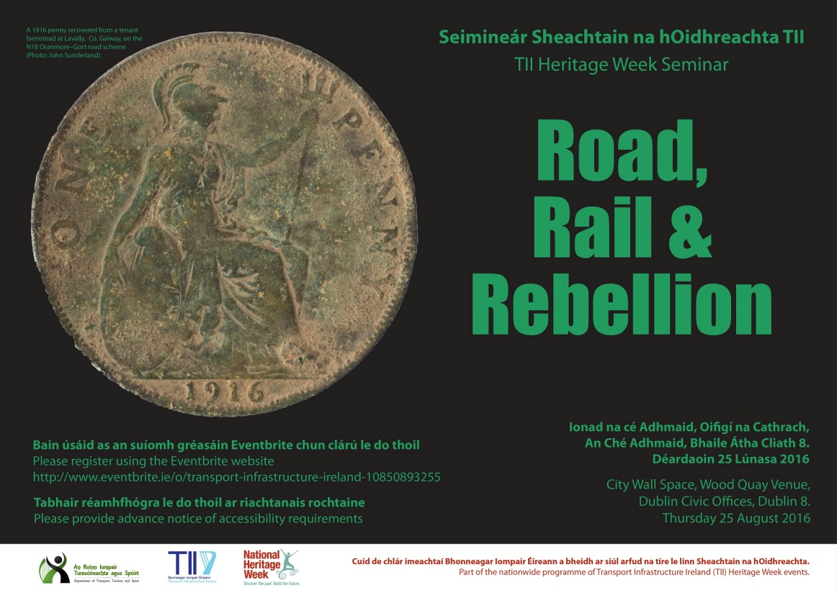**

**\_\_\_\_\_\_\_\_\_\_\_\_\_\_\_\_\_\_\_\_\_\_\_\_\_\_\_\_\_\_\_\_\_\_\_\_\_\_\_\_\_\_\_\_\_\_\_\_\_\_\_\_\_\_\_\_\_\_\_\_\_\_\_\_\_\_\_\_\_\_\_\_\_\_**

**NEW! Visual Artists Ireland advises an extra 48 Million Euro is possible for the Arts**

In a report to be issued next week, Visual Artists Ireland shows that the introduction of a tourist tax could raise over an additional 48,000,000 Euro for the cultural sector based on CSO statistics issued for bed nights in 2015.

The financial reality for the culture sector is such that organisations who have survived the draconian cuts to the central cultural budget are still suffering as they attempt to deliver quality art programmes across the country.  Our most recent 2016 report shows that 76% of visual artists in Ireland live under the poverty line. Reports from other art forms show similar figures. This decline mirrors the fall in core arts budgets and despite the one-off extra financial supports sent out by the Department of Arts, Heritage and the Gaeltacht pre-election, there appears to be only verbal promises and no concrete evidence that significant funding will be made available any time soon.

Following research into other areas of funding across Europe, it was seen that European countries who have introduced Tourist Bed Night taxes have seen little negative impact on their visitor numbers. In France a per person per night charge exists of up to €2. Germany breaks it down per region and can be either up to 5% or €1 to €3. Italy also breaks it down per region with rates between €1 to €5. Catalonia has also introduced the take of €.45 which includes cruise ships as well as other forms of tourist accommodation.

The CSO statistics show that Hotels, Guest Houses, and Bed & Breakfasts accounted for 24,104,000 bed nights in 2015. With a proposed levy of 2 Euro per person per night, the culture sector could gain an extra €48,208.000 to go towards a fair social welfare system for artists who have precarious incomes, and also go towards additional funds for the Arts Council who has the remit to support individual artists at all stages of their career and the arts organisations who work with them. If Rented house / Apartments are taken into the mix there is potential for an additional €18,858,000. Figures are unknown for cruise ship nights but it can be clearly seen that numbers become significant when spread across the entire tourist accommodation sector.

Noel Kelly, CEO of Visual Artists Ireland, stated “Visitor numbers are up, we need to guarantee that we give them what they and the Irish population deserve. The government has long asked for alternative routes to finding additional funding the the support of the arts. There is no one panacea, so we feel that as part of a blended funding strategy, this introduction would instantly bolster a group of people and organisations who are on their knees. The government supports for the big name projects is welcome, but we need this to have a long term sustainable source of core funding directed specifically at supporting artists and arts organisation.”

He added “Of course we expect resistance from the tourism industry to this idea, but from what we have read in international studies, the introduction of this form of taxation only hurts if operated on a small local basis rather than as a national strategy. We fear that Ireland can suffer from an insecurity in this matter and it is up to each of us to find ways to support the arts, which are a strong selling point for tourists and international corporates setting up in Ireland.”

**\_\_\_\_\_\_\_\_\_\_\_\_\_\_\_\_\_\_\_\_\_\_\_\_\_\_\_\_\_\_\_\_\_\_\_\_\_\_\_\_\_\_\_\_\_\_\_\_\_\_\_\_\_\_\_\_\_\_\_\_\_\_\_\_\_\_\_\_\_\_\_\_\_\_\_\_\_\_\_\_\_\_\_\_\_\_\_**

**NEW! Government announces change of Department title**

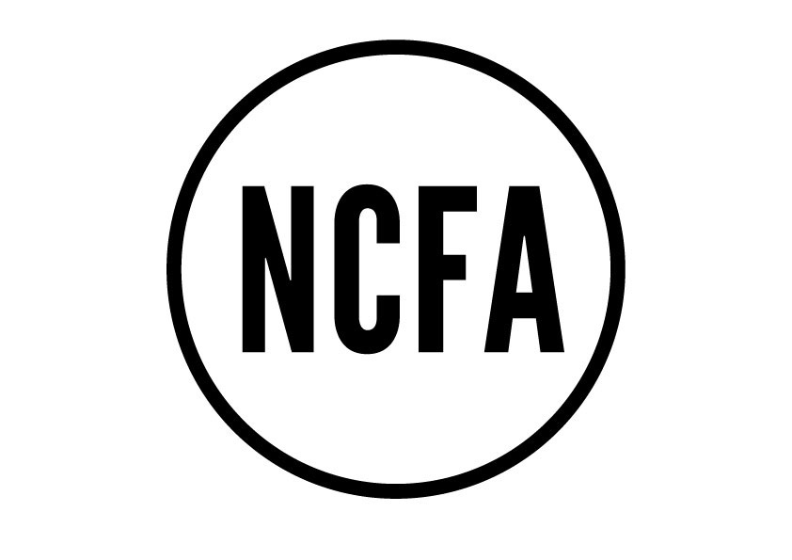

Government announces change of Department title to Arts , Heritage, Rural, Regional & Gaeltacht Development

Unanimous support for motion on the Arts as presented by Niamh Smyth TD (FF) by all parties to a full public gallery

Richard Boyd Barrett TD added an amendment to the motion calling for an increase in arts funding, to bring it in line with the European average of 0.6% of GDP

The National Campaign for the Arts was represented by a full public gallery in the Dáil and overflow rooms today on the occasion of a private members motion on the Arts by Niamh Smyth TF (FF). We welcomed the debate and motion as set out by Niamh Smyth, TD and that fact that this motion was accepted by all parties in the house.

Many of the speakers remarked how unusual it was to have such a large number of people in the public gallery; demonstrating the importance of this campaign.

The campaign noted the strong commitment on all sides of the house to the development and agreement of a new national cultural policy with real vision, ambition and concrete targets and looks forward to a robust, democratic process of policy making, involving all parties through the Joint Committee for the Arts as well as the Dáil.

The NCFA welcome that the government, in the course of this evening’s debate, announced a change of title for the department; which was read into the Dáil record by Minister of State Marcella Corcoran Kennedy, TD as The Department of Arts, Heritage, Rural, Regional & Gaeltacht Development.

The NCFA also welcomed the amendment to the motion by Richard Boyd Barrett, TD which included an increase in funding for the Arts to 0.6% of GDP which if adopted, would have a transformative effect on the Arts in Ireland.

During the course of the debate there were contributions by the following 26 Ministers and TDs:

Niamh Smyth (FF), Minister Heather Humphreys (FG), Minister Finian McGrath (Ind), Peadar Toibín (SF), Gerry Adams (SF), Aengus O’ Snodaigh (SF), Maurice Quinlivan (SF), Carol Nolan (SF), Joan Burton (Lab), Richard Boyd Barrett (AAA PBP), Mick Barry (AAA PBP), Maureen O’Sullivan (Ind), Thomas Pringle (Ind), Catherine Connolly (Ind), Michael Healy-Rae (Ind), Michael Collins (Ind), Danny Healy-Rae (Ind), Catherine Murphy (Soc Dem), Catherine Martin (Green), Micheál Martin (FF), Hildegard Naughton (FG), Tom Neville (FG), Junior Minister Marcella Corcoran Kennedy (FG),  Junior Minister Helen McEntee (FG), Kevin O’Keeffe (FF) and Aindrias Moynihan (FF).

The Campaign

Established in 2009 as a response to the McCarthy Report, The National Campaign for the Arts is a nationwide, volunteer-led, grass roots movement that makes the case for the Arts in Ireland.  The NCFA’s pre-election manifesto included calls on the government to:

1. Commit to increasing annual investment in Arts and Culture to 0.3% of GDP, taking us half way to the European average
2. Publish the cultural policy document Culture 2025 in draft form for interrogation by the Oireachtas Arts Committee.
3. Maintain on an annual basis, the €50 million allocated to the Department of Arts for 2016 commemorations, and ring-fence it for The Arts Council and The Irish Film Board.
4. Implement tax efficiencies/strategies to stimulate corporate and philanthropic giving
5. Create a new Arts fund from National Lottery funds.
6. Appoint an expert panel of Artists/Cultural Managers to function as Policy and Strategy Advisors to the Minister and the Department.

\* = Assessment of the Economic Impact of the Arts in Ireland 2011, prepared by Indecon International Economic Consultants

For further information, visit [www.ncfa.ie](http://www.ncfa.ie/).

**\_\_\_\_\_\_\_\_\_\_\_\_\_\_\_\_\_\_\_\_\_\_\_\_\_\_\_\_\_\_\_\_\_\_\_\_\_\_\_\_\_\_\_\_\_\_\_\_\_\_\_\_\_\_\_\_\_\_\_\_\_\_\_\_\_\_\_\_\_\_\_\_\_\_\_**

**NEW! What Next? | Weekly meeting next Wednesday 29 June, 8.30am**

Next weeks’s What Next? meeting to discuss ways in which to move the campaign forward will take place on Wednesday 29th of June at 8.30am to 10am. The meeting is open to cultural practitioners from all disciplines and supporters of the arts.

Location:  
VAI  
7-9 Central Hotel Chambers,  
Dame Court,  
Dublin 2

Wednesday 29 June, 8.30am

**Discussed at meeting on 22 June:**

Recognition of the value of culture in:  
– Policy  
– Status of the artist  
– Art in Education

Difficulties faced by all artists in securing equitable payment and how this might be changed  
– Solidarity on Payment Guidelines. Non compliance with unfair conditions (exhibitions/institutions that don’t pay artist fees)  
– Acknowledgement of exhibitions/institutions that comply with Artist Payment Guidelines  
– Lobby Arts Council and local authorities to adopt an evaluation system to asses organisations in receipt of funding on their compliance to Payment Guidelines

Tourist Tax / Patronage Tax  
– Should Ireland implement a Tax on Bed Nights, a system used in many EU countries (France, Germany, Italy and more)  
– Visual Artists Ireland shows that the introduction of a tourist tax could raise over an additional 48,000,000 Euro for the cultural sector based on CSO statistics issued for bed nights in 2015

Dáil debate on the Arts to take place on 22nd June at 4.30, expectation of high attendance of cultural practitioners in the visitor gallery

Future What Next? meetings  
– see if there is interest in alternating the times of the meetings every two weeks, 8.30am one week, 6.30pm the following  
– Aim to have monthly meetings in a larger public space  
– part of the monthly meeting to allow a platform for representatives from different cultural backgrounds to detail issues specific to visual art/theatre/dance/music/literature in order to find common ground and clarify message

**Discussed at meeting on 15 June:**

Public Engagement:

How the campaign can galvanise the support of the public to communicate the value of our culture to government and connect across cultural disciplines.  
Open discussion about plans for the coming weeks and months.

Political Updates:

NCFA Constituency reps have been meeting with TD’s in their regions and it is having an impact.  
On Tuesday 14 June, NCFA met with Brendan Howlin, Joan Burton and Kevin Humphreys. Following this, Mr. Howlin has since secured the agreement of the Taoiseach that the draft cultural strategy (Culture 2025) will be referred to the Oireachtas Committee for debate and amendment prior to finalisation.  
Fianna Fail have put forward a motion on Arts to be discussed in the Dail next Tuesday evening (21/06)

**\_\_\_\_\_\_\_\_\_\_\_\_\_\_\_\_\_\_\_\_\_\_\_\_\_\_\_\_\_\_\_\_\_\_\_\_\_\_\_\_\_\_\_\_\_\_\_\_\_\_\_\_\_\_\_\_\_\_\_\_\_\_\_\_\_\_\_\_\_\_\_\_\_\_\_\_\_\_\_\_\_\_\_\_\_\_**

### NEW! The Possibilities of Place | 9 Stones Artists’ 10 Year Exhibition at Visual Carlow

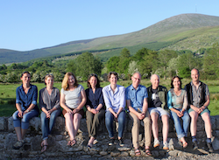

2 July to 16 October 2016 |  Season launch: 10 July, 3pm  
Visual Centre for Contemporary Art, Carlow

The Possibilities of Place – 9 Stones Artists’ 10 year celebration exhibition. New works by Rachel Joynt RHA, Anthony Lyttle, Remco de Fouw ARHA, Michelle Byrne, Annabel Konig, Gwen Wilkinson, Martin Lyttle, Jules Michael and Cathy Fitzgerald will be on display. In conjunction with this exhibition the group is launching an anniversary publication kindly supported by the Carlow Arts Office. The work of each member is generously presented and a specially commissioned essay by Cliodhna Schaffrey also features.

On the 10th of July there will be the “Season Launch” of all the exhibitions at Visual at 3pm and there may be a short panel discussion also. This would be a friendly talk and involve the artists involved in the all the shows at Visual.

[**www.facebook.com/events/542803929260389/**](http://scanmail.trustwave.com/?c=6600&d=55vv19IXhINzKVfhD4F8f6yEoCCu1Ianyxzp0Z61MQ&s=380&u=http%3a%2f%2fvisualartists%2eus9%2elist-manage%2ecom%2ftrack%2fclick%3fu%3de67e46c7b14e756132f46a50c%26id%3d4faad20538%26e%3df4dbf7f416) |  [**9stones.wordpress.com/**](http://scanmail.trustwave.com/?c=6600&d=55vv19IXhINzKVfhD4F8f6yEoCCu1Iany0K8hc2yPA&s=380&u=http%3a%2f%2fvisualartists%2eus9%2elist-manage%2ecom%2ftrack%2fclick%3fu%3de67e46c7b14e756132f46a50c%26id%3ddb2723b959%26e%3df4dbf7f416)

**\_\_\_\_\_\_\_\_\_\_\_\_\_\_\_\_\_\_\_\_\_\_\_\_\_\_\_\_\_\_\_\_\_\_\_\_\_\_\_\_\_\_\_\_\_\_\_\_\_\_\_\_\_\_\_\_\_\_\_\_\_\_\_\_\_\_\_\_\_\_\_\_\_\_\_**