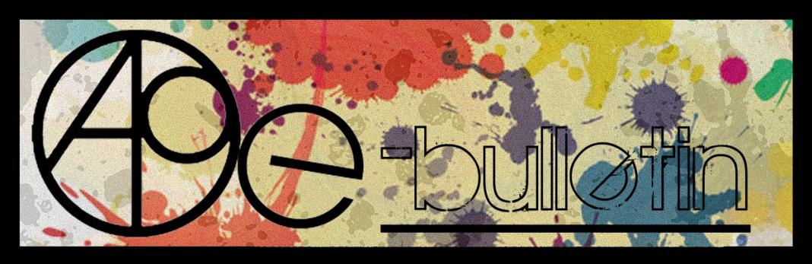

**Kilkenny County Council Arts Office E-bulletin 25th September 2015**

Dear All,   
  
Welcome to the fortnightly e-bulletin from Kilkenny County Council's Arts Office. Each bulletin is packed with the latest information on Kilkenny Arts Office activities, county events as well as news and opportunities for arts practitioners from around the country.

This service will be provided fortnightly. To include an item in the next e-bulletin please send a brief outline of your advert with relevant contact details, including any websites or pages with links to [**julie.mcguirk@kilkennycoco.ie**](mailto:julie.mcguirk@kilkennycoco.ie) **before 8th October**. The next e-bulletin will be on the **9th October.**

While every effort has been made to ensure the accuracy of our information, we strongly advise readers to verify all details to their own satisfaction.

Regards,

Julie McGuirk  
Arts Office,  
T: 056 7794547  
E: [julie.mcguirk@kilkennycoco.ie](mailto:julie.mcguirk@kilkennycoco.ie)   
W: [www.kilkennycoco.ie/eng/Services/Arts/](http://www.kilkennycoco.ie/eng/Services/Arts/)

BECOME PART OF IT, SUBMIT A POEM.....[www.rhymerag.net](http://kk-moss/Sites/arts_office/Shared%20Documents/Julianne%20Morgan/E-bulletin/30th%20May%20e-bulletin/www.rhymerag.net)  
Kilkenny County Council Arts Office Partner Local Authority of the ArtLinks Programme [www.artlinks.ie](http://www.artlinks.ie)

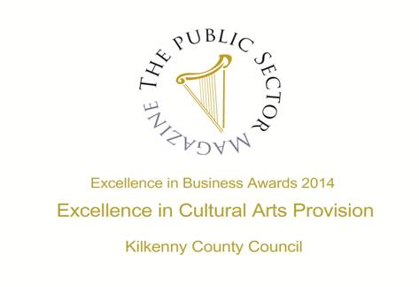

|  |  |
| --- | --- |
|  |  |
|  |  |

**Arts Office**

* Autumn 2015 Adult Writers’ Workshop for beginners announced!
* Broadsheet 15 now available at all Kilkenny Library branches
* The Brewery Project in association with Heritage Tales presents The Last Brewey
* Black Stack Studio Workshops
* Song: Little Black Wren - Heart on a String (Official)

**Kilkenny Events**

* Autum Workshops at Black Stack Studios
* Cats Theatre Group Presents ‘The Elephant man’
* Graphic Novel Course
* Gowran Little Theatre: A Wake in the West
* Music in Kilkenny Autumn 2015
* Culture 2025 – National Cultural Policy Regional Consultation Meetings.
* Three Sisters 2020 Voice Box Series: KCAT Callan

**Courses / Training / Jobs / Internships**

* JobBridge internships at craft enterprises
* National Craft Gallery Education Support Internship
* National Youth Council of Ireland Announces New Youth Arts Advocacy and Leadership Training - DEADLINE APPROACHING!
* Certificate in Youth Arts - Open for Applications
* SYMPOSIUM: Making Design Matter: [Irish Design 2015](http://www.eventbrite.ie/o/irish-design-2015-7957716800)

**Call for Submissions / Residencies**

* Invitation to Tender - Spirituality Training Programme
* Profile Your Public Art in the November/December Issue of Visual Artists’ News Sheet

**Awards / Bursaries / Schemes**

* Culture Ireland’s annual funding
* Art Council of Northern Ireland Travel Awards
* Arts Council Festivals and Events Funding
* Fulbright Awards to Study, Research or Teach in the US

**Of Interest**

* Design Heroes: Miroslav Havel at the Index Gallery, Waterford
* National Choral Singing Week
* Poetry Aloud Poetry Speaking Competition for post-primary schools announced
* Posters of Protest and Revolution at The National Print Museum

**Arts Office**

**Autumn 2015 Adult Writers’ Workshop for beginners announced!**

**As part of our on-going commitment to Kilkenny writers, Kilkenny County Council Arts Office & Library Service would like to announce their adult Autumn 2015 Writers’ Workshop for beginners**

**Creative Prose**

**Dates: Friday’s 9th, 16th and 23rd October and 6th, 13th and 20th of November 2015**

**Duration: 6 weeks**

**Venue: Loughboy Library, Kilkenny  
Time: 6pm - 8pm**

**Cost: €45 / €40 concession**

This six week course is suitable for those who are new to creative writing. The emphasis will be on writing itself, based on the premise that the best way to learn how to write, is to write! However, participants will discuss many aspects of the written word throughout the course. As a starting point, participants will ask, why do we write? Then go on to discuss areas such as dialogue, characterisation, theme, inspiration, imagination, the importance of empathy and passion and the nature of creativity itself. Briefly explored will be the topics of memoir writing and journal keeping - the idea of writing itself as therapy. Throughout the weeks will also explore the works of great authors past and present and get a sense of their methods and motivations. This list is by no means prescriptive or exhaustive. There will be a degree of flexibility built into the format, based on the needs and desires of the participants. The emphasis will be on fun and self-expression, with the ultimate aim of each of the students producing their own works of art, unique to themselves, in an atmosphere that is both safe and nurturing.

*Tara Heavey read modern English at Trinity College Dublin. She has had five novels published internationally, in countries such as Croatia, Spain, Germany, Holland, England, Australia and the U.S. She has also had short stories published, together with various articles in the national press. She is currently working on a new novel. She lives in County Kilkenny with her family.*

**Poetry**

**Tutor:** **Mark Roper**

**Dates: Wednesday’s 7th, 14th and 21st of October and 4th, 11th**

**and 18th of November 2015**

**Duration: 6 weeks**

**Venue: Ferrybank Library, Kilkenny  
Time: 3-5pm**

**€45 / €40 concession**

This six week course is aimed at those who have always wanted to have a go at making a poem. It requires no previous experience. The course will begin with the tutor, an experienced creative writing teacher, bringing in examples of what he considers to be successful modern poems. The class will discuss these poems, and will work out together what elements are important for their success. At all times participants will be encouraged to express their opinions and to share their thoughts. The course tutor is a firm believer in the fact that starting to write works best in a social setting. The next class will introduce participants to the importance of the line and the linebreak in a poem. One of the most distinguishable features of a poem is that it doesn’t run right across the page, it stops halfway! Why is this? What is to be gained from continually starting a new line? This will lead on to a discussion of form in poetry, and the crucial importance of sound. A series of guided writing exercises will take place in the class, offering participants a safe haven to have a go at making their own poem. The course will be reasonably flexible as it proceeds, with the tutor responding to the make-up and the needs of the group. The aim will be to create a warm working environment in which students can learn, participate, enjoy themselves and create.

*Mark Roper moved to Ireland from England in 1980. He has published 6 collections of poetry. His latest collection, A Gather of Shadow, Dedalus 2012, won the Michael Hartnett Award in 2014 and was shortlisted for The Irish Times Poetry Now Award in 2013. Mark was Editor of Poetry Ireland for 1999. The River Book: A Celebration of the Suir, a collaboration with photographer Paddy Dwan, was published, to much acclaim, in 2010. A second collaboration with Paddy Dwan, The Backstrand: Tramore’s Open Secret, was published in 2013. The pair are currently at work on a book about the Comeragh Mountains. The Invader, an opera composed by Eric Sweeney to a libretto by Mark Roper, was premiered in Ireland in May 2014. An experienced Creative Writing teacher, Mark has run courses and workshops in many different settings, including schools, prisons, and senior citizen centres. From September 2002 to May 2003 he was writer-in-residence at Waterford Regional Hospital.*

**Deadline for Bookings is 4pm on Monday 5th October.**

**Participants are expected to sign up and commit to the 6 weeks of their chosen course. There is a nominal fee of €45 / €40 concession to secure your place in the course. Places are limited to 12 participants per course so please book early to avoid disappointment. Do note that these workshops are at a beginners level.**

**To secure a place on the above courses please contact the Arts Office on 056 7794547/ or email** [julie.mcguirk@kilkennycoco.ie](mailto:julie.mcguirk@kilkennycoco.ie)

**Broadsheet 15 now available at all Kilkenny Library branches**

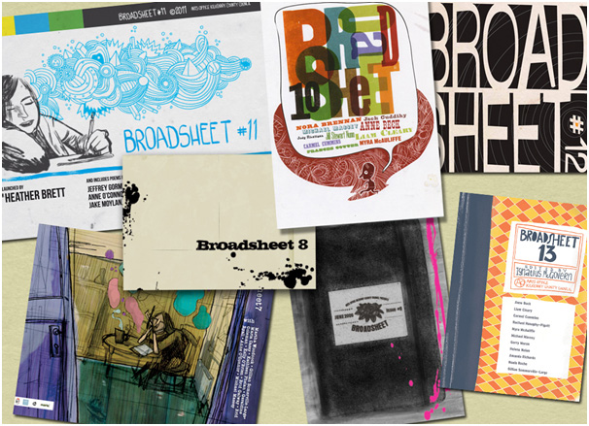The 2015 edition of the [Kilkenny Arts Office](https://www.facebook.com/KilkennyArtsOffice) poetry Broadsheet is now available at all Kilkenny Library branches.

The Broadsheet 15 was launched to great success during this year's Kilkenny Arts Festival. It features the work of 9 local poets and was edited by [Tony Curtis (Irish poet)](https://www.facebook.com/pages/Tony-Curtis-Irish-poet/107436395952621)

Pick up your free copy today at all [Kilkenny County Library](https://www.facebook.com/pages/Kilkenny-County-Library/150354328360198) branches!

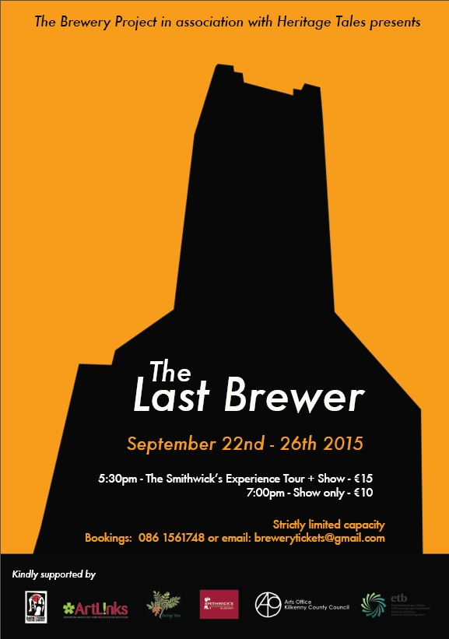

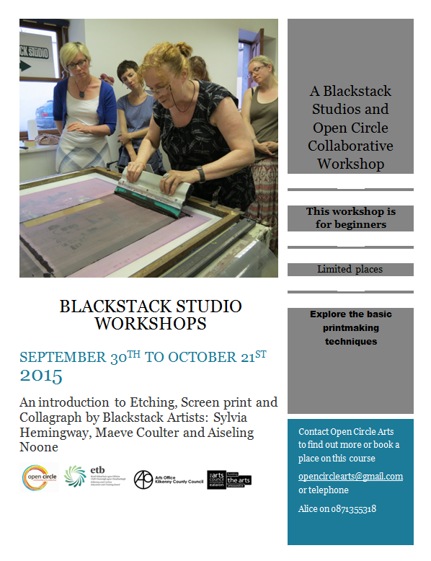

**Little Black Wren – Heart on a String**

This music video collaboration was made possible by the support of ArtLinks partnership programme - Kilkenny, Carlow, Waterford and Wexford Local Authorities and the Art Council of Ireland. Single available for download from iTunes:  
[https://itunes.apple.com/ie/artist/li...](https://itunes.apple.com/ie/artist/little-black-wren/id782679081)

For full video see: https://www.youtube.com/watch?v=NyjhFsnuq3E&feature=youtu.be

Song:  
Little Black Wren - Heart on a String  
Written and performed by Little Black Wren  
Piano and string arrangement by Gavin Murphy <http://www.gavinmurphy.ie/>  
Recorded, Mixed & Mastered by Jed Parle at Crossroads Recording, Ballycallan, Co Kilkenny, Ireland [http://www.crossroadsrecording.ie](http://www.crossroadsrecording.ie/)  
  
Video:  
Camera, lighting and editing by Alan Slattery of Mycrofilms www.mycrofilms.com  
Choreographed by Deirdre Grant  
Dancer - Susie Lamb  
Filmed on location at Fennelly's, Callan, Co Kilkenny, Ireland   
  
HEART ON A STRING  
  
You've got my attention  
Would you like a piece of this puzzle  
Are you feeling bright  
Will you take more than you can chew  
Like a girl feeling blue  
There's a radio playing in a different room  
Would you find it before noon breaks us down  
  
Heart on a string  
Is ripping me ripping me ripping me ripping me  
Heart shakes a rocking boat at sea  
How will you find me?  
  
You've got my affection  
If you like there's that shiny new hotel  
For this night  
I might be cold, cold as ice  
For the drinks that we'll drown in  
There's a rooftop we can dance over on the way  
I'm familiar with such terrain from those good old dark days  
  
Heart on a string  
Is ripping me ripping me ripping me ripping me  
Heart shakes a rocking boat at sea  
How will you find me?  
  
Heart on a string  
Is ripping me ripping me ripping me ripping me  
Heart shakes a rocking boat at sea  
How will you find me?

**Kilkenny Events**

**Blackstack Autumn Workshops**



**42 Parliament St., Kilkenny**  
[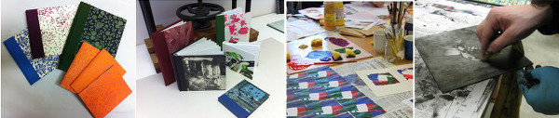](http://www.blackstackstudio.com/v1/wp-content/uploads/2011/08/workshopimage.jpg)  
  
Bookings can be made on the website [www.blackstackstudio.com](http://www.blackstackstudio.com), or by    
emailing [sylvia@blackstackstudio.com](mailto:sylvia@blackstackstudio.com)  
Special workshops can also be arranged for groups of 3 or 4 people    
(email as above)  
  
WORKSHOPS:-  
  
SCREENPRINTING: Weekend 3rd & 4th  October. 10am-4pm    
This is a beginners or refreshers screenprinting class for visual artists. You will learn how to make screenprints with photographic or hand drawn imagery. Cleaning and coating the screen, exposing the image, and registration and printing will all be covered.

Tutor:  Aiseling Noone  
  
COLLOGRAPH PRINTING: 2 Saturdays  17rd & 24th October. 10am-4pm   
A collograph is made by printing from a surface of collaged textures. Participants will learn how to make their own collograph plates and print using the ?à la poupée? method; a way of creating a multicoloured print using just one plate. Chine Collé will also be    
introduced as a way of adding colour.

Tutor: Maeve Coulter  
  
EXPERIMENT WITH PRINTMAKING;  Saturday 7th November  10am-4pm   
This workshop is for beginners or improvers. In this one-day workshop you will be able to explore and experiment with the basic printmaking techniques of drypoint, etching, chine colle or carborundum or you can further develop plates you already have using these techniques. A second day can be added if enough participants require.

Tutor: Sylvia Hemmingway  
  
SCREENPRINTING: Weekend 21st & 22nd November. 10am-4pm    
This is a beginners or refreshers screenprinting class for visual artists. You will learn how  to make screenprints with photographic or hand drawn imagery. Cleaning and coating the screen, exposing the image, and registration and printing will all be covered.

Tutor: Aiseling Noone  
  
DRYPOINT : Saturday 28th November. 10am-4pm   
Participants will get hands-on experience of this direct form of    
printmaking, which is especially suited to beginners. You will get the    
opportunity to try out different tools and experiment with mark making    
for a variety of effects. You will learn how to incise a plate and    
ink, wipe and print your image on to dampened paper using oil based    
inks. Tutor: John Busher

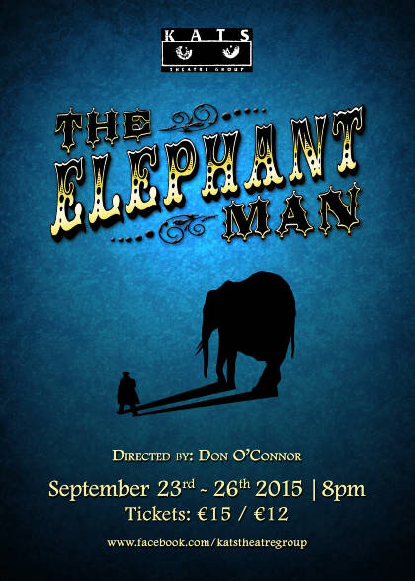

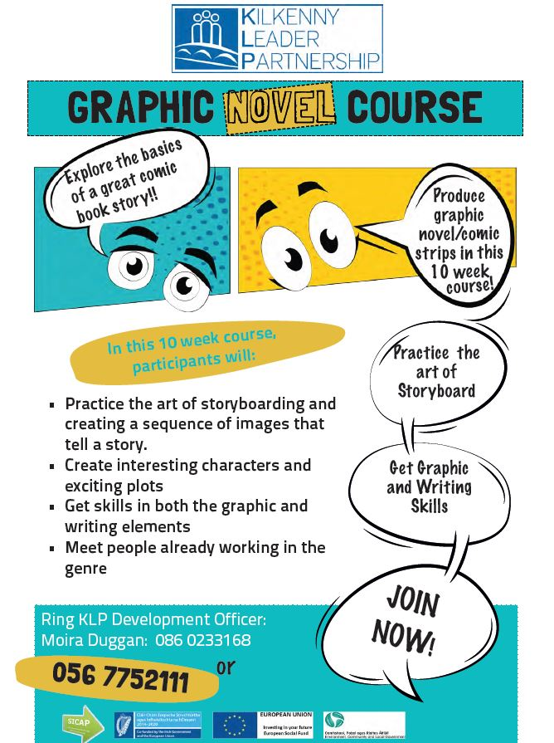

**Gowran Little Theatre: A Wake in the West**

Gowran Little Theatre will stage "A Wake in the West" October 16th -19th 8pm-10pm.

<Tel:0871331130>

**Music in Kilkenny Autumn 2015**

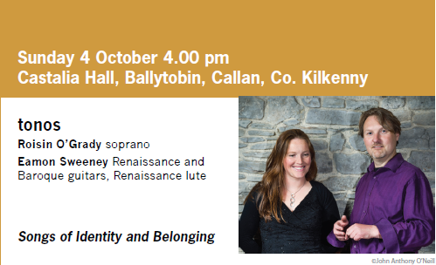

tonos specialise in the music of the 16th–18th centuries. Songs record the beating heart of a culture – preserving the feelings and beliefs of ages past. In this concert tonos perform songs and instrumental music from across the centuries – including the earliest known complete song dating from 2000 years ago. Songs which focus on universal themes – nationhood, religion, love, mortality. Songs from Ireland, Italy, England, France, Spain, Greece.

Press Quote: O'Grady has a beautiful voice, full of emotion... Sweeney was the perfect complement. Classical Guitar MagazineA 2-day course focusing on the photo stencil technique of screen printing (a durable semi permanent stencil). The screen is coated with light sensitive emulsion and left to dry. A b&amp;w image on a translucent surface is placed against the screen and exposed to UV light causing the emulsion to bind and harden to the mesh surface of the screen. Participants will  
learn how to prepare and create b&amp;w images for screen using hand drawn or digital imagery, as well as experimenting with different printed imagery, print surfaces, registration, colour-layering and mixing and much more. A thorough introduction for those wishing to begin screen-printing on fabric or those looking to refresh their skills.  
A basic supply of materials is included in fee.

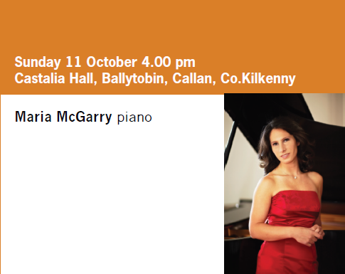

**Maria McGarry** is one of Ireland’s leading pianists. Awarded the prestigious ‘Artist Diploma in Performance’ from The Juilliard School, she enjoys a successful career that has taken her across Europe, North America and Asia. She has performed at venues such as London’s

Wigmore Hall, Warsaw’s Philharmonie, Geneva’s Palais de Nations, the Aspen Music Festival and has represented Ireland at international cultural events including the EU Culture Weeks in New Delhi and the European Biennale for Young Artists in Bari. Following a successful debut recital at the NCH in 2002, Ms. McGarry is much sought after as a soloist and chamber musician in Ireland. Her recent performance of Beethoven's 2nd Piano Concerto with RTENSO received positive critical reviews and a standing ovation.printblock.ie

A 2-day course focusing on the photo stencil technique of screen printing (a durable semi permanent stencil). The screen is coated with light sensitive emulsion and left to dry. A b&amp;w image on a translucent surface is placed against the screen and exposed to UV light causing the emulsion to bind and harden to the mesh surface of the screen. Participants will  
learn how to prepare and create b&amp;w images for screen using hand drawn or digital imagery, as well as experimenting with different printed imagery, print surfaces, registration, colour-layering and mixing and much more. A thorough introduction for those wishing to begin screen-printing on fabric or those looking to refresh their skills.  
A basic supply of materials is included in fee.

printblock.ie

[http://visualartists.ie/…/screen-printing-on-textiles-cour…/](http://visualartists.ie/jobs-ops/courses/screen-printing-on-textiles-course-dublin/)

A 2-day course focusing on the photo stencil technique of screen printing (a durable semi permanent stencil). The screen is coated with light sensitive emulsion and left to dry. A b&amp;w image on a translucent surface is placed against the screen and exposed to UV light causing the emulsion to bind and harden to the mesh surface of the screen. Participants will  
learn how to prepare and create b&amp;w images for screen using hand drawn or digital imagery, as well as experimenting with different printed imagery, print surfaces, registration, colour-layering and mixing and much more. A thorough introduction for those wishing to begin screen-printing on fabric or those looking to refresh their skills.  
A basic supply of materials is included in fee.

printblock.ie

[http://visualartists.ie/…/screen-printing-on-textiles-cour…/](http://visualartists.ie/jobs-ops/courses/screen-printing-on-textiles-course-dublin/)

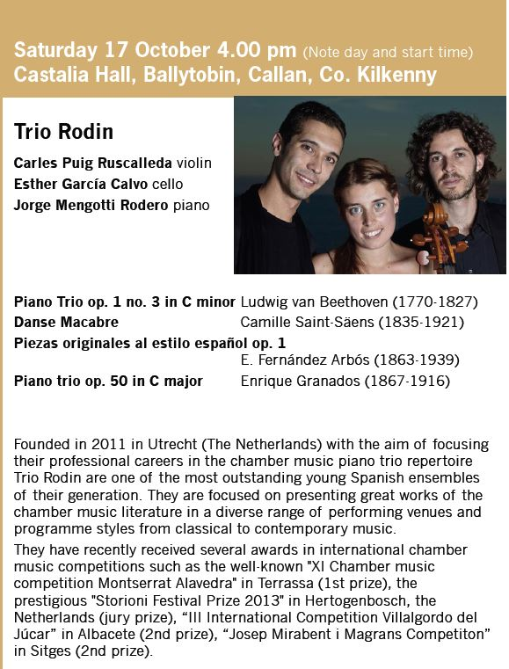

**Culture 2025 – National Cultural Policy Regional Consultation Meetings.**

Parade Tower, Kilkenny – 13th October 2015.  
Time : 2.30 p.m. to 5.00 p.m.  
To cater for members of the public in Kildare, Offaly, Laois, Wicklow, Carlow, Wexford and Kilkenny.

You need to register to attend only 100 places!

Background  
On 7th August 2015 the Minister for Arts, Heritage and the Gaeltacht, Ms Heather Humphreys T.D. launched the National Cultural Policy - Culture 2025 - Discussion Document This discussion document has been informed by a colloquium of cultural stakeholders that was organised by the Department, in association with the Royal Irish Academy (RIA), on 25th May 2015.  
In this document the Minister stated that, over the next number of months, there would be an in-depth consultation process about Culture 2025 with all relevant stakeholders in the cultural sector and across all strands of society. As part of this process the Minister has announced a series of regional public meetings throughout the country which will culminate in an Open Policy Debate on Culture 2025 which will take place in Dublin on 19th October 2015. These meetings are being organised by the Department of Arts, Heritage and the Gaeltacht in conjunction with the Local Authority Arts Officers.

1. Meetings  
There will be five regional meetings culminating in a sixth one-day Open Policy Debate in Dublin.  
The purpose of the meetings will be to discuss the issues raised in the Culture 2025 Discussion Document.  
The regional meetings will be of half day duration and while being open to the public will be limited to one hundred per meeting. The Dublin meeting will be all day event and will be limited to two hundred. Those who wish to attend should register with the Department by email beforehand.

The meetings arranged are as follows:

Cavan, Town Hall – 15th September 2015.   
Time : 2.30 p.m. to 5.00 p.m.   
To cater for members of the public in Cavan, Monaghan, Leitrim, Longford, Westmeath and Donegal.

Cork, City Hall: - 25th September 2015.   
Time : 10.00 a.m. to 12.30 p.m.  
To cater for members of the public in Cork and Kerry.

Galway, Town Hall Theatre – 2nd October 2015.   
Time : 10.00 a.m. to 12.30 p.m.  
To cater for members of the public in Galway, Mayo, Sligo and Roscommon.

Limerick, Hunt Museum - 8th October 2015.  
Time : 2.30 p.m. to 5.00 p.m.  
To cater for members of the public in Limerick, Clare and Tipperary.

Kilkenny, City Offices – 13th October 2015.  
Time : 2.30 p.m. to 5.00 p.m.  
To cater for members of the public in Kildare, Offaly, Laois, Wicklow, Carlow, Wexford and Kilkenny.

Dublin, Open Policy Debate, Great Hall, Royal Hospital Kilmainham (Irish Museum of Modern Art) – Monday 19th October 2015.   
Time: 9.30 a.m. to 4.00 p.m.  
To cater for members of the public in Dublin, Louth and Meath.

2. Attendance at meetings  
Attendance at the regional meetings will be limited to 100 per meeting while attendance at the Dublin meeting will be limited to two hundred.   
People wishing to attend should register at [https://www.surveymonkey.com/r/YTQMNLC](https://www.facebook.com/l.php?u=https%3A%2F%2Fwww.surveymonkey.com%2Fr%2FYTQMNLC&h=kAQE_pnIsAQGJcg_l1TYFL6BskEX71YChNPoOG_hsrdoZKQ&enc=AZMGjgv5AYHCwTC8pz-jXGIQkqR08sgCbhdEFKGXvIew8VGyINVICLxockoIHkIRcHbBY9M8Fo5LE0KYen01DXOKkmTlkAgPnbVtFPgvf5-DQHwiZRsjvZefmy9KMnOuT8_S-NmJoQs8ssq-KiNsWMlsqMOBDEFFdDdz4LgjD8WYo84NEkBWw02ZlypDb37V2BaZu4YNaQg0DchstqyfCHC1&s=1) indicating the preferred meeting:  
A copy of the Culture 2025 Discussion Document is also available at [http://www.ahg.gov.ie/en/Culture/Culture2025/](http://l.facebook.com/l.php?u=http%3A%2F%2Fwww.ahg.gov.ie%2Fen%2FCulture%2FCulture2025%2F&h=NAQEEARP6AQEX1JIqXPZVW5zCdW7qtN_SQqYHsp_BppJgLQ&enc=AZP6NwlETcfCcpV1I80EqOueLWtiKkJwsR6rV7IgVg3RAwoVpFkILmSgUZ7fLoHEPvim0SrdsCoGSmT_8sII6ujB9MOPaDNaP8W0DgYIe9EWCgmlyq5k0R83_A6h5KIzFLUs-YQuQNIRuesVp-vZH28CAdsyFxlmBk7mMVnj3z_9KxIVztgZkcqmCKK6wGnoKgh9tw1CvXuwHtjNSRgy6hzz&s=1)

3. Submission of comments  
You can submit your comments to writing to:  
Culture 2025  
Cultural Institutions Unit  
Department of Arts, Heritage and the Gaeltacht  
New Road  
Killarney  
Co. Kerry  
or by email to culturalpolicy@ahg.gov.ie  
September 2015

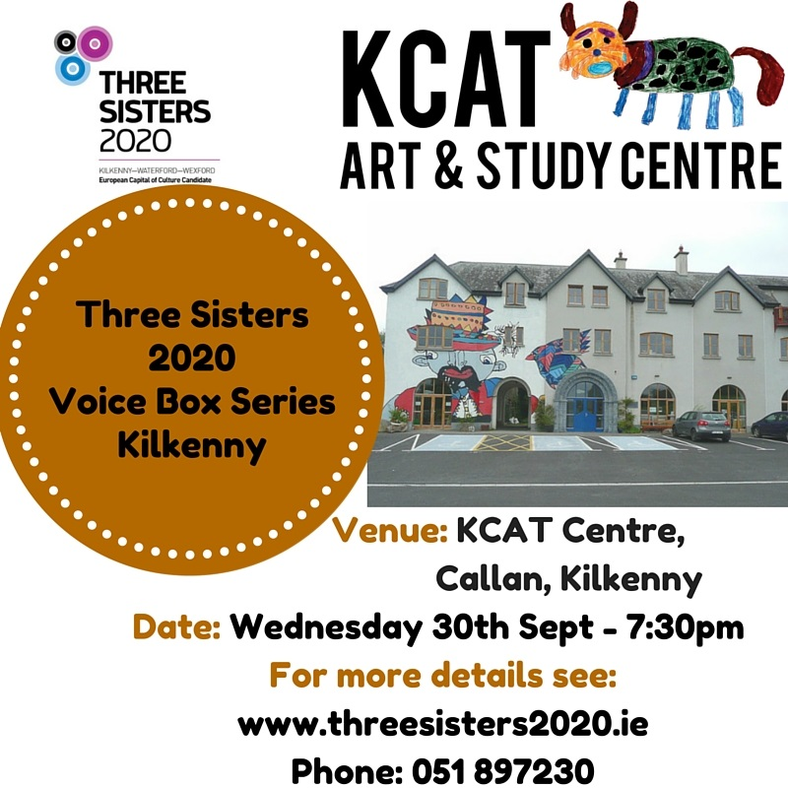

**Courses / Training / Jobs / Internships**

**JobBridge internships at craft enterprises**

A large number of craft enterprises are sole traders who have up until now been excluded from participation in the JobBridge scheme due to their size – some requirements has been waived for the initial pilot for the craft sector. Find out if your enterprise can qualify for an internship by contacting Nuala McGrath on [nuala@dccoi.ie](mailto:nuala@dccoi.ie).

The pilot scheme presents an exciting opportunity for interns wishing to gain experience in a craft organisation and to bring their talent, fresh ideas and new thinking to a craft organisation for a 9 month period and gain valuable experience and the relevant knowledge and skills required to enter a career in craft.

One of the standard criteria to qualify for an internship is that an organisation must have a minimum of 1 full time employee who is employed for 30 hours or more per week. That specific requirement has been waived for the initial pilot for the craft sector. To see over 50 craft internships on offer, simply review the opportunities on [JobBridge.ie](http://www.jobbridge.ie/) by job title and adhere to the terms and conditions of the JobBridge scheme.

**National Craft Gallery Education Support Internship**

**Description**  
The intern will gain practical experience in the development, delivery and administration of craft and design educational programming, through the National Craft Gallery. The intern will receive formal/informal training in the following: workshop development/delivery, event planning and child protection policy. On completion the intern will have attained skills in communication, presentation, ability to co-ordinate/deliver education programmes, increased knowledge of craft and widened their network of craft practitioners.  
**Skills Requirements**  
Ability to work within a team. Excellent verbal and written communication skills. Professional demeanor. Excellent Microsoft Office and IT skills. Excellent organisational skills with great attention to detail. Ability to prioritise tasks, to problem-solve independently and collaborate with others. An awareness and understanding of craft and design practices beneficial.

**Contact:** Nuala McGrath **Telephone:** 056 779 6133 **Email:** [nuala@dccoi.ie](mailto:nuala@dccoi.ie)

**National Youth Council of Ireland Announces New Youth Arts Advocacy and Leadership Training - DEADLINE APPROACHING!**

NYCI is delighted to announce details of a new initiative supporting young people to celebrate and advocate for youth arts activity and provision in their local area.

Is there a burning youth arts issue in your community (you need a new home for your group, you’d like to be able to welcome more new members, there’s no group nearby – or maybe you just want to celebrate and tell everyone about the great work your group does!)  We have the youth leadership project for you!

 Using NYCI’s advocacy expertise across a range of issues affecting young people for many years, and the experience of successfully hosting the National Youth Arts Showcase,  The National Youth Council of Ireland invites applications from 3-4 young people plus a leader, to take part in youth advocacy/leadership training.

This training will take place over 2 days in Dublin include a number of expert inputs on how decisions in Ireland are made, communications and working with the media, working with elected representatives and using your voice to promote your message.

There will also be opportunities for young people to continue to work with NYCI on other advocacy events in the run up to the General Election (for example in the past young people have presented their experiences of being part of arts projects to Joint Oireachtas Committees, met with relevant ministers etc).

As well as meeting experts in their field and exploring youth leadership and advocacy, participants of past showcases have very much enjoyed the residential social element of meeting and making friends with young people from other youth arts projects.

Application forms and further details are available at [http://www.youtharts.ie/advocacy-leadership-training](http://youth.us1.list-manage2.com/track/click?u=34a7524d115d856708ac53cbd&id=bfa7973072&e=576a67049e)

**Certificate in Youth Arts - Open for Applications**

NYCI Arts Programme is delighted to welcome applications for the NUI Certificate in Youth Arts.

The [**Certificate in Youth Arts**](http://youth.us1.list-manage.com/track/click?u=34a7524d115d856708ac53cbd&id=7289414ee7&e=576a67049e) is a part time programme of study in Irish Youth Arts Practice, with 6 modules covered over 12 contact days between October and June (with additional  independent study and project work by the student.) The programme is a partnership initiative of Maynooth University and the National Youth Council of Ireland Arts Programme and leads to an award of the National University of Ireland, placed at Level 7 on the National Qualifications Framework.

The [Certificate in Youth Arts](http://youth.us1.list-manage.com/track/click?u=34a7524d115d856708ac53cbd&id=fbe76942c8&e=576a67049e)aims to introduce those working in the non-formal education sector to the concepts, principles and practice of youth arts using a context and practice approach.

Full prospectus, application form and frequently asked questions are available on youtharts.ie/cert

Alternatively, you can contact Anne O Gorman on 01 4255932 or [anneog@nyci.ie](mailto:anneog@nyci.ie)

**Closing date for applications is Friday, 2nd October 2015.**

**SYMPOSIUM: Making Design Matter** [**Irish Design 2015**](http://www.eventbrite.ie/o/irish-design-2015-7957716800)

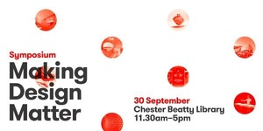

ID2015 hosts a one day symposium to coincide with the launch of 'Platinum' the A'Design Award exhibition at the Design Hub and designation of Dublin as the World Design Hub 2015.

The symposium, 'Making Design Matter', examines the role of design in policy, communities, education and innovation. Does design matter, and what does that mean? This symposium seeks to ask some hard-hitting questions to spark dynamic discussion. What is design and how is it is perceived by governments, industry and wider society? What is the future of design education? Can design deliver on big promises of leading innovation? What does the future look like?

The symposium will be structured around a series of panels discussing the themes of Design in Policy, Making Design Matter, Design Education for the 21st Century and Design Led Innovation. Panels will involve a short presentation from each speaker followed by a quick fire discussion.

Book your free ticket at <http://www.eventbrite.ie/e/symposium-making-design-matter-tickets-18324766871?aff=ebrowse>

Do you have questions about SYMPOSIUM: Making Design Matter? [Contact Irish Design 2015](http://www.eventbrite.ie/e/symposium-making-design-matter-tickets-18324766871?aff=ebrowse#lightbox_contact)

**Calls for Submissions/Residencies**

**Invitation to Tender - Spirituality Training Programme**

[](http://www.youth.ie/)The National Youth Council of Ireland wishes to contract an organisation / individual to develop and deliver a specifically designed training programme and resource/toolkit on spirituality designed for practitioners working with young people across the out of school / non-formal education setting.

Deadline October 30th 2015

Download full details at <http://www.youth.ie/spirituality-tender>

**Profile Your Public Art in the November/December Issue of Visual Artists’ News Sheet**

[](http://fw008705-flywheel.netdna-ssl.com/wp-content/uploads/2014/07/VAN.jpg)If you have recently been involved in a public commission, percent for art project, socially engaged project or any other form of art outside the gallery we would like you to email us the information for publication in the November/December issue of the Visual Artists News Sheet.

Send images (3-4MB in size) and a short text, no more than around 300 words, in the following format:

Artist’s name  
Title of work  
Commissioning body  
Date advertised  
Date sited/carried out  
Budget  
Commission type  
Project Partners  
Brief description of the work  
Work must have been undertaken in the last six months  
Send your info ASAP to:  
Publications Assistant, Lily Power:  
E: lily@visualartists.ie

**Deadline**: 9 October 2015

**Awards / Bursaries / Schemes**

**Culture Ireland’s annual funding**

|  |  |  |
| --- | --- | --- |
| **Deadline** | **Timing of project** | **Decision** |
| 15 October 2015 | January 2016 onwards | Early December |

The next deadline for receipt of grant applications is 15 October 2015, i.e., applications for funding to present work internationally from January 2016 onwards must be submitted by this close off date.  Applications may be made by either the Irish artist or company or the international presenter or partner.

Applications are not accepted outside of the regular grants round, unless an **exceptional** case can be made that the event or festival is very **high profile** and that attendance could not have been anticipated by the above deadline. For ease of reference please read Culture Ireland [funding criteria.](http://www.cultureireland.ie/about/purpose-of-awards)

**Art Council of Northern Ireland Travel Awards**  
[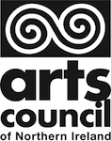](http://fw008705-flywheel.netdna-ssl.com/wp-content/uploads/2015/08/Arts-Council-NI.png)

These awards enable individual artists to travel from Northern Ireland to develop their skills and expertise. Applicants must provide evidence that they have been invited by a host organisation in the country to which they intend to travel.

Who can apply?  
Individual artists and arts administrators. Employees of statutory bodies are eligible to apply but they must prove that the funds which they are seeking are for work and or costs which are not properly the concern of their employer and do not form part of their professional employment.

How to apply?  
Applications for this scheme can be made using our online form or by downloading a hard copy.  
Applications for funding are accepted on a rolling basis. You must apply at least four weeks before your anticipated date of departure.

For guidance notes and an application form, [**CLICK HERE**](http://www.artscouncil-ni.org/funding/scheme/travel-awards?utm_source=NewZapp&utm_medium=email&utm_campaign=Arts%20Council%20NI%20Newsletter%202%20September%202015)

**Deadline** for applications: Ongoing

**Arts Council Festivals and Events Funding**  
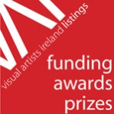

Arts Council Festivals and Events Scheme  
Application deadline: 24 September 2015, 5.30pm

The festival and events scheme is open to multi-disciplinary festivals and single artform festivals. Events may be one-off projects or programmed over a number of months. Maximum award €20,000

Full details: [**www.artscouncil.ie/Funds/festivals-and-events-scheme/**](http://www.artscouncil.ie/Funds/festivals-and-events-scheme/)

Full list of Arts Council funding available: [**www.artscouncil.ie/available-funding/**](http://www.artscouncil.ie/available-funding/)

**Fulbright Awards to Study, Research or Teach in the US**

[](http://fw008705-flywheel.netdna-ssl.com/wp-content/uploads/2015/09/Fulbright_logo_webSmall.jpg)The Fulbright Irish Awards provide grants for Irish citizens and EU citizens who have been resident in the Republic of Ireland for three or more years to research, study or lecture in the US on an annual basis.

The awards are open to candidates from all disciplines including the visual arts.

The application period for 2016-2017 Irish awards is now open, with a deadline of 4pm Friday 30 October 2015.

For more information please visit: [**www.fulbright.ie/irish-citizen-awards**](http://www.fulbright.ie/irish-citizen-awards)

**Of Interest**

**Design Heroes: Miroslav Havel at the Index Gallery, Waterford**

Design Heroes: Miroslav Havel  
Until 19 September 2015  
Index Gallery, Central Library, Lady Lane, Waterford  
Curated by Roisin de Buitlear

[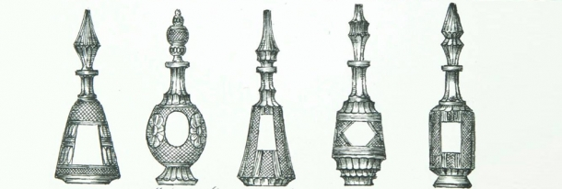](http://www.google.ie/url?sa=i&rct=j&q=&esrc=s&source=images&cd=&cad=rja&uact=8&ved=0CAcQjRxqFQoTCK-u9aycjcgCFcuO2wod2PQGOA&url=http://www.craftinireland.com/events/details/design-heroes-miroslav-havel-exhibition-and-accompanying-lecture-series&psig=AFQjCNEm2RU5LuF7IVG14EewcM41LlghZQ&ust=1443099927012400)

Design Heroes is an exhibition of design drawings and original works of Waterford Crystal’s most famous designer Miroslav Havel, whose design work was responsible for developing the crystal brand we see today. Miroslav Havel Drzkov, born Czechoslovakia and came to Ireland in 1947, and was the first employee of the newly established Waterford Crystal. This exhibition reveals his extraordinary skill in designing and shows for the first time, personal glasswork from the family archives. Included in the exhibition will be a large number of original drawings, sketches, notes, photographs and original engraved pieces gathered from private collections, that have never been publicly displayed.

Design Heroes: Miroslav Havel runs as part of the year long programme of events co-ordinated by Irish Design 2015: runs alongside the Future Legacy – Contemporary contexts for Glass in Tourism, Design and Technologies Symposium at WIT, 18th to 19th September and also coincides with the Refract and the Masters of The Glass exhibitions happening between May and September in Waterford City.

The accompanying lecture series dates are:  
Central Library  
Friday 18th September, 4.00pm  Collecting Glass: Heritage, History and the National Museum of Ireland Collection by Dr Audrey Whitty, Keeper, Art and Industrial Division, Decorative Arts and History, National Museum of Ireland, Dublin

Ardkeen Library  
Tuesday 15th September 6.30pm  
Crystal or Glass? Contemporary Irish Glass Now by Sinead Brennan, Glass Artist and Glass Society of Ireland member

For further information or to book for any of the lectures contact Waterford Central Library, Lady Lane, Waterford  
Further information and bookings:  
T: 051 849975/085 7027884  
E: library@waterfordcouncil.ie  
E: waterfordtheglasscity@gmail.com  
[WaterfordTheGlassCity](https://www.facebook.com/WaterfordTheGlassCity)

## C:\Users\jmcguirk\AppData\Local\Microsoft\Windows\Temporary Internet Files\Content.Outlook\FR48KURY\Members of IYC 2014 during rehearsal.JPGNATIONAL CHORAL SINGING WEEK

## 4th to 11th October 2015

# *Singing is good for you!*

Did you know that Choral Singing is good for your Mental Health? That singing in a choir provides us with the ‘feel good factor’ and makes a positive impact on our general sense of well being?  Choral or group singing can help to reduce feelings of isolation and loneliness, has been shown to increase the production of endorphins and adrenaline, heightening feelings of well-being, gives the participant a physical workout and is an enjoyable way to meet new people and make music together.  To prove it, thousands of voices from across the island of Ireland are uniting in song from 4th to 11th October to celebrate National Choral Singing Week and World Mental Health Day (10th October) promoting the message that, *Choral Singing is good for your Mental Health!*

To find out about events in your area see [www.aoic.ie/festivals_events_initiatives/national_choral_singing_week](http://www.aoic.ie/festivals_events_initiatives/national_choral_singing_week), email [aoic@ul.ie](mailto:aoic@ul.ie) or find the National Choral Singing event on Facebook.

**Poetry Aloud Poetry Speaking Competition for post-primary schools announced**

Our annual poetry speaking competition for post-primary schools, organised in partnership with the National Library of Ireland.

About: Poetry Aloud is an annual poetry speaking competition open to all post-primary students on the island of Ireland. It is organised by Poetry Ireland and the [National Library of Ireland](http://www.nli.ie/en/udlist/programme-and-events-education-post-primary.aspx?article=8ea92d17-2d3c-405b-b026-10ea4420666c). Since it was launched in 2006, Poetry Aloud has grown from just a few hundred entries to over 1,700 entries in 2014.

Prizes: Each category winner receives €300 and book tokens to the value of €300 for the winner’s school library. An overall winner will be chosen from the three category winners and will receive a further €200, the Seamus Heaney perpetual trophy and a signed book of poetry. The runner up in each category will receive a book token Certificates of participation will be presented to all finalists.

How to Apply

Applications are now being accepted for Poetry Aloud 2015.

Application forms for Poetry Aloud 2015 must be returned by **Monday 28 September** to:  
  
Poetry Aloud Competition  
Learning & Outreach   
The National Library of Ireland  
Kildare Street, Dublin 2

**Posters of Protest and Revolution at The National Print Museum**

17 September – 8 November 2015  
The National Print Museum, Garrison Chapel, Beggars Bush Barracks, Haddington Road, Dublin 4

To celebrate the year of design, Irish Design 2015 and the National Print Museum host the Irish debut ‘A World to Win, Posters of Protest and Revolution’, an exhibition organised by the Victoria and Albert Museum, London.

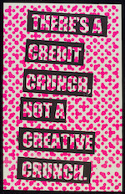‘A World to Win’ is an exhibition of posters of protest and revolution exploring a century of posters agitating for political change. From the “Votes of Women” campaigns of the early twentieth century to the recent occupy movements, political activists around the world have used posters to mobilise, educate and organise. The exhibition will comprise of approximately seventy posters drawn from the V&A collection and will feature a diverse array of artists, graphic designers and print collectives.

E: info@nationalprintmuseum.ie, T: 01 6603770

[www.nationalprintmuseum.ie](http://www.nationalprintmuseum.ie/)  |   [www.facebook.com/NationalPrintMuseum?fref=ts](http://www.facebook.com/NationalPrintMuseum?fref=ts)