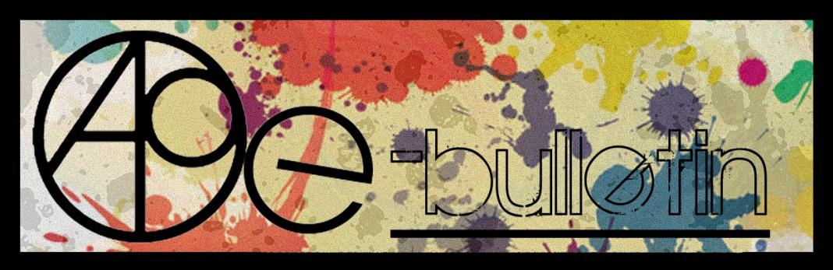

**Kilkenny County Council Arts Office E-bulletin 3rd June 2016**

Dear All,   
  
Welcome to the fortnightly e-bulletin from Kilkenny County Council's Arts Office. Each bulletin is packed with the latest information on Kilkenny Arts Office activities, county events as well as news and opportunities for arts practitioners from around the country.

This service will be provided fortnightly. To include an item in the next e-bulletin please send a brief outline of your advert with relevant contact details, including any websites or pages with links to [**niamh.brophy@kilkennycoco.ie**](mailto:niamh.brophy@kilkennycoco.ie) **before 15th June.** The next e-bulletin will be on the **17th June.**

While every effort has been made to ensure the accuracy of our information, we strongly advise readers to verify all details to their own satisfaction.

Regards,

**Niamh Brophy, Arts Administrator**

Arts Office LogoWithText01

5 Dean Street, Kilkenny

T: (056) 7794138

E: [niamh.brophy@kilkennycoco.ie](niamh.brophy@kilkennycoco.ie%20)

W: <www.kilkennycoco.ie/eng/Services/Arts>

[Facebook](https://www.facebook.com/KilkennyArtsOffice/) [twitter](https://twitter.com/kkartsoffice)

[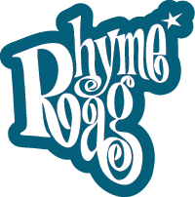](http://www.rhymerag.net/) [Facebook](https://www.facebook.com/KilkennyArtsOffice/) 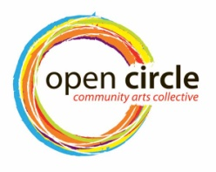 [Facebook](https://www.facebook.com/KilkennyArtsOffice/) [twitter](https://twitter.com/kkartsoffice) [](http://www.artlinks.ie/) [Facebook](https://www.facebook.com/KilkennyArtsOffice/)

<www.rhymerag.net> <https://opencirclearts.ie/> [www.artlinks.ie](http://www.artlinks.ie)

**Kilkenny County Council Cultural Services -**

**Creating and Sustaining Great Communities and Places**

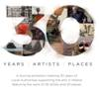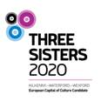 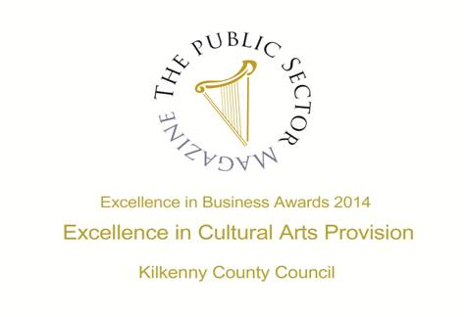

**Arts Office**

* SEWCIALISING - FREE TALK AT KILKENNY ARTS OFFICE - And the Sewcialising begins....Rosie O’Reilly, Re-dress, talks about the social, environmental and economic effects of our purchasing choices.
* Our latest Rhyme Rag poem to be published is ‘The Heart-Hive’ by Tarla Murphy

**Kilkenny Events**

* Full Circle | Debra Bowden at Cill Rialaig Arts Centre, Co. Kerry
* Dreaming in Blue Kilkenny artist, Julie Cusack at Solomon Fine Art
* **Cottage/ArtStudio Available, Co. Kilkenny**
* Music Composer available for work
* The Courage to Be – Clowning Workshop
* Outdoor Cinema at Kilkenny Castle
* KCAT: [End of Year Exhibition 2016](http://kcat.ie/end-of-year-exhibition-2016/)
* Anita Groener, Citizen at the Butler Gallery
* Call for Kilkenny Film Extras
* Ghosts of Grangegorman at the RHA by Kilkenny artist Alan Counihan
* National Craft Gallery News
* Upcoming Workshops at Kozo Studio and Gallery
* Music in Kilkenny June Concerts
* Artist launches new book and art exhibition at the Cat’s Laughs Festival, Kilkenny
* Exhibition space is available in City Library, John’s Quay
* Studio for Rent, Thomastown
* Legendary Footsbarn Theatre announced for 2016 Kilkenny Arts Festival

**Courses / Training / Jobs / Internships**

* **Dublin Writers Conference**
* Writer / Screenwriter in Residence - Department of English
* **Administration Roles, Dance Theatre of Ireland**
* RUA RED seeks Development Manager
* University of Bradford – School of Dementia Studies – Postgraduate Certificate in Dementia Studies (Arts and Activities)
* Open Call | 126 Internship Placements 2016

**Call for Submissions / Residencies / Public Art**

* Cinemagic Young Film-Maker 2016 will take place during the Cinemagic Belfast Festival in October
* Linen Hall Library – 2016 Michael McLaverty Short Story Award – closing Thursday 30th June
* DRL Per Cent for Art Literature Commission
* **Open Call | The McCann FitzGerald Law into Art Project**
* **Open Call | Exhibition Opportunities at Sirius Arts Centre, Co. Cork**
* **Artist in Residence Programme 2017 at Sirius Arts Centre, Co. Cork**
* Open Call for Exhibitions | Linenhall Arts Centre, Castlebar
* Open Call | OpenART Biennial 2017, Sweden
* Royal Ulster Academy 135th Annual Exhibition Open For Entries
* Hennessy Portrait Prize 2016 l National Gallery of Ireland
* Open Call | Emerging Irish Artist Residency Award 2016 | Burren College of Art
* Open Call | Art and Science Residency at the European Space Agency
* Open Call | Enniskillen Visual Arts Open 2016
* Open Call | Public Art Commission, The Liberties, Dublin 8.
* Per Cent for Art Commission | Gaelscoil Shliabh Rua, Dublin 18
* Per Cent For Art Commission | Scoil Mhuire National School, Tullamore, Co. Offaly
* Glebe House Poetry Competition

**Awards / Bursaries / Schemes**

* Arts Council of Ireland: Upcoming Funding Deadlines
* Arts Council Arts Participation Bursary Award - Information Clinic 14 June 2016 at Create
* The Arts Council and UCC seek to appoint a Traditional Artist in Residence 2016/17
* Belltable and Fishamble: Open Call for Applications for Mentoring Programme for Playwrights and Directors
* European Cultural Foundation – STEP travel grants – ongoing
* Tyrone Guthrie Centre – Film Maker Bursary
* Accessing EU Funding for the Arts

**Of Interest**

* **Visual Artists Ireland calls on government for immediate action to alleviate poverty in the visual arts**
* **VAI and NCFA Addressing Current Challenges Facing the Arts Sector**
* #ArtsDeptNow Petition to be Delivered to Government on 3 June, 4pm
* NI Community Arts Partnership’s Chief Executive Conor Shields’ CAPtain’s Blog – “The Programme for Government and the Arts”
* What Next? National Campaign for the Arts Public Meeting | 9 June

**Arts Office**

**SEWCIALISING - FREE TALK AT KILKENNY ARTS OFFICE**

**And the Sewcialising begins....Rosie O’Reilly, Re-dress, talks about the social, environmental and economic effects of our purchasing choices.**

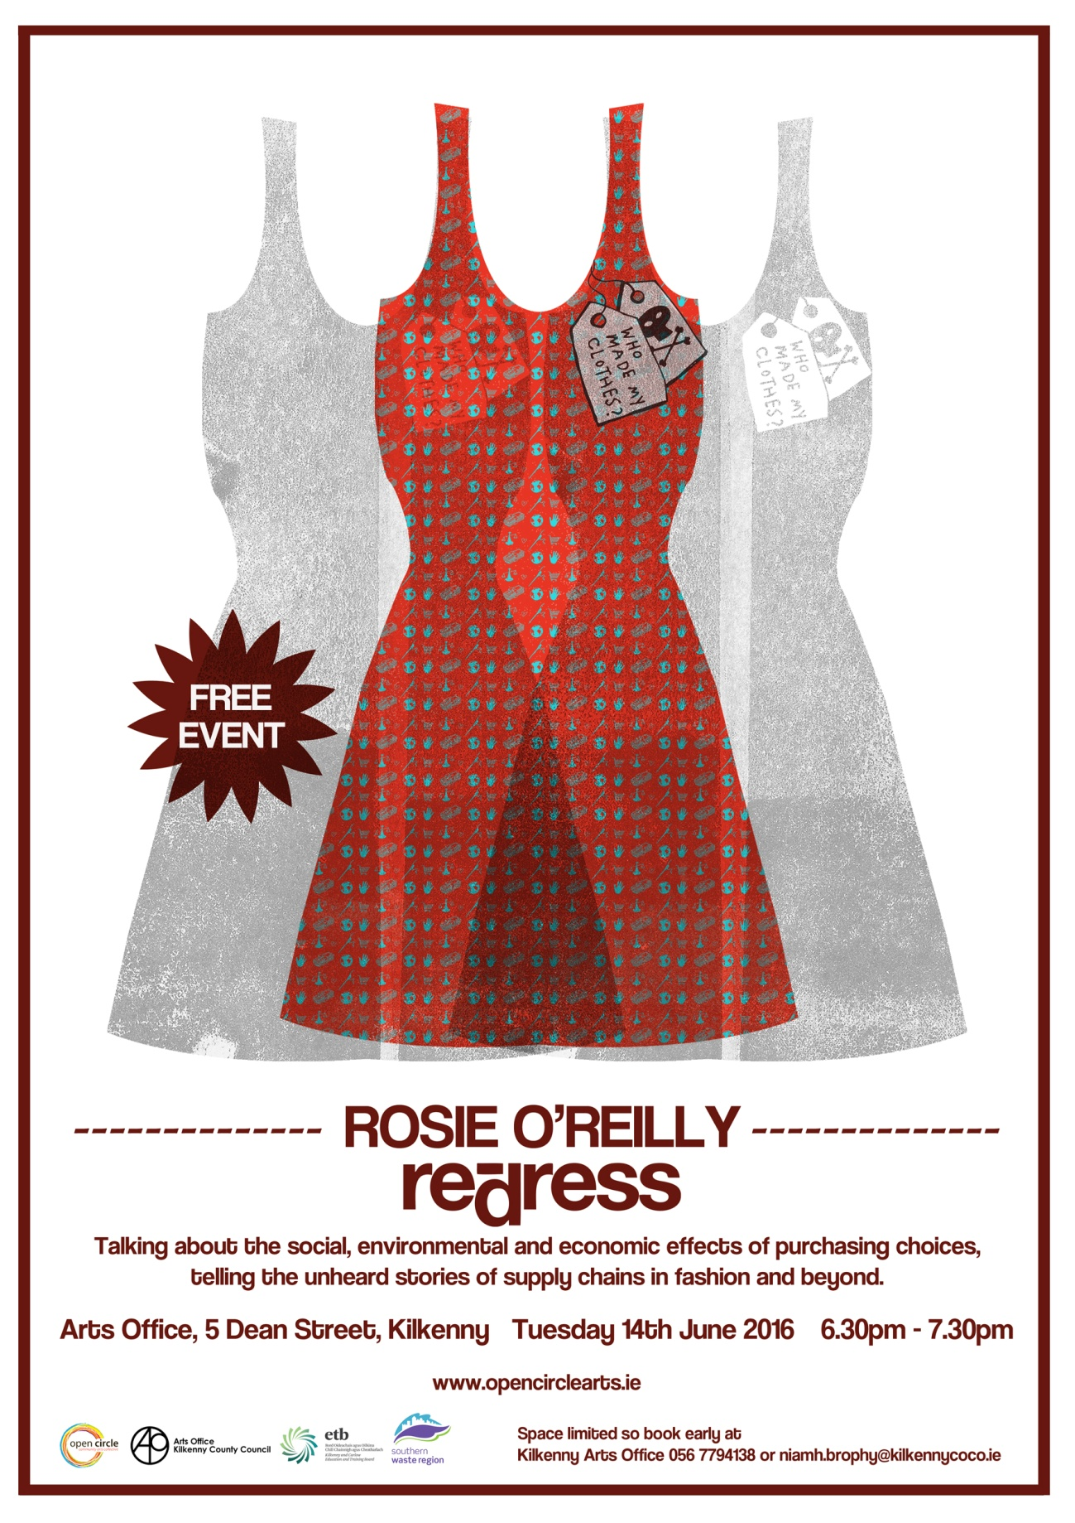

Open Circle Arts is once again running an exciting summer outreach programme. The Sewcialising Project investigates our relationship with our clothes. It aims to open up discussions about the clothes we choose to wear, where they come from and where they end up. The series of workshops for the month of July explores the (re) making of clothing through re-designing, repairing and mending; by reclaiming material from worn and discarded garments, the very fibres are charged with meaning, they are saturated with the traces of everyday life; through wear and tear.  Can discarded garments reflect our history, becoming actual material memories of times past, love lost or found, disappointments endured or victories won? These garments could then be read as a guide to our past, reconstructed and brought back to life. Central to the discussion is the value we place on these everyday items, each workshop is designed to explore the ways in which we can extend the life of these garments to keep them in active service.

As an introduction to this wonderful project Rosie O’ Reilly from Re-dress will be talking about the social, environmental and economic effects of purchasing choices, telling the unheard stories of supply chains in fashion and beyond.

This FREE EVENT will take place on Tuesday 14th June at the Kilkenny Arts Office, 5 Dean Street, Kilkenny from 6:30pm to 7:30pm. Space is limited so book early at Kilkenny Arts Office 056 7794138 or email [niamh.brophy@kilkennycoco.ie](mailto:niamh.brophy@kilkennycoco.ie)

Rosie O'Reilly works as a visual artists and designer. Her work as an artist is concerned with reframing environmental discourse. She has exhibited at ‘Seasons in Translation’, Spain, (2014), Museum of Contemporary Art, Dublin (2013), and had a solo show at ‘4/704’,The Fringe Theatre Festival, Dublin, (2013). She is the designer of contemporary brand WE ARE ISLANDERS which brings art to fashion with limited runs of hand painted pieces. She co-founded [re-dress.ie](http://scanmail.trustwave.com/?c=6600&d=kKnO12zS8YAg0DmPw0I_Z27Vpeh-cbcqAVM299wgjA&s=380&u=http%3a%2f%2fre-dress%2eie), a communications project that since 2008 has been telling the unheard stories of supply chains in fashion and beyond through creative collaborations, events and workshops.

For more information on ‘Sewcialising’ please see the Open Circle Arts website or Facebook page [www.opencirclearts.ie](http://www.opencirclearts.ie)

**\_\_\_\_\_\_\_\_\_\_\_\_\_\_\_\_\_\_\_\_\_\_\_\_\_\_\_\_\_\_\_\_\_\_\_\_\_\_\_\_\_\_\_\_\_\_\_\_\_\_\_\_\_\_\_\_\_\_\_\_\_\_\_\_\_\_\_\_\_\_\_\_\_\_\_\_\_\_\_\_\_\_\_\_\_\_\_**

**Our latest Rhyme Rag poem to be published is ‘The Heart-Hive’ by Tarla Murphy**

This was selected by our editor Kathy D'Arcy [@KathyDArcyCork](https://twitter.com/KathyDArcyCork)

and illustrated by [Alé Mercado/Atticus/Pitercios](http://scanmail.trustwave.com/?c=6600&d=8ObM13z3nSs3KvCzjpLzLxQ6l3tT4bQdsc7e_HLjuQ&s=380&u=https%3a%2f%2fwww%2efacebook%2ecom%2fAleMercadoAtticusPitercios) [@AtticusMercado](http://scanmail.trustwave.com/?c=6600&d=8ObM13z3nSs3KvCzjpLzLxQ6l3tT4bQdsZff9ifivA&s=380&u=http%3a%2f%2ftwitter%2ecom%2f%23%21%2fatticusmercado)

See this poem and more at <http://www.rhymerag.net/>

Or on the Rhyme Rag Facebook page <https://www.facebook.com/rhymerag/?fref=ts>

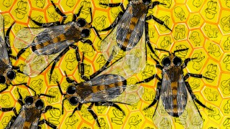

**Kilkenny Events**

### Full Circle | Debra Bowden at Cill Rialaig Arts Centre, Co. Kerry

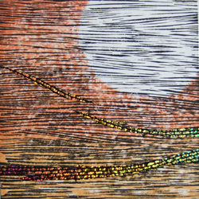

5 to 24 June 2016 |Opening: 5 June, 12.30

Cill Rialaig Arts Centre, Ballinskelligs, Co. Kerry

‘Full Circle’ is an exhibition of woodblock prints by Debra Bowden. Bowden is the first Irish artist to be awarded a scholarship to Awaji Island, Japan to work under the tutelage of masters Toru Ueba sans, Masahiro Takade sans and Shoichi Katamura sans.

E: crsiopa@gmail.com, T: 066 9479277  
[www.facebook.com/CillRialaigArtsCentre/](http://scanmail.trustwave.com/?c=6600&d=-rDK14NjKgMYTTFXhPwuSnYe4IEe4Ps_R9mmLlUjfg&s=380&u=http%3a%2f%2fvisualartists%2eus9%2elist-manage1%2ecom%2ftrack%2fclick%3fu%3de67e46c7b14e756132f46a50c%26id%3dfd703c6f2d%26e%3df4dbf7f416)

**\_\_\_\_\_\_\_\_\_\_\_\_\_\_\_\_\_\_\_\_\_\_\_\_\_\_\_\_\_\_\_\_\_\_\_\_\_\_\_\_\_\_\_\_\_\_\_\_\_\_\_\_\_\_\_\_\_\_\_\_\_\_\_\_\_\_\_\_\_\_\_\_\_\_\_\_\_\_\_\_\_\_\_\_\_\_**

### Dreaming in Blue Kilkenny artist, Julie Cusack at Solomon Fine Art

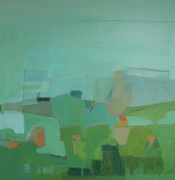

3 to 25 June

An exhibition of new paintings by Julie Cusack, her first solo exhibition with the gallery. This body of work was born out of Cusack’s desire to make paintings that reflect the theatre of landscape and its many elements. Julie’s abstracted landscapes are vibrant, layered and have always been rooted in drawing. Working primarily on paper and board she combines paint with drawn elements as drawing for her is not only a way to represent object or place but is also a way to engage in the intuitive physicality of making marks on a surface. Starting with an image sometimes, from memory, sometimes from observation, she layers paint and graphite on board or paper and begins the process of editing. Some areas become obscured or recede while others push forward and what evolves is a dance between surface and depth, between what is random and what is particular. Ultimately Julie endeavours to create abstracted compositions which represent a fictional place between the external and the internal.

Solomon Fine Art, Balfe Street, Dublin 2  
T: +353 (0)86 8142380  
E: [info@solomonfineart.ie](mailto:info@solomonfineart.ie)  
W: [solomonfineart.ie](http://scanmail.trustwave.com/?c=6600&d=-7DK1_aFqzLhYHrU9YBqV5Akb2rZ1zdJsAe5b2uZKw&s=380&u=http%3a%2f%2fvisualartists%2eus9%2elist-manage%2ecom%2ftrack%2fclick%3fu%3de67e46c7b14e756132f46a50c%26id%3d1ca806cdac%26e%3df4dbf7f416)

**\_\_\_\_\_\_\_\_\_\_\_\_\_\_\_\_\_\_\_\_\_\_\_\_\_\_\_\_\_\_\_\_\_\_\_\_\_\_\_\_\_\_\_\_\_\_\_\_\_\_\_\_\_\_\_\_\_\_\_\_\_\_\_\_\_\_\_\_\_\_\_\_\_\_\_\_\_\_\_\_\_\_\_\_\_\_\_**

**Cottage/ArtStudio Available, Co. Kilkenny**

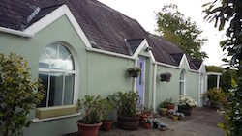

2 bedroomed one level detached cottage available immediately, large kitchen and living/studio, shower/toilet.

High ceilings and Arched large windows. 2 patios and car parking. Stunning panoramic views. Adjacent to main farmhouse. Unfurnished or Furnished. 16 km from Kilkenny. 2km from Ballyragget.

Contact Colette on 083 8305583

**\_\_\_\_\_\_\_\_\_\_\_\_\_\_\_\_\_\_\_\_\_\_\_\_\_\_\_\_\_\_\_\_\_\_\_\_\_\_\_\_\_\_\_\_\_\_\_\_\_\_\_\_\_\_\_\_\_\_\_\_\_\_\_\_\_\_\_\_\_\_\_\_\_\_\_**

**Music Composer available for work**

My name is Diarmuid Nolan. I just finished a 4 year BA in Songwriting in DIT (BIMM Dublin). I'm a composer and work mostly on composing music for games, television and film.

For any enquiries please email me at: [dnolan2007@gmail.com](mailto:dnolan2007@gmail.com)

Here is a link to a portfolio of some of my work

[https://drive.google.com/open?id=0B8EPs-UN0\_RDVnpRbXRmLWZTVHc](http://scanmail.trustwave.com/?c=6600&d=ncnE1zbOjJ5Y8VY9yRwsMkz5lQhizTr6cmDdRIfg-A&s=380&u=https%3a%2f%2fdrive%2egoogle%2ecom%2fopen%3fid%3d0B8EPs-UN0%5fRDVnpRbXRmLWZTVHc)

**\_\_\_\_\_\_\_\_\_\_\_\_\_\_\_\_\_\_\_\_\_\_\_\_\_\_\_\_\_\_\_\_\_\_\_\_\_\_\_\_\_\_\_\_\_\_\_\_\_\_\_\_\_\_\_\_\_\_\_\_\_\_\_\_\_\_\_\_\_\_\_\_\_\_\_\_\_\_\_\_\_\_\_\_\_\_\_**

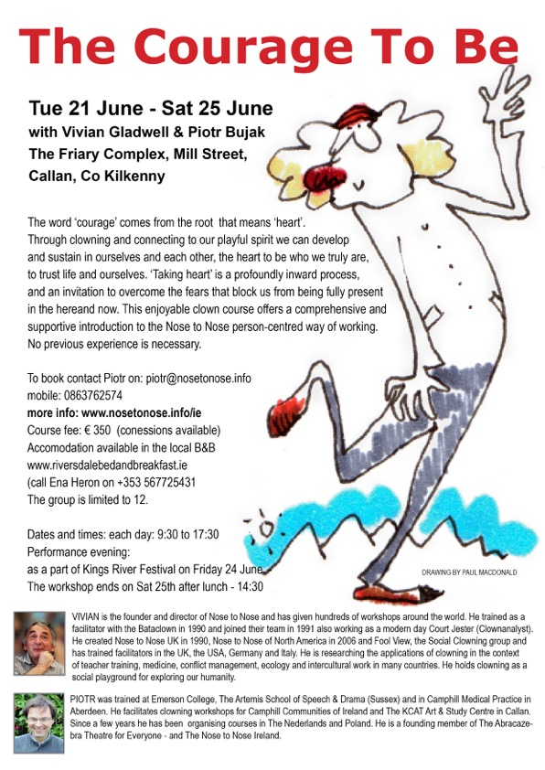

**\_\_\_\_\_\_\_\_\_\_\_\_\_\_\_\_\_\_\_\_\_\_\_\_\_\_\_\_\_\_\_\_\_\_\_\_\_\_\_\_\_\_\_\_\_\_\_\_\_\_\_\_\_\_\_\_\_\_\_\_\_\_\_\_\_\_\_\_\_\_\_\_\_\_\_\_\_\_\_\_\_\_\_\_\_\_\_**

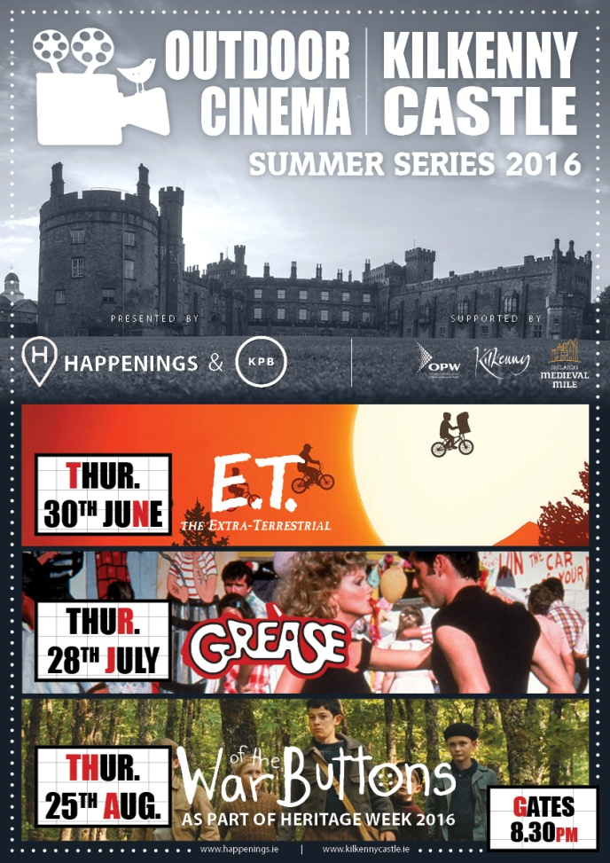

**\_\_\_\_\_\_\_\_\_\_\_\_\_\_\_\_\_\_\_\_\_\_\_\_\_\_\_\_\_\_\_\_\_\_\_\_\_\_\_\_\_\_\_\_\_\_\_\_\_\_\_\_\_\_\_\_\_\_\_\_\_\_\_\_\_\_\_\_\_\_\_\_\_\_\_\_\_\_\_\_\_\_\_\_\_\_\_**

# KCAT: [End of Year Exhibition 2016](http://kcat.ie/end-of-year-exhibition-2016/)

# EOY-INVITE-2016-BACK-new

**\_\_\_\_\_\_\_\_\_\_\_\_\_\_\_\_\_\_\_\_\_\_\_\_\_\_\_\_\_\_\_\_\_\_\_\_\_\_\_\_\_\_\_\_\_\_\_\_\_\_\_\_\_\_\_\_\_\_\_\_\_\_\_\_\_\_\_\_\_\_\_\_\_\_\_\_\_\_\_\_\_\_\_\_\_\_\_**

# Anita Groener, Citizen at the Butler Gallery

#### Anita G Front

#### Open Daily 10am – 5.30pm

Exhibition continues until June 12, 2016

**Meet the Artist** 1pm Thursday 2nd June

The Butler Gallery is delighted to present Citizen, a multi-media exhibition of drawings, video and silhouette installations by Dutch born and long-time Dublin-based artist, Anita Groener.

Citizen explores the phenomenon of, and our consciousness about refugees, based on the current global crisis and how a renewed collective alienation is emerging. Homelessness is ubiquitous in the world yet homeless people are perceived as invisible. Citizen builds on the central theme running through Groener’s work: that is a consideration of home and displacement as situated within current geopolitical realities. Scale, physical presence and the nature of human endeavor are present throughout Groener’s work, but never more so than the voyage we are taken on with this body of work.

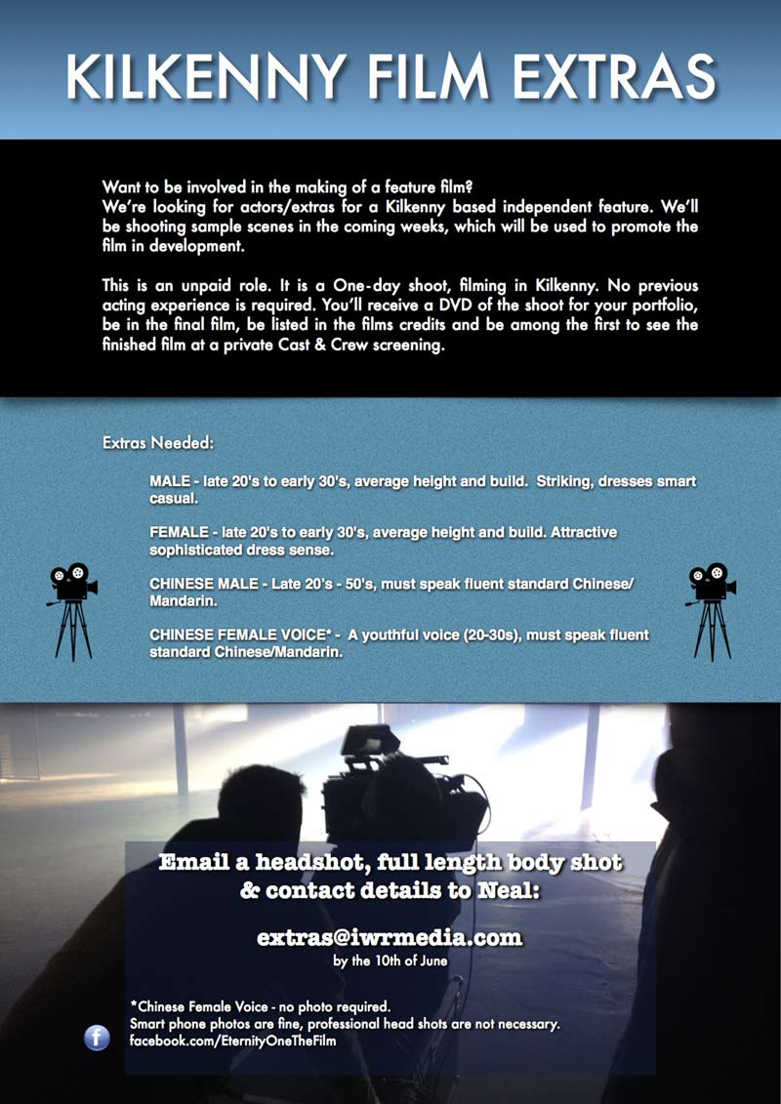

**\_\_\_\_\_\_\_\_\_\_\_\_\_\_\_\_\_\_\_\_\_\_\_\_\_\_\_\_\_\_\_\_\_\_\_\_\_\_\_\_\_\_\_\_\_\_\_\_\_\_\_\_\_\_\_\_\_\_\_\_\_\_\_\_\_\_\_\_\_\_\_\_\_\_\_\_\_\_\_\_\_\_\_\_\_\_**

# Ghosts of Grangegorman at the RHA by Kilkenny artist Alan Counihan

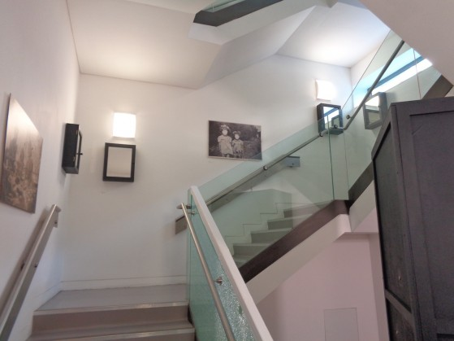

Ghosts of Grangegorman, a space-specific installation by Alan Counihan based on the belongings of dead or discharged patients of Grangegorman Mental Hospital, (later St Brendan’s Hospital) is now showing at the [Royal Hibernian Academy](http://www.rhagallery.ie/), Ely Place, Dublin as part of the RHA Annual Open Exhibition until 11 June 2016.

Alan was invited to create a space-specific work based on the [*Personal Effects*](http://www.artsandhealth.ie/case-studies/personal-effects-a-history-of-possession/)  project for the gallery during the Annual Open Exhibition. The Personal Effects project is an ongoing work that began as an exploration of the personal effects of dead or discharged patients of Grangegorman Mental Hospital which were discovered in an attic of that institution in 2010. The fruit of that research and exploration was exhibited as a multi-media installation that was first shown in 2014 at the Long Stores of St Brendan’s Hospital, Grangegorman, Dublin.

Details at the front desk of the RHA as to location of the installation.



**Exhibition**

**Liminal: Irish Design at the Threshold 8 April 2016 – 3 July 2016**

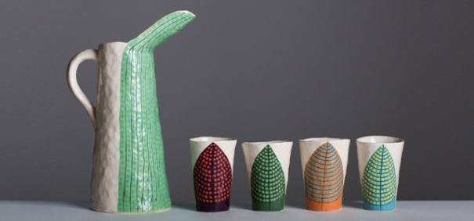

Liminal – Irish design at the threshold, presents some of Ireland’s most exciting design, from product to scientific, architecture to animation, and food to furniture. The exhibiting designers, companies and studios have been selected for the innovative outlook of their work, its connectivity and ability to transcend disciplinary boundaries to address the issues of today. Presenting a pivotal chapter in Irish design, Liminal explores, identifies and showcases Irish creativity, and how designers, companies and studios are moving across disciplinary boundaries and the limits of what design has been, into what design can become. As design increasingly seeks to create holistic experiences and narratives, Ireland is placed to play a significant role in 21st century design, helping meet the challenges of tomorrow. The exhibition demonstrates Irish design excellence across disciplines and considers the possibilities for the future.

The evolving flagship exhibition from ID2015, Liminal – Irish design at the threshold, is presented in Kilkenny after its tour of design weeks in Eindhoven, Milan, New York and Dublin. The exhibition features over 20 designers, companies and studios involved in collaborations across disciplines.

Co-curated by Louise Allen, Alex Milton and Angela O’Kelly

**Education & Outreach**

**FAMILY DAY: CHARACTER DESIGN\* Sat 18 June 10.30am, 12 noon & 2.30pm**

Learn what shapes make a cartoon look happy or sad, quiet or energetic, then design your own character inspired by Cartoon Saloon's Song of the Sea with animator Rory Conway. [Book Now](javascript:void(location.href='mailto:'+String.fromCharCode(101,118,101,110,116,115,64,110,97,116,105,111,110,97,108,99,114,97,102,116,103,97,108,108,101,114,121,46,105,101)+'?subject=Family%20Day%20Booking%20-%20Character%20Design%20June%2018&body=Parent%20Name%0ATel%0APreferred%20Time%2010.30am%20%2F%2012noon%20%2F%202.30pm%0A%0AChild%201%20Name%0AChild%201%20Age%0A%0AChild%202%20Name%0AChild%202%20Age%0A%0AChild%203%20Name%0AChild%203%20Age'))

**LATE DATE: STORY-LED DESIGN EXPERIENCES Thurs 30 June, 6.30pm**

Design consultancy Design Partners talk about the development of products such as the Calor Mini Bbq and Silvair Smart Control System, sharing the story-led design approach they utilise to create exceptional design experiences.

**DROP-IN: DESIGN DISCOVERY Daily**

Drop-in with the family to discover design through Liminal:  
**Liminal Explorer**: Become a design detective, seeking out visual designs  
**ARCKIT Play**: Test your architectural design ideas with ARCKIT

**SCHOOLS: GUIDED VISITS & WORKSHOPS 12 April – 30 June (Tues-Fri)**

Our educators introduce students to design and craft through a tailored exhibition tour and invite you to book a class workshop:  
**Primary:** Line Shape Pattern  
**Secondary:** ARCKIT Modular Homes  
**Leaving Cert:** Art, Craft & Design Gallery Question  
**Third Level:** ARCKIT Modular Builds

**Gallery Tours**

CRAFTERNOON TOURS\* Sat, 3pm Visitors are invited to book for our informal afternoon tour. GUIDED EXHIBITION VISITS\* Would you like to bring a group to the National Craft Gallery? We accommodate groups from 5 to 25 people. No fee applies. Contact us and we will tailor a tour suit the needs of your visit. \*Booking required - email events@nationalcraftgallery.ie or call 056 7796151

**Upcoming Art and Craft Workshops at KOZO Studio and Gallery**

June - July 2016

**11 June (Saturday): EMBROIDERY**- ***Beginners***  
**10.30am – 5pm**  
Tutor: **ALEXIS BERNSTORFF, artistic director of the *ROS TAPESTRY***  
This workshop will teach 6 principal stitches and their variations - using wool, cotton/silk and metallic threads. Participants will be inspired by a range of techniques to realise various designs. Alexis has 15 years experience teaching crewelwork embroidery and is the guide behind the dynamics of the Ros Tapestry.   
€ 70 for the full day - including all materials   
   
\*\*\*\*\*\*\*\*\*\*  
**12 June (Sunday): PAPER MAKING DAY**- ***Beginners***  
**10.30am - 1pm**HAND PAPER MAKING - Introduction to traditional and contemporary techniques of making beautiful handmade papers from pure plant fibres and a range of recycled materials.  
**2.30 - 5pm**SILK FIBRE PAPERMAKING - A truly fascinating, contemporary technique for making `fabric-like`, colourful silk papers using raw silk fibres and fabric dyes. Easy to continue and set up at home, this process is ideal to create unique interior decorations and striking silk papers for artworks, embroidery, collages...etc.  
**Fees** for each workshop: € 35           **OR:** € 65 for the full day -including all materials   
   
\*\*\*\*\*\*\*\*\*\*  
**18 June (Saturday)**  
**10.30am - 5pm BATIK Workshop** - ***Beginners***  
A full day programme introducing an ancient technique of fabric dyeing where hot wax is used as a resist.  
Participants will learn all necessary basic techniques - and complete three small/medium batik pieces with up to 4 colours on cotton fabric and/or paper.  
€ 75 for the full day, including all materials  
  
\*\*\*\*\*\*\*\*\*\*  
**16 July (Saturday)**  
**10.30am - 5pm Felt Making Workshop** – ***Beginners***  
The workshop introduces wet felting techniques using dyed and un-dyed Merino wool and silk fibre inclusions.  
Learn to design and make a unique wall piece or a small but beautiful felted bag. Participants will make a small practice piece before progressing to a larger project.  
€ 75 for the full day, including all materials  
   
\*\*\*\*\*\*\*\*\*\*  
**17 July (Sunday)**  
**10.30am – 5.30pm Paper Making and Paper Art Follow-on Course** – ***Advanced Level***  
   
Designed for participants who already work with paper/fibre based processes, this course offers assistance and guidance in areas of three dimensional, sculptural and installation based works, experimental processes of batik, wax based works on paper, paper dyeing and texturing. It also covers ideas for the preparation and use of plant based pulps (without added chemicals). Participants are encouraged to bring their own ideas and questions into the workshop and invited to show and discuss previous works and projects.  
**Places are limited for 5 participants.**  
€ 80 for the full day, including all materials  
    
   
BOOKINGS are confirmed with € 30 deposit paid in advance.\* Courses are run for small groups only so please call to book early.  
**With any questions, for advice or check availability and for all BOOKINGS please contact TUNDE directly:  
087-2543362**  
[**tundetune@gmail.com**](mailto:tundetune@gmail.com)  
[**www.tundetoth.com**](http://www.tundetoth.com/)

**\_\_\_\_\_\_\_\_\_\_\_\_\_\_\_\_\_\_\_\_\_\_\_\_\_\_\_\_\_\_\_\_\_\_\_\_\_\_\_\_\_\_\_\_\_\_\_\_\_\_\_\_\_\_\_\_\_\_\_\_\_\_\_\_\_\_\_\_\_\_\_\_\_\_\_\_\_\_\_\_\_\_\_\_\_\_\_**

**Music In Kilkenny**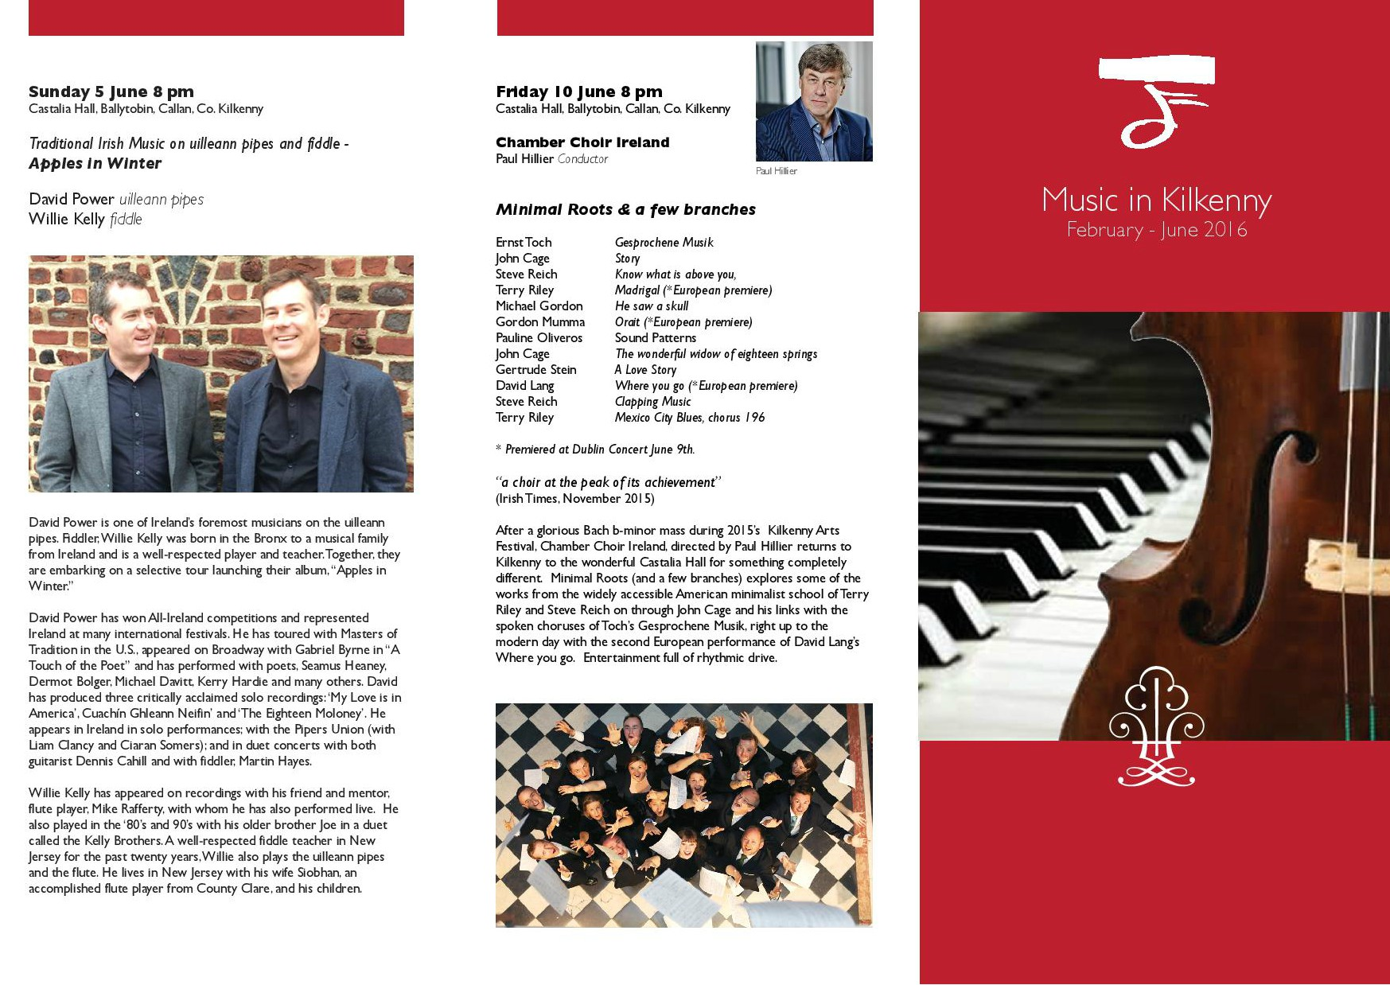

**Artist launches new book and art exhibition at the Cat’s Laughs Festival, Kilkenny**

Artist, Carmel T. Madigan is about to launch her third book ‘Conversations with Nature’ and accompanying art exhibition, at the upcoming Cat’s Laughs festival in Kilkenny city during the June bank holiday weekend. The book and exhibition launch will take place at the Ormonde Hotel, Kilkenny, on Thursday, June 2nd at 6pm and the exhibition will continue through to Monday June 6th. The book will be launched by Ms. Catherine Boland of the Irish Contemporary Arts Society.

Carmel is no stranger to the south east Region, having being selected to exhibit at the Greystones Arts Festival on a number of occasions, together with exhibiting at the Wexford Opera Fringe Festival, the Cockleshell Art Gallery, Duncannon, Co. Wexford and at the Old Market House Arts Centre in Dungarvan, Co. Waterford.

Carmel’s works are to be found in private and public collections including the Office of Public Works, the Departments of Defence and Education, Waterford Municipal Art Collection, Bank of Ireland, Invesco Ltd., and Dromoland Castle. She has quickly become highly sought after by collectors at home and abroad and was recognised by the art world in her selection for the Florence Biennale in Italy together with her invitation to exhibit at the Amsterdam Whitney Gallery, New York, which she did in 2010.

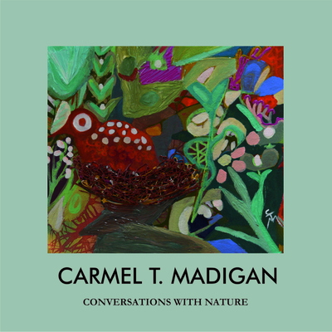

‘Conversations with Nature’ is her new book that portrays her working career as an artist, the processes of creativity and the sources of inspiration that each contribute to her individualistic, organic style. The book also features her creative eco-collaborations with County Clare schools as artist in residence on behalf of Clare Arts Office. One of these creations*, The Garden of Global Friendship*, was chosen by an Taisce to be exhibited at the inaugural green schools expo at the Royal Dublin Society this year.

Carmel T. Madigan’s pervious publications include ‘The Wild flowers of Loophead’ (2012) and ‘Seasons, Species & Patterns of a North East Atlantic Rocky Shore’ (2014).

The artist also runs the Loophead Summer Art and Nature (Hedge) school at Loophead, Co. Clare during July and August.

**Exhibition space is available in City Library, John’s Quay**

For more information, contact Aisling Kelly on 056 779 4175 or email [aisling.kelly@kilkennylibrary.ie](mailto:aisling.kelly@kilkennylibrary.ie)

**\_\_\_\_\_\_\_\_\_\_\_\_\_\_\_\_\_\_\_\_\_\_\_\_\_\_\_\_\_\_\_\_\_\_\_\_\_\_\_\_\_\_\_\_\_\_\_\_\_\_\_\_\_\_\_\_\_\_\_\_\_\_\_\_\_\_\_\_\_\_\_\_\_\_\_\_\_\_\_\_\_\_\_\_\_\_\_**

**Studio for Rent, Thomastown**

The studio is a shared open plan space in the top of a converted barn with 2 other artists but the artist would have their own sectioned off space . It's a small space and very reasonable rent, ideal for a painter / graphic designer etc or office space . It's available from now and looking for long term artist / 6 months minimum .

Please call 0879650026 for more information.

|  |
| --- |
| **Legendary Footsbarn Theatre announced for 2016 Kilkenny ArtsFestival** |

|  |
| --- |
| http://i.emlfiles1.com/cmpimg/5/1/8/3/7/1/files/imagecache/76922/w640_109988_fb_tentsm.jpg |

|  |
| --- |
| ***"Footsbarn, indeed, is a theatre festival unto itself, a wonderfully eclectic mixture of styles and influences, of nationalities and cultures, all melded into a seamlessly fluid torrent of pure theatre.”* Fintan O’Toole, The Irish Times**  We're thrilled to announce Footsbarn Theatre as one of the highlights of Kilkenny Arts Festival 2016. Having enchanted countless audiences worldwide, the legendary travelling ensemble will be pitching its famous tent in the heart of Kilkenny's medieval city.    Footsbarn's multinational performers create a magical blend of visual theatre, masks, puppetry, words and music. The company will be in residence for the whole Festival, presenting the Irish premieres of two contrasting productions - read on...! |

**Course / Training / Jobs / Internships**

**Dublin Writers Conference**

The **Irish Writers Centre** is delighted to be hosting the **Dublin Writers Conference** on the 24 - 26 June. This weekend conference will provide first class training in aspects of writing craft as well as digital marketing for authors. It will provide practical support, valuable training and is ideal for both fiction and non-fiction authors.

The writing craft sessions will focus on a variety of methods authors can use to improve their craft and broaden their writing skills. Changes to book promotion due to social media will be discussed during the digital marketing sessions and will focus on how authors can use this to their advantage.

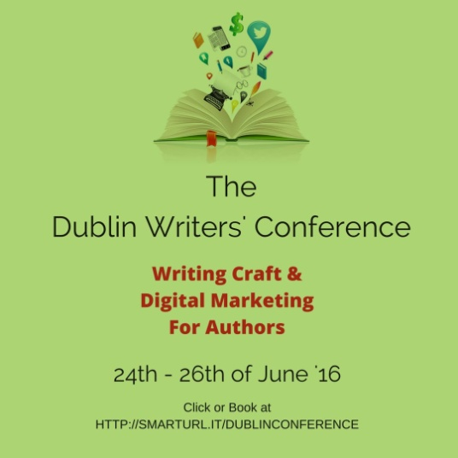

We have a wide range of speakers attending from the US, the UK & Ireland including **Conor Kostick,** **Margaret Murphy, Laurence O'Bryan,** and **Debbie Young.**

Join us this June at a unique event for Dublin, a writer’s conference aimed at writers. Places are limited so please book as soon as possible.

For full information and booking, and a full list of speakers visit: <http://thebookpromoter.com/conference/>

**\_\_\_\_\_\_\_\_\_\_\_\_\_\_\_\_\_\_\_\_\_\_\_\_\_\_\_\_\_\_\_\_\_\_\_\_\_\_\_\_\_\_\_\_\_\_\_\_\_\_\_\_\_\_\_\_\_\_\_\_\_\_\_\_\_\_\_\_\_\_\_\_\_\_\_\_\_\_\_\_\_\_\_\_\_\_\_**

**Writer / Screenwriter in Residence - Department of English**

Contract Type: Temporary

Department: [English](https://www.maynoothuniversity.ie/english)

Closing Date: Friday, June 10, 2016

Position Open To: All

Maynooth University and Kildare County Council Library and Arts Services seek applications for two posts:

• Writer-in-Residence  
• Screenwriter-in-Residence

Both positions run from October 2016 – May 2017, with duties expected to average approximately four hours per week contact time with students and the wider public. Successful applicants will be expected to be on campus or in Kildare Libraries one or two days per week for that contact time and for drop-in consultations. The post holders will also be expected to participate in community events such as the Kildare Readers’ Festival (October) / Film Lab Workshops, and to host readings in a programme curated between the applicants, the University and the Kildare Library and Arts Service, with a budget set aside for the purpose. Writers will be provided with office space on the campus of Maynooth University.

A contract-for-services fee of €15,000 inclusive of travel expenses is offered for the eight month period, with a third payable on commencement, a third payable half-way through, and a third payable on completion. There is an additional budget of €2,000 per residency for invitations extended to other writers.

For full details see: <http://alturl.com/vju6f>

**\_\_\_\_\_\_\_\_\_\_\_\_\_\_\_\_\_\_\_\_\_\_\_\_\_\_\_\_\_\_\_\_\_\_\_\_\_\_\_\_\_\_\_\_\_\_\_\_\_\_\_\_\_\_\_\_\_\_\_\_\_\_\_\_\_\_\_\_\_\_\_\_\_**

**Administration Roles, Dance Theatre of Ireland**  
  
Category: Job  
Deadline: 9 June  
Web: [http://www.dancetheatreireland.com/pages/opport.htm](http://scanmail.trustwave.com/?c=6600&d=tvC11_1dKSHzL5jjODf2w4mB1W-YcfvB0LbJALdPrA&s=380&u=http%3a%2f%2fcreate-ireland%2eus11%2elist-manage1%2ecom%2ftrack%2fclick%3fu%3dae8a0e4da904d891196932bf8%26id%3d0f830a0236%26e%3dff568af62e)  
Email: [dancetheatreireland@gmail.com](mailto:dancetheatreireland@gmail.com)  
  
Dance Theatre of Ireland is a professional contemporary dance theatre company based in a purpose-built, Centre for Dance in Dún Laoghaire, with extensive Arts & Health, Community and Educational Outreach programmes in dance, working locally, nationally and internationally.  
  
**Centre & Outreach Coordinator**  
Dance Theatre of Ireland requires an experienced and dynamic Coordinator for a multi-faceted full-time position with primary responsibility for managing DTI’s Centre for Dance programme of classes and its National Educational Outreach programs. The Centre for Dance has some 1500 people engaged in dance activities throughout the year.  
  
The position requires personable marketing, sales, management and communications experience in the arts, service or retail sectors, plus a high degree of financial and business acumen.  
  
**Marketing & Finance Administrator**  
Dance Theatre of Ireland requires an experienced and dynamic person for a multi-faceted full-time position that supports all aspects of the Company’s work, including the Centre for Dance's programme of classes, Educational Outreach, Productions and Touring. Experience in Marketing / PR and Social Media; and Payroll & Book keeping; fluency in Excel, Access, Word, Publisher and Mail Chimp.  Digital Photo and Video editing is a plus as is a knowledge of Quickbooks.  Excellent keyboard and numeracy skills are essential.  
  
This is an ideal role for a person who likes multi-tasking, helping people, has a visual, as well as technical flair and a passion for dance.  
  
Please send letter of application and CV to The Artistic Directors at above email address.

**\_\_\_\_\_\_\_\_\_\_\_\_\_\_\_\_\_\_\_\_\_\_\_\_\_\_\_\_\_\_\_\_\_\_\_\_\_\_\_\_\_\_\_\_\_\_\_\_\_\_\_\_\_\_\_\_\_\_\_\_\_\_\_\_\_\_\_\_\_\_\_\_\_\_**

**RUA RED seeks Development Manager**

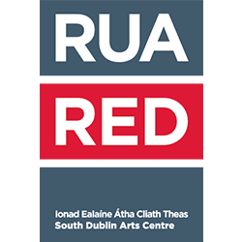

Deadline: 17 June 2016

RUA RED South Dublin Arts Centre is looking for a Development Manager to join our team. The Development Manager will be responsible for devising, leading and delivering the organisation’s Communications and Fundraising strategy including: PR, advocacy, sales, marketing and fundraising, working to agreed targets. The chosen candidate will work closely with the Executive Director and the Management Team. The post is offered as a full time role 40 hours per week, and the salary offered will be commensurate with the experience of the successful candidate.

For full job description and application details, please visit: [ruared.ie/about/opportunities](http://ruared.ie/about/opportunities)

To apply lease forward a CV and a covering letter (1 A4 page) to [kphillips@ruared.ie](mailto:kphillips@ruared.ie) by Friday 17th June 2016. Short listed candidates will be asked to attend an interview on 28th or 29th June at RUA RED.

RUA RED, South Dublin Arts Centre, Tallaght, Dublin 24.

T: 01 451 5860  
E: [info@ruared.ie](mailto:info@ruared.ie)  
W:[ruared.ie](http://ruared.ie/" \t "_blank)

**\_\_\_\_\_\_\_\_\_\_\_\_\_\_\_\_\_\_\_\_\_\_\_\_\_\_\_\_\_\_\_\_\_\_\_\_\_\_\_\_\_\_\_\_\_\_\_\_\_\_\_\_\_\_\_\_\_\_\_\_\_\_\_\_\_\_\_\_\_\_\_\_\_\_\_\_\_\_\_\_\_\_\_\_\_\_\_**

**University of Bradford – School of Dementia Studies – Postgraduate Certificate in Dementia Studies (Arts and Activities)**

Aimed at arts practitioners, activity coordinators and others with an interest in developing and delivering creative activities with people who have dementia, this one-year, part-time distance learning programme consists of two 30 credit modules studied between September and June each academic year.

**Module 1, Understanding the experiences of people with dementia**, encourages you to develop a one to one relationship with a person with dementia and conduct an investigation into his or her experiences of having dementia and receiving services, with a view to improving quality of life or quality of care.

**Module 2, Arts and activities in dementia care**, covers the design, delivery and evaluation of personally-meaningful activities, arts projects, or psychosocial interventions for people with dementia.

There is increasing interest in the potential for the creative arts, participatory approaches and novel forms of self-expression to enhance well-being and social participation for people with dementia.

Awareness is growing that taking part in such activities can help to maintain self-esteem, reduce stigma, and keep a sense of identity intact. In addition there are many things that we can learn from people who have dementia and who may communicate in a variety of ways that are not accessed using traditional methods for communication or research.

This programme will enable you to develop your skills in designing, delivering and evaluating such activities and will enhance your opportunities for gaining employment in this field or attracting funding for your projects.

For further information please contact Dr. Andrea Capstic at a.j.capstick@bradford.ac.uk or visit the [University of Bradford website](http://www.bradford.ac.uk/study/courses/view/?c=dementia-studies-arts-activities-pgcert-part-time)

**Open Call | 126 Internship Placements 2016**



Deadline for applications: 1 June

126 extends an open call to graduates who wish to participate in their 2016 Internship programme. Four interns will be selected for a six month internship running from July to December 2016. The interns will be mentored by the board members and will gain experience in all aspects of running the gallery including (but not limited to): fundraising, applications, curation, marketing, archiving, web design and arts administration. The internship culminates in a project, exhibition or event to be developed and curated by the interns under the mentorship of the 126 board and to take place at 126 in December.

\* PLEASE NOTE: 126 is an artist led, non profit organisation run voluntarily by a board of professional artists who undertake all aspects of running the gallery. As such, this is an unpaid opportunity.

For more information see <http://126.ie/>

Please contact internship coordinators, Cliodhna Timoney or Blaithin Hughes with any inquiries, by emailing: [contact@126.ie](mailto:contact@126.ie)

**Call for Submissions / Residencies**

**Cinemagic Young Film-Maker 2016 will take place during the Cinemagic Belfast Festival in October**

The event will showcase the best short film entries of the year and we will also be producing a series of workshops and master classes with renowned members of the film and TV industry. A digital filmmaking prize will be awarded for the best film in each age and genre category – the winning entries will also be screened ‘In Competition’ during the Cinemagic International Film Festival For Young People in 2017.

How to Enter

Please email an online screening link to your film along with an entry form to [chris@cinemagic.org.uk](mailto:chris@cinemagic.org.uk).

Alternatively you can also submit your entry on DVD.  
DVD entries (along with the entry form) should be posted to CINEMAGIC YOUNG FILMMAKER 2016, Chris Shaw, Cinemagic, 49 Botanic Avenue, Belfast BT7 1JL.

The competition deadline is 2nd September 2016.

Please note: the competition is only open to young filmmakers aged 25 and under living in the uk and ireland. Films are to be no longer than 10 minutes.

Entry forms and rules/regulations are available to download from the Cinemagic website: [www.cinemagic.org.uk](http://www.cinemagic.org.uk/submissions/young-filmmaker-competition)

**\_\_\_\_\_\_\_\_\_\_\_\_\_\_\_\_\_\_\_\_\_\_\_\_\_\_\_\_\_\_\_\_\_\_\_\_\_\_\_\_\_\_\_\_\_\_\_\_\_\_\_\_\_\_\_\_\_\_\_\_\_\_\_\_\_\_\_\_\_\_\_\_\_\_\_\_\_\_\_\_\_\_\_\_\_**

**Linen Hall Library – 2016 Michael McLaverty Short Story Award – closing Thursday 30th June**

The Linen Hall Library has announced the launch of the 2016 Michael McLaverty Short Story Award.

This prestigious award, which has run biennially since 2006, was set up to foster and encourage the tradition of the Irish short story.

Adjudicators for this year’s competition are Patsy Horton, Managing Editor of Northern Ireland’s Blackstaff Press, and multi award-winning writer David Park (The Big Snow, The Truth Commissioner, Gods and Angels).

Previous winners of the award have gone on to publish further works. Aiden O’Reilly (2008) has published Greetings, Hero, Michèle Forbes (2010) has published the acclaimed debut novel Ghost Moth, and Mandy Taggart (2012) has published The Man of the House.

Entry guidelines:

* Entrants must have been born in Northern Ireland or the Republic of Ireland and be over 18 years of age.
* The prize is £2,000.
* Entry fee: £10.
* Theme: Lost Fields

Closing date for submissions:  
Thursday 30th June.  
  
For more information please visit [linenhall.com](https://www.linenhall.com/news/167)

**\_\_\_\_\_\_\_\_\_\_\_\_\_\_\_\_\_\_\_\_\_\_\_\_\_\_\_\_\_\_\_\_\_\_\_\_\_\_\_\_\_\_\_\_\_\_\_\_\_\_\_\_\_\_\_\_\_\_\_\_\_\_\_\_\_\_\_\_\_\_\_\_\_\_\_\_\_\_\_\_\_\_\_\_\_\_**

**DRL Per Cent for Art Literature Commission**

We are inviting applications for a literature commission as part of the dlr Public Art Programme of commissions. This commission is open to writers working in any genre (e.g. fiction, non-fiction, poetry, graphic novels, script-writing, screen-writing, etc.) . A central aim will be the creation of new work.

The writer will concentrate on working in the Blackrock area of the County, with a specific focus on Blackrock Library and broadening its visibility in the area. This should include an element of engagement and interaction with the public. The area should in some way inspire the commission and be a focus of the work.

The closing date for applications is Friday 17 June.

<http://www.dlrcoco.ie/arts/per_cent_for_art_literature_commission.htm>

**\_\_\_\_\_\_\_\_\_\_\_\_\_\_\_\_\_\_\_\_\_\_\_\_\_\_\_\_\_\_\_\_\_\_\_\_\_\_\_\_\_\_\_\_\_\_\_\_\_\_\_\_\_\_\_\_\_\_\_\_\_\_\_\_\_\_\_\_\_\_\_\_\_\_\_\_\_\_\_\_\_\_\_\_\_\_\_**

**Open Call | The McCann FitzGerald Law into Art Project**

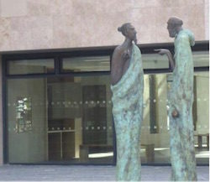

Deadline: June 24

UCD and McCann FitzGerald are inviting expressions of interest from artists who are interested in being considered for an exciting and prestigious art commission for the UCD Sutherland School of Law.

The commission is open to artists at all levels of experience. This will be a two stage commission process. For Stage 1, assessments will be made on previous work, artistic merit and evidence of ability to deliver projects. Shortlisted artists will then receive an honorarium to prepare proposals for Stage 2.

If you wish to be considered for this project please send a hard copy of your CV and images of previous work to:  
Ruth Ferguson – Curator  
UCD Newman House,  
86 St. Steph

en’s Green,  
Dublin 2.

**\_\_\_\_\_\_\_\_\_\_\_\_\_\_\_\_\_\_\_\_\_\_\_\_\_\_\_\_\_\_\_\_\_\_\_\_\_\_\_\_\_\_\_\_\_\_\_\_\_\_\_\_\_\_\_\_\_\_\_\_\_\_\_\_\_\_\_\_\_\_\_\_\_\_\_\_\_\_\_\_\_\_\_**

**Open Call | Exhibition Opportunities at Sirius Arts Centre, Co. Cork**

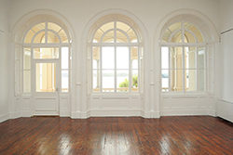

Deadline: Monday 13 June, 5pm  
The Old Yacht Club, Cobh, Co. Cork

Submissions are now open for the next exhibition programme (January to December 2017) at Sirius Arts Centre. Artists and curators are chosen for exhibitions and projects in one of two ways – by invitation and by open submission. It is estimated that there will be a small number of slots for solo or group projects in 2017 that will be chosen from open submission applications.

Please read the following information before you apply for the open submission:  
1. Applications are considered for both solo and group projects.  
2. The term of a project will be agreed between the artist(s) and the director of Sirius Arts Centre.  
3. Sirius Arts Centre offers remuneration to artists exhibiting in accordance with the Arts Council guidelines. However, given the changes in funding streams for the arts in Ireland, it is recommended that, if accepted – artists apply to their own Arts Councils and local authorities to source funding for travel, transportation and production costs.  
4. There is no fee to apply for an exhibition.

All applications will be reviewed by the curatorial panel and the applicant will be notified as soon as possible after the deadline. Applications can be sent by email. Please send applications to: info@siriusartscentre.ie (with the subject heading ‘Submissions 2017’). Please visit [**www.siriusartscentre.ie/exhibition-opportunities**](http://scanmail.trustwave.com/?c=6600&d=iZTG14ZxTzuoS6XTkGAIJIpeP2jplfdQHFhe1z_C9w&s=380&u=http%3a%2f%2fvisualartists%2eus9%2elist-manage1%2ecom%2ftrack%2fclick%3fu%3de67e46c7b14e756132f46a50c%26id%3d2a6e853afb%26e%3d1968c52731) for more information on requirements. Please note – applications that exceed the required documentation will not be accepted. Applications will not be accepted after the deadline.

**\_\_\_\_\_\_\_\_\_\_\_\_\_\_\_\_\_\_\_\_\_\_\_\_\_\_\_\_\_\_\_\_\_\_\_\_\_\_\_\_\_\_\_\_\_\_\_\_\_\_\_\_\_\_\_\_\_\_\_\_\_\_\_\_\_\_\_\_\_\_\_\_\_\_\_\_\_\_\_\_\_\_\_\_\_\_**

**Artist in Residence Programme 2017 at Sirius Arts Centre, Co. Cork**

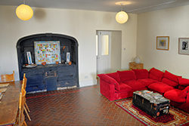

Deadline: Monday 13 June, 5pm  
The Old Yacht Club, Cobh, Co. Cork

Submissions are now open for the next residency programme (January to December 2017) at Sirius Arts Centre.

Sirius Arts Centre has been developing its Artist in Residence programme since 1994. This programme receives some funding from the Arts Council and Cork County Council and is well recognised internationally. The residency programme is designed to offer artists the opportunity to research and develop their practices and to engage in dialogue with Sirius, other organisations in Cork and the surrounding community.

Residents stay in a beautiful, two/three-bedroomed basement apartment in the Sirius Arts Centre’s building, located on the waterfront in the centre of Cobh, twenty minutes by train from Cork City. The residency provides a residential and work space to visual artists, either as individuals or groups.

For information on how to apply please visit: [**www.siriusartscentre.ie/residencies**](http://scanmail.trustwave.com/?c=6600&d=iZTG14ZxTzuoS6XTkGAIJIpeP2jplfdQHF4K3zSVpQ&s=380&u=http%3a%2f%2fvisualartists%2eus9%2elist-manage%2ecom%2ftrack%2fclick%3fu%3de67e46c7b14e756132f46a50c%26id%3d88b95cd505%26e%3d1968c52731)

**\_\_\_\_\_\_\_\_\_\_\_\_\_\_\_\_\_\_\_\_\_\_\_\_\_\_\_\_\_\_\_\_\_\_\_\_\_\_\_\_\_\_\_\_\_\_\_\_\_\_\_\_\_\_\_\_\_\_\_\_\_\_\_\_\_\_\_\_\_\_\_\_\_\_**

**Open Call for Exhibitions | Linenhall Arts Centre, Castlebar**



The Linenhall Arts Centre in Castlebar, Co. Mayo is inviting submissions from visual artists of all disciplines for its forthcoming exhibition programme. The Linenhall Arts Centre programmes a range of contemporary visual arts in a series of exhibitions throughout the year, from emerging artists to those of international reputation, and accepts submissions for exhibitions on an ongoing basis. Submissions are considered by the Linenhall’s Visual Arts Committee.

Submissions should include:

* contact details – name, address, phone number, email address;
* a current curriculum vitae;
* an artist’s statement and proposal;
* a maximum of ten good quality images of the artists work in, jpeg or photographic format. (Original works will not be accepted.)

Submissions should be sent by post to: Marie Farrell, Director, Linenhall Arts Centre, Linenhall St, Castlebar, Co Mayo.

See [www.thelinenhall.com/exhibitions/exhibiting.php](http://www.thelinenhall.com/exhibitions/exhibiting.php) for further details and gallery plan.

The Linenhall Arts Centre, Linenhall Street, Castlebar, Co. Mayo, Ireland  
T: 094 902 3733  
E: [linenhall@anu.ie](mailto:linenhall@anu.ie)  
W: [thelinenhall.com](http://www.thelinenhall.com/)

**\_\_\_\_\_\_\_\_\_\_\_\_\_\_\_\_\_\_\_\_\_\_\_\_\_\_\_\_\_\_\_\_\_\_\_\_\_\_\_\_\_\_\_\_\_\_\_\_\_\_\_\_\_\_\_\_\_\_\_\_\_\_\_\_\_\_\_\_\_\_\_\_\_\_**

**Open Call | OpenART Biennial 2017, Sweden**

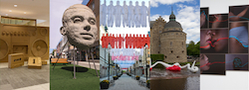

Deadline: 2 August

OpenART is Scandinavia’s biggest public art biennial and takes place in Örebro, Sweden. The city centre is filled with unexpected art that makes people feel happy, disturbed and provoked. Contemporary art from all over the world is showcased for almost three months in the city and offers unexpected encounters. The biennial challenges the visitors to rethink the perception of public space and our way of consuming and digesting art. The cultural exchange with the public is valued through several projects in connection to the exhibition like kids activities, a DIY art course and guided tours. OpenART 2017 will take place from 18 June to 10 September 2017.

Applications are made on the OpenART website, applicants must register and upload images directly at: [opencall.openart.se/Account/](https://opencall.openart.se/Account/Index?ReturnUrl=%2F)

You can enter 3 existing artworks or projects at most per application.  
The submission fee is 300 SEK (approx. €32).

Confirmed artists will receive an artist fee of €1000 (a confirmed group will share €1000), transport, travel and accommodation support. OpenART bears the cost for the transportation to and from the exhibition. In some cases OpenART also provides production support and in dialogue with the artist to find the most appropriate, time-efficient and cost-effective solutions. Artists are expected to participate in the installment of their own artworks. And are also invited to help fellow artists with production and installment on a voluntarily basis. All artists are invited to a set program on the opening weekend of OpenART 2017.

Please send your inquiries to [openart@orebro.se](mailto:openart@orebro.se).

**\_\_\_\_\_\_\_\_\_\_\_\_\_\_\_\_\_\_\_\_\_\_\_\_\_\_\_\_\_\_\_\_\_\_\_\_\_\_\_\_\_\_\_\_\_\_\_\_\_\_\_\_\_\_\_\_\_\_\_\_\_\_\_\_\_\_\_\_\_\_\_\_\_\_**

**Royal Ulster Academy 135th Annual Exhibition Open For Entries**

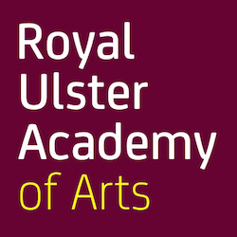

The Royal Ulster Academy 135th Annual Exhibition will take place at the Ulster Museum, Belfast from the 14 October 2016 to 8 January 2017. With over 81,000 visitors in 2015, this long standing event aims to expand contemporary approaches to the visual arts.

The Annual Exhibition showcases works by members of the Academy and works selected through open submission and by invitation.

Fees to enter are £15 per artwork for the first two works and £10 for the third work entered. Students are offered a reduced rate of £10 for the first two works entered and £7.50 for the third work. Your student number must appear on your online entry form for this reduction to apply.

Artists applying through the open submission process can enter a maximum of three works in any medium online, by 15th June 2016. From these entries the Selection Panel will draw up a shortlist of works for delivery to the Academy. The Annual Exhibition will be selected from these shortlisted works.

To enter please visit: [www.royalulsteracademy.org/annual-exhibition](http://www.royalulsteracademy.org/annual-exhibition)

Over £7,000 in prize money will be awarded to exhibiting artists of merit. Independent adjudicator Christopher Le Brun PRA, will select recipients of the Academy’s gold, silver and bronze medal prizes. All other prizes will be awarded by the prize sponsors.

**\_\_\_\_\_\_\_\_\_\_\_\_\_\_\_\_\_\_\_\_\_\_\_\_\_\_\_\_\_\_\_\_\_\_\_\_\_\_\_\_\_\_\_\_\_\_\_\_\_\_\_\_\_\_\_\_\_\_\_\_\_\_\_\_\_\_\_\_\_\_\_\_\_\_**

**Hennessy Portrait Prize 2016 l National Gallery of Ireland**

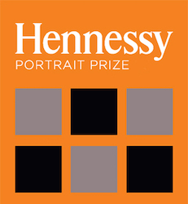

Deadline: 29 July

Application forms for the 2016 competition are now available to download, all submissions must be made online. The Hennessy Portrait Prize is open to artists across all disciplines and aims to encourage interest in contemporary portraiture and raise the profile of the National Portrait Collection. The winner will be announced in November and will once again receive a prize of €15,000 and a commission worth €5,000 to produce a portrait for inclusion in the National Portrait Collection.

For rules and application forms see: [**www.nationalgallery.ie/**](http://www.nationalgallery.ie/en/aboutus/ThisWeek/Hennessy_Portrait_Prize.aspx)

National Gallery of Ireland, Clare Street, Dublin 2

E: [**info@ngi.ie**](mailto:info@ngi.ie)  
T: (01) 661 5133

**Open Call | Emerging Irish Artist Residency Award 2016 | Burren College of Art**

Deadline: 4 July, 5pm

Burren College of Art is inviting artists to submit applications for the Emerging Irish Artist Residency Award 2016. We are looking for recent graduates and emerging artists who are highly motivated and would like the opportunity to receive the following:

• A large artist’s studio for the month of October 2016 with access to all college facilities.  
• Exhibit work in a group show in two venues: BCA Gallery/ 126 Artist-Run Gallery, Galway  
• Opportunity to present a lecture and engage with the College community at BCA.

Applications are welcome from artists working in any medium including: Painting, Drawing, Sculpture, Photography, Performance Art and New Media.

Four selected artists will receive a free one-month residency, including individual studio space and access to all college facilities for October 2016. They will curate and organise a group show based on their time in the Burren and their shared experience, which will be held in the BCA Gallery in 2017 and will travel to 126 Gallery in Galway. Suitable candidates also have the opportunity to present a lecture at the College and engage with students and the broader College community.

There is a €5 submission fee, to cover administration costs. If selected, artists must be willing to pay a one-off fee of €150 to cover housing and utilities costs in Ballyvaughan for one month, and are responsible for covering their own food and material costs.

Selection process by a committee from Burren College of Art and 126 Gallery will take place in July, with successful applicants notified by August 1st.

Residency will take place from October 3rd-28th 2016. Exhibition will take place in BCA & 126 Gallery in Spring 2017.

To submit your application please visit:  
[**www.burrencollege.ie/art/emerging-irish-artist-residency-award-2016**](http://www.burrencollege.ie/art/emerging-irish-artist-residency-award-2016)

**Open Call | Art and Science Residency at the European Space Agency**

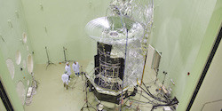

Deadline: 6 June

After three successful cycles of the Art and Science Residency Award, European Digital Art and Science Network present a new scientific partner for the fourth residency in the framework: ESA – the European Space Agency.

Artists above the age of 18 from all countries are invited to apply for a residency at ESA. The winning artist is subject to obtaining clearance to work on site at ESA-ESTEC. This call is open to digital artists to propose innovative concepts and ideas in the field of art, science and technology.

The EDASN are looking for digital artists who will be truly inspired by the scientific work enabled and achieved by ESA. This competition is open for artists to propose all kind of innovative concepts and ideas in the field of art and technology: interactive art, digital music/sound art, computer animation / Film / VFX, digital communities, hybrid art, performance & choreography, digital design.

Full details can be found here: [www.aec.at/artandscience/en/open-call/](http://www.aec.at/artandscience/en/open-call/)

**Open Call | Enniskillen Visual Arts Open 2016**

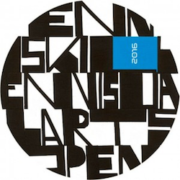

Deadline for applications: Monday 13 June, 12 noon  
Exhibition dates: 16 September to 15 October

Venue: The Higher Bridges Gallery, at The Clinton Centre, Belmore Street Enniskillen & Enniskillen Town (further venues tbc / post submission and selection process)

Applications are now being sought from Artists working in any medium including painting, print, photography, sculpture, installation, video, light, sound, performance, multimedia and applied arts to participate in a major exhibition of Visual Art due to be sited at the Higher Bridges Gallery and Enniskillen town centre. The exhibition will also coincide with the 2016 Fermanagh Arts Festival.

Interested artists can download the application form and terms and conditions from the following link:  
[www.fermanaghomagh.com/arts-and-culture/higher-bridges-gallery/enniskillen-visual-arts-open-2016/](http://www.fermanaghomagh.com/residential-services/arts-and-culture/higher-bridges-gallery/enniskillen-visual-arts-open-2016/)

Please read terms and conditions carefully. The organisers state: subject to the availability of funds and at the discretion of the arts festival, funding may be provided for production/installation.

**Open Call | Public Art Commission, The Liberties, Dublin 8**

image001[1]

Deadline: 9 June  
Budget: €75,000 (inc. VAT)

Dublin City Council and Fáilte Ireland invite proposals for public artworks to be located along the thoroughfare that runs from High Street to James Street in Dublin 8. The work forms part of a programme of public realm improvements to these streets which are now part of The Dubline – a major discovery trail through the city, exploring its history over the past 1000 years. The recent public realm improvements have an opportunity to renew the streets and create a more inviting and engaging route for the people who live, work and visit the area.

Artists are welcome to submit queries to the Public Art Manager (who is managing the commissioning process on behalf of Dublin City Council). Contact [publicart@dublincity.ie](mailto:publicart@dublincity.ie). The closing date for queries is May 26th 2016 at 12pm.

Please carefully read the information in the Commission Brief provided. Detailed guidelines, application forms and procedures can be found in the document [The Liberties Art Commission Brief](http://visualartists.ie/wp-content/uploads/2016/04/The-Liberties-Art-Commission-Brief-1-1.pdf) at

<http://www.dublincityartsoffice.ie/content/files/The_Liberties_Art_Commission_Brief_.pdf>

**Per Cent for Art Commission | Gaelscoil Shliabh Rua, Dublin 18**

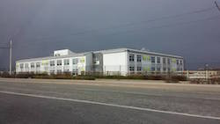

Deadline: Friday 17 June, 12 noon  
Budget: €25,000

Gaelscoil Shliabh Rua Public Art Working Group have made the decision to commission a permanent artwork that is process focused and involves all the young children in this school for their Per Cent for Art project. This artwork can be sited internally or externally to the building.

For the full Brief and Queries:  
Applicants can make enquiries regarding the commission to Rina Whyte, email [rinawhyte@yahoo.com](mailto:rinawhyte@yahoo.com) or by telephone + 353 87 238 9591.

**Per Cent For Art Commission | Scoil Mhuire National School, Tullamore, Co. Offaly**

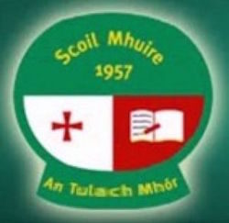

Deadline for Stage 1 Applications: 10 June  
Budget: €34,000 inclusive of all fees, costs and VAT

Under the Per Cent for Art Scheme, Scoil Mhuire National School wishes to commission new visual artwork to celebrate and coincide with the construction and opening of the drop-down and collect area for both Scoil Mhuire and Scoil Bhríde and the complete refurbishment/extension of Scoil Mhuire. This is a 2 Stage Commission process, applicants are requested to read the full content of the Guidelines Document carefully as it contains important information pertaining to all stages of the commission.

Artists Brief:  
The aim of the commission is to provide an opportunity for artists to develop new work influenced by the history, context and aspirations of the students, teachers, parents and community of both schools and the surrounding area. The Project financed under this scheme should maintain the highest level of artistic excellence, be innovative in nature and display a high level of understanding of the context of the commission.

The commission is for a piece or pieces of fixed permanent public sculpture of resilient and weather resistant material with minimal maintenance requirement, reflecting the spirit of the brief. Refer to the red zone in the attached site layout plan. The proposed setting of the work is to be situated outside and visible from both schools as well as passers-by.

Guidelines  
[Scoil Mhuire Per Cent Art Scheme Guideline Document](http://visualartists.ie/wp-content/uploads/2016/05/Scoil-Mhuire-Per-Cent-Art-Scheme-Guideline-Document.pdf)  
[Site Map](http://visualartists.ie/wp-content/uploads/2016/05/Site-Map.pdf)

Kilcruttin, Tullamore, Co. Offaly.  
(057) 9321222 / [www.scoilmhuiretullamore.ie](http://www.scoilmhuiretullamore.ie/)

*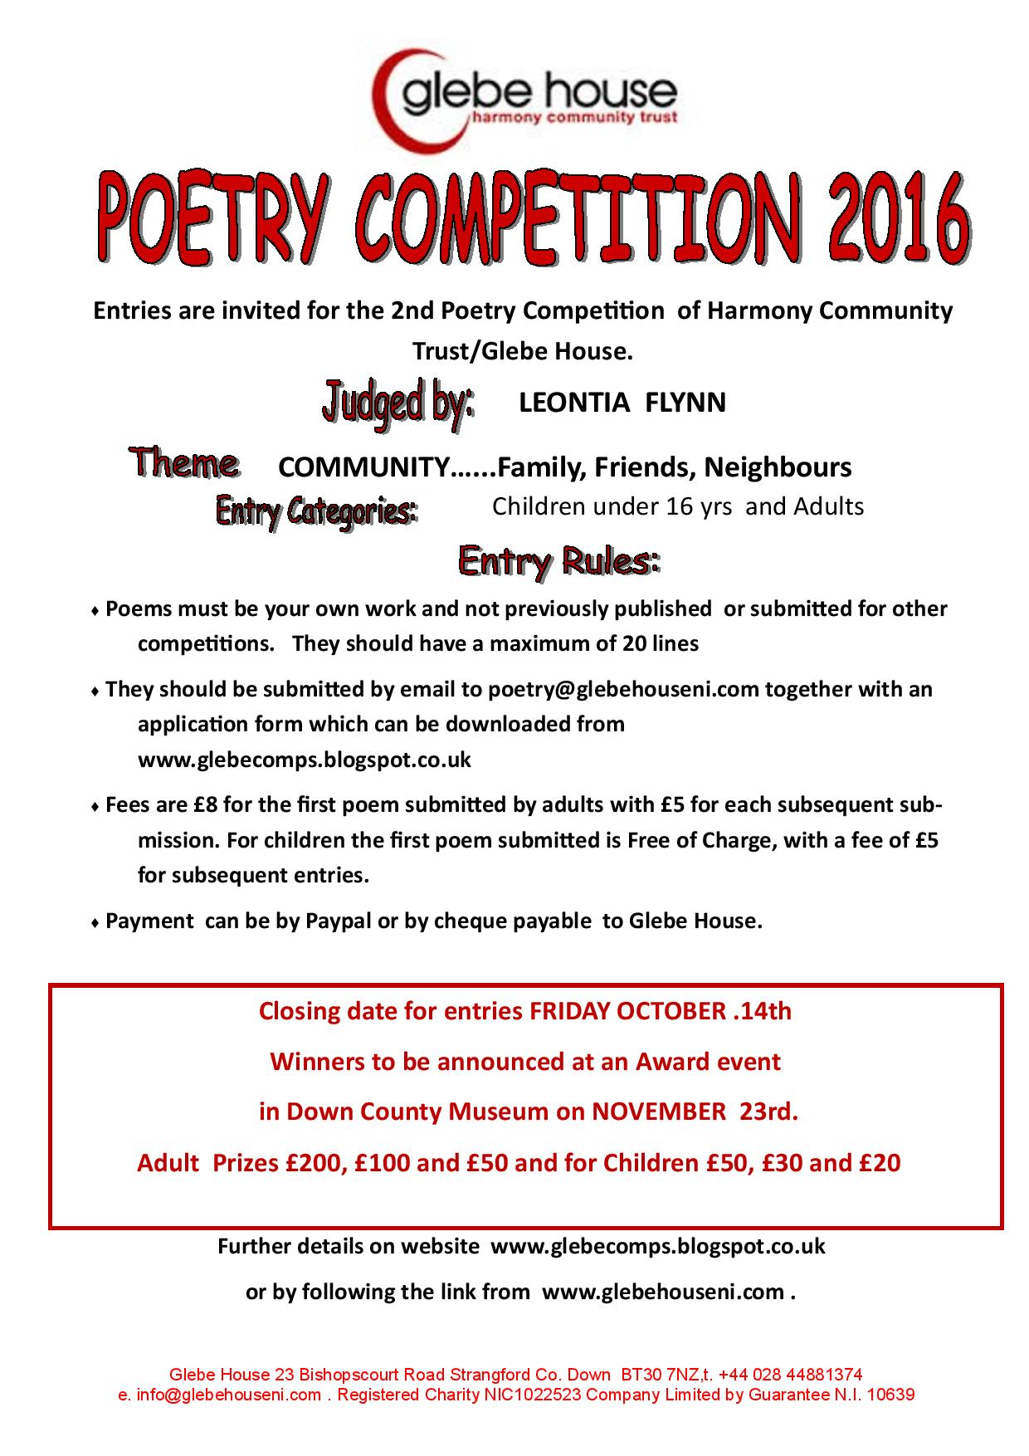*

**Awards / Bursaries / Schemes**

**Arts Council of Ireland: Upcoming Funding Deadlines**

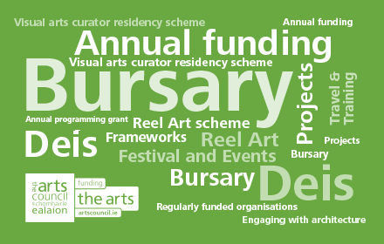

<http://www.artscouncil.ie>

|  |  |  |
| --- | --- | --- |
| Application deadline  **Ongoing** | [**Dámhachtain sparánachta litríochta**](http://www.artscouncil.ie/Funds/Damhachtain-sparanachta-litriochta/)  Dámhachtain sparánachta litríochta | Maximum award **€0**  [**Accepting applications**](http://www.artscouncil.ie/Funds/Damhachtain-sparanachta-litriochta/) |
| Application deadline  **Ongoing** | [**Travel and Training award**](http://www.artscouncil.ie/Funds/Travel-and-Training-award/)  Please note maximum amount awarded differs between artforms. There are three strands to this award: Travel and Training Outbound; Travel and Training Inbound; Creative Europe (Culture sub-programme) Travel Award. | Maximum award **€3,000**  [**Accepting applications**](http://www.artscouncil.ie/Funds/Travel-and-Training-award/) |
| Application deadline  **Ongoing** | [**Visual artists in prisons scheme**](http://www.artscouncil.ie/funds/Visual-artists-in-prisons-scheme/)  The scheme allows artists to work with prisoners in prison/ detention centres for a period of 10 days and complements an existing arts and education programme in the Education Units within the prison system. | Maximum award **€2,400**  [**Accepting applications**](http://www.artscouncil.ie/funds/Visual-artists-in-prisons-scheme/) |
| Application deadline  **Ongoing** | [**Writers in prisons scheme**](http://www.artscouncil.ie/funds/Writers-in-prisons-scheme/)  The scheme offers writers the opportunity to work with prisoners in prison/detention centres and complements an existing arts and education programme in the Education Units within the prison system. | Maximum award **€1,000**  [**Accepting applications**](http://www.artscouncil.ie/funds/Writers-in-prisons-scheme/) |
| Application deadline  **Ongoing** | [**Writers in schools scheme**](http://www.artscouncil.ie/funds/Writers-in-schools-scheme/)  The Writers in Schools Scheme part-funds visits by writers and storytellers to schools throughout the island of Ireland. | Maximum award **€200**  [**Accepting applications**](http://www.artscouncil.ie/funds/Writers-in-schools-scheme/) |
| Application deadline **9 June 2016 17:30** | [**Deis**](http://www.artscouncil.ie/Funds/deis/)  Deis is a scheme established under the Arts Councils Traditional Arts Initiative, 2005-2008. Deis is aimed at encouraging and facilitating the traditional arts community to seek funding from the Arts Council for a range of projects. | Maximum award **€20,000**  [**Opens 10 May 2016**](http://www.artscouncil.ie/Funds/deis/) |
| Application deadline **9 June 2016 17:30** | [**Engaging with architecture scheme**](http://www.artscouncil.ie/Funds/engaging-with-architecture-scheme/)  The purpose of the scheme is to support ambitious, innovative and creative, high quality initiatives that specifically aim to enhance and extend the public’s experience of architecture. The Engaging with Architecture Scheme also seeks to build an expert network of architects, curators, arts programmers, festivals and arts centres working in this area. | Maximum award **€20,000**  [**Opens 10 May 2016**](http://www.artscouncil.ie/Funds/engaging-with-architecture-scheme/) |

**Arts Council Arts Participation Bursary Award - Information Clinic 14 June 2016 at Create**

|  |
| --- |
| http://newsletter.artscouncil.ie/nwstatic/spacer.gif |

The Arts Council will hold an information clinic in association with Create, the national development agency for collaborative arts on Tuesday, 14 June 2016.

Date: 14 June

Time: 11am-1pm

Venue: Filmbase Building, Curved Street, Temple Bar, Dublin

The Arts Council will hold an information clinic in association with Create, the national development agency for collaborative arts on Tuesday, 14 June 2016. The clinic will take place in the Training Room, 2nd floor, Filmbase building, Curved Street, Temple Bar, Dublin 2 from 11am – 1pm.

The clinic is taking place in advance of the deadline for the Arts Council Arts Participation Bursary Award, which is on Thursday, 14 July at 5.30pm. The objective of the Arts Participation Bursary Award is to support individual professional artists in any artform, whose practice centres on collaboration with groups of people in any of the following contexts: health, disability, cultural diversity, older people, and communities of place or interest. The award emphasises the value and benefit to an artist’s development that is derived from an extended process of engagement with their practice and seeks to provide artists with the time and resources to think, research, reflect and engage with their practice. Applicants may apply for an award of up to €10,000.

The clinic will include information about the purpose and priorities of the award, the application process, common mistakes and an opportunity for Q&A. The clinic will also include short presentations from a number of artists that have previously received the Arts Council Arts Participation Bursary Award. Artists will outline their reason for applying, how they used the bursary and what impact it had on the development of their practice. Further detail will be available on the [Arts Council](http://newsletter.artscouncil.ie/e2evpd7e5xu14rbsgtdsq9?a=6&p=50363139&t=28179891)and [Create](http://newsletter.artscouncil.ie/1wwac4vyt7y14rbsgtdsq9?a=6&p=50363139&t=28179891) websites in the coming weeks.

There is no cost for attendance, however, booking is essential. Please email Jenny Walton at [jenny.walton@artscouncil.ie](mailto:jenny.walton@artscouncil.ie) if you wish to attend. Light refreshments will be provided.

Create will also launch a Special Edition of Create News at the event, which will include *Bodies and Subjects,* a paper originally given by Dave Beech at the Create Networking Day held in IMMA, December 2015.

**\_\_\_\_\_\_\_\_\_\_\_\_\_\_\_\_\_\_\_\_\_\_\_\_\_\_\_\_\_\_\_\_\_\_\_\_\_\_\_\_\_\_\_\_\_\_\_\_\_\_\_\_\_\_\_\_\_\_\_\_\_\_\_\_\_\_\_\_\_\_\_\_\_\_\_\_\_\_\_\_\_\_\_\_\_\_\_**

**The Arts Council and UCC seek to appoint a Traditional Artist in Residence 2016/17**

|  |
| --- |
| http://newsletter.artscouncil.ie/nwstatic/spacer.gif |

**Traditional Artist in Residence:**Applications are invited from well-renowned and accomplished traditional artists (musicians, singers, dancers) of distinction, for the above residency, which is jointly funded by the College of Arts, Celtic Studies, and Social Sciences (UCC) and the Arts Council. The role will be offered for the period October 2016 - September 2017.Closing Date for Applications: 29 July 2016 School: School of Music and Theatre Contract Type: Fixed Term Part-Time. **1 October 2016 - 30 September 2017**

The appointee will advise and mentor emerging traditional artists in the UCC community, offering six contact hours per week in the form of workshops, seminars and consultation during university terms. The appointee will give two public performances, and s/he will engage in a collaborative project with staff and students leading to the production, for public dissemination, of original artistic material. In university vacations the appointee will enjoy uninterrupted time to advance his/her own projects.

To Apply:

Applications should be sent by email attachment on or before 29 July 2016. Candidates are invited to submit a letter of application and a C.V. with details of relevant performances, publications (including CDs, DVDs, etc.) and awards to Mary Mitchell-Ingoldsby, School of Music and Theatre, UCC [mmitchell@music.ucc.ie](mailto:mmitchell@music.ucc.ie). Candidates should also address the following questions in their application letter:

1. Outline the relevant skills and experience you would bring to the post of Traditional Artist in Residence.
2. Describe the ways in which you would contribute to the development of traditional arts practice at University.
3. Describe the ways in which you would develop your own arts practice during the residency.

Requests for further particulars, financial information and informal enquiries about the role may also be made to Mary Mitchell-Ingoldsby.

Interviews will be held in Cork in early September.

**\_\_\_\_\_\_\_\_\_\_\_\_\_\_\_\_\_\_\_\_\_\_\_\_\_\_\_\_\_\_\_\_\_\_\_\_\_\_\_\_\_\_\_\_\_\_\_\_\_\_\_\_\_\_\_\_\_\_\_\_\_\_\_\_\_\_\_\_\_\_\_\_\_\_\_\_\_\_\_\_\_\_\_\_\_**

**Belltable and Fishamble: Open Call for Applications for Mentoring Programme for Playwrights and Directors**

|  |
| --- |
| http://newsletter.artscouncil.ie/nwstatic/spacer.gif |

As part of the artist development initiative Belltable:Connect, Belltable and Fishamble: The New Play Company have come together to offer a 10-month mentoring programme for playwrights and directors. The initiative is intended to support the development of emerging and established playwrights and directors, who would benefit from an ongoing mentoring process to investigate and enhance their practice.

The programme will take place in Belltable, 69 O’Connell Street, Limerick, over a series of ten Saturday mornings (10am – 1pm) from September 2016 until June 2017. Participants will discuss their current and future projects, explore the role of the playwright/director, and be mentored through challenges that face them.  A work-in-progress showcase may be presented towards the end of the year, as appropriate.

For more information and to download application forms see <https://www.limetreetheatre.ie/special-announcements/>

Closing date for receipt of applications is strictly 1 July 2016 at 5pm.

**\_\_\_\_\_\_\_\_\_\_\_\_\_\_\_\_\_\_\_\_\_\_\_\_\_\_\_\_\_\_\_\_\_\_\_\_\_\_\_\_\_\_\_\_\_\_\_\_\_\_\_\_\_\_\_\_\_\_\_\_\_\_\_\_\_\_\_\_\_\_\_\_\_\_\_\_\_\_\_\_\_\_\_\_\_\_**

**ieiMedia/IWC Scholarship Opportunity for Writers aged 18–25**

|  |
| --- |
|  |

ieiMedia and the Irish Writers Centre are pleased to offer **one full and one half scholarship** to a writer in the **playwriting** strand of this four-week residential course in Armagh and Dublin during the month of July.  
  
This is a fantastic opportunity to gain valuable training and                                                 experience with professional writers in a group setting and to                                             take part in the **John Hewitt Summer School**.

Deadline for applications: 10 June at 5pm.

|  |  |
| --- | --- |
| |  | | --- | |  | |

<http://irishwriterscentre.ie/collections/writing-opportunities/products/ieimedia-irish-writers-centre-joint-scholarship?mc_cid=96d8ccee98&mc_eid=055476dad7>

# European Cultural Foundation – STEP travel grants – ongoing

**STEP Beyond Travel grants fund up and coming artists and cultural workers – giving priority to individuals up to 35 years and/or in the first 10 years of their career – to travel between EU and countries bordering the EU.**

There is no deadline for this grant scheme, so you can apply at any time but at least one month before your planned travel. The selection process takes up to one month.

For more information on how to apply, a list of eligible travel destinations and to access the application form, go to the “how to apply guidelines”. [ecflabs.org/sites/www.ecflabs.org/files/step-beyond-grant/guidelines/guidelines\_step.pdf](http://ecflabs.org/sites/www.ecflabs.org/files/step-beyond-grant/guidelines/guidelines_step.pdf)

These guidelines are also available in Russian but please note that the final application has to be in English. You can also access the application form directly here – [ecflabs.org/step-beyond-apply?gids[]=4707#group\_step\_1](http://ecflabs.org/step-beyond-apply?gids%5b%5d=4707#group_step_1)

**\_\_\_\_\_\_\_\_\_\_\_\_\_\_\_\_\_\_\_\_\_\_\_\_\_\_\_\_\_\_\_\_\_\_\_\_\_\_\_\_\_\_\_\_\_\_\_\_\_\_\_\_\_\_\_\_\_\_\_\_\_\_\_\_\_\_\_\_\_\_\_\_\_\_\_\_\_\_\_\_\_\_\_\_\_\_\_**

# Tyrone Guthrie Centre – Film Maker Bursary

**This bursary is intended to benefit young/emerging practitioners in the area of filmmaking and scriptwriting thereby nurturing new talent in the sector.**

The film bursary will entitle the successful applicant to progress work in-hand or to develop new proposals over a two-week residency period with accommodation provided in the Big House.

The film bursary is also available for two people who are collaborating on a project together. In the case of a collaborative proposal the bursary is available for a one-week period.

**To apply for the Film Maker bursary please complete the standard** [**online application**](http://www.tyroneguthrie.ie/apply/form)**, outlining your proposal and rationale for this specific award in the “Proposal” section by Friday 24th June.**

<http://www.tyroneguthrie.ie/apply/form>

**\_\_\_\_\_\_\_\_\_\_\_\_\_\_\_\_\_\_\_\_\_\_\_\_\_\_\_\_\_\_\_\_\_\_\_\_\_\_\_\_\_\_\_\_\_\_\_\_\_\_\_\_\_\_\_\_\_\_\_\_\_\_\_\_\_\_\_\_\_\_\_\_\_\_\_\_\_\_\_\_\_\_\_\_\_\_\_**

**Accessing EU Funding for the Arts**

Did you know that the EU supports cultural organisations to work across Europe, enabling them to reach new audiences, promote diversity and build new skills?

[Creative Europe – Culture Sub-Programme](http://scanmail.trustwave.com/?c=6600&d=tIHD16E5B8N_jUK8GQZBg79EnxPUeR91j0is29pw0w&s=380&u=http%3a%2f%2fthewheel%2ecmail19%2ecom%2ft%2fi-l-hkhklkd-blldrukdj-r%2f), [Europe for Citizens](http://scanmail.trustwave.com/?c=6600&d=tIHD16E5B8N_jUK8GQZBg79EnxPUeR91j0qi2Nty0A&s=380&u=http%3a%2f%2fthewheel%2ecmail19%2ecom%2ft%2fi-l-hkhklkd-blldrukdj-y%2f) and [Erasmus+](http://scanmail.trustwave.com/?c=6600&d=tIHD16E5B8N_jUK8GQZBg79EnxPUeR91jxn-34p20w&s=380&u=http%3a%2f%2fthewheel%2ecmail19%2ecom%2ft%2fi-l-hkhklkd-blldrukdj-j%2f) are EC programmes funding a wide range of cultural, historical and youth activities. As funding recipients, many Irish organisations have developed impactful projects in cooperation with organisations across the EU.

To improve knowledge of these programmes, the Arts Council, Leargas and The Wheel will host an information session on EU Funding for the Arts.

This event will focus on the EU’s Creative Europe Culture sub-programme, the Erasmus+ (Youth and Adult Education) and Europe for Citizens (remembrance strand). An overview of current programme priorities will be given and details of how to apply. A panel discussion involving recently successful applicants will take place, providing real life experiences of EU funding.

**Date:**        Tuesday, 14 June 2016

**Time:**      10am – 1pm (registration from 9.30am)

**Venue:**    Europe House, 12-14 Mount Street, Dublin 2.

If you would like to explore European opportunities, then please come and join us. Attendance is free but places are limited – [book your place today](http://scanmail.trustwave.com/?c=6600&d=tIHD16E5B8N_jUK8GQZBg79EnxPUeR91jxmp2dZ5gw&s=380&u=http%3a%2f%2fthewheel%2ecmail19%2ecom%2ft%2fi-l-hkhklkd-blldrukdj-i%2f).

**Deirdre Finlay**  
Europe for Citizens Information Officer  
**The Wheel** | 48 Fleet Street, D02 T883 Dublin 2  
T: (01) 454 8727 | E: [deirdref@wheel.ie](mailto:deirdref@wheel.ie) | W: [www.wheel.ie](http://scanmail.trustwave.com/?c=6600&d=tIHD16E5B8N_jUK8GQZBg79EnxPUeR91j0Krid5y1Q&s=380&u=http%3a%2f%2fwww%2ewheel%2eie)

Find out more about accessing EC funding today, visit [**www.europeforcitizens.ie**](http://scanmail.trustwave.com/?c=6600&d=tIHD16E5B8N_jUK8GQZBg79EnxPUeR91j0z5iNp0hw&s=380&u=http%3a%2f%2fthewheel%2ecmail19%2ecom%2ft%2fi-l-hkhklkd-blldrukdj-d%2f)

Follow us on Twitter @EU4Citizens

**Of Interest**

**Visual Artists Ireland calls on government for immediate action to alleviate poverty in the visual arts**

80% of visual artists in Ireland who depend on their creative income live under the poverty threshold. The Government must act now to ensure that arts funding is increased to a level that supports the Arts Council and other funding bodies as they work with artists and arts organisations.

Since 2008 there has been a 27% increase in funding for the Department of the Arts, Heritage, and the Gaeltacht. During that same period there has been a 28% decrease in funding to the Arts Council which has resulted in damaging cuts to artists and arts organisations, some of which have had to close. The 2016 commemoration saw a rise in one-off funding. The retention of that 2016 funding is important and needs to be in addition to the Arts Council’s current allocation. Commitment through confirmed action is needed now so that artists and arts organisations can reduce the highly precarious financial situation that they find themselves in.

Speaking on Thursday, Noel Kelly – CEO of Visual Artists Ireland said, “We find it hard to understand why there is so much talk of support for the arts and yet when we ask for the most fundamental support there is no confirmed action. The situation is now made more desperate by the further dilution of the arts at the cabinet table through the expansion of the brief of the department.” He continued “We need to see a dedicated Department of Culture and clearly stated and guaranteed supports that will provide us with the means to move the creative people who provide us with the arts from beneath the poverty level.”

Visual Artists Ireland  
Founded in 1980, Visual Artists Ireland: The Representative Body for Professional Artists provides practical support to visual artists in all art forms throughout their careers. VAI provides services, facilities and resources for artists, operates an artistic programme and acts as an advocate for the interests of artists.

Tel: +353 (0)1 672 9488  
Email: [**info@visualartists.ie**](mailto:info@visualartists.ie) / [**noel@visualartists.ie**](mailto:noel@visualartists.ie)

**\_\_\_\_\_\_\_\_\_\_\_\_\_\_\_\_\_\_\_\_\_\_\_\_\_\_\_\_\_\_\_\_\_\_\_\_\_\_\_\_\_\_\_\_\_\_\_\_\_\_\_\_\_\_\_\_\_\_\_\_\_\_\_\_\_\_\_\_\_\_\_\_\_\_\_\_\_\_\_\_\_\_\_\_\_\_\_**

**VAI and NCFA Addressing Current Challenges Facing the Arts Sector**

VAI and NCFA are working closely to devise a campaign to mobilise the growing solidarity in the arts community in response to recent departmental changes in government.

Visual Artists Ireland and the National Campaign for the Arts are aware that this does not only effect the 20,000 or more arts workers, it concerns all citizens who engage, participate, and experience arts and culture – the whole of Irish society. Ireland remains bottom of the European league table for Arts funding and we are committed to working with government and the arts community to find a way to improve support for the sector.

Your support and your voice will be vital in the coming days, weeks and months.

**Some recent media coverage:**

**National press:**  
Irish Times – Recognising the arts at the Cabinet table  
[http://www.irishtimes.com/opinion/editorial/recognising-the-arts-at-the-cabinet-table-1.2644242](http://scanmail.trustwave.com/?c=6600&d=iJTG16Vb9rCCE-2C41RTFyumjonCtqzFGT49m-k72A&s=380&u=http%3a%2f%2fwww%2eirishtimes%2ecom%2fopinion%2feditorial%2frecognising-the-arts-at-the-cabinet-table-1%2e2644242)

Irish Times – Artists Threaten Strike Action  
[http://www.irishtimes.com/culture/art-and-design/artists-threaten-strike-action-over-funding-cuts-1.2653834](http://scanmail.trustwave.com/?c=6600&d=iJTG16Vb9rCCE-2C41RTFyumjonCtqzFGT5kyrxpjA&s=380&u=http%3a%2f%2fvisualartists%2eus9%2elist-manage%2ecom%2ftrack%2fclick%3fu%3de67e46c7b14e756132f46a50c%26id%3d47d9515aba%26e%3d1968c52731)

Irish Times – Recognising the arts at the Cabinet table  
[http://www.irishtimes.com/opinion/editorial/recognising-the-arts-at-the-cabinet-table-1.2644242#.VzSI68HaS5p.twitter](http://scanmail.trustwave.com/?c=6600&d=iJTG16Vb9rCCE-2C41RTFyumjonCtqzFGWxvyuxvjQ&s=380&u=http%3a%2f%2fvisualartists%2eus9%2elist-manage%2ecom%2ftrack%2fclick%3fu%3de67e46c7b14e756132f46a50c%26id%3d981a4701c5%26e%3d1968c52731)

Irish Independent – Lip service and neglect – our official arts policy  
[http://www.independent.ie/opinion/columnists/martina-devlin/lip-service-and-neglect-our-official-arts-policy-34734404.html](http://scanmail.trustwave.com/?c=6600&d=iJTG16Vb9rCCE-2C41RTFyumjonCtqzFGWhuz-s8jQ&s=380&u=http%3a%2f%2fvisualartists%2eus9%2elist-manage2%2ecom%2ftrack%2fclick%3fu%3de67e46c7b14e756132f46a50c%26id%3d7505638b0b%26e%3d1968c52731)

Irish Examiner – Artists Led the Rising, Yet Witless Governments Kill Off Art  
[http://www.irishexaminer.com/viewpoints/columnists/gerard-howlin/revolutionary-artists-led-the-rising-yet-witless-governments-kill-off-art-400072.html](http://scanmail.trustwave.com/?c=6600&d=iJTG16Vb9rCCE-2C41RTFyumjonCtqzFGT1tzug7jA&s=380&u=http%3a%2f%2fvisualartists%2eus9%2elist-manage%2ecom%2ftrack%2fclick%3fu%3de67e46c7b14e756132f46a50c%26id%3d8f1abea3ac%26e%3d1968c52731)

Hotpress Magazine – Arts Community Holds Meeting With Government Over Taoiseach’s Remarks  
[http://www.hotpress.com/Enda-Kenny/news/Arts-Community-Holds-Meeting-With-Government-Over-Taoiseachs-Remarks/17232170.html](http://scanmail.trustwave.com/?c=6600&d=iJTG16Vb9rCCE-2C41RTFyumjonCtqzFGT5lmOs7gQ&s=380&u=http%3a%2f%2fvisualartists%2eus9%2elist-manage1%2ecom%2ftrack%2fclick%3fu%3de67e46c7b14e756132f46a50c%26id%3d88fce3569f%26e%3d1968c52731)

**Online:**  
Arts Management.ie:  
Get In Formation – Irish Arts and Heritage Rising  
[https://artsmanagement.ie/2016/05/18/get-in-formation-irish-arts-heritage-rising/](http://scanmail.trustwave.com/?c=6600&d=iJTG16Vb9rCCE-2C41RTFyumjonCtqzFGWo6y-xo2A&s=380&u=http%3a%2f%2fvisualartists%2eus9%2elist-manage1%2ecom%2ftrack%2fclick%3fu%3de67e46c7b14e756132f46a50c%26id%3dc50b10c80e%26e%3d1968c52731)  
A New Irish Ministry For The Arts or Through a Hedge Backwards  
[https://artsmanagement.ie/2016/05/09/a-new-irish-ministry-for-the-arts-or-through-a-hedge-backwards/](http://scanmail.trustwave.com/?c=6600&d=iJTG16Vb9rCCE-2C41RTFyumjonCtqzFGTc_z71uig&s=380&u=http%3a%2f%2fvisualartists%2eus9%2elist-manage%2ecom%2ftrack%2fclick%3fu%3de67e46c7b14e756132f46a50c%26id%3d1b04f70b21%26e%3d1968c52731)

Petition – Irish Arts, Culture and Heritage Need Adequate Funding and a Dedicated Government Department (ongoing, over 13,000 signatories to date)  
[https://my.uplift.ie/petitions/restore-the-department-of-arts-culture-and-heritage-as-a-stand-alone-department](http://scanmail.trustwave.com/?c=6600&d=iJTG16Vb9rCCE-2C41RTFyumjonCtqzFGWs6xe1qiA&s=380&u=http%3a%2f%2fvisualartists%2eus9%2elist-manage%2ecom%2ftrack%2fclick%3fu%3de67e46c7b14e756132f46a50c%26id%3d110e4280a8%26e%3d1968c52731)

John O’Brien – When To Not Follow The Money  
[https://obriencreativeconsultants.wordpress.com/2016/05/18/when-to-not-follow-the-money/](http://scanmail.trustwave.com/?c=6600&d=iJTG16Vb9rCCE-2C41RTFyumjonCtqzFGTg-xeg82g&s=380&u=http%3a%2f%2fvisualartists%2eus9%2elist-manage2%2ecom%2ftrack%2fclick%3fu%3de67e46c7b14e756132f46a50c%26id%3d9f92a7624e%26e%3d1968c52731)

**Radio:**  
Newstalk – Heather Humphreys argues “the order of words in department title” won’t be important  
[http://www.newstalk.com/Heahter-Humphreys-argues-commitments-to-funding-will-prove-more-important-than-the-order-of-words-in-department-title](http://scanmail.trustwave.com/?c=6600&d=iJTG16Vb9rCCE-2C41RTFyumjonCtqzFGT85zOpvjQ&s=380&u=http%3a%2f%2fwww%2enewstalk%2ecom%2fHeahter-Humphreys-argues-commitments-to-funding-will-prove-more-important-than-the-order-of-words-in-department-title)

Director Lenny Abrahamson on RTE’s Morning Ireland where he spoke to the need for sustained and further investment in Irish, Arts, Culture, Heritage  
[http://www.rte.ie/radio/radioplayer/rteradiowebpage.html#!rii=9:20990538:48:19-05-2016:](http://scanmail.trustwave.com/?c=6600&d=iJTG16Vb9rCCE-2C41RTFyumjonCtqzFGTk_nuw7gQ&s=380&u=http%3a%2f%2fvisualartists%2eus9%2elist-manage%2ecom%2ftrack%2fclick%3fu%3de67e46c7b14e756132f46a50c%26id%3dfbd5405798%26e%3d1968c52731)

Artist Robert Ballagh spoke about the need for Government to invest seriously and sustainably in Irish Arts, Culture, Heritage on Newstalk 106-108 fm  
[http://www.newstalk.com/listen\_back/7/27467/19th\_May\_2016\_-\_Lunchtime\_Part\_2/](http://scanmail.trustwave.com/?c=6600&d=iJTG16Vb9rCCE-2C41RTFyumjonCtqzFGT9lyeFsiQ&s=380&u=http%3a%2f%2fvisualartists%2eus9%2elist-manage%2ecom%2ftrack%2fclick%3fu%3de67e46c7b14e756132f46a50c%26id%3de996f6ce88%26e%3d1968c52731)

**\_\_\_\_\_\_\_\_\_\_\_\_\_\_\_\_\_\_\_\_\_\_\_\_\_\_\_\_\_\_\_\_\_\_\_\_\_\_\_\_\_\_\_\_\_\_\_\_\_\_\_\_\_\_\_\_\_\_\_\_\_\_\_\_\_\_\_\_\_\_\_\_\_\_\_\_\_\_\_\_\_\_\_\_\_\_**

**#ArtsDeptNow Petition to be Delivered to Government on 3 June, 4pm**



A petition signed by over 13,500 people will be handed over to government on Friday the 3rd of June. The petition was set up in response to recent departmental changes in government and is titled “Irish Arts Culture and Heritage Needs Adequate Funding and a Dedicated Government Department” and together with the hashtag #ArtsDeptNow has gained considerable support on social media.

Supporters of the petition are asking individuals and arts organisations to post an image or statement with the hashtag #ArtsDeptNow on Twitter/Facebook on Friday at 4pm, they are hoping the delivery of the petition will become a viral trending event in Ireland and create additional awareness of the growing solidarity in the arts community.

For now, the petition is ongoing and can be signed here: [my.uplift.ie/petitions/restore-the-department-of-arts-culture-](https://my.uplift.ie/petitions/restore-the-department-of-arts-culture-and-heritage-as-a-stand-alone-department?bucket&source=facebook-share-button&time=1462960488)

**\_\_\_\_\_\_\_\_\_\_\_\_\_\_\_\_\_\_\_\_\_\_\_\_\_\_\_\_\_\_\_\_\_\_\_\_\_\_\_\_\_\_\_\_\_\_\_\_\_\_\_\_\_\_\_\_\_\_\_\_\_\_\_\_\_\_\_\_\_\_\_\_\_\_\_\_\_\_\_\_\_\_\_\_\_\_**

**NI Community Arts Partnership’s Chief Executive Conor Shields’ CAPtain’s Blog – “The Programme for Government and the Arts”**

The development of any work of art seldom happens overnight and the skillset that is required to support and facilitate its production in all likelihood was developed over years of training, with trials and tribulations along the way. Creating something that synthesises purposeful design, elegance in execution and depth in messages and meaning remains the challenge that faces all artists and arts facilitators, from whatever discipline. Even the stand-up comedian, seemingly “winging it” conversationally may well have honed her apparently throw away patter through years of blood, sweat and gigs. Seldom do we attach value to things that we attain easily. And in a world where more and more becomes less and less valued, and increasingly disposable, cherishing our arts and the skills, talents and processes sustaining them for the benefit of current and future generations becomes more crucial. The arts, that have created the “soundtracks of our lives” across every medium, not just music, have been our constant companion, reflecting and indeed amplifying who we are as individuals and communities and reminded us time and again of what it is to be human – the joy, the grief, the ecstasy, the tragedy, the beauty and the sheer endurance.

Read the rest of the CAPtain’s blog at

http://conorcommunity.blogspot.ie/2016/05/the-programme-for-government-and-arts.html

**\_\_\_\_\_\_\_\_\_\_\_\_\_\_\_\_\_\_\_\_\_\_\_\_\_\_\_\_\_\_\_\_\_\_\_\_\_\_\_\_\_\_\_\_\_\_\_\_\_\_\_\_\_\_\_\_\_\_\_\_\_\_\_\_\_\_\_\_\_\_\_\_\_\_\_\_\_\_\_\_\_\_\_\_\_\_**

### What Next? National Campaign for the Arts Public Meeting | 9 June



NCFA will host a public meeting for the arts community in Project Arts Centre on Thursday 9 June from 09.45 – 11.15. The purpose of the meeting is a forum to discuss the viability of the setting up of a movement similar to What Next?

What Next? is a national movement of arts and cultural organisations, artists, funders, policy makers, institutions, and individuals in the UK who come together regularly to articulate and strengthen the role of culture in society. They’re interested in how they can act together to make change happen and how they can hold an authentic conversation about value with decision makers, the public and each other.

The National Campaign for the Arts is a volunteer-led, grass roots movement that makes the case for the arts in Ireland. It seeks to ensure that the arts are on local and national government agendas and are recognised as a vital part of contemporary Irish life.

Speakers at the event include Hannah Bird (National Movement Lead, What Next?) and Brian Sheehan (Co-Director, YES Equality).

There will be room for discussion around practical next steps that the arts community can take to get involved at local and national level, and engage in our country’s conversation about culture.

**Timetable**  
Thursday 9 June 09.45 – 11.15  
Project Arts Centre, Space Upstairs, 39 East Essex Street, Dublin 2.

09.30 – 09.45 Arrivals

09.45 – 10.15 Brian Sheehan  
(Co-Director, Yes Equality)  
YES Equality Campaign- Persuading People to Come with You

10.15 – 10.45 Hannah Bird  
(National Movement Lead, What Next?)  
An Introduction to What Next?

10.45 – 11.15 Jo Mangan (Chair, NCFA) & Maria Schweppe (Freelance Arts, Festival & Comedy Producer)  
Q&A – Next Steps

Capacity is limited so please RSVP in advance to confirm your attendance at [www.eventbrite.ie/e/what-next-national-campaign-for-the-arts-tickets-25718979159](http://scanmail.trustwave.com/?c=6600&d=-rDK14NjKgMYTTFXhPwuSnYe4IEe4Ps_R96gfQcmdA&s=380&u=http%3a%2f%2fvisualartists%2eus9%2elist-manage%2ecom%2ftrack%2fclick%3fu%3de67e46c7b14e756132f46a50c%26id%3d2a59d39add%26e%3df4dbf7f416)