Kilkenny County Council

Waste Prevention Grant Scheme 2021

Kilkenny County Council is offering community groups an opportunity to promote waste prevention, creating an opportunity to look at waste differently, to determine if we can handle our resources better, to contribute to a zero waste society and encourage a circular economy. Preference will be given to projects that contribute to a zero-waste lifestyle which by means of education, craft or innovation. Waste streams which are excluded from the fund are tyres and wood, therefore no projects will be considered for funding if the principal material involves tyres or wood.

Funding will be considered for projects with a definitive aim, targeting a specific group and can provide an estimate of waste prevented (by weight) within the project period. Projects will be assessed by a scoring criteria and should be reflected in the project details; be aware of the scoring matrix which your project will be evaluated against (illustrated on the application form).

The maximum funding for each waste prevention project is €500. Previous examples of funded projects include up-cycling community workshops creating sustainable products from waste like curtain fabric into bunting, repair/up-cycling events for Re-Use Month (October annually), Men Shed bicycle repair workshops and projects that encourage the elimination of single use items within a community setting.

The grant scheme supports the following national, regional and local policies;

- Sustainable Development Goals National Implementation Plan 2018 – 2020

- A Waste Action Plan for a Circular Economy – Irelands National Waste Policy 2020-2025

- Southern Region Waste Management Plan 2015-2021

- Kilkenny County Councils Climate Change Adaption Strategy 2019-2024

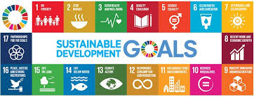

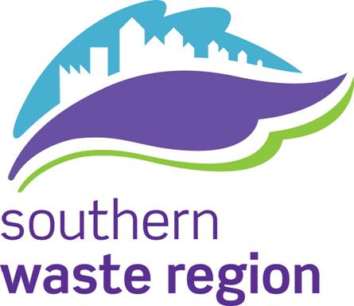
Applicant Information

1. | Name of Organistation
2. | Contact Name
3. | Position in Group
4. | Contact Number
5. | Email Address
6. | Postal Address

Project Details (Use separate sheet)

Describe the project you are seeking funding for and at a minimum include the following;

- Project Overview;

- Project Location;

- Project Duration (No. of Hours);

- Start Date/End Date

- Estimate Number of Participants;

- Estimate kgs of Waste Prevented;

Project Financial Details

Grant Amount Sought: ____________________________

Applicant or Other Contribution: ____________________________

Total Estimated Cost of Project: __________________________

Describe how will you promote the waste prevention project within your community:________________________________________________________
__________________________________________________________________
__________________________________________________________________
__________________________________________________________________
__________________________________________________________________
If your group has members under 18 years or will work with persons under 18 years please advise if this group is compliant with Children’s First Act 2015:

Yes No

If No, please sign Kilkenny County Council’s Child Protection Policy Declaration Form. (Appendix X of Kilkenny County Council’s Policy for the Protection of Children)

Please submit completed application forms to:
Bernadette Moloney
Environmental Awareness Officer
Environment Section
Kilkenny County Council
County Hall
John Street
Kilkenny

Email applications are also acceptable before 5pm on the 14th of May 2021, bernadette.moloney@kilkennycoco.ie

Closing date: 14th May 2021

Assessment Criteria

Projects will be evaluated by a scoring matrix. The scores allocated to each element are described below.

- Details of project including a project schedule (20 Marks).

- Description of a method of quantifying waste prevented (10 marks).

- Demonstration how the project compliments Sustainable Development Goal No. 12; Responsible Consumption and Production and/or promotes the transition to a Circular Economy (5 marks).

- Applicants must describe how they will promote their waste prevention project within their community (5 marks).

- Applications will be scored against value for money (10 marks).

Grant Payment:

- The applicants will be informed of the outcome by 30th June 2021 if their application has been successful or not. If successful a payment of 50% of the approved grant shall be paid to the name of the Organisation specified on the Grant Application form. Please ensure that this name is the same as the name on the Organisation’s bank account.

- The balance grant of the remaining 50% will be paid following receipt of a project completion summary and evidence of monies spent.

- The completion report must be submitted before 25th of October 2021 and must quantify the amount of waste prevented.

- Please be advised that any grant that remains unclaimed after the 25th October 2021 will be cancelled.

