FIRE AND RESCUE SERVICES

The Fire Service is an essential public service and has operated and responded to calls all during the current pandemic. During this public health crisis our focus is on (1) protecting the communities we serve and to limit the spread of COVID 19, (2) To ensure the safety and wellbeing of our staff in the pursuance of their duties, (3) To maintain an effective Emergency Response - we have continued to respond to all incidents.

Capital Projects

Kilkenny Fire Service have taken the delivery of two new jeeps for Callan and Freshford fire brigades. The delivery of a new fire engine for Callan is due in July 2020. Approval for 2no second hand fire engines has been approved by the Dept. Housing Planning and Local Government. Revised layout drawings and cost plans for the new Urlingford Fire Station are been worked on by our Design Team and should be with the Department in the next 10 days.
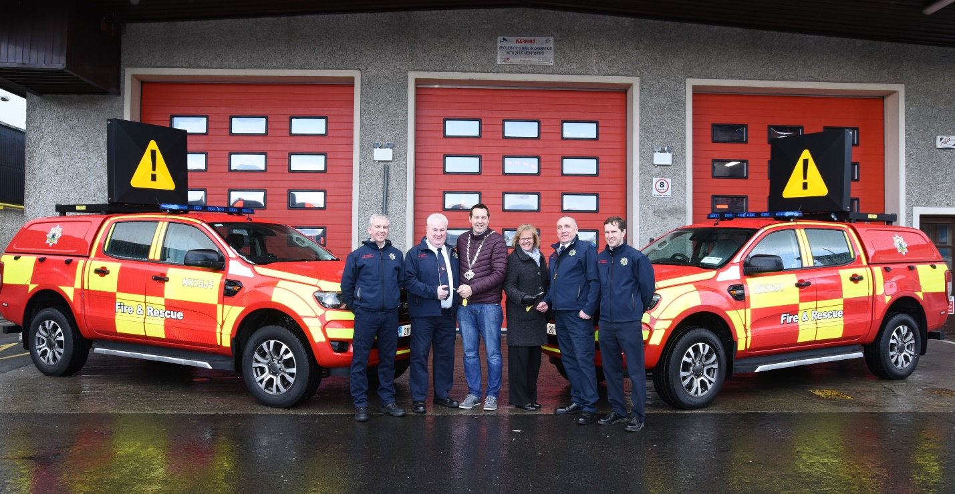

Fire Safety Certificates
- 49 no applications for fire safety certificates were received to 19th May 2020. This was a 40 % increase in 2019 applications for the same period last year. These applications were administered and assessed by staff working from home and from our Headquarter station due to Covid-19.

Fire Services Acts 1981 and 2003
- Fire Prevention staff made targeted inspections of premises both to provide advice and to enforce legislation.
- 1no Fire Safety Notice under the Fire Services Acts 1981 and 2003 was served during Covid -19.
- 1no Fire Safety Assessment was ordered under the Fire Services Acts 1981 and 2003 during this period.

Community Fire Safety

- Ongoing public messaging campaigns are being maintained through our social media channels to encourage members of the public to install smoke alarms and to test their smoke alarms once a week to ensure that they are working.
- Talks and information to various communities is on hold due to current Public Health restrictions.
- Kilkenny Fire and Rescue Service Primary Schools Programme (PSP) is postponed for the time being. This programme has been running since 2006 and over 19,112 3rd class pupils have received the fire safety programme to date.

Training
Heavy Goods Road Traffic Collision courses was provided by Kilkenny Fire and Rescue Service earlier in the year. Planned training was put on hold till later in the year.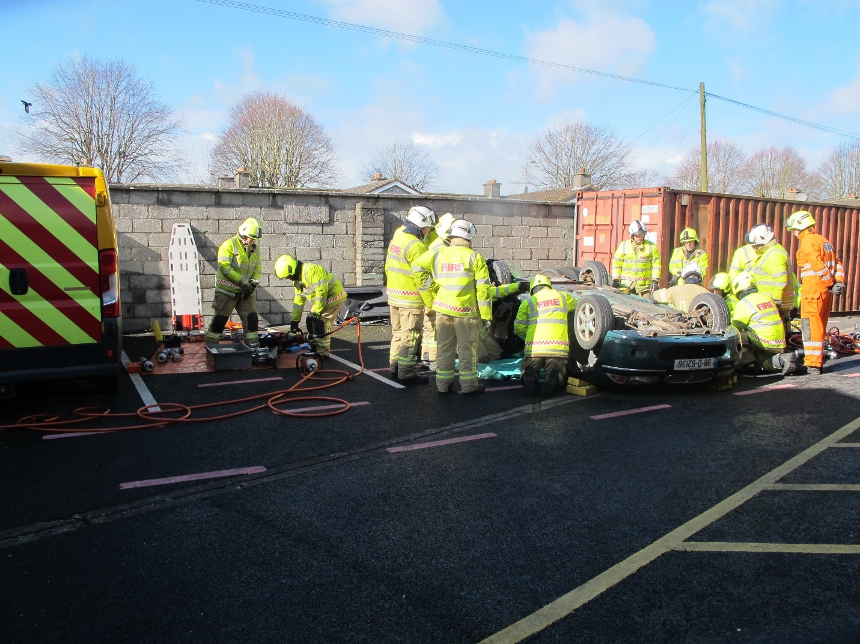
Days before the lockdown - Fire personnel from around the county attended an in-house Heavy Goods Training Course in HQ and Freshford Fire Station

Weekly training has recommenced this week around the county with Induction training on Covid-19.

Operations
- Fire Brigades responded to 342 turnouts up to the 22nd May 2020. The same period last year we responded to 272 turnouts. With the current dry spell and people staying at home there has been an increase of 20 % in fire calls and with a decrease of 13% in road traffic accidents. The Fire Service is a very resilient and useful resource to the Local Authority in that Brigades (trained and equipped manpower) can be mobilised within minutes of an emergency in their area. etc. A temporary body holding unit for the Covid -19 response is located in Kilkenny City Fire Station.
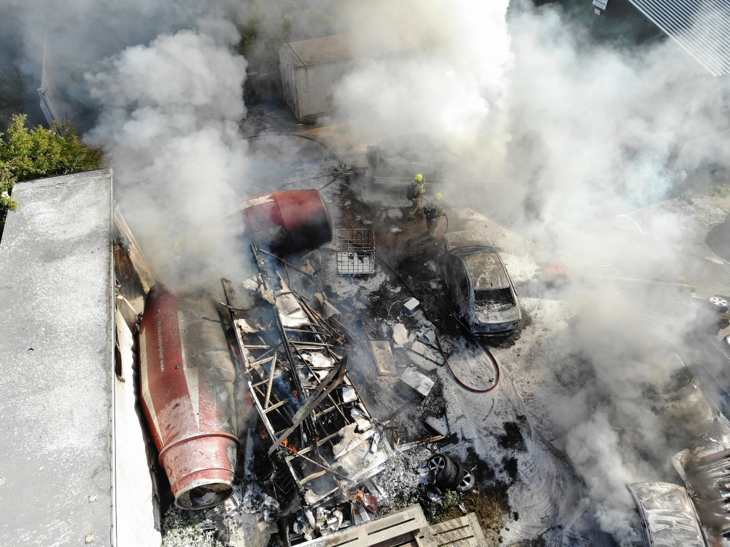
Picture taken by drone operator of a multiple car fire incident
The provision of a fire service Drone in recent months has been a huge benefit to the Brigades response to all types of incidents. Incident Commanders now have access to a bird’s eye view of incidents together with thermal imaging camera to detect hot spots providing key information for safer management of incidents and the photographing for post incident debriefing.

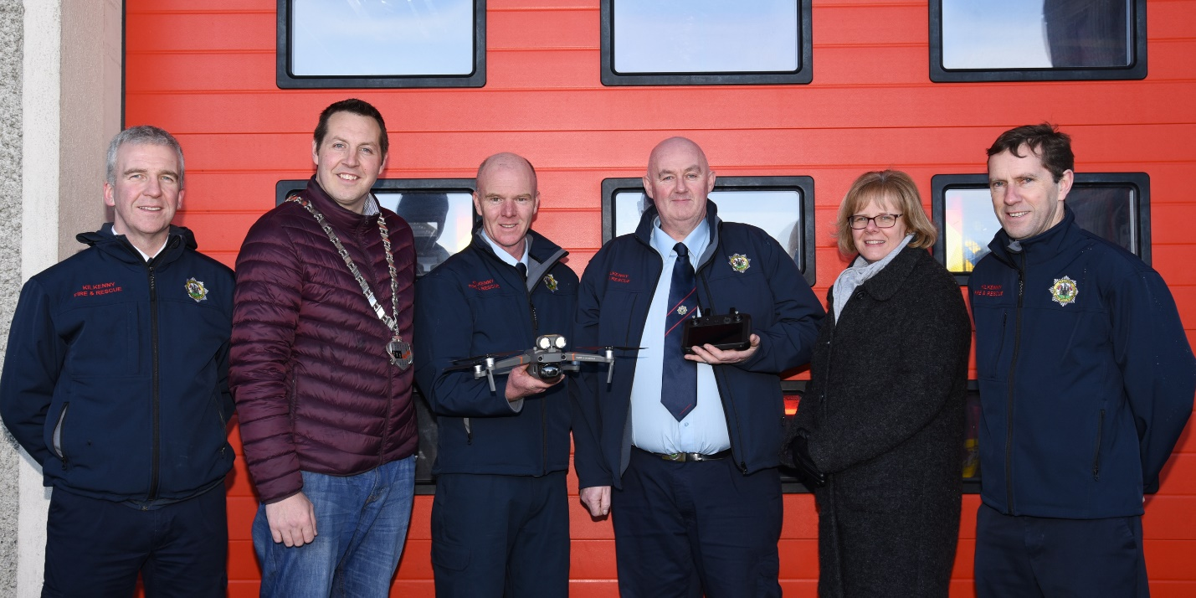

Handing over the Drone by Cathaoirleach Peter Chap Cleere and Director of Services Mary Mulholland to our trained operators. (just before lockdown!)

