Kilkenny

Draft Economic Development Policy – Strategic Directions

2010-2016

Councils of the County and City of Kilkenny

CONTENTS

1. Introduction

2. Irish Economy Competitiveness

3. Regional Competitiveness Profile

4. Government Policy (“Smart” Economy)

5. Kilkenny Industry & Business Profile

6. Economic Policy Strategic Directions
  - Competiveness
  - Target Development Zones
6.3 Kilkenny City – A Growth Hub
6.4 Belview Port
6.5 The District Towns of Callan, Castlecomer, Graignamanagh and Thomastown
6.6 Target Development Sectors
6.7 Third & Fourth Level Education & Research Development
6.8 Agri Food & The Wider Bio Economy
6.9 Tourism
6.10 Arts, Heritage & Culture
6.11 Local Economic Development – Council to Business Interface
6.12 Regional Economic Development.
6.13 Developing International Linkages
6.14 Infrastructure Delivery
6.15 Marketing & Promotion Plan
6.16 Stakeholder involvement – Implementation
7. Appendix A – Rural Enterprise Development – Role and Activities of the Kilkenny Leader Partnership

Appendix B – Micro and SME Development - Role and Activities of the County Enterprise Board

Introduction

The Councils of the County & City of Kilkenny have the objective of positioning and promoting Kilkenny as one of Ireland’s most competitive business locations. The objective is to build on the County’s traditional creative strengths to foster an environment supportive of knowledge based innovation and development and to target sectors where both the Irish economy, and Kilkenny, hold positions of comparative strength.

This policy document identifies and outlines directions for economic development and growth. Some of the directions identified are for local authority delivery, some are market-led and some others for the IDA, Enterprise Ireland and other agencies/groups in the region.

The policy is a mix of short and long term measures but the principal direction is for long term sustainable growth.

2. Irish Economy Competitiveness

Background & Context

Considerable changes are taking place in terms of the dynamics that shape and drive the Irish economy. These changes are originating from global trends, resultant new business needs, and a rapidly altering Irish economic structure and climate. Globally, new markets have emerged and there is increased competition amongst firms on the global stage. Indigenous firms, even those serving local markets, are competing internationally. New global business models are emerging, facilitated by enabling technologies, and there are increased levels of strategic alliances, partnerships and merger/acquisition activities amongst firms. There has been a global shift towards services activities. Ireland has seen significant growth in services over the five years 2000 to 2005 with service exports rising from 21% to 34% of total exports. Mobility of people and capital has increased globally with cities competing against cities for foreign direct investment.

Policy Framework

In framing an economic development policy, a key factor to be addressed is competitiveness. Kilkenny’s competitive position is very much influenced by the competitive strength of the economy generally.

The Report of the Enterprise Strategy Group identified essential framework conditions and competitive advantages needed to increase the number of sustainable enterprises in Ireland (Figure1).

Figure 1: Strategy for Sustainable Enterprise in Ireland
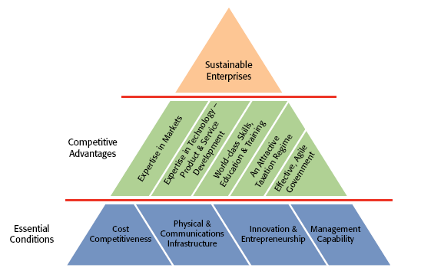
Source: Ahead of the Curve- Ireland’s Place in the Global Economy – Report of the Enterprise Strategy Group, July 2004.

The Report recognised that the collective efforts of the public and private sector need to be harnessed, and aligned, in order to provide for the best essential conditions and to create the strongest possible competitive advantages, to foster and support sustainable enterprises.

This economic development policy is cognizant of those essential conditions and the target development sectors identified are those in which the County holds comparative competitive advantages, whether arising from existing or prospective market expertise, technology development or employee skills, education, and availability.

International Competitiveness Benchmark

The recently published National Competitiveness Council (NCC) Annual Competitiveness Report provides an assessment of the strengths and weaknesses of the Irish economy relative to competitor countries.

The NCC found that Ireland’s competitive position, while weakening over a number of years, has not changed dramatically in the past year. Between January 2000 and April 2008, Ireland experienced a 35% loss in its trade-weighted international price competitiveness. In the year to April 2009, there has been an improvement of 5% in the economy’s international price competitiveness. However, cumulatively the economy lost ground on competitor nations over the last 8/9 years. Ireland continues to retain a range of important competitive strengths, including a young and comparatively well educated workforce, improving infrastructure, growing levels of research and development activity, a modern internationally trading enterprise base and a long track record as a successful location for overseas investors.

The NCC highlights that targeting export-led growth of high quality goods and services is the only sustainable strategy to maintain living standards and to secure long term prosperity.

Apart from price competitiveness, the NCC report also evaluated Ireland’s position across broader business factors, which evaluation can be summarized as follows:

- Taxation:
Taxes on both profits and labour are low relative to other countries, though recent increases in personal taxes have weakened the competitiveness of Ireland’s labour tax wedge.

- Regulation and Competition:
The general regulatory environment in Ireland is perceived to be supportive of enterprise. For example, the financial and administrative costs of starting a business in Ireland are low compared to other countries.

- Finance:
The turmoil in global financial markets and the exposure of Irish banks to bad loans in the declining property sector is affecting Irish firms in terms of their ease of access to, and cost of, finance. With regard to the cost of credit, the majority of loan types in Ireland were more expensive than the Eurozone average.

- Infrastructure:
Ireland’s investment rates in infrastructure have been among the highest in the EU in recent years and there have been tangible improvements. Deficits remain, particularly with respect to the availability of advanced broadband services where Ireland ranks 25th in the OECD in terms of its readiness to support next generation services.

- Education:
Ireland has a young and comparatively well educated workforce.

For example:
  - 42 per cent of the 25-34 year age group in Ireland possesses a third level qualification. This compares very favourably with the OECD average of 34 per cent.
  - Ireland continued to have a high number of graduates in the fields of mathematics, science and computing per 1,000 of population aged 20-29.
  - Older workers in Ireland remain less qualified than the OECD average and a relatively large share of the working age population (34 per cent) has no more than lower secondary education.

- Innovation and R&D:
Starting from a relatively low base, Ireland is making significant progress. For example:
  - Ireland’s innovation performance continues to improve and its score on the summary innovation index is above the EU 15 average.
  - The number of researchers in Ireland is growing, up from five researchers per 1,000 of total employment in 2000, to six per 1,000 in 2006.
  - Total R&D spending in Ireland increased from 1.26 per cent of GNP in 2000 to 1.68 per cent of GNP in 2008. Expenditure on R&D by businesses has increased significantly in recent years.

3. Regional Competitiveness Profile

Forfas Regional Competitiveness Profile

In June 2009, Forfas published a Regional Competitiveness Agenda (RCA) assessing the region’s performance against a number of competitiveness factors, the factors assessed being summarised in Table 1:

Table 1: Competitiveness Factors
Enterprise and Economy | assessing the enterprise structure, employment and Gross Value Added (GVA), the contribution from agency supported enterprises, and sectoral diversity and/or clustering
Skills | an analysis of the skills, educational attainment and education resources
Innovation | research and development investment and activity, collaborations and inter-linkages between HEIs and firms, between firms and customers
Access and Connectivity | transport and broadband infrastructures – recent investments and ongoing infrastructure needs.
Quality of Life | based on factors relevant to the attraction of mobile investment and labour/talent.
Leadership and Local Capacity | outlining relevant organisations and indications of locally driven initiatives and outcomes.

For each factor evaluated, there were a number of key messages.

- Enterprise Dynamic
The South East region exhibited strong employment growth over the period 1998-2007 and, like other regions in Ireland, this growth was driven by considerable expansion within the construction sector and also the public sector. Employment growth in construction activities has been particularly strong in the South East and the recent and dramatic down-turn in this sector may have a greater overall impact here than in other parts of the country.

Manufacturing continues to make an important contribution within the economy of the South East and represents a key competency for the region. New investments in recent years, particularly in the Life Sciences sector, have boosted manufacturing employment and have helped to offset decline in more traditional manufacturing sectors. However, continuing cost pressures, particularly in more labour intensive activities, combined with the deteriorating global economic conditions, will see the manufacturing sector facing serious challenges in the immediate future.

Contributing 10% to overall employment, the agricultural sector remains a significant part of the South East economy. In addition, strong players in the food processing industry have emerged from the region and are significant employers and exporters.

Although the performance of the region in terms of High Performance Start Up (HPSU) development has been comparatively low, there are important initiatives being undertaken within the region in support of increased levels of entrepreneurship and new company formations, not least, the Higher Education Institutes (HEIs) have adopted a proactive approach with industry in terms of applied research, and incubation and enterprise centres throughout the region are providing useful supports to small firms.

Key areas of focus for the region into the future will include: meeting the challenges of a declining construction sector and supporting an increasingly vulnerable manufacturing base; building on key sectoral strengths within the region: life sciences; ICT; engineering; agriculture; food processing – including the identification of strategic relationships and networks within and beyond the region; maximising the potential of the tourism and recreation sector within the region through increased levels of regional collaboration; and continued region-wide approaches in support of greater levels of entrepreneurship in the region.

- Skills development

Educational attainment to leaving certificate and third level has increased within the South East but the region continues to exhibit a relatively high level of early school leaving below leaving cert and relatively lower levels of attainment to third level. The profile of industry in the region, with a strong tradition of manufacturing and agriculture, has been a factor influencing this pattern of educational attainment. A particular challenge for the region will be to address skills development needs of those employees emerging from these sectors and from the construction sector as they experience contraction in the current difficult economic conditions.

The region is well served in terms of access to third level education provision, through the two Institutes of Technology at Waterford and Carlow, NUIM at Kilkenny, and the other providers at Tipperary Institute & Carlow College. The absence of a university within the region has been cited as a key regional deficit and a formal application by WIT for upgrade to university status is currently with government. The Institutes of Technology have been proactive in terms of building relationships with industry, encompassing tailored delivery and development of courses, research collaborations and life-long learning. There is potential for increased levels of interaction with industry and other HEIs both within and beyond the region in these areas.

- Innovation & R&D

Innovation plays a key role as a driver of regional competitiveness. Its creation depends on the interplay of a range of environmental conditions, from quality of life factors to formal support structures in the policy arena.

As one source/driver of innovation, HEIs have an important role to play. HEIs can be highly influential actors in the production and transfer of knowledge, applied research, fostering entrepreneurship, supporting networks, developing appropriate skill sets, as well as partaking in regional planning and development (OECD, 2005). The HEIs within the South East are engaged in these kinds of activities to varying degrees, however increased regional linkages would be beneficial. Beyond the HEIs, other key building blocks are in place within the region, including institutional supports, incubation centres, research institutes and business networks. The genuine networking and shared learning, within and beyond the region, that is required for increased innovation capacity needs to be enhanced.

- Local leadership capacity

Across the State there are a wide range of bodies and organisations at regional, county and sub-county levels that provide support to business and the South East region is no exception. The degree to which there is coherence and clear definition of roles needs to be further investigated through consultation.

The South East region is characterised by a dispersed urban population and a regional Gateway with limited regional impact currently. This has resulted in diverging and competitive dynamics within the region, and a missed opportunity to work with this distinctive diversity through a coherent and co-ordinated approach to regional development. Against this backdrop, the Regional Authority and regional initiatives such as the Spirit of Enterprise Forum are important mechanisms to facilitate greater co-ordination at regional level.

- Access & connectivity infrastructures

The major deficits in road infrastructure which hampered economic development within the South East for many years are now being addressed. The upgrade of the N9 in particular will enhance inter-regional connectivity and reduce travel times to Dublin. The Waterford by-pass project will reduce traffic congestion in the city and brings with it the strong visual impact of a new ‘iconic’ cable-stay bridge over the river Suir. A number of issues remain to be addressed within the region: the east-west links from Waterford to Limerick via Clonmel (N24, and existing but under-used rail transport infrastructure), and completion of the N11 upgrade as far as Wexford. Key investments in the electricity network are required to satisfy future demands and the broadband offering in the region needs to be improved. An agreed prioritisation of key infrastructure requirements for enterprise will be required in the context of tighter budgetary conditions for the immediate future.

- Quality of Life

From an enterprise competitiveness perspective there is full recognition that a high quality of life is a key component in regional competitiveness and is necessary to achieve the following:
  - creating the conditions to foster and support innovation, creativity, and knowledge generation/transfer
  - attracting and retaining skilled people, particularly internationally mobile skilled labour
  - attracting knowledge intensive internationally mobile foreign direct investment, including research and innovation activities

A variety of lifestyle choices can be accommodated in the diverse physical landscape and settlement patterns across the South East region. Key developments in road infrastructure will enhance regional interconnectivity and ease of access to the main population and service centres and reduce traffic throughput in smaller settlements. A key challenge for the region is to ensure greater co-ordination in the promotion of regional quality of life issues such as regional linkage to the motorway system, the continued development and roll-out of broadband or of the continued support/development of major cultural, heritage, leisure and recreational facilities.

4. Government Policy (“Smart Economy”)

Background

In 2009 the Government published Building Ireland’s Smart Economy – A Framework for Sustainable Economic Renewal. Government Policy has the objective of reorganising the economy over the next 5 years by putting in place a framework to address the current economic challenges and to build a “Smart Economy” with a thriving enterprise sector, high-quality employment, secure energy supplies, an attractive environment and first class infrastructure.

The strategy aims to:

- Address the current economic challenges facing the Irish economy by stabilizing the public finances, improving competitiveness, assisting those who lose their jobs, and supporting Irish business and multinational companies;
- Invest heavily in research and development, incentivise multinational companies to locate more R&D capacity in Ireland, and ensure the commercialization and retention of ideas that flow from that investment;
- Implement a ‘new green deal’ to move us away from fossil fuel-based energy production through investment in renewable energy and to promote the green enterprise sector and the creation of ‘green-collar’ jobs;
- Develop first-class infrastructure that will improve qualify of life and increase the competitiveness of Irish business.

Government Actions to Build the Smart Economy

The five Action Areas of the Framework are:

1. Meeting the Short-term Challenge – Securing the Enterprise Economy and Restoring Competitiveness;
2. Building the Ideas Economy – Creating ‘The Innovation Island’;
3. Enhancing the Environment and Securing Energy Supplies;
4. Investing in Critical Infrastructure;
5. Providing Efficient and Effective Public Services and Smart Regulation.

The vision, objective and attributes of the “Smart Economy” concept can be summarized in the following table

Building Ireland’s Smart Economy: A Framework for Sustainable Economic Renewal
Vision | To build a Smart Economy that exhibits economic security, high quality employment, strong environmental and social performance and secure energy supplies and is in the strongest possible position to benefit from the recovery of the global economy.
Objective | To drive economic growth through the enhancement of productivity per person by: securing fiscal stability; enhancing R&D intensive foreign direct investment; investing in human capital and research and development; incentivising innovation and commercialisation; investing in critical public infrastructure; and improving public sector performance, within a high-quality physical and social environment.  The Smart Economy concept involves:  - Moving Ireland up the value chain by developing an exemplary research, innovation and commercialisation ecosystem thereby creating ‘The Innovation Island’;  - Building on Ireland’s significant strengths in terms of the multinational presence and Ireland’s stock of highly-skilled workers by incentivising greater investments in high-value research and development areas which will provide quality jobs;  - Investing in the green economy;  - Building on the Government’s unprecedented investment in research and development with a plan to create a similarly R&D-intensive indigenous enterprise sector through the provision of considerable supports for start-up companies and the attraction of entrepreneurs from overseas to Ireland.
Attributes of the Smart Economy | - High-value and rewarding jobs;  - A thriving entrepreneurial culture;  - A destination of choice for foreign capital and R&D-intensive FDI;  - A magnet for top international talent;  - An attractive incubation environment for entrepreneurs;  - A pool of highly educated workers;  - High-quality infrastructure with widespread adoption of modern technology;  - A modern and responsive public service with empowered citizens;  - Effective and efficient regulation;  - Low costs of doing business and minimal ‘red tape’;  - A favourable tax environment for citizens and business;  - An economy based on clean and efficient energy;  - A high quality living environment;  - Strong civic engagement.
Action Areas
1. Securing the Enterprise Economy and Promoting Competitiveness  Achieving fiscal stability; stabilising the banking sector; aiding the restructuring of the construction sector; reinvigorating financial services; improving competitiveness. |  | 2. Building The ‘Ideas’ Economy – Establishing ‘The Innovation Island’  Fostering ingenuity entrepreneurship and skills; incentivising R&D; developing the exported services sector; stimulating innovation & commercialisation; developing indigenous high value-added industry. | 3. Enhancing the Environment and Securing Energy Supplies  Mobilising the market to protect the environment; developing the Green Enterprise sector; the public sector as a driver of environmental innovation; improving energy security and reducing energy costs. | 4. Investing in Critical Public Infrastructure  Investing in infrastructure; stimulating economic activity and employment; enhancing productivity and competitiveness; improving transportation, environmental services, communications and energy infrastructure. | 5. Efficient and Effective Public Services and Smart Regulation  Achieving greater efficiency in public services; reducing costs and enhancing services; improving citizen focus; effective and efficient regulation.

5. Kilkenny Industry & Business Profile

Major Business Sectors

There are approximately 2,500 non-agricultural employers in County Kilkenny, and only six employers employ more than 250 people. Because of this, the County is not over reliant on a small number of large industries for employment, but rather depends upon a rich diversity of mainly indigenous enterprises across the full spectrum of industry sectors.

The following sectors are particularly important, especially in terms of employment, to the County’s economy:

- Tourism: Tourism is a major revenue generator for the County estimated at approximately €100 Million per annum, and Kilkenny City is a thriving tourist base, accommodating over 200,000 tourists each year. The number of well established festivals such as the Pan Celtic Festival, ‘Rhythm & Roots’ Festival, the Cat Laughs Comedy Festival, the Kilkenny Arts Festival, and the Savour Kilkenny Food Festival all augment an already strong tourist proposition.

- Food & Drink Production and Processing: Glanbia plc employs almost 700 people throughout the County, making it the largest employer by far. Glanbia has developed an R&D facility in Kilkenny, which employs over 50 research professionals. There are a number of other much smaller food producers spread throughout the county.

- Engineering: Businesses specialising in engineering products & services are a major component of the local economy with many emerging since the early 1980’s. Engineering in Kilkenny embraces a wide range of activities in many different engineering sectors, from fine precision engineering products distributed worldwide, through large steel stockholders, to small mechanical and tooling engineering services.

- Creative Arts & Industries: Kilkenny has traditionally been associated with creative and artistic endeavours, and indeed is branded as the ‘Creative Heart of Ireland’. As the base for the Kilkenny Design Workshops (KDW) in the 1960’s, 70’s and 80’s, the workshops pioneered a cross-disciplinary approach to design, with craft, graphic and product designers all working in the same organisation. That approach developed an international reputation for KDW and attracted designers from many different countries to work in a centre of excellence for product and craft design. KDW has spawned a cluster of creative industries and services, including craft, music and art and more recently graphic design, film, multi-media, animation and ICT development. There are over 80 registered craft producers in the County and the Crafts Council of Ireland is actively engaged in craft development in the county (with its headquarters in Kilkenny) along with the Kilkenny Leader Partnership and individual crafts people.

- Retail Centre: There are over 300 retail outlets in Kilkenny City. A huge proportion of these are independent traders, specialist boutiques and fashion stores. Kilkenny's medieval network of streets and lanes offer an attractive mix of traditional shops selling a range of indigenous products.

- Services Centre: Almost 1,000 people are currently employed in the financial services and call centres located in Kilkenny. These include State Street, VHI Healthcare, Bank of Ireland 365 Credit Card Services and TaxBack.com. In addition, Kilkenny City currently acts as an administration centre for a number of state and semi-state agencies including the regional headquarters of the Health & Safety Authority (HSA) and the Health Service Executive (HSE) as well as the national headquarters of The Patents Office, The Crafts Council of Ireland (CCOI) and The Heritage Council.

Labour Force and Employment

The Labour Force in County Kilkenny was circa 43,000 in 2006 (CSO, 2006). The percentage of people employed in farming (at 8%), while decreasing, is still at twice the national average, reflecting the importance of agriculture to the local economy. The County also has slightly higher numbers employed in manufacturing and construction jobs (at 23% combined) compared to the State (at 21% combined) (Table 5.1).

The continuing retraction in agriculture and traditional manufacturing, along with the cyclical downturn currently being experienced in the construction industry, increases the need to provide alternative sources of employment for these sections of the Labour Force in the future.

Table 5.1: Percentage of Labour Force classified by Broad Occupational Group

 | Farming | Manufacturing | Con-struction | Clerical  & Admin | Comm & Trans | Sales & Commerce | Prof, Tech & Health | Other
Kilkenny | 8% | 13% | 10% | 15% | 5% | 13% | 16% | 11%
State | 4% | 12% | 9% | 18% | 6% | 14% | 16% | 11%
Source: CSO, 2006.

As at the end of December 2009, there were over 7,000 people on the live register in County Kilkenny, up from 2,300 at the end of 2007. This represents an increase of over 200% since the end of 2007.

Quality of Life

Set in an agricultural heartland, County Kilkenny is rich in natural beauty and, in addition to being a popular tourist destination, has developed a strong reputation as an attractive place in which to live and work. This has proved to be a major influencing factor in attracting inward investment and workers to the County.

Kilkenny City is rich in historic and archaeological treasures. In the 17th Century the City was a centre of Government. Today it offers a unique selection of historic sites and a unique streetscape and historical architecture, which have combined to give Kilkenny the title of medieval capital of Ireland and contribute significantly to the heritage ethos of the City.

The County is served by an excellent primary and secondary education system. While there is a limited third level presence, there are currently 300 students enrolled, mainly on part-time programmes, with the National University of Ireland Maynooth outreach campus based at St Kieran’s College. The National College of Ireland has also developed an outreach facility at Kilkenny College, offering part-time certificate and diploma level programmes.

The enhancement and development of third and fourth level education delivery into Kilkenny is a priority issue for the economic future of the county.

Kilkenny is also well served by a very active community and voluntary sector, as well as a broad range of sporting organisations and activities including GAA, golf, soccer, rugby, athletics, boxing, walking, cycling, fishing, equestrian sports, horse-racing, greyhound racing, among others.

A key objective for the county is the continued development and support of major cultural, heritage, leisure and recreational facilities in the City of Kilkenny and across the county, not just in their own right, valuable as this is, but as a key economic development driver.

6. ECONOMIC POLICY – STRATEGIC DIRECTIONS

6.1 COMPETITIVENESS

The Forfás Regional Competitiveness Agenda Report on the South East Region indicates how global drivers have implications for where, and how, companies do business and sets out how location decisions are based on economic and business imperatives. The Report states that “It is important that a location or region provides a competitive environment that stimulates entrepreneurship, enables companies to grow and evolve and attracts and retains foreign investment”. The Report identified the six key competitiveness factors as follows:
(1) Enterprise dynamic
(2) Skills and education
(3) Innovation
(4) Economic infrastructures
(5) Quality of life
(6) Leadership and Strategic capacity.

Accordingly, the Kilkenny local authorities will work with Forfás, the IDA, Enterprise Ireland, the enterprise/entrepreneurial sector, education/research providers and local authorities in the region to advance the six elements of the competitiveness agenda.

6.2 TARGET DEVELOPMENT ZONES

Given the very competitive national and international business environment, and resource scarcity, Kilkenny needs to concentrate its development efforts on those business development zones which have critical mass of characteristics to make them attractive business locations, for either foreign direct or Irish generated investment.

Any competitive, viable business investment location has to have the following characteristics:
- A significant quantity of suitably zoned land
- Ready access to all major road, air, rail and sea transport networks
- A cost advantage relative to other potential locations
- Adequate capacity for water and waste water services
- A plentiful supply of an appropriately qualified workforce with an increasing
requirement for 3rd level/similar educational standards
- A strong culture or competitiveness and performance exemplified by a “Can Do”
attitude
- A particular focus on innovation, creativity and a pro business climate
- High speed broadband access

The principal target development zones within the County that meet these relevant criteria are Kilkenny City and the Belview Port area. Both zones contain most, if not all, of the attributes required to attract investment and meet investor requirements for making business location decisions. In addition, the scheduled towns and their hinterlands also satisfy elements of these criteria.

6.3 Kilkenny City – A Growth Hub

Kilkenny City is a major driver of county economic growth by virtue of its outstanding built heritage and natural beauty, high level and range of services and labour force availability and its record as a location of choice for major companies and agencies such as Glanbia, State Street, VHI, Taxback, Revenue Commissioners, the Cartoon Saloon (creators of the Oscar nominated film The Secret of Kells), the Crafts Council of Ireland and the Heritage Council. Additionally, Kilkenny’s attributes include its national and international reputation and brand, geographic position at the centre of the South East Region, road and rail accessibility, University Outreach and hub designation in the National Spatial Strategy. Continued development of the high quality urban character of Kilkenny is essential for County growth. Enhancement of the built environment is critical, as is the continuing programme of city centre, public domain and pedestrian area enhancement as well as the enhancement of the premier buildings/features and their surroundings. Implementation of these measures will enhance Kilkenny’s reputation as an international centre of excellence in urbanism following from its designation as European“Best Town” by the Academy of Urbanism in 2008.

Kilkenny City and its environs have the following specific development attributes:-

- 110 hectares of serviced Industrial / Warehousing / Business / Technology Parks

- Immediately available benefit of key infrastructure, skilled workforce and scaleable business capabilities

- High Speed Broadband throughout Kilkenny City

- Proven existing services capability.

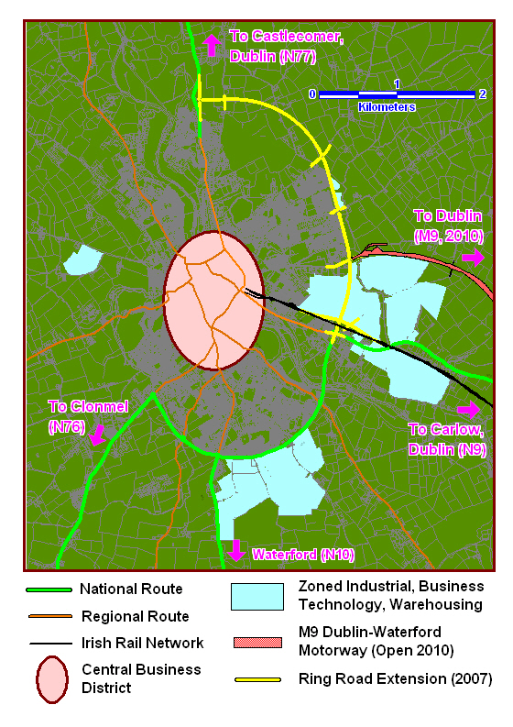

In addition, there are large brownfield sites close to, or at the centre of, the city which are a major development opportunity by virtue of their size and location, at a time when site assembly in any similar city or town centre would be expensive, time consuming and difficult.

Accordingly, Kilkenny City is an ideal location for headquarters office development, for services generally and for internationally traded services, retail, tourism, financial services, medical services, healthcare and medical devices. The city offers particular advantages for ICT and Telecoms development.

6.4 Belview Port

The Port of Waterford at Belview, Kilkenny is part of critical national, regional and county infrastructure. Belview offers significant competitive advantage due to its portal access, short sail times to continental Europe, its estuary location, proximity to the shared gateway of Waterford City, and the significant facilities and supports offered by Waterford Institute of Technology. In addition, Belview offers direct access to rail transport at the port and to the national motorway system and has significant availability of high quality serviced land from the IDA, and others the Belview/Waterford Port Company.

Specifically Belview Port offers the following competitive advantages:-

- Extremely competitive location:
- closest deep water port in Ireland to Europe

- excellent connections to national road network (M9 Dublin Waterford Motorway & N25 Waterford City Bypass – 2010) and direct connection to Irish Rail Network (Dublin-Waterford line)

- 190 hectares of serviced zoned land for pharmaceutical, logistics, bio-pharma, bio-fuel and port related uses; 55 hectares of this strategic IDA site

- Servier investment €120m

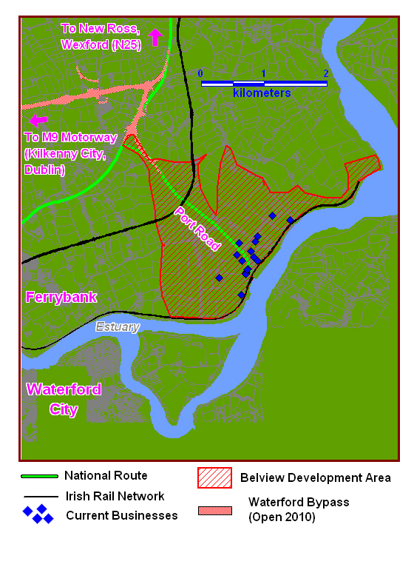

Belview is an ideal location for life sciences (including pharmaceutical, bio-technology, health care), Greentech/Cleantech as well as for large scale manufacturing and processing, energy and logistics. The Kilkenny local authorities will work closely with the IDA and the Port of Waterford to promote and support economic development activity in Belview, including the continued development and expansion of infrastructure and of the port itself.

6.5 The District towns of Callan, Castlecomer, Graiguenamanagh, Thomastown and their hinterlands.

The four County District towns of Callan, Castlecomer, Thomastown and Graiguenamangh have populations close to, or in excess of, 1,500 people and significant rural hinterlands and populations. They are attractive and well presented towns with good urban form, good primary and second level schools, along with well developed services and community facilities, with a capacity to accommodate additional growth. They each have their own distinctive charm and community vitality and identity.

These towns play a particularly important role as service/retail/employment and residential centres within the County. They are all within easy commuting distance of the county’s larger urban and employment centres and are positioned to take advantage of investment opportunities.

The Councils are in a position to positively influence the delivery of serviced business and industrial sites throughout the County. There is some potential for the provision of business start up incubator units, particularly where those business start ups are likely to supply goods\services directly back into the six targeted development sectors referenced earlier. Were suitably located serviced sites to be provided, this would not necessarily have to be provided directly by the Council itself, but could be in partnership with, or support to, other relevant agencies and\or private bodies. There are currently tentative proposals for two such developments, one involving Council lands in Thomastown and the second involving privately held lands in Callan.

A critical analysis of likely development sites within the County, and the options for delivering suitable incubator units, will need to be prepared. Such analysis will be influenced by both Councils financial position, and any options that may emerge will need to be commercially driven. Accordingly, the Council will seek to work with enterprise and community groups in the promotion and marketing of serviced sites/units throughout the county.

6.6 TARGET DEVELOPMENT SECTORS

Given Kilkenny’s business and workforce profile, and position relative to other competitor business locations, the following sectors will be the focus of specific development initiatives:

- Third & Fourth level Education & Research Development
- Agri Food and the Wider Bio-Economy including Eco- Innovation
- Services development including headquarters/offices development, ICT and Telecoms, Financial and Professional Services (see section 6.3)
- Tourism, Arts, Heritage, Culture and Leisure
- Life Sciences including Pharma, Manufacturing, Energy, Logistics (see section 6.4 particularly)

Each of the above sectors are ones for which a compelling case can be made to consider Kilkenny as a site for business investment. Existing infrastructure and workforce availability are such that the requirements for the sectors are largely met and relatively minimal further work will complete a compelling case that can be made to potential investors.

6.7 Third and Fourth Level Education and Research Development.

The development of a knowledge economy in the county can best be supported by third & fourth level education services delivered in the county. It is an objective to promote the development of third and fourth level education in Kilkenny at St. Kieran’s Campus. The Kilkenny local authorities will work with The National University of Ireland (Maynooth), the Institutes of Technology of Waterford and of Carlow, and St. Kieron’s College Trust on the consolidation and continued development of a multi- institution campus at St. Kieran’s. It is of major benefit that inward or local investment will be supported by custom made provision in Kilkenny or in the network of the foregoing colleges, and the commitment of the HEI’s to provide such custom service to the enterprise sector is welcome as it provides a major platform for the county’s economic growth. The Councils will seek to work with the St. Kieran’s College Trust on the development of third/fourth level facilities and infrastructure at the college. Additionally, the Kilkenny local authorities will work with and support the Crafts Council, the Heritage Council, Teagasc, Kildalton College and Kilkenny VEC in the provision of professional and technical education.

6.8 Agri-Food and the Wider Bio-Economy

Agriculture is a very significant element of the county’s economy, and best practice in the agricultural economy and in agri-business performance must be supported and advanced. The county is ideally suitable for agri-food development. The presence of Glanbia, a world leader in food and food ingredients production and distribution, and other major brand name companies in food and food ingredients for human and animal consumption, is testament to the county’s competitive advantages in this sector.

There is critical mass of food and food ingredients companies in the county and in the region with significant resources dedicated to manufacturing, distribution, marketing and research with significant national and export success.

In relation to future development Teagasc, in a 2008 report, indicated that the food and agriculture sector is on the cusp of profound change.
It went on to say that “the potential for new business development is so great that it makes sense to redefine the sector into the broader concept of the bio-economy, encompassing the traditional agri-business sector and a wide range of novel activities that can now be generated from natural resources of land, forestry and the marine”.

This wider approach encompasses agricultural and forestry production, micro-enterprise and SME activity in food/agri/bio, large scale agri businesses in foods and food and drink ingredients for human and animal consumption, agri-environmental products, bio processing and the emerging sectors of bio-energy, clean tech and eco-innovation.. It is also clear that there is a critical mass of interest and expertise in the area of eco-innovation across the region with significant expertise and resources.

The Kilkenny local authorities will work with third level/research agencies, agri food companies and enterprise agencies in the promotion and development of this sector.

See also Appendix A in relation to the policies of the County Enterprise Board and the Kilkenny Leader Partnership for this sector

6.9 Tourism

Kilkenny is one of the most sought after short break urban destinations for Irish residents. This success is based on the quality of the City’s public realm, accommodation, restaurants, festivals, pubs, attractions and access links, especially to Dublin. This is further enhanced by the attractive surrounding countryside, villages and towns.

Building on the City’s success in attracting Irish based business, opportunities exist in relation to international holidaymaker and conference visits. Heritage, culture and scenery remain the greatest tourist draws to Ireland, particularly among ABC1 visitors in the 45+ age-group who constitute the largest element of overseas tourists to Ireland who visit areas outside of Dublin.

Failte Ireland statistics highlight the 45+ age group as Ireland’s largest international visitor segment, it will continue to grow and, based on their interests, is a segment for which the Kilkenny tourism product is particularly well suited to serve.

Kilkenny’s challenge is to maintain its appeal to the many segments of the Irish Market such as Nightlifers, Food and Luxury Seekers, Child Focused, Country Ramblers, Hobby & Enthusiasts, and Business tourists, while developing and promoting its heritage, including gardens, arts and culture.

Accordingly, the Councils will work with Failte Ireland, Kilkenny Tourism and the hospitality sector in the support and development of quality of life projects which will deliver strategic performance improvement. In addition, it is an objective to grow Kilkenny’s reputation internationally and to continue the development of programmes and festivals which will attract national and international conference and holiday makers and achieve longer stays.

6.10 Arts, Heritage & Culture

Arts, Heritage & Culture are integral elements of successful economic development, in addition to their own intrinsic value.
Arts, Heritage and Culture are synonymous with Kilkenny and the highest standards have been achieved and delivered in the visual arts, music, crafts, theatre, film and animation, comedy and literature, with the quality of the city and its heritage being internationally recognised. Economic expansion and growth requires that high end quality of life services be provided for the existing community, visitors and potential investors, whether international, national or local. To this end, the Kilkenny local authorities will seek to expand arts, heritage, leisure and cultural facilities, working with voluntary and state agencies and the community generally. In addition, the Councils will seek to consolidate and improve the quality of existing relationships with arts, heritage and cultural organisations in Kilkenny and to consolidate and enhance arts, heritage and cultural programming, resources permitting.

It is a key objective that there should be continued support for flagship projects in this sector, not simply for their intrinsic value, valuable as this is, but a driver of major economic development.

6.11 Local Economic Development – Council to Business Interface
The Kilkenny local authorities will establish a “Business Support Unit” to act as a point of contact to ensure a quick, co-coordinated response to existing and prospective business by acting as an interface with local authority services and systems, whether this be Planning, Water Services, Roads, Environment, etc. This unit will be headed by the Director of Services with responsibility for economic development and will have appropriate support staff redeployed from within existing resources. The setting up of this unit will formalize pre-existing arrangements.

6.12 Regional Economic Development

It is critically important that the South East Region continues to develop competitive advantage and the economic infrastructure necessary for enterprise consolidation and growth. Enterprise activity at any location within the region has an economic multiplier effect for all surrounding locations, and consolidates and supports economic critical mass, performance and attractiveness for new investment.
Accordingly, the Kilkenny local authorities will continue to support the regional development agenda as outlined in the Forfás Competitiveness Report and will specifically seek to support the provision of essential regional infrastructure and programmes.

These include:
- the development of regional third and fourth level educational and research activities and facilities in the regions third level colleges, specifically the Institutes of Technology in Waterford and Carlow, the NUIM Outreach at Kilkenny, the Teagasc centres at Kildalton and Oakpark, Carlow College and the Tipperary Institute;
- the consolidation and development of Waterford airport, and specifically the extension of the runway to make it jet capable;
- the continued expansion and development of Belview Port and related portal activities;
- the development of the shared Gateway of Waterford, including South Kilkenny and the Kilkenny City hub;
- the continued development of the regions motorway system, and regional and county linkages to that system;
- the provision of service support infrastructure, i.e. water services, gas, energy, broadband etc.

6.13 Developing International Linkages

In an increasingly global, fast moving and difficult business environment, fostering business linkages, both national and international, is of vital importance to economic development. Kilkenny needs to be proactive in developing networking opportunities for local business, whether with other local businesses, or Irish and international companies. In addition, many of the strongest growth economies internationally have a very sizeable state influence or involvement, for example China. The Councils can play a role in helping to develop both commercial and public sector ties that would be of benefit to the County’s economic and social development.

In 2009 the Councils started to develop a relationship with a province in China. It is hoped to develop this relationship further.

Developing the linkages referred to is a long term project that will require substantial time and effort, and one that will deliver benefit in the long term.

Accordingly, the Councils will work with the IDA and Enterprise Ireland in the promotion of the County internationally and will also seek to engage with local companies and to support and provide county promotional material and information. The Council will also seek on a pilot basis to compliment the work of locally based companies seeking to open/expand export markets through municipal local government linkages and other initiatives.

6.14 INFRASTRUCTURE DELIVERY

(a) Transport

There has been significant investment in the county’s transport infrastructure over the last decade. This investment has given the County ready access to all major air, rail and sea ports. Completion of the M9 Dublin-Waterford and M8 Dublin-Cork Motorways early in 2010, combined with the County being serviced by the Dublin-Waterford rail line, as well as direct port access and Belview Port and relatively immediate access to Dublin, Rosslare and Cork ports, ensures that Kilkenny enjoys a central location within the Country. As seen on the map below, Kilkenny is centrally located between Ireland’s major cities, with short travel times to these cities. The council will seek to expand regional and country linkage to the national motorway system to support the expansion of rail services and the development of smart travel patterns in Kilkenny City particularly, and to support the central expansion of Belview Port.

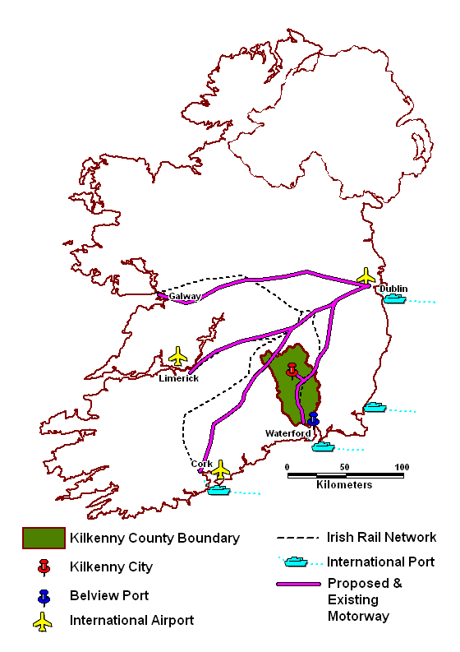

(b) Water Services

Kilkenny County Council is making significant investment in water infrastructure which will provide development capacity for the next 10 years. While this is a period of great economic uncertainty and increasing strain on Council resources and finances, water services capital investment is being prioritised. From a strategic perspective, the main water services project that requires advancement is the Mooncoin Regional Water Supply Scheme. This project is being advanced in partnership with IDA Ireland and will provide an enhanced water supply to Belview Port, Waterford City Environs and South Kilkenny that will facilitate the area’s development needs for the next 12 years. The total investment being made is €29m and this will provide 15,250 m³ per day of potable water from four well fields for the area’s industrial and domestic needs. IDA Ireland will contribute €18m of the total investment with Kilkenny County Council providing the balance.
Accordingly it is an objective to complete all phases of the Mooncoin Regional Water Supply Scheme.

(c) Broadband

Kilkenny City – Kilkenny City and Environs is well served with a number of Broadband suppliers active in the area. Some offer DSL services via the Broadband enabled exchange. A Metropolitan Area Network (MAN) comprising 15km of fibre serves the City. As well as the MAN, the city has a number of fibre networks namely Eircom, ESAT BT and UPC. Cable Broadband is available from UPC with the option of wireless offering from Digiweb and Irish Broadband. The City’s mobile Broadband coverage is good. Backhaul availability to the Kilkenny man needs to be improved as increased availability would be likely to reduce service cost, thereby increasing general business competitiveness.

Belview – the Belview Port area currently has a limited broadband service available. Options are currently being examined to extend the MAN from Waterford City out to Belview Port area and among the issues to be resolved include the route to be taken and the investment funding. It would appear that an investment of circa €400,000 is required to give the required broadband capacity for the area, which capacity could be delivered within 6 months of the final investment decision being made. It is an objective to deliver significant broadband capacity to Belview and to support broadband provision county wide.

6.15 MARKETING & PROMOTION PLAN

A key part of economic development is marketing and promotion, and a marketing and promotion plan is being finalised, the objective of which is to promote, and generate awareness of, Kilkenny as a competitive location from which to do business in Ireland. This will of course be designed to complement the work of the IDA which is the principal state agency for this. Clearly, it is not enough to provide the necessary conditions and infrastructure supports that will attract business to Kilkenny without aggressively making prospective investors aware of the advantages of Kilkenny as a business location, with particular emphasis on those key decision factors that influence potential investors. This point could be simplified by saying that not alone must there be a good message to tell, but the message must be told well. The Marketing and Promotion Plan will be complete by September 2010 and will include production of appropriate promotional material, the formal launch of that campaign via local and national media channels and the promotional campaign’s continuity post launch. In advance of finalising any Marketing Plan, will be consulting with relevant public and private stakeholders and this consultation will have two purposes:

1. To inform the final Marketing Plan and generate local buy in

2. To ensure effective campaign support post roll out

6.16 KEY STAKEHOLDER INVOLVEMENT – IMPLEMENTATION

Crucial to the County’s economic development and to the implementation of this policy is the involvement of key stakeholders. Such stakeholders include:

- The people of Kilkenny and those in a position of economic leadership in all sectors and areas.
- The business/entrepreneurial sector in Kilkenny including prominent businesses in all sectors.
- IDA Ireland
- Enterprise Ireland
- Forfás
- Third Level agencies including NUIM and the Institutes of Technology at Waterford and Carlow and separately St. Kieran’s College Trust.
- Failte Ireland
- Kilkenny County Development Board
- Kilkenny County Enterprise Board
- Kilkenny Leader Partnership
- Kilkenny Chamber of Commerce, Kilkenny Tourism and Kidco.
- Other local authorities in the region and particularly in the Gateway.
- Waterford Airport Company
The Port of Waterford Company at Belview, Kilkenny.

It is essential to engage and to continue to involve key stakeholders in the implementation of the County’s economic development policy and the Council’s will work actively in the development of joint approaches with all stake holders to implement this strategy to secure the County’s economic and social well-being.

Appendix A

RURAL ENTERPRISE DEVELOPMENT

ROLE AND ACTIVITIES OF THE KILKENNY LEADER PARTNERSHIP

Kilkenny LEADER Partnership (KLP) is committed to the economic and social development of County Kilkenny. While the company is pro-active in encouraging applications for grant-aid and other support from innovative rural enterprises from throughout the county, KLP’s LEADER funding was approved on the basis of a detailed plan. The plan recognises the centrality of inter-agency partnership to its success. It focused on a number of specific development sectors which the company identified as providing the optimum opportunity for rural development in the county. The relevant economic sectors from the plan are:
- Rural Tourism
- Renewable Energies
- Food & Drink products
Kilkenny has real strategic opportunities in all the selected sectors. In the case of each sector KLP’s strategic plan is spearheaded by a ‘flagship’ project. These projects are supported by other initiatives both within the LEADER programme and other programmes operated by the company such as the new Local Community & Development Programme (LCDP) and the Rural Social Scheme (RSS).

In terms of tourism in the rural areas as whole, KLP will continue to support the Trail Kilkenny company which it formed with its partners Kilkenny County Council in 2006. With some assistance from Fáilte Ireland the company has developed, maintained and marketed a range of walking, cycling and themed trails to act as a supporting web for rural tourism enterprises. The initiative will lead to the development of further trails under the Trail Kilkenny brand over the next year.

The company is also working on the development of an integrated activity tourism and community resource in the Graiguenamanagh area. This is likely to include the former ‘pitch & putt’ site and is designed to take advantage of the town’s huge potential for activity and cultural tourism. The support of the local authority and other agencies will be the key to the success of the initiative. Following the successful launch of the Castlecomer Discovery Park, KLP is prepared to offer further support towards the development of tourism and other enterprises in the northern Kilkenny region.

In the Thomastown area- once again in cooperation with the local authority, Kilkenny County Enterprise Board and other parties, KLP is seeking to develop an integrated production and retail facility. This would seek to attract both producer/ retailers to establish enterprises in the area and draw shoppers and visitors from throughout the wider region to what will be a unique facility.

Renewable Energy (RE) is a sector that KLP believes has significant potential for economic growth in the county. The Callan region has become a notable hub of RE projects – particularly of the biomass technologies. Building on that local strength KLP is driving the Callan Nexus Project to support the development of a sustainable chain of enterprises based in that region but focusing on benefiting the county as a whole. KLP partners in the project include Coillte, Teagasc and several local community and business interests.
The project is starting to bear fruit in the commitment by community enterprise development company CANDIDA to the construction of a RE-themed Enterprise Centre in Callan.

KLP is active in the deliver of these and other projects and remains open to engagement with promoters and partners on other eligible projects compatible with its development plan.

'Ahead of the Curve, Ireland's Place in the Global Economy' 2004
OECD (2005) Building Competitive Regions
Source: Kilkenny County Enterprise Database and Report, 2009

