**KILKENNY WELCOME TEAM**

**CALLOUT**

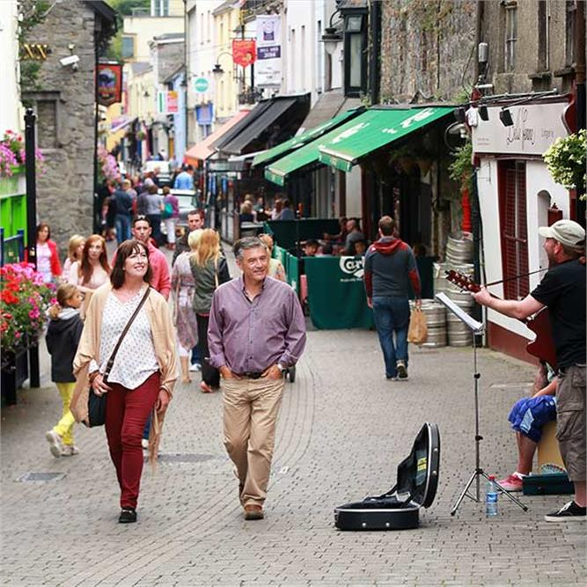

**SUMMER 2023**

**The Plan**  
Recognising that a positive visitor experience will create return visitors and help to bolster the local economy, Kilkenny County Council is launching the **Kilkenny Welcome Team 2023,** whereby trained volunteers will meet and greet visitors, providing a warm Kilkenny welcome along with visitor information.Volunteers will only engage when asked and will not impose on any visitors uninvited.

Visitors often look for information such as opening hours to local attractions, nearby toilet facilities, pharmacists, ATM locations, train and bus times. The **Kilkenny Welcome Team** will be strategically placed at high footfall locations around Kilkenny city to provide this information.

The team will be out and about from the June Bank Holiday weekend. (Thursday – Sunday numbers dependent)

It’s important to note that volunteers will not be handing out maps or leaflets. If a visitor wants a map, they will be directed to a nearby location where they can easily collect one. Volunteers will carry information handbooks for them to refer to. Visitors will also be directed to an online source of information which can be accessed through their smart phones.

The launch of the **Kilkenny Welcome** initiative demonstrates the commitment of Kilkenny County Council in supporting the local tourism sector. This tourism initiative has been developed in partnership with **Kilkenny Tourism** and the **Kilkenny Volunteer Centre**.

**The Team**

We are calling on volunteers to help with the **Kilkenny Welcome Team** provides an opportunity for individuals to put the Kilkenny jersey on and play a meaningful role in the recovery process.

Kilkenny is a beautiful city and is a popular visitor destination. The people who volunteer to be part of the **Kilkenny Welcome Team** will be proud of Kilkenny and want to promote it. They will understand that they are representing Kilkenny and will be committed to providing relevant information in a warm and welcoming manner.

**Recruitment***\**

Recruitment Process:-

* Register your interest by clicking here; <https://www.i-vol.ie/volunteer-opportunity/?ID=a004G00000lko5IQAQ>
* Application form will be sent for completion to applicant
* Follow up informal phone call
* Training organised – Training manual and branded clothing provided

***Criteria***  
What type of person would make a good member of the **Kilkenny Welcome Team**?   
Volunteers will be over 18 years old and have very good local knowledge.  
They will speak fluent English.  
They will participate in all of the training.  
They will be willing to commit to a minimum of one shift per week of three hours per shift.

**Locations**The Kilkenny Welcome Teamwill be based at the Shee Alms House, entrance via St. Mary’s Lane. Volunteers will be asked to arrive at the base 15 minutes prior to going on duty.   
Light refreshments and lockers for personal items will be available at HQ for breaks.

Volunteer teams of two people will be situated at the following locations:

|  |  |  |
| --- | --- | --- |
|  | **Team Location** | **Nearest Map / Leaflet Location** |
| 1 | The Parade | Tourist Office |
| 2 | High Street | Medieval Mile Museum |
| 3 | Junction of Kieran’s Street and High Street | Rothe House |

**Scheduling**It is essential that volunteers are scheduled to work shifts in pairs for safety purposes, while still observing social distancing guidelines. The priority days to schedule are **Friday, Saturday and Sunday.**

First shift: 11am to 2pm  
Second Shift: 2pm to 5pm

**Training**  
The **Kilkenny Welcome Team** are representing Kilkenny. It is essential that they provide a genuinely warm welcome, current information, and that they behave in a reassuring manner which leaves a good impression on the visitor.

To be a team member, volunteers must complete the training, which will take in the following three areas:

1. Visitor Information
2. Code of Conduct
3. Familiarisation

***Visitor Information***  
Each volunteer will be provided with a basic handbook which contains the type of information that a visitor is likely to be seeking.  
*Nearest toilet facilities  
Train and bus times to Dublin, Waterford, etc  
Opening times of visitor attractions*  
*Pharmacies  
ATM machines*

*Where they can leave luggage*

*Tourist Attractions*

*Accommodation*

*Restaurants / Cafes*

*Activities*

*What to do / see in the county / region*

*What’s on? Festivals, at the Watergate Theatre / Set Theatre*

***Code of Conduct***  
Volunteers on duty are representing Kilkenny. It is essential that they provide a genuine welcome, current information, and that they behave in a manner which leaves a good impression on the visitor. The training will cover the ‘Do’s and Don’ts’ while on duty.

***Familiarisation***  
Volunteers will be required to go to visitor attractions in Kilkenny so that they can knowledgeably discuss options for visitors if required. These visits can be carried out in their own time.  
Kilkenny Castle  
Medieval Mile Museum  
St. Canice’s Cathedral  
Smithwick’s Experience  
Rothe House

**Review and Follow Up**  
Once the **Kilkenny Welcome Team** has been up and running for several months, it will be valuable to take the time to review the programme.

**FINAL NOTE :**

We are very grateful and proud of our volunteers who are providing an invaluable service to visitors and locals alike. It’s important to note that our tourism partners have really embraced this initiative and provided huge support to the volunteers. All attractions have opened their doors and allowed the volunteers to avail of tours for example: Kilkenny Castle, The Medieval Mile Museum, St. Canice’s Cathedral, The Design Centre & Craft Gallery.

Our local hotels have invited in our team and extended a cup of tea /coffee for volunteers starting or finishing their shift.

Volunteer Co-ordinator Miriam Mc Grath