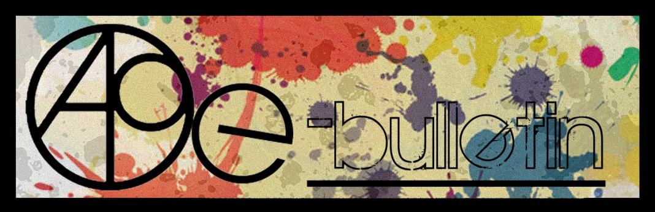

**Kilkenny County Council Arts Office E-bulletin 17th April 2015**

Dear All,   
  
Welcome to the fortnightly e-bulletin from Kilkenny County Council's Arts Office. Each bulletin is packed with the latest information on Kilkenny Arts Office activities, county events as well as news and opportunities for arts practitioners from around the country.

This service will be provided fortnightly. To include an item in the next e-bulletin please send a brief outline of your advert with relevant contact details, including any websites or pages with links to [**niamh.brophy@kilkennycoco.ie**](mailto:niamh.brophy@kilkennycoco.ie) **before 29th April**. The next e-bulletin will be on the **1st May.**

While every effort has been made to ensure the accuracy of our information, we strongly advise readers to verify all details to their own satisfaction.

Regards,

Niamh Brophy  
Arts Office,  
T: 056 7794138  
E: [niamh.brophy@kilkennycoco.ie](mailto:niamh.brophy@kilkennycoco.ie)   
W: [www.kilkennycoco.ie/eng/Services/Arts/](http://www.kilkennycoco.ie/eng/Services/Arts/)

BECOME PART OF IT, SUBMIT A POEM.....[www.rhymerag.net](http://kk-moss/Sites/arts_office/Shared%20Documents/Julianne%20Morgan/E-bulletin/30th%20May%20e-bulletin/www.rhymerag.net)  
Kilkenny County Council Arts Office Partner Local Authority of the ArtLinks Programme [www.artlinks.ie](http://www.artlinks.ie)

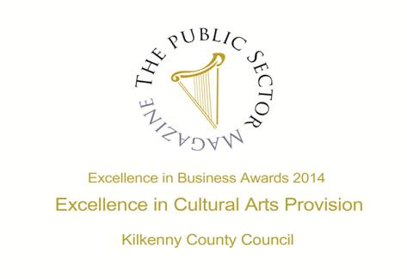

|  |  |
| --- | --- |
|  |  |
|  |  |

**Arts Office**

* R3VERSE - FREE Poetry Workshops for Teenagers
* Kilkenny Poetry Broadsheet 2015: Call for Submissions
* Kilkenny Writer in Residence Rita Kelly offers Intermediate / Advanced Writing Workshops
* Mentoring for Kilkenny Writers with Writer in Residence - Rita Kelly
* Kilkenny Clinic Mentoring Programme for artists 2015
* Read the Next Rhyme Rag poem!
* Save the Date – Rhyme Rag Launch Tuesday 28th April!
* ‘Still, We Work’, Representation of Women and Work – Touring Exhibition coming to Kilkenny soon

**Kilkenny Events**

* Alice in Wonderland 2015: Kilkenny Youth Theatre
* **Abhainn Ri: Call for Ideas**
* **Lucinda Sly**
* Artist By Night Unveils New Work
* **Shared Exhibition Space Opportunity at Kilkenny Arts Week**
* **Spaces Available at Artist-run Studio in Kilkenny**
* Hot Water Bottle
* **National Craft Gallery Workshops**
* **Eigse: Call for Submissions**
* **Storytelling Ulysses**
* Grennan Mill Craft School - Summer Courses 2015
* Butler Gallery Education Panel: Call for Artists
* **Kilkenny County Council Community and Cultural Facilities Capital Funding**
* Poets on Board at City Library, John’s Quay
* **List Your Exhibitions, Events and Opportunities with VAI**
* KCAT Icon Painting
* Ré - Tunes in the Church, Black Abbey
* Kilkenny Roots Festival May 2015
* Coming Soon to the Watergate Theatre
* Kilkenny Steiner School : Relief teachers required
* KOZO Workshop Programme 2015

**Courses / Training / Jobs / Internships**

## [City Life: new NCAD + UCD summer school this July](http://artsmanagement.ie/2015/04/14/city-life-new-ncad-ucd-summer-school-this-july/)

* Certificate in Child Protection and Welfare
* Big Smoke Writing Factory - April 2015
* **MA in Socially Engaged Art, NCAD – Call for Applications**
* Over The Edge Offers Poets Worldwide Online Poetry Workshop with Kevin Higgins
* **Curatorial Internship Opportunities at The Hunt Museum**

**Call for Submissions / Residencies**

* Bursary for documentation of an arts and health project
* Top Mag, For Teens by Teens
* **Artists' Books Stall at Get Together 2015**
* Midlands Feis Ceoil to Hit all the Right Notes with Ireland’s Finest Young Musicians
* Public Art Work, Cashel Tipperary Municipal District Office
* Call to Artists for Participatory Arts & Mental Health Panel – Waterford
* **Open Call: AN POST Public Art Commissions**
* **Centre Culturel Irlandais in Paris: Artists in Residence 2015/16**
* Participatory Artists sought for Tallafest
* **Donaghmore Village Public Art Commission: Call for Artists Proposals**
* **Arts in Education Portal: Call for news and opportunities**
* **Call for Nominations**: **Celebrating partnership between Business and the Arts**
* **RDS National Craft Awards 2015: Call for Entries**
* **Light Work Artist-in-Residence Program**
* The Moth Short Story Prize

**Awards / Bursaries / Schemes**

* **2014/2015 Dates and Deadlines for Culture Ireland Grant Rounds**
* **Grant for Performing Arts 2015**
* Arts and Disability Connect
* **The Arts Council Programme for Ireland 2016: Open Call to the Irish Imagination**
* **Arts Council’s Artist in the Community Scheme – Deadlines 2015**

**Of Interest**

## Ireland's National Day for Visual Artists - Friday, 15th May 2015 in IMMA

* **Sean Lynch to Represent Ireland at the Venice Art Biennale 2015**

## Scripts – Ireland’s Playwriting Festival

**Arts Office**

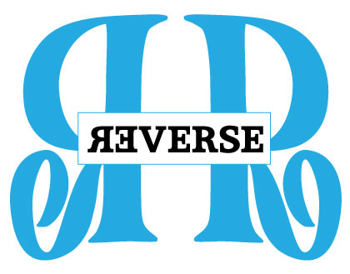

**R3VERSE - FREE Poetry Workshops for Teenagers**

**Do you want to learn to write poetry? Do you want to improve your poetry writing skills?**

**Do you want to have FUN? And all of this for FREE!**

**Tutor:** Rita Kelly

**Time:** Monday’s 5pm – 7pm

**Dates:** Monday’s – 13th, 20th and 27th April and 11th, 18th and 25th May(6 weeks, breaking for Bank Holiday)

**Location**: No. 5 Dean Street, Kilkenny City

**Cost:** Free!

Over six one-hour workshop sessions, the participants will be facilitated through the poetry writing process from original idea/concept in drafting, writing, editing, reading and completing poems. You will discover the process through investigating sample poems interwoven with working through your own ideas. You will create and then edit you own poem text, and you will be advised on submission for publication, on reading your poem to an audience, plus many practical tips aside. There will be writing to do in every session, and also between sessions. Bring a dedicated copybook/notebook plus an A4 lined writing pad — and a pen, biro or pencil!

**Get yourself ready to submit your work to our dedicated online poetry journal** [www.rhymerag.net](http://www.rhymerag.net)

**These free workshops can be booked by contacting Rita Kelly directly at** [ritakelly26@gmail.com](mailto:ritakelly26@gmail.com) **or 087 6728974.**

**Limited spaces available.**

**Rita Kelly Biography**

Rita Kelly, considered by some as a gifted poet in both English and Irish, has won many awards for her writing.  She has published six collections of poetry. Born in Galway, 1953 she now lives in Tramore with breathtaking views of the sea and the beach. She has had a long and very enjoyable connection to the Kilkenny Writers for nearly 30 years now; working with wonderful poets and writers in the Clogh, Bennettsbridge, Thomastown, Graiguenamanagh areas and most recently with great and creative students in Scoil Aireagail, Ballyhale’s Tranisition Years.

**Call for Submissions: Kilkenny Poetry Broadsheet Issue 15**

Kilkenny County Council Arts Office is delighted to announce a call for submissions for the publication of the fifteenth issue of the very popular **Kilkenny Poetry Broadsheet**. The aim of the publication is to give local writers a platform for their work. Each poem selected is included in the broadsheet which is available free throughout the County. One hundred and ninety two poems were submitted for consideration by seventy seven poets with thirteen poems by thirteen poets selected by Editor Enda Coyle-Greene in 2014 with the publication launched as part of the Kilkenny Arts Festival by American poet Billy Collins.

This fifteenth issue of Kilkenny Poetry Broadsheet will be edited by **Tony Curtis**.

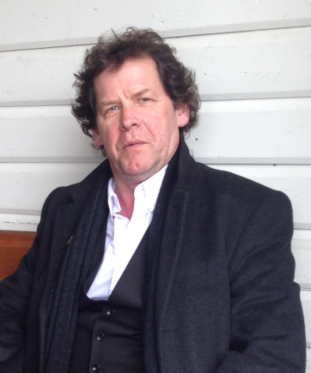 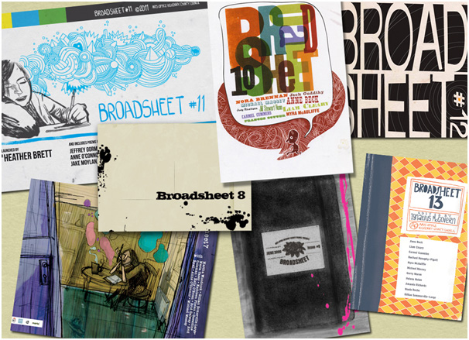 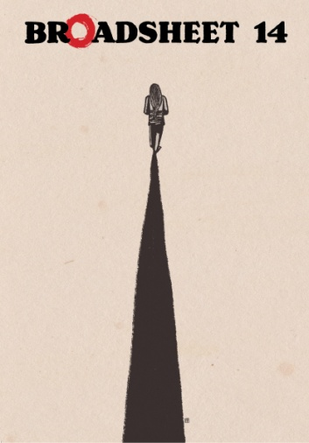

**Tony Curtis** was born in Dublin in 1955. An award-winning poet, Curtis has published nine warmly received collections. His most recent collections are: 'Pony' (with paintings and drawing by David Lilburn, Occasional Press 2013); 'Currach' (with photographs by Liam Blake, 2013); 'Folk' (Arc Publications 2011). His children's book 'An Elephant Called Rex and a Dog Called Dumbo' (with illustrations by Pat Mooney) was published in 2011. A new collection 'Approximately in the Key of C' is forthcoming from Arc Publications. Curtis has been awarded the Varuna House exchange Fellowship to Australia, The Irish National Poetry Prize, and has read his poetry all over the world to great acclaim. He is a member of Aosdana.

We are now accepting submissions from poets born or based in Kilkenny City and County.

**Closing date for receipt of submissions is no later than 4pm on Tuesday 5th May.**

Application forms and submission rules are available from the Arts Office, John’s Green house, John’s Green, Kilkenny. T: 056 7794138 E: [niamh.brophy@kilkennycoco.ie](mailto:niamh.brophy@kilkennycoco.ie)

Or can be downloaded from: <http://www.kilkennycoco.ie/eng/Services/Arts/News/Call-for-Submissions-Kilkenny-Poetry-Broadsheet-Issue-15.html>

No electronic submissions accepted.

**Kilkenny Writer in Residence Rita Kelly offers Intermediate / Advanced Writing Workshops**

Kilkenny County Council’s Arts Office is pleased to announce the appointment of Rita Kelly as Kilkenny’s Writer in Residence (WIR). Over the next few months Rita will be working with Kilkenny writers, facilitating creative writing workshops and offering mentoring advice. Writing workshops aimed at bringing writers, of intermediate and advanced experience, to the next level will take place in the Arts Office, 5 Dean Street, Kilkenny, through the initial provision of three weekends of writing.

***********************

**Creative Writing Weekend for Adults**

**Tutor: Rita Kelly  
Venue: Arts Office, 5 Dean Street, Kilkenny  
Time: 10am – 1pm and 2pm – 4:30pm**

**Cost: €45 / €40 concession**

**Dates:**

**Workshop 1: Saturday 11th and Sunday 12th April**

**Workshop 2: Saturday 25th and Sunday 26th April**

**Workshop 3: Saturday 16th and Sunday 17th May**

(NB Participants need to book for one weekend only. Attendance at a second workshop is allowed subject to initial booking numbers, so please indicate when booking if you wish your name to be placed on a waiting list for a second weekend should places become available.)

These weekends allow for a definite and extended period of high concentration so that writers and poets can go deeply into the process in an undisturbed space and time.

Workshops are open to poets, fiction and non-fiction writers. They are suitable for experienced and emerging writers and there is much to be gained from this kind of focused interaction, as there is to be gained from the mix of genres. As Rita points out ‘*Poets are often delighted to find that their poetry exhibits a noticeable narrative and prose writers find it encouraging and heartening that their prose reveals a lyrical quality*’

These workshops welcome writers and poets who are committed to creative writing and to the idea of creative writing; who are interested in developing their skills, techniques and writing prowess within an atmosphere of mutual respect and encouragement.

Participants will be asked to submit a maximum of 3 poems, 1 short story or 1 novel chapter as samples of their work on receipt of confirmation of booking.

***********************

**Interested in booking a place?**

Places are limited to 12 participants per workshops so please book early to avoid disappointment.Open to Kilkenny based writers only.

**To secure a place on the above courses please contact Rita Kelly at** [ritakelly26@gmail.com](mailto:ritakelly26@gmail.com) **or 087-672 8974 ensuring you indicate you weekend/s of preference**.

**Deadline for booking is 4pm on Friday 3rd April.**

**Rita Kelly Biography**

Rita Kelly, considered by some as a gifted poet in both English and Irish, has won many awards for her writing.  She has published six collections of poetry. Born in Galway, 1953 she now lives in Tramore with breathtaking views of the sea and the beach. She has had a long and very enjoyable connection to the Kilkenny Writers for nearly 30 years now; working with wonderful poets and writers in the Clogh, Bennettsbridge, Thomastown, Graiguenamanagh areas and most recently with great and creative students in Scoil Aireagail, Ballyhale’s Tranisition Years.

**The Arts Office, Kilkenny County Council acknowledges the support of the Arts Council/An Chomhairle Ealaíon, Kilkenny Carlow ETB and Kilkenny County Council Library Service.**

**Mentoring for Kilkenny Writers with Writer in Residence - Rita Kelly**

The Arts Office is delighted to announce their mentoring programme with Kilkenny County Council’s Writer in Residence Rita Kelly. These mentoring opportunities will be available to a select number of Kilkenny writers and places will be allocated through an application and selection process.

Rita will support a number of writers in their chosen genre, at a time of transition, on a one-to-one basis.

What is that transition? It is the raising of your work to a new level. It is a new awareness of your work which will allow you to further build on gained insights long after the actual mentoring time is over.

What is mentoring? It is a professional relationship with a sympathetic writer for a timetabled period. Both mentor and mentee will bring evidence of commitment to the engagement. The mentoring will help you move beyond the private process of writing as Rita will investigate and evaluate that writing process. She will endeavour to discover what you want to achieve with your writing and will help and facilitate you in achieving this.

The successful candidates will need to evidence a certain level of competency and experience as part of their applications as the mentoring will only be of benefit to writers who have already committed to the production of a body of work. The quantity is not significant but the quality and the promise of quality is very important to Rita as part of this process.

Overall the mentoring sessions will encourage growth and development by providing guidance and support. Writers and poets tend to have individual issues and concerns; these will be addressed as part of this mentoring process.

The mentoring sessions will run over a 5 week period over April and May 2015 at the Arts Office in Dean Street, Kilkenny. The practical arrangements and the specifics of the sessions will worked out between Rita and the successful candidates. Cost to mentees is €15 per 2 hourly sessions. The dates and times of sessions, as well as number of sessions to be arranged between mentor and mentee.

******************************************************************************************

**Interested in applying?**

**To apply for a mentoring opportunity, please prepare a cover letter, (no longer than 2 pages), outlining your creative work to date and what you feel you will gain from the mentoring and send to:**

**Rita Kelly at** [**ritakelly26@gmail.com**](mailto:ritakelly26@gmail.com) **or contact her with any queries on 087-672 8974.**

**DEADLINE FOR APPLICATION IS 17th April**

**Numbers are strictly limited and early application is advised**. **Open to Kilkenny based writers only.**

******************************************************************************************

**Rita Kelly Biography**

Rita Kelly, considered by some as a gifted poet in both English and Irish, has won many awards for her writing.  She has published six collections of poetry. Born in Galway, 1953 she now lives in Tramore with breathtaking views of the sea and the beach. She has had a long and very enjoyable connection to the Kilkenny Writers for nearly 30 years now; working with wonderful poets and writers in the Clogh, Bennettsbridge, Thomastown, Graiguenamanagh areas and most recently with great and creative students in Scoil Aireagail, Ballyhale’s Tranisition Years.

**The Arts Office, Kilkenny County Council acknowledges the support of the Arts Council/An Chomhairle Ealaíon and Kilkenny County Council Library Service.**

**Kilkenny Clinic Mentoring Programme for artists 2015**

Kilkenny County Council Arts Officer Mary Butler is pleased to invite applications from eligible artists for the Kilkenny Clinic Mentoring Programme. This is part of Kilkenny’s ArtLinks programme 2015.

This hugely successful programme, now in its fourth year, provides an opportunity for artists to meet face-to-face with a specialist mentor who has expertise in their artform to discuss and develop their artistic practice. This Clinic Mentoring Programme is open to qualifying Kilkenny artists who are registered members of ArtLinks only. Artists interested in applying for programme support should download an application form from:

http://www.kilkennycoco.ie/eng/Services/Arts/News/KILKENNY-CLINIC-MENTORING-PROGRAMME-FOR-ARTISTS-2015.html

**The closing date for receipt of Clinic Mentoring applications is: Monday, 27th April, 2015 at 12 noon**

About the mentoring programme

Clinic mentoring sessions cover a [range of topics](http://www.failteireland.ie/Business-Supports/Managing-Your-Business/Business-Mentoring/Examples-of-Mentoring-Themes) specific to an individual artist’s needs. The sessions provide the artist with the opportunity to discuss such areas as;

* Planning and developing their artistic practice and professional development path
* Working in context with the wider artistic community
* Marketing their artistic practice and maximising online awareness
* Commercialising their creativity

The mentoring service offers the following benefits to the artist:

* Expert guidance
* Objective, independent advice
* Relevant and practical support
* Confidential assistance on sensitive issues
* A sound board to help in making decisions

Mentoring is provided by a selected panel of experts comprising all artforms. Mentoring support will be offered to successful artists from Mid May to Mid July 2015.

**Please note:**

**The Kilkenny Clinic Mentoring for Literature has already been advertised as part of our Writer in Residence Programme with Rita Kelly. Therefore literature / writing practitioners should note that support for Literature mentoring will not be considered as part of this application process for Literature Mentoring please see W.I.R. opportunity .**

What the artists say:

*‘I just wanted to say a huge thank you for setting up my mentoring session. My mentor was totally focused, sensitive and so generous with her time and action plans.  I needed this experience so badly and it has firmly anchored me back on track again. She was totally the right person for me to see and I am so grateful to her and to Artlinks for providing me with the opportunity to have this terrific experience.’*

*Christabel Atkins, Visual Artist*

About ArtLinks

Established in 2007 ArtLinks provides supports for artists across all disciplines living in the South East to assist them develop their practice for the future. The programme provides mentoring, bursaries, networking and professional development opportunities for professional and emerging artists across the partner region.

Artists must be a member of Artlinks to be eligible for any of our supports, so registration is essential. Membership is free and is open to both Professional and Emerging Artists who are resident within the four Local Authority County Councils of; Carlow, Kilkenny, Waterford and Wexford. Register online at [www.artlinks.ie](http://www.artlinks.ie)

# Editorial contact:

For further information contact:

Niamh Brophy on (056) 7794138 or email at [**niamh.brophy@kilkennycoco.ie**](mailto:niamh.brophy@kilkennycoco.ie)

**Read the next Rhyme Rag published poem**

The next poem to be published for **Rhyme Rag** is **‘Clock’** by **Tim Ferris.**

Tim Ferris is fifteen and attends St. Kieran’s College, Kilkenny. His hobbies include playing golf and shooting, primarily hunting fox and pheasant during the winter months.

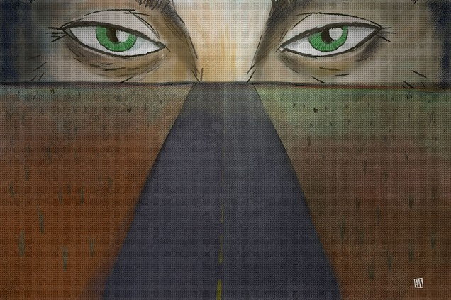

This poem was selected by Editor John W. Sexton and Illustrated by Ale Mercado.

**Read it here:** <http://www.rhymerag.net/2015/04/clock/>

Thanks to all for submitting poems. And don’t forget to submit work or encourage others you may know to do so! See all details on [www.rhymerag.net](http://www.rhymerag.net)

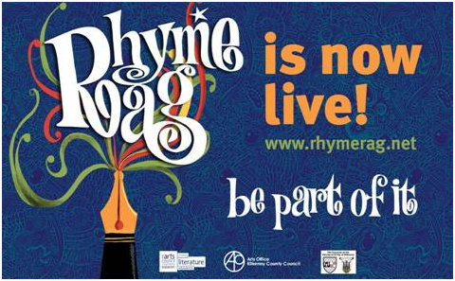

**SAVE THE DATE!**

**[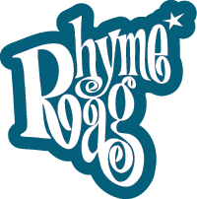](http://www.rhymerag.net/)**

**RHYME RAG LAUNCH DATE - TUESDAY  APRIL 28th2015**

[**'Still We Work'  
representations of women and work**](http://www.nwcilegacyproject.com/)

ABOUT the TOUR

In 2015, STILL, WE WORK will tour to Letterkenny, Kilkenny, and Limerick, working with five independent curators and NWCI members, this Spring/Summer and Autumn.

DATES and PLACES

DONEGAL: TOUR LAUNCH AND EXHIBITION  
OPENING EVENT, 5PM, FRIDAY 8TH MAY, REGIONAL CULTURAL CENTRE, LETTERKENNY  
  
**Exhibition runs Tuesday - Saturday, May 12th - 23rd, RCC, curated by Marie Barrett**

The exhibition will travel on to Kilkenny in June for the Abhainn Rí Festival of Participation and Inclusion in Callan, 26 June - 5 July, with the support of Kilkenny Arts Office. And to Limerick in October, dates to be announced closer to the time, with the support of Limerick City Gallery of Art and Dance Limerick.

TOUR TEAM

The STILL, WE WORK artists' commissions and exhibition were originated by Legacy Project Curator, Valerie Connor. She advised on subsequent touring in 2014 and devised the 2015 tour for NWCI. She is coordinating the project with tour manager Monica Flynn and the independent exhibition curators who are are working with the tour partners and supporters.

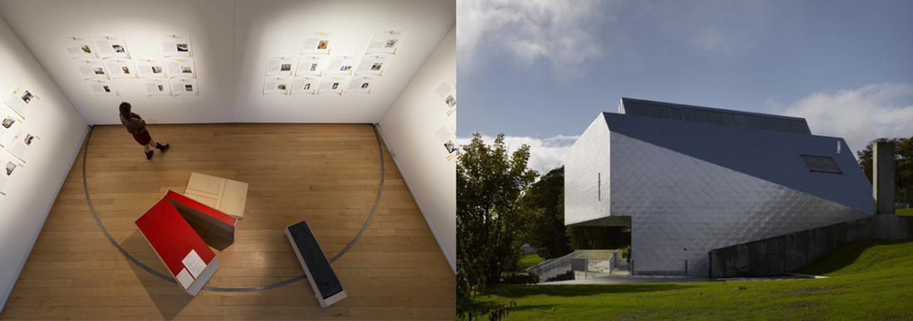

Left: 'Still, We Work' at the Gallery of Photography, Dublin, 2013. Photo Brian Cregan. Right: RCC, Letterkenny.

The exhibition curators involved with the tour are Marie Barrett, Rosie Lynch & Hollie Kearns, Monica Flynn and Michele Horrigan.   
  
The partners and supporters are represented by Shaun Hannigan (RCC Director), Mary Butler (Kilkenny Arts Officer), Una McCarthy (LCGA Director), Jenny Traynor (Dance Limerick) and the organising committee of the Abhainn Ri festival in Callan.

PARTNERS

The National Women's Council of Ireland acknowledges the financial support of the Arts Council/An Chomhairle Ealaíon Visual Arts Touring Award in making this tour possible with partners Regional Cultural Centre Letterkenny, Kilkenny Arts Office, Limerick City Gallery of Art and Dance Limerick and supporters Abhainn Ri Festival and Dance Limerick.

|  |  |  |  |  |
| --- | --- | --- | --- | --- |
| [Picture](http://regionalculturalcentre.com/) | [Picture](http://www.donegalcoco.ie/) | [Picture](http://www.kilkennycoco.ie/eng/Services/Arts) | [Picture](http://www.gallery.limerick.ie/) | [Picture](http://www.limerick.ie/council) |

**Kilkenny Events**

**Alice in Wonderland 2015: Kilkenny Youth Theatre**

***‘I am not a child, I am nearly thirteen!’ - Alice***

Barnstorm’s Kilkenny Youth Theatre presents Lewis Carroll’s ‘Alice in Wonderland’. Over the years there has been the love and death of ‘Romeo and Juliet’, the twisted ‘Gormenghast’ and Kilkenny Youth Theatre’s take on the film noir KoHL. Kilkenny Youth Theatre now look forward to taking one of the most loved childhood stories and adapting for the stage.

Alice is 12 and ½ years of age and it bothers her to still be thought of as a child. Why do all these other people get to make the decisions, confuse her and boss her, after all, she is nearly thirteen.

‘Alice In Wonderland’ has a cast of 21 young people from all around Kilkenny, and the production will take an alternative approach to costume and set by taking influence from the Steampunk movement, where design and look is inspired by 19th century industrial steam-powered machinery, which lends itself perfectly to the madness of Wonderland.

James Kennedy, who plays the Cheshire Cat, says that he enjoys working on ‘Alice in Wonderland’ and that “it is a unique magical world that takes you away from reality”. James loves being part of Kilkenny Youth Theatre and “feels that the connection has grown so strong that it now feels like a family.”

Orla McGovern plays the Gryphon. She says that bringing something so well known to life is very challenging and it’s great as an actor to find new ways to present such familiar characters. She says the Youth Theatre “lets you learn lots of new skills in a fun and interesting way” and that things are taught so that it feels like “skills and knowledge simply sweeps in”.

Anna Galligan, Barnstorm’s Outreach Officer and Director of the play, says ‘Alice in Wonderland has seen many adaptations from Disney to Burton. We have remained very true to Lewis Carroll’s original books of Alice both in Wonderland and the Looking Glass. The main change is Alice is now 12 and ½ years of age, as Humpty says ‘a most uncomfortable age’. It is when we begin to leave childhood and enter our teenage years. As most of our most of our group have recent experience of this we thought it would be interesting to do. Also there are great opportunities to work as an ensemble especially in the larger scenes of the Queen’s Garden and the Knave’s Trial. It also is an insane story so it presented great challenges so we could see what is theatrically possible.’

**‘Alice In Wonderland’** is running from Thursday 16th - Saturday 18th April at 7.30pm, with a matinee on 18th April at 3pm, at The Barn, Church Lane, Kilkenny (behind St. Canice’s Cathedral). Tickets are €10/€8 (Under 18’s) and can be booked at 056 7751266 or by emailing [anna@barnstorm.ie](mailto:anna@barnstorm.ie)

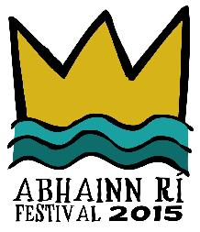26th June to 5**th** July 2015, Callan, Co. Kilkenny

**CALL FOR IDEAS**

CRAFT, MUSIC, THEATRE, SPORT, ENVIRONMENT, HERITAGE, FOOD, ARCHITECTURE, VISUAL ARTS, LITERATURE, DESIGN, FILM, YOUTH AND FAMILY DAYS

The Abhainn Rí Festival is seeking ideas for our 2015 programme. Over the past 5 years the Abhainn Rí Festival of Participation and Inclusion has taken bold steps to support, commission, and host activities that explore the unique built environment of the town of Callan as an interactive venue. This year we are inviting proposals to contribute to an exciting programme of events that will shape Abhainn Rí 2015.

**Who we are:**

We are a small festival with big ambitions. We pool together the creative, social and civic resources of the town to make this special festival happen. The Abhainn Rí Festival is built on collaboration and is run by a management committee of 12 voluntary members.

**Who can apply:**

We welcome proposals from individuals and groups in the fields of craft, music, theatre, sport, environment, heritage, food, architecture, visual arts, literature, design, and beyond. We are interested in activities and events that are intergenerational, activate overlooked spaces, introduce new ideas, celebrate the local community and promote inclusion.

Your proposal could take the form of a workshop, a talk, a social gathering, a walk, an exhibition, a performance, a sports event. Your event can be ticketed or free. Your event could be aimed at a small or large audience.

**Before you apply:**

Familiarise yourself with the programme of previous festivals and consider the activities already happening in the town. Where appropriate make sure you link in local organisations before submitting your proposal. Visit our festival archive and links on abhainnrifestival.com and facebook.com/AbhainnRiCallan

A major project for this year’s festival is **The Bridge Street Project**, an inclusive site specific contemporary theatre and architecture project that will use the streetscape and interiors of buildings on Upper Bridge Street as a stage for a performance that will take place at 10pm every night during the festival. At daytime Bridge Street will be open for public access and we are searching for creative folk to imaginatively utilise this space, other buildings, as well as other venues in the town during the 10 day festival.

We are particularly interested in daytime, late afternoon and early evening events that will harness the interest of those visiting for the performance. We will have hungry folks arriving. Do you have a hospitality/food project, can you provide light entertainment, or can you hold fun interactive workshops that could utilise the existing spaces and businesses in Callan? We are keen to involve projects that could collaborate with local businesses, pubs and shops to initiate an early evening event. We are also looking for entertainment and stallholders for the Family Field Day.

**How we will support your event/proposal:**

We are seeking projects that are self-supporting, that generate their own audience and their own income. You will be responsible for implementing all elements of your project. In saying that, successful events/activities will be included in the festival programme (printed & online), your events/activities will be covered by festival insurance, included in all press release material and you will be mentored by the festival committee to ensure your event is realised to its full potential.

**Selection Process:**

We will select proposals based on a number of key factors: Does the proposal meet the festival’s aims of participation and inclusion? How well considered is your project conceptually and practically? Is what is being proposed feasible? Do we as a festival have the capacity to support the proposed activity? Is there an existing audience for this type of event? If not, do we have the capacity to promote the event and develop a new audience? What resources are needed to make it happen?

|  |  |
| --- | --- |
| *Visit us:* |  |
| *website:* | *http://www.abhainnrifestival.com* |
| *facebook:* | *Abhainn Ri Callan* |
| *twitter:* | *@AbhainRiFestiv* |
| *Contact us:* |  |
| *email:* | *info@abhainnrifestival.com* |
| *phone:* | *085 216 1269* |

**Deadline for submissions: Friday 24th of April 2015, 5.30pm**

**How to apply:**

Your proposal should include the following:

1.A short description of your activity/event (100 words)

2.A short description of who you are (50-100 words)

3.Why you want to take part in the Abhainn Rí Festival

4.Any supporting documentation you feel is necessary: letters of support, C.Vs, past work/projects

**Submissions to be made by email to** [**info@abhainnrifestival.com**](mailto:info@abhainnrifestival.com)

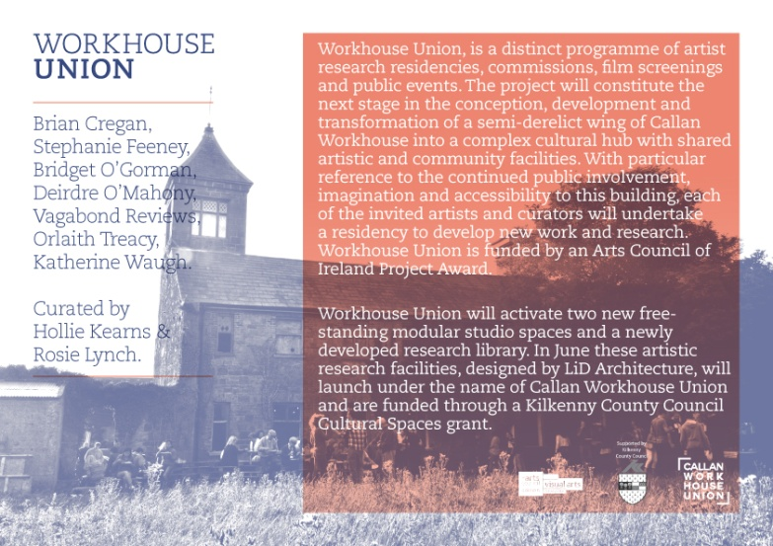

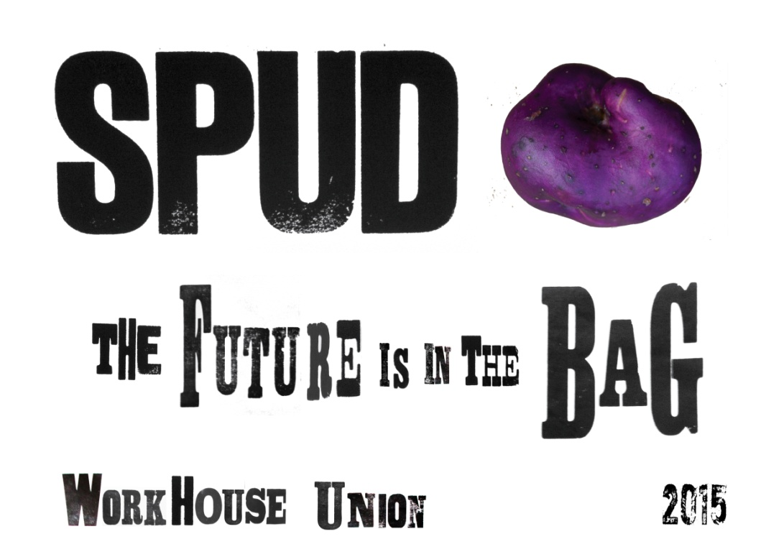

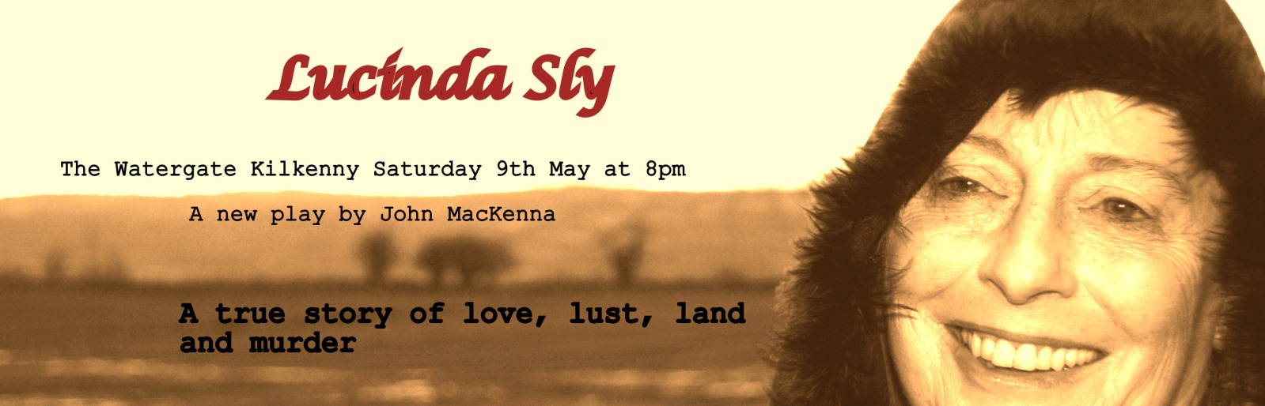

**Artist By Night Unveils New Work**

*"Brilliant, exquisite and awe-inspiring..."*

*"Magnificent... meticulous technique"*

Tia Vellani, the artist formerly known as "Artist by Night", unveils her new artwork this month at the main branch of the Kilkenny Library on John's Quay. Her unusual collection of glass tapestries expands a traditional form of bead weaving from a pattern and story-based art form into an abstract and conceptual art form, blending science, music and visual art. Exhibiting the work of artists across the county, Kilkenny County Libraries provides opportunities to view and purchase the latest offerings of some of Ireland's artists at affordable prices.

Recognised for her diverse background, Dr. Vellani has created works of art based on musical notation by transforming sound into colour. Vellani is committed to the exploration of multi-disciplinary creative endeavours.

Kilkenny County Library's mission is to support local artists by making artworks accessible to as many people as possible, providing free exhibition space in suitable branches and stocking a specialised Art book collection for borrowing.

Exhibition space is available to artists by contacting Aisling Kelly, City Library on 056 779 4174.

**Some Music-based Artworks on Display:**

**Beethoven:** Moonlight Sonata

**J.S. Bach:** Invention in A Minor

**Chopin:** Prelude in E Minor

**Debussy:** The Little Shepherd

|  |
| --- |
| http://i2.cmail2.com/ti/y/C0/837/BB6/043645/images/ncg_logo.111537.gif |
|  |
| |  |  |  |  |  |  |  |  |  |  |  |  |  |  |  |  |  |  |  | | --- | --- | --- | --- | --- | --- | --- | --- | --- | --- | --- | --- | --- | --- | --- | --- | --- | --- | --- | |  | |  | | --- | | [Adult Workshop: COLLECTING, THINKING, DRAWING](http://nationalcraftgallery.cmail2.com/t/y-l-iunhdd-jtddlybih-e/)  **Fri 17 April 2pm-6pm, Cost €20**  **No previous experience neccessary**  Talk, walk and [workshop](http://nationalcraftgallery.cmail2.com/t/y-l-iunhdd-jtddlybih-s/) exploring drawing as a tool for design with applied artist [Stuart Cairns.](http://nationalcraftgallery.cmail2.com/t/y-l-iunhdd-jtddlybih-g/)  In this workshop Stuart will give an insight into using observations in walking, looking and finding as a way of discovering creative inspiration and training the eye. During the workshop participants will be taken on a walk and encouraged to look, gather and find points of interest in their surrounding environment. Participants need to bring a digital camera [phone camera is fine] as well as materials for drawing such as inks, pencils, paper and sketchbooks.  Stuart will give a short talk on his own creative process at the start of the workshop explaining how he uses walking and collecting to drive the creation of the objects he makes. Stuart’s work can be seen in our current exhibition Side by Side and is part of the Design & Crafts Council of Ireland’s Portfolio Critical Selection 2015-2016 | |  |  |  | | --- | | [Booking 056 7796151, events@nationalcraftgallery.ie](mailto:events@nationalcraftgallery.ie) | | [http://i1.cmail2.com/ei/y/BD/560/7A0/csimport/Unknown-460x556.163147.jpeg](http://nationalcraftgallery.cmail2.com/t/y-l-iunhdd-jtddlybih-w/) | |  | |  | |  |  |  | | --- | | MEET THE MAKERS: Simon Doyle  **Thurs 23 April | 6pm, FREE**  Join us for our [Late Date](http://nationalcraftgallery.cmail2.com/t/y-l-iunhdd-jtddlybih-yd/) with maker Simon Doyle were he will discuss his work in the current exhibition Side by Side.  Simon Doyle is a furniture designer and maker based in Dublin. He describes the Shakers as an early influence, the 19th century American religious sect whose furniture rejected decoration in favour of the simple; seeking beauty through quality and reduction. He believes they sought this beauty and proportion in spite of it being unnecessary to the function of the object but because it was contributory to their inner peace and harmony. Doyle approaches each piece of furniture in the context of craft and industry; where the two intersect and where they are at their most distant, whether that be visible joinery and the traditional techniques of craft, or metalwork and the contemporary manufacturing techniques of modern industry.  Doyle will be discussing the processes behind the furniture he has been involved with since setting up his studio in 2013, following the initial ideation and concept through to the finished piece. Part of this period has included experimentation with steam bending, resulting in an array of failures with the occasional and encouraging breakthrough. Here more on Thursday 23rd April at National Craft Gallery, Kilkenny. | |  |  |  | | --- | |  | | http://i2.cmail2.com/ei/y/BD/560/7A0/csimport/SimonDoyleIMG1edit.164046.jpg | |  | |  | |  |  |  | | --- | |  | | **'Crafternoon Tea' at NCG, 22nd May**  We invite you to join us at the National Craft Gallery for 'Crafternoon Tea' and an informal tour of our exhibitions on Friday 22nd May at 1pm.  The talk and tour will explore the exhibition Appetite for Design an exhibition featuring the work of leading Irish designers, architects, cooks and restaurateurs which will document, discuss and speculate about the design of food and our experience of it.  FREE EVENT  For more details contact  events@nationalcraftgallery.ie or phone 056 7796151 | |  | |

[www.nationalcraftgallery.ie](http://nationalcraftgallery.cmail2.com/t/y-l-iunhdd-jtddlybih-yh/)

**Eigse: Call for Submissions**

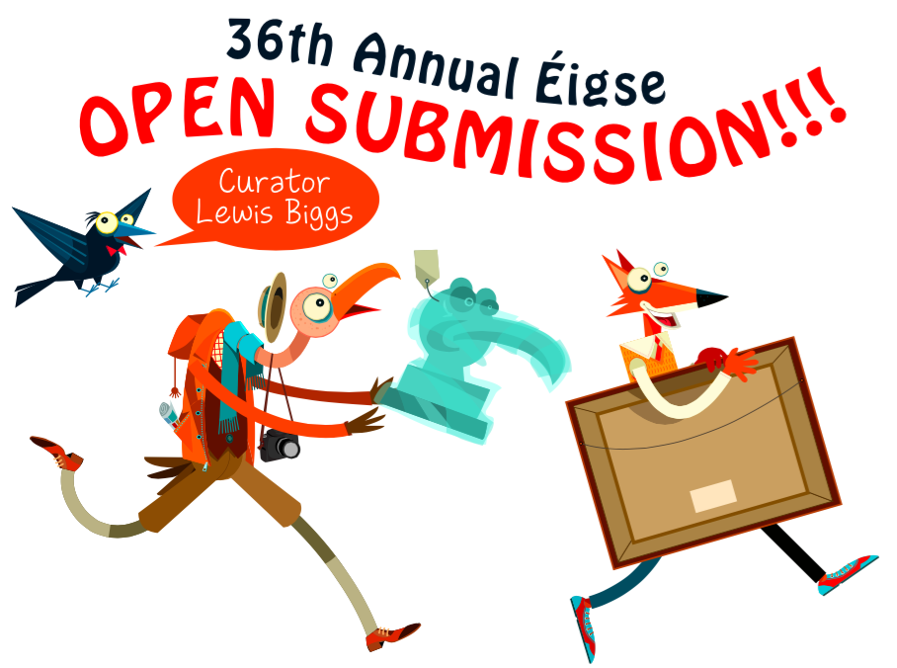

**Storytelling Ulysses**

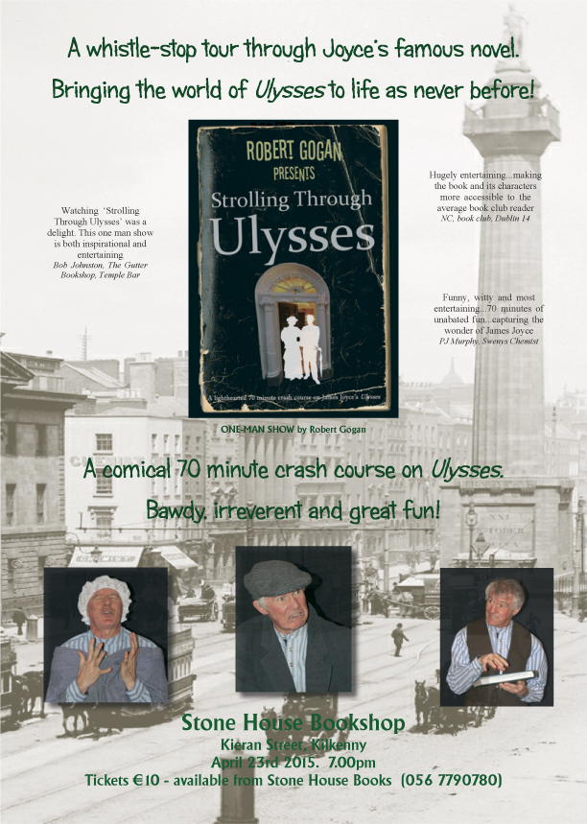

**Shared Exhibition Space Opportunity at Kilkenny Arts Week**

Artist Tia Vellani is looking for other artists who wish to share exhibition space at Kilkenny Arts Festival this August.

Please reply by April 30 as space must be found and booked early.

Contact Tia Vellani 087 607 9748 or tiavellani@gmail.com

[www.tiavellani.weebly.com](http://lists.visualartists.ie/lt.php?c=1322&m=4359&nl=1&s=d3c261c0eeb6b48867f449d29e09414b&lid=106394&l=-http--www.tiavellani.weebly.com)

**Spaces Available at Artist-run Studio in Kilkenny**

Artist-run studio set in rural Kilkenny, overlooking the Blackstairs Mountains, offering three studio spaces and accommodation for artist in residence, plus space for facilitation of art and craft related workshops.

For more information email; [blackwatchstudio@gmail.com](mailto:blackwatchstudio@gmail.com)

**Hot Water Bottle**

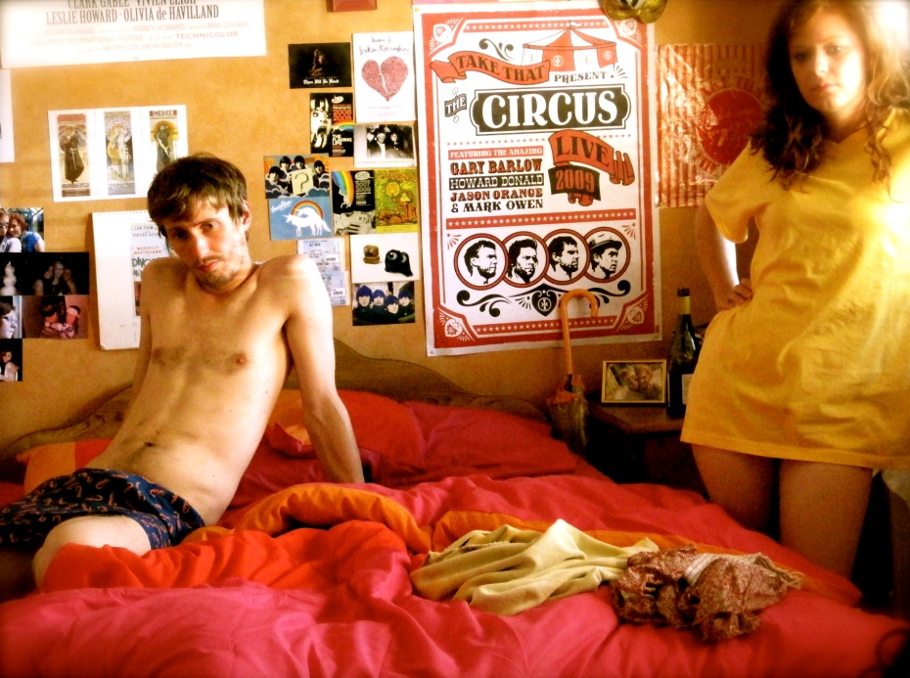

The Kilkenny set comedy ***Hot Water Bottle*** has been released online.

Set over the course of a year in Kilkenny, *Hot Water Bottle* tells the story of Frank and Alice, a couple who broke up but struggle to stay broken up. As each season progresses, they find themselves drawn back into the same old routine of drunken nights and walks of shame. Time might move on, but they can’t.

The cast are **Suzanne O’Brien, David Thompson, Simone Kelly** and **Peter McGann**. It is written and directed by **John Morton** and produced by **Alan Slattery** and **Paddy Dunne** of **Mycrofilms**. The film was supported by **Kilkenny Arts Office.**

*Hot Water Bottle* premiered as one of the Irish Short Film selection at the 57th annual Corona Cork Film Festival and also played Darklight Film Festival and The Cat Laughs Comedy Festival. For more, please visit **mycrofilms.com**.

Here's the link to the movie: <https://www.youtube.com/watch?v=gxdAGSt8bf0>

**Grennan Mill Craft School - Summer Courses 2015**

• Metalcraft & Jewellery for Beginners & Improvers  
**Thursday 4th June - Sunday 7th June** / 10am-5pm   
4 day course exploring many techniques in Metalsmithing & Jewellery-making including enamelling, soldering, forming, surface decoration & more...   
Minimum 6 – Maximum 8 persons  
Course Fee €260  
Materials Fee €15 - includes copper & gilding metal, enamels, solders & sundries.

• Silver Jewellery for Beginners & Improvers  
**Friday 12th June - Sunday 14th June** / 10am-5pm   
3 day course exploring many techniques in Silver Jewellery making  
Minimum 6 – Maximum 9 persons  
Course Fee €200  
Materials Fee €20 (includes 8 grams of silver)

***For more details please text / phone Metalcraft Tutor Eva Lynch on 087 6210830 or email at [evylynch@hotmail.com](mailto:evylynch@hotmail.com) ***

Place will only be secured once deposit of 50% or full payment has been received. Full course fee required by: Friday 29th May for ALL courses  
• Cheques made payable to ‘’Grennan College’  
• Class formation is dependent on an adequate number of applicants – minimum 6 persons for each individual course irrespective of craft  
• Should Grennan Mill cancel the course, your monies will be refunded in full

**Butler Gallery Education Panel: Call for Artists**

Butler Gallery is currently recruiting professional visual artists for its Arts Education Panel. We seek expressions of interest from experienced and enthusiastic artists, who have an interest in arts education practice and a passion for enabling engagement with programmed exhibitions and facilitating arts experiences in a gallery context.

Artists will carry out response workshops, courses and one-off activities on **a free-lance basis** in Butler Gallery, Kilkenny Castle and a range of outreach venues throughout Kilkenny. Artists must be available for seasonal (paid) meetings and training opportunities with other panel members. Applications will be accepted from artists based in any county, but please note, we do not offer a travel allowance.

Applications will be accepted by post or email until **Monday 11 May at 12pm**.

Please include the following:

* Curriculum Vitae with relevant experience clearly outlined
* Examples of current practice – max 10 images.
* A completed Artist Panel Information Form. (available to download from 7 April on www.butlergallery.com)
* An expression of interest (one A4 page) that demonstrates:
* How this opportunity relates to your practice
* An understanding and interest in this model of working
* Commitment to being involved in contributing to training opportunities and skills sharing with fellow panel members

**Guidelines**:

• Shortlisted applicants will be called to interview in early June 2015.

• Applications received after 12 noon on Monday 11 May will not be deemed eligible.

• The successful candidates will be required to complete Garda Vetting and Child Protection Training.

**Please send applications clearly marked EDUCATION PANEL to:**

**Bairbre-Ann Harkin, Education Curator, Butler Gallery, Kilkenny Castle, Kilkenny**

**or**

**bairbre.ann@butlergallery.com**

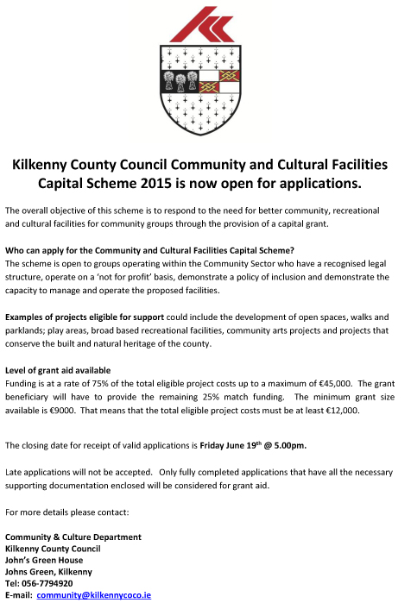

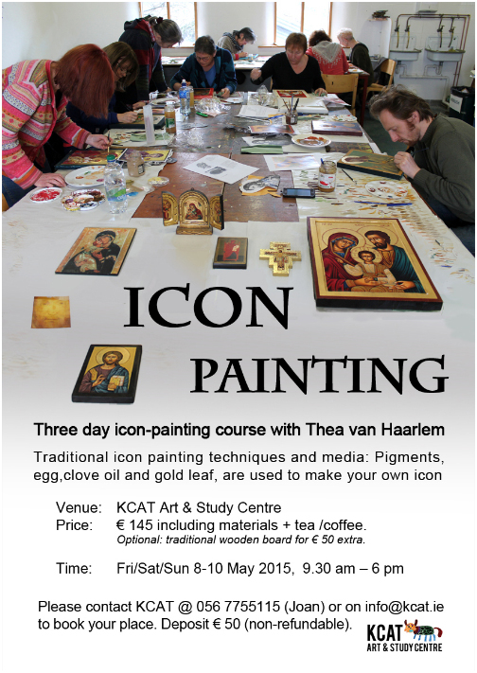

**Poets on Board at City Library, John’s Quay**

Submissions for **May** are now being accepted.

Closing date: **8th May**

Please email poems to: [citylibrary@kilkennylibrary.ie](mailto:citylibrary@kilkennylibrary.ie)

Rules:

* One well-crafted poem per month can be submitted
* Five poems overall will be selected and will be displayed for the month
* One poem will be selected every 3 months and its author will receive a book voucher prize!
* Phone 056 779 4174 for further information

Congratulations to the winner of our first book voucher prize of the year, Gillian Somerville-Large!

Gillian’s poem, *Snowdrops*, is on our blog. You can read it here: <http://kilkennylibrary.kilkenny.ie/Blog/?p=387>

Thank you for submitting poems for April. Here is list of poems on display this month. If your poem is not up this month, it may be displayed at a later stage instead.

**Poets on Board – April**

**After Diagnosis – Mary O’Shea**

**Bluebell – Nora Brennan**

**Love is - Kevin Connelly**

**South-Facing Softness – Mia King**

**Threadbare – Sé Nicholson**

Please send your entries for May to us by 8th May. There will be another book voucher at the end of June for one of the poets whose work was displayed from April to June.

**List Your Exhibitions, Events and Opportunities with VAI**

**Visual Artists Ireland**’s e-bulletin is a twice-weekly service providing the latest information on news, opportunities, exhibitions and events relating to the visual arts in Ireland. We seek to advertise every visual art event and exhibition happening in Ireland or Ireland based visual artists showing internationally each week in our e-bulletin. We also seek to advertise all opportunities that may benefit visual artists and help them pursue their professional art career.

In addition, all listings published in the e-bulletin are also published on our website and are automatically fed into our Facebook and Twitter pages; thus providing a free mutli-platform promotional service to artists and arts organisations.

We do not charge for this service, we simply need you to send us your listings.

Please submit info for our listings via the online form on our website, [CLICK HERE](http://lists.visualartists.ie/lt.php?c=1325&m=4362&nl=1&s=d3c261c0eeb6b48867f449d29e09414b&lid=107205&l=-http--visualartists.ie/contact/eguidelines)**:**

Content received via the online form on our website allows you to upload an image (max 150 x 150 pixels please) to accompany your listing.

In addition, info received via the forms is prioritised, so when we have a large volume to get through listings received via the forms get published first.

**Timing wise**: At least one week before the issue you want to be in is optimum

**Exhibitions** and events info is published in the  **Sunday E Bulletin**

**Opportunities**, courses, talks, calls for proposals, jobs, studios to rent etc for artists goes  in the **Wednesday E Bulletin**

If you have any questions email us at:  
E: [listings@visualartists.ie](mailto:listings@visualartists.ie)

**Ré - Tunes in the Church, Black Abbey**

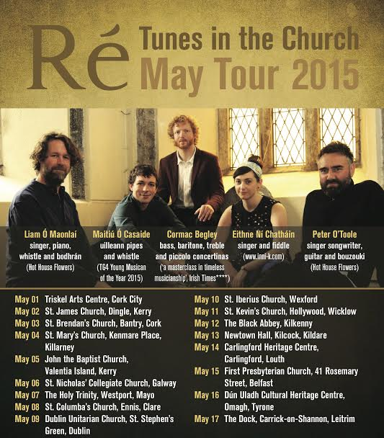

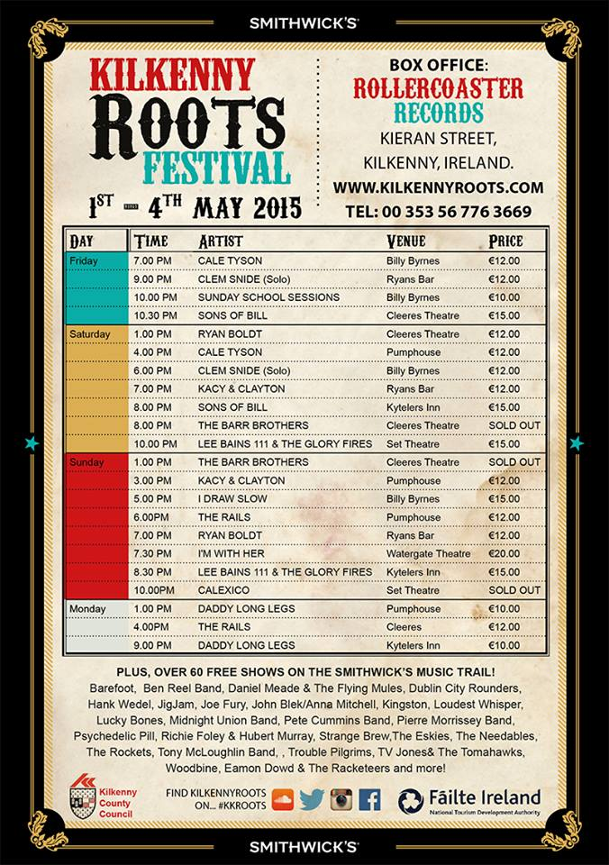

## Coming Soon to the Watergate Theatre

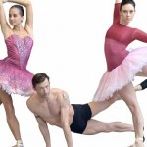

[Tutus And Beyond](http://watergatetheatre.com/programme/tutus-and-beyond/)  
Wed 22nd April 2015  
Tickets: € 15/12/10



[Road Safety Show](http://watergatetheatre.com/programme/road-safety-show/)  
Mon 27th April 2015  
Tickets: € TBC



[I'm With Her - Sara Watkins, Sarah Jarosz & Aoife O'Donovan](http://watergatetheatre.com/programme/im-sara-watkins-sarah-jarosz-aoife-odonovan/)  
Sun 3rd May 2015  
Tickets: € 20

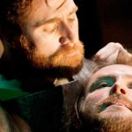

[The Assassination of Brian Boru](http://watergatetheatre.com/programme/the-assassination-of-brian-boru/)  
Wed 6th May 2015  
Tickets: € 14/12

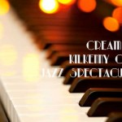

[Cream Of Kilkenny Cats Jazz Spectacular](http://watergatetheatre.com/programme/cream-of-kilkenny-cats-jazz-spectacular/)  
Fri 8th May 2015  
Tickets: € 10

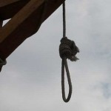

[Lucinda Sly](http://watergatetheatre.com/programme/lucinda-sly/)  
Sat 9th May 2015  
Tickets: € 14/12

<http://watergatetheatre.com/>

|  |  |
| --- | --- |
| |  | | --- | |  | |

**Kilkenny Steiner School : Relief teachers required**

Kilkenny Steiner school is currently seeking teachers to act as relief in times of illness or absence.

We are looking for an expression of interest from individuals who are interested in becoming part of a panel of teachers that may be called on in the future.

Individuals should ideally fulfill at least one of the criteria below:

-Be a fully qualified primary national school teacher with a knowledge and/or openness to expanding their knowledge of Primary Steiner training/ethos

-Be a fully qualified Primary Steiner teacher

- Have a minimum of 5 years working in an official Steiner Waldorf Primary setting.

If interested please send a CV and Cover letter outlining your interest in working in a Steiner School to [kilkennysteinerschool@gmail.com](mailto:kilkennysteinerschool@gmail.com) with relief teacher in subject or a hard copy to Kilkenny Steiner School, Ballytobin, Callan, Co Kilkenny. Applicants will be garda vetted following interview.

[www.kilkennysteinerschool.com](http://www.kilkennysteinerschool.com)

Closing Date: April 27th 2015

**KOZO Workshop Programme 2015**

**KOZO Studio WORKSHOP Programme  
for adults (incl. young people from 16 years)**

**APRIL - JUNE 2015**

The **WORKSHOP PROGRAMME** at KOZO Studio continues this SPRING with extra dates added for PAPERMAKING Courses – all designed and run for small groups of participants at KOZO Studio in The Estate Yard, Castlecomer Discovery Park, Co. Kilkenny.

We scheduled workshops for **complete beginners** as well as **returning participants** and those of you with **previous experience** or your own creative practices.

**Tutor:** Tunde Toth – Visual Arts Practitioner, Arts Educator, Papermaker

Read on to check out our **inspiring choice of workshops:**

#### EMBROIDERY WORKSHOP for BEGINNERS with Alexis Bernstorff - Textile Artist and Textile Restoration expert from the ROS TAPESTRY 23 MAY (Saturday) 11am - 5pm

This workshop will teach 6 principal stitches and their variations - using wool, cotton/silk and metallic threads. Participants will be inspired by a range of techniques to realise simple designs.  
  
Alexis has 15 years experience teaching crewelwork embroidery and is the guide behind the dynamics of the Ros Tapestry. There will be designs from the Ros Tapestry available to purchase on request.  
€ 70 for the full day - including all materials 

#### Advanced Level EMBROIDERY WORKSHOP with Alexis Bernstorff - from the ROS TAPESTRY 20 JUNE (Saturday) 11am - 5pm

This is a follow-on, advanced level course, offering comprehensive tools to realise a variety of designs and artworks.  
It will refresh participants on basic stitches (if necessary) and teach four more stitches using wool, cotton/silk and metallic threads and other materials such as wire and unspun wool and silk.  
The workshop will focus on Form, Volume and Effects and each stitch will be explored under these headings. Stitch direction, padding and consideration of the fall of light will allow participants to expand on the potential of embroidery as a creative, artistic medium.  
€ 70 for the full day - including all materials

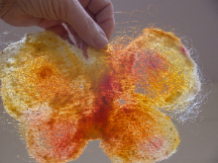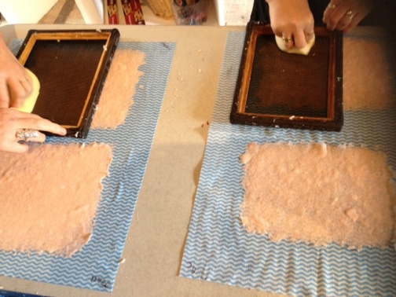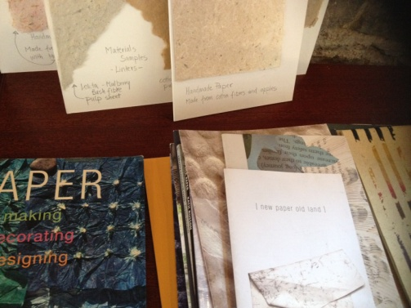

#### ****19 April (Sunday): PAPER MAKING  DAY****- Beginners - 2 places left

10.30am - 1.30pm HAND PAPER MAKING - Introduction to traditional and contemporary techniques of making beautiful handmade papers from pure plant fibres and a range of recycled materials.  
2.30 - 5.30pm SILK FIBRE PAPERMAKING - A truly fascinating, contemporary technique for making `fabric-like`, colourful silk papers using raw silk fibres and fabric dyes. Easy to continue and set up at home, this process is ideal to create unique interior decorations and striking silk papers for artworks, embroidery, collages, card making...etc.  
Next date for this workshop: 17 May (see below)  
Fees for each workshop: € 35   
OR: € 65 for the full day - including all materials  
  
**********  
**10 May (Sunday): FELT MAKING (Wet Felting)**- Beginners -  
11am - 5.30pm  
A full day workshop introducing wet felting processes using dyed and un-dyed merino wool with pure silk fibres and threads incorporated for details and added texture. Design and create your own unique bag or scarf or wall piece!  
Fee: € 70 for the full day, including all materials  
  
**********  
**17 May (Sunday): PAPER MAKING  DAY**- Beginners and participants with some previous experience  
For details see PAPER MAKING DAY programme above (19 April)  
   
**********  
**7 June (Sunday): PAPER ART and HAND PAPER MAKING**  
FOLLOW-ON, ADVANCED LEVEL COURSE - only for participants with previous experience.  
10.30am - 5.30pm  
  
Designed for participants who already work with paper/fibre based processes, this course offers assistance and guidance in areas of three dimensional, sculptural and installation based works, experimental processes of batik, paper dyeing and texturing. It also covers ideas for the preparation and use of plant based pulps (without added chemicals). Participants are encouraged to bring their own ideas and questions into the workshop and invited to show and discuss previous works and projects. The day also includes a short slideshow presentation on examples of contemporary paper art and paper making.  
Places are limited for 5 participants.  
€ 80 for the full day, including all materials  
  
**********  
**14 June (Sunday): BATIK Workshop**- Beginners  
A full day programme introducing an ancient technique of fabric dyeing where hot wax is used as a resist.  
Participants will learn all necessary basic techniques - and complete three small/medium batik pieces with up to 4 colours on cotton fabric and/or paper.  
€ 70 for the full day, including all materials  
  
  
GIFT VOUCHERS are available for the workshop of your choice!  
   
BOOKINGS are confirmed with € 30 deposit paid in advance.*  
Courses are run for small groups of participants only so please call to book early.  
With any questions, for advice or check availability and for all BOOKINGS please contact TUNDE directly:  
  
**Tunde Toth - Artist**  
**087-2543362**  
[tundetune@gmail.com](mailto:tundetune@gmail.com)  
[www.tundetoth.com](http://tundetoth.us9.list-manage.com/track/click?u=927a06abce3366093569f0241&id=73399962f2&e=1f1b25985b)  
[www.tundetothpaperart.blogspot.com](http://tundetoth.us9.list-manage1.com/track/click?u=927a06abce3366093569f0241&id=4fd328d620&e=1f1b25985b)

**Courses / Training / Jobs / Internships**

|  |  |
| --- | --- |
|  | [City Life: new NCAD + UCD summer school this July](http://artsmanagement.ie/2015/04/14/city-life-new-ncad-ucd-summer-school-this-july/) |

#### **City Life: A Shared Summer School**

*Celebrated for its rich cultural heritage and history, Dublin is at a crucial point of transition. Currently re-negotiating its approach to urbanity, the city is an exemplar of many of the most critical challenges facing the contemporary global metropolis.*

*In July 2015 (13th – 31st), UCD and NCAD will join forces to offer a unique summer school programme giving students the opportunity to pursue their disciplinary and scholarly interests through a creative and critical engagement with the ongoing transformation of Dublin today.*

*Over a three-week period, students will explore and respond to Dublin’s rich urban culture. Along with numerous tours, visits and special events, the programme will combine shared studio activity with focused workshops, seminars and lectures.*

*Students will be given unique access to leaders in the cultural and creative sector, meeting and working with significant practitioners, artists, museum directors, and critical thinkers. High-profile visiting speakers will also contribute to the programme.*

Along with Dr Declan Long from NCAD, I'll be coordinating one of the programme tracks:

##### **Culture, Memory and the City:**

*This strand is intended for participants keen to interrogate the relationship between memory and the city, through psycho-geographic and critical writing practices. Daily sessions will explore the imprint and trace of modern Irish historical experience on Dublin’s urban spaces and institutions. Together we will track (and experience) how film, photography, commemoration, ritual, artistic practice and urban placemaking have intersected with political, social, economic conditions over the past century.*

*Students will be encouraged to formulate a creative and critical response to daily topics in the form of a photo essay/blog, piece of critical writing and group presentation. Sample sessions include:*

* *Institutions, Archives and Memory (National Gallery of Ireland / National Archives)*
* *Making and Working: Producing Culture in the City (Temple Bar Gallery & Studios / Francis Bacon Studio, Dublin City Gallery – The Hugh Lane / Project Arts Centre, Temple Bar)*
* *Public Monuments and Urban Memories (walking tour of Dublin city public monuments)*
* *Film, the City, and Memory: Dublin Onscreen (film viewing in association with the Irish Film Institute, Temple Bar)*

Applications are open until 1 May, and details of the programme & costs are available here: <http://ncad-ucd.ie/summer-school/>

**Certificate in Child Protection and Welfare**

NYCI's Child Protection Programme are now inviting applications for their 'Certificate in Child Protection and Welfare' which is accredited by Maynooth University. This 100 hour course is delivered over five blocks of three days mid-week in a Dublin City Centre Venue.

It is aimed at those in key positions of responsibility in services working with young people. The course will begin in September 2015 and end in May 2016. The cost is €1000 per person for members of NYCI and €1200 for non-members.

For more information please see the information brochure below and to apply please complete and return the application form before 29th of May 2015.

<http://www.youth.ie>

**Big Smoke Writing Factory - April 2015**

Hello writers!   
  
We've a whole new range of courses beginning in April, so we're holding an Open Day on Thursday 9th April, from 5.30pm-8pm, where members of the team will be on hand to answer any questions you might have about upcoming workshops and to help you figure out which class might suit you best.  
  
If you're a beginner, our next ten-week [Beginning To Write](http://clicks.aweber.com/y/ct/?l=BjhQw&m=3kxPQqFdROEc6a0&b=KzPf1956kmwNQii8zOe5UQ) class starts Thursday April 16th, while our six-week [Beginning To Write Fiction](http://clicks.aweber.com/y/ct/?l=BjhQw&m=3kxPQqFdROEc6a0&b=q5BovIHJMLGcfflsNgiOlA) class starts Tuesday April 14th. Or maybe you've taken beginners' classes and just want to get back into writing, or generate new material - try out our six-week [Get Writing](http://clicks.aweber.com/y/ct/?l=BjhQw&m=3kxPQqFdROEc6a0&b=O2R2qCPdy4mLMvYsYa3M4Q) class, starting Wednesday April 15th.    
  
If you've already started a project and are looking for feedback, we've a wide range of intermediate and advanced workshops coming up. [Intermediate Creative Writing](http://clicks.aweber.com/y/ct/?l=BjhQw&m=3kxPQqFdROEc6a0&b=f3kDp54KmUF121aRlDjkog) is a good fit for people who've taken beginners' classes and want to keep developing their work, while our [Developing Your Work In Progress](http://clicks.aweber.com/y/ct/?l=BjhQw&m=3kxPQqFdROEc6a0&b=TwWFRBlJxtZ3Y6fVzb1qPQ) will suit people who've taken a few classes and have a particular project they want to develop. If you're particularly interested in sci-fi, fantasy or horror, we have a [Speculative Fiction Workshop](http://clicks.aweber.com/y/ct/?l=BjhQw&m=3kxPQqFdROEc6a0&b=wNmktcNMg4GWOck2UlIMgA) starting up, and if you're working on a novel-length project, our [Nov el In Progress](http://clicks.aweber.com/y/ct/?l=BjhQw&m=3kxPQqFdROEc6a0&b=esF1acC337pm4gFV3jaxMw) workshop is the place for you.   
  
We also have specialist courses starting up - a four-week class in [Feature Journalism](http://clicks.aweber.com/y/ct/?l=BjhQw&m=3kxPQqFdROEc6a0&b=gy64MF.o9rwch2uUDmEI_g), an eight-week [Poetry workshop](http://clicks.aweber.com/y/ct/?l=BjhQw&m=3kxPQqFdROEc6a0&b=LMbaRO.FT8WkZ2mHIECrUQ), and an [Exploring Playwriting](http://clicks.aweber.com/y/ct/?l=BjhQw&m=3kxPQqFdROEc6a0&b=ajNVFnPsgnHFUIVRjTRqDw) class. And we've a number of exciting one-days running on Saturdays in April, including [The Science of Magic](http://clicks.aweber.com/y/ct/?l=BjhQw&m=3kxPQqFdROEc6a0&b=TLZFwQaDiVEaBYQBVRL3tg) for anyone interested in world-building, a [Performance for Writers](http://clicks.aweber.com/y/ct/?l=BjhQw&m=3kxPQqFdROEc6a0&b=HdQ8xzvOi0Ae888gX6_f_A) workshop, and a seminar focusing on [Cover Letters and Synopses](http://clicks.aweber.com/y/ct/?l=BjhQw&m=3kxPQqFdROEc6a0&b=T5pDE35Vb.c0WjnNYMguKA).   
  
You're spoiled for choice, really. As ever, please do contact us if you've any queries about any of these courses. Happy writing!  
  
-- The Big Smoke team

[Big Smoke Writing Factory](http://clicks.aweber.com/y/ct/?l=BjhQw&m=3kxPQqFdROEc6a0&b=SbaK6as8zzZZL.DIKjwB5A),  
Dollard House,  
2-5 Wellington Quay,  
Temple Bar,  
Dublin 2,  
Ireland.  
  
Phone: 087-976-6253  
Email:   
[bigsmokewritingfactory at gmail dot com](mailto:bigsmokewritingfactory@gmail.com?subject=Query%20from%20newsletter)  
Facebook: [/writingfactory](http://clicks.aweber.com/y/ct/?l=BjhQw&m=3kxPQqFdROEc6a0&b=yXyvXK_hABy4YeFplGCUDw)  
Twitter: [@bigsmokewriting](http://clicks.aweber.com/y/ct/?l=BjhQw&m=3kxPQqFdROEc6a0&b=mXTLpNmc496YUvF1_BMqOA)

**MA in Socially Engaged Art, NCAD – Call for Applications**

Applications are now being sought for the MA Socially Engaged Art (Further, Adult and Community Education). The MA SEA focuses on the dynamic relationship between socially engaged arts practice and pedagogy, particularly within further education, non-formal educational and community settings, with an embedded qualification to teach in the FE sector.

Recognising the range of methodologies used in socially engaged art that draw on educational concepts and forms, the MA SEA is a site for experimental learning and critical debate in socially engaged art and education practice.

The programme is coordinated by artist Fiona Whelan and Nuala Hunt – Head of Continuing Education in NCAD. Other staff include: artists Chris Maguire, Glenn Loughran, Ailbhe Murphy, Marie Barrett as well as adult educator Anne Gallagher and community worker John Bissett.

The MA SEA will attract students from a range of disciplines who want to immerse themselves in a trans-disciplinary enquiry. Applicants should have a Level 8 (BA Hons) degree in art or design or in another discipline with a personal and demonstrable commitment to the arts in social contexts.

For further information, see [http://www.ncad.ie/postgraduate/school-of-education/ma-in-socially-engaged-art/](http://lists.visualartists.ie/lt.php?c=1315&m=4352&nl=1&s=d3c261c0eeb6b48867f449d29e09414b&lid=104748&l=-http--www.ncad.ie/postgraduate/school-of-education/ma-in-socially-engaged-art/) or contact <huntn@ncad.ie>

Deadline for applications is 30th April 2015.

**Over The Edge Offers Poets Worldwide Online Poetry Workshop with Kevin Higgins**   
   
Starting in very early May, Over The Edge is offering aspiring poets worldwide a ten week online poetry workshop with poet Kevin Higgins, whose best-selling first collection, *The Boy With No Face*, published by Salmon Poetry, was short-listed for the 2006 Strong Award for Best First Collection by an Irish poet.   
   
Each of the ten weeks Kevin will email participants a poetry writing exercise for the following week and participants will submit one of their poems to Kevin for constructive criticism. Kevin will work with participants on making each of their poems the best possible poem it can be.  
   
Kevin is a highly experienced workshop facilitator and several of his students have gone on to achieve publication success. He has facilitated poetry workshops at Galway Arts Centre for the past ten years. One of his workshop participants won the prestigious Hennessy Award for New Irish Poetry; two have been shortlisted for the Shine/Strong Award for Best First Collection by an Irish poet; two have won the Cúirt New Writing Prize; and another the Cúirt Poetry Grand Slam; several have published collections of their poems with reputable publishers.  
   
The workshop will run for ten weeks, commencing **Wednesday May 6th**. The cost to participants is €110. There are no refunds. The workshop will be conducted in English only.   
  **YOU CAN REGISTER ONLINE NOW**  
<http://www.overtheedgeliteraryevents.blogspot.ie/2014/02/over-edge-offers-poets-worldwide-online.html>

**Curatorial Internship Opportunities at The Hunt Museum**

Hunt Museum, Rutland Street, Limerick

The Hunt Museum is currently seeking applications for 3 and 6-month unpaid internships in its award-winning Education and Public Programmes Department to commence in Summer/Autumn 2015 and Winter 2016. Shorter-term internships (3 months) are also available.

The Hunt Museum offers several internships throughout the year to students, recent graduates and early-career Museum professionals. Interns get hands-on experience in the day-to-day operation of The Hunt Museum’s Education Department and have the opportunity to develop a project during the period of their internship under the supervision of Dr Dominique Bouchard, Curator of Education and Outreach. Recent Education and Public Programme Internship alumni have found paid employment at institutions including the British Museum (UK), Lowry Arts Centre (UK), Bishop’s Stopford Museum (UK), the Centre Pompidou (France), and the Waikato Museum (New Zealand).

We are currently seeking applications for the Education and Public Programmes Curatorial Internship.

Curatorial Internship – Education and Public Programmes (6 or 12 months).

Curatorial interns play a key role in the development of The Hunt’s interpretation, public programmes and education initiatives. Interns will have opportunities to gain experience in project management, programme development, interpretation, audience development, and digital media. Past interns have created films, helped curate exhibitions, create and manage festivals and events, contribute to interpretation, present their work at museum conferences, and have even published articles!

Specifications and application form can be downloaded directly from The Hunt’s website here: [http://goo.gl/1uzwRS](http://lists.visualartists.ie/lt.php?c=1307&m=4344&nl=1&s=e784eec6bf8bb9680747b324b9c9eee1&lid=103541&l=-http--goo.gl/1uzwRS%20) or request an application pack by emailing dominique@huntmuseum.com.

Deadlines:  
– Summer 2015 (May/June – Nov/Dec 2015): NOW OPEN – please apply ASAP  
– Autumn 2015 (1 Sept – 15 March 2016): 5.00pm Friday 15 May 2015  
– Winter 2016 (Dec/Jan 2015/6 – 15 June 2016 – ): 5.00pm Friday 25 September 2015

Short-listed applicants will be invited by email to interview 2-3 weeks following the application deadlines above. We regret that due to the volume of applications received only short-listed candidates will be contacted.

The Hunt Museum exhibits one of Ireland’s greatest private collections of art and antiquities, dating from the Neolithic to the 20th Century, and includes works by Renoir, Picasso and Jack B. Yeats. The Museum is housed in an elegant Palladian-style building designed by the Italian architect, Davis Ducart, in 1765. Today, The Hunt Museum is a cultural and artistic centre in Limerick providing a wide range of education, heritage and culture activities including a vibrant schools programme, curatorial lectures and family focused events. [www.huntmuseum.com](http://lists.visualartists.ie/lt.php?c=1307&m=4344&nl=1&s=e784eec6bf8bb9680747b324b9c9eee1&lid=103542&l=-http--www.huntmuseum.com/)

**Call for Submissions / Residencies**

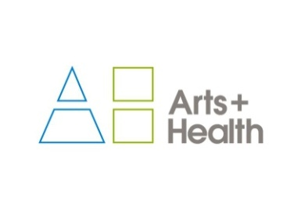

**artsandhealth.ie**

**Bursary for documentation of an arts and health project**

artsandhealth.ie is the national website providing a focal point and resource for the field of [arts and health](http://www.artsandhealth.ie/about/what-is-arts-and-health/) in Ireland. Developed by the Waterford Healing Arts Trust (WHAT) and Create in 2011 with funding from the Arts Council, the site is now managed by WHAT.

artsandhealth.ie invites applications from arts and health practitioners (artists working in healthcare settings, healthcare professionals, arts and health partnerships etc.) for a bursary to produce documentation of an arts and health project. The proposed documentation can take the form of a **short film / audio documentary and / or publication** which can be widely disseminated with a view to encouraging high quality, creative documentation of arts and health practice and creating a greater national understanding of the nature of this practice

Examples of existing documentation of arts and health practice can be found in the Resources section of artsandhealth.ie

**Bursary**

A bursary of €4000 will be made available to the successful applicant for the production of film / audio documentary and / or publication about an arts and health project.

**Eligibility Criteria**

Anyone responsible for delivering/co-delivering an arts and health project in the Republic of Ireland, in keeping with artsandhealth.ie’s definition of arts and health, may apply (see [www.artsandhealth.ie/about/what-is-arts-and-health](http://www.artsandhealth.ie/about/what-is-arts-and-health)).

**Who can not apply?**

Projects managed directly by WHAT or by members of the [Editorial Panel](http://www.artsandhealth.ie/about/about-artsandhealth-ie) of artsandhealth.ie cannot apply.

**Timeframe**

The closing date for the receipt of applications is 29th May. Applicants will be notified of decisions by 19th June 2015. It is expected that the final documentation will be completed and submitted to artsandhealth.ie by 31st March 2016.

**Application Procedure**

Please complete the application form below and submit with:

* CV(s) of artist(s) / arts and health practitioner(s)
* CV(s) of lead documenter(s)
* Up to five captioned photographic images of project and / or examples of previous, relevant work of lead artist(s) / arts and health practitioner(s). Website links are acceptable.
* Examples of previous, relevant work of lead documenter(s). Website links are acceptable.
* Support letter(s) from partner(s)

**Submissions should be sent by email to** [info@artsandhealth.ie](mailto:info@artsandhealth.ie) **by Friday, 29th May at 12 noon.**

For further information, contact [info@artsandhealth.ie](mailto:info@artsandhealth.ie)

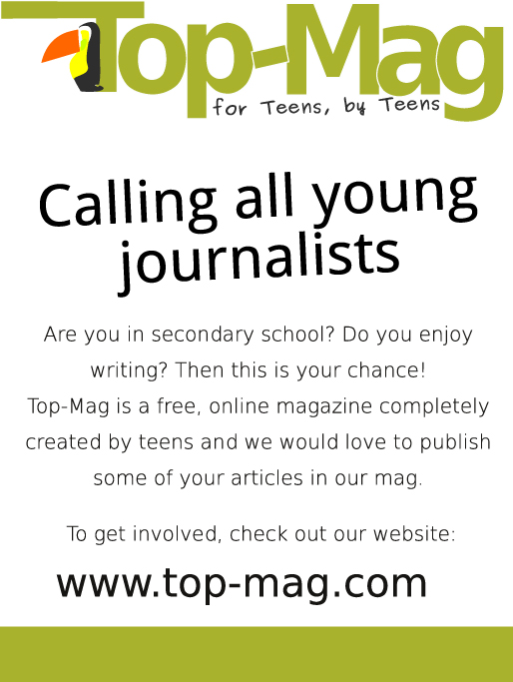

**Public Art Work, Cashel Tipperary Municipal District Office**

Tipperary County Council invites submissions for a public art work to be situated on the Plaza at Cashel-Tipperary Municipal District Office, Rosanna Road, Tipperary Town.

The Budget for the commission is €18,000.

Full Details of the Brief and Application forms are available on [www.etenders.gov.ie](http://www.etenders.gov.ie) , [www.tipperarycoco.ie](http://www.tipperarycoco.ie) or from the Cashel Tipperary Municipal District Office, Rosanna Road, Tipperary Town, Tel 0761 06 5720

Closing date for submissions is 4pm Friday 24th April 2015.

**Call to Artists for Participatory Arts & Mental Health Panel – Waterford**

Waterford Healing Arts Trust and the Waterford Wexford Mental Health Services invite artists practicing literature, drama, animation, photography, multimedia, dance, or film to apply for a place on a panel of artists who will deliver aspects of the *Iontas* arts and mental health programme in Waterford. Deadline for submissions is Thursday 30 April 2015 at 4.00pm.

The panel will be in place from May ’15 up until 31 March ’18 and during this time artists on the panel will be awarded opportunities to facilitate short-term arts projects (approx 8 weeks in duration) in two mental health settings in Waterford: the Activation Therapy Unit, St. Otteran’s Hospital and the Department of Psychiatry, University Hospital Waterford. There may be further opportunities for artists on the panel to work in other settings.

This opportunity is open to artists who have experience in collaborative / participatory arts, preferably in a mental health context.

For a full artists brief, application form and details on how to apply see <http://www.artsandhealth.ie/2015/04/02/call-to-artists-for-participatory-arts-mental-health-panel-waterford/>

For more information contact Claire on 051 842664 or [what@hse.ie](mailto:what@hse.ie).

# ****Artists' Books Stall at Get Together 2015**** VAI Logo

Visual Artists Ireland is now accepting submissions for the Artists' Books Stall at**Get Together 2015**, which will take place at IMMA on 15 May. The stall will be situated in the VAI Cafe area and provide an opportunity for artists and publishers to display their wares to a large number of artists, curators and arts workers.

This year, we would like to widen the submission criteria to include any zines or DIY, handmade publications with a visual element.

Books should not exceed 30 x 30cm in size and can be dropped off at our offices or sent by post. No more than three copies of a book should be sent. There will be no charge or commission taken but publishers must organise for the return of any unsold books. A VAI representative will man the stall throughout the day, but VAI cannot take responsibility for any damage or loss incurred.

Please email [lily@visualartists.ie](mailto:lily@visualartists.ie) with details of the book you intend to submit (title, size, price, quantity, short description). Publications must be received by Wednesday 1 May.

Publishers can also choose to keep any unsold books in the permanent VAI Book Shop situated in our Dublin office. These will also be available to buy on our website in a few weeks. 15% commission will be taken on books sold from the permanent shop.

Further information:  
[lily@visualartists.ie](mailto:lily@visualartists.ie)

**Midlands Feis Ceoil to Hit all the Right Notes with Ireland’s Finest Young Musicians**  
  
‘Midlands Feis Ceoil’ - A new Music Competition will attract many of Ireland’s finest young musicians to the Midlands in June 2015. With over 80 Individual competitions in the areas of Pianoforte, Strings, Wind & Brass and Vocal including overall Awards and Bursaries (€250 each) to the most promising Instrumentalist and Vocalist. The Midlands Feis Ceoil will be held in the Radisson Blu Hotel, Athlone, Co. Westmeath beginning on June 15th, closing with a Prizewinner’s Gala Concert on June 18th. Deadline for competition entry is May 8th at 5pm, to be made online at [www.midlandsfeisceoil.com](http://www.midlandsfeisceoil.com)  
  
Performers can expect to receive positive feedback from our highly respected and esteemed adjudicating panel. Our adjudicators will be: Pianoforte - Ms Thérèse Fahy, Strings - Mr Michael d’Arcy, Wind & Brass - Mr James Cavanagh, Vocal - Ms Virginia Kerr. All competitions are open to the public with daily tickets available at the door for €5 or a weekly pass for €15.  
  
Mr Ryan McNeill, Director of Midlands Feis Ceoil - “The Midland Counties have a fantastic musical history and by offering this wonderful opportunity to young musicians, many locally based, we hope that the area will continue to to thrive musically into the future. We are very proud that Midlands Feis Ceoil offers the musical community in this area something it has been missing. We are delighted with the amount of positive feedback we have received already from many teachers and musicians within the area and further afield, and we look forward to welcoming them to Athlone in June. This festival helps to showcase our own very talented young musicians and I would encourage everyone with an interest in music to visit the Feis. I'd like to wish all competitors every success in their competitions and wish them the best of luck with their future musical goals”  
  
Performers and supporters can keep up to date with this year’s Midlands Feis Ceoil through the official Facebook and Twitter feeds where you will find regular updates and posts.  
  
Facebook: [www.facebook.com/midlandsfeisceoil](http://www.facebook.com/midlandsfeisceoil)  
Twitter: @MidlandsFeis #midlandsfeis  
  
Midlands Feis Ceoil are still accepting sponsorship and advertising requests and offer a wide range of packages to suit all budgets. Should you be interested in sponsoring a competition or advertising your business in the official programme please contact Midlands Feis Ceoil directly at 0858353072 or by email at [midlandsfeisceoil@gmail.com](mailto:midlandsfeisceoil@gmail.com) . More information is also available via our website at [www.midlandsfeisceoil.com](http://www.midlandsfeisceoil.com)

**Open Call: AN POST Public Art Commissions**  
  
GPO Witness History  
  
Deadline: 13 May 4 pm.  
Website: [www.anpost.ie](http://www.anpost.ie)  
To book for information session on 15 April  
Email: [info@gpowitnesshistory.ie](mailto:info@gpowitnesshistory.ie)  
Info on commission: [ruairi.ocuiv@gmail.com](mailto:ruairi.ocuiv@gmail.com)  
  
An Post are in the process of constructing GPO Witness History, a interpretative and exhibition centre to be located within the GPO on O'Connell Street. An Post, is seeking proposals for public art commissions.  
  
An Post invites interest in this opportunity from across all art forms and contemporary arts practices including for example, architecture, dance, film, music, opera, theatre, verbal arts and visual arts and in all media,  
including drawing, print, video, performance and more.  
  
A briefing meeting will be held on the evening of Wednesday April 15 in the public hall at the GPO. Booking is necessary. To book a place email [info@witnesshistory.ie](mailto:info@witnesshistory.ie)  
  
An Post have appointed Valerie Connor and Ruaíri O'Cuiv as curators. The commissioning value can be set between €10,000 and €50,000  
  
Selection Process is an open submission two-stage competitive process  
  
Stage 1 - Short List  
Proposals will initially be assessed and short-listed by experts in public art.  
  
Stage 2 - Final Selection  
  
The final selection will involve experts in the contemporary arts, representatives of An Post, OPW and the Interpretive and Exhibition Centre as well as other expertise. Candidates whose proposals  
have reached the final selection process might be called upon to be interviewed.  
  
More information about the history of the postal service, An Post and the GPO at [www.anpost.ie](http://www.anpost.ie)

**Participatory Artists sought for Tallafest**

Tallafest is a Town and County fair celebrating Tallaght heritage, arts, culture, environment and people.  The fair takes place in and around the main street in Tallaght village and The Priory Church grounds. It is organised and run by Tallaght Community Council a voluntary apolitical group working for the community.

 Tallaght Community Council has been a voluntary community group for over 40 years, actively volunteering across a variety of issues and areas, with the aim of pushing for policies and investment in Tallaght for the benefit of it’s residents, environment and economy. TCC has experienced a renewal in the last 3 to 4 years, seeing it become more active and relevant in Tallaght for more people. To mark The Gathering in Tallaght in 2013 TCC ran the first Tallafest, a Town and country fair. The event proved to be very successful and combined the urban town with the rural hinterlands.

 In 2015, Tallafest will be celebrated on Saturday 15th August from 12.30 – 17.00pm. Tallafest wishes to develop it’s focus on The Arts with a wish to bring professional artists from all areas of the arts (with a participatory practice) on board. The budget is unfortunately very small for this event but all proposals / ideas will be considered and funding sought where possible, all materials will be covered.

 Deadline for proposals / ideas Friday 1st May, 2015

**Donaghmore Village Public Art Commission: Call for Artists Proposals**

Building Peace through the Arts | Donaghmore Village Public Art Commission

Tender to commission the appointment of an artist to design, produce and install an artwork in the public realm. DDCA seeks expressions of interest from experienced and suitably qualified artists or design teams in developing a new public artwork. The total budget available for the artwork is up to £30,000 (inclusive of VAT) Appointment of the successful artist/design team is contingent upon the availability of funds from the Arts Council of Northern Ireland.

Queries to  
E: [aislingmcelhone@googlemail.com](mailto:aislingmcelhone@googlemail.com)

The deadline for expressions of interest is 30 April 2015 at 5pm  
Late submissions will not be accepted  
Applications must be in English and prices in £ Sterling, inclusive of VAT

Submissions should be posted to:  
Aisling McElhone  
DDCA, Torrent Complex, 9 Hillview Avenue, Donaghmore, BT70 3DL, NI  
or E: [aislingmcelhone@googlemail.com](mailto:aislingmcelhone@googlemail.com)

**Centre Culturel Irlandais in Paris: Artists in Residence 2015/16**

The Centre Culturel Irlandais is delighted to announce the recipients of its 2015-16 programme of residencies. 22 artists across the spectrum of artistic backgrounds will spend from one month to three months in Paris to develop their proposed projects, which range from composing a multi-violin composition influenced by the Paris Metro system to an exploration of queer narratives and queer cultures in Paris. This year sees CCI partnering three Irish arts organisations for the first time in the awarding of a design residency (Design Crafts Council of Ireland – DCCoI), a music residency (Music Network) and a composer’s residency (Contemporary Music Centre).

Artists in residence have been appointed on an annual basis since the Centre Culturel Irlandais was inaugurated in October 2002. Through the residencies and its diverse cultural programme, the Centre Culturel Irlandais showcases Ireland’s dynamic contemporary culture on an international stage.

Recipients of the visual artist residencies are: Susan McWilliam, Alan Phelan, Padraig Spillane, Corban Walker and Tom Watt.  
Special projects residencies are awarded to: Corinna Askin and Softday (Sean Taylor and Mikael Fernstrom).  
The design residency was awarded to: Joe Hogan in association with DCCoI

Further information:  
Rosetta Beaugendre, Centre Culturel Irlandais, 5 rue de Irlandais, 75005 Paris, France  
T: 00 33 1 58 52 10 34 / 30  
E: [rbeaugendre@centreculturelirlandais.com](mailto:rbeaugendre@centreculturelirlandais.com)  
[www.centreculturelirlandais.com](http://lists.visualartists.ie/lt.php?c=1325&m=4362&nl=1&s=d3c261c0eeb6b48867f449d29e09414b&lid=107209&l=-http--www.centreculturelirlandais.com)

**Arts in Education Portal: Call for news and opportunities**   
  
Do you have upcoming events, news or opportunities that you want to share with the Arts-in-Education Community?   
  
The new national Arts in Education Portal will be launched in May 2015. This national initiative is being driven by the Department of Arts, Heritage and the Gaeltacht and the Department of Education and Skills, as part of the implementation of the Arts in Education Charter. The vision for the Portal is to be the key national digital resource of arts and education practice in Ireland.   
  
The news and opportunities section of the Portal aims to provide a space for finding out about policy updates, current events, projects, funding and opportunities, both locally and nationally.  
  
News items should be relevant to the Arts-in-Education sector, and should relate to:  
  
* An upcoming sectoral event, exhibition or launch;  
* An opportunity for artists and/or teachers, for example, CPD, training, or an open call for projects;  
* A funding opportunity;  
* A significant development in policy;  
* The publication of a document or a piece of research relevant to the field.   
  
Submissions should be no longer than 300 words and should include the following:  
  
* A title  
* Name of author or agency  
* Contact details  
* A date or deadline (after 19th May)  
* A high-res image  
  
Please send submissions to Jo Holmwood / Orla Kenny at [info@kidsown.ie](mailto:info@kidsown.ie) by 30th April 2015.   
  
For further information on the development of the Arts in Education Portal visit [www.kidsown.ie](http://www.kidsown.ie)

|  |  |
| --- | --- |
| |  | | --- | |  | |
|  |
|  |

**Light Work Artist-in-Residence Program**

Each year Light Work invites 12-15 artists to participate in its residency program, including one artist co-sponsored by Autograph ABP and one artist in conjunction with the Urban Video Project (UVP). Artists selected for the residency program are invited to live in Syracuse for one month. They receive a $5,000 stipend, an apartment to stay in, a private digital studio, a private darkroom, and 24-hour access to our facility.

Participants in the residency program are expected to use their month to pursue their own projects: photographing in the area, scanning or printing for a specific project or book, and so on. Artists are not obligated to lecture at our facility, though we hope that the artists are friendly and accessible to local artists and students. Work by each Artist-in-Residence becomes a part of the Light Work Collection and is published in a special edition of Contact Sheet: The Light Work Annual along with an essay commissioned by Light Work.

Questions? : Questions about the facility may be directed to [lab@lightwork.org](mailto:lab@lightwork.org) and questions about the application process or residency can be sent [toair@lightwork.org](mailto:toair@lightwork.org).

**Deadline 1 July 2015**

For information about our facilities, see [www.lightwork.org/lab](http://www.lightwork.org/lab)

**Call for Nominations: Celebrating partnership between Business and the Arts**   
  
For 24 years, the Allianz Business to Arts Awards have recognised businesses, artists and arts organisations that develop creative partnerships, bringing the arts and artists into mutually beneficial relationships across society. We invite you to share the stories of your partnerships, and join our alumni.  
  
Winning projects demonstrate that working together these sometimes diverse worlds can come together to create brilliant art, unforgettable experiences and long-held memories which enhance the character and reputation of all involved.  
  
In 2015 Business to Arts will place a marker in the sand - through the creation of the first annual report on Arts Sponsorship. This unique piece of research will be based on a short series of questions put to nominating sponsors, and will aim to give a snapshot of investment sentiment across business sectors.  
  
Nominate your partnerships to the Allianz Business to Arts Awards - to demonstrate your pride in what you have achieved; to seek to join the prestigious list of winners which represent the very best models developed between the corporate and cultural worlds in Ireland; and to ensure that your investment in arts and culture takes its place proudly in the landscape which will be recorded and mapped through the Awards process this year and subsequently.  
  
We can't map this landscape without your nominations.  
  
Winners receive a limited edition sculpture commissioned by daa, presented at a ceremony in September.  
  
**Award Categories**  
As well as arts sponsorship, the Awards recognise examples of arts and business organisations working together in other areas such as mentoring, training, staff engagement or development, commissioning artists, CSR initiatives, community engagements etc.  
  
1. Best Large Sponsorship (value over €25,000 cash or in-kind)  
2. Best Small Sponsorship (value €25,000 or under, cash or in-kind)  
3. Best Long Term Partnership (3 years or more)  
4. Best Use of Creativity in the Community  
5. Best Creative Staff Engagement  
6. Jim McNaughton Perpetual Award for Best Commissioning Practice  
7. Jim McNaughton/TileStyle €10,000 Artist's Bursary  
8. daa €5,000 Arts Award  
9. Allianz €5,000 Community Art Prize  
9. Judges' Special Recognition Award for Portfolio of Arts Sponsorship  
  
**Closing date for nominations: 5pm, Tuesday 5 May 2015**  
  
Click [here](http://cts.vresp.com/c/?BusinesstoArts/626e7ee420/608128ad7e/bc3e1b7679) for information on the application process, the Awards alumni of past winners, and to complete the application form.  
   
**#ABtoAAwards**

**RDS National Craft Awards 2015: Call for Entries**

**[Please note a nominal fee applies]**

The RDS is now calling for entries for the 2015 RDS National Craft Awards which has an increased prize fund of €40,000. The annual RDS National Craft Awards showcase and reward excellence in Irish craft.

Major Awards:

* RDS Award of Excellence €5,000 (top prize awarded in each strand)
* Irish Design 2015 Award €5,000 (open to emerging & established category winners)
* RDS IACI Muriel Gahan Award €2,000 (emerging maker)
* RDS Graduate Award €2,000 (emerging maker)
* National Crafts & Design Fair Award (value €2,000, emerging maker)
* RDS William Smith O’Brien Perpetual Challenge Cup (open to emerging & established makers)

The category prizes in the 2015 RDS National Craft Awards are sponsored by the Design & Crafts Council of Ireland. This year the 13 category prize winners in each strand will receive €500 as well as an RDS medal & certificate. There is also a special additional €5,000 prize to celebrate Irish Design 2015, which will be awarded for design innovation and excellence in a craft entry this year.

See [www.rds.ie/craft](http://lists.visualartists.ie/lt.php?c=1315&m=4352&nl=1&s=d3c261c0eeb6b48867f449d29e09414b&lid=104719&l=-http--www.rds.ie/craft)  for details of the many other sponsored prizes and to view the rules of entry.  
Winning and selected entries will be shown at the RDS National Craft Awards Exhibition at the Discover Ireland Dublin Horse Show, RDS, August, 2015, and award winners will be shown at the National Crafts and Design Fair, RDS, December, 2015.

Enter online at [www.rds.ie/craft](http://lists.visualartists.ie/lt.php?c=1315&m=4352&nl=1&s=d3c261c0eeb6b48867f449d29e09414b&lid=104720&l=-http--www.rds.ie/craft%C2%A0)  
Deadline 10 June 2015

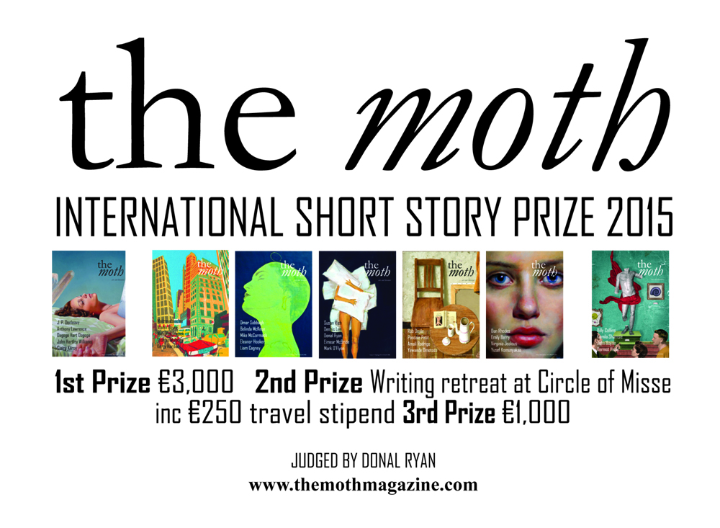

Donal Ryan judges this year's Moth Short Story Prize, with prizes of €3,000, a week-long writing retreat at [Circle of Misse](http://www.circleofmisse.com/) in France (including a €250 travel stipend) and €1,000.

There's a word limit of 6,000, and an entry fee of €12.

**Closing date 30 June 2015**.

**Awards / Bursaries / Schemes**

**2014/2015 Dates and Deadlines for Culture Ireland Grant Rounds**

Please note Culture Ireland has set funding rounds and deadlines for 2015. There will be three funding rounds in 2015 and seperate calls for showcasing opportunities and Edinburgh Festivals will be announced during the year.

**Application Deadline | Timing of Project/Event | Decision Due**

* 15 June 2015  | September 2015 onwards | Early August
* 15 October 2015 |  January 2016 onwards | Early December

[http://www.cultureireland.ie/](http://lists.visualartists.ie/lt.php?c=1232&m=4271&nl=1&s=d3c261c0eeb6b48867f449d29e09414b&lid=96096&l=-http--www.cultureireland.ie/)

**Grant for Performing Arts 2015**

**Several grants for accommodation and meals announced.**

Each grant covers up to 300,00 EUR (three hundred EUR)   
**The grant covers full board (accommodation and three meals per day)   
during participation in "ArtsOasis" international program in Italy**

**Information about the Project**

"ArtsOasis" is the annual international residential lab for performing arts practitioners from different countries working in various techniques, genres and styles. This creative residency is open to dancers, choreographers, actors and contemporary circus performers with professional stage experience, multidisciplinary artists passionate and inspired by movement, dance and physical theatre, interested in practical research of contemporary performance practice together with colleagues from different countries.

**Project Dates and Location**

**June 1st - 6th, 2015 - Tuscany province, Italy**

**Selection Criteria and Eligibility**

**Who can apply?**  
professional dancers  
choreographers  
actors (dance theatre, physical theatre, drama theatre, musical theatre)  
contemporary circus performers  
movement directors, physical theatre directors  
multidisciplinary artists inspired by movement and dance

The grant is awarded on a competitive basis. The applications are considered on the basis of the candidates background and previous achievements, individual experience and qualifications. Priority is given to those candidates who are able to show their reliability, potential to professional development and clear motivation to participate in contemporary performing arts processes at international level.

**Please view the web page for full application guidelines:**

[**http://www.artuniverse.org/grants**](http://www.artuniverse.org/grants)

**Arts and Disability Connect**

|  |
| --- |
| http://newsletter.artscouncil.ie/nwstatic/spacer.gif |

The Arts Council and Arts & Disability Ireland announce the second phase of Arts and Disability Connect, a new awards scheme for artists with disabilities in the Republic of Ireland. Supported by the Arts Council the scheme will have a fund of €25,000 to distribute in 2015.

Specifically targeted at individual artists with disabilities Arts and Disability Connect includes New Work, Mentoring and Training awards. The scheme offers artists the opportunity to: connect with other practitioners or venues; make a change in their practice; ‘step up’ in terms of scope and scale; reach new audiences and to engage in mentoring and training.  
  
  
Application forms and guidelines for 2015 will be available to download from Thursday 2 April 2015 at [www.adiarts.ie](http://newsletter.artscouncil.ie/brj9j540ptj14rbsgtdsq9?a=6&p=48507525&t=28179891)

**Deadline: Thursday 21 May 2015 at 4pm**

For general queries about the awards please contact:   
[info@adiarts.ie/](mailto:info@adiarts.ie/) 01 8509002

**The Arts Council Programme for Ireland 2016: Open Call to the Irish Imagination**

Ireland is on the eve of a great anniversary; the centenary of the proclamation of the republic. The Arts Council, through support from the Department of Arts, Heritage and the Gaeltacht, is charged with remembering, celebrating and interrogating the Centenary of the Easter Rising 1916 in art and ideas. In the century since, artists have been the chief signifiers of our nation. Their work, created in hope, has been the enduring imaginative life of what Ireland can become.

The Arts Councils programme as part of Ireland 2016 will take place across the full year. The open call we announce today as part of our programme represents a unique opportunity for artists and arts organisations to invigorate the Irish imagination. We will invest €1 million in major commissions as part of Ireland 2016. The work will be presented to the public in 2016 and will represent a key response by our contemporary artists to the centenary of the Easter Rising.

The open call for national projects is open to all individuals and organisations who are resident in the state, although the Arts Council may accept an application from outside Ireland in exceptional circumstances and where the final outcome will benefit the arts in the state. Projects will be selected by a Jury made up of two international experts, a national expert and two members of the Arts Council. It will be chaired by the Chair of the Arts Council, Sheila Pratschke.

In recognising the part played by artists in the events of 1916, and in recognising the role of the artist in contemporary Ireland, a series of special bursaries for emerging artists will also be funded. These Bursaries will enable a new generation of artists to develop their practice and provide them with the opportunity to reflect on the role of artists in Irish society in 2016.

**Open Call for National Projects**  
1 million will be available for ambitious projects, in any artform, up to €500,000 and with no lower limit  
Closing date for initial applications is 15 April 2015

**Artists’ Bursaries**  
There will be 16 bursaries, each to the value of €12,500  
Closing date for completed bursary applications is 16 July

**Touring Programme**  
An additional allocation will be made to the 2016 Touring and Dissemination of Work Scheme  
Closing dates:  
7 May 2015 for tours from January to June 2016  
3 December 2015 for tours from July to December 2016

Full details for those considering applying are available on the Arts Council website  
[www.artscouncil.ie/Ireland2016](http://lists.visualartists.ie/lt.php?c=1313&m=4350&nl=1&s=d3c261c0eeb6b48867f449d29e09414b&lid=104361&l=-http--www.artscouncil.ie/Ireland2016)

**Arts Council’s Artist in the Community Scheme – Deadlines 2015**

Twice yearly, the Arts Council offers grants to enable artists and communities of place/or interest to work together on projects. The Artist in the Community Scheme is managed by Create, the national development agency for collaborative arts.

The scheme is open to artists from any of the following artform disciplines: architecture, circus, street art and spectacle, dance, film, literature (Irish and English language), music, opera, theatre, visual arts and traditional arts. The projects can take place in a diverse range of social and community contexts eg arts and health; arts in prisons; arts and older people; arts and cultural diversity.

The aim of the scheme is to encourage meaningful collaboration between communities of place and/or interest and artists. It is essential that consultation take place between the artist and the community group, so that both parties are involved in deciding on the nature of the project realisation. Group ownership of the art should be maintained at every stage. The Project Realisation may result in a variety of outcomes.

There are two phases to the scheme. Phase One [Research & Development,](http://lists.visualartists.ie/lt.php?c=1289&m=4326&nl=1&s=d3c261c0eeb6b48867f449d29e09414b&lid=101957&l=-http--www.create-ireland.ie/artist-in-the-community-scheme-research-and-development-award.html) is open to artists who wish to research and develop a project in a community context.

There is also a [Research & Development/Mentoring](http://lists.visualartists.ie/lt.php?c=1289&m=4326&nl=1&s=d3c261c0eeb6b48867f449d29e09414b&lid=101958&l=-http--www.create-ireland.ie/artist-in-the-community-scheme-research-and-development/mentoring-award.html) strand, open to artists who wish to develop a community based project and who have identified an artist mentor they want to work with during the research and development phase.

Phase Two [Project Realisation](http://lists.visualartists.ie/lt.php?c=1289&m=4326&nl=1&s=d3c261c0eeb6b48867f449d29e09414b&lid=101959&l=-http--www.create-ireland.ie/artist-in-the-community-project-realisation-award.html) , is open to communities of interest or place (or their representative organisations) with an artist.

**2015 Deadlines:  
(Round 2)   29 June 2015**

For information on the Scheme and advice on applying, contact Katherine Atkinson, [support@create-ireland.ie](mailto:support@create-ireland.ie) or phone 01-4736600  
Visit [http://www.create-ireland.ie/about-the-artist-in-the-community-scheme.html](http://lists.visualartists.ie/lt.php?c=1289&m=4326&nl=1&s=d3c261c0eeb6b48867f449d29e09414b&lid=101960&l=-http--www.create-ireland.ie/about-the-artist-in-the-community-scheme.html)

**_____________________________________________________________________________________**

**Of Interest**

## Ireland's National Day for Visual Artists - Friday, 15th May 2015 in IMMA

|  |
| --- |
| Gt2015 It gives me great pleasure to invite you to Get Together 2015, the fourth year of Ireland's National Day for VIsual Artists.  For our fourth Get Together we have taken the theme of "Maintaining Creativity!"  With a wide range of artists speaking about their lives, their practice, creating opportunities, and how to keep going... This year's Get Together is in direct response to what you have told us that you wanted to see. As well as the frantic central gather and information area which will host tables with organsations offering supports or services to Visual Artists as well as the VAI Help Desk... Events on the day include the following  Don't delay in booking as the day has become more and more popular each year... There is something for everybody! |
| |  |  |  | | --- | --- | --- | | [Artists Speak](http://lists.visualartists.ie/lt.php?c=1329&m=4366&nl=1&s=d3c261c0eeb6b48867f449d29e09414b&lid=107733&l=-http--visualartists.ie/get-together-2015/get-together-2015-artists-speak/)  Sixteen Visual Artists speak about their practice, their inspirations, and overcoming challenges | [Life](http://lists.visualartists.ie/lt.php?c=1329&m=4366&nl=1&s=d3c261c0eeb6b48867f449d29e09414b&lid=107734&l=-http--visualartists.ie/get-together-2015/life-exploring-opportunities/)  ... specifics of how to make and manage a livelihood... | [Work](http://lists.visualartists.ie/lt.php?c=1329&m=4366&nl=1&s=d3c261c0eeb6b48867f449d29e09414b&lid=107735&l=-http--visualartists.ie/get-together-2015/work-practise-practice/)  Practise Practice! - how we can create the environments that supports us as we sustain a practice | | [Speed Curating](http://lists.visualartists.ie/lt.php?c=1329&m=4366&nl=1&s=d3c261c0eeb6b48867f449d29e09414b&lid=107736&l=-http--visualartists.ie/get-together-2015/speed-curating/)  Its back! Twenty four curators making themselves available for advice, conversation, and critique of your work. | [Award](http://lists.visualartists.ie/lt.php?c=1329&m=4366&nl=1&s=d3c261c0eeb6b48867f449d29e09414b&lid=107737&l=-http--visualartists.ie/get-together-2015/visual-artists-ireland-members-award-2015/)  The first recipient of the Visual Artists Ireland Members Award will be announced... | Collaborations  With **Bealtaine, Create**, and **VAI** - [**GENERATION X, Y and Z** - How do we value experience?](http://lists.visualartists.ie/lt.php?c=1329&m=4366&nl=1&s=d3c261c0eeb6b48867f449d29e09414b&lid=107738&l=-http--visualartists.ie/get-together-2015/generation-x-y-and-z-intergenerational-conversations/) With **126 Gallery**, the launch of the [Footfall report](http://lists.visualartists.ie/lt.php?c=1329&m=4366&nl=1&s=d3c261c0eeb6b48867f449d29e09414b&lid=107739&l=-http--visualartists.ie/get-together-2015/footfall-research-report-launch/) on artist led organisations in Ireland | | [Travel](http://lists.visualartists.ie/lt.php?c=1329&m=4366&nl=1&s=d3c261c0eeb6b48867f449d29e09414b&lid=107740&l=-http--visualartists.ie/get-together-2015/travel/)  Planes, Trains, Automobiles, and Shank's Pony - How to get to IMMA and where to go once you are there. | [Booking](http://lists.visualartists.ie/lt.php?c=1329&m=4366&nl=1&s=d3c261c0eeb6b48867f449d29e09414b&lid=107741&l=-http--visualartists.ie/get-together-2015/book-your-tickets/)  On-line booking system. Please make sure that you select the right ticket... You can also book here for the Speed Curating Slots | [Schedule](http://lists.visualartists.ie/lt.php?c=1329&m=4366&nl=1&s=d3c261c0eeb6b48867f449d29e09414b&lid=107742&l=-http--visualartists.ie/get-together-2015/schedule/)  What! When! and Where! to help you plan your day - Don't forget to leave time to chat with your fellow artists and friends both old and new. | | Get Together | The Robot!  Keep a look out for the Robot and help us develop our 20:20 Vision strategy for individual artists! There will be lots of opportunity for you to tell us how you feel things need to be in the future! | Prices    We have reduced our ticket price this year for members. This is to facilitate the additional charge for Speed Curating Appointments. | |

**Sean Lynch to Represent Ireland at the Venice Art Biennale 2015**

Aodhán Ó Ríordáin TD, Minister of State announces Ireland’s Representation for the 56th International Art Exhibition at Dublin Launch

The Minister of State for New Communities, Culture and Equality, Aodhán Ó Ríordáin TD, was joined by artists, curators and invited guests at the Dublin launch of Ireland’s representation at the 56th International Art Exhibition in Venice. Ireland at Venice is led by Culture Ireland in partnership with the Arts Council.

Sean Lynch has been selected as the artist to represent Ireland with a new artwork entitled Adventure: Capital at the Venice Art Biennale 2015. The Commissioner for the Irish Pavilion in 2015 is Mike Fitzpatrick, Director of Limerick’s European Capital of Culture 2020 bid and Head of School, Limerick School of Art and Design, LIT. The Curator is Woodrow Kernohan, Director of EVA International – Ireland’s Biennial, Limerick City.

The Venice Biennale has for over a century held its place as the most important international showcase for visual arts and in recent years has attracted some 400,000 visitors. The Venice Biennale represents Culture Ireland’s largest financial commitment to international showcasing of visual arts and the Arts Council’s largest commitment to developing visual artists’ international practice. Adventure: Capital will be Lynch’s most ambitious project to date combining sculptural, video and archival elements.

Speaking at the launch in Alliance Francaise, Minister of State Aodhán Ó Ríordáin said “Culture Ireland supports some 300 events throughout the year across the globe. The Venice Biennale is the largest of these and year on year the visitor numbers are increasing. This exhibition provides an unrivalled opportunity for the international art community to engage with Irish contemporary art practice and for Irish artists to showcase their work on an international stage.”

Commissioner Mike Fitzpatrick described Sean Lynch’s work “As a transcendental journey through history and myth, from the Gobán Saor to castaway minimalist sculpture. Lynch’s ethnographic methodology playfully challenges hegemonic structures and entwined flows of capital, migration, and forms a exceptionally unique form of complex narrative mediated through film and object.”

Curator Woodrow Kernohan added “It is very significant that the Irish Pavilion will be located in the Arsenale main venue this year, as it means that it will seen by everyone who comes to the Biennale. Visitors to “Adventure: Capital” will be taken on a circular journey by the figure of a wandering stone-carver – starting at a quarry in Cornwall, travelling through the financial heart of London, via regional airports, to a field in Cork and culminating at a roundabout in Wexford. “Adventure: Capital” tells an alternative history composed of overlooked fragments, hearsay and rumour.”

Since 2005 the Department of Arts, Heritage and the Gaeltacht and the Arts Council have partnered on supporting Ireland’s representation at Venice given the importance of the Biennale for artists’ development and for curators to work in an international context.

**Scripts - Ireland’s Playwriting Festival**

**Wild for the Wireless**

**Birr Theatre and Arts Centre -  Saturday 18 April at 8pm €10**

**a live performance and recorDing of 3 new plays for radio**

**RTE Drama On One producer, Kevin Brew will lead a discussion on the making of a radio play and will provide feedback on all three plays before announcing the winner**

Last October, playwrights were invited to submit 15 minute Radio Plays on the topic “A Bump in the Road” for selection. Three were selected and have been mentored this week by Eugene O’ Brien (Eden/Pure Mule/Red Rock).

**In 2014 Scripts and Midlands 103 won a silver PPI Award for their co production of the radio play** *Meat And Blue Wicked* written by Gillian Greer, (the Oscars of the radio!).

**Scripts – Irelands Playwriting Festival** made an exciting debut in Birr in 2013, producing 7 new plays in 7 days. The Festival is firmly established in the literary world, with links made with The Abbey Theatre, The Irish Writer’s Centre and Listowel Writer’s Week. Highlights of this innovative playwriting festival included a script development process with playwright  workshops, pop-up plays and the production of a radio play

Following on from this success, a dedicated project on the genre of Radio Drama seemed to be the next logical step for Scripts and so, **Wild for the Wireless 2015** came to be.  **This Saturday (18th April) at Birr Theatre & Arts Centre, all three plays will be performed by actors in a live recording**.

Full details: [www.scriptsireland.com](http://www.scriptsireland.com)  <https://www.facebook.com/scriptsireland?fref=tss>

Tickets €10 and Box Office: [www.birrtheatre.com](http://www.birrtheatre.com)  057 9122911.  Tickets available at the door on the night.