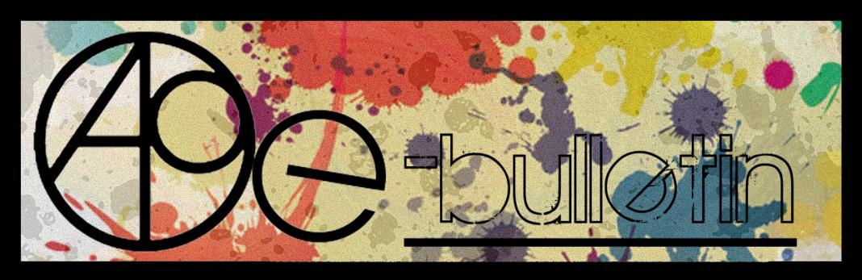

**Kilkenny County Council Arts Office E-bulletin 1st May 2015**

Dear All,   
  
Welcome to the fortnightly e-bulletin from Kilkenny County Council's Arts Office. Each bulletin is packed with the latest information on Kilkenny Arts Office activities, county events as well as news and opportunities for arts practitioners from around the country.

This service will be provided fortnightly. To include an item in the next e-bulletin please send a brief outline of your advert with relevant contact details, including any websites or pages with links to [**niamh.brophy@kilkennycoco.ie**](mailto:niamh.brophy@kilkennycoco.ie) **before 13th May**. The next e-bulletin will be on the **15th May.**

While every effort has been made to ensure the accuracy of our information, we strongly advise readers to verify all details to their own satisfaction.

Regards,

Niamh Brophy  
Arts Office,  
T: 056 7794138  
E: [niamh.brophy@kilkennycoco.ie](mailto:niamh.brophy@kilkennycoco.ie)   
W: [www.kilkennycoco.ie/eng/Services/Arts/](http://www.kilkennycoco.ie/eng/Services/Arts/)

BECOME PART OF IT, SUBMIT A POEM.....[www.rhymerag.net](http://kk-moss/Sites/arts_office/Shared%20Documents/Julianne%20Morgan/E-bulletin/30th%20May%20e-bulletin/www.rhymerag.net)  
Kilkenny County Council Arts Office Partner Local Authority of the ArtLinks Programme [www.artlinks.ie](http://www.artlinks.ie)

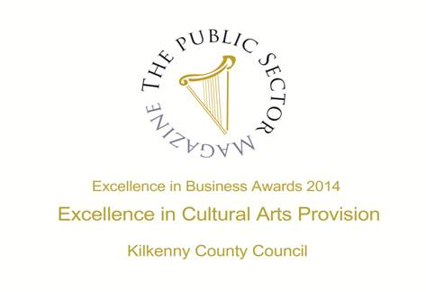

|  |  |
| --- | --- |
|  |  |
|  |  |

**Arts Office**

* Stunning poetry and illustration at the launch of Rhyme Rag
* FINAL REMINDER – DEADLINE TUESDAY 5TH MAY Kilkenny Poetry Broadsheet 2015: Call for Submissions

**Kilkenny Events**

* **Home: Evening Event of Nimble Spaces**
* **Lucinda Sly**
* **Discover the Clown Within**
* **Gypsy Ray Photograph’s at the Butler Gallery**
* **Kilkenny Choir Event**
* **National Craft Gallery - Crafternoon Tea**
* **National Craft Gallery – National Drawing Day**
* **National Craft Gallery – Appetite for Design**
* **Upcoming Art Classes at Blackwatch Studio, Co. Kilkenny**
* Classes Spring 2013 - Blackstack Studio, 42 Parliament St., Kilkenny
* **YIFM Summer Camps 2015**
* Joe Hill Songwriting Competition - Thomastown
* Grennan Mill Craft School - Summer Courses 2015
* Butler Gallery Education Panel: Call for Artists
* **Kilkenny County Council Community and Cultural Facilities Capital Funding**
* KCAT Icon Painting
* Kilkenny Leader Partnership
* **Dance and Movement Improve Workshop at KCAT**
* Poets on Board at City Library, John’s Quay
* Ré - Tunes in the Church, Black Abbey
* Kilkenny Roots Festival May 2015
* Coming Soon to the Watergate Theatre
* KOZO Workshop Programme 2015

**Courses / Training / Jobs / Internships**

* NYCI Youth Arts programme is pleased to announce the details of our Summer School programme 2015
* **Irish Writers Centre seeks General Manager**

**Call for Submissions / Residencies**

* Bursary for documentation of an arts and health project
* **Living Arts Project - Arts in Education**
* Film Artist in Residence
* Top Mag, For Teens by Teens
* **Artists' Books Stall at Get Together 2015**
* Midlands Feis Ceoil to Hit all the Right Notes with Ireland’s Finest Young Musicians
* **Open Call: AN POST Public Art Commissions**
* **RDS National Craft Awards 2015: Call for Entries**
* **Light Work Artist-in-Residence Program**

**Awards / Bursaries / Schemes**

* **2014/2015 Dates and Deadlines for Culture Ireland Grant Rounds**
* Arts and Disability Connect
* **Arts Council’s Artist in the Community Scheme – Deadlines 2015**

**Of Interest**

* The Bird Song Project

**Arts Office**

**Stunning poetry and illustration at the launch of Rhyme Rag**

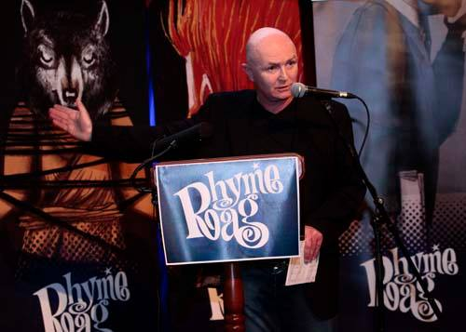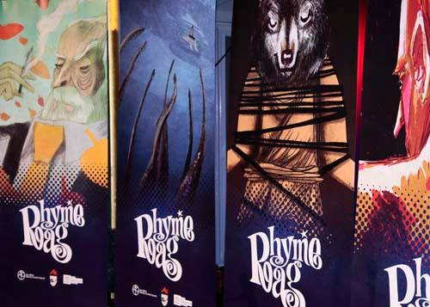

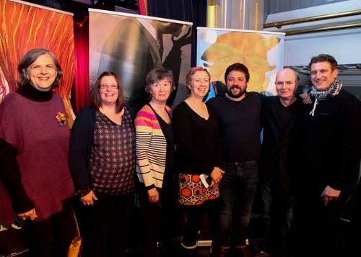 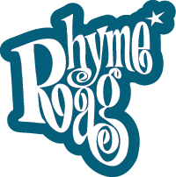

On Tuesday 28th April the Set Theatre was a haven of new poetry from Kilkenny young writers at the launch of ***Rhyme Rag*** ([www.rhymerag.net](http://www.rhymerag.net)), an online online illustrated poetry journalfor young Kilkenny writers aged 12-21.

So how does it work? Young people are asked to submit poems online at [www.rhymerag.net](http://www.rhymerag.net); resident editor, poet John W. Sexton, reads all the poems and gives personal feedback on all work submitted selecting two poems per month, which are then professionally illustrated and published on the website by illustrator and designer Ale Mercado. In addition, the *Kilkenny People* features a poem from the website every week.

Arts Officer Mary Butler comments ‘Tuesday’s launch was a great opportunity to celebrate and showcase great poetry from our young writers and allow for a community to come together, to start connecting with each other and to get a sense of themselves as part of a creative community and for all to be inspired.’

A stunning backdrop of Ale Mercado’s illustrated works complimented the fifteen young Kilkenny poets who took to the stage to read their work and included Orla McGovern, Fabian Gaspari, Melanie Byrne, Anna Eileen Doyle, Jack Larkin, Ciara Delaney, Luke O’Dwyer, Maeve Moran, Aine O’Neill, Liam Wallace, Tarla Murphy, Aoife Hughes, Alan Mooney, Laura Nash and Matt Burke.

Siobhán Parkinson, Ireland’s first Children’s’ Laureate, launched the event with a speech about how a poem is a dynamic force that holds the energy of the writer. ‘Whatever it is that drives a poem — an insight,  a thought, an image, an emotion, a sound — the poet’s task is to find a form of words that can hold that energy in tension. The verbal structure we call a poem holds its energy so that the reader can also experience that energy; in the same way, Rhyme Rag holds the energy of all these young poets’ poetry, and that energy leaps out of this beautiful website at the reader. ‘

St. Kieran’s College English teacher Larry Cotter talked about poetry in the classroom and about his collaboration on the new *Rhyme Rag* Teachers’ Information Pack, which was made available to teachers at the launch and can be obtained on request from the Kilkenny Arts Office. He says ‘*Rhyme Rag* is a great help to any teacher trying to encourage students to write. Only poems of the highest quality appear and this high standard promotes a real sense of achievement among the students whose work is chosen. It is also an invaluable resource in the classroom. To have local young voices appear in print and on the web in such an attractive publication is a great creative stimulant. I encourage all teachers of English to use the resource pack to get their students writing their own poems. When the students are happy with their work send it in. Who knows maybe they will be next to appear online or in the pages of the Kilkenny People?’

To round off the event, performance poet Stephen Murray, who ran a marathon of poetry workshops in schools that day, gave an exciting reading of his own work that left everyone asking for more.

**Those attending commented: *‘***I actually haven't stopped telling people about my experience at your recent Rhyme Rag Launch. It made a powerful impact on me. The contemporary and professional level of the setting, presentation and speeches afforded the respect and dignity the teens deserved and I believe this kind of  support for young adults is crucial as they make the transition into adult hood.’ (Alice Bennett);

‘What a fantastic event yesterday, congratulations to all involved particularly the young poets. Amazing talent and courage displayed in getting up there in front of a crowd and reciting their work.’ (Trish, Lifeline Kilkenny);

*‘*The launch was fantastic, everyone was very friendly and nice, John W. Sexton was so great in aiding us all to read our poems. Reading my poem out was great life experience and to make people aware of it. My brother and I had a great time and I am grateful for being published and for the invite.’ (Fabian Gaspari, published poet)

***Rhyme Rag*** is initiated and produced by Kilkenny County Councils Arts Office. It is complemented by poetry workshops and school residencies. These projects are further supported by Poetry Ireland, Kilkenny Library Service and the Arts Council of Ireland.

**BECOME PART OF IT, SUBMIT A POEM** [**www.rhymerag.net**](http://www.rhymerag.net)

**FINAL REMINDER - Call for Submissions: Kilkenny Poetry Broadsheet Issue 15**

Kilkenny County Council Arts Office is delighted to announce a call for submissions for the publication of the fifteenth issue of the very popular **Kilkenny Poetry Broadsheet**. The aim of the publication is to give local writers a platform for their work. Each poem selected is included in the broadsheet which is available free throughout the County. One hundred and ninety two poems were submitted for consideration by seventy seven poets with thirteen poems by thirteen poets selected by Editor Enda Coyle-Greene in 2014 with the publication launched as part of the Kilkenny Arts Festival by American poet Billy Collins.

This fifteenth issue of Kilkenny Poetry Broadsheet will be edited by **Tony Curtis**.

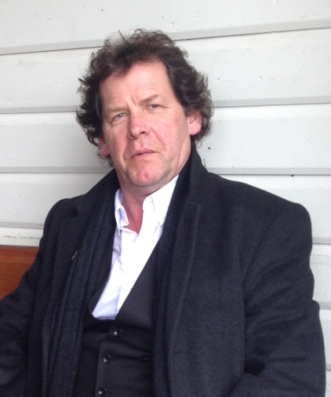 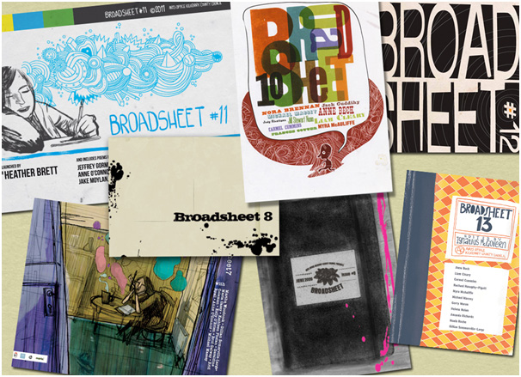 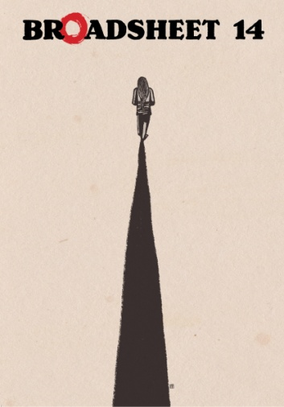

**Tony Curtis** was born in Dublin in 1955. An award-winning poet, Curtis has published nine warmly received collections. His most recent collections are: 'Pony' (with paintings and drawing by David Lilburn, Occasional Press 2013); 'Currach' (with photographs by Liam Blake, 2013); 'Folk' (Arc Publications 2011). His children's book 'An Elephant Called Rex and a Dog Called Dumbo' (with illustrations by Pat Mooney) was published in 2011. A new collection 'Approximately in the Key of C' is forthcoming from Arc Publications. Curtis has been awarded the Varuna House exchange Fellowship to Australia, The Irish National Poetry Prize, and has read his poetry all over the world to great acclaim. He is a member of Aosdana.

We are now accepting submissions from poets born or based in Kilkenny City and County.

**Closing date for receipt of submissions is no later than 4pm on Tuesday 5th May.**

Application forms and submission rules are available from the Arts Office, John’s Green house, John’s Green, Kilkenny. T: 056 7794138 E: [niamh.brophy@kilkennycoco.ie](mailto:niamh.brophy@kilkennycoco.ie)

Or can be downloaded from: <http://www.kilkennycoco.ie/eng/Services/Arts/News/Call-for-Submissions-Kilkenny-Poetry-Broadsheet-Issue-15.html>

No electronic submissions accepted.

**Kilkenny Events**

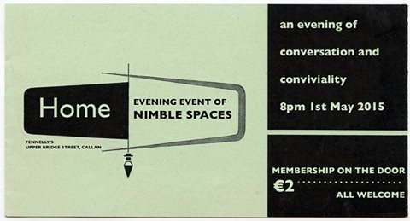

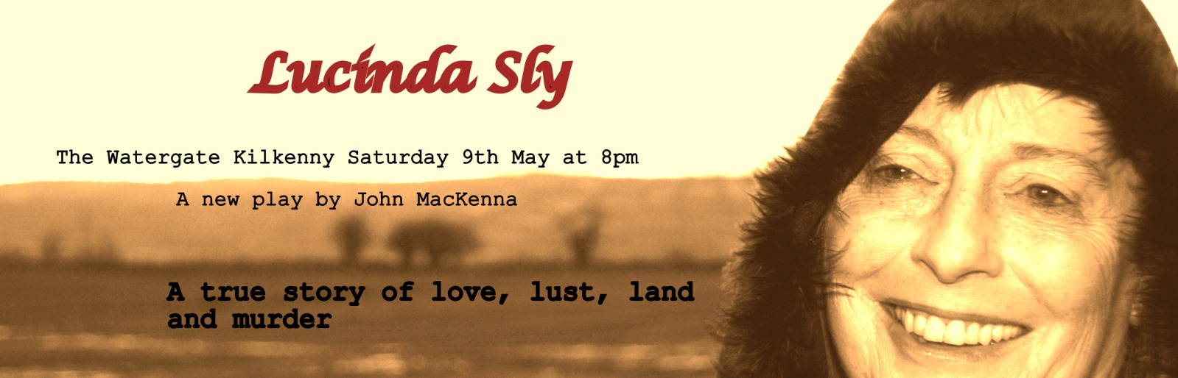

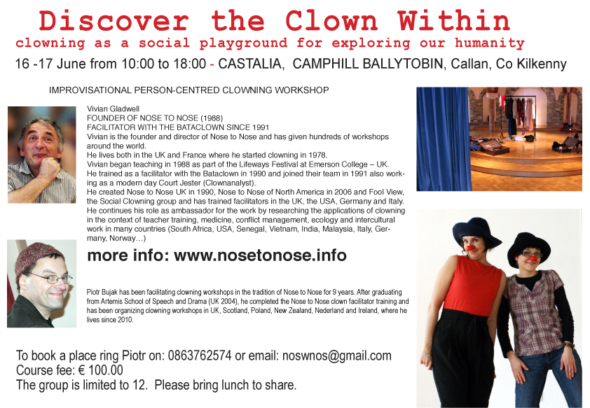

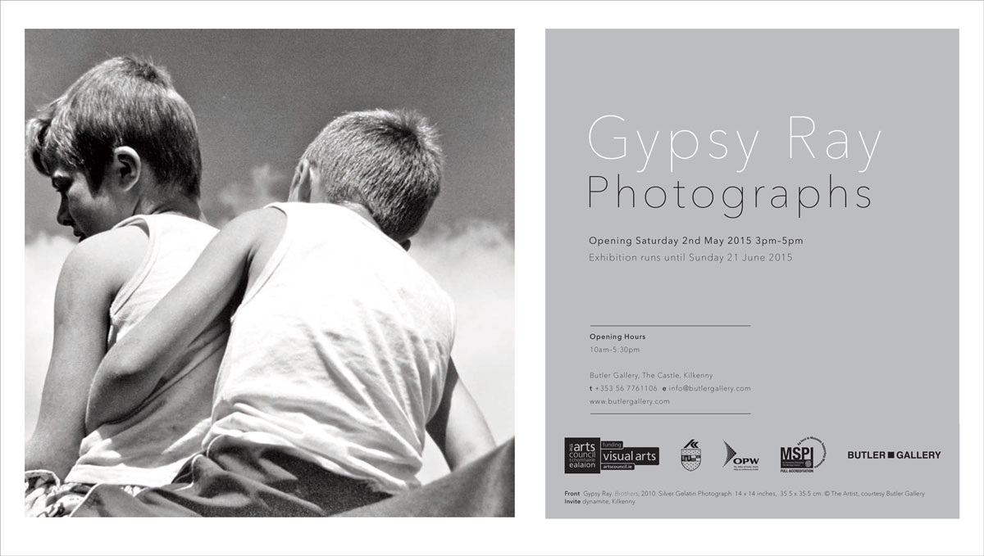

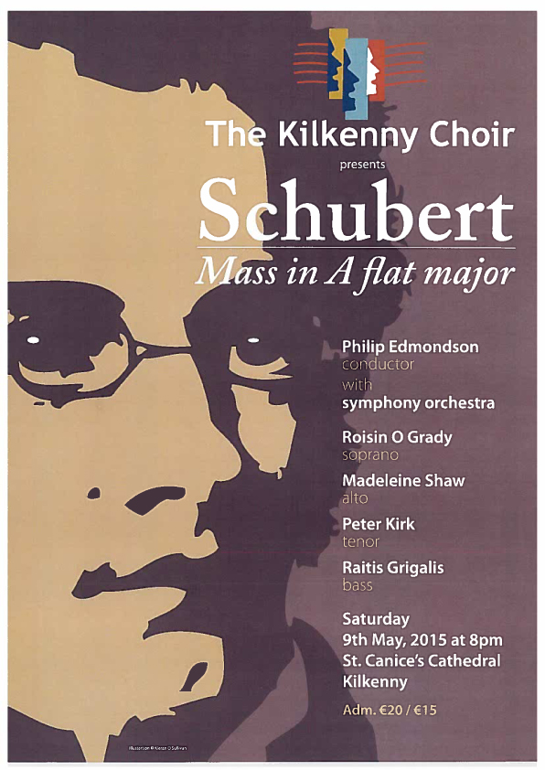

|  |
| --- |
| http://i2.cmail2.com/ti/y/C0/837/BB6/043645/images/ncg_logo.111537.gif |
|  |
| |  |  |  |  |  |  |  | | --- | --- | --- | --- | --- | --- | --- | |  | |  | | --- | |  | |  |  |  | | --- | |  | | **'Crafternoon Tea' at NCG, 22nd May**  We invite you to join us at the National Craft Gallery for 'Crafternoon Tea' and an informal tour of our exhibitions on Friday 22nd May at 1pm.  The talk and tour will explore the exhibition Appetite for Design an exhibition featuring the work of leading Irish designers, architects, cooks and restaurateurs which will document, discuss and speculate about the design of food and our experience of it.  FREE EVENT  For more details contact  events@nationalcraftgallery.ie or phone 056 7796151 | |  | |

[www.nationalcraftgallery.ie](http://nationalcraftgallery.cmail2.com/t/y-l-iunhdd-jtddlybih-yh/)



National Drawing Day   
  
Sat May 16, 12noon – 4pm  
FREE EVENT, Fun drawing workshops & activities for all ages  
  
The National Craft Gallery have programmed an afternoon of drawing activities with a craft and design twist. Families are invited to investigate, explore and discover new ways of seeing with our fun range of experimental drawing workshops and activities.  
  
GIANT FIBRE PORTRAITS with textile artist Caroline Schofield  
  
Transform the Castle Yard into a magical large-scale drawing with Caroline Schofield using the grass as a giant canvas. Strike a pose on the grass while the shape of your body is mapped using brightly colored yarns. Watch the map grow bigger and brighter through out the day. How about a unique family fiber portrait!  
  
YUMMY PRINTS with textile print-maker Caroline Ryan  
  
Inspired by our exhibition Appetite for Design textile print-maker Caroline Ryan of PRINTBLOCK Collective will explore all things foodie through silk-screen printing. Explore line, colour, design and cook up a colourful textile print on the day to take home. Suitable for all the family.



[**APPETITE FOR DESIGN**](http://www.nationalcraftgallery.ie/exhibitions)

**8 MAY 2015 – 30 JUNE 2015**

[Appetite for Design](http://www.nationalcraftgallery.ie/exhibitions) features the work of leading Irish and international designers, cooks and restaurateurs, documenting, discussing and speculating about the design of food and our experience of it.   Food is no longer merely about the simple act of eating, and the pure experience of smell and taste. New trends and materials have led to unique opportunities for the designers of today to enhance and elevate one's culinary experience by speaking to our minds as well as our stomachs. Engaging all our senses in a holistic culinary experience.

[Appetite for Design](http://www.nationalcraftgallery.ie/exhibitions) showcases examples of the aesthetics, promotion, communication and representation of food, along with the equipment and tools used to prepare and consume food. Featured work includes Bompas & Parr, Marije Vogelzang, Omer Polek, The Decorators, Chapter One and Loam.

A series of culinary evenings and performances to accompany the exhibition will hosted by [Godless Domestic](http://www.thedomesticgodless.com/), [Dublin Pop-up,](https://www.facebook.com/dublinpopup) [Culinary Counter](https://www.facebook.com/theculinarycounter) and Barry Fitzgerald.

The exhibition is curated by [Designgoat](http://wearedesigngoat.com/) and explores the very best of Food Design and builds on the increasing global recognition of outstanding Irish produce from coast to coast, and seabed to soil.

**APPETITE FOR DESIGN Eating Experiences**

[Eating Experience Programme](http://www.nationalcraftgallery.ie/news/article/eating-experience-programme)

As part of Appetite for Design exhibition curators, Designgoat, invite chefs, food designers and artists to create a series of Eating Experiences, presented in the National Craft Gallery. Each individual Eating Experience will be a totally different culinary encounter; showcasing seasonal, wonderful and bizarre foods.

[Eating Experience 1 with Barry Fitzgerald](http://www.nationalcraftgallery.ie/news/article/eating-experience-programme) Sat 9 May, 6.30pm

Former Head Chef of Etto, Dublin and of Michelin-starred the Hardwood Arms, London; Barry’s style of food is seasonal, creative, uncomplicated and approachable.

[Eating Experience 2 with Godless Domestic](http://www.nationalcraftgallery.ie/news/article/eating-experience-programme) Sat 23 May, 6.30pm

The Domestic Godless, explore the potential of food, through its taste, its presentation, its history and its cultural values, as a vehicle for irreverent artistic endeavour and experimentation.

[Eating Experience 3 with Culinary Counter](http://www.nationalcraftgallery.ie/news/article/eating-experience-programme) - Sat 6 June, 6.30pm.

The Culinary Counter, run by chefs Mark Moriarty and Ciaran Sweeney, aims to break down barriers between the kitchen and the customer. An exciting theatrical tasting menu will be served from these young brilliant chefs.

[Eating Experience 4 with Dublin Pop-Up](http://www.nationalcraftgallery.ie/news/article/eating-experience-programme) - Sat 20  June, 6.30pm.

Cúán Greene and Harry Colley of Dublin Pop Up offer innovative and extraordinary fine dining catering experiences, which play with traditional dining formats through dramatic food and unique locations.

**Booking for the Eating Experience series is through** [**eventbrite.com**](http://www.eventbrite.com/e/appetite-for-design-eating-experience-1-tickets-16675895051?aff=es2)**, which will be open from Monday 27th April. Limited places available. Unfortunately, special dietary requirements cannot be accommodated.**

**Exhibition Curator’s Talk & Launch**

Fri 8 May, 6.30pm

Designers Ahmed Fakhry and Cian Corcoran in conversation, followed by the exhibition Launch.

[**Family Day: National Drawing Day**](http://www.nationalcraftgallery.ie/news/article/national-drawing-day)

Sat 16 May, 12noon – 4pm

Drop-in drawing workshops and activities for all ages with a craft and design twist.

More info [here](http://www.nationalcraftgallery.ie/news/article/national-drawing-day)

Families are invited to investigate, explore and discover new ways of seeing with our fun range of experimental drawing workshops and activities inspired by our current exhibition [Appetite for Design.](http://www.nationalcraftgallery.ie/) Take part in one of our free craft and design-based workshops, **Yummy Prints**, **Giant Fibre Portraits** and **The Drawing Banquet** with plenty more self guided activities for all ages to enjoy.

**YUMMY PRINTS** *with textile print-maker Caroline Ryan*

Inspired by our exhibition Appetite for Design textile print-maker Caroline Ryan of [PRINTBLOCK](http://printblock.ie/) Collective will explore all things foodie through silk-screen printing. Explore line, colour, design and cook up a colourful textile print on the day to take home. Suitable for all the family

**GIANT FIBRE PORTRAITS** *with textile artist Caroline Schofield*

Transform the Castle Yard into a magical large-scale drawing with Caroline Schofield using the grass as a giant canvas. Strike a pose on the grass while the shape of your body is mapped using brightly colored yarns. Watch the map grow bigger and brighter through out the day. How about a unique family fiber portrait!

**DRAWING BANQUET** *with artist Mella Cahill*

Let the tablecloth be your canvas and the food your drawing tools at this dinner party like no other. Artist Mella Cahill will lead this imaginative drawing workshop inspired by the dinner table, suitable for all the family.

**All Drop –in, Ideal family activities. No booking required**

<http://www.nationalcraftgallery.ie/news/article/national-drawing-day>

[**Late Date: Packaging Design For Food**](http://www.nationalcraftgallery.ie/news/article/late-date-packaging-design-for-food)

Thurs 21May, 6.30pm

Kathryn Wilson of [Slater Design](http://www.slaterdesign.com), Karen and Natalie Keane *of* [Bean and Goose Chocolate](http://wearedesigngoat.com/?ds-gallery=bean-and-goose) with Sarah and Eleanor Duggan of[The Little Green Grocer](https://afternoon-dlite.squarespace.com/afternoon-dlite/2014/04/10/the-little-green-grocer%20-%20https://afternoon-dlite.squarespace.com/afternoon-dlite/2014/04/10/the-little-green-grocer)*,* talk inventive packaging design - the vital ingredient.

[**Bealtaine Festival: Crafternoon Tea**](http://www.nationalcraftgallery.ie/news/article/bealtaine-festival-crafternoon-tea)Fri 22 May, 1pm

A social afternoon to celebrate creativity as we age, join us for a food design talk, tour and afternoon tea.

[**Family Day: Mad Hatter’s Tea Party**](http://www.nationalcraftgallery.ie/exhibitions)

Sat 13 June 10.30am & 12noon

Children are invited to a Mad Hatter’s tea party were creativity and food will collide to create a magical eating experience.

[**Late Date: Public Spaces & Food**](http://www.nationalcraftgallery.ie/exhibitions)

Thurs 25 June, 6.30pm

Suzanne O’Connell of [The Decorators](http://the-decorators.net/About) and John Mahon of [The Locals](http://www.thelocals.ie/about), talk eating spaces.

[**Schools**](http://www.nationalcraftgallery.ie/learn/schools)

Tuesday – Friday, 10am & 12noon

Food Design focused tour and activities for Primary School students.

**WEEKENDS: DISCOVER & DESIGN**

Visitors of all ages can design, draw, build, and create with self-guided activities at the weekend. Drop in and get creative.

**Eating Experience tickets are available through eventbrite.com**

**To book our other events please contact us at 056 7796151 or email** [**events@nationalcraftgallery.ie**](http://kk-moss/Sites/arts_office/Shared%20Documents/Internal/Niamh/2015%20projects/E-bulletin/Downloads/events@nationalcraftgallery.ie)

**[nationalcraftgallery.ie](http://www.nationalcraftgallery.ie)**

[**facebook.com/NationalCraftGallery**](https://www.facebook.com/NationalCraftGallery)

[twitter.com/NCGKilkenny](http://kk-moss/Sites/arts_office/Shared%20Documents/Internal/Niamh/2015%20projects/E-bulletin/Downloads/twitter.com/NCGKilkenny)

[**Ormonde College Of Further Education End Of year Show 2015**](https://www.facebook.com/events/103607223304748/?ref=1&feed_story_type=17)

[8 May](https://www.facebook.com/events/calendar/2015/May/8) at 18:00–19:30, [Ormonde College of Further Education,](https://www.facebook.com/pages/Ormonde-College-of-Further-Education-Kilkenny/135431993193649) Ormonde Road, Kilkenny

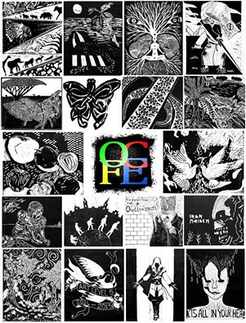

The OCFE would like to invite you to their annual End Of Year Show which will take place in the Ormonde College as well as the old Presbyterian church next door which only this year has been converted into a studio for Fine Art advanced Certificate students.  
  
In this show, there will be a range of works on display by students from the media studies, Fine Art Portfolio Preparation and Advanced Certificate in Fine Art courses.  
  
The work will include drawings, paintings, 3D combined media, photography, digital art and media to name but a few.  
  
All are welcome to come and browse around at the work created by the students.  
There will be light refreshments available.

**Upcoming Art Classes at Blackwatch Studio, Co. Kilkenny**

Art classes commencing end of June at Blackwatch Studio, Frenyestown, Johnswell, Co. KIlkenny.

For further information contact Alice Bennett 086 396 9290 or email [blackwatchstudiokk@gmail.com](mailto:blackwatchstudiokk@gmail.com)

**Classes Spring 2013 - Blackstack Studio, 42 Parliament St., Kilkenny**

Bookings can be made on the website [www.blackstackstudio.com](http://www.blackstackstudio.com/),  or by emailing [sylvia@blackstackstudio.com](mailto:sylvia@blackstackstudio.com)

If you have a group of 3 or 4 people we can also arrange a special workshop to suit you - email Sylvia at the above address.

Screenprinting (Weekend 25th & 26th April or  23rd & 24th May 10am-4pm €160)

This is a beginners or refreshers screenprinting class for visual artists. You will learn how

to make screenprints with photographic or hand drawn imagery. Cleaning and coating the

screen, exposing the image, registration and printing will all be covered.

Bookbinding (Saturday 9th May 10am-4pm €80)

Learn easy bookbinding techniques to make notebooks, sketchbooks and albums. We will look at different binding techniques and their possibilities and then you will be guided through the steps for making three or more of your own books. Materials are included in the above price, but you can also bring any special papers or materials you might like to incorporate into your book.

Experiment with printmaking (Saturday 16th May €75)

This workshop is for beginners or improvers. In this one-day workshop you will be able to explore the basic printmaking techniques of drypoint, etching, chine colle or carborundum or you can further develop plates you already have using these techniques. A second day can be added if enough participants require.

**YIFM Summer Camps 2015**

**YIFM Summer Camps** are for young people to come and learn all about film making, teamwork, creativity, problem solving and a whole lot more. Young people will be guided through interactive workshops in all aspects of film making. From writing the script to shooting the movie and creating their own director’s cut. At the end of this fun filled week they will attend their very own **movie premiere**where they can bring along their family and friends. They will each receive a copy of their short films on DVD.

**DATES                                                            PRICES**

June 29th – July 3rd                                       €150 per child.                                        July 27th – 31st                                             €10 discount for each additional sibling.

**August 17th – 21st**

For Further Information, please visit our website [www.yifm.com](http://www.yifm.com/)

Or call us on 056 7764677.

**Joe Hill Songwriting Competition - Thomastown**

The George Brown Memorial Committee is pleased to announce their first ever songwriting competition. 2015 marks the 100th anniversary of the execution of Joe Hill in Utah, USA. Joe was a workers activist and member of the Industrial Workers of the World. His execution was controversial and is considered to be a miscarriage of justice resulting from his trade union activities.

Joe Hill will be a central theme of the 2015 George Brown Commemoration, with a key-note speech on his story and subsequent influence on the worker’s movement. We are also offering a prize of €150 for the best submission in our songwriting competition, where we are asking for words to two new verses for the song Joe Hill. These verses should deal with the difficulties experienced by workers since 1915 and/or the advances achieved over the subsequent century. They should follow the standard format of the other verses and fit to the usual tune for the song. If you are not familiar with the song you can find a version by Luke Kelly on Youtube at:

<https://www.youtube.com/watch?v=Q2OivplOBq8>

The closing date for the competition is midnight Monday 1st June 2015. Submissions should be made to the George Brown E-mail address:

[georgebrown.inistioge@gmail.com](mailto:georgebrown.inistioge@gmail.com)

or to Joe Doyle, George Brown Memorial Committee, Thomastown, County Kilkenny

I dreamed I saw Joe Hill last night  
Alive as you and me  
Says I, "But Joe, you're ten years dead"  
"I never died", says he  
"I never died", says he.

In Salt Lake, Joe, says I  
Him standing by my side  
"They framed you on a murder charge"  
Says Joe, "I never died"  
Says Joe, "I never died."

The copper bosses they shot you, Joe,  
They filled you full of lead  
"Takes more than guns to kill a man"  
Says Joe, "And I ain't dead"  
Says Joe, "And I ain't dead."

And standing there as big as life  
And smiling with his eyes  
Says Joe, "What they forgot to kill"  
"Went on to organize"  
"Went on to organize."

Joe Hill ain't dead, he says to me  
Joe Hill ain't never died  
Where working man are out on strike  
Joe Hill is at their side  
Joe Hill is at their side.

In San Diego up to Maine  
In every mine and mill  
Where working men defend their rights  
It's there you'll find Joe Hill  
It's there you'll find Joe Hill.

I dreamed I saw Joe Hill last night  
Alive as you and me  
Says I, But Joe, you're ten years dead  
I never died, says he  
I never died, says he.

**Grennan Mill Craft School - Summer Courses 2015**

• Metalcraft & Jewellery for Beginners & Improvers  
**Thursday 4th June - Sunday 7th June** / 10am-5pm   
4 day course exploring many techniques in Metalsmithing & Jewellery-making including enamelling, soldering, forming, surface decoration & more...   
Minimum 6 – Maximum 8 persons  
Course Fee €260  
Materials Fee €15 - includes copper & gilding metal, enamels, solders & sundries.

• Silver Jewellery for Beginners & Improvers  
**Friday 12th June - Sunday 14th June** / 10am-5pm   
3 day course exploring many techniques in Silver Jewellery making  
Minimum 6 – Maximum 9 persons  
Course Fee €200  
Materials Fee €20 (includes 8 grams of silver)

***For more details please text / phone Metalcraft Tutor Eva Lynch on 087 6210830 or email at [evylynch@hotmail.com](mailto:evylynch@hotmail.com) ***

Place will only be secured once deposit of 50% or full payment has been received. Full course fee required by: Friday 29th May for ALL courses  
• Cheques made payable to ‘’Grennan College’  
• Class formation is dependent on an adequate number of applicants – minimum 6 persons for each individual course irrespective of craft  
• Should Grennan Mill cancel the course, your monies will be refunded in full

**Butler Gallery Education Panel: Call for Artists**

Butler Gallery is currently recruiting professional visual artists for its Arts Education Panel. We seek expressions of interest from experienced and enthusiastic artists, who have an interest in arts education practice and a passion for enabling engagement with programmed exhibitions and facilitating arts experiences in a gallery context.

Artists will carry out response workshops, courses and one-off activities on **a free-lance basis** in Butler Gallery, Kilkenny Castle and a range of outreach venues throughout Kilkenny. Artists must be available for seasonal (paid) meetings and training opportunities with other panel members. Applications will be accepted from artists based in any county, but please note, we do not offer a travel allowance.

Applications will be accepted by post or email until **Monday 11 May at 12pm**.

Please include the following:

* Curriculum Vitae with relevant experience clearly outlined
* Examples of current practice – max 10 images.
* A completed Artist Panel Information Form. (available to download from 7 April on www.butlergallery.com)
* An expression of interest (one A4 page) that demonstrates:
* How this opportunity relates to your practice
* An understanding and interest in this model of working
* Commitment to being involved in contributing to training opportunities and skills sharing with fellow panel members

**Guidelines**:

• Shortlisted applicants will be called to interview in early June 2015.

• Applications received after 12 noon on Monday 11 May will not be deemed eligible.

• The successful candidates will be required to complete Garda Vetting and Child Protection Training.

**Please send applications clearly marked EDUCATION PANEL to:**

**Bairbre-Ann Harkin, Education Curator, Butler Gallery, Kilkenny Castle, Kilkenny**

**or**

**bairbre.ann@butlergallery.com**

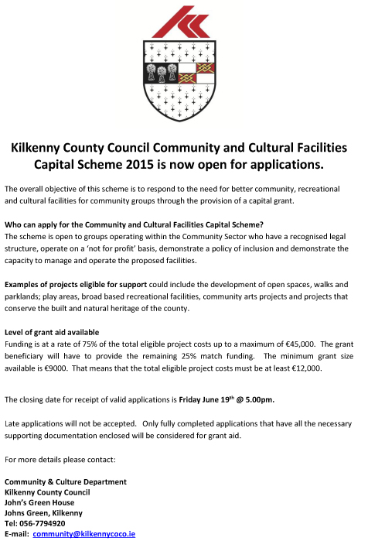

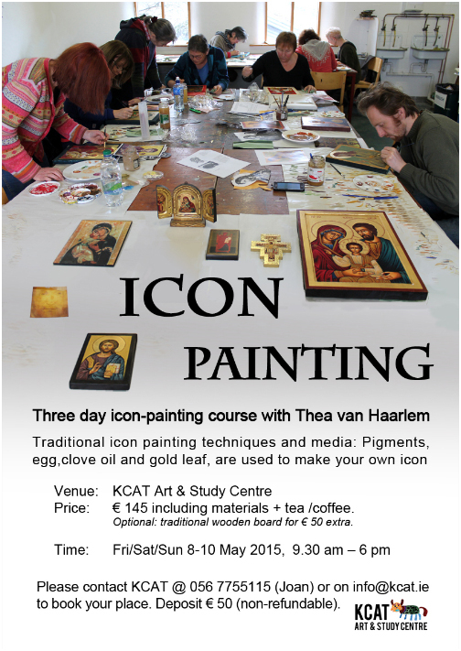

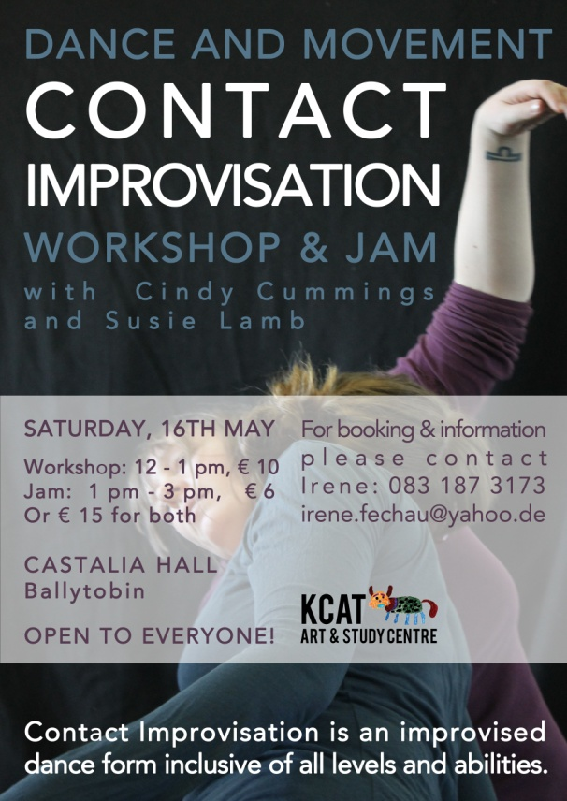

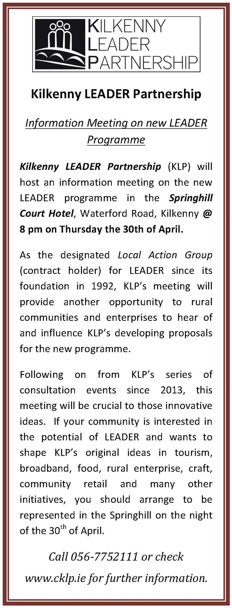

**Poets on Board at City Library, John’s Quay**

Submissions for **May** are now being accepted.

Closing date: **8th May**

Please email poems to: [citylibrary@kilkennylibrary.ie](mailto:citylibrary@kilkennylibrary.ie)

Rules:

* One well-crafted poem per month can be submitted
* Five poems overall will be selected and will be displayed for the month
* One poem will be selected every 3 months and its author will receive a book voucher prize!
* Phone 056 779 4174 for further information

Congratulations to the winner of our first book voucher prize of the year, Gillian Somerville-Large!

Gillian’s poem, *Snowdrops*, is on our blog. You can read it here: <http://kilkennylibrary.kilkenny.ie/Blog/?p=387>

Thank you for submitting poems for April. Here is list of poems on display this month. If your poem is not up this month, it may be displayed at a later stage instead.

**Poets on Board – April**

**After Diagnosis – Mary O’Shea**

**Bluebell – Nora Brennan**

**Love is - Kevin Connelly**

**South-Facing Softness – Mia King**

**Threadbare – Sé Nicholson**

Please send your entries for May to us by 8th May. There will be another book voucher at the end of June for one of the poets whose work was displayed from April to June.

**Ré - Tunes in the Church, Black Abbey**

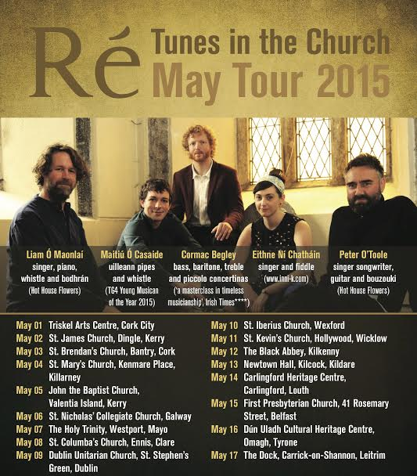

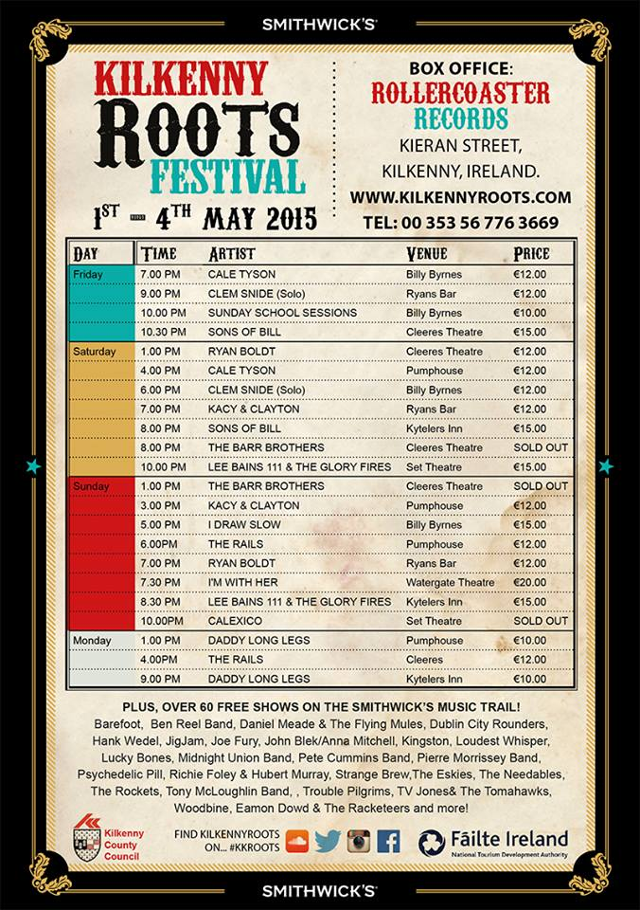

## Coming Soon to the Watergate Theatre



[I'm With Her - Sara Watkins, Sarah Jarosz & Aoife O'Donovan](http://watergatetheatre.com/programme/im-sara-watkins-sarah-jarosz-aoife-odonovan/)  
Sun 3rd May 2015  
Tickets: € 20

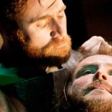

[The Assassination of Brian Boru](http://watergatetheatre.com/programme/the-assassination-of-brian-boru/)  
Wed 6th May 2015  
Tickets: € 14/12



[Cream Of Kilkenny Cats Jazz Spectacular](http://watergatetheatre.com/programme/cream-of-kilkenny-cats-jazz-spectacular/)  
Fri 8th May 2015  
Tickets: € 10

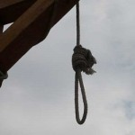

[Lucinda Sly](http://watergatetheatre.com/programme/lucinda-sly/)  
Sat 9th May 2015  
Tickets: € 14/12

<http://watergatetheatre.com/>

|  |
| --- |
|  |

**KOZO Workshop Programme 2015**

**KOZO Studio WORKSHOP Programme  
for adults (incl. young people from 16 years)**

**APRIL - JUNE 2015**

The **WORKSHOP PROGRAMME** at KOZO Studio continues this SPRING with extra dates added for PAPERMAKING Courses – all designed and run for small groups of participants at KOZO Studio in The Estate Yard, Castlecomer Discovery Park, Co. Kilkenny.

We scheduled workshops for **complete beginners** as well as **returning participants** and those of you with **previous experience** or your own creative practices.

**Tutor:** Tunde Toth – Visual Arts Practitioner, Arts Educator, Papermaker

Read on to check out our **inspiring choice of workshops:**

#### EMBROIDERY WORKSHOP for BEGINNERS with Alexis Bernstorff - Textile Artist and Textile Restoration expert from the ROS TAPESTRY 23 MAY (Saturday) 11am - 5pm

This workshop will teach 6 principal stitches and their variations - using wool, cotton/silk and metallic threads. Participants will be inspired by a range of techniques to realise simple designs.  
  
Alexis has 15 years experience teaching crewelwork embroidery and is the guide behind the dynamics of the Ros Tapestry. There will be designs from the Ros Tapestry available to purchase on request.  
€ 70 for the full day - including all materials 

#### Advanced Level EMBROIDERY WORKSHOP with Alexis Bernstorff - from the ROS TAPESTRY 20 JUNE (Saturday) 11am - 5pm

This is a follow-on, advanced level course, offering comprehensive tools to realise a variety of designs and artworks.  
It will refresh participants on basic stitches (if necessary) and teach four more stitches using wool, cotton/silk and metallic threads and other materials such as wire and unspun wool and silk.  
The workshop will focus on Form, Volume and Effects and each stitch will be explored under these headings. Stitch direction, padding and consideration of the fall of light will allow participants to expand on the potential of embroidery as a creative, artistic medium.  
€ 70 for the full day - including all materials

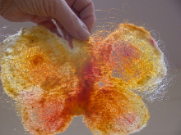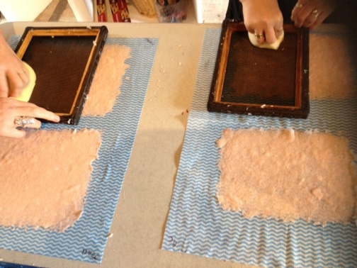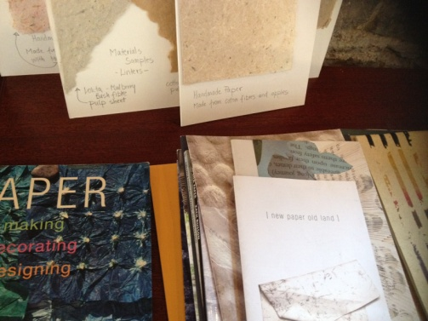

**********  
**10 May (Sunday): FELT MAKING (Wet Felting)**- Beginners -  
11am - 5.30pm  
A full day workshop introducing wet felting processes using dyed and un-dyed merino wool with pure silk fibres and threads incorporated for details and added texture. Design and create your own unique bag or scarf or wall piece!  
Fee: € 70 for the full day, including all materials  
  
**********  
**17 May (Sunday): PAPER MAKING  DAY**- Beginners and participants with some previous experience  
For details see PAPER MAKING DAY programme above (19 April)  
   
**********  
**7 June (Sunday): PAPER ART and HAND PAPER MAKING**  
FOLLOW-ON, ADVANCED LEVEL COURSE - only for participants with previous experience.  
10.30am - 5.30pm  
  
Designed for participants who already work with paper/fibre based processes, this course offers assistance and guidance in areas of three dimensional, sculptural and installation based works, experimental processes of batik, paper dyeing and texturing. It also covers ideas for the preparation and use of plant based pulps (without added chemicals). Participants are encouraged to bring their own ideas and questions into the workshop and invited to show and discuss previous works and projects. The day also includes a short slideshow presentation on examples of contemporary paper art and paper making.  
Places are limited for 5 participants.  
€ 80 for the full day, including all materials  
  
**********  
**14 June (Sunday): BATIK Workshop**- Beginners  
A full day programme introducing an ancient technique of fabric dyeing where hot wax is used as a resist.  
Participants will learn all necessary basic techniques - and complete three small/medium batik pieces with up to 4 colours on cotton fabric and/or paper.  
€ 70 for the full day, including all materials  
  
  
GIFT VOUCHERS are available for the workshop of your choice!  
   
BOOKINGS are confirmed with € 30 deposit paid in advance.*  
Courses are run for small groups of participants only so please call to book early.  
With any questions, for advice or check availability and for all BOOKINGS please contact TUNDE directly:  
  
**Tunde Toth - Artist**  
**087-2543362**  
[tundetune@gmail.com](mailto:tundetune@gmail.com)  
[www.tundetoth.com](http://tundetoth.us9.list-manage.com/track/click?u=927a06abce3366093569f0241&id=73399962f2&e=1f1b25985b)  
[www.tundetothpaperart.blogspot.com](http://tundetoth.us9.list-manage1.com/track/click?u=927a06abce3366093569f0241&id=4fd328d620&e=1f1b25985b)

**Courses / Training / Jobs / Internships**

NYCI Youth Arts programme is pleased to announce the details of our Summer School programme 2015

Summer School 2015 is a three day residential youth arts practice training in NUI Galway, running from 10th-12th June 2015 (check in on Tuesday 9th June). The theme this year is Story Making. Summer School is about approaching your work with young people in a fresh way. It is an opportunity to be inspired, use new art forms, break out of your everyday routine, network and get creative!

Summer School is suitable for anyone working with young people in the non-formal education sector who wishes to explore ways of introducing, enhancing and extending youth arts provision for the young people with whom they work. It is aimed both at those looking to improve their art form and delivery techniques or those totally new to youth arts.

You can download the brochure here:

<http://www.youtharts.ie/sites/default/files/NYCI_Summer_School_2015.pdf>

You can download the booking form here:

<http://www.nycitraining.org/yass2015>

The workshops on offer this year are:

**Story Theatre and Ensemble Improvisation** – Annie Ryan of Corn Exchange Theatre will teach improvisation techniques which will allow participants to engage their youth group in story making.

**Discover Your Voice** – Max Hafler will teach hands on techniques to find and understand your voice and to be able to work through voice with a youth group.

**Paper, Story and Space** – Maeve Clancy will give you the know how to create comic books and 3D paper models all in the pursuit of storytelling with your youth group.

For queries contact Niamh at 01-4784122 Niamh@nyci.ie.

*“I would just like to thank you again for such a great experience. It was a wonderful few days and I’m so pleased I got to meet and work with a wide variety of people. I feel so much more confident now with my approach to working with young people.”* ***Participant Summer School 2014***

**Irish Writers Centre seeks General Manager**

Irish Writers Centre,19 Parnell Square North, Dublin, Co. Dublin City

Reporting to and working directly with Director, the General Manager is a core member of the team, responsible for the administrative and financial operations of Ireland’s national literature resource and support organisation for writers.  
Key areas of responsibilities:  
• Organisation of the Centre’s educational programme  
• Coordination of staff and building  
• Financial management of accounting systems  
• Coordination and delivery of the Centre’s administrative processes in dealing with members, writers and the general public.

Key skills and aptitudes required:  
• Minimum 5 years administration experience at an equivalent level of responsibility.  
• A motivated self-starter with strong interest in working in the arts and with an ability to prioritise and deliver concurrent programmes.  
• Be reliable, proactive and highly organized, with a strong aptitude for problem solving and an eye for accuracy and detail.  
• Have outstanding interpersonal and communication skills with the ability to be diplomatic, discreet and confident in dealing with writers, the general public, funders and stakeholders.  
• Have excellent computer skills with a command on MS Office and Google docs/drive. Experience of Abode Photoshop and web content management systems an advantage.  
• Have proven financial experience in managing accounts, preferably with a recognised accounting software package. Experience of PayPal an advantage.

Apply by email only outlining your suitability for the role to director@writerscentre.ie ensuring to put General Manager position in the subject line and with cover letter, CV and supporting documents collated into a single attachment.

Deadline for applications is Thursday May 7th at 5pm with interviews taking place the following week. Late entries will not be considered.

Salary range: €24,000 – 25,500pa

[http://irishwriterscentre.ie/pages/staff-vacancies](http://lists.visualartists.ie/lt.php?c=1331&m=4368&nl=1&s=d3c261c0eeb6b48867f449d29e09414b&lid=108612&l=-http--irishwriterscentre.ie/pages/staff-vacancies)

**Call for Submissions / Residencies**

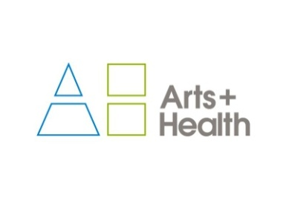

**artsandhealth.ie**

**Bursary for documentation of an arts and health project**

artsandhealth.ie is the national website providing a focal point and resource for the field of [arts and health](http://www.artsandhealth.ie/about/what-is-arts-and-health/) in Ireland. Developed by the Waterford Healing Arts Trust (WHAT) and Create in 2011 with funding from the Arts Council, the site is now managed by WHAT.

artsandhealth.ie invites applications from arts and health practitioners (artists working in healthcare settings, healthcare professionals, arts and health partnerships etc.) for a bursary to produce documentation of an arts and health project. The proposed documentation can take the form of a **short film / audio documentary and / or publication** which can be widely disseminated with a view to encouraging high quality, creative documentation of arts and health practice and creating a greater national understanding of the nature of this practice

Examples of existing documentation of arts and health practice can be found in the Resources section of artsandhealth.ie

**Bursary**

A bursary of €4000 will be made available to the successful applicant for the production of film / audio documentary and / or publication about an arts and health project.

**Eligibility Criteria**

Anyone responsible for delivering/co-delivering an arts and health project in the Republic of Ireland, in keeping with artsandhealth.ie’s definition of arts and health, may apply (see [www.artsandhealth.ie/about/what-is-arts-and-health](http://www.artsandhealth.ie/about/what-is-arts-and-health)).

**Who can not apply?**

Projects managed directly by WHAT or by members of the [Editorial Panel](http://www.artsandhealth.ie/about/about-artsandhealth-ie) of artsandhealth.ie cannot apply.

**Timeframe**

The closing date for the receipt of applications is 29th May. Applicants will be notified of decisions by 19th June 2015. It is expected that the final documentation will be completed and submitted to artsandhealth.ie by 31st March 2016.

**Application Procedure**

Please complete the application form below and submit with:

* CV(s) of artist(s) / arts and health practitioner(s)
* CV(s) of lead documenter(s)
* Up to five captioned photographic images of project and / or examples of previous, relevant work of lead artist(s) / arts and health practitioner(s). Website links are acceptable.
* Examples of previous, relevant work of lead documenter(s). Website links are acceptable.
* Support letter(s) from partner(s)

**Submissions should be sent by email to** [info@artsandhealth.ie](mailto:info@artsandhealth.ie) **by Friday, 29th May at 12 noon.**

For further information, contact [info@artsandhealth.ie](mailto:info@artsandhealth.ie)

|  |  |  |  |  |  |  |  |  |  |
| --- | --- | --- | --- | --- | --- | --- | --- | --- | --- |
| |  |  |  |  |  |  |  |  |  | | --- | --- | --- | --- | --- | --- | --- | --- | --- | | |  |  | | --- | --- | | |  | | --- | | ****Living Arts Project - Arts in Education**** | |  |  |  | | --- | --- | | |  | | --- | |  | |  |  |  |  |  | | --- | --- | --- | --- | | |  |  |  | | --- | --- | --- | | |  | | --- | | https://gallery.mailchimp.com/0ef8f072d15d881da2de05f87/images/65811ee4-bb3d-4d87-a14b-ce9b43128523.png |  |  | | --- | | **CALL FOR VISUAL ARTISTS: Living Arts Project, 2015-16**  The Arts Department of Wexford County Council and Wexford Arts Centre in partnership with the Arts Council are now seeking applications from interested primary schools and visual artists to partake in our annual **Living Arts Project** commencing in October 2015. | | | | |
| |  |  |  |  |  |  |  |  |  |  |  |  |  |  | | --- | --- | --- | --- | --- | --- | --- | --- | --- | --- | --- | --- | --- | --- | | |  |  | | --- | --- | | |  | | --- | | Established in 2013, the Living Arts Project is a long-term visual arts educational scheme which consolidates the existing partnership between the Arts Department of Wexford County Council (WCC) and Wexford Arts Centre (WAC), and intends to make engagement with, and understanding of, the fundamentals of contemporary visual art even more attainable for local audiences.    In order to facilitate this development, the scheme is comprised of an artist in residence programme for interested primary schools and practicing visual artists resident in County Wexford. | |  |  |  | | --- | --- | | |  | | --- | |  | |  |  |  |  | | --- | --- | --- | | |  | | --- | | [https://gallery.mailchimp.com/video_thumbnails/6ac1502ba39c6ff2d9f99ab283869981.png](http://wexfordarstcentre.us6.list-manage.com/track/click?u=0ef8f072d15d881da2de05f87&id=50e69a5e3b&e=c8eaee1678) | |  | |  |  |  | | --- | --- | | |  | | --- | |  | |  |  |  | | --- | --- | | |  | | --- | | Following a review of each schools expression of interest; four artists will be selected and appointed to the relevant schools to create a body of work over the school year. This residency will prioritise the development of the artist’s work within the project and use this development to in turn encourage competent engaging work from the participating pupils while also offering teachers an opportunity to observe and learn creative practises. It is the implicit intention of WCC and WAC to consider visual artists working in all and every mode of artistic practice in order to provide schools with the opportunity to access as wide a variety of art making approaches as possible so as to encourage better understanding of contemporary practice in addition to more established methods of creating art. The programme will culminate in an exhibition of works by artists and pupils from all participating schools at Wexford Arts Centre in April/May 2016. This is of particular importance as not only do pupils have the opportunity to benefit from the detailed guidance of such a programme, they also will see their work exhibited in an art gallery context for their friends, family and community to view.    In order to further develop the artist in residence scheme and offer additional opportunities for meaningful artistic exchange and collaboration, we will continue our internship programme in 2015-16. A total of four paid internships are available with a mentoring session scheduled at the end of each residency in order for interns to obtain advice on their own practice. The successful applicants must be flexible in terms of contact hours and will be required to work at least four hours per week for fifteen weeks.  We are now receiving applications from visual artists interested in participating on the project.  For details on the application process and to download a brief please click [here](http://wexfordarstcentre.us6.list-manage2.com/track/click?u=0ef8f072d15d881da2de05f87&id=8fe94dd4a5&e=c8eaee1678).   For further information on the Living Arts Project please email [catherine@wexfordartscentre.ie](mailto:catherine@wexfordartscentre.ie).  Deadline for receipt of applications is **4pm, Monday 11 May 2015.** | |  |  |  | | --- | --- | | |  | | --- | |  | | | |
| |  |  |  |  |  |  |  |  |  |  |  |  | | --- | --- | --- | --- | --- | --- | --- | --- | --- | --- | --- | --- | | |  |  |  | | --- | --- | --- | | |  | | --- | | https://gallery.mailchimp.com/0ef8f072d15d881da2de05f87/images/3d5ff7a7-ce46-48f0-9f30-54ba91b8e579.jpg |  |  | | --- | | https://gallery.mailchimp.com/0ef8f072d15d881da2de05f87/images/02026a3a-1c0e-4aba-9789-ede82bb56cf6.jpg | |  |  |  | | --- | --- | | |  | | --- | |  | |  |  |  | | --- | --- | | |  | | --- | | For further information on Wexford Arts Centre's full arts programme please visit [www.wexfordartscentre.ie](http://www.wexfordartscentre.ie) or call 053 9123764.   For further information on Wexford County Council’s full arts programme please visit [www.wexford.ie/arts](http://www.wexford.ie/arts) or call 053 9196441. | |  |  |  | | --- | --- | | |  | | --- | | The Living Art Project is funded by the Arts Department of Wexford County Council, The Arts Council and participating schools.  The project is administered by Wexford Arts Centre. | |  |  |  | | --- | --- | | |  | | --- | |  | | | |

**FILM ARTIST IN RESIDENCE (SCREENWRITER)**

1 September 2015 - 31 August 2016

Applications are invited from film artists of distinction for the above role, jointly funded by the Arts Council and University College Cork, in association with the Cork Film Festival.

The Film Artist in Residence is designed to provide a screenwriter with a unique opportunity to develop his/ her practice in a university environment while offering students the opportunity to engage with a practising artist in a meaningful way during the course of their studies.

The appointment of Film Artist in Residence is for one year and the successful applicant will be paid a fee of €20,000. S/he will offer five contact hours per week in the form of screenwriting workshops, lectures and individual student consultations over two semesters, and will enjoy uninterrupted time to advance his/her own work during the university vacations. The Cork Film Festival will host a dedicated public event with the Film Artist in Residence at the festival in November 2015.

Please apply by letter or email outlining your suitability for the role, on or by 1st May, including a C.V. with details of screenwriting experience. Applicants must have a screenwriting credit on a feature film that has been produced.

Informal enquiries about the post may be made to Dr Gwenda Young, UCC (g.young@ucc.ie). Interviews will be held in Cork on 26th May.

Please send applications to [UCCFilmStudies@ucc.ie](mailto:UCCFilmStudies@ucc.ie)



**Open Call: AN POST Public Art Commissions**  
  
GPO Witness History  
  
Deadline: 13 May 4 pm.  
Website: [www.anpost.ie](http://www.anpost.ie)  
To book for information session on 15 April  
Email: [info@gpowitnesshistory.ie](mailto:info@gpowitnesshistory.ie)  
Info on commission: [ruairi.ocuiv@gmail.com](mailto:ruairi.ocuiv@gmail.com)  
  
An Post are in the process of constructing GPO Witness History, a interpretative and exhibition centre to be located within the GPO on O'Connell Street. An Post, is seeking proposals for public art commissions.  
  
An Post invites interest in this opportunity from across all art forms and contemporary arts practices including for example, architecture, dance, film, music, opera, theatre, verbal arts and visual arts and in all media,  
including drawing, print, video, performance and more.  
  
A briefing meeting will be held on the evening of Wednesday April 15 in the public hall at the GPO. Booking is necessary. To book a place email [info@witnesshistory.ie](mailto:info@witnesshistory.ie)  
  
An Post have appointed Valerie Connor and Ruaíri O'Cuiv as curators. The commissioning value can be set between €10,000 and €50,000  
  
Selection Process is an open submission two-stage competitive process  
  
Stage 1 - Short List  
Proposals will initially be assessed and short-listed by experts in public art.  
  
Stage 2 - Final Selection  
  
The final selection will involve experts in the contemporary arts, representatives of An Post, OPW and the Interpretive and Exhibition Centre as well as other expertise. Candidates whose proposals  
have reached the final selection process might be called upon to be interviewed.  
  
More information about the history of the postal service, An Post and the GPO at [www.anpost.ie](http://www.anpost.ie)

|  |
| --- |
|  |
|  |
|  |

**Light Work Artist-in-Residence Program**

Each year Light Work invites 12-15 artists to participate in its residency program, including one artist co-sponsored by Autograph ABP and one artist in conjunction with the Urban Video Project (UVP). Artists selected for the residency program are invited to live in Syracuse for one month. They receive a $5,000 stipend, an apartment to stay in, a private digital studio, a private darkroom, and 24-hour access to our facility.

Participants in the residency program are expected to use their month to pursue their own projects: photographing in the area, scanning or printing for a specific project or book, and so on. Artists are not obligated to lecture at our facility, though we hope that the artists are friendly and accessible to local artists and students. Work by each Artist-in-Residence becomes a part of the Light Work Collection and is published in a special edition of Contact Sheet: The Light Work Annual along with an essay commissioned by Light Work.

Questions? : Questions about the facility may be directed to [lab@lightwork.org](mailto:lab@lightwork.org) and questions about the application process or residency can be sent [toair@lightwork.org](mailto:toair@lightwork.org).

**Deadline 1 July 2015**

For information about our facilities, see [www.lightwork.org/lab](http://www.lightwork.org/lab)

**RDS National Craft Awards 2015: Call for Entries**

**[Please note a nominal fee applies]**

The RDS is now calling for entries for the 2015 RDS National Craft Awards which has an increased prize fund of €40,000. The annual RDS National Craft Awards showcase and reward excellence in Irish craft.

Major Awards:

* RDS Award of Excellence €5,000 (top prize awarded in each strand)
* Irish Design 2015 Award €5,000 (open to emerging & established category winners)
* RDS IACI Muriel Gahan Award €2,000 (emerging maker)
* RDS Graduate Award €2,000 (emerging maker)
* National Crafts & Design Fair Award (value €2,000, emerging maker)
* RDS William Smith O’Brien Perpetual Challenge Cup (open to emerging & established makers)

The category prizes in the 2015 RDS National Craft Awards are sponsored by the Design & Crafts Council of Ireland. This year the 13 category prize winners in each strand will receive €500 as well as an RDS medal & certificate. There is also a special additional €5,000 prize to celebrate Irish Design 2015, which will be awarded for design innovation and excellence in a craft entry this year.

See [www.rds.ie/craft](http://lists.visualartists.ie/lt.php?c=1315&m=4352&nl=1&s=d3c261c0eeb6b48867f449d29e09414b&lid=104719&l=-http--www.rds.ie/craft)  for details of the many other sponsored prizes and to view the rules of entry.  
Winning and selected entries will be shown at the RDS National Craft Awards Exhibition at the Discover Ireland Dublin Horse Show, RDS, August, 2015, and award winners will be shown at the National Crafts and Design Fair, RDS, December, 2015.

Enter online at [www.rds.ie/craft](http://lists.visualartists.ie/lt.php?c=1315&m=4352&nl=1&s=d3c261c0eeb6b48867f449d29e09414b&lid=104720&l=-http--www.rds.ie/craft%C2%A0)  
Deadline 10 June 2015

**Awards / Bursaries / Schemes**

**2014/2015 Dates and Deadlines for Culture Ireland Grant Rounds**

Please note Culture Ireland has set funding rounds and deadlines for 2015. There will be three funding rounds in 2015 and seperate calls for showcasing opportunities and Edinburgh Festivals will be announced during the year.

**Application Deadline | Timing of Project/Event | Decision Due**

* 15 June 2015  | September 2015 onwards | Early August
* 15 October 2015 |  January 2016 onwards | Early December

[http://www.cultureireland.ie/](http://lists.visualartists.ie/lt.php?c=1232&m=4271&nl=1&s=d3c261c0eeb6b48867f449d29e09414b&lid=96096&l=-http--www.cultureireland.ie/)

**Arts and Disability Connect**

|  |
| --- |
| http://newsletter.artscouncil.ie/nwstatic/spacer.gif |

The Arts Council and Arts & Disability Ireland announce the second phase of Arts and Disability Connect, a new awards scheme for artists with disabilities in the Republic of Ireland. Supported by the Arts Council the scheme will have a fund of €25,000 to distribute in 2015.

Specifically targeted at individual artists with disabilities Arts and Disability Connect includes New Work, Mentoring and Training awards. The scheme offers artists the opportunity to: connect with other practitioners or venues; make a change in their practice; ‘step up’ in terms of scope and scale; reach new audiences and to engage in mentoring and training.  
  
  
Application forms and guidelines for 2015 will be available to download from Thursday 2 April 2015 at [www.adiarts.ie](http://newsletter.artscouncil.ie/brj9j540ptj14rbsgtdsq9?a=6&p=48507525&t=28179891)

**Deadline: Thursday 21 May 2015 at 4pm**

For general queries about the awards please contact:   
[info@adiarts.ie/](mailto:info@adiarts.ie/) 01 8509002

**Arts Council’s Artist in the Community Scheme – Deadlines 2015**

Twice yearly, the Arts Council offers grants to enable artists and communities of place/or interest to work together on projects. The Artist in the Community Scheme is managed by Create, the national development agency for collaborative arts.

The scheme is open to artists from any of the following artform disciplines: architecture, circus, street art and spectacle, dance, film, literature (Irish and English language), music, opera, theatre, visual arts and traditional arts. The projects can take place in a diverse range of social and community contexts eg arts and health; arts in prisons; arts and older people; arts and cultural diversity.

The aim of the scheme is to encourage meaningful collaboration between communities of place and/or interest and artists. It is essential that consultation take place between the artist and the community group, so that both parties are involved in deciding on the nature of the project realisation. Group ownership of the art should be maintained at every stage. The Project Realisation may result in a variety of outcomes.

There are two phases to the scheme. Phase One [Research & Development,](http://lists.visualartists.ie/lt.php?c=1289&m=4326&nl=1&s=d3c261c0eeb6b48867f449d29e09414b&lid=101957&l=-http--www.create-ireland.ie/artist-in-the-community-scheme-research-and-development-award.html) is open to artists who wish to research and develop a project in a community context.

There is also a [Research & Development/Mentoring](http://lists.visualartists.ie/lt.php?c=1289&m=4326&nl=1&s=d3c261c0eeb6b48867f449d29e09414b&lid=101958&l=-http--www.create-ireland.ie/artist-in-the-community-scheme-research-and-development/mentoring-award.html) strand, open to artists who wish to develop a community based project and who have identified an artist mentor they want to work with during the research and development phase.

Phase Two [Project Realisation](http://lists.visualartists.ie/lt.php?c=1289&m=4326&nl=1&s=d3c261c0eeb6b48867f449d29e09414b&lid=101959&l=-http--www.create-ireland.ie/artist-in-the-community-project-realisation-award.html) , is open to communities of interest or place (or their representative organisations) with an artist.

**2015 Deadlines:  
(Round 2)   29 June 2015**

For information on the Scheme and advice on applying, contact Katherine Atkinson, [support@create-ireland.ie](mailto:support@create-ireland.ie) or phone 01-4736600  
Visit [http://www.create-ireland.ie/about-the-artist-in-the-community-scheme.html](http://lists.visualartists.ie/lt.php?c=1289&m=4326&nl=1&s=d3c261c0eeb6b48867f449d29e09414b&lid=101960&l=-http--www.create-ireland.ie/about-the-artist-in-the-community-scheme.html)

**_____________________________________________________________________________________**

**Of Interest**

## Ireland's National Day for Visual Artists - Friday, 15th May 2015 in IMMA

|  |
| --- |
| Gt2015 It gives me great pleasure to invite you to Get Together 2015, the fourth year of Ireland's National Day for VIsual Artists.  For our fourth Get Together we have taken the theme of "Maintaining Creativity!"  With a wide range of artists speaking about their lives, their practice, creating opportunities, and how to keep going... This year's Get Together is in direct response to what you have told us that you wanted to see. As well as the frantic central gather and information area which will host tables with organsations offering supports or services to Visual Artists as well as the VAI Help Desk... Events on the day include the following  Don't delay in booking as the day has become more and more popular each year... There is something for everybody! |
| |  |  |  | | --- | --- | --- | | [Artists Speak](http://lists.visualartists.ie/lt.php?c=1329&m=4366&nl=1&s=d3c261c0eeb6b48867f449d29e09414b&lid=107733&l=-http--visualartists.ie/get-together-2015/get-together-2015-artists-speak/)  Sixteen Visual Artists speak about their practice, their inspirations, and overcoming challenges | [Life](http://lists.visualartists.ie/lt.php?c=1329&m=4366&nl=1&s=d3c261c0eeb6b48867f449d29e09414b&lid=107734&l=-http--visualartists.ie/get-together-2015/life-exploring-opportunities/)  ... specifics of how to make and manage a livelihood... | [Work](http://lists.visualartists.ie/lt.php?c=1329&m=4366&nl=1&s=d3c261c0eeb6b48867f449d29e09414b&lid=107735&l=-http--visualartists.ie/get-together-2015/work-practise-practice/)  Practise Practice! - how we can create the environments that supports us as we sustain a practice | | [Speed Curating](http://lists.visualartists.ie/lt.php?c=1329&m=4366&nl=1&s=d3c261c0eeb6b48867f449d29e09414b&lid=107736&l=-http--visualartists.ie/get-together-2015/speed-curating/)  Its back! Twenty four curators making themselves available for advice, conversation, and critique of your work. | [Award](http://lists.visualartists.ie/lt.php?c=1329&m=4366&nl=1&s=d3c261c0eeb6b48867f449d29e09414b&lid=107737&l=-http--visualartists.ie/get-together-2015/visual-artists-ireland-members-award-2015/)  The first recipient of the Visual Artists Ireland Members Award will be announced... | Collaborations  With **Bealtaine, Create**, and **VAI** - [**GENERATION X, Y and Z** - How do we value experience?](http://lists.visualartists.ie/lt.php?c=1329&m=4366&nl=1&s=d3c261c0eeb6b48867f449d29e09414b&lid=107738&l=-http--visualartists.ie/get-together-2015/generation-x-y-and-z-intergenerational-conversations/) With **126 Gallery**, the launch of the [Footfall report](http://lists.visualartists.ie/lt.php?c=1329&m=4366&nl=1&s=d3c261c0eeb6b48867f449d29e09414b&lid=107739&l=-http--visualartists.ie/get-together-2015/footfall-research-report-launch/) on artist led organisations in Ireland | | [Travel](http://lists.visualartists.ie/lt.php?c=1329&m=4366&nl=1&s=d3c261c0eeb6b48867f449d29e09414b&lid=107740&l=-http--visualartists.ie/get-together-2015/travel/)  Planes, Trains, Automobiles, and Shank's Pony - How to get to IMMA and where to go once you are there. | [Booking](http://lists.visualartists.ie/lt.php?c=1329&m=4366&nl=1&s=d3c261c0eeb6b48867f449d29e09414b&lid=107741&l=-http--visualartists.ie/get-together-2015/book-your-tickets/)  On-line booking system. Please make sure that you select the right ticket... You can also book here for the Speed Curating Slots | [Schedule](http://lists.visualartists.ie/lt.php?c=1329&m=4366&nl=1&s=d3c261c0eeb6b48867f449d29e09414b&lid=107742&l=-http--visualartists.ie/get-together-2015/schedule/)  What! When! and Where! to help you plan your day - Don't forget to leave time to chat with your fellow artists and friends both old and new. | | Get Together | The Robot!  Keep a look out for the Robot and help us develop our 20:20 Vision strategy for individual artists! There will be lots of opportunity for you to tell us how you feel things need to be in the future! | Prices    We have reduced our ticket price this year for members. This is to facilitate the additional charge for Speed Curating Appointments. | |

