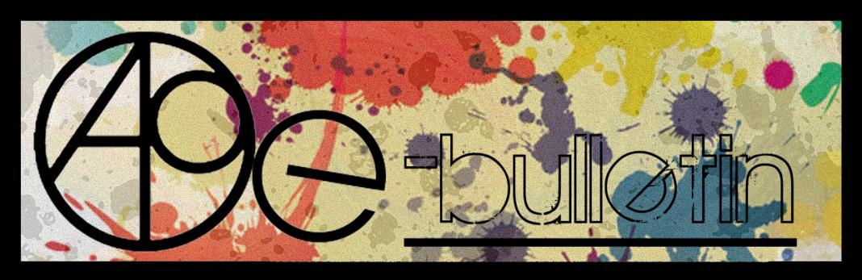

**Kilkenny County Council Arts Office E-bulletin 20th February 2015**

Dear All,   
  
Welcome to the fortnightly e-bulletin from Kilkenny County Council's Arts Office. Each bulletin is packed with the latest information on Kilkenny Arts Office activities, county events as well as news and opportunities for arts practitioners from around the country.

This service will be provided fortnightly. To include an item in the next e-bulletin please send a brief outline of your advert with relevant contact details, including any websites or pages with links to [**niamh.brophy@kilkennycoco.ie**](mailto:niamh.brophy@kilkennycoco.ie) **before 4th March**. The next e-bulletin will be on the **6th March.**

While every effort has been made to ensure the accuracy of our information, we strongly advise readers to verify all details to their own satisfaction.

Regards,

Niamh Brophy  
Arts Office,  
T: 056 7794138  
E: [niamh.brophy@kilkennycoco.ie](mailto:niamh.brophy@kilkennycoco.ie)   
W: [www.kilkennycoco.ie/eng/Services/Arts/](http://www.kilkennycoco.ie/eng/Services/Arts/)

BECOME PART OF IT, SUBMIT A POEM.....[www.rhymerag.net](http://kk-moss/Sites/arts_office/Shared%20Documents/Julianne%20Morgan/E-bulletin/30th%20May%20e-bulletin/www.rhymerag.net)  
Kilkenny County Council Arts Office Partner Local Authority of the ArtLinks Programme [www.artlinks.ie](http://www.artlinks.ie)

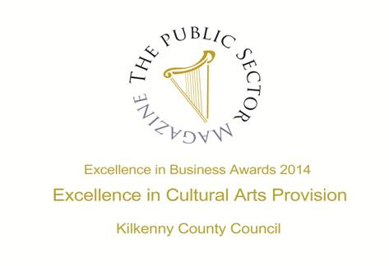

|  |  |
| --- | --- |
|  |  |
|  |  |

**Arts Office**

* Open Circle Community Arts Collective seeks Development Worker
* Rhyme Rag is now live!

**Kilkenny Events**

* Kilkenny International Gospel Festival
* **Karibu exhibition at Kilkenny Castle**
* ‘Townlands 3’ an exhibition by Gypsy Ray and Alan Counihan
* Sharon Verrall Exhibition opening
* Exhibition Space available at City Library
* TradFest
* Coming Soon to the Watergate Theatre
* Fresh Talent at the National Craft Gallery, Kilkenny
* The Design & Crafts Council seeks Administrator
* KOZO Workshop Programme 2015

**Courses / Training / Jobs / Internships**

* **Art Criticism Writing Workshop at VISUAL**
* **Documenting Your Work with Photographer Ros Kavanagh at VISUAL**
* **Life Casting and Silicone Prostethics Workshop with Evil Chimp FX at VISUAL Carlow**
* Digitisation in a Day: Crowdsourcing Workshop
* Digitisation in a Day: 3D Recording Workshop
* Museum Curator (JobBridge Internship), Kilkenny
* Bitesize arts and health training, Cornwall, UK
* Seeking voices for the Irish Youth Training Choir

**Call for Submissions / Residencies**

* **Lost Spaces 2015: Call for Ideas**
* Hospitalfield Arts Interdisciplinary Residency March and August 2015
* **Light Work Artist-in-Residence Program**
* **Yeats 2015 Architecture Competition**
* **axis: Ballymun 2016/2017 Gallery Programme | Call for Submissions**
* **Summer Open Submission Exhibition at glór**
* **Project Space at PP/S | Call for Submissions**
* **Exhibition Opportunities at Mountmellick Art Gallery**
* **Impressions Fine Art Print Expo 2015 | Call for Submissions**
* **The White Review**
* **The Caterpillar International Poetry Prize**
* **Scottish Arts Club Short Story Competition**
* **2015 Bristol Short Story Prize**
* **Calling All Young Poets** - Seán Dunne Young Poets’ Award
* **Call for performers of various genres and techniques**
* Open Call for Exhibition Proposals Municipal Gallery, dlr LexIcon, Dún Laoghaire
* **Irish Journal of Arts Management and Cultural Policy: Call for Papers**
* **National Arts-in-Education Portal: Call for Expressions of Interest**
* **FOH Space at Garter Lane Arts Centre | Call for Submissions**
* **Connecting Creativity Residency 2015 Tranas Sweden: Call for Applications**
* **Irish Sound, Science and Technology Convocation: Call for Submissions 2015**

**Awards / Bursaries / Schemes**

* **2014/2015 Dates and Deadlines for Culture Ireland Grant Rounds**
* Young Ensembles Scheme 2015
* Opera Production Award 2016
* Project awards – deadline 5.30pm Thursday 19 March 2015
* Arts Council announces deadlines for schemes in Dance and Theatre
* **Arts Council’s Artist in the Community Scheme – Deadlines 2015**
* **Sky Academy Closing Date 5 March: €38k to an artist 18-30**
* **Sky Arts Amplify Treatments accepted 1 March-3 April for €1.25m fund**
* Arts Council announces Round 2 of Festivals and Events Scheme 2015

**Of Interest**

* Play Resource Centre – Arts and Craft Shop – now open to non-members
* **Kids’ Own Publishing and F.E. McWilliam Gallery & Studio: Creativity in Primary Education Symposium**

**Open Circle Community Arts Collective seeks Development Worker**

[www.opencirclearts.ie](http://l.facebook.com/l.php?u=http%3A%2F%2Fwww.opencirclearts.ie%2F&h=yAQE4mtR2&s=1)

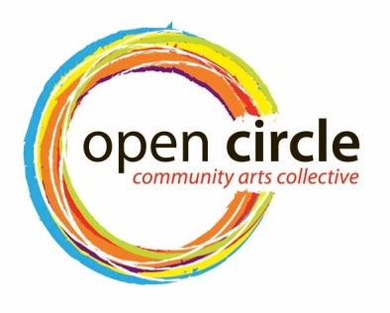

The Arts Office, Kilkenny County Council invites applications from interested individuals who have experience working with the community in a developmental... capacity for the delivery of a combined personal development and artistic programme, including community outreach, exhibitions and exchanges.

Invite and co-ordinate inputs to the group for the year and facilitate development of whole project ideas and capacity. They will also promote the project externally and maintain and further develop social media position for the project.

**Role of the Development Worker**  
The duties of the Development Worker will include:  
• Undertaking research for programme development   
• Guiding the development of an annual programme of work for the project participants and the wider public where appropriate   
• Co-ordinating and administering this programme  
• Acting as a Communication Liaison officer to and from the Project, the facilitating practitioners, the Arts Office and other outside sources   
• Invite and co-ordinate other inputs to the Project for the year   
• Facilitate development of whole project ideas and capacity   
• Promote and Market the Project locally and nationally   
• Support the implementation of the brand of the project   
• Maintain and further develop social media output for the project  
• Further develop the membership database  
• Assist with introducing new groups and new members to the project, taking social inclusion matters into consideration  
• Assist in the sourcing of funding for the Project and completing funding applications   
• Co-ordinate and develop a strategy for the future of project and all that this entails   
• The coordinator must forge and maintain a relationship between project, the Arts Office, the facilitating artists / practitioners and the participants  
• Monitor, evaluate and document all aspects of the Projects programmes  
• Any other duties deemed necessary and reasonable by the Kilkenny County Council Arts Office.  
• The Development Worker will   
o report to the Arts Officer on a regular basis  
o Submit a written annual report and analysis of the programmes including budgets to the Arts Officer   
  
This position is on a part time basis initially twelve hours weekly. tbc.  
  
Application by CV and Cover Letter to marking the envelope as Open Circle Development Worker and forward to Mary Butler, Arts Officer, Kilkenny County Council, County Hall, John Street, Kilkenny. No electronic applications accepted.

This project is currently supported by Kilkenny County Council Arts Office, the Arts Council of Ireland and Kilkenny / Carlow ETB.

Insurance and Tax: The successful applicant will be responsible for all taxes which arise from any payment by Kilkenny County Council of the agreed fee including and without prejudice the generality of this provision, all income tax and VAT .

**The deadline for receipt of applications is 23rd February 2015.**

The Arts Office, Kilkenny County Council and Open Circle Community Arts Collective acknowledges the support of the Arts Council/An Chomhairle Ealaíon and Kilkenny / Carlow ETB

**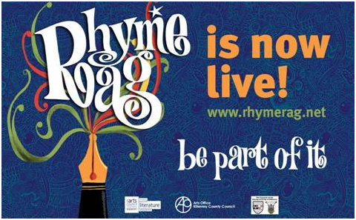**

**Kilkenny Events**

**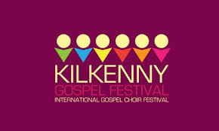**

**We are delighted to announce that the 2015 Kilkenny International Gospel festival will be lead by Marcanthony.  He has worked with many well known singers including Cissy Heuston, he has hosted gospel workshops for over ten years.**

**Programme 2015.**

**Friday, June 19th (Ormonde Hotel)**

10 – 12 am  Workshop for Primary School Children, Mr. Marcanthony Henry, Director/Musician/Singer from New York City

5.00 pm      Official Opening of the Festival performed by Mayor Andrew McGuinness in Kilkenny City Hall.   Complimentary light refreshments will be available.

8 – 9 pm       Introductory workshop with Mr. Marcanthony Henry.

**Saturday, June 20th (Ormonde Hotel)**

09.30 am  Morning Praise – Rev William Purcell, Musical Director, Kilkenny Gospel Choir

10.00 am  Workshop 1 – Mr. Marcanthony Henry

11.00 am  Tea/Coffee

11.30 am  Workshop 2 – Mr. Marcanthony Henry

12.30 pm  Lunch

02.00 pm  Workshop 3 – Mr. Marcanthony Henry

03.30 pm  Tea/Coffee

04.30 pm Concert Rehearsal

05.30 pm  Break

08.00 pm Celebration Concert in the  Black Abbey

**Sunday, June 21st (St. Mary’s Cathedral)**

11.00 am  Worship – Special Festival Mass

03.00 pm  Gospel Singing/Walking Tour of Kilkenny’s Medival City

Costs: $40.00 (€35.00) per person for weekend.

Children €5.00

All food and accommodation will be extra.  There will be a discounted menu available to participants during the workshops in the Ormonde Hotel.

<http://kilkennygospelchoirfestival.com/>

**Karibu exhibition at Kilkenny Castle**

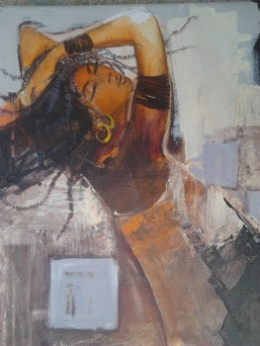

Exhibition continues until 28 February, 2015.  
  
The exhibition will be opened by Salome Mbugua, Founder and President of AkiDwA, the national  
network of migrant women in Ireland and Donat Mabana, Co-ordinator of SOS Congolese Youth.    
Music will be provided by Congolese musician  
Serge Greatman.  
  
Karibu is a network of artists originally from Congo living in Ireland. Featured artists include Nhono Tambidila, Bennoit Numbi, Guy Tshishiku, Greg Kalala and Masekabay Zanga.  
  
Light refreshments will be served.  
  
This exhibition has been supported by Butler Gallery.

**‘Townlands 3’ an exhibition by Gypsy Ray and Alan Counihan**

12th February - 7th March 2015

Reception will take place on the 14th February, 3-5pm in The Old Market House Arts Centre, Lower Main Street, Dungarvan, Co.Waterford.

*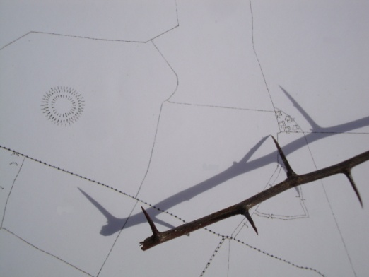*

*Townlands* is an exhibition of works made over the past six years by artists Alan Counihan and Gypsy Ray as part of *The Townlands Project*. Works to be shown at the Old Market Arts Centre in Dungarvan, Co Waterford include photographs, drawings and sculpture, all of which have grown out of creative interaction with the artists’ local landscape. All of the works in this exhibition have their roots in an experience of the rural and have proved popular with viewers wherever they have been shown. *Townlands* exhibitions are constantly revitalised with new works born out of our ongoing explorations.

It is hoped that this exhibition will have the effect of encouraging all those who engage with it to explore their own places and communities and to discover what makes them unique in the world.

For more information see :

[www.townlands.net](http://www.townlands.net)

[www.gypsyray.wordpress.com](http://www.gypsyray.wordpress.com)

[www.alancounihan.net](http://www.alancounihan.net).

**Sharon Verrall Exhibition opening**

Opening reception on February 26th at 7pm in The Watergarden Gallery, Ladywell Street, Thomastown. A Year in Haiku is an exhibition of paintings & poetry by Kilkenny artist and writer Sharon Verrall. The series of work has evolved over the course of a year observing nature and the changing seasons, internally and externally. While the works pay homage to the traditional essence of Haiku & Haiga, they are the artist’s own vision of the world we live in. Techniques incorporated were painting with gesso and watercolour, dry-brush layering and screen-printing with collage and stitching. The haiku were transcribed using a vintage Continental typewriter. The show runs until March 27th.

**Exhibition Space available at City Library**

Exhibition space is available in City Library, John’s Quay for artists/photographers. Bookings are generally taken for a month. Groups and schools are also welcome.

Phone Aisling on 056 779 4174 to book.

## \\kk-moss\DavWWWRoot\Sites\arts_office\Shared Documents\Internal\Niamh\2015 projects\E-bulletin\Feb 20th\TradFest_edited-1.jpg

## Coming Soon to the Watergate Theatre



[Reeling In The Showband Years](http://watergatetheatre.com/programme/reeling-showband-years/)   
Fri 20th February 2015  
Tickets: € 30

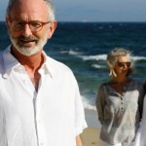

[Stories, Poetry and Dreams](http://watergatetheatre.com/programme/stories-poetry-dreams/)  
Fri 27th February 2015  
Tickets: € 20

For more details see <http://watergatetheatre.com>

|  |  |
| --- | --- |
| **Fresh Talent at the National Craft Gallery, Kilkenny**  **FRESH TALENT**  **6 FEBRUARY 2015 – 18 MARCH 2015**  Fresh Talent shines a light on the creative new wave of designers emerging since 2011 who work within and across disciplines. The exhibition includes a mix of award winning graduate projects from Irelands major universities and from Irish students abroad and a selection of designers and practitioners who are establishing their businesses. The exhibition draws from a range of fields and incorporates a selection of design disciplines; Craft, Architecture, Set Design, Visual Communication, Product Design, Fashion, Design Engineering all feature.  All events are **FREE** but booking is required.  **EXHIBITION CURATOR’S TALK & LAUNCH**  Fri 6 Feb, 6pm, 7pm  Angela O’Kelly in conversation with guests.  [**DRAWING AS RESEARCH**](http://www.nationalcraftgallery.ie/news/article/drawing-as-research-with-jewellery-designer-inga-reed)  Fri 13 Feb, Wed 25 Feb, Wed 11 Mar, 10.30am -12.30pm  Explore drawing as a tool for developing creative ideas with Inga Reed  [**LATE DATE: MEET THE MAKERS**](http://www.nationalcraftgallery.ie/news/article/meet-the-makers)  Thurs 26 Feb, 6.30pm  Fresh Approaches to Jewellery with Arturo Borrego  [**SCHOOLS WORKSHOPS**](http://www.nationalcraftgallery.ie/news/article/schools-workshops)  Tues 3, Wed 4, Thur 5, Fri 6 March 10am & 1.30pm  Exhibition talk and hands on print workshop with Caroline Ryan  [**INTERNATIONAL WOMENS DAY WORKSHOP**](http://www.nationalcraftgallery.ie/news/article/object-portrait-assemblage-collage-juxtaposition-with-artist-kate-o-kelly)  Sun 8 March, 12- 2pm & 3pm -5pm  **Object: Portrait,** Assemblage, Collage, Juxtaposition with artist Kate O Kelly  [**FAMILY DAY: SET DESIGN CREATIONS**](http://www.nationalcraftgallery.ie/news/article/fresh-talent-family-days)  Sat 14 March, 10.30 & 12noon  Set Design Creations with Orla Reynolds  [**AFTERNOON TALKS: MEET THE MAKERS**](http://www.nationalcraftgallery.ie/news/article/meet-the-makers)  Sat 14 March, 2.30pm  Set & Furniture Designer with Orla Reynolds  **To book or regisiter your interest in any of our events please contact National Craft Gallery at 056 7796151 or email** [**events@nationalcraftgallery.ie**](events@nationalcraftgallery.ie)  **[www.nationalcraftgallery.ie](http://www.nationalcraftgallery.ie)**  [**https://www.facebook.com/NationalCraftGallery**](https://www.facebook.com/NationalCraftGallery)  <twitter.com/NCGKilkenny>  Description: Macintosh HD:Users:educationassistant:Desktop:w3b-641x300.jpg  Image of furniture work by Darragh Casey   |  | | --- | |  | |

**The Design & Crafts Council seeks Administrator**

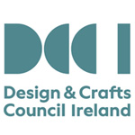

The Design & Crafts Council of Ireland, (DCCoI) is the main champion of the craft industry in Ireland, fostering its growth and commercial strength, communicating its unique identity and stimulating quality design, innovation and competitiveness. DCCoI’s activities are funded by the Department of Jobs, Enterprise and Innovation via Enterprise Ireland.

The Design & Crafts Council of Ireland wish to contract an administrator to help deliver a number of projects in 2015 across the various areas of the Innovation and Development Programmes team. The contract will include administration of the following projects in close liaison with the respective managers in DCCoI:

• CRM and Sage operating system  
• Enterprise Development Programmes  
• Innovation and Design led Programmes  
• European Initiatives  
• Projects developed for our membership organisations  
• Ongoing development of the DCCoI Enterprise Website  
• Partnership programmes

Contract Purpose:  
The Design & Crafts Council of Ireland wish to appoint a dynamic administrator to assist with and administer a suite of projects that are delivered across the innovation team. The successful candidate will require strong knowledge of CRM, excellent organisational and administration skills and a good understanding of current DCCoI programmes and flexibility in terms of working with DCCoI staff, clients and key organisations on an ongoing basis.

Essential Functions/Responsibilities:  
• Development and training of key DCCoI staff in relation to CRM.  
• Establishing clear timelines and identifying key actions in relation to projects to include: research and consultation, administration, report writing and evaluation.  
• Demonstrate an ability to engage with the design and craft sectors.  
• Demonstrate knowledge of design processes, new technologies and the potential impact and opportunities for the craft sector.  
• Administer and deliver projects to agreed timelines and within budget.  
• Manage and update the back end of the Enterprise Website.  
• Manage and monitor Survey Monkey questionnaires.  
• Prepare regular progress updates for DCCoI, based on agreed targets.  
• Communicate and animate interest in the programme at local and national level.

Knowledge, Skills and Abilities:  
• Educated to degree level and/or a minimum of 3 years post-qualification experience or equivalent in the enterprise, innovation and/or cultural fields.  
• Excellent organisational and administration skills.  
• Knowledge of CRM and Sage operating systems is essential.  
• Proficient use of design tools and programmes to create forms/ applications/ data bases.  
• Good communication and public relations skills.  
• Excellent interpersonal skills with the ability to work on one’s own initiative and in teams.  
• Understanding and knowledge of the design and craft sectors is desirable.  
• A high level of initiative, energy and motivation is required.  
• Driving license and own transport required.

Applications to:  
• Please email a cover letter and c.v. including your daily rate for the contract to: Nuala Mc Grath, HR and Corporate Services Manager  
• Contact email: recruitment@dccoi.ie  
• Contact Address: Design & Crafts Council of Ireland, Castle Yard, Kilkenny.

**The closing date for receipt of applications is: 5pm on Wednesday 25th February, 2015**

[www.dccoi.ie](http://www.dccoi.ie/)

**KOZO Workshop Programme 2015**

|  |  |  |  |  |  |
| --- | --- | --- | --- | --- | --- |
| |  |  |  |  |  | | --- | --- | --- | --- | --- | | |  |  | | --- | --- | | |  | | --- | |  | |  |  |  | | --- | --- | | |  | | --- | | **KOZO Studio WORKSHOP Programme** for adults (incl. young people from 16 years)  **GIFT VOUCHERS are available for the workshop of your choice!**  These courses take place at **KOZO Studio** The Estate Yard, Castlecomer Discovery Park, Co. Kilkenny  **FEBRUARY -  MARCH 2015**   **22 February (Sunday): PAPER MAKING DAY** - Beginners **10.30am - 1.30pm HAND PAPER MAKING** - Introduction to traditional and contemporary techniques of making beautiful handmade papers from pure plant fibres and a range of recycled materials. **2.30 - 5.30pm SILK FIBRE PAPERMAKING** - A truly fascinating, contemporary technique for making `fabric-like`, colourful silk papers using raw silk fibres and fabric dyes. Easy to continue and set up at home, this process is ideal to create unique interior decorations and striking silk papers for artworks, embroidery, collages, card making...etc.  Fees for each workshop: € 35  OR: € 65 for the full day - including all materials  \*\*\*\*\*\*\*\*\*\*  **1 March (Sunday)** **11am - 5.30pm BATIK Workshop** - Beginners A full day programme introducing an ancient technique of fabric dyeing where hot wax is used as a resist. Participants will learn all necessary basic techniques - and complete three small/medium batik pieces with up to 4 colours on cotton fabric and/or paper.  € 70 for the full day, including all materials  \*\*\*\*\*\*\*\*\*\*  **7 March (Saturday): PAPER MAKING DAY**- Beginners and participants with some previous experience in papermaking and/or textile processes. This programme is scheduled the same way as the Papermaking Day in February (please see above) but is designed for participants who have a little experience in similar techniques.  \*\*\*\*\*\*\*\*\*\*  **22 March (Sunday): PAPER ART and HAND PAPER MAKING  - *FOLLOW-ON, ADVANCED LEVEL COURSE -*** only for participants with previous experience. **10.30am - 5.30pm**  Designed for participants who already work with paper/fibre based processes, this course offers assistance and guidance in areas of three dimensional, sculptural and installation based works, experimental processes of batik, paper dyeing and texturing. It also covers ideas for the preparation and use of plant based pulps (without added chemicals). Participants are encouraged to bring their own ideas and questions into the workshop and invited to show and discuss previous works and projects. The day also includes a short slideshow presentation on examples of contemporary paper art and paper making. **Places are limited for 5 participants.**  € 80 for the full day, including all materials | | | |
| |  |  |  | | --- | --- | --- | | |  |  | | --- | --- | | |  | | --- | | **BOOKINGS are confirmed with € 30 deposit paid in advance.\* Courses are run for small groups of participants only so please call to book early. With any questions, for advice or check availability and for all BOOKINGS please contact me directly:  Tunde Toth - Artist 087-2543362** [**tundetune@gmail.com**](mailto:tundetune@gmail.com)[**www.tundetoth.com**](http://www.tundetoth.com) | | | |

**Courses / Training / Jobs / Internships**

**\_\_\_\_\_\_\_\_\_\_\_\_\_\_\_\_\_\_\_\_\_\_\_\_\_\_\_\_\_\_\_\_\_\_\_\_\_\_\_\_\_\_\_\_\_\_\_\_\_\_\_\_\_\_\_\_\_\_\_\_\_\_\_\_\_\_\_\_\_\_\_\_\_\_\_\_\_\_\_\_\_\_\_\_\_\_\_**

**Art Criticism Writing Workshop at VISUAL**

21 February & 28 March  
10am – 4.30pm  
Cost: 15  
VISUAL, Old Dublin Road, Carlow

PVA is an online and printed Journal of art criticism. Over the course of two saturdays, PVA editors and art critics Nathan O donnell and Marysia Wiekiewicz- Carroll will lead workshops on writing art criticism. These will be open and welcoming sessions, exploring the theoretical and practical aspects of writing about visual art and what it means to produce a regional art criticism. Workshops are open to writers at any level. Places are limited and attendance on both days is essential.

[www.visualcarlow.ie/exhibitions/event/paper-visual-art-writing-art-criticism](http://lists.visualartists.ie/lt.php?c=1297&m=4334&nl=1&s=d3c261c0eeb6b48867f449d29e09414b&lid=102435&l=-http--www.visualcarlow.ie/exhibitions/event/paper-visual-art-writing-art-criticism)

**Documenting Your Work with Photographer Ros Kavanagh at VISUAL**

For Artists and Photographers  
Sat 28th February & Sat 7th March 11am- 4.30pm  
Cost: €100  
VISUAL, Old Dublin Road, Carlow

This workshop led by professional photographer Ros Kavanagh, wiil involve guidance on: colour accrate photography of flat artwork, behind glass and cross polarisation; the use of colour patches and icc profiles; the use of studio lighting and speedlight flash; photographing sculpture using lighting; and installation photography. Participants wil need to be proficient with a digital SLR camera and familiar with Photoshop. Due to the technical and hands on nature of this workshop places will be limited. Attendance on both days is mandatory.

[www.visualcarlow.ie/exhibitions/event/documenting-your-work-with-photographer-ros-kavanagh](http://lists.visualartists.ie/lt.php?c=1297&m=4334&nl=1&s=d3c261c0eeb6b48867f449d29e09414b&lid=102436&l=-http--www.visualcarlow.ie/exhibitions/event/documenting-your-work-with-photographer-ros-kavanagh)

**Life Casting and Silicone Prostethics Workshop with Evil Chimp FX at VISUAL Carlow**

Ever wanted to channel your inner zombie or create your own crazy cat face? Then this work shop is for you! Brought to you by Dave Cullen from Evil Chimp FX, this four day workshop will cover everything you need to know to make your own masks!

From an introduction to life casting, to sculpting your face prosthetic, right through to application of the mask and removal of the prosthetics, this workshop is a step by step guide to silicone prosthetics. Participants will be given the have their work professionally photographed and will be given access to digital files be able to keep their own life cast after the workshop.

This promises to be a truly unique experience.

– Sunday 22 Feb 10am – 6pm  
– Monday 23 Feb 10am – 6pm  
– Sunday 1 Mar 10am – 6pm  
– Monday 2 Mar 10am – 6pm

€350

Please Note: €175 deposit required by 7th Feb 2015

Age: 18+

[www.visualcarlow.ie/events/info/a-life-casting-and-silicon-prosthetics-workshop](http://lists.visualartists.ie/lt.php?c=1302&m=4339&nl=1&s=d3c261c0eeb6b48867f449d29e09414b&lid=102743&l=-http--www.visualcarlow.ie/events/info/a-life-casting-and-silicon-prosthetics-workshop) | [www.facebook.com/EvilChimpFx](http://lists.visualartists.ie/lt.php?c=1302&m=4339&nl=1&s=d3c261c0eeb6b48867f449d29e09414b&lid=102744&l=-http--www.facebook.com/EvilChimpFx)

**Digitisation in a Day**

**Crowdsourcing Workshop: 24th February 2015, 10am – 5pm**

**Crowdsourcing**provides an ideal method to engage the public meaningfully in the research process.

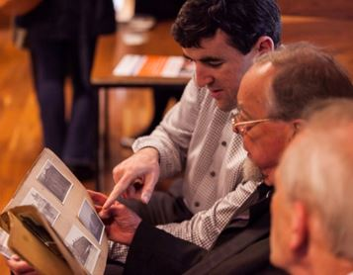

Academic and cultural heritage institutions are increasingly using crowdsourcing (also known as citizen science) to create or enhance existing collections and resources, and to provide opportunities for the public to engage in the production of knowledge. Volunteers in crowdsourcing projects**proofread, encode, translate, and transcribe text, collect, classify, and organise data, add metadata, as well as (geo)tag, identify, and digitise objects.**

Participants in this workshop will gain knowledge about crowdsourcing projects from theory to conception and completion. Examples of different kinds of crowdsourcing projects and methods will be reviewed in both the arts and sciences, while issues of audience and audience retention will also be discussed. Workshop participants will get hands-on experience by participating in the **Letters of 1916** project, the first public humanities project in Ireland, from both the project and individual perspective.

**Fees/workshop**

* €100 (€180 for both): Educational/Heritage Institutions
* €300 (€500 for both): All others

Numbers are limited to 25 participants and fees include coffees and lunch. Registration closes five days prior to each workshop.

**A number of sponsored places are available for participants from educational/heritage institutions.**

<http://www.learndigitalhumanities.ie/events/digitisation-in-a-day/>

**Digitisation in a Day**

**3D Recording Workshop: 12th March 2015, 10am –  5pm**

**3D Recording**is nowadays a necessary component in the **preservation, understanding, analysis and presentation** of cultural heritage. Fieldwork projects, research centres, and heritage institutions are increasingly employing digital recording methods not only as a means to present information to the public, but also to **augment conventional records** and **enhance research outcomes**.

The main aim of this workshop is to introduce participants to the capabilities of **computational imaging** for **recording, visualising and analysing buildings’ and objects’ three-dimensional properties**. The theoretical part of the workshop will provide the fundamental concepts and the data capture and processing methods applied to each technique, referring to characteristic examples and applications. During the practical part of the workshop, participants will get **hands-on** experience by performing all stages involved in 3D recording, i.e. capture, processing and viewing.  They will also have the chance to use pre-captured datasets, as well as produce their own records.

Please note that for this workshop participants are required to bring their own laptops, cameras (optional), install free software and download a set of pre-captured datasets.

[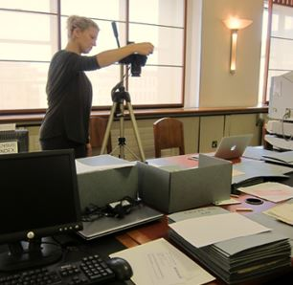](http://www.learndigitalhumanities.ie/wp-content/uploads/2015/01/DigDay2.jpg)

**Fees/workshop**

* €100 (€180 for both): Educational/Heritage Institutions
* €300 (€500 for both): All others

Numbers are limited to 25 participants and fees include coffees and lunch. Registration closes five days prior to each workshop.

**A number of sponsored places are available for participants from educational/heritage institutions.**

<http://www.learndigitalhumanities.ie/events/digitisation-in-a-day/>

**Museum Curator (JobBridge Internship), Kilkenny**

The Irish Defence Forces have advertised a JobBridge Internship for a Museum Curator, based in the Military Museum, Stephens Barracks, Kilkenny City.

This is a 9-month placement (40 hours per week) and an allowance of €50 is paid on top of your current social welfare payment. The intern will gain experience in skills in curatorship at a practical level. The intern will receive formal/informal training in the administrative and logistical aspects of day to day Museum operation.

Candidates for the position must have Leaving Certificate or equivalent (Compulsory). Diploma/Degree in Museum Curatorship; Computer Literacy (Desirable). Personal Competencies: Initiative, Teamwork, Analytical Thinking, Achievement, Integrity, Customer Service Orientation, Conceptual Thinking, Empathy.

See JobBridge website, reference INTE-908456, live until 19 March 2015

# Bitesize arts and health training, Cornwall, UK

Are you interested in designing and delivering your own arts and health projects?

* **Delivering Creative Projects for Older People – Thursday, 26 February 2015**
* **Introduction to Arts and Health – Tuesday, 10 March 2015**
* **Delivering Creative Projects for Mental Health and Wellbeing –Thursday, 26 March 2015.**
* **Documenting, Reporting and Evaluating – Thursday, 16 April 2015**

**Cost:** Each session costs £12.50 including refreshments and training materials.  
**Time and location:** 1.00pm to 5.00pm at the Arts for Health Cornwall offices, Jubilee Wharf, Penryn.  
Bookings: [www.artsforhealthcornwall.org.uk/events-booking](http://www.artsforhealthcornwall.org.uk/events-booking)  
Booking is essential; only 8 places are available for each session.

**Seeking voices for the Irish Youth Training Choir**

IYTC provides young singers aged 14-17 with the opportunity to train with leading vocal and choral professionals during a weekend residential summer course and performance for Irish Youth Training Choir. After this they can expect to progress on and train in a week long residential Irish Youth Choir course for ages 18-28.

During the weekend residential course, members participate in a daily routine of physical and vocal warm-ups, sectional and full choir rehearsals - a complete singing experience!  Sports and recreational activities are organized as part of the course.

* Applicants to IYTC must be born or resident in Ireland.
* Aged 14 - 17 during the June 2015 course you may apply for Irish Youth Training Choir.
* Have relevant choral/singing experience
* Have a nominating music teacher or relevant equivalent
* In exceptional circumstances people not fitting these criteria may be considered.

Applicants must be available from Thursday 25th June to Sunday 28th June inclusive. Application forms and further information are available from Lily Mc Garry, Administrator, Association of Irish Choirs or Dermot O’ Callaghan, CEO, Association of Irish Choirs

W: [www.aoic.ie](http://www.aoic.ie) E: [aoic@ul.ie](mailto:aoic@ul.ie) T: 061 234823/ 061 202715

**Call for Submissions / Residencies**

**Lost Spaces 2015: Call for Ideas**

The Lost Spaces design competition asks professionals and students in the fields of art, architecture, design and engineering to respond to the diverse challenges of design, social sustainability and low impact design improvements. The ideas competition aims to explore alternatives improving the use, public realm and ecological value of a lost space.

A ‘lost space’ is any space that remains underutilized within our urban environment. They might be leftover pieces, a ghost of the planning past. Lost spaces are part of the public realm, rarely designed to function with both social and environmental benefit to the city.

You may consider a lost space as a passageway, a roundabout, space between two buildings, a highway shoulder, or tenants of the city’s history and memory. We’d like to ask you to dream, take risks and stretch what we think is possible.

Award $7500 CAD  
Registration and questions deadline: March 20, 2015  
Submissions due: March 30, 2015

This international ideas competition is open to artists and designers anywhere. Unique perspectives of diverse disciplines and collaborative teams is encouraged. See the call for ideas link for specifics about tailoring your idea to the local climate conditions.

[http://dtalks.org/call-for-ideas](http://lists.visualartists.ie/lt.php?c=1289&m=4326&nl=1&s=d3c261c0eeb6b48867f449d29e09414b&lid=101956&l=-http--dtalks.org/call-for-ideas)

### Hospitalfield Arts Interdisciplinary Residency March and August 2015

The application deadline for Hospitalfield's March and August Interdisciplinary Residency: 19 March 2015, midnight.

The Interdisciplinary Residency Programme at Hospitalfield has been devised to appeal across all art forms, it has been planned as an opportunity to support those working across the arts who recognise that they require some time to focus on the development of their work.

If you need information to support a funding application in advance of our selection dates please use the material on our website. <http://hospitalfield.org.uk/programme/events/interdisciplinary-residency-march-august-2015/>

**Light Work Artist-in-Residence Program**

Each year Light Work invites 12-15 artists to participate in its residency program, including one artist co-sponsored by Autograph ABP and one artist in conjunction with the Urban Video Project (UVP). Artists selected for the residency program are invited to live in Syracuse for one month. They receive a $5,000 stipend, an apartment to stay in, a private digital studio, a private darkroom, and 24-hour access to our facility.

Participants in the residency program are expected to use their month to pursue their own projects: photographing in the area, scanning or printing for a specific project or book, and so on. Artists are not obligated to lecture at our facility, though we hope that the artists are friendly and accessible to local artists and students. Work by each Artist-in-Residence becomes a part of the Light Work Collection and is published in a special edition of Contact Sheet: The Light Work Annual along with an essay commissioned by Light Work.

Questions? : Questions about the facility may be directed to [lab@lightwork.org](mailto:lab@lightwork.org) and questions about the application process or residency can be sent [toair@lightwork.org](mailto:toair@lightwork.org).

**Deadline 1 July 2015**

For information about our facilities, see [www.lightwork.org/lab](http://www.lightwork.org/lab)

**Yeats 2015 Architecture Competition**

‘…of Clay and Wattles Made’

An Open Submission International Architectural Competition Inspired by Yeats’ Poem ‘The Lake Isle of Innisfree’ – Also open to artists.

Presented by the Institute of Technology Sligo in association with the Model, Sligo, Yeats 2015, Hazelwood Demesne Ltd, and Sligo County Council.

Submissions are invited for conceptual interpretations of WB Yeats’ poem ‘The Lake Isle of Innisfree’. An International Architectural Competition open to regional, national and international practitioners of architecture and art, proposes a poetic architectural intervention for the island of Innisfree which will mediate between Yeats’ poetic vision and contemporary architectural ideas.

The winning design will be constructed on the island for 13th June 2015, as a realisation of Yeats’ vision – a gift on his 150th birthday.

For further information and to download a brief view website

[www.yeats2015-architecture-competition.com](http://lists.visualartists.ie/lt.php?c=1280&m=4318&nl=1&s=d3c261c0eeb6b48867f449d29e09414b&lid=101269&l=-http--www.yeats2015-architecture-competition.com)

Award value €30,000

**Deadline for Submissions 17.00 hours, 12th March 2015**

**axis: Ballymun 2016/2017 Gallery Programme | Call for Submissions**

axis: Ballymun is delighted to invite submissions from artists who are studying in, living in, working in, have a connection to or are originally from North Dublin. There is a focus on promoting artists and creative professionals at the beginning of their career. This call for submissions is open to artists working in across all mediums.

For full details: [niamh.fitzpatrick@axisballymun.ie](mailto:niamh.fitzpatrick@axisballymun.ie)

**Submissions are ongoing.**

[www.axis-ballymun.ie](http://lists.visualartists.ie/lt.php?c=1280&m=4318&nl=1&s=d3c261c0eeb6b48867f449d29e09414b&lid=101281&l=-http--www.axis-ballymun.ie)

**Summer Open Submission Exhibition at glór**

glór, Causeway Link, Ennis, Co. Clare

glór is delighted to invite submissions from artists, both established and emerging, who are resident in, or from, Co. Clare. The exhibition will be held at glór and will open on Wednesday 1st July 2015.

The exhibition will be selected by an independent curator and decisions are final. A curator’s award of €500 will also be made.

More than one piece may be selected for exhibit from successful submissions.

The exhibition is open to wall mounted work only (could include 2D&3D).

Please note that work in other formats, including digital, is not eligible.

Submissions & Queries to [gallery@glor.ie](mailto:gallery@glor.ie)

[www.glor.ie](http://lists.visualartists.ie/lt.php?c=1280&m=4318&nl=1&s=d3c261c0eeb6b48867f449d29e09414b&lid=101282&l=-http--www.glor.ie)

**Project Space at PP/S | Call for Submissions**

Submissions guidelines are now available for artists/groups who are interested in proposing artist-initiated projects, exhibitions, events or performances in the PP/S project space, to take place alongside our own curated programme. Submissions are ongoing.

Please visit the ‘get involved’ page guidelines and submission form, or email info@pallasprojects for more information.

Completed forms can be sent to [info@pallasprojects.org](mailto:info@pallasprojects.org) with the subject line: ‘Project Space Submissions’.

[www.pallasprojects.org/index.php/events/project-space-at-pp-s-open-call-for-submissions-2015](http://lists.visualartists.ie/lt.php?c=1280&m=4318&nl=1&s=d3c261c0eeb6b48867f449d29e09414b&lid=101283&l=-http--pallasprojects.org/index.php/events/project-space-at-pp-s-open-call-for-submissions-2015)

**Exhibition Opportunities at Mountmellick Art Gallery**

Mountmellick Art Gallery at Mountmellick Library is housed on the first floor of the library.

The 80m2 space is bright and spacious. The main room has curved glass walls and there are two additional smaller rooms. Exhibition changes monthly. We welcome applications from professional and amateur artists and we try to provide the public with a diverse range of artistic styles and media for their viewing.

Application form is available on the gallery website.

[www.laois.ie/leisureandculture/libraries/branchlibraries/mountmellick/](http://lists.visualartists.ie/lt.php?c=1280&m=4318&nl=1&s=d3c261c0eeb6b48867f449d29e09414b&lid=101284&l=-http--www.laois.ie/leisureandculture/libraries/branchlibraries/mountmellick/)

**Impressions Fine Art Print Expo 2015 | Call for Submissions**

Established in 1988, Impressions is Ireland’s longest running open submission print exhibition. It encourages, promotes and exhibits the best of printmaking in Ireland. As the first and longest running national Open Print exhibition ‘Impressions’ sees itself as a vital platform to make this creativity visible and a means to highlight the amount of activity in, and enthusiasm for this art form.

‘Impressions’ is already becoming a ‘landmark’ show in the Irish Arts Calendar and the aim is to continue to broaden the scope and ambition of the exhibition, to profile innovation and new technologies and to draw attention to the particular qualities and potentials of the medium.

**Online submissions are now open and will close on April 10th.**

[www.impressionsbiennial.com](http://lists.visualartists.ie/lt.php?c=1280&m=4318&nl=1&s=d3c261c0eeb6b48867f449d29e09414b&lid=101285&l=-http--www.impressionsbiennial.com/) | [www.facebook.com/impressionsprint](http://lists.visualartists.ie/lt.php?c=1280&m=4318&nl=1&s=d3c261c0eeb6b48867f449d29e09414b&lid=101286&l=-https--www.facebook.com/impressionsprint)

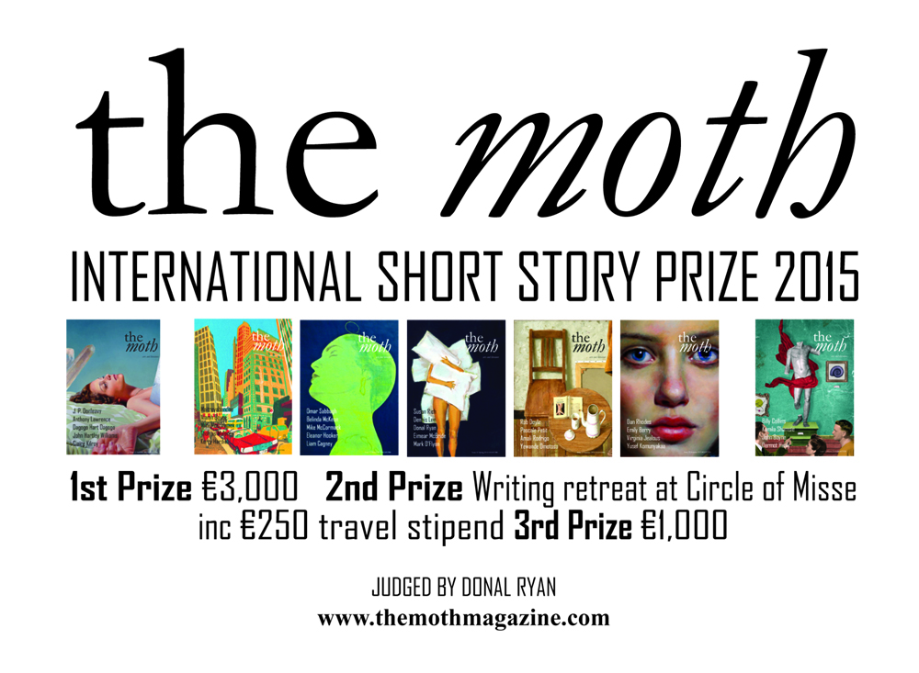

Donal Ryan judges this year's Moth Short Story Prize, with prizes of €3,000, a week-long writing retreat at [Circle of Misse](http://www.circleofmisse.com/) in France (including a €250 travel stipend) and €1,000.

There's a word limit of 6,000, and an entry fee of €12.

**Closing date 30 June 2015**.

**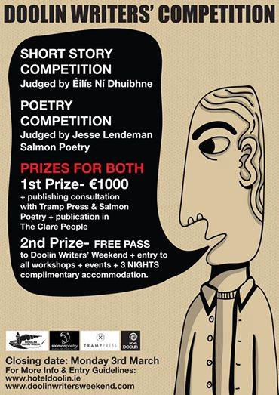**

**The White Review**

**Deadline: 1  March 2015**  
Submissions opens on 1 December 2014  
First prize: £2,500 Judges: Ned Beauman   
The White Review Short Story Prize is an annual short story competition for emerging writers. We encourage submissions from all literary genres, and there are no restrictions on theme or subject matter. We would only emphasise that the prize was founded to reward ambitious, imaginative and innovative approaches to creative writing.    
More details <http://www.thewhitereview.org/prizes/the-white-review-short-story-prize-2015/>

**The Caterpillar International Poetry Prize**

**Closing date: 31 March 2015**  
Prize: €1,000 plus publication in The Caterpillar   
Details: To celebrate the first year of The Caterpillar, an arts & literature magazine for children, we're looking for a stand-out poem written by an adult for children (aged 7-11) to which we can award a prize of €1,000. The prize is open to everyone, as long as the work is original and previously unpublished. The entry fee is €12 per poem, and you can enter as many poems as you like. The prize will be judged by the publishers of The Caterpillar and The Moth. For further details go to [www.thecaterpillarmagazine.com](http://irishwriterscentre.us9.list-manage.com/track/click?u=b6ac145e44235d03eb0c4adb6&id=65c6e8f88d&e=055476dad7)

**Scottish Arts Club Short Story Competition**

**Deadline 31 March 2015**  
First Prize of £800 The competition is open to all writers worldwide aged over 16 years, published and unpublished. Stories entered for the competition should be 1,500 words or less and can be on any topic. The stories do not have to be associated with Scotland.    
All details <http://www.scottishartsclub.co.uk>

**2015 Bristol Short Story Prize**

Open to all published and unpublished writers, UK and non-UK based, over 16 years of age.  
Stories can be on any theme or subject and entry can be made online via the website or by  
post. Entries must be previously unpublished with a maximum length of 4,000 words (There is no minimum). The entry fee is £8 per story.

**The closing date for entries is April 30th 2015.**

Full details and rules at [www.bristolprize.co.uk](http://irishwriterscentre.us9.list-manage.com/track/click?u=b6ac145e44235d03eb0c4adb6&id=2ed33bae2e&e=055476dad7)

**Calling All Young Poets**  **- Seán Dunne Young Poets’ Award**

Waterford City and County Council’s Seán Dunne Young Poets’ Award is a long-term commemorative tribute to the memory of Waterford writer Seán Dunne. This award continues to promote the work and the vision of the poet, with emerging and aspiring young authors by recognizing their talents in the poetry genre. The Arts Office is also pleased to engage in a workshops programme for various secondary schools in the City & County using the works of Seán Dunne as inspiration**.**

**Deadline** **12 noon on the 20th March 2015.**

You can download full details and the Entry Form here: [Entry Form Seán Dunne Young Poets Award 2015 (Entry Form Seán Dunne Young Poets Award 2015, 191 kbs)](http://www.waterfordcouncil.ie/en/media/RESIDENT/Arts/Sean_Dunne_Young_Poets_Award_2015.pdf)

**Call for performers of various genres and techniques**

**Summer residential program "Arts Oasis", Tuscana, Italia**. The event is inviting artists **from all over the world.** The workshop will take place at the **XII century monastery,** famous as the place of seclusion for the outstanding **Dante Alighieri. Room, full board & local transportation** are provided for participants. There is a limited number of **partial scholarships.** If you wish to find out more:  [**https://twitter.com/iugte\_art**](https://twitter.com/iugte_art)

**Open Call for Exhibition Proposals Municipal Gallery, dlr LexIcon, Dún Laoghaire**

Dún Laoghaire-Rathdown County Council invites proposals for its 2015/2016 exhibition programme for the new Municipal Gallery, dlr LexIcon. The callout is open to professional artists, curators and arts organisations to apply. Proposals for either solo, two person, or group shows are welcome; three separate exhibitions will be programmed. At least one will specifically feature the work of artists connected to Dún Laoghaire-Rathdown County. The three exhibitions will take place between October 2015 and December 2016. **The closing date for applications: Friday 20th March 2015 @ 12 noon.**

The Arts Office will host a site visit to the Gallery on Wednesday 25th February at 6.30 p.m. to introduce the space and answer any specific questions.

To book a place for this, please email Ciara King, Assistant Arts Officer-Arts Programme Development: [cking@dlrcoco.ie](mailto:cking@dlrcoco.ie)

Facilitated gallery visits cannot be accommodated outside of this time.

Download the full details of the application process here:

[Open Call for Exhibition Proposals for Municipal Gallery](http://www.dlrcoco.ie/arts/Municipal_Gallery_Exhibition_Proposals.pdf) (pdf - 230kb)

<http://www.dlrcoco.ie/arts/exhibition_proposals_call.htm>

**Irish Journal of Arts Management and Cultural Policy: Call for Papers**

The Editorial Board of the Irish Journal of Arts Management and Cultural Policy is seeking submissions of research articles and proposals for book reviews by academics and practitioners for Volume 3 of the Journal. Submissions should address topics concerning Ireland or Northern Ireland, may focus on any of the following areas:

* cultural policy
* arts and cultural management
* cultural tourism
* creative industries
* cultural economics and marketing
* heritage and museum studies
* governance and administration
* audience development and participation
* philanthropy/fundraising
* cultural finance
* production/consumption
* arts and education

The Journal is published annually and edited by an editorial board comprised of Irish academics. All research-based submissions are blind peer-reviewed by an international panel of academics and practitioners. If you are interested in submitting to the journal, please email a brief abstract and article title to [info@culturalpolicy.ie](mailto:info@culturalpolicy.ie) by 1 April 2015. Final submissions, 4,000-5,000 words, will be due 1 June 2015.

Full submission guidelines and further details may be found at:  [www.culturalpolicy.ie](http://lists.visualartists.ie/lt.php?c=1302&m=4339&nl=1&s=d3c261c0eeb6b48867f449d29e09414b&lid=102700&l=-http--culturalpolicy.ie/index.php/ijamcp/about)

**National Arts-in-Education Portal: Call for Expressions of Interest**

Are you an artist or teacher involved in an exciting arts-in-education project? Do you want to be among the first to showcase your work on the new Arts-in-Education portal? Do you want to share your work and your learning to inspire others and be part of an ongoing conversation exploring arts in education practice in Ireland?

We want to hear from you if you are involved in a project that:

* Involves artists, teachers and children
* Is underpinned by a strong ethos of arts-in-education practice
* Has been documented through photography, video or other media
* Has been developed with child protection policy and other relevant procedures in place

Over the coming year, new features and functions will be launched, but in this first phase, the priority will be on profiling existing projects and partnerships and developing resources that can be of use to support you in your work, as well as current news and opportunities.

Kids’ Own, in partnership with an editorial committee, is leading the development of content for the new national Arts-in-Education Portal, which is due to be launched in May 2015. The portal is being developed subsequent to the publication of the Arts in Education Charter, which was signed by the Minister for Arts, Heritage & Gaeltacht, and the Minister for Education & Skills, in December 2012. The vision for the portal is to be the key national digital resource of arts and education practice in Ireland.

Deadline for submissions is: Monday, 2 March 2015

Criteria and submission guidelines:  [kidsown.ie](http://lists.visualartists.ie/lt.php?c=1302&m=4339&nl=1&s=d3c261c0eeb6b48867f449d29e09414b&lid=102702&l=-http--kidsown.ie/criteria-guidelines-call-expressions-interest/)

**FOH Space at Garter Lane Arts Centre | Call for Submissions**

FOH Space is an opportunity for students, recent graduates and emerging artists to exhibit new work in Garter Lane Arts Centre’s front of house area to run alongside our 2015 exhibition programme in the gallery. Now in its third year, the FOH Space is again kindly supported by AIB Waterford and presents an exciting chance for experimentation and development in a historic and active space.

For more details: [gallery@garterlane.ie](mailto:gallery@garterlane.ie)

For full guidelines and detailed plans and images of spaces see [www.garterlane.ie](http://lists.visualartists.ie/lt.php?c=1289&m=4326&nl=1&s=d3c261c0eeb6b48867f449d29e09414b&lid=101965&l=-http--www.garterlane.ie/)

**Connecting Creativity Residency 2015 Tranas Sweden: Call for Applications**

Kultivera in association with Wexford Arts Centre provides residency opportunities for visual artists during August. Applications are open to Swedish and international visual artists. The residency offers a valuable support structure for emerging and mid career artists and brings critically engaging contemporary work to our community.

Kultivera provide individual rooms for accommodation and has twenty-four hours access to both studios and facilities. We provide individual spaces and several open plan studio spaces. Participants are required to commit to the full length of time of the residency but arrangements can be made if participants need to travel for short periods of time due to professional or personal commitments.

**Programme Dates**  
The 2015 Artist in Residence will run from the 1st August – 6 September, 2015.

**Eligibility**Six artist’s residencies are open to regional, Swedish and international visual artists working in any medium.

**Application Guidelines**  
-Create a profile and upload work to: [www.coracle.eu.com](http://lists.visualartists.ie/lt.php?c=1302&m=4339&nl=1&s=d3c261c0eeb6b48867f449d29e09414b&lid=102713&l=-http--www.coracle.eu.com)  
-Fill in this brief on-line form www.kulturresidens.com/artist-residency-application-form-2015/

Applicants will receive a confirmation of receipt within four working days.

Incomplete applications will not be considered. A selection panel will review the submissions and make its decision solely on the information provided. The panel members include practicing artists and other arts professionals. Applicants will be notified of the results for the 2015 residency by email before April 30, 2014.

Please read the FAQ section <www.kulturresidens.com/frequently-asked-questions/> before you apply

Enquiries: [arts@kultivera.nu](mailto:arts@kultivera.nu)  
The application deadline is March 30, 2015  
[www.kulturresidens.com](http://lists.visualartists.ie/lt.php?c=1302&m=4339&nl=1&s=d3c261c0eeb6b48867f449d29e09414b&lid=102714&l=-http---http--www.kulturresidens.com/)

**Irish Sound, Science and Technology Convocation: Call for Submissions 2015**

Don’t forget to submit art works, performances, papers, or workshop proposals to this years Irish Sound, Science and Technology Convocation.

RESONANCE AND RECAPITULATION: ECHO OF A RENAISSANCE

In 2011, the first ISSTC was held in Limerick. In 2014, Limerick was the City of Culture, regenerating the diverse and exciting arts practices in the city. In 2015, ISSTC returns to Limerick. In a moment of reflection and on returning to the city of the first convocation, next year’s theme of resonance, recapitulation and renaissance asks contributors to consider past works, old ideas unused, re-birthing projects through new ears and experiences. [http://issta.ie/index.php/call-2015/](http://lists.visualartists.ie/lt.php?c=1289&m=4326&nl=1&s=d3c261c0eeb6b48867f449d29e09414b&lid=101976&l=-http--issta.ie/index.php/call-2015/)

**Awards / Bursaries / Schemes**

**2014/2015 Dates and Deadlines for Culture Ireland Grant Rounds**

Please note Culture Ireland has set funding rounds and deadlines for 2015. There will be three funding rounds in 2015 and seperate calls for showcasing opportunities and Edinburgh Festivals will be announced during the year.

**Application Deadline | Timing of Project/Event | Decision Due**

* 15 June 2015  | September 2015 onwards | Early August
* 15 October 2015 |  January 2016 onwards | Early December

[http://www.cultureireland.ie/](http://lists.visualartists.ie/lt.php?c=1232&m=4271&nl=1&s=d3c261c0eeb6b48867f449d29e09414b&lid=96096&l=-http--www.cultureireland.ie/)

**Young Ensembles Scheme 2015**

|  |
| --- |
| http://newsletter.artscouncil.ie/nwstatic/spacer.gif |

The Young People, Children and Education (YPCE) Team wishes to advise that applications will be accepted for the Young Ensembles Scheme 2015 from Tuesday 10 March 2015 for projects taking place between July 2015 and June 2016.

The primary purpose of this award is to support groups of young people between the ages of 12 and 23 to create ambitious and original work together in any art form (e.g.; circus, dance, digital media, film, music, theatre, literature, visual arts, architecture or any combination of the above). Groups/ensembles must be made up of 3 or more members. The maximum award available is €10,000. The deadline for the Young Ensemble Scheme 2015 is **Thursday 9 April 2015 at 5:30pm.**

**Further information**

 Young Ensembles Scheme 2015 guidelines are available to download at [www.artscouncil.ie](http://www.artscouncil.ie) If you require further information, please contact Karen Whelan, YPCE Assistant at 01 619 7805 or [Karen.whelan@artscouncil.ie](mailto:Karen.whelan@artscouncil.ie)

**Opera Production Award 2016**

|  |
| --- |
| http://newsletter.artscouncil.ie/nwstatic/spacer.gif |

The Arts Council's Opera Production award is intended to support the making and presentation of opera productions during 2016, in line with the Arts Council’s published policy for opera.

Applicants may seek support for the production of opera at varying scales, such as:

* Main scale opera for presentation to audiences in larger venues
* Small and medium scale opera, for presentation to audiences in small/medium venues

The deadline for applications for the [Opera Production Award](http://newsletter.artscouncil.ie/fblvn33re2014rbsgtdsq9?a=6&p=48378402&t=28179891) is **Thursday 19 March 2015**.

All details at: [www.artscouncil.ie](http://www.artscouncil.ie)

**Project awards – deadline 5.30pm Thursday 19 March 2015**

|  |
| --- |
| http://newsletter.artscouncil.ie/nwstatic/spacer.gif |

The Arts Council will offer the following Project awards. The Arts Council's Project awards support specific project activities under each of the listed artform/arts practice areas.

* [Arts Participation Project Award](http://newsletter.artscouncil.ie/rny35784thg14rbsgtdsq9?a=6&p=48378403&t=28179891)
* [Circus Project Award](http://newsletter.artscouncil.ie/15od13o61re14rbsgtdsq9?a=6&p=48378403&t=28179891)
* [Dance Project Award](http://newsletter.artscouncil.ie/n6b20btqax214rbsgtdsq9?a=6&p=48378403&t=28179891)
* [Film Project Award](http://newsletter.artscouncil.ie/chkw40hek0e14rbsgtdsq9?a=6&p=48378403&t=28179891)
* [Music Project Award](http://newsletter.artscouncil.ie/f9ckbpqj20414rbsgtdsq9?a=6&p=48378403&t=28179891)
* [Street Arts and Spectacle Project Award](http://newsletter.artscouncil.ie/1eycw0e2gmy14rbsgtdsq9?a=6&p=48378403&t=28179891)
* [Theatre Project Award](http://newsletter.artscouncil.ie/jvhmw1p41y414rbsgtdsq9?a=6&p=48378403&t=28179891)

The award guidelines for each award can be downloaded from the [available funding](http://newsletter.artscouncil.ie/1jvp40uf0jq14rbsgtdsq9?a=6&p=48378403&t=28179891) section of the Arts Council's website. [www.artscouncil.ie](http://www.artscouncil.ie)

The deadline for all the above awards is **5.30pm on Thursday 19 March 2015.**

**Arts Council announces deadlines for schemes in Dance and Theatre**

|  |
| --- |
| http://newsletter.artscouncil.ie/nwstatic/spacer.gif |

The application window for the next round of Dance and Theatre Schemes will open on **Tuesday 17 March** next. The deadline for the new schemes is **5.30pm on Thursday, 16 April 2015**. Applications will be accepted through the Arts Council’s Online Services Website.

The schemes are:

[**Dance Artist Residency**](http://newsletter.artscouncil.ie/1fd29db4i6l14rbsgtdsq9?a=6&p=48378404&t=28179891) – The purpose of this scheme is to stabilise and support a network of dance artists in residence across the country.

The aims of this scheme are:

* to consolidate both professional and community based dance practice in a variety of regional contexts;
* to offer opportunities to dance artists around the country to engage in a programme of artistic work relevant to their own practise;
* to offer opportunities to local authorities and venues to develop dance practise in their area;
* to encourage the development of long-term planning and sustainability of independent dance activities.

[**Theatre Artist Residency**](http://newsletter.artscouncil.ie/66nhpk8pt3f14rbsgtdsq9?a=6&p=48378404&t=28179891) – The purpose of this scheme is to offer theatre artists the opportunity to create a year-long work programme in partnership with venues and local authorities. The specific contents of the work programme will be designed by the theatre artist on collaboration with the local authority and/or venue.

The aims of this scheme are:

* to offer opportunities to theatre artists across the country to engage in a  programme of artistic work relevant to their own practice;
* to offer opportunities to venues and local authorities to develop theatre practice in their area;
* to encourage the development of long-term planning and sustainability of independent theatre activities;
* to encourage a co-ordinated approach between key arts providers at local/ regional level.

[**Theatre Artist Development Funding**](http://newsletter.artscouncil.ie/q8b7p8r9v3t14rbsgtdsq9?a=6&p=48378404&t=28179891) – the purpose of this scheme is to offer theatre and other arts organisations the opportunity to offer developmental or training programmes to groups of individual theatre artists in a mentored environment, or to offer opportunities to groups of theatre artists to propose their own developmental ideas to organisations.

The aims of this scheme are as:

* to offer opportunities to theatre artists to develop their practice in a supported way;
* to offer opportunities to organisations who undertake development and/or training initiatives to fund those activities directly;
* to encourage the development of long-term planning and sustainability of development and training activities within professional theatre.

[**Theatre Resource-Sharing Funding**](http://newsletter.artscouncil.ie/1asxmnk9gt314rbsgtdsq9?a=6&p=48378404&t=28179891) – The purpose of this award is to offer organisations the opportunity to share administrative and production resources with a number of individual theatre artists over a specified period of time.

The aims of this scheme are:

* to offer administrative and/or production assistance to theatre artists[[1]](http://newsletter.artscouncil.ie/1nu9u48qr9214rbsgtdsq9?a=6&p=48378404&t=28179891" \o ") in developing projects and ideas;
* to offer opportunities to organisations who facilitate and support the development of theatre artists’ projects to fund those activities directly;
* to encourage the strategic planning and sustainability of resource sharing activities within professional theatre.

Guideline documents offering details on each scheme will be available on the website in advance of the closing date. [www.artscouncil.ie](http://www.artscouncil.ie)

**Arts Council’s Artist in the Community Scheme – Deadlines 2015**

Twice yearly, the Arts Council offers grants to enable artists and communities of place/or interest to work together on projects. The Artist in the Community Scheme is managed by Create, the national development agency for collaborative arts.

The scheme is open to artists from any of the following artform disciplines: architecture, circus, street art and spectacle, dance, film, literature (Irish and English language), music, opera, theatre, visual arts and traditional arts. The projects can take place in a diverse range of social and community contexts eg arts and health; arts in prisons; arts and older people; arts and cultural diversity.

The aim of the scheme is to encourage meaningful collaboration between communities of place and/or interest and artists. It is essential that consultation take place between the artist and the community group, so that both parties are involved in deciding on the nature of the project realisation. Group ownership of the art should be maintained at every stage. The Project Realisation may result in a variety of outcomes.

There are two phases to the scheme. Phase One [Research & Development,](http://lists.visualartists.ie/lt.php?c=1289&m=4326&nl=1&s=d3c261c0eeb6b48867f449d29e09414b&lid=101957&l=-http--www.create-ireland.ie/artist-in-the-community-scheme-research-and-development-award.html) is open to artists who wish to research and develop a project in a community context.

There is also a [Research & Development/Mentoring](http://lists.visualartists.ie/lt.php?c=1289&m=4326&nl=1&s=d3c261c0eeb6b48867f449d29e09414b&lid=101958&l=-http--www.create-ireland.ie/artist-in-the-community-scheme-research-and-development/mentoring-award.html) strand, open to artists who wish to develop a community based project and who have identified an artist mentor they want to work with during the research and development phase.

Phase Two [Project Realisation](http://lists.visualartists.ie/lt.php?c=1289&m=4326&nl=1&s=d3c261c0eeb6b48867f449d29e09414b&lid=101959&l=-http--www.create-ireland.ie/artist-in-the-community-project-realisation-award.html) , is open to communities of interest or place (or their representative organisations) with an artist.

**2015 Deadlines:  
(Round 1): 19 March 2015  
(Round 2)   29 June 2015**

For information on the Scheme and advice on applying, contact Katherine Atkinson, [support@create-ireland.ie](mailto:support@create-ireland.ie) or phone 01-4736600  
Visit [http://www.create-ireland.ie/about-the-artist-in-the-community-scheme.html](http://lists.visualartists.ie/lt.php?c=1289&m=4326&nl=1&s=d3c261c0eeb6b48867f449d29e09414b&lid=101960&l=-http--www.create-ireland.ie/about-the-artist-in-the-community-scheme.html)

**Sky Academy Closing Date 5 March: €38k to an artist 18-30**



Thursday 5 March is the closing date for the Sky Academy Scholarships. An artist aged 18-30 and based in Ireland for 5 years or more will be among this year’s Arts Scholarship winners, receiving an investment of €38,000 plus high level mentoring – giving the time and support to develop their creative practice and take their career to the next level.  
   
Applicants need to be a member of [IdeasTap.com](http://cts.vresp.com/c/?BusinesstoArts/e6bb9f9bde/608128ad7e/d8d67c5624), which is free to join, and can submit either a written or filmed application in the categories of visual art, theatre, dance, music, creative writing (excluding film or TV scripts) and creative producing. Applications will be assessed by industry professionals, including Irish Ambassador Kris Nelson of Tiger Dublin Fringe, with winners announced at the South Bank Awards in June 2015.

More information <http://www.ideastap.com/Opportunities/Brief/Sky-Academy-Arts-Scholarships-260215#Overview>

**Sky Arts Amplify Treatments accepted 1 March-3 April for €1.25m fund**  
  
Sky Arts Amplify is a new initiative which encourages arts organisations and production companies to join forces to pitch for up to €1.25m annually for new ideas to make groundbreaking TV - getting away from traditional performance capture or behind-the-scenes footage and thinking about how the TV experience can match the live experience. Treatments will be reviewed by the commissioning teams at Sky, and some organisations will be invited to pitch. Treatments will be accepted from 1 March until 3 April for this first round of funding. Applications will re-open later in the year.

Further information from <http://www.businesstoarts.ie/sky-to-invest-almost-e4million-for-arts-organisations-and-tvfilm-production-companies-to-collaborate-on-innovative-tv-projects/>

**Arts Council announces Round 2 of Festivals and Events Scheme 2015**

|  |
| --- |
| http://newsletter.artscouncil.ie/nwstatic/spacer.gif |

The Arts Council announces Round 2 of the 2015 Festivals and Events Scheme (FES). The Council recognises the distinctive role arts festivals play in sustaining a vibrant arts profile at a local level.  Festivals provide opportunities for audiences and artists to experience new work and ways of making work. The Council acknowledges the valuable contribution made by voluntary committees in developing these festivals.

The Festivals and Events Scheme is open to multi-disciplinary festivals, single art form festivals, once-off events and concert series.

There are two strands of funding available:

Strand 1:  Up to €10,000

Strand 2:  Between €10,001 and €20,000

The Festivals and Events Scheme is open to all organisations that promote festivals or events with a clear artistic purpose that will take place in the second half of the calendar year 2015 (July – December).

**The closing date for Round 2 is 26 February 2015.**

All applications are assessed in a competitive context and within available resources.  Applications are assessed against the following criteria:

1. Artistic merit and ambition
2. Meeting the objectives and priorities of the scheme
3. Feasibility (including financial and other support)

**First Time Applications**  
First time applicants to the scheme are advised to contact the team prior to submitting an application: by email to [firsttime@artscouncil.ie](mailto:firsttime@artscouncil.ie)

Guidelines and criteria for this scheme will be available on our website at the end of December 2014 and the window for applying will open from 27 January 2015 on our online services.

For all details see: [www.artscouncil.ie](http://www.artscouncil.ie)

**\_\_\_\_\_\_\_\_\_\_\_\_\_\_\_\_\_\_\_\_\_\_\_\_\_\_\_\_\_\_\_\_\_\_\_\_\_\_\_\_\_\_\_\_\_\_\_\_\_\_\_\_\_\_\_\_\_\_\_\_\_\_\_\_\_\_\_\_\_\_\_\_\_\_\_\_\_\_\_\_\_\_\_\_\_\_\_**

**Of Interest**

**Play Resource Centre – Arts and Craft Shop – now open to non-members**

The Art and Craft offer a wide range of arts and craft products with discounted prices – up to 50% cheaper**.** The profit we make goes directly towards the development of our services.Our staff are always on hand to help customers with arts and craft ideas as well as advice.Why not save time and order online. Visit [www.playresource.org](http://www.playresource.org/) and place your order

Telephone: 028 9035 7545  
Email: shop@playresource.org  
Visit: North City Business Centre, Duncairn Gardens, Belfast, BT15 2GG

For more information contact: Nicola Hobson, Membership Services Officer, Play Resource – Centre of Creativity  
Play Resource Warehouse Limited

T 028 9035 7546  
F 028 9075 5596  
E nicola@playresource.org  
W [www.playresource.org](http://www.playresource.org/)

**Kids’ Own Publishing and F.E. McWilliam Gallery & Studio: Creativity in Primary Education Symposium**

**Creativity in Primary Education: How can we impact on children’s learning experiences through the arts?**  
A symposium at F.E. McWilliam Gallery & Studio  
On: Thursday 19th March, 1-5pm

Kids’ Own Publishing and the F.E. McWilliam Gallery & Studio invite artists, teachers, practitioners and sector professionals with an interest in current arts in education practice to a symposium at the FE McWilliam Gallery & Studio, Banbridge on Thursday 19th March, 1-5pm.

Through this symposium, delegates are invited to engage with the Virtually There touring exhibition and to question how we create the space for children’s creative thinking in our schools.

The day will include presentations and a panel discussion with representatives from the arts and education sectors.

Places are limited, so booking is essential: [info@femcwilliam.com](mailto:info@femcwilliam.com) or phone 028 4062 3322.