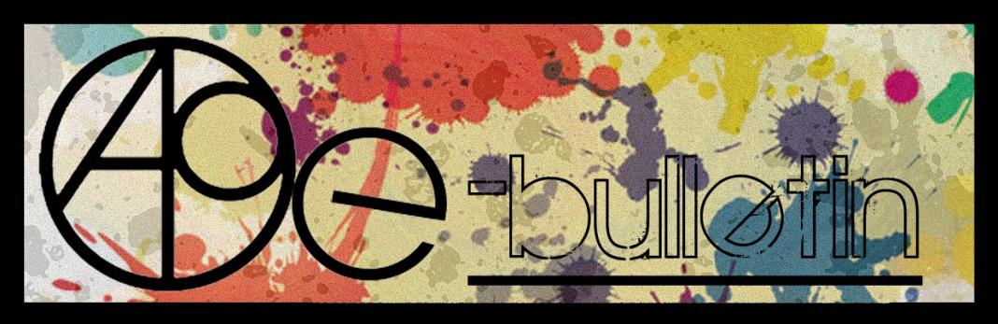

**Kilkenny County Council Arts Office E-bulletin 20th March 2015**

Dear All,   
  
Welcome to the fortnightly e-bulletin from Kilkenny County Council's Arts Office. Each bulletin is packed with the latest information on Kilkenny Arts Office activities, county events as well as news and opportunities for arts practitioners from around the country.

This service will be provided fortnightly. To include an item in the next e-bulletin please send a brief outline of your advert with relevant contact details, including any websites or pages with links to [**niamh.brophy@kilkennycoco.ie**](mailto:niamh.brophy@kilkennycoco.ie) **before 1st April**. The next e-bulletin will be on the **3rd April.**

While every effort has been made to ensure the accuracy of our information, we strongly advise readers to verify all details to their own satisfaction.

Regards,

Niamh Brophy  
Arts Office,  
T: 056 7794138  
E: [niamh.brophy@kilkennycoco.ie](mailto:niamh.brophy@kilkennycoco.ie)   
W: [www.kilkennycoco.ie/eng/Services/Arts/](http://www.kilkennycoco.ie/eng/Services/Arts/)

BECOME PART OF IT, SUBMIT A POEM.....[www.rhymerag.net](http://kk-moss/Sites/arts_office/Shared%20Documents/Julianne%20Morgan/E-bulletin/30th%20May%20e-bulletin/www.rhymerag.net)  
Kilkenny County Council Arts Office Partner Local Authority of the ArtLinks Programme [www.artlinks.ie](http://www.artlinks.ie)

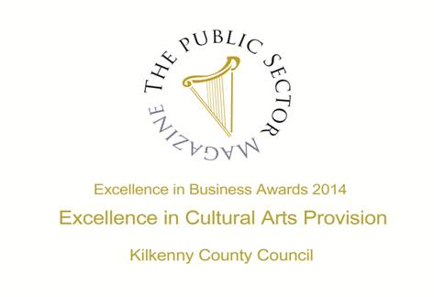

|  |  |
| --- | --- |
|  |  |
|  |  |

**Arts Office**

* Read the Next Rhyme Rag poem!

**Kilkenny Events**

* Music in Kilkenny
* Butler Gallery seeks workshop proposals for National Drawing Day 2015
* **Michael Kane, Recent Paintings at Butler Gallery**
* **‘The Secret of Kells’ | Exhibition of Prints at the Droichead Arts Centre**
* Star of ‘The Stag’ to work with Young Film Makers
* Loughboy Writers Group – Broadsheet Launch
* Poets on Board at City Library, John’s Quay
* KCAT Icon Painting
* KCAT Dance
* MOOT
* Kilkenny Roots Festival May 2015
* Nimble Spaces Ways to Live Together: New Cultures of Housing
* Kilkenny Castle's Spring Programme - *Series of FREE Garden Talks to The Parade Tower*
* L'Arche Kilkenny: Community Leader and Person in Charge
* Community Tourism Diaspora Fund
* Coming Soon to the Watergate Theatre
* Kilkenny's Memorials, Plaques and Signs - Can you help?
* Kilkenny Steiner School : Relief teachers required
* KOZO Workshop Programme 2015

**Courses / Training / Jobs / Internships**

* Certificate in Child Protection and Welfare

# Maynooth University: Dramatherapy and Creative Writing Workshop

* **MA in Socially Engaged Art, NCAD – Call for Applications**
* Museums and Makers Inspiring Each Other (Seminar)
* CreateSound.ie: Mobile Music-Making Workshops (Dance, Hip Hop, etc)
* Over The Edge Offers Poets Worldwide Online Poetry Workshop with Kevin Higgins
* **Curatorial Internship Opportunities at The Hunt Museum**
* Local Authority Education Curator, Co. Dublin
* Play Therapy Conference 2015

**Call for Submissions / Residencies**

* Public Art Work, Cashel Tipperary Municipal District Office
* **Lost Spaces 2015: Call for Ideas**
* **‘SECRET’ Exhibition at Science Gallery Dublin | Call for Submissions**
* **Call for Nominations**: **Celebrating partnership between Business and the Arts**
* **RDS National Craft Awards 2015: Call for Entries**
* **Calling all artists!** L**andscape Artist of the Year 2015**
* **Light Work Artist-in-Residence Program**
* **Impressions Fine Art Print Expo 2015 | Call for Submissions**
* Red Line Book Festival: Call for Submissions for 2015 Festival

**Awards / Bursaries / Schemes**

* **2014/2015 Dates and Deadlines for Culture Ireland Grant Rounds**
* Young Ensembles Scheme 2015
* Arts and Disability Connect
* Deis Recording & Publication Award
* Touring and Dissemination of Work scheme – January to June 2016
* **The Arts Council Programme for Ireland 2016: Open Call to the Irish Imagination**
* Arts Council announces deadlines for schemes in Dance and Theatre
* **Arts Council’s Artist in the Community Scheme – Deadlines 2015**

**Of Interest**

* Brewery Lane Writers Weekend 2015
* Waterford New Music Week 2015

**Read the next Rhyme Rag published poem**

The next poem to be published for **Rhyme Rag** is **‘Dimmest Glow’** by **Jack Larkin.**

**Jack Larkin** is 17 and attend St. Kieran’s College, Kilkenny. He writes mainly science fiction short stories, as an accompaniment to his interest in physics, chemistry and mathematics.



This poem was selected by Editor John W. Sexton and Illustrated by Ale Mercado.

**Read it here:** <http://www.rhymerag.net/2015/03/dimmest-glows/>

Thanks to all for submitting poems. And don’t forget to submit work or encourage others you may know to do so! See all details on [www.rhymerag.net](http://www.rhymerag.net)

Thanks to all for submitting poems. And don’t forget to submit work or encourage others you may know to do so! See all details on [www.rhymerag.net](http://www.rhymerag.net)

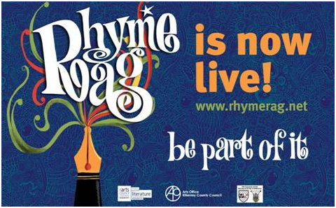

**Kilkenny Events**

**Music in Kilkenny**

**Castalia Hall, Ballytobin, Callan, Co. Kilkenny**

**Saturday 21 March 2015 8 pm**

István Várdai - cello

Finghin Collins - piano

**Sonata in A major Op. 69 Ludwig van Beethoven (1770-1827)**

*Allegro ma non troppo*

*Scherzo: Allegro mol to*

*Adagio cantabile - Allegro vivace*

**Sonata in E minor Op. 38 Johannes Brahms (1833-1897)**

*Allegro non troppo*

*Allegretto quasi menuetto*

*Allegro*

Interval

**Suite Populaire Espagnole Manuel de Falla (1876-1946)**

*El Paño Moruno*

*Nana*

*Canción*

*Polo*

*Asturiana*

*Jota*

**Sonata Op. 40 Dmitri Shostakovich (1906-1975)**

*Allegro non troppo*

*Allegro*

*Largo*

*Allegro*

**Next Concert**: Sunday 26 April 4 pm - Duo Dzeta performing Suk, Szymanovsky, R. Strauss & Dvorak.

Music in Kilkenny is supported by the Arts Council of Ireland, Kilkenny Co. Council and the Camphill Community of Ballytobin.

*Committee: John Clark, Brian Fennelly, Beatrice Kelly, Kieran O’Sullivan, Susan Proud*

**Butler Gallery seeks workshop proposals for National Drawing Day 2015**

Butler Gallery Kilkenny invites artists to submit workshop proposals for National Drawing Day 2015, a countrywide event initiated by the National Gallery of Ireland, and coordinated in Kilkenny for the past seven years by the **Butler Gallery**. The event extends across the grounds of Kilkenny Castle, offering a creative and colourful range of artist-led **outdoor** workshops.

Workshop materials and volunteer assistants will be provided. Successful applicants will direct set-up before 12pm and run the workshop on Saturday 16th May between 12pm-4pm. A fee will be paid to successful applicants.

We welcome proposals that encourage participation from a diverse age-range. Please email your proposal to Education Curator Bairbre-Ann Harkin at [bairbre.ann@butlergallery.com](mailto:bairbre.ann@butlergallery.com) by **5pm Friday 27 March**. Emails should be marked ‘National Drawing Day 2015 Proposal’ in the subject bar and include the following;

Artist CV

Example of current work (link to website / media attached to email)

Outline of proposed activity

List of materials required and estimate of cost

For more information about National Drawing Day in Kilkenny, please see <http://vimeo.com/butlergallery> and [www.butlergallery.com](http://www.butlergallery.com). If you have any questions, contact Bairbre-Ann at [bairbre.ann@butlergallery.com](mailto:bairbre.ann@butlergallery.com) / 056 7761106.

The Butler Gallery National Drawing Day is supported by the Office of Public Works and Kilkenny County Council Arts Office.

# Title: Butler Gallery seeks workshop proposals for National Drawing Day 2015  
# Location: Butler Gallery Kilkenny  
# Telephone Number: 056 7761106  
# Website: www.butlergallery.com  
# email: bairbre.ann@butlergallery.com  
# Deadline: 5pm Friday 27th March 2015

**Michael Kane, Recent Paintings at Butler Gallery**

Until April 19, 2015  
Michael Kane, Recent Paintings  at the Butler Gallery

Opening Hours  
The gallery is open seven days a week  
March 10am – 1pm; 2pm – 5pm  
April 10am – 1pm; 2pm – 5.30pm  
Further information:  
Ailís Feehan, Butler Gallery, The Castle,  Kilkenny  
T: 00 353 (0)56 7761106  
E: [ailis@butlergallery.com](mailto:ailis@butlergallery.com)  
[www.butlergallery.com](http://lists.visualartists.ie/lt.php?c=1313&m=4350&nl=1&s=d3c261c0eeb6b48867f449d29e09414b&lid=104370&l=-http--www.butlergallery.com)

**‘The Secret of Kells’ | Exhibition of Prints at the Droichead Arts Centre**

4 March – 18 April  
Droichead Arts Centre, Drogheda, Co. Louth

An exhibition of prints from the acclaimed animated film The Secret of Kells will be on display at the Droichead Arts Centre.

This is your opportunity to visit this exhibition of limited edition art prints of scenes from The Secret of Kells, the critically-acclaimed animated feature film by Kilkenny’s Cartoon Saloon.

[www.droichead.com](http://lists.visualartists.ie/lt.php?c=1310&m=4347&nl=1&s=d3c261c0eeb6b48867f449d29e09414b&lid=103754&l=-http--www.droichead.com)

**Star of ‘The Stag’ to work with Young Film Makers**

**Hugh O’Conor**, (My Left Foot, Chocolat and The Stag) is set to make a film with the young film makers at this years **National Youth Film School (NYFS).** He is now working with the next generation of talent by writing a script in collaboration with members of the Young Irish Film Makers in Kilkenny. The resulting short film will be made during this summer as part of the National Youth Film School.

### The National Youth Film School is a film training and production programme run by Young Irish Film Makers (YIFM) since 2002. In 2014 they teamed up with the Irish Film Board/Bord Scannan na hEireann and The National Film School at IADT in Dun Laoghaire to run this high talent programme for future film makers. The film school is a unique opportunity for any young person (16-19yrs) considering a career in Film or Television.

This Easter, young students will be given the opportunity to attend film making master classes from industry experts at workshops help in the National Film School at IADT. During the Summer there will be two week-long courses where students attend practical workshops and get the chance to work on a professionally run crew to produce a short film. The final films will premiere in front of an industry audience in Autumn 2015 to showcase the emerging young film making talent. Young budding film makers are invited to sign up to take part in this amazing opportunity and become a member of the crew.

Industry backing for NYFS comes from Canon Ireland, Screen Training Ireland, the Screen Directors Guild and Screen Producers Ireland. This kind of industry engagement means the young people will be working with the best in the business to learn their craft. Screenwriters in 2014 included Oscar nominated Will Collins (Song of the Sea) and Ailbhe Keogan (Run & Jump). All of this support for NYFS has established it as the premiere film training programme for young people in Ireland.

The Easter and Summer programmes are specifically designed for young people who have some film-making experience and want to pursue a career in film-making or television. The programme will be jam packed with interactive workshops in all aspects of film-making - from writing to lighting, production to editing - all with professional experts in the field. This coupled with the experience of working with a professional film crew to actually make a high quality short film is an experience not to be missed.

Over the years, the National Youth Film School has attracted young people from all over Ireland, Europe and the USA for this one-of-a-kind opportunity to work at a professional level on a broadcast quality film production. Many young people have used their work with YIFM as a portfolio piece to apply to film schools such as The National Film School at IADT in Dun Laoghaire.

**Young Irish Film Makers** have been producing films with young people all over Ireland since 1991 and boasts past members such as 2015 Oscar nominated Tomm Moore (Writer/Director of ‘Song of the Sea’), who says this of the organisation: ‘*Young Irish Film Makers inspired me to become a film maker. The easy going, yet disciplined atmosphere introduced me to the joys of teamwork and storytelling at an early age. I have carried those lessons through my whole career.’*

**The National Youth Film School** has **limited capacity**, so log on to [www.yifm.com](http://www.yifm.com/) now to register.

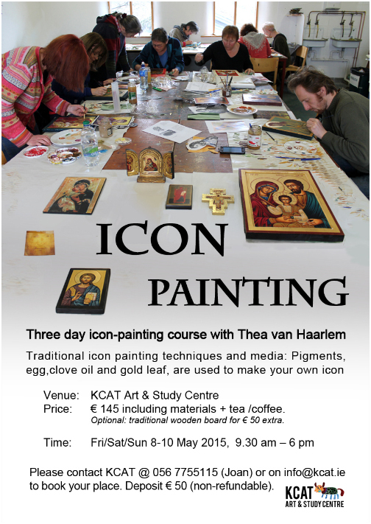

**Poets on Board at City Library, John’s Quay**

Submissions for **April** are now being accepted.

Closing date: **10th April**

Please email poems to:

[citylibrary@kilkennylibrary.ie](mailto:citylibrary@kilkennylibrary.ie)

Rules:

* One well-crafted poem per month can be submitted
* Five poems overall will be selected and will be displayed for the month
* One poem will be selected every 3 months and its author will receive a book voucher prize!
* Phone 056 779 4174 for further information

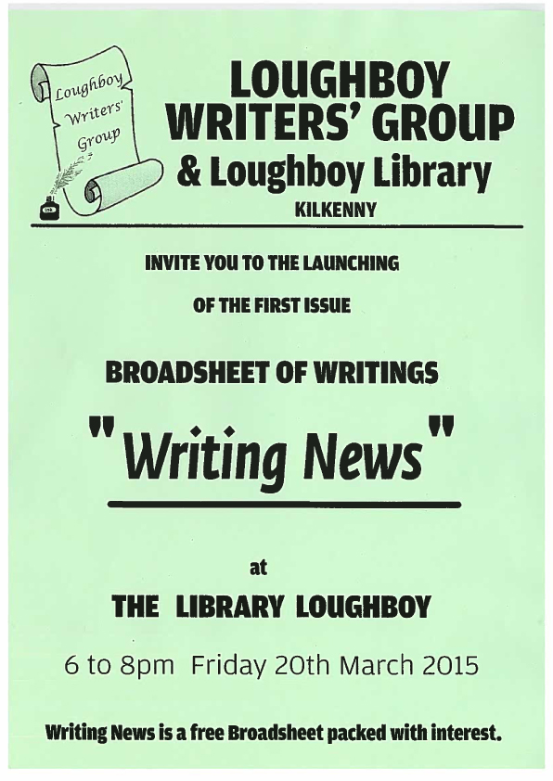

**MOOT**

**MOOT (**[THEMOOTARTGALLERY.ORG](http://THEMOOTARTGALLERY.ORG)**)** is an art, music and culture website based in Kilkenny run by Stephen Morton and Peter Lawlor with the aim to bring original creative content both on and offline.

**Recent content :**

MOOTART PROFILES : Diego Lazzarin

MOOTCASTS : Radio On w/Replete. Dead Town Radio w/Stephen Morton.

**Upcoming Events:**

MOOT presents Kobina w/ Moot DJ's The Bernard Shaw, Dublin.

Visit:

<http://www.themootartgallery.org/>

<https://www.facebook.com/mootireland>

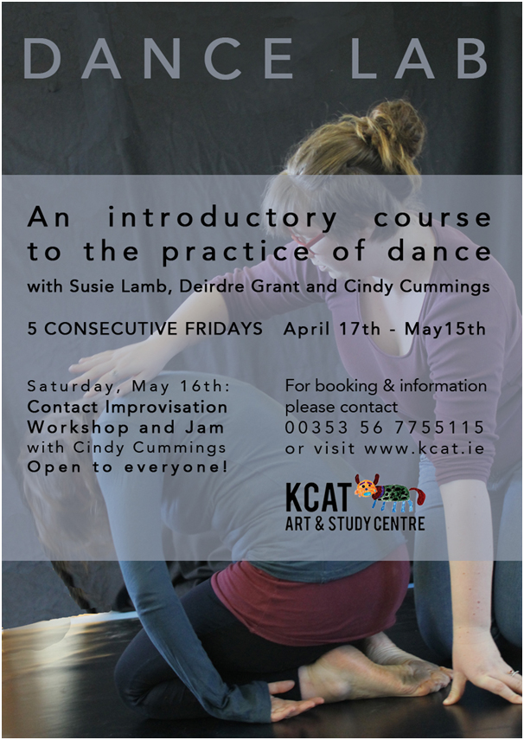

**Nimble Spaces Ways to Live Together: New Cultures of Housing**

Proposals for the upcoming Nimble Spaces Ways to Live Together: New Cultures of Housing taking place in VISUAL Centre for Contemporary Art, Carlow on Friday May 1st are welcome.The conference will include talks, panel discussions and smaller active workshops. Are you someone with particular housing needs? Are you an architect/designer, researcher, artist, student, activist? Are you a group or an association of people who are tackling a particular housing issue? We are looking for innovative thinking, projects and lived experience to contribute to the breadth of this conference. We are now accepting proposals. If you would like to contribute please submit a 250 word outline of your proposal to [info@nimblespaces.org](mailto:info@nimblespaces.org) / **Deadline March 24th at 5pm.** The Conference is a co-production between Nimble Spaces, Camphill Communities of Ireland, VISUAL Centre for Contemporary Art, Maynooth University Department of Geography and DIT, Dublin School of Architecture.  Call for Ideas / Contact Details: Rosie Lynch 085 22922973. [info@nimblespaces.org](mailto:info@nimblespaces.org). [www.nimblespaces.org](http://www.nimblespaces.org)

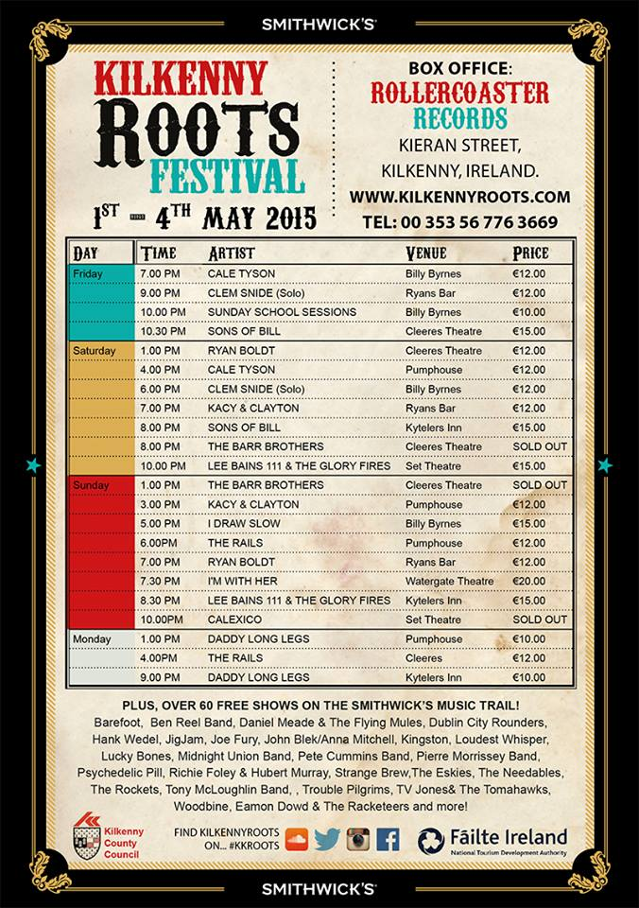

**Kilkenny Castle's Spring Programme - *Series of FREE Garden Talks to The Parade Tower***  
  
OPW Kilkenny Castle is delighted to announce the return of the very popular ***Series of FREE Garden Talks to The Parade Tower*** (as part of the Castle's Spring Programme of Events) starting on Tuesday evening 10 March and continuing weekly until Tuesday 21 April (with the exception of St Patrick's Day).

* **FREE** Talks start at 8pm with doors open from 7pm  -  Tuesday evenings  -  Entry is on a first come basis
* Further updates from [www.kilkennycastle.ie](http://www.kilkennycastle.ie)

Please note the following Speakers:

* Tuesday 24 March:  **Gerry Daly** - ('The Irish Garden Magazine')  -  *'Back to the Future - Sustainable Gardening'*
* Tuesday 31 March:  **Carl Wrigh**t - (Caher Bridge Garden, Clare) - '*Wrestling a Garden from the Wilds'*
* Tuesday 7 April:  **Paddy Tobin** - (Irish Garden Plant Society)  - 'Mount Congreve - *A Great Irish Garden'*
* Tuesday 14 April:  **June Blake** - (June Blake's Garden, Blessington) - '*Changing your Garden'*
* Tuesday 21 April:  **Paul Cutler** - (OPW's Altamont Gardens)

# L'Arche Kilkenny: Community Leader and Person in Charge

L’Arche is an international movement which builds communities with people with intellectual disabilities. The L’Arche vision is unique and inspires an ecumenical Christian community, open to people of all faiths or none, who share its values and mission:

* We are people with and without learning disabilities, sharing life in communities belonging to an international federation;
* We celebrate the unique value of every person and recognise our need of one another;
* Mutual relationships and trust in God are at the heart of our journey together.

In Ireland, L'Arche is both an intentional community and a registered charity providing housing and support for adults with learning disabilities in a variety of settings, from family-style shared houses, to independent living in sheltered accommodation.  Founded in the Ireland in 1978, we now have 4 Communities, Kilkenny, Cork, Dublin and Belfast.

L’Arche Kilkenny was founded in May 1978. It has 3 houses, 4 chalets, a workshop, garden project and café. There are 13 adults who have an intellectual disability living in the community and 12 more who attend the workshops. There are 41 employed and volunteer members, and DSP participants of the community. It is in the process of registering with HIQA.

#### Community Leader: We are seeking a Community Leader/ Person in Charge with an understanding of and a strong commitment to the ethos of L’Arche, which is based on celebrating the unique value of every person and recognise our need of one another. Please visit our web sites [www.larche.ie](http://www.larche.ie/) or contact us for further information. The Community Leader will have the requisite strategic insight, visionary leadership and the strong interpersonal skills necessary to oversee the provision of existing services as well as the development of the community to meet emerging needs. The ideal candidate will have an understanding of HSE policy and HIQA requirements and other relevant legislation and policies.

For a job description please call Jennifer on 056 7755494 or forward a comprehensive CV and personal statement to: [admin@larche.ie](mailto:admin@larche.ie). For further information contact Monika Bermingham 086 3472052/ 0567725628.

**All applications must be made on or before Friday 27th March 2015**

**Community Tourism Diaspora Fund**

Applications for funding are now being sought under the Community Tourism Initiative for the Diaspora. The initiative, launched last year, builds on the community involvement legacy of The Gathering 2013 and is a joint partnership between IPB Insurance, Fáilte Ireland and the 31 Local Authorities. The closing date is March 31st.

For further details see

<http://www.kilkennycoco.ie/eng/RSSLatestNewsAndAnnouncements/€3-million-Public-Private-Partnership-Invests-in-Irish-Communities-supporting-Diaspora-tourism-.38630.shortcut.html>

## Coming Soon to the Watergate Theatre

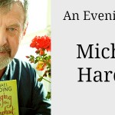

[An Evening With Michael Harding](http://watergatetheatre.com/programme/evening-michael-harding/)  
Sat 21st March 2015  
Tickets: € 16

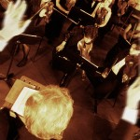

[Kilkenny Music Festival Gala Concert](http://watergatetheatre.com/programme/kilkenny-music-festival-gala-concert-2/)  
Tue 24th March 2015  
Tickets: € 10/€8

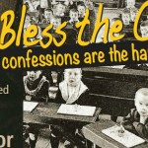

[God Bless The Child](http://watergatetheatre.com/programme/god-bless-child/)  
Thu 26th March 2015  
Tickets: € 16/€12

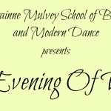

[An Evening Of Dance](http://watergatetheatre.com/programme/evening-dance/)  
Sat 28th March 2015  
Tickets: € 12/€10

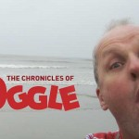

[The Chronicles Of Oggle](http://watergatetheatre.com/programme/the-chronicles-of-oggle/)  
Tue 7th April 2015  
Tickets: € 16/12

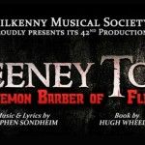

[Sweeney Todd](http://watergatetheatre.com/programme/sweeney-todd/)  
Sun 12th April 2015  
Tickets: € 20/ €15

<http://watergatetheatre.com/>

|  |  |
| --- | --- |
| Kilkenny's Memorials, Plaques and Signs - Can you help?  Kilkenny's Memorials, Plaques and Signs - Can you help? Memorials and plaques are an often overlooked part of our cultural heritage. They identify and honour people, historic events and heritage landmarks of the county. Whilst we know that there are many such plaques, memorials and signs located throughout County Kilkenny, to date they have never been recorded. So, the Heritage Office of Kilkenny County Council is now undertaking an audit of these plaques and memorials, and we would like your help.  For further details:  <http://www.kilkennycoco.ie/eng/RSSLatestNewsAndAnnouncements/Kilkenny-s-Memorials-Plaques-and-Signs-Can-you-help-.html>    United Nations. Famine Garden Plaque   |  | | --- | |  | |

**Kilkenny Steiner School : Relief teachers required**

Kilkenny Steiner school is currently seeking teachers to act as relief in times of illness or absence.

We are looking for an expression of interest from individuals who are interested in becoming part of a panel of teachers that may be called on in the future.

Individuals should ideally fulfill at least one of the criteria below:

-Be a fully qualified primary national school teacher with a knowledge and/or openness to expanding their knowledge of Primary Steiner training/ethos

-Be a fully qualified Primary Steiner teacher

- Have a minimum of 5 years working in an official Steiner Waldorf Primary setting.

If interested please send a CV and Cover letter outlining your interest in working in a Steiner School to [kilkennysteinerschool@gmail.com](mailto:kilkennysteinerschool@gmail.com) with relief teacher in subject or a hard copy to Kilkenny Steiner School, Ballytobin, Callan, Co Kilkenny. Applicants will be garda vetted following interview.

[www.kilkennysteinerschool.com](http://www.kilkennysteinerschool.com)

Closing Date: April 27th 2015

**KOZO Workshop Programme 2015**

**KOZO Studio WORKSHOP Programme  
for adults (incl. young people from 16 years)**

**APRIL - JUNE 2015**

The **WORKSHOP PROGRAMME** at KOZO Studio continues this SPRING with extra dates added for PAPERMAKING Courses – all designed and run for small groups of participants at KOZO Studio in The Estate Yard, Castlecomer Discovery Park, Co. Kilkenny.

We scheduled workshops for **complete beginners** as well as **returning participants** and those of you with **previous experience** or your own creative practices.

**Tutor:** Tunde Toth – Visual Arts Practitioner, Arts Educator, Papermaker

Read on to check out our **inspiring choice of workshops:**

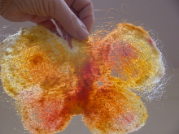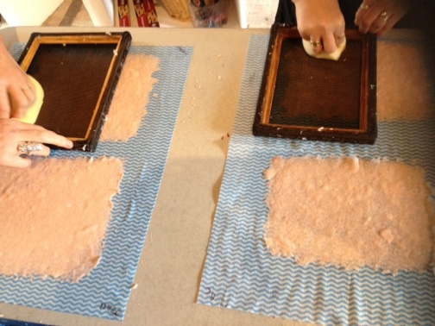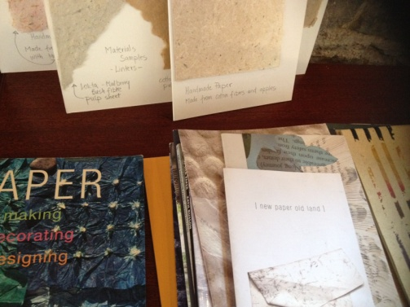

**19 April (Sunday): PAPER MAKING DAY**- ***Beginners*  
10.30am - 1.30pm HAND PAPER MAKING** - Introduction to traditional and contemporary techniques of making beautiful handmade papers from pure plant fibres and a range of recycled materials.  
**2.30 - 5.30pm SILK FIBRE PAPERMAKING**- A truly fascinating, contemporary technique for making `fabric-like`, colourful silk papers using raw silk fibres and fabric dyes. Easy to continue and set up at home, this process is ideal to create unique interior decorations and striking silk papers for artworks, embroidery, collages, card making...etc.

*Next date for this workshop: 17 May (see below)*

**Fees** for each workshop: € 35   
**OR:** € 65 for the full day - including all materials

**********

**10 May (Sunday)**  
**11am - 5.30pm FELT MAKING – wet felting** - ***Beginners***A full day workshop introducing wet felting processes using dyed and un-dyed merino wool with pure silk fibres and threads incorporated for details and added texture. Design and create your own unique bag or scarf or wall piece!  
**Fee:** € 70 for the full day, including all materials

**17 May (Sunday): PAPER MAKING DAY** – ***Beginners* and *participants with some previous experience***For details see PAPER MAKING DAY programme above (19 April)

**********

**7 June (Sunday): PAPER ART and HAND PAPER MAKING - *FOLLOW-ON, ADVANCED LEVEL COURSE -****only for participants with previous experience.*  
**10.30am - 5.30pm**  
  
Designed for participants who already work with paper/fibre based processes, this course offers assistance and guidance in areas of three dimensional, sculptural and installation based works, experimental processes of batik, paper dyeing and texturing. It also covers ideas for the preparation and use of plant based pulps (without added chemicals). Participants are encouraged to bring their own ideas and questions into the workshop and invited to show and discuss previous works and projects. The day also includes a short slideshow presentation on examples of contemporary paper art and paper making.  
**Places are limited for 5 participants.**  
€ 80 for the full day, including all materials

**********

**14 June (Sunday)**  
**11am - 5.30pm BATIK Workshop** - ***Beginners***A full day programme introducing an ancient technique of fabric dyeing where hot wax is used as a resist.  
Participants will learn all necessary basic techniques - and complete three small/medium batik pieces with up to 4 colours on cotton fabric and/or paper.  
€ 70 for the full day, including all materials

**GIFT VOUCHERS are available for the workshop of your choice!**

BOOKINGS are confirmed with € 30 deposit paid in advance.*  
Courses are run for small groups of participants only so please call to book early.  
**With any questions, for advice or check availability and for all BOOKINGS please contact TUNDE directly:**  
  
**Tunde Toth - Artist  
087-2543362**[tundetune@gmail.com](mailto:tundetune@gmail.com)[www.tundetoth.com](http://www.tundetoth.com)

[www.tundetothpaperart.blogspot.com](http://www.tundetothpaperart.blogspot.com)

* DEPOSITs are returned if the Studio has to cancel a workshop. Cancellations from participants will be accepted up to 2 weeks before the course date and deposits will be returned. In other cases participants may be offered rescheduled dates/options.



**BATIK Workshop** on Sunday **14th of June** at KOZO Studio!

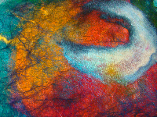

An example of a beautifully made **SILK FIBRE PAPER piece** - created at one of our previous workshops - by one of the many talented and enthusiastic participants!

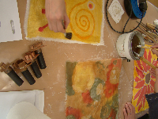

**BATIK works in the making**- during our last beginner`s workshop at KOZO Studio.

*Copyright © 2015 KOZO Studio and Gallery, All rights reserved.*

**Courses / Training / Jobs / Internships**

**Certificate in Child Protection and Welfare**

NYCI's Child Protection Programme are now inviting applications for their 'Certificate in Child Protection and Welfare' which is accredited by Maynooth University. This 100 hour course is delivered over five blocks of three days mid-week in a Dublin City Centre Venue.

It is aimed at those in key positions of responsibility in services working with young people. The course will begin in September 2015 and end in May 2016. The cost is €1000 per person for members of NYCI and €1200 for non-members.

For more information please see the information brochure below and to apply please complete and return the application form before 29th of May 2015.

<http://www.youth.ie>

# Maynooth University: Dramatherapy and Creative Writing Workshop

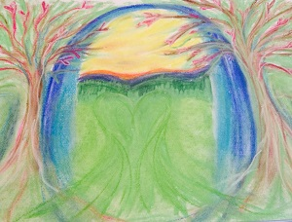

**When:** Saturday, March 21, 2015 - 10:00 to 17:00  
**Where:** Arts Building, North Campus , Maynooth University

Would you like to find out more about Dramatherapy and Creative Writing? Would you like to get your creative juices going after the Christmas break?  Come and join us on Saturday 21st March 2015 at Maynooth University for a one-day workshop on Dramatherapy and Creative Writing inspired by Joseph Campbell’s ‘The Hero’s Journey’. The day will include a creative welcome and warm up session, a seminar style introduction to Joseph Campbell’s work and an experiential workshop which will include both Dramatherapy and Creative Writing practices based on the Hero’s Journey. At the end of the day you will have experienced writing through drama therapy techniques and writing as transformation to express your creativity. We look forward to seeing you there!

Eva Lindroos and Siofra O’Donovan

* Registration is essential. To register, and for further information please contact Eva Lindroos, Subject Leader Dramatherapy MA Programme at [Eva.Lindroos@nuim.ie](mailto:Eva.Lindroos@nuim.ie)
* Places are limited and will be allocated on a first come, first served basis. Price: €65 per workshop. *A deposit of €30 is required to secure your place.
* Please send your application to [dramatherapy@nuim.ie](mailto:dramatherapy@nuim.ie). Cheques made payable to Department of English should be sent by post to Eva Lindroos, Subject Leader Dramatherapy MA Programme, Department of English, Iontas Building, Maynooth University.

**MA in Socially Engaged Art, NCAD – Call for Applications**

Applications are now being sought for the MA Socially Engaged Art (Further, Adult and Community Education). The MA SEA focuses on the dynamic relationship between socially engaged arts practice and pedagogy, particularly within further education, non-formal educational and community settings, with an embedded qualification to teach in the FE sector.

Recognising the range of methodologies used in socially engaged art that draw on educational concepts and forms, the MA SEA is a site for experimental learning and critical debate in socially engaged art and education practice.

The programme is coordinated by artist Fiona Whelan and Nuala Hunt – Head of Continuing Education in NCAD. Other staff include: artists Chris Maguire, Glenn Loughran, Ailbhe Murphy, Marie Barrett as well as adult educator Anne Gallagher and community worker John Bissett.

The MA SEA will attract students from a range of disciplines who want to immerse themselves in a trans-disciplinary enquiry. Applicants should have a Level 8 (BA Hons) degree in art or design or in another discipline with a personal and demonstrable commitment to the arts in social contexts.

For further information, see [http://www.ncad.ie/postgraduate/school-of-education/ma-in-socially-engaged-art/](http://lists.visualartists.ie/lt.php?c=1315&m=4352&nl=1&s=d3c261c0eeb6b48867f449d29e09414b&lid=104748&l=-http--www.ncad.ie/postgraduate/school-of-education/ma-in-socially-engaged-art/) or contact <huntn@ncad.ie>

Deadline for applications is 30th April 2015.

**Museums and Makers Inspiring Each Other (Seminar)**

Museums and Makers Inspiring Each Other will be held on Thursday 16 April 2015 6-8pm, Science Gallery Dublin, Naughton Institute, Pearse Street, Trinity College, Dublin 2.

Museums are often viewed as dead spaces. Yet museums contain incredible collections and inspire creativity, learning and curiosity. What is in store for the future of museums as they face numerous challenges? Can they work creatively outside the box? Makers are one such community who can inspire and collaborate with museums; both have the potential to co-create and co-curate new programmes for diverse audiences.

Join them for a discussion on some current programmes, schemes and initiatives; Museomix (France) is the first international cultural makeathon and gathers mediators, tinkerers, designers, developers, artists and scientists to create, invent, prototype and test innovative museum installations with new technologies. Festival of Curiosity, Dublin, is an annual festival of science and culture, and transforms the city into a play space of experiment, exploration, debate and interaction.

Hosted by Don Undeen, Senior Manager MediaLab at the Metropolitan Museum of Art, New York and Ellen Byrne, Festival of Curiosity, Dublin, and featuring Ian Brunswick (Science Gallery Dublin), Mark Nagurski (Culture Tech, Northern Ireland), Jasper Visser (Inspired by Coffee, Netherlands), Debbie Hustic (Radiona Hackerspace, Croatia), Laura Tobin (Dublin Maker) and Juliette Giraud (Museomix, France).

Organised by The Creative Museum EU Project, the Chester Beatty Library, in association with Science Gallery Dublin

**Over The Edge Offers Poets Worldwide Online Poetry Workshop with Kevin Higgins**   
   
Starting in very early May, Over The Edge is offering aspiring poets worldwide a ten week online poetry workshop with poet Kevin Higgins, whose best-selling first collection, *The Boy With No Face*, published by Salmon Poetry, was short-listed for the 2006 Strong Award for Best First Collection by an Irish poet. Kevin’s second collection of poems, Time Gentlemen, Please, was published in 2008 by Salmon Poetry and his poetry is discussed in *The Cambridge Introduction to Modern Irish Poetry*. His third collection *Frightening New Furniture* was published in 2010 by Salmon and his work also appears in the generation defining anthology *Identity Parade –New British and Irish Poets* (Ed. Roddy Lumsden, Bloodaxe, 2010) and in *The Hundred Years’ War: modern war poems* (Ed. Neil Astley, Bloodaxe, April 2014). A collection of Kevin’s essays and book reviews, Mentioning The War, was published by Salmon Poetry in 2012. Kevin’s poetry has been translated into Greek, Spanish, Turkish, Italian, Japanese & Portuguese. His most recent collection of poetry, *The Ghost in The Lobby*, was published in February 2014, also by Salmon. Last year, Kevin's poetry was the subject of a paper 'The Case of Kevin Higgins, or, '[The Present State of Irish Poetic Satire' presented by David Wheatley at](http://georgiasam.blogspot.ie/2014/05/the-case-of-kevin-higgins-or-present.html) a Symposium on Satire at the University of Aberdeen.   
   
Each of the ten weeks Kevin will email participants a poetry writing exercise for the following week and participants will submit one of their poems to Kevin for constructive criticism. Kevin will work with participants on making each of their poems the best possible poem it can be.  
   
Kevin is a highly experienced workshop facilitator and several of his students have gone on to achieve publication success. He has facilitated poetry workshops at Galway Arts Centre for the past ten years. One of his workshop participants won the prestigious Hennessy Award for New Irish Poetry; two have been shortlisted for the Shine/Strong Award for Best First Collection by an Irish poet; two have won the Cúirt New Writing Prize; and another the Cúirt Poetry Grand Slam; several have published collections of their poems with reputable publishers.  
   
The workshop will run for ten weeks, commencing **Wednesday May 6th**. The cost to participants is €110. There are no refunds. The workshop will be conducted in English only.   
  **YOU CAN REGISTER ONLINE NOW**  
<http://www.overtheedgeliteraryevents.blogspot.ie/2014/02/over-edge-offers-poets-worldwide-online.html>

# CreateSound.ie: Mobile Music-Making Workshops (Dance, Hip Hop, etc)

CreateSound logo

We run hands-on workshops and classes in community projects, youth centres and schools where participants get to make music in modern genres such as Hip Hop and Dance Music. We provide ALL the equipment (e.g. laptops, software, keyboards etc) so that it’s convenient, accessible and so that you don’t need to worry about spending money on these things! Students get to engage in a creative activity, through music styles they enjoy whilst also getting valuable experience using the latest computer hardware and software.

We have various options to suit different budgets (e.g. short once-off workshops or a series of classes) along with occasional funded programmes. Workshops are always geared toward an outcome such as finished individual tracks, a public performance or music produced for a community event.

From experience, this activity works best with smaller-sized groups of teens or older, and when participants already have an interest in music.  We mainly operate in Leinster and Ulster, but run programmes further afield depending on duration. Please call or email for more information.

**Phone:** 086 1296995  
**Email:** [info@createsound.ie](mailto:info@createsound.ie)

Video & further info online: [www.createsound.ie](http://www.createsound.ie/)

Examples locations: <https://www.google.com/maps/d/edit?mid=zL7n2teyWJk8.kN5aXXT8QXSM>

Examples of student music: <http://www.createsound.ie/#/sounds/4572448276>

**Curatorial Internship Opportunities at The Hunt Museum**

Hunt Museum, Rutland Street, Limerick

The Hunt Museum is currently seeking applications for 3 and 6-month unpaid internships in its award-winning Education and Public Programmes Department to commence in Summer/Autumn 2015 and Winter 2016. Shorter-term internships (3 months) are also available.

The Hunt Museum offers several internships throughout the year to students, recent graduates and early-career Museum professionals. Interns get hands-on experience in the day-to-day operation of The Hunt Museum’s Education Department and have the opportunity to develop a project during the period of their internship under the supervision of Dr Dominique Bouchard, Curator of Education and Outreach. Recent Education and Public Programme Internship alumni have found paid employment at institutions including the British Museum (UK), Lowry Arts Centre (UK), Bishop’s Stopford Museum (UK), the Centre Pompidou (France), and the Waikato Museum (New Zealand).

We are currently seeking applications for the Education and Public Programmes Curatorial Internship.

Curatorial Internship – Education and Public Programmes (6 or 12 months).

Curatorial interns play a key role in the development of The Hunt’s interpretation, public programmes and education initiatives. Interns will have opportunities to gain experience in project management, programme development, interpretation, audience development, and digital media. Past interns have created films, helped curate exhibitions, create and manage festivals and events, contribute to interpretation, present their work at museum conferences, and have even published articles!

Specifications and application form can be downloaded directly from The Hunt’s website here: [http://goo.gl/1uzwRS](http://lists.visualartists.ie/lt.php?c=1307&m=4344&nl=1&s=e784eec6bf8bb9680747b324b9c9eee1&lid=103541&l=-http--goo.gl/1uzwRS%20) or request an application pack by emailing dominique@huntmuseum.com.

Deadlines:  
– Summer 2015 (May/June – Nov/Dec 2015): NOW OPEN – please apply ASAP  
– Autumn 2015 (1 Sept – 15 March 2016): 5.00pm Friday 15 May 2015  
– Winter 2016 (Dec/Jan 2015/6 – 15 June 2016 – ): 5.00pm Friday 25 September 2015

Short-listed applicants will be invited by email to interview 2-3 weeks following the application deadlines above. We regret that due to the volume of applications received only short-listed candidates will be contacted.

The Hunt Museum exhibits one of Ireland’s greatest private collections of art and antiquities, dating from the Neolithic to the 20th Century, and includes works by Renoir, Picasso and Jack B. Yeats. The Museum is housed in an elegant Palladian-style building designed by the Italian architect, Davis Ducart, in 1765. Today, The Hunt Museum is a cultural and artistic centre in Limerick providing a wide range of education, heritage and culture activities including a vibrant schools programme, curatorial lectures and family focused events. [www.huntmuseum.com](http://lists.visualartists.ie/lt.php?c=1307&m=4344&nl=1&s=e784eec6bf8bb9680747b324b9c9eee1&lid=103542&l=-http--www.huntmuseum.com/)

**Local Authority Education Curator, Co. Dublin**

Dún Laoghaire-Rathdown County Council is seeking expressions of interest from professional Education Curators who have experience in creating opportunities for the general public to engage with artworks

Dún Laoghaire-Rathdown County Council Arts Office is seeking to appoint an Education Curator to create opportunities for the general public to engage with the County Collection by curating an exhibition of artworks from the County Collection and devising and co-ordinating a public engagement series for the casual visitor based on the artworks on show.  
  
Project Fee: €3,210

Closing date for applications: 26 March 2015

<http://www.dlrcoco.ie/arts/Call%20out%20for%20Curator%20Educator%20for%20County%20Collection%20Final.pdf>

**Call for Submissions / Residencies**

**Public Art Work, Cashel Tipperary Municipal District Office**

Tipperary County Council invites submissions for a public art work to be situated on the Plaza at Cashel-Tipperary Municipal District Office, Rosanna Road, Tipperary Town.

The Budget for the commission is €18,000.

Full Details of the Brief and Application forms are available on [www.etenders.gov.ie](http://www.etenders.gov.ie) , [www.tipperarycoco.ie](http://www.tipperarycoco.ie) or from the Cashel Tipperary Municipal District Office, Rosanna Road, Tipperary Town, Tel 0761 06 5720

Closing date for submissions is 4pm Friday 24th April 2015.

**Lost Spaces 2015: Call for Ideas**

The Lost Spaces design competition asks professionals and students in the fields of art, architecture, design and engineering to respond to the diverse challenges of design, social sustainability and low impact design improvements. The ideas competition aims to explore alternatives improving the use, public realm and ecological value of a lost space.

A ‘lost space’ is any space that remains underutilized within our urban environment. They might be leftover pieces, a ghost of the planning past. Lost spaces are part of the public realm, rarely designed to function with both social and environmental benefit to the city.

You may consider a lost space as a passageway, a roundabout, space between two buildings, a highway shoulder, or tenants of the city’s history and memory. We’d like to ask you to dream, take risks and stretch what we think is possible.

Award $7500 CAD  
Registration and questions deadline: March 20, 2015  
Submissions due: March 30, 2015

This international ideas competition is open to artists and designers anywhere. Unique perspectives of diverse disciplines and collaborative teams is encouraged. See the call for ideas link for specifics about tailoring your idea to the local climate conditions.

[http://dtalks.org/call-for-ideas](http://lists.visualartists.ie/lt.php?c=1289&m=4326&nl=1&s=d3c261c0eeb6b48867f449d29e09414b&lid=101956&l=-http--dtalks.org/call-for-ideas)

**‘SECRET’ Exhibition at Science Gallery Dublin | Call for Submissions**

Science Gallery, Trinity College, Dublin

Science Gallery Dublin are seeking proposals for upcoming exhibition, SECRET, which opens to the public on August 7th 2015. SECRET will be an international exhibition and events programme exploring the social and technological aspects of secrecy, particularly the future of surveillance, espionage and privacy. Encompassing cryptography, leaks, hidden messages, secret satellites, big data, conspiracy theories, puzzles, easter eggs and cryptocurrencies, SECRET will explore how hackers, spies, journalists, psychologists, criminals, companies and governments are exploring the new world of secrets.

Do you have an artwork that shows secrecy in a new light? Are you designing a device that will change everything from privacy to piracy? Or maybe you research the psychological drive to keep secrets or solve puzzles? We want your exhibit, installation and event ideas.

To find out more about what we’re looking for, budget, and some helpful tips on what helps make a successful Science Gallery Open Call proposal, please visit [opencall.sciencegallery.com](http://lists.visualartists.ie/lt.php?c=1307&m=4344&nl=1&s=e784eec6bf8bb9680747b324b9c9eee1&lid=103507&l=-http--opencall.sciencegallery.com).

The Open Call for SECRET will close at 12pm on 26th March 2015.

[https://opencall.sciencegallery.com/secret](http://lists.visualartists.ie/lt.php?c=1307&m=4344&nl=1&s=e784eec6bf8bb9680747b324b9c9eee1&lid=103508&l=-https--opencall.sciencegallery.com/secret)

|  |  |
| --- | --- |
| |  | | --- | |  | |
| |  |  |  | | --- | --- | --- | | |  |  | | --- | --- | | |  | | --- | | https://gallery.mailchimp.com/8e6585bf9e0ad43eb3a6b8e34/images/f42c6cd4-e3a9-4497-964f-4f1b3270d745.jpg | | | |
| |  |  |  |  |  |  |  |  |  |  | | --- | --- | --- | --- | --- | --- | --- | --- | --- | --- | | |  |  | | --- | --- | | |  | | --- | |  | | | |  | | --- | | ****Calling all artists!**** L****andscape Artist of the Year 2015**** **Now open for entries, the Sky Arts Landscape Artist of the Year competition is a search for Britain and Ireland's very best landscape artists. The competition is free to enter and the prize is £10,000 commission for the National Trust's permanent collection.**  **The competition provides an opportunity for amateur and professional artists to showcase their talent, develop their skill and enjoy national exposure on a prime-time television programme.**  ****Selection Panel:****  **Kathleen Soriano - Independent Curator and Art Historian**  **Tai-Shan Schierenberg - Artist**  **Kate Bryan - Fair Director for Art 15**  **Prize:  £10,000 commission for The National Trust**  ****How To Enter:****  **Open to all artists, professional and amateur alike. Each applicant must submit at least two landscape paintings and a third of any genre is allowed. Entries can be in any material (excluding photography, video, sculpture and all forms of digital media). Collage & mixed media are allowed.**  **Applicants must be 16+**  ****Deadline for entries 20th March 2015 by 12pm GMT****  ****For further information and to apply:**** [www.sky.com/landscape](http://www.sky.com/landscape)  ****Twitter: @Landscape2015 #landscape2015 @skyarts****  ****For all enquiries, please contact the competition organisers, Storyvault Films****  ****E:**** [artist@storyvault.tv](mailto:artist@storyvault.tv) ****T: 020 8741 3929**** | | | |  | | --- | |  |  |  | | --- | |  | | | |  | | --- | |  | | | |

**Light Work Artist-in-Residence Program**

Each year Light Work invites 12-15 artists to participate in its residency program, including one artist co-sponsored by Autograph ABP and one artist in conjunction with the Urban Video Project (UVP). Artists selected for the residency program are invited to live in Syracuse for one month. They receive a $5,000 stipend, an apartment to stay in, a private digital studio, a private darkroom, and 24-hour access to our facility.

Participants in the residency program are expected to use their month to pursue their own projects: photographing in the area, scanning or printing for a specific project or book, and so on. Artists are not obligated to lecture at our facility, though we hope that the artists are friendly and accessible to local artists and students. Work by each Artist-in-Residence becomes a part of the Light Work Collection and is published in a special edition of Contact Sheet: The Light Work Annual along with an essay commissioned by Light Work.

Questions? : Questions about the facility may be directed to [lab@lightwork.org](mailto:lab@lightwork.org) and questions about the application process or residency can be sent [toair@lightwork.org](mailto:toair@lightwork.org).

**Deadline 1 July 2015**

For information about our facilities, see [www.lightwork.org/lab](http://www.lightwork.org/lab)

**Call for Nominations: Celebrating partnership between Business and the Arts**   
  
For 24 years, the Allianz Business to Arts Awards have recognised businesses, artists and arts organisations that develop creative partnerships, bringing the arts and artists into mutually beneficial relationships across society. We invite you to share the stories of your partnerships, and join our alumni.  
  
Winning projects demonstrate that working together these sometimes diverse worlds can come together to create brilliant art, unforgettable experiences and long-held memories which enhance the character and reputation of all involved.  
  
In 2015 Business to Arts will place a marker in the sand - through the creation of the first annual report on Arts Sponsorship. This unique piece of research will be based on a short series of questions put to nominating sponsors, and will aim to give a snapshot of investment sentiment across business sectors.  
  
Nominate your partnerships to the Allianz Business to Arts Awards - to demonstrate your pride in what you have achieved; to seek to join the prestigious list of winners which represent the very best models developed between the corporate and cultural worlds in Ireland; and to ensure that your investment in arts and culture takes its place proudly in the landscape which will be recorded and mapped through the Awards process this year and subsequently.  
  
We can't map this landscape without your nominations.  
  
Winners receive a limited edition sculpture commissioned by daa, presented at a ceremony in September.  
  
**Award Categories**  
As well as arts sponsorship, the Awards recognise examples of arts and business organisations working together in other areas such as mentoring, training, staff engagement or development, commissioning artists, CSR initiatives, community engagements etc.  
  
1. Best Large Sponsorship (value over €25,000 cash or in-kind)  
2. Best Small Sponsorship (value €25,000 or under, cash or in-kind)  
3. Best Long Term Partnership (3 years or more)  
4. Best Use of Creativity in the Community  
5. Best Creative Staff Engagement  
6. Jim McNaughton Perpetual Award for Best Commissioning Practice  
7. Jim McNaughton/TileStyle €10,000 Artist's Bursary  
8. daa €5,000 Arts Award  
9. Allianz €5,000 Community Art Prize  
9. Judges' Special Recognition Award for Portfolio of Arts Sponsorship  
  
**Closing date for nominations: 5pm, Tuesday 5 May 2015**  
  
Click [here](http://cts.vresp.com/c/?BusinesstoArts/626e7ee420/608128ad7e/bc3e1b7679) for information on the application process, the Awards alumni of past winners, and to complete the application form.  
   
**#ABtoAAwards**

**RDS National Craft Awards 2015: Call for Entries**

**[Please note a nominal fee applies]**

The RDS is now calling for entries for the 2015 RDS National Craft Awards which has an increased prize fund of €40,000. The annual RDS National Craft Awards showcase and reward excellence in Irish craft.

Major Awards:

* RDS Award of Excellence €5,000 (top prize awarded in each strand)
* Irish Design 2015 Award €5,000 (open to emerging & established category winners)
* RDS IACI Muriel Gahan Award €2,000 (emerging maker)
* RDS Graduate Award €2,000 (emerging maker)
* National Crafts & Design Fair Award (value €2,000, emerging maker)
* RDS William Smith O’Brien Perpetual Challenge Cup (open to emerging & established makers)

The category prizes in the 2015 RDS National Craft Awards are sponsored by the Design & Crafts Council of Ireland. This year the 13 category prize winners in each strand will receive €500 as well as an RDS medal & certificate. There is also a special additional €5,000 prize to celebrate Irish Design 2015, which will be awarded for design innovation and excellence in a craft entry this year.

See [www.rds.ie/craft](http://lists.visualartists.ie/lt.php?c=1315&m=4352&nl=1&s=d3c261c0eeb6b48867f449d29e09414b&lid=104719&l=-http--www.rds.ie/craft)  for details of the many other sponsored prizes and to view the rules of entry.  
Winning and selected entries will be shown at the RDS National Craft Awards Exhibition at the Discover Ireland Dublin Horse Show, RDS, August, 2015, and award winners will be shown at the National Crafts and Design Fair, RDS, December, 2015.

Enter online at [www.rds.ie/craft](http://lists.visualartists.ie/lt.php?c=1315&m=4352&nl=1&s=d3c261c0eeb6b48867f449d29e09414b&lid=104720&l=-http--www.rds.ie/craft%C2%A0)  
Deadline 10 June 2015

**Impressions Fine Art Print Expo 2015 | Call for Submissions**

Established in 1988, Impressions is Ireland’s longest running open submission print exhibition. It encourages, promotes and exhibits the best of printmaking in Ireland. As the first and longest running national Open Print exhibition ‘Impressions’ sees itself as a vital platform to make this creativity visible and a means to highlight the amount of activity in, and enthusiasm for this art form.

‘Impressions’ is already becoming a ‘landmark’ show in the Irish Arts Calendar and the aim is to continue to broaden the scope and ambition of the exhibition, to profile innovation and new technologies and to draw attention to the particular qualities and potentials of the medium.

**Online submissions are now open and will close on April 10th.**

[www.impressionsbiennial.com](http://lists.visualartists.ie/lt.php?c=1280&m=4318&nl=1&s=d3c261c0eeb6b48867f449d29e09414b&lid=101285&l=-http--www.impressionsbiennial.com/) | [www.facebook.com/impressionsprint](http://lists.visualartists.ie/lt.php?c=1280&m=4318&nl=1&s=d3c261c0eeb6b48867f449d29e09414b&lid=101286&l=-https--www.facebook.com/impressionsprint)

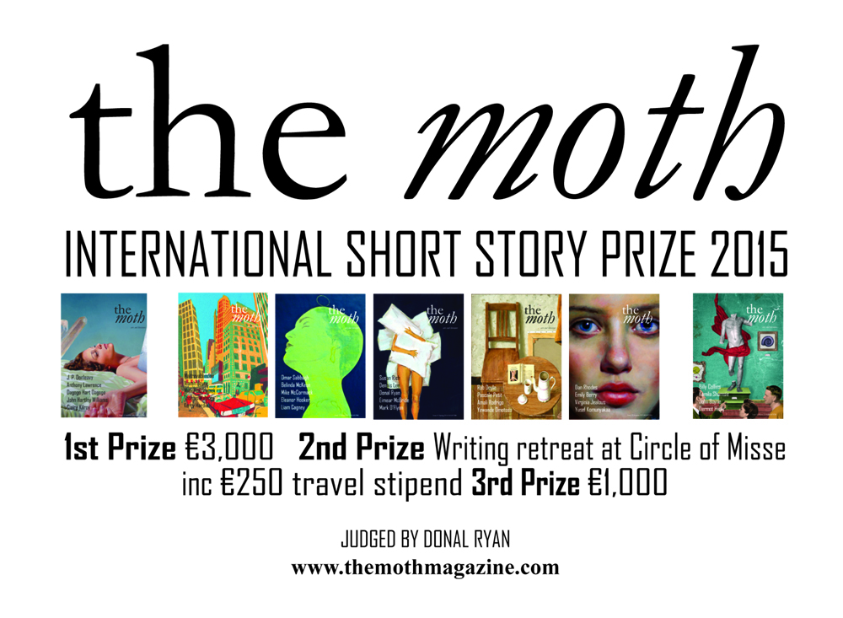

Donal Ryan judges this year's Moth Short Story Prize, with prizes of €3,000, a week-long writing retreat at [Circle of Misse](http://www.circleofmisse.com/) in France (including a €250 travel stipend) and €1,000.

There's a word limit of 6,000, and an entry fee of €12.

**Closing date 30 June 2015**.

**Red Line Book Festival:** Call for Submissions for 2015 Festival

11-17 October 2015

The Red Line Book Festival is a curated festival. Participation is by invitation only with writers selected by the festival curatorial team. Writers wishing to be considered for presentation in the Red Line Book Festival 2015 are invited to submit proposals and ideas to the Festival selection panel. The submission process is open to everyone living on the island of Ireland. There is no fee to submit proposals. The closing date for submissions is April 15th 2015.

<http://www.redlinebookfestival.com>

**Awards / Bursaries / Schemes**

**2014/2015 Dates and Deadlines for Culture Ireland Grant Rounds**

Please note Culture Ireland has set funding rounds and deadlines for 2015. There will be three funding rounds in 2015 and seperate calls for showcasing opportunities and Edinburgh Festivals will be announced during the year.

**Application Deadline | Timing of Project/Event | Decision Due**

* 15 June 2015  | September 2015 onwards | Early August
* 15 October 2015 |  January 2016 onwards | Early December

[http://www.cultureireland.ie/](http://lists.visualartists.ie/lt.php?c=1232&m=4271&nl=1&s=d3c261c0eeb6b48867f449d29e09414b&lid=96096&l=-http--www.cultureireland.ie/)

**Young Ensembles Scheme 2015**

|  |
| --- |
| http://newsletter.artscouncil.ie/nwstatic/spacer.gif |

The Young People, Children and Education (YPCE) Team wishes to advise that applications will be accepted for the Young Ensembles Scheme 2015 from Tuesday 10 March 2015 for projects taking place between July 2015 and June 2016.

The primary purpose of this award is to support groups of young people between the ages of 12 and 23 to create ambitious and original work together in any art form (e.g.; circus, dance, digital media, film, music, theatre, literature, visual arts, architecture or any combination of the above). Groups/ensembles must be made up of 3 or more members. The maximum award available is €10,000. The deadline for the Young Ensemble Scheme 2015 is **Thursday 9 April 2015 at 5:30pm.**

**Further information**

 Young Ensembles Scheme 2015 guidelines are available to download at [www.artscouncil.ie](http://www.artscouncil.ie) If you require further information, please contact Karen Whelan, YPCE Assistant at 01 619 7805 or [Karen.whelan@artscouncil.ie](mailto:Karen.whelan@artscouncil.ie)

**Arts and Disability Connect**

|  |
| --- |
| http://newsletter.artscouncil.ie/nwstatic/spacer.gif |

The Arts Council and Arts & Disability Ireland announce the second phase of Arts and Disability Connect, a new awards scheme for artists with disabilities in the Republic of Ireland. Supported by the Arts Council the scheme will have a fund of €25,000 to distribute in 2015.

Specifically targeted at individual artists with disabilities Arts and Disability Connect includes New Work, Mentoring and Training awards. The scheme offers artists the opportunity to: connect with other practitioners or venues; make a change in their practice; ‘step up’ in terms of scope and scale; reach new audiences and to engage in mentoring and training.  
  
  
Application forms and guidelines for 2015 will be available to download from Thursday 2 April 2015 at [www.adiarts.ie](http://newsletter.artscouncil.ie/brj9j540ptj14rbsgtdsq9?a=6&p=48507525&t=28179891)

**Deadline: Thursday 21 May 2015 at 4pm**

For general queries about the awards please contact:   
[info@adiarts.ie/](mailto:info@adiarts.ie/) 01 8509002

**Deis Recording & Publication Award**

|  |
| --- |
| http://newsletter.artscouncil.ie/nwstatic/spacer.gif |

The deadline for the next round of the Arts Council's Deis Recording & Publication Award is **Thursday 9 April, 2015 at 5.30pm**. The window for making an application opens on Tuesday 10 March 2015.

The purpose of the Deis Recording and Publication Award is to provide support for traditional arts recording projects, or recording projects involving collaboration between the traditional arts and other artforms and for projects centred on the publication of work, such as tutors, tune collections and critical writing that are in line with the Arts Council’s policy on the traditional arts.

Priority will be given to projects that demonstrate:

* Attention to artistic quality
* Innovation
* Significant benefit to the traditional arts community.

The award is open to individuals, groups, ensembles or organisations.

Award Guidelines for the Deis Recording & Publication Award are published on the [available funding](http://newsletter.artscouncil.ie/tecusf95nej14rbsgtdsq9?a=6&p=48507526&t=28179891) section on our website.

Applications will only be accepted through the Arts Council’s [online services](http://newsletter.artscouncil.ie/1uo5ikiywno14rbsgtdsq9?a=6&p=48507526&t=28179891) website. The **applicant must be registered,** with the online services site prior to making an application. It is recommended that applicants **allow five working days for registration** prior to making an application.

**Touring and Dissemination of Work scheme – January to June 2016**

|  |
| --- |
| http://newsletter.artscouncil.ie/nwstatic/spacer.gif |

The deadline for applications for tours beginning in the period January to June 2016 will be **Thursday 7 May 2015**. Application forms and guidelines will be available online from 7 April 2015.

As in previous rounds of this scheme, applicants are also welcome to apply for north/south tours. The same priorities and criteria will apply to both jurisdictions, and applications, as at present, will need to show a working engagement between producers and venues.

Arts Audiences is running pre-application workshops aimed at any organisation or individual considering applying for funding under the upcoming Touring and Dissemination of Work Scheme. These workshops are aimed at those who have applied before, and/or toured before, as well as those who are new to the application. The workshop is for applicants who have developed their ideas, to help with specific areas, and answer questions.

Two workshops will take place in Galway, Wednesday 1 April and in Dublin, Thursday 2 April.

All administration for this scheme will be done by the Arts Council / An Chomhairle Ealaíon and general inquiries can be directed to val.ballance@artscouncil.ie

**The Arts Council Programme for Ireland 2016: Open Call to the Irish Imagination**

Ireland is on the eve of a great anniversary; the centenary of the proclamation of the republic. The Arts Council, through support from the Department of Arts, Heritage and the Gaeltacht, is charged with remembering, celebrating and interrogating the Centenary of the Easter Rising 1916 in art and ideas. In the century since, artists have been the chief signifiers of our nation. Their work, created in hope, has been the enduring imaginative life of what Ireland can become.

The Arts Councils programme as part of Ireland 2016 will take place across the full year. The open call we announce today as part of our programme represents a unique opportunity for artists and arts organisations to invigorate the Irish imagination. We will invest €1 million in major commissions as part of Ireland 2016. The work will be presented to the public in 2016 and will represent a key response by our contemporary artists to the centenary of the Easter Rising.

The open call for national projects is open to all individuals and organisations who are resident in the state, although the Arts Council may accept an application from outside Ireland in exceptional circumstances and where the final outcome will benefit the arts in the state. Projects will be selected by a Jury made up of two international experts, a national expert and two members of the Arts Council. It will be chaired by the Chair of the Arts Council, Sheila Pratschke.

In recognising the part played by artists in the events of 1916, and in recognising the role of the artist in contemporary Ireland, a series of special bursaries for emerging artists will also be funded. These Bursaries will enable a new generation of artists to develop their practice and provide them with the opportunity to reflect on the role of artists in Irish society in 2016.

**Open Call for National Projects**  
1 million will be available for ambitious projects, in any artform, up to €500,000 and with no lower limit  
Closing date for initial applications is 15 April 2015

**Artists’ Bursaries**  
There will be 16 bursaries, each to the value of €12,500  
Closing date for completed bursary applications is 16 July

**Touring Programme**  
An additional allocation will be made to the 2016 Touring and Dissemination of Work Scheme  
Closing dates:  
7 May 2015 for tours from January to June 2016  
3 December 2015 for tours from July to December 2016

Full details for those considering applying are available on the Arts Council website  
[www.artscouncil.ie/Ireland2016](http://lists.visualartists.ie/lt.php?c=1313&m=4350&nl=1&s=d3c261c0eeb6b48867f449d29e09414b&lid=104361&l=-http--www.artscouncil.ie/Ireland2016)

**Arts Council announces deadlines for schemes in Dance and Theatre**

|  |
| --- |
| http://newsletter.artscouncil.ie/nwstatic/spacer.gif |

The application window for the next round of Dance and Theatre Schemes will open on **Tuesday 17 March** next. The deadline for the new schemes is **5.30pm on Thursday, 16 April 2015**. Applications will be accepted through the Arts Council’s Online Services Website.

The schemes are:

[**Dance Artist Residency**](http://newsletter.artscouncil.ie/1fd29db4i6l14rbsgtdsq9?a=6&p=48378404&t=28179891) – The purpose of this scheme is to stabilise and support a network of dance artists in residence across the country.

The aims of this scheme are:

* to consolidate both professional and community based dance practice in a variety of regional contexts;
* to offer opportunities to dance artists around the country to engage in a programme of artistic work relevant to their own practise;
* to offer opportunities to local authorities and venues to develop dance practise in their area;
* to encourage the development of long-term planning and sustainability of independent dance activities.

[**Theatre Artist Residency**](http://newsletter.artscouncil.ie/66nhpk8pt3f14rbsgtdsq9?a=6&p=48378404&t=28179891) – The purpose of this scheme is to offer theatre artists the opportunity to create a year-long work programme in partnership with venues and local authorities. The specific contents of the work programme will be designed by the theatre artist on collaboration with the local authority and/or venue.

The aims of this scheme are:

* to offer opportunities to theatre artists across the country to engage in a  programme of artistic work relevant to their own practice;
* to offer opportunities to venues and local authorities to develop theatre practice in their area;
* to encourage the development of long-term planning and sustainability of independent theatre activities;
* to encourage a co-ordinated approach between key arts providers at local/ regional level.

[**Theatre Artist Development Funding**](http://newsletter.artscouncil.ie/q8b7p8r9v3t14rbsgtdsq9?a=6&p=48378404&t=28179891) – the purpose of this scheme is to offer theatre and other arts organisations the opportunity to offer developmental or training programmes to groups of individual theatre artists in a mentored environment, or to offer opportunities to groups of theatre artists to propose their own developmental ideas to organisations.

The aims of this scheme are as:

* to offer opportunities to theatre artists to develop their practice in a supported way;
* to offer opportunities to organisations who undertake development and/or training initiatives to fund those activities directly;
* to encourage the development of long-term planning and sustainability of development and training activities within professional theatre.

[**Theatre Resource-Sharing Funding**](http://newsletter.artscouncil.ie/1asxmnk9gt314rbsgtdsq9?a=6&p=48378404&t=28179891) – The purpose of this award is to offer organisations the opportunity to share administrative and production resources with a number of individual theatre artists over a specified period of time.

The aims of this scheme are:

* to offer administrative and/or production assistance to theatre artists[[1]](http://newsletter.artscouncil.ie/1nu9u48qr9214rbsgtdsq9?a=6&p=48378404&t=28179891" \o ") in developing projects and ideas;
* to offer opportunities to organisations who facilitate and support the development of theatre artists’ projects to fund those activities directly;
* to encourage the strategic planning and sustainability of resource sharing activities within professional theatre.

Guideline documents offering details on each scheme will be available on the website in advance of the closing date. [www.artscouncil.ie](http://www.artscouncil.ie)

**Arts Council’s Artist in the Community Scheme – Deadlines 2015**

Twice yearly, the Arts Council offers grants to enable artists and communities of place/or interest to work together on projects. The Artist in the Community Scheme is managed by Create, the national development agency for collaborative arts.

The scheme is open to artists from any of the following artform disciplines: architecture, circus, street art and spectacle, dance, film, literature (Irish and English language), music, opera, theatre, visual arts and traditional arts. The projects can take place in a diverse range of social and community contexts eg arts and health; arts in prisons; arts and older people; arts and cultural diversity.

The aim of the scheme is to encourage meaningful collaboration between communities of place and/or interest and artists. It is essential that consultation take place between the artist and the community group, so that both parties are involved in deciding on the nature of the project realisation. Group ownership of the art should be maintained at every stage. The Project Realisation may result in a variety of outcomes.

There are two phases to the scheme. Phase One [Research & Development,](http://lists.visualartists.ie/lt.php?c=1289&m=4326&nl=1&s=d3c261c0eeb6b48867f449d29e09414b&lid=101957&l=-http--www.create-ireland.ie/artist-in-the-community-scheme-research-and-development-award.html) is open to artists who wish to research and develop a project in a community context.

There is also a [Research & Development/Mentoring](http://lists.visualartists.ie/lt.php?c=1289&m=4326&nl=1&s=d3c261c0eeb6b48867f449d29e09414b&lid=101958&l=-http--www.create-ireland.ie/artist-in-the-community-scheme-research-and-development/mentoring-award.html) strand, open to artists who wish to develop a community based project and who have identified an artist mentor they want to work with during the research and development phase.

Phase Two [Project Realisation](http://lists.visualartists.ie/lt.php?c=1289&m=4326&nl=1&s=d3c261c0eeb6b48867f449d29e09414b&lid=101959&l=-http--www.create-ireland.ie/artist-in-the-community-project-realisation-award.html) , is open to communities of interest or place (or their representative organisations) with an artist.

**2015 Deadlines:  
(Round 2)   29 June 2015**

For information on the Scheme and advice on applying, contact Katherine Atkinson, [support@create-ireland.ie](mailto:support@create-ireland.ie) or phone 01-4736600  
Visit [http://www.create-ireland.ie/about-the-artist-in-the-community-scheme.html](http://lists.visualartists.ie/lt.php?c=1289&m=4326&nl=1&s=d3c261c0eeb6b48867f449d29e09414b&lid=101960&l=-http--www.create-ireland.ie/about-the-artist-in-the-community-scheme.html)

**_____________________________________________________________________________________**

**Of Interest**

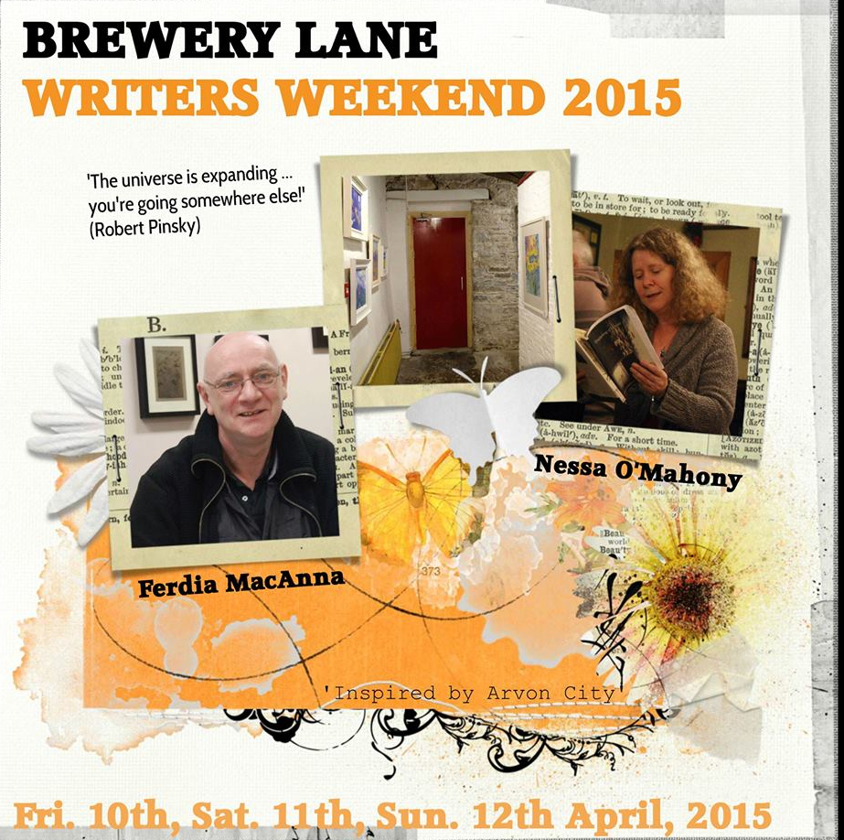

**Brewery Lane Writers’ Weekend**

**Fri. 10th, Sat. 11th, Sun. 12th April 2015**

**Inspired by** [**Arvon City**](http://www.arvon.org/blog/my-arvon-week/2014/04/cindy-george-arvon-city-weekend/)

**Fee: €160 early bird if paid by Thursday 12th Feb or €175 if paid later**

*'The universe is expanding ... you're going somewhere else!'* (Robert Pinsky).

Join writers Ferdia MacAnna & Nessa O'Mahony for three days of writing in the intimate setting of Brewery Lane Theatre, Carrick-on-Suir. Expand and develop your range of writing skills and learn how techniques used in screenwriting, poetry and memoir can help to expand your writing toolkit. You will work with Nessa & Ferdia, two experienced writers and teachers of writing, over three full days, exploring the link between real life and imagination and discover new ways of identifying and transforming material. There will be facilitated workshops, one-to-one sessions and time for you to write.

For booking details please email Margaret O'Brien: [margaretwriting@gmail.com](mailto:margaretwriting@gmail.com)

**Waterford New Music Week 2015**

Now in its 17th year, Waterford New Music Week is an annual festival presented by the Department of Performing & Creative Arts, School of Humanities, Waterford Institute of Technology and Garter Lane Arts Centre, celebrating and promoting contemporary music in formal and informal settings throughout Waterford city,

The festival programme includes two seminars Monday 23rd that will be of interest to all film fans.   
  
PRE-COMPOSED MUSIC FOR FILM  
  
10.15 – 11.15 am { GARTER LANE GALLERY }   
  
WIT music students Pat O’Connor & John O’Hanlon discuss Scorcese’s Shutter Island & Kubrick’s 2001: A Space Odyssey in relation to the use of pre-composed music by composers such as Ligeti & Penderecki, & the suitability of this music to the Sci-Fi & Horror genres.   
  
Admission Free, All welcome.   
  
POST-PRODUCTION SOUND  
  
11.30 – 12.30 pm { GARTER LANE GALLERY }   
  
Award winning sound designer, editor and re-recording mixer Steve Fanagan of Ardmore Sound & Screenscene will give a presentation on post-production sound for film in relation to Frank which won British Independent Film Award in 2014.   
  
Admission Free, All welcome.

<https://www.facebook.com/WaterfordNewMusicWeek?ref=ts&fref=ts>