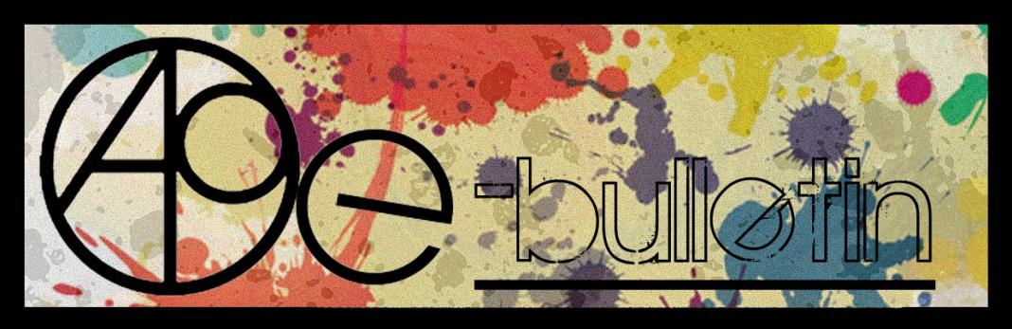

**Kilkenny County Council Arts Office E-bulletin 26th June 2015**

Dear All,   
  
Welcome to the fortnightly e-bulletin from Kilkenny County Council's Arts Office. Each bulletin is packed with the latest information on Kilkenny Arts Office activities, county events as well as news and opportunities for arts practitioners from around the country.

**This service will be temporarily suspended due to limited staff numbers. We are happy to promote events and activities through our Facebook and Twitter account ‘Kilkenny Arts Office’ so please continue to send information through for uploading to the address** [**artsoffice@kilkennycoco.ie**](mailto:artsoffice@kilkennycoco.ie)

While every effort has been made to ensure the accuracy of our information, we strongly advise readers to verify all details to their own satisfaction.

Regards,

Niamh Brophy  
Arts Office,  
T: 056 7794138  
E: [niamh.brophy@kilkennycoco.ie](mailto:niamh.brophy@kilkennycoco.ie)   
W: [www.kilkennycoco.ie/eng/Services/Arts/](http://www.kilkennycoco.ie/eng/Services/Arts/)

BECOME PART OF IT, SUBMIT A POEM.....[www.rhymerag.net](http://kk-moss/Sites/arts_office/Shared%20Documents/Julianne%20Morgan/E-bulletin/30th%20May%20e-bulletin/www.rhymerag.net)  
Kilkenny County Council Arts Office Partner Local Authority of the ArtLinks Programme [www.artlinks.ie](http://www.artlinks.ie)

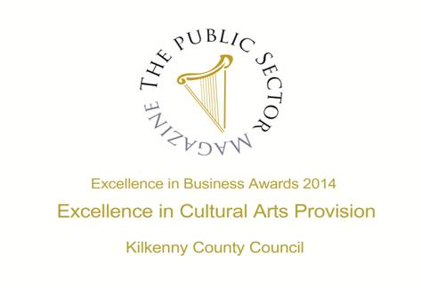

|  |  |
| --- | --- |
|  |  |
|  |  |

**Arts Office**

* [Opening - STILL, WE WORK: Representations of Women and Work](https://www.facebook.com/events/463190627190375/?ref=1&feed_story_type=263&action_history=%5B%7B%22surface%22%3A%22permalink%22%2C%22mechanism%22%3A%22surface%22%2C%22extra_data%22%3Anull%7D%5D)

**Kilkenny Events**

* Fennelly’s Late Night Sessions
* “The Art of Ability” exhibition by the Irish Wheelchair Association
* Chapter Room Concert - St. Canice’s Cathedral
* Bridge Street Project
* Abhainn Rí Festival 2015
* 'Clay is my Canvas' **an Exhibition of New Ceramic Artwork by Karen Morgan**
* **‘On the Bright Side’ Exhibition of Andrew Pike**
* Butler Gallery: Call for Submisions
* Meadow’s Bloom Hedge School
* Ale Mercado’s Illustrating Exhibition ‘Exile’ at Cork Community Printshop
* Starburst Summer Camp
* On the Bright Side Retrospective Exhibition of Andrew Pike
* Summer Art Courses at Rothe House
* **Hollow Sounds at Ballykeeffe Amptheatre**
* Ballykeeffe Amphitheatre Kilmanagh Summer Concert Schedule
* Devious Theatre Company: The Union performs this July
* Coming Soon to the Watergate Theatre
* KOZO Workshop Programme 2015
* Creative Summer Camp
* Upcoming Events at the Watergate Theatre

**Courses / Training / Jobs / Internships**

* **Drama League of Ireland 50th Annual Summer School**
* Your Sponsorship Offering - Introductory Workshop
* Shinnors Scholar 2015 MA in Curatorial Studios, Limerick: Call for Applications

**Call for Submissions / Residencies**

### TULCA 2015 Open Call for Artists Submissions

* **Fundit.ie – We are seeking Design, Craft and Fashion Projects for the site**
* WHAT: Calling all lover of words
* FOUNDATION15 presents QUANTUM LEAP – Call for Submissions
* [Trinity Creative Funding Awards: Call for Artists Proposals](http://visualartists.ie/jobs-ops/funding-awards/trinity-creative-funding-awards/)
* 2015 Over The Edge New Writer of The Year competition
* **Hospital Arts Festival 2015: Open Call to Artists**
* **Social Mhuire National School, Barnstown, Wexford, Percent for Art Commission: Call for Artists**

**Awards / Bursaries / Schemes**

* [The Arts Council Project Awards, 2015](http://visualartists.ie/jobs-ops/funding-awards/the-arts-council-project-awards-2015/)
* Bursary Awards next closing date – 5.30pm, Thursday, 16 July 2015
* **Arts Council’s Artist in the Community Scheme – Deadlines 2015**

**Of Interest**

### Studios Available at Hive Emerging, Waterford

**Arts Office**

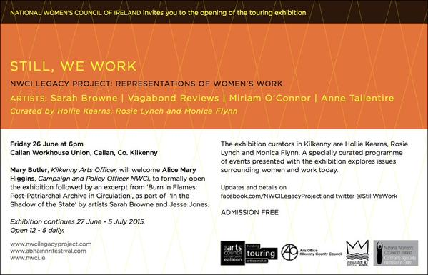

**Kilkenny Events**

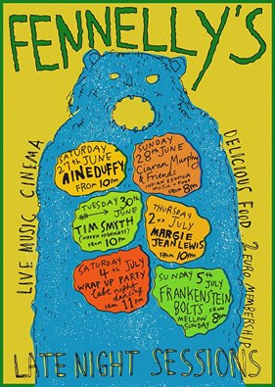

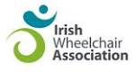

**“The Art of Ability”**

**An Exhibition of Paintings**

**By Artists**

**In The Irish Wheelchair Association**

**Claddagh Court Kilkenny.**

**Venue: Estate Yard,**

**Castlecomer Demesne**

**26th - 30th June 2015**

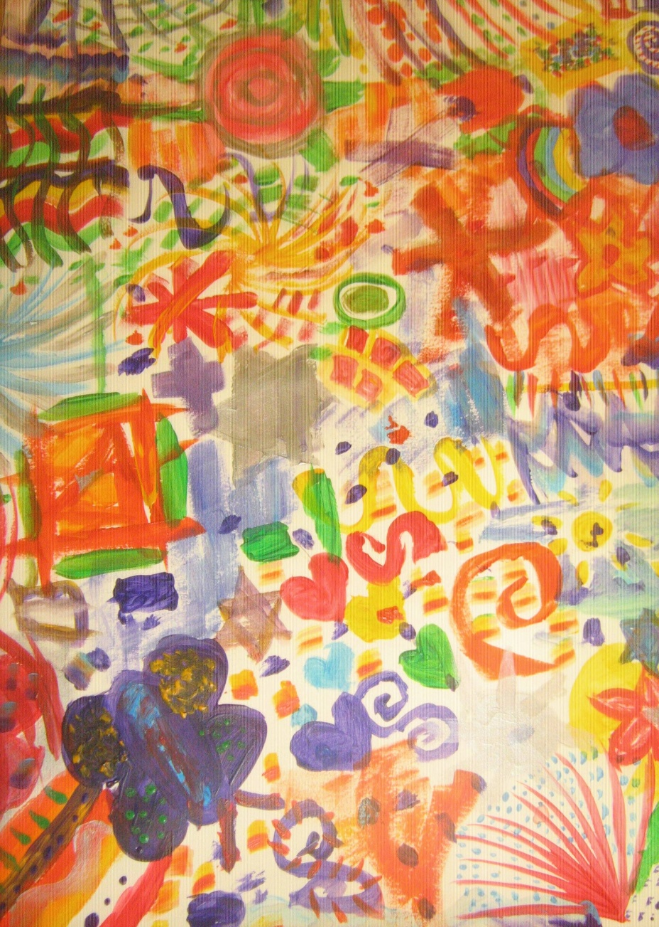

**‘The Art of Ability’**

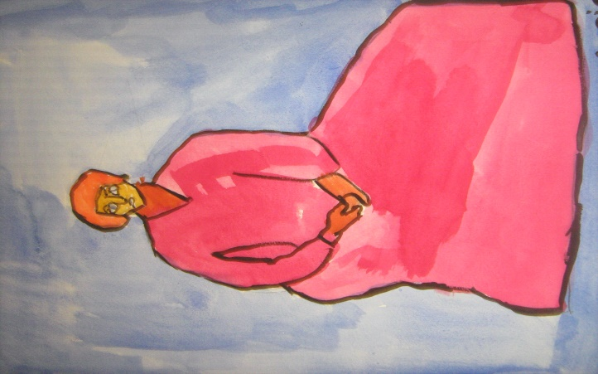‘The Art of Ability’ is an Exhibition of Paintings by Artists in The Irish Wheelchair Association, Claddagh Court Kilkenny.This exhibition highlights the unique creativity of individual ability. And the ability to create, in itself, is an art which is not exclusive, or confined to any one group. The artwork in this exhibition showcases the unlimited expression of creative imagination and motivation.

Hosted within the beautiful surrounds of the Castlecomer Demesne, and with much gratitude to Mr. Errol Delaney, the Exhibition will be open to the public from 26th –

30th June in the Estate Yard Venue. Come and visit this wonderful work.

**Chapter Room Concert - St. Canice’s Cathedral**

4pm, Sunday 28th June 2015

Admission €15 (concessions €10)

Marja Gaynor (violin)

Aoife Nic Athlaoich (cello)

Malcolm Proud (harpsichord)

Music by Haydn, Mozart, Leclair and Barrière.

So lasst mich scheinen *Mignon’s song III* (Johann Wolfgang von Goethe)

Was bedeutet die Bewegung? *Suleika I* (Marianne von Willemer)

Auf dem Wasser zu singen (Friedrich Leopold Graf zu Stolberg)

O du, wenn deine Lippen mich berühren *Heimliches Lieben* (Caroline Louise von Klenke)

Ach, was soll ich beginnen vor Liebe? (Wilhelm von Schütz *Lacrimas)*

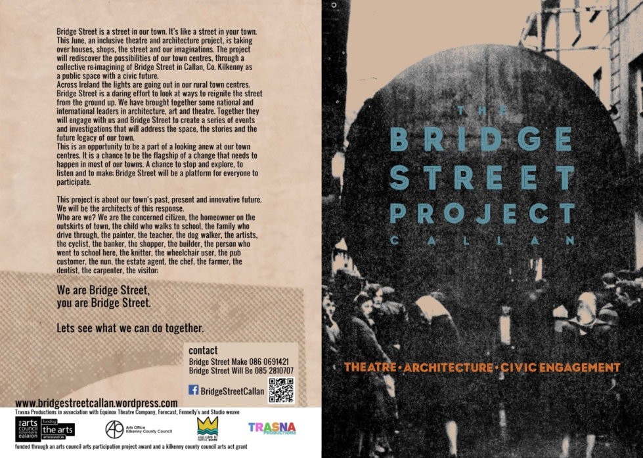

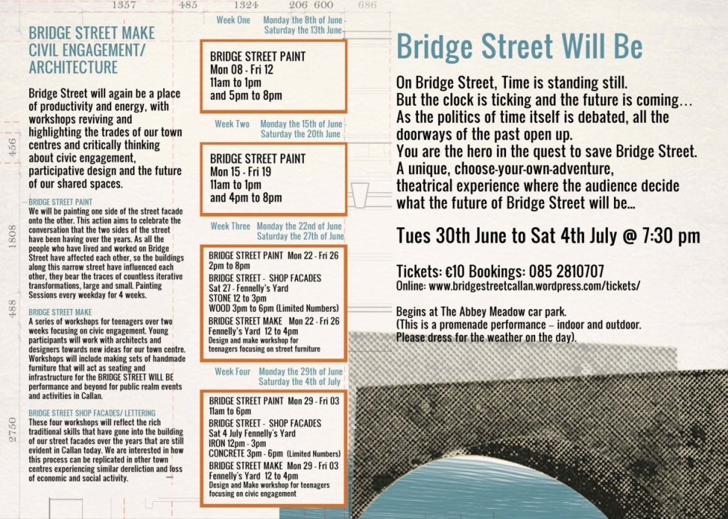

**Abhainn Rí Festival 2015**

Callan, Co. Kilkenny  
**Friday 26th June – Sunday 5th July 2015**  
<http://www.abhainnrifestival.com>

The Abhainn Rí Festival, is a unique community festival that showcases the diverse and exciting cultural and community life of the small town of Callan. Now in it’s sixth year, the eclectic festival’s ten day programme, running from Friday June 26th to Sunday July 5th, is bursting with visual art, music, theatre, heritage, inclusion, street theatre, architecture and food events. The real star of the Abhainn Rí Festival is the town itself and the programme highlights forgotten and overlooked corners of this handsome town, such as Bridge Street, The Abbey Meadow, Lockes Hall, The Workhouse, Fennellys, an old agricultural co-operative, and the streets of the town itself.   
  
**Outdoors:**   
The annual Field Day will make another appearance this year and will take place in Abbey Meadow on 28th of June. This fun day out for all the family will include a vintage car display, vintage tractor run, dog show, The Great Callan Duck Race, bouncy castle, bungee trampoline, wheel of fortune, food stalls and much much more. The field day will coinside with a special event The Elemental Session, a music event for all gae groups, begins as the field day winds down. On Sunday 5th of July Children at Play will be in full swing on Bridge Street Lower and will include street games and food stalls. Abhainn Rí 2015 will host a number of outdoor workshops throughout the duration of the festival including grafetti, yoga and willow art to name a few.  
  
**Food:**   
On the menu this year, The International Dinner and Dance which will take place at the Parish Hall on Friday 3rd of July will serve a variety of delicious European and Persian cuisine. Bring your own wine and dance the night away to the tunes of Callan’s own Highway Men. Highlights also include the Farmers Market and Food Fair. The 4th of July Food and Games celebration will include hot dogs, pie eating competition, American fancy dress, rodeo bulls, line dancing and much more! In conjunction with the Festival Gig, Festival Courtyard Tapas Bar will be serving up tasty nibbles from KCAT’s courtyard.   
  
**Spoken word:**   
Take a trip down memory lane with Callan’s Pictorial Past Evening, enjoy an evening of poetry with the Poetry Reading and Persian Food event or just sit back and have a laugh at Comedy Night. Enjoy the very best Callan has to offer and explore the deepest recesses of verbal communication in all it’s applications with this year’s Open Mic Spoken Word evening.  
  
**Theatre:**   
This June at Abhainn Rí Festival 2015, The Bridge Street Project, an inclusive theatre and architecture project, is taking over houses, shops, the street and our imaginations. The project will rediscover the possibilities of our town centres, through a collective re-imagining of Bridge Street as a public space with a civic future. Across Ireland the lights are going out in our rural town centres. The Bridge Street Project will culminate in Bridge Street Will Be, an innovative site specific contemporary theatre performance that will take place on the streetscape and interiors of overlooked buildings on Upper Bridge Street. This is a unique, choose-your-own-adventure, inclusive theatrical experience where the audience decides the future of Bridge Street. The performance takes place on Bridge Street and runs every night from Tuesday 30th of June to Saturday 4th of July.   
Other highlights include Everybody Needs A Little Magic taking place Friday the 3rd of July in the Workhouse Chapel, whislt Monkeyshine Theatre will be bringing their wandering venue, The Vagabond, to Abbey Meadow on Sunday 5th of July where they will be holding a number of storytelling performances and workshops.  
  
**Visual art:**From Saturday 27th June until Sunday 5th of July Still, We Work (Sarah Browne, Vagabond Rieviews, Mirrian O,Connor, Anne Tallentine), the touring exhibtion from the National Womens Council of Ireland will be showcased in the newly developed Callan Workhouse Union space. This exhibition considers contemporary representations of women and work, and produces new connections amongst artists, activists and audiences. It is a unique opportunity for artists and women to come together and examine issues around women and work today.   
  
On the Bright Side, a retrospective exhibtion by KCAT Studio Artist, Andrew Pike will take place in KCAT’s Art and study Centre . This retrospective exhibition presents an extensive and broad selection of his work made since 1999, including sketches for the 2006 Big River Parade, self-portraits, animations, and commissions highlighting his ongoing dedication to the artistic process.   
  
Breda Lynch, a Kilkenny born artist, based in Limerick, presents an exhibtion comprising of multi-disciplinary elements that display her ongoing interest and research into identity, the double, and dialogues from the peripheral of history. An exhibition of three local photographers capturing moments in time through nature, portraits and landsacpes will be be on display in L’Arche Cafe fromTuesday 30th to Friday the 4th July.  
  
  
**Music:**  
This year Callan will be alive with the sound of music with a wide variety of free events ranging from a trad-session in Hourigans Bar on opening night to The Elemental Session taking place in the Abbey Meadow on the 28th of June, hosts a fine mix of local and national artists of all genres. This year’s festival is sure to have something for everyone, culminating in The Festival Gig on Saturday 4th July at Abbey Meadow car park.  
  
This is Callan’s 6th annual Abhainn rí Festival of participation and inclusion. We have a full varied programme of exciting events and activities to share with you. Join in on the fun, educational and inspiring workshops on offer. Learn new skills and meet new people. We hope you come along and be apart of something spectacular!

**'Clay is my Canvas' an Exhibition of New Ceramic Artwork by Karen Morgan**Opening this**Thursday 25th June 7pm,**at **The Watergarden Gallery,**  
Ladywell St, Thomastown, Co.Kilkenny,  
  
Exhibition runs until July 25th   
Opening Hours: Tuesday – Friday, 9.30am- 4.30pm

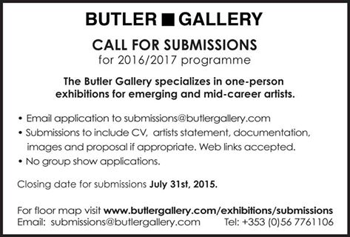

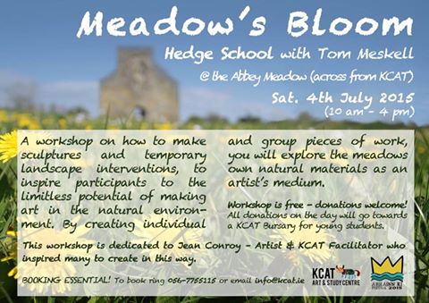

**Ale Mercado’s Illustrating Exhibition ‘Exile’ at Cork Community Printshop**

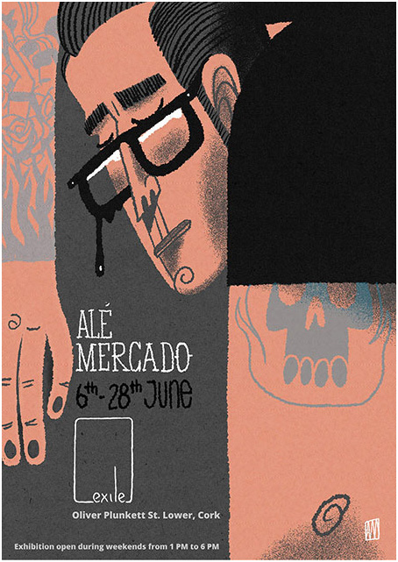

Cork Community Printshop welcomes [Alé Mercado/Atticus/Pitercios](https://www.facebook.com/AleMercadoAtticusPitercios) into ‘Exile’ from 6th – 28th June.

Creating his illustrations from pen and digital work, Alé Mercado has developed a strong personal style. Dark and witty, his work is merged with the screen and woodblock printing processes. For this exhibition, Mr Mercado is presenting his latest pieces inspired by cult films, German expressionist cinema but also the medieval dark ages.   
  
Plus, we are hosting a special event when the artist will present his work on Saturday 13th June. It will be followed by live music, food and drinks. Make sure you don't miss it.   
  
[Exhibition open during weekends from 1 to 6 PM.]

For full event details see: <https://www.facebook.com/events/852520394793913/>

For more info on Ale Mercado see: <http://alemercado.com>

**Starburst Summer Camp**

Dates:6th, 7th & 8th July  
Times:10am-1pm daily  
Art, Drama, Music and Games  
Suitable for children aged 4-11yrs  
Price: €50 per child (sibling discount applies)  
Location: St. Patrick's Parish Centre, Loughboy, Kilkenny.

<https://www.facebook.com/events/1591803234441320/>

**On the Bright Side Retrospective Exhibition of Andrew Pike**

KCAT Art & Study Centre

Callan

Sat 27 June - Sun 5 July, 12 – 5 daily

Andrew Pike has been a KCAT studio artist since its founding in 1999. This retrospective exhibition presents an extensive and broad selection of his work made during that period, including sketches for the 2006 Big River parade, self portraits, animations and commissions and highlighting his ongoing dedication to the artistic process. On the Bright Side is part of Abhainn Rí Festival 2015 programme.

KCAT Art & Study Centre

Mill Lane

Callan

Co. Kilkenny

056-7755115

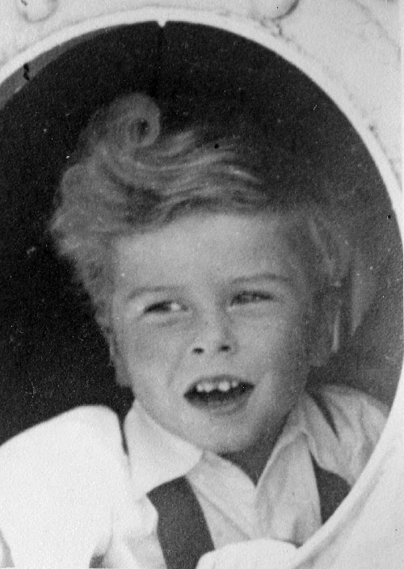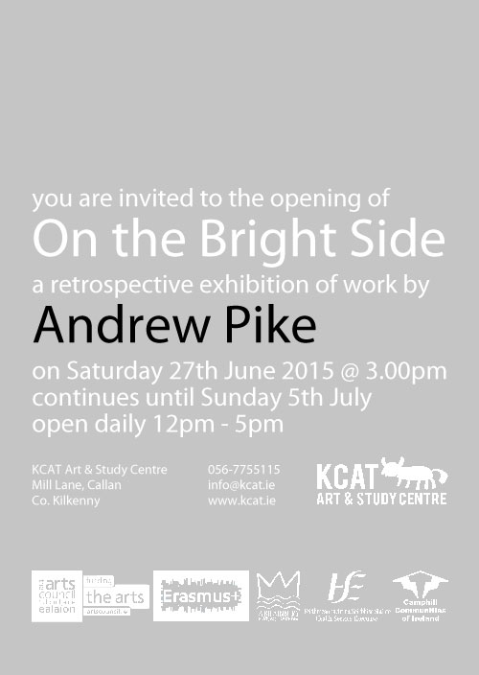

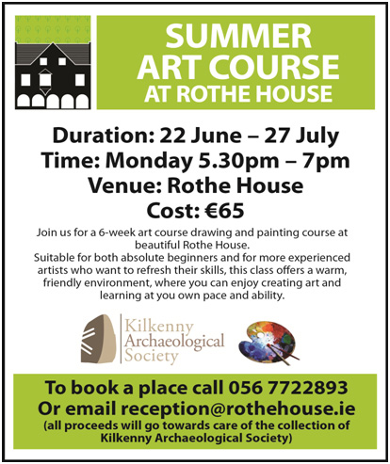

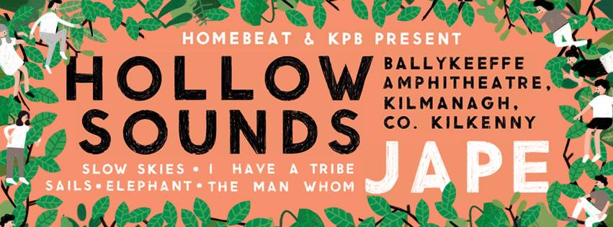

HOLLOW SOUNDS  
July 03rd & 4th 2015 / Ballykeeffe Amphitheatre, Co. Kilkenny.   
  
Independent promoters KPB & Homebeat are delighted to announce Hollow Sounds - a new two day event of film, music, food and fun set in the stunning Ballykeeffe Amphitheatre, Co. Kilkenny.  
  
Ballykeeffe is a wonder of the Irish countryside, a majestic sweeping stage set amongst the amphitheatre nestled in a beautiful old quarry just a few kilometres outside Kilkenny City.   
  
Hollow Sounds brings a fantastic line up of cutting edge Irish music & classic cinema to this incredible setting at the height of summer on July 3rd & 4th.   
  
On Friday, July 03, Happenings making their Kilkenny debut and will screen the classic ‘Goonies’. An evening... for one and all to enjoy in the magical surrounds of Ballykeeffe.   
  
-------------------------------------------------------------------------------  
  
LINE UP:  
  
FRI JULY 3rd | 8pm - 23.00   
  
Happenings Outdoor Screening of ‘The Goonies’. 9.00 pm (€5)   
  
SAT JULY 4th | 13.00 - 23.00   
  
Jape I Slow Skies I Elephant | The Man Whom | Sails | I Have A Tribe |   
  
AFTER PARTY w Jape (DJ SET) / Taste DJs & more in The Set Theatre from 23.00  
  
STAYING:   
  
This is a non camping event - Hollow Sounds patrons will be able to avail of associated accommodation deals in Kilkenny City & surrounds.   
  
GETTING TO / FROM :   
  
Parking is available at Ballykeeffe.   
  
Busses will run from Kilkenny City from 7.30 pm Friday July 3rd (Returning after the movie) & from 13.00 - 15.00 on Sat July 4th (returning from 23.00 after Jape).   
  
  
TICKETS :  
  
Website : www.eventbrite..   
Happenings present : ‘The Goonies’. €5 (€10 w return bus from / to Kilkenny)   
Hollow Sounds Saturday day pass :   
Early birds : €30   
Regular : €38.50  
Regular + Return bus from Kilkenny : €45

**Ballykeeffe Amphitheatre Kilmanagh Summer Concert Schedule**   
  
**Goldilocks and the Three Bears (children's theatre show)** June 28th  
**Sharon Shannon** ,July 25th  
**Jane Eyre** by Chapterhouse Outdoor Theatre July 31st  
**Damien Dempsey** Aug 8th.  
  
More acts to be added.  
Tickets for Nathan Carter are now on sale at Ticketmaster ,Kilkenny Book Centre, Rollercoaster records and locally.  
@ 25 euro  
  
Events contact is Matt O'Sullivan - 087 6261134

|  |  |
| --- | --- |
| |  | | --- | | Devious Theatre Company: The Union performs this July | |

|  |  |
| --- | --- |
| |  | | --- | | [War Of Attrition at Project Arts Centre, Dublin](http://devioustheatre.us1.list-manage1.com/track/click?u=81e2bda1e5d5f4cf50d626fc9&id=2d603dff77&e=506f5f26a9) | |

|  |  |
| --- | --- |
| |  | | --- | | Adrian Kavanagh’s first play for us has been in the works for a while now and we’re looking forward to debuting the show in Kilkenny from July 29th to August 1st in Cleere’s Theatre.  The Union is a furiously funny dramatic retelling of the rise and fall of St. Dominic’s Student Union. The play takes place in the final days of the current student union regime in a failing regional college. Five erstwhile colleagues are locked in one room knowing that one of them stole the €10,060 fundraised cash that their reputations, hopes, dreams, careers and election campaigns are hinged on. Backs will be stabbed, hearts will be broke and throats will be cut.  The clock is ticking. We’re going to see how united this Union really is.  Alexandra Christle, Hazel Doyle, Kevin Mooney, Niall Morrissey and Colin O'Brien will take to the stage with John Morton directing Adrian Kavanagh's script. [Find out more details here](http://devioustheatre.us1.list-manage.com/track/click?u=81e2bda1e5d5f4cf50d626fc9&id=bb802837a4&e=506f5f26a9).  The show will preview in The Duiske Inn, Graiguenamanagh on July 24th and 25th. We're very excited to be making our debut trip to the beautiful village of Graig, hometown of the show's writer Adrian Kavanagh. | |

### Upcoming Events at the Watergate Theatre

Here’s a look at some of the shows, gigs and other events taking place here at the Watergate Theatre in the next few weeks. You can speak to our helpful box office staff at any time by phoning [056 7761674](tel:+353567761674).

[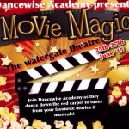](http://watergatetheatre.com/programme/dancewise-academy-presents-movie-magic/)

### [Dancewise Academy presents Movie Magic](http://watergatetheatre.com/programme/dancewise-academy-presents-movie-magic/) (25/06/2015)

A night of dance from your favourite movies and musicals..

[**Book Online**](http://watergatetheatre.com/programme/dancewise-academy-presents-movie-magic/)

[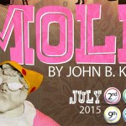](http://watergatetheatre.com/programme/moll/)

### [Moll](http://watergatetheatre.com/programme/moll/) (02/07/2015)

Performing 2-4 and 9-11 July.

[**Book Online**](http://watergatetheatre.com/programme/moll/)

[](http://watergatetheatre.com/programme/watergate-golf-classic/)

### [Watergate Golf Classic](http://watergatetheatre.com/programme/watergate-golf-classic/) (17/07/2015)

[**Book Online**](http://watergatetheatre.com/programme/watergate-golf-classic/)

[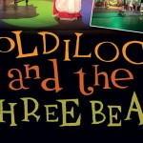](http://watergatetheatre.com/programme/goldilocks-and-the-three-bears/)

### [Goldilocks and the Three Bears](http://watergatetheatre.com/programme/goldilocks-and-the-three-bears/) (18/07/2015)

Goldilocks and the Three bears and Ruff The dog! perform live on stage!.

[**Book Online**](http://watergatetheatre.com/programme/goldilocks-and-the-three-bears/)

[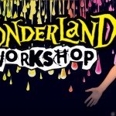](http://watergatetheatre.com/programme/wonderland-workshops/)

### [Wonderland Workshops](http://watergatetheatre.com/programme/wonderland-workshops/) (20/07/2015)

Running until Friday 24 July 2015..

[**Book Online**](http://watergatetheatre.com/programme/wonderland-workshops/)

[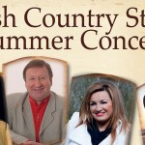](http://watergatetheatre.com/programme/irish-country-stars-summer-concert-2/)

### [Irish Country Stars Summer Concert](http://watergatetheatre.com/programme/irish-country-stars-summer-concert-2/) (29/07/2015)

[**Book Online**](http://watergatetheatre.com/programme/irish-country-stars-summer-concert-2/)

[](http://watergatetheatre.com/programme/pulp-fiction-soundtrack-live/)

### [Pulp Fiction Soundtrack: Live!](http://watergatetheatre.com/programme/pulp-fiction-soundtrack-live/) (01/08/2015)

Featuring music from Pulp Fiction, Jackie Brown and Reservoir Dogs.

[**Book Online**](http://watergatetheatre.com/programme/pulp-fiction-soundtrack-live/)

[](http://watergatetheatre.com/programme/poulencs-the-human-voice-kilkenny-arts-festival/)

### [Poulenc's The Human Voice (Kilkenny Arts Festival)](http://watergatetheatre.com/programme/poulencs-the-human-voice-kilkenny-arts-festival/) (07/08/2015)

[**Book Online**](http://watergatetheatre.com/programme/poulencs-the-human-voice-kilkenny-arts-festival/)

[](http://watergatetheatre.com/programme/susannas-secret-kilkenny-arts-festival/)

### [Susanna's Secret (Kilkenny Arts Festival)](http://watergatetheatre.com/programme/susannas-secret-kilkenny-arts-festival/) (08/08/2015)

2 performances as part of Kilkenny Arts Festival 2015.

[**Book Online**](http://watergatetheatre.com/programme/susannas-secret-kilkenny-arts-festival/)

[](http://watergatetheatre.com/programme/bastard-amber-kilkenny-arts-festival/)

### [Bastard Amber (Kilkenny Arts Festival)](http://watergatetheatre.com/programme/bastard-amber-kilkenny-arts-festival/) (14/08/2015)

2 performances as part of Kilkenny Arts Festival 2015.

<http://watergatetheatre.com/>

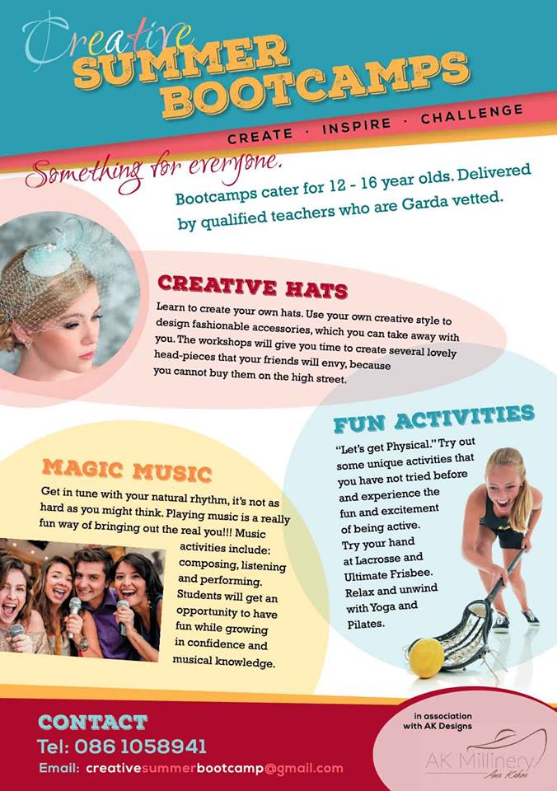

#### The ****WORKSHOP PROGRAMME**** at KOZO Studio continues – designed and facilitated for small groups of participants at KOZO Studio in The Estate Yard, Castlecomer Discovery Park, Co. Kilkenny.    EMBROIDERY WORKSHOPS with ALEXIS BERNSTORFF, artistic director of the ROS TAPESTRY

#### ****11 JULY (Saturday)**** 10.30am – 5pm (****3 places**** are available) ****12 SEPTEMBER (Saturday)**** 10.30am – 5pm   For Beginners and Participants with Previous Experience This workshop will teach 6 principal stitches and their variations - using wool, cotton/silk and metallic threads. Participants will be inspired by a range of techniques to realise various designs. Alexis has 15 years experience teaching crewelwork embroidery and is the guide behind the dynamics of the Ros Tapestry.  € 70 for the full day - including all materials  **********

### ****PAPER MAKING DAYs**** - Beginners

#### ****12th JULY (Sunday)**** (****2 places**** are available) ****26th JULY (Sunday)**** (****4 places**** are available) ****10.30am - 1.30pm**** ****HAND PAPER MAKING**** - Introduction to traditional and contemporary techniques of making beautiful handmade papers from pure plant fibres and a range of recycled materials. ****2.30 - 5.30pm**** ****SILK FIBRE PAPERMAKING****- A truly fascinating, contemporary technique for making `fabric-like`, colourful silk papers using raw silk fibres and fabric dyes. Easy to continue and set up at home, this process is ideal to create unique interior decorations and striking silk papers for artworks, embroidery, collages ...etc. ****Fees**** for each workshop: € 35  ****OR:**** € 65 for the full day - including all materials **********

### ****BATIK Workshop**** - Beginners

#### ****22nd AUGUST(Saturday)**** ****11am - 5.30pm****  A full day programme introducing an ancient technique of fabric dyeing where hot wax is used as a resist. Participants will learn all necessary basic techniques - and complete three small/medium batik pieces with up to 4 colours on cotton fabric and/or paper. € 70 for the full day, including all materials **********

### ****PAPER ART and HAND PAPER MAKING -**** FOLLOW-ON ADVANCED LEVEL COURSE  Only for participants with previous experience

**20th SEPTEMBER (Sunday)**  
**10.30am - 5.30pm**  
  
Designed for participants who already work with paper/fibre based processes, this course offers assistance and guidance in areas of three dimensional, sculptural and installation based works, experimental processes of batik, paper dyeing and texturing. It also covers ideas for the preparation and use of plant based pulps (without added chemicals).  
Participants are encouraged to bring their own ideas and questions into the workshop and invited to show and discuss previous works and projects. The day also includes a short slideshow presentation on examples of contemporary paper art and paper making.  
**Places are limited for 5 participants.**  
€ 80 for the full day, including all materials  
  
**GIFT VOUCHERS are available for the workshop of your choice!**  
BOOKINGS are confirmed with € 30 deposit paid in advance.*  
Courses are run for small groups of participants only so please call to book early.  
**With any questions, for advice or check availability and for all BOOKINGS please contact TUNDE directly:**  
  
**Tunde Toth –** Artist, Arts Educator  
**087-2543362**  
E: [**tundetune@gmail.com**](mailto:tundetune@gmail.com)  
[**www.tundetoth.com**](http://tundetoth.us9.list-manage.com/track/click?u=927a06abce3366093569f0241&id=496deedf58&e=1f1b25985b)  
[**www.tundetothpaperart.blogspot.com**](http://tundetoth.us9.list-manage.com/track/click?u=927a06abce3366093569f0241&id=c0fc4c8e80&e=1f1b25985b)  
[**www.kozostudio.wordpress.com**](http://tundetoth.us9.list-manage.com/track/click?u=927a06abce3366093569f0241&id=aea99380d1&e=1f1b25985b)  
   
* DEPOSITs are returned if the Studio has to cancel a workshop. Cancellations from participants will be accepted up to 2 weeks before the course date and deposits will be returned. In other cases participants may be offered rescheduled dates/options.  
 

**Courses / Training / Jobs / Internships**

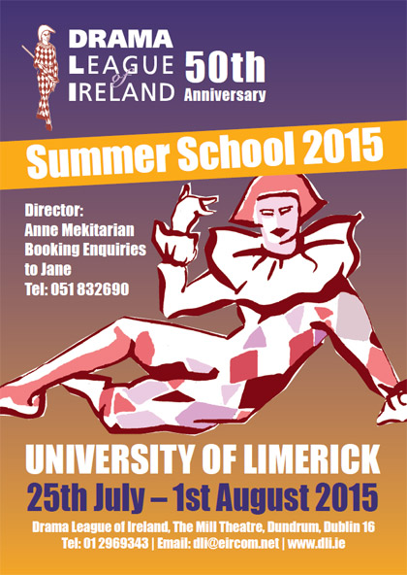

We are so excited about our 2015 50th DLI Summer School!  Read all about the courses on offer on the [**DLI Summer School page**](http://www.dli.ie/summerschool.htm) and [**check out our online brochure**](http://www.dli.ie/downloads/DLI%20SS%20brochure%202015.pdf).

**Here’s a message from Anne with the latest update!**

Hi everyone!  Nearly there now!  Just a few places left on each of the following courses:

**Course F:  The Articulate Body: An Introduction to Physical Theatre    
Tutor:  Sue Mythen**  
Sue’s group achieves the most amazing work, all under her gentle and supportive guidance.  This will be a lively, dynamic and quite thrilling experience.  Not to be MISSED!

**Course H:  Walking the Tightrope                             
Tutor:   Louise Lowe**  
One of the most highly regarded alternative practitioners, Louise’s courses are action-packed, stimulating roller-coaster rides. If you are up for a challenge – THIS is the one for you!

**Course A:  Stepping Out: Introduction to Acting  
Tutor:   David Horan**  
Hugely popular with all of his students, David is lively, personable, VERY knowledgeable and has an excellent sense of fun!  Ideal for Beginners/Improvers - you’ll LOVE him!

**Course C:  Serious Fun . . . .  
Tutor:   Chrissie Poulter**  
DLI Summer School is never the same without Chrissie – her serene (and impish!) presence is decidedly therapeutic.  We are THRILLED that she is with us to celebrate our 50th! A few places remaining . . .

**Course E:  Meeting Ourselves Meeting the Text   
Tutor:   Andy Crook**  
Highly and warmly regarded by all of his students, Andy makes a very welcome return to us for our special anniversary year. Make no mistake: his will be a GREAT course!  Just a few places left  . . .

Now is the time to reserve your place.  Make a choice; send me an application form and deposit:  and you’re IN!   Do it today! Don’t miss the great DLI Annual Experience at UL - plus the extras Jane and I have planned for this year’s celebrations.  What plans?  You’ll just have to come and see!

**Your Sponsorship Offering - Introductory Workshop**

Business to Arts hosts regular two-hour seminars for projects new to seeking sponsorship. The seminar will help you develop your organisation’s sponsorship case. This is a sponsorship-focused seminar only and does not cover other forms of fundraising.

Seminars are held regularly and are only open to Affiliated Arts organisations.

<http://www.businesstoarts.ie/newstream/blog/your-sponsorship-offering-introductory-seminar/>

### Shinnors Scholar 2015 MA in Curatorial Studios, Limerick: Call for Applications

Limerick City Gallery of Art, Limerick City and County Council and Limerick School of Art and Design, Limerick Institute of Technology are calling for applications for the Shinnors Scholar 2015 MA in Curatorial Studios.

Application forms and particulars are available to download [www.gallery.limerick.ie](http://www.gallery.limerick.ie)

Completed application forms should also be returned to Dr Peter Downey, Research Project Management Officer, Graduate Studies and Research Office Limerick Institute of Technology, Moylish Park, Limerick, Ireland to include a cover letter, CV and transcript of academic results.

**Deadline: 10th July 2015**  
Further information and queries:  
E:  [graduatestudies@lit.ie](mailto:graduatestudies@lit.ie)

**Call for Submissions / Residencies**

### TULCA 2015 Open Call for Artists Submissions

TULCA is a unique festival that provides the opportunity for artists to engage with a wide audience in new and unusual ways. As well as an artist fee, we offer curatorial and artistic development and technical support. There is a significant press, marketing and audience campaign along with a fully illustrated catalogue with commissioned essays, a dynamic programme of education within primary and secondary schools and third level institutions.

The festival also offers an extraordinary chance to build new collaborations and extend your network with artists nationally and internationally. A combination of art and non-art venues, including Galway University Hospital, 126 Artist-Led Gallery, Galway Arts Centre, Nuns Island Theatre etc will be used to house parts of the exhibition. Works for these contexts will be selected accordingly. TULCA 2015 will be curated by writer, art historian and independent curator, Mary Cremin.

Artists are welcome to propose the presentation of existing works or the production of new work. Work must not have been previously exhibited in Galway. Artists curated through this open call are responsible for the transport, delivery and collection of their work.

For a full Artists Brief and to apply see [tulcafestival.com](http://tulcafestival.com/)  
Applications should be submitted via email:  
E: opencall2015@tulcafestival.com  
Further information;  
E: info@tulcafestival.com  
**Deadline: July 5th 2015**

**Fundit.ie – We are seeking Design, Craft and Fashion Projects for the site**

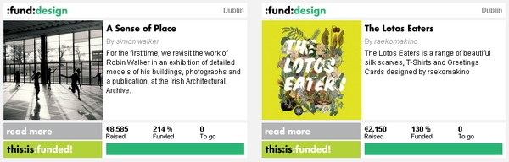  
  
You know that [*Fund it*](http://cts.vresp.com/c/?BusinesstoArts/8f0bfb005c/608128ad7e/8353a19431/BusinesstoArts/ce21f4596f/TEST/6d67a8957f) has helped raise over €3million for creative projects in Ireland and that it has the highest crowdfunding success rate in the world among comparable websites, right?   
  
During Summer 2015, we are seeking to develop new projects in the Design, Craft and Fashion categories. If you have a great idea or know a creator that would be interested in our help to generate funding and presales, send them [our way](mailto:admin@fundit.ie).  
Specific examples we are looking for include:  
•    Design – Merchandise & products (eg. [Raekomkino’s botanical accessories and gifts](http://cts.vresp.com/c/?BusinesstoArts/8f0bfb005c/608128ad7e/3523c58250))   
•    Craft – Individual and collective exhibitions, publications, products   
•    Fashion – shows, collections, publications and more…

**WHAT: Calling all lover of words**

It’s that time of the year again when we, *Waterford Healing Arts Trust,*invite readers near and far to send us their favourite poem / short prose extract for an annual event we are planning called ‘We haven’t had an earthquake lately’ (as said by AA Milne’s Eeyore some time ago).

We are looking for words that inspire / soothe / provoke / comfort / engage… in short words that touch you.

Please email us your words by return with the author’s name and the reason for your choice. Let us know if you would be available to read your words at a public reading in The Book Centre, Waterford on 9th October as part of the Well Festival of Arts and Wellbeing, or whether you would like someone to read them on your behalf.

*Waterford Healing Arts Trust,*

*University Hospital Waterford,*

*Dunmore Road,*

*Waterford*

*051-842664*

[WHAT@hse.ie](mailto:WHAT@hse.ie)

[www.waterfordhealingarts.com](http://www.waterfordhealingarts.com/)

**FOUNDATION15 presents QUANTUM LEAP – Call for Submissions**

[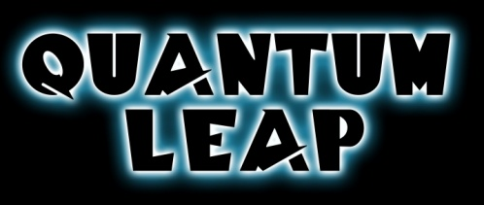](http://www.foundationartsfestival.com/wp-content/uploads/2015/05/0301f696_Quantum_Leap_title_by_maggot216.jpeg)

We are delighted to invite submissions for this year’s **Foundation15 Arts Festival** exhibition. This year the exhibition takes it’s cue from the cult sci-fi television show [**Quantum Leap**](http://foundationartsfestival.com/f15-brief/) (1989-1993). The protagonist Dr. Sam Beckett is a brilliant scientist who, following his quantum experiment in time travel, leaps through space-time, temporarily inhabiting the bodies of other people and altering the events of history.

“Dr Beckett’s space-time travel parallels the investigative nature of an artist’s practice. Artists also travel through time, referencing, appropriating or challenging concepts and aesthetic notions of their predecessors, often interpreting these ideas through a contemporary filter. Inherent in our comprehension of appropriation is the concept that the new work recontextualises whatever it references, it may ultimately even alter our perception of art history. Beyond this, Quantum Leap’s concern with science, the passage of time, identity, gender and the inhabitance of the ‘other’ has also been a fertile playground for artists.” – Brendan Fox, Curator

This year artists exhibiting in the exhibition have the opportunity to win three prizes,  the **Foundation15 Critics Choice Award**, the **Foundation15 People’s Choice Award**, and for artists who have graduated since 2013 the **Foundation15 Undergraduate Award**. More information about these awards can be found on the [Awards page](http://foundationartsfestival.com/awards/).

Submissions can be made via the [online application form](http://foundationartsfestival.com/f15-artist-submission/) up to 11.59pm on Tuesday the 30th of June. A €10 submission fee will apply and can be paid by PayPal or debit/credit card during the application process. For more information see the [terms and conditions page](http://foundationartsfestival.com/f15-terms-conditions/) or email us at [submit@foundationartsfestival.com](mailto:submit@foundationartsfestival.com)

[**Trinity Creative Funding Awards: Call for Artists Proposals**](http://visualartists.ie/jobs-ops/funding-awards/trinity-creative-funding-awards/)

Trinity College have launched funding awards designed to support the creation of new work and foster the development of interdisciplinary projects, ideally involving a collaboration with Trinity College Dublin. The awards are open to non-Trinity applicants and the focus is on interdisciplinary creative arts practices across forms including performance, visual art, music, film, design, new media, animation, and creative technologies. Up to four awards of up to €10,000 will be granted to support the development of projects which will then be presented within an exhibition or performance context in Trinity in 2016.

Further information:  
E: bcass@tcd.ie  
<http://www.tcd.ie/trinity-creative/>

**2015 Over The Edge New Writer of The Year competition**

*OPEN TO POETS & FICTION WRITERS*

*WORLDWIDE*

NOW TAKING ONLINE PAYMENTS

COMPETITION JUDGE: DAVE LORDAN

Major Sponsor*: Charlie Byrne’s Bookshop,*

other sponsors to date:

Dock No. 1 Bar*, ISupply, Quay Street;* Ward’s Hotel Lower Salthill*;*

*Clare Daly TD,* Kenny’s Bookshop & *Derek Nolan TD*

Closing date: Wednesday, August 5th, 2015

Over The Edge: Open Reading in Galway City Library on Thursday, October 29th, 2015 (6.30-8pm).

For further details contact Over The Edge on 087-6431748,

e-mail [over-the-edge-openreadings@hotmail.com](mailto:over-the-edge-openreadings@hotmail.com)

or to make an online payment see [http://overtheedgeliteraryevents.blogspot.com](http://overtheedgeliteraryevents.blogspot.com/)

Major Sponsor: *Charlie Byrne’s Bookshop*,

other sponsors to date: Dock No. 1 Bar, *ISupply, Flood Street*;

Ward’s Hotel, Salthill; *Clare Daly TD*, Kenny’s Bookshop & *Derek Nolan TD*

**Hospital Arts Festival 2015: Open Call to Artists**

Please Note A Submission Fee Applies

Submission for the visual arts section of Hospital Arts Festival 2015 is now open.This year we will be working in collaboration with guest curator Moran Been-noon.  
With consideration to the heritage of Hospital’s 800 years, ideas in the relation to the concept of Land, Labour, Industry are welcome for this year’s festival.

Also, For One Night Only, a video open call specifically for film, video and animation shorts, invites artists to submit, electronically, video works of no longer than 15 minutes, with the narrative relevant to the overall working theme for Hospital Arts Festival 2015, Land, Labour, Industry.

Each submission must be accompanied by a submission fee of €10 payable by Paypal:  
to [hospitalartsfest@gmail.com](mailto:hospitalartsfest@gmail.com)  
Please include your Paypal receipt number or forward on email acknowledgment of the payment with your submission  
Deadline: **Monday, 20 July at 5pm**

Further information:  
[www.hospitalartsfest.com](http://lists.visualartists.ie/lt.php?c=1346&m=4383&nl=1&s=d3c261c0eeb6b48867f449d29e09414b&lid=113874&l=-http--www.hospitalartsfest.com)

**Awards / Bursaries / Schemes**

[**The Arts Council Project Awards, 2015**](http://visualartists.ie/jobs-ops/funding-awards/the-arts-council-project-awards-2015/)

The Arts Council’s Project awards support specific project activities under each of the following art form and arts practice areas. The award guidelines for each award can be downloaded from the [available funding](http://www.artscouncil.ie/available-funding/) section of the Arts Council’s website.

Visual Arts Project Award  
Music Project Award  
Opera Project Award  
Theatre Project Award  
Traditional Arts Project Award

Applications will only be accepted through the Arts Council’s [online services website](https://onlineservices.artscouncil.ie/Secure/Login.aspx?lang=en-ie) and all supporting material must be submitted online. Applicants who have not previously used the online services site must [register in advance](https://onlineservices.artscouncil.ie/Register.aspx) of making an application. It may take up to five working days for your registrations to be confirmed so it is very important that you register as early as possible.

We now provide updates and assistance on the use of online services through our new [Facebook page](https://www.facebook.com/artscouncilireland). Feel free to post or send us a message via the page if you need online services support when making a Project Award application: [www.facebook.com/artscouncilireland](http://www.facebook.com/artscouncilireland)

The awards are open to individuals and organisations. However, organisations in receipt of funding under any of the main Arts Council grant programmes (Regularly Funded Organisations, Annual Funding, Annual Programming Grant) will not be eligible to apply.  
**Deadline 5.30pm, Thursday, 20 August, 2015**

**2014/2015 Dates and Deadlines for Culture Ireland Grant Rounds**

Please note Culture Ireland has set funding rounds and deadlines for 2015. There will be three funding rounds in 2015 and seperate calls for showcasing opportunities and Edinburgh Festivals will be announced during the year.

**Application Deadline | Timing of Project/Event | Decision Due**

* 15 June 2015  | September 2015 onwards | Early August
* 15 October 2015 |  January 2016 onwards | Early December

[http://www.cultureireland.ie/](http://lists.visualartists.ie/lt.php?c=1232&m=4271&nl=1&s=d3c261c0eeb6b48867f449d29e09414b&lid=96096&l=-http--www.cultureireland.ie/)

**Bursary Awards next closing date – 5.30pm, Thursday, 16 July 2015**

|  |
| --- |
| http://newsletter.artscouncil.ie/nwstatic/spacer.gif |

The window for making an application opens on Tuesday, 16 June 2015. The deadline for the Arts Council's Bursary Awards is **Thursday, 16 July 2015 at 5.30pm.**

The Bursary Award is available in the following artforms:

* Literature (Irish & English Language)
* Theatre
* Traditional Arts
* Visual Arts
* YPCE

The Arts Council provides Bursary Awards in order to assist individual artists in the development of their art practice. The award emphasises the value and benefit to an artist’s development that is derived from a focused period of engagement with their practice.

Guidelines for each award are published on the [available funding](http://newsletter.artscouncil.ie/1i2sre0kp1s14rbsgtdsq9?a=6&p=48727903&t=28179891)section on our website.

***Please note***

Applications will only be accepted through the Arts Council’s [online services](http://newsletter.artscouncil.ie/1pxvszvni3w14rbsgtdsq9?a=6&p=48727903&t=28179891) website. Applicants who have not previously used this system must register in advance of making an application. It is recommended that applicants allow five working days for registration prior to making an application.

**Arts Council’s Artist in the Community Scheme – Deadlines 2015**

Twice yearly, the Arts Council offers grants to enable artists and communities of place/or interest to work together on projects. The Artist in the Community Scheme is managed by Create, the national development agency for collaborative arts.

The scheme is open to artists from any of the following artform disciplines: architecture, circus, street art and spectacle, dance, film, literature (Irish and English language), music, opera, theatre, visual arts and traditional arts. The projects can take place in a diverse range of social and community contexts eg arts and health; arts in prisons; arts and older people; arts and cultural diversity.

The aim of the scheme is to encourage meaningful collaboration between communities of place and/or interest and artists. It is essential that consultation take place between the artist and the community group, so that both parties are involved in deciding on the nature of the project realisation. Group ownership of the art should be maintained at every stage. The Project Realisation may result in a variety of outcomes.

There are two phases to the scheme. Phase One [Research & Development,](http://lists.visualartists.ie/lt.php?c=1289&m=4326&nl=1&s=d3c261c0eeb6b48867f449d29e09414b&lid=101957&l=-http--www.create-ireland.ie/artist-in-the-community-scheme-research-and-development-award.html) is open to artists who wish to research and develop a project in a community context.

There is also a [Research & Development/Mentoring](http://lists.visualartists.ie/lt.php?c=1289&m=4326&nl=1&s=d3c261c0eeb6b48867f449d29e09414b&lid=101958&l=-http--www.create-ireland.ie/artist-in-the-community-scheme-research-and-development/mentoring-award.html) strand, open to artists who wish to develop a community based project and who have identified an artist mentor they want to work with during the research and development phase.

Phase Two [Project Realisation](http://lists.visualartists.ie/lt.php?c=1289&m=4326&nl=1&s=d3c261c0eeb6b48867f449d29e09414b&lid=101959&l=-http--www.create-ireland.ie/artist-in-the-community-project-realisation-award.html) , is open to communities of interest or place (or their representative organisations) with an artist.

**2015 Deadlines:  
(Round 2)   29 June 2015**

For information on the Scheme and advice on applying, contact Katherine Atkinson, [support@create-ireland.ie](mailto:support@create-ireland.ie) or phone 01-4736600  
Visit [http://www.create-ireland.ie/about-the-artist-in-the-community-scheme.html](http://lists.visualartists.ie/lt.php?c=1289&m=4326&nl=1&s=d3c261c0eeb6b48867f449d29e09414b&lid=101960&l=-http--www.create-ireland.ie/about-the-artist-in-the-community-scheme.html)

**Of Interest**

### Studios Available at Hive Emerging, Waterford

Hive Emerging is now accepting submissions for studios.

Established in 2009, Hive Emerging is a not-for-profit studios and gallery organisation run by artists for artists.  Located at the very heart of the city, on the corner of Michael Street and New Street in Waterford City, Hive Emerging focuses on group activities providing artists with exposure, experience, networking, accreditation and sales opportunities. The gallery space, which has welcomed more than 200 artists to the city of Waterford, features five exhibition rooms with two screening rooms. Hive Emerging provides seven studios, along with a stage, an arts library and a workshop space.

Interested artists should submit:  
• an artist’s CV (Word/PDF)  
• images of work including medium, dimensions (JPEG attachment)  
• a concise statement of interest outlining the artist and their current work (Word attachment )

With regards to video and performance art, we would require video as part of submissions. Hive Emerging accepts links to both Youtube and Vimeo

Further information and to apply:

E: hiveemerging@gmail.com  
**Deadline: Wednesday 8th July, 5.30pm**  
Hive Emerging, 25 Michael Street, Waterford  
[hiveemerging.com](http://hiveemerging.com/)