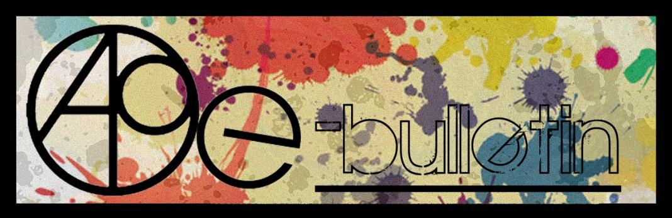

**Kilkenny County Council Arts Office E-bulletin 29th May 2015**

Dear All,   
  
Welcome to the fortnightly e-bulletin from Kilkenny County Council's Arts Office. Each bulletin is packed with the latest information on Kilkenny Arts Office activities, county events as well as news and opportunities for arts practitioners from around the country.

This service will be provided fortnightly. To include an item in the next e-bulletin please send a brief outline of your advert with relevant contact details, including any websites or pages with links to [**niamh.brophy@kilkennycoco.ie**](mailto:niamh.brophy@kilkennycoco.ie) **before 10th June**. The next e-bulletin will be on the **12th June.**

While every effort has been made to ensure the accuracy of our information, we strongly advise readers to verify all details to their own satisfaction.

Regards,

Niamh Brophy  
Arts Office,  
T: 056 7794138  
E: [niamh.brophy@kilkennycoco.ie](mailto:niamh.brophy@kilkennycoco.ie)   
W: [www.kilkennycoco.ie/eng/Services/Arts/](http://www.kilkennycoco.ie/eng/Services/Arts/)

BECOME PART OF IT, SUBMIT A POEM.....[www.rhymerag.net](http://kk-moss/Sites/arts_office/Shared%20Documents/Julianne%20Morgan/E-bulletin/30th%20May%20e-bulletin/www.rhymerag.net)  
Kilkenny County Council Arts Office Partner Local Authority of the ArtLinks Programme [www.artlinks.ie](http://www.artlinks.ie)

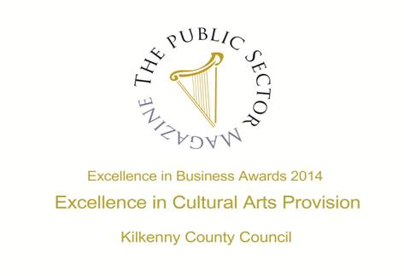

|  |  |
| --- | --- |
|  |  |
|  |  |

**Arts Office**

* See the Rhyme Rag Launch on Kilkenny Matters, Irish TV
* Read the next Rhyme Rag poem!
* Still, We Work – Touring Exhibition

**Kilkenny Events**

* Meadow’s Bloom Hedge School
* The Laughing Stock Comedy Club
* Kilkenny Creative Hub – Expression of interest sought
* Blackstack Print Studio at Eigse
* **Blackwatch Studio, Kilkenny Seeks Arts and Crafts Workshop Facilitators**
* Carnegie Trust "Test Town" competition
* **At a loss for Words – Workshop**
* Three Choirs’ Concert at St. Canice’s Cathedral
* **‘Yer Wan’ at Brewery Corner**
* Kilkenny County Council ‘Streetscape Paint Scheme 2015’
* Ballykeeffe Amphitheatre Kilmanagh Summer Concert Schedule
* Seventies Disco Saturday Night feat. ONASSIS Disco Band + Those responsible
* **Grennan Mill Craft School Graduate Show 2015**
* **Kilkenny International Gospel Choir Festival**
* **Butler Gallery Employment Opportunity**
* **Songwriters in the Round**
* **National Craft Gallery – Appetite for Design**
* New Living City Initiative for Kilkenny
* Have you got a bright idea for your community?
* **Susie Ro at Castalia**
* **Stone Carving Workshop, with James Horan and Aileen Anne Brannigan, Kilkenny**
* Joe Hill Songwriting Competition - Thomastown
* Vultures – A New Radio Series
* Grennan Mill Craft School - Summer Courses 2015
* **Kilkenny County Council Community and Cultural Facilities Capital Funding**
* Coming Soon to the Watergate Theatre
* KOZO Workshop Programme 2015

**Courses / Training / Jobs / Internships**

* **MA in Socially Engaged Art, NCAD - Deadline for applications extended**
* **Information event on EU supports for youth arts**
* **Designing Exhibitions: Exhibiting Design Seminar at Chester Beatty Library**
* **Summer Internship Opportunities at Irish Design 2015**
* **Children’s Art in Libraries Programme, Seeks Curator/Artist Proposals**
* Visual Arts Workers Forum
* **International Directing Workshop**
* **MA SPACE Limerick School of Art & Design | Call for Applications**
* NYCI Youth Arts programme is pleased to announce the details of our Summer School programme 2015

**Call for Submissions / Residencies**

* **The Finnish Institute in London, Announces the Finnish Residency Artists, UK and Ireland**
* **Science Gallery, Dublin: Open Call for Artists Proposals**
* **Claremorris Open Exhibition 2015, Call for Artist Entries**
* **Hospital Arts Festival 2015: Open Call to Artists**
* **Art and Agriculture Residencies: Call for Artists Proposals**
* The Moth Short Story Prize and The Caterpillar Short Story Prize
* The Soloist – Call for Musicians
* Emerging Visual Artist Award 2015 - Call for Applications
* **RDS National Craft Awards 2015: Call for Entries**
* **Social Mhuire National School, Barnstown, Wexford, Percent for Art Commission: Call for Artists**
* **Summer Residencies at GMIT, Castlebar**

**Awards / Bursaries / Schemes**

* **2014/2015 Dates and Deadlines for Culture Ireland Grant Rounds**
* **Allianz €5,000 Community Art Prize: Deadline Extended**
* **Engaging Architecture Scheme, Arts Council**
* Bursary Awards next closing date – 5.30pm, Thursday, 16 July 2015
* **Arts Council’s Artist in the Community Scheme – Deadlines 2015**

**Of Interest**

* Coming Soon: Movie-style trailers for all the arts
* **WIT Graduate Show 2015**
* **Nine Stone Artists Exhibition**

**Arts Office**

**See the Rhyme Rag Launch on Kilkenny Matters, Irish TV**

Kilkenny Matters on Irish TV features the launch of the Rhyme Rag which took place in the Set Theatre on Tuesday 28th April.

Follow the link to see this event and more <http://www.irishtv.ie/kilkenny-matters-47/>

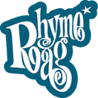

Please feel free to circulate it to those who you think may be interested.

**Read the next Rhyme Rag published poem**

The next poem to be published for **Rhyme Rag** is **‘Sooth-Said** by **Orla McGovern.**

Orla McGovern is 17 and attends Presentation Secondary School in Loughboy. She enjoys reading fantasy in particular but will dip into other genres as well. She also enjoys video games, but books are her main interest. Orla has had work previously published in Words to Tie to Bricks, which was part of the writing course in CTY Ireland 2013. She mostly writes poetry but has also been known to write a bit of prose here and there. She has twice appeared in Rhyme Rag.

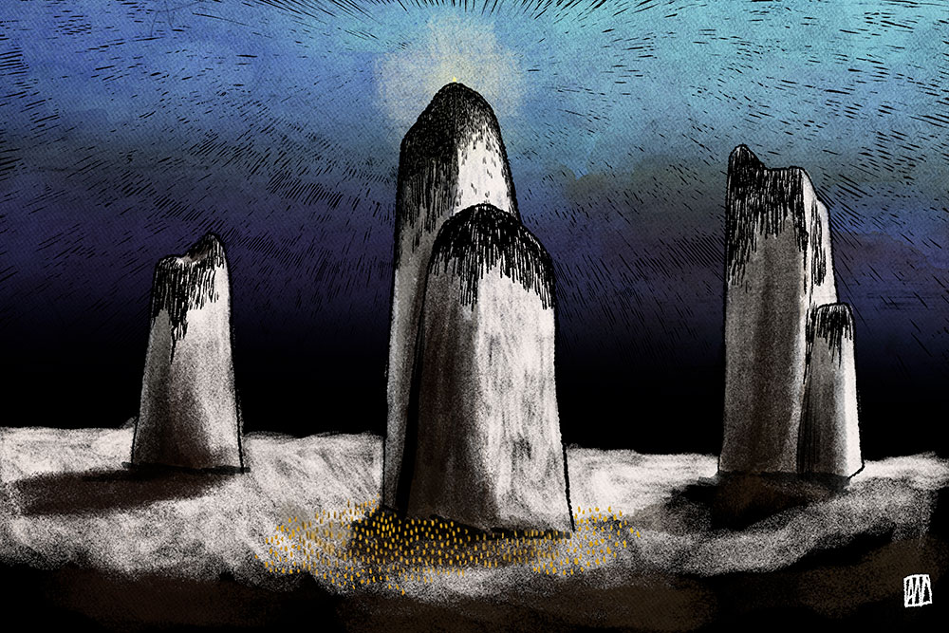

This poem was selected by Editor John W. Sexton and Illustrated by Ale Mercado.

**Read it here:** <http://www.rhymerag.net/2015/05/sooth-said/>

Thanks to all for submitting poems. And don’t forget to submit work or encourage others you may know to do so! See all details on [www.rhymerag.net](http://www.rhymerag.net)

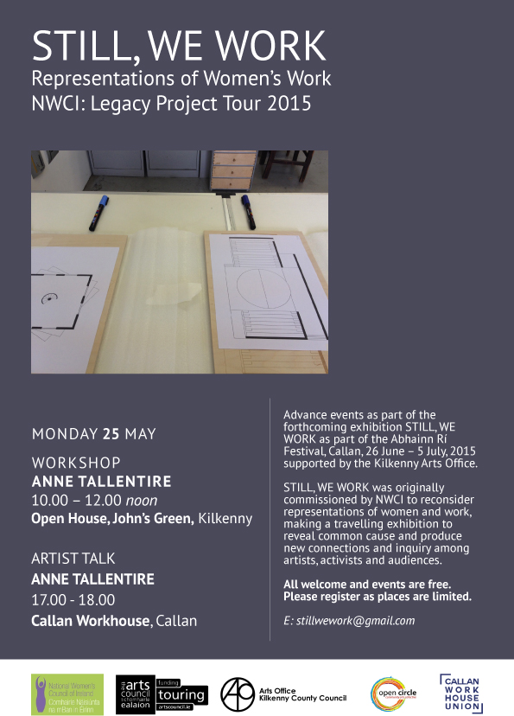

**Kilkenny Events**

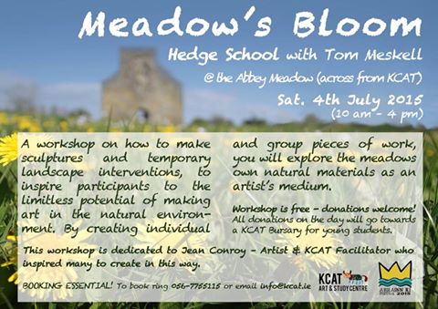

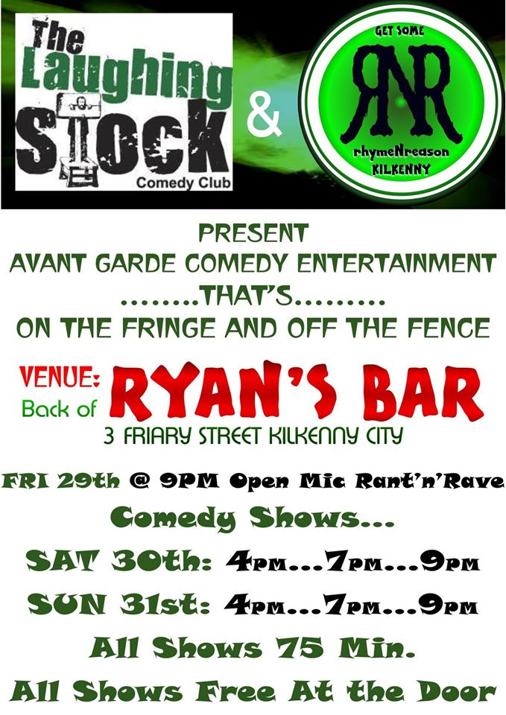

**Kilkenny Creative Hub – Expression of interest sought**

A group from the UCD Innovation Academy, on behalf of KK Co. Co., are exploring what it would take to develop Kilkenny city and county into a coordinated Creative Hub. They are looking for input from artists and creative people from all disciplines.

If you would be willing to share your thoughts and ideas, please contact Evan on 086-2472345 or [evan@knowyournumbers.ie](mailto:evan@knowyournumbers.ie)

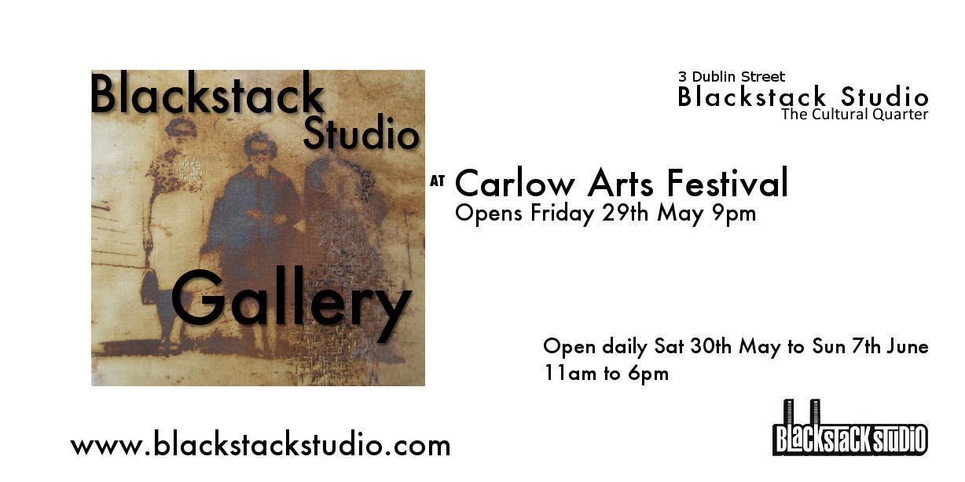

**Blackwatch Studio, Kilkenny Seeks Arts and Crafts Workshop Facilitators**

Blackwatch Studio, just 7 km from the Kilkenny city in the rural north, is seeking arts and crafts facilitators to deliver workshops.  
For further information contact Vicki:  
T:086 837 0205  
E: [blackwatchstudiokk@gmail.com](mailto:blackwatchstudiokk@gmail.com)

**Carnegie Trust "Test Town" competition**

This competition organised by the Carnegie Trust is open to Ireland as well as UK and is seeking ideas from innovative people to hold local activities that support start-ups in ways that are appropriate and effective for each community. They will provide 10 towns with funding of up to £3,000 each to run a skills development activity for entrepreneurs that uses the town centre. Closing date is 15th June.

<http://www.testtown.org.uk/testtown-2015/>

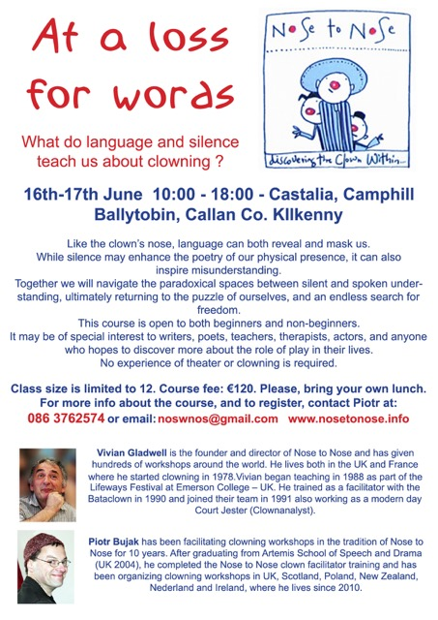

**Three Choirs’ Concert at St. Canice’s Cathedral**

Three Cathedral Choirs Concert to launch the annual Cathedral June Concert series   
Three Choirs’ Concert - 7th June 2015, 4pm – St Canice’s Cathedral, Kilkenny

For a fourth consecutive year, the music department at St Canice’s Cathedral, Kilkenny will host a series of Sunday afternoon concerts in June. This year’s series starts on June 7th with an exciting combined performance by the cathedral choirs of St. Canice’s Kilkenny, Christ Church Waterford and St. Mary’s Limerick. ... The programme includes the combined choirs in a performance of Schubert’s Mass in G, conducted by St Canice’s choral director David Forde and accompanied by cathedral organist, Malcolm Proud. Eric Sweeney will conduct the choir of Christ Church Cathedral Waterford in his own Mass of St. Patrick, accompanied by organist Cecilia Keogh. Peter Barley will conduct the choir of St. Mary’s Cathedral Limerick in music by Byrd and other composers. St. Canice’s Cathedral choir will perform a range of choral works, and will also be conducted and accompanied by cathedral organ scholar Róisín Rowley-Brooke. All three choirs will combine for a performance of Parry’s famous choral masterpiece I was glad. With over 60 voices, the Three Choirs’ Concert at 4pm on 7th June event promises to be a most memorable event.

The concert series will continue on each Sunday throughout June, with chamber music concerts in the intimate surroundings of the cathedral chapter room. Sunday 14th sees Kilkenny-based recorder player Laoise O’Brien and guitarist Michael O’Toole returning having performed to great acclaim in the 2014 series. Soprano Roisin O’Grady will sing Purcell and Schubert on Sunday 21st, accompanied by Malcolm Proud. The final concert will take place on Sunday 28th June with violinist Marja Gaynor, cellist Aoife Nic Athlaoich and harpsichordist Malcolm Proud. The concerts are at 4pm, tickets are €15 (€10), and available at the door or in advance from the cathedral on (056) 776 4971. Refreshments are available after the concerts, with an opportunity to meet and chat with the artists.

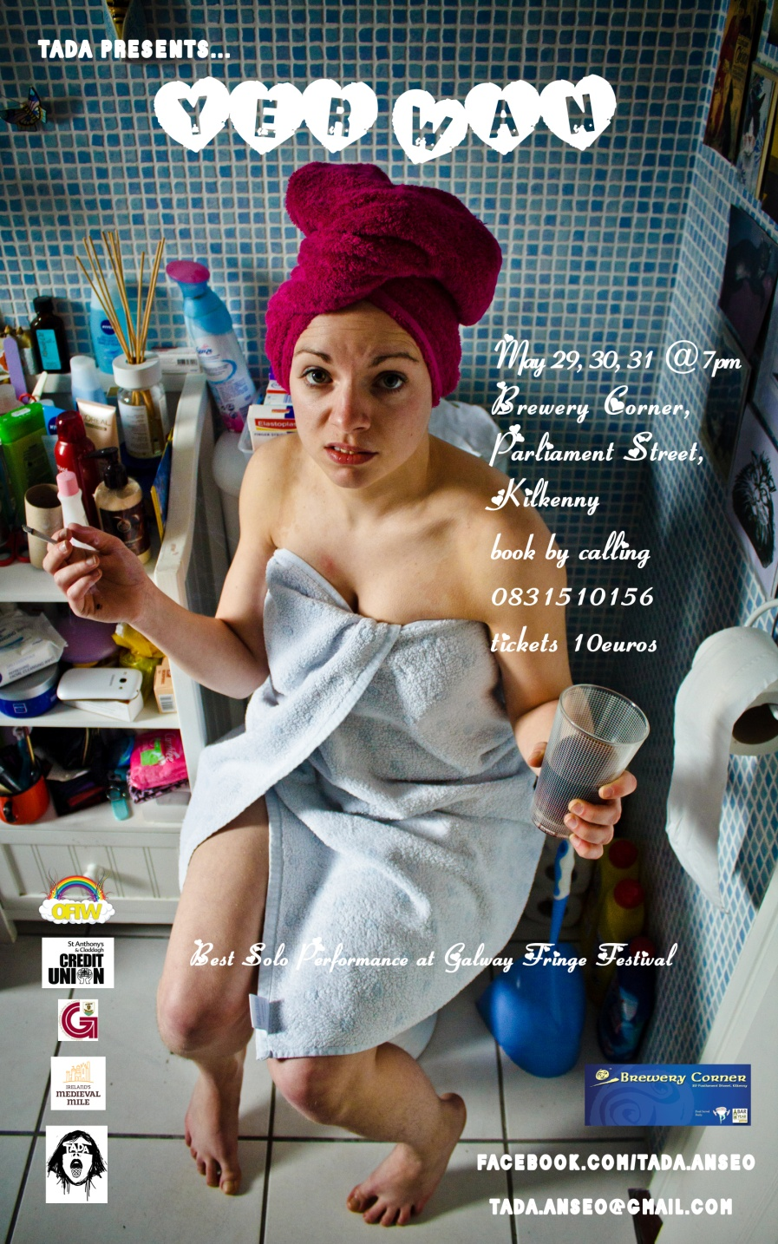

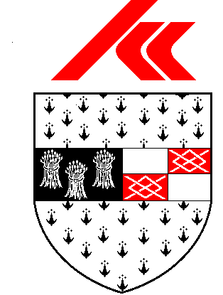

**KILKENNY COUNTY COUNCIL STREETSCAPE PAINT SCHEME 2015**

**TOWNS OF CALLAN AND GRAIGUENAMANAGH**

Kilkenny County Council is pleased to announce the ‘**Streetscape Paint Scheme 2015’** whereby a fund has been allocated to assist with the cost of painting the front façade of commercial / business buildings and/or hand painted shop signage within the towns of **CALLAN** **AND** **GRAIGUENAMANAGH**, subject to terms and conditions. 

If the scheme is oversubscribed those applicants eligible to continue in the application process will be randomly selected.

**Applications are welcome throughout the year subject to funding being available.**

Application Forms and further particulars may be obtained from the **Property Section, Kilkenny County Council, C/o City Hall, High Street, Kilkenny**. Contact - Tel 056 779 4534 or [www.kilkennycoco.ie](http://www.kilkennycoco.ie).

**Grennan Mill Craft School Graduate Show 2015**

**FRIDAY May 29**th**SATURDAY May 30**th **SUNDAY May 31**st **MONDAY JUNE 1**st   
   
**10.00am – 6.00pm daily**  
   
Grennan Mill Craft School is delighted to present their annual Graduate Show which will take place over the June Bank Holiday weekend.  Take a walk down the leafy lane enjoying the bird song and the swathes of cow parsley adorning the verges.  
    
This annual exhibition is a showcase of craft produced over two years by the 10 graduating students of Grennan Mill Craft School.  Grennan Mill prides itself in teaching age-old crafts to a very high standard using traditional tools and techniques.  The crafts include Batik, Ceramics, Metalcraft, Woven Textiles and Printmaking and each craft will be well-represented in the exhibition which is laid out on five floors throughout the mill. It is a great opportunity to see some high quality pieces of work which have been created by very talented students who have completed over two years, FETAC Level 5 Art, Craft and Design and the Level 6 Art. Some works by the students will be for sale at very reasonable prices.  
   
The Graduating students this year come from Ireland, Italy, Lithuania, India, South Africa & Germany and the work this year has reflected their birth countries.  
    
Admission to the exhibition is free, and all ages are welcome.  The ground floor is wheelchair accessible.  Car parking facilities are at the end of the entrance lane, just outside the Mill yard.

There is a café serving a selection of home-made baking and cooking. It will be open on Saturday 30th & Sunday 31st May

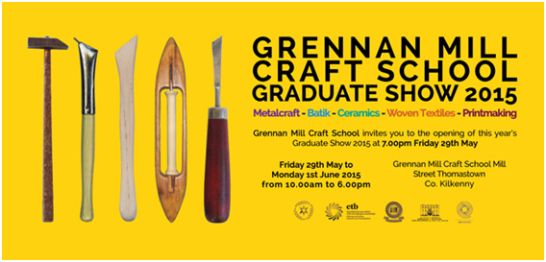

For additional information on both the exhibition and upcoming Summer Courses, please contact **Alexandra Meldrum** (Course Director) at **056 7724557** or [grennanmillcraftschool@gmail.com](mailto:grennanmillcraftschool@gmail.com)        
 

**Ballykeeffe Amphitheatre Kilmanagh Summer Concert Schedule**   
  
**Nathan Carter** June 12th   
**Goldilocks and the Three Bears (children's theatre show)** June 28th  
**Sharon Shannon** ,July 25th  
**Jane Eyre** by Chapterhouse Outdoor Theatre July 31st  
**Damien Dempsey** Aug 8th.  
  
More acts to be added.  
Tickets for Nathan Carter are now on sale at Ticketmaster ,Kilkenny Book Centre, Rollercoaster records and locally.  
@ 25 euro  
  
Events contact is Matt O'Sullivan - 087 6261134

# Seventies Disco Saturday Night feat. ONASSIS Disco Band + Those responsible

## 

Saturday, June 6, 2015 8:30 PM until Sunday, June 7, 2015 12:30 AM

**€8 at the door**

**A ticket from EVENTBRITE is €20 because it entitles three people entry at the door - so it's a discount. Go on - treat yourself and your friends to a night of Disco Heaven!**

**Do I have to bring my printed ticket to the event?**

Yes Please however - nobody is who they say they are on the Internet - but please bring the real you to the dancefloor....

**[Kilkenny International Gospel Choir Festival](http://kilkennygospelchoirfestival.com/" \o "Kilkenny International Gospel Choir Festival)**

[19-21 June 2015](http://kilkennygospelchoirfestival.com/" \o "Kilkenny International Gospel Choir Festival)

Programme 2015

**Friday, June 19th (Ormonde Hotel)**

10 – 12 am  Workshop for Primary School Children, Mr. Marcanthony Henry, Director/Musician/Singer from New York City

5.00 pm      Official Opening of the Festival performed by Mayor Andrew McGuinness in Kilkenny City Hall.   Complimentary light refreshments will be available.

8 – 9 pm       Introductory workshop with Mr. Marcanthony Henry.

**Saturday, June 20th (Ormonde Hotel)**

09.30 am  Morning Praise – Rev William Purcell, Musical Director, Kilkenny Gospel Choir

10.00 am  Workshop 1 – Mr. Marcanthony Henry

11.00 am  Tea/Coffee

11.30 am  Workshop 2 – Mr. Marcanthony Henry

12.30 pm  Lunch

02.00 pm  Workshop 3 – Mr. Marcanthony Henry

03.30 pm  Tea/Coffee

04.30 pm Concert Rehearsal

05.30 pm  Break

08.00 pm Celebration Concert in the  Black Abbey

**Sunday, June 21st (St. Mary’s Cathedral)**

11.00 am  Worship – Special Festival Mass

03.00 pm  Gospel Singing/Walking Tour of Kilkenny’s Medival City

Costs: $40.00 (€35.00) per person for weekend.

Children €5.00

All food and accommodation will be extra.  There will be a discounted menu available to participants during the workshops in the Ormonde Hotel.

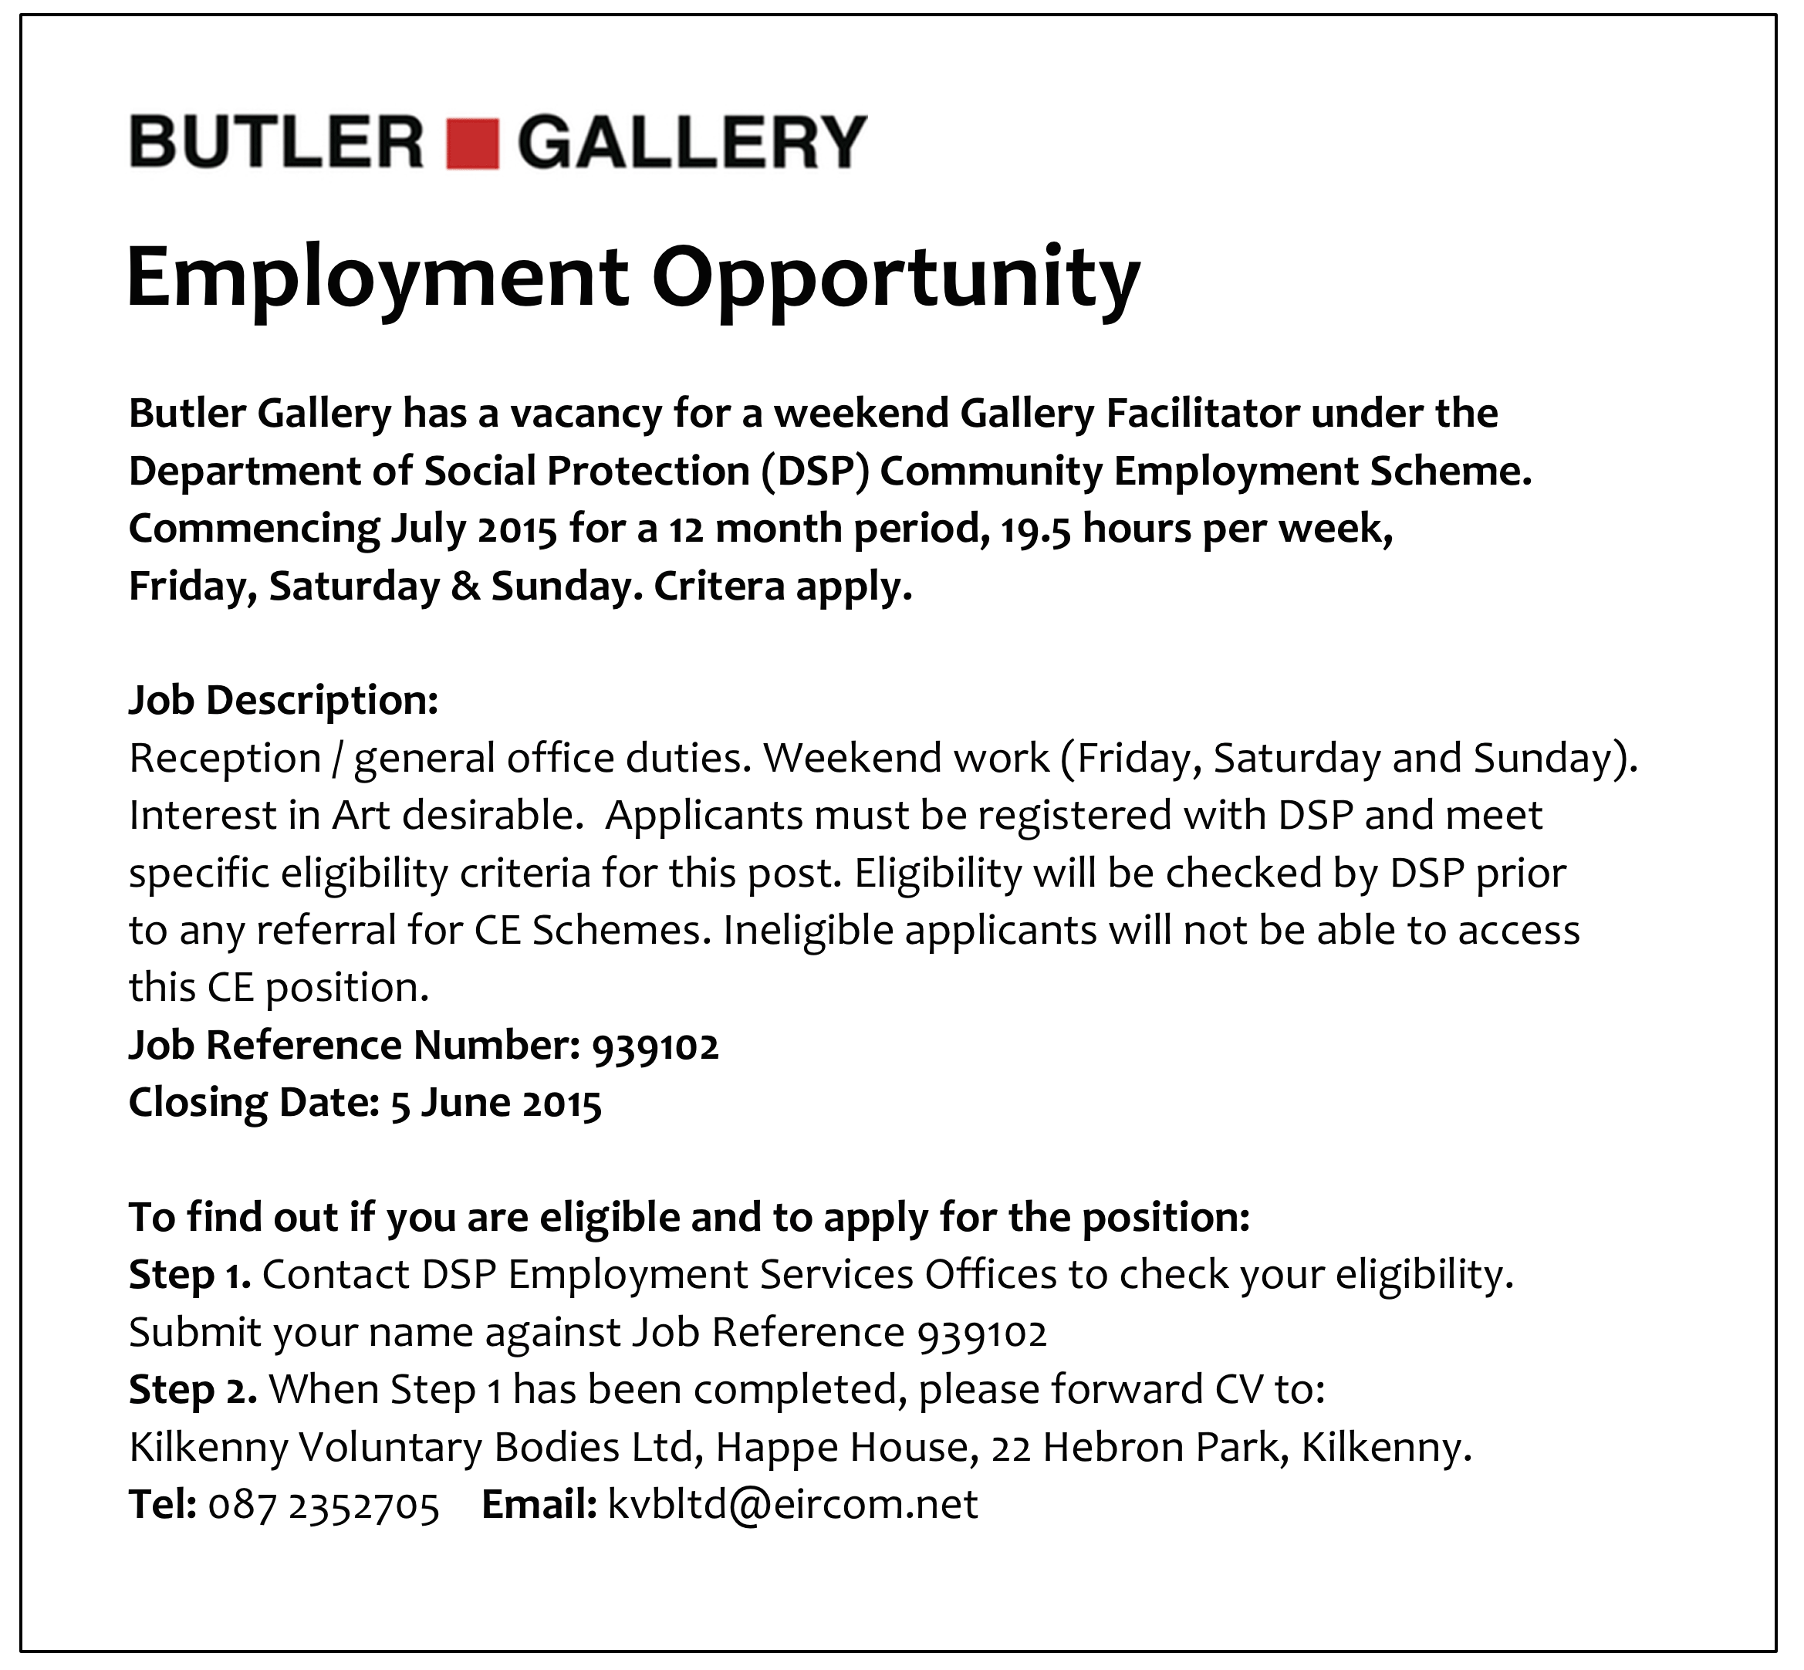

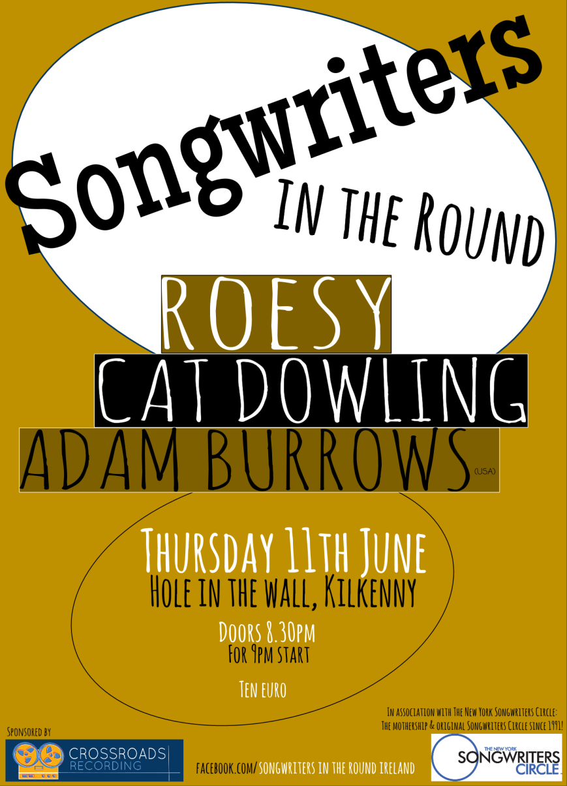



[**APPETITE FOR DESIGN**](http://www.nationalcraftgallery.ie/exhibitions)

**8 MAY 2015 – 30 JUNE 2015**

[Appetite for Design](http://www.nationalcraftgallery.ie/exhibitions) features the work of leading Irish and international designers, cooks and restaurateurs, documenting, discussing and speculating about the design of food and our experience of it.   Food is no longer merely about the simple act of eating, and the pure experience of smell and taste. New trends and materials have led to unique opportunities for the designers of today to enhance and elevate one's culinary experience by speaking to our minds as well as our stomachs. Engaging all our senses in a holistic culinary experience.

[Appetite for Design](http://www.nationalcraftgallery.ie/exhibitions) showcases examples of the aesthetics, promotion, communication and representation of food, along with the equipment and tools used to prepare and consume food. Featured work includes Bompas & Parr, Marije Vogelzang, Omer Polek, The Decorators, Chapter One and Loam.

A series of culinary evenings and performances to accompany the exhibition will hosted by [Godless Domestic](http://www.thedomesticgodless.com/), [Dublin Pop-up,](https://www.facebook.com/dublinpopup) [Culinary Counter](https://www.facebook.com/theculinarycounter) and Barry Fitzgerald.

The exhibition is curated by [Designgoat](http://wearedesigngoat.com/) and explores the very best of Food Design and builds on the increasing global recognition of outstanding Irish produce from coast to coast, and seabed to soil.

**APPETITE FOR DESIGN Eating Experiences**

[Eating Experience Programme](http://www.nationalcraftgallery.ie/news/article/eating-experience-programme)

As part of Appetite for Design exhibition curators, Designgoat, invite chefs, food designers and artists to create a series of Eating Experiences, presented in the National Craft Gallery. Each individual Eating Experience will be a totally different culinary encounter; showcasing seasonal, wonderful and bizarre foods.

[Eating Experience 3 with Culinary Counter](http://www.nationalcraftgallery.ie/news/article/eating-experience-programme) - Sat 6 June, 6.30pm.

The Culinary Counter, run by chefs Mark Moriarty and Ciaran Sweeney, aims to break down barriers between the kitchen and the customer. An exciting theatrical tasting menu will be served from these young brilliant chefs.

[Eating Experience 4 with Dublin Pop-Up](http://www.nationalcraftgallery.ie/news/article/eating-experience-programme) - Sat 20  June, 6.30pm.

Cúán Greene and Harry Colley of Dublin Pop Up offer innovative and extraordinary fine dining catering experiences, which play with traditional dining formats through dramatic food and unique locations.

**Booking for the Eating Experience series is through** [**eventbrite.com**](http://www.eventbrite.com/e/appetite-for-design-eating-experience-1-tickets-16675895051?aff=es2)**, which will be open from Monday 27th April. Limited places available. Unfortunately, special dietary requirements cannot be accommodated.**

Families are invited to investigate, explore and discover new ways of seeing with our fun range of experimental drawing workshops and activities inspired by our current exhibition [Appetite for Design.](http://www.nationalcraftgallery.ie/) Take part in one of our free craft and design-based workshops, **Yummy Prints**, **Giant Fibre Portraits** and **The Drawing Banquet** with plenty more self guided activities for all ages to enjoy.

**YUMMY PRINTS** *with textile print-maker Caroline Ryan*

Inspired by our exhibition Appetite for Design textile print-maker Caroline Ryan of [PRINTBLOCK](http://printblock.ie/) Collective will explore all things foodie through silk-screen printing. Explore line, colour, design and cook up a colourful textile print on the day to take home. Suitable for all the family

**GIANT FIBRE PORTRAITS** *with textile artist Caroline Schofield*

Transform the Castle Yard into a magical large-scale drawing with Caroline Schofield using the grass as a giant canvas. Strike a pose on the grass while the shape of your body is mapped using brightly colored yarns. Watch the map grow bigger and brighter through out the day. How about a unique family fiber portrait!

**DRAWING BANQUET** *with artist Mella Cahill*

Let the tablecloth be your canvas and the food your drawing tools at this dinner party like no other. Artist Mella Cahill will lead this imaginative drawing workshop inspired by the dinner table, suitable for all the family.

**All Drop –in, Ideal family activities. No booking required**

<http://www.nationalcraftgallery.ie/news/article/national-drawing-day>

[**Family Day: Mad Hatter’s Tea Party**](http://www.nationalcraftgallery.ie/exhibitions)

Sat 13 June 10.30am & 12noon

Children are invited to a Mad Hatter’s tea party were creativity and food will collide to create a magical eating experience.

[**Late Date: Public Spaces & Food**](http://www.nationalcraftgallery.ie/exhibitions)

Thurs 25 June, 6.30pm

Suzanne O’Connell of [The Decorators](http://the-decorators.net/About) and John Mahon of [The Locals](http://www.thelocals.ie/about), talk eating spaces.

[**Schools**](http://www.nationalcraftgallery.ie/learn/schools)

Tuesday – Friday, 10am & 12noon

Food Design focused tour and activities for Primary School students.

**WEEKENDS: DISCOVER & DESIGN**

Visitors of all ages can design, draw, build, and create with self-guided activities at the weekend. Drop in and get creative.

**Eating Experience tickets are available through eventbrite.com**

**To book our other events please contact us at 056 7796151 or email** [**events@nationalcraftgallery.ie**](http://kk-moss/Sites/arts_office/Shared%20Documents/Internal/Niamh/2015%20projects/E-bulletin/Downloads/events@nationalcraftgallery.ie)

**[nationalcraftgallery.ie](http://www.nationalcraftgallery.ie)**

[**facebook.com/NationalCraftGallery**](https://www.facebook.com/NationalCraftGallery)

[twitter.com/NCGKilkenny](http://kk-moss/Sites/arts_office/Shared%20Documents/Internal/Niamh/2015%20projects/E-bulletin/Downloads/twitter.com/NCGKilkenny)

**New Living City Initiative for Kilkenny**

The Living City initiative focuses on the regeneration of retail and commercial districts and encouraging people to live in the historic centres of Cork, Dublin, Galway, Kilkenny, Limerick and Waterford. The aim of the Living City initiative is to bring life back into the heart of the relevant cities by offering tax relief for qualifying expenditure incurred on the refurbishment or conversion of certain buildings where conditions are met. For further information see <http://www.kilkennycoco.ie/eng/Services/Planning/The-Living-City-Initiative/Living-City-Initiative.html>

**Have you got a bright idea for your community?**

The Bright Ideas fund (€100,000) is open to everyone across Ireland with an idea to transform or rejuvenate their community within 12months. Closing date 31st May 2015. <http://kbcbrightideas.com/>

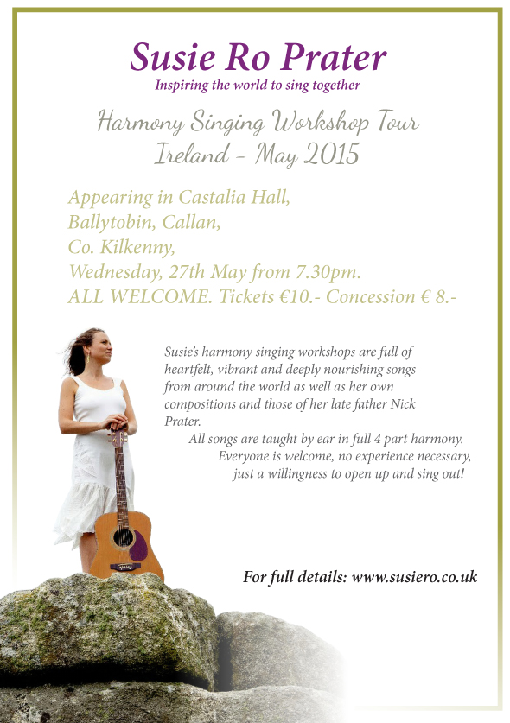

**Stone Carving Workshop, with James Horan and Aileen Anne Brannigan, Kilkenny**

Beginners course in letter carving or sculpting in stone  
13th & 14th June 10am – 4.30pm both days  
Cost €150

Venue: Mill Lane, Callan, Co Kilkenny

Tools and stone provided. Each student should bring home a finished piece, basic stone carving skills and good memories.

Tea and coffee provided but please bring a lunch!  
Design and carve your own sculpture/plaque/ sign

Further information:  
T:  0861676219  
E: [jameshsculpture@hotmail.com](mailto:jameshsculpture@hotmail.com)

**Joe Hill Songwriting Competition - Thomastown**

The George Brown Memorial Committee is pleased to announce their first ever songwriting competition. 2015 marks the 100th anniversary of the execution of Joe Hill in Utah, USA. Joe was a workers activist and member of the Industrial Workers of the World. His execution was controversial and is considered to be a miscarriage of justice resulting from his trade union activities.

Joe Hill will be a central theme of the 2015 George Brown Commemoration, with a key-note speech on his story and subsequent influence on the worker’s movement. We are also offering a prize of €150 for the best submission in our songwriting competition, where we are asking for words to two new verses for the song Joe Hill. These verses should deal with the difficulties experienced by workers since 1915 and/or the advances achieved over the subsequent century. They should follow the standard format of the other verses and fit to the usual tune for the song. If you are not familiar with the song you can find a version by Luke Kelly on Youtube at:

<https://www.youtube.com/watch?v=Q2OivplOBq8>

The closing date for the competition is midnight Monday 1st June 2015. Submissions should be made to the George Brown E-mail address:

[georgebrown.inistioge@gmail.com](mailto:georgebrown.inistioge@gmail.com)

or to Joe Doyle, George Brown Memorial Committee, Thomastown, County Kilkenny

I dreamed I saw Joe Hill last night  
Alive as you and me  
Says I, "But Joe, you're ten years dead"  
"I never died", says he  
"I never died", says he.

In Salt Lake, Joe, says I  
Him standing by my side  
"They framed you on a murder charge"  
Says Joe, "I never died"  
Says Joe, "I never died."

The copper bosses they shot you, Joe,  
They filled you full of lead  
"Takes more than guns to kill a man"  
Says Joe, "And I ain't dead"  
Says Joe, "And I ain't dead."

And standing there as big as life  
And smiling with his eyes  
Says Joe, "What they forgot to kill"  
"Went on to organize"  
"Went on to organize."

Joe Hill ain't dead, he says to me  
Joe Hill ain't never died  
Where working man are out on strike  
Joe Hill is at their side  
Joe Hill is at their side.

In San Diego up to Maine  
In every mine and mill  
Where working men defend their rights  
It's there you'll find Joe Hill  
It's there you'll find Joe Hill.

I dreamed I saw Joe Hill last night  
Alive as you and me  
Says I, But Joe, you're ten years dead  
I never died, says he  
I never died, says he.

**Vultures – A New Radio Series**

The new radio serial from Devious Theatre has gone online in its entirety. *Vultures* is a 20 part murder mystery serial originally broadcast on KCLR96FM last month.

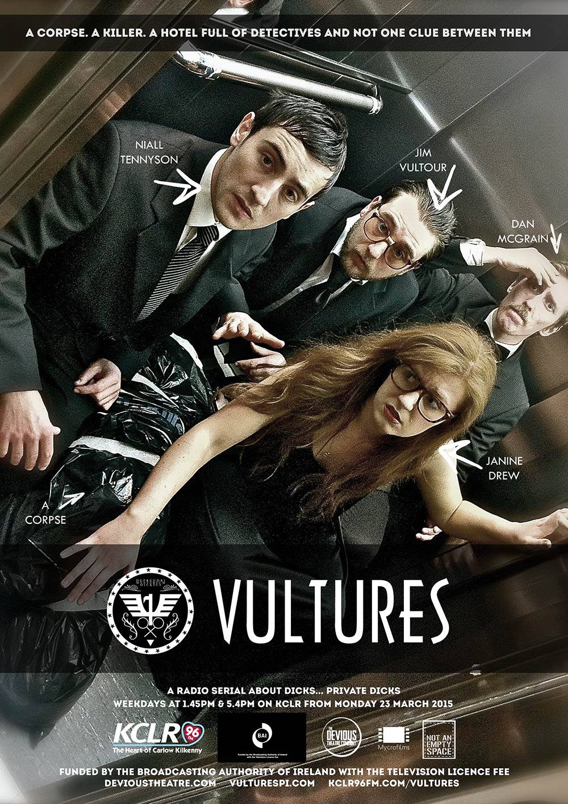

*Vultures* focuses on the private detectives of Vulture Private Investigations, a small time detective agency in south east Ireland. **Janine Drew, Dan McGrain, Jim Vultour** and **Niall Tennyson** are the detectives in question and the story follows them as they get caught up in a suspenseful murder mystery at the Detective Union Of Ireland AGM. The show follows the varying perspectives of the four bungling sleuths as they trawl the corridors of Wisteria Lodge, searching for a killer, quizzing a colourful cast of suspects and trying to figure out who killed Ireland’s most famous detective Basil Maguire? And why?

The cast for the series are **Stephen Colfer, Ross Costigan, John Doran, Amy Dunne, Seán Hackett, Ken McGuire, John Morton, Niamh Moyles, Suzanne O’Brien** and **David Thompson**. It is written and directed by John Morton, produced and engineered by Ken McGuire with **Alan Slattery** as associate producer and an original score from **David Sheenan**.

The first run of *Vultures* was a web series produced by **Mycrofilms** from 2007 – 2012 and was created and produced by **Paddy Dunne, John Morton** and **Alan Slattery.** You can listen to the entire series on **devioustheatre.com/past-shows/vultures-2015**

**Grennan Mill Craft School - Summer Courses 2015**

• Metalcraft & Jewellery for Beginners & Improvers  
**Thursday 4th June - Sunday 7th June** / 10am-5pm   
4 day course exploring many techniques in Metalsmithing & Jewellery-making including enamelling, soldering, forming, surface decoration & more...   
Minimum 6 – Maximum 8 persons  
Course Fee €260  
Materials Fee €15 - includes copper & gilding metal, enamels, solders & sundries.

• Silver Jewellery for Beginners & Improvers  
**Friday 12th June - Sunday 14th June** / 10am-5pm   
3 day course exploring many techniques in Silver Jewellery making  
Minimum 6 – Maximum 9 persons  
Course Fee €200  
Materials Fee €20 (includes 8 grams of silver)

***For more details please text / phone Metalcraft Tutor Eva Lynch on 087 6210830 or email at [evylynch@hotmail.com](mailto:evylynch@hotmail.com) ***

Place will only be secured once deposit of 50% or full payment has been received. Full course fee required by: Friday 29th May for ALL courses  
• Cheques made payable to ‘’Grennan College’  
• Class formation is dependent on an adequate number of applicants – minimum 6 persons for each individual course irrespective of craft  
• Should Grennan Mill cancel the course, your monies will be refunded in full

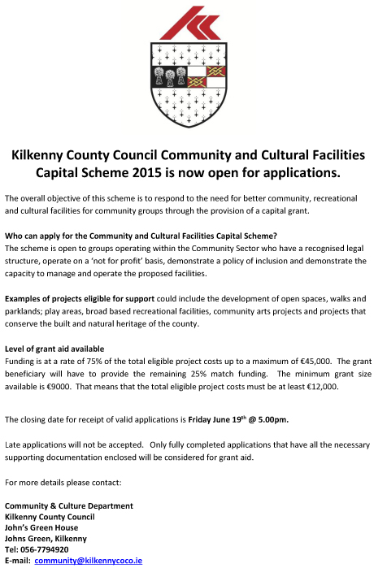

## Coming Soon to the Watergate Theatre

Here’s a look at some of the shows, gigs and other events taking place here at the Watergate Theatre in the next few weeks. You can speak to our helpful box office staff at any time by phoning [056 7761674](tel:+353567761674).

[**Book Online**](http://watergatetheatre.com/programme/st-kierans-college-awards-night/)

[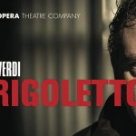](http://watergatetheatre.com/programme/rigoletto/)

### [Rigoletto](http://watergatetheatre.com/programme/rigoletto/) (28/05/2015)

[**Book Online**](http://watergatetheatre.com/programme/rigoletto/)

[](http://watergatetheatre.com/programme/the-man-in-the-womans-shoes-3/)

### [The Man In The Woman's Shoes](http://watergatetheatre.com/programme/the-man-in-the-womans-shoes-3/) (29/05/2015)

A one-man show written and performed by Mikel Murfi - back by popular demand!. See [full event & ticket details](http://watergatetheatre.com/programme/the-man-in-the-womans-shoes-3/).

[**Book Online**](http://watergatetheatre.com/programme/the-man-in-the-womans-shoes-3/)

### [Jesters Stage Academy presents Movie Mayhem](http://watergatetheatre.com/programme/jesters-stage-academy-presents-movie-mayhem/) (11/06/2015)

An evening of movie blockbusters with Jesters.

[**Book Online**](http://watergatetheatre.com/programme/jesters-stage-academy-presents-movie-mayhem/)

### [Dancewise Academy presents Movie Magic](http://watergatetheatre.com/programme/dancewise-academy-presents-movie-magic/) (25/06/2015)

A night of dance from your favourite movies and musicals..

[**Book Online**](http://watergatetheatre.com/programme/dancewise-academy-presents-movie-magic/)

### [Moll](http://watergatetheatre.com/programme/moll/) (02/07/2015)

Performing 2-4 and 9-11 July.

<http://watergatetheatre.com/>

**KOZO Studio WORKSHOP Programme  
for adults (incl. young people from 16 years)**

**MAY - JULY 2015**

**PRESS RELEASE** For immediate release (May 2015)

The **WORKSHOP PROGRAMME** at KOZO Studio continues – designed and facilitated for small groups of participants at KOZO Studio in The Estate Yard, Castlecomer Discovery Park, Co. Kilkenny.

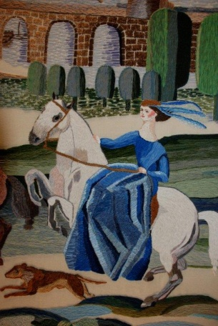**!! NEW !!** courses added:

**EMBROIDERY WORKSHOPS**

with ***ALEXIS BERNSTORFF*, artistic director of the ROS TAPESTRY**

**20 JUNE (Saturday) 10.30am - 5pm**

*Beginners and Participants with Previous Experience ++*

This workshop will teach 6 principal stitches and their variations - using wool, cotton/silk and metallic threads. Participants will be inspired by a range of techniques to realise various designs. Alexis has 15 years experience teaching crewelwork embroidery and is the guide behind the dynamics of the Ros Tapestry.

€ 70 for the full day - including all materials

*++ This workshop is tailored to the interests and experience level of those taking part*

**********  
**7 June (Sunday): PAPER MAKING DAY**- ***Beginners*  
This COURSE will be repeated on 12th July** (Sunday) (Please see below).

Follow-on and Advanced Level courses will be scheduled for August/September.

**10.30am - 1.30pm HAND PAPER MAKING** - Introduction to traditional and contemporary techniques of making beautiful handmade papers from pure plant fibres and a range of recycled materials.  
**2.30 - 5.30pm SILK FIBRE PAPERMAKING**- A truly fascinating, contemporary technique for making `fabric-like`, colourful silk papers using raw silk fibres and fabric dyes. Easy to continue and set up at home, this process is ideal to create unique interior decorations and striking silk papers for artworks, embroidery, collages ...etc.

**Fees** for each workshop: € 35   
**OR:** € 65 for the full day - including all materials

**14 June (Sunday)**  
**11am - 5.30pm BATIK Workshop** - ***Beginners***A full day programme introducing an ancient technique of fabric dyeing where hot wax is used as a resist.  
Participants will learn all necessary basic techniques - and complete three small/medium batik pieces with up to 4 colours on cotton fabric and/or paper.  
€ 70 for the full day, including all materials

**********

**12 July (Sunday): PAPER MAKING DAY**- ***Beginners*  
10.30am - 1.30pm HAND PAPER MAKING**

**2.30 - 5.30pm SILK FIBRE PAPERMAKING**

COURSE DETAILS as ABOVE (Please see Paper Making Day on 7th June)

**GIFT VOUCHERS are available for the workshop of your choice!**

BOOKINGS are confirmed with € 30 deposit paid in advance.*  
Courses are run for small groups of participants only so please call to book early.  
**With any questions, for advice or check availability and for all BOOKINGS please contact TUNDE directly:**  
  
**Tunde Toth –** Artist, Arts Educator **087-2543362  
E:** [tundetune@gmail.com](mailto:tundetune@gmail.com)[www.tundetoth.com](http://www.tundetoth.com)

[www.tundetothpaperart.blogspot.com](http://www.tundetothpaperart.blogspot.com)

[www.kozostudio.wordpress.com](http://www.kozostudio.wordpress.com)

* DEPOSITs are returned if the Studio has to cancel a workshop. Cancellations from participants will be accepted up to 2 weeks before the course date and deposits will be returned. In other cases participants may be offered rescheduled dates/options.

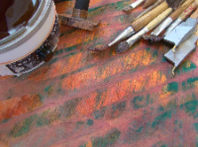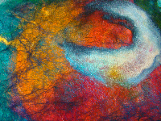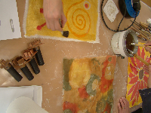

* **BATIK Workshop** on Sunday **14th of June** at KOZO Studio!
* An example of a beautifully made **SILK FIBRE PAPER piece** - created at one of our previous workshops - by one of the many talented and enthusiastic participants!

**Courses / Training / Jobs / Internships**

**MA in Socially Engaged Art, NCAD - Deadline for applications extended**

Applications are now being sought for the MA Socially Engaged Art (Further, Adult and Community Education). The MA SEA focuses on the dynamic relationship between socially

 engaged arts practice and pedagogy, particularly within further education, non-formal educational and community settings, with an embedded qualification to teach in the FE sector.

Recognising the range of methodologies used in socially engaged art that draw on educational concepts and forms, the MA SEA is a site for experimental learning and critical debate

 in socially engaged art and education practice. The course is coordinated by artist Fiona Whelan and Nuala Hunt - Head of Continuing Education in NCAD. Other staff include: artists

 Chris Maguire, Glenn Loughran, Ailbhe Murphy.

Marie Barrett as well as adult educator Anne Gallagher and community worker John Bissett.

The MA SEA will attract students from a range of disciplines who want to immerse themselves in a trans-disciplinary enquiry. Applicants should have a Level 8 (BA Hons) degree in art or design or in another discipline with a personal and demonstrable commitment to the arts in social contexts. Deadline for applications has been extended to 30th June 2015.

For further information, see <http://www.ncad.ie/postgraduate/school-of-education/ma-in-socially-engaged-art>

**Information event on EU supports for youth arts**

**Creative Europe Desk (CED) Ireland Culture Office and Léargas**

Date: 16 June 2015

Time: 10am-2pm

Venue: European Union House, Dawson Street, Dublin 2

Email: [cedculture@artscouncil.ie](mailto:cedculture@artscouncil.ie)

Creative Europe Desk (CED) Ireland Culture Office and Léargas joint information event on EU supports for youth arts - Tuesday 16th June 2015.

The event will focus on the EU's Creative Europe Culture sub-programme and the Erasmus+ programme (focusing on Youth and Adult Education sectors).

An overview of each programme will be given along with details of how to apply. There will be speakers who are representatives of arts organisations

presenting their experience of applying for and carrying out activities under each of the programmes.

This is an excellent opportunity to explore international opportunities for yourself, the artists and practitioners you work with and importantly

the young people taking part in your activities.

Register by 9 June 2015.

Programme

10am Registration, tea, coffee & networking

10.30 Creative Europe Presentation

11am Project example - Weather Stations, Tallaght Community Arts

11.30 Break

11.45 Erasmus+ Presentation

12.15 Project examples - Erasmus+

1pm Workshops (including lunch)

2pm Event close

Further information

Audrey Keane, CED (Ireland) Culture t: 01 618 0256 e: [cedculture@artscouncil.ie](mailto:cedculture@artscouncil.ie)

**Designing Exhibitions: Exhibiting Design Seminar at Chester Beatty Library**

Friday 12th June, 2pm – 5.30pm  
Chester Beatty Library, Dublin Castle, Dublin 2

A seminar presented by Irish Design 2015 exploring exhibition design and how it connects with the with the curatorial process of making exhibitions. The seminar will look at the collaborative process which can be involved in producing exhibitions; exhibition designers and graphic designers working with curators to create the narration of the exhibition vision, considering the logistics of venues and tour programmes while most importantly ensuring the design engages audiences.

The seminar will take place on Friday 12th June on the closing weekend of the Hidden Heroes: the Genius Of Everyday Things, from the Vitra Design Museum.

Key Note Speaker: Jochen Eisenbrand, Chief Curator, Vitra Design Museum. With contributions from curators, galleries, museums and designers. See website for further info.

Seminar kindly supported by The Goethe Institute.

Free event, with booking through: [www.designing-exhibitions.eventbrite.ie](http://lists.visualartists.ie/lt.php?c=1350&m=4387&nl=1&s=d3c261c0eeb6b48867f449d29e09414b&lid=115285&l=-http--www.designing-exhibitions.eventbrite.ie)

[www.irishdesign2015.ie/programme/single/designing-exhibitions](http://lists.visualartists.ie/lt.php?c=1350&m=4387&nl=1&s=d3c261c0eeb6b48867f449d29e09414b&lid=115286&l=-http--www.irishdesign2015.ie/programme/single/designing-exhibitions)

**Summer Internship Opportunities at Irish Design 2015**

Irish Design 2015 (ID2015) is seeking enthusiastic summer interns who are passionate about design to support ID2015’s exciting national and international programme of design exhibitions and events.

ID2015 Summer interns will be involved in a dynamic programme, celebrating and promoting Irish design and designers. You’ll be part of a core team who will engage the wider public with this celebration.

The ideal candidate will be a student or recent graduate of a design-based discipline who is hard working, computer literate and interested in developing their career in design. Please note that this position requires a minimum commitment of 3 days per week over a two month period.

Interested? Submit your CV and cover letter outlining your interest in a summer internship with ID2015 to hello@irishdesign2015.ie

[www.irishdesign2015.ie](http://lists.visualartists.ie/lt.php?c=1350&m=4387&nl=1&s=d3c261c0eeb6b48867f449d29e09414b&lid=115319&l=-http--www.irishdesign2015.ie/)

**Children’s Art in Libraries Programme, Seeks Curator/Artist Proposals**

In 2015 the Children’s Art in Libraries programme is offering a rare opportunity to a curator or artist to create an engaging visual arts exhibition for children that will stimulate both their curiosity and imagination. The Children’s Art in Libraries programme (CAL) is a unique initiative directly influenced by its distinctive context that seeks to provide innovative high quality arts experiences for children of all ages. CAL is an initiative of the Dublin City Council Arts Office and works in partnership with Dublin City Public Libraries to deliver innovative programming for children across a broad range of art forms.

Further information; please contact the Children’s Art in Libraries Programme Co-ordinator, Irma Grothuis on 086-820 5949, mornings only.  
**Deadline: Friday 5th June 2015**

**Visual Arts Workers Forum**

Ormston House is delighted to host the fourth Visual Arts Workers Forum at 69 O'Connell Street (the former Belltable Arts Centre), Limerick City on Friday 29 May 2015.  
  
Voice your criticality, inspire your peers, debate your concerns - this forum is our opportunity to co-support the field of the visual arts in Ireland right now. Tickets for this year’s forum are limited, so early booking is advised!  
  
Please find below information on the programme, timetable & tickets.  
  
[www.vawf.ie](http://ormstonhouse.us2.list-manage.com/track/click?u=6b4747556a27b6f85fb1cc52f&id=22cc3ee872&e=896e5fadd6)  
[www.ormstonhouse.com](http://ormstonhouse.us2.list-manage.com/track/click?u=6b4747556a27b6f85fb1cc52f&id=aae9ff7737&e=896e5fadd6)

**International Directing Workshop**

**July 6-11 -**Intensive summer school recommended to directors, choreographers   
and artists interested in learning about ensemble building, directing, structuring the rehearsal process,   
applying new techniques and methodologies, networking with practitioners from different countries   
and finding future creative partnerships with like-minded people.

The training is designed as the **multidisciplinary intensive lab**   
with participation and practice together with performers from different parts of the world and various artistic techniques.

**The working language is English.**

**Participants can receive the Certification.**

**About the place:**  
The workshop will take place in the **XVth century castle**, today the international multi arts centre, located in the beautiful Austrian countryside. **Comfortable accommodation at the castle guest house and three meals per day are available for the group (bio vegetarian food as well).**

**Travel information:**  
**Nearest airports**: Graz or Vienna. From the airport participants can take a train.

**To see full program details and application, please visit:**

[**https://twitter.com/iugte_art**](https://twitter.com/iugte_art)

**MA SPACE Limerick School of Art & Design | Call for Applications**

MA SPACE invites candidates from Art, Design and other related fields who are interested in creating art that addresses topics such as; Space and Place, Food Politics, Gender Politics, Ecology, Climate Change, environmental politics, Science and Art, Civil Rights, Globalization and Economics, Health, Trans-Global Movement, Labour and Land Politics, etc

Social Practice is located in the overlap of art, society and politics. It has been described as art activism, critical art, socially engaged art, social practice art, activism, political art, participatory, dialogical or collaborative art.

Second round MA SPACE applications for the academic year 2015-16 are now being considered, application form and information on the programme at: [http://www.lit.ie/Courses/MASPACE/](http://lists.visualartists.ie/lt.php?c=1342&m=4379&nl=1&s=e784eec6bf8bb9680747b324b9c9eee1&lid=112565&l=-http--www.lit.ie/Courses/MASPACE/)

Deadline for applications 5pm on Friday 5th June 2015.

**NYCI Youth Arts programme is pleased to announce the details of our Summer School programme 2015**

Summer School 2015 is a three day residential youth arts practice training in NUI Galway, running from 10th-12th June 2015 (check in on Tuesday 9th June). The theme this year is Story Making. Summer School is about approaching your work with young people in a fresh way. It is an opportunity to be inspired, use new art forms, break out of your everyday routine, network and get creative!

Summer School is suitable for anyone working with young people in the non-formal education sector who wishes to explore ways of introducing, enhancing and extending youth arts provision for the young people with whom they work. It is aimed both at those looking to improve their art form and delivery techniques or those totally new to youth arts.

You can download the brochure here:

<http://www.youtharts.ie/sites/default/files/NYCI_Summer_School_2015.pdf>

You can download the booking form here:

<http://www.nycitraining.org/yass2015>

The workshops on offer this year are:

**Story Theatre and Ensemble Improvisation** – Annie Ryan of Corn Exchange Theatre will teach improvisation techniques which will allow participants to engage their youth group in story making.

**Discover Your Voice** – Max Hafler will teach hands on techniques to find and understand your voice and to be able to work through voice with a youth group.

**Paper, Story and Space** – Maeve Clancy will give you the know how to create comic books and 3D paper models all in the pursuit of storytelling with your youth group.

For queries contact Niamh at 01-4784122 Niamh@nyci.ie.

*“I would just like to thank you again for such a great experience. It was a wonderful few days and I’m so pleased I got to meet and work with a wide variety of people. I feel so much more confident now with my approach to working with young people.”* ***Participant Summer School 2014***

**Call for Submissions / Residencies**

**The Finnish Institute in London, Announces the Finnish Residency Artists, UK and Ireland**

Four Spaces, Four Artists  
The Finnish Institute in London announce the Finnish residency artists for the UK and Ireland

The Finnish Institute in London is delighted to announce artists Ville Haimala, Essi Kausalainen, Kimmo Modig and Hanna Husberg have been chosen for artist residencies in the UK and Ireland. The Institute organised the residency programme in collaboration with Frame Visual Art Finland and Helsinki International Artist Programme (HIAP).

Ville Haimala will be in residence in Lighthouse in Brighton, Essi Kausalainen in Wysing Arts Centre in Cambridge, Kimmo Modig in The White Building (SPACE) in London and Hanna Husberg in Temple Bar Studios and Gallery in Dublin.

“All the four artists are working in a wonderfully open-minded and border-crossing way,” says Pauliina Ståhlberg, the director of the Finnish Institute in London. “The Institute has found residency programmes an invaluable way for artists to develop their practice and gain wider international networks. We trust residencies greatly benefit the Finnish art scene as a whole.”

The Finnish Institute in London is a private, non-profit trust bringing together individuals, communities and organisations. Our mission is to identify emerging issues important to contemporary society in Finland, the United Kingdom and the Republic of Ireland. We encourage cross-disciplinary and cross-border collaboration by creating networks and building new partnerships.

Further information:  
E: [animaya.grant@finnish-institute.org.uk](mailto:animaya.grant@finnish-institute.org.uk)  
E: [info@finnish-institute.org.uk](mailto:info@finnish-institute.org.uk)  
T: +44 (0)20 3764 5090  
The Finnish Institute in London, Unit 1, 3 York Way, London N1C 4AE, UK  
[www.finnish-institute.org.uk](http://lists.visualartists.ie/lt.php?c=1346&m=4383&nl=1&s=d3c261c0eeb6b48867f449d29e09414b&lid=113859&l=-http--www.finnish-institute.org.uk)

**Science Gallery, Dublin: Open Call for Artists Proposals**

The Science Gallery Dublin is looking for Artists proposals for Trauma, an international, open-call exhibition and events programme that will explore biological, psychological, societal, and cultural trauma. We’re looking for artists, scientists, doctors and designers to propose exhibits, artworks, and projects that connect with the emotional upheaval of trauma on a physical, biological and psychological level.

Trauma: a sudden, violent, stressful and disturbing event, often a physical injury can be short-lived or long-lasting with impacts that range from deeply personal to universal. Artistic reflections on trauma are amongst the oldest human creations, yet they examine the same topics as cutting-edge neuroscience. At this fuzzy boundary between brain and body, pain and survival, memory and self, individual and collective, trauma comes in many forms. How does trauma affect the brain, the body, the national psyche, or all three? How do buildings and artworks record the traumas of our past? How do we bounce back after a trauma, and how is our understanding of trauma’s effects changing?

Trauma will also coincide with the centenary commemorations of the 1916 Easter rising, and raise questions about how society as a whole experiences trauma, how cities can show scars, and how social fabric can fray, tear, and ultimately be reinvented. At a unique time of commemoration, Trauma will offer a deeper understanding of the way we as organisms, individuals and even nations experience pain, loss, injury and ultimately recovery.

**Deadline 4th June 2015 4pm**

Further information and submission details:  
[opencall.sciencegallery.com](http://lists.visualartists.ie/lt.php?c=1346&m=4383&nl=1&s=d3c261c0eeb6b48867f449d29e09414b&lid=113868&l=-http--opencall.sciencegallery.com)

**Claremorris Open Exhibition 2015, Call for Artist Entries**

Please note an entry fee applies and artists will not receive a fee for taking part  
COE ’15 12th September to 3rd October  
Curated by Brian Cass  
Applications are now sought from artists working in any medium including painting, print, photography, sculpture, installation, video, light, sound, performance and multi media.

We are delighted to announce that Brian Cass will curate COE ’15. Brian Cass is the Curator for Creative Arts, Trinity College, Dublin. He was previously responsible for managing the Turner Prize and delivering it in Derry in 2013. He managed the Changing States: Contemporary Irish Art and the Francis Bacon Studio exhibition programme at BOZAR Centre for Fine Arts, Brussels, as part of Culture Ireland’s programme for Ireland’s presidency of the EU in 2013.

He held curatorial and project management roles with the Irish Museum of Modern Art, Dublin, leading on projects such as Time out of Mind: Works from the IMMA Collection (2012); The Moderns: The Arts in Ireland from the 1900s to the 1970s (2010); Anne Tallentire: this and other things 1999-2010 (2010); Philippe Parreno: November (2009) and James Coleman (2008). He has written for and edited exhibition catalogues and artist books, directed and produced programmes for RTE and was gallery manager of The Model, Sligo.

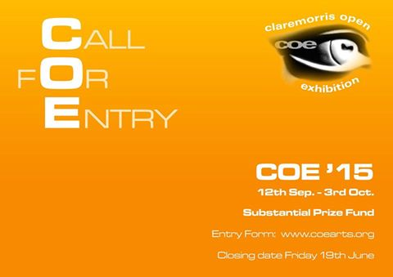

For an application form, [www.coearts.org](http://lists.visualartists.ie/lt.php?c=1346&m=4383&nl=1&s=d3c261c0eeb6b48867f449d29e09414b&lid=113872&l=-http--www.coearts.org)**Deadline 19th June 2015**Postal entries to COE Office, Main Street, Claremorris, Co. Mayo  
E: Email entries to [coe15.entries@gmail.com](mailto:coe15.entries@gmail.com)

**Hospital Arts Festival 2015: Open Call to Artists**

Please Note A Submission Fee Applies

Submission for the visual arts section of Hospital Arts Festival 2015 is now open.This year we will be working in collaboration with guest curator Moran Been-noon.  
With consideration to the heritage of Hospital’s 800 years, ideas in the relation to the concept of Land, Labour, Industry are welcome for this year’s festival.

Also, For One Night Only, a video open call specifically for film, video and animation shorts, invites artists to submit, electronically, video works of no longer than 15 minutes, with the narrative relevant to the overall working theme for Hospital Arts Festival 2015, Land, Labour, Industry.

Each submission must be accompanied by a submission fee of €10 payable by Paypal:  
to [hospitalartsfest@gmail.com](mailto:hospitalartsfest@gmail.com)  
Please include your Paypal receipt number or forward on email acknowledgment of the payment with your submission  
Deadline: **Monday, 20 July at 5pm**

Further information:  
[www.hospitalartsfest.com](http://lists.visualartists.ie/lt.php?c=1346&m=4383&nl=1&s=d3c261c0eeb6b48867f449d29e09414b&lid=113874&l=-http--www.hospitalartsfest.com)

**Art and Agriculture Residencies: Call for Artists Proposals**

Art and Agriculture II and Agri-Culture are two research-based residency projects involving collaborative engagement between artists and diverse agricultural contexts found both locally and around the world. The projects have emerged as an exploratory partnership between Roscommon Arts Centre and the Leitrim Sculpture Centre, based in Counties Roscommon and North Leitrim.

Taking the proximity of these centre’s to regional agricultural shows and marts, artists are invited to explore these specific contexts as well as respond to wider agricultural settings and practices prevalent globally or which represent wider social tendencies and landscapes of concern.

Residency Outline  
Artists are invited to submit a Residency Proposal that outlines specific areas of social, cultural or environmental interest and its collaborative potential. Proposals should also summarise the artistic approach, processes involved and any relevant technical information. Potential exhibition outcomes should be noted and these will most likely take place at the end of the research period during the agricultural shows.

Residency outcomes can take the form of an exhibition, a talk, performance or public event and may engage with various publics and the agricultural community.

Residency Fees  
Artist/s selected for the Art & Agriculture II LSC residency will be provided with free accommodation, studio and gallery and access to technical facilities. A €2,500 residency fee is provided to the successful artist and is budgeted by them in a residency proposal. Eligible costs may include living expenses, artist’s fee, materials, travel, specialised equipment, technical support. The budget is only an approximate guide that demonstrates that artists have considered the feasibility of their project.

Artist/s selected for the Agri-Culture residency at Roscommon Arts Centre will be provided with a residency fee of €2,300 and an additional €500 towards travel and accommodation. They will have full use of the gallery in the arts centre as a production space for the duration of the residency, with a view to this research period informing a public outcome/exhibition/event at both Roscommon Arts Centre and Leitrim Sculpture Centre.

Further information:  
[www.leitrimsculpturecentre.ie](http://lists.visualartists.ie/lt.php?c=1346&m=4383&nl=1&s=d3c261c0eeb6b48867f449d29e09414b&lid=112641&l=-http--www.leitrimsculpturecentre.ie)  
[www.Roscommonartscentre.ie](http://lists.visualartists.ie/lt.php?c=1346&m=4383&nl=1&s=d3c261c0eeb6b48867f449d29e09414b&lid=113875&l=-http--www.Roscommonartscentre.ie)  
**Deadline: 5th June 2015**Notification by 12th June

**The Moth Short Story Prize and The Caterpillar Short Story Prize**

With just 6 weeks left to enter this year’s Moth Short Story Prize, judged by Donal Ryan, it’s time to get writing! The word limit is 6,000 (no minimum length) and it can be on any subject.

The prizes: 1st €3,000; 2nd a week-long writing retreat at [Circle of Misse](http://www.circleofmisse.com/) in France (including a €250 stipend); 3rd €1,000

The winning stories will be published in the autumn 2015 issue of The Moth.We’re also running the new Caterpillar Short Story Prize – with a single prize of €1,000 (and publication in *The Caterpillar*) for the best story written by an adult for children (aged 7-11).   
  
You can enter The Moth Short Story Prize and The Caterpillar Short Story Prize at <http://www.themothmagazine.com/a1-page.asp?page=0>

**The Soloist**

|  |
| --- |
|  |
|  |
|  |

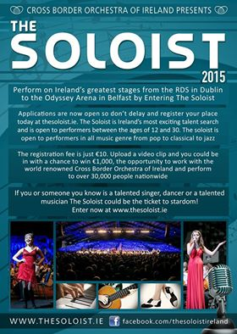

**Emerging Visual Artist Award 2015 - Call for Applications**

|  |  |
| --- | --- |
| |  | | --- | | Wexford Arts Centre and Wexford County Council are pleased to announce a call for submissions for their annual Emerging Visual Artist Award.    The Emerging Visual Artist Award is a partnership initiative between Wexford Arts Centre, Wexford County Council and the Arts Council.   The initiative supports promising visual artists in Ireland with an award of €5,000 and a solo exhibition at Wexford Arts Centre.  It aims to recognize and support the development of committed emerging artists, in kick starting their career and achieving professional recognition.   The successful recipient  will be required to create a new body of work during the period October 2015 – December 2016, which will be exhibited at Wexford Arts Centre during January – February 2017.  **Who is eligible to apply for the Award?** - Applicants practicing any visual art form are eligible to apply; - Applicants must have resided in Ireland for a minimum twelve month period to be eligible to apply; - Applicants cannot be enrolled in an undergraduate programme in their art form at the time of the application deadline;   **What selection criteria will be used?** - Applicant’s demonstrated commitment as a serious professional to her/his art form; - Overall excellence of the applicant’s art work; - Demonstration of exceptional talent; | |

|  |  |
| --- | --- |
| |  | | --- | |  | |

|  |  |
| --- | --- |
| |  | | --- | | Submissions must be emailed to [emergingvisualartistaward@gmail.com](mailto:emergingvisualartistaward@gmail.com) and include the following: - An up to date CV; - A work statement detailing themes, working methods and medium – 300 word limit; - A proposal in relation to the body of work which will be undertaken – 350 word limit; - Timescale breakdown – research, production, delivery; - Budget breakdown – materials, travel, studio hire, etc.;   - Examples of work to date i.e. documentation in the form of 10 jpeg images;  Full details for each image is required, i.e. title, medium, measurements, date of work. Three copies of each film, video or audio work can be sent by post to: Emerging Visual Artist Award, Wexford Arts Centre, Cornmarket, Wexford Town or alternatively links to video and/or audio works can be emailed.   **Notes on submissions:** **Please adhere to the following notes whilst preparing your application:** - Please format all information in **one document** and keep to the word limit on the artist statement and proposal; - Please save each Jpeg image with the following details: Artist’s Name_Title_Medium_Dimensions_Year (for example: NoelSmith_LandscapeInBlue_AcrylicOnWoodenPanel_43x30cms_2015); - If sending film, audio or video work please label with your name and contact number, work title, and duration; **-** Do not submit any hardcopy material including catalogues, invitations, artist books, etc.  **Please enclose a €7.50 processing fee with your application.** Cheques should be made payable to Wexford Arts Centre, or you can ring the Box Office at Wexford Arts Centre on +353 (0)53 9123764 with your debit card details.   The deadline for receipt of email submissions is **4.00p.m. Thursday 4th June 2015**. For gallery plans and images please log on to <http://www.wexfordartscentre.ie/application-process-20151.html>.  Images: Teresa Gillespie (2013 EVA Award Winner), below explanation (clocks stop at 3pm and existence continues), exhibition in-situ at Wexford Arts Centre, January-February 2015. | |
|  |
|  |
|  |

**RDS National Craft Awards 2015: Call for Entries**

**[Please note a nominal fee applies]**

The RDS is now calling for entries for the 2015 RDS National Craft Awards which has an increased prize fund of €40,000. The annual RDS National Craft Awards showcase and reward excellence in Irish craft.

Major Awards:

* RDS Award of Excellence €5,000 (top prize awarded in each strand)
* Irish Design 2015 Award €5,000 (open to emerging & established category winners)
* RDS IACI Muriel Gahan Award €2,000 (emerging maker)
* RDS Graduate Award €2,000 (emerging maker)
* National Crafts & Design Fair Award (value €2,000, emerging maker)
* RDS William Smith O’Brien Perpetual Challenge Cup (open to emerging & established makers)

The category prizes in the 2015 RDS National Craft Awards are sponsored by the Design & Crafts Council of Ireland. This year the 13 category prize winners in each strand will receive €500 as well as an RDS medal & certificate. There is also a special additional €5,000 prize to celebrate Irish Design 2015, which will be awarded for design innovation and excellence in a craft entry this year.

See [www.rds.ie/craft](http://lists.visualartists.ie/lt.php?c=1315&m=4352&nl=1&s=d3c261c0eeb6b48867f449d29e09414b&lid=104719&l=-http--www.rds.ie/craft)  for details of the many other sponsored prizes and to view the rules of entry.  
Winning and selected entries will be shown at the RDS National Craft Awards Exhibition at the Discover Ireland Dublin Horse Show, RDS, August, 2015, and award winners will be shown at the National Crafts and Design Fair, RDS, December, 2015.

Enter online at [www.rds.ie/craft](http://lists.visualartists.ie/lt.php?c=1315&m=4352&nl=1&s=d3c261c0eeb6b48867f449d29e09414b&lid=104720&l=-http--www.rds.ie/craft%C2%A0)  
Deadline 10 June 2015

**Social Mhuire National School, Barnstown, Wexford, Percent for Art Commission: Call for Artists**

The Board of Management of Scoil Mhuire National School, Barntown wishes to commission two site specific public artworks under the Per Cent for Art Scheme, funded by the Department of Education and Science. Scoil Mhuire Barntown is a parish, co-educational primary school which caters for pupils from junior infants to sixth class. The school serves the community of Barntown which encompasses the outer reaches of Wexford town. We think of ourselves as a rural school and love the way our school nestles under Forth mountain. The view from our new front door is a fabulous panoramic view of the mountains from Mount Brandon and the Blackstairs to the Wicklow mountains.

Budget €18,000

Applicants are requested to read the full content of the Artist Brief, [CLICK HERE](http://lists.visualartists.ie/lt.php?c=1342&m=4379&nl=1&s=e784eec6bf8bb9680747b324b9c9eee1&lid=112531&l=-http--visualartists.ie/wp-content/uploads/2015/05/Artist-Brief-Scoil-Mhuire-Barntown.pdf), carefully as it contains important information pertaining to all stages of the commission.

**Stage 1**  
Artists are invited to express their interest in being considered for this project at the first stage of this commission.  
Please submit  
•            CV  
•            Images /recordings of previous work, no more than 5  
•            Artist’s proposal/sketch, no more than 500 words

These should be combined into a single PDF file of no more than 10MB.  
**Deadline**: stage 1 completed application form together with supporting documentation and material is **26th June 2015, 12 noon.**

**Stage 2**  
From the completed stage 1 applications, a shortlist of not more than six artists will be selected by panel jury. This panel, whose decision is final, has the right to clarify any issue which may arise in the course of selection.  A fee of €500 will be paid to shortlisted artists if further work is required to prepare a detailed submission including written outline, budget outline, feasible timeline/schedule and visual representation. The shortlisted artists will also be invited to present/develop their proposals in a way that will be easily accessible to staff and pupils. The committee will actively seek input of pupils and staff in the selection process.

Site Visits  
Site visits will be arranged for shortlisted artists at Stage 2 of the commissioning process.

Shortlisted artists will be required to submit a **Tax Clearance Certificate** and subject to **Garda vetting**  
Social Mhuire, Barnstown reserves the right not to proceed with any of the submissions received.

Further information and digital submissions to:  
E: [info@barntownns.ie](mailto:info@barntownns.ie)  
Hard copy submissions to be posted to:  
Scoil Mhuire Nation School, Barntown, Co. Wexford  
**Deadline 26th June 2015, 12 noon**

**Summer Residencies at GMIT, Castlebar**

GMIT Mayo has launched its Artists Summer Residency Programme 2015 which supports emerging and established artists in the region. The programme provides opportunities for artists to research and develop their practice through the provision of studio space on campus, access to GMIT’s library facilities and participation in an exhibition at the historic Mayo campus. The residency will take place over six weeks in July and August and applications are now being accepted for the programme. Four places will be available, following an interview process that is to take place in mid-June on campus.

To apply for a place on this programme and for further information:  
E: John.Mulloy@gmit.ie  
[www.gmit.ie](http://lists.visualartists.ie/lt.php?c=1342&m=4379&nl=1&s=e784eec6bf8bb9680747b324b9c9eee1&lid=112549&l=-http--www.gmit.ie/news/gmit-mayo-launches-artists-summer-residency-programme)  
**Deadline 5 June 2015**

**Awards / Bursaries / Schemes**

**2014/2015 Dates and Deadlines for Culture Ireland Grant Rounds**

Please note Culture Ireland has set funding rounds and deadlines for 2015. There will be three funding rounds in 2015 and seperate calls for showcasing opportunities and Edinburgh Festivals will be announced during the year.

**Application Deadline | Timing of Project/Event | Decision Due**

* 15 June 2015  | September 2015 onwards | Early August
* 15 October 2015 |  January 2016 onwards | Early December

[http://www.cultureireland.ie/](http://lists.visualartists.ie/lt.php?c=1232&m=4271&nl=1&s=d3c261c0eeb6b48867f449d29e09414b&lid=96096&l=-http--www.cultureireland.ie/)

**Allianz €5,000 Community Art Prize: Deadline Extended**

Deadline extended to 5pm, Friday 12 June 2015

The Allianz Community Art Prize, part of the annual Allianz Business to Arts Awards, sees Allianz Ireland invest €5,000 in a community-based arts initiative which is supported by their Staff. Business to Arts are accepting applications until 12 June, from groups or organisations that work with the community through creativity.

The Prize is open to both arts and non-arts organisations, but there must be a specific link to an arts-based activity. You should be able to demonstrate the impact of the arts project on your community and show how funding from Allianz will make a measurable difference to the project scale/scope.

It is preferable that your application should include the ‘sponsorship’ of an Allianz staff member. You can specify on your application if you do not have a contact in Allianz, and Business to Arts will help find one within Allianz.

The Prize will be presented at the Allianz Business to Arts Awards on 1 September 2015, an excellent opportunity to mingle with arts organisations and businesses that are committed to progressing the arts in Ireland.

Information, conditions and the application form are available here: [www.businesstoarts.ie/awards/allianz/allianz-community-art-prize](http://lists.visualartists.ie/lt.php?c=1350&m=4387&nl=1&s=d3c261c0eeb6b48867f449d29e09414b&lid=115246&l=-http--www.businesstoarts.ie/awards/allianz/allianz-community-art-prize/)

**Engaging Architecture Scheme, Arts Council**  
  
Category: Scheme  
Deadline: 11 June 17:30  
Email: [kate.odonnell@artscouncil.ie](mailto:kate.odonnell@artscouncil.ie)  
  
Maximum awarded €20,000  
Artform and practice(s) Architecture, Local arts, Venues  
Applicant type Individual Artist, Organisation  
Collaborative application possible? Yes  
Contact Kate ODonnell  
Telephone 01 618 02 36  
  
The purpose of the scheme is to support ambitious, innovative and creative, high-quality initiatives that specifically aim to enhance and extend   
the public's experience of architecture. The Engaging with Architecture Scheme also seeks to build an expert network of architects, curators, arts programmers,   
festivals and arts centres working in this area. Please note that successful applicants may be required   
  
to participate in an Arts Council research projects seeking to gather data on the public's engagement with architecture. There are two strands to the scheme.   
  
Funding is available under strand 1 to support the research and development of a project and, under strand 2, for the realisation of a project.  
  
Who can apply?  
  
The scheme is open to individuals, local authorities and organisations (including organisations that are in receipt of funding under the Arts Council's three main grant  
programmes  
- Regularly Funded Organisations; Annual Funding; Annual Programming Grant).  
  
The award is open to individuals and organisations who are resident in (the Republic of) Ireland. There are certain exceptions where the Arts Council may deem eligible   
applications made by those based outside (the Republic of) Ireland. However, before admitting as eligible any such application, the Arts Council would need to be satisfied   
that the outcomes of any such proposal would benefit the arts in (the Republic of) Ireland.

**Bursary Awards next closing date – 5.30pm, Thursday, 16 July 2015**

|  |
| --- |
| http://newsletter.artscouncil.ie/nwstatic/spacer.gif |

The window for making an application opens on Tuesday, 16 June 2015. The deadline for the Arts Council's Bursary Awards is **Thursday, 16 July 2015 at 5.30pm.**

The Bursary Award is available in the following artforms:

* Literature (Irish & English Language)
* Theatre
* Traditional Arts
* Visual Arts
* YPCE

The Arts Council provides Bursary Awards in order to assist individual artists in the development of their art practice. The award emphasises the value and benefit to an artist’s development that is derived from a focused period of engagement with their practice.

Guidelines for each award are published on the [available funding](http://newsletter.artscouncil.ie/1i2sre0kp1s14rbsgtdsq9?a=6&p=48727903&t=28179891)section on our website.

***Please note***

Applications will only be accepted through the Arts Council’s [online services](http://newsletter.artscouncil.ie/1pxvszvni3w14rbsgtdsq9?a=6&p=48727903&t=28179891) website. Applicants who have not previously used this system must register in advance of making an application. It is recommended that applicants allow five working days for registration prior to making an application.

**Arts Council’s Artist in the Community Scheme – Deadlines 2015**

Twice yearly, the Arts Council offers grants to enable artists and communities of place/or interest to work together on projects. The Artist in the Community Scheme is managed by Create, the national development agency for collaborative arts.

The scheme is open to artists from any of the following artform disciplines: architecture, circus, street art and spectacle, dance, film, literature (Irish and English language), music, opera, theatre, visual arts and traditional arts. The projects can take place in a diverse range of social and community contexts eg arts and health; arts in prisons; arts and older people; arts and cultural diversity.

The aim of the scheme is to encourage meaningful collaboration between communities of place and/or interest and artists. It is essential that consultation take place between the artist and the community group, so that both parties are involved in deciding on the nature of the project realisation. Group ownership of the art should be maintained at every stage. The Project Realisation may result in a variety of outcomes.

There are two phases to the scheme. Phase One [Research & Development,](http://lists.visualartists.ie/lt.php?c=1289&m=4326&nl=1&s=d3c261c0eeb6b48867f449d29e09414b&lid=101957&l=-http--www.create-ireland.ie/artist-in-the-community-scheme-research-and-development-award.html) is open to artists who wish to research and develop a project in a community context.

There is also a [Research & Development/Mentoring](http://lists.visualartists.ie/lt.php?c=1289&m=4326&nl=1&s=d3c261c0eeb6b48867f449d29e09414b&lid=101958&l=-http--www.create-ireland.ie/artist-in-the-community-scheme-research-and-development/mentoring-award.html) strand, open to artists who wish to develop a community based project and who have identified an artist mentor they want to work with during the research and development phase.

Phase Two [Project Realisation](http://lists.visualartists.ie/lt.php?c=1289&m=4326&nl=1&s=d3c261c0eeb6b48867f449d29e09414b&lid=101959&l=-http--www.create-ireland.ie/artist-in-the-community-project-realisation-award.html) , is open to communities of interest or place (or their representative organisations) with an artist.

**2015 Deadlines:  
(Round 2)   29 June 2015**

For information on the Scheme and advice on applying, contact Katherine Atkinson, [support@create-ireland.ie](mailto:support@create-ireland.ie) or phone 01-4736600  
Visit [http://www.create-ireland.ie/about-the-artist-in-the-community-scheme.html](http://lists.visualartists.ie/lt.php?c=1289&m=4326&nl=1&s=d3c261c0eeb6b48867f449d29e09414b&lid=101960&l=-http--www.create-ireland.ie/about-the-artist-in-the-community-scheme.html)

**_____________________________________________________________________________________**

**Of Interest**

**Coming Soon: Movie-style trailers for all the arts**

|  |
| --- |
| http://newsletter.artscouncil.ie/nwstatic/spacer.gif |

In our digital world, video has become a powerful way to promote upcoming arts events, and many people would rather watch a movie-style trailer or a short news report than read an article or a brochure.

Although some arts organisations in Ireland, are already making these sort of promotional /news videos, and would like them to be viewed by as many people as possible, we don’t have a central structure for distributing them.

The Arts Council would like to create such a structure, to help generate more videos, ensure they are in a unifying format, distribute them in as many additional ways as possible (eg. social media, Culturefox, YouTube, Vimeo), and package some as ‘arts magazine’ programmes for broadcast.

Our ambition is that within a year, most arts organisations will be making and editing their own trailers or news pieces about upcoming concerts, plays, gigs, performances, exhibitions -- and encouraging people to attend.

This is an exciting prospect -- imagine, for example, if for every work that goes on tour you could see a short interview with the artist, the director, the curator to whet your appetite before it reached your local venue!

We’ve engaged the Institute of Local Television for this project; its team members have considerable experience of this from Scotland, they take a very practical approach and are focused on getting things done.

To that end they will be engaging with arts organisations across the country in the months ahead, making videos, training/mentoring and helping arts organisations to make and edit their own, assisting with promotion, building a central structure.

So watch out for them at arts events, please extend them every courtesy. If you're an artist or you work for an arts organisation and you would like to get involved, Dr David Rushton of the Institute of Local Television would love to hear from at [local.tv@virgin.net](mailto:local.tv@virgin.net)

**WIT Graduate Show 2015**

Opening: 29 May at 7pm  
Waterford Institute of Technology, College Street Campus (Good Shepherd)  
Opening times 10am – 5pm, closed at 4pm on Friday 5th of June.

The staff and students of Waterford Institute of Technology, Department of Creative and Performing Arts, invite you to a preview of The Art & Design Degree Show 2015 at 7pm on Friday 29th of May in the College Street Campus (Good Shepherd).

The show will be opened by Mr. Conor Nolan, Waterford City Arts Officer. The show will be open to the public from 2nd June to the 5th of June, 2015.

[www.wit.ie/cpaatwit](http://lists.visualartists.ie/lt.php?c=1347&m=4384&nl=1&s=e784eec6bf8bb9680747b324b9c9eee1&lid=114388&l=-http--www.wit.ie/cpaatwit)

