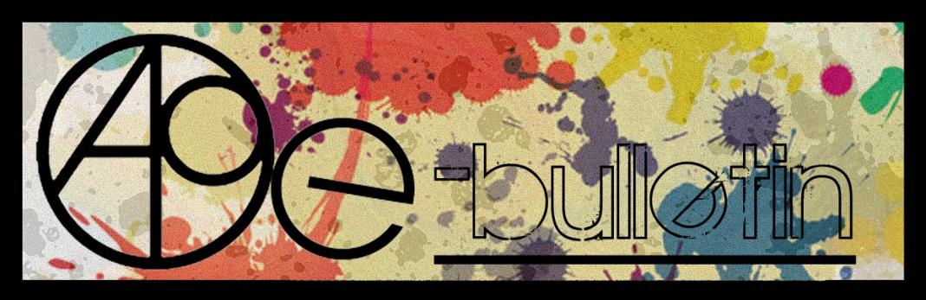

**Kilkenny County Council Arts Office E-bulletin 23rd October 2015**

Dear All,   
  
Welcome to the fortnightly e-bulletin from Kilkenny County Council's Arts Office. Each bulletin is packed with the latest information on Kilkenny Arts Office activities, county events as well as news and opportunities for arts practitioners from around the country.

This service will be provided fortnightly. To include an item in the next e-bulletin please send a brief outline of your advert with relevant contact details, including any websites or pages with links to [**julie.mcguirk@kilkennycoco.ie**](mailto:julie.mcguirk@kilkennycoco.ie) **before 5th November**. The next e-bulletin will be on the **6th November.**

While every effort has been made to ensure the accuracy of our information, we strongly advise readers to verify all details to their own satisfaction.

Regards,

Julie McGuirk  
Arts Office,  
T: 056 7794547  
E: [julie.mcguirk@kilkennycoco.ie](mailto:julie.mcguirk@kilkennycoco.ie)   
W: [www.kilkennycoco.ie/eng/Services/Arts/](http://www.kilkennycoco.ie/eng/Services/Arts/)

BECOME PART OF IT, SUBMIT A POEM.....[www.rhymerag.net](http://kk-moss/Sites/arts_office/Shared%20Documents/Julianne%20Morgan/E-bulletin/30th%20May%20e-bulletin/www.rhymerag.net)  
Kilkenny County Council Arts Office Partner Local Authority of the ArtLinks Programme [www.artlinks.ie](http://www.artlinks.ie)

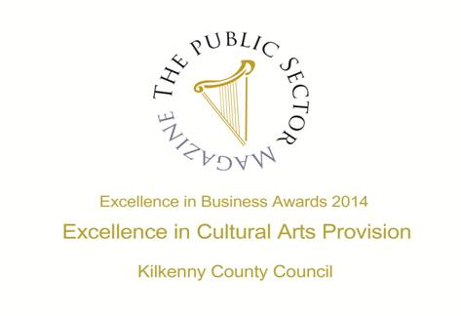

|  |  |
| --- | --- |
|  |  |
|  |  |

**Arts Office**

* **Я3VERSE - FREE Poetry Workshops for teenagers with NEW tutor Edward Denniston**
* **Open Circle Information Evening**

**Kilkenny Events**

* **Barn Owl Players at Rothe House on Halloween Night at 8pm**
* **Brian Kennedy at the Watergate Theatre Saturday 7th November**
* **Coppélia Touring with Ballet Ireland at the Watergate Theatre**
* **Kilkenny Musical Society presents Little Shop of Horrors**
* **KILKENOMICS 2015 Thursday 5th November to Sunday 8th November**
* [**Late Date Evenings at the National Craft Gallery, Kilkenny**](http://nationalcraftgallery.cmail2.com/t/y-l-djqgl-jtddlybih-jr/)
* **Music in Kilkenny Saturday 14 November 8 pm**
* **Butler Gallery My Minds exhibition, opening Saturday, October 24.**
* **Discover the Clown Within**
* **Rockfall Music Festival 2015 Friday 23th to Monday 26th October**
* **Savour Kilkenny - Festival of Food 2015 Friday 23rd to Monday 26th October 2015**
* **The Waterboys Live At The Hub Kilkenny**
* **Waiting for Godot at the Watergate Theatre November 6th at 8pm**

**Courses / Training / Jobs / Internships**

* **Artist Talk with Isobel Egan art Riverbank Arts Centre, Kildare**
* **Arts Council Touring and Dissemination of Work Scheme Information Workshops**
* **Free CAO Portfolio Preparation Workshop @ LIT Clonmel**
* **Realising the Hidden Potential of Ireland's Towns**

**Call for Submissions / Residencies**

* **Artists in Residence at The Leitrim Sculpture Centre: Call for Applications for 2016**
* **Call for Applications for the 2016 Golden Fleece Award are open.**
* **Call For Papers- The Great Famine and its Impacts**
* **Joan Clancy Gallery Feile na Nollaig, Christmas Group Show: Artist Call**
* **Per Cent for Art Opportunities in Grangegorman: Call for Artists**
* **Seacourt: The Centre for Contemporary Printmaking, Artist Call**

**Awards / Bursaries / Schemes**

* **Bursaries Available for ‘The Story House’ to Kilkenny Writers**

**Of Interest**

* **IVARO Announces RETURN 2015 is Open for Claims**

**Arts Office**

**Я3VERSE - FREE Poetry Workshops for teenagers with NEW tutor Edward Denniston**

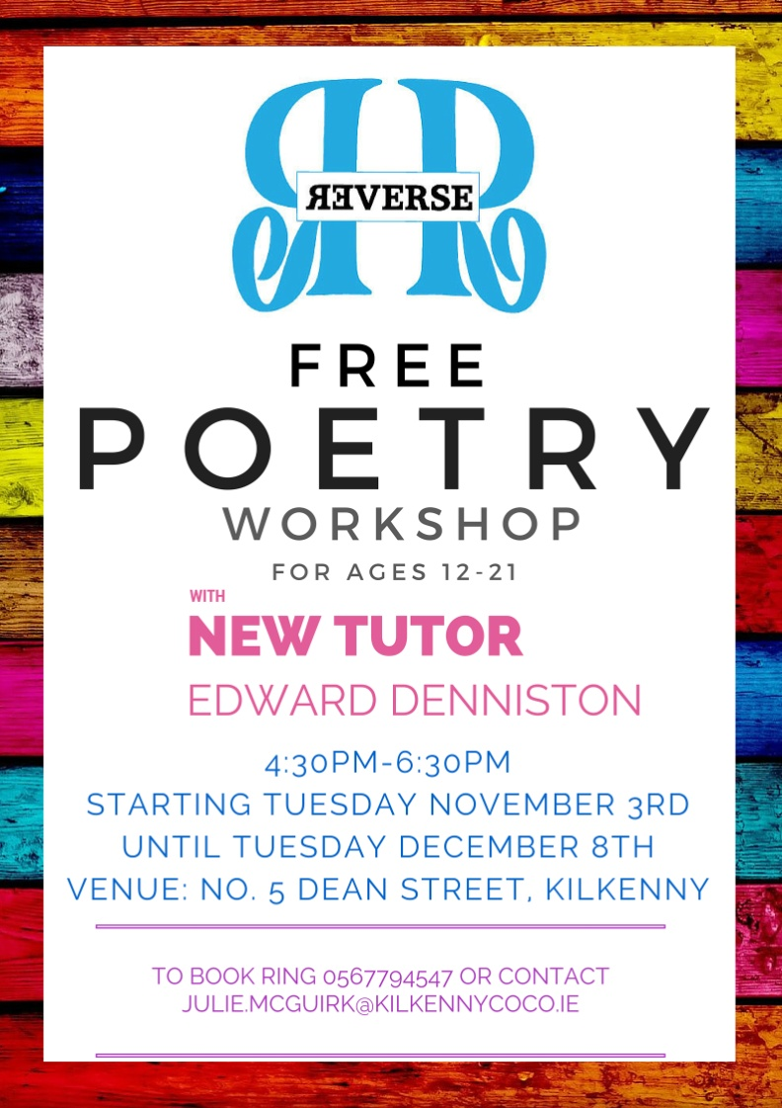

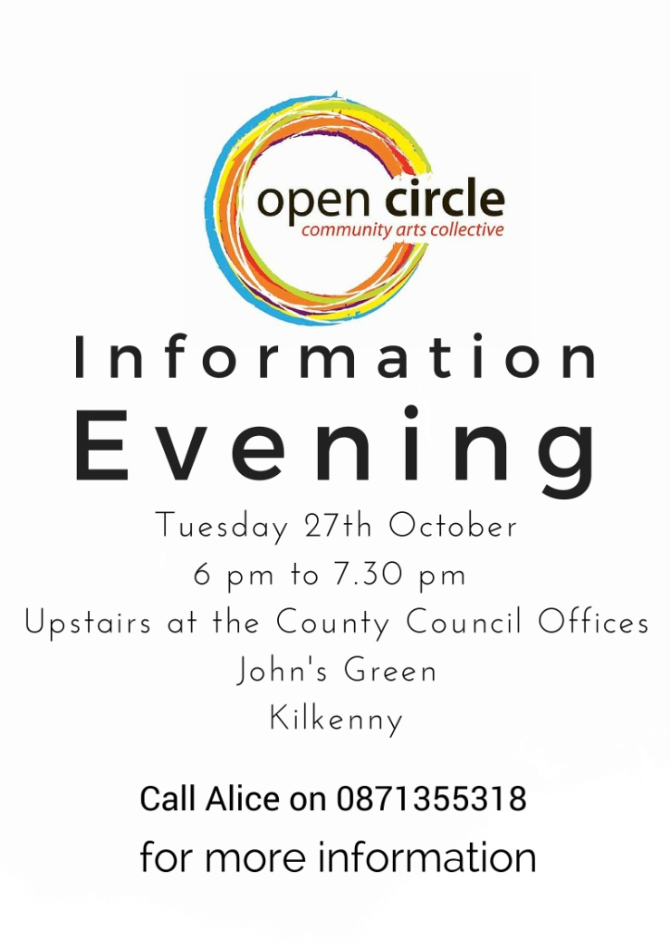

**Kilkenny Events**

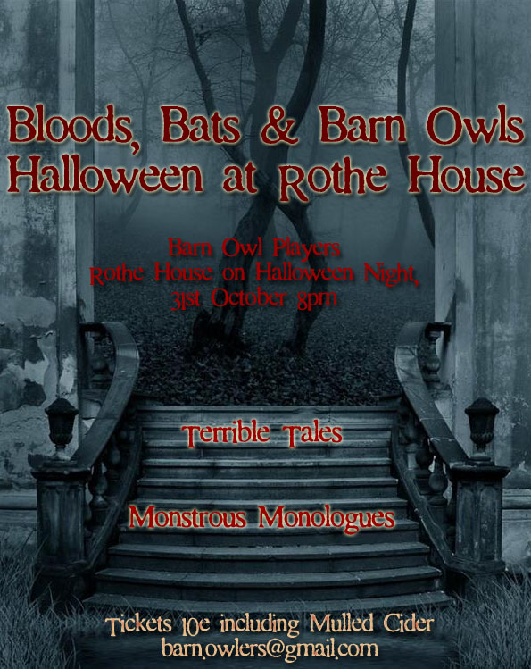

**Brian Kennedy at the Watergate Theatre Saturday 7th November**

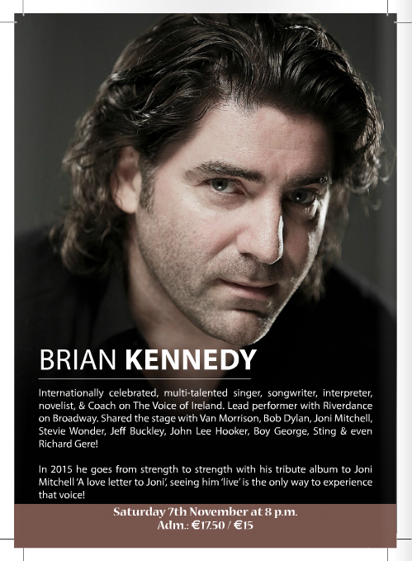

**Coppélia Touring with Ballet Ireland at the Watergate Theatre**

Friday 30th October 8pm at the Watergate Theatre Tickets €20

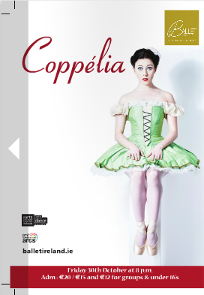

Franz and his reporter finance Hildy, are curious about the beautiful girl, Coppélia. Hildy begins to suspect things are not all that they seem… She and her friends follow the seemingly perfect starlet, arriving at Dr Coppelius’ laboratories. Inside, they stumble upon a magical and strange world, uncovering secrets that will change them forever!

Setting the much-loved story at a County Fair, in the 50s choreographer Morgann Runacre-Temple (Carmen, Romeo & Juliet), with writer Stella Feehily, have re-interpreted this witty and pertinent ballet inspired by the eternal obsession with youthful perfection. With its nod to the movie glamour of yesteryear, its captivating dance and the charming music of Léo Delibes and Tom Lane, Coppélia will enchant and enthral audiences of all ages.

Ballet Ireland is delighted to tour this light-hearted ballet following the success of Swan Lake last year.

**Kilkenny Musical Society presents Little Shop of Horrors**

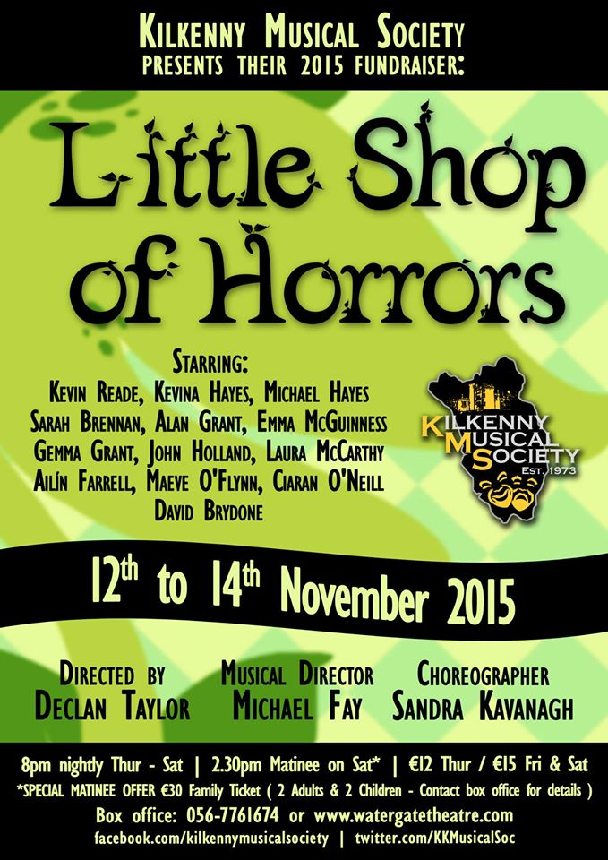

**KILKENOMICS 2015 Thursday 5th November to Sunday 8th November**

[www.kilkenomics.com](http://www.kilkenomics.com/)

Welcome to the sixth edition of Kilkenomics - Europe’s first economics festival - which brings together some of the world’s leading economists, financial analysts and media commentators with some of our funniest, sharpest standup comedians. We’ve been called “Davos with jokes” and we wouldn’t disagree with that assessment.

Our informal, entertaining formats invite our audiences to  engage and enjoy. As we like to say: it’s serious, but it’s fun too! Jump into Kilkenomics now and engage with as many shows as possible, equip yourself with the information and insight we hope can help us all make smart choices for our futures - inform and entertain yourselves.

|  |  |  |  |  |
| --- | --- | --- | --- | --- |
| [Late Date Evenings at the National Craft Gallery, Kilkenny](http://nationalcraftgallery.cmail2.com/t/y-l-djqgl-jtddlybih-jr/)   |  |  | | --- | --- | |  | [http://i4.cmail2.com/ei/y/D8/325/1D1/csimport/makers-link-300x300.143541.gif](http://nationalcraftgallery.cmail2.com/t/y-l-djqgl-jtddlybih-jy/) | |  |  |   Sometimes the best way to understand work is to listen to the designer/maker explain their thinking and making processes this gives a unique insight into their work and practise and an opportunity to ask questions. The [**National Craft Gallery**](http://nationalcraftgallery.cmail2.com/t/y-l-djqgl-jtddlybih-jj/) has a vibrant programme of talks by artists, designers and exhibition curators throughout the year.  We open our doors late for an after hours look at the current exhibition, usually on the last Thursday of the month, accompanied by a glass of wine and an informal discussion. It’s a great chance to meet new friends and discuss an alternative point of view.  Enquiries: 056 779 6151 / [**events@nationalcraftgallery.ie**](mailto:events@nationalcraftgallery.ie?subject=LATE%20DATE) |
|  |

|  |
| --- |
| **Music in Kilkenny Saturday 14 November 8 pm**  **Castalia Hall, Ballytobin, Callan, Co. Kilkenny**  **Florian Kitt** cello  **Harald Ossberger** piano  **Sonata for cello and piano Op. 4 (1910)** Zoltan Kodaly (1882-1967)  **"Orion" (1984 for F..Kitt)** Toru Takemitsu (1930-1996)  **Sonata for cello and piano in D minor (1916)**  Claude Debussy (1862-1918)  **‘Pohádka’ (Fairy Tale)** Leos Janácek (1854-1928)  **Suite italienne (1934)** Igor Stravinsky (1882-1971)  **Florian Kitt**  Austrian cellist, completed his studies with Gaspar Cassadó in Cologne and  André Navarra in Detmold after graduating from the Vienna Musikakademie  as a pupil of Frieda Litschauer. Following his debut at the Kon- zerthaus in  Vienna 1964 he has appeared as soloist with many leading orchestras and  con- ductors, given cello recitals and made nume- rous recordings. These  engagements took him to most of the European countries, North- and  South-America, the Near East and Australia. Most successful were always  his performan- ces of more recent works – György Ligeti's cello-concerto at  the Royal Festival Hall in London with the Philharmonia Orchestra under  DiegoMasson brought raving acclaim by press and the public, Luciano  Berio's concerto "Ri- torno degli Snovidenia" in Rome, Nigel Osbor- ne's  concertos, both dedicated to Florian Kitt were successful all over the world.  Florian Kitt is also a very devoted teacher, apart from various masterclasses  he holds a professorship at the University for Music in Graz since 1970. In  addition to his extensive repertoire of established classic and romantic  works, his especial feeling for contemporary music has inspired many  major composers to dedicate works to him.  **Harald Ossberger**  Born in Graz in 1948, he grew up in Linz. He studied the piano with Grete  Hinterhofer and Alexander Jenner at the University of Music and Performing  Arts Vienna, gaining his final diploma with distinction. He also is laureate  of many competitions. He has performed in most European countries, in  the Middle East and also in Japan, South Corea, Taiwan, India, North,  Middle and South America. Additionally he has made numerous radio, TV  and CD recordings. Besides his solo career he is also a fervent chamber  musician: since 1974 he is a member of the »Ensemble 20. Jahrhundert  (exxj)«, Vienna. In 1978 he has founded the “Concordia Trio”(together with  the violinist Erich Schagerl and the cellist Josef Luitz).  He has performed with many of the important musicians from Austria and  abroad like Josef Sivo, René Staar, Christian Altenburger, Mario Hossen,  Hermilo Novelo, Florian Kitt, Attila Pasztor, Milan Turkovic, Roger Salander,  Alois Brandhofer, Dieter Flury; on two pianos with Manfred Wagner – Artzt  and Michael Lipp. He also regularly performed with Henryk Szeryng in  many European countries, starting in 1979  until the death of the violinist in 1988. |

**Butler Gallery My Minds exhibition, opening Saturday, October 24**

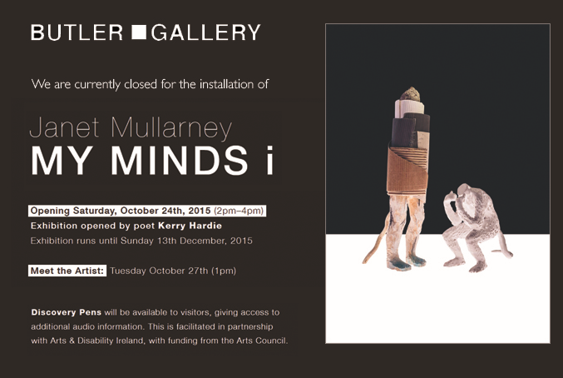

**Discover the Clown Within**

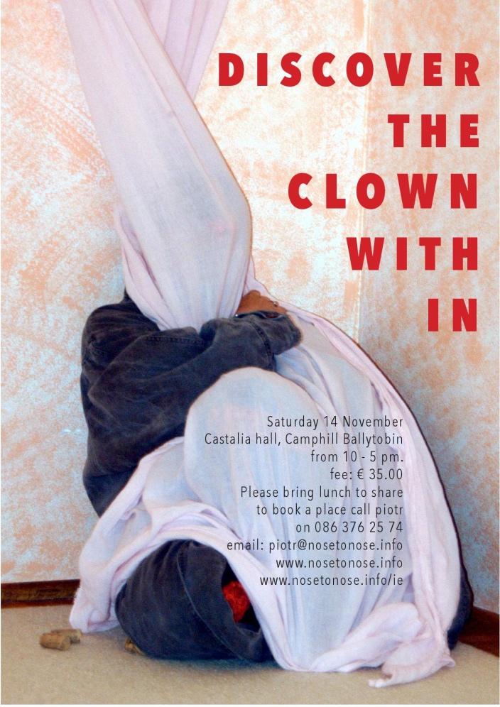

**ROCKFALL MUSIC FESTIVAL 2015 Friday 23th to Monday 26th October**

[www.rockfallfestival.com](http://www.rockfallfestival.com/)

The Rockfall Festival takes place over the October Bank Holiday weekend in October in venues throughout Kilkenny City

This Festival (now in it’s 27th year) is Kilkenny’s longest running festival. The Music festival began in 1989 with six music venues around Kilkenny City and was run over three nights. In the intervening years the festival has grown both in terms of venues and in 2013 the festival was run over four nights and in 22 venues around the City and attracted approximately 10,000 people to the Festival’s gigs.  This festival which runs over the October Bank Holiday and is jam-packed with exciting events and sure to offer something for all tastes and ages: with live music and street entertainment.

What sets the Rockfall Festival apart is that is it is organised voluntarily by a group of people, all the local bands play free of charge and all monies raised from the Festival are donated to the O’Neill Centre in Kilkenny, to help in their work providing ongoing therapy services to children with physical, sensory and intellectual disabilities. Over the years Diageo has been very supportive of the Rockfall Festival, the launch of the Festival has taken place in the Cellar Bar in the Brewery in Kilkenny over the last number of years.

<http://www.rockfallfestival.com/>

<http://www.facebook.com/rockfallmusic>

- See more at: http://www.visitkilkenny.ie/rockfall_festival#sthash.HVyCSCZz.dpuf

**Savour Kilkenny - Festival of Food 2015 Friday 23rd to Monday 26th October 2015**

[www.savourkilkenny.com](http://www.savourkilkenny.com/)

Savour Kilkenny Food Festival, each year develops a programme of activities, which embraces all sectors of the food community from artisan producers to restaurateurs, food agencies to food farmers. We are delighted to have involvement and participation this year from so many Kilkenny businesses which has enabled us to provide an action-packed weekend of activities suitable for all, and many free of charge. Enjoy food markets, cookery demonstrations, food art, food debates and discussions as well as lots of dining events in local hotels, restaurants, cafes and bars.

The 2015 Brochure is now available to view/download - [**Savour Kilkenny: Festival of Food 2015 Brochure**](http://www.savourkilkenny.com/savour-kilkenny-brochure-2015/)

 The Waterboys Live At The Hub Kilkenny

**On the back of numerous sold out shows in Ireland , The Waterboys have  just announced an extra date for The Hub, Cillin Hill, Kilkenny on Monday November 2nd. Tickets at €47.50 including booking fee  are available from www.ticketstop.ie or from roller coaster records in Kilkenny City .**  
  
The Waterboys has for over three decades taken the audience on a musical journey through folk, rock, gospel, soul and Celtic music, ever changing and with an aim to give the audience something unexpected. The Waterboys have done some fantastic concerts in Ireland the last decade but this will be a first for Kilkenny .   
  
  
**Industry Entertainment Presents The Waterboys**   
*Monday November 2nd*   
The Hub , Cillin Hill , Kilkenny  
  
Tickets 47.50 (Including Booking fee)  
[www.ticketstop.ie](http://www.ticketstop.ie/)  
Ticket information – 01-6120001  
[www.industryentertainment.ie](http://www.industryentertainment.ie/)  
  
**Please note that there is a €3 car parking charge (per car) at The Hub.**

**Waiting for Godot at the Watergate Theatre November 6th at 8pm**

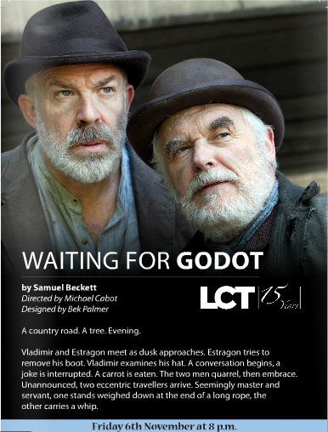

Ticket prices: €18/15

**Courses / Training / Jobs / Internships**

**Artist Talk with Isobel Egan art Riverbank Arts Centre, Kildare**

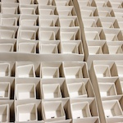4 December, 7pm  
Riverbank Arts Centre, Main St, Newbridge, Co. Kildare

Join us for an evening of artist talk, inspired by Isobel Egan’s Inside Out exhibition and the Year of Design 2015.

Inside out: Isobel Egan Will discuss how her work draws parallels between the physical and the emotional aspects of life. Material Matters: Frances McDonald, will examine the changing role that ceramic art plays in contemporary art practice. Constructing Space through Pattern: Alice Casey and Cian Deegan from TAKA Architects will pre4sent examples of how their designs assemblies make patterns and space.

For more information please visit: [www.riverbank.ie/event/inside-outside-artist-talk-with-isobel-egan/](http://www.riverbank.ie/event/inside-outside-artist-talk-with-isobel-egan/)

**Arts Council Touring and Dissemination of Work Scheme Information Workshops**

[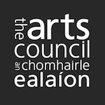](http://fw008705-flywheel.netdna-ssl.com/wp-content/uploads/2014/08/arts_council_logo.jpg)The Arts Council Touring and Dissemination of Work Scheme application window **opens** **November 3,** the application deadline will be early December. Sign up now for pre-application workshops with the new WEBINAR option. The sessions are relevant to those who have applied before and or toured before as well as those who are new to application and are for applicants who have developed their ideas, covering the audience portion of their application.

2 November 2pm to 4pm, The Abbey Theatre, Lower Abbey St, Dublin 1  
<http://www.eventbrite.ie/e/pre-application-workshop-tickets-18394092225>  
November 3 10am to 12noon Webinar  
From the comfort of your own desk, you will be able to login and participate live in the workshop as well as ask live questions.  
All who register will receive simple instructions regarding how to join us on the day:  
Further information:  
<https://www.eventbrite.ie/e/pre-application-webinar-tickets-18394162435>

**Free CAO Portfolio Preparation Workshop @ LIT Clonmel**

[Center for Creative Media @ LIT Clonmel](http://www.eventbrite.ie/o/center-for-creative-media-lit-clonmel-7533970193)  Saturday, 21 November 2015 from 10:00 to 14:00 (GMT) [Clonmel, Ireland](http://www.eventbrite.ie/d/ireland--clonmel/events/)

Register at http://www.eventbrite.ie/e/cao-portfolio-preparation-workshop-lit-clonmel-tickets-18796033442?aff=ebrowse

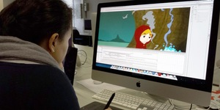

The portfolio preparation workshop is aimed at those who intend applying for a place on either the **BSc (Honours Degree) in Digital Animation Production** or the **BSc (Honours Degree) in Game Art & Design** course in LIT Clonmel.

**What's the aim of the workshop?**

To give you an opportunity to find out more about the courses and the subjects that are taught  
 To give you and your parents the opportunity to meet with staff and get a tour of the campus  
 To give you an opportunity to find out more about the type of jobs that are out there for Game Artists & Designers and Animators  
 To learn more about what we look for in a portfolio  
 To get some advice on how to best prepare your portfolio  
 To learn how to submit your portfolio online  
 To let you ask questions about the type of things you would like to include in your portfolio

 For further information about the B.Sc in Digital Animation Production programme see [http://lit.ie/Courses/LC518](http://lit.ie/Courses/LC518/default.aspx)

For further information about the BSc in Game Art & Design see [http://lit.ie/Courses/LC502](http://lit.ie/Courses/LC502/default.aspx)

**Realising the Hidden Potential of Ireland's Towns**

**The Set Theatre**, Langton House Hotel, John Street, Kilkenny

Thursday, 5 November 2015 from 08:30 to 17:30 (GMT)

This Conference will discuss how the historic urban characters of many of our main streets are losing vitality and value through under-use or over-development. It will look at how the social and economic forces which drive towns need to be better understood in order to manage the process of chane nad optimise the towns' value.

On 5th November, the Heritage Council will bring together a wide ranging and thought provoking group of speakers to agree a policy agenda to advocate for the economic future of Ireland's towns.  This conference will be of relevance to people working in the community, in addition to planners, architects and policy-makers.

**Irish Planning Institute CPD recognised (3 credits).**

**We are also pleased to confirm The Royal Institute of the Architects of Ireland CPD accreditation for the conference.**

<http://www.eventbrite.ie/e/realising-the-hidden-potential-of-irelands-towns-tickets-18775798920?aff=ebrowse>

Ticket prices: €55/45

**Calls for Submissions/Residencies**

**Artists in Residence at The Leitrim Sculpture Centre: Call for Applications for 2016**

[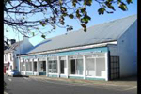](http://fw008705-flywheel.netdna-ssl.com/wp-content/uploads/2015/08/LSC-vai.jpg)Leitrim Sculpture Centre in association with Leitrim County Council Arts Office, are offering five residencies to visual artists, based at LSC.  
Each residency includes an artist’s stipend of €2,500 and comes with a one-person exhibition at the end of the residency period.

For further information and guidelines on how to apply [CLICK HERE](http://www.leitrimsculpturecentre.ie/programme/residencies.html)**Deadline**: Monday 21 September at 5pm  
E: info@leitrimsculpturecentre.ie  
T: 071 985 5098  
www.leitrimsculpturecentre.ie  
Leitrim Sculpture Centre, New Line, Manorhamilton, Co Leitrim  
Ionad Dealbhóireachta, Cluainín, Co Liatroim

**Call for Applications for the 2016 Golden Fleece Award are open.**

[APPLY](http://www.goldenfleeceaward.com/howtoapply.html)

Applications for the 2016 Golden Fleece Award are open.

The Golden Fleece Award is an artistic fund established as a charitable bequest by the late Helen Lillias Mitchell. The award aims to support and promote the diversity of Irish creativity in the arts and crafts. Its mission is to help talented artists needing support at strategic stages of their careers.

All applications must be made online (entry fee €20).

The closing date for entries is Friday 20th November 2015.

The overall fund for the 2016 Award is €20,000.

Full details of eligibility criteria and application requirements are available [here](http://www.goldenfleeceaward.com/applicationrequirements.html)

|  |
| --- |
|  |
|  |
|  |

**Call For Papers- The Great Famine and its Impacts**

The aim of the conference is to highlight new research and resources, yet also to refocus attention on material and visual technologies, economies, and epistemologies that shape Famine memories and legacies. Papers might address (but are not limited to):

* visibility of impacts of the Famine upon the land and environment
* social and material cultures of food and hunger
* ritual and social practices of protest, resistance and commemoration
* architectural history and legacy of workhouses and other institutions
* print and periodical culture
* photographic and cinematic engagements
* dramatic stagings of the Famine
* folklore collection and the museology of social histories
* archaeologies of death and burial
* Famine and popular culture
* tourism and heritage development
* tenement life and displacement/settlement in Ireland and the diaspora
* historical and contemporary artistic engagements with the Famine
* intertwined representations of Famine and contemporary migrations

Abstracts of 250-300 words for 20-minute papers, or proposals for roundtable sessions on specific themes and comprising 10-minute contributions, are invited and can be submitted by **15 December**, along with 100-word biographical statements, to:

Dr. Marguerite Corporaal ([m.corporaal@let.ru.nl](mailto:m.corporaal@let.ru.nl)), director of INIFS  
Dr. Oona Frawley ([oona.frawley@nuim.ie](mailto:oona.frawley@nuim.ie)), local organizer  
Dr. Emily Mark-FitzGerald ([emily.mark@ucd.ie](mailto:emily.mark@ucd.ie)), advisor

[The Great Famine and its Impacts_CFP.pdf](https://visualmaterialfamine.files.wordpress.com/2015/10/the-great-famine-and-its-impacts_cfp.pdf)

**Joan Clancy Gallery Feile na Nollaig, Christmas Group Show: Artist Call**

[](http://fw008705-flywheel.netdna-ssl.com/wp-content/uploads/2015/10/Joan-Clancy-Gallery-Mweelahorna-Ring-Dungarvan-Co-Waterford.-Exterior-view.-jpg.jpg)Artists are invited to make submissions for inclusion in the 2015 Feile na Nollaig Christmas Group Show. Joan Clancy Gallery is best known for showcasing painting and welcomes submissions from artists working in this discipline.  
Please send no more than 4 jpg images accompanied by your CV and Artist Statement either by e-mail or on DVD for consideration to:  
E: info@joanclancygallery.com  
T: 086 813 4597  
[www.joanclancygallery.com](http://www.joanclancygallery.com/)  
Please note there is no submission fee and 40% is charged on sales  
Joan Clancy Gallery, Mweelahorna, Ring, Dungarvan, Co Waterford

The submission period is from now to the end of December 2015. The anthology while welcoming submissions from writers with a Limerick connection is also open to writers from other parts of the country. Specifically we are seeking quality writing which reflect reactions to the 1916 Rising and what it means for us today, these may be historical, or of a contemporary nature. Word count is limited to 1500/2000, poetry and graphics can also be submitted and is limited to three poems/graphics per submission. New and established writers are invited to submit.  
Contributors will receive a copy of the anthology in which their work is featured and can order further copies at a discounted rate.  
The anthology will be edited by John Liddy and Dominic Taylor and will be published by The Limerick Writers’ Centre.  
Submission is by email only and must be submitted in one attached Word document.  
Further Information: Dominic Taylor, The Limerick Writers’ Centre, 12 Barrington Street, Limerick 087 2996409. Email limerickwriterscentre@gmail.com

**Per Cent for Art Opportunities in Grangegorman: Call for Artists**

[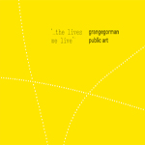](http://fw008705-flywheel.netdna-ssl.com/wp-content/uploads/2015/10/Grangegorman_Public_Art_small.jpg)September 2015 marks the beginning of a new phase of public art opportunities within Grangegorman, Dublin city’s new urban quarter. This artists’ call provides introductory information on Grangegorman Public Art. It is designed to be comprehensive and so far consists of six diverse but complementary public art pathways. Outlined in the invitation booklet is the background to this new urban quarter together with information on the level of funding and support available, along with details of the application procedures. Whether individually or collectively, *‘…the lives we live’ Grangegorman Public Art* is delighted to invite artists and art-workers to consider participating in one or more of the six pathways. These six pathways are designed to facilitate choice as well as a wide range of ideas that will add to the distinctiveness of the area, whether working along with existing communities, past histories or emerging futures. The governing aim is for the highest standards of art and engagement.

**Deadlines** vary for each of the six pathways

Artists wishing to apply are advised to read the full invitation booklet, [CLICK HERE](http://visualartists.ie/wp-content/uploads/2015/10/Grangegorman-Public-Art-.pdf)  
Artists wishing to register interest, should complete the Registration of Interest form, [CLICK HERE](http://visualartists.ie/wp-content/uploads/2015/10/Grangegorman-Register-Interest.pdf)  
Return all forms to:  
E: public.art@ggda.ie  
Briefs for each pathway are provided on receipt of the completed registration form and will include selection panelists, stage two artists’ fees where relevant, opt out clauses and the query process.  
[www.ggda.ie](http://www.ggda.ie/)

**Seacourt: The Centre for Contemporary Printmaking, Artist Call**

[](http://fw008705-flywheel.netdna-ssl.com/wp-content/uploads/2015/10/seacourt1.jpg)Call out for printmakers and visual artists using printmaking in their practice to exhibit at the Annual Members’ Exhibition at Seacourt: The Centre for Contemporary Printmaking , Bangor in November 2015. To become a member of Seacourt, [CLICK HERE](http://www.seacourt-ni.org.uk/membership/).  
Works to be sent or dropped off at Seacourt by 5pm Thursday 12 November 2015

For full details and application information:  
T: +44 (0)28 9146 0595  
E: info@seacourt-ni.org.uk  
[www.seacourt](http://www.seacourt-ni.org.uk/)  
Seacourt The Centre for Contemporary Printmaking, Unit 20 Dunlop Industrial Units, 8 Balloo Drive, Bangor (Down) BT19 7QY, Northern Ireland

**Awards / Bursaries / Schemes**

**Bursaries Available for ‘The Story House’ to Kilkenny Writers**

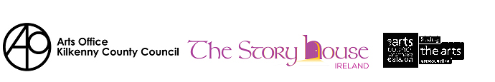

The Arts Office, Kilkenny County Council is pleased to announce their support for the second year to the Story House Bursary 2016.

The Story House Ireland is a not-for-profit residential writing centre inspired by The Arvon Foundation. A Poetry Course will be run on the grounds of Borris House , Co. Carlow from 11th to 16th April 2016 with tutors Nessa O’ Mahoney and Peter Sirr.

See [www.thestoryhouseireland.org](http://www.thestoryhouseireland.org) for full details.

The Arts Office, Kilkenny County Council is awarding a bursary of €500 to a Kilkenny writer to attend The Story House 2016 to support their professional development. For an application form go to Arts Section of [www.KilkennyCoCo.ie](http://www.KilkennyCoCo.ie) or contact Julie McGuirk, Arts Administrator on 0567794547 [julie.mcguirk@kilkennycoco.ie](mailto:julie.mcguirk@kilkennycoco.ie)

Follow The Story House Ireland on Twitter@TSHIreland

**Recipients of the Story House Bursary 2015, cannot enter for the current 2016 bursary.**

**Completed application forms must be submitted on or before 12 noon on Monday 16th November 2015.**

**Of Interest**

**IVARO Announces RETURN 2015 is Open for Claims**

[RETURN 1](http://fw008705-flywheel.netdna-ssl.com/wp-content/uploads/2013/11/RETURN-1.png)**The Irish Visual Artists Rights Organisation** (**IVARO**) is pleased to announce that RETURN 2015 is open for claims. RETURN is our annual service which distributes royalties to any visual creator whose works have been reproduced in books and magazines published in Ireland. Claims can be made by completing an online application form providing examples of what books or magazines your work has featured in. We’ll then pay you a share of royalties we’ve collected for photocopies and scans of publications. Artists who applied successfully for RETURN in previous years can apply this year for all of the same publications once again and add any new publications in 2014 to their claim. While royalty payments can vary year to year, everyone who makes a successful claim is guaranteed a minimum payment. In 2014 the average payment was €85. Artists and beneficiaries have until October 29th to claim.

**How to Claim**  
Simply complete the Online Claim Form [**ivaro.return**](http://www.ivaro.ie/return) by midnight, Thursday 29th October

Before completing the form please read the frequently asked questions: RETURN FAQ [**ivaro.royalties**](http://www.ivaro.ie/return/claim-your-share-of-reprographic-and-broadcasting-royalties)

What previous claimants say “Thanks so much!.. the ‘return’ money arrived yesterday. A lovely bonus at this time of year” “Thanks for looking after our interests. It’s lovely to find the little injection in my bank account.”

IVARO is Irelands not-for-profit copyright management organisation for visual creators. IVARO manages the rights of its’ members through our Copyright Licensing, RETURN and Artists Resale Right services. In addition IVARO engages in advocacy and advice for visual artists. RETURN royalties come from revenue generated by a collective licensing scheme. In Ireland photocopying licenses are issued to businesses and educational institutions by the Irish Copyright Licensing Agency (ICLA). On behalf of visual artists in Ireland, IVARO negotiates a share of this revenue and distributes it through the RETURN service. RETURN is available to all visual creators, not simply IVARO members. Payments are made to qualifying artists, photographers, illustrators, and other visual artists, including heirs and beneficiaries.

For queries regarding RETURN please contact us on:  
T: (01) 672 9488  
E: info@ivaro.ie  
[**www.ivaro.ie**](http://www.ivaro.ie/)