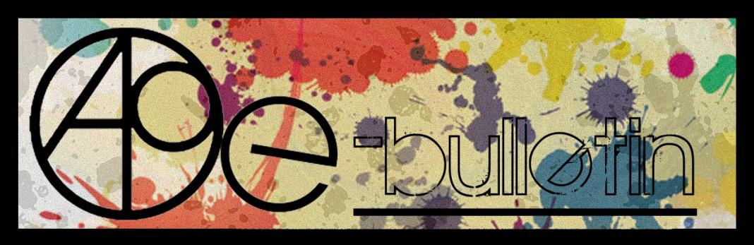

**Kilkenny County Council Arts Office E-bulletin 26th August 2016**

Dear All,   
  
Welcome to the fortnightly e-bulletin from Kilkenny County Council's Arts Office. Each bulletin is packed with the latest information on Kilkenny Arts Office activities, county events as well as news and opportunities for arts practitioners from around the country.

This service will be provided fortnightly. To include an item in the next e-bulletin please send a brief outline of your advert with relevant contact details, including any websites or pages with links to [**niamh.brophy@kilkennycoco.ie**](mailto:niamh.brophy@kilkennycoco.ie) **before 7th September.** The next e-bulletin will be on the **9th September.**

While every effort has been made to ensure the accuracy of our information, we strongly advise readers to verify all details to their own satisfaction.

Regards,

**Niamh Brophy, Arts Administrator**

Arts Office LogoWithText01

5 Dean Street, Kilkenny

T: (056) 7794138

E: [niamh.brophy@kilkennycoco.ie](niamh.brophy@kilkennycoco.ie%20)

W: <www.kilkennycoco.ie/eng/Services/Arts>

[Facebook](https://www.facebook.com/KilkennyArtsOffice/) [twitter](https://twitter.com/kkartsoffice)

[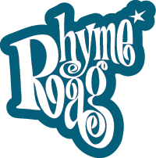](http://www.rhymerag.net/) [Facebook](https://www.facebook.com/KilkennyArtsOffice/) 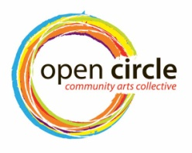 [Facebook](https://www.facebook.com/KilkennyArtsOffice/) [twitter](https://twitter.com/kkartsoffice) [](http://www.artlinks.ie/) [Facebook](https://www.facebook.com/KilkennyArtsOffice/)

<www.rhymerag.net> <https://opencirclearts.ie/> [www.artlinks.ie](http://www.artlinks.ie)

**Kilkenny County Council Cultural Services -**

**Creating and Sustaining Great Communities and Places**

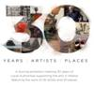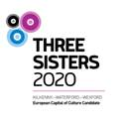 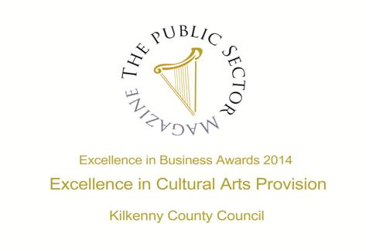

**Arts Office**

* **NEW!** Local scribes recognised at launch of Poetry Broadsheet
* **NEW!** Culture Night – Save the Date!
* **NEW!** Read the next Rhyme Rag published poem

**Kilkenny Events**

* **FINAL WEEKEND!** Heritage Week
* **FINAL WEEKEND!** ‘Exploring the Mental’ by Alan Counihan
* **FINAL WEEKEND!** The Field at the Watergate Theatre
* **NEW!** Lorraine Fenlon Exhibition at Loughboy Library until Sept 2nd
* **NEW!** Family Day at Castlewarren – Sunday 28th August
* **NEW!** YIFM After Schools Workshops 2016/2017
* **NEW!** Sculptor and Ceramic Courses at KCAT
* **NEW!** Kilkenny KCAT artists exhibit at ‘Lost and Found Outsider Art’
* **NEW!** Music in Kilkenny – 16th September
* National Craft Gallery Exhibition and Events
* Cork singer songwriter Ger Wolfe at Woodstock Gardens
* Pulled by Niamh Moroney
* Callan Drummers
* Butler Gallery Michael Snow The Viewing of Six Works
* Kilkenny Library Service Events
* CLIMB Programme - Cois Nore Cancer Support Centre, Kilkenny
* Heritage Week
* Ceramics Ireland Festival 2016

**Courses / Training / Jobs / Internships**

* **NEW!** RUA RED Annual Winter Open Exhibition and Art Prize
* **NEW!** NYCI Child Protection Awareness Programme for Artists with Tom Kent – Dublin
* **NEW!** Volunteers Wanted for Open House Dublin 2016
* Jobs page on artsmanagement.ie updated

### **Novel Fair 2017**

**Call for Submissions / Residencies / Public Art**

* **NEW!** Golden Fleece Award: Call for Submissions
* **NEW!** RUA RED Annual Winter Open Exhibition and Art Prize
* **NEW! #UpcycleChallenge2016**
* **Tales From the Forest | Call for Submissions for Online Magazine**
* **Open Call | DLR Visual Art Commission and Exhibition**
* **Open Call | InktoberFest, New Visual Arts Festival, Wicklow**
* **National Youth Council of Ireland | Artist and Youth Work Residency Scheme**
* **Open Call | DLR Announce 120,000 euro Roger Casement Memorial Commission**
* **Percent for Art Commission | St Joseph’s National School, Louth**
* **The United Nations / Ranan Lurie Political Cartoon Awards 2016**
* **Open Call | Droichead Arts Centre Exhibition Programme 2017**

## Irish Writers’ Centre Listing of Call for Submissions for Competitions

* Open Call | RUA RED Art Prize and Winter Open 2016 | (\*Submission Fee)
* **Open Call for Exhibitions and Studios Membership | Custom House Studios 2017/18**
* **Open Call for Exhibition Programme 2017, The Séamus Ennis Arts Centre, Co. Dublin**

**Awards / Bursaries / Schemes**

* **NEW!** Visual Artists Workspace Scheme 2017 – Opens Thursday, 18th August 2016 For Applications
* **Arts Council | Reel Art Scheme 2016**
* **Arts Council | Festivals and Events Scheme 2017**
* Jack Harte Bursary 2017

**Of Interest**

# [NEW! The Museum of August Destiny](https://artsmanagement.ie/2016/07/29/on-now-the-museum-of-august-destiny/)

**Arts Office**

**NEW! Local scribes recognised at launch of Poetry Broadsheet**

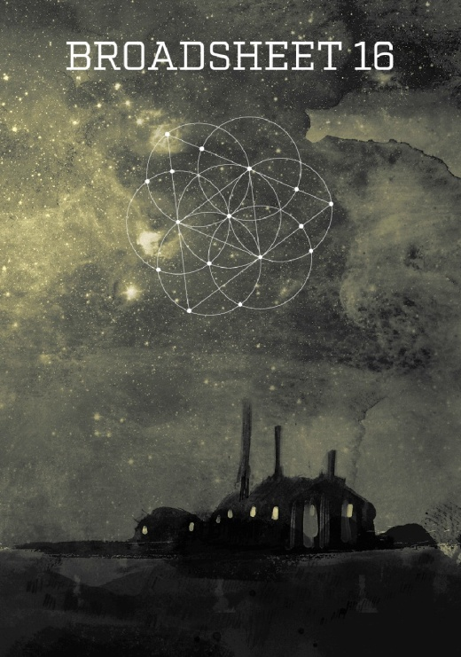 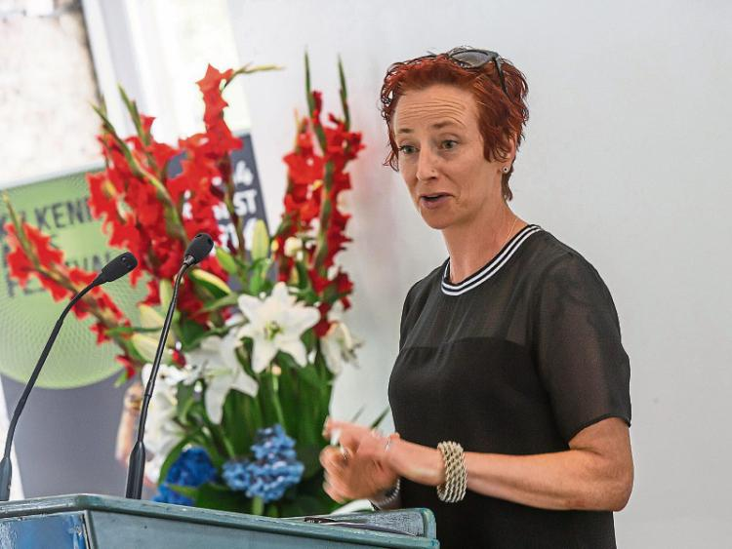

Written by: Mary Cody [mary.cody@kilkennypeople.ie@marygcody](mailto:mary.cody@kilkennypeople.ie@marygcody)

Local writers were given a platform to showcase their work at the launch of the 16th edition of Poetry Broadsheet.

The event, which was part of the Kilkenny Arts Festival took place at the Parade Tower on Friday evening.

Poets were joined by their friends and families at the launch which was opened by renowned Irish poet, Paul Muldoon.

Mr Muldoon told the audience that he was 'delighted' to launch the Kilkenny Poetry Broadsheet - which is a publication which aims to give local writers a platform for their work. He praised the publication and paid special reference to the format saying that he was 'immediately accessible'.

Arts Officer, Mary Butler hosted the event and welcomed all the writers to the launch of their work.

Festival Director, Eugene Downes also spoke and said that poetry was an important part of the festival and noted the involvement of the late Seamus Heaney in Kilkenny Arts Festival.

This year's editor is American-Irish poet Kimberly Campanello. Her most recent collection is Strange Country. Currently she is a lecturer in Creative Writing at York St John University in the UK.

“These works range in subject from the refugee crisi to the economic state of the country to one's relationship with their dog.”

Ms Campanello stated that in judging this year's competition she was looking for what Seamus Heaney calls technique, which is 'a poet's way with words. his management of metre, rhythm and verbal texture; it involves also a definition of his stance towards life, a definition of his own reality. It involves the discovery of ways to go out of his normal cognitive bounds and raid the inarticulate.”

The poets featured in Broadsheet 16 are Shane Joyce, Kevin Dowling, Máire Ní Lorcáin, Nora Brennan, Angela Esmonde, Alice Bennett, Mary Malin, Carmel Cummins, Nuala Roche, Mary O'Shea and Ray Bolger.

If you didn’t make the launch some of our wondeful Broadsheet poets reading their work on KCLR with Ken McGuire. <http://kclr96fm.com/talking-kilkenny-poetry-broadsheet-2016/>

**\_\_\_\_\_\_\_\_\_\_\_\_\_\_\_\_\_\_\_\_\_\_\_\_\_\_\_\_\_\_\_\_\_\_\_\_\_\_\_\_\_\_\_\_\_\_\_\_\_\_\_\_\_\_\_\_\_\_\_\_\_\_\_\_\_\_\_\_\_\_\_\_\_\_**

**NEW! Culture Night – Save the Date!**

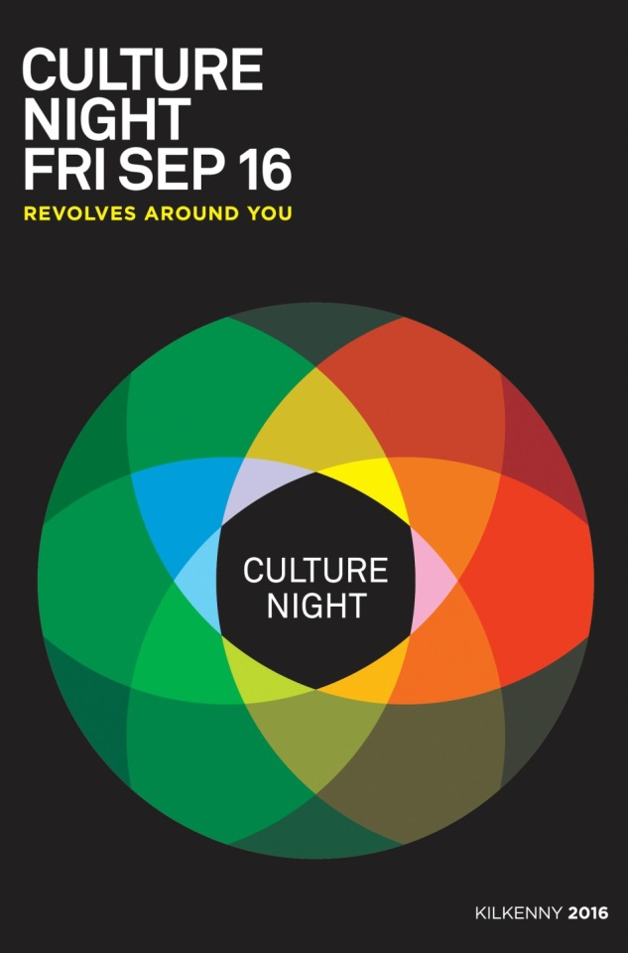

Have a look at the regional events on [www.culturenight.ie](http://l.facebook.com/l.php?u=http%3A%2F%2Fwww.culturenight.ie%2F&h=FAQHotNnhAQGunFpaoyx0JiAtO10I_U1T2v7bgupvATgcKw&enc=AZO1rMZBNThMni7KMitQrZ50eAPIYmdAIy-jw2DRpBXTT5DGqYRPCj5dZGvWH49JuY_kAqqDBLSjX6ffLIstLOpRfGIMKOTyBWzQttacbf0WshY_M72FOBZGp7UIcedZRhAMrFNjmrORpCD034bVB6OKekqYeAHsu0ypvbYfr2OdPI59hIX-gYGpymam7IKT8KDbbQh7qo19nhW1wlF5vQ4K&s=1) for a taste of what's happening.

Follow the Culture Night Kilkenny Facebook page also!!!

**\_\_\_\_\_\_\_\_\_\_\_\_\_\_\_\_\_\_\_\_\_\_\_\_\_\_\_\_\_\_\_\_\_\_\_\_\_\_\_\_\_\_\_\_\_\_\_\_\_\_\_\_\_\_\_\_\_\_\_\_\_\_\_\_\_\_\_\_\_\_\_\_\_\_**

**NEW! Read the next Rhyme Rag published poem**

The next poem to be published for **Rhyme Rag** is **‘Girls'** by **Destiny Ewohime and Rukky Etaferi.**

Illustrated by Ale Mercado check it out at [http://www.rhymerag.net/2016/08/girls/](http://scanmail.trustwave.com/?c=6600&d=3-601_uKm9t4AN6QzJK8pwxXYcsm6Oc5Dd_ahfr4Dg&s=380&u=http%3a%2f%2fwww%2erhymerag%2enet%2f2016%2f08%2fgirls%2f)

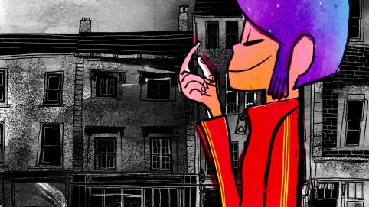

**Kilkenny Events**

**FINAL WEEKEND! Heritage Week**

Heritage Week 20 - 28 August 2016  
[‪#‎peopleandplace‬](https://www.facebook.com/hashtag/peopleandplace?source=feed_text&story_id=1099729823397171) [‪#‎100yearsofheritage‬](https://www.facebook.com/hashtag/100yearsofheritage?source=feed_text&story_id=1099729823397171)

****

**\_\_\_\_\_\_\_\_\_\_\_\_\_\_\_\_\_\_\_\_\_\_\_\_\_\_\_\_\_\_\_\_\_\_\_\_\_\_\_\_\_\_\_\_\_\_\_\_\_\_\_\_\_\_\_\_\_\_\_\_\_\_\_\_\_\_\_\_\_\_**

**FINAL WEEKEND: ‘Exploring the Mental’ by Alan Counihan**

**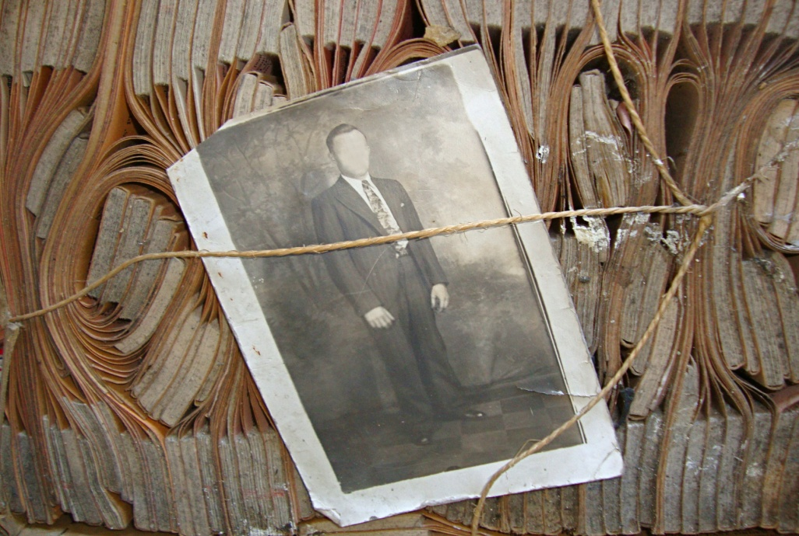**

**Exploring “The Mental”**

*Exploring “The Mental”,* an exhibition examining a much neglected aspect of local and national heritage, will be on view at St Canice’s Psychiatric Hospital, Kilkenny, from 20-28th August during Heritage Week 2016. Less a history of the hospital than a people’s history of life within its walls this exhibition seeks to throw light on an institution and many others like it around the country with which until recent times every family had some degree of connection.

*Exploring “The Mental”* is the fifth and final installation of the Personal Effects Project begun by artist Alan Counihan in 2012 as an investigation of the institutional archives and the belongings of dead or discharged patients from Grangegorman Mental Hospital in Dublin which has received wide coverage in national media. ***Ghosts of Grangegorman,*** a radio documentary based on the project, was produced and broadcast by RTE Radio 1 in September 2015.

The exhibitions to date have proved an effective tool for the presentation of the history of institutional care for those deemed to have been living with mental ill health in Ireland, for public discussion of that challenging history and of models for change and improvement in the delivery of Ireland’s mental health care services. This exhibition seeks to encourage collaborative and communal involvement in a process of acknowledgement, catharsis and healing which might contribute positively to the future delivery of services within the county and further afield.

*Exploring “The Mental”* is not an art exhibition. Any artistic content lies in the presentation of real facts and the experiences of real people. The development of this work has been suported by the Health Service Executive and by an Artlinks Bursary Award.

The exhibition will be on view in the old mortuary building of St Canice’s Hospital from 11am – 4pm daily during Heritage Week 2016.

**\_\_\_\_\_\_\_\_\_\_\_\_\_\_\_\_\_\_\_\_\_\_\_\_\_\_\_\_\_\_\_\_\_\_\_\_\_\_\_\_\_\_\_\_\_\_\_\_\_\_\_\_\_\_\_\_\_\_\_\_\_\_\_\_\_\_\_\_\_\_**

**FINAL WEEKEND!**

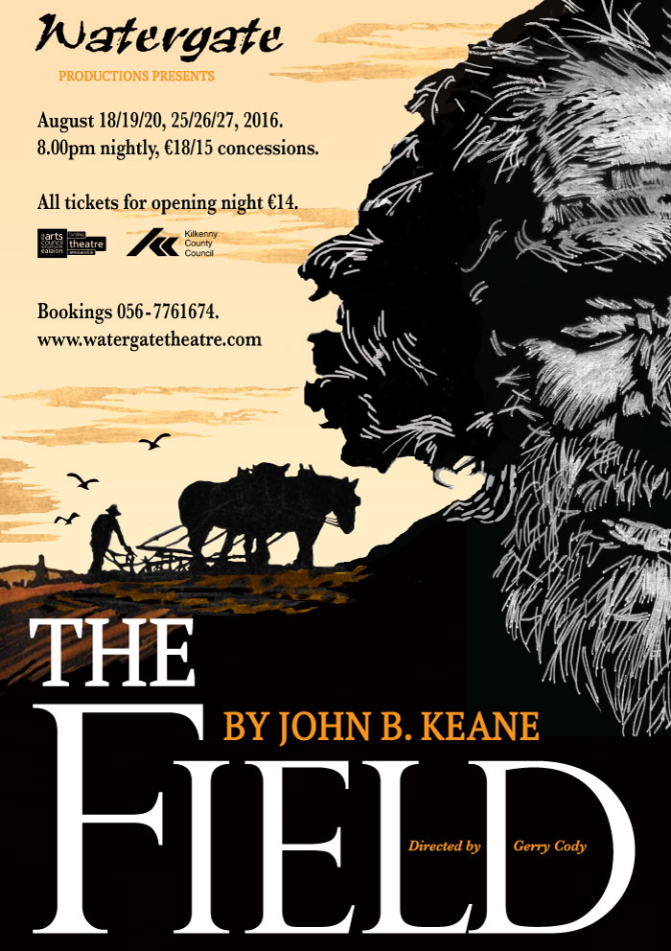

**\_\_\_\_\_\_\_\_\_\_\_\_\_\_\_\_\_\_\_\_\_\_\_\_\_\_\_\_\_\_\_\_\_\_\_\_\_\_\_\_\_\_\_\_\_\_\_\_\_\_\_\_\_\_\_\_\_\_\_\_\_\_\_\_\_\_\_\_\_\_**

**NEW! Lorraine Fenlon Exhibition at Loughboy Library until Sept 2nd**

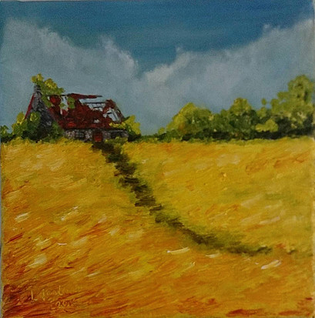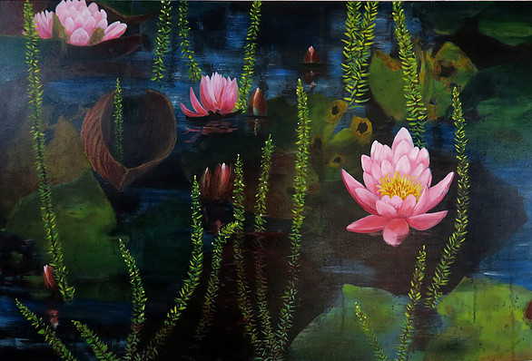

Lorraine was born in Dublin into a family of artists, musicians & bookworms and has been painting from a young age. She moved to the Isle of Man in 1992 where she lived for 13 years.  She returned to her Irish roots in 2005 to settle in County Carlow. Since then, she has taken part in over 30 group exhibitions and has just had her 8th successful solo exhibition.  She runs her own painting school for adults and children and is a registered tutor with Carlow & Kilkenny ETB.

In May 2014 she was invited by Carlow Arts Festival to host her first solo show which opened up several opportunities including gallery representation and offers of further exhibitions. In May 2015, she took part in ‘Portraits for the Post Office’ project and had a portrait selected as a piece for Carlow Post Office. There followed another solo show in Carlow County Library and her first Dublin solo in the Leinster Gallery, Sth Frederick Street.

She paints a diverse range of subjects, working from still life to portraits.  She is inspired by light, shadow & form in nature and reflections on water and uses her ‘artist’s licence’ to push the boundaries with a vibrant colour palette!  Focusing on exaggerated close ups of luscious fruit, cheeky fish paintings & rich contemporary landscapes and seascapes, her work stands out as easily recognisable.  Her work is also proving popular as collectable prints and art cards.

“2015 was a very busy and enjoyable year and now I will be taking part in the ‘Hares on the March’ project for the Jack & Jill foundation. My hare will be called ‘Michelle, The Healing Hare’ and will wear a painted cloak of colourful passionflowers trimmed with a frieze of ‘QR’ codes that will link to various helplines. I have just been informed that my Hare has been sponsored by the Royal College of Physicians in Ireland (RCPI) which is very exciting news."

<http://www.lorrainefenlon.com/>

**\_\_\_\_\_\_\_\_\_\_\_\_\_\_\_\_\_\_\_\_\_\_\_\_\_\_\_\_\_\_\_\_\_\_\_\_\_\_\_\_\_\_\_\_\_\_\_\_\_\_\_\_\_\_\_\_\_\_\_\_\_\_\_\_\_\_\_\_\_\_**

**NEW! YIFM  After School Workshops 2016/2017**

**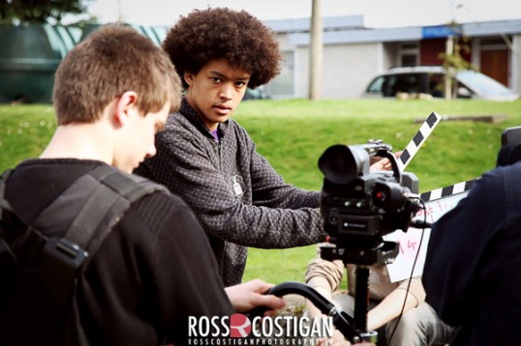**

**REGISTRATION September 5th - 12th**

**Classes starting the week of Monday 19th**

Cost = €80 \*\*\* per term \*\*\* for one class (Mon or Tues, Wed or Thurs)

**Class Sizes:**

Juniors Max 15 / Day

Seniors Max 15 / Day

**ACTIVITIES;**

MONDAYS 4:00 – 6:00 pm

**OR**

TUESDAYS  4:00 – 6:00 pm

Juniors (9-12yrs)

WEDNESDAYS  4:30 – 6:30 pm

**OR**

 THURSDAY  4:30 – 6:30 pm

Seniors (13-18yrs)

**\*\*\*\*NB\*\*\*\*\***

**Each term must be fully paid for at the beginning of term.**

**Classes will work on a first come, first served basis but ONLY fully paid YIFM members will receive a place.**

**Junior & Senior classes will contain the same content in both classes and so places are limited to one class / person**

If anyone has any queries regarding these changes, please do not hesitate to contact us at any time.

**\_\_\_\_\_\_\_\_\_\_\_\_\_\_\_\_\_\_\_\_\_\_\_\_\_\_\_\_\_\_\_\_\_\_\_\_\_\_\_\_\_\_\_\_\_\_\_\_\_\_\_\_\_\_\_\_\_\_\_\_\_\_\_\_\_\_\_\_\_\_\_\_\_**

**NEW!**

**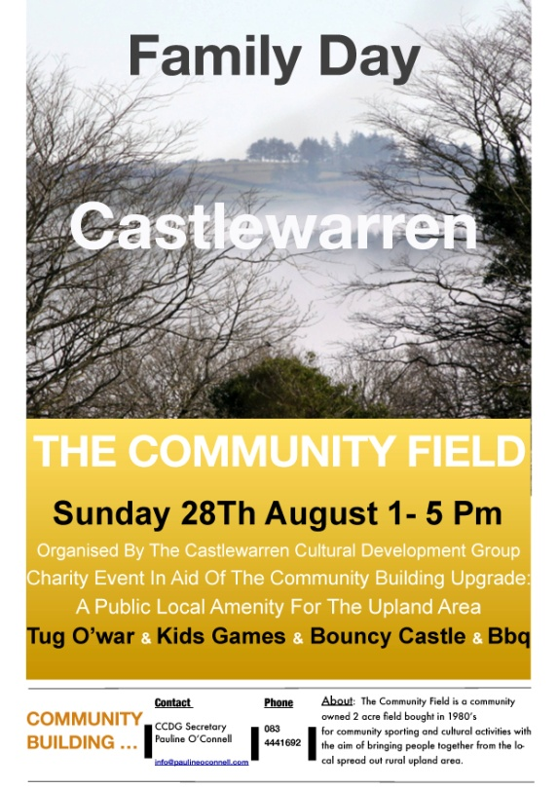**

**NEW! Sculpture and Ceramic Courses at KCAT**

**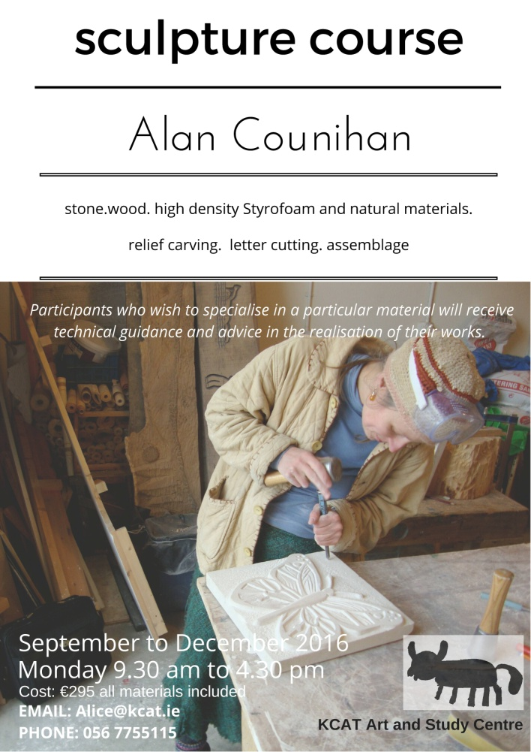**

**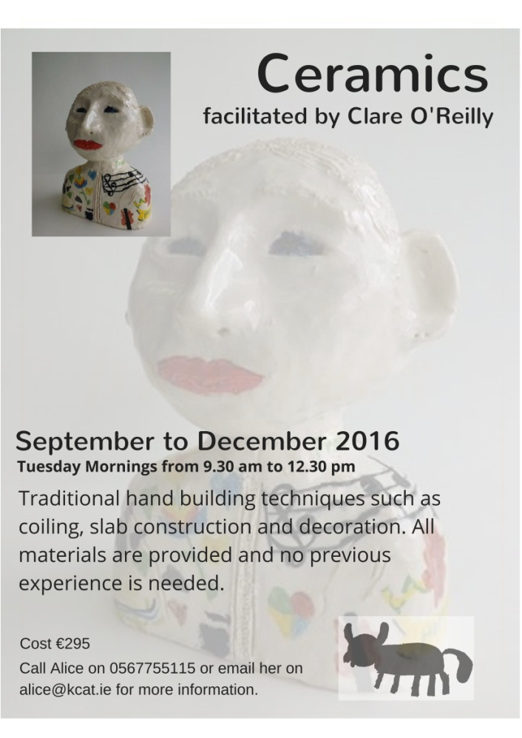**

**\_\_\_\_\_\_\_\_\_\_\_\_\_\_\_\_\_\_\_\_\_\_\_\_\_\_\_\_\_\_\_\_\_\_\_\_\_\_\_\_\_\_\_\_\_\_\_\_\_\_\_\_\_\_\_\_\_\_\_\_\_\_\_\_\_\_\_\_\_\_**

**NEW!**

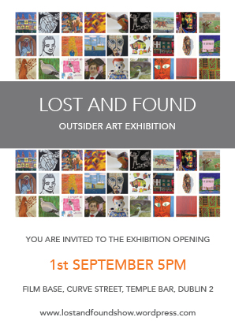

KCAT Studio Artists Andrew Pike, Declan Byrne, Eileen Mulrooney, Fergus Fitzgerald, Jack Foskin, Jason Turner and Mary Cody are all exhibiting work in this exciting exhibition opening on Thursday 1st of September

**\_\_\_\_\_\_\_\_\_\_\_\_\_\_\_\_\_\_\_\_\_\_\_\_\_\_\_\_\_\_\_\_\_\_\_\_\_\_\_\_\_\_\_\_\_\_\_\_\_\_\_\_\_\_\_\_\_\_\_\_\_\_\_\_\_\_\_\_\_\_\_\_\_**

**NEW! Cork singer songwriter Ger Wolfe will play an acoustic session in the Tea House at Woodstock Gardens**

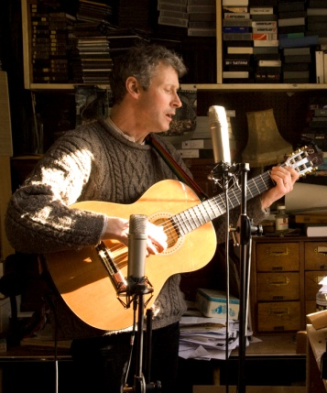

Cork singer songwriter Ger Wolfe will play an acoustic session in the Tea House at Woodstock Gardens the 11th of September from 6 to 8pm.  Well known songwriter of songs like ‘The Curra Road’, ‘The Lark of Mayfield’ and ‘She scattered crumbs’, Ger Wolfe has released seven CD’s of original material over the last twenty years; his latest entitled “I Have Been Loved”. Celebratory, reflective, independent in mind and nature, Ger continues to plough his own way through the Irish musical landscape, heedless of fad or fashion. True to the art of the songwriter he tells his own story as he should, in his own unique voice. Ger is a fine poet and composer all rolled into one, a multi-instrumentalist and a lover of the human voice as the best instrument we have to relate to the mystery of life. Come and hear him play live if you have the chance and visit [www.gerwolfe.com](http://www.gerwolfe.com) to find out more

Tickets €10  
Reservations from gerwolfe@gmail.com or ( text only) 087-6601139

<https://www.facebook.com/events/563206367195212/>

**\_\_\_\_\_\_\_\_\_\_\_\_\_\_\_\_\_\_\_\_\_\_\_\_\_\_\_\_\_\_\_\_\_\_\_\_\_\_\_\_\_\_\_\_\_\_\_\_\_\_\_\_\_\_\_\_\_\_\_\_\_\_\_\_\_\_\_\_\_\_\_\_\_\_\_**

**NEW! Music in Kilkenny – 16th September**

**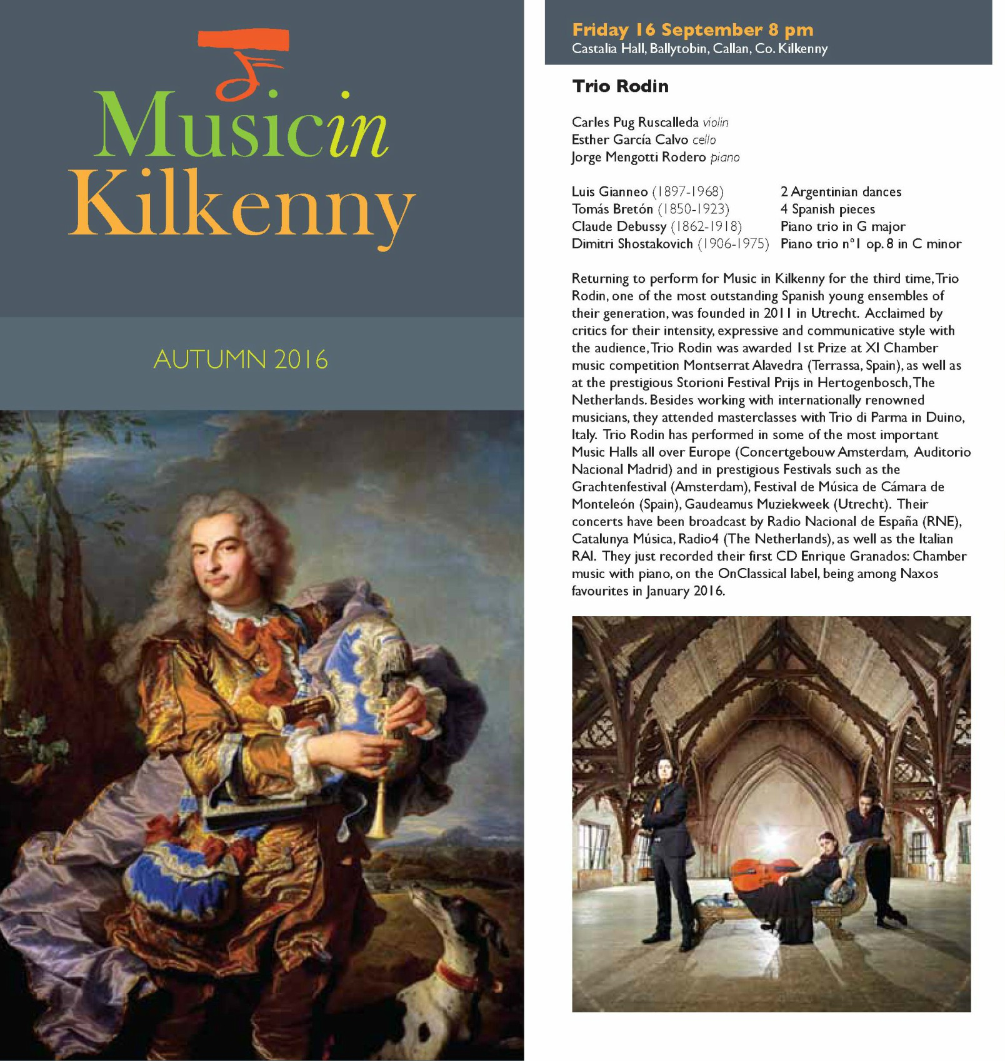**

**\_\_\_\_\_\_\_\_\_\_\_\_\_\_\_\_\_\_\_\_\_\_\_\_\_\_\_\_\_\_\_\_\_\_\_\_\_\_\_\_\_\_\_\_\_\_\_\_\_\_\_\_\_\_\_\_\_\_\_\_\_\_\_\_\_\_\_\_\_\_\_\_\_\_\_**

**NEW! National Craft Gallery Exhibition and Events**

****

|  |  |  |  |  |  |  |  |  |  |
| --- | --- | --- | --- | --- | --- | --- | --- | --- | --- |
| |  |  |  |  |  |  |  |  |  | | --- | --- | --- | --- | --- | --- | --- | --- | --- | |  | |  | | --- | | August brings us a stunning exhibition of work by Irish and international ceramists exploring themes of function and form, vase and vessel. A full programme of events including talks, installations and workshops kick off for the [**Kilkenny Arts Festival**](http://scanmail.trustwave.com/?c=6600&d=86Ci16b4hQYjhYZGX6pHXbfYCgQhqm4LBAgDjZ0fiQ&s=380&u=http%3a%2f%2fnationalcraftgallery%2ecmail19%2ecom%2ft%2fy-l-dujtfy-jtddlybih-e%2f) and continue through the autumn, [**for September and October events see our website**](http://scanmail.trustwave.com/?c=6600&d=86Ci16b4hQYjhYZGX6pHXbfYCgQhqm4LBAdXjssb2A&s=380&u=http%3a%2f%2fnationalcraftgallery%2ecmail19%2ecom%2ft%2fy-l-dujtfy-jtddlybih-s%2f). | |  |  |  | | --- | | [EXHIBITION: VASE - Function Reviewed](http://scanmail.trustwave.com/?c=6600&d=86Ci16b4hQYjhYZGX6pHXbfYCgQhqm4LBAgHjpxL3A&s=380&u=http%3a%2f%2fnationalcraftgallery%2ecmail19%2ecom%2ft%2fy-l-dujtfy-jtddlybih-g%2f) | | [Alison Kay - Vase: Fucnction Reviewed National Craft Gallery Kilkenny Ire](http://scanmail.trustwave.com/?c=6600&d=86Ci16b4hQYjhYZGX6pHXbfYCgQhqm4LBAle281K2w&s=380&u=http://nationalcraftgallery.cmail19.com/t/y-l-dujtfy-jtddlybih-w/) | |  | | [**Alison Kay**](http://scanmail.trustwave.com/?c=6600&d=86Ci16b4hQYjhYZGX6pHXbfYCgQhqm4LBFIC2cwY3A&s=380&u=http%3a%2f%2fnationalcraftgallery%2ecmail19%2ecom%2ft%2fy-l-dujtfy-jtddlybih-yd%2f) | [**Heidi Bjørgan**](http://scanmail.trustwave.com/?c=6600&d=86Ci16b4hQYjhYZGX6pHXbfYCgQhqm4LBAFXjppL3A&s=380&u=http%3a%2f%2fnationalcraftgallery%2ecmail19%2ecom%2ft%2fy-l-dujtfy-jtddlybih-yh%2f) | [**Andrew Wicks**](http://scanmail.trustwave.com/?c=6600&d=86Ci16b4hQYjhYZGX6pHXbfYCgQhqm4LBAcDic8f2Q&s=380&u=http%3a%2f%2fnationalcraftgallery%2ecmail19%2ecom%2ft%2fy-l-dujtfy-jtddlybih-yk%2f) | [**Jonathan Wade**](http://scanmail.trustwave.com/?c=6600&d=86Ci16b4hQYjhYZGX6pHXbfYCgQhqm4LBFcEiskY2g&s=380&u=http%3a%2f%2fnationalcraftgallery%2ecmail19%2ecom%2ft%2fy-l-dujtfy-jtddlybih-yu%2f) | [**Susan Nemeth**](http://scanmail.trustwave.com/?c=6600&d=86Ci16b4hQYjhYZGX6pHXbfYCgQhqm4LBAFS3Jgc3Q&s=380&u=http%3a%2f%2fnationalcraftgallery%2ecmail19%2ecom%2ft%2fy-l-dujtfy-jtddlybih-jl%2f) | [**Agalis Manessi**](http://scanmail.trustwave.com/?c=6600&d=86Ci16b4hQYjhYZGX6pHXbfYCgQhqm4LBAAHjZpOiQ&s=380&u=http%3a%2f%2fnationalcraftgallery%2ecmail19%2ecom%2ft%2fy-l-dujtfy-jtddlybih-jr%2f) | [**Nicholas Lees**](http://scanmail.trustwave.com/?c=6600&d=86Ci16b4hQYjhYZGX6pHXbfYCgQhqm4LBFBS1cca3Q&s=380&u=http%3a%2f%2fnationalcraftgallery%2ecmail19%2ecom%2ft%2fy-l-dujtfy-jtddlybih-jy%2f) | [**Mike Byrne**](http://scanmail.trustwave.com/?c=6600&d=86Ci16b4hQYjhYZGX6pHXbfYCgQhqm4LBFcA25pJ3g&s=380&u=http%3a%2f%2fnationalcraftgallery%2ecmail19%2ecom%2ft%2fy-l-dujtfy-jtddlybih-jj%2f) | [**Natasha Daintry**](http://scanmail.trustwave.com/?c=6600&d=86Ci16b4hQYjhYZGX6pHXbfYCgQhqm4LBFNRiZ9LjA&s=380&u=http%3a%2f%2fnationalcraftgallery%2ecmail19%2ecom%2ft%2fy-l-dujtfy-jtddlybih-jt%2f) | [**Felicity Aylieff**](http://scanmail.trustwave.com/?c=6600&d=86Ci16b4hQYjhYZGX6pHXbfYCgQhqm4LBAle38gd3g&s=380&u=http%3a%2f%2fnationalcraftgallery%2ecmail19%2ecom%2ft%2fy-l-dujtfy-jtddlybih-ji%2f) | [**Carol McNicoll**](http://scanmail.trustwave.com/?c=6600&d=86Ci16b4hQYjhYZGX6pHXbfYCgQhqm4LBAYD1ZhM0Q&s=380&u=http%3a%2f%2fnationalcraftgallery%2ecmail19%2ecom%2ft%2fy-l-dujtfy-jtddlybih-jd%2f) | [**Anne Marie Laureys**](http://scanmail.trustwave.com/?c=6600&d=86Ci16b4hQYjhYZGX6pHXbfYCgQhqm4LBFRf2pgZig&s=380&u=http%3a%2f%2fnationalcraftgallery%2ecmail19%2ecom%2ft%2fy-l-dujtfy-jtddlybih-jh%2f) | [**Sara Flynn**](http://scanmail.trustwave.com/?c=6600&d=86Ci16b4hQYjhYZGX6pHXbfYCgQhqm4LBAIC3cYfjA&s=380&u=http%3a%2f%2fnationalcraftgallery%2ecmail19%2ecom%2ft%2fy-l-dujtfy-jtddlybih-jk%2f) | [**Derek Wilson**](http://scanmail.trustwave.com/?c=6600&d=86Ci16b4hQYjhYZGX6pHXbfYCgQhqm4LBAMF1ZxL2A&s=380&u=http%3a%2f%2fnationalcraftgallery%2ecmail19%2ecom%2ft%2fy-l-dujtfy-jtddlybih-ju%2f) | [**Deok Ho Kim**](http://scanmail.trustwave.com/?c=6600&d=86Ci16b4hQYjhYZGX6pHXbfYCgQhqm4LBFNViJwXjQ&s=380&u=http%3a%2f%2fnationalcraftgallery%2ecmail19%2ecom%2ft%2fy-l-dujtfy-jtddlybih-tl%2f) | [**Kap Sun Hwang**](http://scanmail.trustwave.com/?c=6600&d=86Ci16b4hQYjhYZGX6pHXbfYCgQhqm4LBFRS1Z0ZjQ&s=380&u=http%3a%2f%2fnationalcraftgallery%2ecmail19%2ecom%2ft%2fy-l-dujtfy-jtddlybih-tr%2f) | [**Tanya Gomez**](http://scanmail.trustwave.com/?c=6600&d=86Ci16b4hQYjhYZGX6pHXbfYCgQhqm4LBARej5tNiQ&s=380&u=http%3a%2f%2fnationalcraftgallery%2ecmail19%2ecom%2ft%2fy-l-dujtfy-jtddlybih-ty%2f) | [**Peter Ting**](http://scanmail.trustwave.com/?c=6600&d=86Ci16b4hQYjhYZGX6pHXbfYCgQhqm4LBAVT2csdiQ&s=380&u=http%3a%2f%2fnationalcraftgallery%2ecmail19%2ecom%2ft%2fy-l-dujtfy-jtddlybih-tj%2f) | [**Janice Tchalenko**](http://scanmail.trustwave.com/?c=6600&d=86Ci16b4hQYjhYZGX6pHXbfYCgQhqm4LBAAE28lMiQ&s=380&u=http%3a%2f%2fnationalcraftgallery%2ecmail19%2ecom%2ft%2fy-l-dujtfy-jtddlybih-tt%2f) | [**Kate Malone**](http://scanmail.trustwave.com/?c=6600&d=86Ci16b4hQYjhYZGX6pHXbfYCgQhqm4LBFAC2poZ3g&s=380&u=http%3a%2f%2fnationalcraftgallery%2ecmail19%2ecom%2ft%2fy-l-dujtfy-jtddlybih-ti%2f) | [**Hitomi Hosono**](http://scanmail.trustwave.com/?c=6600&d=86Ci16b4hQYjhYZGX6pHXbfYCgQhqm4LBFQE2pxJ2w&s=380&u=http%3a%2f%2fnationalcraftgallery%2ecmail19%2ecom%2ft%2fy-l-dujtfy-jtddlybih-td%2f) | [**Akiko Hirai**](http://scanmail.trustwave.com/?c=6600&d=86Ci16b4hQYjhYZGX6pHXbfYCgQhqm4LBANRjcpMjQ&s=380&u=http%3a%2f%2fnationalcraftgallery%2ecmail19%2ecom%2ft%2fy-l-dujtfy-jtddlybih-th%2f) | [**Philip Eglin**](http://scanmail.trustwave.com/?c=6600&d=86Ci16b4hQYjhYZGX6pHXbfYCgQhqm4LBAQC2Z9JjA&s=380&u=http%3a%2f%2fnationalcraftgallery%2ecmail19%2ecom%2ft%2fy-l-dujtfy-jtddlybih-tk%2f) | [**Lucinda Mudge**](http://scanmail.trustwave.com/?c=6600&d=86Ci16b4hQYjhYZGX6pHXbfYCgQhqm4LBFIHjZoZ0A&s=380&u=http%3a%2f%2fnationalcraftgallery%2ecmail19%2ecom%2ft%2fy-l-dujtfy-jtddlybih-tu%2f) | [**Helen Doherty**](http://scanmail.trustwave.com/?c=6600&d=86Ci16b4hQYjhYZGX6pHXbfYCgQhqm4LBAJe2J1L2A&s=380&u=http%3a%2f%2fnationalcraftgallery%2ecmail19%2ecom%2ft%2fy-l-dujtfy-jtddlybih-il%2f) | [**Babs Haenen**](http://scanmail.trustwave.com/?c=6600&d=86Ci16b4hQYjhYZGX6pHXbfYCgQhqm4LBFRV3chKjQ&s=380&u=http%3a%2f%2fnationalcraftgallery%2ecmail19%2ecom%2ft%2fy-l-dujtfy-jtddlybih-ir%2f)| [**Alison Britton**](http://scanmail.trustwave.com/?c=6600&d=86Ci16b4hQYjhYZGX6pHXbfYCgQhqm4LBFdVjZtL2Q&s=380&u=http%3a%2f%2fnationalcraftgallery%2ecmail19%2ecom%2ft%2fy-l-dujtfy-jtddlybih-ij%2f) | [**Grainne Watts**](http://scanmail.trustwave.com/?c=6600&d=86Ci16b4hQYjhYZGX6pHXbfYCgQhqm4LBAZf2phMig&s=380&u=http%3a%2f%2fnationalcraftgallery%2ecmail19%2ecom%2ft%2fy-l-dujtfy-jtddlybih-it%2f) | [**Ruan Hoffmann**](http://scanmail.trustwave.com/?c=6600&d=86Ci16b4hQYjhYZGX6pHXbfYCgQhqm4LBFVWj8Yaig&s=380&u=http%3a%2f%2fnationalcraftgallery%2ecmail19%2ecom%2ft%2fy-l-dujtfy-jtddlybih-ii%2f)  **6 August - 6 November**  Curated by Brian Kennedy [**VASE: Function Reviewed**](http://scanmail.trustwave.com/?c=6600&d=86Ci16b4hQYjhYZGX6pHXbfYCgQhqm4LBAdfipsc3A&s=380&u=http%3a%2f%2fnationalcraftgallery%2ecmail19%2ecom%2ft%2fy-l-dujtfy-jtddlybih-id%2f) explores functionality in ceramics through a series of works by Irish and international artists. The exhibition showcases a range of objects, from the consciously matching to the gloriously mismatched, the proudly functional to the emphatically dysfunctional, the useful and the useless. [**VASE: Function Reviewed**](http://scanmail.trustwave.com/?c=6600&d=86Ci16b4hQYjhYZGX6pHXbfYCgQhqm4LBFNfiZgZ2w&s=380&u=http%3a%2f%2fnationalcraftgallery%2ecmail19%2ecom%2ft%2fy-l-dujtfy-jtddlybih-ih%2f) offers a lively and stimulating debate on form versus function within contemporary ceramics and encourages an animated debate on hierarchies within contemporary ceramics, making us look anew at the objects that surround us. | |  | |

**\_\_\_\_\_\_\_\_\_\_\_\_\_\_\_\_\_\_\_\_\_\_\_\_\_\_\_\_\_\_\_\_\_\_\_\_\_\_\_\_\_\_\_\_\_\_\_\_\_\_\_\_\_\_\_\_\_\_\_\_\_\_\_\_\_\_\_\_\_\_**

**‘Pulled’ by Niamh Moroney**

**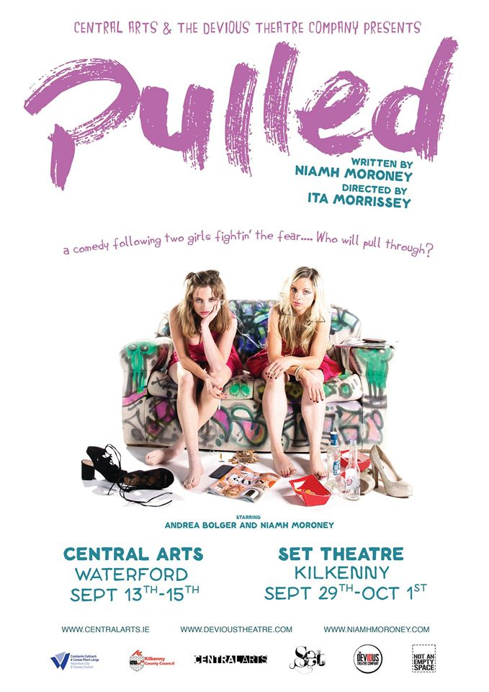**

**\_\_\_\_\_\_\_\_\_\_\_\_\_\_\_\_\_\_\_\_\_\_\_\_\_\_\_\_\_\_\_\_\_\_\_\_\_\_\_\_\_\_\_\_\_\_\_\_\_\_\_\_\_\_\_\_\_\_\_\_\_\_\_\_\_\_\_\_\_\_\_\_**

**Callan Drummers**

**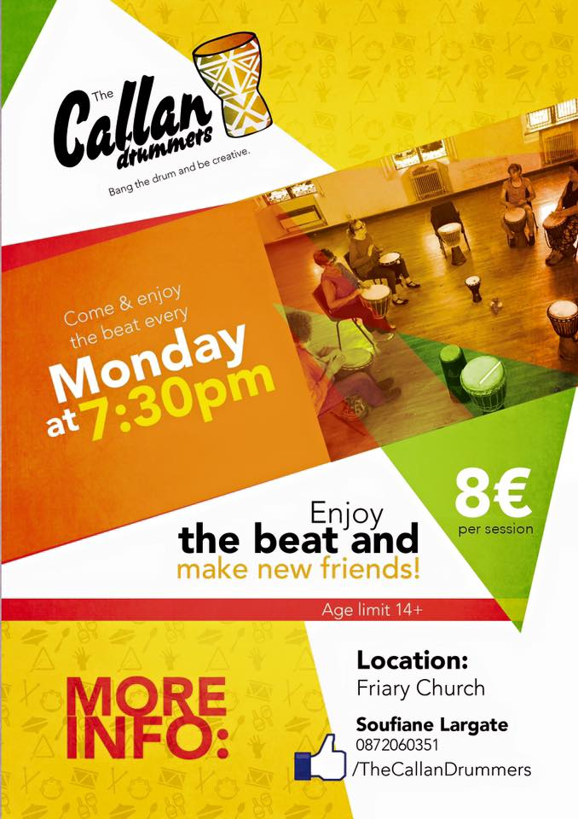**

**\_\_\_\_\_\_\_\_\_\_\_\_\_\_\_\_\_\_\_\_\_\_\_\_\_\_\_\_\_\_\_\_\_\_\_\_\_\_\_\_\_\_\_\_\_\_\_\_\_\_\_\_\_\_\_\_\_\_\_\_\_\_\_\_\_\_\_\_\_\_\_\_\_\_\_\_\_\_\_\_\_\_\_\_\_\_**

**Butler Gallery Michael Snow The Viewing of Six Works**

**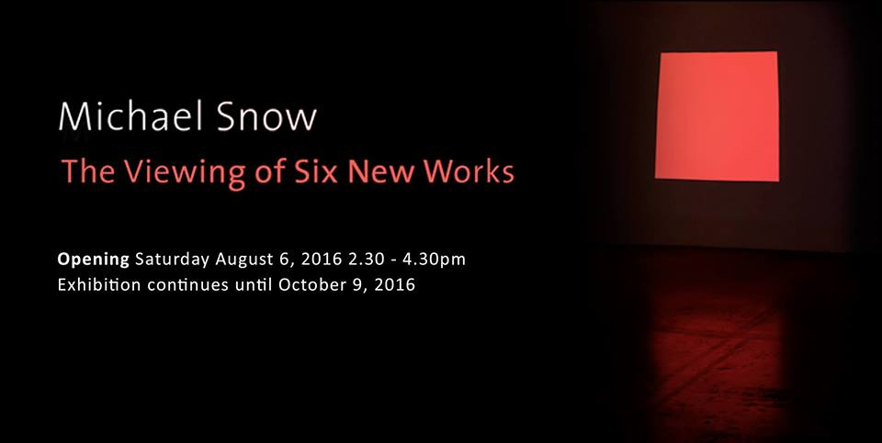**

The Butler Gallery is honoured to present a major exhibition by the internationally renowned visual artist, filmmaker and musician Michael Snow.  
  
Snow’s extensive and multidisciplinary career includes painting, sculpture, video, film, sound, photography, holography, drawing, writing, and music. His highly influential body of work, which spans more than five decades, explores the nature of perception, consciousness, language, and temporality. Snow is one of the world’s leading experimental filmmakers, having inspired the Structural Film movement with his groundbreaking film Wavelength (1967).  
  
The Viewing of Six New Works (2012) draws on Snow’s past work of examining the nature of perception and the physical rel...ationship of the artwork to the viewer. Six projectors cast richly coloured monochrome geometries onto white walls. The rectangular shape elongates, rotates, and contorts into shapes that include trapezoid and rhombus. These transmuting light projections simulate the varying ways a person might look at a rectangular wall-mounted artwork by digitally mimicking and mirroring the movement of the eyes. There is a notable sense of play and experimentation in the way Snow relates what he is thinking in this conceptually pristine yet beautiful installation. “The work is an attempt to present only the movements of perception, not perception itself. The art of looking." - Michael Snow  
  
Michael Snow is a visual artist, filmmaker and musician. He first exhibited in New York in the 1960s and became internationally recognized for pioneering avant-garde cinema with the film Wavelength (1967). His work is represented in private and public collections worldwide including the Museum of Modern Art, New York; the Hirshhorn Museum, Washington, DC; the National Gallery of Canada, Ottawa; the Art Gallery of Ontario, Toronto; Museum Ludwig, Cologne; Centre Georges-Pompidou, Paris, and both the Montréal Museum of Fine Arts and the Musée d'Art Contemporain in Montréal. Michael Snow has represented Canada at the Venice Biennale and is a member of the Order of Canada and a Knight of the Order of Arts and Letters in France. Snow has recently exhibited Solo Snow at Le Fresnoy and a solo exhibition at The Vienna Secession, a sculpture retrospective at the Art Gallery of Ontario and a solo show at the Philadelphia Museum of Art. Michael Snow is represented by the Jack Shainman Gallery, New York.  
  
With thanks to the Arts Council for essential annual funding and to the OPW, Department of Social Protection and Kilkenny Local Authorities for additional assistance.

**\_\_\_\_\_\_\_\_\_\_\_\_\_\_\_\_\_\_\_\_\_\_\_\_\_\_\_\_\_\_\_\_\_\_\_\_\_\_\_\_\_\_\_\_\_\_\_\_\_\_\_\_\_\_\_\_\_\_\_\_\_\_\_\_\_\_\_\_\_\_\_\_\_\_\_\_\_\_\_\_\_\_\_\_\_\_\_**

**Kilkenny Library Service Events**

Kilkenny Library Service presents an audience with Liz Nugent bestselling author of “Unravelling Oliver”  
in Graiguenamanagh Library on Friday 26th August @ 7pm for this year’s Town of Books Festival 2016 Graiguenamanagh which takes place from 26th-28th August –Friday through to Sunday. All Welcome...

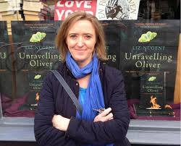

<http://www.graiguenamanaghtownofbooks.com/>

Kilkenny Library Service presents an audience with Rick O'Shea RTE 2fm & Radio1 Broadcaster on Friday 26th August @ 10am in Graiguenamanagh Library for this years "Town of Books Festival" which takes place from 26th-28th August from Friday through to Sunday. All Welcome.

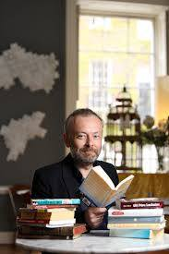

<http://www.graiguenamanaghtownofbooks.com/>  
<https://www.facebook.com/groups/therickosheabookclub/>

**\_\_\_\_\_\_\_\_\_\_\_\_\_\_\_\_\_\_\_\_\_\_\_\_\_\_\_\_\_\_\_\_\_\_\_\_\_\_\_\_\_\_\_\_\_\_\_\_\_\_\_\_\_\_\_\_\_\_\_\_\_\_\_\_\_\_\_\_\_\_\_\_\_\_\_\_\_\_\_\_\_\_\_\_\_\_\_**

**CLIMB Programme.- Cois Nore Cancer Support Centre, Kilkenny**

Cois Nore are running the following programme this September.

CLIMB (Children's Lives Include Moments of Bravery)

CLIMB is a programme for Children aged 5-12 years who are experiencing the impact of a parent's cancer diagnosis.

This programme shall be run over 6 weeks and the groups will be run in the evenings so as not to disrupt school attendance.

The programme is creative,using drama, arts and play.  Also based on having fun together and meeting new friends.

CLIMB Aims.

\*To understand a Cancer diagnosis by providing information on Cancer.

\*To learn how to express his or her feelings and emotions.

\* To learn how to cope with feelings.

\* To feel part of a social group by making friendships with other children sharing a similar experience.

This course is free of charge.  If you know of anyone who may want to avail of this service, We can be contacted on 056 7752222.

**\_\_\_\_\_\_\_\_\_\_\_\_\_\_\_\_\_\_\_\_\_\_\_\_\_\_\_\_\_\_\_\_\_\_\_\_\_\_\_\_\_\_\_\_\_\_\_\_\_\_\_\_\_\_\_\_\_\_\_\_\_\_\_\_\_\_\_\_\_\_\_\_\_\_\_\_\_\_\_\_\_\_\_\_\_\_\_**

**Ceramics Ireland Festival 2016**

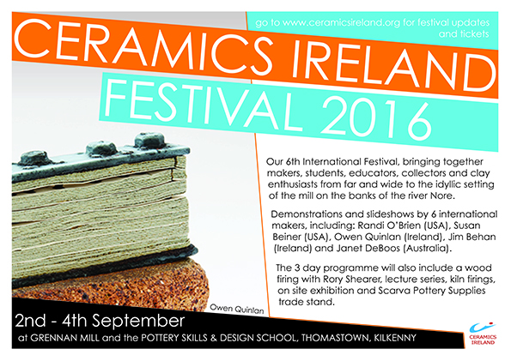

**Course / Training / Jobs / Internships**

**NEW! NYCI Child Protection Awareness Programme for Artists with Tom Kent – Dublin**

Visual Artists Ireland  
Email: monica@visualartists.ie  
September 17, 2016  
10:00 am - 2:00 pm



**Cost:** €40 / 20 VAI Members

Have you previously undertaken Child Protection Training? If not, then this is the session will provide you with certified basic Child Protection Training through the National Youth Council of Ireland's (NYCI) Children First Programme. This session is aimed at artists who work with Children and Young People through a range of media including visual arts, music, literature, dance, theatre and film. In particular of interest for artists working in schools but also other contexts such as workshops in libraries and community settings and public art projects that involve engagement with Children and Young People.  Format The NYCI Children First Child Protection Awareness Programme is the basic awareness course developed for staff and volunteers working with young people, and is the recognised training programme for the youth work sector. The course is delivered through tutor input, group discussion and exercises.  The session covers the following topics: Legislation and policy Values and attitudes Reasonable grounds for concerns Dealing with disclosures Code of behaviour – working safely with young people Scenarios **Tom Kent** is Director of Programmes with [**YMCA Ireland**](http://www.ymca-ireland.net/). Tom began his career in the Tourism Industry and went on to join YMCA Ireland in 2006. He has extensive experience in training & development and managing quality control systems. His primary role is running the YMCA STEP programme across 5 centres in the Republic of Ireland.

**\_\_\_\_\_\_\_\_\_\_\_\_\_\_\_\_\_\_\_\_\_\_\_\_\_\_\_\_\_\_\_\_\_\_\_\_\_\_\_\_\_\_\_\_\_\_\_\_\_\_\_\_\_\_\_\_\_\_\_\_\_\_\_\_\_\_\_\_\_\_\_\_\_\_\_\_\_\_\_\_\_\_\_\_\_\_\_**

**NEW! Volunteers Wanted for Open House Dublin 2016**

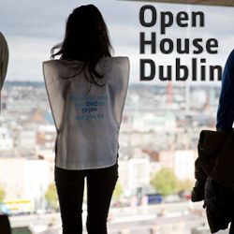

Open House Dublin 2016  
October 14 to 16

Open House Dublin 2016 are looking for volunteers to give three or more hours for their time over the weekend of 14 to 16 October. Full training (one evening) will be provided. In return you get priority access to buildings on the programme and a party will take place on the last night of Open House Dublin.

To volunteer with us please follow this link [**https://goo.gl/forms/79zJ4iSAW9SUC63c2 and complete the registration form**](https://goo.gl/forms/79zJ4iSAW9SUC63c2%20and%20complete%20the%20registration%20form)Please contact Hannah via email volunteers@architecturefoundation.ie or on (01) 8747 203  
[**www.architecturefoundation.ie/**](http://www.architecturefoundation.ie/)

**\_\_\_\_\_\_\_\_\_\_\_\_\_\_\_\_\_\_\_\_\_\_\_\_\_\_\_\_\_\_\_\_\_\_\_\_\_\_\_\_\_\_\_\_\_\_\_\_\_\_\_\_\_\_\_\_\_\_\_\_\_\_\_\_\_\_\_\_\_\_\_\_\_\_\_\_\_\_\_\_\_\_\_\_\_\_\_**

**Jobs page on artsmanagement.ie updated**

The [jobs page](http://scanmail.trustwave.com/?c=6600&d=kPKN17TZidqo6bB9kDv-jsXjgqAqBm1qNRuu4iXpCg&s=380&u=https%3a%2f%2fartsmanagement%2eie%2fjobs%2f) of artsmanagement.ie was refreshed with a whole summer crop of new positions!

<https://artsmanagement.ie/jobs/>

**\_\_\_\_\_\_\_\_\_\_\_\_\_\_\_\_\_\_\_\_\_\_\_\_\_\_\_\_\_\_\_\_\_\_\_\_\_\_\_\_\_\_\_\_\_\_\_\_\_\_\_\_\_\_\_\_\_\_\_\_\_\_\_\_\_\_\_\_\_\_\_\_\_\_\_\_\_\_\_\_\_\_\_\_\_\_\_**

|  |
| --- |
| **NOVEL FAIR 2017** |

Described by *The Irish Times* as a '*Dragon's Den* for writers', the **Novel Fair** is an **Irish Writers Centre** initiative which aims to introduce up-and-coming writers to top publishers and literary agents, giving novelists the opportunity to bypass the slush pile, pitch their ideas and place their synopsis and sample chapters directly into the hands of publishers and agents.

Over the past few years a range of publishers and agents have attended the Fair including Penguin Random House Ireland, Hachette Ireland, Transworld Ireland, Curtis Brown, New Island Books, O’Brien Press/Brandon, Liberties Press, Lilliput Press, Tramp Press, The Book Bureau, Marianne Gunn O’Connor Literary Agency, Jonathan Williams Literary Agency, Lisa Richards Agency, Feldstein Agency and Author Rights Agency and New York based agent Regal Hoffmann & Associates.

[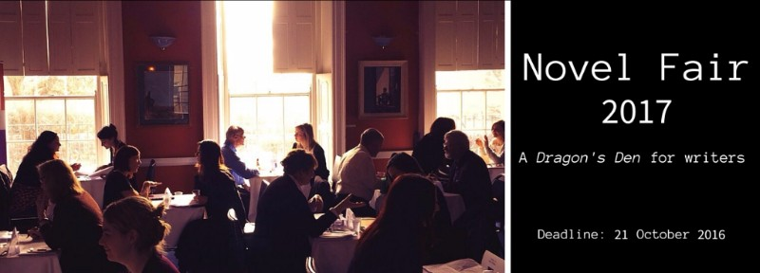](http://scanmail.trustwave.com/?c=6600&d=kYqG1y83ZSapRd5a70VGDOZQ2gWgYfyANy0NfJFwmg&s=380&u=http://irishwriterscentre.us9.list-manage.com/track/click?u=b6ac145e44235d03eb0c4adb6&id=d0e7ad239d&e=055476dad7)

There have been a number of success stories since the Novel Fair has been established, such as:

* Janet E. Cameron’s novel *Cinnamon Toast* (Hachette)
* Niamh Boyce’s novel *The Herbalist* (Penguin Ireland) which was longlisted for IMPAC 2015
* *Beatsploitation* by Kevin Curran (Liberties Press)
* *Here In No Place* by Alan Timmons' (New Island)
* *The Reluctant Cannibal* by Ian Flitcroft (Legend Press)
* Daniel Seery’s novel *A Model Partner* (Liberties Press)
* Susan Lanigan’s White Feathers (Brandon Press)
* *Eggshells* by Caitriona Lally (Liberties Press)
* Andrea Carter's novel *Death at Whitewater Church* (Constable & Robinson)
* *Swimming on Dry Land* by Helen Blackhurst (Seren)

The **Novel Fair 2017** submissions period is now officially open with the **deadline for applications on 21 October 2016**. The Fair itself takes place on **18** **February 2017**.

Take a look at our [video of Novel Fair 2015](https://www.youtube.com/watch?v=uPC18mdSslc) to get a flavour for just how exciting this event can be!

Before entering the competition, please ensure that you have read the **Terms & Conditions** very carefully as the Fair is open to previously **unpublished aspiring novelists** only.

<http://irishwriterscentre.ie/collections/frontpage/products/novel-fair-2017>

**Call for Submissions / Residencies / Public Art**

**NEW! RUA RED Annual Winter Open Exhibition and Art Prize**

Deadline for submissions: Friday, 9th September, 5pm

RUA RED Annual Winter Open exhibition of fine and applied arts. Submissions may be in any discipline for example painting, sculpture, new media, printmaking, ceramics, glass, photography, installation and jewellery.

This open submission is an opportunity for graduates, emerging and established artists from Ireland (including Northern Ireland) to exhibit their work in Gallery 1.

The overall winner of the RUA RED Art Prize will be awarded a solo show in Gallery 2 at some point during the ensuing 12 month period. The People’s Choice Award sponsored by The Square is determined by a public vote from visitors to the exhibition, the winner will collect €1000 towards their professional practice.

Exhibition dates: 5th November – 24th December.

For guidelines and application form see: [**http://ruared.ie/about/opportunities**](http://ruared.ie/about/opportunities)

RUA RED, South Dublin Arts Centre, Tallaght, Dublin 24.  
T: 01 451 5860  
E: [**info@ruared.ie**](mailto:info@ruared.ie)  
W:**[ruared.ie](http://ruared.ie/)**

**\_\_\_\_\_\_\_\_\_\_\_\_\_\_\_\_\_\_\_\_\_\_\_\_\_\_\_\_\_\_\_\_\_\_\_\_\_\_\_\_\_\_\_\_\_\_\_\_\_\_\_\_\_\_\_\_\_\_\_\_\_\_\_\_\_\_\_\_\_\_\_\_\_\_\_**

**NEW!**

**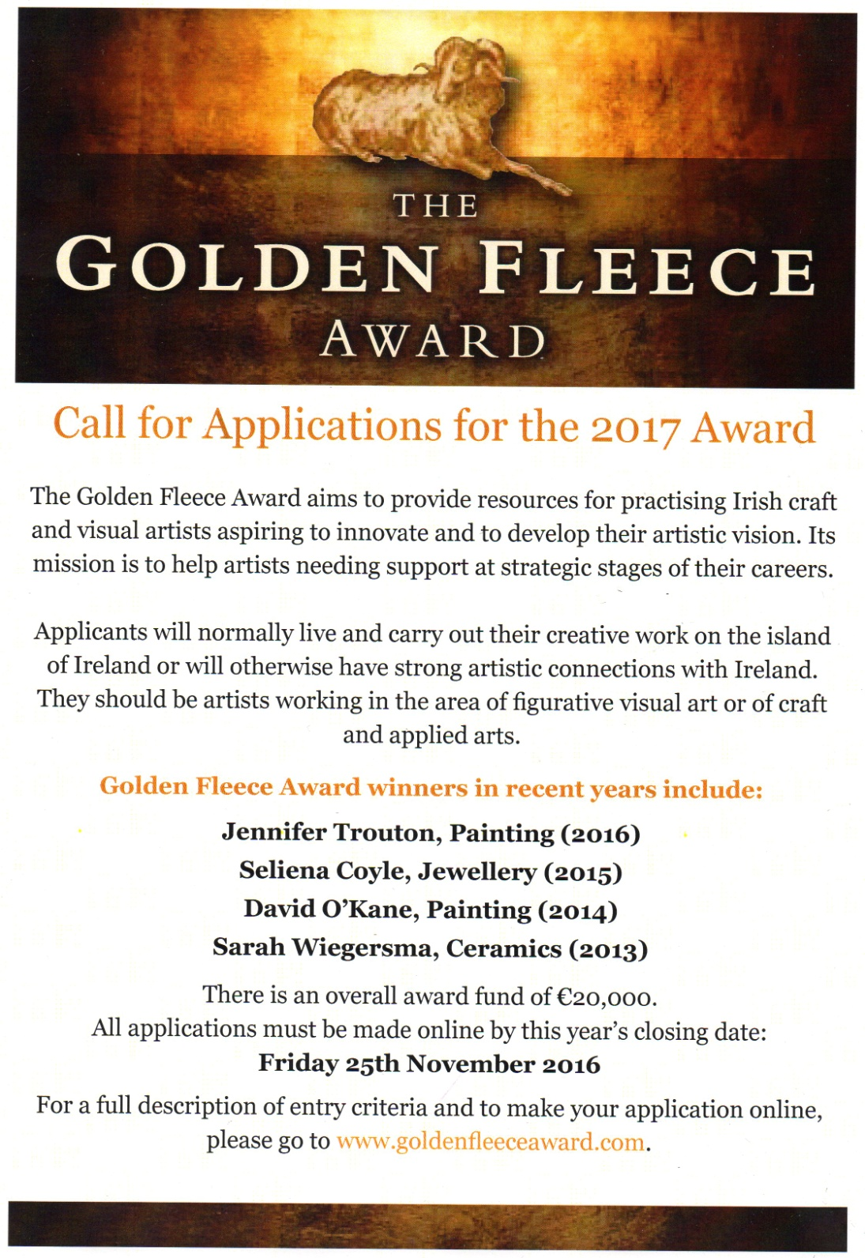**

**NEW!**

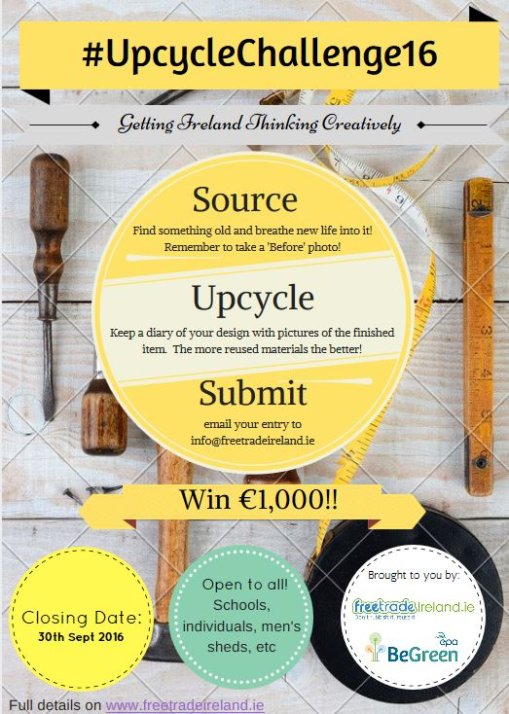

**\_\_\_\_\_\_\_\_\_\_\_\_\_\_\_\_\_\_\_\_\_\_\_\_\_\_\_\_\_\_\_\_\_\_\_\_\_\_\_\_\_\_\_\_\_\_\_\_\_\_\_\_\_\_\_\_\_\_\_\_\_\_\_\_\_\_\_\_\_\_\_\_\_**

**Tales From the Forest | Call for Submissions for Online Magazine**

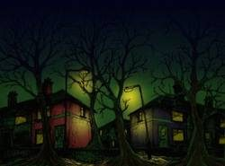Deadline: 25 September 2016

Tales From The Forest is a quarterly online magazine, with each issue having a different theme. Issue #2 is now available online ([**https://talesfromtheforest.net/).**](http://scanmail.trustwave.com/?c=6600&d=kM6i12poUJLh7Mpua4LzxDAfhyWWumvQNcKU43KhMw&s=380&u=https%3a%2f%2ftalesfromtheforest%2enet%2f%29)

Now taking submissions for Issue 3, the theme is ‘We Were Little’. We welcome submissions of poetry, fiction, artwork or any mixing of mediums to tell a story. No limitations on poetry or visual art, but stories should be limited to 1,000 words.

[**talesfromtheforest.net/submissions/**](http://scanmail.trustwave.com/?c=6600&d=kM6i12poUJLh7Mpua4LzxDAfhyWWumvQNZKQ5nX2Nw&s=380&u=http%3a%2f%2fvisualartists%2eus9%2elist-manage%2ecom%2ftrack%2fclick%3fu%3de67e46c7b14e756132f46a50c%26id%3d13a707eeb7%26e%3df4dbf7f416) |  **[www.facebook.com/TalesFromTheForestMagazine/](http://scanmail.trustwave.com/?c=6600&d=kM6i12poUJLh7Mpua4LzxDAfhyWWumvQNcCYsiP3ZQ&s=380&u=http%3a%2f%2fvisualartists%2eus9%2elist-manage%2ecom%2ftrack%2fclick%3fu%3de67e46c7b14e756132f46a50c%26id%3d09d2712fee%26e%3df4dbf7f416)**

**\_\_\_\_\_\_\_\_\_\_\_\_\_\_\_\_\_\_\_\_\_\_\_\_\_\_\_\_\_\_\_\_\_\_\_\_\_\_\_\_\_\_\_\_\_\_\_\_\_\_\_\_\_\_\_\_\_\_\_\_\_\_\_\_\_\_\_\_\_\_\_\_\_\_\_**

**Open Call | DLR Visual Art Commission and Exhibition**

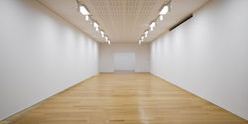Deadline: 19 October, 12 noon

Dún Laoghaire-Rathdown County Council wishes to commission two visual artists to create a new body of work which will culminate in an exhibition (by each artist) in the Municipal Gallery, dlr LexIcon. Two artists will be selected by way of an open submission selection process. Each artist will be paid a commission of €10,000 and will be given an agreed period of time of at least 1 year to undertake the commission. The resultant artworks will be displayed in the dlr LexIcon Gallery over a five to seven week period (including installation and take-down), in 2018 or 2019 at dates mutually agreed by the selected artist and the dlr Arts Office.

Applications are invited from artists who are living in, working in or originally from Dún Laoghaire-Rathdown or who have studied visual art in the county.

More information, application details and site photos can be found here: [**www.dlrcoco.ie/sites/default/files/atoms/files/visual\_art\_commission\_dlr\_lexicon\_2018-19\_0.pdf**](http://scanmail.trustwave.com/?c=6600&d=kM6i12poUJLh7Mpua4LzxDAfhyWWumvQNZmWtXDwbA&s=380&u=http%3a%2f%2fvisualartists%2eus9%2elist-manage1%2ecom%2ftrack%2fclick%3fu%3de67e46c7b14e756132f46a50c%26id%3d608bcc0a79%26e%3df4dbf7f416)

[**www.dlrcoco.ie**](http://scanmail.trustwave.com/?c=6600&d=kM6i12poUJLh7Mpua4LzxDAfhyWWumvQNcLCs3TwMQ&s=380&u=http%3a%2f%2fvisualartists%2eus9%2elist-manage2%2ecom%2ftrack%2fclick%3fu%3de67e46c7b14e756132f46a50c%26id%3dad7c0e1fbc%26e%3df4dbf7f416)

**\_\_\_\_\_\_\_\_\_\_\_\_\_\_\_\_\_\_\_\_\_\_\_\_\_\_\_\_\_\_\_\_\_\_\_\_\_\_\_\_\_\_\_\_\_\_\_\_\_\_\_\_\_\_\_\_\_\_\_\_\_\_\_\_\_\_\_\_\_\_\_\_\_\_\_\_\_\_\_\_\_\_\_\_**

**Open Call | InktoberFest, New Visual Arts Festival, Wicklow**

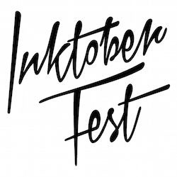Deadline: 29 August

Submissions are now open to participate in a new visual arts festival in Wicklow Town titled InktoberFest. The project will take place from the 1st – 3rd October, 2016.

An arts trail of exhibitions in varying spaces will be created through Wicklow town using two large Halls to form the beginning and end of the arts trail along with a series of vacant shop spaces leading from one Hall to the other.

The two Halls will act as typical gallery white spaces and host most of the selected work. The vacant shop spaces we will be supplied are intended for individual artists/ groups to create autonomous exhibitions.

We are seeking work and proposals for both types of spaces.

As Wicklow town currently has no Cinema, no theatre, no music hall and no gallery for contemporary art the festival will service the community by exposing many people in Wicklow to the exciting work being produced by Contemporary Artists. The event has no theme as such but rather it aims to celebrate creative diversity through a broad spectrum of contemporary visual arts and to explore the range of approaches artists have today.

This is the first year of the event and we are working on a volunteer capacity without any financial backing or funding to make it happen. For this reason there is a €10 application fee. This will be used to directly subsidise the administrative costs, IT resources and space to process applications. Any surplus in this fund will be diverted into the practical installation costs of InktoberFest.

There will also be a 25% commission on any work sold through the festival. All funds raised through this will go directly towards InktoberFest 2017 as mean to perpetuate the Festival as an annual event.

It is our ambition to reduce and remove these costs in the future once other forms of financing the event has been attained.

All submissions via website- [**inktober.org/submissions**](http://scanmail.trustwave.com/?c=6600&d=kM6i12poUJLh7Mpua4LzxDAfhyWWumvQNcWW6H7yYA&s=380&u=http%3a%2f%2fvisualartists%2eus9%2elist-manage%2ecom%2ftrack%2fclick%3fu%3de67e46c7b14e756132f46a50c%26id%3d1df5fc432a%26e%3df4dbf7f416)

**\_\_\_\_\_\_\_\_\_\_\_\_\_\_\_\_\_\_\_\_\_\_\_\_\_\_\_\_\_\_\_\_\_\_\_\_\_\_\_\_\_\_\_\_\_\_\_\_\_\_\_\_\_\_\_\_\_\_\_\_\_\_\_\_\_\_\_\_\_\_\_\_\_\_\_**

**National Youth Council of Ireland | Artist and Youth Work Residency Scheme**

The deadline for receipt of applications is Monday 5 September 2016

The Young People, Children and Education (YPCE) Team wishes to advise that the window of application is now open for the Artist and youth work residency scheme 2016/17. This scheme is managed by the National Youth Council of Ireland (NYCI) on behalf of the Arts Council and the Department of Children and Youth Affairs

The artist and youth work residency scheme is designed to promote innovative partnerships between youth groups, artists and (where relevant) arts organisations. A residency may take the form of an artist in residence in a youth work setting and/or a youth group in residence in an arts setting.

There are two strands to the artist and youth work residency scheme. Strand 1 – development; and Strand 2 – full residency.

Strand 1 – development (€1500, with potential to apply for a further €3500)  
This strand is intended to support an organisation or artist to work with proposed partners to develop a collaborative residency programme. Successful applicants for Strand 1 will have the opportunity to submit a follow-up proposal within three months of receiving their award for funding to follow through on the proposed programme.

Strand 2- full residency (€5000)  
This strand is intended to support residency programmes that have been jointly developed by the partners involved (i.e. the artist, youth group and any other key partner organisation) and that fully meet the criteria for the award.

The maximum award available is €5,000.

If you require further information, please contact Niamh Dillon, Youth Arts Project Officer, National Youth Council of Ireland at 01 478 41 22 or [**niamh@nyci.ie**](mailto:niamh@nyci.ie)

For more information on the scheme and how to apply visit here:**[http://www.youtharts.ie/content/artist-youth-work-scheme](http://scanmail.trustwave.com/?c=6600&d=kM6i12poUJLh7Mpua4LzxDAfhyWWumvQNcPD53erNg&s=380&u=http%3a%2f%2fvisualartists%2eus9%2elist-manage%2ecom%2ftrack%2fclick%3fu%3de67e46c7b14e756132f46a50c%26id%3d896539a970%26e%3df4dbf7f416)**

**\_\_\_\_\_\_\_\_\_\_\_\_\_\_\_\_\_\_\_\_\_\_\_\_\_\_\_\_\_\_\_\_\_\_\_\_\_\_\_\_\_\_\_\_\_\_\_\_\_\_\_\_\_\_\_\_\_\_\_\_\_\_\_\_\_\_\_\_\_\_\_\_\_\_\_\_\_\_\_\_\_\_\_\_\_**

**Open Call | DLR Announce 120,000 euro Roger Casement Memorial Commission**

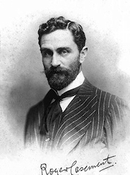Dún Laoghaire-Rathdown County Council invites expressions of interest from artists for the creation of a new artwork to be situated in the newly developed Dún Laoghaire Baths area. The commission is to commemorate the life of Roger Casement and his particular significance to the local area.

Roger Casement was born in Sandycove, Co. Dublin on September 1, 1864. Casement was one of the most interesting Irishmen in the late nineteenth and early twentieth centuries. He held a number of consular appointments in various locations in Africa. During this time he investigated human rights abuses in the Belgian Congo. He later reported on the abuse of rubber workers in Brazil for which he was knighted in 1911. Casement later resigned from the Foreign Office and devoted his energies to Irish independence. Most notably he went to Germany to garner their support for a Rising in Ireland. On Good Friday 1916 he landed at Banna Strand, County Kerry, where he was immediately arrested. When he was transferred to London to stand trial his last sight of Ireland was from the boat at Dún Laoghaire harbour. He was found guilty of high treason and executed at Pentonville Prison on 3 August 1916.

The commissioners are seeking a representational sculpture of Casement. It is proposed to locate the commission at the end of the new jetty to be built in the Dún Laoghaire Baths area (see Architectural Plans in Brief). The brief does not specify the materials to be used; however, the preferred materials of the commissioning body are bronze, stone or concrete. The artwork is intended to be permanent and of high quality. The materials used should take into consideration the environmental demands of the site.

Budget  
The total budget available for the artwork is up to €120,000 (inclusive of VAT).

Commission Process  
This is a two-stage commission process. Stage 1 is open to any artists. A maximum of 4 artists will be shortlisted for Stage 2. Shortlisted artists will be paid a fee of €1,500 to develop Stage 2 proposals.

The selection panel will be comprised of 6 people, including representatives from DLR Memorial Committee, Arts Office, Architect Department and 2 independent professional artists.

Deadline  
The deadline for Stage 1 applications is Friday 7 October 2016 at 12 noon.  
Late submissions will not be accepted.

Queries  
All queries should be sent by email to [**shelly@visualartists.ie**](mailto:shelly@visualartists.ie) or call 01 6729488

**\_\_\_\_\_\_\_\_\_\_\_\_\_\_\_\_\_\_\_\_\_\_\_\_\_\_\_\_\_\_\_\_\_\_\_\_\_\_\_\_\_\_\_\_\_\_\_\_\_\_\_\_\_\_\_\_\_\_\_\_\_\_\_\_\_\_\_\_\_\_\_\_\_\_\_**

**Percent for Art Commission | St Joseph’s National School, Louth**  
  
Deadline for Stage 1 Expressions of Interest: Tuesday 6 September, 12 noon

St. Joseph’s N. S. for their Per Cent for Art project would like to commission a Professional Artist(s) who can provide them with a permanent artwork that would involve engagement with the school community. Their new school extension opened in April 2016. Although the official opening will be on the 21st October 2016, they wish to have their Per Cent for Art Commission completed in September 2017 to coincide with the first year of the school.

Budget €33,000

It is recommended that you read the Briefing Document and Guidelines and supply supporting documentation and material as requested. Application Form is contained in the Briefing Document Only hard copy submissions will be accepted. We will not accept submissions by email.

View: [**Stage1 Briefing Document & Application Form | St. Joseph’s N.S. Dundalk**](http://scanmail.trustwave.com/?c=6600&d=u5SZ1ytTFcOi-0vOEWfz9tsIodsGAwOgb7BwQvG61g&s=380&u=http%3a%2f%2fvisualartists%2eus9%2elist-manage%2ecom%2ftrack%2fclick%3fu%3de67e46c7b14e756132f46a50c%26id%3d2d78e08f18%26e%3d1968c52731)

Queries:  
Applicants can make enquiries regarding the commission to Vincent O’Shea, email: [**vincent.oshea@eircom.net**](mailto:vincent.oshea@eircom.net) mobile: 087 2384599

## \_\_\_\_\_\_\_\_\_\_\_\_\_\_\_\_\_\_\_\_\_\_\_\_\_\_\_\_\_\_\_\_\_\_\_\_\_\_\_\_\_\_\_\_\_\_\_\_\_\_\_\_\_\_\_\_\_\_\_\_\_\_\_\_\_\_\_\_\_\_\_\_\_\_\_\_\_\_\_\_\_\_\_\_\_

**The United Nations / Ranan Lurie Political Cartoon Awards 2016**

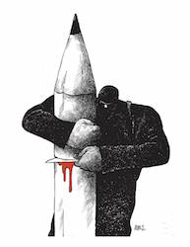

Deadline: 15 November

The United Nations / Ranan Lurie Political Cartoon Awards are now open for entries in the 2016 cartoon competition. Eligible for entry are works done from the beginning of September 2015, to the 15th of October 2016, reflecting the importance of human dignity, mutual respect and friendship among nations, as well as economic consideration and environmental responsibilities towards each other.

The total prize money fund for 2016 is $18,000, of which $10,000 are reserved for the First Prize winner, $5,000 for the Second Prize winner and $3,000 for the Third Prize winner. Plaques will also be awarded to the winners of the first three prizes. Ten (10) honorable mentions will also be announced.

Entries may be made by any professional individual and should consist of political cartoons printed in any publication and in any language.

Winning cartoons will be chosen for their high professional standards in art, political analysis of events, projection of events to come, humor, while also reflecting the spirit and principles of the U.N.

The United Nations has established this annual competition in 2005, to promote the highest standard of excellence in political cartoons. It is named after political cartoonist Ranan Lurie.

No Entry Fee to apply. For application form and further details see: [**http://lurieunaward.com**](http://lurieunaward.com)

**\_\_\_\_\_\_\_\_\_\_\_\_\_\_\_\_\_\_\_\_\_\_\_\_\_\_\_\_\_\_\_\_\_\_\_\_\_\_\_\_\_\_\_\_\_\_\_\_\_\_\_\_\_\_\_\_\_\_\_\_\_\_\_\_\_\_\_\_\_\_\_\_\_\_\_\_\_\_\_\_\_\_\_\_\_\_\_**

**Open Call | Droichead Arts Centre Exhibition Programme 2017**

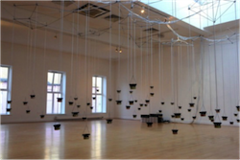

Deadline: Monday 29 August 2016

Droichead Arts Centre is now accepting proposals for its 2017 exhibition programme. The exhibition can be a solo or a group exhibition, involving any medium, and new or existing works. A gallery floor plan is available on request. Submissions should be sent in one email (not exceeding 20mb) with the subject line ‘2017 Proposal’ to: [**rita.mcquillan@droichead.com**](mailto:rita.mcquillan@droichead.com)

Submission guidelines:  
• Detailed proposal  
• Documentation of work  
• Biographies and CVs  
• Timeline for delivery  
• Technical requirements  
• Any other relevant supporting material

Droichead Arts Centre, Stockwell St., Drogheda, Co. Louth.  
T: 041 9833946  
E: [**info@droichead.com**](mailto:info@droichead.com)  
W: [**droichead.com**](http://scanmail.trustwave.com/?c=6600&d=3rj01xCdXejm_getNMEAnovK-uGLoXrJ-vR1mOdovg&s=380&u=http%3a%2f%2fvisualartists%2eus9%2elist-manage%2ecom%2ftrack%2fclick%3fu%3de67e46c7b14e756132f46a50c%26id%3db8cac8930b%26e%3d1968c52731)

**\_\_\_\_\_\_\_\_\_\_\_\_\_\_\_\_\_\_\_\_\_\_\_\_\_\_\_\_\_\_\_\_\_\_\_\_\_\_\_\_\_\_\_\_\_\_\_\_\_\_\_\_\_\_\_\_\_\_\_\_\_\_\_\_\_\_\_\_\_\_\_\_\_\_\_**

## Irish Writers’ Centre Listing of Call for Submissions for Competitions

The Irish Writer’s Centre provides a great listing of poetry, short story, prose, novel and much more creative writing competition. See their website or some of their listings here:

<http://irishwriterscentre.ie/>

[**The Ogham Stone: Call for Submissions**](http://www.theoghamstoneul.com/)

**Deadline:**Sunday 28 August.

***Details:***The Ogham Stone, the University of Limerick’s literature and arts journal, is currently inviting submissions for the Spring 2017 edition. The journal has fast become an influential platform for writers and artists to present their work, and it remains committed to showcasing exciting new work by emerging and established artists. Last year the journal published just under fifty pieces, including short stories, flash fiction, poetry and artwork, and featured new work by Irish writers Colum McCann, Paula Meehan, Joseph O’Connor and Mary O’Malley. The Spring 2017 issue welcomes submissions in fiction, memoir, poetry, visual arts and photography, short graphic novels, and creative non-fiction. So buff and shine your work and get it to us before the deadline of 28th August 2016! For detailed submission guidelines please see our website: www.theoghamstoneul.com.

--

[**The Aesthetica Creative Writing Award**](http://www.aestheticamagazine.com/creative-writing-award/)  
**Deadline**: 31 August 2016  
**Prizes**: Includes £500 prize money for the Poetry winner & £500 prize money for the Short Fiction winner; full list of prizes on the website.   
**Details**: Poetry entries should be no more than 40 lines; Fiction entries should be no more than 2,000 words. Works published elsewhere are accepted. You may enter as many times as you wish. Both Poetry and Fiction entries should be written in English.

[**Books Ireland Short Story Competition**](http://irishwriterscentre.ie/collections/writing-opportunities/products/www.booksirelandmagazine.com/competition)

**Deadline:** 31 August 2016  
**Prizes:** 1st: €400 plus a place on writing course at the Irish Writers Centre and publication in Books Ireland magazine. 2nd €200 and 3rd €100   
**Details:** 2nd Books Ireland Short Story competition. Entry is open to any nationality writing in English, with no restriction on style or theme. Maximum words allowed is 2600.

[**The Manchester Poetry Prize**](http://www.manchesterwritingcompetition.co.uk/Poetry-Prize.php)  
**Deadline**: 23 September 2016  
**Prizes**: £10,000  
**Details**: Entry fee is £17.50, £10,000 prize for the best portfolio of three to five poems (maximum combined length: 120 lines). Open internationally to new and established writers aged 16 or over (no upper age limit).

[The Caterpillar Story for Children Prize 2016](http://www.thecaterpillarmagazine.com/a1-page.asp?ID=7644&page=17)

**Deadline**: 30 September 2016.  
**Prizes:**1st Prize: €500 plus a 2-week stay at The Moth’s Artists’ Residence  
2nd Prize: €300  
3rd Prize: €200  
All three winning stories will appear in the winter 2016 issue of *The Caterpillar***Details:** Send an original, unpublished story of no more than 1,500 words – on any theme or subject, as long as it is appropriate for 7–11 year olds. The entry fee is €12 per story, and you can enter as many stories as you like.

[**Off the Beaten Track Writing Competition**](http://seniortravelexpert.com/off-beaten-track-writing-competition/)  
**Closing date:** 30 September 2016  
**Prize:** £100.00 cash prize plus 10 runner-up vouchers and published on website  
**Entry fee:** Free to enter  
**Length:** Maximum 750 words, fact or fiction  
We are looking for interesting, original articles which relate to the theme: Off the Beaten Track.  The winning entry will be the one that is judged to most effectively persuade readers of the **Senior Travel Expert** website that they would like to visit the place described!

[**The World Book of Poetry**](http://michaelosullivan59.weebly.com/world-book-of-poetry.html)  
**Deadline**: 31 October 2016  
**Details**: Poets are invited to submit poems for the World Book of **Poetry**.This is a unique opportunity for poets to find a world-wide audience for their work.

[The Ballymaloe International Poetry Prize](http://www.themothmagazine.com/a1-page.asp?ID=8010&page=13)  
**Deadline**: 31 December 2016  
**Prize:** The winner receives €10,000. Each of the other shortlisted entrants receive €1,000.  
**Details:** The Prize is open to anyone (over 18), as long as the work is original and previously unpublished. The entry fee is €12 per poem, and you can enter as many poems as you like.

**\_\_\_\_\_\_\_\_\_\_\_\_\_\_\_\_\_\_\_\_\_\_\_\_\_\_\_\_\_\_\_\_\_\_\_\_\_\_\_\_\_\_\_\_\_\_\_\_\_\_\_\_\_\_\_\_\_\_\_\_\_\_\_\_\_\_\_\_\_\_\_\_\_\_\_**

**Open Call | RUA RED Art Prize and Winter Open 2016 | (\*Submission Fee)**

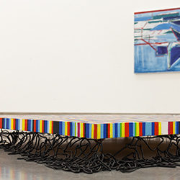Deadline: Friday 9 September, 5pm 2016

RUA RED Annual Winter Open exhibition of fine and applied arts. Submissions may be in any discipline for example painting, sculpture, new media, printmaking, ceramics, glass, photography, installation and jewellery.

This open submission is an opportunity for graduates, emerging and established artists from Ireland (including Northern Ireland) to exhibit their work in Gallery 1.

The overall winner of the RUA RED Art Prize will be awarded a solo show in Gallery 2 at some point during the ensuing 12 month period. The People’s Choice Award sponsored by The Square is determined by a public vote from visitors to the exhibition, the winner will collect €1000 towards their professional practice.

Submission details  
Artists can submit a maximum of three works. Each submission must include the following:  
• Completed Submission Form  
• Artist Statement, bio and C.V  
• Images (maximum of 3)  
• Registration and Handling Fee payable to ‘South Dublin Arts Centre Company’

A Registration and Handling Fee of €10 (inclusive of VAT) is required for each work. This payment must be submitted with the application form. No work will be considered without payment. Cheques / postal orders should be made to ‘South Dublin Arts Centre Company’.

Download Guidelines and Application form from: [**ruared.ie/about/opportunities**](http://ruared.ie/about/opportunities)

Exhibition dates: 5th November – 24th December. All sales are subject to 25% commission during the continuance of the exhibition.

RUA RED, South Dublin Arts Centre, Tallaght, Dublin 24.  
T: 01 451 5860  
E: [**info@ruared.ie**](mailto:info@ruared.ie)  
W:**[ruared.ie](http://ruared.ie/)**

**\_\_\_\_\_\_\_\_\_\_\_\_\_\_\_\_\_\_\_\_\_\_\_\_\_\_\_\_\_\_\_\_\_\_\_\_\_\_\_\_\_\_\_\_\_\_\_\_\_\_\_\_\_\_\_\_\_\_\_\_\_\_\_\_\_\_\_\_\_\_\_\_\_\_\_\_\_\_\_\_\_\_\_\_\_\_\_**

**Open Call for Exhibitions and Studios Membership | Custom House Studios 2017/18 Programme**

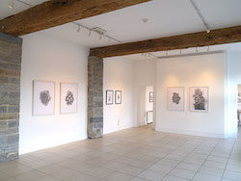Deadline: 31 September 2016

Custom House Studios are now inviting submissions for Exhibitions and Studios for 2017/18. Please submit proposals for exhibitions at the Custom House Studios gallery during 2017/18, and for use of studios ( short term contracts 1 – 3 months) in 2017/18, and long term studios in 2017/8 .

Submissions by Email – include all letters of interest, CVs and documentation of work maximum 10 images in one attached file only in PDF format, (no JPGS or other image formats accepted). For work on video please provide links for online viewing. Send to: [**customhouse@eircom.net**](mailto:customhouse@eircom.net)

For more information:  
T: +353 (0)98 28735  
E: [**info@customhousestudios.ie**](mailto:info@customhousestudios.ie)  
W: [**customhousestudios.ie**](http://scanmail.trustwave.com/?c=6600&d=2f3q11fTtd9HUCvOPL8ih8qB4Ijy_J98Ha50qRV5gA&s=380&u=http%3a%2f%2fvisualartists%2eus9%2elist-manage1%2ecom%2ftrack%2fclick%3fu%3de67e46c7b14e756132f46a50c%26id%3d6117d9a499%26e%3df4dbf7f416)

**\_\_\_\_\_\_\_\_\_\_\_\_\_\_\_\_\_\_\_\_\_\_\_\_\_\_\_\_\_\_\_\_\_\_\_\_\_\_\_\_\_\_\_\_\_\_\_\_\_\_\_\_\_\_\_\_\_\_\_\_\_\_\_\_\_\_\_\_\_\_\_\_\_\_\_\_\_\_\_\_\_\_\_\_\_\_\_**

**Open Call for Exhibition Programme 2017, The Séamus Ennis Arts Centre, Co. Dublin**  
  
Category: Open Call  
Deadline: 20 September  
Web: [www.tseac.ie/page/apply-to-exhibit](http://scanmail.trustwave.com/?c=6600&d=pM7i12yOQajFCE1hfMU9hOP94_6BJw57h_QPBqPQ2A&s=380&u=http%3a%2f%2fcreate-ireland%2eus11%2elist-manage1%2ecom%2ftrack%2fclick%3fu%3dae8a0e4da904d891196932bf8%26id%3d295a1071d5%26e%3dff568af62e)   
Email: [info@tseac.ie](mailto:info@tseac.ie)  
  
The Séamus Ennis Arts Centre is currently looking for exhibition proposals from artists for solo/two person exhibitions in their Easter Snow Gallery for 2017. All 2D or wall mountable work acceptable including paintings, prints, drawings, photography, etc. Exhibitions will run for eight weeks.  
  
To submit a proposal send five images of recent work on a CD/USB key, Artist CV and Artist Statement/Exhibition Proposal to Colette Lawless, Séamus Ennis Arts Centre, Naul, Co. Dublin.  
  
Please contact Colette with any questions at [info@tseac.ie](mailto:info@tseac.ie)

**Awards / Bursaries / Schemes**

### NEW! Visual Artists Workspace Scheme 2017 – Opens Thursday, 18th August 2016 For Applications

The deadline for applications is 5:30pm Thursday 13 October 2016

This scheme is funded by The Arts Council and administered by Visual Artists Ireland.

Applications for this scheme will open on Thursday, 18th August 2016. Only applications made through the online system will be considered.

You may access the form  at [**https://www.tfaforms.com/rest/forms/view/432848**](http://scanmail.trustwave.com/?c=6600&d=zO651yPIp2RgQhQOYu3zyC5lxSqh__ldbsp8F110mQ&s=380&u=http%3a%2f%2fvisualartists%2eus9%2elist-manage%2ecom%2ftrack%2fclick%3fu%3de67e46c7b14e756132f46a50c%26id%3dac1d9de4d1%26e%3df4dbf7f416)

Visual Artists Ireland, on behalf of the Arts Council, invites applications for grants of up to a maximum of €40,000 towards the running costs of visual artists’ workspaces. In keeping with the Council’s policy document Visual Artists’ Workspaces in Ireland – A New Approach, this scheme has the aim of assisting artists workspaces throughout the country to provide the best possible environment for working visual artists and, where feasible, to enable a level of subsidy for resident visual artists.

The scheme will award grants of up to €40,000 towards running costs such as light, heat, rent, administration and/or appropriate management costs. (Capital costs cannot be applied for through this scheme).

Guidelines and Online Application Form: [**Workspace Scheme Document 2017 Final**](http://scanmail.trustwave.com/?c=6600&d=zO651yPIp2RgQhQOYu3zyC5lxSqh__ldbpl6Rlkikg&s=380&u=http%3a%2f%2fvisualartists%2eus9%2elist-manage%2ecom%2ftrack%2fclick%3fu%3de67e46c7b14e756132f46a50c%26id%3db98c173876%26e%3df4dbf7f416).

**\_\_\_\_\_\_\_\_\_\_\_\_\_\_\_\_\_\_\_\_\_\_\_\_\_\_\_\_\_\_\_\_\_\_\_\_\_\_\_\_\_\_\_\_\_\_\_\_\_\_\_\_\_\_\_\_\_\_\_\_\_\_\_\_\_\_\_\_\_\_\_\_\_**

**Arts Council | Reel Art Scheme 2016**  
  
The deadline for receipt of applications is Friday 7 October 2016 at 5pm.

The Arts Council has announced the deadline for the 2016 Reel Art scheme. Launched in 2008, Reel Art is designed to provide film artists with a unique opportunity to make highly creative, imaginative and experimental documentaries on an artistic theme. Operated in association with Filmbase and the Audi Dublin International Film Festival, Reel Art will wholly support two films with grants of €70-€80,000 per project. Reel Art films will premiere at the Dublin International Film Festival in February 2018.

The Arts Council’s purpose in offering the Reel Art scheme is to support film artists to make documentary art films that would not otherwise get made. A key aim of the scheme is to complement, rather than replicate, the documentary and other funding programmes offered by the Arts Council, broadcasters and funding agencies in Ireland.

Reel Art projects should be conceived for theatrical exhibition at film festivals and in arthouse cinema settings. Only proposals for original, imaginative and aesthetically-driven treatments of arts subjects will be considered. Proposals that offer visually engaging, creative and experimental approaches to their subject will be prioritised.

Film artists interested in applying for Reel Art are invited to attend an information session on the scheme on Tuesday 6 September at 3pm in Filmbase, Curved Street, Temple Bar, Dublin 2. This session will outline the purpose and priorities of the award and will answer questions on the scheme. Anyone interested in attending is required to register their interest by sending an email to [**reelart@filmbase.ie**](mailto:reelart@filmbase.ie).

Updated guidelines for Reel Art 2016, together with application forms for the scheme are available for download from the website [**www.filmbase.ie/reelart**](http://scanmail.trustwave.com/?c=6600&d=kM6i12poUJLh7Mpua4LzxDAfhyWWumvQNZaU4nKgMQ&s=380&u=http%3a%2f%2fvisualartists%2eus9%2elist-manage%2ecom%2ftrack%2fclick%3fu%3de67e46c7b14e756132f46a50c%26id%3d4e36fceadc%26e%3df4dbf7f416) as are details of previous Reel Art projects.

**\_\_\_\_\_\_\_\_\_\_\_\_\_\_\_\_\_\_\_\_\_\_\_\_\_\_\_\_\_\_\_\_\_\_\_\_\_\_\_\_\_\_\_\_\_\_\_\_\_\_\_\_\_\_\_\_\_\_\_\_\_\_\_\_\_\_\_\_\_\_\_\_**

**Arts Council | Festivals and Events Scheme 2017**

The closing date for Round 1 is 29 September 2016.

The Arts Council announces Round 1 of the 2017 Festivals and Events Scheme (FES). The Council recognises the distinctive role arts festivals play in sustaining a vibrant arts profile at a local level. Festivals provide opportunities for audiences and artists to experience new work and ways of making work.

The objective of the scheme is to support a diverse range of arts festivals and events. While these might be expressed in a variety of forms, the scheme’s focus is firmly placed on public engagement and activities that have the arts as their core and foundation.

The Festivals and Events Scheme is open to multi-disciplinary festivals, single art form festivals, once-off events and concert series. There are two strands of funding available:  
Strand 1: Up to €10,000  
Strand 2: Between €10,001 and €20,000

All first-time applicants or those who previously received funding below the €10,000 threshold in their most recent application must apply under Strand 1 of the scheme. Those applicants who were offered €10,000 or more (up to €20,000) in their most recent application may apply to Strand 2.

The Festivals and Events Scheme is open to organisations promoting festivals or events with a clear artistic purpose and that will take place in the first half of the calendar year 2017. Applications for funding for festivals taking place in the second half of 2017 should apply to Round 2.

The scheme is also open to organisations running a series of events (e.g. concerts) throughout the calendar year – in other words, apply under this round for support for the full programme of events.

For Guidelines and Application Details see: [**www.artscouncil.ie/Funds/festivals-and-events-scheme/**](http://scanmail.trustwave.com/?c=6600&d=kM6i12poUJLh7Mpua4LzxDAfhyWWumvQNcOV4H71Yg&s=380&u=http%3a%2f%2fvisualartists%2eus9%2elist-manage%2ecom%2ftrack%2fclick%3fu%3de67e46c7b14e756132f46a50c%26id%3d25acff4acf%26e%3df4dbf7f416)

**\_\_\_\_\_\_\_\_\_\_\_\_\_\_\_\_\_\_\_\_\_\_\_\_\_\_\_\_\_\_\_\_\_\_\_\_\_\_\_\_\_\_\_\_\_\_\_\_\_\_\_\_\_\_\_\_\_\_\_\_\_\_\_\_\_\_\_\_\_\_\_\_**

**Jack Harte Bursary 2017**

[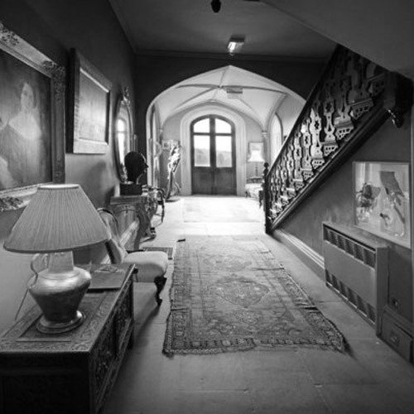](http://cdn.shopify.com/s/files/1/0631/7333/products/Annaghmakerrig_BW.jpg?v=1468346406)

**Announcing the third year of the Jack Harte Bursary awarded by**

**the Irish Writers Centre in association with the Tyrone Guthrie Centre**

The Irish Writers Centre and the Tyrone Guthrie Centre at Annaghmakerrig have come together again to offer a two-week fully resourced Writer-in-Residence Bursary to take place in spring 2017. The award is named in honour of Jack Harte, founder of the Irish Writers Centre, in celebration and acknowledgement of his contribution to Irish literature. Liz Nugent and Sarah Moore Fitzgerald have previously received this award.

**Who Can Apply:**

This is an open call to writers resident on the island of Ireland with a proven track record and at least one book of fiction or short stories published by a recognised publisher. Priority will be given to works of fiction.

**Application Deadline:**23 Friday September, 2016 at 5pm.

<http://irishwriterscentre.ie/collections/writing-opportunities>

**Of Interest**

# [NEW! The Museum of August Destiny](https://artsmanagement.ie/2016/07/29/on-now-the-museum-of-august-destiny/)

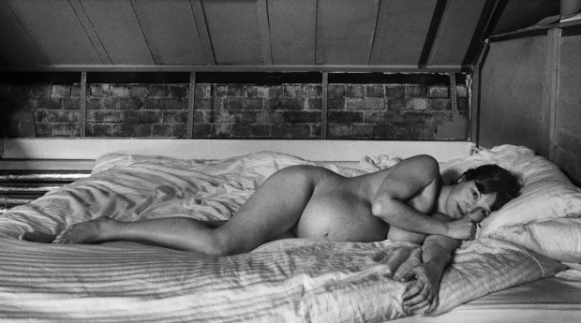

Dragana Jurisic, Jessie, 2016

[The Museum of August Destiny](http://www.lismorecastlearts.ie/augustdestiny/) (17 July – 4 September) features six artists born or working in Ireland and explores the resonance of the Proclamation of the Irish Republic, a century after it was written. The participating artists are [Aideen Barry](http://www.aideenbarry.com/" \t "_blank), [Mark Clare](http://www.markclare.com/), [Amanda Coogan](http://www.amandacoogan.com/), [Anthony Haughey](http://anthonyhaughey.com/), [Dragana Jurisic](http://www.draganajurisic.com/) and [Sarah Pierce](http://themetropolitancomplex.com/).

The exhibition proposes an alternative means of making 1916 again manifest, by creating a ‘capsule’ museum responding to the final line of the 1916 Proclamation:

In this supreme hour the Irish nation must by its valour and discipline and by the readiness of its children to sacrifice themselves for the common good, prove itself worth of the ***august destiny*** to which it is called.

The Museum of August Destiny has commissioned each artist to respond to one of six ‘visions’ of Irish destiny set out in the Proclamation: (1) sovereignty and ‘unfettered control of Irish destinies’; (2) religious and civil liberty; (3) equal rights and opportunities for citizens; (4) the pursuit of happiness and prosperity of the whole nation and all of its parts; (5) cherishing the children of the nation; and (6) oblivion of the differences ‘which have divided a minority from the majority in the past’.

Housed within museum cases on loan from the [Pearse Museum at St. Enda’s, Rathfarnham](http://pearsemuseum.ie/), the six artworks present individual meditations (utilizing sounds/objects/images) on the realization or retreat from our ‘august destiny’. A seventh case will host rotating contributions from the residents of Lismore and its surrounds: making visible a range of political, personal, conceptual, utopian, critical, and condemnatory responses.

[Lismore Castle Arts](http://www.lismorecastlearts.ie/)  
General opening: Monday – Sunday, 10.30 – 5.30  
St Carthage Hall opening hours: Friday – Sunday, 1-6 pm  
Running: 17 July-4 September  
Admission to St Carthage Hall is free