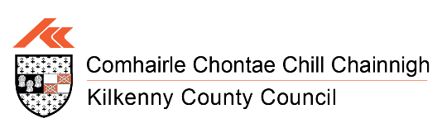
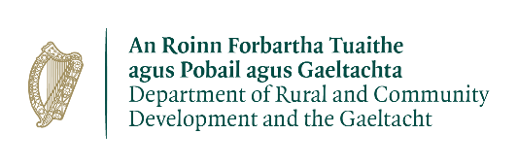

2026/27 Outdoor Recreation Infrastructure Scheme Call
Call for Expressions of Interests from the public
The Minister for Rural and Community Development and the Gaeltacht, Dara Calleary TD, has launched the 2026-2027 Outdoor Recreation Infrastructure Scheme (ORIS) with €20 million available for investment.
The Outdoor Recreation Infrastructure Scheme provides funding for the development and maintenance of new and existing outdoor recreational infrastructure in rural areas and will support hundreds of outdoor recreation projects nationwide.
Now in its tenth year, the scheme has to date invested over €150 million in over 2,000 recreation projects at our mountains, lakes, rivers, beaches, blue-ways, bogs, forest walks and upland areas.
Successful past projects funded by ORIS in County Kilkenny include:
- Woodstock Gardens & Arboretum – Inclusivity and Accessibility Enhancement Scheme
- Jenkinstown Wood Enhancement Scheme
- Lacken Boardwalk Replacement Scheme
- Kilkenny Countryside Park
- Silaire Wood, Graigenamanagh Walking Trail Extension
- Castlecomer Discovery Park Masterplan Plus Planning & Design for Free Activity Attractions
- Ennisnag Loop Walk - New 2km loop walk
- Millennium Forest - Trail Enhancement and Accessibility Scheme
A list of eligible activities is detailed below, however, it should be noted that this list is not exhaustive:-

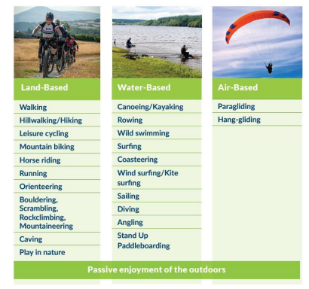
It does not include activities that take place outdoors on confined courses or pitches (such as Gaelic Games, golf, soccer, and show-jumping) or motorised activities (such as quads/scramblers). As a consequence, such activities are not eligible for funding under ORIS.
It is a requirement that the infrastructure funded under ORIS should be available free of charge to the public.
To find out more about ORIS including project eligibility see https://www.gov.ie/en/department-of-rural-and-community-development-and-the-gaeltacht/services/outdoor-recreation-infrastructure-scheme/
Kilkenny County Council makes applications for a number of projects throughout the county at each funding call.
Ahead of the submission of applications to the Department for 2026-2027, Kilkenny County Council is seeking Expressions of Interest from the public for suitable projects under all measures;

- Measure 1: Small Scale Repair/Maintenance/Development/Promotion and Marketing (Grant Amounts: Up to €40,000)
- Measure 2: Medium Scale Repair/ Maintenance/Upgrade and New Trail/Amenity Development (Grant Amounts: Up to €200,000)
- Measure 3: Strategic Large-Scale Repair/Upgrade and New Strategic Trail/Amenity Development (Grant amounts: Up to €500,000)
- Project Development Measure: Development costs for New Projects (Grant amounts: vary up to combined maximum of €100,000 per local authority)
Local authorities may also submit an additional application to support the predevelopment work required to develop equestrian trails/bridleways. This is with a view to increasing the number of these facilities in a targeted way.
Where a project requires planning permission, this must be in place in advance of an application being submitted.

Projects should be located mainly in the countryside and not in the environs of a town or village unless the proposed project is linking a town or village into the countryside.
If you have a potential project that you would like to propose for consideration, please submit an expression of interest to Kilkenny County Council Capital Delivery Office and Parks Department.
All expressions of interest must be submitted in WORD Format to mark.mcgarry@kilkennycoco.ie by 4.00p.m. on Friday the 14th of August 2026 to allow sufficient time for applications to be prepared and finalised.

