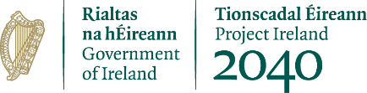 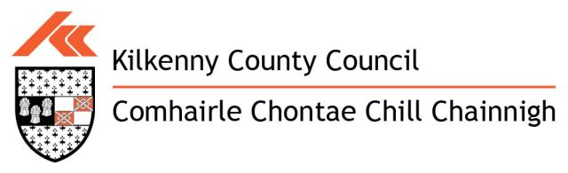 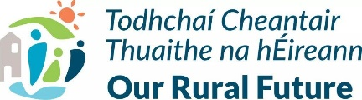

**KILKENNY COUNTY COUNCIL**

**CLÁR 2025 Scheme Outline**

CLÁR (Ceantair Laga Árd-Riachtanais) is a targeted investment programme for rural areas that aims to provide funding for small infrastructural projects in areas that have experienced significant levels of de-population. This funding assists in building the resilience of these rural communities. The CLÁR programme allocation has increased to €11 million nationally in 2025. The CLÁR 2025 programme will be delivered through 3 separate Measures as follows:

Measure 1. Developing Community Facilities & Amenities

Measure 2. Mobility, Cancer Care and Community First Responder and

Meals on Wheels Transport.

Measure 3. ‘Our Living Islands’

This Scheme outline refers to Measure 1: Developing Community Facilities & Amenities which are projects delivered via local authorities (LA’s).

**Measure 2 and Measure 3 is being administered through the Department of Rural & Community Development.**

Measure 1 will support a variety of capital interventions that contribute to the enhancement of existing, and/or the development of new, accessible Community Recreation Facilities. The list below provides an indication of the types of interventions that may be supported, but is not exhaustive:

* Small scale renovation works to community facilities open to the wider community such as community centres/sports centres/clubhouses of sporting groups/youth centres/men’s sheds etc. This includes external works such as parking and accessibility enhancements.
* Multi-Use Gaming Areas MUGAs)/Astro-Turf Facilities
* Skateboard Parks
* Playgrounds
* Handball Alleys
* Tennis Courts
* Basketball Courts
* Community Gyms/Community Cinemas
* Sensory/Community Gardens
* Outdoor Bowling areas
* Walking/Running Tracks
* Enhanced Outdoor Toilet and changing facilities
* Improving access at sports grounds e.g. development/upgrade of spectator stands at local sports grounds with a particular focus on improving access of all abilities and ages.

**Grant Funding and Rate of Aid**

A minimum grant of €5,000 and maximum grant of €65,000 will apply to this measure.

To facilitate projects of a slightly greater scale, Kilkenny County Council can submit 2 applications seeking grant funding of up to €100,000. Each local authority can submit the following:

• 13 applications seeking funding of between €5,000 and €65,000

• 2 applications seeking funding of between €5,000 and €100,000

The scheme will provide up to 90% of the cost. The remaining 10% or balance of the cost must be provided in cash through local authority/community/other resources. Philanthropic contributions will be accepted as full or part of match funding costs. This funding must be in place at the time of application.

**CLÁR Eligible Electoral Districts**

|  |  |  |  |
| --- | --- | --- | --- |
| **Coolaghmore** | **Tullahought** | **Jerpoint West** | **Balleen** |
| **Killamery** | **Attanagh** | **Listerlin** | **Ballyconra** |
| **Kilmaganny** | **Clogharinka** | **Tiscoffin** | **Baunmore** |
| **Kilmanagh** | **Kilmacar** | **Castlebanny** | **Clomantagh** |
| **Scotsborough** | **Mothell** | **Castlegannon** | **Galmoy** |
| **Boolyglass** | **Muckalee** | **Kilkeasy** | **Glashare** |
| **Muckalee** | **Brownsford** | **Pleberstown** | **Lisdowney** |
| **Tubbrid** | **Dysartmoon** | **Ullard** |  |

**Application Forms and further particulars may be downloaded from** [**www.kilkennycoco.ie**](http://www.kilkennycoco.ie) **or contact Alison McGrath, Community Section, Patrick’s Court, Kilkenny on Tel: 056-7794967.**

**Completed applications are to be sent to Kilkenny County Council’s Community Department, Patrick’s Court, Kilkenny, R95 N28F, Kilkenny by 4pm, Wednesday 28th May, 2025.**

All intended applicants should contact Alison McGrath, Kilkenny County Council 056-7794967 or Catherine Byrne-Murphy, Kilkenny County Council, 056-7794115 prior to the submission of their applications**.**