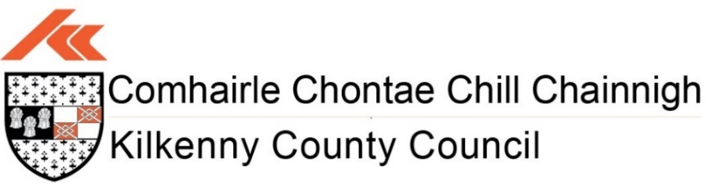

**Kilkenny County Council**

**Community Event Grant Scheme 2025**

**Application Form**

**Closing Date:**

Friday 14th February 2025 at 5:00pm

**Please return completed applications and supporting documentation**

**by post or email:**

**Post:** Diane Seale, Community and Culture, Kilkenny County Council,

Patricks Court, Patrick Street, Kilkenny, R95N28F

**Email:** [diane.seale@kilkennycoco.ie](mailto:diane.seale@kilkennycoco.ie)

**Any queries:**

Contact Diane Seale: 056 7794289 / diane.seale@kilkennycoco.ie

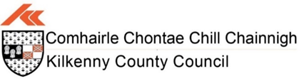

**Community Event Grant Scheme 2025**

**Guidelines**

**Purpose of the scheme:**

The main purpose of the Community Event Grants scheme is to provide financial assistance to community event organisers for the development, promotion and the running of small-scale community events organised by local not-for-profit voluntary groups. The types of events considered for this grant may include social inclusion events, promotion of healthy living or intercultural events that recognise and celebrate diversity.

**Guidelines:**

* All applications must be submitted before the closing date, late applications will not be accepted.
* Financial support can be applied for under this grant is from €100 up to a maximum of €1,000.
* Offers of funding may be for a lesser amount than that sought by the applicant, in circumstances where the scheme may be over subscribed.
* Small scale events are classed as those with expected attendance less than 2,500 people.
* The event must take place in 2025.
* No double funding from Kilkenny County Council is allowed.
* The scheme is not intended to support festivals that are of a fund-raising nature.
* The contact person and address listed on this form will be used for all correspondence with regards to this grant application.
* All funded events must take place within County Kilkenny.
* All groups should hold appropriate insurance cover for the event being held.
* Full compliance with Child Protection Policies is required for events involving children and young people (0-18yrs).
* Full compliance with event management and Health & Safety should be in place.
* The event organiser should ensure that they are fully compliant with General Data Protection Regulations (GDPR).
* The group must provide details of a bank account in its own name.
* Kilkenny County Council may publicly share information about all funded festival / events and include information about these projects in reports and publications.
* Only one application per event and per group will be considered.

**Examples of Eligible Projects**

* Field Days
* Horse Shows
* Agricultural Shows
* Vintage Rallies
* Historical Society Events
* Arts & Culture Events
* Community Events

**Ineligible Listings**

* Fundraising Events
* Festivals with attendance of more than 2,500 attendees
* St. Patricks Day Events
* Christmas Events
* Transport Costs to attend Events
* Annual Functions e.g. (Club Dinners, Christmas Dinners, Social Nights Out)

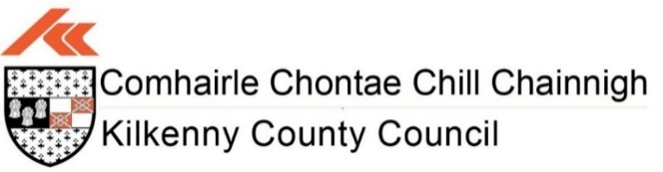

**Community Event Grant Scheme 2025**

**Application Form**

***PLEASE USE BLOCK LETTERS FOR HAND WRITTEN APPLICATIONS***

|  |  |
| --- | --- |
| Section 1: Contact Information for correspondence | |
| **Name:** |  |
| **Address:** |  |
| **Telephone Number:** |  |
| **Email Address: (*please include*)** |  |

|  |  |
| --- | --- |
| Section 2: Organisation and Event Details | |
| **Name of Organisation:** |  |
| **Position in the Organisation:** |  |
| **Brief Description of Organisation:** |  |
| **Are you a member of Kilkenny Public Participation Network (PPN)?** |  |
| **Name of Event:** |  |
| **Event Location:** |  |
| **Confirmed Date of Event:** |  |
| **Event Website: (*if applicable*)** |  |
| **Brief description of proposed event.** |  |
| **Describe how and why your proposed festival or event will benefit the local community.** |  |
| **Please outline how you intend to make your event Accessible and Socially Inclusive.** |  |
| **Describe how your proposed festival or event will promote Healthy Living & Cultural Awareness.** |  |
| **Who will be involved in the organising of the event?** |  |
| **What experience do you have in organising events?** |  |

***Note: Please attach the details of your proposed Event Programme***

|  |  |
| --- | --- |
| Section 3: Funding | |
| **Estimated overall cost of the Event?**  ***\*Please provide at least one quote.*** | € |
| **Amount of funding being requested from the scheme?** | € |
| **Are you applying for funding from any other sources?** | **YES NO** |
| **If yes, provide details of the source and amount.** | **Source:** |
| € |
| **If no, please indicate how you fund the balance of your costs.** | **Source:** |
| € |

***Note: No double funding from Kilkenny County Council is allowed***

|  |  |
| --- | --- |
| Section 4: Projected Costs | |
| Element of Work / Programme / Item *Please provide details of proposed costs associated with the project* | Cost |
|  | € |
|  | € |
|  | € |
|  | € |
|  | € |
|  | € |
|  | € |
|  | € |
|  | € |
|  | € |
| **Total Cost** | **€** |

|  |  |
| --- | --- |
| Section 5: Acknowledgement *Recognition must be given to Kilkenny County Council in any promotional material associated with the project. e.g. Promotional Materials, Signage and Social Media. (Kilkenny County Council Logo to be included).* | |
| **Please state how your organisation proposes to publicly acknowledge Kilkenny County Council’s Community Event Grant contribution?** |  |

|  |
| --- |
| Disclaimer |
| Kilkenny County Council will not be liable in respect of any loss, damage or costs of any nature arising directly or indirectly from this application or the subject matter of the application.  **Data Protection**  Kilkenny County Council collects some personal data during the application and processing of this grant scheme, particularly, names, addresses and contact details (emails and telephone numbers). These details are necessary for the consideration and adjudication on the grants scheme. The grant applications are sometimes shared between relevant County Council Departments for the purpose of supporting the application and also to ensure that similar events are not double funded, and in relation to other festival/events funded by the Council. At all stages the personal data is handled in full accordance with the Data Protection Legislation. Your express consent is required, acknowledging that you understand that you may be submitting personal data.  I/we have read and agree with the above terms and conditions.  **Signed:** __________________________________ **Date:** ________________ |

|  |
| --- |
| **Checklist** |
| * Completed Application Form * Copy of Bank Account Statement Header for the Group/Organisation |

|  |
| --- |
| **Declaration** |
| * I confirm that the information given on this form is accurate and correct. * I confirm I have read and fully understand the guidelines for the ‘Community Event Grant 2025’   **Signed:** __________________________________ **Date:** ________________ |

|  |  |  |
| --- | --- | --- |
| Assessment Criteria: *(For office use only)* | | |
| No. | Assessment Criteria | Scoring |
| **1.** | Community Participation & Benefit | **MAX – 30** |
| **2.** | Evidence of Social Inclusion | **MAX – 30** |
| **3.** | Promoting Healthy Living & Cultural Awareness | **MAX – 20** |
| **4.** | Deliverables e.g.   * Group Track Record * Capacity & Ability to Deliver | **MAX – 20** |

**Closing Date for Applications: Friday 14th February 2025 at 5:00pm**

**Please return completed applications and supporting documentation by post or email:**

**Post:** Diane Seale, Community and Culture, Kilkenny County Council,

Patricks Court, Patrick Street, Kilkenny, R95N28F

**Email:** [diane.seale@kilkennycoco.ie](mailto:diane.seale@kilkennycoco.ie)

**Any queries:**

Contact Diane Seale: 056 7794289 / [diane.seale@kilkennycoco.ie](mailto:diane.seale@kilkennycoco.ie)