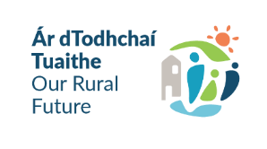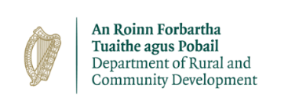****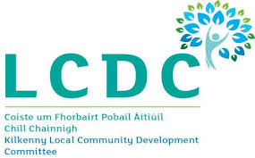



**Kilkenny Local Community Development Committee**

**Local Enhancement Programme 2025**

**Open for Applications**

The **Local Enhancement Programme (LEP)** provides funding to support community groups across Ireland.

The **LEP**  is funded by the Department of Rural and Community Development and administered by the Local Community Development Committees (LCDCs) in each Local Authority area.

**Who is eligible for funding-** Locally based community and voluntary groups in urban and rural areas and not-for-profit organisations.

The following provides examples (non-exhaustive list) of the type of **projects** that may receive funding under the programme:

* Development/renovation of community centres
* Development of youth clubs or facilities
* Development of sports or play/recreation facilities
* Improvements to town parks and common areas and spaces
* Public Realm Improvements
* Purchase of equipment
* Maintenance of premises, including painting and repairs
* Capital work to increase biodiversity, or to reduce the carbon footprint of a facility
* Energy Costs (electricity costs, refuse charges, heating charges) – current funding only
* Operating Costs (existing rental/lease costs, insurance bills) – current funding only
* Only operating/running costs for the 1st June 2024 to 30th May 2025 are eligible.

**How to apply**? Application Forms& Guidelines are available for download from Kilkenny County Council website [www.kilkennycoco.ie](http://www.kilkennycoco.ie) or by **Email:** [communitygrants@kilkennycoco.ie](mailto:communitygrants@kilkennycoco.ie)

**The closing date for receipt of valid applications is Friday 14th February 2025 at 12.00 noon**