 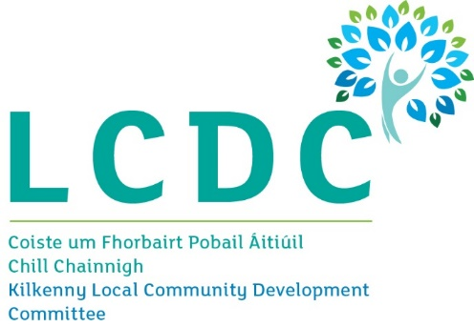

**Help us shape a plan for your future**

Kilkenny County Council and the Kilkenny Local Community Development Committee want you to tell us about the opportunities, and challenges you face, across the county that affect your lives. To inform the next Local Economic and Community Plan (LECP) for the county we want you to share with us your vision for Kilkenny, and feedback on our proposed goals and objectives, and help us establish the key outcomes we will deliver across 10 key areas:

* Climate & Sustainability
* Supporting Businesses
* Culture, Heritage & Tourism
* Rural Economy
* Education & Skills
* Attracting Graduates
* Health Inequalities
* Community Development
* Social Investment
* Housing

**What is the Kilkenny LECP?**

Kilkenny County Council and the Kilkenny Local Community Development Committee has begun the process of preparing a new Local Economic and Community Plan (LECP). This Plan will build upon and replace the previous Plan, which covered the period 2016 – 2021.

The new LECP will set out, for the period 2023 – 2028, the objectives and actions we believe are needed to promote and support the economic and local community development of County Kilkenny.

As part of the first step to inform our new plan Kilkenny County Council have prepared a draft [**Socio-Economic Statement**](https://www.yourkilkennylecp.ie/downloads/kilkenny-socio-economic-statement.pdf). <https://www.yourkilkennylecp.ie/>

As part of our community consultation, we would like to hear your views on our 10 draft high level goals and the sustainable community and economic objectives set out within it, alongside your desired outcomes and vision for Kilkenny.

**Why are we Consulting?**

In order to ensure that the LECP is as reflective of the needs and desires of the local community, citizens and businesses of Kilkenny, its vital that we understand your priorities in order to reflect them into the final plan.

**How can I get involved?**

**Take our citizen survey**

Please click the link above to be redirected to the LECP survey page. This survey will take approximately 10-15 minutes to complete and will close on **Friday 23rd September 2022.**

**The Draft Socio Economic Statement and Draft High Level Goals are also available for public viewing at the following locations:**

|  |  |  |
| --- | --- | --- |
| **Location** | **Address** | **Opening times** |
| County Hall | John Street, Kilkenny, R95 A39T | Monday to Friday 9am-1pm & 2pm-5pm |
| Municipal District Office Castlecomer | Kilkenny Street, Castlecomer, Co. Kilkenny, R95 KW93 | Monday to Friday 9am-1pm & 2pm-5pm |
| Municipal District Office Thomastown | Ladyswell, Thomastown, Co. Kilkenny, R95 TX68 | Monday to Friday 9am-1pm & 2pm-5pm |
| Municipal District Office Callan | Clonmel Road, Callan, Co. Kilkenny, R95 RK06 | Monday to Friday 9am-1pm & 2pm-5pm |
| Municipal District Office Ferrybank | Ferrybank Shopping Centre, Ferrybank, Waterford, X91 DE42 | Monday to Friday 9am-1pm & 2pm-5pm |
| Graignamanagh Library | Convent Road, Graignamanagh, Co. Kilkenny R95 V342 | Tuesday 10am-8pm, Wednesday to Friday 10am-5pm & Saturday 10am-1:30pm |
| Urlingford Library | The Courthouse, Urlingford, Co. Kilkenny, E41 A2X4 | Tuesday 10am-8pm, Thursday 10am-5pm, Friday & Saturday 10am-1:30pm |

**Alternatively written submissions may be sent to the following address:**

LECP Consultation,

Community Section,

John’s Green House,

Kilkenny

R95 CX92

Closing date for receipt of submissions Friday, 23rd September, 2022

**Attend a virtual workshop**

During the month of October we will be holding three virtual workshops, one for municipal districts in the county, as follows.

* [**Castlecomer (virtual event) – Friday 7th October, 19:00-21:00**](https://us02web.zoom.us/meeting/register/tZckdemorjIpHtGUEQT8DUbIwib61WE7PYHN)
* [**Callan-Thomastown (virtual event) – Monday 10th October, 19:00-21:00**](https://us02web.zoom.us/meeting/register/tZUrcOGqrDkpHtcgH12lPT6KOEBrxSlPexZT)
* [**Piltown (virtual event) – Wednesday 12th October, 19:00-21:00**](https://us02web.zoom.us/meeting/register/tZwuce2trT4jGt0zDloYcxGuNZTZOkrQNivo)

**Attend an in-person event**

Or register to attend our public workshop in Kilkenny City

* **Kilkenny City – Springhill Court Hotel, Waterford Road, Kilkenny, R95 NX32 - Wednesday 5th October, 19:00-21:00**

You must pre-register for attendance. To register for the event for your area click the link: <https://www.yourkilkennylecp.ie/>