 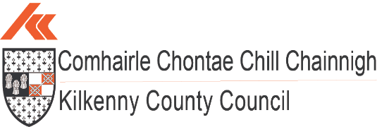

***Quarter 2 2023 Economic Report***



**Population:**

**(source: CSO.ie – Census 2022)**

The National population of Ireland now stands at **5,149,139**, up 8.1% or 387,274 from 2016. This is the first time that a census has recorded a population of greater than 5 million since 1851.

Natural increase made up 3.5%, with net migration making up 4.6%

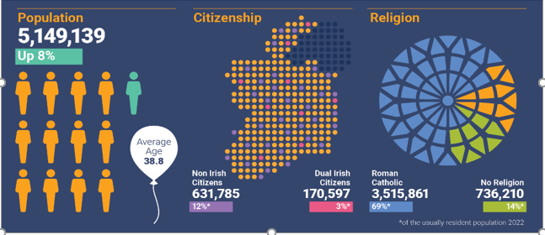

The population of County Kilkenny is now **104,160,** up 5% from 2016.

The 5% increase in Kilkenny County represents one of the lowest population increases in Ireland – tied at 5% with Donegal and Tipperary. The highest percentage population increase took place in Longford, where the population increased by 14% since 2016.

The population of Kilkenny City rose is now **27,184**, up 2.5% between 2016 and 2022.

Within the South East, Kilkenny City is 3rd in the ranking of urban centres by population with the top four in the below order:

1. Waterford City at 60,079;
2. Carlow Town at 27,351;
3. Kilkenny City at 27,184;
4. Wexford Town at 21,524

Nationally, Kilkenny is 13th in the CSO 2022 ranking of Ireland’s largest urban centres, as measured by population.

The average age of Kilkenny’s population in 2022 was 39.7 years, compared with 37.9 years in 2016.

Nationally, the average age of the population was 38.8, up from 37.4 in 2016.

The number of people aged 65 and over continues to grow. This age group increased by 21% to 17,056 in Kilkenny, and by 22% to 776,315 at a national level since 2016.



**Housing:**

**(sources: CSO.ie, Daft.ie Q2 2023)**

According to the latest Daft.ie House Price Report for Quarter 2, 2023 the average asking price in County Kilkenny for a house is **€283,177** – 8.5% lower than the national average of **€309,648** and 25% lower than in Dublin City Centre where the average asking price is **€377,543**.

## **Median Asking Prices**

|  |  |  |  |
| --- | --- | --- | --- |
| **Location** | **2 Bed Apartment** | **3 Bed Semi-D** | **4 Bed Semi-D** |
| **Kilkenny** | €175,000 | €222,500 | €300,000 |
| **Dublin** | €275,000 | €375,000 | €530,000 |

There are currently **285** residential properties for sale across County Kilkenny, with **70**, or 24% located in Kilkenny City (daft.ie)

## **Comparative Rent Prices**

While rents nationally have increased by 10.7% year on year, the cost of rental accommodation in Kilkenny is comparatively more affordable.

The average cost of rental accommodation in Kilkenny at **€1,363** (across all property types) is 24% lower than the national average of **€1,792** and 41% lower than the average rent in Dublin City Centre at **€2,307**.

There are currently 5 properties for rent in County Kilkenny, with no properties advertised in Kilkenny city. (daft.ie)

|  |  |
| --- | --- |
| **Location** | **Average Rental Prices across all House Types** |
| **National Average** | €1,792 |
| **Dublin City Centre** | €2,307 |
| **Kilkenny** | €1,363 |

**House Ownership in Kilkenny**

**(source: CSO.ie – Census 2022)**

In 2022, in Kilkenny, 72% of households owned their own home, with a further 23% renting. This

compared with 66% of households owning their home nationally and 28% renting.

**National Housing Ownership and Rental Snapshot Census 2022:**

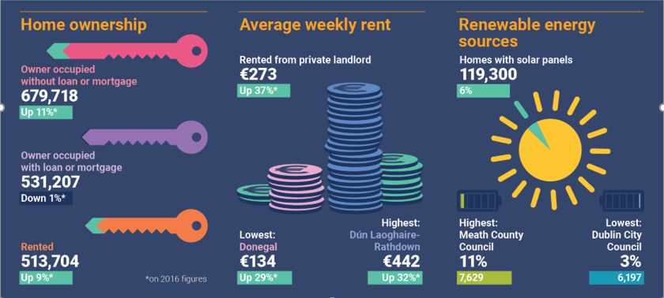

**Housing stock and vacant dwellings statistics:**

**(source: CSO.ie – Census 2022)**

The total housing stock in Kilkenny County in 2022 was 41,279, up 5.2% from 39,226 in 2016.

The number of vacant dwellings in 2022 was 3,183, up 6.3% from 2,995 in 2016.

The vacancy rate in 2022 was **7.7%,** up from **7.6%** in 2016.

**Planning:**

**(from KCC Q2 Housing report – planning)**

## **Current Developments - Multi-Unit Developments with Planning APPROVAL**

As of the beginning of July 2023, there are a total of 49 multi-unit housing developments with live planning permissions secured within Kilkenny City. Some of these have already been built out. Within these schemes there are 2,298 permitted housing units.

22 housing schemes are either active or built out in the City with valid commencement notices for 675 units.

|  |  |  |
| --- | --- | --- |
| **31st March 2023** | **Kilkenny City** | **Commencement Notices** |
| **Number of Schemes** | 49 | 22 |
| **Number of Units** | 2,298 | 675 |

As of the beginning of July 2023, within Ferrybank and the larger county towns (i.e., towns with a population of over 1,500 such as Callan, Thomstown, Graiguenamanagh, Castlecomer and Rosbercon) a total of 25 multi-unit housing developments have planning permission.

Within these schemes there are permissions for 575 housing units. 13 housing schemes are active or built out with valid commencement notices for 261 units.

|  |  |  |
| --- | --- | --- |
| **31st March 2023** | **Ferrybank and District Towns** | **Commencement Notices** |
| **Number of Schemes** | 25 | 13 |
| **Number of Units** | 575 | 261 |

Within the wider county there are 32 multi-unit housing developments with planning permission. Within these schemes there are 278 permitted housing units.

13 housing schemes are active / built out with valid commencement notices for 72 units.

|  |  |  |
| --- | --- | --- |
| **31st March 2023** | **Wider County** | **Commencement Notices** |
| **Number of Schemes** | 32 | 13 |
| **Number of Units** | 278 | 72 |

In total within the City and County there are 106 multi-unit housing developments with planning permission secured. Within these schemes there are 3,151 permitted housing units.

48 housing schemes are active with valid commencement notices for 1,008 units.

|  |  |  |
| --- | --- | --- |
| **31st December 2022** | **City and County** | **Commencement Notices** |
| **Number of Schemes** | 106 | 48 |
| **Number of Units** | 3,151 | 1,008 |

In addition to the above granted permissions there are currently 24 multi-unit development applications in the Kilkenny County Council Planning system which are yet to be determined. These could potentially yield a further 532 units for the county. 161 are in the City, 295 are located in the Local Area Plan towns, and 76 are in smaller villages / settlements of the county.



**Working in Kilkenny:**

**(source: cso.ie – Census 2022)**

The Labour force participation rate in Kilkenny among people aged 15 and over was just over **60%** in 2022.

There were 46,196 people (aged 15 and over) at work in Kilkenny in 2022, an increase of 4,833 or **12%** from 2022.

Nationally, there was an increase of **16%** from 2016.

In Kilkenny, 12,906 people (aged 15 and over) worked from home at least one day a week in 2022. This represented 28% of the workforce. The national figure was 32%.

**Monthly Unemployment:**

**(source: cso.ie)**

The seasonally adjusted monthly unemployment rate Nationally in July 2023 was **4.1%.**

The absolute number of people on the live register in Kilkenny in July was **2,853** - in July 2023, Kilkenny was one of only six counties with less than 3,000 on the Live Register.



**Business Demography:**

(sources: EI, IDA and BDS)

IDA year end 2022 reported the highest Foreign Direct Investment (FDI) employment level ever and a 9% increase on 2021 with 301,475 people directly employed in the multinational sector in Ireland.

24,019 jobs were created in FDI employment, with 242 investments won – 103 of them new name investments.

52% of investments won went to regional locations – with employment growth in every region of the country.

The total number of people employed in IDA companies in the South East at the end of 2022 was 15,520, a 3% increase on 2021.

In July 2023, IDA Ireland reported steady investment growth in the first half of 2023 with 139 investments won - 52 of which were new name or first-time investments.

48% of these investments went to regional locations.

218,178 people were employed in Enterprise Ireland companies at the end of 2022, with client companies creating 19,660 jobs demonstrating growth of 5% on 2021.

Sectors such as Climate, Sustainability and Agritech saw an increase in employment of 13% and Digital Technology saw an increase of 9% in employment.

**Snapshot of Growth across Industries – EI companies:**

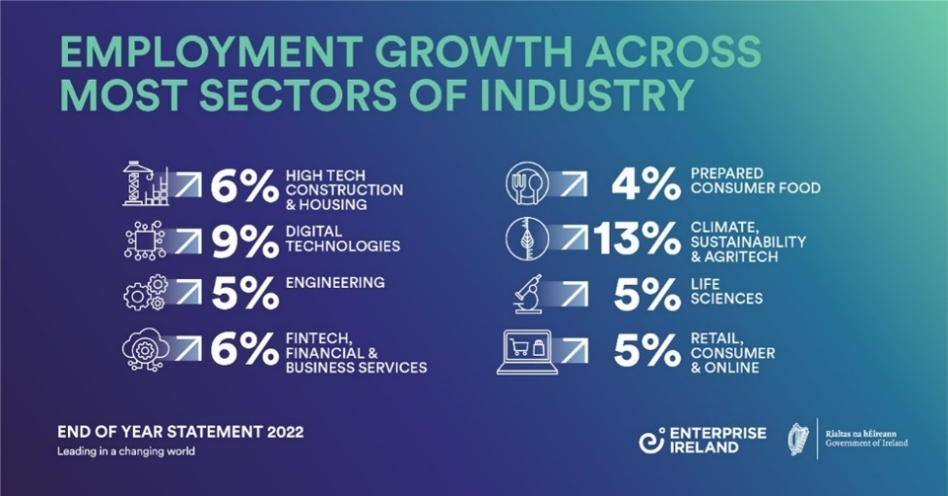

This trend continued in the regional spread of job creation, with 68% of the jobs created being based outside of Dublin.

**Snapshot of growth in the regions – EI companies – South East in line with Dublin and higher than most other regions:**

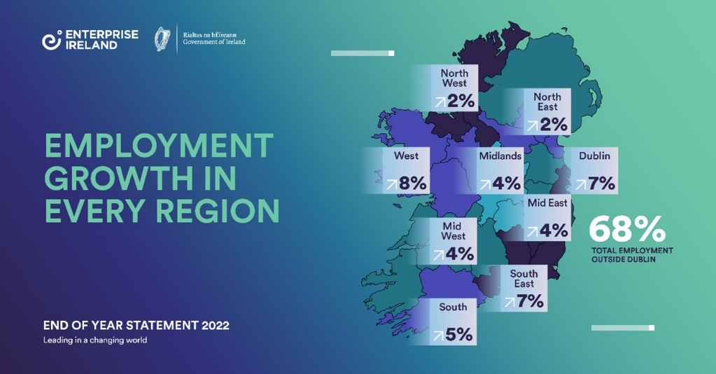

**Kilkenny Business Demography:**

**(source: cso.ie)**

There were 9 businesses in Kilkenny County in 2021 with 250 and over employees;

449 businesses in Kilkenny County with between 10 and 250 employees;

And 5,701 businesses in Kilkenny County with less than 10 employees

**Kilkenny Local Enterprise Office Demography:**

**(source: LEO Kilkenny)**

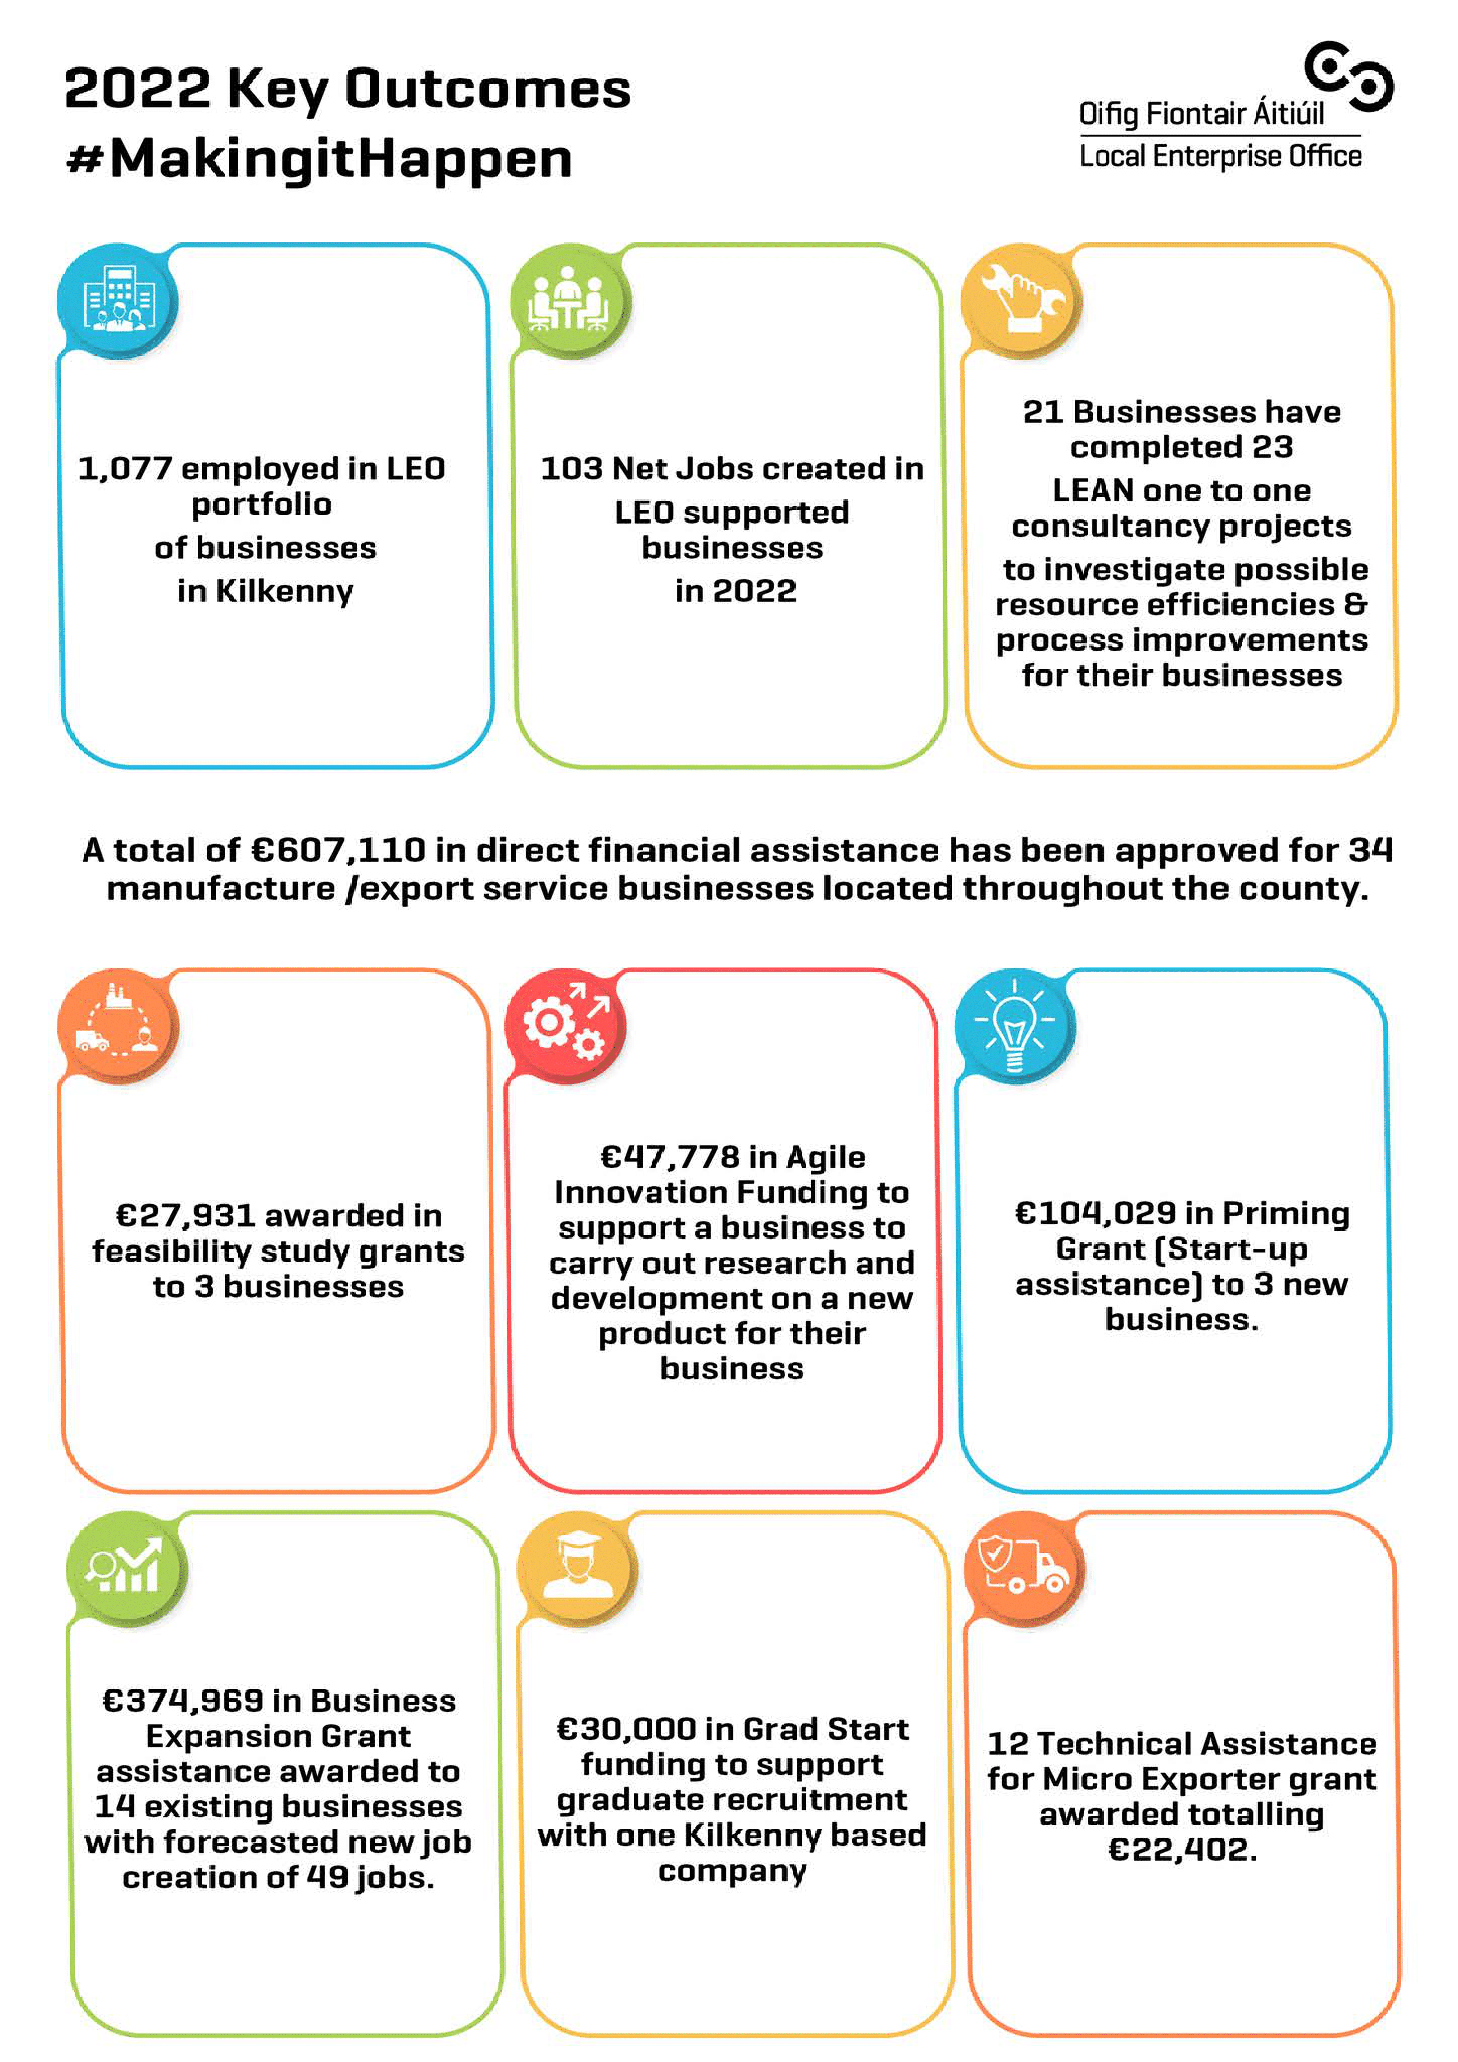

**Third Level Education:**

There were 4,620 students from Kilkenny County enrolled in a 3rd level institution in the academic year 2021/2022.

Of these 4,610 students, 32% or 1,484 were enrolled in a course in SETU.

Approximately 1,300 students completed their Leaving Certificate in 2022, of which 877 or 67% wend on to enroll in 3rd level education.

The most popular areas of study in SETU for students were Business and Administration, and Health and Welfare.

**Enterprise and Economic Development news Q2/Q3 2023:**

* Monday June 12th 2023, saw the launch of a new Framework document, the Local Economic and Community Plan 2023 to 2028 for Kilkenny in a joint initiative by Kilkenny County Council and the LCDC.



* Minister of State for Business, Employment and Retail, Neale Richmond TD visited the Local Enterprise Office Kilkenny (LEO) on Friday, July 7th where he met with council officials, members of the LEO team as well as some of their client Businesses.

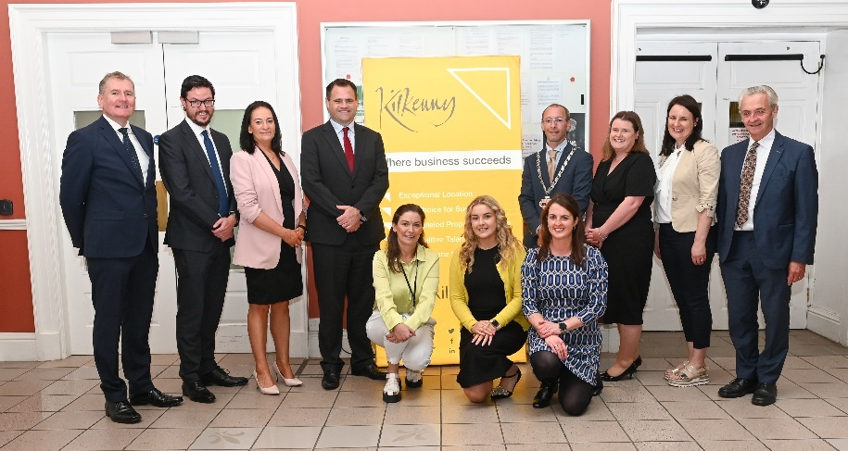

* Kilkenny Local Enterprise Office is holding a Going Green Showcase in Hotel Kilkenny on 14th September 2023 – a Showcase of all Agencies & Energy Supports.

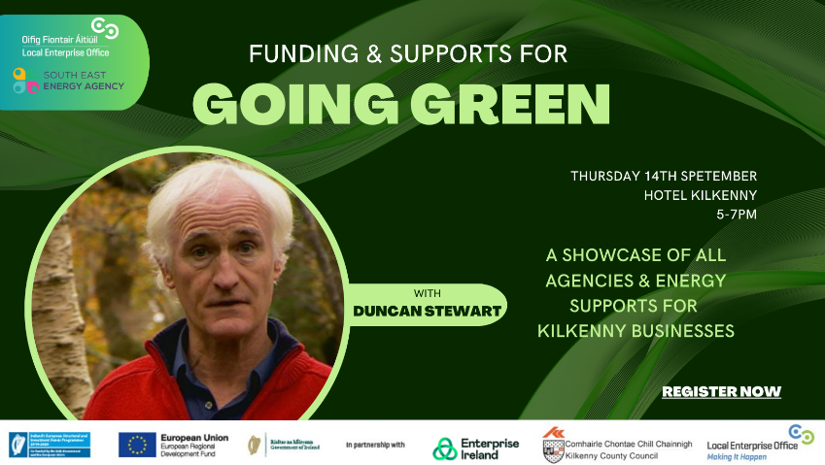

* Kilkenny County Council is hosting an Industry Breakfast event “Full Forward Kilkenny” in the Newpark Hotel on 19th September with a guest speaker from Abbott Group outlining recruitment strategies and evolving needs in the coming year.



* Work is nearing completion on Kilkenny’s first Carbon Neutral building in Loughboy. State Street Intl expect to move to their new in Q4 2023.

* Construction work on The Mayfair library in the Abbey Quarter site is expected to finish in Q3 2023, with the library fit out to be completed by the end of the year.



* Kilkenny City received an allocation of 6 million Eur under URDF Call 3 to tackle targeted vacant or derelict Town Centre properties.
* Kilkenny’s remote working hubs are being highlighted in a media campaign regionally and nationally to promote usage throughout September and October 2023.



* Kilkenny Local Enterprise Office is running an annual National Women’s Enterprise Day event on 19th October in the Parade Tower of Kilkenny Castle to promote, encourage and stimulate female entrepreneurship across Ireland.

