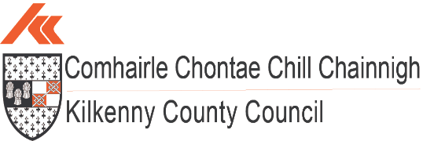 

***Quarter 2 2025 Economic Report***



**Population:**

**(source: CSO.ie – Census 2022)**

Census 2022 recorded the National population of Ireland as being **5,149,139**, up 8.1% or 387,274 from 2016. Census 2022 was the first to record a population of greater than 5 million since 1851.

Natural increase made up 3.5%, with the 4.6% balance being attributed net migration.

(cso.ie visual)

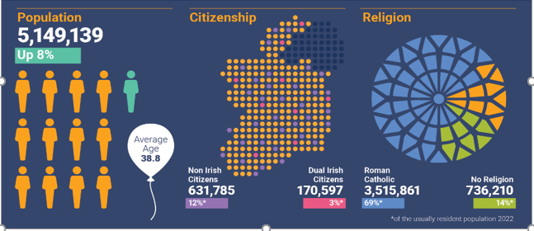

Census 2022 showed that the population of Kilkenny grew to **104,160,** up 5% from 2016. The 5% increase in Kilkenny County represented one of the lowest population increases in Ireland – tied at 5% with Donegal and Tipperary. The highest percentage population increase took place in Longford, where the population increased by 14% since 2016.

The population of Kilkenny City was **27,184** in April 2022, up 2.5% from 2016, placing it 3rd in the ranking of urban centres in the South East in terms of population as set out below.

1. Waterford City at 60,079;
2. Carlow Town at 27,351;
3. Kilkenny City at 27,184;
4. Wexford Town at 21,524

Nationally, Kilkenny is 13th in the CSO 2022 ranking of Ireland’s largest urban centres, as measured by population.

The average age of Kilkenny’s population in 2022 was 39.7 years, compared with 37.9 years in 2016.

Nationally, the average age of the population was 38.8, up from 37.4 in 2016.

The number of people aged 65 and over increased by 21% to 17,056 in Kilkenny and by 22% to 776,315 at a national level between 2016 and 2022.



**Housing:**

**(sources: Daft.ie housing report Q2 2025)**

According to the latest Daft.ie House Price Report for Quarter 2 2025 the average asking price in County Kilkenny for a house is **€330,683** - 7.6% lower than the national average of **€357,851.** On average, list prices nationally in the first quarter of 2025 were 12.3% higher than the same period a year earlier.

Prices rose by an average of 3 per cent across Ireland during the second quarter of the year. The current rate of inflation is the highest in 10 years.

The total number of second-hand homes available to buy on June 1st was over 12,000, which is up from less than 9,300 on March 1st.

## **Average Asking Price (+ annual change)**

|  |  |  |  |
| --- | --- | --- | --- |
| **Location** | **1 Bed Apartment** | **3 Bed Semi-D** | **4 Bed Bungalow** |
| **Co. Kilkenny** | €130,000 (+26.9%) | €224,000 (10.7%) | €453,000 (+15.2%) |
| **Waterford City** | €134,000 (+33.4%) | €231,000 (+13.5%) | €424,000 (+20.3%) |
| **Co. Carlow** | €116,000 (+25.3%) | €200,000 (+9.3%) | €404,000 (+13.7%) |
| **Cork City** | €179,000 (+25.5%) | €309,000 (+6.9%) | €566,000 (13.2%) |

There are currently **239** residential properties for sale across County Kilkenny, with **70** located in Kilkenny City *(Source: daft.ie Aug 2025)*

## **Comparative Rent Prices**

Rents increased again by a further 1.6% and rents are now on average 6.9% higher than a year ago.

Nationally, average listed rent prices have increased 6.9% year-on-year at the end of Q2 2025.

Countrywide, market rents rose by an average of 1.6% in the second quarter of 2025. This is down from 3.4% Last quarter. It is the eighteenth consecutive quarterly increase in rents in a run stretching back to the start of 2021. *(Daft.ie)*

The total number of properties available to rent on August 1st was just under 2,300, down 15% on the same date a year ago and the fourth consecutive quarter of falling availability.

In Kilkenny, rents were up 9.5% year-on-year at the end of Q2 2025.

The average cost of rental accommodation in Kilkenny at **€1,691** (across all property types) is 18% lower than the national average of **€2,055** and 32% lower than the average rent in Dublin City Centre at **€2,508.**

There are currently 19 properties listed for rent in County Kilkenny, and 4 properties listed for rent in Kilkenny City. *(Daft.ie Aug 2025)*

|  |  |
| --- | --- |
| **Location** | **Average Rental Prices Across All Property Types** |
| **National Average** | **€2,055** |
| **Dublin City Centre** | **€2,508** |
| **Kilkenny** | **€1,691** |

**House Ownership in Kilkenny**

**(source: CSO.ie – Census 2022)**

In 2022, in Kilkenny 72% of households owned their own home, with a further 23% renting. This compared with 66% of households owning their home nationally and 28% renting.

Figures released by the CSO show that in total, 509 new homes were built in Kilkenny in 2024 of which 322 were located in Kilkenny City and Environs.

|  |  |  |  |  |
| --- | --- | --- | --- | --- |
| Statistic Label | Year | Local Electoral Area | UNIT | VALUE |
| New Dwelling Completions | 2024 | Castlecomer, Kilkenny | Number | 70 |
| New Dwelling Completions | 2024 | Kilkenny, Kilkenny | Number | 322 |
| New Dwelling Completions | 2024 | Piltown, Kilkenny | Number | 51 |
| New Dwelling Completions | 2024 | Callan-Thomastown, Kilkenny | Number | 66 |
|  |  |  |  | 509 |

[*https://data.cso.ie/table/NDA05*](https://data.cso.ie/table/NDA05) *– to create this table below.*

**National Housing Ownership and Rental Snapshot Census 2022 (cso.ie visual):**

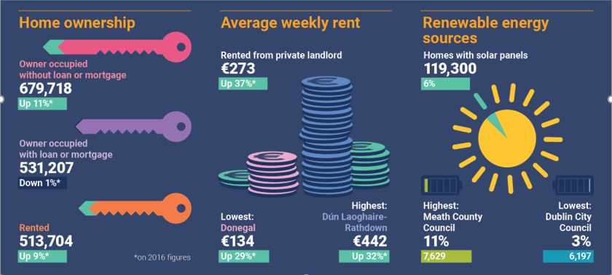

**Housing stock and vacant dwellings statistics:**

**(source: CSO.ie – Census 2022)**

Between April 2016 and April 2022, housing stock in county Kilkenny grew by 5% from 39,226 to 40,996. The number of vacant dwellings increased by 5% from 2,995 to 3,140. Many properties classed as vacant in the census may only be vacant for a short period of time and for a wide variety of reasons including homes for sale or rent, new build or renovation, etc. However, there were more than 857 dwellings classed as vacant both in the 2016 and 2022 censuses in Kilkenny, which could be an indication of a longer-term vacancy status.

**Vacant Property Refurbishment Grant:**

The latest figures for the Vacant Property Refurbishment Grant, up to December 31st 2024, show that almost €1.2 million has been paid out for vacant property grants in Kilkenny since the [scheme's launch](https://www.kilkennypeople.ie/news/property/1325265/huge-interest-in-vacant-homes-refurbishment-grant-in-kilkenny.html), with 22 homes brought back into use so far.

Nationally, over €77 million has been paid out in relation to the refurbishment of 1,449 homes nationwide.

Overall, since the launch of the grant in July 2022, in Kilkenny there have been 249 applications, 165 approvals and 22 grants issued up to December 31, 2024.

*Source: gov.ie*



**Working in Kilkenny:**

**(source: cso.ie – Census 2022)**

The Labour force participation rate in Kilkenny among people aged 15 and over was **60%** in 2022.

There were 46,196 people (aged 15 and over) at work in Kilkenny in 2022, an increase of 4,833 or **12%** from2016.

Nationally, there was an increase of **16%** from 2016.

In Kilkenny, 12,906 people (aged 15 and over) worked from home at least one day a week in 2022. This represented 28% of the workforce. The national figure was 32%.

**Monthly Unemployment:**

**(source: cso.ie)**

The seasonally adjusted Live Register total for July 2025 was 169,600 people (4.9%), 4.1% from April 2025

On an annual basis, the unemployment rate of 4.9% was down from a rate of 4.5% in July 2024.

In terms of age, the youth unemployment rate (for people aged 15-24 years) was 11.4% in April 2025, a slight decrease since last quarter.

The 25-34 years age group made up the largest number of those on the Live Register in July 2025 at 44,446 people or 23.9% of the total

The unadjusted Live Register total stood at 185,627 people for July 2025, of which 52% were male and 73% were Irish.

There were 3,372 people on the live register in Kilkenny in July 2025.



**Kilkenny Business Demography:**

**(source: cso.ie)**

There were 9 businesses in Kilkenny County in 2024 with 250 and over employees;

460 businesses in Kilkenny County with between 10 and 250 employees;

And 5,820 businesses in Kilkenny County with less than 10 employees.

**Third Level Education:**

**(source: HEA.ie & cso.ie)**

There were 4,570 students from Kilkenny County enrolled in a 3rd level institution in the academic year 2023/2024.

Approximately 1,200 students completed their Leaving Certificate in County Kilkenny in 2023, of which 890 or 75% went on to enroll in 3rd level education in 2023/2024.

The total number of students enrolled in SETU dropped 10.54% from 17,835 to 15,955 between the academic year 2021/2022 and 2022/2023, and a further 2.1% to the academic year 2023/2024.

The most popular areas of study in SETU for students were Business, Administration and Law, followed by Health and Welfare, and thirdly Engineering, Manufacturing and Construction.

These three broad fields of study made up almost 60% of all enrollments in SETU.

The overall enrollment numbers across higher education institutions in Ireland remained static for the period between 2022/2023 and 2023/2024.

**Enterprise and Economic Development news Q2 2025:**





A new affordable housing scheme has been launched for Kilmacow, Co. Kilkenny. A

total of thirteen 3-bedroom homes will be made available for purchase with support

of the Local Authority Affordable Purchase Scheme. These A-rated homes are

available for purchase by successful applicants at a price lower than its market

value.





Kilkenny has been selected to receive funding as part of Fáilte Ireland’s Home of

Halloween pilot scheme. The initiative aims to position Ireland as the global home of

Halloween, with €2.1 million invested across seven locations through to 2028,

boosting tourism and local heritage with events taking place throughout the month

of October and into November