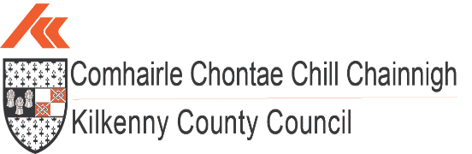

Quarter 4 2025 Economic Report
Population:
(source: CSO.ie – Census 2022)
Census 2022 recorded the National population of Ireland as being 5,149,139, up 8.1% or 387,274 from 2016. Census 2022 was the first to record a population of greater than 5 million since 1851.
Natural increase made up 3.5%, with the 4.6% balance being attributed net migration.

(cso.ie visual)
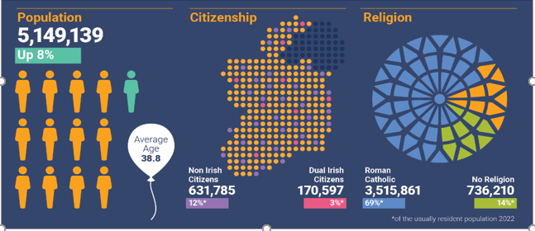

Census 2022 showed that the population of Kilkenny grew to 104,160, up 5% from 2016. The 5% increase in Kilkenny County represented one of the lowest population increases in Ireland – tied at 5% with Donegal and Tipperary. The highest percentage population increase took place in Longford, where the population increased by 14% since 2016.

The population of Kilkenny City was 27,184 in April 2022, up 2.5% from 2016, placing it 3rd in the ranking of urban centres in the South East in terms of population as set out below.

- Waterford City at 60,079;
- Carlow Town at 27,351;
- Kilkenny City at 27,184;
- Wexford Town at 21,524
Nationally, Kilkenny is 13th in the CSO 2022 ranking of Ireland’s largest urban centres, as measured by population.
The average age of Kilkenny’s population in 2022 was 39.7 years, compared with 37.9 years in 2016.
Nationally, the average age of the population was 38.8, up from 37.4 in 2016.
The number of people aged 65 and over increased by 21% to 17,056 in Kilkenny and by 22% to 776,315 at a national level between 2016 and 2022.

Housing:
(sources: MyHome.ie housing report Q4 2025)
According to the latest MyHome.ie House Price Report for Quarter 4 2025 the estimated median asking price for a house in County Kilkenny is €250,000. The national median in Q4 was €380,000, while the median in Dublin was €475,000.
The report shows momentum in Irish house prices softening somewhat. National asking prices were almost flat in Q4, up just 0.1%, with the annual rate of asking-price inflation slowing to 5.4%. Inflation is now 5.4% in Dublin and 5.5% in the rest of Ireland.
While most counties continue to see price increases, Kilkenny was one of only three counties nationally to see a fall in prices, down €5,000 since last quarter.
The total number of homes available to buy in December 2025 was around 12,200, up around 7% from the same time the previous year.

Asking Price (+ annual change)

Median Asking Prices — Q4 2025 (MyHome.ie)
Location | Median Asking Price | Year-on-Year Change
Co. Kilkenny | €250,000 | –1.96%
Co. Carlow | €250,000 | –2.91%
Co. Waterford | €232,500 | +3.33%
Waterford City | €190,000 | +2.7%
Cork City | €350,000 | +7.7%
There are currently 187 residential properties for sale across County Kilkenny (up from 153 in Q3), with 52 located in Kilkenny City (similar amount to the 46 in Q3)
(Source: daft.ie January 2026)

Comparative Rent Prices
Nationally, rents continued to rise, with the most recent Q3 2025 Daft data showing a 4.3% year-on-year increase in average listed rents.
Across the country, market rents rose steadily through 2025, with annual open-market rent inflation of 4.3%, broadly in line with increases recorded in the previous two years. This reflects an ongoing pattern of quarterly growth amid persistently tight rental supply.
Rental availability remains at historically low levels. On 1 November 2025, there were just under 1,900 properties available to rent nationwide — a decline of 21% compared with the same date one year earlier.
In Kilkenny, Daft’s most recent official data (Q2 2025) indicated rents were up 9.5% year-on-year. (No newer Daft rental data is available at the time of reporting.)
A local analysis of all Kilkenny properties advertised for rent at the end of January 2026 shows an average monthly rent of €1,750 across all property types (self-calculated). This remains significantly lower than the national average rent of approximately €2,080 per month based on Daft’s latest Q3 2025 figures, and substantially below average rents in Dublin City Centre, which stand at €2,575 per month.
Location | Average Rental Prices Across All Property Types
National Average | €2,080
Dublin City Centre | €2,575
Kilkenny | €1,750

House Ownership in Kilkenny
(source: CSO.ie – Census 2022)
In 2022, in Kilkenny 72% of households owned their own home, with a further 23% renting. This compared with 66% of households owning their home nationally and 28% renting.
Figures released by the CSO show that in total, 509 new homes were built in Kilkenny in 2024 of which 322 were located in Kilkenny City and Environs.
Statistic Label | Year | Local Electoral Area | UNIT | VALUE
New Dwelling Completions | 2024 | Castlecomer, Kilkenny | Number | 70
New Dwelling Completions | 2024 | Kilkenny, Kilkenny | Number | 322
New Dwelling Completions | 2024 | Piltown, Kilkenny | Number | 51
New Dwelling Completions | 2024 | Callan-Thomastown, Kilkenny | Number | 66
 |  |  |  | 509

https://data.cso.ie/table/NDA05 – to create this table below.
National Housing Ownership and Rental Snapshot Census 2022 (cso.ie visual):

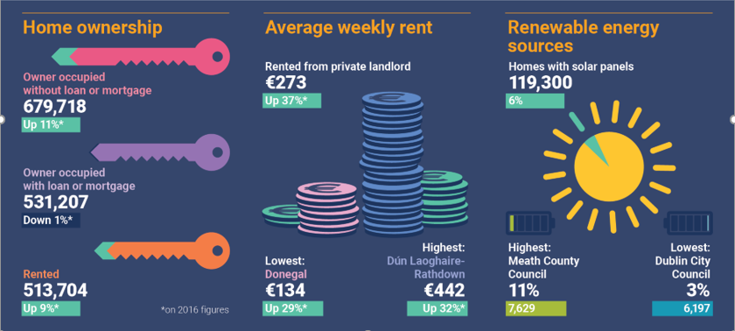
Housing stock and vacant dwellings statistics:
(source: CSO.ie – Census 2022)
Between April 2016 and April 2022, housing stock in county Kilkenny grew by 5% from 39,226 to 40,996. The number of vacant dwellings increased by 5% from 2,995 to 3,140. Many properties classed as vacant in the census may only be vacant for a short period of time and for a wide variety of reasons including homes for sale or rent, new build or renovation, etc. However, there were more than 857 dwellings classed as vacant both in the 2016 and 2022 censuses in Kilkenny, which could be an indication of a longer-term vacancy status.

Vacant Property Refurbishment Grant:
Since the launch of the Vacant Property Refurbishment Grant in 2022, 114 previously vacant or derelict homes in Kilkenny have been brought back in to use, with €6.38 million having been paid out for vacant property grants in Kilkenny since the scheme's launch. There was a very significant increase from 22 homes at the end of 2024.
Nationally, the rate of grant payments more than doubled from 1,349 grants in 2024 to 3,066 grants in 2025.
Overall, since the launch of the grant in July 2022, in Kilkenny there have been 369 applications (up 48% from 249 last year), 284 approvals (up 72% from 165), and 114 completed grant payments (a 418% increase on last year’s total of 22 homes).
Source: gov.ie Feb 2026
GeoDirectory’s Q2 2025 data shows Kilkenny’s residential vacancy rate at 3%, below the national rate of 3.7%
Planning:

Current Developments - Multi-Unit Developments with Planning Approval
As of the end of December 2025, there are a total of 35 multi-unit housing developments with live planning permissions secured within Kilkenny City. Some of these have been built out. Within these schemes there are 1,895 permitted housing units.

No of Schemes | No. Units Permitted | No. Units Built | No. Units Under Construction | Balance
35 | 1,895 | 437 | 183 | 1,275

As of the end of December 2025, within Ferrybank and the larger county towns (i.e., towns with a population of over 1,500 such as Callan, Thomastown, Graiguenamanagh, Castlecomer and Rosbercon) a total of 29 multi-unit housing developments have planning permission.
Within these schemes there are permissions for 690 housing units.

No of Schemes | No. Units Permitted | No. Units Built | No. Units Under Construction | Balance
29 | 690 | 80 | 216 | 394

Within the wider county there are 19 multi-unit housing developments with planning permission. Within these schemes there are 263 permitted housing units.

No of Schemes | No. Units Permitted | No. Units Built | No. Units Under Construction | Balance
19 | 263 | 45 | 52 | 166
In total within the city and county there are 83 multi-unit housing developments with planning permission secured. Within these schemes there are 2,848 permitted housing units.

No of Schemes | No. Units Permitted | No. Units Built | No. Units Under Construction | Balance
83 | 2,848 | 562 | 451 | 1,835

In addition to the above granted permissions there are currently 22 multi-unit development applications in the Kilkenny County Council Planning system which are yet to be determined. These could potentially yield a further 570 units for the county. 324 are in the City, 180 are located in the Local Area Plan towns, and 66 are in smaller villages / settlements of the county
.
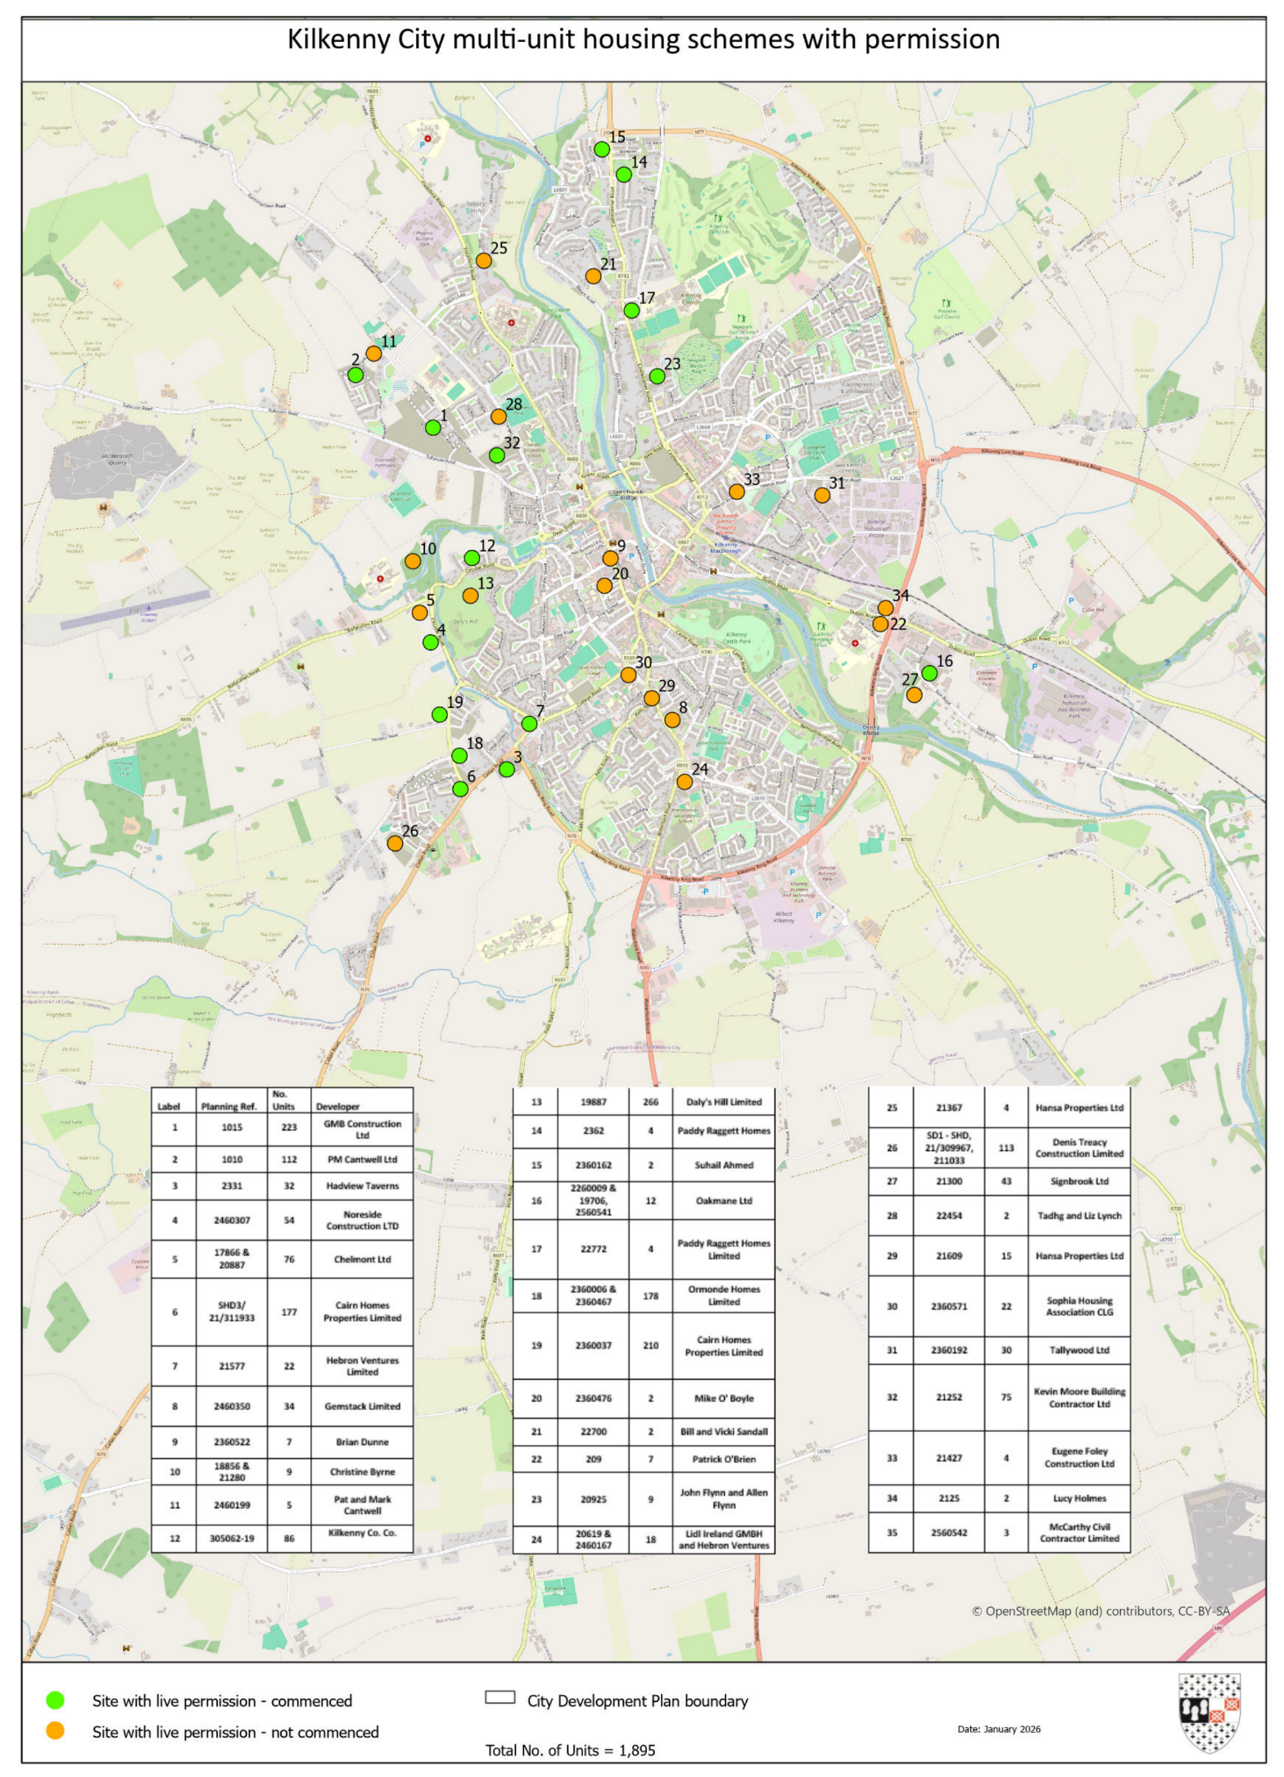

Working in Kilkenny:
(source: cso.ie – Census 2022)

The Labour force participation rate in Kilkenny among people aged 15 and over was 60% in 2022.
There were 46,196 people (aged 15 and over) at work in Kilkenny in 2022, an increase of 4,833 or 12% from 2016.
Nationally, there was an increase of 16% from 2016.
In Kilkenny, 12,906 people (aged 15 and over) worked from home at least one day a week in 2022. This represented 28% of the workforce. The national figure was 32%.

Monthly Unemployment:
(source: cso.ie)
The seasonally adjusted Live Register total for January 2026 was 171,300 people, a decrease of 1,200 from December 2025.
The seasonally adjusted unemployment rate for January 2026 was 4.7%, unchanged from December 2025.
The Q4 2025 unemployment rate was 4.4%, an improvement over the Q3 2025 rate of 5.3%.
In terms of age, the youth unemployment rate (for people aged 15-24 years) fell to 9.8% in Q4 2025, down slightly from 9.9% in Q4 2024.
The 25-34 years age group again made up the largest number of those on the Live Register throughout Q4 2025. In December the figures stood at 41,139 people or 24.1% of the total.
The unadjusted Live Register total stood at 170,674 people for January 2026, of which 56.7% were male and 71.1% were Irish. This is an increase of 5,439 people or 3.3% compared to January 2025.
There were 2,236 people on the live register in Kilkenny in January 2026.

Kilkenny Business Demography:
(source: cso.ie)
There were 9 businesses in Kilkenny County in 2024 with 250 and over employees;
460 businesses in Kilkenny County with between 10 and 250 employees;
And 5,820 businesses in Kilkenny County with less than 10 employees.

Third Level Education:
(source: HEA.ie, so.ie, SETU)
There were 4,735 students from County Kilkenny enrolled in third level institutions in the academic year 2024/2025, a slight increase from the previous year.
Approximately 1,210 students completed their Leaving Certificate in Kilkenny in 2024. Of these, 915 students (or 75.6%) progressed to third level education in the 2024/2025 academic year. The figures for 2025/2026 are not yet available.
Total enrolment at South East Technological University (SETU) for 2023/2024 was 18,338 students, a 15% increase from the previous year’s figure of 15,955. This reverses the previous year’s drop of almost 13%.
The most popular areas of study at SETU in 2024/2025 remained consistent: Business, Administration, and Law – 20.6%, Health and Welfare – 16.3%, Engineering, Manufacturing and Construction – 10.7%. These three disciplines together accounted for over 47% of all enrolments.
The total number of students enrolled in third level education across Ireland in 2024/2025 was 278,880, showing a stable trend compared to the previous year.

Industry Activity
In 2025 there were 312,400 people employed in IDA supported companies – a new record.
Employment grew 1.5% during 2025, with 323 investment projects approved, also a record, and a 38% increase on the previous year.
These new investments are expected to create more than 15,000 additional jobs in the coming years. 183 of these 323 projects, over half, are located outside Dublin. 12.4% of the workforce are employed in IDA supported companies.
(source: IDA via Irish Independent)

232,425 people were employed in Enterprise Ireland companies nationally in 2025 with 2,938 jobs created in 2025, a 1.3% increase on 2024.
Enterprise and Economic Development news Q4 2025:
Ambassador Book Launch
Kilkenny County Council is proud to present a new book celebrating the stories of 13 Kilkenny ambassadors. The individual stories within the book celebrate the achievements of a selection of well-known Kilkenny based people.
By sharing personal stories, first-hand experiences of success, and of living and working in Kilkenny, this book highlights and showcases what makes Kilkenny a great place to live and work.
LEO Jobs Growth 2025
The Local Enterprise Office (LEO) Kilkenny is now financially supporting 192 small businesses, which together employ 1,119 people.
Nationally, the LEO network reported its highest employment levels since its inception, with 40,285 jobs now supported across 7,148 client companies. Across Ireland, LEO-supported businesses created 7,261 new jobs in 2025, representing a 7% increase on 2024 and marking the 12th consecutive year of jobs growth. 82% of all new jobs created by LEO clients in 2025 were outside Dublin

