 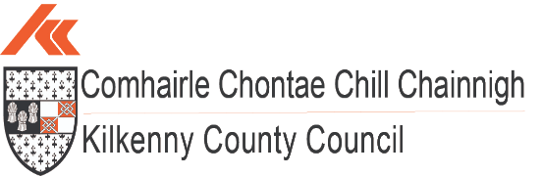

***Quarter 1 2024 Economic Report***



**Population:**

**(source: CSO.ie – Census 2022)**

The National population of Ireland now stands at **5,149,139**, up 8.1% or 387,274 from 2016. This is the first time that a census has recorded a population of greater than 5 million since 1851.

Natural increase made up 3.5%, with net migration making up 4.6%

(cso.ie visual)

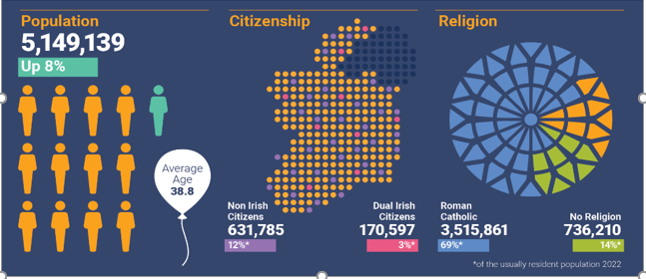

The population of County Kilkenny is now **104,160,** up 5% from 2016.

The 5% increase in Kilkenny County represents one of the lowest population increases in Ireland – tied at 5% with Donegal and Tipperary. The highest percentage population increase took place in Longford, where the population increased by 14% since 2016.

The population of Kilkenny City rose is now **27,184**, up 2.5% between 2016 and 2022.

Within the South East, Kilkenny City is 3rd in the ranking of urban centres by population with the top four in the below order:

1. Waterford City at 60,079;
2. Carlow Town at 27,351;
3. Kilkenny City at 27,184;
4. Wexford Town at 21,524

Nationally, Kilkenny is 13th in the CSO 2022 ranking of Ireland’s largest urban centres, as measured by population.

The average age of Kilkenny’s population in 2022 was 39.7 years, compared with 37.9 years in 2016.

Nationally, the average age of the population was 38.8, up from 37.4 in 2016.

The number of people aged 65 and over continues to grow. This age group increased by 21% to 17,056 in Kilkenny, and by 22% to 776,315 at a national level since 2016.



**Housing:**

**(sources: CSO.ie, Daft.ie Q1 2024)**

According to the latest Daft.ie House Price Report for Quarter 1, 2024 the average asking price in County Kilkenny for a house is **€301,521** – 7.6% lower than the national average of **€326,469** and up 5.4% year on year in Kilkenny.

Nationally, having fallen 1.3% in Quarter 4 2023, the average list price rose by 1.8% between December 2023 and March 2024.

## **Average Asking Prices**

|  |  |  |  |
| --- | --- | --- | --- |
| **Location** | **1 Bed Apartment** | **3 Bed Semi-D** | **4 Bed Detached** |
| **Kilkenny** | €107,000 | €201,000 | €401,000 |
| **Waterford** | €101,000 | €194,000 | €341,000 |
| **Carlow** | €95,000 | €178,000 | €356,000 |
| **Cork City** | €142,000 | €273,000 | €479,000 |

There are currently **269** residential properties for sale across County Kilkenny, with **75**, or 28% located in Kilkenny City (daft.ie)

## **Comparative Rent Prices**

Average listed rent prices nationally have increased 4.9% year on year at the end of Q1 2024 – this is the lowest rate of rent inflation since early 2021. (Daft.ie)

*“Improved availability of rental homes from late 2022 to late 2023 led to falling inflation. Those improvements in availability now look to have finished, at least for now. This suggests, thus, that further pressure on open-market rents this year is likely to be upward, rather than downwards.”*

*(*Ronan Lyons, Associate Professor of Economics at Trinity College Dublin)

The average cost of rental accommodation in Kilkenny at **€1,375** (across all property types) is 25% lower than the national average of **€1,836** and 42% lower than the average rent in Dublin City Centre at **€2,353**.

There are currently 10 properties listed for rent in County Kilkenny. (daft.ie)

|  |  |
| --- | --- |
| **Location** | **Average Rental Prices across all House Types** |
| **National Average** | €1,836 |
| **Dublin City Centre** | €2,353 |
| **Kilkenny** | €1,375 |

**House Ownership in Kilkenny**

**(source: CSO.ie – Census 2022)**

In 2022, in Kilkenny, 72% of households owned their own home, with a further 23% renting. This

compared with 66% of households owning their home nationally and 28% renting.

In 2023 there were 231 new homes (including single dwellings, scheme houses and apartments) in County Kilkenny, 163 of which were located in Kilkenny City and Environs.

**National Housing Ownership and Rental Snapshot Census 2022 (cso.ie visual):**

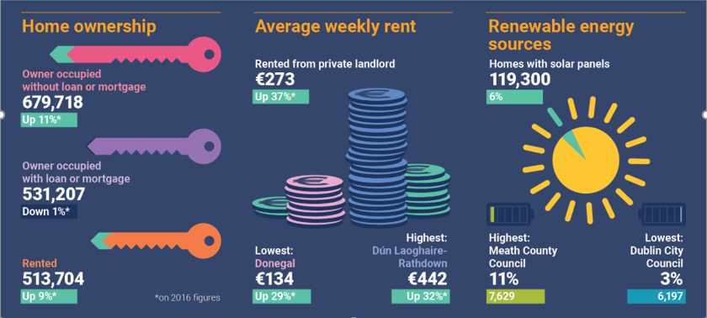

**Housing stock and vacant dwellings statistics:**

**(source: CSO.ie – Census 2022)**

The total housing stock in Kilkenny County in 2022 was 41,279, up 5.2% from 39,226 in 2016.

The number of vacant dwellings in 2022 was 3,183, up 6.3% from 2,995 in 2016.

The vacancy rate in 2022 was **7.7%,** up from **7.6%** in 2016.

**Planning:**

**(from KCC Q1 2024 Housing report – planning)**

## **Current Developments - Multi-Unit Developments with Planning APPROVAL**

As of the beginning of April 2024, there are a total of 48 multi-unit housing developments with live planning permissions secured within Kilkenny City. Some of these have already been built out. Within these schemes there are 2,252 permitted housing units.

22 housing schemes are either active or built out in the City with valid commencement notices for 818 units.

|  |  |  |
| --- | --- | --- |
| **31st March 2024** | **Kilkenny City** | **Commencement Notices** |
| **Number of Schemes** | 48 | 22 |
| **Number of Units** | 2,252 | 818 |

As of the beginning of April 2024, within Ferrybank and the larger county towns (i.e., towns with a population of over 1,500 such as Callan, Thomastown, Graiguenamanagh, Castlecomer and Rosbercon) a total of 26 multi-unit housing developments have planning permission.

Within these schemes there are permissions for 550 housing units. 12 housing schemes are active or built out with valid commencement notices for 249 units.

|  |  |  |
| --- | --- | --- |
| **31st March 2024** | **Ferrybank and District Towns** | **Commencement Notices** |
| **Number of Schemes** | 26 | 12 |
| **Number of Units** | 550 | 249 |

Within the wider county there are 31 multi-unit housing developments with planning permission. Within these schemes there are 247 permitted housing units.

12 housing schemes are active / built out with valid commencement notices for 61 units.

|  |  |  |
| --- | --- | --- |
| **31st March 2024** | **Wider County** | **Commencement Notices** |
| **Number of Schemes** | 31 | 12 |
| **Number of Units** | 247 | 61 |

In total within the City and County there are 105 multi-unit housing developments with planning permission secured. Within these schemes there are 3,049 permitted housing units.

46 housing schemes are active with valid commencement notices for 1,128 units.

|  |  |  |
| --- | --- | --- |
| **31st March 2024** | **City and County** | **Commencement Notices** |
| **Number of Schemes** | 105 | 46 |
| **Number of Units** | 3,049 | 1,128 |

In addition to the above granted permissions there are currently 29 multi-unit development applications in the Kilkenny County Council Planning system which are yet to be determined. These could potentially yield a further 605 units for the county. 166 are in the City, 332 are located in the Local Area Plan towns, and 107 are in smaller villages / settlements of the county.



**Working in Kilkenny:**

**(source: cso.ie – Census 2022)**

The Labour force participation rate in Kilkenny among people aged 15 and over was just over **60%** in 2022.

There were 46,196 people (aged 15 and over) at work in Kilkenny in 2022, an increase of 4,833 or **12%** from 2022.

Nationally, there was an increase of **16%** from 2016.

In Kilkenny, 12,906 people (aged 15 and over) worked from home at least one day a week in 2022. This represented 28% of the workforce. The national figure was 32%.

**Monthly Unemployment:**

**(source: cso.ie)**

The seasonally adjusted Live Register total for April 2024 was 174,200 people, down by 300 people or 0.2% from March 2024.

The unadjusted Live Register total stood at 169,497 people for April 2024.

In April 2024 there were 108,407 people on the Live Register for less than one year, which was 7,927 fewer people than April 2023.

In April 2024, the seasonally adjusted unemployment rate was 4.4%, up .3 percentage points from a revised rate of 4.1% in March 2024. On an annual basis, the seasonally adjusted unemployment rate rose to 4.4% in April 2024 from 4.1% in April 2023.

The absolute number of people on the live register in Kilkenny in April 2024 was **2,295** – with Kilkenny one of eight counties with less than 3,000 on the Live Register.



**Business Demography:**

(sources: EI, IDA and BDS)

IDA year end 2022 reported the highest Foreign Direct Investment (FDI) employment level ever and a 9% increase on 2021 with 301,475 people directly employed in the multinational sector in Ireland.

24,019 jobs were created in FDI employment, with 242 investments won – 103 of them new name investments.

52% of investments won went to regional locations – with employment growth in every region of the country.

The total number of people employed in IDA companies in the South East at the end of 2022 was 15,520, a 3% increase on 2021.

In July 2023, IDA Ireland reported steady investment growth in the first half of 2023 with 139 investments won - 52 of which were new name or first-time investments.

48% of these investments went to regional locations.

218,178 people were employed in Enterprise Ireland companies at the end of 2022, with client companies creating 19,660 jobs demonstrating growth of 5% on 2021.

Sectors such as Climate, Sustainability and Agritech saw an increase in employment of 13% and Digital Technology saw an increase of 9% in employment.

**Snapshot of Growth across Industries – EI companies (Enterprise Ireland visual representation):**

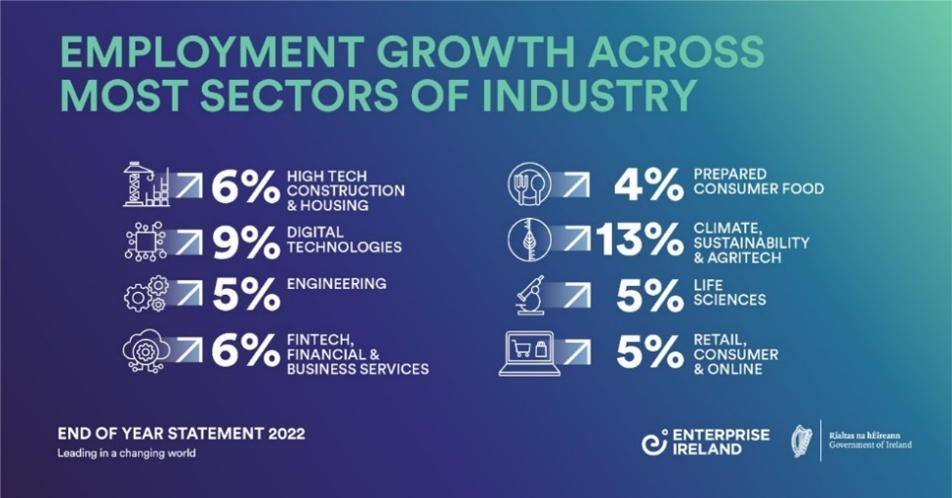

This trend continued in the regional spread of job creation, with 68% of the jobs created being based outside of Dublin.

**Snapshot of growth in the regions – EI companies – South East in line with Dublin and higher than most other regions (Enterprise Ireland visual representation):**

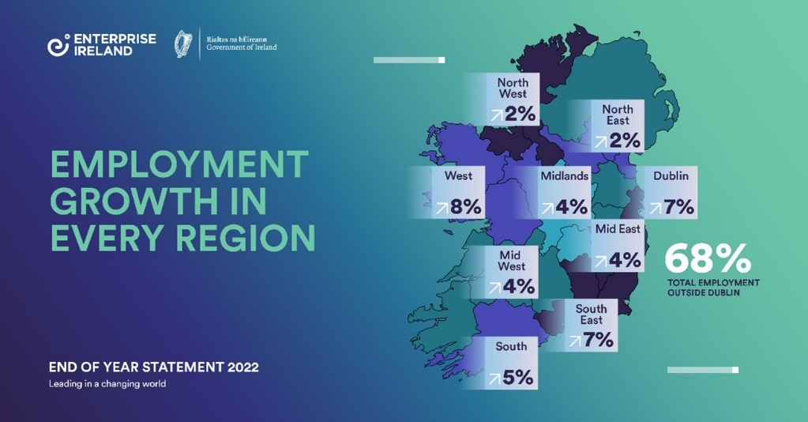

**Kilkenny Business Demography:**

**(source: cso.ie)**

There were 9 businesses in Kilkenny County in 2021 with 250 and over employees;

449 businesses in Kilkenny County with between 10 and 250 employees;

And 5,701 businesses in Kilkenny County with less than 10 employees

**Kilkenny Local Enterprise Office Demography:**

**(source: LEO Kilkenny)**

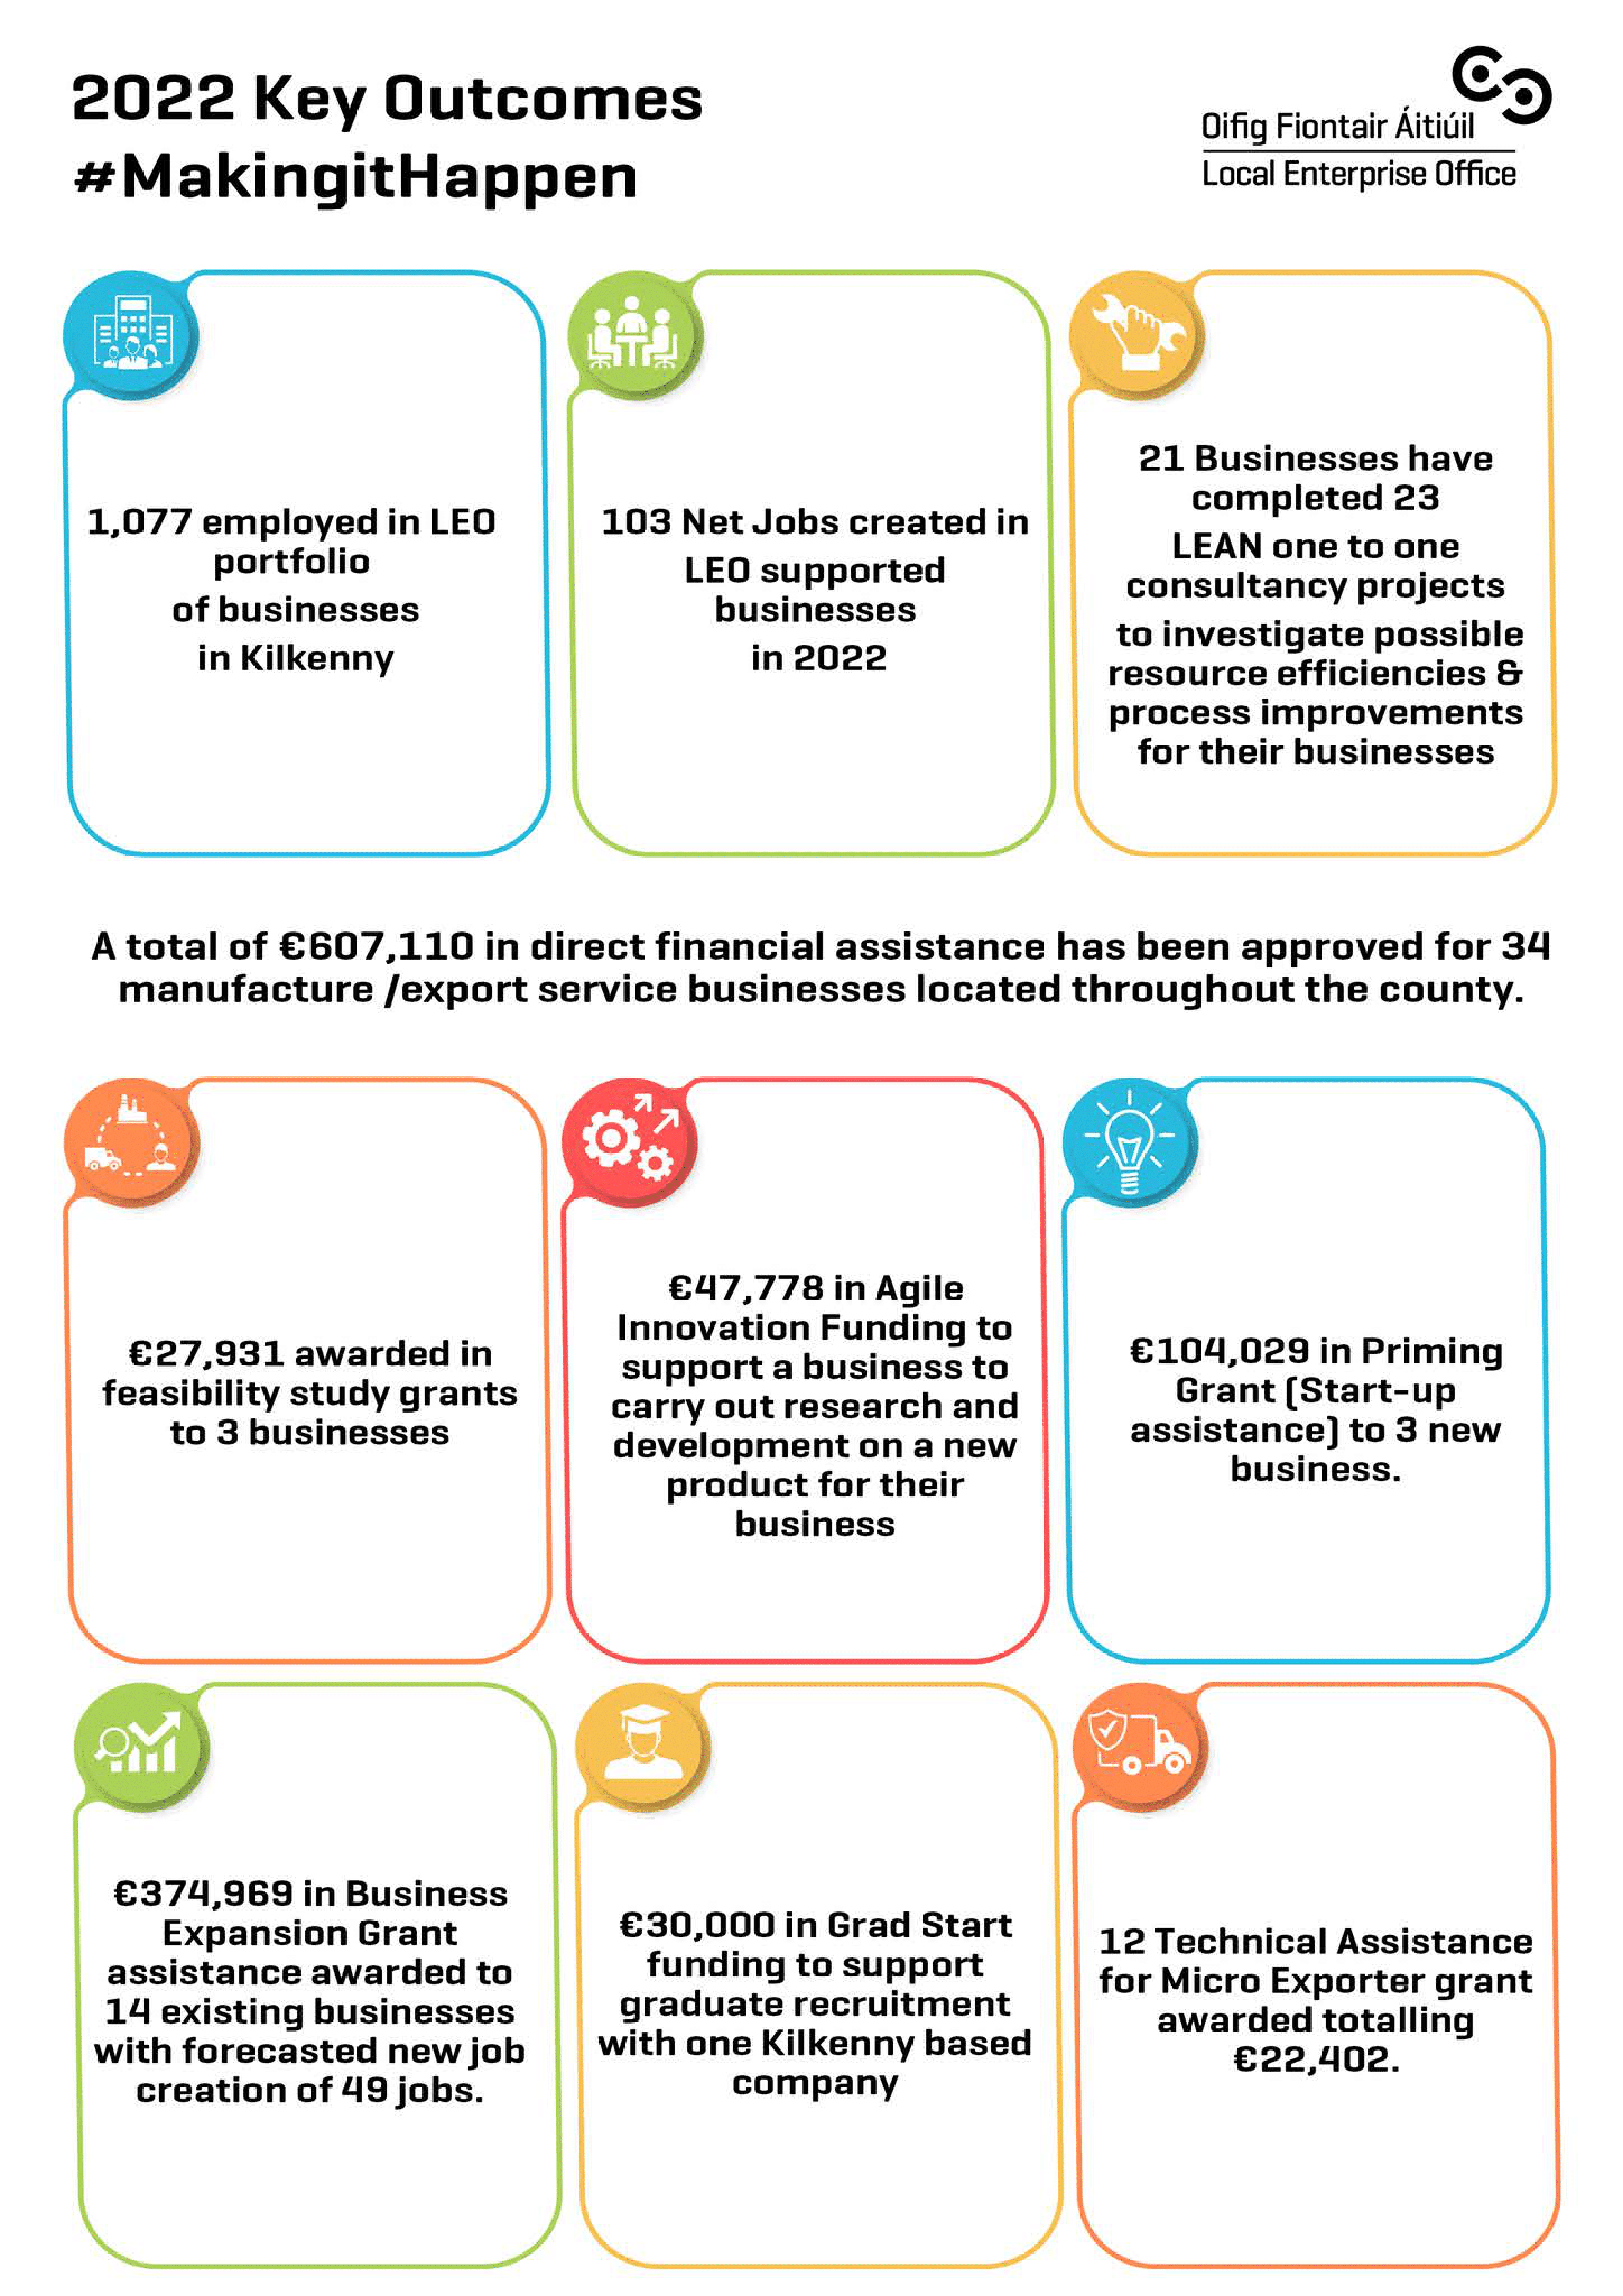

**Third Level Education:**

There were 4,610 students from Kilkenny County enrolled in a 3rd level institution in the academic year 2022/2023.

Of these 4,610 students, 29% or 1,350 were enrolled in a course in SETU.

Approximately 1,300 students completed their Leaving Certificate in 2022, of which 877 or 67% wend on to enroll in 3rd level education.

The most popular areas of study in SETU for students were Business and Administration, and Health and Welfare.

The total number of students enrolled in SETU dropped 10.54% from 17,835 to 15,955 between the academic year 2021/2022 and 2022/2023.

The overall change in enrollment numbers across higher education institutions in Ireland was -1.6% for the same period.

**Enterprise and Economic Development news Q1 2024:**

* Wednesday April 24th saw the official opening of the new Mayfair Library in Kilkenny’s Abbey Quarter. Minister Heather Humphreys visited Kilkenny to perform the opening, and the 1,800 square metre facility opened to the public the following day.

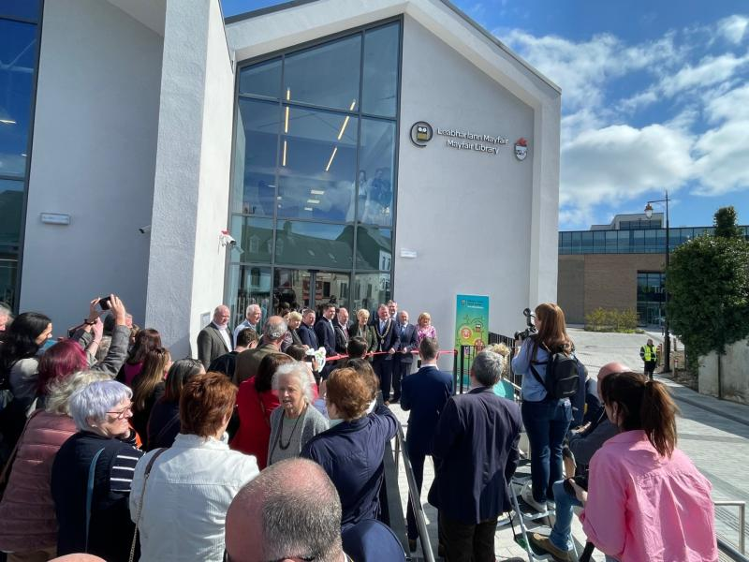

* Wednesday April 24th also saw Minister Humphreys perform the official opening of the new remote working hub “Exit 4” in Urlingford – the first fully dedicated remote working hub in rural Kilkenny.

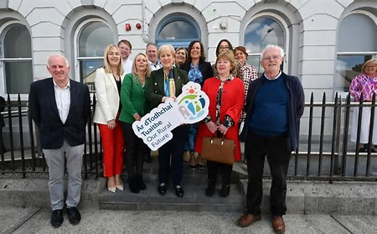

* On Tuesday April 30th Failte Ireland launched a new Five-Year plan that will help drive and sustain tourism in Kilkenny at a reception in St. Canice’s Cathedral. The Kilkenny Destination and Experience Development Plan (DEDP) aims to create a sustainable tourism destination by extending the tourism season and spreading business across all parts of the region over the next five years.

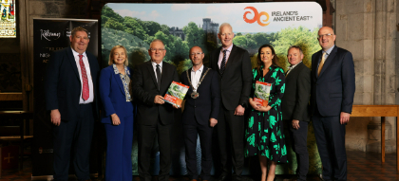

* Also on April 30th in St. Canice’s Cathedral, Kilkenny County Council launched the 'Kilkenny City pilot Night Time Economy Action Plan 2024-2025' and intends to identify a number of key night time opportunities for development over the next 18 months, with particular focus on creating new and exciting concepts after 6pm between Sunday and Thursday.



* Kilkenny County Council, working in partnership with Developers Cairn & Glenveagh Homes Ltd. and with support from the Department of Housing, Local Government & Heritage, is launched the first two schemes of Affordable Homes in Kilkenny City under the Local Authority Affordable Purchase Scheme. The application portal will remain open until Wednesday 22nd May.