

**Housing:**

**(sources: Daft.ie)**

According to the latest Daft.ie House Price Report for Quarter 4, 2023 the average asking price in County Kilkenny for a house is **€295,585** – 7.6% lower than the national average of **€320,046** and 20.6% lower than in Dublin City Centre where the average asking price is **€372,260**.

## **Average Asking Prices**

|  |  |  |  |
| --- | --- | --- | --- |
| **Location** | **2 Bed Terraced** | **3 Bed Semi-D** | **4 Bed Bungalow** |
| **Kilkenny** | €151,000 | €215,000 | €402,000 |
| **Dublin** | €369,000 | €485,000 | €644,000 |

There is currently **197** residential property sales listings across County Kilkenny, with **62** property listings in Kilkenny, noting that 7 of these listings are promoting new housing developments containing 154 units in total. (daft.ie)

## **Comparative Rent Prices**

According to the latest Daft.ie Rental Price Report for Quarter 3, 2023, while rents nationally have increased by 8% year on year, which is the lowest rate of inflation in 2 years, the cost of rental accommodation in Kilkenny is comparatively more affordable.

The average cost of rental accommodation in Kilkenny at **€1,411** (across all property types) is 22.6% lower than the national average of **€1,823** and 39.1% lower than the average rent in Dublin City Centre at **€2,317**.

There are currently 17 properties for rent in County Kilkenny, with 3 properties advertised in Kilkenny city. (daft.ie)

|  |  |
| --- | --- |
| **Location** | **Average Rental Prices across all House Types** |
| **National Average** | €1,823 |
| **Dublin City Centre** | €2,317 |
| **Kilkenny** | €1,411 |

**House Ownership in Kilkenny**

**(source: CSO.ie – Census 2022)**

In 2022, in Kilkenny, 72% of households owned their own home, with a further 23% renting. This

compared with 66% of households owning their home nationally and 28% renting.

**National Housing Ownership and Rental Snapshot Census 2022 (cso.ie visual):**

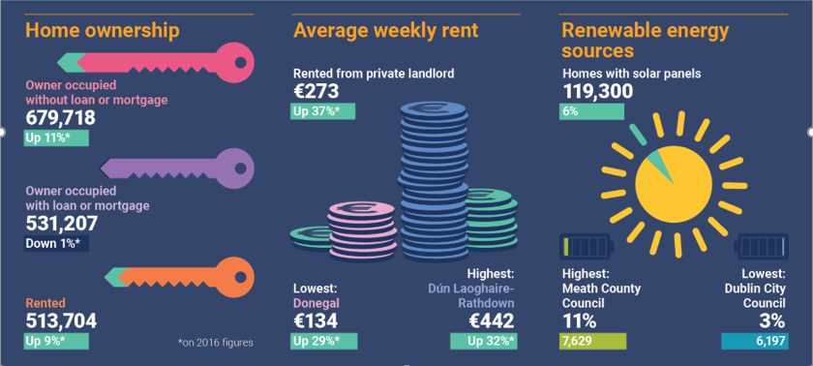

**Housing stock and vacant dwellings statistics:**

**(source: CSO.ie – Census 2022)**

The total housing stock in Kilkenny County in 2022 was 41,279, up 5.2% from 39,226 in 2016.

The number of vacant dwellings in 2022 was 3,183, up 6.3% from 2,995 in 2016.

The vacancy rate in 2022 was **7.7%,** up from **7.6%** in 2016.

**Planning**

## Current Developments - Multi-Unit Developments with Planning APPROVAL

As of December 2023, there are a total of 48 multi-unit housing developments with live planning permissions secured within Kilkenny City. Some of these have been built out. Within these schemes there are 2,210 permitted housing units.

19 housing schemes are either active or built out in the City with valid commencement notices for 637 units.

|  |  |  |
| --- | --- | --- |
| **31st December 2023** | **Kilkenny City** | **Commencement Notices** |
| **Number of Schemes** | 48 | 19 |
| **Number of Units** | 2,210 | 637 |

### LIHAF Projects (latest update 2023)

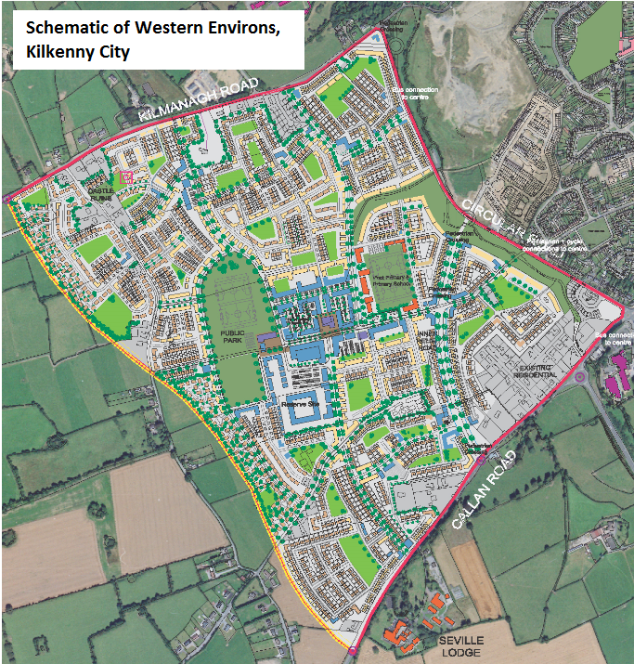Kilkenny County Council secured approval for two major developments under the Government’s Local Infrastructure Housing Activation Fund (LIHAF), namely the Western Environs (renamed Breagagh Valley) Kilkenny City and Ferrybank in South Kilkenny.

In the case of the Breagagh Valley, work on the infrastructure required to facilitate the provision of up to 800 houses was completed in 2021.

Planning permission has been granted for circa 850 houses in the area since 2019 with construction active on one site that has capacity to deliver 183 units.

As part of the roll out of the new Breagagh Valley neighbourhood, two new secondary schools have secured planning permission and are being delivered under the patronage of the Carlow Kilkenny Education and Training Board (CKETB).  The two schools have been approved funding from the Department of Education. A site has been reserved by the Department of Education for a primary school with outline permission secured.

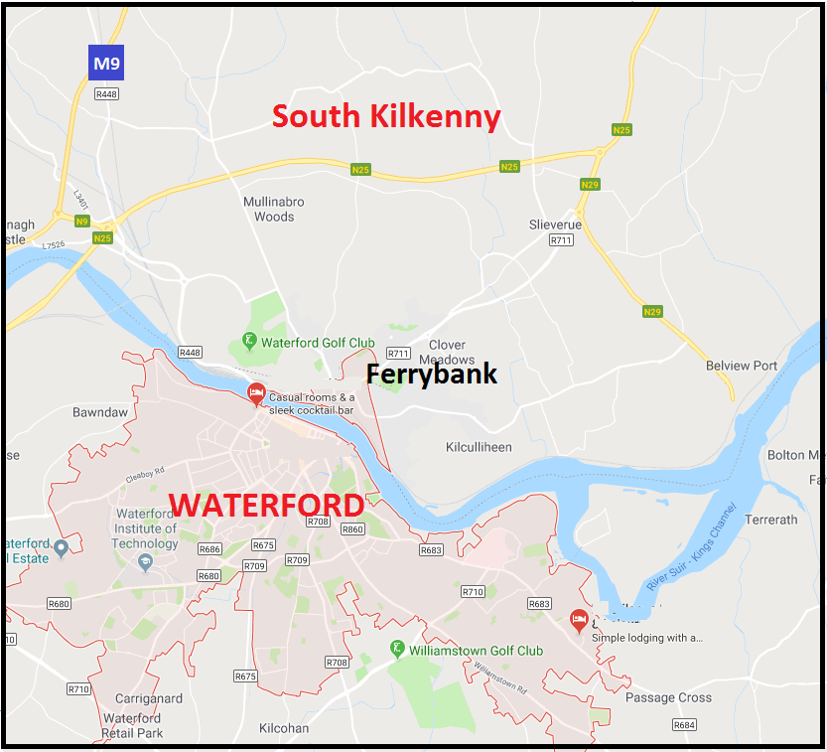In the case of Ferrybank on the northern suburbs of Waterford City, the Ferrybank Neighbourhood Park (part funded under LIHAF) has been completed and opened to the public in October 2020. This amenity will facilitate the provision of additional housing in the area.

In December 2023 within Ferrybank and the larger county towns (i.e., towns with a population of over 1,500 such as Callan, Thomastown, Graiguenamanagh, Castlecomer and Rosbercon) a total of 24 multi-unit housing developments have planning permission.

Within these schemes there are permissions for 535 housing units. 12 housing schemes are active or built out with valid commencement notices for 242 units.

|  |  |  |
| --- | --- | --- |
| **31st December 2023** | **Ferrybank and District Towns** | **Commencement Notices** |
| **Number of Schemes** | 24 | 12 |
| **Number of Units** | 535 | 242 |

Within the wider county there are 29 multi-unit housing developments with planning permission. Within these schemes there are 243 permitted housing units.

9 housing schemes are active / built out with valid commencement notices for 45 units.

|  |  |  |
| --- | --- | --- |
| **31st December 2023** | **Wider County** | **Commencement Notices** |
| **Number of Schemes** | 29 | 9 |
| **Number of Units** | 243 | 45 |

In total within the City and County there are 101 multi-unit housing developments with planning permission secured. Within these schemes there are 2,988 permitted housing units.

40 housing schemes are active with valid commencement notices for 924 units.

|  |  |  |
| --- | --- | --- |
| **31st December 2023** | **City and County** | **Commencement Notices** |
| **Number of Schemes** | 101 | 40 |
| **Number of Units** | 2,988 | 924 |

In addition to the above granted permissions there are currently 31 multi-unit development applications in the Kilkenny County Council Planning system which are yet to be determined. These could potentially yield a further 597 units for the county. 138 are in the City, 348 are located in the Local Area Plan towns, and 111 are in smaller villages / settlements of the county.



**Working in Kilkenny:**

**(source: CSO.ie – Census 2022)**

The Labour force participation rate in Kilkenny among people aged 15 and over was just over **60%** in 2022.

There were 46,196 people (aged 15 and over) at work in Kilkenny in 2022, an increase of 4,833 or **12%** from 2016.

Nationally, there was an increase of **16%** from 2016.

In Kilkenny, 12,906 people (aged 15 and over) worked from home at least one day a week in 2022. This represented 28% of the workforce. The national figure was 32%.

**Monthly Unemployment:**

**(source: CSO.ie)**

The seasonally adjusted national unemployment rate for December 2023 (for all persons aged 15-74 years) was 4.9%.

The number of people on the live register in Kilkenny in December 2023 was 2,410.

Kilkenny was amongst the counties that saw the largest percentage decrease in the number of persons on the Live Register in the 12 months to December 2023 at -15.1%, alongside Cavan (-15.7%) and Kerry (-11.6%)



**Business Demography:**

**(sources: EI, IDA)**

The **IDA** has reported strong annual results for 2023 showing an increased number of investments, steady levels of employment across the FDI sector, robust regional investment and strong performance across key transformation areas of research development and innovation, sustainability, digitalisation and talent development.

A 2.5% increase in the number of investments into Ireland during 2023 totaling 248 and enabling the creation of almost 19,000 jobs was reported and further broken down to show 132 investments secured across regional locations, representing 54% of the overall figure. The total number of regional jobs now stands at 163,471 and growth in the Southeast region was up by 1.4%. There are 15,520 people employed in IDA client businesses in the South East in 2022.

There were 132 investments secured across regional locations during 2023, representing 54% of the overall figure. The total number of regional jobs now stands at 163,471. The Midlands Region saw the strongest level of growth, up 5.8%. There was growth in the Border Region (up 2.7%) and Midwest Region (up 2.6%) with the Southwest and Southeast regions up by 1.2% and 1.4% respectively. Elsewhere, the West Region was down by 1.8% whilst Dublin and the Mid East Region declined by 1.2% and 4.8% respectively.

**Enterprise Ireland** works with and supports over 4,000 Irish companies, which employed 225,495 people in 2023, the highest ever recorded. 15,530 new jobs were created by Enterprise Ireland supported companies in 2023, and more than two-thirds, 68%, of these jobs were outside Dublin.

Each of Enterprise Ireland’s three main sectoral divisions recorded jobs growth with Food and Sustainability now employing 66,047 people (+3%), Industrial and Life Sciences employing 93,652 (+2%) and Technology & Services employing 65,796 people (+2%).

Climate, Sustainability and Agritech performed strongly, with employment increasing by 7%, as did Dairy, Drinks and Food FDI with a 5% increase in employment.

Life Sciences companies saw employment increase by 4% and employment in the High Tech Housing and Construction sector increased by 3%.

Growth was strong in Kilkenny with employment increasing by 5% in 2023. Employment in Enterprise Ireland-backed companies in Kilkenny was 5,630 in 2023, with 293 net jobs created in Kilkenny last year.

**Local Enterprise Office**

There are 1,100 people employed in LEO Kilkenny supported in Kilkenny, 2023 saw a net gain of 53 jobs in the LEO client portfolio.

**Kilkenny Business Demography:**

**(source: cso.ie)**

There were 9 businesses in Kilkenny County in 2021 with 250 and over employees;

449 businesses in Kilkenny County with between 10 and 250 employees;

And 5,701 businesses in Kilkenny County with less than 10 employees

**Third Level Education:**

**(source: HEA)**

There were 4,610 students from Kilkenny County enrolled in a 3rd level institution in the academic year 2022/2023.

Of these 4,610 students, 29% or 1,350 were enrolled in a course in SETU

**Higher Education Institutions attended by students from County Kilkenny**

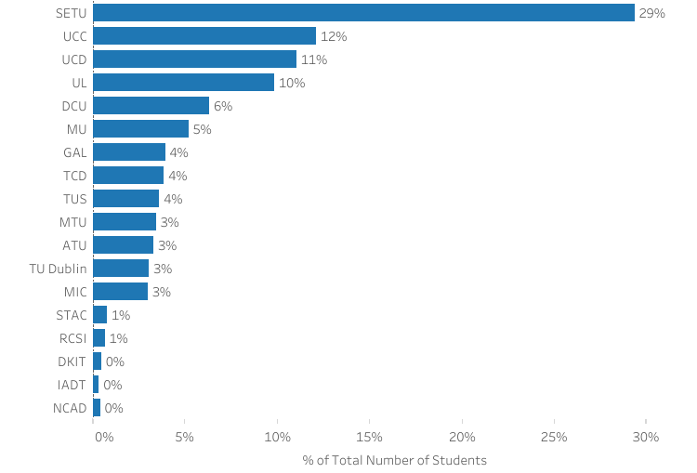

**Fields of Study - Students from County Kilkenny**

|  |  |
| --- | --- |
| Business, administration and law | 21% |
| Health and welfare | 17% |
| Engineering, manufacturing and construction | 12% |
| Arts and humanities | 11% |
| Education | 11% |
| Natural sciences, mathematics and statistics | 11% |
| Information and Communication Technologies (ICTs) | 5% |
| Social sciences, journalism and information | 5% |
| Services | 3% |
| Agriculture, forestry, fisheries and veterinary | 3% |

Source: https://hea.ie/statistics/data-for-download-and-visualisations/access-our-data/access-our-data-students/