ABOUT
REMARC SURVEY

REMARC is an EPA-funded research project involving researchers from UCD, UCC and TU Dublin. The REMARC survey aims to investigate current household practices, awareness levels, opinions and needs regarding septic tank and packaged treatment system maintenance.

PROJECT CONTACTS

Dr. Linda Fox-Rogers (project head)
UCD School of Architecture, Planning & Environmental Policy
Email: linda.fox-rogers1@ucd.ie
Phone: 01 716 2710

Dr. Simon Mooney
(postdoctoral researcher)
UCD School of Architecture, Planning
& Environmental Policy
Email: simon.mooney1@ucd.ie
Phone: 085 702 6670

PROJECT WEBSITE

https://www.remarcproject.com/



  - 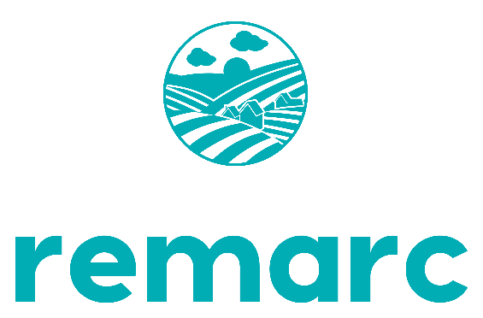



Remediation of Faulty Septic Tanks: A Mixed Methods Approach to Environmental Risk Communication (REMARC)

PARTICIPATE IN OUR ONLINE SURVEY

Do you live in a house with a private domestic wastewater treatment system (e.g. septic tank)?

If so, you are invited to participate in an anonymous national survey about system management. Your knowledge/views towards household system maintenance will help aid policy change and supports for system users nationwide! If you are interested and/or would like more information, please use the URL or scan the QR code below.

URL: https://eu.surveymonkey.com/r/remarcsurvey

QR code:


