
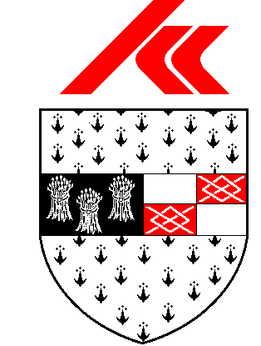KILKENNY COUNTY COUNCIL
CHOMHAIRLE CHONTAE CHILL CHAINNIGH
Dunmore Recycling & Waste Disposal Centre
Notice of Easter Weekend Closure

Please note that Dunmore Recycling & Waste Disposal Centre will be CLOSED from
Friday 3rd April to Monday 6th April 2026 inclusive
The facility will re-open on Tuesday 7th April, 8.00 am to 4.30pm

