Kilkenny County Council’s

Environmental Education & Awareness Strategy 2024

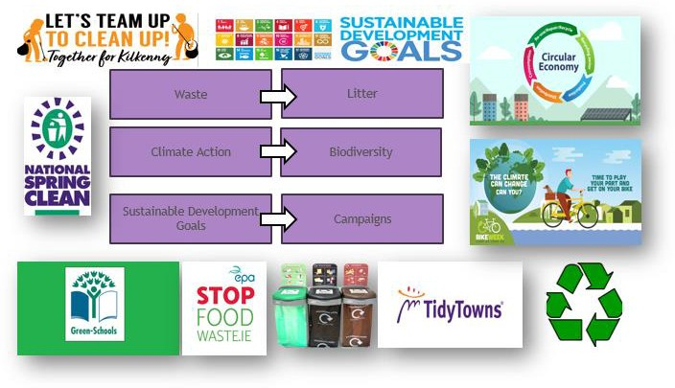

# Waste

Kilkenny County Council as part of the Southern Waste Region has a strategic vision to rethink our approach to manage waste by viewing waste streams as valuable material resources, leading to a healthier environment and sustainable commercial opportunity for our economy. It is a priority of Kilkenny County Council to meet the objectives of the National Waste Management Plan for a Circular Economy 2024-2030. Ireland is moving away from the traditional linear ‘take-make-use-dispose’ model towards a ‘circular economy’ regenerative growth model where resources are reused or recycled as much as possible, and the generation of waste is minimised.

The transition to a circular economy is essential to reduce pressure on natural resources, aid in achieving climate targets, support Sustainable Development Goals and create sustainable growth and jobs. [National Waste Management Plan for a Circular Economy 2024-2030 - mywaste](https://www.mywaste.ie/national-waste-management-plan/) [My Waste](https://www.mywaste.ie/national-waste-management-plan/)

## Strategy Objectives

* Promote the waste hierarchy
* Educate the public, Council Staff, businesses and commercial entities on waste prevention and waste segregation.
* Encourage and support the recovery, repair & reuse of waste
* Train, network & collaborate to implement waste prevention and re-use projects
* Promote the Kilkenny County Council Green Charter to encourage festivals and community events to improve their environmental performance and address the “polluters pay principle”.

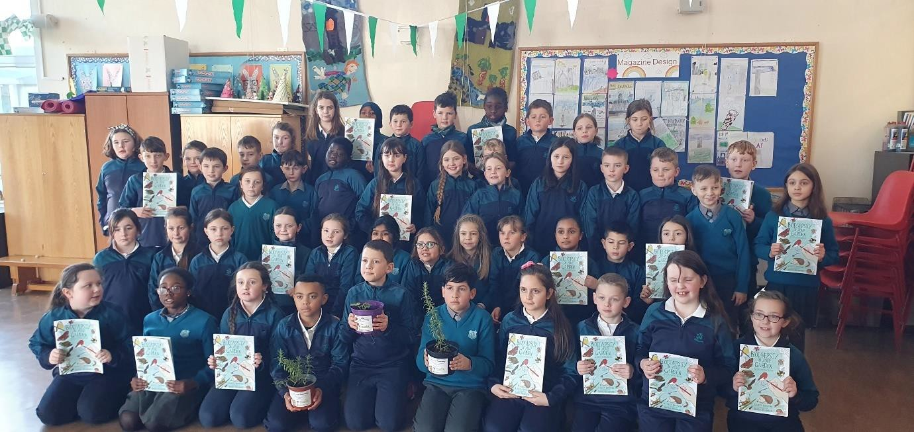

## St Canice’s Primary School waste plan for circular economy

**Actions 2024**

1. Collaborate with the regional waste office to roll out a specific regional waste prevention project and continue to promote mywaste.ie as an educational tool and platform for schools and community groups to utilise
2. Continue to collaborate with the Local Authority Prevention Network (LAPN) on the themes of food waste, relove paint, repair and reuse, rethinking single use, greening events, water conservation, energy efficiency, textiles and fashion, C&D, greener cleaning and gardening and the circular economy.
3. Continue to support the green school programme by means of school visits, school assessments, co-ordinators annual information meeting and facilitate workshops as appropriate to their relevant environmental theme
4. Continue to work with the LAPN to promote [www.greenyourfestival.ie](http://www.greenyourfestival.ie/) and [www.stopfoodwaste.ie](http://www.stopfoodwaste.ie/), engage with other food prevention initiatives and encourage festivals and local community events to adopt the Council’s Green Charter for Events

**Collaborative Partners;** Regional Waste Office, CIT, EPA, LAPN, Schools, Communities, Dunmore Recycling Centre

# Litter

The Council’s Litter Management Plan 2024-2026 emphasises strong waste enforcement of the law, the requirement to eliminate litter pollution in collaboration with local communities.

## Strategy Objectives

* + Increase awareness of the problems associated with litter and dog fouling
  + Support youth education via the Green Schools programme and collaborations with other partners
  + Work in partnership with local community organisations i.e. Tidy Towns groups
  + Co-ordinate the Tidy Towns Forum
  + Encourage community clean ups- National Spring Clean and “Team Up to Clean Up”
  + Encourage the public to report of illegal dumping that occur on public lands
  + Collaborate with other Local Authorities on litter themed campaigns especially for radio on a local and regional context

## Actions 2020

1. Execute a new dog fouling campaign in collaboration of the local community
2. Increase awareness on the use of pet faeces disposal bins provided by MD’s.
3. Increase the awareness of the Councils Litter Line Number 1800-200-156 and online report system via Environmental Website
4. Co-ordinate the Team Up to Clean Up County wide initiative
5. Support tidy towns entrants via the Tidy Towns Forum and by funding streams available
6. Complete a community mural in a rural village or town, similar to the Biodiversity and Anti-Litter themed mural in Kilkenny
7. Continue to support the development and delivery of Environmental Awareness Campaigns by securing funding under National and Regional funding avenues-
   * Anti-Litter and Anti-Graffiti
   * Anti-Dumping Initiative (ADI)
   * Community Environmental Action Fund
8. Ensure that all objectives of the current Litter Management Plan are on target as 2026 is the final year of this adopted plan.

Anti-graffiti mural commissioned to mark the All Ireland Pollinator Plan at the Closh, Kilkenny City (December 2019)


## Anti-graffiti mural commissioned to mark the All Ireland Pollinator Plan at the Closh, Kilkenny City (Dec 2019)

**Collaborative Partners;** Other Councils, Tidy Town groups, community groups, schools, An Taisce, area offices and waste enforcement staff.

# Climate Change

Climate change is recognized as the most serious and threatening global environmental problem. Kilkenny County Council is committed to reducing its energy consumption and adopted its inaugural Climate Action Plan in February 2024.

The Plan sets out how the Council will respond to the climate crisis by improving energy efficiency, reducing greenhouse gas emissions, and embedding climate resilience across the organisation. It also addresses how the Council will adopt a leadership role in the county by supporting local communities, businesses and other stakeholders to take climate action.

The Plan’s vision is that Kilkenny County Council will be “A climate resilient organisation that inspires and supports the County’s transition to a climate resilient, biodiversity rich, sustainable and carbon neutral economy by 2050”.

The Plan, which contains 95 actions, was adopted following extensive public and stakeholder consultation, gathering scientific data, and deliberations by the Elected Representatives and Staff of Kilkenny County Council. Click here to view the final Kilkenny County Council Climate Action Plan 2024-2029.

## Strategy Objectives

* Assist with the implementation of Kilkenny’s Climate Action Plan 2024-2030 and identified actions specific to Environment and the EAO.
* Facilitate educational opportunities for climate change workshops to promote better understanding of how to reduce emissions
* Collaborate with the Councils Energy Team to achieve targets and raise awareness of their activities

## Actions 2020

1. Arrange climate change awareness talks for in-house staff
2. Arrange climate change workshops for schools
3. Review CAP actions and ensure all actions associated to the EAO is completed
4. Continue to roll out energy loan kits to all library branches

**Collaborative Partners;** Other Councils, Climate Action Team, Tidy Town Groups, community groups, schools, An Taisce, Climate Change Co-ordinator, CARO, 3CEA and local libraries

# Biodiversity

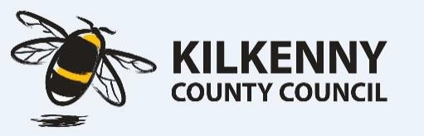Kilkenny County Council is a proud partner of the All Ireland Pollinator Plan, therefore work with schools and community groups through funding opportunities or

green schools always present opportunities to advise groups about biodiversity and highlight the relevant assistance available to them.

## Strategy Objectives

* + To Support the Biodiversity Officer with the development of a Biodiversity Plan for the County and implement public awareness of the plan once completed.
  + Disseminate information regarding best practice e.g. in relation to watercourse management; the control of invasive species etc). Support demonstration projects undertaken by the community / NGO’s groups / stakeholders.

**Collaborative Partners;** Heritage Officer, Biodiversity Data Centre, Tidy Towns and Community Groups, Schools

# Sustainable Development Goals

The 2030 Agenda for Sustainable Development, adopted by all United Nations Member States in 2015. At its heart are the 17 Sustainable Development Goals (SDGs), which are an urgent call for action by all countries - developed and developing - in a global partnership. They recognize that ending poverty and other deprivations must go hand-in-

hand with strategies that improve health and education, reduce inequality, and spur economic growth – all while tackling climate change and working to preserve our oceans and forests.

There are three goals which have particular relevance to the Environmental Education & Awareness Strategy 2020

* + 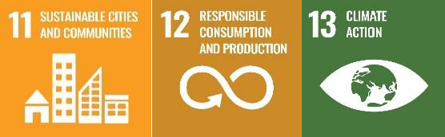No. 11 Sustainable Cities & Communities
  + No. 12 Responsible Consumption Production
  + No. 13 Climate Action

The SDG’s act like an umbrella overarching this strategy and the relevant goals will be highlighted publicly in line with the Department of Communication, Climate Action and Environment request to raise the SDG’s profile on a local level when a relevant project or initiative is being undertaken as part of the Environmental Education & Awareness Strategy.

**Campaigns**

The environmental education and awareness campaigns for 2024 are set out below.

|  |  |  |  |  |  |  |
| --- | --- | --- | --- | --- | --- | --- |
| **Task** | **Start Date** | **End Date** | **Duration** |  |  | |
| Deposit Return Scheme | 01/02/2024 | 01/06/2024 | 121 |  |  | |
| WEEE | 01/01/2024 | 31/12/2024 | 365 |  |  | |
| Brown Bin Campaign | 01/01/2024 | 31/12/2024 | 365 |  |  | |
| National Spring Clean | 01/02/2024 | 30/04/2024 | 89 |  |  | |
| Air Quality and Pollution Mitigation (Smoky Coals and Anti Cigarette) | 15/04/2024 | 13/05/2024 | 28 |  |  | |
| Team Up to Clean Up | 01/05/2024 | 23/09/2024 | 145 |  |  | |
| Dog Fouling | 01/06/2024 | 30/09/2024 | 121 |  |  | |
| Anti Food Waste | 05/06/2024 | 11/06/2024 | 6 |  |  | |
|  |  |  |  |  |  | |
|  |  |  |  |  |  | |
| 01/02/2024 22/03/2024 11/05/2024 30/06/2024 19/08/2024 08/10/2024 27/11/2024  Deposit Return Scheme  WEEE  Brown Bin Campaign National Spring Clean  Air Quality and Pollution Mitigation (Smoky Coals and Anti Cigarette)  Team Up to Clean Up  Dog Fouling Anti Food Waste | | | | | |  |
|  |
|  |
|  |
|  |
|  |
|  |
|  |
|  |
|  |
|  |
|  |
|  |
|  |
|  |  |  |  |  |  | |