18th May, 2021

N O T I C E

Kilkenny County Council is in the possession of (6) six horses which were impounded on Monday 17th May, 2021, as described hereunder:-

Our Ref | Impounded from | Description | Microchip Number | Previously Microchipped
09/21 | Hebron Lands | Skewbald Female (15 years) 14 hands | 372141420705254 | No
10/21 | Hebron Lands | Bay Male Foal (4 months) 10 hands | 372141420705242 | No
11/21 | Hebron Lands | Bay Female (15 years) 10 hands | 372141420705384 | No
12/21 | Hebron Lands | Chestnut Female (15 years) 10 hands high | 972270000233869 | Yes but not with KCC
13/21 | Hebron Lands | Bay Female (4 years) 12 hands | 372141420705266 | No
14/21 | Hebron Lands | Grey Male Foal (4 months)  10 hands | 372141420705396 | No

Should these animals remain unclaimed by Monday next 24th May, 2021, they will be sold/disposed/rehomed as appropriate.

Sale/Disposal will take place as outlined in the Control of Horses Act, 1996.

Catherine Millea
-----------------------
Catherine Millea
Senior Staff Officer
Environment
056 – 7794470

To: Kilkenny Garda Station, Dominic St, Kilkenny

09/21 | 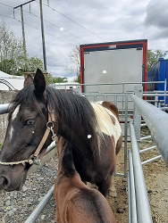 | 10/21 | 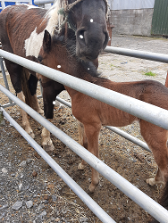
11/21 | 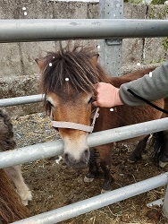 | 12/21 | 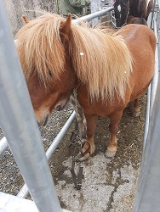
13/21 | 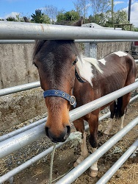 | 14/21 | 