Top of Form

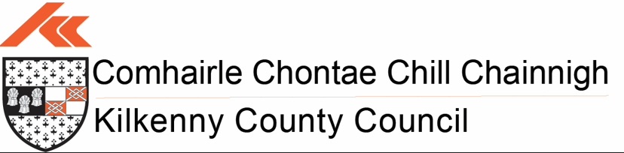

2024/25 Outdoor Recreation Infrastructure Scheme Call

Posted on [10.12.2024](https://monaghan.ie/communitydevelopment/2023/06/08/2023-outdoor-recreation-infrastructure-scheme/) by [Kilkenny](https://monaghan.ie/communitydevelopment/author/monaghan/) County Council

Minister for Rural and Community Development, Heather Humphreys TD, has announced a major €20 million fund to support outdoor recreation projects.

The 2024/25 Outdoor Recreation Infrastructure Scheme (ORIS) will see the development of natural amenities such as our woodlands, mountains, rivers, lakes, beaches, bogs, walkways and will place a particular focus on developing amenities for adventure tourism in rural Ireland.

The funding is aimed at supporting outdoor recreation tourism, a growing tourism sector internationally, which has the potential to have major economic spin-off benefits for our rural towns and villages as well as improving the health and well-being of rural communities.

A list of eligible activities is detailed below, however, it should be noted that this list is not exhaustive:-

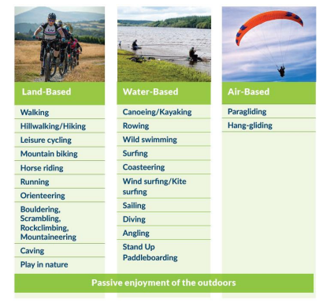

It does not include activities that take place outdoors on confined courses or pitches (such as Gaelic Games, golf, soccer, and show-jumping) or motorised activities (such as quads/scramblers). As a consequence such activities are not eligible for funding under ORIS.

**It is a requirement that the infrastructure funded under ORIS should be available free of charge to the public**.

**Kilkenny County Council is seeking Expressions of Interest for projects under all measures;**

* **Measure 1**: Small Scale Repair/Development/Promotion and Marketing – grant up to €40,000
* **Measure 2**: Medium Scale Repair/Upgrade and New Trail/Amenity Development – grant up to €200,000
* **Measure 3**: Strategic Large-Scale Repair/Upgrade and New Strategic Trail/Amenity Development projects – grant up to €500,000
* **Project Development Measures** – Will provide funding for the detailed development of projects which would enable them to reach a standard for application under Measure 2 or 3 of ORIS – grant up to €50,000

As set out in the scheme outline attached, projects with evidence of strong community engagement will be prioritised.  Where a project requires planning permission, this must be in place in advance of an application being submitted.

Projects should be located mainly in the countryside and not in the environs of a town or village unless the proposed project is linking a town or village into the countryside.

Please email the Capital Delivery Office & Parks Department of Kilkenny County Council, providing details of any potential project, within the county, that meets the prescribed criteria for eligibility under the Scheme that you would like to have considered. Once submissions are reviewed contact will be made to advise on the outcome of this assessment process.

All expressions of interest must be submitted in **WORD Format** to [oris24-25@kilkennycoco.ie](mailto:oris24-25@kilkennycoco.ie) by **4.00p.m. on Friday the 17th January 2025** to allow sufficient time for applications to be prepared and finalised.

