**ISSUE NO 2**

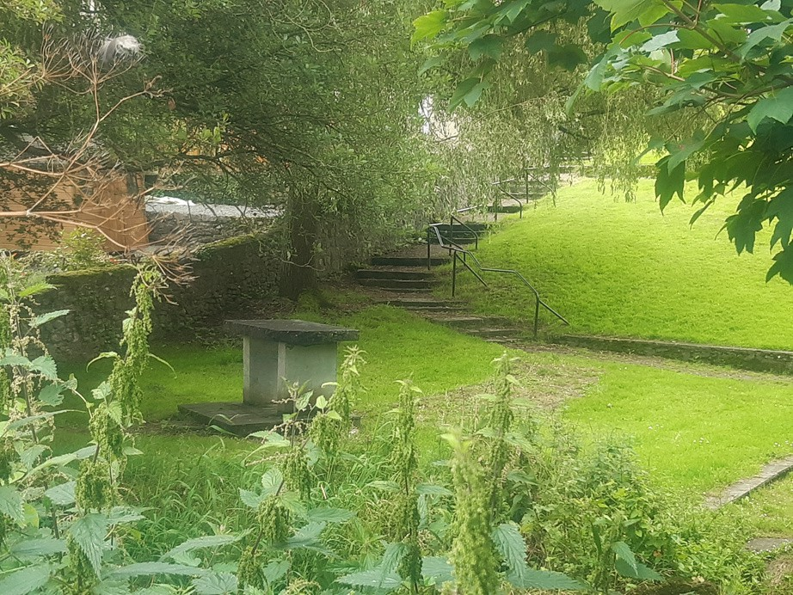Newsletter

**BUTTS AREA REGENERATION**



**October 2024**

# Introducing The Butts Town Team

The Butts Town Team was established this summer and we are meeting regularly at 19 Pearse St.

The aim of the Team is to come together as a community and help to make The Butts a better place to live. Plans are being developed for The Butts and the Town Team are working hard to be part of this planning process. If the community comes together and agrees on issues we can then bring these ideas to those developing the plans.

The Team is covering 9 sub groups. Housing, Sport, Youth, Age Friendly, Community Events, Heritage, Traffic/Road Safety, Education and Tidy Estate/Bio Diversity.

If anyone in the estate has any suggestions to help with developing these plans or would like to join the sub groups above please leave your name and contact number with Marie in 19 Pearse St and someone will call you back.

*Regards, The Butts Town Team*

# Family Tidy Estate Event

## Saturday 12th October 2024 10am to 12pm,

 Meet at 19 Pearse St

 Drinks & treats afterwards

The Butts Town Team are having a Family Tidy Estate Event. We are asking all residents to come out and participate. This should only take 10 to 15 minutes of your time. We are looking for as many adults as possible to help the children.

All equipment will be provided, hi-vis vest, pickers etc.

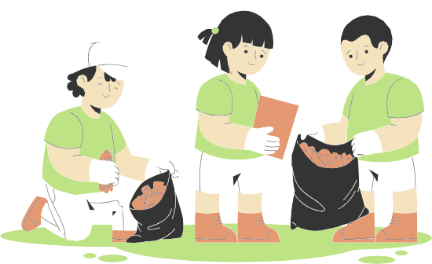



**Community News Event News**

# Estate Management

The Butts has entered the ***Tidy Estates Competition for Kilkenny County Council Housing Estates 2024*** in the category for larger estates. The clean-up event will be part of this work to help maintain the estate and keep it looking well.



## Age Friendly Programme - Mayfair Library, Parliament St, R95 N23R

The Mayfair Library will host a programme of events for older people, between 6th of September and 1st of November. The next event ***Assisted Decision Making & Safeguarding*** will be hosted by Rob O’Connor and Gemma Flood, HSE. This will take place on Friday 18th of October from 11 to 1pm. Contact 056 7794174 for more information.

***Events***

## Upcycling Workshops for Young People aged 13-18yrs

Dates: November 7th and 14th Time: 4.45-6.30pm

Location: St. Canice’s Neighbourhood Hall

Dive into the world of upcycled art by using preloved fabric to create your own unique designs. Experiment with textile markers, printing, hand stitching, and add some flair with studs, buttons, and other unique embellishments. In the second workshop turn your textile art into stylish, reusable drawstring bag!

Perfect for carrying your shoes, headphones, art supplies, makeup, or even your fruit and veggies.

Join us for these two workshops and get ready to unleash your creativity

To book please email

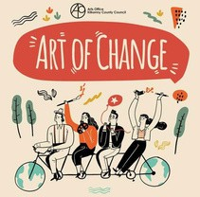[kathy .conlan@kilkenny coco.ie](mailto:kathy.conlan@kilkennycoco.ie). Under 18’s must have a guardian book on their behalf.

