27th May, 2021

TO: AN CATHAOIRLEACH &
EACH MEMBER OF THE PILTOWN MUNICIPAL DISTRICT

Dear Councillor,
You are requested to attend the Annual Meeting of the Piltown Municipal District to be held on Wednesday, 2nd June 2021 at 9.30am.

The Agenda is as follows:
- Election of Cathaoirleach
- Election of Leas Cathaoirleach
- Agree Schedule of Meetings (attached)

Yours Sincerely,
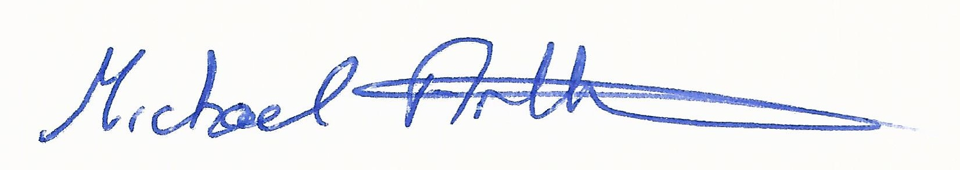

__________________________
Michael Arthurs
Senior Executive Officer
Meetings Administrator Piltown MD

