27th May, 2021

TO: AN CATHAOIRLEACH &
EACH MEMBER OF THE PILTOWN MUNICIPAL DISTRICT

Dear Councillor,
You are requested to attend a Meeting of the Piltown Municipal District to be held on Wednesday, 2nd June 2021 at 10.00am. In compliance with ongoing Public Health Guidance relating to the Covid 19 pandemic, and as facilitated by amended Standing Orders; the meeting will be conducted remotely using the MicroSoft Teams video conferencing system. The amended Standing Orders allow for full business and statutory decisions to be agreed using the remote meetings format.

The Agenda is as follows:
- Minutes of Ordinary Statutory Meeting held 5th May 2021 and matters arising (attached)
- Consideration of Reports and Recommendations
  - Update Monthly Roadworks (S Cullen)
  - Update South East Greenway (S McKeown)
  - Update North Quays (S McKeown)
- Business prescribed by Statute, Standing Orders or Resolutions of the Municipal District Members for transaction at such meeting
- Notices of Motion
- Correspondence
- A.O.B.

Yours Sincerely,
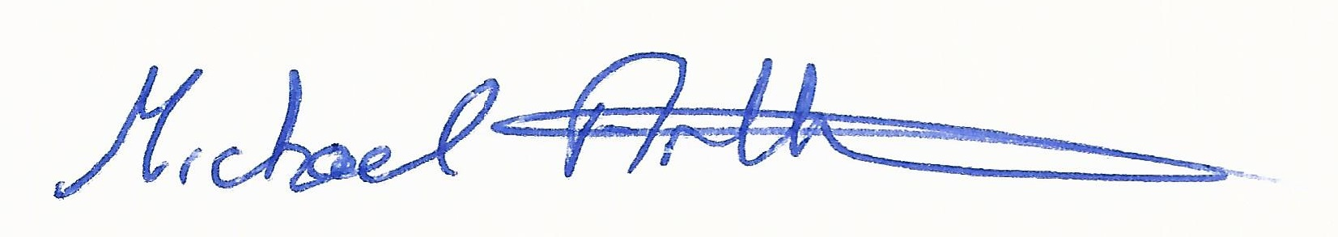

__________________________
Michael Arthurs
Senior Executive Officer
Meetings Administrator Piltown MD

